**NASA DEVELOP National Program**



NOAA National Centers for Environmental Information

*Spring 2016*

Cascade and Sierra Nevada Mountains

Water Resources

A Comparison of Remotely-Sensed Climate Data Records over the Cascade and Sierra Nevada Mountains for Improved Climate Monitoring

 **Technical Report**

Final Draft – March 31, 2016

Sam Swanson (Project Lead)

Kevin Rapa

Michael Kruk, ERT, Inc. (Science Advisor)

# I. Abstract

Shifting hydrologic processes have grown to be a significant problem in California, Oregon, and Washington. In recent years, average winter temperatures have risen, spring snowmelt has occurred earlier, and a greater portion of precipitation has fallen as rain rather than snow in the Sierra Nevada and Cascade mountain ranges. The natural reservoir of water stored in mountain snowpack has drastically declined, limiting water availability in the summer and forcing water managers to reassess their water management regimes. Current methods of understanding orographic precipitation in the West are limited to ground-station and volunteer-based observations, which are spatially limited in such areas. Considering the needs of the Western Regional Climate Center and the National Weather Service Western Region, this project enhanced the understanding of precipitation in the Sierra Nevada and Cascade mountain ranges, using the NOAA Climate Prediction Center Morphing technique (CMORPH), NASA’s Global Precipitation Model (GPM), and the NOAA National Weather Service Snow Data Assimilation System (SNODAS) satellite data records. A comparison between satellite and *in situ* datasets revealed information about the usefulness of remotely-sensed data in estimating orographic precipitation. Ultimately, this project created several products for the end-user: graphics and maps comparing *in situ* and satellite data, maps detailing precipitation variability, and maps identifying regions that lack *in situ* data while performing well at the remotely-sensed level.

**Keywords**

Water resources, precipitation, snow water equivalent (SWE), Western United States, CPC-Morphing technique (CMORPH), Global Precipitation Measurement (GPM), Snow Data Assimilation System (SNODAS)

# 

# II. Introduction

Hydrologic processes in California, Nevada, Oregon, and Washington are unique among the rest of the United States. Their primary water source for human and ecological use is stored in the natural reservoirs of snowpack at high elevations during the winter and spring (Mote et al. 2005; Vicuna and Dracup 2007). Since 1950, studies have shown a decreasing trend in snowpack and snow-water equivalent (SWE) in mountainous areas (Mote et al. 2005). This trend has been repeatedly correlated with temperature increases hypothesized to be a result of human-induced climate change (Melillo et al. 2014; Vicuna and Dracup 2007; Mote et al. 2005). Furthermore, the fraction of precipitation falling as snow has decreased at low- to mid-elevations, thus shifting peak snowmelt runoff to occur earlier in the spring (Knowles et al. 2007; Stewart et al. 2005; Maurer et al. 2007). Consequently, less precipitation is stored as snow in the mountains for summer runoff, forcing water managers to reassess their management schemes and limiting water for human and ecological use (Maurer et al 2007). Thus, changes in water supply, demand, and reliability in California, Nevada, Oregon, and Washington, also referred to as “the West”, warrant more accurate monitoring of water availability.

The National Weather Service (NWS) and the Western Regional Climate Center (WRCC) work together to disseminate high quality climate information in their regions, which include Washington, Oregon, Nevada, and California. For their purposes, the gridded dataset PRISM (Parameter Elevation Regression on Independent Slopes Model) is the most widely used tool in estimating precipitation (N. Oakley, personal communication). PRISM extrapolates known precipitation measurements from ground stations to areas lacking *in situ* measurements. The WRCC also consults the Global Historical Climatology Network (GHCN), an amalgam of many ground-based data collection organizations, including Snow Telemetry (SNOTEL), Remote Automated Weather Stations (RAWS), Automated Surface Observing System units (ASOS), and the Cooperative Observer Network (COOP). While this network of ground stations has benefits, they are spatially limited in their precipitation and snowpack measurements in the Cascade and Sierra Nevada mountain ranges (N. Oakley, personal communication). Previous studies have shown that satellite-derived precipitation estimates, when validated by ground observations, can be useful in monitoring climate indicators in the continental US (Prat and Nelson 2015). However, regions with highly variable geography, like the mountainous northwestern United States, continue to prove difficult for satellite-derived algorithms to accurately estimate precipitation and snowfall events (Prat and Nelson 2015). These difficulties may be resolved with new satellite products at higher spatial resolutions (O. Prat, personal communication).

As part of the NASA Applied Sciences Program Water Resources Application Area, this study aimed to compare and analyze remotely-sensed and *in situ* precipitation data in the Sierra Nevada and Cascade mountain ranges to gauge the usefulness of satellite data in mountainous regions. This study qualified the usefulness of satellite resources in understanding water availability in mountain snowpack across the western United States, and informed both climate monitoring and forecasting efforts.

The 3 objectives of this research were (1) to determine if satellite data are useful in measuring orographic precipitation by comparing satellite climate data records (CDRs) to currently-used ground station data, (2) to compose a suite of map products to enhance the understanding of precipitation, and (3) to further understand SWE in the study area by comparing the Snow Data Assimilation System (SNODAS) data records to SNOTEL ground observations.

# 

# III. Methodology

The data were identified, processed, visualized, and analyzed before being presented as a final product to the end-users. This process involved (1) an analysis of satellite and ground data differences in precipitation measurements, (2) the creation of baseline and benefits maps, and (3) the determination of usefulness of satellites in measuring SWE.

The first objective required the Climate Prediction Center Morphing Technique (CMORPH) CDRs, the Global Precipitation Measurement (GPM), three GHCN datasets, and the PRISM dataset. The CMORPH dataset is a satellite-derived CDR produced by the National Oceanic and Atmospheric Administration (NOAA). The satellites in the CMORPH algorithm use a passive microwave sensing technique to derive global precipitation estimates. Although these estimates are derived, the data are available at high spatial and temporal resolutions of .073° (8 km2 at the equator) from 1998 to 2013 at a 30-minute temporal resolution. These estimates were collected in a numeric weather prediction adjusted format, which corrects biases in the original CMORPH data. From the NOAA corrected repository, the global CMORPH dataset was downloaded in the form of compressed .tar files. Being an enormous dataset, it required much further processing. Using the statistical program R, an un-compression process was automated to expand the CMORPH files into binary .bz2 files. From there, R code looped through each .bz2 file, processing each into a raster and clipping it to the study area. In the interest of the NWS and WRCC, the 30-minute raster’s were aggregated into daily sums, greatly reducing the size of the dataset.

The second data source, GPM, is a global mission to produce satellite-derived precipitation measurements. Launched by the National Aeronautic Space Administration (NASA) and the Japanese Aerospace Exploration Agency (JAXA) in 2013, GPM is a continuation of the Tropical Rainfall Measuring Mission (TRMM), which collected rainfall estimates at tropical latitudes until April 2015. GPM creates a merged product of global precipitation estimates since March 14, 2014 from 60°N to 60°S at a high spatial resolution of 0.1° (11.13 km2 at the equator) and temporal resolution of 30 minutes. These records were collected from the NASA Precipitation Measurement Mission Data Downloads page via FTP. This data was subset to the study area before being downloaded, and then downloaded as GeoTiff files at a 1 day temporal resolution.

The GHCN and PRISM datasets, which the NWS and WRCC currently use, were chosen for comparisons against CMORPH and GPM. Of over twenty sources included in GHCN, three were used in this study: SNOTEL, ASOS units, and COOP. These provide precipitation measurements in the study area and are consulted daily by monitoring organizations. The datasets of the GHCN, however, have fewer estimates at higher elevations, notably in the Sierra Nevada and Cascade mountains. The GHCN datasets were processed from four space-delimited text files. Three of the text files contained raw precipitation estimates from the three GHCN sources, the date of each record, and the station ID associated with each. The remaining text file contained station metadata, including each station's latitude and longitude, unique ID, and elevation.

PRISM was the second ground-based dataset used for comparison against the satellite data. PRISM uses a large collection of station networks, including GHCN, to interpolate measurements at high elevations. PRISM differs from GHCN in that it is a gridded dataset at a .037° resolution (4km2 at the equator). The WRCC uses this dataset where station data are unavailable. The PRISM dataset was downloaded as daily estimates from the Oregon State University PRISM Climate Group website. The files came compressed in a .zip format, which were uncompressed using R programming. They were then subset to our study area.

After completing the initial processing of the CMORPH, GPM, GHCN, and PRISM datasets, comparisons between satellite and ground station precipitation measurements were made at each station point using the nearest-lying raster pixel. In order to determine which satellite-raster pixels to extract, each GHCN station was plotted on a map, and their geographic coordinates noted. From under each station point, we extracted the accompanying satellite-raster pixel value and appended it to the station record for each date. The resulting table contained GHCN station ID fields, elevation fields, longitude and latitude coordinates for both the GHCN stations and satellite pixels, and precipitation fields of both ground and satellite datasets for every day. From here, weighted averages were calculated in the table to account for multiple stations lying in the same raster pixel. This was done by converting a sample raster from each gridded dataset into a shapefile, and then converting the shapefile into Theissen polygons. Using this, each GHCN station was then giving an identifier to define it as lying inside a specific raster pixel using the “near” tool in ArcToolbox. Several univariate and bivariate statistical methods were used to visualize and understand the variance in the data. Bivariate analyses consisted of scatterplots between the satellite and ground station precipitation. The plots were split into summer and winter seasons (April 1-October 1 and October 1-April 1) and then further subdivided according to the areas of the Northwest and California/Nevada River Forecast Centers (RFCs).

Daily data was visualized as scatterplots comparing satellite-derived and ground-based precipitation estimates for the entire study period. Both best fit and 1-to-1 regression lines were overlaid onto the data in order to show relative agreement between datasets. Root mean square error (RMSE) is a common measurement of difference between values predicted by an estimator and values actually observed. The RMSE was calculated to quantify statistical agreement in the scatterplots. RMSE values of 0 represent perfect agreement. Furthermore, an analysis of satellite-*in situ* agreement by elevation was conducted. *In situ* metadata includes the elevation of each measuring station. By comparing satellite and ground-station precipitation estimates on the y-axis to elevation on the x-axis, trending over- and underestimations at varying altitudes are illuminated.

In addition to a suite of scatter plots for the satellite/ground comparisons, maps comparing satellite- and station-derived winter averages were created using ArcMap. Daily estimates were aggregated by station and water year using R to create average precipitation amounts at each station for each water year. A water year describes a year as water resources accumulate in a season, from October 1 to September 31. They were further averaged over the 15 year study period, and then split into summer and winter halves. The winter half was utilized to make two difference maps illustrating the difference of GPM and CMORPH measurements from GHCN measurements. Because GPM is a very recent product, the GPM / GHCN difference map covered only October 1, 2015 to December 31, 2015. The CMORPH CDR, blanketing a much larger time scale, allowed the CMORPH / GHCN difference map to cover winter months between October 1, 1998 and December 31, 2013. These difference maps were displayed as color-coded points on a base-map, with red shades representing a satellite underestimation and blue shades representing a satellite overestimation.

From the above comparisons, it became apparent that CMORPH outperforms GPM in the study area. Further investigation focused on CMORPH data. To this end, CMORPH raster’s were subtracted from PRISM raster’s using a raster calculator to produce CMORPH / PRISM difference maps. Displayed as a suite of 6 maps, one for each month of the winter season, these difference maps allow our end-users to visually compare where regions of greatest agreement and disagreement occur between CMORPH and PRISM precipitation estimates as the wet season progresses. The color graduations for this suite of maps were classified into half standard deviations, with values within a half standard deviation being considered ‘beneficial’ for the purposes of creating benefits maps.

Benefit maps showing where satellite data could best fill in station data gaps were also produced using estimates from CMORPH with the highest correlation to GHCN measurements. For the first part of the benefits map, a map showing areas of low GHCN station density was created using the kernel density tool. Areas with a higher station density are less likely to have unavailable climate records, and so these areas are less wanting of satellite coverage. The second part of this product was derived from the January CMORPH versus PRISM difference map. Only areas within a half standard deviation of zero difference were included. In addition to this, areas with high GHCN station density were clipped away. The result was overlaid on a base map, and this comprised the final benefits map. By highlighting these locations, the WRCC, NWS, and regional RFC’s learned where their monitoring efforts would benefit the most from the inclusion of remotely-sensed data if *in situ* station measurements are sparse or unavailable.

For objective 3, the topic of interest shifted from precipitation to SWE, following a similar methodology. SWE measures the amount of water stored in snowpack, and thus is an important factor in predicting the timing and amount of snowmelt runoff. NOHRSC's Snow Data Assimilation System (SNODAS) is currently used by the WRCC to monitor SWE. SNODAS produces high-quality, 1km2-resolution measurements on a daily time-scale. The ability of SNODAS, a satellite-derived, merged estimate, to measure SWE was evaluated by comparing it to ground-based measurements from SNOTEL stations. Correlations and disparities using scatter plots were analyzed, maps of SWE normal displaying both satellite and *in situ* data were displayed, and a benefits map for the WRCC’s consideration was produced.

# 

# IV. Results & Discussion

The results from the analysis between GPM and GHCN stations showed a general underestimation by GPM. In both the Northwest and California/Nevada RFC’s, PRISM’s RMSE is lower than GPM’s (11.90 and 5.84 vs 12.88 and 8.06, respectively) and therefore is more strongly correlated with GHCN data. Perhaps a longer study period, rather than the 3 months available for this research (October to December), will show a stronger correlation between the two datasets. However, these poor results early in GPM’s lifetime led to a further investigation of CMORPH, PRISM, and GHCN. For similar graphics concerning the California/Nevada RFC, see appendix A.

**GPM and PRISM vs GHCN**

Northwest RFC

PRISM (mm/day)

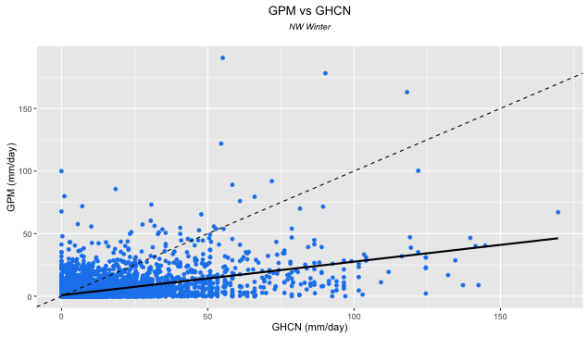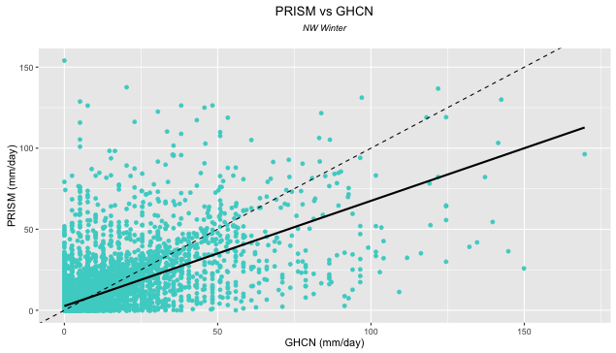

RMSE: 12.88

RMSE: 11.90

GPM (mm/day)

100

50

0

150

150

100

50

0

0

50

100

150

GHCN (mm/day)

GHCN (mm/day)

Figure 1. Daily GPM and PRISM estimates of precipitation versus GHCN measurements from October 1, 2015 to December 31, 2015. GPM measurements fail to synchronize satisfactorily with GHCN measurements as precipitation rises, instead falling as precipitation amounts rise.

When visualized across the study area, GPM estimates are generally not precise. The greatest underestimations of GPM from GHCN measurements are seen in the mountainous Northwest. The central Sierras, however, see overestimations. The southernmost tip of California and the plains east of the Sierra Nevada and Cascades show some agreement, though not universally (see appendix B, figure 16).

Unlike GPM, daily estimates of precipitation by CMORPH between 1998 and 2013 overestimate GHCN measurements. Over the same time period, PRISM outperforms CMORPH in both RFCs with root mean square errors of 9.19 and 5.85 versus CMORPH’s root mean square errors of 17.29 and 12.95 (see figure 2.). The distribution of data points above and below the R2 = 1dotted line show general overestimations by CMORPH and slight underestimations by PRISM. Regression lines can be greatly swayed by outliers; long right tails in both graphs are pulling the regression lines downwards. Severe CMORPH underestimations at high precipitation events skew its best-fit line, which would otherwise follow a trend of overestimation. It seems that neither CMORPH nor PRISM accurately estimate precipitation events over 250 mm/day.

**CMORPH and PRISM vs GHCN**

Northwest RFC

PRISM (mm/day)

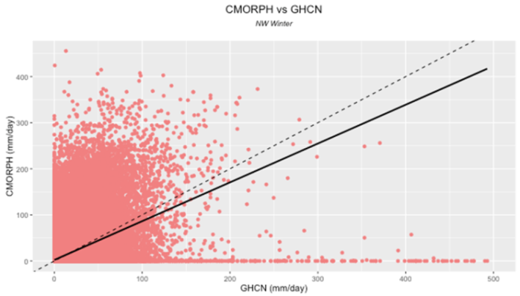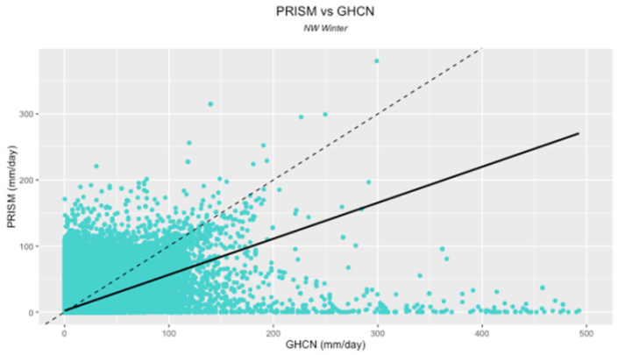

CMORPH (mm/day)

0

0

100

300

400

200

500

400

300

200

100

100

200

300

400

500

RMSE: 17.29

RMSE: 9.19

0

GHCN (mm/day)

GHCN (mm/day)

Figure 2. A greater proportion of CMORPH estimates land above the 1-to-1 line, implying overestimation of precipitation events compared to GHCN. Although the best fit line of CMORPH is closer to the 1-to-1 perfect correlation line than PRISM’s (a result of severe underestimation during strong precipitation events), RMSE values show better estimation by PRISM overall.

These trends are further illustrated in figure 3, which plot daily data averaged by GHCN daily observations in mm and layer CMORPH data onto PRISM data. At the daily level, the number of observations was too great to discern trends between datasets. Averaged so that each x-axis value correlates with 1 y-axis value for each dataset, CMORPH displays overestimation relative to the R2 = 1 line, while PRISM displays a slight underestimation. Both datasets show greater accuracy in the California/Nevada RFC (see appendix A, figure 11).

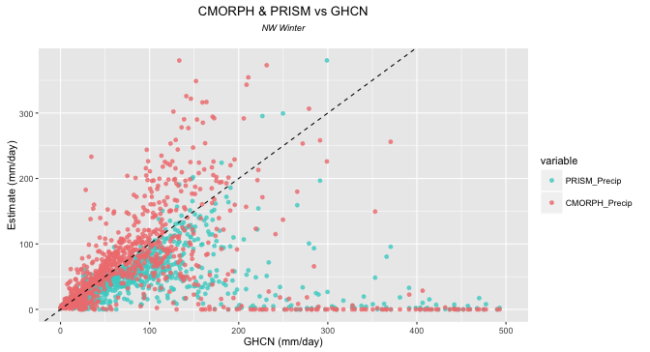

PRISM

CMORPH

Precipitation estimate (mm/day)

300

200

100

0

0

100

200

300

400

500

**CMORPH and PRISM vs GHCN**

Northwest RFC

GHCN (mm/day)

Figure 3. By overlaying CMORPH and PRISM against GHCN measurements, it is evident that CMORPH tends to overestimate while PRISM underestimates precipitation events.

In figure 4 (see also appendix A, figure 12), one can see daily observations of GHCN, PRISM, and GHCN against elevation by RFC. Once again, PRISM underestimates some of GHCN data, especially during extreme events above 250 mm/day and in the Northwest RFC. CMORPH largely overestimates at all elevations. It should be noted that because daily estimates are numerous, some detail is lost due to points overlapping each other in each scatterplot. To account for this, daily data were aggregated to 15-year normals for the purpose of spotting general trends (see figure 9).

**GHCN, PRISM, & CMORPH by Elevation**

Northwest RFC

500

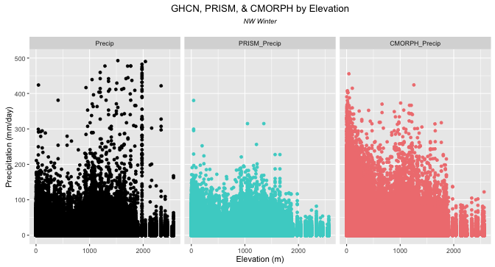

Precipitation (mm/day)

0

100

200

300

400

2000

2000

1000

1000

0

0

2000

1000

0

CMORPH

PRISM

GHCN

Elevation (m)

Figure 4. While CMORPH overestimates at all elevations, neither CMORPH nor PRISM accurately estimates high precipitation events around 2000 meters (at high elevation).

When aggregated across the entire study period, geographic pitfalls of CMORPH emerge (see appendix B, figure 16). CMORPH underestimates GHCN-measured mountain precipitation in both the Northwest and California/Nevada RFCs by up to 29.07 mm/day. West of the Cascades and the Sierra Nevadas, CMORPH estimates do not improve greatly. CMORPH estimates in southern California and the rain shadow east of the mountains in Washington, Oregon, and Nevada show the greatest correlation with GHCN. There, precipitation estimates are smaller on the whole, and the flat geography is better suited to remote sensing tools. A similar story is told by a suite of 6 maps showing monthly average differences in estimation between CMORPH and PRISM over the 15-year study period (see appendix B, figure15). In October, the differences are low due to little rainfall occurring in the study area at that time (see figure 5a). As the winter (wet season) progresses, the magnitude of CMORPH underestimations at high elevations rise (figure 5b). In the Cascades, differences reach as much as -16.22 mm/day on average in some pixels. Comparisons also show, once again, general agreement in the plains east of the mountains.

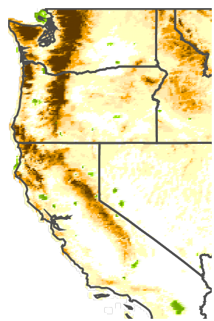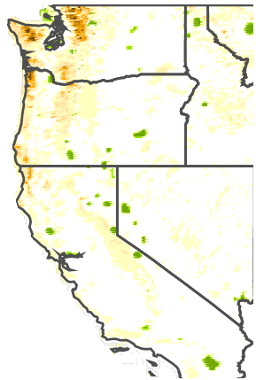 

Figure 5b. January averages show CMORPH underestimates are seen in mountainous areas.

Figure 5a. In the month of October, CMORPH / PRISM differences are low due to infrequent precipitation events.

CMORPH overestimation

CMORPH is most similar

CMORPH underestimation

The WRCC and the NWS would like to know which areas, if any, would benefit most from satellite-derived data. Clipped from the benefits maps are regions with high densities of ground stations and large CMORPH / PRISM differences. The result, shown in figure 6, is a conclusive map that recommends where remotely-sensed precipitation estimates can be utilized as a supplement to GHCN networks or if GHCN/PRISM data is unavailable.

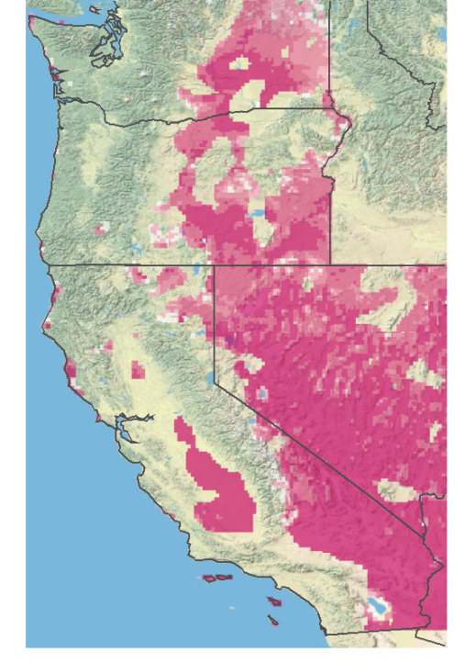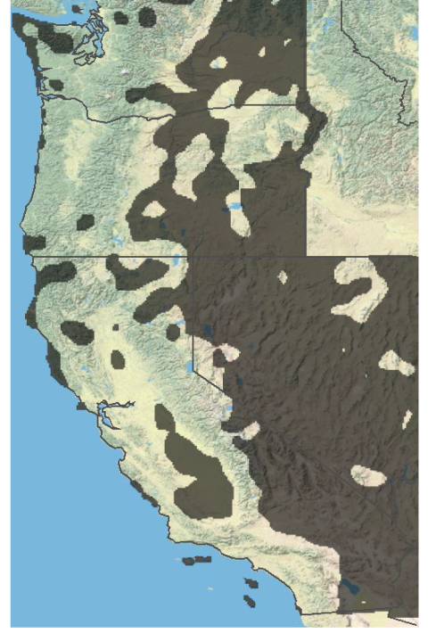

0.00 - 0.56 mm/day

0.57 - 1.11 mm/day

1.12 - 1.67 mm/day

1.68 - 2.23 mm/day

2.24 - 2.79 mm/day

Magnitude of difference

between CMORPH and

PRISM

Figure 6a. Areas with low GHCN Figure 6b. Areas where CMORPH

station density are highlighted in and PRISM aligned most were

black. combined with the GHCN density

map.

Preliminary results comparing SNODAS and SNOTEL snow water equivalent (SWE) observations are promising. A strong correlation is shown between the two datasets (see figure 7 and appendix A, figure 13). Because SWE is a variable that accumulates throughout the winter season, monthly maximum SWEs are used to summarize the results. Each observation represents the monthly maximum SWE for one month at one SNOTEL station between October 2003 and December 2013.

**SNODAS vs SNOTEL**

Northwest RFC

3000

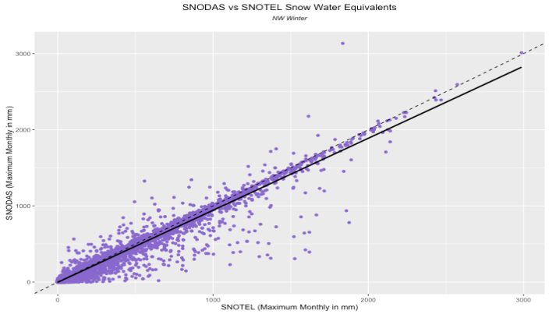

SNODAS (Monthly maximum in mm)

Figure 7. SNODAS and SNOTEL snow-water equivalent estimates and observations show high correlation (Adjusted R2: 0.95).

Adjusted R2: 0.95

2000

1000

0

0

3000

2000

1000

SNOTEL (Monthly maximum in mm)

A further investigation into the extent to which SNODAS and SNOTEL agree at various elevations yields similar results; SNODAS and SNOTEL very closely mirror one another at all elevations (see figure 8 and appendix A, figure 14). Communication with Gregory Fall of NOAA and NOHRSC’s dataset keeper disclosed that “SNOTEL observations figure prominently in SNODAS assimilation, which occurs regularly during the winter months, so a strong correlation between the two would be unsurprising” (G. Fall, personal communication). Therefore, although these results are promising, we recommend further investigation of SNODAS’s effectiveness in our study region independent of SNOTEL data. Nina Oakley has voiced a similar sentiment, suggesting the CDEC/California Snow Survey’s dataset and others that are not assimilated into SNODAS’s algorithm for validation in the Sierra Nevadas, and to contact the Oregon or Washington State Climate Offices or River Forecast Centers for independent SWE datasets in their regions.

**SNOTEL and SNODAS Snow Water Equivalents by Elevation**

Northwest RFC

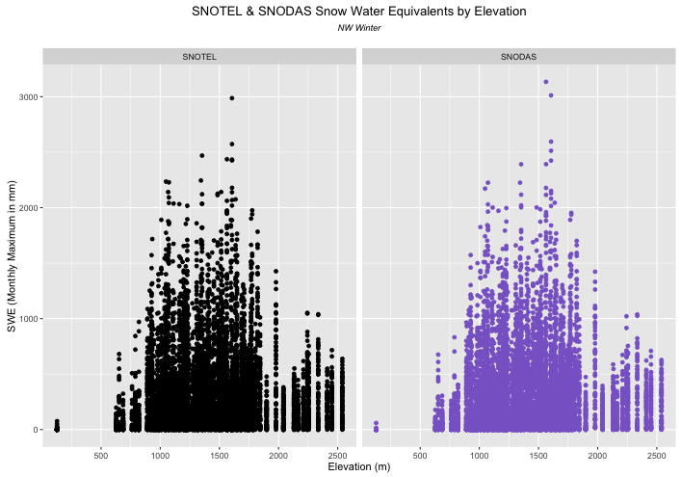

SWE (Monthly maximum in mm)

500

500

1500

1500

3000

3000

2000

2000

1000

1000

0

1000

2000

3000

SNOTEL (Monthly maximum in mm)

Figure 8. SNODAS, at all elevations, shows very close agreement with SNOTEL observations.

# 

# V. Conclusions

# From our results, we are able to draw several conclusions about the effectiveness of satellite-derived precipitation and snow water equivalent estimates in the Cascade and Sierra Nevada mountain ranges. We recommend CMORPH precipitation estimates over GPM currently. However, as GPM records extend into a longer time period, it may become just as useful of an alternative to ground interpolation. Presently, end-users will benefit the most from CMORPH at low elevations as a supplement to ground estimates, specifically in southern California and the eastern regions of Washington, Oregon, and Nevada. Disagreements among CMORPH / PRISM and CMORPH / GHCN grow as altitude increases in the Cascade and Sierra Nevada mountains. Furthermore, because of SNOTEL's integration in the SNODAS dataset, their exceptionally close relationship is unsurprising.  We recommend further studies to validate SNODAS SWE estimates in the Cascades and Sierra Nevada using independent SWE measurement stations, such as the CDEC/California Snow Survey, or by removing SNOTEL from the SNODAS algorithm.

# VI. Acknowledgments

• NCEI, Asheville, NC

• Michael Kruk

• Jessica Sutton

• Nina Oakley

• Andrea Bair

• Emma Baghel

• Dr. Olivier Prat

• Mike Squires

• Ronald Leeper

• Jonathan Brannock

Any opinions, findings, and conclusions or recommendations expressed in this material are those of the author(s) and do not necessarily reflect the views of the National Aeronautics and Space Administration.

This material is based upon work supported by NASA through contract NNL11AA00B and cooperative agreement NNX14AB60A.

# 

# VII. References

"CPC: Monitoring and Data - Global Precipitation Analyses." *CPC: Monitoring and Data –*

*Global Precipitation Analyses*. National Oceanic and Atmospheric Administration, n.d. 11 Feb. 2016.

Fall, Greg. Personal communication via email. 19 March 2016.

Knowles, Noah, Michael D. Dettinger, and Daniel R. Cayan. "Trends in Snowfall versus

Rainfall in the Western United States." *Journal of Climate J. Climate* 19.18 (2006): 4545-559.

Maurer, E. P., I. T. Stewart, C. Bonfils, P. B. Duffy, and D. Cayan. "Detection, Attribution, and

Sensitivity of Trends toward Earlier Streamflow in the Sierra Nevada." *J. Geophys. Res.*

*Journal of Geophysical Research* 112.D11 (2007).

Melillo, Jerry M., Terese Richmond, and Gary W. Yohe, Eds., 2014: Highlights of Climate

Change Impacts in the United States: The Third National Climate Assessment. U.S. Global Change Research Program, 148 pp.

Milly, P. C. D., Julio Betancourt, Malin Falkenmark, et al. 2008. Stationarity is Dead: Whither

Water Management? Science 319 (5863): 573-574.

Mote, Philip W., Alan F. Hamlet, Martyn P. Clark, and Dennis P. Lettenmaier. "Declining

Mountain Snowpack in Western North America*." *Bull. Amer. Meteor. Soc. Bulletin of*

*the American Meteorological Society* 86.1 (2005): 39-49.

Oakley, Nina. Personal communication via teleconference. 1 February 2016.

Prat, Olivier P., Brian R. Nelson, Lou Vasquez, Ralph Ferraro, Scott Rudlosky, and Jian-Jian

Wang. *Evaluation of Satellite Based Quantitative Estimates (QPEs) over CONUS (2002-2012): Comparison with Surface and Radar Precipitation Datasets*. Tech. Asheville: NOAA, 2014.

Prat, O. P., and B. R. Nelson. "Evaluation of Precipitation Estimates over CONUS Derived from

Satellite, Radar, and Rain Gauge Data Sets at Daily to Annual Scales (2002–2012)."

*Hydrol. Earth Syst. Sci. Hydrology and Earth System Sciences* 19.4 (2015): 2037-056.

Prat, Olivier P. Personal communication. 3 February 2016.

Stewart, Iris T., Daniel R. Cayan, and Michael D. Dettinger. "Changes toward Earlier

Streamflow Timing across Western North America." *Journal of Climate J. Climate* 18.8

(2005): 1136-155.

Vicuna, S., and J. A. Dracup. "The Evolution of Climate Change Impact Studies on

Hydrology and Water Resources in California." *Climatic Change* 82.3-4 (2007): 327-50.

**VIII. Content Innovation**

We plan to create a Glossary Viewer, an Interactive Plot Viewer of our scatterplots, and a Data Profile, as the datasets included in this study were drawn from massive data files with difficulty.

# IX. Appendices

Appendix A: Graphs for California/Nevada RFC

**GPM and PRISM vs GHCN**

California/Nevada RFC

PRISM (mm/day)

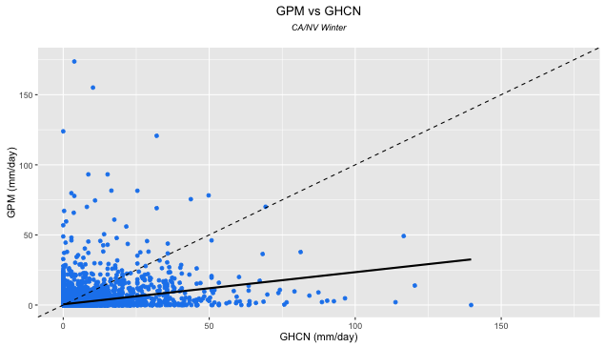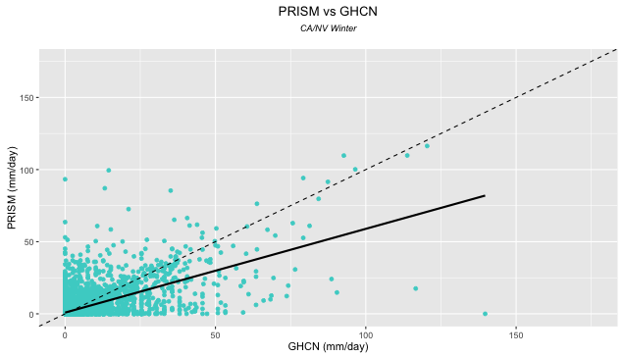

RMSE: 8.06

RMSE: 5.84

150

100

50

0

50

100

150

50

150

100

GPM (mm/day)

0

0

GHCN (mm/day)

GHCN (mm/day)

Figure 9. GPM and PRISM daily estimates against GHCN measurements of precipitation, in mm/day. PRISM follows the 1-to-1 line well, while GPM estimates show little to no correlation with GHCN measurements

**CMORPH and PRISM vs GHCN**

California/Nevada RFC

PRISM (mm/day)

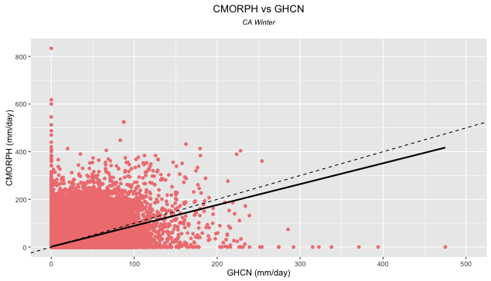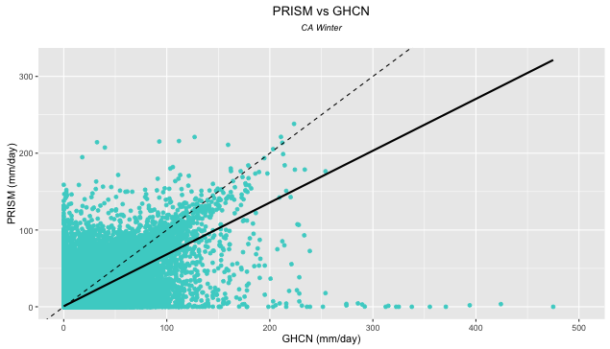

CMORPH (mm/day)

600

800

400

200

RMSE: 5.85

RMSE: 12.95

0

0

500

400

300

200

100

100

200

300

400

500

0

GHCN (mm/day)

GHCN (mm/day)

Figure 10. CMORPH fails to outperform PRISM in the California/Nevada RFC. Although the best fit regression line of CMORPH is very close to the 1-to-1 line, this is a results of underestimating outliers at high precipitation events “pulling down” an otherwise overestimating dataset, as seen by more estimates above the 1-to-1 line than below it.

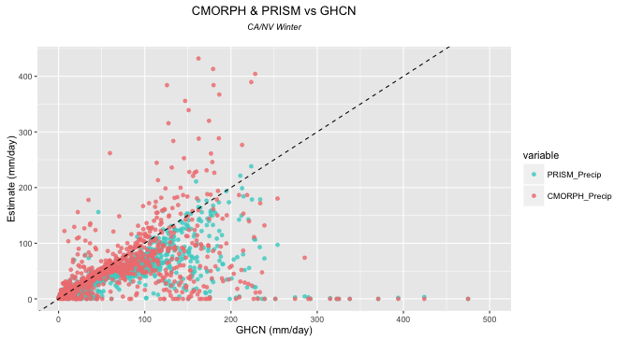

PRISM

CMORPH

Precipitation estimate (mm/day)

300

200

100

0

0

100

200

300

400

500

**CMORPH and PRISM vs GHCN**

California/Nevada RFC

GHCN (mm/day)

Figure 11. CMORPH and PRISM both show tighter trends towards observed measurements in the California/Nevada RFC than the Northwest RFC. However, CMORPH overestimations remain.

**GHCN, PRISM, & CMORPH by Elevation**

California/Nevada RFC

500

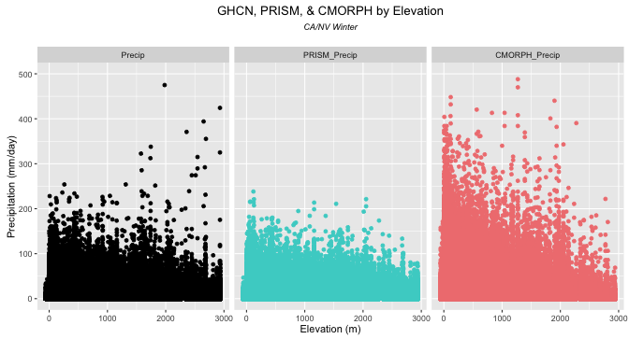

3000

2000

1000

0

2000

1000

2000

1000

Precipitation (mm/day)

0

100

200

300

400

0

0

CMORPH

PRISM

GHCN

Elevation (m)

Figure 12. The California/Nevada RFC sees fair estimation of GHCN precipitation measurements by PRISM at most elevations, excepting at very high altitudes (<2500 m). CMORPH strongly overestimates at low- and mid-elevations.

**SNODAS vs SNOTEL**

California/Nevada RFC

SNODAS (Monthly maximum in mm)

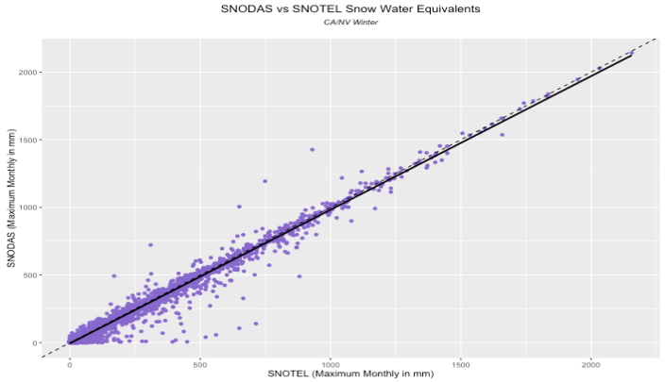

1500

500

2000

1000

2000

1500

1000

500

Adjusted R2: 0.98

0

0

SNOTEL (Monthly maximum in mm)

Figure 13. The California/Nevada RFC displays an even higher Adjusted R2 value than the Northwest RFC’s (0.98 vs 0.95).

**SNOTEL and SNODAS Snow Water Equivalents by Elevation**

California/Nevada RFC

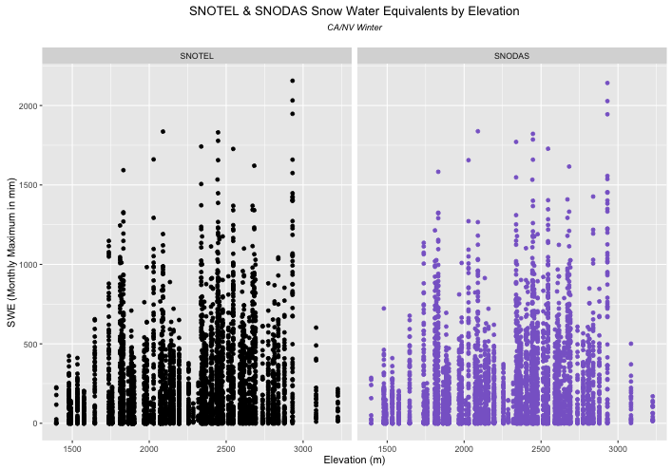

SWE (Monthly maximum in mm)

2500

3000

2000

1500

3000

2500

2000

1500

1500

500

2000

1000

0

SNOTEL (Monthly maximum in mm)

Figure 14. Across all elevations, SNOTEL and SNODAS observations and estimates agree very well. At very high elevations, SWE drops due to extremely cold temperatures and snowpack with small percentages of water content.

Appendix B: Maps

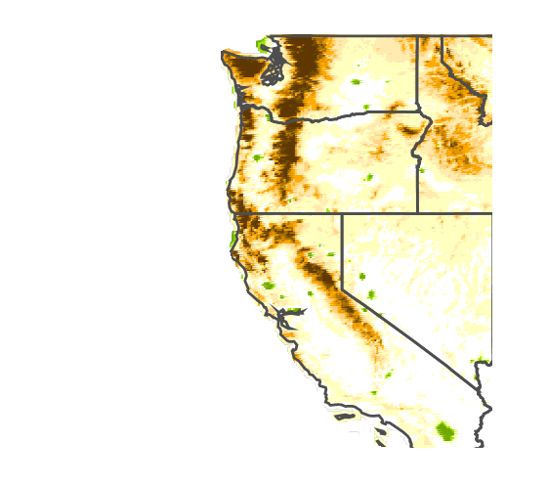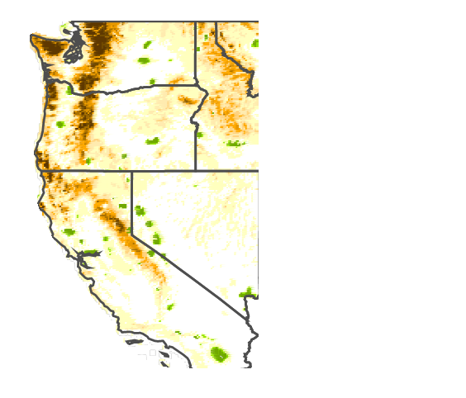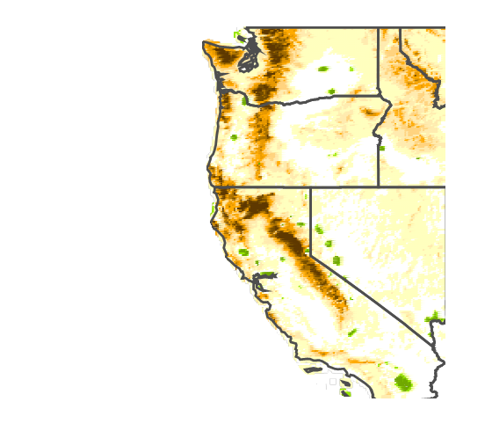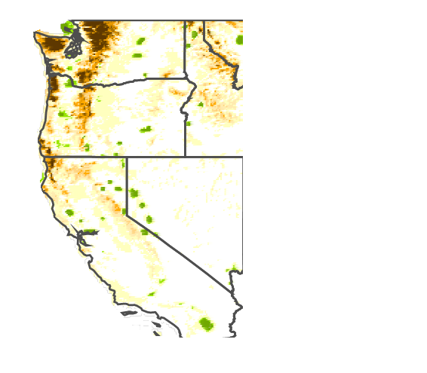

Figure 15. From October to January, CMORPH underestimations exacerbate until a peak during December and January, and then subside by March. Many isolated areas of overestimates are also visible. These areas are lakes, which may be creating false readings.

-2.79 to -1.66 mm/day

-1.67 to -0.55 mm/day

-0.56 to 0.57 mm/day

0.58 to 1.68 mm/day

1.69 to 2.80 mm/day

2.81 to 11.32 mm/day

-3.90 to -2.78 mm/day

-5.02 to -3.89 mm/day

-6.13 to -5.01 mm/day

-7.24 to -6.12 mm/day

-8.36 to -7.23 mm/day

-16.22 to -8.35 mm/day

March

February

January

December

November

October

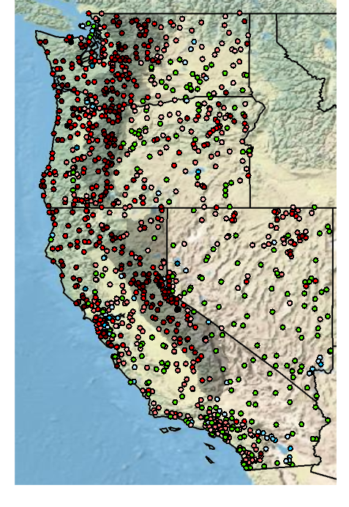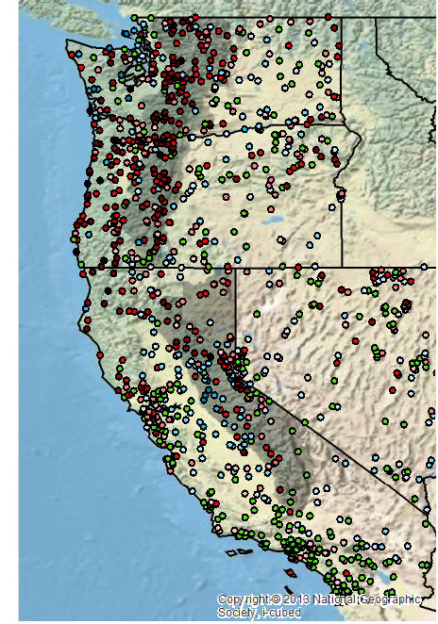­

Figure 16. Comparisons between satellite and ground data show a tendency for satellites to underestimate at higher elevations. It should be noted that these maps take place on two different timescales, and so comparisons between CMORPH and GPM should not be drawn from these maps. While CMORPH records extend back to 1998, GPM records extend from just October to December 2015 .

**Satellite Differences from GHCN**

Satellite difference

From GHCN

-57.14 - -20.00 mm/day

-19.99 - -10.00 mm/day

-9.99 - -5.00 mm/day

-4.99 - -2.50 mm/day

-2.49 - -1.00 mm/day

-0.99 - -0.50 mm/day

-0.49 - 0.50 mm/day

0.51 - 1.00 mm/day

1.01 - 2.50 mm/day

2.51 - 5.00 mm/day

5.01 - 10.00 mm/day

GPM minus GHCN

CMORPH minus GHCN