**NASA DEVELOP National Program**



NASA Jet Propulsion Laboratory

*Fall 2016*

Costa Rica Agriculture II

Analyzing Advantages of ECOSTRESS as a Tool for Drought Detection and Water Management Practices

 **Technical Report**

Rough Draft – October 6, 2016

David Comer (Project Lead)

Sol Kim

Ian Heming

Katherine Cavanaugh

Dr. Joshua Fisher, NASA Jet Propulsion Laboratory, California Technical Institute (Science Advisor)

Dr. Christine Lee, NASA Jet Propulsion Laboratory, California Technical Institute (Science Advisor)

Previous Contributors:

Gregory Halverson

Mark Barker

Savannah Cooley

Steven Pestana

# 1. Abstract

El Niño Southern Oscillation (ENSO) conditions in 2015 have caused inadequate and unpredictable measures of rain throughout Central America. Costa Rica is located near the geographic center of the Central American drought, and loss of harvest due to inadequate rainfall is driving farmers to seek methods for mitigating effects of drought. To optimize available water resources, remote sensing methods can be used for the implementation of site-specific management strategies. The Normalized Difference Vegetation Index (NDVI) and evapotranspiration (ET) are currently used to measure changes in vegetative landscape characteristics but yield different spatial and temporal results concerning drought detection. The derivation of these datasets from Landsat versus MODIS imagery introduces further disparity. This project addressed the drought detecting capabilities of NDVI, and compared whether Landsat or MODIS, if either, is successful in providing a product that can identify vegetative trends from fine-scale landscapes in near-real time. The ECOsystem Spaceborne Thermal Radiometer on Space Station (ECOSTRESS) is scheduled to be launched to the International Space Station (ISS) in 2018 and will provide an ET product that advances the spatial and temporal coverage individually supplied by Landsat and MODIS. Using the Priestly-Taylor Jet Propulsion Laboratory (PT-JPL) model, this project used simulated ECOSTRESS data to assess the benefits ECOSTRESS will provide over existing datasets in both monitoring and mitigating vegetative responses to water and heat stress.

**Keywords**

ECOSTRESS, NDVI, evapotranspiration, drought, precision agriculture, irrigation, plant water stress, water conservation.

# 2. Introduction

* 1. ***Background Information***

El Niño Southern Oscillation (ENSO) events are characterized by naturally occurring variations from sea surface temperature (SST) trends and cause alterations in atmospheric conditions throughout the world (Hoell *et al*., 2014). The Dry Corridor in Central America is a semi-arid region characterized by recurring droughts, upon which many stakeholders rely for residence and resources. Spanning across parts of Belize, Guatemala, El Salvador, Honduras, Nicaragua, Costa Rica, and Panama, the area accounts for one third of the total landscape of Central America and is especially susceptible to the atmospheric effects of ENSO events (UNOCHA, 2014; UNOCHA, 2016). The onset of the most recent drought in the Dry Corridor varies by elevation and geographic location, with most areas experiencing effects between 2013 and 2014. ENSO conditions in 2015 aggravated these natural climatic events, causing inadequate and unpredictable measures of rain (UNOCHA, 2015). The alteration of historical rainfall trends has caused affected countries to fall victim to water shortage and crop failure, which in turn is decreasing food security, safety, and the livelihood of residents (UNOCHA, 2014; UNOCHA, 2015, UNOCHA, 2016).

Costa Rica is located near the geographic center of the Central American drought, and loss of harvest due to inadequate rainfall is driving farmers to seek methods for mitigating effects of drought on agriculture. Unlike other areas in the Dry Corridor, Costa Rica has access to infrastructure and funding that allow water to be diverted from the wet, Atlantic region to agricultural fields on the dry, Northwestern Pacific coast (Jiménez *et al*., 2001). To optimize available water resources, remote sensing methods can be used for the implementation of site-specific management strategies (Bongiovanni *et al*., 2004). Remotely sensed data provides a combination of spatial and temporal coverage that *in situ* data cannot achieve, including the location of crop water stress in near real-time (Bongiovanni *et al*., 2004; Gu *et al*., 2007).

The Normalized Difference Vegetation Index (NDVI) and evapotranspiration (ET) are remote sensing tools used to measure changes in the vegetative characteristics of a landscape. By analyzing NDVI and ET over time, the magnitude and direction of both gradual and abrupt changes in vegetative health and consumption can be addressed (Verbesselt *et al.,* 2011; DeJong *et al*., 2012; Vogelmann *et al*., 2012; Nash *et al*., 2014). While both tools can provide an assessment of environmental drivers and processes, they yield different results in the analysis of drought detection (Karnieli *et al*., 2010; DeJong *et al*., 2012). NDVI, an index of ‘greenness,’ analyzes plant health by detecting the amount and health of photosynthetic vegetation (Nash *et al*., 2014). ET has two components: evaporation and transpiration. Evaporation, the water exchange from open sources to the atmosphere, and transpiration, the water exchange from plants to the atmosphere, are indicative of soil moisture conditions and plant stress (Hong *et al.*, 2005; Fisher *et al.,* 2010; Anderson *et al.,* 2012; Anderson *et al*., 2016).

NDVI and ET can be derived from both Landsat and MODIS imagery, yet the source of data acquisition introduces further disparity in the spatial and temporal analysis of drought detection (Doraiswamy *et al.*, 2004; Anderson *et al*., 2012). Landsat imagery encompasses a high spatial resolution of 30 meters, but the temporal resolution is limited to a 16-day cycle (Wulder *et al.*, 2007). MODIS imagery has a low spatial resolution of 250 to 1000 meters, but a high temporal resolution of 1 to 2 days (Hong *et al.*, 2005). As a result, the current platforms are unable to provide a product with both high temporal and spatial resolution, and a combination of the two are needed to complete such analyses.

The ECOsystem Spaceborne Thermal Radiometer Experiment on Space Station (ECOSTRESS) will be launched to the International Space Station (ISS) in 2018 and will provide an ET product that advances the spatial and temporal coverage individually supplied by Landsat and MODIS. With a spatial resolution of 38m by 69m and a temporal resolution of 4 days, ECOSTRESS will allow for higher accuracy in the monitoring and mitigation of vegetative responses to water and heat stress (Fisher *et al.* 2011, Fisher *et al.* 2015).

* 1. ***Project Partners & Objectives***

EARTH University, an agricultural university in Costa Rica, utilizes georeferenced and in-field soil, plant, and water variable measurements to inform agricultural management practices. The Costa Rica Agriculture II team partnered with EARTH University to assist with irrigation and management decisions, crop water requirements, and the ability to identify field locations where crops receive too much or too little water. The study area encompasses the forested (32,233.6 km2) and agricultural areas (5445.9 km2) within the administrative boundary of Costa Rica, and accounts for 73% of the country (Figure 1). Vegetative land cover types were determined using the dataset from Fernández-Landa et al., 2016 provided by FONAFIFO. For this study, a baseline was created from 2003-2012 conditions, and compared against conditions in the drought years 2013, 2014, and 2015.

To determine the most effective way of detecting the magnitude and direction of changes in vegetative stress, we compared the drought detecting capabilities of the Normalized Difference Vegetation Index against evapotranspiration and determined which platform of derivation, Landsat or MODIS, was more successful in providing a product that can identify vegetative trends from fine-scale landscapes in near-real time. Will ECOSTRESS be our only option to create a detailed spatial and temporal analysis of vegetated health?

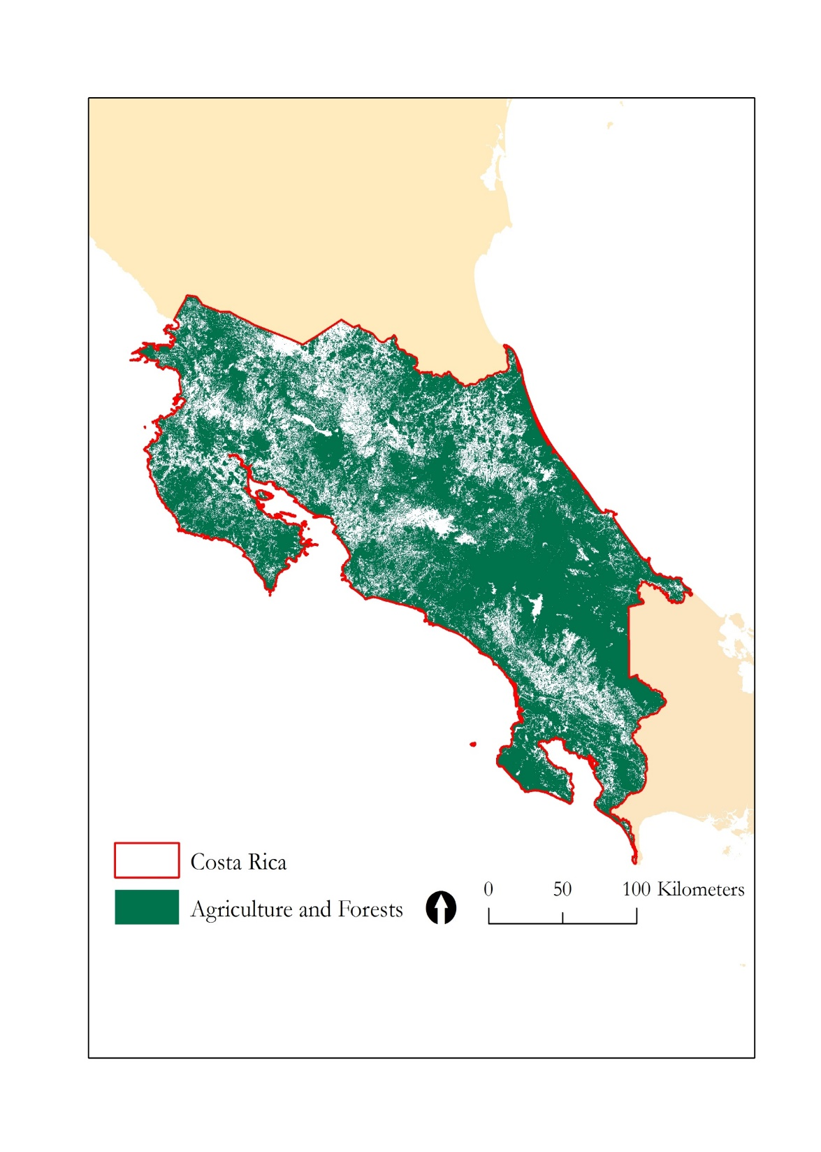

**Figure 1**. Study area within Costa Rica.

# 3. Methodology

***3.1 NDVI***

NDVI values range from -1 to +1. Values of -1 and +1 are rarely seen in nature, however negative values correspond to elements such as water and clouds, positive values correspond to photosynthetic vegetation, and neutral values correspond to elements such as concrete and sand (Weier *et al.*, 2000).

For the Landsat analysis, we derived NDVI from Landsat 7 Surface Reflectance images spanning from January 1, 2003 to October 1, 2016, and accessed all data products from Google Earth Engine (GEE). GEE computed the Landsat 7 NDVI product from atmospherically corrected surface reflectance images, and provided the product in an 8-day global composite with a spatial resolution of 30m. We masked cloud cover, associated shadows, and water using an 8-day composite of the CFmask, a band within the Landsat Surface Reflectance product that allows for the identification of cloud, cloud shadows, snow, and water.

For the MODIS spatial analysis, we computed NDVI by normalizing the difference between the red and infrared bands (band 1 and band 2) from the MODIS Surface Reflectance MOD09GA product. GEE computed the MOD09GA product from atmospherically corrected surface reflectance images, and provided the product in a daily composite with a spatial resolution of 500m. We masked cloud cover, associated shadows, and water using the MODIS cloud internal algorithm flag, cloud shadow flag, and land/water flag (USGS 2016). We re-projected MODIS imagery to the Universal Transverse Mercator (UTM) projection system. For the MODIS temporal analysis, we analyzed NDVI using the MOD13Q1 NDVI product, a pre-processed and atmospherically corrected MODIS 16-day product that utilizes the clearest pixel within a 16-day window to create a composite.

We stacked the Landsat and MODIS images and created a raster brick, a multi-band image format, for each stack of NDVI images using the R statistical computing language. We created a simple random sample of 1000 points within forested areas of the study area and created an additional simple random sample of 1000 points within agricultural areas of the study area. We interpolated an NDVI monthly time series across each point with seasonal variations removed, and identified and summarized long term NDVI trends, as well as breaks in these trends (Figure 2).

Derive NDVI from Landsat 7 and MODIS Surface Reflectance images, 2003-2016, masking clouds and gaps

Create 1000 random points inside of forested areas

Extract NDVI values from Landsat and MODIS images for each random point

Create 1000 random points inside of agricultural areas

Interpolate NDVI monthly time series for each random point and remove seasonal variation using the STL procedure in R

Identify long term NDVI trends and the three largest breaks in trends for each random point using the Breaks for Additive Seasonal Trend Method (BFAST)

Create a baseline from mean 2003-2012 NDVI trends, compare annual mean of the drought years 2013, 2014, 2015 to the baseline

**Figure 2**.NDVI trend analysis workflow.

***3.2 NDVI Trend Analysis***

NDVI values were extracted from each raster brick to the shapefile point locations, and a monthly NDVI time series was interpolated for each random point. Using the Seasonal Decomposition of Time Series by Loess (STL), seasonal oscillations were removed from each trend. STL is a class in R that separates data into trend, seasonal, and remainder components in order to remove seasonal variation in vegetation from the input trend line (Cleveland et al. 1990).

Using Breaks For Additive Season and Trend (BFAST) method, a trend analysis of NDVI was used to assess temporal ‘greening’ and ‘browning’ trends for each point. BFAST is a package in R that separates time series data into trend, seasonal, and remainder components in order to characterize the magnitude and direction of gradual and abrupt changes within the trend (Verbesselt et al. 2011, Vogelmann et al. 2012). Seasonal components were set to “none”, as seasonal trends had already been removed with STL. We recorded NDVI at the start of each time series trend (2003) and NDVI at the end of each time series trend (2016) for each point, and calculated change in NDVI across the time series by taking the difference between end NDVI and start NDVI. We also recorded the magnitude of the three largest breaks in the BFAST time series trend for each point with their associated dates.

Using GEE, we created a baseline from mean NDVI of each pixel from 2003 to 2012, and calculated annual drought year means from mean NDVI of each of the 1000 sample points within agricultural and forested land cover for 2013, 2014, and 2015. We compared drought year means to baselines to assess spatial ‘greening’ and ‘browning’ anomalies in each year. To compare the differences in drought year anomalies and spatial differences between Landsat and MODIS, we used the Welch Two-Sample t-test with a confidence level of 0.99.

***3.2 ET***

Heat, radiation, and pressure are all energy components that drive evaporative processes, which are dependent upon several vegetative, climatic, and atmospheric conditions (Fisher *et al.*, 2011). During periods of limited water availability, plants will close their stomata in an effort to reduce water loss through transpiration (Wahid *et al*., 2007). Because transpiration acts as a form of thermoregulation, stomatal closure will cause the temperature of plants to increase (Wahid *et al*., 2007). Furthermore, limited precipitation inputs and increased air temperatures will increase evaporation rates, which in turn increase soil temperatures (Fisher *et al*., 2011; Otkin, 2014). As a result, by measuring both incoming energy and LST, ET can be derived by determining the amount of energy used to evaporate water versus heat the surface (Fisher *et al.*, 2011).

***3.2 ECOSTRESS***

We simulated 206 ECOSTRESS Level-2 (L-2) Land Surface Temperature (Ts) products over the span of one full year, 2015 (Hulley, 2015). L-2 requires four inputs, VIIRS, MERRA-2, ASTER, and the RTTOV model. VIIRS data provided radiance, NDVI, geolocation, view angle, and height, and we only chose swaths with full profiles of Costa Rica for analysis. MERRA-2 data provided atmospheric profiles, ASTER data provided GED emissivity and NDVI, and the RTTOV model accounted for radiative transfer (Hulley, 2015).

# 4. Results & Discussion

***4.1 Landsat NDVI Temporal Analysis***

There was no overall change in NDVI across the study period within agriculture, but there was significant browning within forests (Table 1).

**Table 1.** Change in the NDVI trend within agriculture and forests.

|  |  |  |  |
| --- | --- | --- | --- |
| **Vegetation Type** | **NDVI Change** | **Point Occurrence** | **P-value** |
| Landsat Agriculture | 0.001 ± 0.144 | 1000 | 0.77 |
| Landsat Forest | -0.018 ± 0.123 | 1000 | <0.01 |

BFAST was able to identify the largest break in the time series trend for each point within agriculture (1000 breaks), but BFAST was not able to identify any breaks in one point within forests (999 breaks). 25.8% of breaks occurred within the drought years 2013 and 2014 for agriculture, and breaks within these years display a browning trend, as they had an average magnitude of = -0.059 ± 0.143 (Table 2). No breaks occurred in the year 2015, and the majority of breaks fall within the year 2005, when vegetation was greening (Figure 2).

Similarly, 20.3% of total breaks occurred within the drought years 2013, 2014, and 2015 for forests, and breaks within these years display a browning trend, as they had an average magnitude of = -0.041 ± 0.098 (Table 2). The majority of breaks fall within the year 2014, where vegetation was browning (Figure 2).

**Table 2**. Percentage of breaks that fall within each year.

|  |  |  |
| --- | --- | --- |
| Break Year | Percentage of Breaks in Agriculture (%) | Percentage of Breaks in Forests (%) |
| 2003 | 0.0 | 0.0 |
| 2004 | 1.8 | 1.5 |
| 2005 | **14.3** | 11.0 |
| 2006 | 10.3 | 10.4 |
| 2007 | 8.7 | 8.2 |
| 2008 | 7.4 | 7.5 |
| 2009 | 10.8 | 10.7 |
| 2010 | 10.3 | 10.7 |
| 2011 | 10.6 | 8.2 |
| 2012 | 9.6 | 11.4 |
| 2013 | 6.6 | 6.5 |
| 2014 | 9.6 | **13.5** |
| 2015 | 0.0 | 0.3 |
| 2016 | 0.0 | 0.0 |

Agriculture and forests both experienced several browning events from 2005 to 2016, but in both land cover types, the 2014 browning event was the most severe (Figure 3, Figure 4).

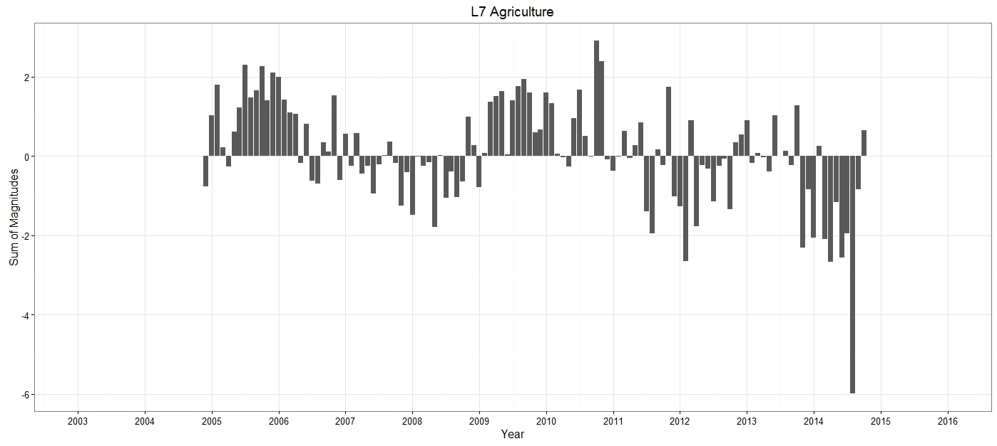

**Figure 3**. Sum of magnitudes of NDVI break for each decimal year from 2002 to 2016 within agriculture, where positive values represent greening and negative values represent browning.

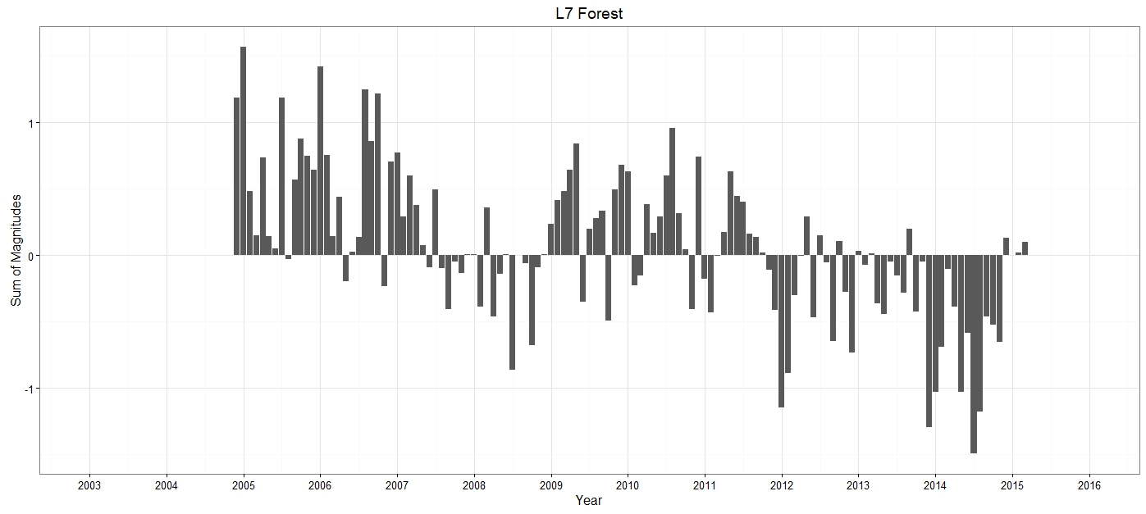

**Figure 4**. Average magnitude of NDVI break for each year from 2002 to 2016 within forests, where positive values represent greening and negative values represent browning.

***4.2 Landsat NDVI Spatial Analysis***

There were negligible differences between the annual NDVI means in 2013, 2014, and 2015 and the baseline for agricultural land cover. Forested vegetation was greener than the baseline in 2013, t(1918)=3.19, p=0.001 and browner than the baseline in 2015, t(1718)=-4.63, p<0.001. There was negligible difference between the annual NDVI mean in 2014 and the baseline (Table 3). Agricultural and forested vegetation were greener in 2013 than 2014, t(1970)=3.87, p<0.01 and t(1891)=4.29, p<0.01, respectively (Table 3). There was negligible difference between annual NDVI means in 2014 and 2015 for agricultural land cover, but forested vegetation was greener in 2014 than in 2015, t(1862)=2.74, p<0.01 (Table 3).

**Table 3**. Mean Landsat NDVI values for the baseline and each drought year.

|  |  |  |
| --- | --- | --- |
| **Year** | **Landsat Agriculture** | **Landsat Forest** |
| Baseline | 0.605 ± 0.115 | 0.663 ± 0.083 |
| 2013 | 0.619 ± 0.135 | 0.676 ± 0.096 |
| 2014 | 0.595 ± 0.138 | 0.656 ± 0.107 |
| 2015 | 0.597 ± 0.131 | 0.642 ± 0.108 |

The mean NDVI anomaly values in 2013 were greener than those in 2014 for both agricultural and forest land cover, t(1948)=6.81, p<0.01 and t(1800)=7.54, p<0.01, respectively (Table 4). There was negligible difference in mean NDVI anomaly values between 2014 and 2015 for agricultural land cover, but mean NDVI anomaly values were greener in 2014 than those in 2015 for forest land cover, t(1790)=4.01, p<0.01 (Table 4). For both agricultural and forest land covers, anomalies are positive in 2013, and negative in 2014 and 2015 (Table 4).

**Table 4**. Mean NDVI anomaly values for each drought year, where the anomaly represents mean drought year minus the baseline for each pixel.

|  |  |  |
| --- | --- | --- |
| **Anomaly** | **Landsat Agriculture** | **Landsat Forest** |
| 2013 | 0.015 ± 0.074 | 0.013 ± 0.047 |
| 2014 | -0.009 ± 0.082 | -0.005 ± 0.060 |
| 2015 | -0.007 ± 0.080 | -0.018 ± 0.072 |

Throughout the drought years, Landsat detected that vegetation was either browning or staying consistent. 37.8%, 51.1%, 50.0% of agricultural areas fell under the baseline in 2013, 2014, and 2015, respectively. 33.9%, 43.2%, and 51.0% of forested areas fell under the baseline in 2013, 2014, and 2015, respectively.

***4.3 MODIS NDVI Spatial Analysis***

Agricultural and forested vegetation were browner than the baseline in 2013, t(1989)=6.81, p<0.01 and t(1956)=-3.34, p<0.01, respectively (Table 5). Agricultural and forested vegetation were browner than the baseline in 2014, t(1995)=-3.35, p<0.01 and t(1978)=-3.45, p<0.01, respectively (Table 5). There was negligible difference between the annual NDVI mean in 2015 and the baseline for both agricultural and forest land covers (Table 5). There was negligible difference between annual NDVI means in 2013 and 2014 for both forest and agricultural land covers, as well as between annual NDVI means in 2014 and 2015 (Table 5).

**Table 5**. Mean MODIS NDVI values for the baseline and each drought year.

|  |  |  |
| --- | --- | --- |
| **Year** | **MODIS Agriculture** | **MODIS Forest** |
| Baseline | 0.733 ± 0.097 | 0.791 ± 0.076 |
| 2013 | 0.721 ± 0.103 | 0.779 ± 0.085 |
| 2014 | 0.718 ± 0.100 | 0.779 ± 0.078 |
| 2015 | 0.727 ± 0.094 | 0.783 ± 0.080 |

There were negligible differences in mean NDVI anomaly values between 2013 and 2014 for both agricultural and forested land cover. The mean NDVI anomaly values were browner in 2014 than those in 2015 for both agricultural and forest land covers, t(1986)=-5.12, p<0.01 and t(1830)=-2.34, p<0.01, respectively (Table 6).

**Table 6**. Mean NDVI anomaly values for each drought year, where the anomaly represents mean drought year minus the baseline for each pixel.

|  |  |  |
| --- | --- | --- |
| **Anomaly** | **MODIS Agriculture** | **MODIS Forest** |
| 2013 | -0.012 ± 0.033 | -0.012 ± 0.029 |
| 2014 | -0.015 ± 0.036 | -0.011 ± 0.031 |
| 2015 | -0.006 ± 0.039 | -0.007 ± 0.040 |

Throughout the drought years, MODIS detected that vegetation was either browning or staying consistent. 34.8%, 33.8%, 44.0% of agricultural areas fell under the baseline in 2013, 2014, and 2015, respectively. 30.6%, 34.2%, and 44.1% of forested areas fell under the baseline in 2013, 2014, and 2015, respectively.

***4.4 MODIS versus Landsat NDVI Spatial Analysis***

Landsat and MODIS yielded different results in the location of drought events for the 2013, 2014, and 2015 drought anomalies (Figure 5, Figure 6, Figure 7).

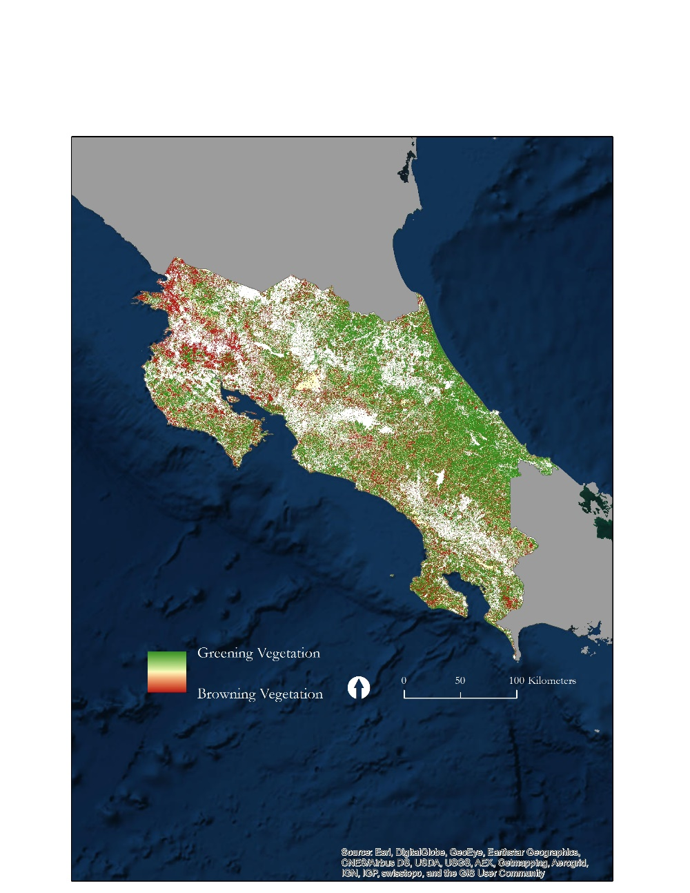 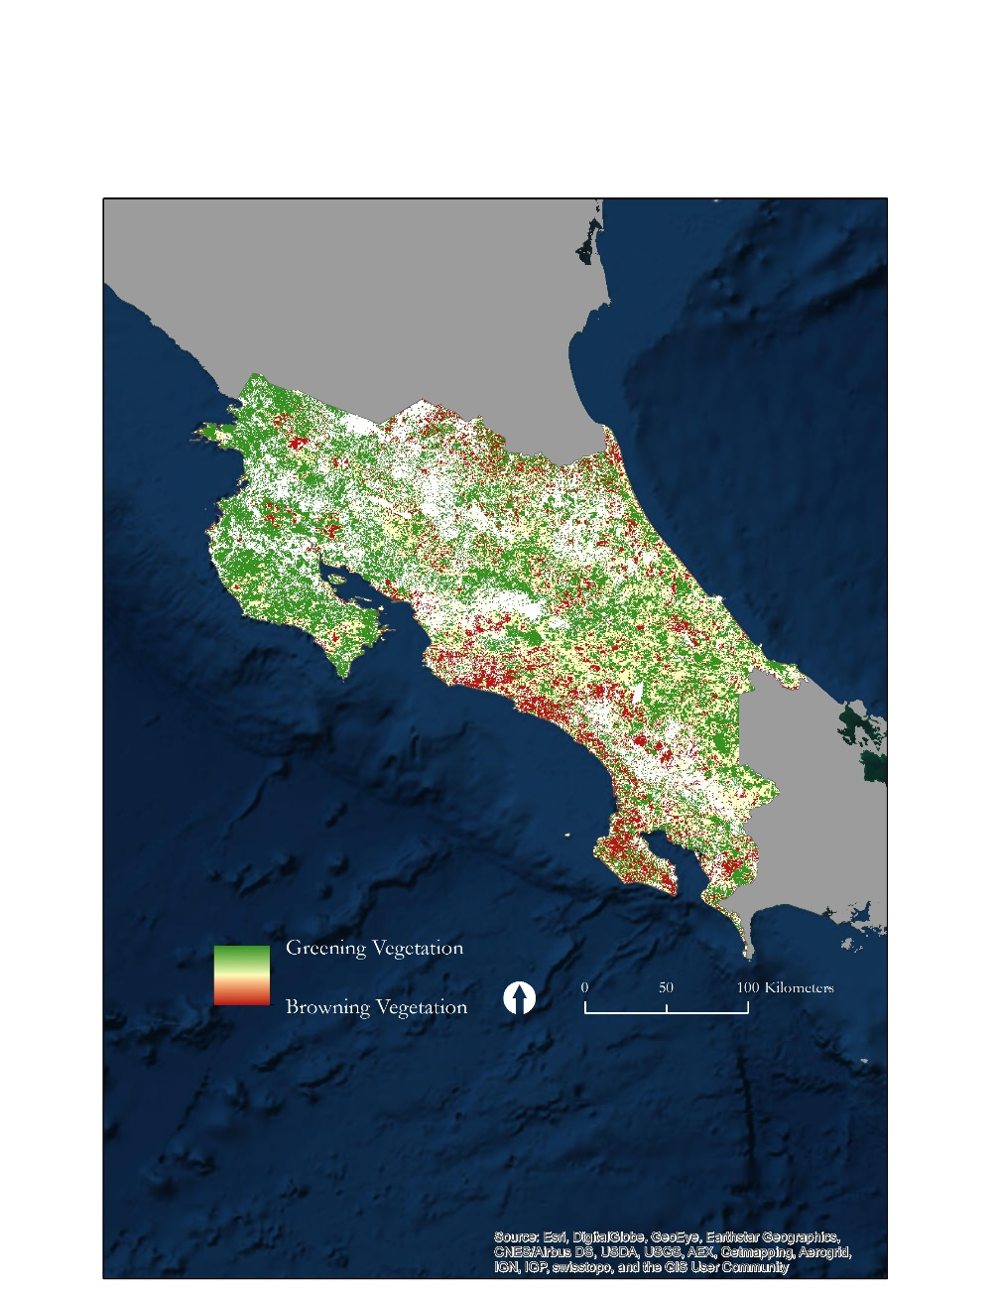

**Figure 5.** The 2013 drought anomaly for Landsat (left) and MODIS (right). White areas are outside of the study area.

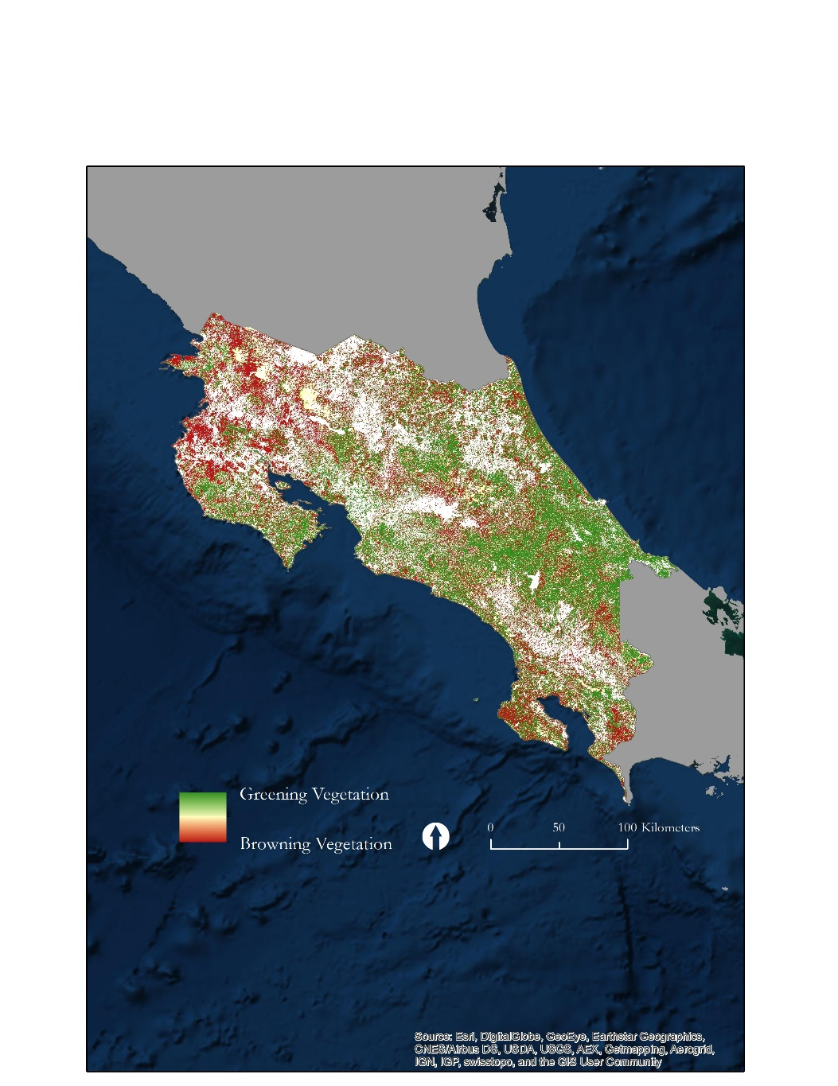 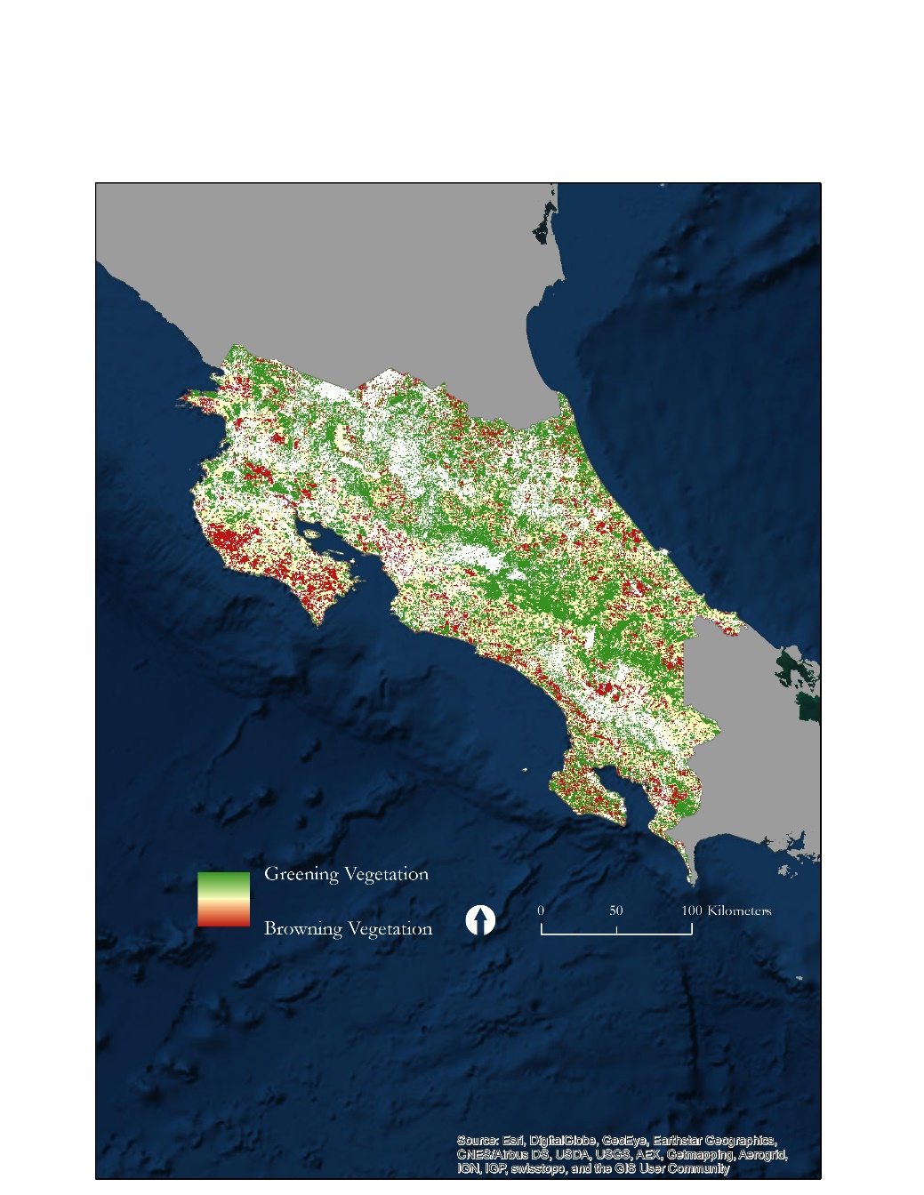

**Figure 6.** The 2014 drought anomaly for Landsat (left) and MODIS (right). White areas are outside of the study area.

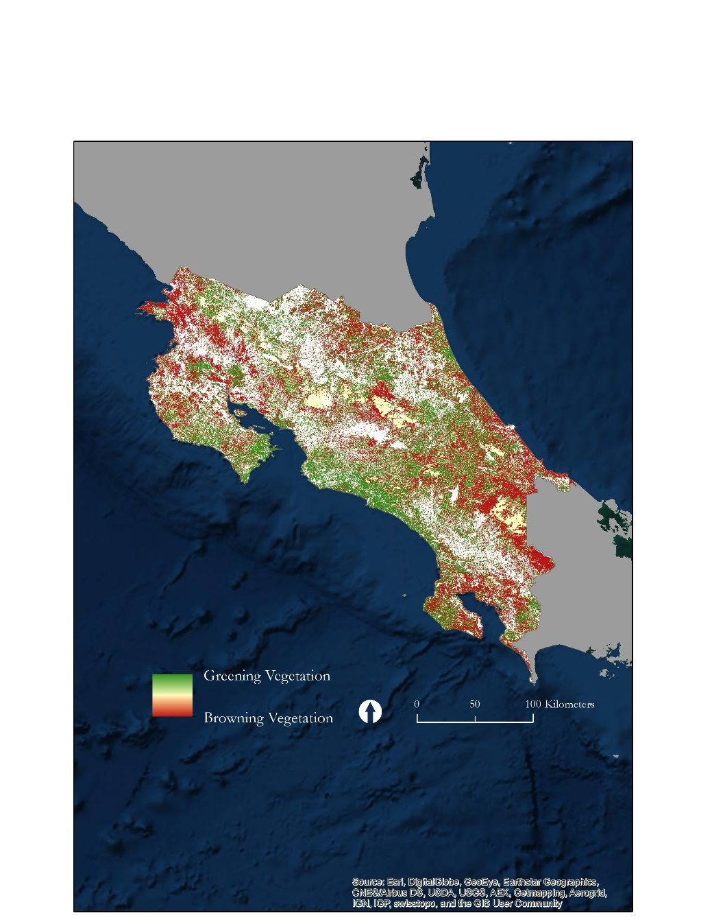 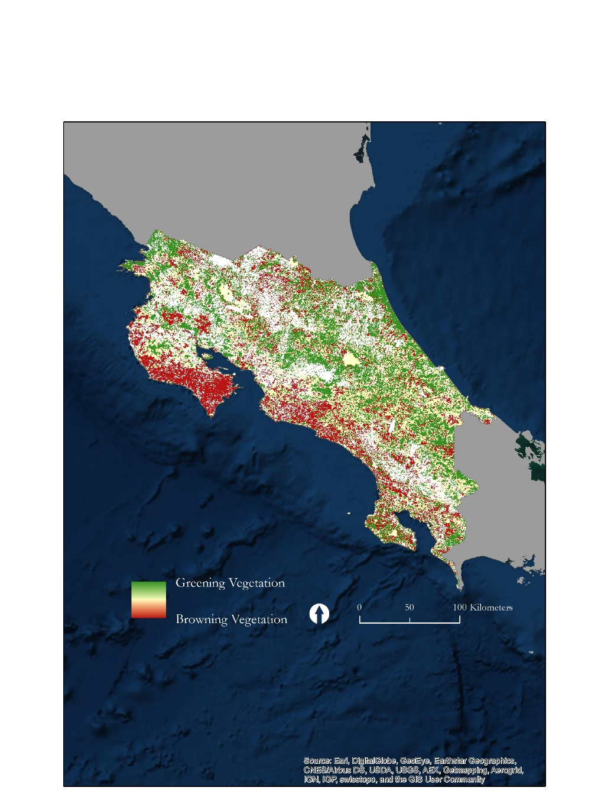

**Figure 7.** The 2015 drought anomaly for Landsat (left) and MODIS (right). White areas are outside of the study area.

***4.5 Analysis of Results***

The temporal analysis of NDVI from Landsat yielded different patterns in the greening and browning of agricultural and forested vegetation over the study period. Irrigation systems and water management practices are utilized for agriculture, but not for forests, which may account for the consistent NDVI means in agriculture across the study period. Regardless, there is a consistent pattern between the timing of greening and browning breaks within agriculture and forest, as both land cover types experience greening breaks in 2005 and 2009 and browning breaks in 2008 and 2014. However, the magnitude of these breaks is much greater in forested, non-irrigated lands than in agricultural fields.

The spatial analysis of NDVI from Landsat and MODIS show major discrepancies. MODIS has been shown to have biases in NDVI over Landsat, as seen by the consistently higher NDVI values produced by MODIS throughout the study (Boccardo, 2006). Within both agriculture and forests, Landsat detected a positive anomaly for the drought year 2013, while MODIS detected a negative anomaly. MODIS detected a large portion of areas where vegetation did not differ between 2013 and the baseline, yet Landsat classified many of these same areas as having a greening anomaly. Because the spatial resolution of Landsat is much finer than that of MODIS, Landsat may have been able to detect these greening anomalies in places where MODIS was unable to. While both satellites detect negative anomalies within agriculture and forest in 2014 and 2015, there are discrepancies in the magnitude of these browning events. Similarly, because of Landsat’s spatial resolution, it may be able to detect these spatial anomalies with much more accuracy than MODIS can.

Aside from satellite bias, Costa Rica’s geographic heterogeneity must be considered as a potential cause for discrepancy. Land cover varies from desert to tropical rain forest, and as a result, different vegetative areas will exhibit different greening and browning anomalies during periods of rain and drought (Henderson, 2002). Furthermore, ENSO events will drive increased rainfall in some areas of Costa Rica, yet will drive droughts in others, producing different rainfall anomalies in different ecological zones (Hoell *et al*., 2014).

The results that we have generated lack: the ET component including ET from ECOSTRESS, a temporal analysis on MODIS NDVI, and comparisons of ET and NDVI as drought detection tools. To verify which satellites provide us with the most accurate drought detection, we will need to compare with ground data collected in-situ.

***4.6 Future Work***

One of the major limitations of the current study is the lack of ET data. Once this data is acquired for Landsat, MODIS, and ECOSTRESS, the spatial and temporal analysis methodology set for NDVI needs to be repeated. Once the same methodology is applied to ET, inter-satellite spatial and temporal comparisons can be made.

The temporal analysis for NDVI on MODIS daily also needs to be completed. The temporal methodology has been already applied to NDVI from Landsat which provides an example of the temporal results.

In analyzing which satellite provides the most accurate drought detection, we must include in-situ ground data. This data is available from EARTH University.

# 5. Conclusions

This study has laid the framework for comparing NDVI and ET as tools for drought detection as well as assessing the advantages ECOSTRESS can provide over existing remotely sensed datasets from MODIS and Landsat. Our partner for this project, EARTH University in Costa Rica, provided a unique geographic location to analyze drought detection. Costa Rica lies in the geographic center of the Central American drought which began in 2013 and was further exacerbated by the 2015 ENSO event.

A methodology was laid out for comparisons of NDVI and ET as drought detection tools and spatial/temporal resolutions of MODIS, Landsat, and ECOSTRESS. In this study, a complete spatial analysis was completed for MODIS and Landsat NDVI. The results were inconsistent between these two satellites and ground based measurements are required to analyze which satellite is more accurate. Inconsistencies could come from a variety of factors including, but not limited to, spatial and temporal resolution, Costa Rica’s heterogeneous geography and the NDVI bias of MODIS compared to Landsat.

# 6. Acknowledgments

* Dr. Johan Perret (EARTH University, Costa Rica)
* Dr. Christine Lee (Jet Propulsion Laboratory, California Technical Institute)
* Dr. Joshua Fisher (Jet Propulsion Laboratory, California Technical Institute)
* Dr. Glynn Hulley (Jet Propulsion Laboratory, California Technical Institute)
* Dr. Laura Jewell (Jet Propulsion Laboratory, California Technical Institute)
* Munish Sikka (Jet Propulsion Laboratory, California Technical Institute)
* Ben Holt (Jet Propulsion Laboratory, California Technical Institute)
* Nick Rousseau (NASA DEVELOP Center Lead, Jet Propulsion Laboratory)
* Erika Higa (NASA DEVELOP Assistant Center Lead, Jet Propulsion Laboratory)

Any opinions, findings, and conclusions or recommendations expressed in this material are those of the author(s) and do not necessarily reflect the views of the National Aeronautics and Space Administration.

This material is based upon work supported by NASA through contract NNL11AA00B and cooperative agreement NNX14AB60A.

# 7. References

Anderson, M., Allen, R., Morse, A., & Kustas, W. (2012). Use of Landsat Imagery in Monitoring Evapotranspiration and Managing Water Resources. *Remote Sensing of the Environment*, *122*(Landsat Legacy Special Issue), 50–65.

Anderson, M., Zolin, C., Sentelhas, P., Hain, C., Semmens, K., Yilmaz, M. T., … Tetrault, R. (2016). The Evaporative Stress Index as an indicator of agricultural drought in Brazil: An assessment based on crop yield impacts. *Remote Sensing of the Environment*, *174*(2016), 82–99.

Boccardo, P., Borgogno Mondino, E., & Claps, P. (2006). Co-Registration and Inter-Sensor Comparison of MODIS and Landsat 7 ETM+ Data Aimed at NDVI Calculation. *Italian Ministry of Education and Research (MIUR COFIN 2003)*.

Bongiovanni, R., & Lowenberg-Deboer, J. (2004). Precision Agriculture and Sustainability. *Precision Agriculture*, *5*(2004), 359–387.

Brown, J., & Bird, N. (2011). Costa Rica’s Sustainable Resource Management: Successfully Tackling Tropical Deforestation. Overseas Development Institute.

DeJong, R., Verbesselt, J., Schaepman, M., & DeBruin, S. (2012). Trend Changes in Global Greening and Browning: Contribution of Short-Term Trends to Longer-Term Change. *Global Change Biology*, *18*, 642–655. https://doi.org/10.1111/j.1365-2486.2011.02578.x

Doraiswamy, P., Hatfield, J., Jackson, T., Akhmedov, B., Prueger, J., & Stern, A. (n.d.). Crop Condition and Yield Simulations Using Landsat and MODIS. *Remote Sensing of the Environment*, *92*(2004), 548–559.

Fernández-Landa, A., Algeet-Abarquero, N., Fernández-Moya, J., Guillén-Climent, M., Pedroni, L., García, F., … Fernandes, E. (2016). An Operational Framework for Land Cover Classification in the Context of REDD+ Mechanisms. A Case Study of Costa Rica. *Remote Sensing*, *8*(593), 1–17.

Fisher, J., ECOSTRESS Algorithm DEVELOPMENT TEAM, ECOSTRESS Science Team, Jet Propulsion Laboratory, & California Institute of Technology. (2015). ECOsystem Spaceborne Thermal Radiometer Experiment on Space Station (ECOSTRESS). *Jet Propulsion Laboratory*, *D*-*94645*.

Fisher, J., Whittaker, R., & Malhi, Y. (2011). ET Come Home: Potential Evapotranspiration in Geographical Ecology. *Global Ecology and Biogeography*, *20*, 1–18.

Gu, Y., Brown, J., Verdin, J., & Wardlow, B. (2007). A five-year analysis of MODIS NDVI and NDWI for grassland drought assessment over the central Great Plains of the United States. *Geophysical Research Letters*, *34*(L06407), 1–6. https://doi.org/10.1029/2006GL029127

Henderson, C. (2002). *Field Guide to the Wildlife of Costa Rica*. University of Texas Press. Retrieved from https://books.google.com/books/about/Field_Guide_to_the_Wildlife_of_Costa_Ric.html?id=q2KzTTBMrLkC

Hoell, A., Funk, C., & Barlow, M. (2014). The Regional Forcing of Northern Hemisphere Drought during Recent Warm Tropical West Pacific Ocean La Nina Events. *Climate Dynamics*, *42*(11), 3289–3311. https://doi.org/10.1007/s00382-013-1799-4

Hong, S., Hendrickx, J. M. H., & Borchers, B. (2005). Effect of Scaling Transfer between Evapotranspiration Maps Derived from Landsat 7 and MODIS Images. *Proc. of SPIE*, *5811*.

Hulley, G., Hook, S., Abbott, E., Malakar, N., Islam, T., & Abrams, M. (2015). The ASTER Global Emissivity Database (ASTER GED): Mapping Earth’s emissivity at 100-meter spatial resolution. *Geophysical Research Letters*.

Jimenez, J., Gonzalez, E., & Mateo-Vega, J. (2001). *Perspectives for the Integrated Management of The Tempisque River Basin, Costa Rica* (Organization for Tropical Studies).

Karnieli, A., Agam, N., Pinker, R., Anderson, M., Imhoff, M., Gutman, G., & Panov, N. (2010). Use of NDVI and Land Surface Temperature for Drought Assessment: Merits and Limitations. *Journal of Climate*, *23*, 618–633. https://doi.org/10.1175/2009JCLI2900.1

Nash, M., Bradford, D., Wickham, J., & Wade, T. (2014). Detecting Change in Landscape Grenness over Large Areas: An Example for New Mexico, USA. *Remote Sensing of the Environment*, *150*(2014), 152–162.

Otkin, J., Anderson, M., Hain, C., & Svoboda, M. (2014). Examining the Relationship between Drought Development and Rapid Changes in the Evaporative Stress Index. *Journal of Hydrometeorology*, *15*, 938–956. https://doi.org/10.1175/JHM-D-13-0110.1

United Nations Office for the Coordination of Humanitarian Affairs. (2014). *Drought in Central America* (Situation No. 1). Central America: Regional Office for Latin America and the Caribbean in collaboration with humanitarian partners from Guatemala, Honduras, and El Salvador.

United Nations Office for the Coordination of Humanitarian Affairs. (2015). *Central America Sub-Regional Analysis* (Humanitarian Needs Overview No. 1). Central America: Regional Office for Latin America and the Caribbean in collaboration with humanitarian partners from Guatemala, Honduras, and El Salvador.

United Nations Office for the Coordination of Humanitarian Affairs. (2016). *Latin America and the Caribbean: Sustained Support Needed as El Nino Batters Fragile Region* (Humanitarian Needs Overview No. 1). Latin America and the Caribbean: Regional Office for Latin America and the Caribbean in collaboration with humanitarian partners from Guatemala, Honduras, and El Salvador.

Verbesselt, J., Herold, M., Hyndman, R., Zeileis, A., & Culvenor, D. (2010). A Robust Approach for Phenological Change Detection within Satellite Image Time Series. *Remote Sensing of the Environment*, *114*(12), 2970–2980.

Vogelmann, J., G. Xian, C. Homer, and B. Tolk. 2012. Monitoring Gradual Ecosystem Change Using Landsat Time Series Analyses: Case Studies in Selected Forest and Rangeland Ecosystems. Remote Sensing of the Environment 122(Landsat Legacy Special):92-105.

Wahid, A., Gelani, S., Ashraf, M., & Foolad, M. (2007). Heat tolerance in plants: An overview. *Environmental and Experimental Botany*, *61*(2007), 199–223.

Weier, J., & Herring, D. (2000). Measuring Vegetation (NDVI & EVI). NASA Earth Observatory, EOS Project Science Office.

Weng, Q., Lu, D., & Schubring, J. (2004). Estimation of Land Surface Temperature - Vegetation Abundance Relationship for Urban Heat Island Studies. *Remote Sensing of the Environment*, *89*(2004), 467–483.

Wulder, M., White, J., Goward, S., Masek, J., Irons, J., Herold, M., … Woodcock, C. (2008). Landsat Continuity: Issues and Opportunities for Land Cover Monitoring. *Remote Sensing of the Environment*, *112*(3), 955–969.

# 8. Content Innovation

**Content Innovation #1**

Google Earth Engine Tutorial 1

Google Earth Engine Tutorial 2

Emailed to [Tiffani.N.Miller](mailto:Lauren.M.Childs@nasa.gov)@nasa.gov with filename 2016Fall_JPL_CostaRicaAgII_TechPaper_GEETutorial_1

2016Fall_JPL_CostaRicaAgII_TechPaper_GEETutorial_2

**Content Innovation #2**

VPS

shared through Google Drive at: <https://drive.google.com/drive/folders/0B_zCsO0hMuGtUVlUckVma09JSEU>

**Content Innovation #3**

Inline Supplementary Material

* Table 1
* Table 2
* Table 3
* Table 4
* Table 5
* Table 6
* Figure 1
* Figure 2
* Figure 3
* Figure 4
* Figure 5
* Figure 6
* Figure 7