Short Title (Location + Main App Area)

Longer subtitle (Example: Synthetic Aperture Radar Data Decision Support for Atlantic Blue Fin Tuna Population Assessment and Management in the Gulf of Mexico)

 **Technical Report**

November 22nd, 2024

Author 1 (Project Lead)

Author 2

Author 3

Author 4

***Advisor(s):***

Advisor 1, Affiliation (Science Advisor)

Advisor 2, Affiliation (Science Advisor)

***Previous Contributors:***

Contributor 1

Contributor 2

***Lead:***  
Node Lead (Node Name, e.x. Maryland – Goddard)

# 1. Abstract

Insert here (150 to 250 words, one paragraph). The abstract should be fully contained and give the reader a good grasp of the project. It **must** include the following points:

1. NASA Earth observations used
2. The partner organization(s) & their current decision-making process
3. The problem and what you did in response
4. Benefits/outcomes of the project
5. Major results
6. Analysis of feasibility based on results & limitations found within the project

**Key Terms**

Insert 2 to 8 keywords here that relate to your project. Consider what words someone would use to search for your project. These should be directly copied and pasted into your Project Summary document. Example: remote sensing, MODIS, Floating Algal Index, biodiversity hotspot, MaxEnt

# 2. Introduction

Be concise; this section should be between 500 and 800 words as one to two pages should suffice. It is also REQUIRED to include at least 5 references from peer-reviewed literature and a study area map. Please cite all sources in-text using APA 7 format. Content that you ***must*** include in your introduction can be found below in whatever order you think flows best. Note that these should not be thought of as each needing their own subsection:

1. **Background Information** – Relevant information to inform the reader of the current environmental issue, what decision is being made, etc.
2. **Scientific Basis** –previous studies, the general scientific basis, and use of **remote sensing methods** in this context. Remember that at least 5 peer-reviewed journal articles must be referenced.
3. **Project Partners** – Explain who your partners are and the work that they do. Also, answer the following questions: What environmental decision are they trying to make? What do they currently do to address this environmental problem/decision? How does your project attempt to address their needs and how will your partner benefit from your end products/results?
4. **Project Objectives** – These should be short and specific action items that your project completed in paragraph form, not a bulleted list.
5. **Study Area** – Describe the geographic location of the study and include a study area map that contains required map elements (i.e., inset map, scalebar, north arrow, and legend if applicable).
6. **Study Period** – Explain the reasoning behind the time period in which you are looking at (years and dates of data). Why are these years/dates important?
7. **For II & III term projects** – Include a paragraph discussing what was done and/or found in the previous term (with partners and objectives).
8. **Feasibility** – While this doesn’t have to be a specific paragraph or section of your introduction, it should be clear to reader how the concept of assessing the feasibility of using remote sensing methods for this application is central to the goals of this project alongside creating end products to inform your partner’s environmental decision-making.

# 3. Methodology

This should be the focus of the paper – be concise, yet clear and explanatory. Be specific in explaining why you employed your methodologies – remember your partner is your audience! Highlight the NASA Earth observations utilized and their capabilities. Include a paragraph or more in each of the following sections. There is no word cap but be thoughtful and keep it in the 2-6 page range. **Use past tense, active voice whenever possible! Also, don’t forget to cite any data or indices that you used and include the version number for each software that you used.**

***3.1 Data Acquisition***

What data did you get, what level products were they, for what dates did you get images, where did you get the images from, etc.? Add a table to display this information if you are using multiple platforms/sensors. However, just a table alone will not suffice – you need to describe your data sources and acquisition in the body of the text. You do not need a separate paragraph for each data source but the reader should be able to fully understand how to acquire the data in the same manner that your team did. Remember to properly cite Earth observation and ancillary datasets in the References section.

***3.2 Data Processing***

Data processing refers to the steps you took after acquiring the data to prepare them for analysis. What did you do to the data to make them ‘readable’? Were there conversions needed in order to analyze them? Did you have to mosaic images or use a cloud mask? Did you have to normalize anything to fit other datasets? Did you run an NDVI calculation, change detection, etc.? Remember to properly cite any indices, models, and tools you are utilizing from other authors, including DEVELOP projects. Also, include the version number for all software that you used.

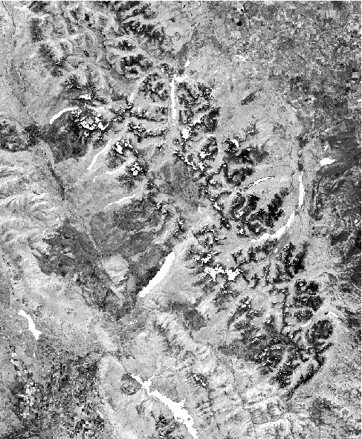

[copyright statement placeholder for visualizations using private imagery like DigitalGlobe/Maxar products:

e.g., WorldView-2. (Source: DigitalGlobe). © 2021 Maxar]

Figure 1. A composited and cloud-masked NDMI image clipped to the 4 km study boundary of Glacier National Park (from Landsat 5 TM, 2005).

$$\begin{aligned}\text{NDMI = }\frac{\text{NIR - SWIR}}{\text{NIR + SWIR}}\#(1)\end{aligned}$$

***3.3 Data Analysis***

Analysis refers to the scientific and statistical methods you applied to your processed, “analysis-ready” data to gain new insights about the study area. What methods did you use to analyze the data – statistical analysis, validation, etc.? Did you conduct a land cover change analysis? Did you run a principal components analysis? Did you input data parameters into a random forest model? Explain what you did and why you did it.

# 4. Results

Choose the most important results to highlight here and be sure to include images, graphs, maps, charts, etc. When writing this section, think about the Feasibility & Partner Implementation discussion (Section 5.2). When writing about your results and uncertainties (Sections 4.1 and 4.2), focus more on simply presenting what you found after completing your methodology. Then, the interpreted claims that you make in Interpretation of Results (Section 5.1) and Feasibility & Partner Implementation (Section 5.2) should follow directly from the results that you presented in Section 4. Finally, do not shy away from reporting “negative” results as they are. No word cap, but 2-6 pages is a good range.

***4.1 Analysis of Results***

Communicate what you found from the methodology that you outlined in the Data Analysis section. What can you tell from your graphs, images, etc.? What is the data showing? What was the outcome of the analysis that you conducted? Save major interpretations of these results for the Interpretation of Results (5.1) and Feasibility & Partner Implementation (5.2) sections.

***4.2 Errors & Uncertainties***

In this section, quantify errors whenever possible and note factors, parameters, etc. that were not considered or could not be accounted for. What are the potential holes, problems, and limitations with your methodology?

Table 3

*Interannual periods used to create persistence maps*

|  |  |
| --- | --- |
| **Persistence Year Range** | **Interannual Periods Aggregated for Persistence** |
| 2000-2005 | 2000-2001, 2001-2002, 2002-2003, 2003-2004, 2004-2005 |
| 2005-2011* | 2005-2006, 2006-2007, 2007-2009, 2009-2010, 2010-2011 |
| 2010-2016* | 2010-2011, 2011-2013, 2013-2014, 2014-2015, 2015-2016 |

*Ranges that have gaps due to missing interannual periods from Landsat for 2008 and 2012.

# 5. Conclusions

Word count: 200 to 600, about a page.

***5.1 Interpretation of Results***

**Interpret your results in this section –** what should the reader and your partner take away based on the results that you presented earlier on? How do these interpretations relate to the environmental decision/issue that you introduced at the beginning of the tech paper? How do your partners benefit from these results or how are they more informed?

***5.2 Feasibility & Partner Implementation***

This is one of the most important sections of the Tech Paper and should not be considered as an afterthought. This section should be partner-centric and should comment on the feasibility of applying your methods or end products to your partner’s decision-making practices related to the environmental problem at hand. Did your project find that the partner could utilize some or all of the methods you employed to inform their decision-making? What steps can your partner take to further your methodology if needed? If applicable, what aspects of your methods were *not* feasible for use? If you found that it was not feasible to use remote sensing for your partner’s needs, this is still an important conclusion! Finally, if (and only if) there is another term planned, don’t forget to discuss how the next team is going to proceed.

# 

# 6. Acknowledgements

Keep to a concise paragraph or bullets of names. Include your partner point of contact, science advisor(s), your Lead, PC point of contact, and anyone else that made a significant contribution to your DEVELOP project. Then, end with the following legal statements (some might not be applicable to your project):

This material contains modified Copernicus Sentinel data (insert year), processed by ESA.

This work utilized data made available through the NASA Commercial Smallsat Data Acquisition (CSDA) program.***(See Comment Attached)***

Any opinions, findings, and conclusions or recommendations expressed in this material are those of the author(s) and do not necessarily reflect the views of the National Aeronautics and Space Administration.

This material is based upon work supported by NASA through contract 80LARC23FA024.

# 

# 7. Glossary

In alphabetical order, define field-specific terms and acronyms, but not only acronyms. When the body is complete, re-read your paper and identify the scientific jargon to add to the glossary. The goal of this section is to help the reader better understand the work presented in the paper. Include vocabulary that the reader may not be familiar with, in addition to defining the acronyms in your paper. Write this section as if someone who isn’t familiar with your application area is reading your paper!

Examples:

**Earth observations** – Satellites and sensors that collect information about the Earth’s physical, chemical, and biological systems over space and time

**MODIS** – Moderate Resolution Imaging Spectroradiometer

# 8. References

NASA DEVELOP uses APA 7 formatting. Start your **alphabetized** list of references on a new page (insert a Page Break rather than hitting ‘enter’) and use hanging indentation. **Please ensure that all references in this section are cited in the text**. **Similarly, all in-text citations should have a corresponding reference in the References section**. Also, **do not copy-paste a citation from elsewhere without checking the format.** Even automatic citation generators cannot be trusted to format correctly! We want to be consistent within DEVELOP. Include a Digital Object Identifier (DOI) for NASA and other satellite data products, as well as all journal articles for which it is available. Look to the examples below as a guide!

For references that do not have an example on this list, please refer to the [Purdue Online Writing Lab APA Citation Guide](https://owl.purdue.edu/owl/research_and_citation/apa_style/apa_style_introduction.html). If you are ever unsure about how to reference something, please reach out to Project Coordination!

**Examples of Common Citation Types Used in DEVELOP Tech Papers:**

***(Journal Article Example)***

Lacaux, J. P., Tourre, Y. M., Vignolles, C., Ndione, J. A., & Lafaye, M. (2007). Classification of ponds from high-spatial resolution remote sensing: Application to Rift Valley Fever epidemics in Senegal. *Remote Sensing of Environment*,*106*(1), 66–74. <https://doi.org/10.1016/j.rse.2006.07.012>

***(Report by a Government Agency/Organization Examples)***

National Oceanic and Atmospheric Association & U.S. Fish and Wildlife Service. (2019). Recovery plan for the Gulf of Maine distinct population segment of Atlantic salmon (*Salmo salar)*. https://media.fisheries.noaa.gov/dam-migration/final_recovery_plan2.pdf

O’Brien, R. A. (1999). *Forest resources of the Flathead National Forest.* United States Department of Agriculture, Forest Service, Rocky Mountain Research Station. https://www.fs.fed.us/rm/ogden/pdfs/flathead.pdf

***(Previous DEVELOP Project Example, cited in the style of an unpublished manuscript)***

Hietpas, K., Ochoa-Madrid, E., Williams, E., & Spencer, O. (2021). *Fairfax Water Resources: Estimating urban flood susceptibility, historical flooding extent, and land cover change in Fairfax County, Virginia to aid in flood mitigation planning* [Unpublished manuscript]. NASA DEVELOP National Program, Virginia – Langley.

***(Webpage Content Example)***

The amount of information available for citing a webpage varies widely. At a minimum, the full URL or DOI should be provided. Any further information (author names, date) should also be provided if available. **Do not include** “Retrieved Month Date, Year, from URL” unless you anticipate that the page is updated or edited over time. (Including this was more common under APA 6.)

The skeleton:

Lastname, F. M. (Year, Month Date). *Title of page*. Site name. URL

An example:

Donges, N. (2021, September 16). *A complete guide to the random forest algorithm*. Built In. https://builtin.com/data-science/random-forest-algorithm

***(Data Example)***

This one tends to be more complicated, but it’s important to cite your data! Here is the formatting skeleton:

Lastname, F. M. or Name of Group (data release year). *Title of dataset* (Version No.) [Data set]. Data Archive/Publisher/Distributor. Retrieval date, if relevant. Data locator/identifier (DOI or URL)

...and here is an example for a Terra MODIS product:

Wan, Z., Hook, S., & Hulley, G. (2021). *MODIS/Terra Land Surface Temperature/Emissivity Daily L3 Global 1km SIN Grid* (V061) [Data set]. NASA EOSDIS Land Processes DAAC. Retrieved January 20, 2022, from https://doi.org/10.5067/MODIS/MOD11A1.061

# 9. Appendices

Begin each appendix on a **new page** (insert a Page Break rather than hitting ‘enter’)with the word appendix in the top center. Use an identifying capital letter (e.g., Appendix A, Appendix B, etc.) if you have more than one appendix.

Label tables and figures in the appendix as you would in the text of your manuscript, using the letter A before the number to clarify that the table or figure is found in the appendix (e.g., Figure A1, Table B2, etc.)

**Don’t forget to refer to all appendix figures/tables in the body of the tech paper.** If an appendix consists entirely of a single table or figure, the title of the table or figure should serve as the title of the appendix.

**The appendix is not the place to stick every map/graph/figure that you want to send to your partners!** The purpose of the appendix is to supplement your tech paper, not add copious amount of new information; therefore, the appendices have a page limit of 10. If you want to put 10 or more pages of appendices or supplementary information, it should be submitted as an extra, optional deliverable (reach out to Project Coordination if this is the case for your team). This extra, optional deliverable can mimic how the appendices are set up in the tech paper.

**Example Appendix:**

Appendix A: *Insert title here*

Table A1

*Total historical potential defoliation extent*

|  |  |  |  |  |
| --- | --- | --- | --- | --- |
|  | **Defoliation Extent** | | | |
|  | *Light* | *Moderate* | *Severe* | *Total* |
| *Total defoliation (km²)* | 2185.08 | 933.12 | 22.55 | 3140.74 |
| *Percentage of total defoliation* | 69.57 | 29.71 | 0.72 | 100 |

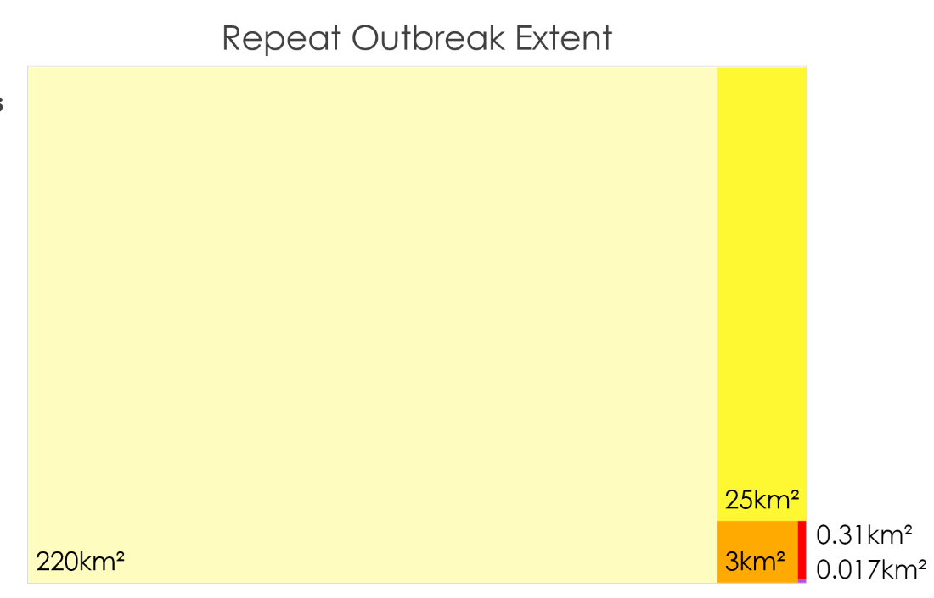

*Figure A1.* Repeated potential defoliation events between 2012 and 2021, ranging from two events (lightest yellow) to six (purple).