Africa Food Security & Agriculture II
Predicting the Likelihood of Human-elephant Conflict and Assessing Patterns in Elephant Movements Over Varying Habitat Conditions in the Kavango-Zambezi Area


Technical Report
Final– April 1st, 2021

Madison Bradley (Project Lead)
Ariel Calle
Michael Corley
Erica Kriner

Advisors:
Dr. Marguerite Madden, University of Georgia, Department of Geography (Science Advisor)
Dr. Sergio Bernardes, University of Georgia, Department of Geography (Science Advisor)
Dr. Andrea Presotto, Salisbury University, Geography and Geosciences Department (Science Advisor)
Dr. William Langbauer, Bridgewater State University, Biology Department (Science Advisor)

Previous Contributors:
Jennifer Gallucci
Jonathan Moallem
Erika Munshi

1. Abstract
In the Kavango-Zambezi area of southern Africa, three million people live within areas frequently traveled by free-ranging elephants. As the region continues to develop rapidly, urban and agricultural settlements further encroach upon the land that these elephants use. As elephants come into more frequent contact with urban areas, human populations face financial loss through crop damage and the potential for injury from direct conflict with elephants. Elephant populations are also at risk of injuries from conflict as well as illness related to the consumption of waste. In order to implement human-elephant conflict mitigation strategies, local conservation groups need to be informed on best practices for coexistence. This project aided Ecoexist Project and Connected Conservation in understanding the ecological factors that drive elephant movement into human settlements and provided Earth observation data to support future conflict management. The team used Landsat 5 Thematic Mapper (TM) and Landsat 8 Operational Land Imager (OLI) data to create land use land cover maps and calculate vegetation indices and used TerraClimate data to analyze drought conditions. These classified maps display a time series of human settlement from 1990 to the present and were made explorable alongside other environmental variables in an updated Google Earth Engine tool. This project also provided heatmaps that show the risk of human-elephant conflict based on historical data of human-elephant conflict locations. This analysis will provide support for conservation experts in determining best practices for future mitigation and prevention of human-elephant conflict.

Key Terms
human-wildlife coexistence, land use land cover, NDVI, food security, spatial risk analysis, African elephants

2. Introduction
2.1 Background Information
In the Kavango-Zambezi region of Sub-Saharan Africa, human-elephant conflict (HEC) threatens the lives and livelihoods of vulnerable communities (Gerhardt-Weber, 2017). Here, three million people find themselves living in close quarters with African elephants, Loxodonta africana (African Elephant Status Report, 2016). Urban and agricultural expansion is continuously encroaching upon the available rangeland for elephants, and the corridors in which they travel and find resources are shifting (Gerhardt-Weber, 2017). This habitat fragmentation, compounded by ecological factors such as drought or bushfires which make normally abundant resources scarce, drive elephants into other areas with high resource yield, such as agricultural plots (Dr. Loki Osborn, Personal Communication, February 2, 2021). In addition to these stressors, elephant and human populations are rapidly approaching the region’s carrying capacity, subsequently increasing the frequency of HEC as resource competition intensifies (Shaffer, 2019). Elephant raids often reduce crop yields, injure livestock, destroy property, or otherwise disrupt the daily function of small, rural villages. In some rare cases, instances of HEC result in the loss of elephant or even human life (Buchholtz et al., 2019).

The focus for conservation work has begun to shift away from mitigation tactics and towards preventative measures since elephants are quick to learn different mitigation techniques, making them less effective over time (Mmbaga, 2017). Also adding to the pressures of legislating solutions is that public perceptions of conservation practices are becoming more negative as elephant conflict increases (Shaffer, 2019). This reported lack of trust between stakeholders creates a need for data that can show how urban expansion is affecting elephant rangeland and contributing to HEC, and also highlight potential areas for conservation and elephant corridors.

The first term of this project provided the partners with an analysis of environmental factors that may influence elephant movements and with tools for comparing the intersection of these variables with the elephant data they collect. The results suggest that elephants spend more time congregating around water sources in the dry season and travel greater distances during the wet season, indicating that crop-raiding events are most likely to occur at the end of the wet season when crops are ready to be harvested and elephants are more mobile. This project expanded upon the first term outputs to enhance the partners’ understanding of elephant movement drivers and identify high-risk areas for HEC over the broader Kavango-Zambezi area (Figure 1) through the incorporation of Land Use Land Cover (LULC) change mapping from 1990-2020 and historical conflict data analysis.

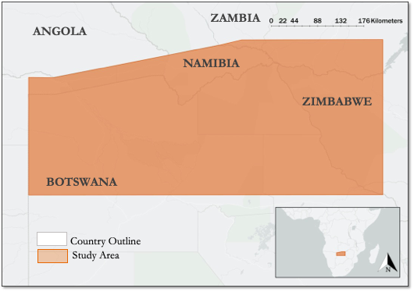
Figure 1. The study area of this project was the Kavango-Zambezi area of southern Africa

2.2 Project Partners & Objectives
The team continued working with two local non-governmental organizations, Connected Conservation and Ecoexist Project. Connected Conservation operates within the Kavango-Zambezi area to foster biodiversity conservation, environmental, social and economic best practices (Connected Conservation, 2021). Connected Conservation has monitored elephant movement and HECs within the area since 2012, and has developed mitigation strategies such as selling locally grown pepper pellets through “The Pepper Company” to deter crop raiding events within the region. Ecoexist Project focuses its efforts in the Okavango Delta of Botswana, where 15,000 elephants and 15,000 people compete for land, food and water resources (Ecoexist Project, 2021). Ecoexist Project has been tracking elephants in the Okavango region since 2014 and uses NASA Earth observations to monitor and map elephant movement corridors, but has not previously applied Earth observations to HEC risk assessments. Both partners aim to use the results and findings of the project to educate local agencies and decision makers in order to to better the livelihoods of farmer and elephant co-inhabitants while promoting coexistence.

First, the team produced a LULC time series analysis to identify areas of significant urban and agricultural expansion that encroach on elephant habitat. The team produced HEC risk heat maps to identify areas of high, moderate, and low risk of conflict in the study region. By studying the landscape corridors the elephants frequent alongside the LULC classification, careful land use planning methods can be employed to minimize HEC occurrence. End users will be able to import the HEC heat maps into a Google Earth Engine (GEE) script to perform specific repeat analysis by altering spatial and temporal parameters within the code produced by the DEVELOP team. Partners will be able to identify key areas and focus on specific phenological data freely and as needed. The StoryMap deliverable created by the team provides a much-needed visual representation that outlines the scope of this project and combines aspects of our final products with qualitative data to show the perspectives of local residents, farmers, conservationists, and other stakeholders affected by HEC events.

3. Methodology
3.1 Data Acquisition
3.1.1 Environmental Variables
To assess potential environmental drivers of HEC, the team accessed Earth observations in GEE, as shown in Table 1. The team assessed vegetation health by calculating Normalized Difference Vegetation Index (NDVI) and Soil Adjusted Vegetation Index (SAVI) using Landsat 5 Thematic Mapper (TM) and Landsat 8 Operational Land Imager (OLI) Surface Reflectance (SR) Tier 1 data (USGS, 2021a; USGS 2021b). The team also utilized Landsat 5 TM, Landsat 8 OLI, and elevation data from the Shuttle Radar Topography Mission (SRTM) to create annual LULC maps of from 1990-2020, excluding the years 2002 and 2012 which had no data (Farr, 2007).

The team extracted drought, surface temperature, and precipitation accumulation data from the TerraClimate: Monthly Climate and Climatic Water Balance for Global Terrestrial Surfaces dataset produced by the University of Idaho and imported into GEE. This dataset joins atmospheric evapotranspiration and temperature measurements with interpolated surface temperature and moisture measurements from the Climate Research Unit Time Series 4.0 (CRU ts4.0), Japan’s 55-year Reanalysis (JRA55), and WorldClim datasets (Abatzoglou, Dobrowski, Parks, Hegewisch, 2018). To capture drought, the team used the Palmer Drought Severity Index (PDSI) from TerraClimate which is a metric commonly used to quantify long-term drought in low and middle latitudes (Dai & National Center for Atmospheric Research Staff, 2019). In addition to PDSI, the team also extracted interpolated surface temperature and accumulated precipitation raster images from the TerraClimate dataset for the study period 1990-2020.

Table 1. Summary of datasets used for the project.
Dataset or Sensor | Date Range | Variables
Landsat 5 TM Surface Reflectance Tier 1 | January 1990 – May 2012 | NDVI  SAVI  LULC
Landsat 8 OLI Surface Reflectance Tier 1 | April 2013 – December 2020 | NDVI  SAVI  LULC
TerraClimate: Monthly Climate and Climatic Water Balance for Global Terrestrial Surfaces | January 1958 – December 2019 | PDSI  Surface temperature  Precipitation accumulation
SRTM Elevation | February 2000 | LULC

3.1.2 Human-Elephant Conflict Data
Ecoexist Project collected annual HEC and associated attribute data for Botswana via enumerator survey whenever a conflict event arose. The team utilized this dataset for analysis, along with a similar HEC dataset for Victoria Falls from Connected Conservation. From the Ecoexist Project partners, the team examined HEC data from 2008-2010, 2012-2016, 2017, and 2019. From Connected Conservation, we examined data for the years 2012 and 2015-2018. Victoria Falls enumerator survey efforts for HEC incidence have increased over time whereas monitoring has decreased overall in Botswana. Most of the data included GPS coordinates, demographic information related to farmers, vegetation type (as well as crop stage and quality), method of determent, time of raid, elephant demographic data (number of elephants, sex, life stage), and more attributes that were not monitored consistently across all years. The only four attributes that were collected for every year were elephant sex, number of elephants per raid, crop maturity, and the village where the HEC occurred. In addition to conflict data from both partners, we had access to Connected Conservation’s GPS elephant tracking data from 2012-2019, which we used to identify elephant movement zones within the study region in Victoria Falls and rank them by intensity of use.

3.2 Data Processing
3.2.1 Environmental Variables
The team created a GEE tool to access, analyze, and visualize imagery from Landsat 5 TM, Landsat 8 OLI, and TerraClimate between 1990 and 2020. The tool filters Landsat imagery by user-selected date and location then pre-processes the resulting images to mask clouds and shadows and apply a cloud score that ranks images by the lowest cloud cover. Next, the tool creates a composite image for each year based on the least cloudy pixels, which were determined by the cloud score. In order to account for temporal gaps due to cloud masking, the team created 5-month composite images corresponding to the wet season from March to July. The team calculated NDVI and SAVI from the resulting images using Equations 1 and 2 below,

(1)
$$NDVI=\frac{\left(NIR-R\right)}{\left(NIR+R\right)}$$

(2)
$$SAVI=\frac{\left(NIR-R\right)}{\left(NIR+R+L\right)}$$

where Near-Infrared (NIR) and Red (R) refer to Landsat 5 TM bands 4 and 3 and Landsat 8 OLI bands 5 and 4, respectively. NDVI is a metric used to assess “greenness” – a proxy for vegetation health – and is calculated based on the ratio of red and infrared signals in spectral imagery (Madonsela, Cho, Ramoelo, Mutanga, & Naidoo, 2018). SAVI is a similar vegetation index used to assess vegetation health in sparsely vegetated areas (Huete, 1988). For this project, the team leveraged both indices to account for differences in agricultural and non-agricultural areas as well as annual differences in vegetation cover (Schultz, Shapiro, Clevers, Beech, & Herold, 2018). When calculating SAVI, we applied a correction factor (L) between 0 (dense vegetation) and 1 (sparse vegetation) to modify the index for a specific landscape. For this project, we used a correction factor of 0.75 to account for the density of vegetation found in the Kavango-Zambezi area because higher correction factors led to greater soil influences that less accurately represent the vegetation present (Huete, 1988). However, the script allows the user to adjust this value based on the study area being analyzed. The team extracted monthly PDSI, surface temperature, and accumulated precipitation values for each year within the study period from the TerraClimate dataset into a new image collection filtered by the user-selected date and location. The team pre-processed the TerraClimate image collection by reducing the PDSI band by a necessary scale factor of 0.01 and the maximum temperature band by 0.1 in accordance with the TerraClimate user-guide (Abatzoglou, Dobrowski, Parks, Hegewisch, 2018). Finally, the team reduced the image collection to one image per variable per year, derived from the maximum monthly value recorded during each year.

3.2.2 Land Use Land Cover Classification
The team used the cloud-free composite images along with high-resolution base maps in GEE to create sample training data for classification using the GEE Geometry toolbox. The team used land cover classification schemes provided by The Peace Park Foundation Kavango-Zambezi (KAZA) Dataset Land Cover 2005, used for reference in drafting a classification scheme (GeoterraImage, 2007). The existing KAZA classifications were available for 2005. The team referenced the classification scheme provided by the Peace Park Foundation against the classification scheme associated with KAZA’s dataset in order to make educated decisions in aggregating classes. The team input the longitude and latitude coordinates of sample points for each class present in the KAZA 2005 classification into Google Earth Pro v7.3. Within Google Earth Pro, the team recorded a snapshot of the aerial photography for each coordinate and compared it to other classes. After reviewing visual examples for each class, the team aggregated classes with similar attributes into seven classes – bare, urban, agriculture, water, wetland, grassland, and woodland – based on the criteria described in Table A1. More information about the class aggregations can be found in Appendix A. The team validated the training data through visual comparison with high-resolution base maps in GEE, then merged each class of training data into one feature collection. The team then subset the data with a 70:30 random split to produce a training dataset with 70% of the data and a validation dataset with the remaining 30% of the data, to ensure that the training and validation datasets were uncorrelated.

The team utilized the random forest classifier in GEE to create LULC maps for each year in the study period. The random forest classifier is a machine learning supervised classification algorithm that consists of a user-specified number of decision trees which are trained to output classification predictions based on tree aggregations popularity vote (Breiman, 2001). First, the team mapped NDVI and elevation layers onto the composite image collection, resulting in annual composite images with nine layers – blue, green, red, near infrared, shortwave infrared 1, and shortwave infrared 2, and brightness temperature bands from Landsat 5 and 8, NDVI, and elevation from the SRTM (Farr, 2007). At each training point, the random forest classifier recognizes the spectral signatures of each training layer from the stacked images and classifies the composite Landsat images accordingly. The classifier was run using 100 decision trees and the default classifier setting in GEE of a bag fraction of 0.5 per tree and 0 randomization seeds (Breiman, 2011).

3.2.3 Human-Elephant Conflict Data
Because multiple discrepancies existed within and across the partner-sourced HEC datasets due to different data collection efforts between partner organizations, the team employed pre-processing methods to standardize the conflict data within Microsoft Excel. We removed null or erroneous values, conducted coordinate conversion, and removed data for 2013 since there were only ten conflicts recorded by Ecoexist Project and they were all during dry season months (July and August). Every other HEC recorded for each year occurred within the later wet season months (January to May). A similar issue existed for the Connected Conservation data at Victoria Falls, where in 2012 not all of the recorded HEC had recorded georeferenced coordinates. After we cleaned the partner data, we imported the data individually into Esri ArcMap 10.6 Desktop to create annual HEC incidence heat maps and perform all other geospatial processes.

First, the team used the point density tool to calculate an individual heat map for every year for the main study area. We then standardized and merged those into one decadal heat map for each region to identify risk zones as well as to prioritize known elephant corridors and croplands in the region. The same was done for Victoria Falls, except we created our own corridor layers from the GPS elephant tracking data since none existed for this region and the span was only five years. The team used the elephant GPS collar tracking points to create a kernel density heat map of elephant movements where the densest elephant locations were extracted to create an elephant corridor shapefile for the collared elephants in Victoria Falls. Thus, we were able to use the HEC data in conjunction with the LULC maps for Botswana and Victoria Falls to prioritize certain areas more likely to experience a conflict based on historical elephant presence.

The team used partner-provided shapefiles containing agricultural lands and known elephant corridors in the Okavango Delta and Victoria Falls to generate overall HEC heat maps of both regions. We used the Zonal Statistics tool and prioritized zones based on risk, defined as the likelihood for a conflict to occur in an area based on historical trends. In addition, we reduced the categories of HEC incidence to three (Low, Medium, and High) in order to run a basic risk assessment that incorporates our LULC maps. We created a risk index where any pixel that was not urban or agriculture was assigned a value of zero, urban was assigned a value one (as indicators of human presence and a proxy for human-elephant interactions), and agriculture was assigned a value of two. We combined this risk index with our decadal incidence heatmap using the Raster Calculator tool to identify zones that have experienced the most elephant crop raiding activity over the last ten years and prioritized those that occurred within areas defined as agriculture or urban.

3.3 Data Analysis
3.3.1 Human-elephant Conflict Drivers
To assess the relationship between trends in the environmental variables and LULC conversion, the team created a user-friendly graphical user interface (GUI) in GEE to display the calculated variables, including vegetation health, temperature, drought, precipitation, and LULC. The team added the functionality to display time series charts of the calculated variables from user-specified locations with a point inspector tool in the GUI to demonstrate changes in each variable. Once time series charts are produced for the user-selected date range, location, and analyzed variable, the charts can be analyzed within the GUI or can be exported in CSV format for further analysis. The team tested the classified LULC maps for accuracy using error matrix accuracy assessments. We then applied the trained random forest classifier to classify the validation dataset. This produced a ‘classification’ property in the validation dataset, which we assessed for accuracy using the error matrix function in GEE. For each annual classified composite, the team produced a confusion matrix representing the validation, or expected, classification accuracy.

3.3.2 Conflict Data
Using Microsoft Excel, the team created histograms to analyze the risk and frequency of HEC and crop raiding events in relation to certain variables, including sex of participants, number of elephants, repeat raid area, crop maturity and village of occurrence. These histograms were then used to calculate statistical measurements to analyze the dynamics of HEC within the region. The team imported the annual HEC maps for the study region into the GEE environment for the overlay analysis. We used the LULC classification maps in conjunction with these heat maps to delineate potential corridors and areas that were highly utilized by elephants based on the original conflict data provided. By comparing HEC incidence to the classes, we assembled a new high, medium, and low risk assessment map of HECs with the goal of being able to identify and prioritize those areas at higher risk for conservation purposes and to designate where agricultural and urban expansion should be limited as to avoid putting both elephant and civilian lives at risk. While the categories are the same, this incidence heat map highlights different areas of high priority concern not just based on HEC frequency.

4. Results & Discussion
4.1 Analysis of Results
4.1.1 Environmental Variables
The GEE GUI allows users to import ancillary datasets such as HEC risk maps or elephant corridor shapefiles. Thus, end users can directly compare vegetation health, climate conditions, and LULC to elephant movements and reported conflict in the interface for a complete analysis of HEC conflict drivers and resulting HEC. Furthermore, the tool calculates annual changes in NDVI, SAVI, PDSI, temperature, and precipitation over the user-selected date ranges to highlight environmental and climate anomalies associated with trends in HEC.

4.1.2 Land Use Land Cover Change
The 1990 Classification had an 80% validation accuracy, using a composite image from March throughJuly (Figure 2). In order to have zero cloud coverage in the composite image, we created a five-month composite determined based on a cloud score. This five-month period coincides with the wet season when seasonal water is more prominent, and also captures the peak crop harvest time from March through June, when most crop raiding occurs. The five-month composite was necessary to produce cloud-free imagery, but is limiting in that not all of the imagery will be sampled from similar dates. Thus, Landsat scene image footprints are visible in the classified image, suggesting some inconsistencies in the classification across images due to illumination inconsistencies for the satellite return. However, our LULC still had a high accuracy, particularly in the geographic areas with high incidence of HEC, which was the focus of the study.
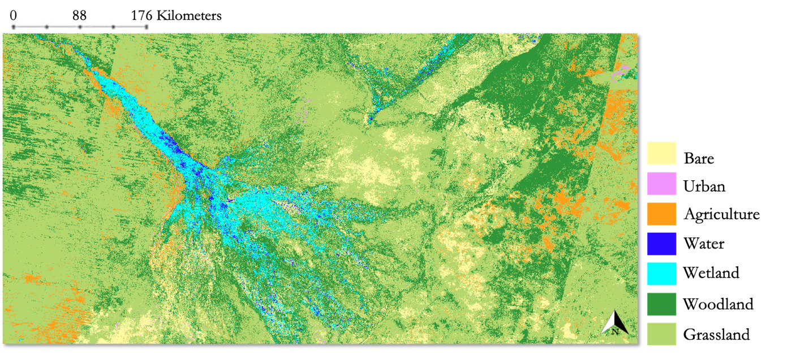
Figure 2. LULC classification for 1990

The 2020 Classification had an 85% validation accuracy (Figure 3). While this was still greater than the accuracy for 1990, one of the main challenges the team faced was training the random forest classifier to distinguish salt pans in the study area. These salt pans are sometimes filled with seasonal water and at other times are barren, depending on what month the images are composited from. Additionally, the classification model accuracy for all years was limited by the computational power of GEE, which imposes restrictions on the size of the training set that is used for classification. Due to the large expanse of the Kavango-Zambezi study area, collecting training data representative of the diversity of land cover within the study area was challenging and may have contributed to lower classification accuracies. These limitations could be overcome, however, by running the random forest model on smaller subregions within the broader Kavango-Zambezi area, which had higher validation accuracy values.
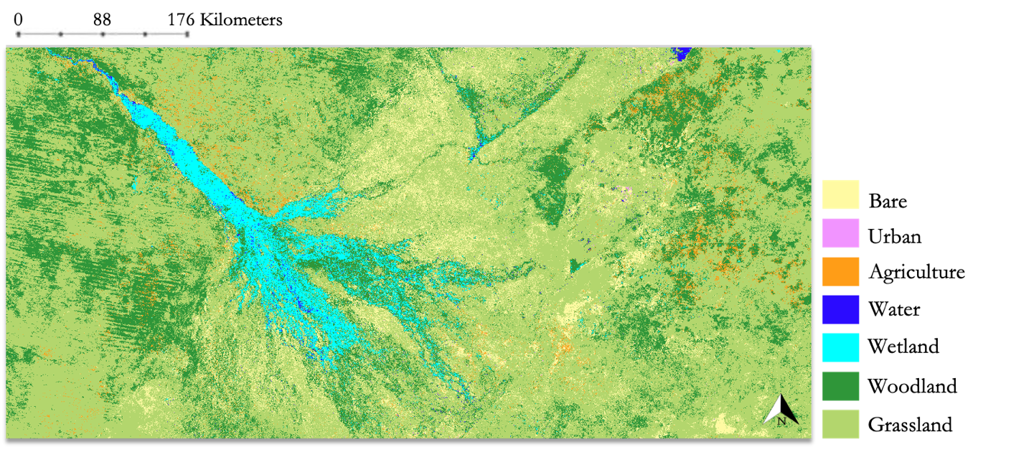
Figure 3. LULC classification for 2020

From 1990-2020, there was significant loss in woodland cover, coinciding with an increase in all other land cover classes (Figure A2). The agriculture class increased by approximately 200 km² and the urban class increased by approximately 2,000 km². These results, combined with the approximate 10,000 km² loss of woodland cover, serve as evidence of the human settlement expansion at the expense of elephant habitat loss or fragmentation. However, further analysis of the land cover transitions on a pixel-by-pixel basis is necessary to determine which land cover classes replaced the woodland cover. Upon closer examination of land cover change between 1990 and 2020, the urban and agricultural expansion is pronounced in two areas of high HEC risk, the Okavango Delta and Victoria Falls (Figure A3 and Figure A4).

4.1.2 Human-elephant Conflict Risk Analysis
We used the results of the HEC incidence heat maps to rank known corridors and agricultural fields, as well as to implement our LULC agricultural and urban classes to prioritize areas that had already been identified as having a higher likelihood of future conflict based on partner-collected HEC data. In Figure 5 below, the villages are displayed proportionally, with those that have seen higher conflict incidence appearing larger. The higher incidence areas had approximately 40 events per square kilometer. We also ranked the known elephant corridors by priority status. Critical corridors were typically adjacent to at least two villages where a higher number of incidence reports over the past ten years had been recorded.

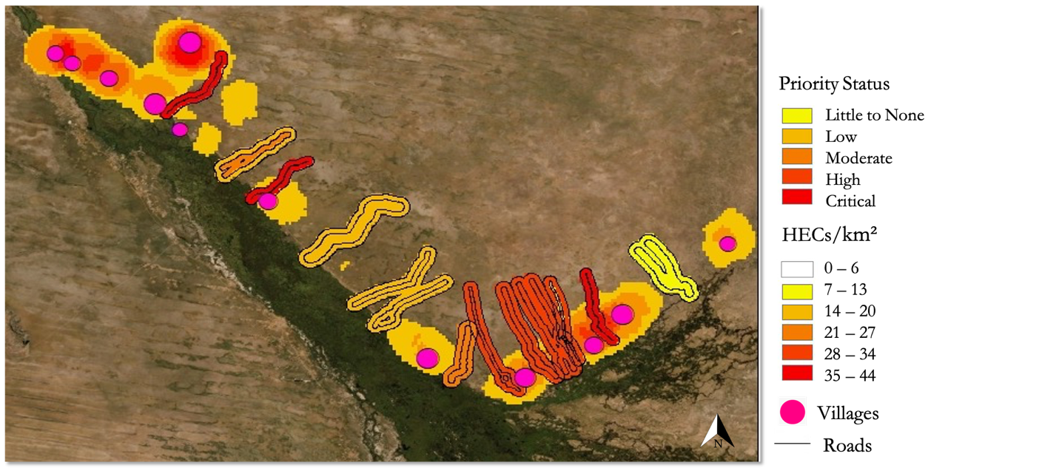
Figure 5. Ranked elephant corridors over HEC incidence heat map for the Okavango Delta (Botswana), standardized and merged.

The team simplified the HEC incidence heat map into three categories (low, medium, or high risk) based on historical data (Figure 6). The sum of this raster with the reclassified LULC categories produced the resultant priority zone map that highlights and specifies areas that may be of high risk but still are not of critical priority because the dominant class was not agriculture. Critical zones were defined as areas with the dominant class being agriculture and where incidence risk was high. Moderate priority zones were defined as either areas with high incidence risk and without mainly agricultural land cover classes, or as areas with medium incidence risk but mainly agricultural classes. Minimal priority zones included areas either with medium incidence risk and mostly urban classes, or areas with low incidence risk with agricultural classes.

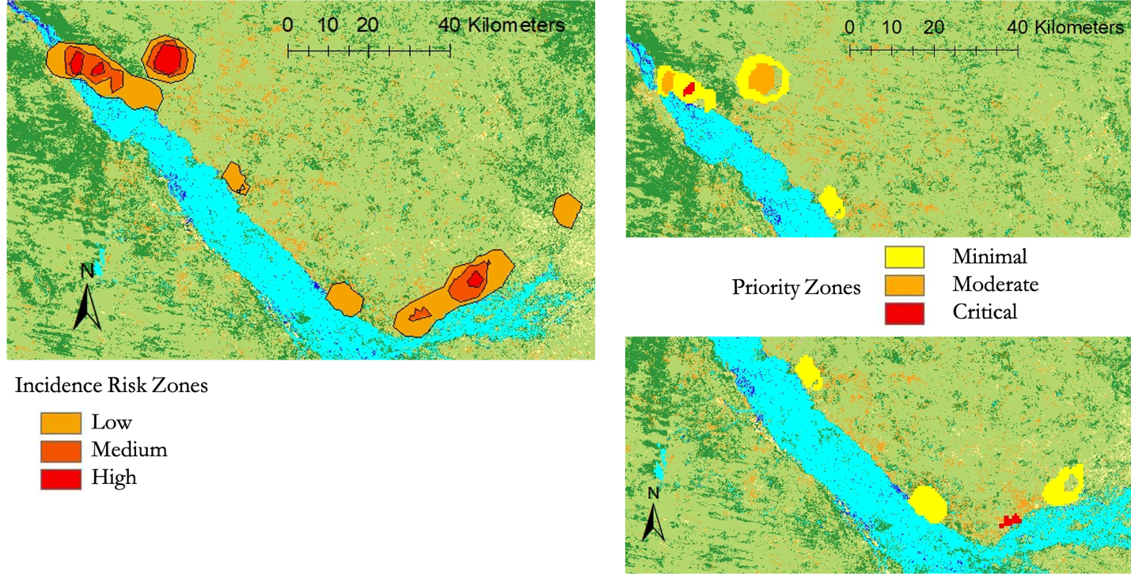
Figure 6. HEC Risk Assessment based on our LULC agriculture and urban classes.

The team generated priority zones using elephant GPS collar tracking data, shown in Figure 7. We aggregated all of the Victoria Falls HEC data from Connected Conservation to produce a heat map with approximately 500 reported HEC events from 2015-2018 (Figure 7A). Here, the risk zones have also been categorized as low, medium, and high. The Connected Conservation 2012-2019 elephant GPS tracking data were clipped to the extent of the study region where there was HEC incidence data (Figure 7B). The result was another point density heat map based on elephant movement density with three categories representing elephant route usage: low, medium, and heavy (Figure 7C). These corridors were also overlaid onto the HEC incidence map and we were able to prioritize them based on intensity of use (Figure 7D).

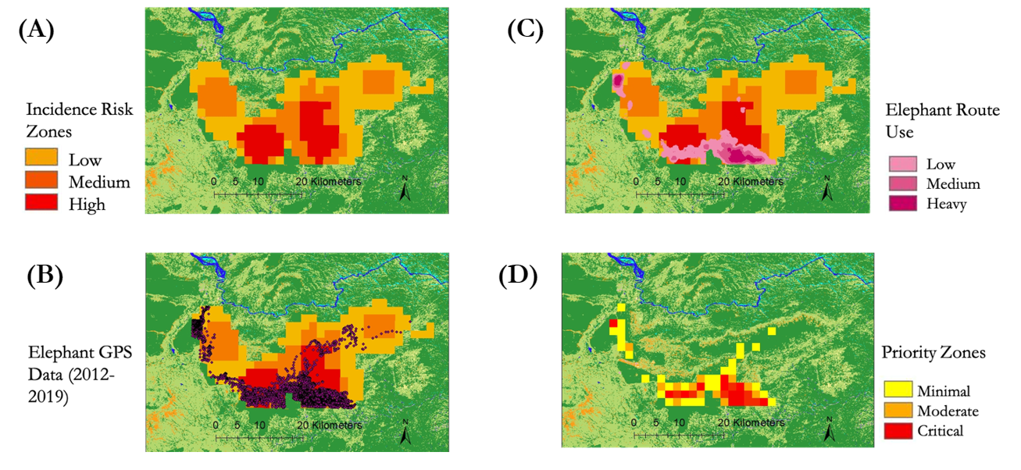
Figure 7. Elephant Corridor Risk Assessment, Victoria Falls

4.1.3 Conflict Data Statistical Analysis
Our analysis of the HEC data provided by Ecoexist Project indicates that roughly 65% of the sampled villages experienced over 100 HEC events during the study period. This relates to the community concern of frequent elephant presence in urban and agricultural areas, as it would mean 65% of the villages averaged over 11 HEC events annually (Figures B1-B4). Given the prevalence of subsistence agriculture within the region, these HEC events could dramatically impact the financial and physical security of people living in close contact with elephants. At the end of the study period, the frequency of HEC in villages was 21 times lower than in 2008 (Figure B5).

In addition to villages, the team analyzed variations in participation between the two genders. Female elephants were four times more likely to participate in HEC events if accompanied by a male. Furthermore, females participated in a quarter of recorded HEC events for the study period, whereas males alone perpetrated 52% of the events (Figure B6). Male elephants were involved in an average of 109 HEC events annually, with females and multi-sex groups averaging 5 and 32 instances annually, respectively (Figure B7). It is interesting to note that within HEC data collected from Connected Conservation, females did not actively participate in HEC until 2014, in which the team observed a positive trend afterward. The exact cause of this phenomena is unknown at the time and requires more research. It is worth highlighting the disparity in HEC participation between sexes during the study period. Specifically, females had eight times the number of participants at the end of the study period than originally, whereas males had 41 times more participants at the beginning of the study period (Figure B7). Females participated in 95% of events involving 20 or more participants; conversely, females participated in less than one percent of events perpetuated by a single elephant. Additionally, 95% of HEC events occurred in groups of ten or less participants (Figure B8). Given partner knowledge of elephant family dynamics in the Botswana region, this could indicate that family groups are not responsible for the majority of HEC events as they tend to operate in groups of eight or larger.

Variations in crop maturity preference were relatively sporadic during the study period. Mature crops were raided 262 times in 2008, but zero times in 2019. Similarly, interim crops were raided 192 times in 2008, and 25 times in 2019. 2008 marked the peak year of crop raiding for all three crop categories except seedlings, in which seedlings peaked at 72 raid events during 2010. Seedlings were raided 22 times a year on average, with interim and mature crops being raided 69 and 59 times a year respectively (Figures B9-10).

The sampled area from Ecoexist Project averaged 212 instances of HEC annually. However, 2010 was the last year in the study period to have a higher frequency of HEC than the average, indicating that the earlier years in the study period had a much larger frequency of HEC than later years (Figure B5). This correlates to the observed decline in HEC frequency during the study. During the decline in HEC frequency, there were observed spikes in HEC in 2015 and 2017. Environmental stressors like drought were assessed for correlation; however, there was only a drought present in 2015, whereas 2017 had peak precipitation accumulation values. The exacts causes of this decline in HEC are unknown at this time, but they could indicate variations in sampling standards, or could attest to the effectiveness of partner mitigation efforts within the region.

4.2 Future Work
If there was more time to continue work on this project, the team would choose to pursue analyzing the role of wildfires and burned areas in elephant movement. This would involve documenting and georeferencing historic fires in relation to elephant tracking data and assessing fire location proximity to elephant movement corridors and areas of high activity. A byproduct of analyzing correlation between fires and elephant locations could be insightful regarding the role of elephants as wildfire disturbance drivers.
Another potential for future work could be differentiating riparian vegetation from wetlands as its own class in a LULC classification. This could provide further insight regarding differences between elephant movement in grasslands, woodlands, wetlands, and riparian vegetation habitats since elephants use these landscapes differently. Utilizing the transect method from vegetation ecology, the composition and distribution of different vegetation species could be monitored and cataloged within habitats transitioning from low to high elephant use. This could possibly shed light into drivers of elephant movement within riverine habitats.
Future research could also be applied to monitoring mining infringement on elephant movement corridors and frequented areas. Considering that female participation in HEC was eight times higher at the end of the study period, it would be worthwhile for partners to pursue tagging more female elephants for future research. To understand the observed trend of increasing female participation continued regression analysis between environmental variables and HEC from 2014 onward is crucial to understanding what factors may be driving the increasing trend. Furthermore, increasing the sample pool of collared elephants to include those that do not actively participate in crop raiding events would be beneficial in eliminating sampling bias and determining more accurate correlations between environmental drivers and patterns in elephant movement.

5. Conclusions
The team built a GEE tool that will allow partners to continuously use Earth observations to monitor LULC change and drivers of HEC. The team created an ArcGIS StoryMap for partners to use in presentations, outreach, and educational programming. The team generated HEC heat maps for each year with data available in order to identify areas of high, medium, and low risk of conflict in the study region with the purpose of conducting an overlay analysis. Using point incidence data, known elephant corridors were prioritized by frequency of HEC. The team also identified areas of critical and moderate priority for proactive HEC mitigation efforts within the Victoria Falls and Okavango Delta areas. These maps, along with the LULC classifications, will allow end-users to identify areas at high risk to analyze trends and patterns their region of interest, and incorporate those areas into land use planning. This risk assessment also allowed us to delineate potential corridors frequently used by elephants in an effort to minimize HEC occurrence and mitigate future conflict events. Urban and agricultural expansion was observed along water sources like the Okavango Delta. Woodland habitat available to elephant use decreased by 10,000 km². Data reveals that females participated in a quarter of recorded HEC events, and that they were four times more likely to participate if accompanied by a male. Given that females participated in less than one percent of single-elephant HEC events, males are the dominant perpetrators of HEC events. This can be corroborated by the statistic that males participated in 64% of HEC events during the study period. Histograms and scatterplots indicate that the frequency of HEC decreased during the study period. Increases in female participation at the end of the study period indicate possible future research focus on possible ongoing dynamic shift in HEC participation. Considering that urban and agricultural expansion increased, yet HEC decreased, could possibly attest to the effectiveness of partner and community mitigation efforts in the region.

6. Acknowledgments
The Spring 2021 Africa Food Security & Agriculture II team would like to thank the following project partners, advisors, NASA DEVELOP Fellows, and previous NASA DEVELOP participants for their invaluable expertise and support throughout this project:
- Connected Conservation, South Africa Office
  - Dr. Ferrell Osborn, Director
  - Malvern Karidozo, Senior Researcher
- Ecoexist Project
  - Dr. Graham McCulloch, Policy Director
  - Dr. Anna Songhurst, Field and Program Director
- Advisors
  - Dr. Marguerite Madden, University of Georgia, Department of Geography
  - Dr. Sergio Bernardes, University of Georgia, Department of Geography
  - Dr. William Langbauer, Bridgewater State University, Biology Department
  - Dr. Andrea Presotto, Salisbury University, Geography and Geosciences Department
- NASA DEVELOP National Program Lead/Fellows
  - Darcy Gray, Georgia Node
  - Crystal Wespestad, Georgia Node (Term 1)
- NASA DEVELOP Past Contributors
  - Jennifer Gallucci
  - Jonathan Moallem
  - Erika Munshi
- Graduate Students
  - Katherine Markham, University of Georgia
  - Anastacia Makati, University of Botswana

Any opinions, findings, and conclusions or recommendations expressed in this material are those of the author(s) and do not necessarily reflect the views of the National Aeronautics and Space Administration.

This material is based upon work supported by NASA through contract NNL16AA05C.

7. Glossary
Earth observations – Satellites and sensors that collect information about the Earth’s physical, chemical, and biological systems over space and time
GEE – Google Earth Engine, platform used for LULC classification
HEC – Human-elephant conflict, events where elephants raid farmers’ crops, threatens residents, damage property, or eat refuse from landfills
LULC – Land Use Land Cover, refers to various land uses and land covers across and landscape that can be used for classification
NDVI – Normalized Difference Vegetation Index, indicator of vegetation greenness
PDSI – Palmer’s Drought Severity Index
SAVI – Soil Adjusted Vegetation Index, indicator of vegetation greenness with a correction factor of soils

8. References
Abatzoglou, J.T., Dobrowski, S.Z., Parks, S.A., Hegewisch, K.C. (2018). TerraClimate, a high-resolution
global dataset of monthly climate and climatic water balance from 1958-2015, Scientific Data
5(170191), https://doi.org/10.1038/sdata.2017.191

Breiman, L. (2001). Random Forests. Machine Learning 45, 5–32, https://doi.org/10.1023/A:1010933404324

Costa, Felipe. (2017). Kavango-Zambezi landscape land cover 2005. [Data set].
https://panda.maps.arcgis.com/home/item.html?id=ecd2e9d5abff4d6f842a564d0ba3876a

Dai, Aiguo & National Center for Atmospheric Research Staff (Eds) (2019) "The Climate Data Guide:
Palmer Drought Severity Index (PDSI)." Retrieved from https://climatedataguide.ucar.edu/climate- data/palmer-drought-severity-index-pdsi

Farr, T.G., Rosen, P.A., Caro, E., Crippen, R., Duren, R., Hensley, S., Kobrick, M., Paller, M., Rodriguez, E.,
Roth, L., Seal, D., Shaffer, S., Shimada, J., Umland, J., Werner, M., Oskin, M., Burbank, D., and
Alsdorf, D.E. (2007). The Shuttle Radar Topography Mission. Reviews of Geophysics, 45(2).
https://doi.org/10.1029/2005RG000183.

GeoterraImage. (2007, May). Land-Cover Classification for Peace Parks Foundation: Kavango-Zambezi
Dataset. Final Data Report and Meta Data (vs. 2). https://drive.google.com/file/d/1GYtSu2gIqfWMqOSP_OZ6X0N4_dfchPYT/view

Gerhardt-Weber, K. E. M. von. (2017). Elephant Movements and Human-Elephant Conflict in a Transfrontier Conservation Area. Botswana Documents. https://library.wur.nl/ojs/index.php/Botswana_documents/article/view/15958
Huete, A.R. (1988). A Soil-Adjusted Vegetation Index (SAVI). Remote Sensing of the Environment 25(3),
295-309. https://doi.org/10.1016/0034-4257(88)90106-X.

Madonsela, S., Cho, M. A., Ramoelo, A., Mutanga, O., & Naidoo, L. (2018). Estimating tree species diversity
in the savannah using NDVI and woody canopy cover. International Journal of Applied Earth
Observation and Geoinformation, 66, 106–115. https://doi.org/10.1016/j.jag.2017.11.005
Mmbaga, N. E., Munishi, L. K., & Treydte, A. C. (2017). Balancing African Elephant conservation with human well-being in Rombo Area, Tanzania. Advances in Ecology, 2017, 4184261. https://doi.org/10.1155/2017/4184261

Schultz, M., Shapiro, A., Clevers, J. G. P. W., Beech, C., & Herold, M. (2018). Forest cover and vegetation
degradation detection in the Kavango Zambezi Transfrontier Conservation area using BFAST
monitor. Remote Sensing, 10(11). https://doi.org/10.3390/rs10111850

Shaffer, L. J., Khadka, K. K., Van Den Hoek, J., & Naithani, K. J. (2019). Human-elephant conflict: A review of current management strategies and future directions. Frontiers in Ecology and Evolution, 6. https://doi.org/10.3389/fevo.2018.00235

USGS (2021a). USGS EROS Archive – Landsat Archives – Landsat 4-5 TM Level-1 Data Products [data]. Retrieved from https://www.usgs.gov/centers/eros/science/usgs-eros-archive-landsat-archives-landsat-4-5-thematic-mapper-tm-level-1-data?qt-science_center_objects=0#qt-science_center_objects. Accessed February 20, 2021. https://doi.org/10.5066/F7N015TQ

USGS (2021b). USGS EROS Archive – Landsat Archives – Landsat 8 OLI and TIRS Level-1 Data Products [data]. Retrieved from https://www.usgs.gov/centers/eros/science/usgs-eros-archive-landsat-archives-landsat-8-oli-operational-land-imager-and?qt-science_center_objects=0#qt-science_center_objects. Accessed February 20, 2021. https://doi.org/10.5066/F71835S6

9. Appendices
Appendix A
Decisions Around LULC Classification
After a general classification scheme was developed, the team tested it in a random forest classification training set in GEE. Upon training set creation and analysis, the team determined that two distinct vegetation classes would more accurately portray the region of interest. Furthermore, two vegetation classes could provide insight regarding differences in elephant movement in various vegetation landscapes. The team decided that it was best to have a “grasslands” and a “woodlands” class. These two vegetation classes were meant to be generalized differentiations of savanna shrubland ecosystems and forest ecosystems. The team’s generalized classification scheme was then submitted to partners for input on accordance with partner end-use requirements. After receiving partner input, the team decided to further aggregate agriculture classes from “dryland / subsistence cultivation” and “commercial cultivation” into a single “agriculture” class. The team agreed with partners that further differentiating agriculture into three classes, could provide further insight regarding amount of HEC events occurring in different agricultural areas, but would require ground truth data from the partners and thus should be considered as an opportunity for future works. Based on partner feedback, the seven classes in our classification scheme are representative of dominant land cover and HEC drivers in the region. The list of classes and a general description of each class can be found in Table A1 below.

Table A1. Summary of classes in the land use land cover classification
Class Number | Class Name | Description
0 | bare | Predominantly non-vegetated areas with exposed rocky soils
1 | urban | Areas of impervious cover that are man-made or related to anthropogenic use
2 | agriculture | Rain fed subsistence and communal cultivated areas
3 | water | Areas of open water present in one through all four seasons
4 | wetlands | Permanent or semi-permanent wetland areas including contained riparian vegetation
5 | woodlands | Tree dominated bushlands and forests
6 | grasslands | Grass and shrub dominated ecosystems with low, open canopies

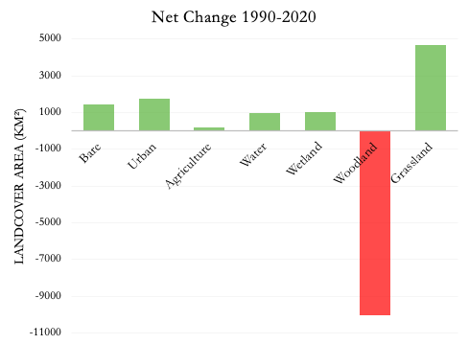

Figure A2. Net land cover change between 1990 and 2020.

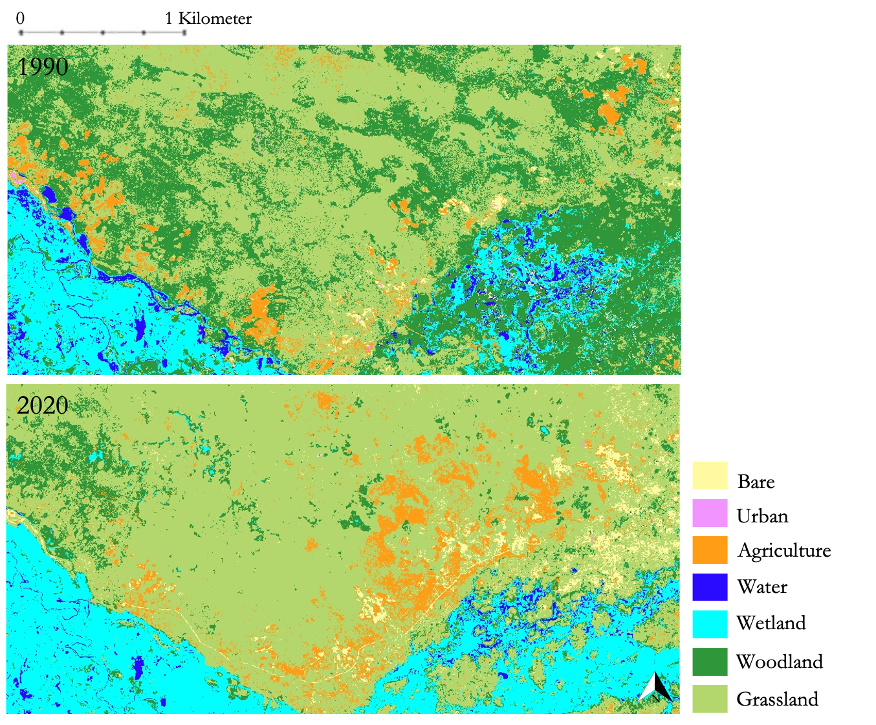
Figure A3. LULC change between 1990 and 2020 along the eastern Okavango Delta panhandle in Botswana demonstrates agricultural expansion around elephant corridors

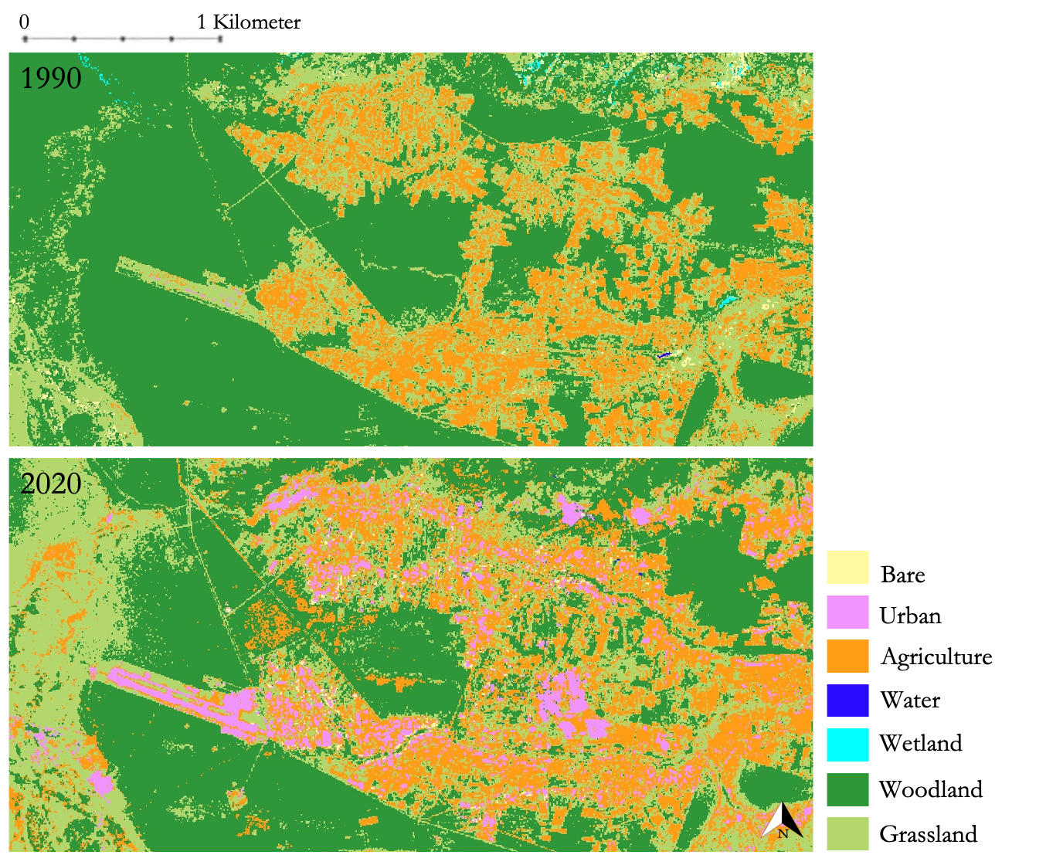
Figure A. LULC change between 1990 and 2020 around the Victoria Falls Airport in Zimbabwe reveals urban and agricultural expansion in increasing HEC risk zones

Appendix B
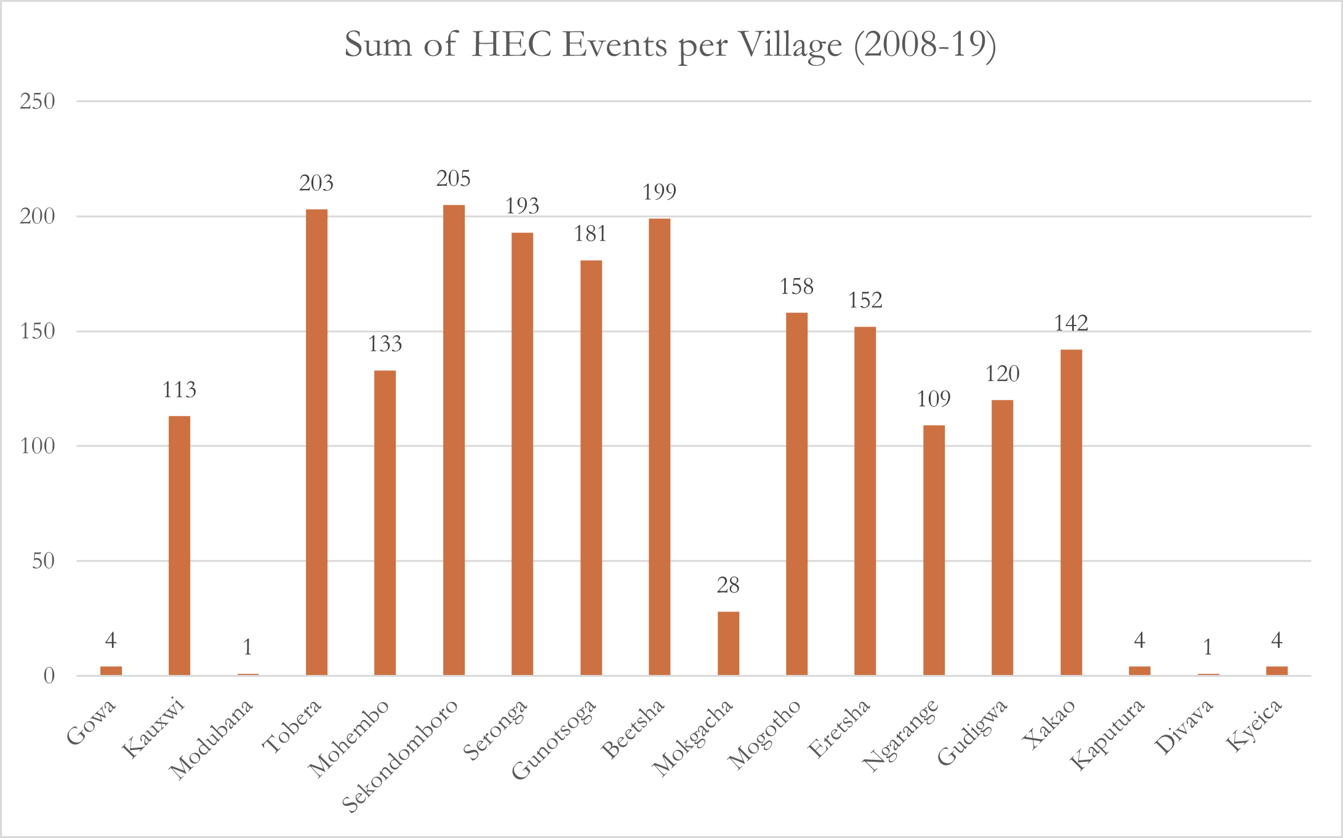
Figure B1. Sum of HEC events per village during the study period

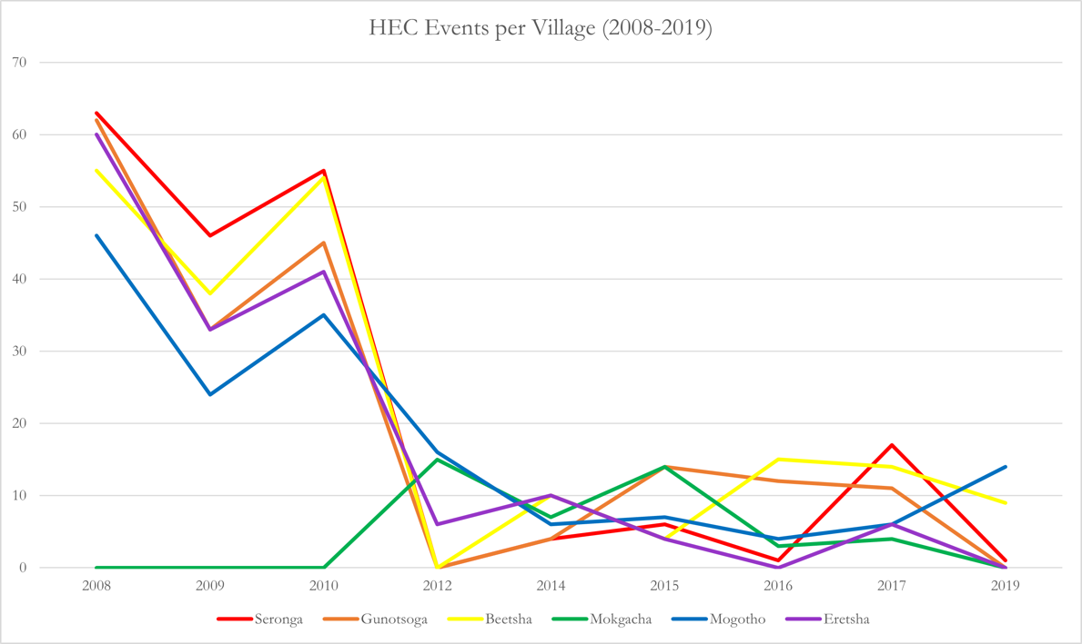
Figure B2. Variation in HEC frequency for villages, including Seronga, Gunotsoga, Beetsha, Mokgacha, Mogotho, Erestha

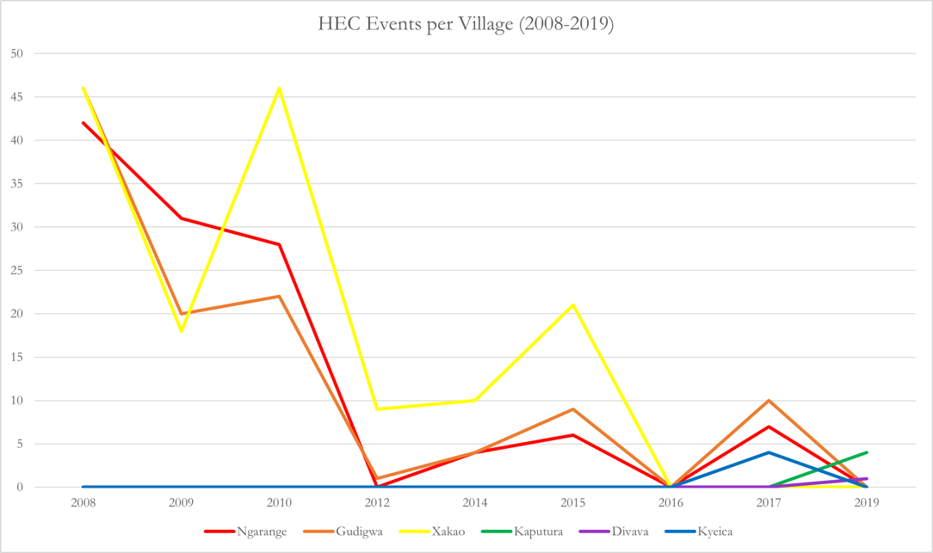
Figure B3. Variation in HEC frequency for villages, including Ngarange, Gudigwa, Xakao, Kaputura, Divava, Kyeica

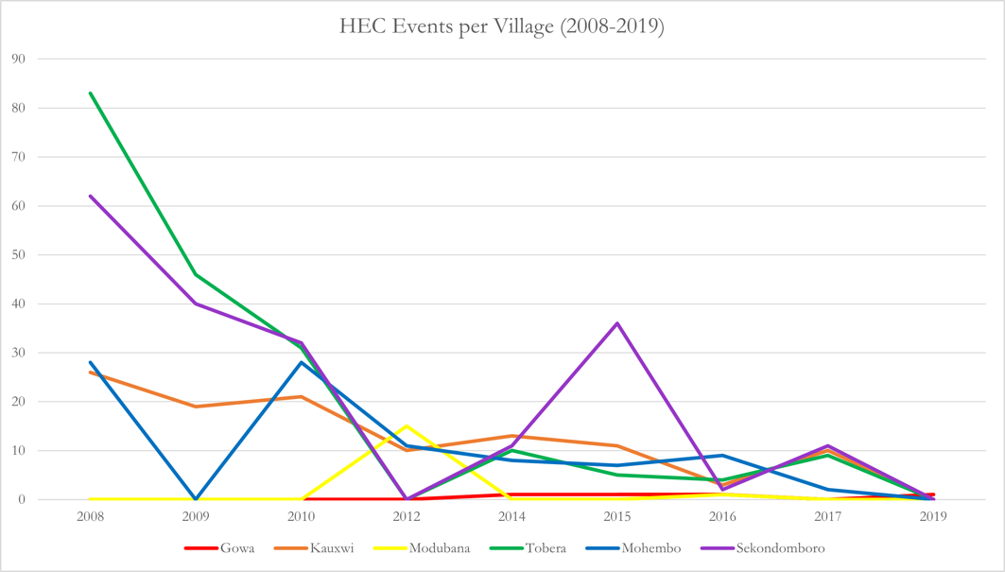
Figure B4. Variation in HEC frequency for villages, including Gowa, Kauxwi, Modubana, Tobera, Mohembo, Sekondomboro

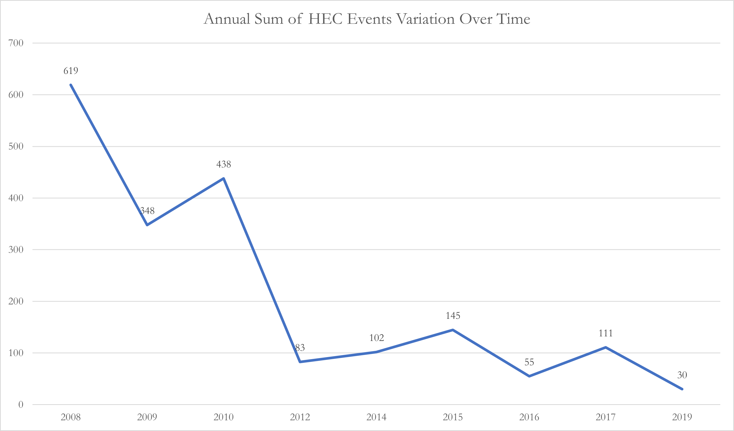
Figure B5. Annual sum of HEC events from 2009 to 2019

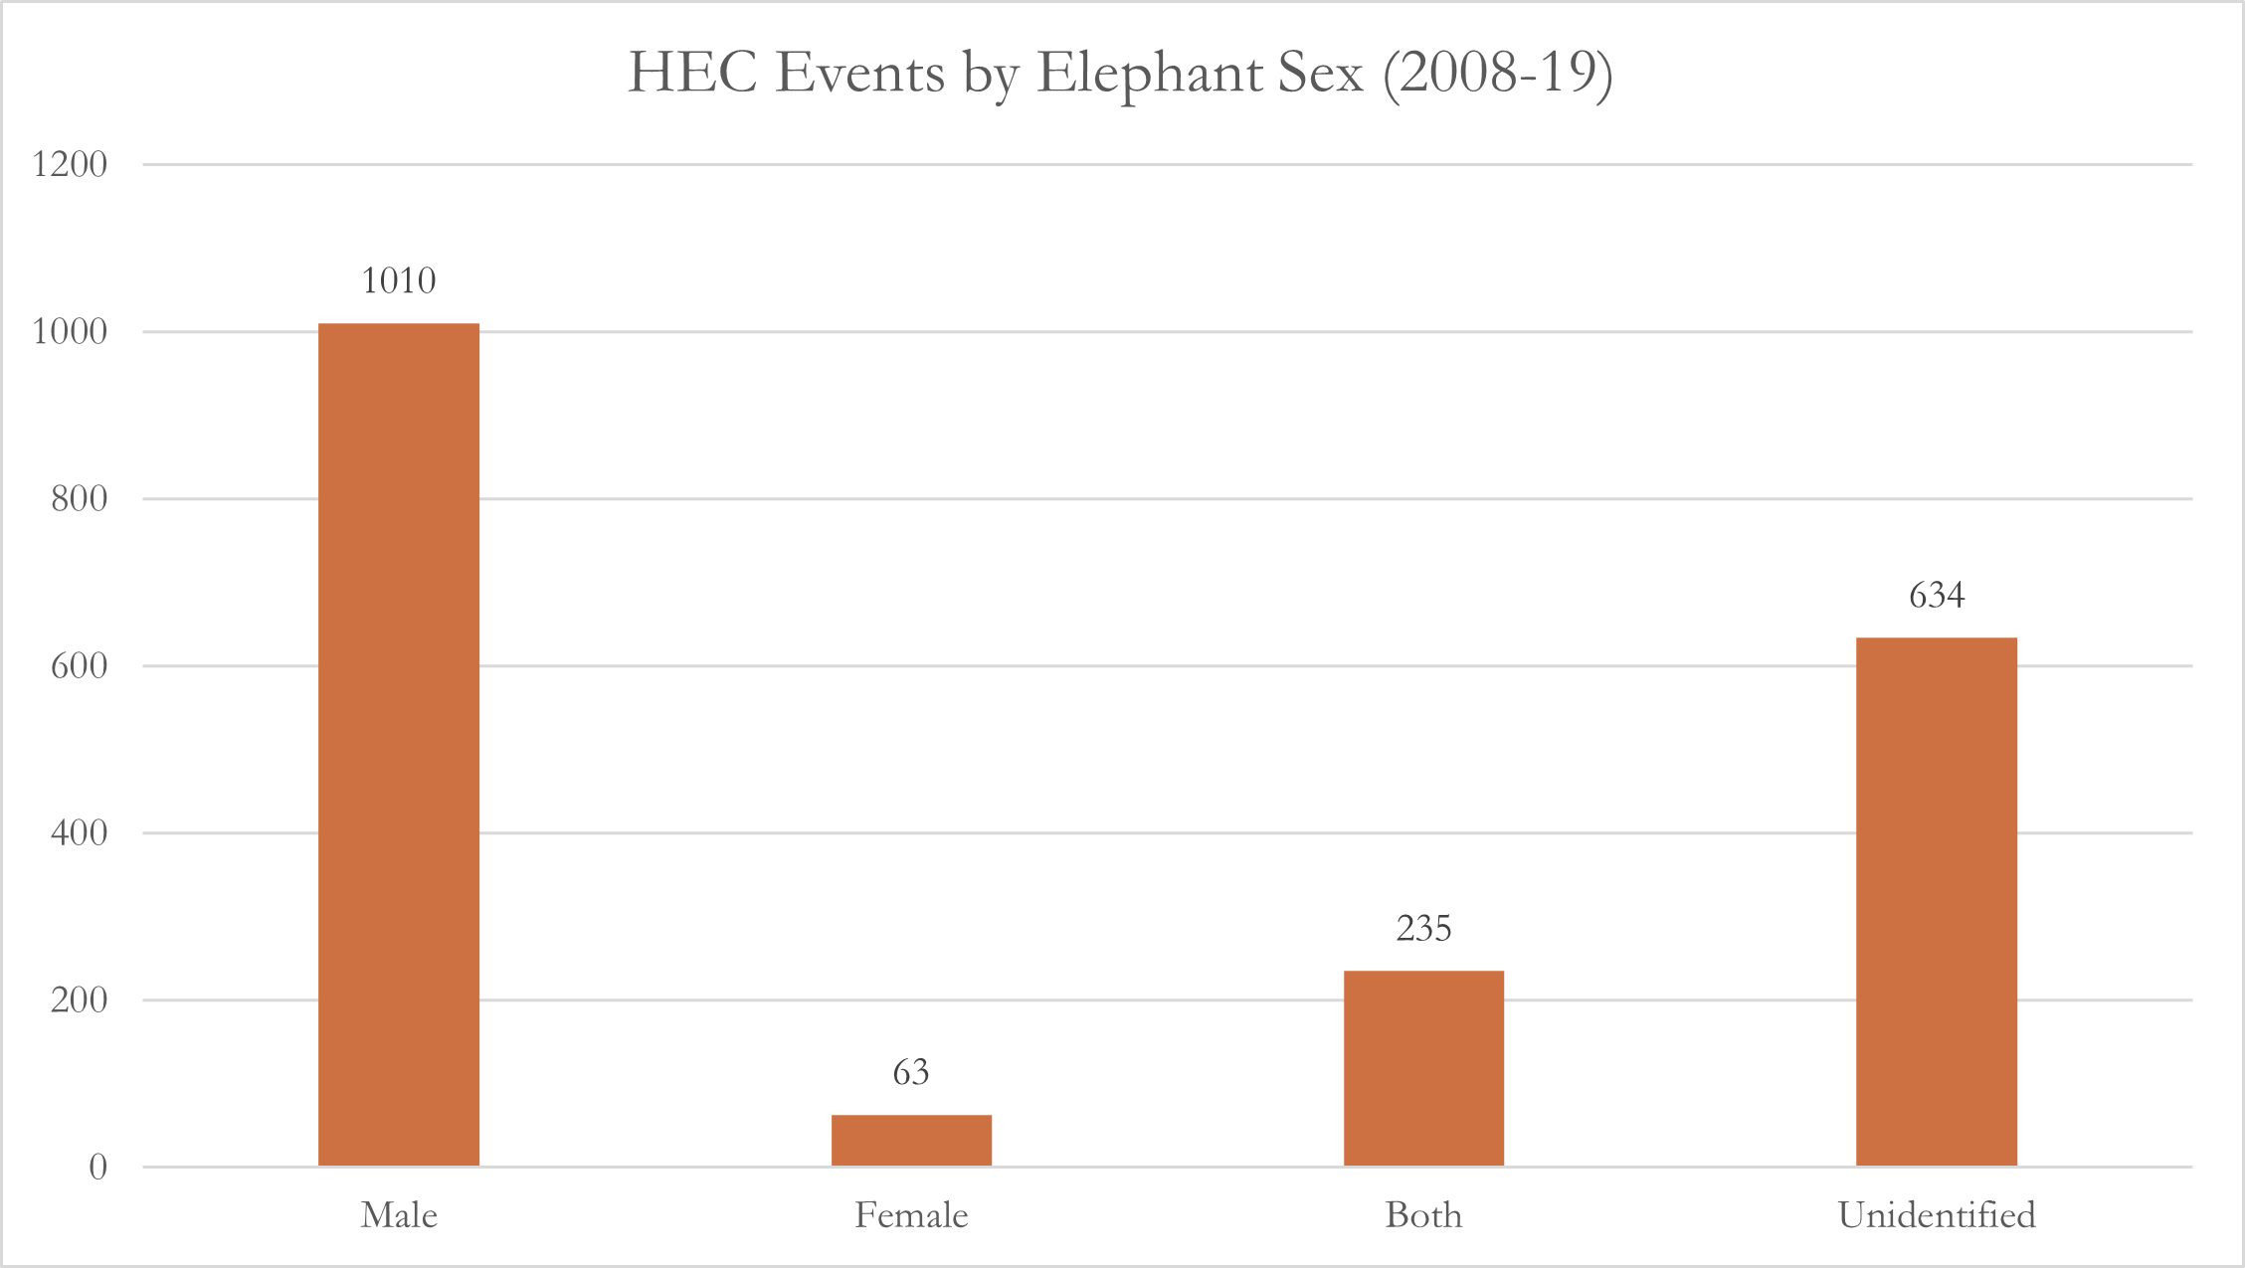
Figure B6. HECs by sex of elephant participant

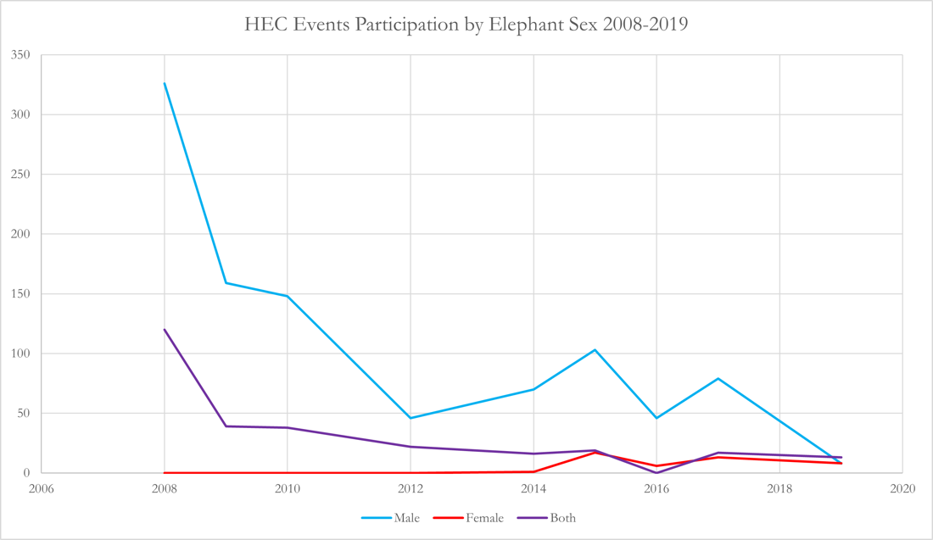
Figure B7. Variation in elephant participation by sex

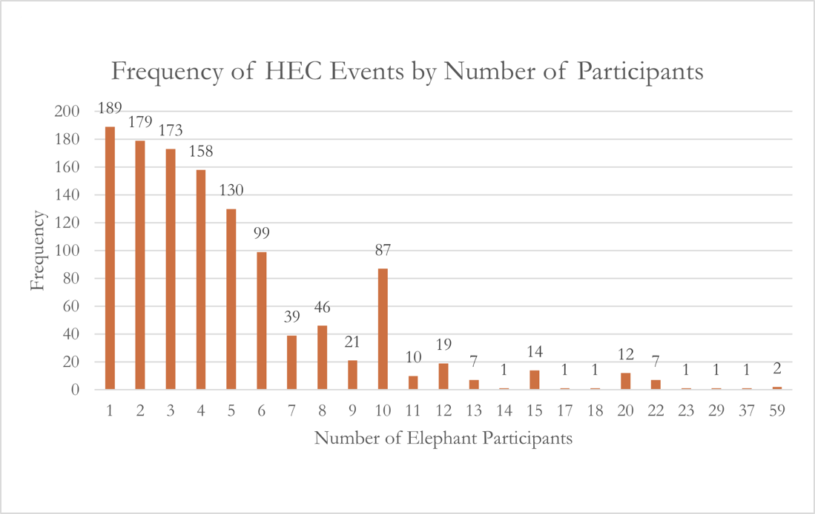
Figure B8. Frequency of HEC events binned by number of participants

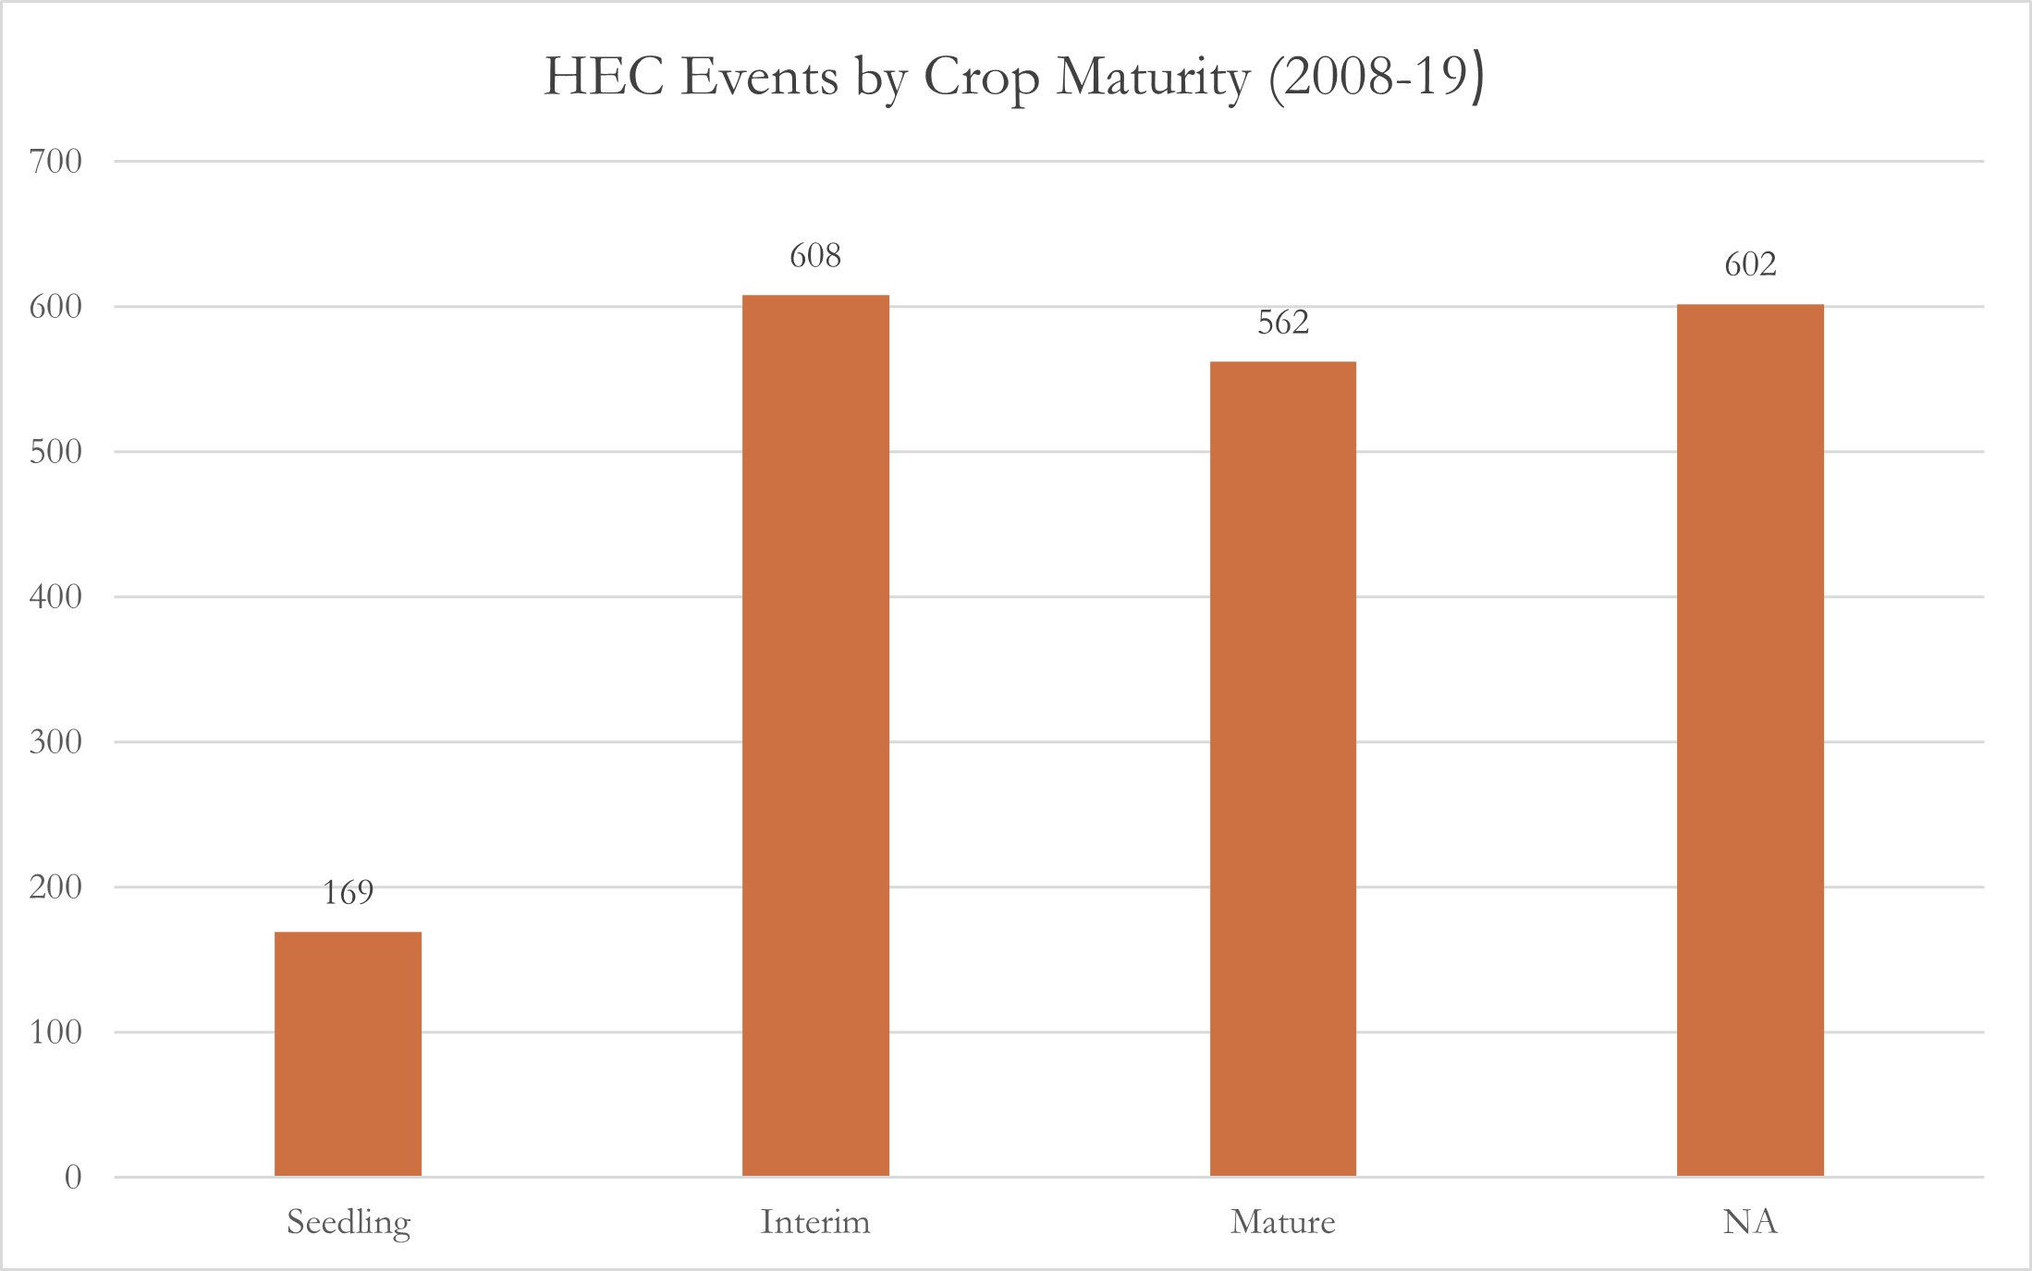
Figure B9. HECs by crop maturity at time of event

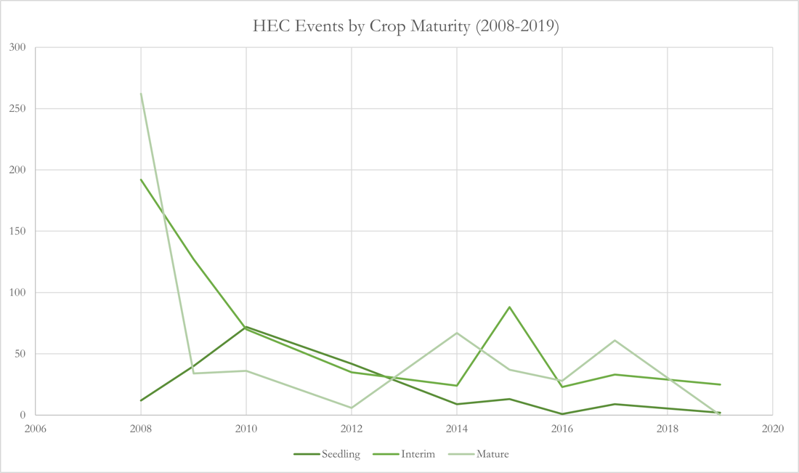
Figure B10. Crop maturity preference over time

