**NASA DEVELOP National Program**

****Mobile County Health Department

**Spring 2016**

**Short Title: Mobile Bay Ecological Forecasting**

**Subtitle:** Monitoring Marsh Conditions in Coastal Alabama Using NASA Earth Observations to Support the Alabama Coastal Foundation’s Restoration and Conservation Initiatives

**VPS Title:** Mission to Marsh: Using NASA Satellite Data to Monitor Coastal Conditions

**Project Team & Partners**

**Project Team:**

Saranee Dutta (Project Lead), Saranee.dutta@gmail.com

Vishal Arya

Jeanett Bosarge

Courtney Kirkham

Tyler Lynn

**Advisors & Mentors:**

Dr. Kenton Ross (NASA Langley Research Center)

Bernard Eichold, M.D., Dr. PH (Mobile County Health Department)

**Partner Organizations:**

Alabama Coastal Foundation (End-User), POC: Mark Berte; Boundary Organization

Dauphin Island Sea Lab (Collaborator), POC: Dr. Just Cebrian

**Project Details**

**Applied Sciences National Applications Addressed:** Ecological Forecasting, Water Resources

**Study Area:** Mobile and Baldwin counties, Alabama

**Study Period:** February 2000 – February 2016

**Earth Observations & Parameters:**

Terra, Moderate Resolution Imaging Spectroradiometer (MODIS), 16-day global vegetation indices

**Ancillary Datasets Utilized:**

* NOAA Coastal Change Analysis Program (C-CAP) – regional land cover
* Alabama Coastal Foundation (ACF) Watershed Data – watershed boundaries
* National Weather Center – precipitation and temperature records
* National Climatic Data Center – precipitation and temperature records

**Models Utilized:**

* TerrSet Geospatial Monitoring and Modeling System Land Change Modeler

**Software Utilized:**

ArcGIS 10.3.1, 2015 - Raster manipulation/analysis, image enhancement, & map creation of

Terra MODIS Normalized Difference Vegetation Index (NDVI) products

**Project Overview**

**Objective:**

The objective of this project was to apply NASA satellite data to address community concerns regarding loss of coastal marshes and assess historical and current marsh conditions within priority watersheds. Terra MODIS (NDVI) data were used to generate phenologic responses in the vegetation canopy greenness of marshes in Mobile and Baldwin County, AL. The analysis of MODIS NDVI time series data were used to perform marsh health trend analyses to assist the Alabama Coastal Foundation in their decision-making process for future conservation initiatives designed to protect and restore marshland.

**Abstract:**

Mobile and Baldwin counties encompass the region known as Coastal Alabama. The fresh, brackish, and salt-water marshes of this area shelter a wide variety of species and provide valuable ecosystem services. Over several decades, this area has experienced extensive marsh loss due to a combination of anthropogenic and natural stressors. This project partnered with the Alabama Coastal Foundation (ACF) and the Dauphin Island Sea Lab (DISL) to address community concerns of ecosystem decay within Coastal Alabama marshland. MOD13Q1 data products from the Terra satellite assisted in extracting vegetation indices and establishing baseline conditions for marsh health and comparing marsh health during disturbance years. These findings will support the ACF by providing data and maps of marsh health trend analyses, which will focus future restoration projects in appropriate areas.

**Community Concerns:**

* Coastal marshes and submerged aquatic sea grass beds of coastal Alabama have decreased in extent over the past few decades.
* Marsh degradation affects the entire estuarine ecosystem where the harvest of shrimp, crab, and oysters are a major local industry.
* Between 1954 and 2002, 54.4% of emergent wetlands were lost due to urban expansion, erosion, and saltwater intrusion, of which 32.8% were salt marshes.
* Surveys collected public input on what citizens of coastal Alabama value about living on the coast. The results indicated that the community was concerned with access to coastal Alabama waters, of which the marshlands are a part, their protection, resiliency to unforeseen events, the habitat and abundance of marine fauna, and the quality of the water.

**Current Management Practices & Policies**:

The Dauphin Island Sea Lab (DISL) monitors the marshlands through the Mobile Bay National Estuary Program, which identifies, restores, and protects estuaries that are significant to the Mobile Bay area. In 2013, these organizations developed a 5-year comprehensive conservation and management plan for Mobile and Baldwin County, AL. In this plan, it was determined that anthropogenic factors are the main cause of stress for intertidal marshes and riparian buffers. The DISL evaluated the watersheds and, with public input, selected priority watersheds on which to focus. The health of marshes in these priority watersheds were determined by conducting ground surveys and using remotely sensed data. The objective of this plan was to measure ecosystem health by restoring and managing our natural and cultural assets. The Alabama Coastal Foundation (ACF) also aims to educate government institutions, businesses, and the public about the state of Alabama’s coastal environments in order to facilitate cooperation and involvement in protecting these environments. These organizations function as advocates for preserving and improving environments along the Alabama coast. Additionally, the ACF encourages free information exchange among concerned parties that may prove useful for the protection and improvement of coastal habitats.

**Decision Support Tools & Benefits:**

|  |  |  |
| --- | --- | --- |
| **End-Product** | **Earth Observations Used** | **Benefit & Impact** |
| Marsh Health Trend Analysis Graphs | Terra MODIS | Assist the Alabama Coastal Foundation in deciding where to focus future protection, restoration, and mitigation efforts based on historical patterns of marsh health characteristics |
| Current Marsh Health Map | Terra MODIS | Current marsh health to be used as input for predictive modeling |
| Land Use Land Cover Projection | C-Caps | Forecasts land use land cover changes that might occur in the future based on historical trends,  Display areas where marshes may be depleted in the future |
| Marsh NDVI Time series | Terra MODIS | Visualize changes in marsh NDVI over 15 year period |

**Project Imagery**

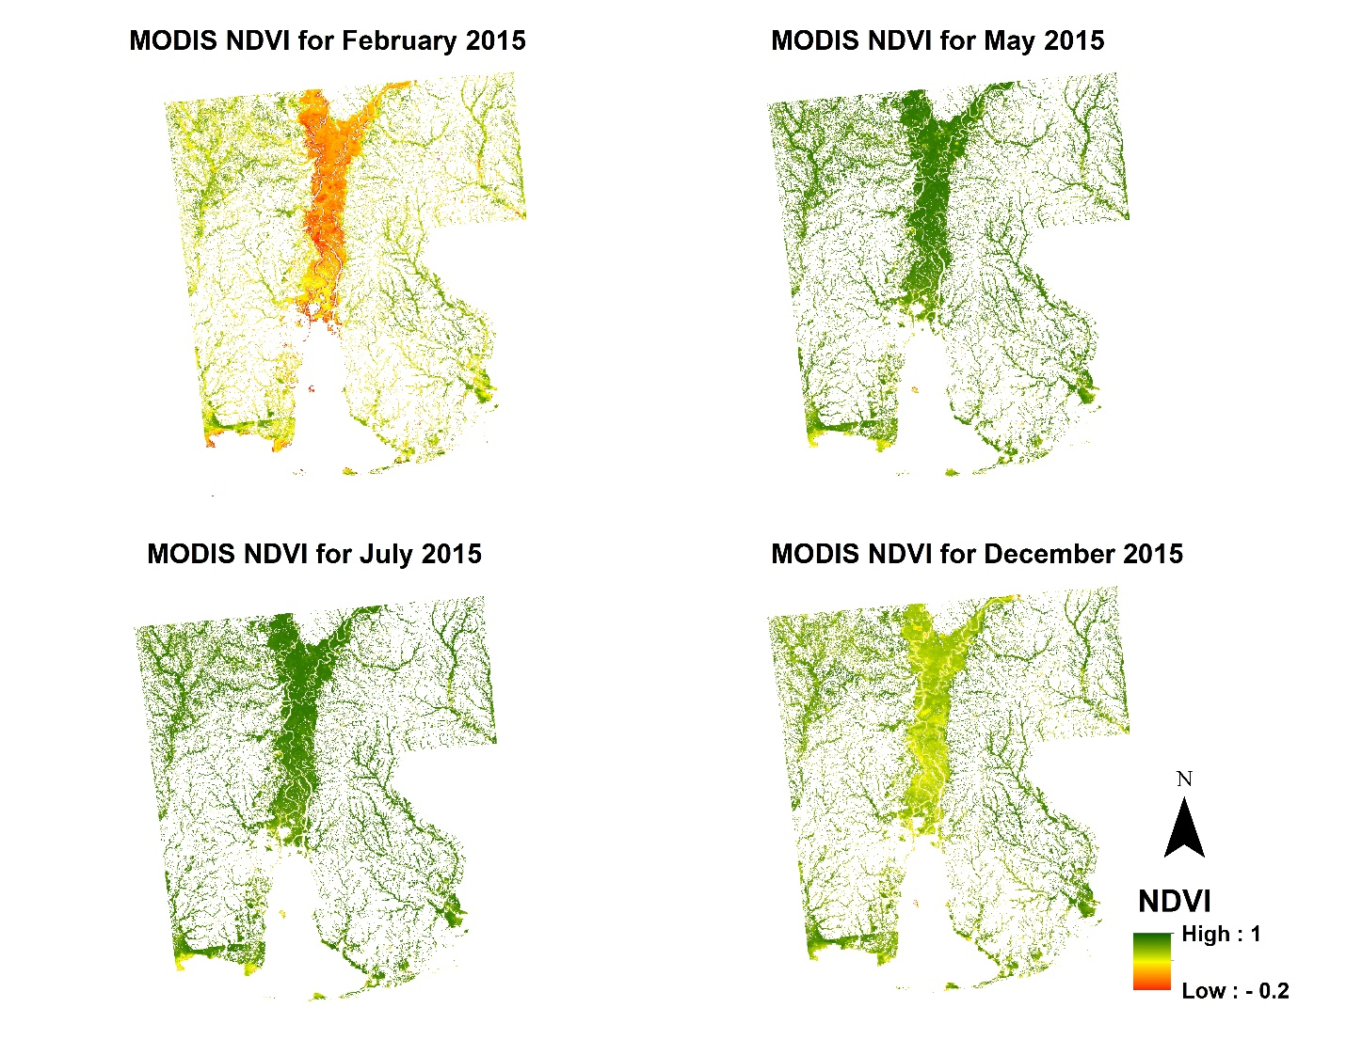

**Caption:** MODIS NDVI showing photosynthetic activity of wetlands in Mobile & Baldwin County, AL. Mobile Bay Eco Forecasting team.

**Image:** 2016Spring_MCHD_MobileBayEcoForecasting_FinalImagery.

**Software Release Requirements**

What category does the tools your project is creating fall within? N/a