**NASA DEVELOP National Program**

**Fort Collins, Colorado (USGS-CSU)**

**Summer 2015 Project Proposal**

**Colorado Agriculture II**

Completing Maps of Forest Harvest History Using Landsat Imagery

**Objective:**

The purpose of this project is to continue and complete the delineation of the location and age of forest harvests occurring between 1987 and 2012 in Landsat scenes covering northern Colorado and southern Wyoming.

Note: This proposal is a continuation of the Colorado Ag Spring 2015 project. Issues with IDL code prevented the team from completing the project to a level that would be an acceptable product for the project partners. So, we propose continuing this valuable project for Summer 2015. The Summer 2015 team will continue where the Spring 2015 team left off. If there is time left after running LandTrendr and analyzing the output, the Summer 2015 team will also classify past harvests as clearcuts or thinning treatments.

**Community Concern:**

Timber harvests in northern Colorado support the local economy, maintain forest health in the absence of fire, reduce the risks of extreme wildfires, and serve as a means to protect critical infrastructure from falling trees after the recent mountain pine beetle outbreak. Forest managers need to understand past harvest activity to prioritize current harvests and thinning, maximize benefits and minimize undesired results. While some forest managers have records of past harvests, they are generally incomplete or inaccurate and often not spatially explicit (i.e., mapped). Accurate maps of harvest history will provide valuable insight to forest susceptibility to beetle infestation, while providing economic data (related to timber sales) that may support alternative energy.

**End-Users/Partners/Boundary Organizations:**

Ben Delatour Scout Ranch (End-User, POC: Robert Sturtevant, Conservation Committee Chair)

Bioenergy Alliance Network of the Rockies (BANR) (End-User, Partner, and Boundary Organization, POC: Anthony Vorster, Feedstock Supply Team Task Manager)

Colorado State Forest Service (End-User, POC: John Twitchell, Steamboat District Forester)

United States Forest Service (Contact has not yet been made. However, Arapahoe, Roosevelt, Routt, and Medicine Bow National Forests fall within the study area and end-products will be made available to these forest managers.)

The team has been in communication with end-users for the past year and has an excellent working relationship. A map showing the location and age of forest harvests for the last 25 years has emerged as a need for all three end-users. These groups currently work together, communicate frequently, and share data. DEVELOP participants will tap into this existing working relationship to communicate progress and to distribute final products. The Ben Delatour Scout Ranch and the Colorado State Forest Service will use the maps to plan upcoming management such as harvests and thinning. The Bioenergy Alliance Network of the Rockies (BANR) will use the product to inform study design of ecological impacts of harvesting and as a data source for the estimation of potential feedstock for biofuel conversion. The team will hand-off products through presentations for the BANR and the Ben Delatour Scout Ranch. Products will be shared with the Colorado State Forest Service at a meeting at their headquarters.

**Decision Making Process:**

The Colorado State Forest Service (CSFS) and Ben Delatour Scout Ranch adaptively and actively manage their forests by continuously planning timber harvests and monitoring the effectiveness of their actions. The CSFS uses National Agricultural Imagery Program (NAIP) imagery from the United States Department of Agriculture (USDA). These organizations do not have an accurate map of past harvests. A map showing the location and age of timber harvests for the past 25 years would help prioritize forest management. Mapping harvests will allow for concise and active management of areas near critical infrastructure.

BANR will use this map of harvest history to inform two tasks: (1) The map will assist research analyzing the ecological impacts of timber harvests to study forest health in a chronosequence of past harvests; (2) The proposed map of harvest history would also be used by BANR to estimate potential feedstock for the wood-to-biofuel industry. Harvest history could be used with other variables to model species composition, total biomass, beetle-killed biomass, and the type of feedstocks that may be available at a given site.

**Earth Observations**

|  |  |  |
| --- | --- | --- |
| **Platform** | **Sensor** | **Geophysical Parameter** |
| **Landsat 5** | Thematic Mapper (TM) | Surface Reflectance |
| **Landsat 8** | Operational Land Imager (OLI) | Surface Reflectance |
| **National Agriculture Imagery Program (NAIP)** | Digital Sensors on Aircraft | Surface Reflectance |

**NASA Earth Observations to be Highlighted:**

The extensive historic record of data captured by the Landsat 5 program, in combination with change detection models, provides an opportunity to assess past forest disturbance where records on timber harvests are incomplete or missing. Twenty-five years of continuous satellite imagery data collection will allow us to fill the gaps in past timber harvest records and validate it with high resolution imagery to inform and improve management decisions and, in turn, forest health. Landsat 8 will be used as ancillary data and to compare historical harvests to current forest conditions.

**Ancillary Datasets:**

National Land Cover Dataset (NLCD) )- from Multi-Resolution Land Characteristics Consortium

Management Boundaries- Provided by the Colorado State Forest Service

**Software & Scripting Utilized:**

• ENVI – IDL scripting, Landsat imagery visualization and preprocessing

• ArcGIS – Landsat imagery basic preprocessing (study area designation, clipping, etc.)

• Brian- can you ad something about LandsatLinkr?

**Models:**

Landsat-based Detection of Trends in Disturbance and Recovery (LandTrendr) (POC: Robert Kennedy, Boston University)

**Decision Support Tools & Analyses:**

|  |  |  |
| --- | --- | --- |
| **Proposed End Products** | **Decision Impacting** | **Current Partner Tool/Method** |
| Map Showing the Location and Age of Forest Harvests From 1987-2012 | Locating sites for upcoming harvests and thinning. Studying ecological impacts of timber harvests and estimating biomass and potential biofuel feedstocks. | Aerial imagery, field surveys, and historical records |

*Map Showing the Location and Age of Forest Harvests From 1987-2012 –* multiple raster layers showing the start date, duration, and magnitude of forest harvests within the study site. Landsat Thematic Mapper (TM) images from 1987-2012 will be used with the LandTrendr model. The harvest map stops in 2012 because 2012 is the last year in which suitable images were captured by Landsat 5 TM. We are only using Landsat 5 TM, and not Landsat 8 OLI, to map harvest history for consistency in each band’s wavelength.

**Project Details:**

**National Application Area Addressed:** Agriculture

**Source of Project Idea:** This project originated from observations of an overlapping need of the three end-users. The team noticed in the field that we need an accurate map of forest harvest to understand current forest attributes such as biomass and mountain pine beetle and spruce beetle outbreak severity. Additionally, the need of the Colorado State Forest Service and the Ben Delatour Scout Ranch for a central, comprehensive, and accurate map of forest harvests became clear. BANR also realized that understanding where and when past harvests occurred will be of paramount importance to understand the impacts of past harvest and to estimate the amount of various feedstocks for a potential biofuel economy.

**Advisor:** Paul Evangelista (Natural Resource Ecology Lab, Colorado State University)

**# of Participants Requested:** 5

**Project Timeline:** 3 terms: 2015 Spring to 2015 Fall

**Study Location:** Northern Colorado and Southern Wyoming, USA: includes Colorado State Forest State Park, Ben Delatour Scout Ranch, Arapaho National Forest, Roosevelt National Forset, Routt National Forest, and Medicine Bow National Forest (Landsat Scene Path 34 Row 32)

**Period being Studied:** 1987-2012

**Previous Related DEVELOP Work:**

Colorado Agriculture

Reconstructing Forest Harvest History Using Landsat Time Imagery

Spring 2015 (Fort Collins)

**Multi-Term Objectives:**

* **Term 1** – DEVELOP participants began mapping forest harvest history from 1987-2012 in northern Colorado and southern Wyoming. Preprocessing and troubleshooting the IDL code for LandTrendr slowed progress.
* **Term 2 (Proposed Term) –** DEVELOP interns will continue the efforts of Term 1 to get a higher quality product. They will complete troubleshooting the LandTrendr code, classify the outputs, and will characterize harvests as clearcuts or thinning treatment if they have time.
* **Term 3-** The team will map tree species composition using correlative models with Landsat 8 imagery, field data, and ancillary datasets at the Colorado State Forest State Park.

**Notes:**

The Bioenergy Alliance Network of the Rockies (BANR) is a USDA-funded consortium of an industry partner and researchers from several federal agencies and universities in Colorado, Wyoming, Montana, and Idaho researching the feasibility of establishing an economy converting beetle-killed wood to an automobile-ready biofuel. Visit banr.colostate.edu for more information.

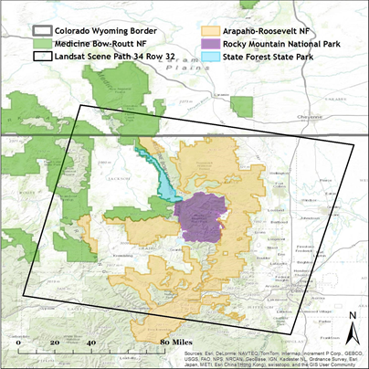

Figure 1. Map showing the location of Colorado State Forest State Park and where it falls within the Path 34 Row 32 Landsat scene.

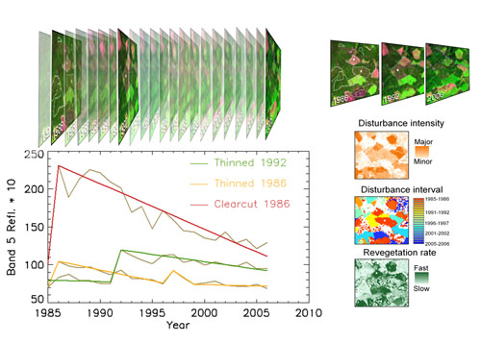

Figure 2. This figure shows how LandTrendr tracks forest disturbances using the trajectory of three pixels from Landsat images from 1985- 2006 as an example. Intense, short disturbances correspond to a clear cut, while moderate, short disturbances indicate thinning. Three of the outputs are shown on the right: disturbance intensity, disturbance interval, and revegetation rate. (http://landtrendr.forestry.oregonstate.edu/)