Central America Transportation & Infrastructure

Employing NASA Earth Observations to Map Historic Flooding in Guatemala and El Salvador

**Technical Report**

Final Draft – August 12th, 2019

Vanesa Martín (Project Lead)

Samuel Heagney

Carly Muir

Gentry Patterson

Dr. Jeffrey Luvall, NASA Marshall Space Flight Center (Science Advisor)

Dr. Robert Griffin, The University of Alabama in Huntsville (Science Advisor)

# 1. Abstract

Central America is one of the world’s most vulnerable regions to natural disasters, including landslides and precipitation-driven flooding. In an effort to support disaster management and emergency response planning, this project developed a methodology that employed Earth observations to map historic flooding extents near the Pacific coast of Guatemala and El Salvador. Radar-based techniques were used to detect inundation impact to areas near rivers. Specific Earth observations consisted of moderate resolution remote sensing systems such as the Shuttle Radar Topography Mission (SRTM), the ALOS Phased Array type L-band Synthetic Aperture Radar (PALSAR), RADARSAT-2, and the C-band synthetic aperture radar (SAR) sensor aboard Sentinel-1. End users for this project consisted of Guatemala’s Coordinadora Nacional para la Reducción de Desastres (CONRED) and the Instituto Nacional de Sismología, Vulcanología, Meteorología, e Hidrología (INSIVUMEH),and El Salvador’s Observatorio Ambiental, all of which focus on disaster monitoring and response. This research was intended for the broader benefit of the Central American political and economic organization known as Sistema de la Integración Centroamericana (SICA), with the aim of integrating NASA Earth observations into its environmental decision making.

**Keywords**

remote sensing, Sentinel 1 C-SAR, Google Earth Engine, flood mapping, SRTM, natural disasters, NDFI, FwDET, ALOS PALSAR, RADARSAT-2

# 2. Introduction

***2.1 Background Information***

El Salvador and Guatemala are listed ninth and twelfth, respectively, on the list of countries most vulnerable to extreme climatic events, such as hurricanes, heavy rainfall, and floods (United Nations, 2015). These events often result in destructive landslides, which lead to devastating social and physical damages when compounded by vulnerable infrastructure. Additionally, economic losses from these events have been disastrous for the region, amounting to more than two billion and one billion US dollars over the last 35 years in Guatemala and El Salvador, respectively (World Bank, 2010). River swelling that occurs near urban areas after heavy rainfall has been particularly concerning to disaster mitigation and prevention agencies. Events like Hurricane Agatha in 2010, which brought more than 400 mm of rainfall, have revealed that resilience capacity should be improved at the local and municipal scales (Stewart & Cangialosi, 2012). This is particularly important for frequent low-impact events, such as precipitation-driven floods and subsequent landslides, which have become more common. Future climate scenarios suggest an increase in the frequency of extreme rainfall events and tropical cyclone intensity, leading to severe flooding from storm surge and inland water bodies (Spencer & Urquhart, 2018).

This work focused on flood-prone areas near the Pacific coast of Guatemala and El Salvador. The bordering nations share a Pacific coastline of approximately 600 km. The tropical climate is predominantly controlled by the Inter-Tropical Convergence Zone (ITCZ), with distinct wet (May to October) and dry (November to April) seasons (Hastenrath, 2002). Orographic precipitation also occurs due to the complex topography created by volcanic activity. During the rainy season, these countries are particularly prone to storms and flooding from both the ITCZ and tropical cyclones (United Nations, 2015). The combination of rainfall, land cover, and topography creates conditions for devastating mudslides and floods. Coupled with both countries’ socioeconomic characteristics, these nations are extremely vulnerable to climatic disasters.

Based on previous work done by Cian, Marconcini, & Ceccato (2018), this project used synthetic aperture radar (SAR) data for flood mapping. SAR sensors have the capacity to gather data during night-time and are not limited by atmospheric conditions, unlike optical sensors. This allows for the mapping of flood events in small- to medium-sized drainage basins where floodwaters often recede before meteorological conditions improve enough to measure with optical sensors (Martinis, Twele, & Voigt, 2009; Psomiadis, 2016).

Advanced Land Observing Satellite (ALOS) Phased Array type L-band Synthetic Aperture Radar (PALSAR) and RADARSAT-2 data were used to map historical flood events from major storms in 2010 and 2011. C-band SAR data were used to analyze flood events that occurred after the launch of Sentinel-1 in 2014. Specifically, we examined flooding produced from weather events during the rainy season of 2017, mainly September and October. The study period was selected due to the anomalously high rainfall that occurred during this time. According to Flood List (2018), over 230 mm of rainfall was recorded in parts of El Salvador and Guatemala within a 24-hour time period during this season (*Figure 1*).

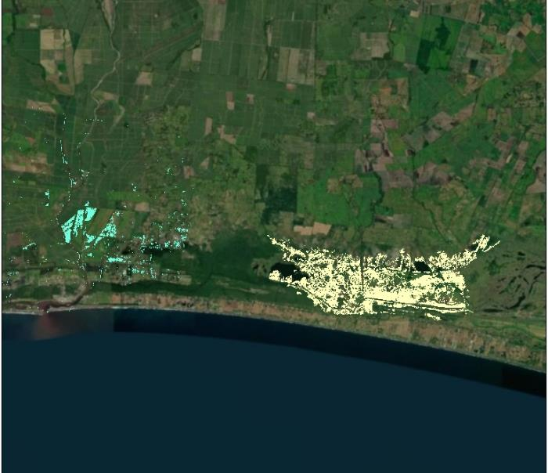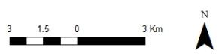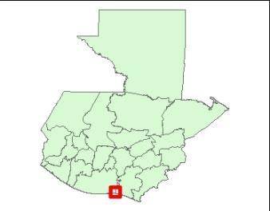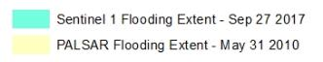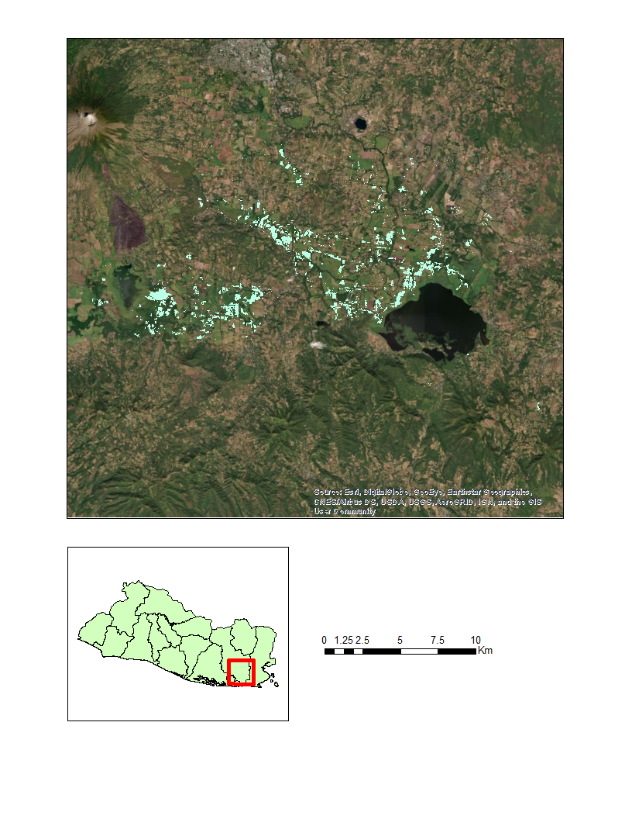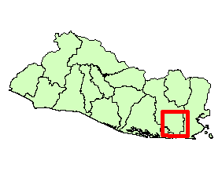

RADARSAT-2 Flooding Extent – May 31 2011

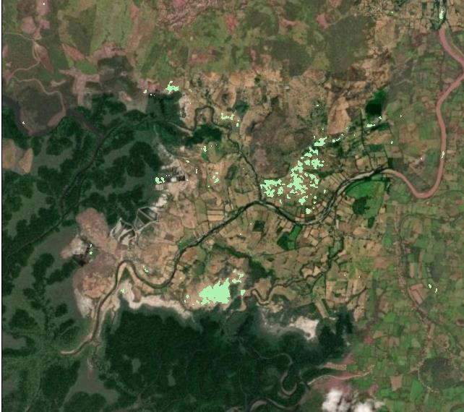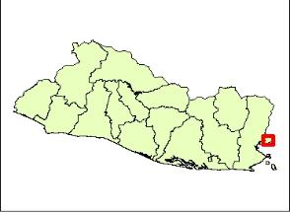

Sentinel 1 Flooding Extent - October 29, 2017

*Figure 1.* These are maps showing the locations of the four flooding events we studied (two in Guatemala – first image, two in El Salvador – second and third images).

* 1. ***Project Partners & Objectives***

The NASA DEVELOP team partnered with end users at Guatemala’s Coordinadora Nacional para la Reducción de Desastres (CONRED) and the Instituto Nacional de Sismología, Vulcanología, Meteorología, e Hidrología (INSIVUMEH), as well as El Salvador’s Observatorio Ambiental. The primary duties of these agencies are to monitor natural disasters and prepare citizens for emergencies, which is why developing a replicable methodology for near-real-time flood mapping is crucial. More generally, the project was a result of the partnership between NASA and the Central American Integration System (SICA), a political and economic organization representing eight Central American countries, including Guatemala and El Salvador. Conclusions and insights gained from this research will ideally inform future flood mapping efforts in the SICA region. Collaborators at NASA SERVIR and NASA Disasters provided technical and country-specific insights throughout the course of this project. Project objectives included providing partners with inundation maps of flood extent and depth, as well as assessments of infrastructural damage in order to help them better prepare for future flooding events. The replicability of our team’s methods was a priority, so we produced an in-depth tutorial for making these maps. Partners can continue to create such maps to inform decision-making by identifying areas of high flood risk as well as effective routes for emergency responders to take during flood events.

# 3. Methodology

***3.1 Data Acquisition***

In order to create inundation maps, we began by collecting SAR imagery taken during or immediately after major flooding events in our regions of interest. It was also necessary to obtain SAR imagery from periods of normal water flow to use for reference and for the calculation of the Normalized Difference Flood Index. The dates we chose to examine included Hurricane Agatha in May of 2010, as well as images taken from a time of historically high rainfall in September and October of 2017. NASA SERVIR provided polygon layers of flooding caused by Tropical Depression 12E in El Salvador in October of 2011 (Table 1). We obtained Sentinel-1 interferometric wide swath C-SAR data in the Vertical-Vertical (VV) polarization from the Copernicus Open Access Hub and used ALOS PALSAR data in the Horizontal-Horizontal (HH) polarization from the Alaska Satellite Facility Vertex data portal. A digital elevation model (DEM) from the Shuttle Radar Topography Mission was acquired using Google Earth Engine (GEE), and finer-resolution local DEMs were provided by partner agencies in Guatemala and El Salvador. These included datasets at a 12.5 m resolution based on ortho-photography for Guatemala and a 1m resolution DEM based on LiDAR for El Salvador. Partners at both CONRED and the Observatorio Ambiental also provided us with road infrastructure shapefiles that we used to identify areas compromised by the flooding events examined in our methodology.

Table 1

*Information regarding each of the four studied flood events*

|  |  |  |  |
| --- | --- | --- | --- |
| **Flood Event** | **Country** | **Date** | **Administrative Region Affected by Flood Extent** |
| **Hurricane Agatha** | Guatemala | May 31, 2010 | Cuilapa, Guatemala |
| **Tropical Depression 12E** | El Salvador | October 12, 2011 | San Miguel, El Salvador |
| **Rainy Season: October 2017** | El Salvador | Oct. 29, 2017 | La Union, El Salvador |
| **Rainy Season: September 2017** | Guatemala | Sept. 27, 2017 | Cuilapa, Guatemala |

***3.2 Data Processing & Analysis***

Sentinel-1 data were processed using the Sentinel Application Platform (SNAP) managed by the European Space Agency. For each flood date of interest, our team subset an image of the region to an area of visible flooding. The same process was performed for images taken from dates of normal water flow in order to create reference images for calculations of the Normalized Difference Flood Index (*Equation 1*). The NDFI is calculated by comparing imagery acquired during flooding events to imagery acquired at times of normal water flow in order to isolate pixels depicting an anomalous presence of water (Cian, Marconcini, Ceccato, & Giupponi, 2018). In preparation for the calculation of NDFI raster layers, subsets were multilooked, radiometrically calibrated, terrain corrected, and then combined into a stack. This stack was then reprojected.

$\text{NDFI = }\frac{\text{Flood - Reference}}{\text{Flood + Reference}}$ (1)

Once these processing steps were completed, the band math operation was utilized to compute NDFI layers from the flood and reference image bands. We determined an appropriate threshold to apply to each NDFI raster by using a combination of the Draw Polygons Tool and the Compute Statistics function within SNAP. The Draw Polygons Tool was used to empirically select darkly colored pixels in flooded areas. Once these flooded regions were selected, the Compute Statistics function was used to find a threshold value based upon the 75th percentile of the selected pixels’ values. Any pixel with a value higher than the threshold value we determined was considered to be a flooded pixel. This threshold was applied to the NDFI band, and the resultant flood band was run through a 5x5 nonlinear median filter to remove any remaining speckle or noise. After completing this process, the product was exported for further processing in QGIS.

ALOS PALSAR L-band data were also processed in SNAP, but due to limitations of the SNAP application, certain processing steps were performed differently. At this time, terrain correction is not supported in SNAP for ALOS PALSAR data. Because the SNAP application requires a Terrain Correction before allowing a reprojection to be calculated, an alternate process was required to reproject the images. Our team found that the mosaic operation within SNAP outputs a reprojected image. By performing a mosaic on each image individually, we were able to obtain reprojected images without needing to correct for the terrain. Since the region we analyzed with the ALOS PALSAR data was comprised of flat, coastal plains, the inability to terrain correct was not a limitation.

Once imported into QGIS, each raster was converted from raster to vector data with the Polygonize Tool. We used the Field Calculator Tool within the attribute table window to assign the surface area of each polygon as a new field. Polygons less than 300 square meters in surface area were removed to reduce the processing time of subsequent steps.

With the newly created flood extent polygons, it was possible to complete the flood depth estimation process (FDEP) using the Esri ArcMap platform. The flood extent polygons were exported from QGIS and uploaded into ArcMap along with the 30 m SRTM DEM, the 12.5 m Guatemalan DEM, and the 1 m Salvadoran DEM. To evaluate flood depth, the flood extent polygons were first converted to a polyline, then to a raster, and finally to a point file. The snap function was used to ensure cells from the flood extent layer aligned to the DEM layer. Once the extent was transformed to a point layer, elevation values were extracted to the points. This point layer enabled the creation of a triangulated irregular network (TIN) interpolation, which can be used to calculate continuous surfaces such as floodwater surfaces. The interpolation divides the polygon into Delaunay triangles and assigns values to these smaller areas in order to better capture the gradient in the floodwater depth (*Figure 2*). The final step to obtaining flood depth values was to rasterize the TIN interpolation and subtract the DEM values from the rasterized TIN values. These steps are similar to those used in other flood depth estimation tools and are shown in *Figure 3* (Cham, Mitani, Fujii, & Ikemi 2015; Cian et al., 2018b; Cohen et al., 2017). This process was carried out separately using SRTM data as well as the local DEMs for all flooded areas.

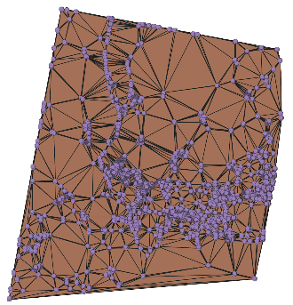

*Figure 2.* This is a TIN interpolation made from an elevation point layer.

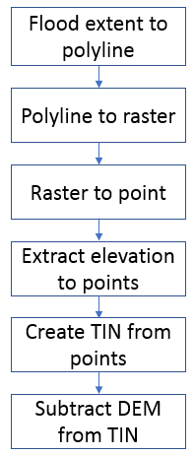

*Figure 3.* This diagram shows the workflow of our flood depth estimation process.

In order to identify infrastructure compromised by the flooding events in our regions of interest, flood water extent was overlaid onto infrastructure shapefiles provided by our partners at CONRED and the Observatorio Ambiental. We then applied the Intersect Tool in ArcMap to determine which roads intersected with the flooding domain and highlighted these areas in red to signal their inaccessibility during flood events. With the Guatemalan dataset, we were able to distinguish between paved and unpaved roads that were compromised by the flood extent (Appendix A).

# 4. Results & Discussion

***4.1 Analysis of Results***

Results returned from the FDEP showed zero meters of flooding for most pixels when the local DEMs were used as an input (*Figure 4*). Given that these pixels are within the boundaries of our flood extent, this result is evidently inaccurate. We attributed this underestimation to the homogeneity of the topography in our chosen study sites, which can be appreciated in *Figure 5*. When homogeneous elevation values are extracted to points that are then used to create the TIN, the interpolated plane is the same value as the DEM. The FDEP process involves subtracting elevation values from TIN interpolation values, but since both values are frequently the same, the resulting depth estimation is 0 m. This general miscalculation of 0 m of flood depth is particularly apparent in the maps made with finer resolution DEMs as inputs, such as those in *Figure 4*.

# 

*Figure 4.* These are results images of the FDEP for Guatemala (left) and El Salvador (right) based on 12.5 m resolution and 1 m resolution local DEMs, respectively.

# 

*Figure 5.* These images illustrate the difference between the finer-resolution DEM provided by partners (right) and the lower-resolution (left) obtained from SRTM, which makes the topography seem more variable than it is on the ground.

However, when a DEM with a coarser 30 m resolution is used as an input, the TIN has more variability and produces a greater range in depth values (*Figure 6*). Values are assigned to a larger land area due to SRTM’s coarser pixel resolution, giving way to the appearance of more topographic and depth variability. It should be noted that this should not be interpreted as a more accurate assessment of the flood, but it is meant to illustrate how the FDEP is affected by various elevation models and terrain types.

# 

*Figure 6.* These images are the results of the FDEP for flooding in Guatemala caused by Hurricane Agatha in 2010.

Regarding the infrastructure risk assessments, we found that the number of compromised roads was minimal given the fact that our flood extent case studies were largely set in rural agricultural areas. These were chosen because we needed to perform our analyses in areas where the flood extent was clearly visible, and we speculated that one of the reasons it was easier to detect water in rural areas was because there were less impervious surfaces to cause runoff, unlike urban areas. Moreover, the flat terrain in these areas allowed water to accumulate and remain long after the initial flood event. The roads that were compromised within our analyses seem to be largely unpaved roads or trails, but we were only able to distinguish road types with the Guatemalan dataset (*Figure 7*; *Appendix Figures B1 to B3*).

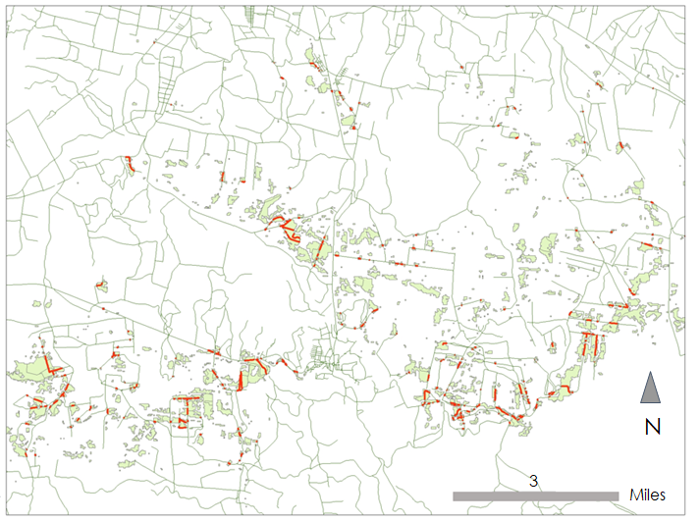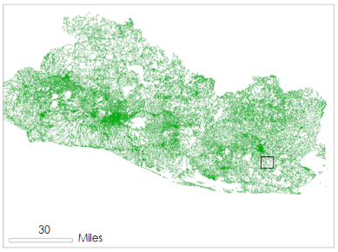

Compromised Roads

Roads

*Figure 7.* Flood extent polygons for Tropical Depression 12E in El Salvador in 2011 overlaid onto a roads shapefile. Compromised roads are shown in red.

***4.2 Limitations and Future Work***

This work was limited by a lack of radar data availability during dates of severe natural disasters over areas that were of interest to our partners, such as the rainy season of 2018 in both Guatemala and El Salvador. Continuing to utilize radar data for mapping flooding events in this region should be a priority in order to improve near-real-time flood mapping methods; a particular focus on areas with more diverse topography could be useful for evaluating the accuracy of the FDEP method we attempted.Our current FDEP results should be validated with actual floodwater depth measurements in order to gauge the accuracy of the project.Compromised infrastructure analyses would benefit from data on the locations of critical infrastructure other than roads, such as hospitals, clinics, and sources of food, as well as socio-economic data that could provide more insight into types of housing by area. Furthermore, the consideration of sea-level rise and storm surge effects on inundation severity near the coast could enhance the accuracy of mapping and forecasting in the future. Seeing as landslides tend to be a frequent consequence of precipitation-driven flooding and river swelling, producing landslide risk assessments to go along with flood depth estimation maps would also be beneficial for disaster mitigation efforts.

Applying data other than SAR data may also provide critical insights that were not considered in this project. NASA’s ICESat-2 is a space-borne LiDAR sensor that was launched in 2018 and has the potential to incorporate sea-level rise into future risk assessments and emergency response scenarios. NASA’s Global Ecosystem Dynamics Investigator (GEDI) is a space-borne LiDAR sensor launched in 2018 with the objective of mapping forest biomass and structure. Data from this sensor have the potential to further elucidate the details of the topography and vegetation in selected regions of interest, possibly resulting in better accuracy when estimating flood depth. Lastly, there are still many near-real-time flood mapping tools being developed. Researchers at the University of Alabama in Tuscaloosa produced the Floodwater Depth Estimation Tool (FwDET) for ArcMap (Cohen et al., 2017). Upon attempting to use it, we found that there was a coding issue and have been in contact with its authors. They are continuing to correct and update the tool, so it is likely that end users will have access to the tool via ArcMap soon in order to continue experimenting with optimal FDEP methods.

# 5. Conclusions

SAR data can be employed to enable rapid monitoring and response to extreme hydrological events. Unlike optical sensors, synthetic aperture radar allows our methodology to be viable regardless of atmospheric conditions or time of day, provided there are data available over the correct time period and study area. The methods presented in this research have the potential to offer a simple alternative or complement to input-intensive hydraulic model flood water depth estimation methods, especially in time-sensitive situations. As mentioned in our future work, our FDEP method should be validated with actual flood depth data and should be tested in areas with more variable topography than those we analyzed. Lastly, by combining the flood extent and flood depth files with secondary data, such as road shapefiles, it is possible to examine at-risk infrastructure rapidly with few inputs necessary. This tool is valuable for providing rapid data for our partner countries where storms often put the population at risk and where effective disaster response planning is crucial.

# 6. Acknowledgments

This project was made possible by the joint agreement between NASA and SICA. Our team would also like to thank our partners at Guatemala’s CONRED and INSIVUMEH organizations, as well as at El Salvador’s Observatorio Ambiental. Special thanks to Ricardo Quiroga at NASA Disasters and Sean McCartney of ARSET, as well as Betzy Hernandez, Africa Flores, Francisco Delgado, and Emil Cherrington from NASA SERVIR for providing contacts and communication between international partners. We would also like to thank our Center Lead at the NASA DEVELOP Alabama – Marshall Node, Madison Murphy, as well as Science Advisors Dr. Rob Griffin and Dr. Jeff Luvall for their help on this project. Thanks also to Jordan Bell from the NASA Disasters team and Kel Markert from NASA SERVIR for their technical support.

This material contains modified Copernicus Sentinel data (2017-2018), processed by ESA.

Any opinions, findings, and conclusions or recommendations expressed in this material are those of the author(s) and do not necessarily reflect the views of the National Aeronautics and Space Administration.

This material is based upon work supported by NASA through contract NNL16AA05C.

# 7. Glossary

# ALOS PALSAR – Advanced Land Observing Satellite (ALOS) Phased Array type L-band Synthetic Aperture Radar (PALSAR) sensor from the Japanese Aerospace Exploration Agency (JAXA)

# DEM – Digital elevation model

**Earth observations** – Satellites and sensors that collect information about the Earth’s physical, chemical, and biological systems over space and time

**FDEP** –Flood Depth Estimation Process;a tool for estimating floodwater depth based on an inundation map and a digital elevation model

**NDFI** – Normalized Difference Flood Index; a technique for measuring flood extents by comparing SAR imagery of water at normal state to SAR imagery of water in flood state

**Radar** –A detection system that uses radio waves to determine the range, angle, or velocity of objects

**RADARSAT-2** – Satellite launched by the Canadian Space Agency (CSA) in 2007 that provides data from a dual-polarization C-band SAR instrument

**SAR** –Synthetic aperture radar; systems that use the motion of a radar antenna over a target region to provide finer spatial resolution than conventional beam-scanning radars

**Sentinel 1 C-band SAR**–A satellite and sensor launched by the European Space Agency (ESA) in 2014 that provides data from a dual-polarization C-band SAR instrument

**SRTM** –Shuttle Radar Topography Mission

# 8. References

Canadian Space Agency. (2011). RADARSAT-2 dual-polarization C-band SAR [Data set]. MDA RADARSAT-2 Portal. Retrieved from <https://gsiportal.mdacorporation.com/gc_cp/#/map>

Cham, T., Mitani, Y., Fujii, K., & Ikemi, H. (2015). Evaluation of flood volume and inundation depth by GIS midstream of Chao Phraya River Basin, Thailand. *WIT Transactions on the Built Environment, 168*, 1049-1060. doi:10.2495/SD150912

Cian, F., Marconcini, M., & Ceccato, P. (2018a). Normalized difference flood index for rapid flood mapping: Taking advantage of EO big data. *Remote Sensing of Environment*, *209*, 712-730. doi:10.1016/j.rse.2018.03.006

Cian, F., Marconcini, M., Ceccato, P., & Giupponi, C. (2018b). Flood depth estimation by means of high-resolution SAR images and lidar data. *Natural Hazards and Earth System Sciences*, *18*(11), 3063-3084. doi:10.5194/nhess-18-3063-2018

Cohen, S., Brakenridge, G. R., Kettner, A., Bates, B., Nelson, J., McDonald, R., . . . Zhang, J. (2018). Estimating floodwater depths from flood inundation maps and topography. *Journal of the American Water Resources Association*, *54*(4), 847-858. doi:10.1111/1752-1688.12609

Flood List. (2018, October 8). *Central America – Deadly floods and landslides after torrential rain*. Retrieved from http://floodlist.com/america/floods-central-america-caribbean-october-2018

Hastenrath, S. (2002). The intertropical convergence zone of the eastern Pacific revisited. *International Journal of Climatology*, *22*(3), 347-356. doi:10.1002/joc.739

JAXA/METI. (2011). ALOS PALSAR Horizontal-Horizontal (HH) Polarization [Data set]. Alaska Satellite Facility Distributed Active Archive Center (ASF DAAC). Retrieved from https://www.asf.alaska.edu/sar-data/palsar/download-data/

Martinis, S., Twele, A., & Voigt, S. (2009). Towards operational near real-time flood detection using a split-based automatic thresholding procedure on high resolution TerraSAR-X data. *Natural Hazards and Earth System Sciences*, *9*(2), 303-314. doi:10.5194/nhess-9-303-2009

NASA JPL. (2013). *NASA Shuttle Radar Topography Mission Global 1 arc second* [Data set]. NASA EOSDIS Land Processes DAAC. https://doi.org/10.5067/MEaSUREs/SRTM/SRTMGL1.003

Psomiadis, E. (2016). Flash flood area mapping utilizing Sentinel-1 radar data. In U. Michel, K. Schulz, M. Ehlers, K. G. Nikolakopoulos, & D. Civco (Eds.), *SPIE Proceedings Volume 10005, Earth Resources and Environmental Remote Sensing/GIS Applications VII* (100051G). doi:10.1117/12.2241055

Spencer, N., & Urquhart, M. (2018). Hurricane strikes and migration: Evidence from storms in Central America and the Caribbean. *Weather Climate and Society*, *10*(3), 569-577. doi:10.1175/WCAS-D-17-0057.1

Stewart, S. R., & Cangialosi, J. P. (2012). Eastern north pacific hurricane season of 2010. *Monthly Weather Review, 140*(9), 2769-2781. doi:10.1175/MWR-D-11-00152.1

United Nations. (2015). *Climate change in Central America: Potential impacts and public policy options*. Mexico City: United Nations Publications. Retrieved from <http://www.ecologic.org/wp-content/uploads/2017/07/Climate-Change-Impacts-in-Central-America.pdf>

World Bank. (2010). *Disaster risk management in Latin America and the Caribbean region* (GFDRR country notes No. 64260). Washington, DC: World Bank. Retrieved from https://www.gfdrr.org/sites/default/ files/publication/drm-country-note-2010-guatemala.pdf

# 9. Appendices

**Appendix A.** Infrastructure risk assessment table

|  |  |  |  |  |
| --- | --- | --- | --- | --- |
|  | Guatemala 2017 (m) | Guatemala 2010  (m) | El Salvador 2017  (m) | El Salvador 2011  (m) |
| All Roads | 26,825.35 | 150,300.75 | 15,401.24 | 29,637.61 |
| Roads without LSR Track or Trail (Unpaved) | 6,794.64 | 37,426.61 | N/A | N/A |

**Appendix B.** Maps of compromised roads

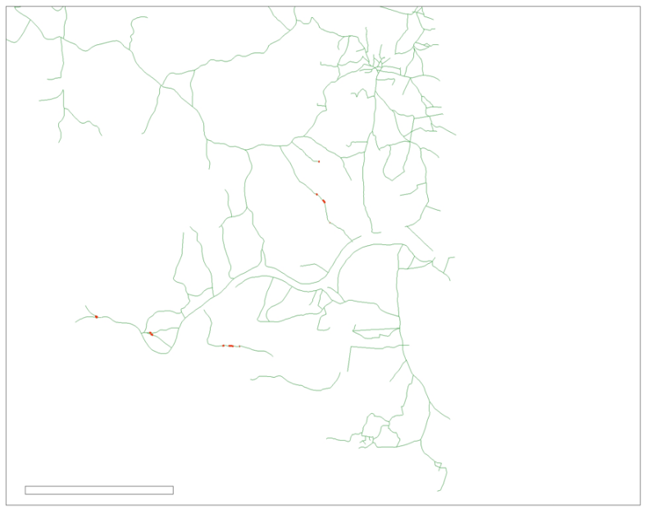

2

Miles

N

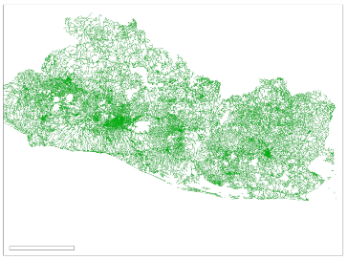

30

Miles

Compromised Roads

Roads

*Figure B1.* This shows compromised roads in El Salvador on October 29, 2017, due to flooding.

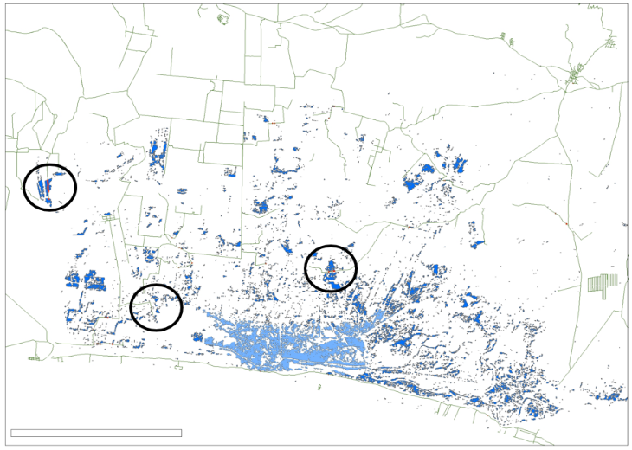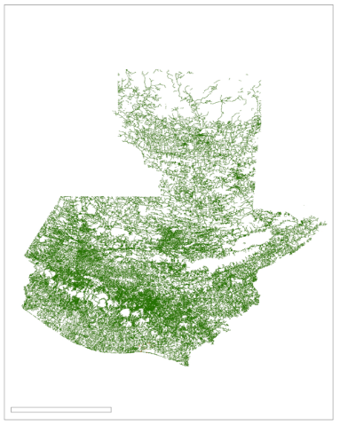

Miles

N

N

90

Miles

5.5

Compromised Roads

Roads

Roads

*Figure B2.* This shows compromised roads in Guatemala on May 31, 2010, as a result of flooding caused by Hurricane Agatha.

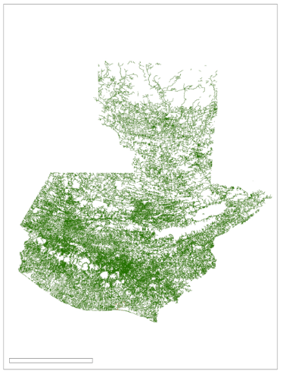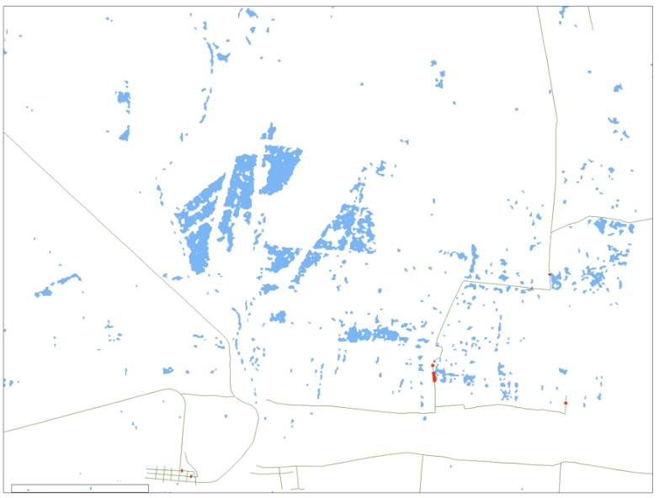

Miles

N

1

90

Miles

Compromised Roads

Roads

*Figure B3.* This shows compromised roads in Guatemala on September 29, 2017, due to flooding.