**NASA DEVELOP National Program**



International Research Institute for Climate and Society

*Spring 2016*

Uruguay Agriculture III

Deconstructing a Drought Severity Index Based on NASA Earth Observations into Principle Components for Better End-User Assessment of the Driving Factors Behind Local Scale Drought

 **Technical Report**

Final Draft – Mar 31, 2016

Jerrod Lessel (Project Lead)

Andrew Kruczkiewicz

Pietro Ceccato, The International Research Institute for Climate and Society, The Earth Institute, Columbia University (Science Advisor)

Previous Contributors:

Alex Sweeney

# I. Abstract

The importance of monitoring drought is indispensable for Uruguay whose economic viability is strongly tied to agriculture and whose energy sector relyies heavily on hydroelectric power. As such, the development of a remotely sensed drought-monitoring tool that can aid government agencies in disseminating drought information to local stakeholders will be helpful in sustaining these important economic sectors. This third and final term of the Uruguay Agriculture project sought to create new visualization techniques for end-users at the Instituto Nacional de Investigacion Agropecuaria (INIA) to view the principle components of the drought severity index (DSI) that was created over the previous two terms of the project. The DSI uses remotely sensed products and is based off of the methodology from Rhee et al. (2010). It uses the climatological anomalies of NASA’s Moderate Resolution Imaging Spectrometer (MODIS) daytime land surface temperature (LST) data, precipitation data from the Climate Prediction Center Morphing Technique (CMORPH), and MODIS Normalized Difference Water Index (NDWI) data. This term investigated the usefulness of creating different methods of presenting the components of the DSI in order to better inform end-users of how the drought is affecting their specific region of interest. The method which proved the most useful was to display the time series for each component within the DSI. This gave a reasonable visualization of how each parameter affects the drought on a local scale while also indicating whether or not there is resilience in the vegetation even during periods of drought. A new color scheme for the maps was also employed in order to address the end-user concerns of the maps appearing to show more extreme drought conditions than was actually occurring. This new color scheme matched that of the percent available water maps which had been previously used by the end-users as the best method with which to monitor drought. This modified DSI has the potential to aid INIA and the Ministry of Agriculture of Uruguay in informing land managers, insurance providers, and policy makers in drought preparation and mitigation practices.

**Keywords**

Drought, Remote Sensing, CMORPH, LST, NDWI, Monitoring, Drought Index

# II. Introduction

The importance of monitoring drought is indispensable for countries whose economic viability is strongly tied to agriculture. Uruguay is such a country. In 2009 the country lost an estimated $400 to $450 million USD due to a several months long drought (MercoPress, 2009). Moreover, a good proportion of Uruguay’s energy power is produced form hydroelectric sources, which are highly sensitive to drought conditions (MercoPress, 2009). During the late 1980’s drought reduced the output of hydroelectric power by so much that the country had to resort to the more expensive option of importing petroleum and adopting strict energy conservation efforts to keep up with the country’s energy demands (National Drought Mitigation Center, 2013). Therefore, decision support tools that specifically address response strategies to drought will become increasingly useful to farmers, insurance providers, and policy makers as they deal with an even more volatile climate in the future.

The preceding terms for this project created a Drought Severity Index (DSI) tool based on the methodology of Rhee et al. (2010). The DSI uses the climatological anomalies of NASA’s Moderate-Resolution Imaging Spectrometer (MODIS) daytime land surface temperature (LST) data, precipitation data from the Climate Prediction Center’s Morphing Technique (CMORPH), and MODIS Normalized Difference Water Index (NDWI) data. In order to validate the DSI data, it was compared to percent available water (PAW) data from a soil water balance (SWB) model provided by the Instituto Nacional de Investigación Agropecuaria (INIA). The end result of the project produced the following index for drought monitoring to be used within Uruguay:

(1/4) *scaled LST-a* + (1/2) *scaled CMORPH-a* + (1/4) *scaled NDWI-a*. (1)

The SWB model data are generated from three parameters: 1) effective rainfall, which is calculated by deducting rainfall recorded at 84 meteorological stations, from a value of surface runoff estimate based on antecedent rain from 5 days earlier, 2) potential evapotranspiration, which is a physical model based on the daily values of temperature, air humidity, wind speed, and solar radiation using the Penman-Monteith method, and 3) water holding capacity defined by the Charter Soil Survey of Uruguay at 1:1,000,000 scale (INIA, 2015).

While the DSI has proved useful to the end-users in the country, they have also expressed concerns with DSI. One concern is that it seems that the DSI maps show more intense drought than had occurred in the country. Another concern from the end-users was that they were not able to assess the level to which the parameters of the DSI (precipitation, LST, and NDWI) were impacting the drought in their local area. For this concern, we decided to research the feasibility of implementing a ternary diagram of the DSI components so that it would be easy to distinguish the drivers of the drought in their local area. This work falls under the NASA National Application Area of agriculture as the new modified DSI has the potential to aid INIA and the Ministry of Agriculture of Uruguay to better inform land managers, farmers, insurance providers, and policy makers in drought preparation decisions and mitigation practices.

# III. Methodology

The DSI is computed within the International Research Institute for Climate and Society’s (IRI) data library and is based on the methodology presented in Rhee et al. (2010) for their CI2 model, which gives a general coefficient scheme as follows:

(1/4) scaled *LST* + (1/2) scaled *Precipitation* + (1/4) scaled *Vegetation Index*.           (2)

This coefficient scheme was shown by Rhee et al. (2010) to be the best in both arid and humid environments and was shown in the previous term (Fall 2013) as the best scheme for Uruguay. We therefore did not adjust the coefficient scheme for the DSI, but we substituted a different precipitation source (NOAA’s CMORPH) in place of NASA’s Tropical Rainfall Measuring Mission (TRMM) and calculated the climatological anomalies for each component within the DSI (LST, precipitation, and vegetation indices). The scaling of each component within the DSI was done in order to create an index which operates between 0 and 1 and is calculated by the formulas shown in table 1.

|  |  |
| --- | --- |
| **DSI parameter** | **Formula** |
| **scaled LST-a** | (LSTmax – LST)/(LSTmax – LSTmin) |
| **scaled CMORPH-a** | (CMORPH – CMORPHmin)/(CMORPHmax – CMORPHmin) |
| **scaled NDWI-a** | (NDWI – NDWImin)/(NDWImax – NDWImin) |

**Table 1:** Formulas used for scaling the various parameters found within the DSI (modified from Rhee et al., 2010). The variables within the formulas (LST, CMORPH, and NDWI) are the climatological anomaly for the respective variable, with the max and min subscript denoting the maximum and minimum monthly climatological anomaly over the study period.

The first issue we sought to address was that the DSI appeared to be overestimating the severity of drought in its map interface, leading to the perception that the drought had affected larger regions of the country and to a greater degree. In order to address this concern, we first looked at the way in which the precipitation parameter was being scaled. Scaling the precipitation parameter using the maximum climatological anomaly (CMORPHmax) appears to give a skewed distribution of the CMORPH data towards < 0 with outliers towards the max and a total range between approximately -7 mm/day for the minimum and 25 mm/day for the maximum. This is different from the LST and NDWI parameters which have a normal distribution centered approximately at 0 with approximate ranges of -8 °C to 8 °C for LST and -0.75 and 0.63 for NDWI. It’s possible that due to the CMORPH data being skewed towards lower numbers because of the outliers in the maximum range, the total DSI itself could be forced to produce lower numbers, which in the case of the DSI would show as a more severe drought environment.

To address this concern we attempted to counteract the maximum outlier effects by changing the scaling formula for the CMORPH data from that shown in table 1 to the following equation:

(CMORPH – CMORPHmin)/(( – CMORPHmin)– CMORPHmin) (3)

In equation (3) we replaced the maximum CMORPH anomaly value by the negative minimum CMORPH anomaly value. This in turn normalizes the CMORPH anomaly values. After applying this change to the DSI we again chose to statistically analyze how well the new DSI correlated with the PAW data.

The second issue was giving the DSI the ability to show how the individual components of the DSI are affecting the overall output of the DSI on a per pixel basis. For example, if the DSI over a specific region of interest output a value of 0.25 (severe drought), how much of that is being driven by the precipitation component and how much of a role does the vegetation index play? This could be useful for end-users as it may indicate areas where, even if precipitation has been lacking, the resilience of specific vegetation types may be such that they are not prone to drought conditions as much as other vegetation types. This would aid in allocation of emergency resources in a more informed manner. To tackle this problem, we created a series of ternary diagrams such as that presented in figure 1. Using these diagrams, the end user would be able to select a region of interest on the DSI map and a ternary diagram would show the main driver of the drought severity for the given area as well as show the other components role in the drought.

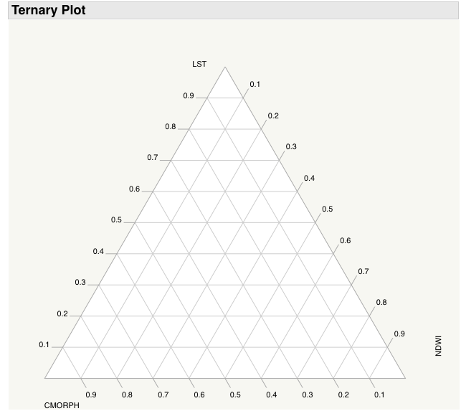

**Figure 1.** General ternary diagram showing the different components of the DSI.

Creating the ternary diagrams is accomplished by individually extracting each component in the DSI and placing its value on the diagram. Since the DSI is normalized between 1 and 0 it gives an accurate representation of how the components are driving the overall value of the DSI. Following the creation of the diagrams we investigated the outcomes of the diagrams and how they can be interpreted by the end-users. Specifically, with respect to how the roles of NDWI and precipitation play into the overall outcome of the DSI during times of drought.

# IV. Results & Discussion

*I. New Scaling Method*

When the new scaling method was applied to the DSI, statistical analysis showed that the original scaling method was in fact more accurate. Table 2 shows the correlation values between the percent available water data and the new scaling method (CMORPH (-min)) and the original scaling method (CMORPH (max)).

|  |  |  |  |  |  |  |  |  |  |  |  |  |
| --- | --- | --- | --- | --- | --- | --- | --- | --- | --- | --- | --- | --- |
|  | **January** | **February** | **March** | **April** | **May** | **June** | **July** | **August** | **September** | **October** | **November** | **December** |
| CMORPH (-min) | 0.711 | 0.793 | 0.736 | 0.610 | 0.647 | 0.245 | **0.489** | 0.392 | 0.426 | 0.729 | 0.753 | 0.838 |
| CMORPH (max) | **0.780** | **0.817** | **0.792** | **0.723** | **0.723** | **0.264** | 0.456 | **0.404** | **0.444** | **0.749** | **0.798** | **0.875** |

**Table 2:** Correlation values between the percent available water data and the DSI using the different scaling methods. Bolded values indicate which method yielded a higher correlation value with the percent available water data.

Table 2 shows that for 11 out of the 12 months analyzed the percent available water data was more correlated with the original DSI scaling method and not that of the new scaling method. These results indicate that it would in fact not be practical to change the scaling method of the DSI.

After these results were relayed to the project partners another suggestion was made. Some of the concern with the overestimation of the severity of the droughts could in fact be due to the color scheme of the DSI (Figure 2). One way to remedy this problem was to have the DSI color scheme match that of the percent available water map color scheme (Figure 3).

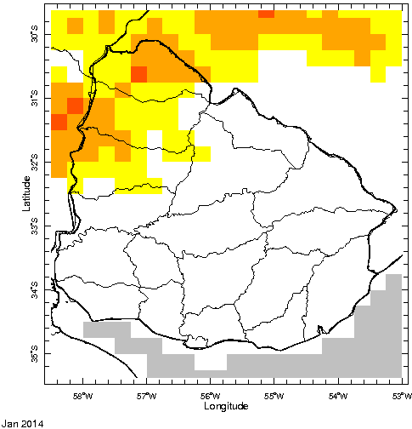

**Figure 2.** An example map of the original color scheme for the DSI showing data from January 2014.

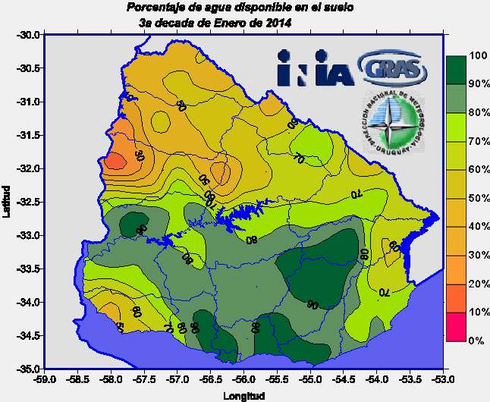 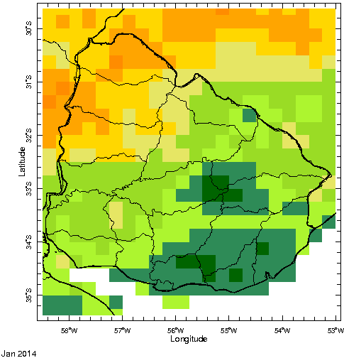

**Figure 3.** An example map of the percent available water provided by INIA, showing the color scheme for the data (left). A corresponding example map of the DSI using the same color scheme as the percent available water data (right). Both maps show data for January 2014.

This new color scheme for the DSI is more familiar to the end-users of the DSI as well as showing a more gradual change from areas which are not currently affected by drought to those that are.

*II. Visualization of Components for the DSI*

The visualization of the DSI components into ternary diagrams did not prove an effective method for the end product. When components were plotted onto a ternary diagram there was a lack of an emergent pattern within the ternary diagram due to the normalization method used to create the ternary diagram (Figure 4).

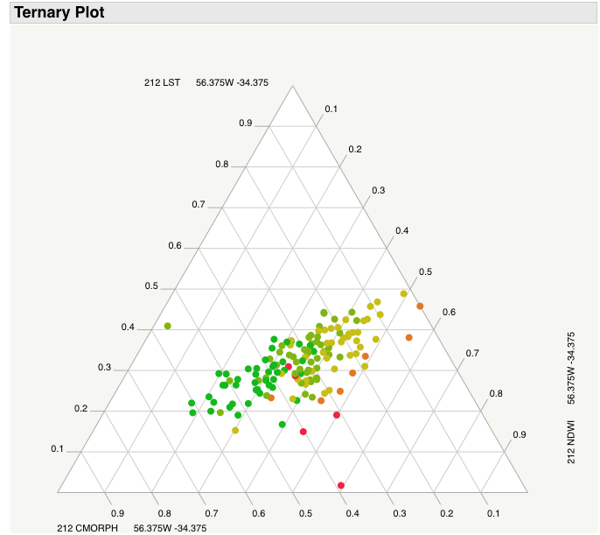

**Figure 4.** An example of a ternary diagram showing all monthly DSI values for a single pixel over the study period.

Since the ternary plot normalizes the values of the DSI to a percent of the sum of the three values, it’s possible for values representing extreme drought to be in the same portion of the ternary diagram as an area with no drought at all. This would not prove useful for end-users as the primary driver of the drought is not apparent and it is unclear how dominant the primary driver is.

A better solution for visualizing the components of the DSI is to display the time series for each component showing the history of that component for the past year (Figure 5). This not only gives a good visual representation of the components within the DSI, but it also shows how the component changed over the past year. This could give valuable information about the various components, especially how the NDWI component reacts to varying degrees of precipitation or LST. If the vegetation shows periods of resilience to drought it should be apparent in the time series for the NDWI compared to both the LST and precipitation parameters.

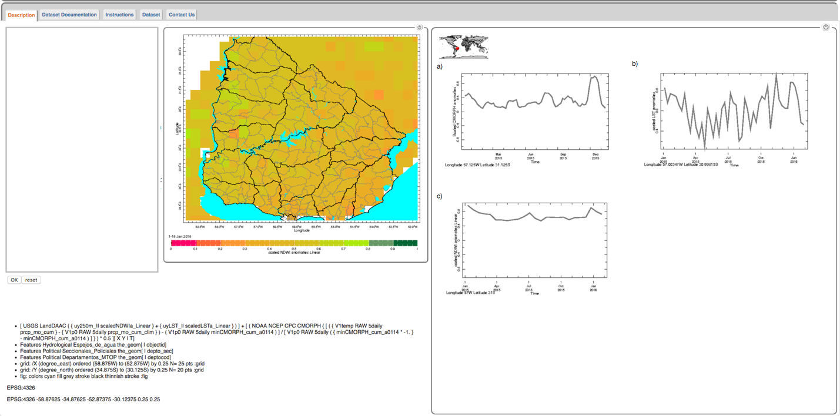

**Figure 5.** Screenshot of the DSI map with corresponding

visualization of components for a single pixel.

# V. Conclusions

In conclusion, the original scaling method was more correlated to the percent available water data than the new method. As such, to address the concern of overestimation of the drought severity with the DSI, a color scheme was chosen to match the current color scheme for maps of percent available water data. This new color scheme is more familiar to the end-users of the DSI as well as showing a more gradual change from areas which are not currently affected by drought to those that are more affected.

With respect to the visualization of the DSI components, it was shown that the ternary diagram was not the most effective method for presenting the DSI components. This is due to the normalization of the components to display them within the ternary diagram. Instead of using a ternary diagram to visualize the components of the DSI, it was decided that the best way to visualize the components was with the use of a time series plot for each component. This not only gives a good visual representation of the components within the DSI but it also shows how the component changed over the past year, which gives valuable information about the various components. The new DSI tool with the updated color scheme and component visualizations has the potential to aid INIA and the Ministry of Agriculture of Uruguay to better inform land managers, farmers, insurance providers, and policy makers in drought preparation decisions and mitigation practices.

# VI. Acknowledgments

Special thank you to Dr. Pietro Ceccato for his help and dedication to being a great mentor and science advisor. Thank you to Guadalupe Tiscornia of the Instituto National de Investigación Agropecuaria (INIA), Uruguay and Ministry of Agriculture. Additionally, a special thank you to Dr. Walter Baethgen for his assistance and expertise on this project and to our past contributor Alex Sweeney.

Any opinions, findings, and conclusions or recommendations expressed in this material are those of the author(s) and do not necessarily reflect the views of the National Aeronautics and Space Administration.

This material is based upon work supported by NASA through contract NNL11AA00B and cooperative agreement NNX14AB60A.

# VII. References

Instituto Nacional de Investigación Agropecuaria (INIA) (2015), retrieved on January 29, 2015 from: http://www.inia.uy/investigaci%C3%B3n-e-innovaci%C3%B3n/unidades/GRAS/Monitoreo-Ambiental/Balance-H%C3%ADdrico/Balance-h%C3%ADdrico-suelos-Uruguay

MercoPress (March 20, 2009), retrieved on November 24, 2014 from: http://en.mercopress.com/2009/03/20/uruguays-preliminary-farm-losses-to-drought-estimated-in-450-million-usd

National Drought Mitigation Center (2013), retrieved on November 24, 2014 from: http://drought.unl.edu/DroughtBasics/TypesofDrought.aspx

Rhee, J., Im, J., & Carbone, G. J. (2010). Monitoring agricultural drought for arid and humid regions using multi-sensor remote sensing data. Remote Sensing of Environment, 114(12), 2875-2887.

# VIII. Content Innovation

1. 2016Spring_IRI_UruguayAgIII_Glossary
2. 2016Sprng_IRI_UruguayAgIII_VPS_FD