NASA DEVELOP National Program
USGS at Colorado State University
Fall 2016

Ethiopia Disasters
Utilizing NASA Earth Observations to Assess Agricultural Drought Severity in Ethiopia and Provide a Tool for Monitoring Drought at the Regional Level


Technical Report
Final Draft – November 17, 2016

Amandeep Vashisht (Project Lead)
Sarah Carroll
Bethlehem Astella
Rebecca Girma
Cara Steger

Dr. Paul Evangelista, Natural Resource Ecology Lab, Colorado State University (Science Advisor)
Dr. Amanda West, Natural Resource Ecology Lab, Colorado State University (Science Advisor)
Brian Woodward, NASA DEVELOP, USGS at Colorado State University (Center Lead)

1. Abstract
Ethiopia has recently been affected by several droughts, with the latest 2015 drought being the worst in half a century. Agriculture, being the predominant sector of the country’s economy, is rain-fed and is therefore very susceptible to droughts. Developing a reliable remotely sensed tool that incorporates a combination of drought-related parameters can help in better detection of drought events with respect to their spatiotemporal extent, duration and severity. This project implemented a scaled drought index utilizing NASA’s Terra Moderate Resolution Imaging Spectroradiometer (MODIS), Tropical Rainfall Measuring Mission (TRMM) and Global Precipitation Measurement (GPM) Integrated Multi-satellite Retrievals for GPM (IMERG) data to assess drought at a regional scale over the last 10 years. The index maps and decision support tools were provided to the project partners to supply timely information for humanitarian aid, and to build their capacity to monitor droughts in the future.
Keywords
Drought Index, agriculture, remote sensing, MODIS, CHIRPS, Normalized Difference Vegetation Index (NDVI), Land Surface Temperature (LST)

2. Introduction

  - Background Information
Drought is recognized as an environmental disaster, mostly related to a reduction in the amount of precipitation received over an extended period of time such as a season or a year (Mishra & Singh, 2010). It can affect agriculture and ecosystems across diverse geographical and temporal scales. Agricultural drought relates to insufficient water to meet the needs of crop production (Hao and Singh, 2015).

Ethiopia is often portrayed as a drought-stricken country both in the media and the scientific literature (McCann, 1990; Viste et al. 2013). Drought impacts are particularly pronounced because the economy of the country relies predominantly on rain-fed agriculture (Tadesse et al., 2015). The country has a diverse climate, with mean annual precipitation as high as 2,000 mm in some parts of the highlands and as low as 300 mm in the arid and semi-arid lowlands. This spatial variation, along with the strong seasonality of precipitation over different areas, makes it difficult to analyze drought trends. The spatial patterns of drought also vary from year to year (Viste et al., 2013).

Droughts are related to climate variations like El Niño Southern Oscillation (ENSO) and Pacific Decadal Oscillation (PDO) (Mishra and Singh, 2010). Four out of nine historical droughts from 1986-2013 were associated with El Niño including the worst drought in the last half-century, in 2015. (USAID AKLDP, 2015). It was observed that the El Niño episode in 2015 caused a delayed onset of the long rainy season (hereafter referred to as kiremt) rains from May to September (USAID AKLDP, 2015). The onset, withdrawal, magnitude, and distribution of kiremt rains has a significant impact on crop production. This is because the main growing season, known as meher, relies on kiremt rains and accounts for 90-95% of the annual crop production in the country (FAO, 2014; Evangelista et al., 2013; Seifu et al., 2004; FEWSNET, 2003). The short rainy season (belg) from February- April does not coincide with meher, and therefore does not have a significant impact on agricultural productivity.

In order to effectively direct response efforts and humanitarian aid, reliable and timely information on duration, location, and severity of drought is needed. A drought index is a tool for assessing the effect of drought that provides a metric for evaluating drought characteristics (Mishra & Singh, 2010).Combining remote sensing, numerical modelling, and geographic information systems to develop drought indices is considered to be a comprehensive method of climate and drought monitoring (Verdin et al., 2005). A number of drought indices have been developed, each with their own strengths and limitations for varying spatio-temporal scales. Due to complexity of drought and its impacts, an adequate drought characterization necessitates a combination of different drought-related parameters or variables that are integrated to form a composite drought index (Hao and Singh, 2015). Composite drought indices developed in the recent past including the Microwave Integrated Drought Index (MIDI; Zhang and Jia, 2013), Scaled Drought Condition Index (SDCI; Rhee et al., 2010), Multivariate Standardized Drought Index (MSDI; Hao and AghaKouchak, 2013) have addressed this issue.

2.2 Project Partners & Objectives
The Ethiopia Disasters team collaborated with multiple partners including the US Department of State Office of Space and Advanced Technology (OES/SAT) and Humanitarian Information Unit (HIU), the Institute of Geo-Information and Earth Observation Sciences (I-GEOS) at Mekelle University, and the United States Geological Survey (USGS) North Central Climate Science Center (NCCSC). The OES/SAT and HIU frequently incorporate satellite imagery in their decision making, and have emphasized the need for an effective drought assessment tool to identify areas of severe drought impact so that humanitarian aid may be allocated accordingly. I-GEOS has not used NASA Earth observations for drought assessment in the past, but recognizes the need to incorporate remote sensing technology in staff/student training so that the organization can independently monitor future droughts. The project collaboration with the USGS NCCSC revealed the need for a drought assessment tool at a regional scale. This collaboration helped in working towards the common goal of effectively utilizing NASA Earth Observations for drought characterization and analysis.

This project sought to increase available information on the extent and severity of drought in Ethiopia by creating a drought monitoring tool and classifying drought conditions at a regional scale utilizing satellite based remote-sensing methods. To address our project partners’ needs, the team developed a scaled drought index for north-central Ethiopia that covers a 10-year time period and analyzed drought severity and impact over agricultural areas in the study area. Furthermore, we created tutorials detailing the project’s methods to enable our partners at I-GEOS to effectively monitor droughts by building their capacity to utilize remote sensing and GIS techniques.

  - Study Area and Study Period
This project focused on the southern Amhara, northern Oromia, and eastern parts of Beneshangul-Gumuz regions, covering approximately 120,000 km² (Figure 1). These regions are predominantly comprised of agrarian communities practicing traditional farming of crops and livestock, and shifting cultivation. Elevation in the study area ranges from approximately 900 to 3,000 m. The study period was from January 2006 to August 2016.

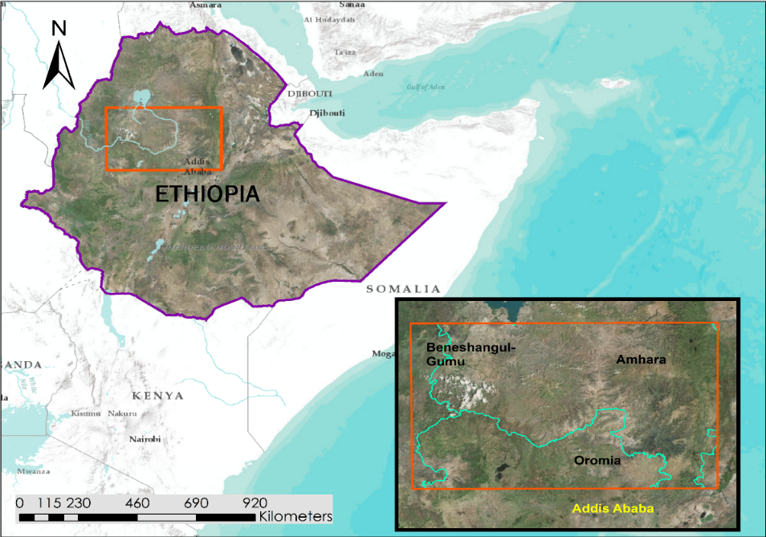
Ethiopia Boundary
Study Area Boundary
Regional Boundary
Figure 1. Study area map displaying study area in north-central Ethiopia.
3. Methodology

3.1 Data Acquisition
To identify regions in Ethiopia experiencing severe drought and food insecurity due to crop failures, we accessed the USGS (United States Geological Survey) Famine Early Warning Systems Network (FEWSNET, 2014) data portal and downloaded the monthly evapotranspiration anomaly data product for continental Africa.

MODIS imagery from the Aqua and Terra satellites were visualized, restricted to the study area, and downloaded using Google Earth Engine (GEE) Code Editor Platform (Table 1). We specified the MODIS Combined 16- day Global, Level-3 NDVI (Normalized Difference Vegetation Index) composite (250 m resolution) and Global, Level-3 8-day LST (Land Surface Temperature) composite (1 km resolution) data products. Two to four composite images for each month from 2006-2016 were exported from GEE for a total of nearly 1,000 images for the study area.

Precipitation data were accessed at the Climate Hazards Group website, where we downloaded the Climate Hazards Group Infrared Precipitation with Stations (CHIRPS; Funk et al., 2015) total monthly precipitation data product (approximately 5 km resolution) calibrated with TRMM Multi-satellite Precipitation Analysis data product (version 7) for the continent of Africa for each year from 2006-2016. Soil Moisture data from the NASA’s SMAP satellite were accessed through the Earth Observing System Data and Information System’s (EOSDIS) Reverb metadata and service discovery tool. The SMAP L4 Radiometer Half-Orbit EASE-Grid Surface and Root Zone Soil Moisture Analysis, Version-2 (9 km resolution) data product was selected for April – December 2015. Annual crop yield data at the regional state administrative level were acquired from the Central Statistical Agency of Ethiopia for the state of Amhara for all available years (CSA, 2014).

Satellites and Sensors | Source | Data Product
Terra Moderate Resolution Imaging Spectroradiometer (MODIS) | United States Geological Survey (USGS) | Land Surface Temperature (LST), Normalized Difference Vegetation Index (NDVI)
Aqua MODIS | USGS | LST, NDVI
Tropical Rainfall Measuring Mission (TRMM) and Global Precipitation Measurement (GPM) | Climate Hazards Group InfraRed Precipitation with Station data (CHIRPS) | Precipitation
Soil Moisture Active Passive (SMAP) | National Snow and Ice Data Center (NSIDC) | Land Surface Soil Moisture
Table 1. Primary Earth Observations, data sources, and selected data products.

3.2 Data Processing
To determine our study area, FEWSNET evapotranspiration anomaly products from 2015 were aggregated. Areas that showed highest positive anomalies (highest evapotranspiration deficit) across agricultural areas as classified by NASA SERVIR’s Land Cover classification map for Ethiopia were chosen as the focus of this study. Preliminary processing of the imagery acquired for the chosen study area involved projecting it to a common projection of WGS 84/ UTM Zone 37 N. Both the NDVI and CHIRPS datasets were resampled to match the 1 km resolution of the LST data.

The NDVI, LST, and Precipitation (Ppt) data from 2006-2016 were aggregated to obtain average monthly rasters. Each dataset was processed separately to first obtain monthly minimum and maximum rasters for each month over 10 years (2006-2015). Month-wise, all rasters from 2006-2016 were then temporally scaled, as in Kogan et al. (1993), using the following equations:

$NDVI_{scaled}=\frac{(NDVI-{NDVI}_{min} )}{({NDVI}_{max}- {NDVI}_{min})}$ (1)

$LST_{scaled}= \frac{({LST}_{max}-LST)}{({LST}_{max}- {LST}_{min})}$ (2)
$Ppt_{scaled}= \frac{(Ppt-{Ppt}_{min})}{({Ppt}_{max}- {Ppt}_{min})}$ (3)
The temporal scaling of each month was done to enable detection of the long-term (10-year) drought index variations for each pixel. The range of the monthly scaled data from 2006-2015 ranged from 0 to 1, with 0 representing the wettest and 1 representing the driest monthly value for each parameter over the 10-year period. The three datasets were weighted and combined following Rhee et al. (2010) to derive a monthly, scaled drought index as shown below:

$Scaled Drought Index=(\frac{1}{4})\left(NDVI_{scaled}\right)+(\frac{2}{4})\left(Ppt_{scaled}\right)+(\frac{1}{4})(LST_{scaled})$ (4)
Since data from 2016 did not cover the entire year (data was available from January to August at the time of this project), 2016 was not included in the 2006-2015 baseline (from which minimum and maximum rasters were obtained). Because of this, the scaled parameters (NDVI, LST, Ppt) for 2016 were outside of the 0 to 1 range- with less than zero (negative) values for all parameters representing wetter and more than one values for all parameters representing drier conditions than the last 10-years. Because the scaled drought index is a weighted linear summation, all values in each of the scaled parameters (for 2016) below zero were set equal to zero, and all values above one were set equal to one to determine monthly scaled drought indices. This was done to compare the monthly drought indices of 2016 with the previous years on the same scale, albeit we note that doing this hides the true drier- and wetter- than baseline characterizations.

3.3 Data Analysis
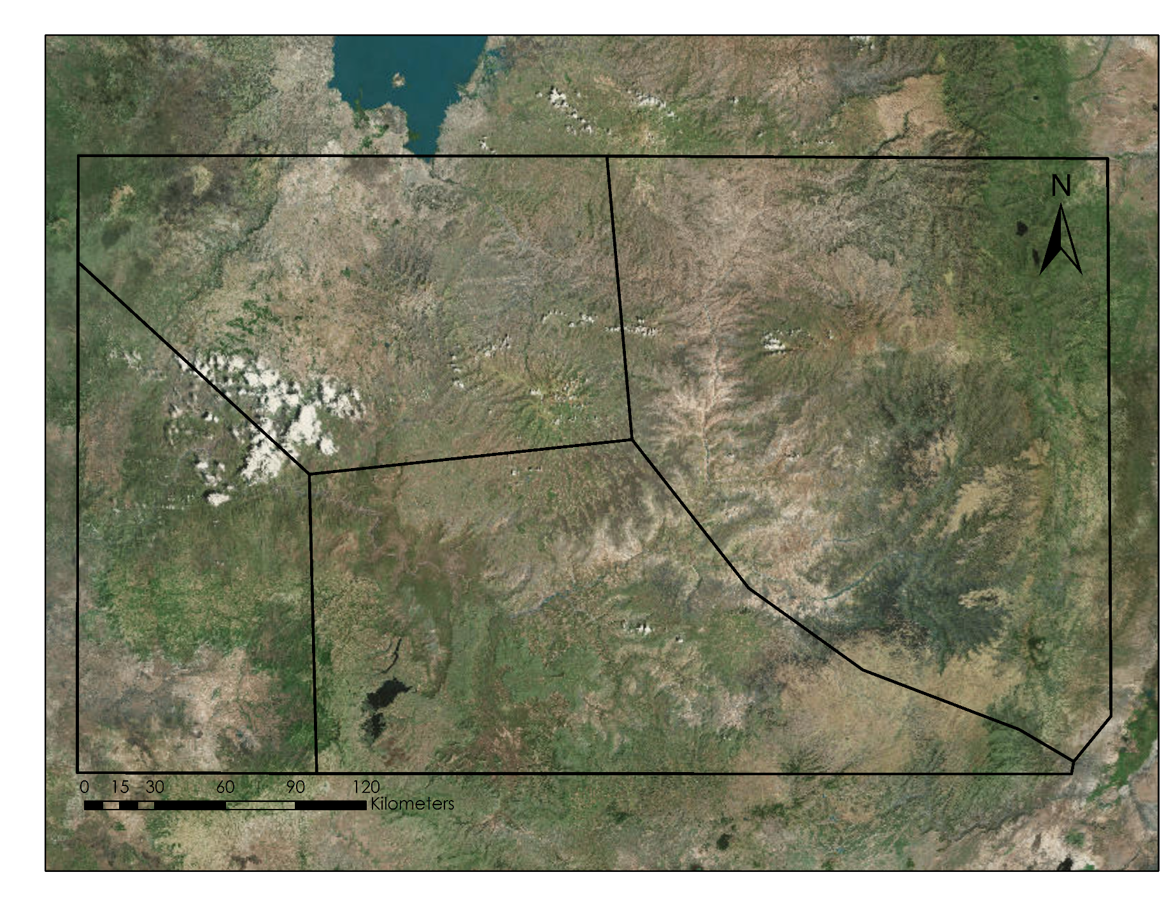
An annual drought index for the meher growing season (May-December) was calculated for each year from 2006-2016 to perform an inter-annual drought index comparison. To maintain a spatially consistent analysis over time, the study area was divided into four nearly homogenous climatic zones: (I) Northwest (NW) Highlands, (II) Northeast (NE) Highlands, (III) Southwest (SW) Rainforest, and (IV) Central Highlands (Viste et al. 2013; Figure 2). These zones primarily account for spatial variation in precipitation across the study area.
II
I
III
IV

The annual drought index for each year was then classified into a scale of drought severity based on the classification schemes defined in Bhuiyan et al. (2006) and Du et al. (2013), and shown below (Table 2):
Figure 2. The four climatic zones dividing the study area.

Drought class | Drought Index Value
Extreme drought | < 0.2
Severe drought | 0.2 - 0.3
Moderate drought | 0.3 - 0.4
Abnormal dry | 0.4 - 0.5
No drought | > 0.5
Table 2. Drought Index Classification

The accuracy of drought indices cannot be directly evaluated with ground measurements of drought observations. Comparing drought index values to other indices and drought parameters is a common method of indirect validation (Hao and Singh, 2015). Additionally, a qualitative comparison of main drought events reported is another way of validating a drought index (Hao and Singh, 2015). To investigate drought impacts on agriculture, we explored a linear regression of regional crop yield data with the scaled drought index produced in this study (CSA, 2014). However, this regression resulted in erroneous results. This was most likely because unlike the crop yield data, our study area did not completely cover any regional state and this created inconsistent spatial extent between the two variables. Next, we sought to compare our drought index values to soil moisture: a drought indicator that directly impacts agricultural productivity. The comparison revealed that the trends in scaled soil moisture and scaled drought index values were similar for the main growing season of 2015 (Figure 3).
Figure 3. Comparison of drought index and surface soil moisture across climate zones from May-Dec in 2015.

Drought Index and Soil Moisture Comparison

Southwest Rainforest
Northwest Highlands
Central Highlands
Northeast Highlands

Figure 3. Drought index comparison with SMAP soil moisture for 2015

4. Results & Discussion

4.1 Analysis of Results
Analysis of the time-series of mean annual drought index across the four climatic zones, as seen in Figure 4, revealed that the spatial patterns of drought vary significantly with time. This is because the spatial drought patterns largely reflect the variation in seasonal precipitation due to Intertropical Convergence Zone (ITZC) (Viste et al., 2013). We observed that the annual drought (for the meher season) was most prominent in NW Highlands and SW Rainforest in 2009, and in NE Highlands and Central Highlands in
Figure 4. Mean Seasonal drought index from 2006 – 2015 by climate zone.
2015. Both 2009 and 2015 droughts were associated with the occurrence of El-Nino events (NOAA, 2015), and 2011 and 2012 brought abnormally dry conditions in SW Rainforest, and Central and NE Highlands. It is important to note that drought variations did not always distinctly adhere to the boundaries of the nearly-homogenous climatic zones used in this study. This is likely because the zones were primarily based on precipitation, which is often difficult to characterize due to orographic effects in mountainous highlands with high relief, combined with limited availability of in-situ gauged data (Simane et al., 2013).

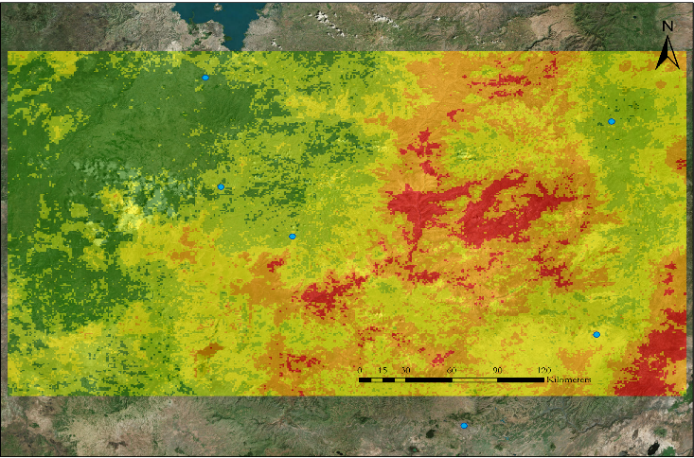
The classification of drought severity provides a readily interpretable visualization of drought conditions in the study area (Figure 5). This classification map showed that severe to extreme drought conditions occurred in north central and eastern parts of the country, in agreeance FEWSNET report (USAID FEWSNET, 2015). However, drought severity alone is insufficient for a comprehensive drought characterization because it does not provide quantitative information on spatial extent that is usually necessary for humanitarian aid distribution.
Finote Selam
Bahir Dar
Debre Birhan
Addis Ababa
Dese
Extreme drought
Severe drought
Moderate drought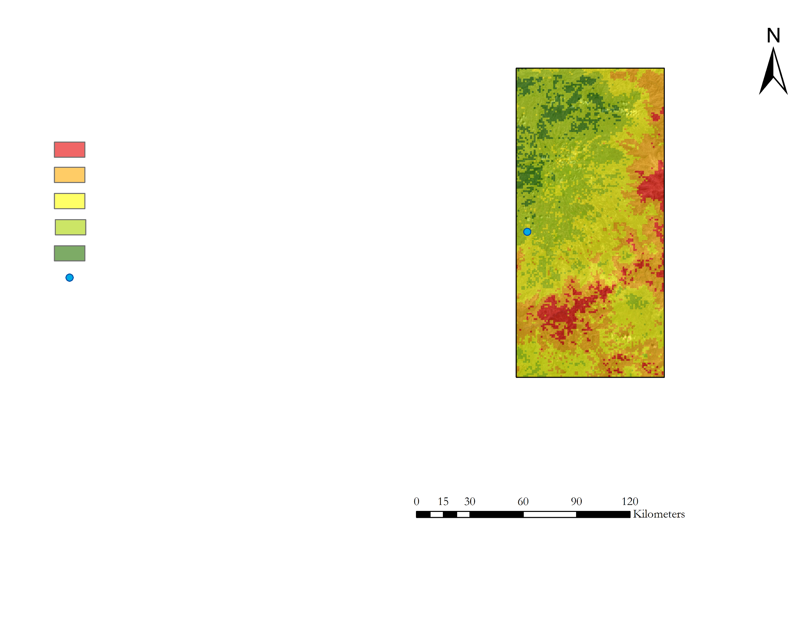
Abnormally dry
No drought
Debre Mark’os
No drought
Cities
Figure 5. 2015 drought classification map.
To address the need for information on
drought extent, we quantified areas under
extreme to severe drought (mean annual drought index <0.3). This area for each of the climatic zones over the study period is shown in Figure 6. While the severity of both 2009 and 2015 droughts were very similar (Figure 4), the 2015 drought event was worse because it affected a greater spatial extent (23,037 sq. km for 2009 and 31,435 sq. km for 2015 in our study area). As is also seen in Figure 6, there is another distinct difference between the prominent droughts. In 2015 drought impacts were intense but affected only two climatic zones (NE Highlands and Central Highlands), whereas in 2009 the
Figure 6. Area under severe – extreme drought for each year by climatic zone.
drought was more widespread. The latter drought affected the NW Highlands and SW Rainforest the most, and also affected NE Highlands and Central Highlands to a smaller spatial extent. This is likely due to the fact that in 2009 precipitation was suppressed in both the main kiremt rains and belg rains (Viste et al., 2013).

The 2009 drought was observed to have largely impacted the NW Highlands and SW Rainforest zones and so we conducted a monthly analysis for these areas to determine the duration of the drought in 2009. Figures 7a and 7b show the mean monthly drought index for NW Highlands and SW Rainforest, respectively. Similarly, for 2015 and following into 2016, the monthly drought index value for the NE Highlands and Central Highlands is shown in figure 8a and 8b. From the beginning of 2009, the drought index is low (meaning high drought severity) for both NW Highlands and SW Rainforest. Both of these zones were affected quite similarly, with “no drought” conditions (mean monthly drought index>0.5) during February and October in NW Highlands; and during February, October, and August in SW Rainforest. Both regions faced extreme drought in the month of May, perhaps due to accumulated stress from failure of belg rains which usually last from February to May. For the recent 2015-2016 drought, a more prominent drought period occurred from January 2015 through April 2016 with the exception of a short recovery in May of 2015, which could be due to delayed belg rains. Both the zones show similar trends, except from June-August, 2016 (the end of our study period) where the NE Highlands seem to have completely recovered (and even shifted to wetter than baseline conditions), but the Central Highlands are still under minimal-to-low drought conditions.
Figures 8a-b. Mean monthly drought index for the two climatic zones experiencing severe drought in 2015.
Figures 7a-b. Mean Monthly drought index for the two climatic zones experiencing severe drought in 2009.

4.2 Errors and Uncertainties
We encountered some limitations in this work that could have led to minor errors in our results. One potential error could stem from the fact that the weights for each scaled parameter included in the drought index are subjective, and could vary from region to region, and vary with time as well. For example, land temperature could be a better indicator of drought for pre-and post-rainfall time periods, while precipitation could be a better indicator of drought during and immediately after rainfall. Also, a linear combination of the parameters may not be suitable to characterize the covariability of the three drought-related parameters considered, since they may interact with each other stochastically. Slight bias may also exist in our annual drought index because of missing pixels due to clouds during the months of heavy rainfall (July and August months for this study).

4.3 Future Work
Future work should involve utilizing Principal Component Analysis (PCA) and multivariate distributions to distill the information from different drought-related variables, and remove the effect of covariability between the parameters. In addition, because soil moisture provides separate, unique information about drought impacts, a future drought index would also integrate soil moisture in the drought index, after the removal of any superfluous information through a PCA or Kernel Entropy Component Analysis (KECA). The study area should be expanded to the entire country of Ethiopia, and a comprehensive validation would be carried out after carefully considering the spatial extent and availability of crop yield data. Also, spatiotemporal analysis would be done considering not only climatic zones in the country, but also agro-ecological zones for an interdisciplinary ecosystems impact assessment of drought.

5. Conclusions
We successfully utilized NASA Earth Observations and ancillary data to successfully create a drought index over the last 10 years. The drought index enabled us to capture drought severity, spatial extent, and duration of the major drought events, specifically the 2009 and 2015 droughts. The 2015 drought was severe but less widespread spatially than the 2009 drought. In 2016, drought conditions persisted through April and recovery was evident from May – August. The end products produced will provide our partners with necessary information for humanitarian aid distribution. The tutorial we created will assist our partners in Ethiopia with their future drought monitoring efforts.

6. Acknowledgments
Dr. Paul Evangelista (Colorado State University, Natural Resource Ecology Laboratory)
Dr. Amanda West (Colorado State University, Natural Resource Ecology Laboratory)
Brian Woodward (Colorado State University, Natural Resource Ecology Laboratory)
Dr. Gabriel Senay (USGS North Central Climate Center)
Ryan Anderson (Colorado State University, Natural Resource Ecology Laboratory)

Any opinions, findings, and conclusions or recommendations expressed in this material are those of the author(s) and do not necessarily reflect the views of the National Aeronautics and Space Administration.

This material is based upon work supported by NASA through contract NNL11AA00B and cooperative agreement NNX14AB60A.

7. References

AghaKouchak, A., Farahmand, A., Melton, F. S., Teixeira, J., Anderson, M. C., Wardlow, B. D., & Hain, C. R. (2015). Remote sensing of drought: Progress, challenges and opportunities. Reviews of Geophysics, 53(2), 452-480.

Bhuiyan, C., Singh, R. P., & Kogan, F. N. (2006). Monitoring drought dynamics in the Aravalli region (India) using different indices based on ground and remote sensing data. International Journal of Applied Earth Observation and Geoinformation, 8(4), 289-302.

CSA. (2014). Annual Agricultural Sample Survey. Addis Abba, Central Statistical Agency of Ethiopia (CSA). Accessed (10-03-2016) from : https://www.csa.gov.et/index.php

Du, L., Tian, Q., Yu, T., Meng, Q., Jancso, T., Udvardy, P., & Huang, Y. (2013). A comprehensive drought monitoring method integrating MODIS and TRMM data. International Journal of Applied Earth Observation and Geoinformation, 23, 245-253.

Evangelista, P., Young, N., & Burnett, J. (2013). How will climate change spatially affect agriculture production in Ethiopia? Case studies of important cereal crops. Climatic Change, 119(3-4), 855-873.

FAO. (2014). Ethiopia: El Niño-Southern Oscillation (ENSO) and the main Kiremt rainy season. Retrieved from: http://www.fao.org/giews/english/shortnews/enso27062014.htm

FEWSNET. (2014). Famine Early Warning Systems Network, FEWSNET, Accessed (09-27-2016) from http://earlywarning.usgs.gov/fews/

Funk, C., Peterson, P., Landsfeld, M., Pedreros, D., Verdin, J., Shukla, S., ... & Michaelsen, J. (2015). The climate hazards infrared precipitation with stations—a new environmental record for monitoring extremes. Scientific Data, 2. Data accessed (09-27-2016) from: http://chg.geog.ucsb.edu/data/chirps/index.html

Hao, Z., & AghaKouchak, A. (2013). Multivariate standardized drought index: a parametric multi-index model. Advances in Water Resources, 57, 12-18.

Hao, Z., & Singh, V. P. (2015). Drought characterization from a multivariate perspective: A review. Journal of Hydrology, 527, 668-678.

Kogan, F. & Sullivan, J. (1993). Development of global drought-watch system using NOAA/AVHRR data. Advances in Space Research, 13(5), 219-222.

McCann, James C. A great agrarian cycle? Productivity in highland Ethiopia, 1900 to 1987. The Journal of Interdisciplinary History 20.3 (1990): 389-416.

Mishra, Ashok K., and Vijay P. Singh. A review of drought concepts. Journal of Hydrology 391.1 (2010): 202-216.

NOAA. (2015). Retrieved from https://www.climate.gov/maps-data.

Rhee, J., Im, J., & Carbone, G. J. (2010). Monitoring agricultural drought for arid and humid regions using multi-sensor remote sensing data. Remote Sensing of Environment, 114(12), 2875-2887.

Seifu, A. (2004). Rainfall variation and its effect on crop production in Ethiopia (Doctoral dissertation, aau)

Simane, B., Zaitchik, B. F., & Ozdogan, M. (2013). Agroecosystem analysis of the Choke Mountain watersheds, Ethiopia. Sustainability, 5(2), 592-616.

Tadesse, T., Senay, G. B., Berhan, G., Regassa, T., & Beyene, S. (2015). Evaluating a satellite-based seasonal evapotranspiration product and identifying its relationship with other satellite-derived products and crop yield: A case study for Ethiopia. International Journal of Applied Earth Observation and Geoinformation, 40, 39-54.

USAID AKLDP. (2015). El Nino in Ethiopia Uncertainties, Impacts and decision-making. Technical Brief. Retrieved from http://www.agri-learning-ethiopia.org/wp-content/uploads/2015/09/AKLDP-El-Nino-brief-Sept-2015.pdf

USAID FEWSNET. (2015) ETHIOPIA Special Report- Illustrating the extent and severity of the 2015 drought. Retrieved from http://reliefweb.int/sites/reliefweb.int/files/resources/FEWS%20NET_Ethiopia%202015%20Drought%20Map%20Book_20151217.pdf
Viste, E., Korecha, D., & Sorteberg, A. (2013). Recent drought and precipitation tendencies in Ethiopia. Theoretical and Applied Climatology, 112(3-4), 535-551.

Verdin, J., Funk, C., Senay, G., & Choularton, R. (2005). Climate Science and Famine Early Warning. Philosophical Transactions: Biological Sciences, 360(1463), 2155-2168.

Zhang, A., & Jia, G. (2013). Monitoring meteorological drought in semiarid regions using multi-sensor microwave remote sensing data. Remote Sensing of Environment, 134, 12-23.

8. Content Innovation

Content Innovation #1
Glossary Viewer

1. Amhara: One of nine administrative regions of Ethiopia, the Amhara region contains the country’s largest body of water – Lake Tana – which is the source of the Blue Nile River. The human population numbers around 17 million people, predominantly farmers, who are primarily of the Amharic ethnic group and follow the Ethiopian Orthodox religion.
2. Beneshangul-Gumuz: One of nine administrative regions of Ethiopia, the Beneshangul-Gumuz region is challenged by poor transportation and communications infrastructure. The human population numbers around 800,000 people, primarily farmers, who are quite heterogeneous in terms of ethnicity, language, and religion.
3. Climate Hazards Group Infrared Precipitation with Stations (CHIRPS): CHIRPS is a geospatial precipitation estimate that integrates site-specific station data with remote sensing observations to produce an interpolated precipitation surface.
4. Digital Elevation Model (DEM): a digital model or 3D representation of a terrain’s surface created from elevation data.
5. Drought index: A measure of drought severity that is created by integrating multiple drought indicators into a single numerical value. A drought index is useful for decision-makers, as it shows a more comprehensive picture than individually analyzing each drought indicator. There are currently over 15 drought indices.
a. Microwave Integrated Drought Index (MIDI): A multi-sensor microwave measure of drought that integrates data on precipitation, soil moisture, and derived land surface temperature to produce a scaled estimate of drought. It was developed to focus on short-term drought, particularly meteorological drought over semi-arid regions.
b. Palmer Drought Severity Index (PDSI) was the first comprehensive drought indicator, developed in 1965. It integrates data on temperature, precipitation, evaporation, transpiration, soil runoff and soil recharge to produce a (negative) number reflecting the state of drought conditions. It is considered most effective for unirrigated cropland.
c. Scaled Drought Condition Index (SDCI): SDCI integrates data on vegetation productivity (NDVI), land surface temperature, and precipitation to produce a scaled estimate of drought. It was designed for agricultural drought monitoring in both arid and humid regions.
6. Drought: There are four basic definitions of drought: meteorological, hydrological, agricultural, and socioeconomic. The first three consider drought as a physical phenomenon, while the last definition considers it as a supply and demand problem. http://www.livescience.com/21469-drought-definition.html
a. Agricultural drought considers the water needs of crops throughout different stages of the growing season. It considers germination rates, growth rates, and crop yields as indicators of drought, focusing on water shortages from precipitation as well as evapotranspiration and soil water deficits.
b. Hydrological drought is associated with the effects of meteorological drought on surface water (e.g. rivers and reservoirs), which is not immediate and may persist for many months or years after the initial precipitation deficits. These situations can be exacerbated by excessive human withdrawals during hydrological drought.
c. Meteorological drought depends on the baseline conditions of a particular site. When the amount of precipitation is significantly lower than the average for an extended period of time, this can be characterized as drought.
d. Socioeconomic drought is concerned with the temporal and spatial variability of water supply and demand. When these are not balanced, conditions of socioeconomic drought can occur.
7. El Niño-Southern Oscillation (ENSO): ENSO is a naturally occurring phenomenon where fluctuating sea surface temperatures in the equatorial Pacific Ocean produce changes in atmospheric and climatic events throughout the globe over a period of 6 -18 months. Every 2-7 years, warm waters during the ENSO cause increased convection, resulting in drier, warmer weather in East Africa and the Horn of Africa.
8. Evapotranspiration (ET): Evapotranspiration measures the combined evaporation and transpiration from the Earth’s surface, accounting for water movement out of the soil, vegetation, and waterbodies into the atmosphere.
9. Famine Early Warning Systems Network (FEWSNET): FEWSNET is a U.S. research network that provides early warning and analysis on acute food insecurity to assist decision-makers and relief agencies plan for and respond to humanitarian crises. It is led by USAID, drawing on the support of NASA, NOAA, USDA, USGS, and two private contractors.
10. Geographic Information Systems (GIS): A GIS is an information system that integrates, stores, edits, analyzes, shares, and displays spatial data.
11. Google Earth Engine (GEE): GEE is a cloud computing platform for processing satellite imagery and other Earth observation data.
12. Institute of Geo-Information and Earth Observation Sciences (I-GEOS): I-GEOS is an institute of research and study established in 2011 at Mekele University in northern Ethiopia. I-GEOS focuses largely on GIS applications in natural resource management.
13. Kiremt rains: Kiremt is a long and heavy period of rain during the summer months (June-September) in Ethiopia.
14. Land Surface Temperature (LST): LST is a type of data that is produced when an algorithm is applied to remote sensing products to correct for atmospheric absorption when measuring land temperature on the surface of the Earth. It is a key indicator of the Earth’s surface energy budget, and is used often when monitoring the state of crops and vegetation.
15. Meher: Meher is the main agricultural growing season in Ethiopia, which corresponds to the kiremt rains.
16. MODIS: The Moderate-resolution Imaging Spectroradiometer (MODIS) is a sensor on board NASA’s Terra and Aqua satellites, which is used to measure large-scale global dynamics in the oceans, lands, and lower atmosphere. It is characterized by its high temporal resolution, passing over the same location on the planet every day.
17. National Snow and Ice Data Center (NSIDC): NSIDC supports research into the Earth’s frozen areas by managing and distributing scientific data, creating tools for data access, supporting data users, performing independent research, and educating the public. It is part of the Cooperative Institute for Research in Environmental Sciences (CIRES) at the University of Colorado at Boulder.
18. Normalized Difference Vegetation Index (NDVI): NDVI is a type of data produced when an algorithm is applied to remote sensing products, and it measures the productivity of the vegetation found on the earth’s surface. It has been widely used since its development in 1973, and is a particularly useful tool for research on crop yields.
19. North Central Climate Science Center (NC CSC): The NC CSC is a research consortium that supports natural resource managers working to anticipate, monitor, and adapt to climate change by providing scientific information, tool and techniques.
20. Oromia: The largest of the nine administrative regions of Ethiopia, the Oromia region is currently experiencing civil unrest, with protests that have resulted in hundreds of civilian deaths from government response. The human population numbers around 27 million people, primarily farmers, who are predominantly of the Oromo ethnic group, though quite heterogeneous in terms of religion.
21. Pacific Decadal Oscillation (PDO): The PDO is a recurring pattern of ocean-atmosphere variability resulting in fluctuating surface water temperatures in the Pacific Ocean. It occurs over a much longer time scale than ENSO (20-30 years), and is theorized to intensify or diminish ENSO impacts on global climate patterns depending on its phase.
22. Rain-fed agriculture: Rain-fed agriculture describes farming practices that rely on rainfall for water, rather than human-engineered irrigation systems. Most Ethiopian farmers practice rain-fed agriculture to support their families.
23. Remote Sensing: Remote sensing generally refers to the acquisition and use of sensor technologies that detect and classify objects on earth using devices attached to satellites or aircraft.
24. Soil Moisture Active Passive (SMAP): SMAP is a NASA satellite launched in 2015 that provides measurements of land surface soil moisture and freeze-thaw state, which are coupled with hydrologic models to infer soil moisture conditions in the root zone. It visits the same location on the planet every 2-3 days.
25. U.S. Department of State’s Humanitarian Information Unit (HIU): The HIU is a U.S. government interagency center for identifying, collecting, analyzing, and disseminating information critical for U.S. preparation and response to humanitarian emergencies worldwide. The agency promotes innovative technologies and best practices for humanitarian information management.
26. US Department of State’s Office of Space and Advanced Technology (OES/SAT): The OES/SAT is a U.S. government office that ensures U.S. space policies and multilateral space activities support U.S. foreign policy objectives and enhance technological competitiveness.

Content Innovation #2
Featured Multimedia (VPS)
https://develop.larc.nasa.gov/2016/fall/EthiopiaDisasters.html

Content Innovation #3
Google Earth Map Viewer
https://drive.google.com/open?id=0Bz7qgi4t-TRfWWlHMkhPaU1lcFU

Content Innovation #4
Inline Supplementary Material

