**NASA DEVELOP National Program**



NASA John C. Stennis Space Center

*Summer 2015*

Mississippi Ecological Forecasting

Utilizing NASA Earth Observations to Locate Potential Habitat for the Dusky Gopher Frog

 **Technical Report**

Final Draft – August 6, 2015

Ross Reahard (Project Lead)

Rudy Bartels

James Brooke

Meredith Williams

Joseph Spruce, NASA Stennis Space Center (Science Advisor)

James “Doc” Smoot, NASA Stennis Space Center (Science Advisor)

Dr. Kenton Ross, NASA Langley Research Center (Science Advisor)

# I. Abstract

The dusky gopher frog (DGF), *Lithobates sevosus*, is currently found in only four ponds in southern Mississippi. This small, wild population is threatened by high risk of inbreeding due to genetic isolation, loss of habitat due to land development, wildfire suppression, and runoff from surrounding roadways and urban areas. In response, this project used data from NASA Earth observations to locate potential habitat for the DGF. Landsat 8 OLI was used to calculate vegetation indices and produce updated land cover classifications. ASTER imagery and Landsat 5 data were used to calculate vegetation indices and water quality indices for the study area. These products were then utilized to identify suitable ponds for DGF habitat, to assess their canopy cover and hydrology over the course of the year, to locate emergent and submergent vegetation, and to derive proximity to roadways, developed land, and other bodies of water. National Agriculture Imagery Program aerial data were also assessed for detecting ponds smaller than those detectable at the Landsat scale. This project was performed to help augment current decision-making practices regarding where relocation and reintroduction ponds for the DGF should be established to help monitor, protect, and restore this critically endangered species. Using this information, partnering organizations will be able to identify and map areas with the ideal land cover, water quality, precipitation and elevation characteristics for DGF habitation.

**Keywords**

Remote Sensing, Ecological Forecasting, Precipitation, Longleaf Pine Forest, Landsat 5, Landsat 8, Dusky Gopher Frog

# II. Introduction

Listed as one of the top 100 endangered species in the world, the dusky gopher frog (DGF), *Lithobates sevosus*, is the most endangered species of frog in North America. Currently, this species is found to inhabit and breed in only four, genetically isolated ponds in Harrison County, Mississippi, meaning each population of DGF in Mississippi has little genetic mixing with other organisms within the same species. Southern Mississippi has been a known habitat for DGFs since the 1920s. The reduction of long leaf pine forests, coupled with the highly specific habitat requirements of *Lithobates sevosus*, makes it especially challenging to federal land wildlife managers to maintain existing populations and increase the number of viable populations through reintroduction and establishment of new populations.

# Background Information:

The dusky gopher frog was listed as an endangered species under the Endangered Species Act of 1973 on December 4, 2001 and received a priority number of 6 out of 18 which indicated a high degree of threat (USFWS 2014). Historically, the DGF inhabited the Gulf Coastal Plain in Southwest Alabama, Southern Mississippi, and Southeast Louisiana from east of the Mississippi River Delta to Mobile Bay. Currently only four populations of the species are known and all are located in Southern Mississippi (USFWS 2014). In 2001, Glen’s Pond was the only known DGF breeding location. Currently Glen’s Pond, two other naturally-occurring ponds and a fourth pond which was established as a recovery plan using translocation experiments are the only known ponds used by DGFs for breeding (USFWS 2014).

In an effort to save the DGF from extinction, the US Fish and Wildlife Service (USFWS) has initiated a recovery plan. The recovery plan has designated approximately 6,477 acres throughout Southwest Alabama and Southeast Louisiana as critical habitat for the dusky gopher frog (USFWS 2014). The strategy for the DGF consists of monitoring the current known ponds, maintaining and enhancing existing populations on public and private land, identifying and securing additional dusky gopher frog populations and habitat, and establishing new populations through translocation or reintroductions (USFWS 2014). In 2012 the DGFs priority number was changed to 5 because the sub-species, Mississippi gopher frog was changed to species, dusky gopher frog, but the high degree of threat and low potential for the recovery of the frog’s wild population has not changed (USFWS 2014).

The dusky gopher frog habitat includes upland sandy and sandy loam soils. Historically, longleaf pine forests and wetland breeding sites within the forest were the optimal habitat (USFWS 2014). The DGF will only inhabit and breed in ephemeral wetland ponds that are geographically isolated from other water bodies, making rainfall the only source of water for these ponds. These need to be located on the topographic high of low lying areas. Ponds must also be hard bottomed, drain almost completely during the non-breeding season, have emergent and submergent vegetation present for egg attachment, and have relatively open canopy cover which is essential for tadpole development. DGFs were historically known to live in abandoned gopher tortoise burrows; however, a decline in gopher tortoises has resulted in the DGF living in stump holes or small mammal burrows within the forest (USFWS 2014). Since *Lithobates sevosus* has extremely specific habitat requirements, it makes recovery plans for the DGF enormously challenging.

Project Objectives:

This project used NASA Earth observations to locate potential breeding sites suitable for the endangered dusky gopher frog. The project focused on Southern Mississippi in Hancock County, Harrison County, Jackson County and one parish in Louisiana, St. Tammany. The breeding pond suitability analysis incorporated percent canopy cover, proximity to roadways, proximity to developed land, and proximity to other bodies of water, identification of small pond water bodies, emergent vegetation, submerged vegetation and appropriate pond hydrology.

Study Area:

The focus for the project consists of the following three Mississippi Counties and one Louisiana Parish: Hancock County (533 sq mi), Harrison County (976 sq mi), Jackson County (1,043 sq mi), and St. Tammany Parish (854 sq mi). The three counties are located south of Hattiesburg, Mississippi and all border the Gulf of Mexico. St. Tammany Parish is located north of New Orleans, and borders west Hancock county, Mississippi. The total combined areas of the three counties and parish is approximately 3,406 square miles.

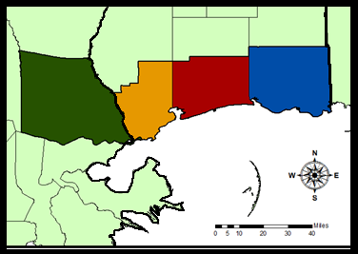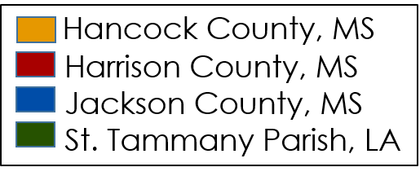

Study Period:

This project will utilize NASA Earth observations and ancillary data collected from 2005 until present. The study period includes data for areas that were impacted by hurricanes, such as Hurricane Katrina and Rita in summer of 2005, Hurricane Gustav in August of 2008, and Hurricane Isaac in August of 2012.

National Application(s) Addressed:

This project applies to the application area of ecological forecasting. The project and information provided by this project will augment current decision-making practices of end-users regarding where relocation and reintroduction ponds for the dusky gopher frog should be established.

Project Partners:

Our partners include the Nature Conservancy and US Fish and Wildlife Service (USFWS). On September 10, 2014, the USFWS released a draft recovery plan for *Lithobates sevosus* to the public. The goals for recovery were creating a GIS database for the species and using remote sensing to locate preexisting and potential gopher frog ponds, neither of which has previously been done by these organizations. The project methodologies and results will provide supplemental information to the current decision making practices regarding where relocation and reintroduction ponds for the dusky gopher frog should be established in order to aid in monitoring, protection, and restoration of this critically endangered species.

# III. Methodology

**Data Acquisition**

Land Cover

USGS 2011 National Landcover Database (NLCD), USGS Landfire and USGS National Gap Analysis Program (GAP) data were acquired for the conterminous area of the United States at 30 meter ground resolution. The USGS Landfire data were acquired for 2001 and 2012 for comparison. Shapefiles of each county were used to clip the NLCD to the study areas. The shapefiles were downloaded through ESRI’s template data. Data were extracted from Coastal Change Analysis Program (CCAP) Regional Land Cover (NOAA CSC) at 30 meter resolution. These files were downloaded through ESRI’s template data.

Elevation

A 30 meter resolution USGS 2011 National Elevation Dataset (NED) was acquired for the study area. 30 meter resolution Digital Elevation Model (DEM) data files from webGIS were acquired for St. Tammany Parish, Jackson County, Harrison County and Hancock County.

Precipitation

Precipitation data at 4 km resolution was extracted from Parameter-Elevation Relationships on Independent Slopes Model (PRISM).

Soil Data

The United States Department of Agriculture (USDA) Natural Resources Conservation Service (NRCS) website was used to download data for soil texture types. Soil Information for Environmental Modeling and Ecosystem Management multi-layer soil characteristics dataset based on the USDA State Soil Geographic Database (STATSGO) was used to download data for the study area at 30 meter resolution.

Multi Spectral Imagery

Imagery from Landsat 5 TM and Landsat 8 OLI were acquired via the USGS EarthExplorer web portal. This imagery was stacked and corrected for atmospheric interference. Data was processed using ERDAS IMAGINE and Exelis ENVI image processing software.

Infrared images of the study area were further processed to extract water features using ERDAS IMAGINE. A mask of permanent water features was created in order to show only the ephemeral water features.

**Data Processing**

Land Cover

Developed vs. Non-Developed

The land cover data from U.S. Geological Survey National Land Cover Dataset (NLCD) and the National Oceanic and Atmospheric Administration, NOAA, Coastal Change Analysis Program, CCAP was used to separate forests versus non-forests. After the vegetation was clipped using the ArcGIS spatial clip tool, the weighted overlay tool in ArcGIS was used to assign weight to forest and non-forest land cover variables. The forest land cover variable was assigned a one whereas the non-forest land cover variable was assigned a zero. Both of the land cover layers from U.S. Geological Survey National Land Cover Dataset and the National Oceanic and Atmospheric Administration (NOAA) Coastal Change Analysis Program (CCAP) were overlaid for accuracy.

Canopy Cover

The canopy cover layer, from USGS LANDFIRE, was clipped from a nationwide data set to the study area. The Canopy cover selected for an optimum pond habitat for the dusky gopher frog is 10 – 30 % tree cover over the pond, less than 20 % shrub cover and herb cover up to 90% cover. The optimal cover was assigned a one and the rest of the cover types were assigned a zero.

Forest Type

The final land cover layer was the forest layer from USGS GAP. Longleaf pines and Loblolly pine forests were assigned a weight of one and a zero for all other forest types. These datasets were then overlaid using the weighted sum tool in ArcGIS.

Precipitation

The precipitation layer, Parameter-elevation Regressions on Independent Slopes Model (PRISM), was downloaded at the national scale (Using FORTRAN90) and clipped to the study region. The data was then normalized for the average precipitation in the study area. The precipitation data was weighted using the weighted overlay tool in ArcGIS.

Soil

The Soil layer from the U.S. Department of Agriculture National Resource Conservation Service was clipped to the study area using the spatial clip tool in ArcGIS. The soils were separated by dusky gopher frog habitat. The upland sandy and sandy loam were used as the optimal habitat soils based on literature reviews. The optimal soils were assigned a one using the weighted overlay tool and the undesired soils were assigned a zero.

Multi Spectral Imagery

Atmospherically corrected Landsat 5 images were obtained from the USGS via Earthexplorer. In order to assess ephemeral ponds, very wet winter conditions were compared to very dry summer conditions. Images from February were used for the wet images and images from August were used for the dry images. Infrared bands (4, 5, and 6) from each season were processed using ERDAS IMAGINE’s change detection function. The results of the change detection were stacked into a single image and classified into seasonal water and non-water classes. Images of the results of the change detection were mosaicked using ERDAS IMAGINE Mosaic Pro.

**Data Analysis**

The data analysis consisted of weighing the selected layers, overlaying the selected layers, and creating a probability model with the selected layers. The methods used in this project were weighed sum, probability, additive summation, and normalized statistics. Each of these methods were integrated into our project to find potential habitats for the dusky gopher frog.

***Weighting***

The first analysis method for this project is a weighted overlay. A weighted overlay assigns each layer a specific weight depending on how important the layer is in relation to the Dusky Gopher Frog habitat. Table 1 shows the weights for each layer involved in this project. The pond Analysis layer (areas with ponds that form throughout the year) has a high weight. The forest type and canopy cover also have a large weight for potential habitat. The precipitation and soil variables have a smaller weight, though they are important to the habitat of the Dusky Gopher Frog, the pond analysis, forest type, and canopy cover a stronger variables involved with the Dusky Gopher Frog habitat.

Table 1: A table describing the layers and their weights in relation to the Dusky Gopher Frog habitat.

|  |  |
| --- | --- |
| **Layer** | **Weight** |
| Pond Analysis (PA) | *200 |
| Forest Type (FT) | *75 |
| Canopy Cover (CC) | *10 |
| Precipitation (P) | *10 |
| Soil (S) | *05 |

The weight was then applied to the layers using ArcGIS. Therefore as shown below, in Figure 2, each pixel has an assigned number for analysis. A value of one means that the pixel has a favorable variable for the Dusky Gopher Frog and a zero means that the pixel does not have a favorable variable for the Dusky Gopher Frog habitat. Each layer will be multiplied and weighted according to the value shown in the table above.

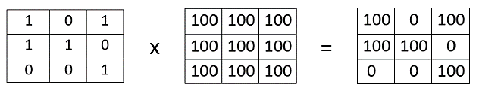

*Figure 2: A figure show the methods in weighting visually.*

***Overlaying***

The overlay part of this project used the weighted sum method. The weighted sum method takes each weighted layer and adds the layer values into each individual pixel. Therefore the pixel with the highest value has the greatest potential for the Dusky Gopher Frog habitat. Figure 3 shows the weighted sum method with individual pixels. MATLAB was implemented to run the summary statistics on the pixel counts.

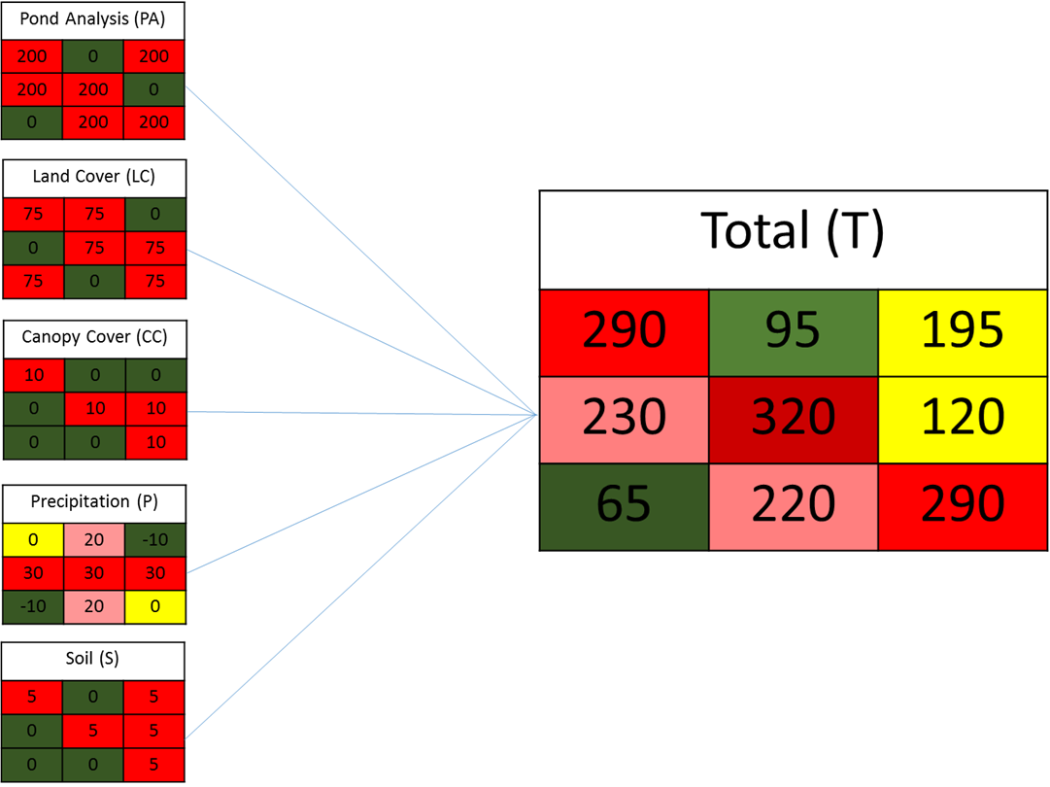

*Figure 3: A figure showing the weighted layers in each pixel with the final output portraying different values, higher values suggest a greater potential habitat and lower values suggest a lower potential habitat for the Dusky Gopher Frog.*

***Probability Model***

The probability model will give a percentage in each pixel of the potential habitat for the Dusky Gopher Frog. The equations below show how the additive procedures were executed and the final probability function was created.

$$Sum of all weighted Layers for each pixel= \left(PA\right)+\left(FT\right)+\left(CC\right)+\left(P\right)+(S)$$

$maximum sum for each pixel=\left(PA=200\right)+\left(FT=75\right)+\left(CC=10\right)+\left(P=30\right)+(S=05)$ = 320

$$Probability of Potental DGF habitat=\frac{Sum of all weighted layers for each pixel}{Maximum sum possible for each pixel}$$

The output from the probability potential model will be in the form of a percentage. The percentage indicates the probability of DGF habitat in that specific area.

# IV. Results & Discussion

Suitable habitat was found throughout the study area. Harrison County and Hancock County, Mississippi, located in the central portion of the study area had more suitable breeding pond locations than Jackson County, Mississippi and St. Tammany Parish, Louisiana. This was due to a combination of land cover, land use, and topography. Additionally, precipitation decreases to the west, with St. Tammany Parish, Louisiana notably drier than the Mississippi counties.

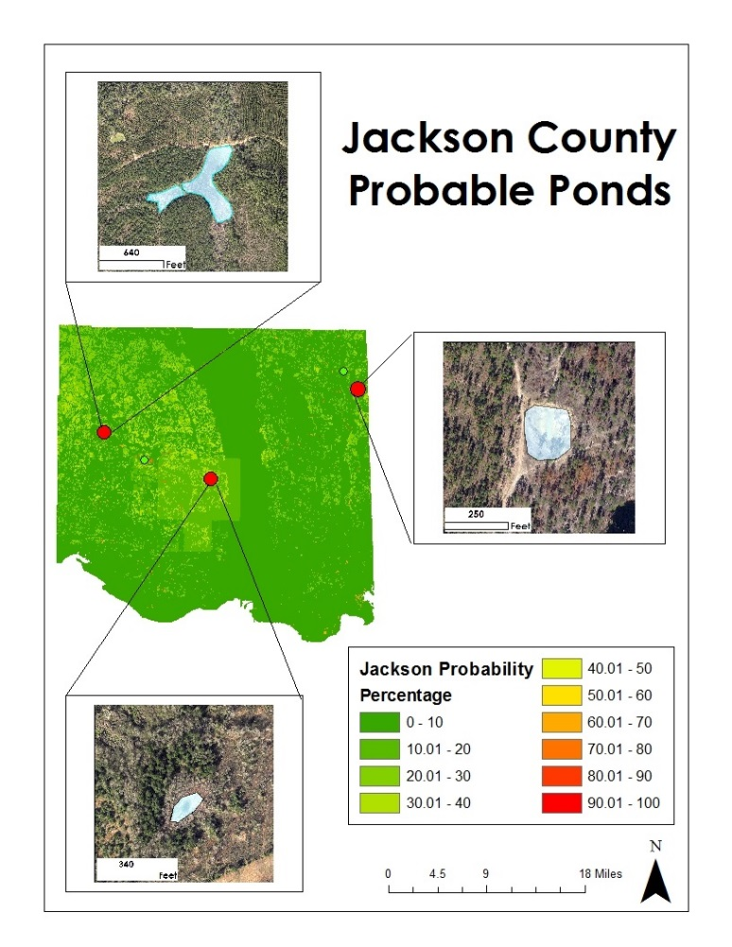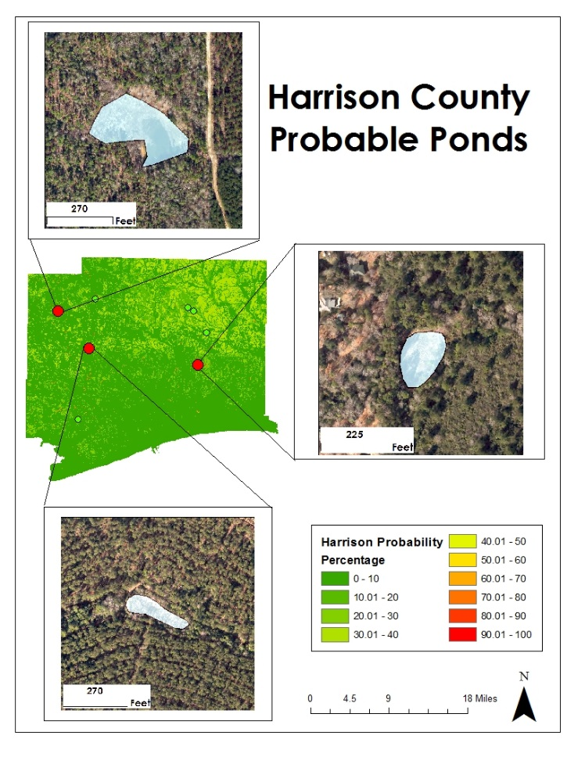

Figure 4 – Selected probable pond locations in Jackson County, Mississippi (left) and Harrison County, Mississippi (right)

Jackson County, Mississippi contained five ponds, one of which appeared to be ideal (fig. 4). This pond had the correct ground cover, forest type and was ephemeral. However, the pond was within 1000 feet of a residential development, which is within the typical range of the dusky gopher frog.

Ten previously undocumented frogs were located in Harrison County, Mississippi, seven of which were appeared to be good prospects for a breeding program (fig. 4). Several ponds appeared to be anthropogenic as opposed to naturally occurring, so there are doubts as to whether they are ephemeral on an annual basis.

Hancock County, Mississippi had excellent potential habitat (fig. 5). A pond located in extreme northern Hancock County had ideal forest canopy closure surrounding the pond, emergent vegetation within the pond for egg deposition, and was remote, yet easily accessible. There was no development within the typical range of the dusky gopher frog.

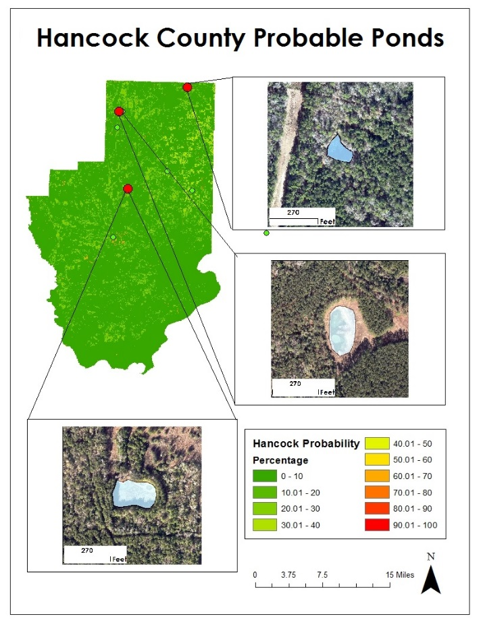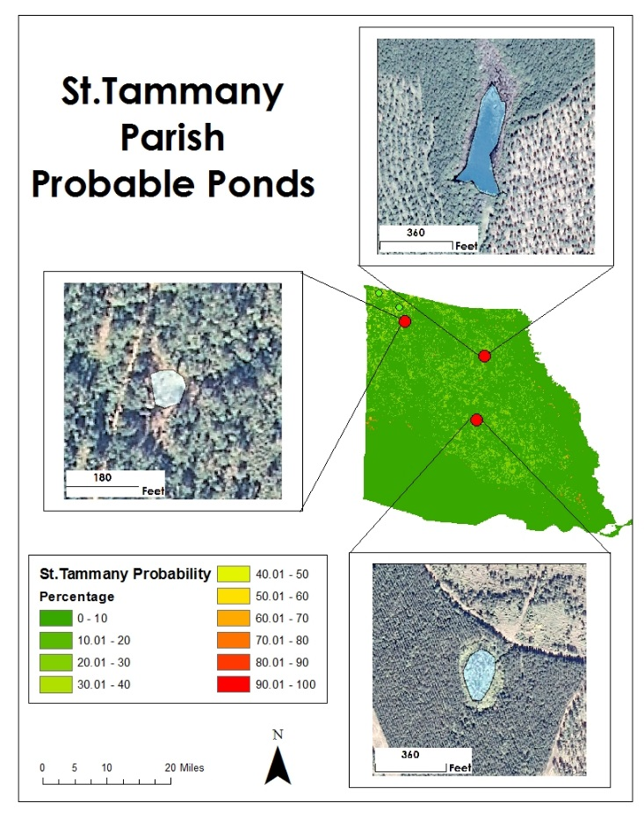

Figure 5 - Selected probable pond locations in Hancock County, Mississippi (left) and St. Tammany Parish, Louisiana (right).

Development and commercial timber operations proved detrimental to suitable habitat in St. Tammany Parish, Louisiana (fig. 5). Only 5 ponds were located that had desirable land cover. The most likely habitat was located in northwest St. Tammany Parish, but was smaller than ideal. The small size leads to doubts about the ponds ability to hold water long enough for successful breeding to occur.

Suitable habitat was found throughout the study area (fig. 6). In the central part of the study area, Hancock County and Harrison County, Mississippi, the land cover and topography contribute to numerous locations for breeding ponds. Once clear of the well-developed coastal areas, there was minimal infringement upon habitat by development. The ideal precipitation in these counties allows the ponds to fill on a yearly basis.

To the east, in Jackson County, Mississippi, the Pascagoula River floodplain makes up a large portion of the county. Within this floodplain there is no suitable habitat due to topography and saltwater intrusion into the lower Pascagoula River floodplain. Outside of the floodplain and developed areas, land cover and topography are suitable for habitat development.

St. Tammany Parish, Louisiana is largely devoid of new suitable habitat. There are extensive suburban areas that have likely wiped out ponds, as well as extensive commercial forestry operations that have destroyed the mature, closed canopy pine forests needed by the dusky gopher frog.

Table 2 :The potential number of habitats per county

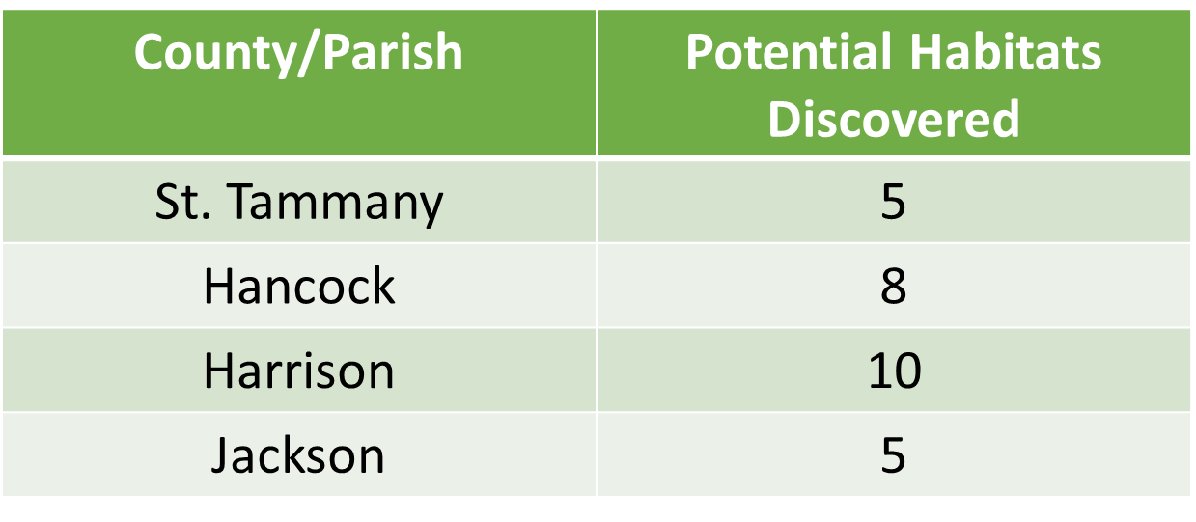

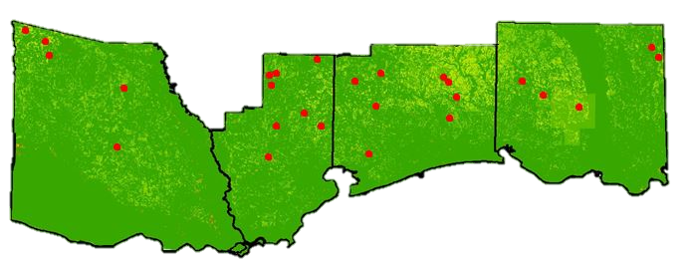

Figure 6 – Study area with pond locations in red.

As with any remote sensing study, there is room for improvement with improved spectral and temporal sensor resolution. Due to the small size of the potential breeding ponds. The 30m resolution of Landsat data led to some mixed pixels and some ponds likely being overlooked entirely. Also this study compared the driest summer and the wettest winter conditions. Some ponds may not reach sufficient size in years with rainfall closer to climatological norm.

Future work on this project could include adjusting the weighted model to give the different parameters different weights in order to further refine the accuracy of the model. Also, expanding the study area, especially to the north in Mississippi maight lead to discovery of more potential habitat.

# V. Conclusions

The probability model proved to find areas that have the potential habitat requirements for the DGF which are; longleaf pine forest with up to 30 percent cover; less than 20 percent shrub cover; herbaceous cover up to 90 percent; sandy loam or upland sandy soil; not close to roadways to prevent runoff and depressions for pond formation. Probability values of 70 percent and above were found in the three Mississippi Counties (Hancock, Harrison, and Jackson) and in the one parish in Louisiana (St. Tammany). The greatest amount of probability values between 70 and 100 percent were located in the Northeastern part of Harrison County, Mississippi followed by Jackson County in Mississippi. The summary statistics revealed there were more values lower than 50 percent probable for the Dusky Gopher Frog habitat. A possible signature of rapid urbanization in the study area is assumed because most of the values were below 50 percent. The application of quality control on the probability model was implemented by the random sampling method. The model was rated with an accuracy percentage of 75 percent. A map for each county with associated probable habitats will be transferred to each end-user to help with the reintroduction and relocation practices for the dusky gopher frog.

# VI. Acknowledgments

* Joseph Spruce - Senior Scientist and Lead Science Advisor at NASA SSC
* James “Doc” Smoot - Senior Scientist and Assistant Science Advisor at NASA SSC
* Ross Reahard - SSC DEVELOP Center Lead
* NASA DEVELOP National Program Office
* Jim Lee - The Nature Conservancy (TNC) – Biologist
* Julie Moore - US Fish and Wildlife Service (USFWS) - Wildlife Biologist
* Ed Moody - USDA Forest Service: DeSoto Ranger District - Wildlife Biologist
* Linda LaClaire - US Fish and Wildlife Service (USFWS) - Wildlife Biologist
* Danny Hartley – US Army Corps of Engineers – Wildlife Biologist

This material is based upon work supported by NASA through contract NNL11AA00B and cooperative agreement NNX14AB60A.

# VII. References

U.S. Fish and Wildlife Service. 2014. Technical/Agency Draft Recovery Plan for the Dusky Gopher Frog (*Rana sevosa*). Atlanta, Georgia. 90 pp.

National Gap Analysis Program Land Cover Data. US Geological Survey. U.S General Land Cover Map.

National Land Cover Database. US Geological Survey. Conterminous United States Land Cover.

LANDFIRE. US Geological Survey. Conterminous United States Land Cover.

The National Elevation Dataset, US Geological Survey. U.S General Elevation Map.

WebGIS. Geographic Information Systems Resource.

Soil Survey Staff, Natural Resources Conservation Service, United States Department of Agriculture. U.S. General Soil Map (STATSGO2).

Soil Information for Environmental Modeling and Ecosystem Management. US Conterminous Soil Map.

Coastal Change Analysis Program Regional Land Cover and Change. NOAA Digital Coast Office for Coastal Management.

PRISM Climate Group, Oregon State University. US Conterminous Precipitation Data.

# VIII. Content Innovation

In preparation for DEVELOP’s coming microjournal, please select two content innovation features to support your paper. For each item, please list the name of the feature, and include the tool itself if possible (eg. glossary terms and definitions). If the tool does not work in Microsoft Word (eg. Interactive MATLAB Figure Viewer), please list the file name and upload the related file to the microjournal folder on the DEVELOP Exchange. If you choose to use Inline Supplementary Material, please also include where the material should appear in the text.

**Some options include:**

AudioSlides

Database Linking Tool

Data Profile

Executable Papers

Featured Author Videos

Featured Multimedia for this Article (video and podcast options)

Glossary Viewer

Inline Supplementary Material (figures, tables, computer code)

Interactive Map Viewer

Interactive MATLAB Figure Viewer

Interactive Plot Viewer

Nomenclature Viewer

# IV. Appendices

1. Pond Locations







