**NASA DEVELOP National Program**

****NASA Langley Research Center

**Spring 2015**

**Virtual Poster Session Wave 1 Submission**

**DEVELOP Short Title:** Great Lakes Climate II

**Team Location:** NASA Langley Research Center – Hampton, Virginia

**Project Lead & Email:** Emily Adams, emily.c.adams@nasa.gov

**VPS Title:** Great Lakes Shoreline Wetland Response to Global Climate Change

**Image:** 2015Spring_LaRC_GreatLakesClimateII_VPSw1_Image.jpeg

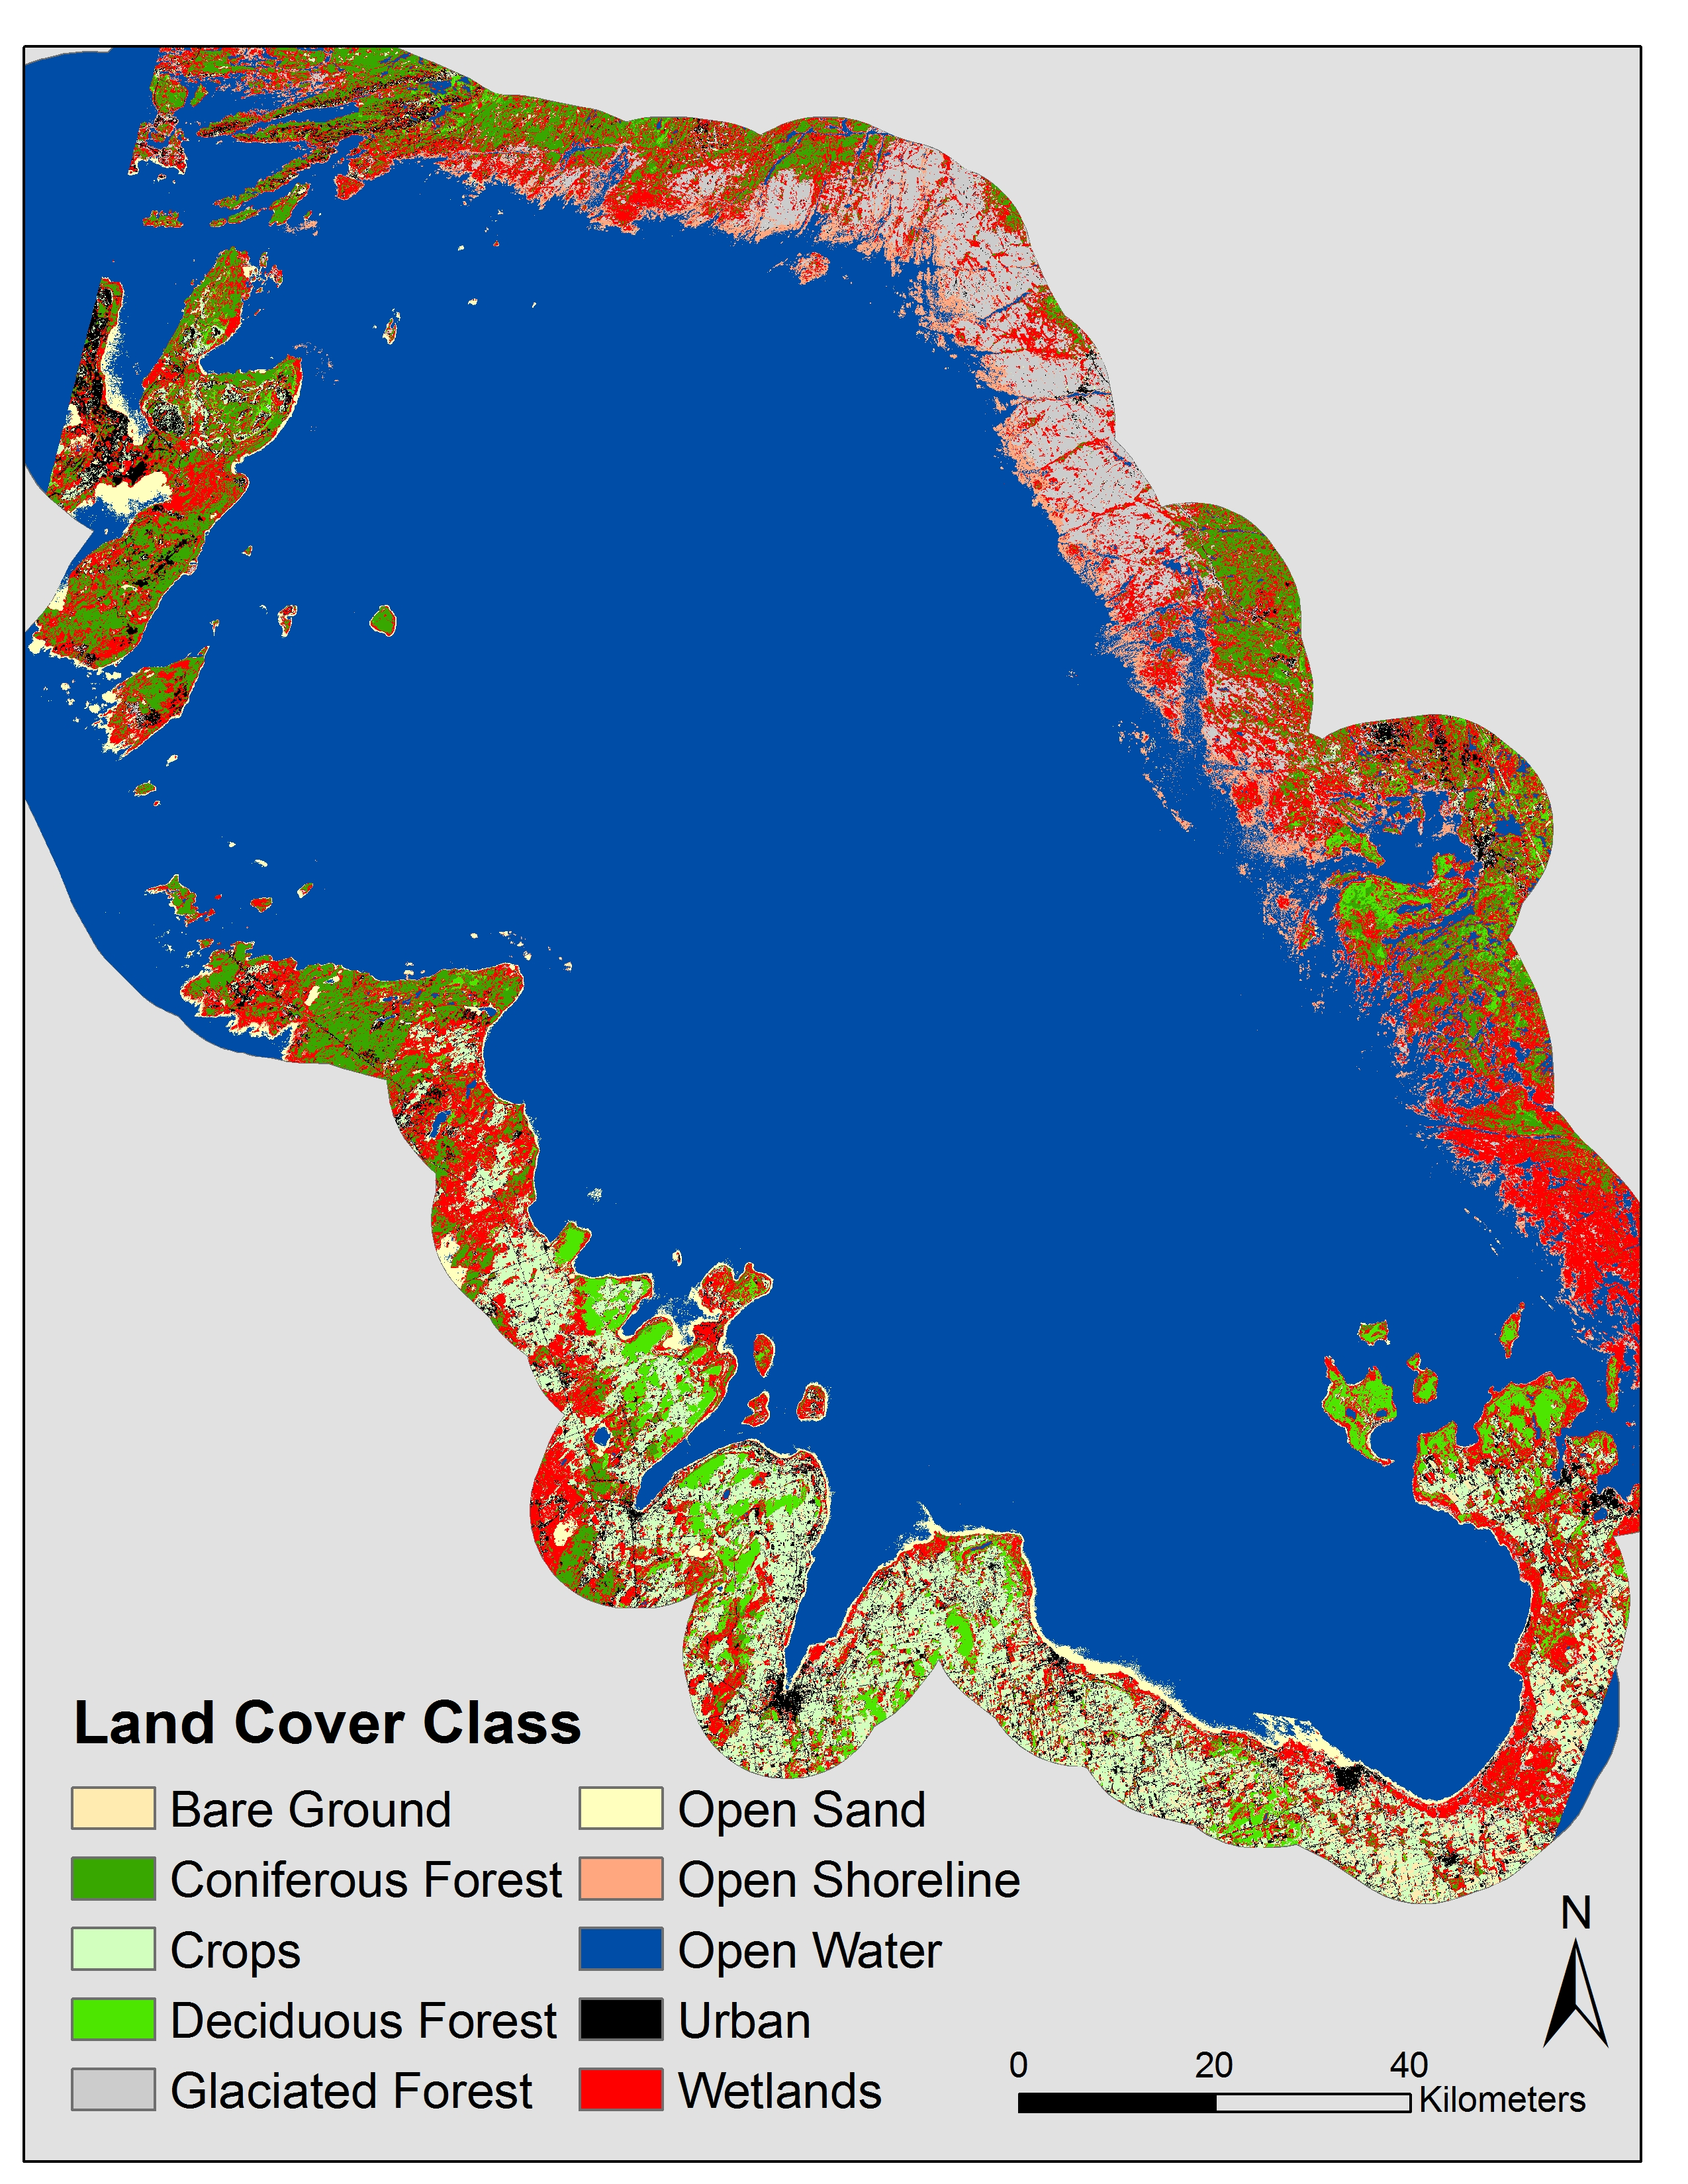

**Caption:** Caption. **Max of 25 words.**

Land classification map of Georgian Bay off Lake Huron in Ontario, Canada, limited to 10 km from the shoreline. Wetlands are shown in red. Image Credit: Great Lakes Climate II Team

**Squib:** (max 50 words)

The Great Lakes are the largest freshwater resource in the world. Climate change models predict decreasing lake levels, altering wetland hydrology. Wetlands play an essential role in ecosystem health. How will wetlands respond to decreasing water levels? Learn how remote sensing can change the way we observe and conserve wetlands.

***Federal Video Resources***

NASA Scientific Visualization Studio: <http://svs.gsfc.nasa.gov/>

USGS B-Roll Gallery: <http://gallery.usgs.gov/video_sets/B-Roll>

Additional resources available at: <https://docs.google.com/spreadsheets/d/1e2mQXg4wcYsubINUA6RNQdLwa3udqczxGx-RbD2xSeI/edit?usp=sharing>

Anyone with the link can edit this document, so please add any other federal resources you find!

**Video Style:** The video will be documentary style, including video clips from team wetlands exploration. During the DEVELOP Intro clip a sound clip of ‘wetlands’ will be playing. A description of wetlands will be read while video clips of wildlife and vegetation are showed. Community concerns will be addressed while video clips of various wetland ecosystem services are being played [i.e. Fishing, kayaks, tourism, etc.]. Methodology will be described briefly, followed by the results [with images and graphs]. Introduction of collaborators with dialog of their description of the benefits and practical uses of this project.

**Things to include in the video, other than the lead in and closing clips, the order of inclusion is entirely up to the team:**

Mandatory Lead in: DEVELOP Intro clip (available on the Exchange at: Start > Earthzine – Virtual Poster Sessions > Video Opening & Closing Clips)

Video Opening: Nature sounds (flowing water for wetlands)

Description:

* What exactly is a wetland?
* What do wetlands provide for us?
* Life without wetlands: Dr. Atkinson
* Introduce Study Sites:
  + Georgian Bay
  + Lake Ontario (Rochester)

Community Concerns:

* Wetlands surrounding the Georgian Bay are among the most diverse wetlands in the Great Lakes Basin
  + Consistent historic low water levels (~10yrs) could affect wetlands
* In this area particularly the economy is heavily dependent on healthy wetlands
  + Fishing as a large source of income, recreational activities (ecotourism)

Objectives:

* Show images according to the objective being described
  + Create automated land cover classification maps
  + Determine the extent of shoreline wetlands from past and current land cover classified maps
  + Time series showing wetland extent and health

Data Usage:

* What data was used:
  + Landsat 5 TM and Landsat 8 OLI for land cover and thermal band, training sites
    - USGS - GLOVIS
  + TOPEX/Poseidon Jason-1 and OSTM Jason-2 altimeters for water levels
  + ASTER – DEM data
    - NASA Reverb ECHO
  + Ground Truth data for verification
* Raster data [DEM, Landsat] clipped to a 10km buffer, middle of lake clipped to conserve RAM when running script

Analysis:

* Landsat 5 TM and Landsat 8 OLI
  + Top of atmosphere correction, images mosaicked together, training sites selected
* Random Forests Land Cover Classification
* ASTER 🡪 DEM
  + Derivative of slope
* ArcGIS, R programming

Results:

* Results are still in progress
* Outputs:
  + Land cover classification wetland extent map [past and present]
  + Wetland change extent map, in relation to water levels

Benefits:

* For our collaborators:
  + Time-series maps provide a powerful visual aid to educate the public on the importance of wetland conservation
  + A land classification methodology using Landsat and other publicly available NASA satellite data provides an inexpensive and timely method for local conservation groups to track wetland changes
  + Wetland change extent maps can provide more accurate information for regional policy makers
* For the public:
  + Easily accessible wetland information for education on conservation topics

Collaborators & End-Users:

* Georgian Bay Forever
* Great Lakes and St. Lawrence Cities Initiative
* Land Information Ontario

How will Participants be Introduced: End of film before the closing credits, clip of group walking [kayaking] through wetlands

Mandatory Video Closing: DEVELOP closing clip (available on the Exchange at: Start > Earthzine – Virtual Poster Sessions > Video Opening & Closing Clips)