Northeast Alaska Climate

Using Earth Observations to Evaluate Snow Variability through a Climatological Analysis to Support Ecological Monitoring in Northeast Alaska

 **Technical Report**

March 31st, 2023

Kristin Anderson (Project Lead)

Omeed Arooji

Isabella Chittumuri

Thomas Germann

***Advisors:***

Dr. Bob Bolton (International Arctic Research Center, University of Alaska Fairbanks)

Julian Dann (University of Alaska Fairbanks)

Dr. Jessie Cherry (National Centers for Environmental Information Regional Climate Services Director, Alaska Region)

Ryan Theurer (Airborne Snow Observatories)

***Fellow:***  
Kathryn Caruso (North Carolina – NCEI)

# 1. Abstract

Alaska is experiencing climate change at an unprecedented rate, with temperatures increasing twice as fast as the national average. The resulting changes to the landscape and ecosystems are significant, including shorter winters, declining snow depth, thawing permafrost, and rapidly receding glaciers. These changes are not only exacerbating the negative impacts of oil exploration but also affecting the food security of indigenous communities that rely on hunting as a subsistence food source. With the US Fish and Wildlife Service managing a potential tundra travel season for the first time in its history, adequate data on historic snow variables is essential to protect the unique habitat of the area. This project used NASA satellite and assimilation system data to inform and improve the current understanding of snow patterns in the Arctic National Wildlife Refuge and the National Petroleum Reserve – Alaska. The DEVELOP team used MODIS Normalized Difference Snow Index data to determine snow season duration, snow change frequency, and the first and last days of snow. The team also utilized the 2.1 Global Land Data Assimilation System and Daymet V4 products to study climatological trends in snow depth and snow water equivalent, respectively, across the study areas. The results of this study give users the capacity to visualize maps of multiple snow variables to monitor changes in snow conditions and proactively prepare for the ecological, cultural, and landscape impacts that changes in snow variability will cause in the future.

**Key Terms**

Remote Sensing, MODIS, GLDAS, Snow Products, Alaska, Snow Water Equivalent, Snow Cover Fraction, Snow Depth

# 2. Introduction

***2.1 Background Information***

In the last 100 years, the surface air temperatures across the Arctic have increased at almost twice the rate of global rise, a phenomenon known as “Arctic amplification” (Screen & Simmonds, 2010; Chylek et al., 2022). As a consequence of a changing Arctic climate, the northern region of Alaska is facing extreme environmental vulnerabilities (Kellogg et al., 2010; Lindsay et al., 2015; Liston & Hiemstra, 2011). Moreover, a reduction in snow cover has been observed, significantly exceeding the rate of sea ice and glacier decline (Cohen et al., 2012). Past studies have stressed the critical implications snow cover reduction has on Arctic ecosystems; findings compounded by recent estimates suggest that these regions may face a 10–40% decrease in snow cover duration as soon as 2050 (AMAP, 2017; Callaghan et al., 2011; Niitynen et al., 2018). Climate shifts such as these will result in multifaceted and cascading effects for the ecology within and beyond Alaska.

Northeast Alaska is known to have one of the most diverse examples of Arctic tundra in the circumpolar Arctic (World Wildlife Fund, 2007), with many native species relying on the wetland habitats of the Beaufort Coastal Plain and the Brooks Foothills, which stretch across the northern coast of Alaska. The majority of this area is managed by the federal government, primarily by the Bureau of Land Management (BLM) at the National Petroleum Reserve-Alaska (NPR-A) and US Fish and Wildlife Service (USFWS) at the Arctic National Wildlife Refuge (ANWR) (ADF&G, 2006), both of which are this project’s study areas (Figure 1). These regions are home to distinct caribou populations, such as the Porcupine Caribou Herd and Central Arctic Herd, which hold significant cultural and subsistence value for local Indigenous communities (Raynolds et al., 2020). Research has shown that environmental conditions, such as snow cover, can be a significant trigger for initiating migratory behavior in species including caribou, polar bears, and shorebirds (ADF&G 2006). For example, the first snowfall likely acts as a stimulus for fall migration and winter range location of caribou (Pedersen et al., 2021; Lent, 1965) and snow conditions may influence clutch initiation and chick-growth period in shorebirds (Meltofte, 2007). Thus, climate change has the potential to impact Alaskan wildlife in numerous ways, such as altering and reducing habitats and leading to drastic changes in the landscape.

Given the potential for oil exploration increase in Northeast Alaska, it is essential to understand environmental variability in the landscape to minimize the impact of these operations to the ecology of this region. Studies have shown that disturbances associated with oil exploration, in areas where tundra vegetation and the underlying permafrost soils are sensitive, can cause ecological damages that are visible after 60 years (Jorgenson et al., 2010). Considering these impacts, seismic exploration is only permitted in winter and is based on freeze depth and adequate snow coverage (Raynolds et al., 2020; Rickard & Brown, 1974). In order to address potential areas of concern related to oil and gas exploration, managers can use Earth observation tools such as snow-cover products to monitor historical snow variability and proactively identify areas that are particularly vulnerable to disturbances caused by seismic exploration and require additional management interventions to support native ecosystems. Previous studies indicate that Normalized Difference Snow Index (NDSI) is an accurate way to determine snow cover (Hall et al., 2002; Salomonson & Appel, 2004) and can be used to assess the snow season duration in Northeast Alaska (Cherry et al., 2017). However, there is a current lack of actionable-data, and managers have difficulty determining when various areas within Alaska will become snow-free or have high snow cover variability. Therefore, this project used snow products from Earth observation instruments and climate assimilation systems to inform managers on historical snow variability trends from August 1, 2000, to July 31, 2022, and proactively identify areas of snow variability within Northeast Alaska.

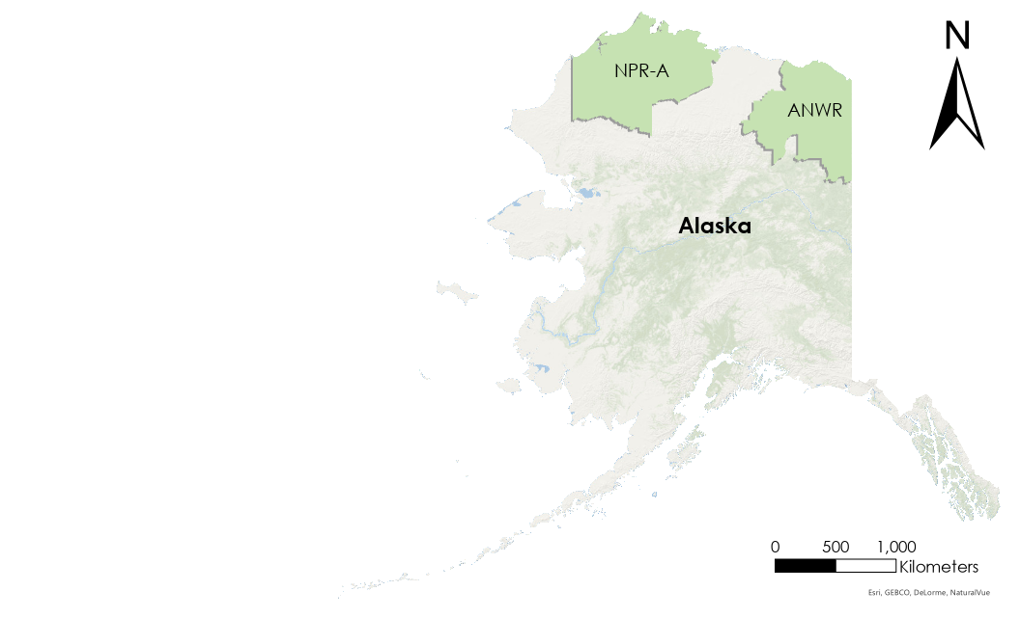

*Figure 1*. The study area includes the National Petroleum Reserve-Alaska (NPR-A) and the Arctic National Wildlife Refuge (ANWR), located in Northeast Alaska. Both park boundaries are indicated in green.

***2.2 Project Partners & Objectives***

The present study, carried out in collaboration with the USFWS and the Alaska Climate Adaptation Science Center (AK CASC), conducted a climatological analysis of snow variables in the ANWR and NPR-A. The USFWS manages the ANWR with a focus on promoting stewardship of the wildlife and landscapes within its jurisdiction, maintaining wilderness values, and ensuring public access and use. The AK CASC provides critical scientific information, tools, and techniques to resource managers and policymakers such as the USFWS. Given the expressed interests of the partners, this project aimed to incorporate NASA and National Oceanic and Atmospheric Administration (NOAA) Earth observations to address data gaps and improve the understanding of snow variability in the region due to the shifting climates. Specifically, the partners were interested in identifying areas that have high variability that can be used for risk mitigation across many disciplines. This project aimed to provide partners with a comprehensive spatiotemporal analysis of snow conditions to identify regions vulnerable to changes in snow availability. Specifically, this project evaluated snow cover fraction, continuous snow season, snow albedo, snow depth, and snow water equivalent (SWE) to understand snow variability in a climatological context in these Northeast Alaska regions. Given the growing concern for ecological impacts of snow variability and seismic exploration in both the ANWR and NPR-A, an up-to-date knowledge of snow cover, depth, and distribution is paramount for refuge managers to prepare for the shifting climate.

# 3. Methods

# *3.1 Data Acquisition*

This study utilized Google Earth Engine’s Python Application Programming Interface (GEE-API), a cloud-based platform for geospatial processing, which provides public access to large-scale cloud computing capabilities and allows users to easily process a wide range of remotely sensed images and vector datasets. The public GEE-API data catalog hosts MODIS and other popular datasets, which are made available to all users.

The shapefile of the NPR-A and ANWR were downloaded from U.S. BLM and USFWS, respectively, to insert geospatial boundaries for the aforementioned datasets. The following data processing and analyses are subsequently restricted to the study areas illustrated in Figure 1.

*3.1.1 Satellite Data*

Snow cover across the regions of interest, the NPR-A and ANWR, was identified through NASA MODIS Snow Cover NDSI Snow Cover Products Collection 6. The Terra MODIS Snow Cover Daily L3 Global 500m Grid (MOD10A1 V6) ‘NDSI Snow Cover’ band composites were used to analyze the temporal variability of snow cover. As a Collection 6 product, these NDSI values were preprocessed to produce a spectral band ratio based on differences (equation below) in the absorption of snow (Salomonson & Appel, 2004). This NDSI equation utilizes the surface reflectance of Bands 4 & 6 (the green & shortwave infrared bands, respectively).

$$NDSI = \frac{\left(Band 4 - Band 6\right)}{\left(Band 4 + Band 6\right)}$$

The National Snow and Ice Data Center (NSIDC) also offers the MYD10A1 product from the Aqua satellite, which includes similar information. However, the Aqua MODIS data were omitted from this study because the Aqua satellite has a more limited record, covering only the period from July 2002 to the present. This satellite also suffered a Band 6 detector failure shortly after its launch (Hall & Riggs, 2007).

*3.1.2 Ancillary Datasets:*

Snow depth across the NPR-A and ANWR was identified using the NASA model-based 2.1 Global Land Data Assimilation System (GLDAS-2.1) snow depth product (SnowDepth_inst). GLDAS-2.1 is a newly available GLDAS data set with a spatial resolution of 27,830 meters and a temporal resolution of three hours. GLDAS-2.1 provides data from 2000 to present, which is forced with a combination of observation and model data from the NOAA/GDAS (Global Data Assimilation System; Derber et al., 1991), GPCP (Global Precipitation Climatology Project), and the AGRMET (Air Force Weather Agency’s AGRicultural METeorological modeling system). For a complete specification of the GLDAS-2 products, the reader is referred to Rui et al. (2020).

SWE was identified using the Daymet Version 4 (V4) SWE product. Daymet is a data product derived from a collection of algorithms and computer software programs designed to interpolate and extrapolate from daily meteorological observations to produce gridded estimates of daily weather parameters. Daymet V4 covers the period from January 1, 1980, to December 31, 2021, and has a 1 km x 1 km spatial resolution and daily temporal resolution. Maintained by the Oak Ridge National Laboratory (ORNL) Distributed Active Archive Center (DAAC), Daymet is presently updated annually, as the previous year’s weather station data become available and reach a status of archive quality (Thorton et al., 2020).

***3.2 Data Processing***

*3.2.1 Snow Cover Fraction*

The MODIS MOD10A1 product contains preprocessed geospatial bands “NDSI_Snow_Cover” and “Snow_Albedo_Daily_Tiles” that underwent a series of screening processes designed to mitigate both omission and commission errors commonly associated with geospatial snow detection, such as cloud cover and low illumination from polar nights. Pixels initially marked as snow free undergo pixel quality assessment to ensure accurate flagging. For instance, snow free pixels are masked and flagged when solar zenith angles exceed 70° due to low illumination challenges (MOD10A1 citation). Pixels flagged by quality assessment can be found within the corresponding “NDSI_Snow_Cover_Algorithm_Flags_QA” band. Riggs et al. (2016) illustrates the specifications of MODIS snow product algorithms and data products in Collection 6.

The team filtered both bands to include only values between 2000 and 2022 and restricted the datasets to the boundaries of our study area. Furthermore, the team created a binary mask for the image collection of “NDSI_Snow_Cover,” designating values of 1 (Snow On) when the snow cover value was greater than or equal to 15 and 0 (Snow Off) when values were less than 15 (Table 1). The approximation of 15% snow cover as a threshold for the binary simplification of snow cover has been commonly used by peer-reviewed physical scientists (National Snow and Ice Data Center, 2023).

Table 1.

*Binary mask designating values of 1 (Snow On) when the snow cover value was greater than or equal to 15 and 0 (Snow Off) when values were less than 15.*

|  |  |
| --- | --- |
| **NDSI Snow Cover Values** | **Binary** |
| 0-14 | 0 |
| 15-100 | 1 |

***3.3 Data Analysis***

*3.3.1 Initial Exploratory Data Analysis*

To obtain an accurate description of the snow cover fraction data, the team conducted multiple analyses to identify normality in the dataset. To test for normality of the data distribution, the team calculated the frequency of mean values for each pixel over the entire study period and performed a Shapiro-Wilk test. The team plotted the frequency distribution of mean values and examined the shape of the distribution curve. The team assessed whether the snow cover fraction data followed a normal distribution and determined the extent of any deviations from normality. Additionally, the team performed a distribution analysis to examine the distribution of mean values across the months of the year. The analysis involved grouping the mean values for each pixel by month and plotting the frequency distribution for each month in a box plot. Finally, to assess the seasonality shifts in snow cover fraction, the team plotted the mean value across four seasons—summer, winter, spring, and fall— as defined by Wendler et al. (2009).

*3.3.2 Historical Trend Analysis and Spatial Aggregation Analysis*

The team produced a historical trend analysis to visualize snow cover fraction, SWE, and corresponding snow season descriptors. Beginning with snow cover end-products, the team conducted adjacent temporal deductions of the Snow On/Off binary mask to track changes in snow cover between preceding and succeeding days. Each pixel value change from 0 ↔ 1 across the study period was analyzed to determine whether a change occurred that marked the first day of continuous snow (FDCS) or the last day of continuous snow (LDCS) for each year. Classification of FDCS required the subsequent 14 days of pixel values to be Snow On, whereas classification of LDCS required the subsequent 14 days of pixel values to be Snow Off (Cherry et al., 2017). The team summarized yearly FDCS and LDCS dates per pixel by reducing the image collection into an image of average dates. The difference in yearly FDCS and LDCS yields a value of snow season length (SSL) per pixel, which the team tracked across all years of the study period to visualize changes in SSL. In addition to analyzing the SSL values, the team also calculated year-to-year snow cover variability by examining the changes in snow cover across the study period. The team created a map of year-to-year snow cover variability to visualize the change in snow cover patterns from year to year in the ANWR and NPR-A regions.

The team also utilized the MODIS NDSI band to compute the yearly average snow cover fraction throughout the study period. In order to capture the complete snow season, a snow year was defined as beginning on September 1st and ending on May 31st of the subsequent calendar year. The team condensed the entire image collection by reducing the pixel mean of the snow year and creating individual images for each year. Similarly using the GLDAS and Daymet D4 dataset, the team created average monthly images of snow depth and SWE, respectively. Both datasets for the study period were averaged monthly by reducing the image collection into an image of each month. Then the team created maps of monthly snow depth and SWE to visualize the change in snow patterns from month to month in the ANWR and NPR-A regions.

To provide an overview of snow cover changes in the ANWR and NPR-A regions, the team aggregated the data spatially. The team calculated the SSL per year for both study areas by averaging the SSL values across all pixels in that region. The team used the resulting SSL values to create a trend line for each region to visualize the changes in SSL over time in ANWR and NPR-A.

# 4. Results & Discussion

***4.1 Analysis of Results***

*4.1.1 Initial Exploratory Data Results*

The normality tests for both NPR-A and ANWR show a left-skewed bimodal distribution in the data (Figure 2). This means that the majority of the snow cover pixel values lay within 0-5 and then from 55 – 80, suggesting that the data is not normally distributed and may contain outliers. The Shapiro–Wilk test for the NPR-A and the ANWR also indicated that the data was not normally distributed with a value of 0.815 (p-value = 0.0), and 0.817 (p-value = 0.0), respectively.

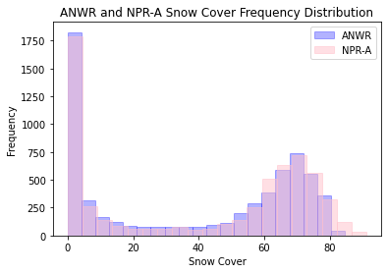

*Figure 2*. Density plot of the frequency of total mean values per pixel for the two regions, ANWR and NPR-A, represented by purple and pink bars, respectively. The x-axis shows the range of mean values (%), while the y-axis shows the frequency of occurrence.

Further inquiry in both areas reveals a significant decline in the percent snow cover fraction from May (month 5) and June (month 6). However, NPR-A had more outliers during May compared with ANWR.

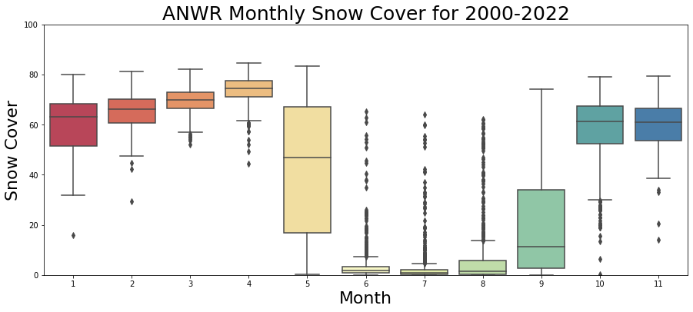

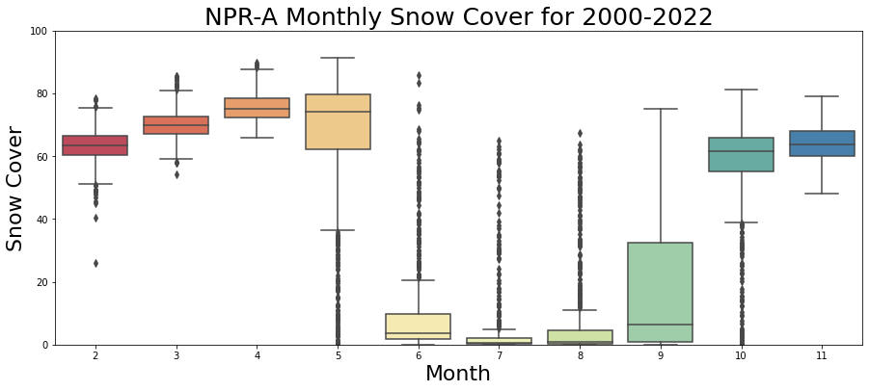

*Figure 3.* Box plots showing the distribution of snow cover for each month from 2000–2022 across ANWR (top) and NPR-A (bottom). The x-axis shows the month, while the y-axis shows the range of mean snow cover values. The whiskers extend to the highest and lowest data points, with any points beyond this range considered outliers and plotted as individual dots. The month of December for ANWR and both January and December for NPR-A were omitted from this analysis due to the data gaps in MODIS satellite data.

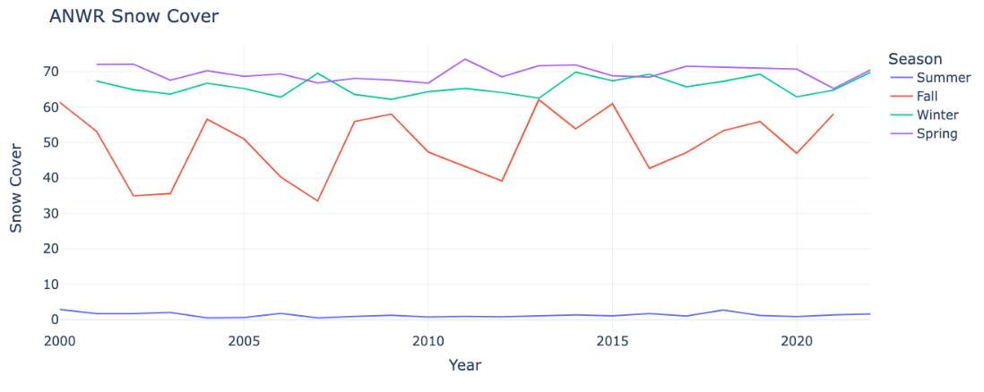

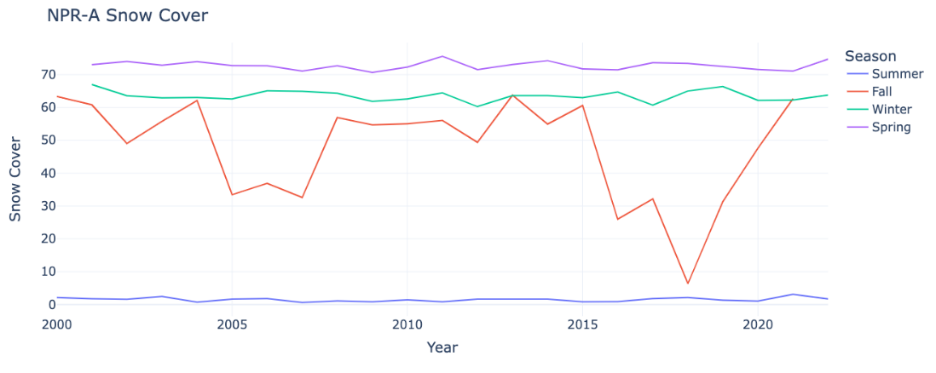

*Figure 4*. The line graphs depict the mean value of percent snow cover (y-axis) per season across the study period (x-axis) for two regions, ANWR (top) and NPR-A (bottom). Each line represents one of four seasons: summer, fall, winter, and spring.

To clearly identify seasonal trends in snow cover, the team grouped the data by season and took the yearly median (since the data were skewed). Figure 4 temporally depicts the median value of seasonal snow cover for both study areas. Each line represents the four seasons; summer, fall, winter, and spring. Looking at the NPR-A graph, there is a huge drop in snow cover in Fall 2018 likely due to data gaps. Over the years, summer has the lowest snow cover while spring has the highest snow cover.

*4.1.2 Historical Trend Analysis*

Using MODIS data, the team created maps of the FDCS, LDCS, and SSL to visualize variations in snow cover trends over time. These maps were utilized to track changes in snow cover fractions across the ANWR and NPR-A regions of Alaska over the study period. The summer months demonstrated the highest variability, with lower variability observed during the spring and fall months, and the lowest variability in February (Figure 5). Owing to data gaps, the months of January, November, and December were excluded from snow cover analyses. The study findings revealed that higher elevation areas in the ANWR and NPR-A demonstrated greater variability in snow cover compared to lower elevation regions.

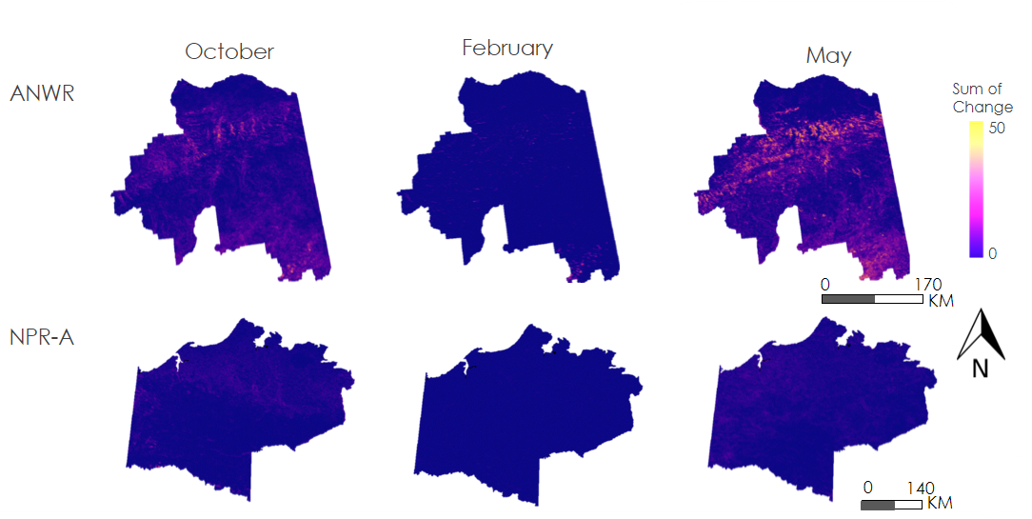

*Figure 5*. This figure presents images indicating the pixel-level variation in snow cover fractions across the ANWR and NPR-A regions of Alaska for the months of October, February, and May. The image is color-coded to indicate areas with high variation in yellow and areas with low variation in blue. The results show that February exhibited minimal variation in snow cover, while the months of October and May contained pixels with high variation in snow cover fractions.

Significant year-to-year variability was observed for both FDCS and LDCS in the ANWR and NPR-A regions (Figure 6). The high elevation areas of ANWR demonstrated a consistent trend, with FDCS occurring earlier in the snow season (August) and LDCS occurring later in the season (October). A distinct trend was also noted in the coastal plain region of ANWR, where LDCS appeared to occur in June. For the majority of the study area, FDCS occurred in September, while LDCS occurred in May.

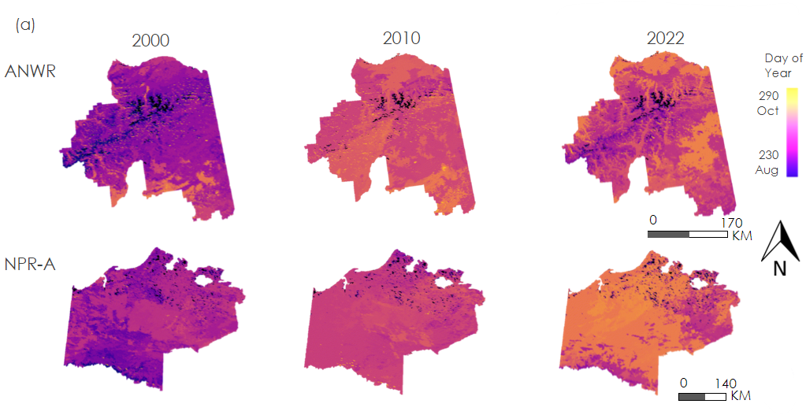

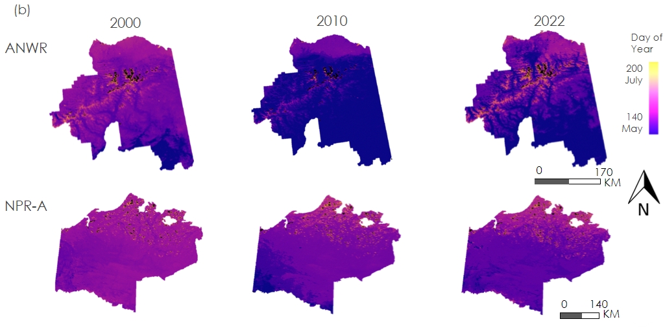

*Figure 6*. Illustrates the (a) first day of continuous snow (FDCS) and (b) last day of continuous snow (LDCS) in both ANWR and NPR-A for the years 2000, 2010, and 2021. For FDCS, the darker colors represent the snow season starting earlier in the year (May), where the warmer colors represent the snow season starting later in the year. The higher elevation areas in ANWR show the snow season starting later in the year. For LDCS, the darker colors represent the snow season ending earlier in the year (July), whereas the warmer colors represent the snow season ending later in the year. The higher elevation areas in ANWR show the snow season ending later in the year.

Additionally, snow season duration followed similar trends observed with FDCS and LDCS. Results indicate that, across the entire period, higher elevation areas tended to have a longer snow season (Figure 7). However, snow season duration varied considerably from year to year (Figure 8), and the longest snow season and the shortest snow season were both observed within a five-year time frame.

No significant trend was observed in snow season duration in both regions, likely due to frequent changes in snow season start and end as well as various blizzards across the regions. However, there were some observations made. In ANWR, the longest snow seasons took place in 2000 and 2004, when the snow season lasted for 259 days, while the shortest snow season was observed in 2016 and lasted 221 days. In NPR-A, the longest snow season was in 2000 and lasted 260 days, while the shortest snow season was observed in 2004 and lasted 209 days.

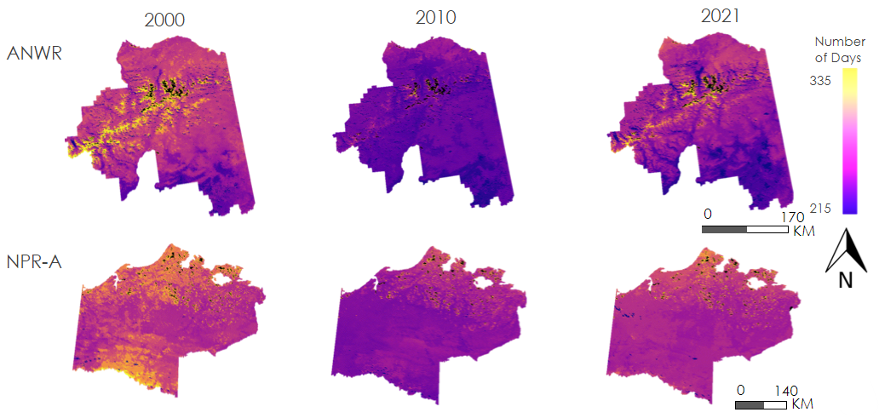

*Figure 7*. Snow season duration in both ANWR and NPR-A for the years 2000, 2010, and 2021. The snow season duration is represented by a color gradient, with darker colors indicating a shorter snow season (minimum of 215 days), and warmer colors representing a longer snow season (maximum of 335 days). The analysis shows that, in ANWR, higher elevation areas have a longer snow season compared to areas with lower elevation.

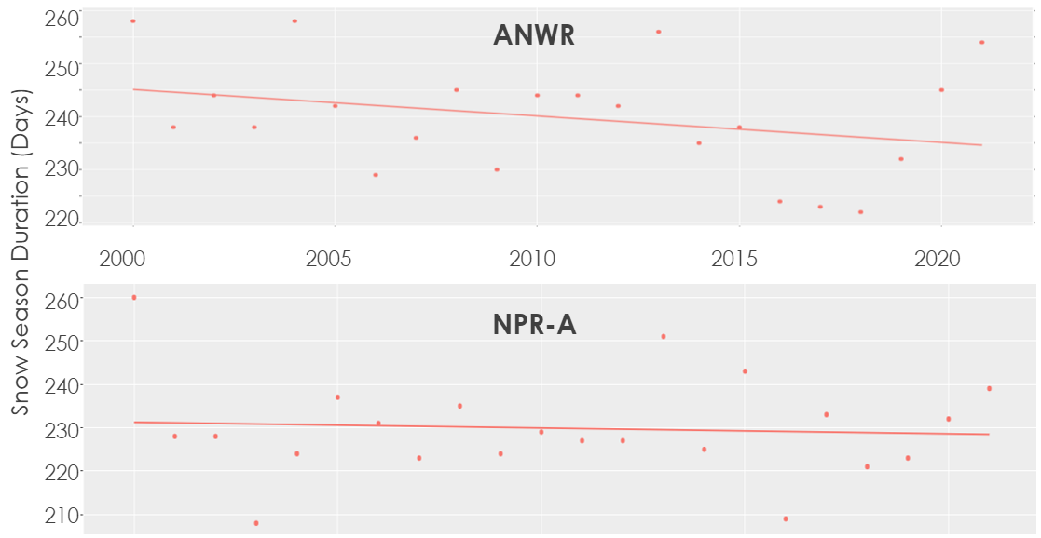

*Figure 8*. A linear regression best line of fit showing the season duration in days (y-axis) in the ANWR and NPR-A regions of Alaska over the study period (x-axis). The data points indicate the snow season duration for each year, while the slope of the lines shows the overall trend in snow season duration over time. The results demonstrate year-to-year variability in snow season duration, with some years having significantly longer or shorter snow seasons than others.

The team also identified mean SWE values across all months (Figure 9). In NPR-A, the southernmost region had higher SWE compared to the coastal plains in the northern parts of the region. Moreover, SWE varied significantly by month, with the lowest amounts of SWE observed in July, August, September, and October, and the highest amounts observed in February, March, April, and May. Similar patterns were observed in ANWR, with the exception of the eastern edge of the Brooks Range, which exhibited higher SWE than other ecological regions in the area.

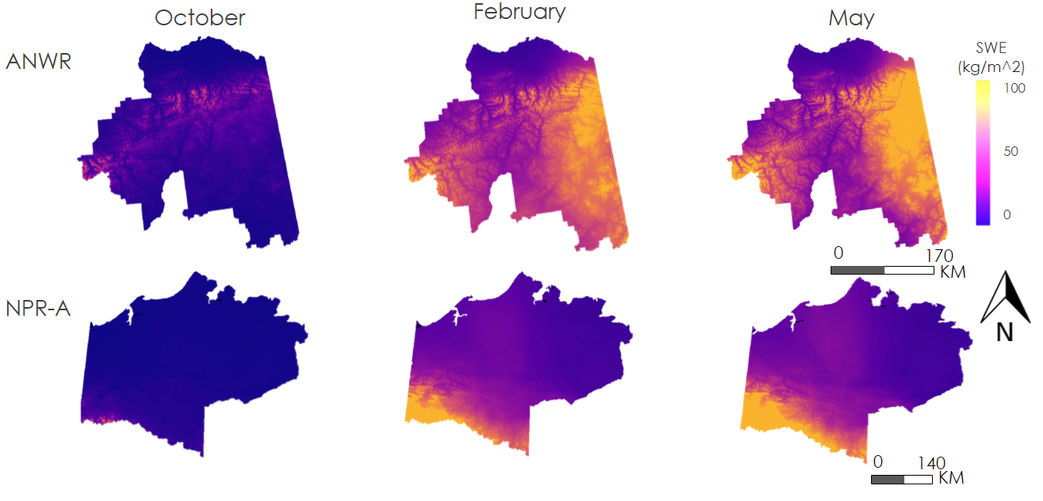

*Figure 9*. SWE in both ANWR and NPR-A for the months of October, February, and May. SWE is represented by a color gradient, with darker colors indicating less SWE (minimum of 0 kg/m2), and warmer colors representing more SWE (maximum of 100 kg/m2). The analysis shows that, in ANWR, higher elevation areas have more SWE compared to areas with lower elevation.

Finally, snow depth followed similar trends to SWE. The greatest snow depth is observed in the high elevation areas of both ANWR and NPR-A. However, due to poor spatial resolution (27 km), it was challenging to accurately determine trends.

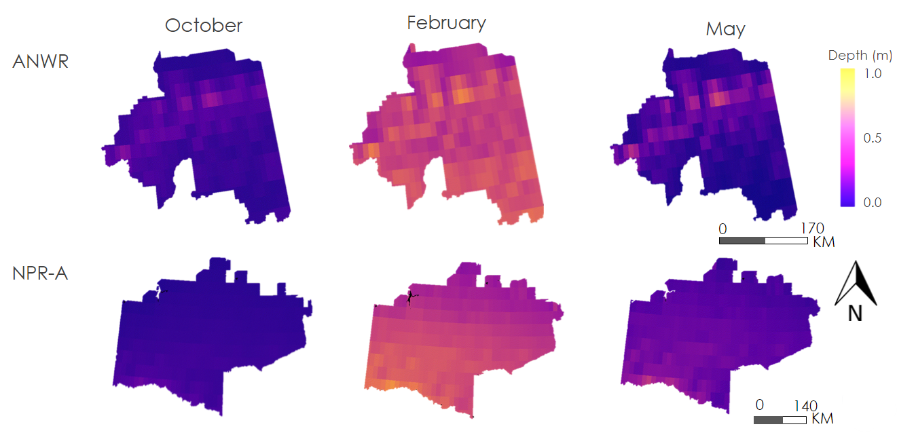

*Figure 10*. Snow depth in both ANWR and NPR-A for the months October, February, and May. Snow depth is represented by a color gradient, with darker colors indicating less snow depth (minimum of 0 m), and warmer colors representing more snow depth (maximum of 1.0 m). The analysis shows that in ANWR higher elevation areas have greater snow depth compared to areas with lower elevation.

*4.1.3 Limitations*

The analysis was limited by the spatial and temporal resolution of the MOD10A1, GLDAS 2.1, and Daymet V4 data products; these datasets have a resolution of 500 m, 27,830 m and 1 km, respectively, which limited the team’s ability to capture snow variability at a smaller spatial scale. For example, Figure 10 shows the low spatial resolution of the GLDAS 2.1 snow depth data. Also, the accuracy of GLDAS estimates is influenced by various factors, including uncertainty in meteorological forcing data, simplified representations of complex physical processes in the models and inadequate calibration of model parameters (Rui et al., 2020). Additionally, Qui et al. (2022) revealed a level of uncertainty around GLDAS snow depth products in tundra, taiga, and maritime snow class regions.

The team also encountered data gaps in MODIS snow cover products. NDSI values were calculated according to the Earth’s reflectance at certain wavelengths, and the amount of daylight greatly impacts what the sensor records. As a result, time of day and time of year have the potential to cause changes in NDSI values. Gaps in the data were significant during polar nights where night lasts for more than 24 hours. Polar night occurs during the December, January, and February months, causing gaps in the data during that time. Other environmental factors, such as cloud cover and snowstorms can also obscure the snow signal in the data.

*4.2 Future Work*

The partners are interested in future studies involving climate, rain, and elevation effects on snow – especially in the different ecological regions of the study areas. Also, for this project, it would be useful to analyze snow patterns across elevation and compare analyses of remote sensing data with *in-situ* data to validate the results of this study. Incorporating elevation data would allow a future team to identify trends in different snow variables analyzed in this project across elevation gradients. More importantly, the use of *in situ* data, such as actual snow depth and snow density measurements, would provide validity measurements against which to compare the spatial patterns and remotely sensed snow cover, depth, and SWE values.

# 

# 5. Conclusions

Overall, these analyses provide insights into historical snow cover patterns in the ANWR and NPR-A regions of Alaska. By examining changes in snow cover over time, the team can better understand the effects of climate change on these areas and develop strategies to mitigate its impact.

SWE varied significantly by month, with the lowest amounts of SWE observed in July, August, September, and October, and the highest amounts observed in February, March, April, and May. In NPR-A, the southernmost region had higher SWE compared to the coastal plains in the northern parts of the region. In ANWR, higher elevation areas have more SWE compared to areas with lower elevation. These findings provide important insights into the spatial and temporal variability of SWE in the region, which has implications for water resources, ecosystem functioning, and regional climate dynamics. The results also highlight the need for continued monitoring and analysis of SWE trends to better understand the underlying factors driving changes in snowpack and their potential impacts on the region.

Snow depth followed similar trends to SWE. The greatest snow depth was observed in high elevation areas of both ANWR and NPR-A. The spatial resolution of 27 km limited the accuracy of the maps, however, and further study is necessary to form solid conclusions about snow depth in the area.

Snow season duration followed similar trends observed with FDCS and LDCS. Results indicate that, across the entire period, higher elevation areas tended to have a longer snow season. However, snow season duration varied considerably from year to year, with both the longest and shortest snow seasons across the study period observed within a five-year time frame.

These results highlight the complexity of snow season dynamics in the region and underscore the importance of continued monitoring and analysis to better understand the underlying factors driving snow season duration trends.

# 6. Acknowledgments

The team would like to acknowledge those who supported and provided guidance for the Northeast Alaska Climate project. We thank NASA DEVELOP Fellow Kathryn Caruso, NASA DEVELOP Project Coordination Fellow Laramie Plott, and the project Science Advisors; Dr. Kent Ross (NASA Langley Research Center), Julian Dann & Dr. Bob Bolton (University of Alaska Fairbanks), Ryan Theurer (Airborne Snow Observatories), Dr. Jessie Cherry (NCEI Alaska Regional Climate Services), and Molly Woloszyn (National Integrated Drought Information System). A special thanks to our project partners who provided us with resources throughout the project. The team would also like to thank Brooke Adams, Ellen Bartow-Gillies, and Steve Ansari at NCEI/NDIS. Additionally, the team thanks the entirety of the NASA DEVELOP network for its support and its provided access to resources from previous teams that have helped guide this project.

Any opinions, findings, and conclusions or recommendations expressed in this material are those of the author(s) and do not necessarily reflect the views of the National Aeronautics and Space Administration.

This material is based upon work supported by NASA through contract NNL16AA05C.

# 

# 7. Glossary

**ANWR –** Arctic National Wildlife Preserve

**Earth observations** – Satellites and sensors that collect information about the Earth’s physical, chemical, and biological systems over space and time

**FDCS –** First Day of Continuous Snow

**GEE-API-** Google Earth Engine Application Programming Interface. A cloud-based platform for geospatial processing, which provides public access to large-scale cloud computing capabilities and allows users to easily process a wide range of remotely-sensed images and vector datasets.

**LDCS –** Last Day of Continuous Snow

**MODIS** – Moderate Resolution Imaging Spectroradiometer. MODIS is an instrument aboard the Terra and Aqua satellites, used for viewing the earth’s surface every 1-2 days in 36 different wavelengths, also known as bands.

**NPR-A –** National Petroleum Reserve-Alaska

**Shapiro-Wilk Test-** The Shapiro–Wilk test is essentially a goodness-of-fit test. That is, it examines how close the sample data fit to a normal distribution. It does this by ordering and standardizing the sample

**SSL –** Snow Season Length

**SWE –** Snow Water Equivalent

# 8. References

Adler, R. F., Huffman, G. J., Chang, A., Ferraro, R., Xie, P. P., Janowiak, J., Rudolf, B., Schneider, U., Curtis, S., Bolvin, D., Gruber, A. G., Susskind, J., Arkin, P., & Nelkin, E. (2003). The version-2 global precipitation climatology project (GPCP) monthly precipitation analysis (1979–present). *Journal of hydrometeorology*, *4*(6), 1147–1167.

Alaska Department of Fish and Game (ADF&G). (2006). Our Wealth Maintained: A Strategy for Conserving Alaska’s Diverse Wildlife and Fish Resources. Alaska Department of Fish and Game, Juneau, Alaska. Xvii+824 p.

AMAP. (2017). Snow, Water, Ice and Permafrost in the Arctic (SWIPA) 2017. Arctic Monitoring and Assessment Programme (AMAP), Oslo, Norway. xiv + 269 pp.

Callaghan, T. V., Johansson, M., Brown, R. D., Groisman, P. Ya., Labba, N., Radionov, V., Barry, R. G., Bulygina, O. N., Essery, R. L. H., Frolov, D. M., Golubev, V. N., Grenfell, T. C., Petrushina, M. N., Razuvaev, V. N., Robinson, D. A., Romanov, P., Shindell, D., Shmakin, A. B., Sokratov, S. A., Warren, S., Yang, D. (2011). The Changing Face of Arctic Snow Cover: A Synthesis of Observed and Projected Changes. *AMBIO*, *40*(1), 17–31. <https://doi.org/10.1007/s13280-011-0212-y>

Cherry, J. E., Zhu, J., and Kirchner, P. B. (2017). Snow cover monitoring with MODIS satellite data in Alaska’s national parks, 2000-2015. Natural Resource Report NPS/SWAN/NRR—2017/1566. National Park Service, Fort Collins, Colorado.

Chylek, P., Folland, C., Klett, J. D., Wang, M., Hengartner, N., Lesins, G., & Dubey, M. K. (2022). Annual Mean Arctic Amplification 1970–2020: Observed and Simulated by CMIP6 Climate Models. *Geophysical Research Letters*, *49*(13), e2022GL099371. <https://doi.org/10.1029/2022GL099371>

Cohen, J. L., Furtado, J. C., Barlow, M. A., Alexeev, V. A., & Cherry, J. E. (2012). Arctic warming, increasing snow cover and widespread boreal winter cooling. *Environmental Research Letters*, *7*(1), 014007. <https://doi.org/10.1088/1748-9326/7/1/014007>

Derber, J. C., Parrish, D. F., & Lord, S. J. (1991). The New Global Operational Analysis System at the National Meteorological Center. *Weather and Forecasting*, *6*(4), 538–547. [https://doi.org/10.1175/1520-0434(1991)006<0538:TNGOAS>2.0.CO;2](https://doi.org/10.1175/1520-0434(1991)006%3c0538:TNGOAS%3e2.0.CO;2)

Hall, D. K., & Riggs, G. A. (2007). Accuracy assessment of the MODIS snow products. *Hydrological Processes*, *21*(12), 1534–1547. <https://doi.org/10.1002/hyp.6715>

Hall, D. K., Riggs, G. A., Salomonson, V. V., DiGirolamo, N. E., & Bayr, K. J. (2002). MODIS snow-cover products. *Remote sensing of Environment*, *83*(1-2), 181-194.

Hall, D. K. and G. A. Riggs. (2016). MODIS/Terra Snow Cover Daily L3 Global 500m SIN Grid, Version 6 [Data Set]. Boulder, Colorado USA. NASA National Snow and Ice Data Center Distributed Active Archive Center. <https://doi.org/10.5067/MODIS/MOD10A1.006>. Date Accessed 03-22-2023.

Jorgenson, J. C., Hoef, J. M. V., & Jorgenson, M. T. (2010). Long-term recovery patterns of arctic tundra after winter seismic exploration. *Ecological Applications*, *20*(1), 205–221. <https://doi.org/10.1890/08-1856.1>

Kellogg, J., Wang, J., Flint, C., Ribnicky, D., Kuhn, P., De Mejia, E. G., Raskin, I., & Lila, M. A. (2010). Alaskan Wild Berry Resources and Human Health Under the Cloud of Climate Change. *Journal of Agricultural and Food Chemistry*, *58*(7), 3884–3900. <https://doi.org/10.1021/jf902693r>

Lent, P. C. (1965). Rutting behaviour in a barren-ground caribou population. *Animal Behaviour*, *13*(2), 259–264. <https://doi.org/10.1016/0003-3472(65)90044-8>

Lindsay, C., Zhu, J., Miller, A. E., Kirchner, P., & Wilson, T. L. (2015). Deriving Snow Cover Metrics for Alaska from MODIS. *Remote Sensing*, *7*(10), Article 10. <https://doi.org/10.3390/rs71012961>

Liston, G. E., & Hiemstra, C. A. (2011). The Changing Cryosphere: Pan-Arctic Snow Trends (1979–2009). *Journal of Climate*, *24*(21), 5691–5712. <https://doi.org/10.1175/JCLI-D-11-00081.1>

Meltofte, H. (2007). *Effects of Climate Variation on the Breeding Ecology of Arctic Shorebirds*. Museum Tusculanum Press.

National Snow and Ice Data Center (2023). Snow Today. <https://nsidc.org/snow-today/about-snow-today>

Niittynen, P., Heikkinen, R. K., & Luoto, M. (2018). Snow cover is a neglected driver of Arctic biodiversity loss. *Nature Climate Change*, *8*(11), Article 11. <https://doi.org/10.1038/s41558-018-0311-x>

Pedersen, S. H., Bentzen, T. W., Reinking, A. K., Liston, G. E., Elder, K., Lenart, E. A., Prichard, A. K., & Welker, J. M. (2021). Quantifying effects of snow depth on caribou winter range selection and movement in Arctic Alaska. *Movement Ecology*, *9*(1), 48. <https://doi.org/10.1186/s40462-021-00276-4>

Raynolds, M. K., Jorgenson, J. C., Jorgenson, M. T., Kanevskiy, M., Liljedahl, A. K., Nolan, M., Sturm, M., & Walker, D. A. (2020). Landscape impacts of 3D-seismic surveys in the Arctic National Wildlife Refuge, Alaska. *Ecological Applications*, *30*(7), e02143. <https://doi.org/10.1002/eap.2143>

Rickard, W. E., & Brown, J. (1974). Effects of Vehicles on Arctic Tundra. *Environmental Conservation*, *1*(1), 55–62. <https://doi.org/10.1017/S0376892900003921>

Riggs, G.A., Hall, D.K., & Román, M.O. (2016). MODIS snow products user guide for Collection 6. <https://modis-snow-ice.gsfc.nasa.gov/uploads/C6_MODIS_Snow_User_Guide.pdf>

Rui, H., Beaudoing, H., & Loeser, C. (2020). README document for NASA GLDAS version 2 data products. In: goddart earth sciences data and information services center (GES DISC): Greenbelt. MD.

Salomonson, V. V., & Appel, I. (2004). Estimating fractional snow cover from MODIS using the normalized difference snow index. *Remote Sensing of Environment*, *89*(3), 351–360. <https://doi.org/10.1016/j.rse.2003.10.016>.

Screen, J. A., & Simmonds, I. (2010). The central role of diminishing sea ice in recent Arctic temperature amplification. *Nature*, *464*(7293), Article 7293. <https://doi.org/10.1038/nature09051>

Thornton, M.M., R. Shrestha, Y. Wei, P.E. Thornton, S. Kao, and B.E. Wilson. (2020). Daymet: Daily Surface Weather Data on a 1-km Grid for North America, Version 4. ORNL DAAC, Oak Ridge, Tennessee, USA. Retrieved March 10, 2023, from <https://doi.org/10.3334/ORNLDAAC/1840>.

Wendler, G., & Shulski, M. (2009). A century of climate change for Fairbanks, Alaska. *Arctic*, 295-300.

World Wildlife Fund. (2007). Protection of the Arctic National Wildlife Refuge: Key to managing one of the World’s most biologically valuable ecoregions, the Arctic Coastal Tundra. Position paper posted online <http://web.mit.edu/12.000/www/m2007/teams/editing/Environment/anwr_position.pdf>