**NASA DEVELOP National Program**

NASA Marshall Space Flight Center

**Fall 2016**

**Short Title: Mississippi River Basin Disasters**

**Subtitle:** Utilizing NASA Earth Observations to Enhance Flood Monitoring Throughout the Mississippi River Basin

**VPS Title:** Deep Waters are Rising: Luckily We Have an Arc(Map)

**Project Team & Partners**

**Project Team:**

Dashiell Cruz (Project Lead), cruzd@uah.edu

Chris Ploetz (Project Lead), ploetcj@gmail.com

Mercedes Bartkovich

Olivia Callaway

Nicholas McVey

**Advisors & Mentors:**

Dr. Jeffrey Luvall (NASA at National Space Science Technology Center)

Dr. Robert Griffin (University of Alabama in Huntsville)

Dr. Andrew Molthan (NASA SPoRT)

Leigh Sinclair (University of Alabama in Huntsville/Information Technology and Systems Center)

**Partner Organizations:**

|  |  |  |  |
| --- | --- | --- | --- |
| **Organization** | **POC (Name, Position/Title)** | **Partner Type** | **Boundary Org?** |
| NASA Short-term Prediction Research and Transition Center (SPoRT) | Dr. Andrew Molthan, NASA Research Meteorologist | Collaborator | Yes |
| USGS Hazards Data Distribution System | Brenda Jones, HDDS Manager (SPoRT collaborator) | End-User | Yes |
| Federal Emergency Management Agency (FEMA) | Christopher Vaughan, Geospatial Coordinator and Team Lead | End-User | Yes |

**Project Details**

**Applied Sciences National Applications Addressed:** Disasters

**Study Area:** Mississippi River Basin (subset): AK, LA, and MS

**Study Period:** December 2015 – January 2016

**Earth Observations & Parameters:**

Landsat 8, Operational Land Imager (OLI) – Surface Reflectance

Shuttle Radar Topography Mission (SRTM) Version 2 – Digital Elevation Model (DEM)

EO-1 Advanced Land Imager (ALI) – Surface Reflectance

**Ancillary Datasets Utilized:**

* National Land Cover Database 2011 (NLCD 2011) – Land cover data
* Oak Ridge National Laboratory LandScan – Population data
* Global Land Cover Facility (University of Maryland) – Global Raster Water Mask

**Software Utilized:**

* ESRI ArcGIS 10.3 – Raster manipulation/analysis, image enhancement, and map creation of Landsat 8 OLI, GIPM, SRTM-v2, and EO-1 ALI

**Project Overview**

**80-100 Word Objectives Overview:**

The Mississippi River Basin is the fourth largest drainage basin in the world, encompassing portions of 31 states from Louisiana to Minnesota. Due to characteristics like topography, climate, and land use, it is prone to flooding throughout the year, so disaster response and relief organizations need data and maps to assist their decision making process for aid prioritization in the area. This project used NASA Earth observations to create an algorithm to determine the flooding probability of a given area for use in the response preparation efforts of flood monitoring and disaster relief organizations.

**Abstract:**

The Mississippi River Basin is an area prone to multi-level flood events of various intensities, as well as a home to millions of Americans. Stretching from Louisiana to Minnesota and draining 41 percent of the contiguous US, the basin covers 13 states and 1.245 million miles making it the third largest drainage basin in the world. This large area is susceptible to water level rises following changes in precipitation, snow melt, and water table levels, which can cause both small and large scale flooding. Disaster relief agencies, such as the Federal Emergency Management Agency (FEMA) and the United States Geologic Survey (USGS) are interested in the creation of a more precise and comprehensive method to use in their decision making process for locating and prioritizing areas that require aid. The flood map algorithm created in this project will help identify the probability of flooding within a given area for use in flood monitoring and the decision making process of relief efforts. The map incorporates the Landsat 8 Operational Land Imager and Digital Elevation Model derived from Shuttle Radar Topology Mission v2 to determine the probability of flooding in an area. Additionally Landscan and Security Infrastructure Preparedness Data were also used to create an exposure map.

**Keywords:**

Mississippi River Basin, disaster relief, Landsat 8 OLI, SRTM V2, flood mapping, flood probability

**Community Concerns:**

* Since 2010, floods have cost Americans $34 billion. The total damage for the 2015 floods in Missouri, Illinois, and the rest of the Midwest were estimated to be $3 billion.
* More than 20 deaths were reported in Louisiana alone in the winter 2015-2016 flood event.
* As many as 15,000 homes and businesses were flooded in the cities of Galvez and St. Amant, Louisiana and over 20,000 individuals were rescued by participating agencies and volunteers in Louisiana during the winter 2015-2016 flood event.
* The 2011 flooding event caused delays in river barge traffic, transporting crops, and river casinos. The closures lasted for weeks and caused an estimated $14 million in losses. The estimated crop losses were calculated to be around $2 billion.

**Current Management Practices & Policies**:

Currently, FEMA relies on flood detection models to plan their relief efforts. The USGS provides these flood maps to FEMA, but the models have no predictive ability and can be used only to find areas that have already flooded. NASA SPoRT is already utilizing NASA Earth observations, such as precipitation information and soil measurements, to help find floods, but it is a longer, more manual process.

**Decision Support Tools & Benefits:**

|  |  |  |  |
| --- | --- | --- | --- |
| **End-Product** | **Earth Observations**  **Used** | **Benefit & Impact** | **Software**  **Release** |
| Flood Probability Algorithm | Landsat 8 OLI, SRTM-v2 C-band | The Flood Probability Algorithm will enhance the project partner’s decision-making process by being able to know the probability of flood within a given area | N/A |
| Flood Exposure Map | Landsat 8 OLI, EO-1 ALI, SRTM-v2 C-band | This map will aid the project partner’s decision-making process by pinpointing areas that have previously experienced severe flooding during the study period | N/A |

**Project VPS/Booklet Imagery**

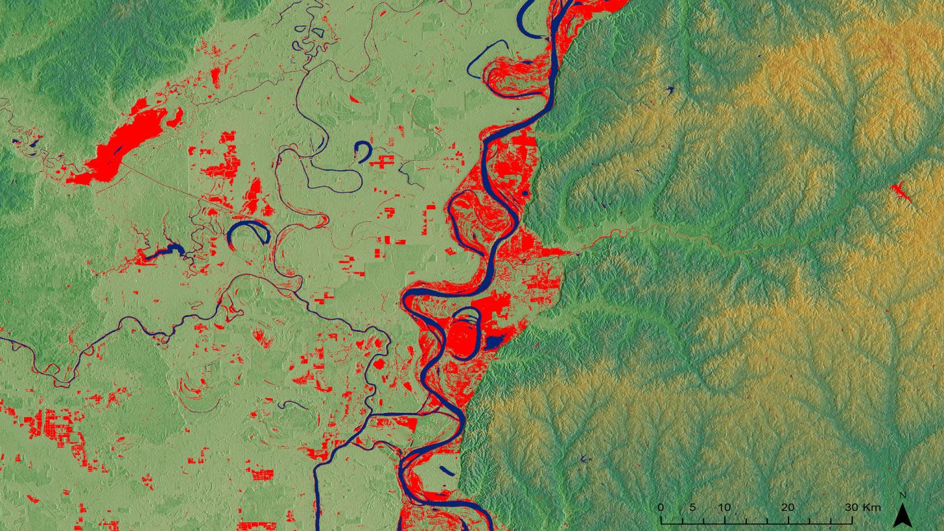

**Caption:** A Flood probability map highlighting the flood extent in part of the study area.

**Image:** 2016Fall_MSFC_MississippiRiverBasinDisasters_FloodProbabilityMap.png