**NASA DEVELOP National Program**



University of Georgia

**Summer 2015**

**Short Title: Southeast U.S. Ecological Forecasting**

**Subtitle:** Utilizing NASA Earth Observations and Proximal Remote Sensing To Map the Spatio-Temporal Distribution of *Hydrilla verticillata*

**VPS Title:** Hunting for Hydrilla: Mapping an Aquatic Intruder

**Project Team & Partners**

**Project Team:**

Shuvankar Ghosh (Project Lead), sghosh.21011984@gmail.com

Peter Hawman (Co-Project Lead), peter.a.hawman@nasa.gov

Wuyang Cai

Elizabeth Dyer

Pradeep Kumar Ragu Chanthar

**Advisors & Mentors:**

Dr. Deepak Mishra (University of Georgia)

Dr. Susan Wilde (University of Georgia)

**Past or Other Contributors:**

Benjamin Page

**Partner Organizations**

J.W. Jones Ecological Research Center, End-user, POC: Dr. Stephen W. Golladay

Henry County Water Authority, End-user, POC: Ken Presley,

Georgia Power, End-user, POC: Anthony Dodd

**Project Details**

**Applied Sciences National Applications Addressed:**

Ecological Forecasting, Water Resources

**Study Area:** Lakes Thurmond, Seminole, Goat Rock, Oliver, and Harding: AL, FL, GA

**Study Period:** August through November for the years 2013 - 2015

**Earth Observations & Parameters**

Landsat 8, OLI - Hydrilla distribution and vegetation indices

**Ancillary Datasets Utilized**

* Unmanned aerial system, DJI Phantom 2 Vision +, Center for Geospatial Research, UGA - Hydrilla distribution for validation
* Hyperspectral digital camera Basler acA1300, University of Georgia -
* Ocean optics non-imaging hyperspectral radiometer, University of Georgia - above water remote sensing reflectance (Rrs) measurements
* *Hydrilla verticillata* field data - locations, density per area, and plant height data

**Models Utilized**

* Deepak Mishra, UGA Radiative Transfer Models (Benthic Mapping)
* Deepak Mishra, UGA Green NDVI

**Software Utilized**

ACOLITE - Atmospheric Correction of Landsat 8 data

ENVI FLAASH – Atmospheric correction of Landsat 8 data

ArcGIS - Map creation of hydrilla distribution from Landsat 8 data

Matlab and Excel - Model calibration and validation of Landsat 8 data

**Project Overview**

**80-100 Word Objectives Overview**

Hydrilla is an invasive aquatic plant that forms dense colonies and can grow to the surface in water over 20 feet deep. Hydrilla branches profusely and after reaching the surface it extends across it forming thick mats, blocking out light to other plants and animals below. The overall objective of this project was to utilize remote sensing data from multiple sources to create a current hydrilla distribution map of the study areas, and to develop a model that partners can use to determine hydrilla distribution in the future throughout the southeastern United States.

**Abstract**

*Hydrilla verticillata* is an invasive aquatic plant that has become a serious problem in Southeastern United States, especially impacting vegetation and water quality. Traditionally, hydrillainfestation has been tackled using a combination of field-based physical, chemical and biological methods which are often costly. Rapid and accurate spatio-temporal estimates of hydrilla density and distribution are needed for better monitoring and management of this invasive plant. This project demonstrated an innovative approach using Landsat 8 OLI data to study the spread of this invasive aquatic plant in inland waters. NASA Landsat 8 Operational Land Imager (OLI) imagery in combination with *in situ* data was used to map hydrilla density and distribution in four lakes across Georgia and Florida. Performances of Visible Atmospherically Resistant Index (VARI) and Green Normalized Difference Vegetation Index (GNDVI) were analyzed for indications of hydrilla density and distribution, using a combination of statistical techniques, such as coefficient of determination (R2), percent normalized root mean square error (%RMSE), and residual trends. The resulting detection tool for monitoring hydrilla distribution was delivered to Georgia Power, the J. W. Jones Ecological Research Center, and the Henry County Water Authority for use in water quality restoration decision-making. This tool will be an efficient alternative to otherwise costly measures, and facilitate adaptive plant management.

**Community Concerns**

* Hydrilla outcompetes native plants and forms surface canopies that block sunlight intensifying lake stratification and causing anoxic conditions.
* Hydrilla harbors toxic epiphytic cyanobacteria that disrupts the food chain causing wildlife fatalities.
* Hydrilla mats clog boat motors disrupting transportation and recreation as well as causing hazardous swimming condition.
* Hydrilla obstructs water withdrawal for drinking water, irrigation, and power generation.

**Current Management Practices & Policies**

Currently, chemicals are used to manage *Hydrilla verticillata*, including copper, diguat, endothall, and fluridone. Applying these chemicals can have adverse effects on the lake ecosystem. A lower-impact strategy has been to introduce triploid (sterile) Grass Carp *(Ctenopharyngodon idella),* a species of fish which consumes aquatic plant material including hydrilla. Because triploid Grass Carp are sterile, their populations can be controlled after introduction to an ecosystem. Partners currently use traditional monitoring practices involving visual analysis, rake collection and sonar analysis.

**Decision Support Tools & Benefits** **Support Tools & Benefits**

|  |  |  |
| --- | --- | --- |
| **End-Product** | **Earth Observations Used** | **Benefit & Impact** |
| Landsat 8 Benthic Model for Hydrilla Mapping | Landsat 8 OLI | Will allow end-users to continually track hydrilla distribution using NASA EO data for mitigation efforts |
| Hydrilla Distribution Maps | Landsat 8 OLI | Define areas where lake managers can target mitigation efforts |

**Project Imagery**

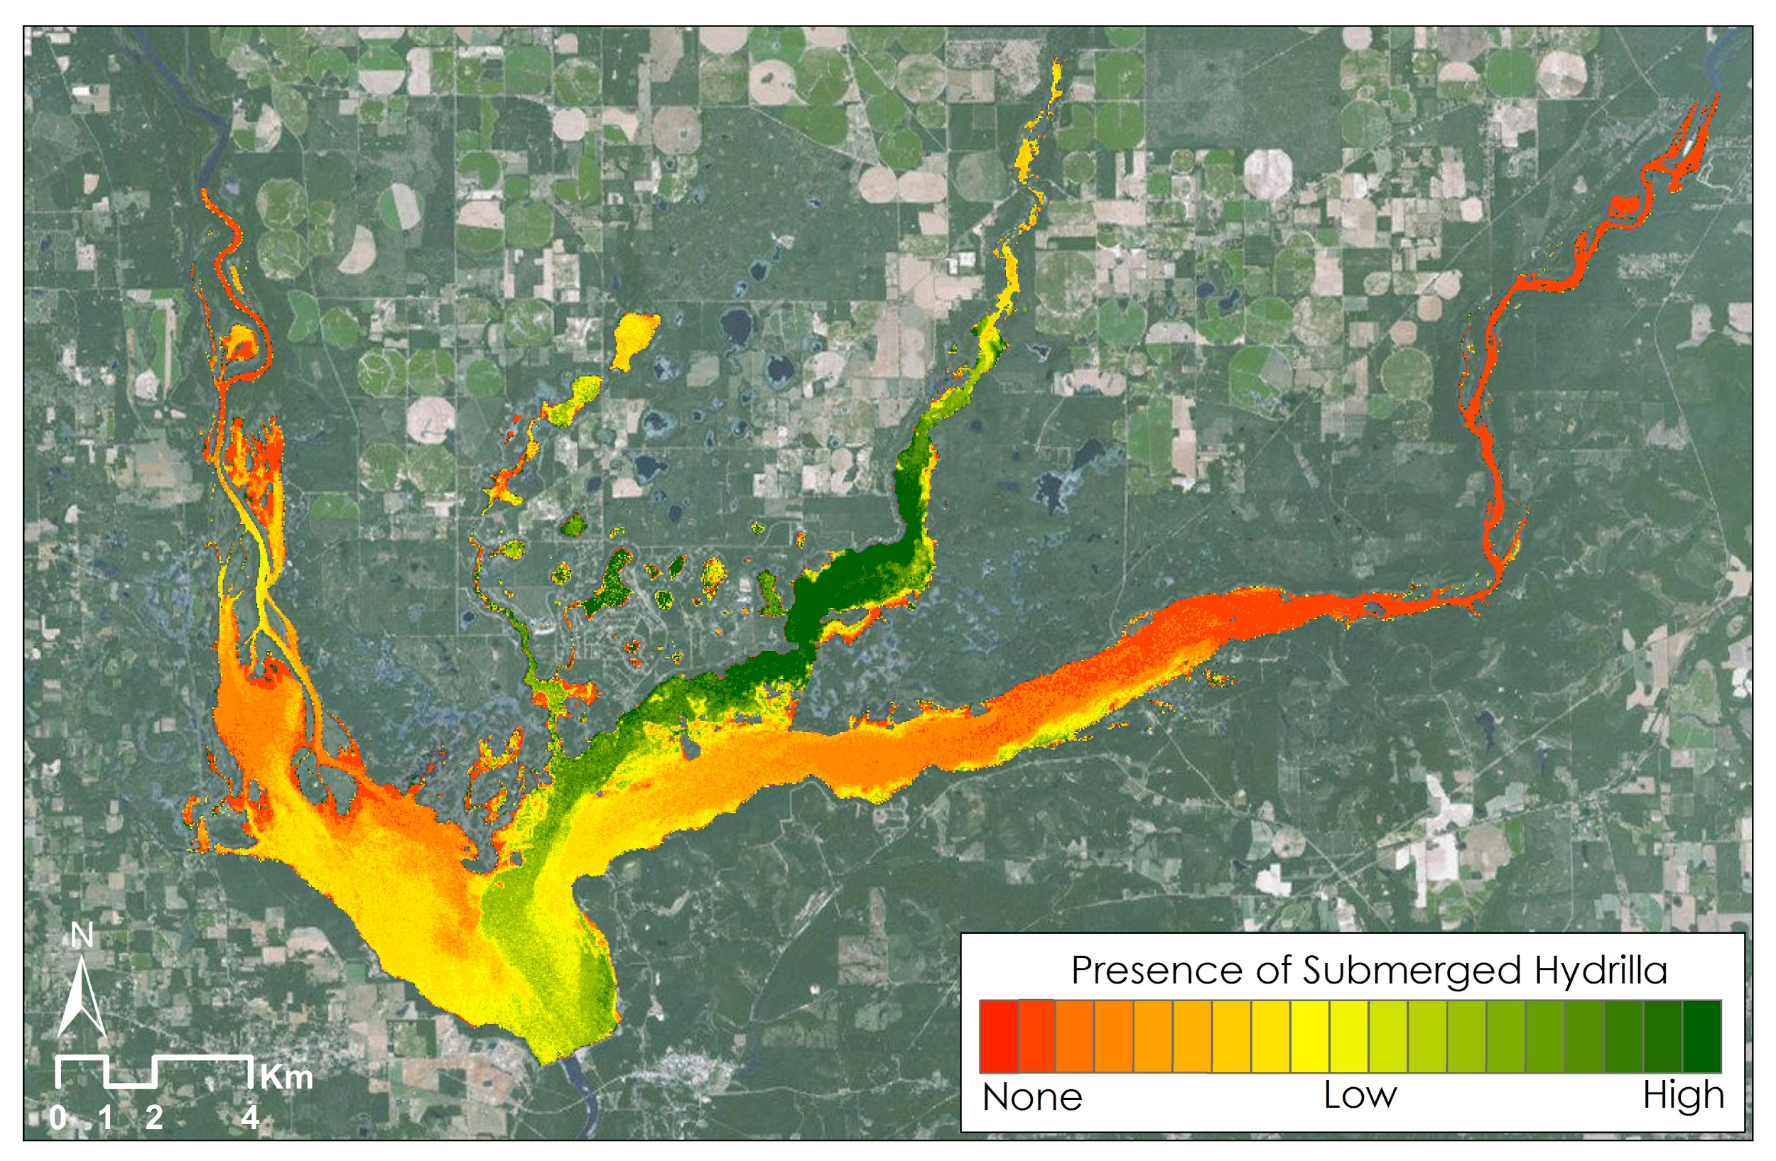

**Caption:** The mapped distribution of submerged hydrilla using VARI (Visible Atmospherically Resistant Index) in Lake Seminole along the Georgia-Florida border in November of 2014. Image Credit: Southeast U.S. Ecological Forecasting Team.

**Image:** 2015Sum_UGA_SoutheastEcoForecasting_ProjectSummaryImage.jpeg