**NASA DEVELOP National Program**



**Marshall Space Flight Center**

***Spring 2014***

**Southeast U.S. Water Resources**

Development of an Alternative Drought Monitoring System using NASA Earth Observation-Derived Drought Indices and Groundwater Storage Estimates for Improved Water Resource Monitoring in the Southeastern United States

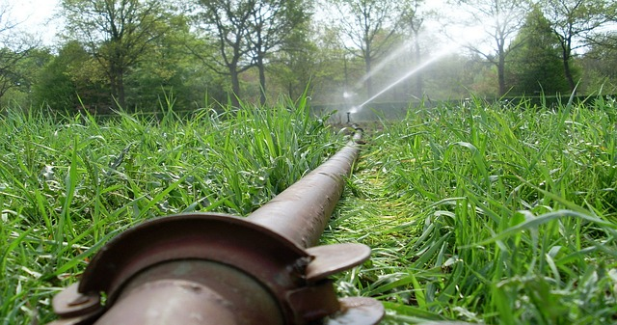

**Technical Report Final**

Apr 3, 2014

Kaylin Bugbee, University of Alabama in Huntsville

Sam Ayers, University of Alabama in Huntsville

Leigh Baggett, University of Alabama in Huntsville

Modeste Muhire, Michigan Technological University

Dr. Jeffrey Luvall, NASA Global Hydrology and Climate Center

Mr. Lynn Torak, USGS Georgia

Mr. Cameron Handyside, Earth System Science Center

# Abstract

Several western states grow nearly half of all U.S. fruits, vegetables, and nuts. However, due to the scarcity of western water resources, Southeastern agricultural production is expected to increase. This increase in production may lead to a higher demand of water resources. Droughts also strain water resources. Drought monitoring tools must be developed In order to improve crop and water resources management in the Southeast. Current monitoring methods utilize averaged weekly stream flow conditions to identify drought areas. However, this method often overlooks areas prone to micro-level droughts. To address this issue, alternative drought monitoring methods using NASA Earth observation data are investigated. Drought indices, including the Normalized Multi-band Drought Index (NMDI), the Land Surface Temperature (LST) - Normalized Difference Vegetation Index (NDVI) ratio (LST/NDVI), and the Vegetation Health Index (VHI), are calculated using Terra’s Moderate Resolution Imaging Spectroradiometer (MODIS). Groundwater withdrawals are also estimated using the Gravity Recovery and Climate Experiment (GRACE) instrument. Additionally, the drought indices are cross-checked with water stress values from the Grid Decision Support System for Agrotechnology Transfer (GriDSSAT) crop model. The drought indices investigated in this project can be used to create an easily accessible model that will serve as a decision support tool for water monitoring agencies such as the United States Geological Survey (USGS). This tool will ultimately improve knowledge of drought conditions which will lead to more reliable water usage management practices and agricultural planning.

**Keywords**

Water Resources, Agriculture, Southeast, Irrigation, Drought Indices, Remote Sensing

# 1. Introduction

There are many crops that are crucial for the United States grown in the Southeast United States, such as corn, cotton, peanuts, and soybeans. However, many farmers struggle satisfactory yields due to droughts. In the early 20th century, many farms in the Southeast lost a majority of their crops due to droughts and lack of irrigation. The Midwest has also lost many of their crops due to lack of rain. For the Southeast to be able to be a top provider of crops again, tools must be developed to withstand the drought.

**Project Objectives**

The objective of this project is to develop alternative drought monitoring methods for the Southeast United States. Alternative drought indices and groundwater storage estimates will be derived using NASA Earth Observations and compared to both the GriDSSAT model and water withdrawal data. The end results will be used by agencies such as the USGS to create an easily accessible model that will aid in monitoring water resources.

**Study Area**

The specific study area of interest of this project consists of two locations within the Southeast. First, USGS water meter data was provided for southern Georgia. Second, GriDSSAT model data was considered for Limestone and Madison County in northern Alabama.

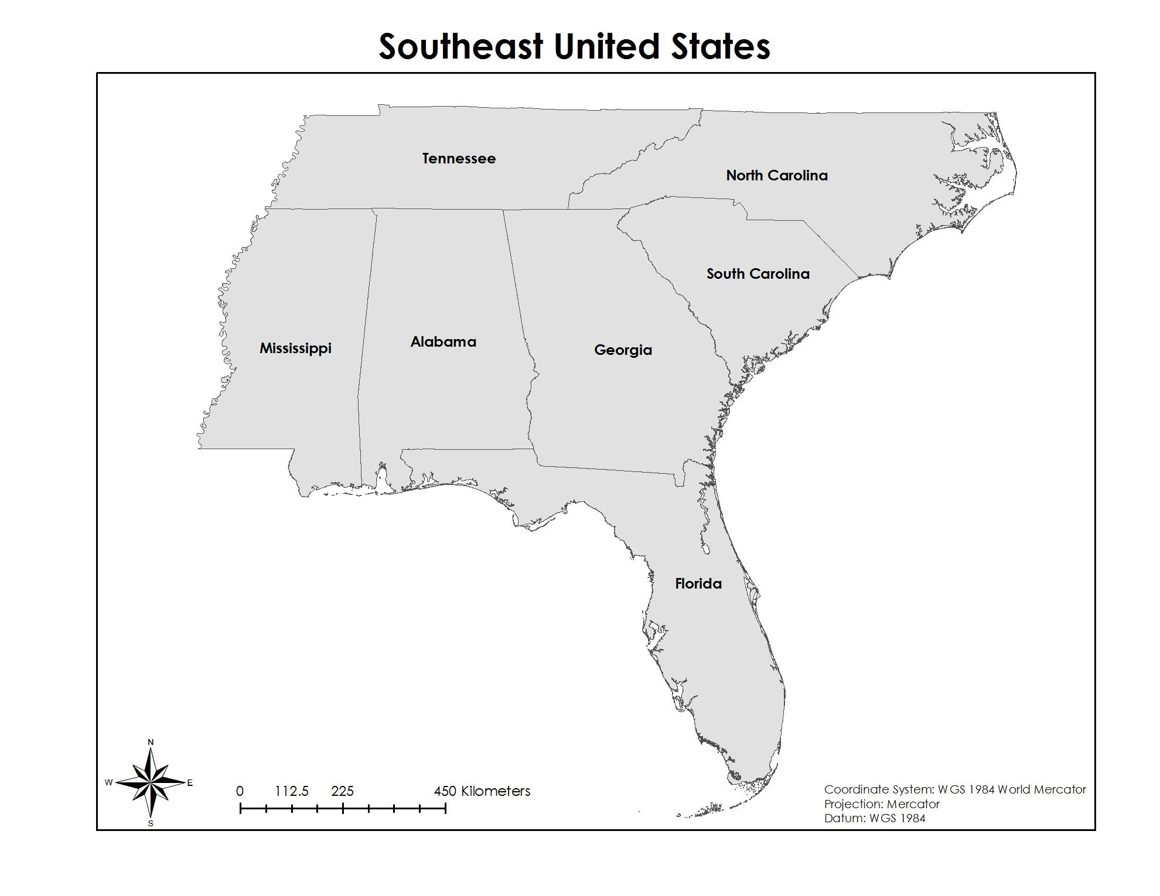

Figure 1 - The study area includes both Georgia and Alabama.

**Study Period**

The primary study period included the months of April through October, 2012. Additional data was considered for the years 2008 – 2011.

**National Applications Addressed**

The primary national applications addressed in this project are water resources and agriculture. The project’s main focus is to determine the ability of satellite-derived drought indices to detect water withdrawals for agriculture.

**Partners/Collaborators**

Partners for this project include the United States Geological Survey (USGS) Georgia Water Science Center and the University of Alabama in Huntsville Earth System Science Center (ESSC). The USGS (Mr. Lynn Torak) provided the irrigation water meter data while the ESSC (Mr. Cameron Handyside) provided the water stress data from the GriDSSAT model. The USGS Georgia Water Science Center is interested in establishing a link between remotely sensed drought indicators and water use for agricultural purposes. Currently, the USGS Georgia Water Science Center does minimal work with remotely sensed data but the Center is looking to incorporate more Earth observation data into their monitoring system.

# 2. Methodology

**Data Acquisition**

***MODIS***

MODIS Level 1B data for the study period was downloaded from the Land Processes Distributed Active Archive Center (LP DAAC, 2014). Images with minimal cloud cover were accepted for this study to minimize errors in image processing.

***GRACE JPL Release Level 05 Data***

GRACE JPL Release Level 05 products were downloaded from the JPL GRACE Tellius page (JPL, 2014). Level 05 GRACE products are processed to remove both changes in continental ice and atmospheric mass. The final level 05 data displays changes in equivalent water thickness in centimeters on a monthly grid.

***USGS Meter Data***

Agricultural irrigation data were provided by Mr. Lynn Torak from the USGS Georgia Water Science Center. The data were provided in Microsoft Excel file format for the years 2010 - 2012. Monthly data was also provided for 2012.

***GriDSSAT***

Water stress values which were derived from the GriDSSAT model were provided for the months April through August for 2009 and for 2012. The temporal resolution of the data is daily and the spatial resolution of the data is 4 km by 4 km. Daily files were downloaded as ASCII and Excel files.

***USDA Cropscape***

Available crop data layers were downloaded from the National Agricultural Statistics Service (NASS), a division of the United States Department of Agriculture, via the CropScape online data portal (USDA, 2014). The crop data was downloaded as shapefiles to be used in ESRI’s ArcGIS.

**Data Processing & Analysis**

***Land Surface Temperature/Normalized Difference Vegetation Index Ratio [LST/NDVI]***

The LST/NDVI ratio consists of two parameters: surface temperature and the NDVI parameter which is derived from reflectance bands. The ratio-LST/NDVI increases during times of drought. Land Surface Temperature (LST) can be represented by emissive band 32 on MODIS. The temperature is recorded in Celsius (centigrade). LST represents energy distribution on the Earth’s surface in the area of interest. NDVI was describes as “the most successful of many attempts to simplify and quickly identify vegetated areas and their condition, and it remains the most well-known and used index to detect live green plant canopies in multispectral remote sensing data” (ONTEL 2012). NDVI is defined by the following formula:

NDVI = $\frac{NIR - red}{NIR + red}$

where NIR indicated the Near Infrared band and red indicates the red band. NDVI values range from -1.0 to +1.0. Higher values represent denser vegetation while negative values represent water, clouds, and snow. Near zero values typically rock and bare soil, moderate values typically represent shrub and grassland, while higher values are usually temperate and tropical rainforest (ESRI 2014).

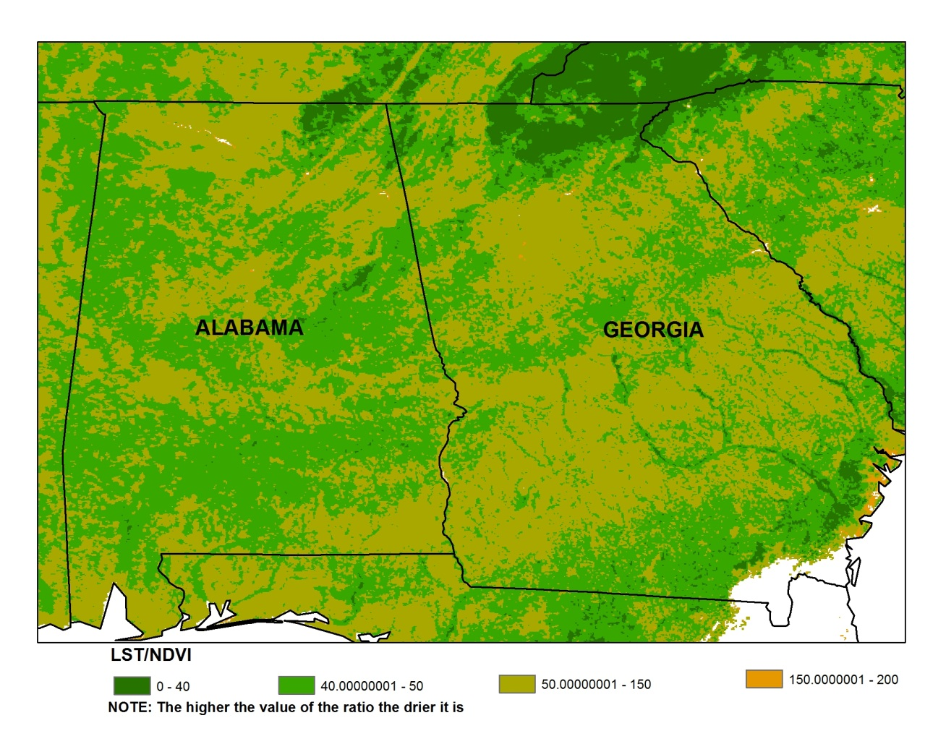

Figure 2 - An image created from the LST/NDVI ratio methodology.

***Normalized Multiband Drought Index [NMDI]***

NMDI provides information both on vegetative and soil drought conditions. MODIS solar reflective bands 2 (0.84 - 0.876μm), 6 (1.628 - 1.652μm), and 7 (2.105 - 2.155μm) are used to calculate the value of NDMI (Wang 2008).

NMDI for vegetation can be calculated by the following method:

${NMDI}_{veg}$ = $\frac{R_{0.86μm}-(R_{1.64μm}-R_{2.13μm})}{R_{0.86μm}+ (R_{1.64μm}- R_{2.13μm})}$

The NMDI vegetation values theoretically range from 0.0 to 1.0 with 0.0 indicating extremely dry conditions while 1.0 indicates extremely wet conditions.

NMDI for soil can be calculated by the following method:

${NMDI}_{soil}$ = 0.9 - $\frac{R_{0.86μm}-(R_{1.64μm}-R_{2.13μm})}{R_{0.86μm}+ (R_{1.64μm}- R_{2.13μm})}$

The NMDI soil values range from 0.0 to 0.9. Values approaching 0.9 indicate dry soil conditions while values approaching zero indicate wet soil conditions. NMDI for both vegetation and soil were computed using the raster calculator tool in ArcGIS 10.2.1.

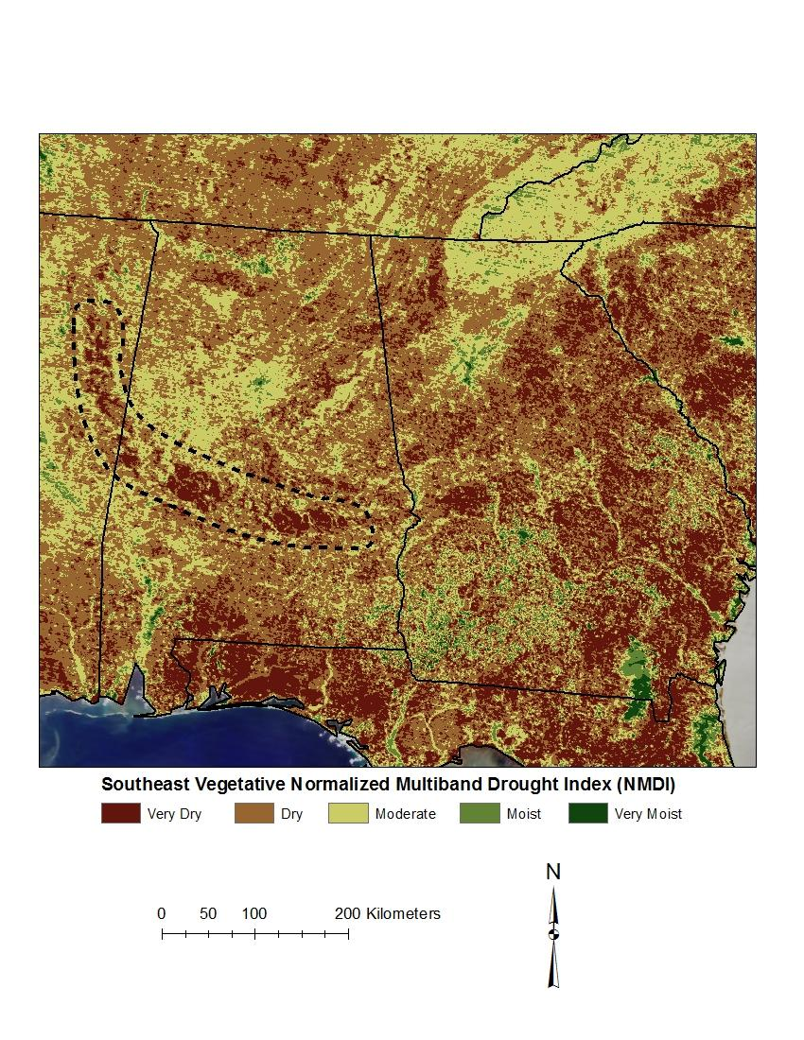

Figure 3 - An image created from the NMDI soil methodology.

***Vegetation Health Index [VHI]***

The VHI is a drought assessment index created by using the Vegetation Condition Index (VCI) and the Temperature Condition Index (TCI). The VCI is based on the NDVI and is calculated using the following equation:

VCI = 100 $\frac{({NDVI}_{i}-{NDVI}_{min})}{({NDVI}_{max}-{NDVI}_{min})}$

*

“where ${NDVI}_{i}$ is the smoothed weekly NDVI, and ${NDVI}_{max}$ and ${NDVI}_{min}$ are absolute maximum and minimum NDVI, respectively, calculated for each pixel and week during the period [...] of the smoothed NDVI” (Rojas 2010). For our VHI images, the absolute maximum and minimum NDVI were calculated for each of the days which were included in the project. The TCI uses brightness temperatures based off of thermal infrared data. It is calculated using the equation:

TCI = 100 $\frac{(T_{max}-T_{i})}{(T_{max}-T_{min})}$

*

where T is the brightness temperature. The VHI combines these indices with the equation:

VHI = ($w_{1}$*VCI) + ($w_{2}$*TCI)

where $w_{1}$ and $w_{2}$ are coefficients for assigning weights to the VCI and TCI. The VHI has values ranging from 0 - 100, where locations with values under 40 represent areas with vegetative stress and predicted crop losses whereas locations with values about 60 represent favorable crop conditions.

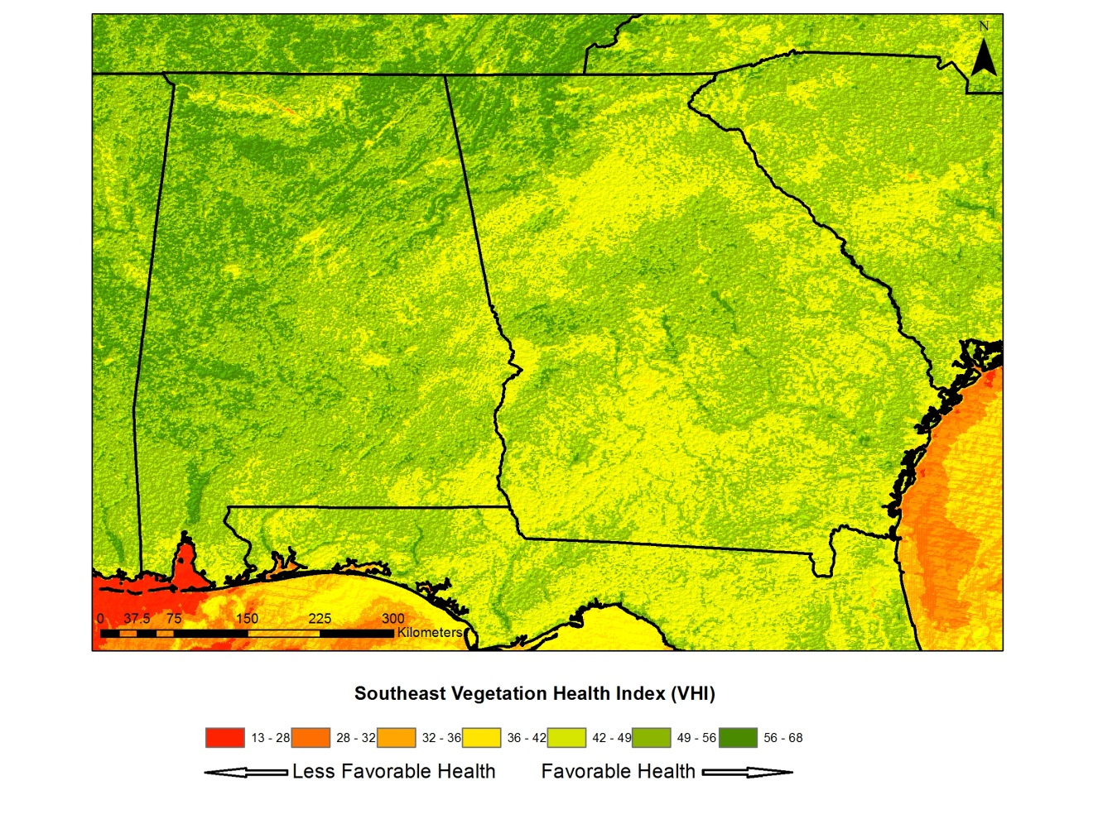

Figure 4 - An image created from the VHI methodology.

***GRACE***

GRACE observations are related to changes in the hydrological cycle by the following equation:

GWα = TWSα,GRACE – ( SWα + SMα + SPα )

Where:

GWα = groundwater storage anomaly

TWSα = total water storage anomaly

SWα = surface water storage anomaly

SMα = soil moisture storage anomaly

SPα = snowpack storage anomaly

Changes in snowpack storage were assumed to be zero due to the climatological nature of the study area. Net changes in surface water and soil moisture storage were also assumed to be negligible. Therefore, a simple relationship between changes in total water storage anomalies and groundwater storage anomalies was investigated. Monthly changes as detected by GRACE were combined for Georgia’s growing season. These monthly changes were then compared with groundwater withdrawal rates for the growing season.

# 

Figure 5 - An image illustrating the total changes in gravitational anomalies measured by GRACE for Georgia during the growing season of 2012.

# 3. Results & Discussion

These graphs (shown below) show the comparisons between the drought indices and the USGS Water Meter Data, measured in acre-inches. The average of each drought index for the days of April 8th, May 10th, and June 27th in 2012 were used for the comparison. The graphs show no linear correlation between the vegetation health values and the water usage values. The graphs do show that the irrigation spots mostly had moderate health, possibly demonstrating that the irrigation systems were being used to keep the crops healthy enough to survive during the drought period.

***Drought Indices Comparison with Annual USGS Water Meter Data***

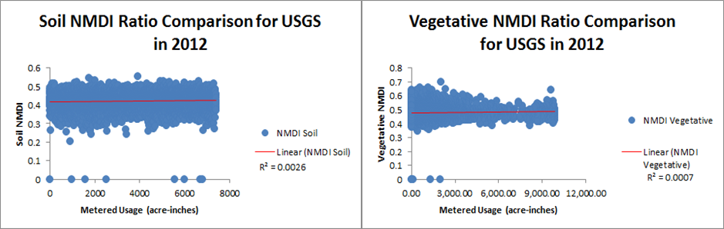

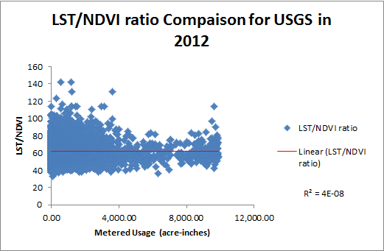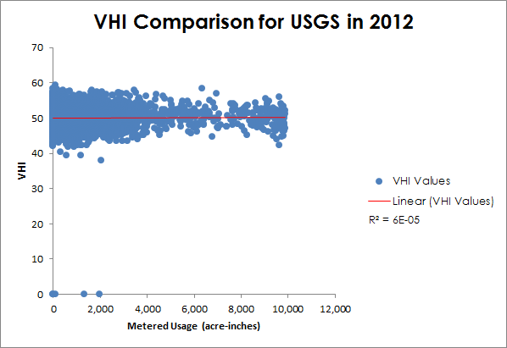

***Drought Indices Comparison with USGS Water Meter Data for June 2012***

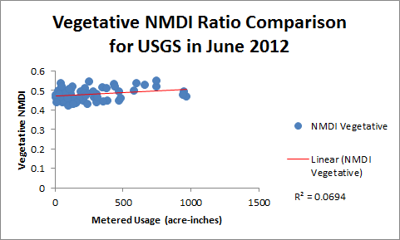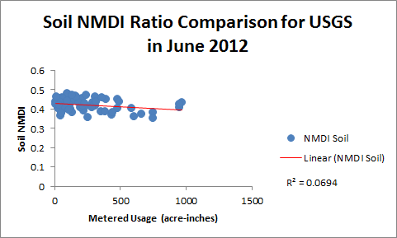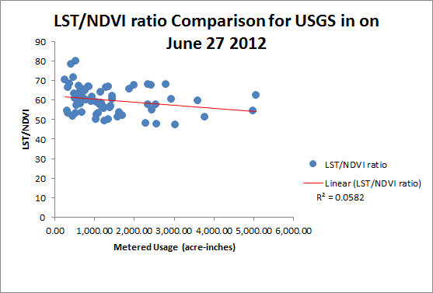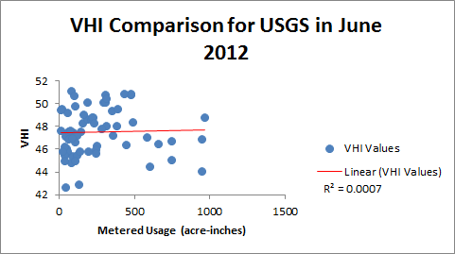

These graphs (shown below)show the comparisons between the drought indices and the USGS Water Meter Data, for just the month of June of 2012. The graphs also show no linear correlation between the vegetation health values and the water usage values.

***Drought Indices Comparison with GriDSSAT Water Stress Values***

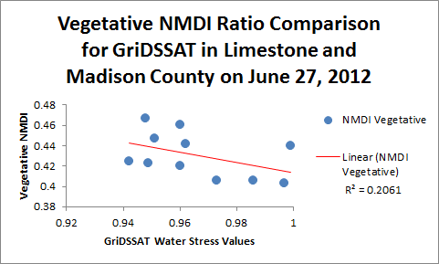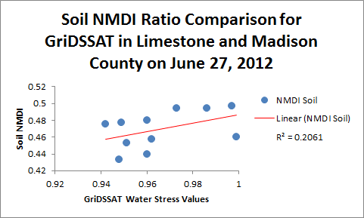

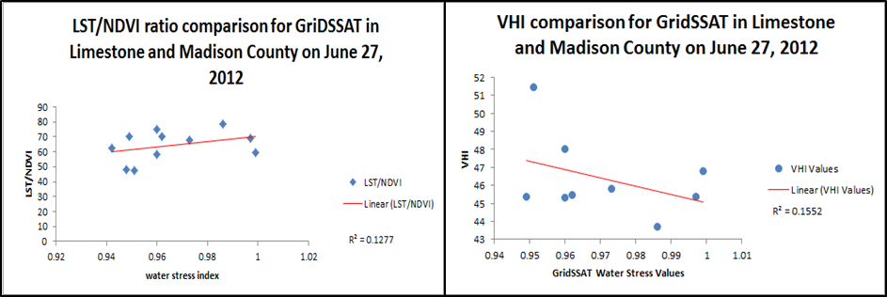

These graphs (shown below)show the comparisons between the drought indices and the GriDSSAT Water Stress Values for June 27, 2012. The graphs show no linear correlation between the vegetation health values and the water stress values.

**GRACE Groundwater Calculation Comparison with USGS Water Withdrawal Data**

The gravitational anomalies for 2012 were compared to the USGS groundwater meter data. Due to the coarseness of the GRACE data, a simple linear interpolation was used to calculate groundwater changes. The comparison between the GRACE data and the groundwater withdrawal data shows no linear correlation.

**Errors & Uncertainty**

The results of the comparison between satellite-derived drought indices and the USGS water meter data do not exhibit a linear trend due to several factors. First, the coarse 1km spatial resolution of the MODIS sensor may limit the ability of the drought indices to reflect what is actually happening in the vegetation. Second, cloud cover greatly affected the amount of images available for image processing for this project. A larger sample size of imagery might improve the correlation between the drought indices and the water use. In addition, the temporal nature of the USGS data was also a limiting factor. Yearly and monthly water usage data was available from the USGS. Since the drought indices were derived from daily images, daily water usage data would perhaps be more useful for establishing a correlation between the two factors. Finally, the relatively small sampling size of the USGS monthly data as compared to the yearly data was also a limiting factor to accuracy.

The results of the comparison between the satellite-derived drought indices and the GriDSSAT water stress values were also most likely limited by the coarse spatial resolution of the MODIS sensor. Since water stress values from the GriDSSAT model are based solely on corn, it was necessary to clip the drought indices images down to only include corn crops.

Errors in the comparison between groundwater withdrawals and GRACE data stem from several factors. First, due to the lack of data, soil moisture conditions were not included in the water budget calculations. This led to inaccurate results in calculating the groundwater changes. Second, the groundwater withdrawal data provided by the USGS was also limited to yearly files. Finally, GRACE data is limited both temporally and spatially. GRACE data is available in 30 day increments with a spatial resolution of 100 km.

# 4. Conclusions

The goal of the project was to come up alternative ways to monitor both drought and groundwater storage change, but a close look at the results calls for a more in depth study and the upgrade in the technology used in the process. Another goal of this project was that the results and methodology will be used to proof an alternative drought and water withdraw monitoring system and create an easily accessible model/interface for the Georgia Water Science Center to use in hope to assist in near real-time water withdraw estimates to better manage the water for irrigation. One last goal of this project was to help improve the GriDSSAT model by estimating irrigated crop area by using Terra’s MODIS.

Although LST/NDVI, NMDI, and VHI do not have a linear correlation between the USGS water meter data and GriDSSAT Water Stress Values, the drought indices do indicate that irrigation is effective in reducing the effects of drought. The irrigation methods keep the vegetation at a moderate health level. However, drought indices also suggest that crop yields could be increased.

Future work could include creating buffered zones around irrigation points and extracting the average derived drought index values within the surrounding area. Also, comparing the drought indices with irrigated as well as non-irrigated crop fields could yield important information concerning the effectiveness of remotely sensed indices to detect drought conditions. GRACE’s gravity anomaly data could be downscaled to provide more accurate groundwater measurements. Future work in this area could use new tools, like Soil Moisture Active Passive (SMAP) satellite and unmanned aerial vehicles, to improve knowledge on the variability of within-field soil moisture. Also, using data that has a higher spatial resolution may help the drought indices show more of a change in the vegetation when there is a drought, for example, Landsat 8 data.

# Acknowledgments

We would like to thank the following for their assistance, advisement, and collaboration for this project:

Dr. Jeffrey Luvall (Global Hydrology and Climate Center)

Mr. Lynn Torak (USGS Georgia Water Science Data)

Mr. Cameron Handyside (Earth System Science Center)

Kel Markert (UAH)

# 

# References

Kuss, Amber, Michelle Newcomer, Wei-Chen Hsu, Abdelwahab Bourai, Abhijit Puanam, Cindy Schmidt, and Felix Landerer. "Downscaling GRACE Data in the Central Valley Aquifer, California." (2012): n. pag. Web.

Mendez-Barroso, Luis, Jaime Garatuza-Payan, and Enrique Vivoni. "Quantifying Water Stress on Wheat Using Remote Sensing In The Yaqui Valley, Sonora, Mexico."*Agricultural Water Management* 95 (2008): 725-36. Print.

Ontel, I. "Analysis of Rainfall Deficit and Its Impact on the Oltenia Plain Vegetation Using Satellite Images from the Period 2000-2009." *The 19th National Geographic Student Symposium,* 19 (2012): 51-65. Print.

Prem B Woli, J.W. "A Simple Water Deficit Index (WDI) for Quantifying Agricultural Drought." *South East Climate Consortium* (2010): n. pag. Print.

Rojas, O., A. Vrieling, and F. Rembold. "Assessing Drought Probability for Agricultural Areas in Africa with Coarse Resolution Remote Sensing Imagery." *Remote Sensing of Environment* 115 (2010): 343-52. Print.

Saradjian, M.A. "Comparison of Land Surface Temperature Mapping Using Modis and Aster Images in Semi-Arid Area." *The International Archives of the Photogrammetry, Remote Sensing and Spatial Information Sciences* (2008): 873-76. Print.

Wan, Z., P. Wang, and X. Li. "Using MODIS Land Surface Temperature and Normalized Difference Vegetation Index Products for Monitoring Drought in the Southern Great Plains." (2004): n. pag. Print.

Wang, L., and J. Qu. "Multiband Drought Index Enhances Soil and Vegetation Moisture Monitoring." *SPIE* (2009): 1-2. Print.

Wang, L., J. John, and X. Qu. "Forest Fire Detection Using the Normalized Multi-band Drought Index (NMDI) with Satellite Measurements." *Agricultural and Forest Meteorology* (2008): 1767-776. Print.