New Orleans Urban Development

Utilizing Earth Observations to Assist Groundwork New Orleans to Reduce Flood Vulnerability in New Orleans, Louisiana, Metropolitan Area

**Technical Report**

Final Draft – August 9th, 2018

Rupsa Bhowmick (Project Lead)

Lulin Zheng

Madison Murphy  
Chelsea Randall

Joe Spruce, Science Systems & Applications, Inc. (Science Advisor)

Dr. Kenton Ross, NASA Langley Research Center (Science Advisor)

Bernard H. Eichold II, M.D., Dr. P.H., Mobile County Health Department (Mentor)

# 1. Abstract

Flooding in New Orleans, Louisiana has increased in intensity and frequency due to sea level rise and land subsidence. Considered one of the rainiest cities in the country, New Orleans often experiences localized street flooding, causing damages to homes and businesses. The Groundwork New Orleans (GWNO) is dedicated to increasing urban resilience to flooding by implementing green infrastructure. However, the current practices for site selection and assessment implemented by the GWNO are costly and time consuming. NASA and ESA Earth observation data were acquired and used to create end products that can supplement the GWNO’s current methods. The project utilized Landsat 8 Operational Land Imager (OLI) and Thermal Infrared Sensor (TIRS), Sentinel-2 Multispectral Instrument (MSI), Sentinel-1 C-Band Synthetic Aperture Radar (C-SAR), and Terra Moderate Resolution Imaging Spectroradiometer (MODIS) imagery. Data were acquired for summer months with consideration to the Atlantic hurricane season to quantify the impact of the GWNO’s tree planting campaigns and provide additional data to supplement the partner’s GWNO’s current practices towards mitigating flood risk in the area. The team used remote sensing and geospatial analysis to map areas with high surface runoff and flood vulnerability. A land cover classification product and Normalized Difference Vegetation Index (NDVI) assessment were produced to monitor changes in urban tree canopy and impervious surface cover. The Normalized Difference Flood Index (NDFI) along with land surface temperature data were computed to create a discrete-time series analysis of flood extent and monitor the urban heat island effect in flood vulnerable communities. Project end products will provide the GWNO with geospatial evidence of the effectiveness of their current tree-planting project for increasing the urban tree cover and improving community resilience to flooding over time.

**Keywords**

Remote sensing, Landsat, Sentinel-1 SAR, MODIS, NDVI, NDFI, green infrastructure, land surface temperature

# 2. Introduction

* 1. ***Background Information***

New Orleans, Louisiana, located on the banks of the Mississippi River, is home to nearly 400,000 people (DADS, 2010). It is the major hub of Louisiana’s Lower Mississippi River, the world’s busiest port system, and serves as a dominant cruise terminal, carrying over one million passengers in 2017 (Port, 2018). New Orleans is vulnerable to erosion and inundation due to coastal habitat loss and degradation in conjunction with high rates of land subsidence (Burkett, Zilkoski, & Hart, 2001). Additionally, recent studies show correlation between the increase in frequency and intensity of flood events with sea level rise due to changing global climates (Parris et al., 2012). In 2005, Hurricane Katrina overwhelmed the city leaving it with catastrophic economic and human losses, $125 billion in damages and over 1,800 casualties (EM-DAT, 2011). The storm surge from this hurricane flooded an estimated 80% of New Orleans (Kates, Colten, Laska, & Leatherman, 2006), resulting in over 600 human casualties (Boyd, 2011), and displaced approximately 650,000 people (Paxon & Rouse, 2008). While New Orleans has rebuilt itself and reinforced much of its infrastructure following the 2005 hurricane season, the threat of flooding still looms today. The high amounts of impervious cover coupled with its comparatively frequent severe storms, heavy rainfall, and prolonged storm surge events leave New Orleans vulnerable to flooding. To address these increasing threats, the Groundwork New Orleans (GWNO) has been implementing green infrastructure including rain gardens, tree planting campaigns, and construction of bioswales to improve flood resilience since 2013.

The practice of implementing green infrastructure has been used to reduce flood risk (Kim, Lee, & Sung, et al., 2016, Guo & Correa, 2013) and urban heat island effect (Kong, et al., 2014). However, these mitigation effects vary due to differences in weather and terrain conditions of the studied location (Guo & Correa, 2013). To aid the GWNO in its goals of implementing green infrastructure in underserved communities, our research provided geospatial evidence to assess how their current projects have increased the community’s resilience over time.

The study area included the city of New Orleans as denoted by the U.S. Census Bureau and based on population density (Figure 1). The study area also contained individual neighborhoods in which the GWNO focuses their work. These neighborhoods are comprised of the Lower Ninth Ward, St. Roch, Bywater, Central City, and the area immediately surround the intersection of Claiborne and St. Bernard Avenues. Our research utilized data from the spring and summer months from 2013 to 2018, with exceptions based on major flood events for the normalized difference flood index (NDFI) analysis (Appendix A1).

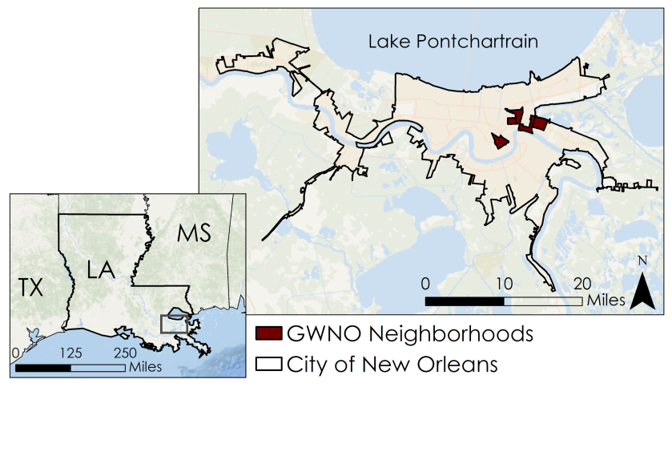

*Figure 1.* Map of New Orleans metropolitan area including five neighborhoods served by the GWNO. The neighborhoods include the Lower Ninth Ward, St. Roch, Bywater, Central City, and the intersection of Claiborne and St. Bernard Avenues.

***2.2 Project Partners & Objectives***

The GWNO is a regional trust of Groundwork USA, a non-profit organization whose mission is to “bring about the sustained regeneration, improvement, and management of the physical environment by developing community-based partnerships that empower people, businesses, and organizations to promote environmental, economic, and social well-being” (Groundwork, 2018). The GWNO team includes a group of young adults known as the Green Team who work to gain leadership skills while working on projects in their own communities. The GWNO implements risk-mitigation projects including the construction of rain gardens, tree plantings, bioswales, urban gardens, community beautification, and coastal restoration. Currently, the GWNO utilizes field surveys and *in situ* data collection for site selection and validation of their decision-making practices. These methods can be costly and time-consuming. The application of NASA Earth observations could provide a time-saving and cost-efficient alternative to their current approach and build their capacity to utilize remotely sensed data in the future.

The objectives of this project included: (1) create an urban tree canopy assessment to allow the GWNO to identify areas with low tree coverage and compute canopy vegetation changes over time, (2) analyze gray infrastructure and impervious surface cover to help determine civic zones with higher risk to surface runoff, (3) assess annual and seasonal land surface temperatures and demonstrate correlations of urban geographies and surface temperatures over time, and (4) compile flood extent and classification maps for the end user to expand their current techniques in mitigating future flood risks. Additionally, our team aimed to build the remote sensing capacity of the GWNO Green Team through four webinars throughout the term in which our team provided in-depth explanations of our methodologies.

# 3. Methodology

***3.1 Data Acquisition***

***3.1.1 Land Cover Classification and Normalized Difference Vegetation Index***

A multispectral approach was taken to adequately classify and analyze the land use and land cover of the study area. The team utilized NASA Earth observations from Landsat 8 Operational Land Imager (OLI) and Sentinel-2 Multispectral Instrument (MSI) from the European Space Agency (ESA). The spatial resolution for the Landsat 8 OLI bands used in this analysis is 30 m while Sentinel-2 data ranges in spatial resolution from 10 m to 60 m, contingent on each band. Landsat 8 was launched in 2013, allowing for a greater timespan of data to be acquired for analysis. Sentinel-2 can only provide data from June 2015 to present, and thus were used as supplementary to accuracy assessments (Pardo-Pascual, 2018). The team acquired Level 1 and Level 2 Landsat 8 OLI imagery from United States Geological Survey (USGS) Earth Explorer for Path 22, Row 39 for dates within our study period (with < 10% cloud cover). Sentinel-2 MSI data were acquired from ESA Open Access Copernicus Hub and USGS Earth Explorer for the dates of interest. The dates used for Normalized Difference Vegetation Index (NDVI) were chosen based on leaf-on dates during late spring and summer of each year (April 1- September 20) to ensure vegetation presence. Due to the lack of cloud-free images during leaf-on seasons for 2016, there was no NDVI calculated for that year. A single date within the same study period for the years 2013 and 2017 was selected for land cover classification and post classification change detection of urban land cover. Additionally, National Agricultural Imagery Program (NAIP) imagery was collected from National Resource Conservation Service (NRCS) Geospatial Data Gateway (GDG) for generating reference points for and accuracy assessment.

***3.1.2 Normalized Difference Flood Index***

To produce a discrete time series analysis of flood extent based on individual flood or heavy rainfall events the team downloaded ESA’s Sentinel-1A C-Band Synthetic Aperture Radar (C-SAR) data (Copernicus, 2018) for dates from January 1, 2016 to July 16, 2018. Sentinel-1A C-SAR data have a 20 m spatial resolution and 12- day temporal resolution and are particularly useful in flood monitoring as they have the capability to monitor land through the cloud cover during severe weather conditions and at night (Cian et al., 2018). The NDFI calculation required a comparison of many reference images including images before, during, and after each flood event of interest. The reference images were acquired for dates throughout the year to provide a reliable flood analysis. Flood and reference images were selected based on the accumulation of daily precipitation from the National Integrated Drought Information System’s (NIDIS) Applied Climate Information System (ACIS) website over seven stations within the New Orleans region (Appendix Figure A1). For each year, the first available image following a major flood event and 11 to 20 reference images from up to three days before and after each flood event were collected (Appendix Table A1). Based on the NIDIS daily precipitation data, the team selected three flood or heavy rainfall dates for each year.

The Sentinel-1 C-SAR images were acquired from the ESA Copernicus Open Access Hub (Copernicus, 2018). All images were downloaded at level L1 as a Ground Range Detected (GRD) geo-referenced product (Minchella, 2016) (Appendix Table A2). Sentinel-1A C-SAR acquires all radar images with a stable incident angle (Fairfax, 2017), therefore all the images on the same orbit track can be directly compared as they exhibit same shadowing and layover effects (Cian et al., 2018). Sentinel-2 MSI Level 1C imagery was downloaded for validation of the 2016 flood extent map (Appendix Table A1).

***3.1.3 Land Surface Temperature***

Landsat 8 TIRS level 1 imagery and Terra Moderate Resolution Imaging Spectroradiometer (MODIS) MOD11A2 products were used in the land surface temperature (LST) assessment. The team used Landsat 8 TIRS level 1 data to obtain annual and overall average LST products from 2013 to 2016 during the months of May to October. The team collected 15 Landsat TIRS level 1 scenes with less than 20% cloud cover from USGS Earth Explorer for WRS path 22 row 39 that covered the city of New Orleans, LA. Additionally, the team downloaded the Terra MODIS MOD11A2 products from USGS Earth Explorer to test the temporal resolution and conduct accuracy assessment of the Landsat LST analysis. The team refined the selection to months corresponding to the Landsat 8 scenes used in LST assessment (Appendix Table A1). The MODIS imagery has a higher temporal resolution than Landsat, which was used to generate a temporal resolution accuracy assessment of Landsat LST products. The team downloaded 37 daily maximum air temperature samples of three stations (Appendix Figure A2, Table D3) from National Oceanic and Atmospheric Administration (NOAA) Climate Data Online Search System to validate the LST results, which were limited to days with the generated Landsat LST products.

***3.2 Data Processing***

***3.2.1 Study Area Shapefile Creation***

The team downloaded the New Orleans city boundary shapefile from U.S. Census Bureau 2010 Tiger/Line Urban Area National shapefile system. This shapefile, generated by U.S. Census Bureau based on the population density of New Orleans in 2010 (U.S. Census Bureau, 2010), was used as the project study area shapefile. The GWNO neighborhood shapefile, provided by the GWNO, outlined a more specific research area shapefile. The team projected all shapefiles and raster layers to the WGS 1984 UTM Zone 15N coordinate system.

***3.2.2 Land Cover Classification Time Series***

Land cover classification of remotely sensed imagery is widely used for quantification of land cover types and changes in land cover over time (Haque & Basak, 2017). For the New Orleans Urban Development project, the aim of the land cover classification product was to provide the GWNO with a means to monitor and assess the impact of their projects on local communities and to aid with future project planning. In Appendix B, Figure B1 provides a general work flow for the creation of the land classification product from start to finish. For the land cover classification product, the team atmospherically corrected Landsat 8 OLI level 1 (30 m) images for top of atmosphere (TOA) reflectance. We pansharpened each image using the ArcGIS Pro 2.1.0. Pansharpen tool with the Gram-Schmidt algorithm to achieve a spatial resolution of 15 m. The tool generated a 4-band composite pansharpened image composed of the visible and near-infrared bands. We clipped the pansharpened images to the study area shapefile to constrain the number of land cover classes.

On each image we ran an initial unsupervised classification using an iso-cluster algorithm, which grouped pixels into an initial 30 classes. The initial 30 classes were assigned and reclassified into one of four land cover classes; which included water, urban, tree, and non-tree vegetation. Specification of the inputs entered into the ArcGIS Pro 2.0.1 Classify tool are given in Table B1 in Appendix B. A method to tease out misclassified pixels from a larger class referred to as “cluster busting” was applied to the initial classification to refine classification results (Jensen, Ramsey, Mackey, Christensen, & Sharitz, 1987). Each land cover class was isolated by class value and used as a mask to extract the areas of the pansharpened RGB image assigned to each. A secondary unsupervised classification was run on the extracted class RGBs, grouping pixels into 12 classes that were again assigned to one of the four land cover classes. Reclassified secondary classifications were merged in QGIS 2.18.20 using the Geospatial Data Abstraction Library (GDAL) merge function.

We conducted an accuracy assessment for each classified image based on a stratified random sample of 100 points. Class values were extracted to these points and used for comparison with the pansharpened RGB image. We assigned each point a reference value reflecting the primary land cover type visible in a 3x3 pixel neighborhood around the point. For areas where it was difficult to discern the land cover from the RGB, NAIP imagery was used to supplement.

To detect change in urban land cover, values of the 2013 image were reclassified from values 1 - 4 to 10 - 40. The 2013 classification was added to the 2017 classification using raster calculator. This resulted in a change map with 16 classes assigned two-digit values. The first digit of the values represented the original 2013 class and the second digit represented the new 2017 class. Zonal statistics were calculated for each classification as well as the change map to determine the area of change for each land cover class.

***3.2.3. Normalized Difference Vegetation Index***

Normalized Difference Vegetation Index is a commonly used vegetation index that utilizes the near infrared wavelength and visible red wavelength to detect chlorophyll content (Frampton, Watmough, & Milton, 2013). Values ranging from 0 to + 1.0 indicate high chlorophyll reflectance and, thus the presence of dense vegetations. Values ranging from -1.0 to 0 indicate little to no chlorophyll present suggesting gray structures or bare soil and values near +1.0 indicate lush and green vegetation (Frampton et. al, 2013). Landsat 8 OLI imagery is too coarse to detect individual vegetation classes such as trees planted by the GWNO within the boundary of New Orleans, so our research focused on the extent to which impervious surface cover has changed over time using NDVI. A calculation of NDVI identified areas with impervious land cover that may be more susceptible to surface runoff. Areas with low NDVI values indicated little to no vegetation, suggesting the presence bare soil or gray surfaces.

Landsat 8 Level 2 data are pre-processed to surface reflectance and require no further pre-processing to calculate NDVI. The team calculated NDVI with Equation 1 using the red (R) band, (band 4) and the near-infrared (NIR) bands (band 5). Sentinel-2 Level-2A data include TOA correction and require no further pre-processing. Equation 1 was used to calculate NDVI for Sentinel-2 MSI images. Sentinel-2 data varies spectrally from Landsat 8, and thus different bands are utilized. The Sentinel-2 red (R) band is band 4, and the near-infrared (NIR) is band 8. While Sentinel-2 MSI could not provide data for in-depth historical analyses, its high spatial resolution allows for an accuracy assessment for 2017. All NDVI calculations were completed using the raster calculator in QGIS 2.18.20. After completing NDVI calculations, the images were clipped to the study area shapefile.

$\text{NDVI=}\frac{\text{NIR-R}}{\text{NIR+R}}$ (1)

***3.2.4 Normalized Difference Flood Index***

The team adapted the NDFI methodology created by Cian et al. (2018) to create flood hazard maps. Radar images have some disadvantages such as: speckle noise (difficulty in visual interpretation), topographic effects, and surface roughness effects (Toan, 2007). The images must go through several preprocessing steps before using as raster images for NDFI analysis (Fairfax, 2017). The team pre-processed the radar images using the Science Toolbox Exploitation Platform (STEP) 6.0.0, an open source toolbox developed by ESA. The pre-processing steps include 1) radiometric calibration which converts Digital Number (DN) into radiance using calibration coefficients and corrects saturation, 2) speckle noise filtering to remove the ‘salt and pepper’ effect that corrupts information about the surface, 3) terrain correction which corrects geometric distortion caused by shadow, layover and slant range and also corrects image orientation, and 4) conversion of the intensity band into backscattering coefficient image (dB image) which is helpful to detect flood pixels (Fairfax, 2017) (Appendix Figure C1). The backscattering coefficient raster images were used for image analysis.

***3.2.5 Land Surface Temperature***

The single band method (Sobrino, Jimenez-Munoz, & Paolini, 2004) was used for LST assessment (Appendix Figure D1). Landsat 8 TIRS Level 1 band 10 images were processed and used to generate LST products. First, images were atmospherically corrected in ArcGIS Pro 2.1.0. Converting the actual amount of radiance sensed by the satellite (DN value) to top of atmosphere reflectance (TOA) was necessary for LST assessment because DN do not represent actual radiance. The TOA layer was calculated from DN to radiance using Equation 2:

${\text{L}}_{\text{λ}}\text{= }{\text{M}}_{\text{ρ}}{\text{D}}_{\text{n}}\text{+ }{\text{A}}_{\text{ρ}}$ (2)

where Lλ is the value of reflectance at the TOA as opposed to at the earth’s surface, Dn is the quantized DN values which shows the actual amount radiance sensed by the satellite, Mρ is the band-specific multiplicative rescaling factor in the metadata, and Aρ is the band-specific additive rescaling factor in the metadata.

Next, a top of brightness temperature (TB) layer was created using Equation 3:

${\text{T}}_{\text{b}}\text{= }\frac{{\text{K}}_{\text{2}}}{\text{ln}{\text{(}\frac{{\text{K}}_{\text{1}}}{{\text{L}}_{\text{λ}}}\text{ +1)}}}\text{-273.15}$ (3)

where, Tb is the value of brightness temperature in units of Celsius, K1 and K2 are the thermal conversion constants from the metadata, and Lλ is the value of reflectance at the top of the atmosphere as opposed to at the earth’s surface.

Once the TB conversion was completed, invalid areas were eliminated in ArcGIS Pro 2.1.0 to remove negative values. This step ensured the proper execution of the single band method of LST assessment. LST was calculated using Equation 4:

$\text{LST = }\frac{{\text{T}}_{\text{b}}}{\text{[1+}\left(\frac{\text{λ}{\text{T}}_{\text{b}}}{\text{ρ}}\right)\text{ln}{\text{ϵ}}\text{]}}$ (4)

where, LST is the value of land surface temperature in degrees Celsius, Tb is the value of TB in degrees Celsius, 𝜆 is the central wavelength of Landsat 8 TIRS band 10, ρ is a constant value equaling 1.438 E -2 mK, and 𝜀 is the emissivity derived from NDVI threshold method (Sobrino et al., 2004). Through these three steps, the team generated LST products for each image. To improve the accuracy, the annual LST product was created by calculating the median value of all images of the same year. The overall LST product for the duration of the study period was calculated from the median value cell statistic of all LST product individual images.

***3.3 Data Analysis***

***3.3.1. Normalized Difference Vegetation Index***

The calculated changes in NDVI over the study period identified areas with high densities of green vegetation (Figure 2). The NDVI map also allowed for evaluation of the spatial distribution of the green infrastructure initiatives of the GWNO and also identified areas with little to no vegetation for potential green infrastructure sites in the future. However, the main purpose of NDVI was to act as an intermediate product utilized by both NDFI and LST analyses.

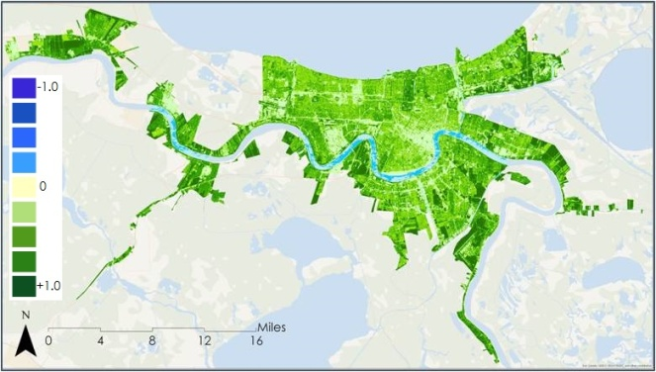

*Figure 2* Normalized Difference Vegetation Index (NDVI) calculated for the New Orleans urban area for 2017. Dark green indicates areas with high NDVI values (densely vegetated areas); whereas yellow indicates areas low NDVI values (little to no vegetation). Blue indicates water bodies.

***3.3.2. Normalized Difference Flood Index***

NDFI characterizes flood mapping that utilizes mean and minimum backscatter of each pixel of both flood and referenced image (Cian et al., 2018). To process the NDFI index, two multitemporal series of images were created: one containing all reference images and one containing all reference images including the flood event image. Statistical analysis of the backscattering of each pixel was performed throughout the whole multitemporal series. The calculated temporal statistics used to compute the NDFI with Equation 5 (Appendix Figure C2). ArcGIS Pro version 2.0.1 used to run the entire process. This process was repeated for all three years and created a total of six images with two images per year. The main purpose of creating mean and minimum raster images using cell statistics is that the mean value of each pixel represents the average behavior of the land surface. The minimum value of each pixel in the stack containing flood image is used to capture discontinuity in the time series i.e., minimum each pixel represents flood pixels as they exhibit very low backscatter.

$\text{NDFI =}\frac{\text{mean σ (reference) - min σ (reference + flood)}}{\text{mean σ (reference) + min σ (reference + flood)}}$ (5)

An accuracy assessment was conducted for the 2016 NDFI flood extent map based on a stratified random sampling of 105 points. After computation of the NDFI, a 0.35 threshold value was selected based on empirical analysis of the waterlogged and dry areas pixel values. The percent accuracy was calculated based on the error matrix retrieved from the stratified random sampling.

A data validation process was applied on the NDFI flood extent map based on August 19, 2016 flood event. The higher spatial and temporal resolution and less cloud cover of Sentinel-2 MSI image consisting band 5 as red, band 4 as green, and band 2 as blue band captured on August 21, 2016 allowed us to validate flood and waterlogged areas extracted from NDFI index.

***3.3.3. Land Surface Temperature Assessment VS Urban Geographies***

To determine LST trends, the team calculated the mean value of each LST product and plotted them by date. The team also conducted zonal statistical analysis in ArcGIS Pro 2.1.0 based on land classification maps and LST maps. The LST zonal statistics analysis resulted in mean LST for urban, tree, non-tree vegetation and water land classes.

In order to explore spatial thermal patterns of green and grey infrastructure, the team conducted a cell statistics analysis in ArcGIS Pro 2.1.0 to generate the mean LST product of all images. The team also compared the GWNO neighborhood scale land classification results to LST products of the same years to explore how the GWNO tree planting projects have influenced spatial thermal patterns. A linear regression model was run in IBM SPSS Statistics 19 between the LST product and NDVI, based on Landsat 8 imagery from October 26, 2017, to explore the correlation between LST and NDVI. This analysis provided statistical evidence of urban heat island effect mitigation by green infrastructure.

A temporal accuracy assessment was conducted by comparing the aggregated Landsat 8 LST product with MODIS MOD11A2V6. The latter product derived from the MODIS Terra Daily imagery, was a proper referent to test whether the lower temporal resolution Landsat 8 product could be used for identifying overall LST in research areas. The team plotted these two products by pixels in Microsoft Excel 2016, displayed thermal maps of these two products in ArcGIS Pro 2.1.0, and conducted a linear regression analysis in IBM SPSS Statistics 19 between those two products.

Lastly, data validation was conducted on Landsat LST products from 2013 to 2017. The team compared 34 data samples of NOAA daily maximum air temperature data with Landsat LST data by date and NOAA weather gauge locations (Appendix Figure A2) to determine whether Landsat LST product could represent daily maximum air temperature in New Orleans urban areas.

# 4. Results & Discussion

***4.1 Analysis of Results***

***4.1.1. Land Cover Classification Time Series***

Based on the refined land cover classifications (Figure 3 and 4), urban land cover occupied the largest land area in square kilometers within the study area followed by non-tree vegetation, tree, and water. Between 2013 and 2017 the greatest change in land cover within the study area was a decrease in non-tree vegetation and an increase in urban tree cover. A slight increase in urban land cover during the study period was also observed. Interestingly, within the GWNO neighborhoods we observed a decrease in the area of urban land cover and an increase in tree cover. The post-classification change map (Figure 5) showed large areas of change from tree to non-tree and non-tree to both tree and urban classes. The calculated class area for both the study area and the GWNO neighborhoods are shown in Figures B2 and B3, as well as given numerically in Tables B2 and B3 in Appendix B.

|  |  |
| --- | --- |
| *Figure 3.* 2013 classification of water, urban, tree, and non-tree vegetation within the New Orleans study area. | *Figure 4.* 2017 classification of water, urban, tree, and non-tree vegetation within the New Orleans study area. |

|  |
| --- |
| *Figure 5.* Post-classification change map showing areas that remained the same class in the original symbology, and the pixels that changed assigned colors to represent the class to which they changed. |

Overall accuracy for the 2013 classification was 92% based on total correct reference points to the total number of points sampled. Both years demonstrated few instances of error for the urban and water classes. The accuracy assessment for 2013 showed the tree cover class had the lowest user accuracy, or highest instance of errors of commission (pixels incorrectly included in the class being assessed). Additionally, the non-tree vegetation class had the lowest producer’s error, or highest number of errors of omission (pixels incorrectly excluded from the class being assessed). Suggesting the classification algorithm had the most difficulty distinguishing between tree and non-tree vegetation. The accuracy for the 2017 classification was slightly lower at 88 % overall accuracy. The error matrix exhibited similar sources of error as the 2013 assessment. However, in 2017 there were instances in which non-tree vegetation was incorrectly omitted and classified as urban. Accuracy assessment error matrices are provided in Appendix B in Table B4 through B7.

The initial unsupervised classification exhibited an increase in urban area as well as a slight decrease in both vegetative classes within the study area. However, the change detection map created using the original 2013 and 2017 classifications showed more variation than would be realistic. Classifications were refined using the “cluster busting” method discussed earlier. Refined classifications exhibited less variability in the post-classification change detection map. While improved, there was some confusion between the vegetative classes and, to a lesser extent, between urban and non-tree vegetation. This may be due to the pansharpening method employed, which reduced the number of bands to the three visible bands and the near infrared band and excluded the shortwave infrared bands which are specifically useful for distinguishing between vegetation types. The classification can be further improved by utilizing a different pansharpening method or data with a finer spatial resolution.

***4.1.2 Normalized Difference Flood Index***

The NDFI flood maps based on individual flood events showed flood exposed areas from 2016 to 2018 (Figure 6). The NDFI values ranges from 0 to 1 with 0 mentioned as dry areas and 1 as water bodies. The spatial and temporal increase in flood exposed areas can be seen from 2016 to 2017. Eastern portions of New Orleans especially experienced a spatial extension of flooded areas during the time period. Figure C3(a-c) in Appendix C shows the spatial extension of flood areas from 2016 to 2017 in different zones of New Orleans. The entire Louis Armstrong New Orleans International Airport situated at the western side of the city shows flood pixels in the 2016, 2017, and 2018 flood maps (Figure 6(a-c).

|  |  |
| --- | --- |
| a | b |
| c | |

*Figure 6.* Flood maps from 2016, 2017, and 2018 based on individual flood or heavy rainfall event obtained with the NDFI method; (a) NDFI obtained flood extent map for august 19, 2016 flood event, (b) NDFI obtained flood extent map for August 14, 2017, (c) NDFI obtained flood extent map for July 16, 2018

The NDFI flood map based on a heavy rainfall event on July 16, 2018 did not show proper flood pixels (Figure 6c). This may be due to the unavailability of sufficient reference images, flood event image from pick rainy season, and data availability only for the first seven months of the year which did not include rainy months.

The overall accuracy for the 2016 classification was 98.94% based on total correct reference points to the total number of points sampled (Appendix Table C1). The accuracy assessment shows few instances of error for the water bodies class. The water body class had the lowest user accuracy, or highest instance of errors of commission (pixels incorrectly included in class being assessed). A Sentinel-2 MSI RGB image captured on August 21, 2016 was used for validation of NDFI flood maps based on August 19, 2016 (Appendix Figure C4). The visual interpretation of these two images shows that NDFI provides reliable results for detecting flood pixels. In Appendix Figure C5(a), the flood pixels over the Louis Armstrong New Orleans International Airport matches with Appendix Figure C5(b) Sentinel-2 MSI RGB image where wet areas or water-logged areas were seen in dark brown color which are identified as the flood affected areas. Similarly, in Appendix Figure C5(C), flood pixels can be identified over New Orleans Lakefront Airport. The brown to dark brown areas in the Sentinel-2 MSI RGB image (Appendix Figure C5(d)) shows those areas that were flooded or water logged.

***4.1.3. Land Surface Temperature***

The average LST demonstrated a slight decrease from 2013 to 2017, as seen in the trendline of Appendix Figure D2. In 2017, the mean value annual LST product within New Orleans urban areas was 301.39 Kelvin, which is 1.32 Kelvin/2.38 Fahrenheit cooler than in 2013 (Appendix Figure D4). The mean LST decrease in the impervious areas was found to be 1.5 Kelvin/2.7 Fahrenheit, while the non-tree vegetation areas was 1.55 Kelvin/2.79 Fahrenheit and tree was 0.73 Kelvin/1.314 Fahrenheit. The decreasing LST trends in New Orleans’ urban areas suggested that the urban heat island effect might be mitigated during the study period. The lower LST decrease extent of tree land cover confirmed the finding that the green space is less vulnerable to temperature changes (Appendix Figure D3).

LST trends across different land cover classes showed that impervious areas are hotter than pervious green vegetation areas (Appendix Figure D3). The average LST product from 2013 to 2016 also displayed the same thermal landscape pattern. The percentage of impervious space in areas with LST higher than the mean LST 303.41 Kelvin is 96.14%, while the overall impervious land cover percentage in New Orleans urban areas in 2017 is 49.75%. Meanwhile, 76.48% areas where LST lower than mean LST value, are pervious land cover types such as water, tree and grassland (Figure 7). These results indicated that green infrastructure exhibited urban cooling effect while grey infrastructure exhibited urban heat island effect in our study areas. A neighborhood-scale spatial analysis between LST and landcover data was conducted to explore the thermal spatial pattern in the GWNO neighborhoods. The team found that there was an increase in vegetation and a decrease in grey infrastructure, followed with the decrease in LST. The mean LST of the GWNO neighborhoods in 2017 was 302.71 Kelvin/85.2 Fahrenheit, while in 2013 is 304.37 Kelvin/88.20 Fahrenheit. The north part of Lower Ninth Ward neighborhood showed significant LST decrease from 2013 to 2014. The North Claiborne and Saint Bernard, and St. Roch neighborhoods showed LST decrease along highway 10 and highway 610. Without significant LST change from 2013 to 2017, the Central City neighborhood still suffered from the urban heat island effect (Figure 8). These results implied that increasing green infrastructure in the GWNO neighborhoods might help to mitigate urban heat island effect.

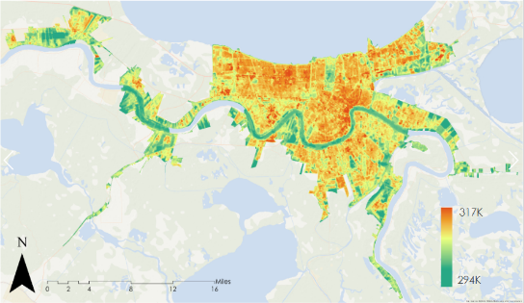

*Figure 7.* Average LST (From Landsat 8 TIRS, 2013, 2014, 2015, 2016, and 2017)

|  |  |  |  |
| --- | --- | --- | --- |
| https://lh6.googleusercontent.com/RN9IeFqtaZLSVpPcJnv9GMXR3GUyRXhSIBAyzSmd4PRYUso74lkt2xIBcdof-qS30AN818DM0j7SUw3IUc7LsmRxJL80zpv0gE700yneYOrOiNPfk4m0MGroOEk3YnItOURQIaEQ  (a) | https://lh5.googleusercontent.com/yuEmfryML0OmIrZRtH0IwU49o7FCTMT9ve3VFyGNa9YoD2G09shOVdGh5vVmBVxEOPQOA67m66h62RW800E0AjlXnlzZHxbnQZ8I-6TI2yUCD1vmwgEQOyqFjI-dBkYJt3cieXuG  (b) | https://lh4.googleusercontent.com/jCGpU-xfN5Wz1ApMJgvmkdsc2l7ibFTEpBSD7l9v9jNR7gdJEJUFnslP-qQdysQNaVMkX_yR62sQMF1YfwUv4wB5GRRmF_gbHFgzlALJIIWHGhI8tWKxc_w3UQgj1DaINIGaPVSi  (c) | https://lh6.googleusercontent.com/Qo5i0cQ2-HnJGjk5FaqyoFRN4Ms4HEFZfNgYa6OcZ9_s54mw0VIsJxw-QXqPpmDdda8Ncz4KBhHrf89Go6bxHrfYcsMZbyu_QqFULYlm48YRJ6ULQu3O7dGQIdRSsylCS4CuHsvT  (d) |

*Figure 8.* Land Use Cover and LST Comparison at the GWNO Neighborhood Scale

(from Landsat 8 2013 and 2017); (a) Land Cover 2013, (b) LST 2013, (c) Land Cover 2017, (d) LST 2017

A linear regression model in IBM SPSS Statistics 19 between LST and NDVI showed that the Pearson Coefficient between LST and NDVI is -0.557 (Appendix Table D1, Figure D5), which indicated that LST has a significant negative correlation with NDVI. Based on our results, the team concluded that the green infrastructure with higher NDVI value tend to have lower LST. The statistical correlation analysis between LST and NDVI substantiated that cooling effect of green infrastructure/vegetation was present in our research areas.

The comparison between Landsat 8 TIRS products and MODIS 1K MOD11A2V6 products showed that the LST product from Landsat 8 TIRS had the same thermal spatial pattern as the MODIS MOD11A2V6 product (Appendix Figures D6& D7). The correlation analysis showed that LST derived from Landsat imagery had a significant positive relationship with MODIS MOD11A2V6 with 0.726 Pearson correlation coefficient (Figure 9, Appendix Table D2). This result indicated that Landsat 8 TIRS LST products based on less observations per year could represent the annual LST condition in New Orleans urban areas.

|  |
| --- |
|  |
| *Figure 9.* Pixel and Pixel Comparison of LST Value  (from Landsat 8 TIRS 2013 to 2017, and MODIS Terra 2013 to 2017) |

Data validation for Landsat 8 TIRS LST products was conducted by aligning the LST product with NOAA daily maximum air temperature. The LST value was close to NOAA air temperature data with 4.20 F mean value difference among 34 samples (Appendix Figure D8 & Table D3). This result showed that Landsat 8 LST products in this research was validated and could represent daily maximum air temperature.

***4.2 Future Work***

For land classification analysis, our team recommends the use of higher spatial resolution imagery, LiDAR data, and high spatial resolution DSM data in future research. These applications would enable better classification of vegetative land cover. The spatial correlation between land cover, NDFI and NDVI can be further assessed by running mathematical regression models. This further analysis can demonstrate whether green infrastructure can reduce flood vulnerability. A historical analysis of NDFI with longer time data can help partners to spatially prioritize their mitigation and adaptation strategies. As previously noted, LST trends from 2013 to 2017 are not obvious. Further analysis should be conducted over a longer time period to confirm LST trends. Additional research can be performed to compare current LST and NDVI to those from earlier dates in the Landsat record, such as mid-1980s. This time series comparison between LST and NDVI products developed from a longer research period could help explain how green infrastructure influence urban heat island effect with greater details.

# 5. Conclusions

Based on this research, our team concluded that from 2013 to 2017 there was a slight increase in urban land cover, an increase in tree cover, as well as a decrease in non-tree vegetation in New Orleans’ urban areas. At the GWNO neighborhood scale, urban areas decreased while tree cover increased from 2013 to 2017. It has been shown that the increase in tree cover in the GWNO neighborhood might mitigate urban heat island effect of these areas during our research period. Our research also confirmed the urban heat island mitigation from green infrastructure by linear regression model between LST and NDVI. NDFI analysis showed an increase in flood exposed areas from 2016 to 2017, especially in eastern New Orleans. This multi-spectral approach to assessing the past contribution to New Orleans’ flood resilience by the GWNO can be utilized by our partner for efficient and accurate decision-making practices and can also lay the foundation for future remote sensing work by the GWNO to continue strengthening New Orleans’ resilience to flooding.

# 6. Acknowledgments

The team would like to extend our most sincere thanks to our science advisors Joe Spruce (Science Systems & Applications, Inc) and Dr. Kenton Ross (NASA Langley Research Center) for their consistent guidance. We would also like to thank our mentor, Bernard H. Eichold II, M.D., Dr. P.H. (Mobile County Health Department) for his continuous support. We express gratitude to Alicia Neal (Groundwork New Orleans) and the Groundwork New Orleans Green Team for their involvement and excitement throughout the project. We would also like to thank Farnaz Bayat (Center Lead, NASA DEVELOP Alabama – Mobile) and Danielle Quick (Impact Analysis Fellow and Assistant Center Lead, NASA DEVELOP Alabama – Mobile) for their endless guidance, encouragement, and advisement.

This material contains modified Copernicus Sentinel data (2014-2018), processed by ESA.

Any opinions, findings, and conclusions or recommendations expressed in this material are those of the author(s) and do not necessarily reflect the views of the National Aeronautics and Space Administration.

This material is based upon work supported by NASA through contract NNL16AA05C and cooperative agreement NNX14AB60A.

# 7. Glossary

**Emissivity -** ratio of the energy radiated from a material's surface to that radiated from a blackbody (a perfect emitter) at the same temperature and wavelength and under the same viewing conditions. It is a dimensionless number between 0 (for a perfect reflector) and 1 (for a perfect emitter).

**Impervious surface -** surface composed of any material that impedes or obstructs water or liquid absorption into the ground

**Land surface temperature (LST) -** radiative skin temperature of the land surface estimated from top of atmosphere brightness temperatures from the infrared spectral channel of a constellation of geostationary satellites

**Normalized Difference Flood Index (NDFI) -** index that categorizes areas as “flooded” as those that are temporarily covered by water with respect to permanent water bodies and non-water land cover classes

**Normalized Difference Vegetation Index (NDVI) -** index measuring chlorophyll content by calculating near infrared and red-light reflection

**Resiliency -** capacity of a system to respond to disturbance and recover quickly

**Urban Heat Island Effect -** a term describing urban areas are warmer than nearby rural areas

# 8. References

Boyd, E. (2011). *Fatalities due to Hurricane Katrina's impacts in Louisiana* (Doctoral dissertation). Department Geography and Anthropology. Baton Rouge, LA, Louisiana State University. (DOI 10.13140).

Burkett, V., Zilkoski, D., & Hart, D. (2001). *Sea-level rise and subsidence: Implications for flooding in New Orleans, Louisiana.* Paper presented at the Subsidence Interest Group Conference, Proceedings of the Technical Meeting. Galveston, Texas. doi: 10.1007/978-3-319-14409-2_14

Cian, F., Marconcini, M., & Ceccato, P. (2018). Normalized Difference Flood Index for rapid flood mapping: Taking advantage of EO big data. *Remote Sensing of Environment, 209*, 712-730. https://doi.org/10.1016/j.rse.2018.03.006

Copernicus. (2018). Copernicus Open Access Hub. Retrieved from Copernicus Open Access Hub: https://scihub.copernicus.eu/dhus/#/home

Data Access and Dissemination Systems (DADS). (2010). Results. Retrieved June 20, 2018, from <https://factfinder.census.gov/faces/tableservices/jsf/pages/productview.xhtml?src=bkmk>

Dennis, M., Barlow, D., Cavan, G., Cook, A., Gilchrist, A., Handley, J., ... Lindley, S. (2018). Mapping urban green infrastructure: A novel landscape-based approach to incorporating land use and land cover in the mapping of human-dominated systems. *Land*, 7(1). 1-17. doi:10.3390/land7010017

EM-DAT, C. (2010). The OFDA/CRED international disaster database. *Université catholique*. https://www.emdat.be/

Fairfax, D. (2017). *Accessing SAR Data.* Retrieved from Applied Remote Sensing Training: https://arset.gsfc.nasa.gov/sites/default/files/disasters/Dewberry/S2E4.pdf

Frampton, W., Dash, J., Watmough, G., & Milton, E. (2013). Evaluating the capabilities of Sentinel-2 for quantitative estimation of biophysical variables in vegetation. *ISPRS Journal of Photogrammetry and Remote Sensing, 82*, 83-92. doi:10.1016/j.isprsjprs.2013.04.007

Guo, Q., & Correa, C. A. (2013). The impacts of green infrastructure on flood level reduction for the Raritan river: Modeling assessment. In World Environmental and Water Resources Congress 2013: Showcasing the Future (pp. 367–376).

Groundwork USA About Us. (2018). Retrieved from https://groundworkusa.org/about-us/

Haque, M., & Basak, R. (2017). Land cover change detection using GIS and remote sensing techniques: A spatio-temporal study on Tanguar Haor, Sunamganj, Bangladesh. *The Egyptian Journal of Remote Sensing and Space Science, 20*(2), 251-263. https://doi.org/10.1016/j.ejrs.2016.12.003

Jensen, J., Ramsey, E., Mackey, H., Christensen, E., & Sharitz, R. (1987). Inland wetland change detection using aircraft MSS data, *Photogrammetric Engineering and Remote Sensing*, *53*,521-529. https://www.asprs.org/asprs-publications/pers

Kates, R., Colten, C., Laska, S., & Leatherman, S. (2006). Reconstruction of New Orleans after Hurricane Katrina: A research perspective. *Proceedings of the National Academy of Sciences, 103*(40), 14653-14660.

Kim, H., Lee, D.-K., & Sung, S. (2016). Effect of urban green spaces and flooded area type on flooding probability. *Sustainability, 8*(2), 134. <https://doi.org/10.3390/su8020134>

Kong, F., Yin, H., James, P., Hutyra, L. R., & He, H. S. (2014). Effects of spatial pattern of greenspace on urban cooling in a large metropolitan area of eastern China. *Landscape and Urban Planning, 128*, 35-47. https://doi.org/10.1016/j.landurbplan.2014.04.018.

Minchella, A. (2016). *Sentinel-1 Overview.* Retrieved from Catapult Satellite Applications: https://sa.catapult.org.uk/wp-content/uploads/2016/05/Sentinel-1_Overview.pdf

Parris, A., Bromirski, P., Burkett, V., Cayan, D., Culver, M., Hall, J., . . . Obeysekera, J. (2012). Global sea level rise scenarios for the United States National Climate Assessment. (http://cpo.noaa.gov/sites/cpo/Reports/2012/NOAA_SLR_r3.pdf). doi:10.3390/rs10020326

Pardo-Pascual, J., Sánchez-García, E., Almonacid-Caballer, J., Palomar-Vázquez, J., Priego de los Santos, E., Fernández-Sarría, A., & Balaguer-Beser, Á. (2018). Assessing the accuracy of automatically extracted shorelines on microtidal beaches from Landsat 7, Landsat 8 and Sentinel-2 Imagery. *Remote Sensing, 10*(2), 326. doi:10.3390/rs10020326

Paxon, C. & Rouse, C.E. (2008). Returning to New Orleans after Hurricane Katrina. *American Economic Review, 98(2), 38-42.* *doi: 10.1257/aer.98.2.38*

Port of New Orleans - About. (2018). Retrieved from <http://www.portno.com.about>

Sobrino, J., Jimenez-Munoz, J., & Paolini, L. (2004). Land surface temperature retrieval from LANDSAT TM 5. *Remote Sensing of Environment, 90*(4), 434-440. https://doi.org/10.1016/j.rse.2004.02.003

Toan, T. L. (2007). *Introduction to SAR Remote Sensing.* Retrieved from ESA Earth Observation Data - Earth Online - ESA: https://earth.esa.int/landtraining07/D1LA1-LeToan.pdf

United States Census Bureau (2016). TIGER/Line Shapefile, 2015, 2010 nation, U.S., 2010 Census Urban Area National. Retrieved from: <https://catalog.data.gov/dataset/tiger-line-shapefile-2015-2010-nation-u-s-2010-census-urban-area-national>

US Geological Survey Earth Resources Observation and Science Center. (2015). *Landsat 8 OLI/TIRS Surface Reflectance*. [Image collection]. Retrieved from <https://dx.doi.org/10.5066/F78S4MZJ>

Wan, Z., Hook, S., Hulley, G. (2015). *MOD11A1 MODIS/Terra Land Surface Temperature/Emissivity Daily L3 Global 1km SIN Grid V006* [Data set]. NASA EOSDIS LP DAAC. doi: 10.5067/MODIS/MOD11A1.006

# 9. Appendices

**Appendix A: Data Resource and Research Methodology**

*Table A1.* Earth observations used for each end product

|  |  |  |  |  |
| --- | --- | --- | --- | --- |
| Product | Sensor | Product Level | Date | Source |
| Land Cover Classification | Landsat 8 OLI | Level 1 | * May 23, 2013 * September 8, 2017 | USGS Earth Explorer |
| NDVI | Landsat 8 OLI | Level 2 | * May 24, 2013 * April 9, 2014 * August 2, 2015 * April 1, 2017 |
| Sentinel-2 MSI | Level 1 C | * May 8, 2017 | ESA Open Access Copernicus Hub |
| LST | Landsat 8 TIRS | Level 1 | * May 24, 2013 * September 13, 2013 * October 15, 2013 * June 12, 2014 * July 30, 2014 * August 15, 2014 * August 31, 2014 * August 02, 2015 * September 19, 2015 * June 07, 2016 * August 04, 2016 * September 21, 2016 * October 07, 2016 * September 08, 2017 * October 26, 2017 | USGS Earth Explorer |
| MODIS Terra | MODIS MOS11A2 | * May 01, 2013 * May 09, 2013 * May 17, 2013 * May 25, 2013 * September 06, 2013 * September 14, 2013 * September 22, 2013 * September 30, 2013 * October 08, 2013 * October 16, 2013 * October 24, 2013 * June 02, 2014 * June 10, 2014 * June 18, 2014 * June 26, 2014 * July 04, 2014 * July 12, 2014 * July 20, 2014 * July 28, 2014 * August 05, 2014 * August 13, 2014 * August 21, 2014 * August 29, 2014 * August 05, 2015 * August 13, 2015 * August 21, 2015 * August 29, 2015 * September 06, 2015 * September 14, 2015 * September 22, 2015 * September 30, 2015 * June 01, 2016 * June 09, 2016 * June 17, 2016 * June 25, 2016 * August 04, 2016 * August 12, 2016 * August 20, 2016 * August 28, 2016 * September 05, 2016 * September 13, 2016 * September 21, 2016 * September 29, 2016 * October 07, 2016 * October 15, 2016 * October 23, 2016 * October 31, 2016 * September 06, 2017 * September 14, 2017 * September 22, 2017 * September 30, 2017 * October 08, 2017 * October 16, 2017 | USGS Earth Explorer |
| NDFI | Sentinel-1 C-SAR | Level 1 C | * January 23, 2016 * January 28, 2016 * February 4, 2016 * April 21, 2016 * May 3, 2016 * May 15, 2016 * May 27, 2016 * July 14, 2016 * August 7, 2016 * August 8, 2016 * September 12, 2016 * October 18, 2016 * November 11, 2016 * November 23, 2016 * December 17, 2016 * December 29, 2016 * August 19, 2016* * January 22, 2017 * February 3, 2017 * February 27, 2017 * March 11, 2017 * March 23, 2017 * April 16, 2017 * April 28, 2017 * May 22, 2017 * June 27, 2017 * July 21, 2017 * August 2, 2017 * August 26, 2017 * September 7, 2017 * September 19, 2017 * October 13, 2017 * October 25, 2017 * November 6, 2017 * November 18, 2017 * December 12, 2017 * August 14, 2017* * January 5, 2018 * January 29, 2018 * February 22, 2018 * March 6, 2018 * March 18, 2018 * April 11, 2018 * May 5, 2018 * May 29, 2018 * June 10, 2018 * June 22, 2018 * July 16, 2018* | ESA Open Access Copernicus Hub |
|  | Sentinel-2 MSI | Level 1 C | * August 21, 2016 | ESA Open Access Copernicus Hub |

The * indicates dates of flood events

*Table A2.* Sentinel-1A C-SAR Acquisition Criteria

|  |  |
| --- | --- |
| Sensor Mode | Interferometric Wide (IW) |
| Direction | Ascending Pass |
| Polarization | VV, VH |
| Product Type | Ground Range Detected (GRD) |

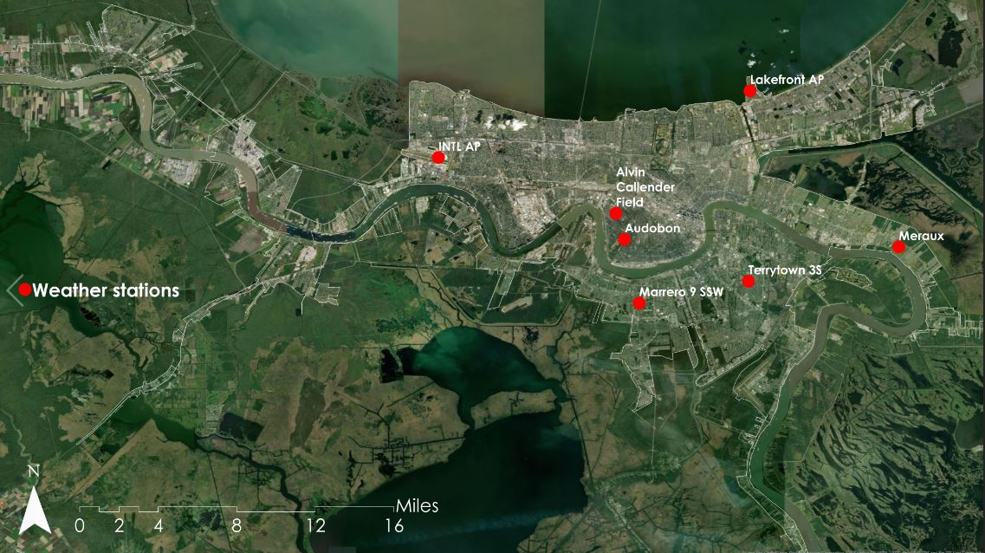

*Figure A1.* Daily precipitation data measurement station points provided by National Integrated Drought Information System’s (NIDIS) Applied Climate Information System (ACIS)

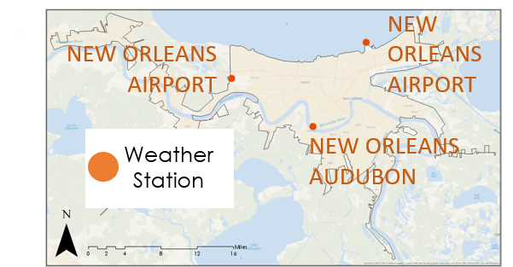

*Figure A2.* Location of NOAA Weather Gauge Station for LST validation

**Appendix B: Supplementary Figures and Tables for Land Cover Classification**

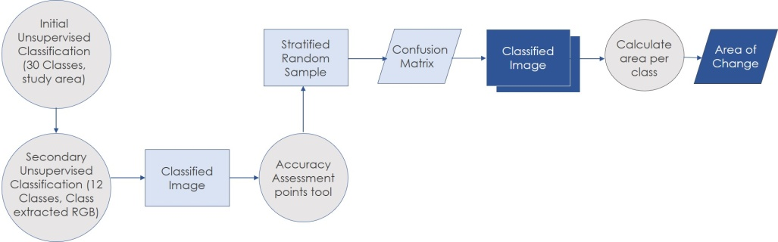

*Figure B1.* Flowchart of the methods to conduct a land cover classification and time series analysis for New Orleans.

*Table B1.* Input parameters for unsupervised classification using ArcGIS Pro 2.1.0 Classify tool.

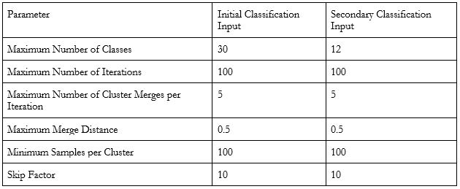

|  |  |
| --- | --- |
|  |  |
| *Figure B2:* Area (Km²) occupied by land cover class within the New Orleans study area. | *Figure B3:* Area (Km²) of change from original class to new class. |

*Table B2.* Area of each land cover class by year for entire study area (Km²).

|  |  |  |
| --- | --- | --- |
| Class | 2013 | 2017 |
| Water | 35.35 | 43.02 |
| Urban | 341.21 | 346.35 |
| Tree | 125.08 | 144.07 |
| Non-tree Vegetation | 194.57 | 162.76 |

*Table B3.* Area of each land cover class by year within GWNO neighborhoods (Km²).

|  |  |  |
| --- | --- | --- |
| Class | 2013 | 2017 |
| Water | 1.15 | 1.26 |
| Urban | 11.80 | 10.72 |
| Tree | 1.01 | 1.82 |
| Non-tree Vegetation | 2.30 | 2.44 |

*Table B4.* 2013 Land cover classification accuracy assessment error matrix.

|  |  |  |  |  |  |
| --- | --- | --- | --- | --- | --- |
| **Class** | Water | Urban | Tree | Non-tree vegetation | Total Reference Points |
| Water | 10 | 0 | 0 | 0 | 10 |
| Urban | 1 | 46 | 0 | 1 | 48 |
| Tree | 1 | 0 | 12 | 3 | 16 |
| Non-tree vegetation | 0 | 1 | 1 | 24 | 26 |
| **Total Classified Points** | 12 | 47 | 13 | 28 | 100 |
| **Total Correct Reference Points** | 92 |  | | | | |
| **Total True Reference Points** | 100 |  | | | | |
| **Percent Accuracy (%)** | 92 |  | | | | |

*Table B5.* 2013 user accuracy and producer’s error.

|  |  |
| --- | --- |
| **User's Accuracy (Errors of Commission)** | |
| Water | 100.00 |
| Urban | 95.83 |
| Tree | 75.00 |
| Non-tree vegetation | 92.31 |
| **Producer's Error (Errors of Omission)** | |
| Water | 83.33 |
| Urban | 97.87 |
| Tree | 92.31 |
| Non-tree vegetation | 85.71 |

*Table B6.* 2017 land cover classification accuracy assessment error matrix

|  |  |  |  |  |  |
| --- | --- | --- | --- | --- | --- |
| **Class** | Water | Urban | Tree | Non-tree vegetation | **Total Reference Points** |
| Water | 10 | 0 | 0 | 0 | 10 |
| Urban | 1 | 45 | 0 | 2 | 48 |
| Tree | 0 | 1 | 17 | 3 | 21 |
| Non-tree vegetation | 0 | 0 | 5 | 16 | 21 |
| **Total Classified Points** | 11 | 46 | 22 | 21 | 100 |
| **Total Correct Reference Points** | 88 |  | | | |
| **Total True Reference Points** | 100 |  | | | |
| **Percent Accuracy (%)** | 88 |  | | | |

*Table B7.* 2017 user accuracy and producer’s error.

|  |  |
| --- | --- |
| **User's Accuracy (Errors of Commission)** | |
| Water | 100.00 |
| Urban | 93.75 |
| Tree | 80.95 |
| Non-tree vegetation | 76.19 |
| **Producer's Error (Errors of Omission)** | |
| Water | 90.91 |
| Urban | 97.83 |
| Tree | 77.27 |
| Non-tree vegetation | 76.19 |

**Appendix C: Supplementary Figures and Tables for NDFI based Flood Extent Analysis**

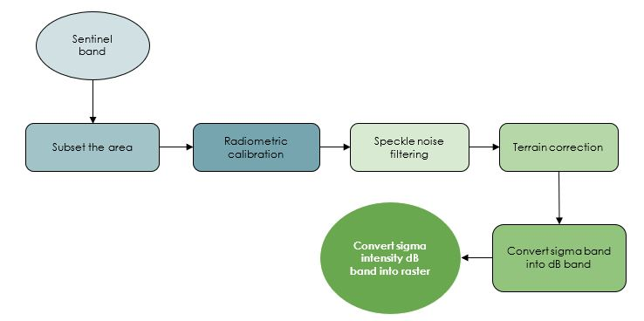

*Figure C1.* Flow chart showing preprocessing steps of Sentinel-1 C-SAR image

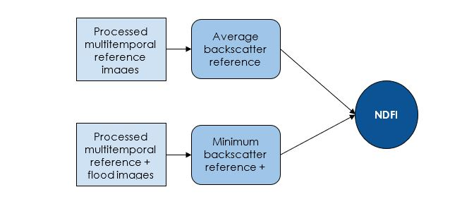

*Figure C2.* Flow chart for calculating NDFI with temporal statistics extracted from processed Sentinel-1 C-SAR reference and flood images

|  |  |  |  |
| --- | --- | --- | --- |
| **Spatial zones** | **2016** | **2017** | **Flooded areas extended** |
| (a) Middle |  |  | City Park, Lakeview, Fairgrounds, New Orleans Lakefront Airport, Areas near to the Inner Harbor Navigation Canal such as Camp Leroy Johnson, Pontchartrain Park, Desire Development Neighborhood |
| (b) North east |  |  | Seabrook, West Lake, Pines Village, Plum Orchard, Walnut Square Apartments, Carmel Brook, New Orleans East Area, Michoud, areas near to the Michoud Canal such as NASA Michoud Assembly Facility |
| (c) South east |  |  | Areas near to the Timberlane, Manhattan Athletic club, Coast Guard Air Station New Orleans, Bayou Barriere, NAVY exchange, New Orleans MEPS, NAS JRB New Orleans Housing Service Center |

*Figure C3.* NDFI based flood extent map shows spatial and temporal changes of flood exposed areas from 2016 to 2017 in (a) Middle (b) North eastern (c) Southeastern New Orleans

*Table C1.* 2016 flood map classification accuracy assessment error matrix

|  |  |  |
| --- | --- | --- |
| Class | Dry areas | Water bodies |
| Total | 94 | 10 |
| Total correct | 94 | 10 |
| Total incorrect | 1 | 0 |
| Percent Accuracy (%) | 98.94 | 100 |

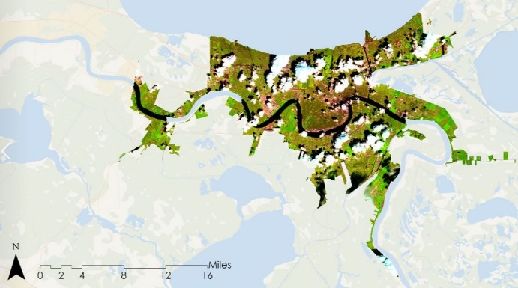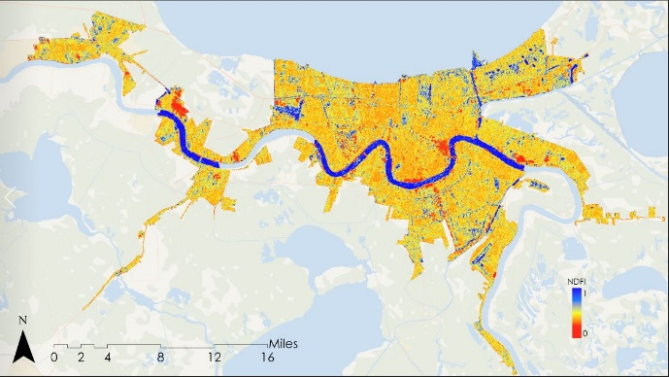

a) NDFI map based on august 19, 2016 flood event b) Sentinel-2 MSI RGB image captured on august 21, 2016 created with Sentinel-1 C SAR images

*Figure C4.* Comparison between NDFI flood map with Sentinel-1A C SAR and Sentinel-2 MSI RGB image

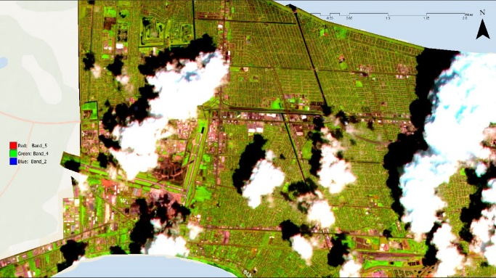

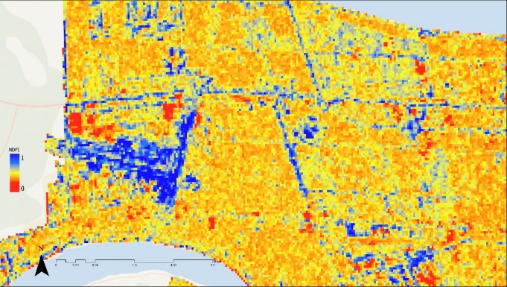

a) Louis Armstrong New Orleans International b) Louis Armstrong New Orleans International

Airport on NDFI for August 19, 2016 Airport on Sentinel-2 MSI RGB image captured

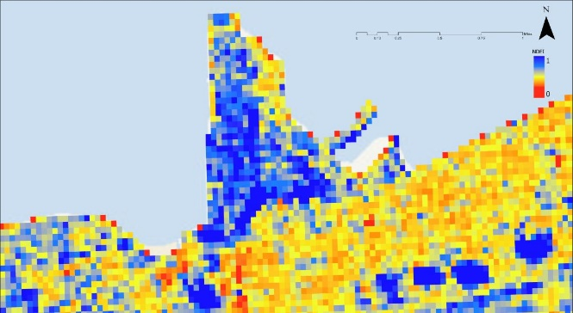 On August 21, 2016

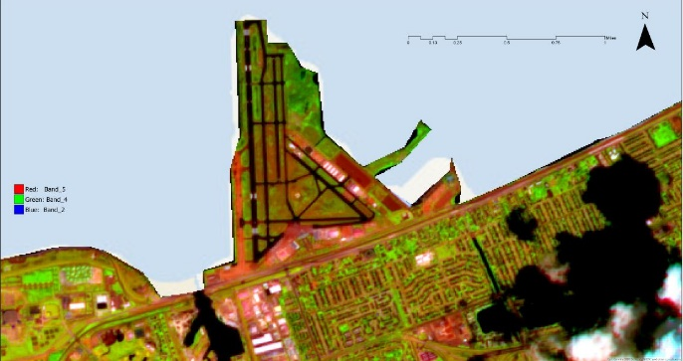

c) New Orleans Lakefront Airport on NDFI for d) New Orleans Lakefront Airport on Sentinel-2 MSI

August 19, 2016 flood RGB image captured on August 21, 2016

*Figure C5.* Flood pixels comparison between NDFI flood map with Sentinel-1A C SAR and Sentinel-2 MSI RGB image

**Appendix D: Supplementary Figures and Tables for LST Assessment**

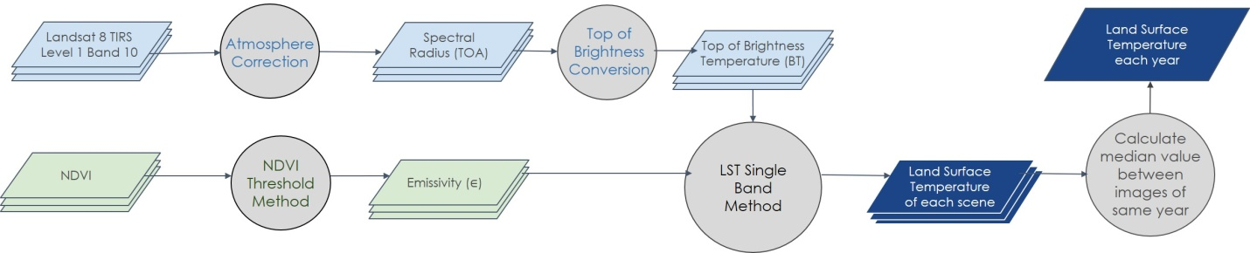

*Figure D1*. Flow chart of the methods used to conduct a land surface temperature assessment for New Orleans.

|  |  |
| --- | --- |
|  |  |
| *Figure D2.* Mean LST trends from 2013 to 2017 within New Orleans Urban Areas | *Figure D3.* Mean LST trends of different land cover in New Orleans Urban Areas  (From Landsat 8, 2013 and 2017) |

|  |  |
| --- | --- |
| 2013 | 2014 |
| 2015 | 2016 |
| 2017 |  |

*Figure D4.* Annual LST derived from Landsat imagery acquired in 2013, 2014, 2015, 2016, and 2017

*Table D1.* Correlation analysis between LST and NDVI based on Landsat 8 10/26/2017

|  |  |  |  |
| --- | --- | --- | --- |
|  |  | LST | NDVI |
| LST | Pearson Correlation  Sig. (2-tailed)  N | 1  731241 | -.557**  .000  731241 |
| NDVI | Pearson Correlation  Sig. (2-tailed)  N | -.557**  .000  731241 | 1  731241 |

**. Correlation is significant at the 0.01 level (2-tailed)

|  |
| --- |
|  |
| *Figure D5.* Scatter plot and correlation analysis between LST and NDVI (from Landsat 8 10/26/2017) |

|  |  |
| --- | --- |
| *Figure D6.* Aggregated Landsat LST Product  (from Landsat 8 TIRS 2013 to 2017) | *Fig D7*. MODIS MOD11A2V6 Product  (from MODIS Terra 2013 to 2017) |

*Table D2.* Correlation analysis between Landsat8 TIRS LST product and MODIS 1 KM LST product

|  |  |  |  |
| --- | --- | --- | --- |
|  |  | Landsat 8 TIRS | MODIS |
| Landsat 8 TIRS | Pearson Correlation  Sig. (2-tailed)  N | 1  807 | .726**  .000  807 |
| MODIS | Pearson Correlation  Sig. (2-tailed)  N | .726**  .000  807 | 1  807 |

**. Correlation is significant at the 0.01 level (2-tailed)

|  |
| --- |
|  |
| *Figure D8.* Comparison between LST Value from Landsat and NOAA Daily Maximum Air Temperature |

*Table D3.*  Data Validation by comparing Landsat8 TIRS LST product with NOAA daily maximum air temperature

|  |  |  |  |  |  |  |
| --- | --- | --- | --- | --- | --- | --- |
| Gauge Station Name | Longitude | Latitude | Dates | NOAA Gauge Temperature Max /°F | LST from Landsat /°F | Difference |
| NEW ORLEANS AUDUBON | -90.1302° W | 29.9166° N | 20130524 | 94 | 83.34 | 10.66 |
| NEW ORLEANS AUDUBON | -90.1302° W | 29.9166° N | 20130828 | 90 | 90.16 | -0.16 |
| NEW ORLEANS AUDUBON | -90.1302° W | 29.9166° N | 20130913 | 95 | 87.63 | 7.37 |
| NEW ORLEANS AUDUBON | -90.1302° W | 29.9166° N | 20140612 | 93 | 85.77 | 7.23 |
| NEW ORLEANS AUDUBON | -90.1302° W | 29.9166° N | 20140815 | 94 | 91.10 | 2.90 |
| NEW ORLEANS AUDUBON | -90.1302° W | 29.9166° N | 20140831 | 94 | 86.94 | 7.06 |
| NEW ORLEANS AUDUBON | -90.1302° W | 29.9166° N | 20150802 | 99 | 94.32 | 4.68 |
| NEW ORLEANS AUDUBON | -90.1302° W | 29.9166° N | 20160617 | 96 | 82.97 | 13.03 |
| NEW ORLEANS AUDUBON | -90.1302° W | 29.9166° N | 20160921 | 94 | 86.74 | 7.26 |
| NEW ORLEANS AUDUBON | -90.1302° W | 29.9166° N | 20161007 | 93 | 88.27 | 4.73 |
| NEW ORLEANS AIRPORT | -90.2775° W | 29.9969° N | 20130524 | 89 | 78.19 | 10.81 |
| NEW ORLEANS AIRPORT | -90.2775° W | 29.9969° N | 20130828 | 87 | 85.03 | 1.97 |
| NEW ORLEANS AIRPORT | -90.2775° W | 29.9969° N | 20130913 | 94 | 87.98 | 6.02 |
| NEW ORLEANS AIRPORT | -90.2775° W | 29.9969° N | 20140612 | 90 | 86.16 | 3.84 |
| NEW ORLEANS AIRPORT | -90.2775° W | 29.9969° N | 20140730 | 87 | 85.82 | 1.18 |
| NEW ORLEANS AIRPORT | -90.2775° W | 29.9969° N | 20140815 | 92 | 87.08 | 4.92 |
| NEW ORLEANS AIRPORT | -90.2775° W | 29.9969° N | 20140831 | 92 | 85.16 | 6.84 |
| NEW ORLEANS AIRPORT | -90.2775° W | 29.9969° N | 20150802 | 96 | 91.79 | 4.21 |
| NEW ORLEANS AIRPORT | -90.2775° W | 29.9969° N | 20150919 | 93 | 87.78 | 5.22 |
| NEW ORLEANS AIRPORT | -90.2775° W | 29.9969° N | 20160804 | 97 | 82.48 | 14.52 |
| NEW ORLEANS AIRPORT | -90.2775° W | 29.9969° N | 20161007 | 91 | 85.33 | 5.67 |
| NEW ORLEANS AIRPORT | -90.2775° W | 29.9969° N | 20170908 | 83 | 86.48 | -3.48 |
| NEW ORLEANS AIRPORT | -90.2775° W | 29.9969° N | 20171026 | 76 | 81.03 | -5.03 |
| NEW ORLEANS LAKEFRONT AIRPORT | -90.0288° W | 30.0494° N | 20130524 | 89 | 81.11 | 7.89 |
| NEW ORLEANS LAKEFRONT AIRPORT | -90.0288° W | 30.0494° N | 20130828 | 89 | 90.21 | -1.21 |
| NEW ORLEANS LAKEFRONT AIRPORT | -90.0288° W | 30.0494° N | 20130913 | 94 | 88.85 | 5.15 |
| NEW ORLEANS LAKEFRONT AIRPORT | -90.0288° W | 30.0494° N | 20140612 | 90 | 81.69 | 8.31 |
| NEW ORLEANS LAKEFRONT AIRPORT | -90.0288° W | 30.0494° N | 20140730 | 85 | 88.99 | -3.99 |
| NEW ORLEANS LAKEFRONT AIRPORT | -90.0288° W | 30.0494° N | 20140815 | 91 | 93.41 | -2.41 |
| NEW ORLEANS LAKEFRONT AIRPORT | -90.0288° W | 30.0494° N | 20140831 | 92 | 85.63 | 6.37 |
| NEW ORLEANS LAKEFRONT AIRPORT | -90.0288° W | 30.0494° N | 20150802 | 96 | 95.23 | 0.77 |
| NEW ORLEANS LAKEFRONT AIRPORT | -90.0288° W | 30.0494° N | 20150919 | 87 | 88.81 | -1.81 |
| NEW ORLEANS LAKEFRONT AIRPORT | -90.0288° W | 30.0494° N | 20160617 | 93 | 87.51 | 5.49 |
| NEW ORLEANS LAKEFRONT AIRPORT | -90.0288° W | 30.0494° N | 20160804 | 95 | 83.03 | 11.97 |
| NEW ORLEANS LAKEFRONT AIRPORT | -90.0288° W | 30.0494° N | 20161007 | 89 | 84.47 | 4.53 |
| NEW ORLEANS LAKEFRONT AIRPORT | -90.0288° W | 30.0494° N | 20170908 | 84 | 87.39 | -3.39 |
| NEW ORLEANS LAKEFRONT AIRPORT | -90.0288° W | 30.0494° N | 20171026 | 77 | 80.80 | -3.80 |
|  |  |  | mean | 90.81 | 86.61 | 4.20 |
|  |  |  | sd | 5.04 | 3.85 | 5.02 |