**NASA DEVELOP National Program**



NASA Marshall Space Flight Center

*Fall 2016*

Lake Victoria Water Resources III

Utilizing NASA Earth Observations to Identify Water Hyacinth Dynamics and Other Water Quality Parameters in Lake Victoria

**Technical Report** 

Final Draft – November 17, 2016

Daryl Ann Winstead (Project Lead)

Maggi Klug

Tony Ngabo

Ankur Shah

Kristen Barnard

Dr. Jeffrey Luvall (NASA at National Space Science and Technology Center)

Dr. Robert Griffin (University of Alabama in Huntsville)

Africa Flores (NASA SERVIR Coordination Office)

Leigh Sinclair (University of Alabama in Huntsville/Information Technology and Systems Center)

Previous Contributors:

Jeanne’ le Roux

Sara Amirazodi

Christina Fischer

Dwight Tigner

Austin Vacek

# 1. Abstract

With a surface area of 68,800 km², Lake Victoria is the largest lake in Africa. More than 30 million people living around the lake in Kenya, Tanzania, and Uganda rely on the lake for everyday use. With populations increasing around the lake, runoff from various sources is negatively impacting the water quality in the lake resulting in the introduction of the invasive water hyacinth (*Eichhornia crassipes*). The NASA SERVIR Coordination Office at Marshall Space Flight Center, the SERVIR-Eastern and Southern Africa Hub, the Regional Centre for Mapping of Resources for Development (RCMRD), and the Makerere University Department of Geomatics and Land Management have been assessing and monitoring water quality parameters, such as chlorophyll concentration, temperature, and turbidity, for Lake Victoria using the Moderate Resolution Imaging Spectrometer (MODIS) sensor on the Aqua satellite. As a continuation of the Lake Victoria Water Resources II project from Spring 2016, this project focused on implementing an atmospheric correction and water extraction algorithm into the Surface Aquatic Vegetation Detection Toolbox (SAVDT) that was previously created. The SAVDT processes satellite imagery from Landsat 5, 7, and 8 or Sentinel-2 and results in an output shapefile that detects the location of aquatic vegetation on the surface of the Winam Gulf in Lake Victoria. This project also conducted an accuracy assessment on the SAVDT outputs using high-resolution data from World View 2 and 3. The completed SAVDT will be used to complement the partner organization's current efforts on researching and monitoring the water hyacinth.

**Keywords**

Surface Aquatic Vegetation Detection Toolbox (SAVDT), Sentinel-2 MSI, invasive species, RCMRD, NASA SERVIR, water hyacinth

# 2. Introduction

* 1. ***Background Information***

Lake Victoria extends over 68,800 square kilometers, and it is the second largest freshwater lake in the world (Horne and Goldman 1994). It spans Kenya, Uganda, and Tanzania and serves as the main reservoir of the Nile River. Lake Victoria plays a significant role in providing the region’s inhabitants with income through fishing activities. According to the Lake Victoria Fisheries Organization, the lake facilitates not only fishing activities, but also supplies drinking water and other ecological goods. Moreover, the lake plays a role in power generation and transportation.

With rising human activity, pollution in Lake Victoria has increased sewage, agricultural runoff, and industrial waste degrading the water quality. Eutrophication, a process which feeds rapid plant and algae growth, contributed to the depletion of available oxygen in the water. Besides impacting the potability of Lake Victoria’s water, this pollution leads to the invasion of water hyacinth. Native to the northern tropics of South America, water hyacinth has a high growth rate due to its ability to outcompete other aquatic species for food and oxygen; it has been described as the world’s worst aquatic weed (Cook 1990). Water hyacinth was first recognized in Lake Kyoga, Uganda in May 1988, and by 1991, it had spread to Lake Victoria and the Kagera River (Bwathondi and Mahika 1994). The adverse impacts of water hyacinth on Lake Victoria and the surrounding communities include: impeding shore access for fishing, hindering ferry transportation, interfering with hydroelectric power generation, blocking water intake for water supply and industry, and disrupting native aquatic plant communities (Gichuki et al. 2001).

At NASA DEVELOP’s Marshall Space Flight Center, the efforts to study the nature of water hyacinth’s invasion of Lake Victoria started in the Fall of 2015, with subsequent projects conducted in the Spring of 2016 and Fall of 2016. In the Fall of 2015, team members focused on gathering satellite imagery to detect changes in the aquatic vegetation in the Winam Gulf area of the lake. During the Spring of 2016, the project focused on implementing the Modified Normalized Difference Water Index (MNDWI) methodology into a near real-time automated python script. Additionally, this term focused on the inclusion of Sentinel-2 Multi Spectral Instrument (MSI) imagery for an increased temporal resolution over the course of the study period.

For the final project term, Fall 2016, the objectives were to implement atmospheric correction for Landsat 8 Operational Land Imager (OLI) imagery using Surface Aquatic Vegetation Detection Toolbox (SAVDT) python script, conduct accuracy assessments on model outputs, and analyzing the accuracies in order to determine the best method to determine water hyacinth extent. Satellite imagery from November 2013 and August 2016 were used to complete these objectives.

* 1. ***Project Partners & Objectives***

This project focused on mapping the extent of water hyacinth on the Winam Gulf portion of Lake Victoria, Figure 1. As it is difficult to manage such a large water body, many other organizations have partnered with DEVELOP.

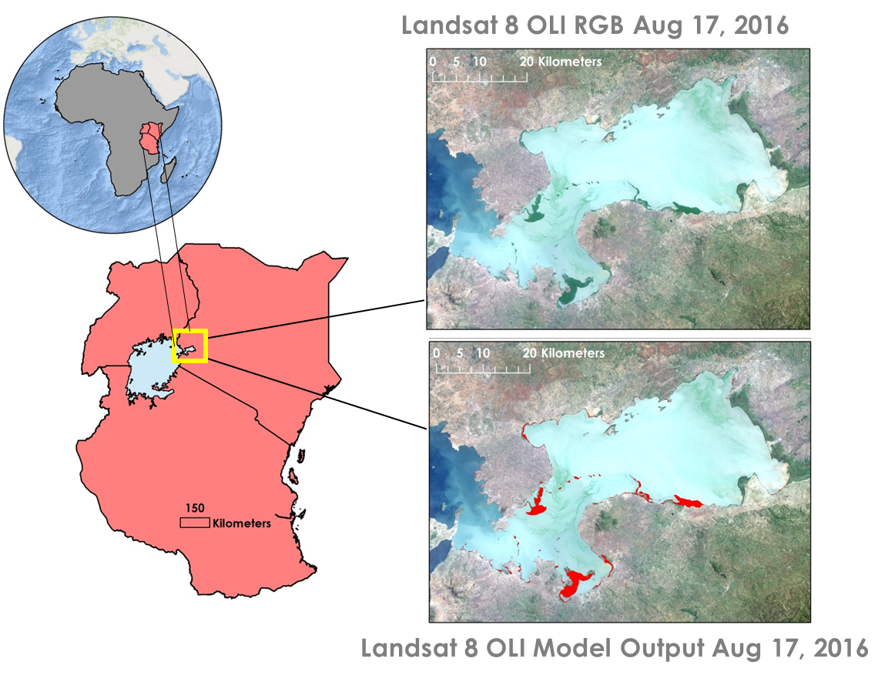

Figure 1 Winam Gulf in Lake Victoria

SERVIR is a joint venture between NASA and the U.S. Agency for International Development (USAID), providing satellite-based Earth monitoring, imaging, and predictive models to help improve environmental decision-making among developing nations. The NASA SERVIR Coordination Office at Marshall Space Flight Center and the SERVIR-Eastern and Southern Africa Hub assisted the project by giving guidance and knowledge throughout the project term.

The Regional Centre for Mapping of Resources for Development (RCMRD), the Makerere University Department of Geomatics and Land Management, and the SERVIR-Eastern and Southern Africa Hub are end-user organizations. Since the conventional methodologies used for *in situ* measurements are time-consuming and have various limitations, they will use the data, products, and scripts created in the project to support further research on the water hyacinth problem in Lake Victoria. The SERVIR-Eastern and Southern Africa Hub and RCMRD benefitted from the project since the potential areas of water hyacinth growth were detected and this facilitated a better understanding of the hyacinth dynamics. Finally, the SERVIR-Eastern and Southern Africa Hub will disperse the data to a wide user base in order to provide sufficient knowledge for the management of the water quality of the Winam Gulf portion of Lake Victoria. Continuous monitoring of the hyacinth can help prompt more aggressive mitigation efforts in areas which are affected the most by the invasive species.

The NASA Applied Sciences Water Resources National Application Area was addressed by this project as we examined the invasive water hyacinth’s impact on water quality in the Winam Gulf in Lake Victoria.

The main objectives for this third term of the Lake Victoria Water Resources project were to implement an atmospheric correction into the SAVDT, conduct accuracy assessments on the output of the SAVDT, and analyze the outputs of the assessments.  The previous two terms during the Fall of 2015 and Spring of 2016 focused on developing a hyacinth vegetation detection algorithm using the Modified Normalized Difference Water Index (MNDWI) technique to determine areas where the water hyacinth may be present and automation of that methodology, respectively. Furthermore, the team finalized the SAVDT to improve the ability to detect water hyacinth and other macrophytes in Lake Victoria.

# 3. Methodology

***3.1 Data Acquisition***

The data that were used for this project includes Landsat 7 Enhanced Thematic Mapper Plus (ETM+), Landsat 8 OLI, Sentinel-2 MSI, and Worldview 2 and 3. Landsat 8 Level 1 geotiffs were downloaded via python script using the open source DEVELOP National Program Python Module (Dnppy) package which downloads the data from the Amazon Web Service website. The function “fetch_Landsat8” was used to retrieve the desired Landsat scenes. The python module “datetime” was used to set the variables pertaining to the computer operating system’s current date and fifteen days prior to the current date by using the functions “date.today()” and “timedelta()”. Band 3 (green), band 6 (short wave infrared), and the quality assessment band (BQA) were downloaded by this script for the study area: path 170, row 60.

Landsat 7 ETM+ and 8 OLI surface reflectance products produced by the USGS were acquired by submitting a request through the USGS Earth Explorer website because they cannot be downloaded through the dnppy script. The surface reflectance products were used in addition to the Landsat 7 ETM+, Landsat 8 OLI, and Sentinel-2 MSI images due to an atmospheric correction being applied to the images. Sentinel-2 MSI data Level 1-C JP2000 images were downloaded from the European Space Agency’s (ESA) Scientific Data Hub website. When utilizing the SAVDT, the user is responsible for acquiring Sentinel-2 MSI data and inputting it into the Sentinel script. WorldView 1 and Geoeye-1 imagery were acquired directly from the project partners at NASA SERVIR Coordination Office. The data were obtained to test the accuracy of the output.

***3.2 Data Processing***

The SAVDT was constructed using a series of python scripts in order to accommodate the use of multiple satellite sensors in order to increase the data in the temporal aspect. The imagery from Landsat 7 ETM+ and 8 OLI and Sentinel-2 MSI were processed using the SAVDT. The toolbox calculates the Modified Normalized Difference Water Index (MNDWI) which uses the green and shortwave infrared (SWIR) wavelengths accordingly (Equation 1).

$$MNDWI= \frac{(green-SWIR)}{(green+SWIR)}$$

**Equation 1**: Modified Normalized Difference Water Index Calculation

The output from the toolbox is a shapefile depicting the areas where water hyacinth could be present. This shapefile was used to conduct further analysis.

The high resolution images were mosaicked, projected, and clipped to the study area shapefile. This allowed for analysis to be conducted only on the model outputs that overlapped with the high resolution images.

Second Simulation of the Satellite Signal in the Solar Spectrum (6S Atmospheric Correction) was implemented into the SAVDT by using a series of python scripting and ArcMap tools provided the NASA SERVIR Coordination Office. A few assumptions were made such as assuming the environment to be tropical, aerosol depth is 0.05, and the reflectance is over lake water.

An atmospheric correction was performed on the Sentinel-2 imagery by using the Sen2cor package and SNAP (Sentinel Application Platform). Sentinel images were loaded into SNAP, and sen2cor atmospheric correction was implemented by using SNAP’s Thematic Land Processing feature.

***3.3 Data Analysis***

An accuracy assessment was conducted on the SAVDT outputs that were derived using Landsat 7 ETM+ and 8 OLI and Sentinel-2 MSI satellites. The accuracy assessment was conducted using high resolution imagery from WorldView 1 and Geoeye-1 which was provided to the team the NASA SERVIR Coordination Office. WorldView 1 and Geoeye-1 are commercial satellites with a fine spatial resolution allowing for easy visual distinction between macrophytes and water. These images were used as a substitute for *in situ* presence and absence points.

For the November 29, 2013 SAVDT outputs, 250 random points were generated over the areas classified at surface vegetation. Additionally, 250 random points were generated over the portion of the study area that coincided with the WorldView-1 image. This allowed for a total of 500 randomly generated points that represented predicted absence and presence points. Each point was visually examined in comparison to the WorldView-1 image and recorded as a true positive, false positive, true negative, and false negative (Figure 3). Due to the spatial resolution between Landsat 8 OLI and WorldView-1, any point located within 30m (the extent of one Landsat pixel) of water hyacinth was classified as such. These results were recorded in a confusion matrix table (Figure 2) and accuracy statistics were calculated.

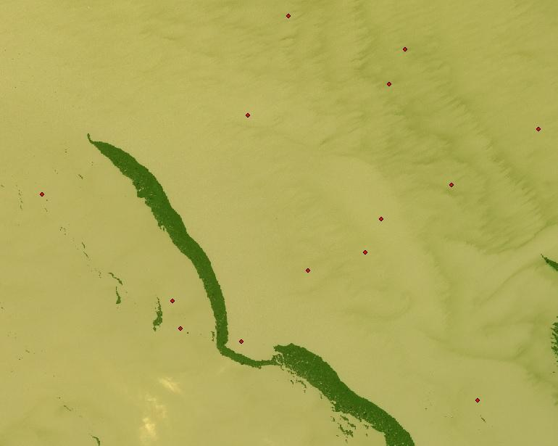

Figure 2 Example of Randomly Generated Points over High Resolution Image

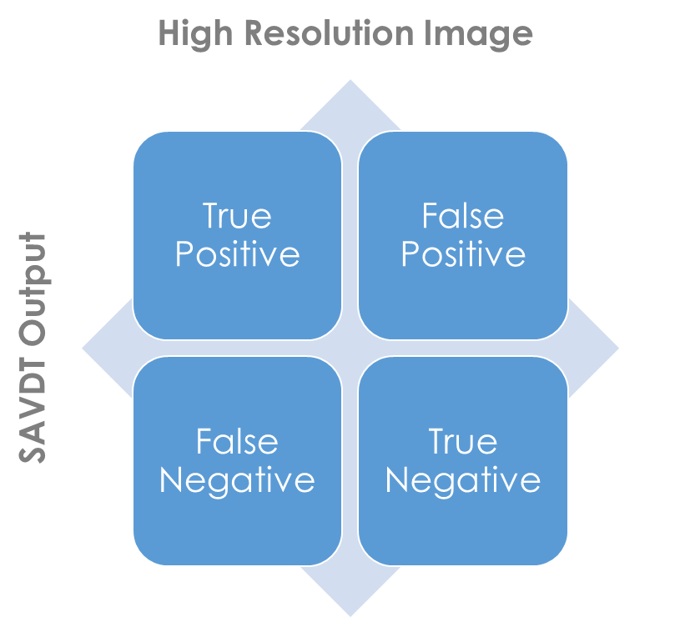

Figure 3 Error Matrix Classification

For the August 25, 2016 SAVDT outputs, the previously stated methods were used for generating the 500 random points and visually assessing and classifying each of those points. However, Geoeye-1 was used for the high resolution imagery since it was available for August 26, 2016, 24 hours after the scenes from Landsat 7 ETM+ and Sentinel-2 MSI. Due to the spatial resolution between Landsat 7 ETM+, Sentinel-2 MSI, and Geoeye-1, any point located within 30m (the extent of one Landsat pixel) of water hyacinth was classified as such. These results were recorded in a confusion matrix table and accuracy statistics were calculated.

# 4. Results & Discussion

***4.1 Analysis of Results***

Table 1 Accuracy Assessments

|  |  |  |
| --- | --- | --- |
| Accuracy Assessments | WorldView-1 Nov 29, 2013 | Geoeye-1 Aug 26, 2016 |
| Landsat 7 ETM+ Aug 25, 2016 | -- | 86.4% |
| Landsat 7 ETM+ Surface Reflectance Aug 25, 2016 | -- | 85% |
| Landsat 8 OLI Nov 26, 2013 | 94.4% | -- |
| Landsat 8 OLI Surface Reflectance Nov 26, 2013 | 85.8% | -- |
| Sentinel-2 MSI Aug 25, 2016 | -- | 82% |

Table 1 shows the resulting accuracy assessments. Where there is not a percentage outcome, high resolution imagery was not available for that date. Overall, the accuracy assessments were over 80%. There was a slight decrease in accuracy from the non-atmospherically corrected images and the atmospherically corrected images. The accuracy for the Landsat 8 OLI image from November 26, 2013 was the highest with 94.4%. The accuracy for the Sentinel-2 MSI image was the lowest at 82%.

***4.2 Limitations & Uncertainties***

The resolution of the Landsat 7 ETM+ and Landsat 8 OLI, and Sentinel-2 MSI is not high enough to differentiate between water hyacinth and other macrophytes on the surface of the water. The model outputs are generalized to water macrophytes, or surface vegetation, as opposed to only the water hyacinth. Since the accuracy assessment was conducted using the high resolution imagery, limited Landsat and Sentinel-2 scenes were available in which the dates coincided with the availability of the high resolution imagery. In addition, Landsat 7 ETM+ was used for one of the accuracy assessments and the image contains missing data thus resulting in missed data that could contain water hyacinth and other surface vegetation (Figure 5).

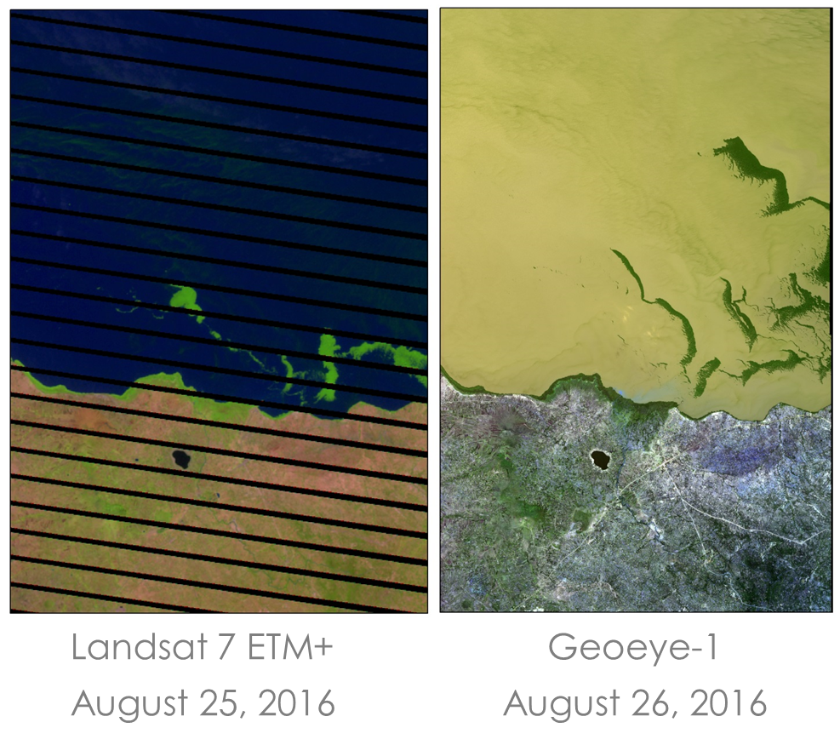

Figure 4 Example of missing data in Landsat 7 ETM+ data and how water hyacinth changes very rapidly

***4.3 Future Work***

Due to the nature of the Landsat 7 ETM+, Landsat 8 OLI, and Sentinel-2 MSI satellites, it is very difficult to find images from both satellites with the same date. As time progresses, more imagery will become available, increasing the chances of the satellites passing over the Winam Gulf in Lake Victoria on the same date. This will aid in quantifying the differences in the satellite sensors. In addition, having *in situ* measurements gathered on the same day as the satellite imagery will aid in a more robust accuracy assessment of the model outputs. Currently, the SAVDT is setup to monitor surface vegetation in the Winam Gulf in Lake Victoria as opposed to the entire lake. The SAVDT could be constructed to monitor the entirety of the lake as well as other locations where water hyacinth is present.

# 5. Conclusions

The atmospheric correction for Sentinel-2 MSI imagery was unsuccessful since the sen2cor software package works best on Linux operating systems. Further accuracy assessments using *in situ* measurements and high resolution images will need to be conducted in order to better determine the overall accuracy of the SAVDT. Overall, the accuracy assessments were over 80%. Accuracy assessment for November 26, 2013 Landsat 8 OLI model output was the highest. Accuracy assessments were not conducted over the entire Winam Gulf due to limited high resolution data.

# 6. Acknowledgments

The Lake Victoria Water Resources team would like to thank the mentors and partners who provided their time and support to make this project possible:

Mentors/Advisors

* Dr. Jeffrey Luvall, NASA at National Space Science and Technology Center
* Dr. Robert Griffin, University of Alabama in Huntsville
* Africa Flores, NASA SERVIR Coordination Office at MSFC
* Leigh Sinclair, University of Alabama in Huntsville/Information Technology and Systems Center

Partners

* Dr. Anthony Gidudu, Makerere University Department of Geomatics and Land Management
* Robinson Mugo, SERVIR - Eastern and South African Hub
* James Nyaga, SERVIR - Eastern and South African Hub

Others

* Emily Adams, NASA SERVIR Coordination Office at MSFC
* Kel Markert, NASA SERVIR Coordination Office at MSFC
* Dashiell Cruz, NASA DEVELOP Assistant Center Lead/Impact Analysis Fellow

Any opinions, findings, and conclusions or recommendations expressed in this material are those of the author(s) and do not necessarily reflect the views of the National Aeronautics and Space Administration.

This material is based upon work supported by NASA through contract NNL11AA00B and cooperative agreement NNX14AB60A.

# 7. References

Bwathondi, P. and G. Mahika. 1994. A report of the infestation of water hyacinth (Eichhornia crassipes) along the Tanzanian side of Lake Victoria. National Environment Council, Dar es Salaam, Tanzania.

Cook, C. D. K, 1990. Origin, autecology, and spread of some of the world’s most troublesome aquatic weeds, p. 31-38. In: A. H. Pieterse and K. Murphy (eds.). Aquatic Weeds: The ecology and management of nuisance aquatic vegetation. Oxford University Press, Oxford, England.

Gichuki, J., F. Dahdouh Guebas, J. Mugo, C. O. Rabour, L. Triest and F. Dehairs. 2001. Species inventory and the local uses of the plants and fishes of the Lower Sondu Miriu wetland of Lake Victoria, Kenya. Hydrobiologia 458:99-106

Horne, A. J. and C. R. Goldman. 1994. Limnology, 2nd Edition. McGraw Hill, Inc. p. 29.

Twongo, T. 1991. Status of Water Hyacinth in Uganda, p. 55-57. In: A. Greathead and P. de Groot (eds.). Control of Africa’s Floating Water Weeds. Commonwealth Sci. Council, Zimbabwe.

# 8. Content Innovation

**Content Innovation #1**

Audio Slides

Emailed to [Tiffani.N.Miller](mailto:Lauren.M.Childs@nasa.gov)@nasa.gov with filename 2016Sum_MSFC_LakeVictoriaWaterIII_TechPaper_AudioSlides

**OR** shared through Google Drive at: <https://goo.gl/u49jps>

**Content Innovation #2**

VPS

Emailed to [Tiffani.N.Miller](mailto:Lauren.M.Childs@nasa.gov)@nasa.gov with filename 2016Sum_MSFC_LakeVictoriaWaterIII_VPS

**OR** shared through Google Drive at: <https://goo.gl/u49jps>

**Content Innovation #3**

Interactive Map Viewer

Emailed to [Tiffani.N.Miller](mailto:Lauren.M.Childs@nasa.gov)@nasa.gov with filename 2016Sum_MSFC_LakeVictoriaWaterIII_TechPaper_InteractiveMapViewer

**OR** shared through Google Drive at: <https://goo.gl/u49jps>

# 9. Appendices

Appendix I – SAVDT Outputs

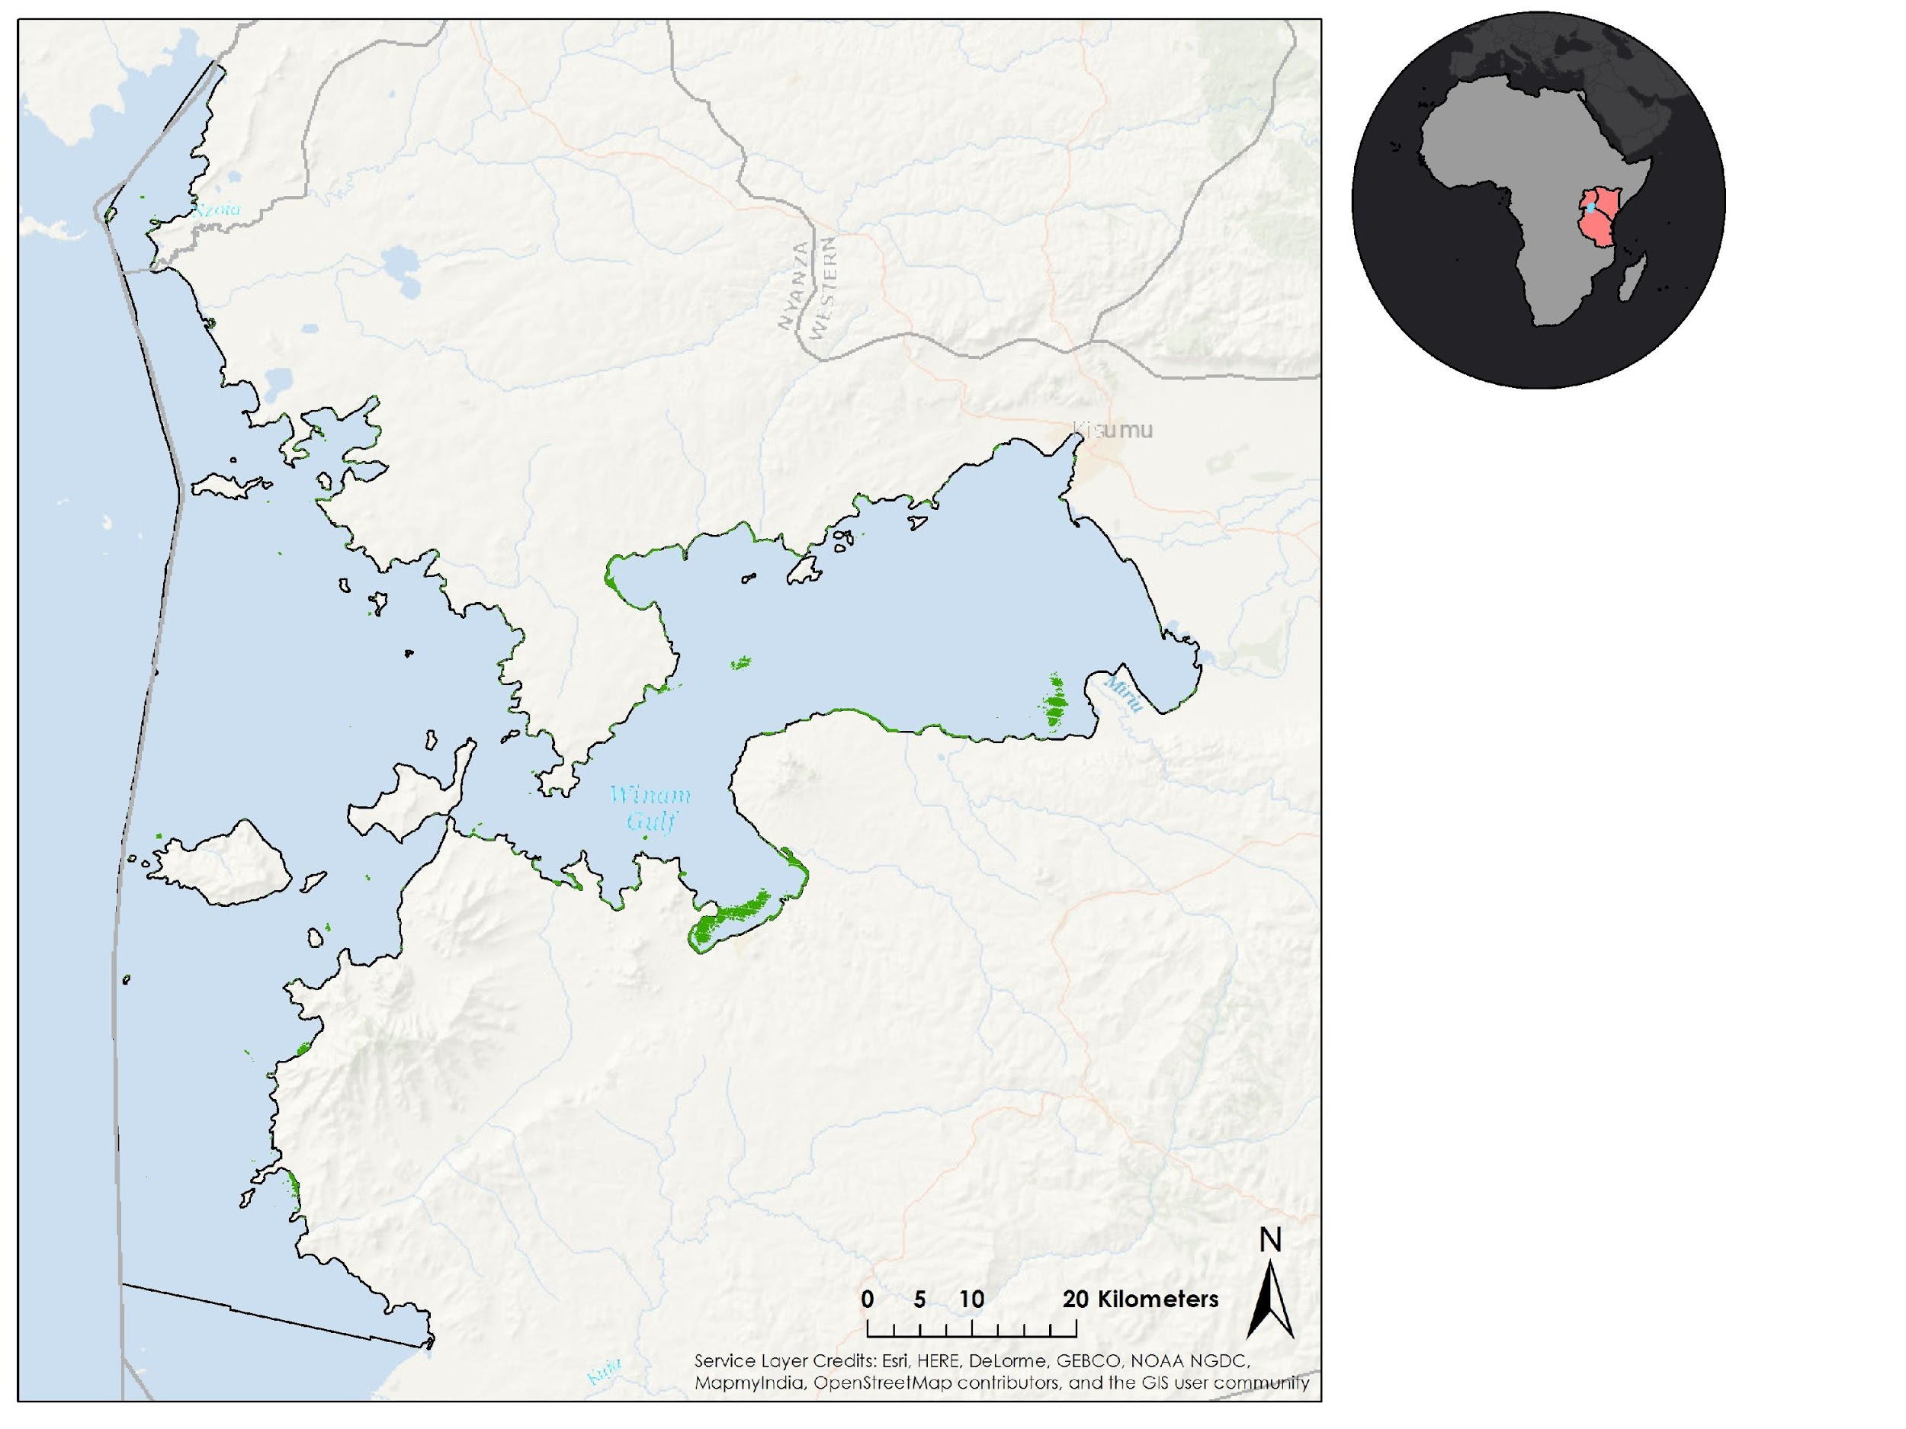

Figure 5 Landsat 7 ETM+ output from August 25, 2016

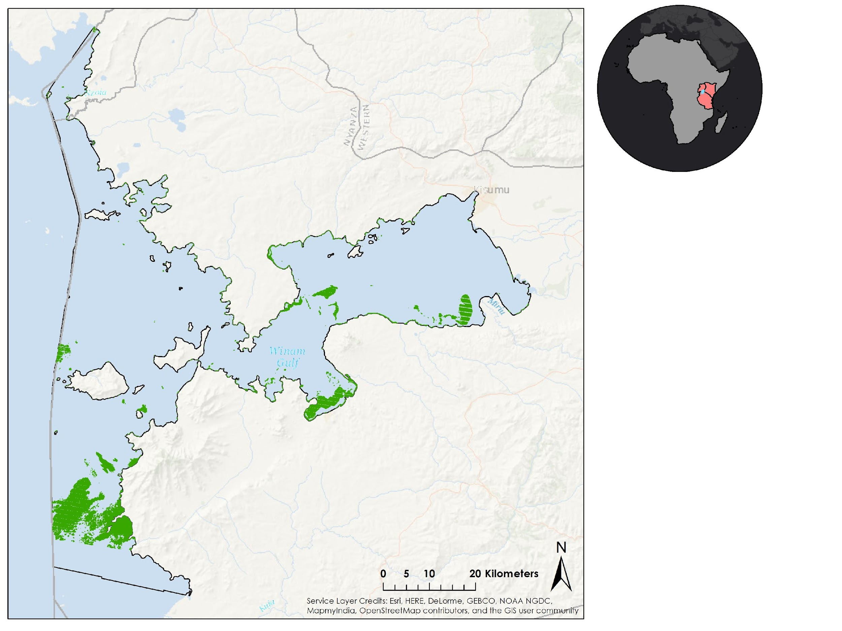

Figure 6 Landsat 7 ETM+ Surface Reflectance output from August 25, 2016

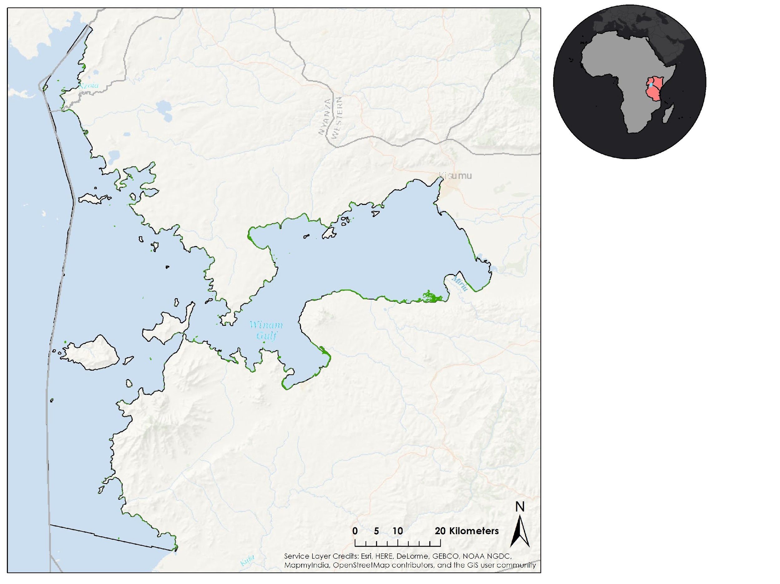

Figure 7 Landsat 8 OLI output from November 26, 2013

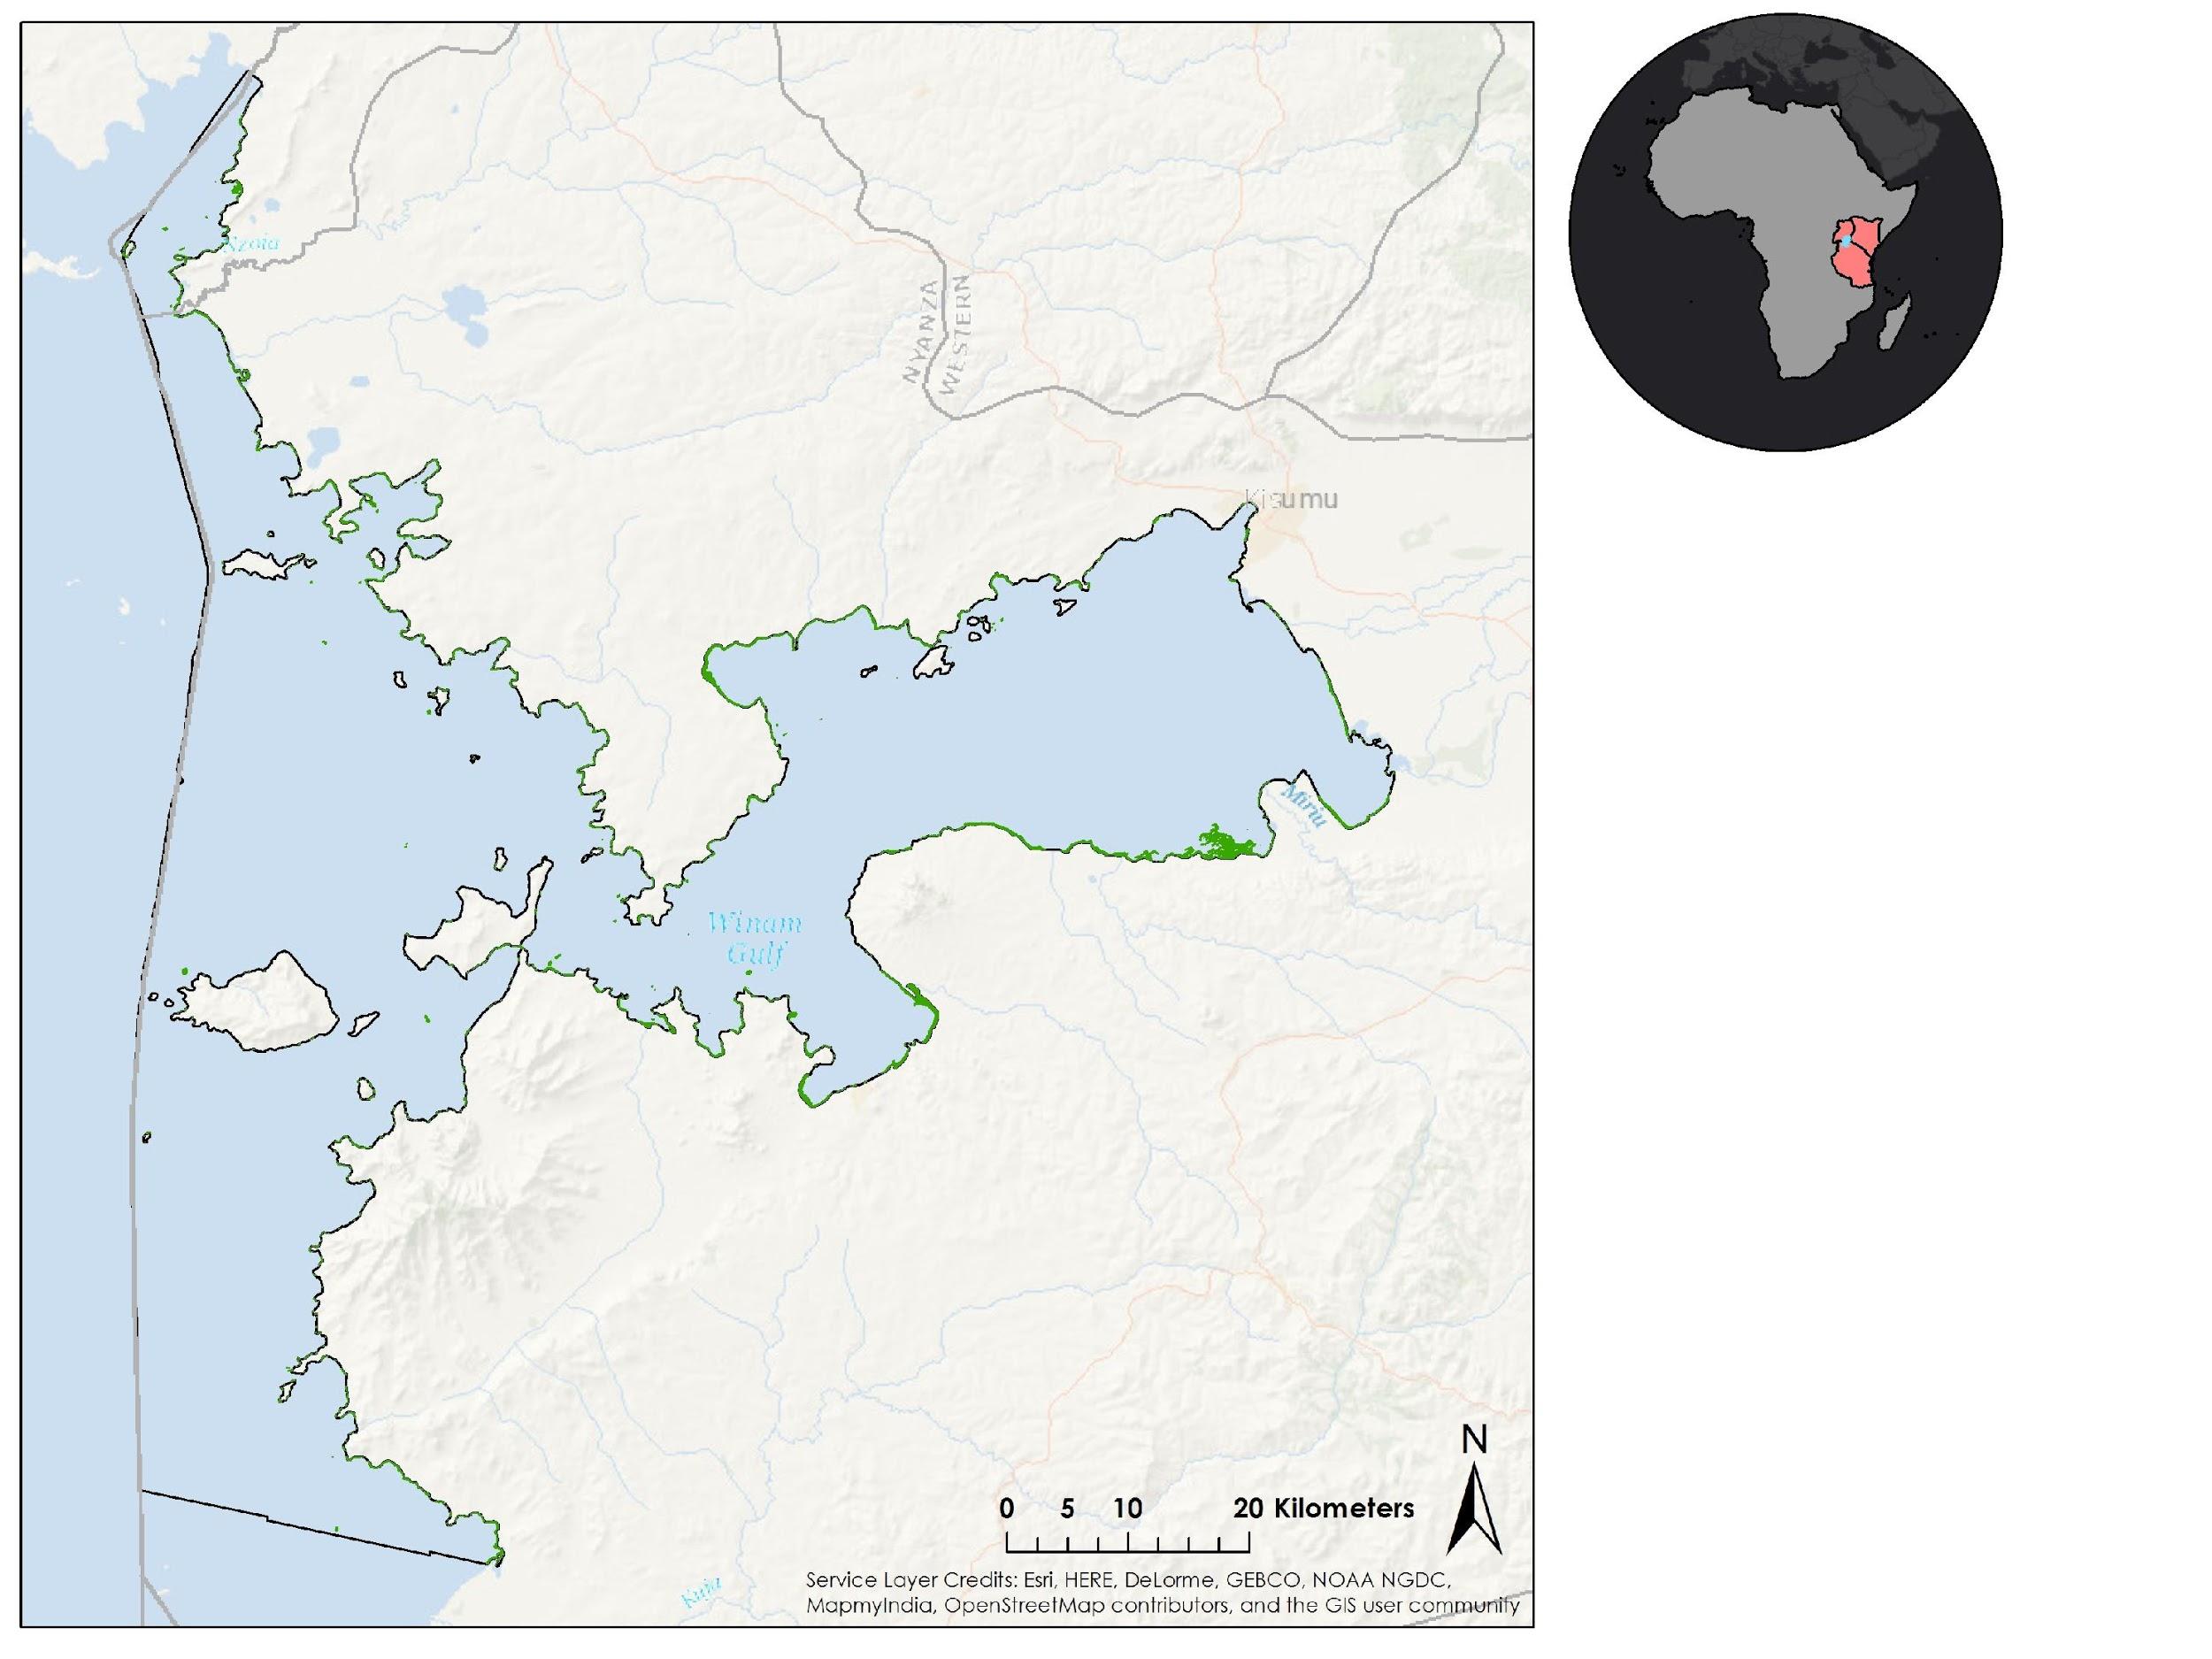

Figure 8 Landsat 8 OLI Surface Reflectance output from November 25, 2013