**NASA DEVELOP National Program**

**Goddard Space Flight Center**

**Summer 2015 Project Proposal**

**Idaho Disasters**

Using SMAP Earth Observations to Analyze the Link between Vegetation Moisture and Fire Susceptibility

**Objective:**

The proposed DEVELOP project will explore fire susceptibility by evaluating the correlation between fire occurrence and vegetation and soil moisture gathered by the Soil Moisture Active Passive (SMAP) mission. The results of this study will benefit the broad fire community and extend the data products and technical capabilities of the RECOVER decision support system for use by the Bureau of Land Management and Idaho Department of Lands in southern Idaho.

**Community Concern:**

Wildfire is a common hazard throughout semiarid savanna ecosystems. Following fire, ground vegetation is typically eliminated, leaving the landscape devoid of cover. These communities may then experience a series of adverse changes due to landslides, soil erosion, and invasive plant infestations. Wildfires have occurred for millennia, but climate change and related factors appear to be increasing their frequency and intensity, creating a demand for advanced wildfire decision support capabilities to identify fire susceptibility. Our end users can use our analyses to “allocate resources to regions that are more susceptible to fires” (Mike Kuyper, BLM).

**End-Users/Partners/Boundary Organizations:**

Bureau of Land Management, Idaho State Office and cooperating District Offices (End-User, POCs: Steve Jirik, Mike Kuyper)

Idaho Department of Lands, Boise Field Office ( End-User, POCs: Dixie Booker-Lair, Robin Dunn)

RECOVER Project (Partner, NASA Goddard POCs: John Schnase, Mark Carroll; Partner/Boundary Organization, Idaho State University POC: Keith Weber)

The entire Fall 2014 Idaho Disasters team met with our project end-users in Idaho in October, 2014. We discussed at length various products and tools that will be useful for our end-users as well as other government and local agencies that were in attendance. The vegetation moisture map of southern Idaho will incorporated into the RECOVER platform (see Notes) which is currently available and used by our end-users. We will also provide maps of fire susceptibility as a function of vegetation moisture. Our end-users will use the additional map layers in the online platform in conjunction with their current resources to identify regions of higher fire susceptibility in order to allocate their resources more efficiently

**Decision Making Process:**

Currently, the BLM uses vegetation moisture measurements that are collected at two-week intervals in discrete locations across the state. The measurements are collected from March to October by various national, state, local, and independent agencies and inputted into the National Fuel Moisture Database. Areas with drier vegetation receive resources such as helicopters, dozers, and other fire suppression equipment from field offices (the BLM has 16 field offices in Idaho) that are less susceptible. The Idaho Department of Lands follows similar guidelines, but the number of fires they respond to is much lower since most of the land in southern Idaho is managed by the BLM.

**Earth Observations:**

|  |  |  |
| --- | --- | --- |
| **Platform** | **Sensor** | **Geophysical Parameter** |
| **SMAP** | SMAP | Soil & vegetation moisture, evapotranspiration |
| **Terra** | MODIS | NDVI, Vegetation quality |

**NASA Earth Observations to be Highlighted:**

The Summer 2015 term is perfectly timed with initial access to the new SMAP data. The possibilities for using SMAP are still being conceptualized, but our plan is to use SMAP for soil and vegetation moisture. Since there is ground-truthing data on vegetation moisture across southern Idaho, we can assess the effectiveness and accuracy of SMAP and its usefulness in determining fire susceptibility. NDVI will be used to compare the relationship with soil and vegetation moisture with vegetation quality.

**Ancillary Datasets:**

National Fuel Moisture Database – United States Forest Service Wildland Fire Assessment System

Fire polygons – INSIDE Idaho GIS Database, University of Idaho

**Software & Scripting Utilized:**

* ArcGIS & ArcServer - Raster manipulation/analysis, map creation, Web services-based product delivery
* Python - Software integration
* ENVI – raster manipulation

**Decision Support Tools & Analyses:**

|  |  |  |
| --- | --- | --- |
| **Proposed End Products** | **Decision Impacting** | **Current Partner Tool/Method** |
| RECOVER Website Extension (SMAP) | Allocation of resources | Aerial imagery and field surveys. |

*Recover Website Extension (SMAP)* – We will first import the raw datasets from the SMAP satellite and determine their relationship with fire susceptibility using zonal statistics and correlation analyses. The output map will display a susceptibility index as a direct result of the SMAP data.

**Project Details:**

**National Application Area(s) Addressed:** Disasters

**Source of Project Idea:** This project is associated with Phase 2 operational deployment of the RECOVER DSS sponsored by NASA's Applied Sciences Program under ROSES A.35 - Wildland Fires (See Phase 1 and Phase 2 proposals titled " RECOVER: Rehabilitation Capability Convergence for Ecosystem Recovery — An Automated Burned Area Emergency Response Decision Support System for Post-fire Rehabilitation Management of Savanna Ecosystems in the Western US" for additional information).

**Advisor(s):** John Schnase, Co-I Mark Carroll (NASA GSFC), Co-I Keith Weber (ISU GIS TReC)

**# of Participants Requested:** 4 (2 at GSFC, 2 at ISU)

**Project Timeline:** 3 Terms: Fall 2014 – Summer 2015

**Study Location:** Idaho

**Period being Studied:** January 2015 – July 2015 (the lifetime of SMAP data)

**Previous Related DEVELOP Work:**

Idaho Disasters I

Using NASA Earth Observations to Create a Database and Determine Regional and Temporal Wildfire Susceptibility in Idaho Savannahs

Fall 2014

Idaho Disasters II

Using NASA Earth Observations to Identify Savannah and Shrubland Vegetation in Southern Idaho

Spring 2015

**Multi-Term Objectives:**

* **Term 1** – During this term, the team investigated the relationship between NDVI, surface temperature, and fire occurrence. The remote sensing parameters did not have any strong correlations with the number of fires each year. A secondary analysis compared the NDVI at locations that burned versus those that didn’t burn. The participants found that in April the NDVI at burned locations was significantly higher than unburned regions, which may be an indicator of more fuel for fires later in the year.
* **Term 2** – The objective of this term is to use Landsat Imagery to identify vegetation to the genus level. These vegetation maps are helpful to the end-users since different species of vegetation have different attributes that make them more susceptible to fire and have different management techniques.
* **Term 3 (Proposed Term)** – The goal of the final term is to investigate vegetation and soil moisture and its relationship with fire susceptibility. If there is a strong relationship, then we can integrate our findings on NDVI from the first term, plotted against the vegetation cover from the second term, and stacked with vegetation moisture results into a fire susceptibility map that aids wildfire managers in allocating resources prior to the active fire season.

**Notes:** RECOVER is a site-specific decision support system that automatically brings together in a single analysis environment all the information necessary for post-fire rehabilitation decision-making. In response to a fire detection event RECOVER, uses the rapid resource allocation capabilities of cloud computing to automatically collect Earth observational data, derived decision products, and historic biophysical data so that when the fire is contained, BAER teams will have a complete and ready-to-use RECOVER dataset and GIS analysis environment that is customized for the target wildfire.

The RECOVER system was originally developed for use in savannah ecosystems and focused on the post-wildfire decision processes of the BAER teams. During RECOVER's evaluation phase, our agency partners recommended that the capabilities of the recovery system be extended to (1) enable RECOVER's use in forested ecosystems and (2) enable RECOVER's use in pre- and active-fire decision processes.

The RECOVER DSS is made up of a RECOVER Server and a RECOVER Client (Fig. 1). The RECOVER Server is a specialized Integrated Rule-Oriented Data System (iRODS) data grid server deployed in the Amazon Elastic Compute Cloud. The RECOVER Client is a full-featured Adobe Flex Web Map GIS analysis environment. When provided a wildfire name and geospatial extent, the RECOVER Server aggregates site-specific data from pre-designated, geographically distributed data archives. It then does the necessary transformations and re-projections required for the data to be used by the RECOVER Client. It exposes the tailored collection of site-specific data to the RECOVER Client through web services residing on the Server.

Figure 1. RECOVER Server and Client interfaces. For YouTube demonstrations, please see:  
 <http://www.youtube.com/watch?v=LQKi3Ac7yNU> RECOVER Server  
 <http://www.youtube.com/watch?v=SGhPpiSYpVE> RECOVER Client

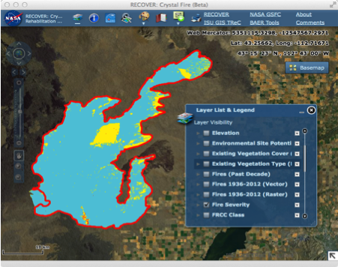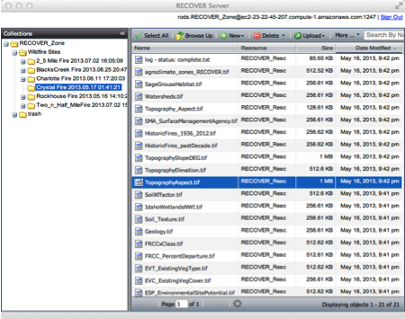

In a typical scenario-of-use, RECOVER uses the rapid resource allocation capabilities of cloud computing to automatically gather its various Earth observational and ancillary data products. Additional data can be added manually if needed, and the entire data collection is refreshed throughout the burn so that when the fire is contained, BAER teams have at hand a complete and ready-to-use RECOVER dataset that is customized for the target wildfire. The RECOVER server continues to gather data after the fire to support long-term monitoring of ecosystem recovery.

Our extensive use of web services allows RECOVER’s site-specific data to be consumed by state-of-the-art web-based GIS applications, such as the RECOVER’s Adobe Flex Client. This makes it possible for our agency partners to avail themselves of RECOVER’s analytic capabilities on any computer running a web browser, without having to acquire and maintain standalone GIS software. In addition, RECOVER’s web services architecture facilitates the future development of client applications that run on mobile devices. Most modern smart phones, tablets, etc. actually consist of just the display and user interface components of sophisticated applications that run in cloud data centers. This is the mode of work that RECOVER is intended to eventually accommodate.