Idaho Water Resources II

Evaluating Evapotranspiration and Water Budget Components in

Semi-Arid Sagebrush Steppe

**Technical Report**

Rough Draft – October 4th, 2018

Ian Lauer (Project Lead)

Carl Jurkowski

Carolyn Macek

Francis Zurek

Keith T. Weber, Idaho State University, GIS TReC (Science Advisor)

Previous Contributors:

Ian Lauer

Madison Broddle

Dane Coats

Leah Kucera

Zach Sforzo

# 1. Abstract

Evapotranspiration (ET) is a vital component of the hydrologic cycle, especially in semi-arid environments; water availability can have a substantial impact on ecosystem services, such as grazing patterns of native and domesticated animal populations, vegetation health, and fire susceptibility. Current practices to measure ET rely on costly field sampling approaches or models that are typically calibrated for agricultural land cover. Validating remotely sensed ET models with paired *in situ* eddy covariance tower data from Reynolds Creek Experimental Watershed (RCEW) will increase the confidence of measuring ET using remotely sensed data in the sagebrush steppe environment. ET estimates and model inputs were derived from NASA Terra Moderate Resolution Imaging Spectroradiometer (MODIS) and Advanced Spaceborne Thermal Emission and Reflection Radiometer (ASTER), Aqua MODIS, Landsat 7 Enhances Thematic Mapper (ETM+), and Landsat 8 Operational Land Imager (OLI) and Thermal Infrared Sensor (TIRS). Additionally, the project used modeled data from Google Earth Engine Evapotranspiration Flux (EEFlux), Simplified Surface Energy Balance (SSEBop), MODIS Global ET Project (MOD16), and North American Land Data Assimilation System (NLDAS-2 Noah). The NLDAS-2 Noah model produced the best correlation to the RCEW *in situ* measurements,with an average coefficient of determination of r2 = 0.87. The other three models resulted in coefficients ranging from r2 = 0.043 (EEFlux) to r2 = 0.87 (SSEBop and MOD16). Although NLDAS-2 Noah has the lowest spatial resolution of the tested models (~12 km), it has the highest temporal resolution (hourly), which is promising for developing hybrid models paired with higher spatial resolution datasets such as SSEBop.

**Keywords**: MODIS, MSAVI-2, EEFlux, SSEBop, Landsat, Google Earth Engine, evapotranspiration, semi-arid

# 2. Introduction

* 1. ***Background Information***

Evapotranspiration (ET), the sum of water loss to the atmosphere from surface evaporation and plant transpiration, is a critical component of the hydrologic cycle, particularly in semi-arid environments (Ke, Im, Park, & Gong, 2016) where water availability for vegetation is limited. Watershed-scale ET measurements can be useful for understanding water loss in the water balance but have previously been neglected due to spatial and temporal complexity. In the future, areas like the Intermountain West are predicted to experience higher susceptibility to changes in the hydrologic cycle in response to climate alterations compared to other ecoregions (Sridhar & Nayak, 2010). In Idaho, greater than 60% of the land, approximately 35 million acres, is publicly managed (Vincent, Hanson, and Argueta, 2017). Because of the expansive and remote nature of these lands, land managers currently rely on interpolated data from limited *in situ* measurements and coarse resolution remotely sensed datasets to perform research and adopt resource management policies. To improve the ability for land managers to make decisions on ecosystem health and services, high-resolution, spatially extensive datasets are needed for managers to better understand hydrologic and vegetative health conditions.

In summer 2018, the Idaho Water Resources I team investigated remotely sensed soil moisture observations for the semi-arid sagebrush steppe. The team used *in situ* data from the Reynolds Creek Experimental Watershed (RCEW) (Figure 1) to validate observations of beta-quality, 1 km resolution, SMAP/Sentinel-1 enhanced soil moisture products. The Soil Moisture Active Passive sensor (SMAP) was launched by NASA in 2015. However, shortly after launch, SMAP’s active radar amplifier malfunctioned; this left only the passive sensor, which had reduced spatial resolution (36 km) and ground penetration depth (Chan et al., 2016). A new methodology that utilized backscatter from SMAP/Sentinel-1 L2 Radiometer/Radar 30-Second Scene 3 km EASE-Grid Soil Moisture V002 sharpened the spatial resolution of soil moisture outputs to 1 km (Das & Dunbar, 2017; Das et al., 2017) but had limited testing at the time of the first term’s project. The summer 2018 team’s simple regression analysis showed moderate to strong correlations between SMAP/Sentinel-1 soil moisture products and *in situ* soil moisture measurements. Additionally, low correlations were found between SEB/Sentinel-1 soil moisture, satellite-estimated precipitation (GPM IMERG), and Normalized Difference Vegetation Index (Lauer, Coats, Kucera, Sforzo, & Broddle, 2018). These results showed significant promise for continued use of the platform but necessitated further exploration of soil moisture influence on vegetative health in the study area.

**Idaho**

**Study area boundary**

**20 km**

**10**

**5**

**0**

**Eddy covariance flux towers**

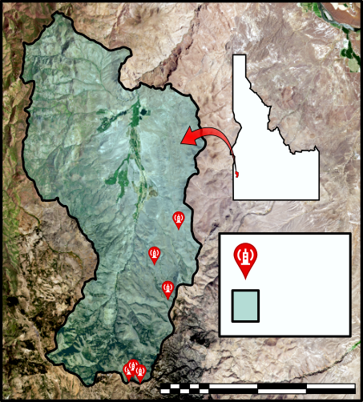

*Figure 1.* The Reynolds Creek Experimental Watershed (RCEW) in southwest Idaho was the study area for this research. It contains six eddy covariance flux towers (red balloons) for *in situ* ET measurements.

For this project, Idaho Water Resources II, data from NASA Earth-observing satellites and various ET models were compared to *in situ* data from eddy covariance towers at RCEW. Eddy covariance towers are used to measure land surface-atmospheric gas and energy exchange variables, which are then utilized in environmental models such as ET. The *in situ* ET measures at RCEW were used to assess the accuracies of remotely sensed ET measurements and models in the semi-arid sagebrush steppe. These sites include three distinct vegetation communities across a range of elevations. Two of the sites were in communities dominated by mountain big sagebrush (*Artemisia tridentata* spp. *vaseyana*) at ~1900 m (hereafter, called Mountain Sage 1) and ~2100 m (Mountain Sage 2). The two lower elevation sites used for comparison contained Wyoming big sage (*Artemisia tridentate* spp. *wyomingensis*; Wyoming Sage) and low sagebrush (*Artemisia arbuscula*; Low Sage), at ~1600 m and ~1400 m respectively. There are two different groups of vegetation corresponding to relatively lower and higher elevations. Lower elevation land cover (~1100 m-~1500 m) consisted predominantly of greasewood, cultivated land, Wyoming sagebrush, and bitterbrush. Mountain sagebrush-snowberry, Wyoming sagebrush-bitterbrush, low sagebrush, conifers, and quaking aspen dominated higher elevations. While previous research has compared satellite-based ET model accuracy within agricultural systems and across environmental variables, such as varying elevation and climate zones (Ayenew, 2003; Velpuri, Senay, Singh, Bohms, & Verdin, 2013), there has been little research specifically assessing model applicability within a semi-arid climate and natural land cover. This work will give land management agencies greater confidence in applying remotely sensed measurements in future products and assess the best methods for determining ET in this particular ecosystem. We assessed four remotely sensed ET models, Google Earth Engine Evapotranspiration Flux (EEFlux), Operational Simplified Surface Energy Balance (SSEBop), Moderate Resolution Imaging Spectroradiometer (MODIS) Global Evapotranspiration Project (MOD16), and North America Land Data Assimilation Systems 2 Noah (NLDAS-2-Noah), each of which utilized different algorithms for calculating ET. EEFlux implements Mapping Evapotranspiration at High Resolution with Internalized Calibration (METRIC) within the Google Earth Engine API (GEE), allowing rapid mapping of regional ET measurements. SSEBop estimates ET across a variety of climatological conditions and elevations, which advertises improved automation for modeling across large spatial scopes (Senay et al., 2013). The MOD16 algorithm incorporates a number of complex processes excluded in other models, including surface evaporation, which may be of particular importance in semi-arid environments (Mu, Zhao, & Running, 2011). Lastly, the NLDAS-2-Noah model has hourly data, allowing for examination of ET trends at a fine temporal scale, and assimilates large meteorological datasets, such as *in situ* or satellite-measured precipitation.

* 1. ***Project Partners & Objectives***

The project team partnered with several federal and state agencies including the US Fish and Wildlife Service (USFWS), the Idaho Department of Fish and Game (IDFG), the Idaho National Laboratory (INL), and the US Department of Agriculture (USDA) Natural Resources Conservation Service (NRCS) and Agricultural Research Service (ARS).

The USFWS and IDFG consult with other local agencies and are responsible for the dissemination of data to area stakeholders, such as ranchers, landowners, and other land managers. These two partners were interested in obtaining higher spatial and temporal resolution data for the purpose of wildlife conservation, including foraging, endangered species monitoring, and resource management. Specifically, the USFWS and IDFG were interested in using ET data to better understand sagebrush recovery pre- and post-fire. Additionally, these organizations were concerned with monitoring vegetation health and distribution in order to understand their impacts on both rangeland management and native animal populations. The INL also had a vested interest in understanding the hydrologic cycles in semi-arid environments at large spatial extents, particularly along the Idaho Snake River Plain where water recharges the Snake River Plain Aquifer.

The USDA ARS and NRCS provided the publicly available *in situ* data that were used for analysis and comparison with remotely sensed ET models, including *in situ* ET, precipitation, and soil moisture. Partnership with NASA DEVELOP allows the USDA ARS and NRCS to disseminate data by providing them with tools and methodologies that pertain to their current research goals as an experimental watershed. Although RCEW is highly instrumented, the datasets provided by this project give the partners a fuller picture of the hydrologic cycle in this watershed.

The primary objective of this project was to assess the effectiveness of multiple remotely sensed models to map ET across semi-arid environments. Additionally, this project aimed to validate the models by comparing them against *in situ* data from the eddy covariance towers at RCEW. The final objective was to compare ET data to elevation, soil moisture, and precipitation data from RCEW datasets, as well as modified soil-adjusted vegetation index (MSAVI-2) derived from Landsat 8 Operational Land Imager (OLI) imagery. Time-lagged cross-correlation between the hydrologic variables was produced to create a more holistic view of water availability in Reynolds Creek. Final products included a handoff document comprised of the correlations between measured hydrologic variables and ET, which project partners can use to select the ET model that best fits their needs. Additionally, a video tutorial illustrating the methodologies used in assessing ET models within the region was produced to help partners replicate the methodologies.

# 3. Methodology

***3.1 Data Acquisition***

The team analyzed data from four preprocessed remotely sensed ET models for the study period from 2015 to 2017. These ET products were produced with various data from the Aqua MODIS, Terra MODIS, Terra ASTER, Landsat 7 Enhanced Thematic Mapper Plus (ETM+), Landsat 8 OLI, and Landsat 8 Thermal Infrared Sensor (TIRS). First, SSEBop ET estimates were acquired from the United States Geological Survey (USGS) via the GEE Climate Engine (app.climateengine.org), whose product is derived from Aqua MODIS data (MYD16A2: MODIS/Aqua Net Evapotranspiration 8-Day L4 Global 500 m SIN Grid V006; Running, Mu, & Zhao, 2017). Second, MOD16 ET was acquired from Google Earth Engine (MOD16A2: MODIS/Terra Net Evapotranspiration 8-Day L4 Global 500 m SIN Grid V006; Running, Mu, & Zhao, 2017). Third, NLDAS-2 Noah Actual ET data was acquired through NASA Giovanni (Noah Land Surface Model L4 Hourly 0.125 x 0.125 degree V002; Mocko, D., 2012; Xia et. al., 2012). Last, METRIC ET was acquired from the EEFlux app (eeflux-level1.appspot.com; Irmak et al., 2012; Allen, Masahiro, & Trezza, 2007; and Univ. of Nebraska et al., 2018).

In addition to modeled ET data, vegetation health maps, elevation, and *in* *situ* precipitation, soil moisture, and evapotranspiration data were acquired. MSAVI-2 vegetation index maps were produced with the red and near-infrared bands of the Landsat 8 OLI and Landsat 8 TIRS Collection 1 V1. Digital elevation models (DEM) were acquired from the USGS National Elevation Dataset (NED). MSAVI-2 is calculated using the following equation:

$$\text{MSAVI-2=}\frac{\text{(2*NIR+1-} \sqrt{{\left(\text{2*NIR+1}\right)}^{\text{2}}\text{-8*}\left(\text{NIR-RED}\right)}\text{)}}{\text{2}}$$

*In situ* data collected from eddy covariance towers within RCEW, such as ET, soil moisture, and precipitation, were used to verify the NASA remotely sensed data products and ET models. *In situ* ET data were acquired from Gerald Flerchinger at the USDA ARS (Fellows et al., 2017). Soil moisture data used in this project were compiled by the Idaho Water Resources I team (Lauer et al., 2018). A flowchart of the models used in this project, a brief description of methodologies, and outcomes is shown in figure 2.



**Google Earth Engine:**

Combine GEE and *in situ* data; extract values at RCEW sites

**ArcGIS Pro:**

Clip to study area; extract values at RCEW Points

Compare ET maps to elevation, soil moisture, etc.

ET Maps & Correlation

Plots

GEE ET Models: EEFlux

MOD16

SSEBop

*RCEW* ET &

soil moisture,

MSAVI-2

Other Models:

NLDAS-2-Noah

*Figure 2.* Flowchart of models used in this project, methodologies, and overall outcomes.

***3.2 Data Processing***

Spatial data were processed with Esri ArcGIS Pro (version 2.2), GEE, and MATLAB (version R2018b). Esri ArcGIS Pro was used to process geospatial files and datasets for RCEW, to sample ET data, and to create visual maps and end products. The Reynolds Creek dataset included shapefiles for watershed delineation, instrument location (eddy covariance towers, meteorological stations, and soil moisture sensors), soil type, elevation, and vegetation classification. ET data from the EEFlux and MOD16 modeling tools were downloaded via GEE and processed in Esri ArcGIS Pro. All ET data were clipped to the study area and sampled at eddy covariance tower and soil moisture sensor site locations. Sampling results were exported for further analysis in MATLAB and Excel.

To evaluate the relationship between remotely sensed ET to vegetation type and elevation across the watershed, monthly ET (2015) maps of EEFlux and SSEBop were compared to a RCEW vegetation map and DEM. NLDAS-2-Noah and MOD16 were not analyzed with environmental data due to having poor spatial resolution and abnormally high ET outputs, respectively. Cultivated areas, defined by a RCEW vegetation map, were removed from clipped ET maps with ArcPro raster calculator tool to reduce the influence of the abnormally high ET values associated with those areas. The resulting raster image was analyzed with the ArcGIS Pro zonal statistics tool, evaluating ET and vegetation type relative to elevation. Elevation relationships were determined using the ArcGIS Pro zonal statistics tool with EEFlux and SSEBop ET models and the RCEW 1-m DEM. Minimum, maximum, mean, and standard deviation data from each of the products were exported from ArcGIS Pro to Excel where the data were plotted and compared to the other ET models.

***3.3 Data Analysis***

Relationships between remotely sensed ET and *in situ* ET, as well as soil moisture, precipitation, MSAVI-2, and elevation, were completed using the Microsoft Excel regression tool and MATLAB xcorr cross-correlation tool. Linear regressions were analyzed between remotely sensed ET and *in situ* measurements at each eddy covariance site producing regression coefficients (r2 values). The time-lag correlation between modeled and *in situ* ET measurements, relative to environmental variables, was assessed in MATLAB with the xcorr function. Exact r2 values are relative to the application; however, r2 < 0.3, r2 =0.3-0.7, and r2 > 0.7 were considered weak, moderate, and strong respectively.

# 4. Results & Discussion

***4.1 Analysis of Results***

Based on the minimum resolution of their model inputs, Spatial and temporal resolutions vary with different ET datasets. Spatial resolutions ranged from ~12 km (NLDAS-2-Noah) to 30 m (EEFlux), shown in Figure 3, and temporal resolutions ranged from 10-day (SSEBop) to hourly (NLDAS-2-Noah). MOD16, SSEBop, and EEFlux data produced unique ET measurements at each validation site. However, the low spatial resolution of NLDAS-2-Noah model divided the four eddy covariance towers into only two unique pixels, split between comparatively higher and lower elevation validation sites. Datasets were kept at their native spatial resolution, and comparisons between *in situ* data and remotely sensed data were analyzed at monthly averages. A time series of RCEW *in situ* ET for visual comparison is shown in Figure 4.

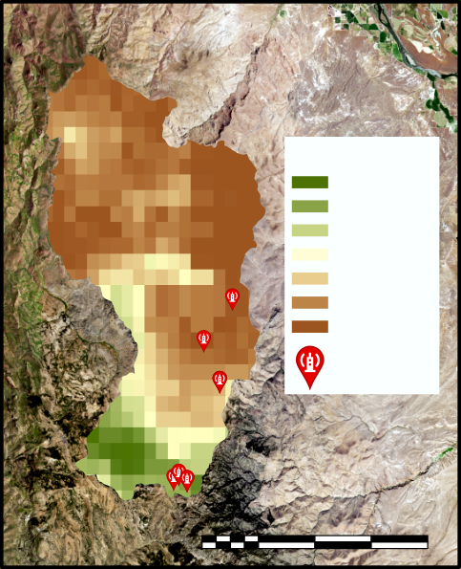 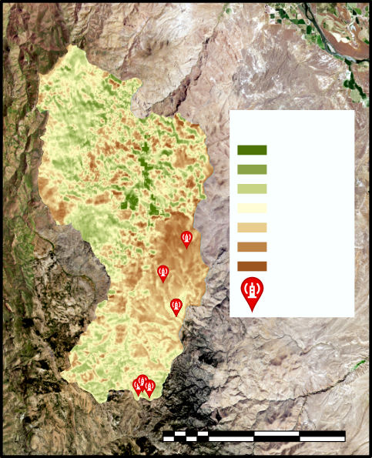

**Evapotranspiration**

**0**

**15**

**(mm/**

**8 days)**

**E.C. Flux Towers**

**SSEBop**

**Evapotranspiration**

**(mm/**

**month)**

**110**

**0**

**E.C. Flux Towers**

**0 5 10 20 km**

**0 5 10 20 km**

**EEFlux**

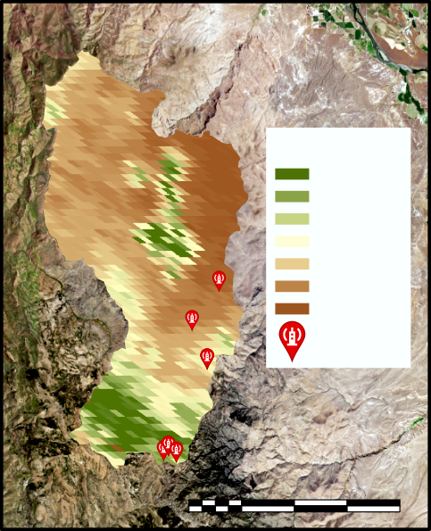 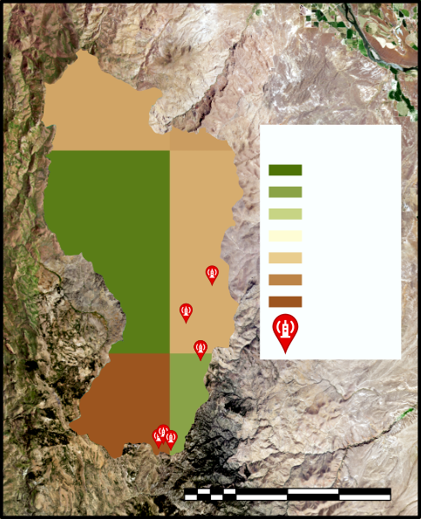

**Evapotranspiration**

**(mm/**

**8 days)**

**45**

**0**

**E.C. Flux Towers**

**Evapotranspiration**

**(mm/**

**month)**

**60**

**0**

**E.C. Flux Towers**

**NLDAS-2-Noah**

**MOD16**

**0 5 10 20 km**

**0 5 10 20 km**

*Figure 3.* A comparison of spatial resolutions of the four ET models. Resolutions are from left to right, SSEBop 1 km, MOD16 500 m, EEFlux 30 m, NLDAS ~12 km.

***4.1.1 NLDAS-2-Noah***

NLDAS-2-Noah has the highest temporal resolution (hourly) and the lowest spatial resolution (~12 km). Time series analysis was conducted at daily and monthly temporal scales and compared to contemporaneous RCEW measurements. Daily correlations performed worse compared to monthly total correlations. Daily regression coefficients ranged from 0.53 to 0.69 and monthly total regression coefficients for the study period ranged from 0.7 to 0.87 (Figure 5A). Total ET varied between elevation sites, where higher elevation sites had higher total ET compared to lower elevation sites. Both groups of sites followed a similar annual trend of increasing ET until mid-year and decreasing ET in the later months of the year (Figure 5B). In general, NLDAS-2-Noah under-predicted total ET throughout the entire year and more substantially in the summer months (May-August). This model underpredicted ET by an average 53% throughout the year. NLDAS-2-Noah assimilates meteorological data from sites across the United States to compute an ET product. Therefore, high regression coefficients may be a product of this model utilizing RCEW meteorological data and may not produce similarly accurate results when used in regions that lack dense local meteorological data.

*Figure 4*. Reynolds Creek ET time series for the year 2016 for comparison with modeled ET time series.

*Figure 5*. A) NLDAS-2-Noah Modeled ET vs. RCEW ET regression analysis for study period 2015-2017. B) NLDAS-2-Noah ET time series for the year 2016.

***4.1.2 SSEBop***

SSEBop has a temporal resolution of ten days but, for the purpose of comparing models, daily values were summed to monthly total ET. This model has a spatial resolution of 1 km. Correlation coefficients between eddy covariance towers and modeled ET ranged from 0.21 to 0.85 with an average r2 of 0.49 over the length of the study period (Figure 6A). SSEBop follows the general trend of increasing ET during the growing months and decreasing ET during the winter months (Figure 2B). Overall, this model tends to underestimate ET throughout the entire year by an average of 48% throughout the year.

*Figure 6.* A) SSEBop Modeled ET vs. RCEW ET regression analysis for the study period 2015-2017. B) SSEBop ET time series for the year 2016.

***4.1.3 EEFlux***

EEFlux utilizes imagery from Landsat 7 ETM+ and Landsat 8 OLI and TIRS, resulting in a roughly eight-day temporal resolution depending on cloud cover and Landsat 7 ETM+ band errors, and were collected for the years 2015 through 2017. Its spatial resolution is 30m. Monthly total ET coefficient correlations ranged from 0.32 to 0.83 with an average of 0.66 across all sites throughout the study period (Figure 7A). The EEFlux model showed monthly total ET increasing to the summer months and decreasing in the later months. A secondary spike in ET is seen in September 2016 for Wyoming big sage, low sage, and mountain big sage 1. This spike in ET can be seen in the other two years of data, though not as obvious or during the same months (Figure 7B). EEFlux tends to underestimate ET throughout the entire year by an average of 23%. ET roughly correlated with elevation with an average r2 of 0.6 across the study period.

*Figure 7.* A) EEFlux Modeled ET vs. RCEW ET regression analysis for the study period 2015-2017. B) EEFlux ET time series for the year 2016.

***4.1.4 MOD16***

The MOD16 product contains eight-day cumulative ET estimates; each estimate was averaged over the month to produce a monthly total ET value. The spatial resolution of this data set is 500m. Correlation coefficients between MOD16 and RCEW *in situ* ET data over the length of the study period resulted in r2 values ranging from 0.04 to 0.61 with an average r2 of 0.45. Correlation coefficients for 2016 are shown in figure 8A. Time series analysis of modeled ET shows varying trends and magnitudes of ET over the four years (Figure 8B). However, MOD16 showed an increase of total ET in the summer months and a decrease of ET during the winter months. This model showed a second spike in ET in September in Wyoming sage, low sage, and mountain sage 1 sites. This model consistently overestimated ET by an average of 300% throughout the year.

*Figure 8.* A) MOD16 ET time series for the study period 2015-2017. B) MOD16 Modeled ET vs. RCEW ET regression analysis for 2016.

***4.1.5 Environmental Factors***

Each of the ET models reached yearly highs in early summer, decreased in mid-summer, and had a second, but lower magnitude peak beginning in early autumn, which corresponded to expected periods of vegetation growth and decline. Despite similar patterns between models, exact timing and magnitude varied between sampling sites and ET models. There was a strong relationship between elevation and ET for EEFlux (r2 = 0.73) and RCEW (r2 = 0.95), and a moderate relationship for SSEBop (r2 = 0.52). In general, ET increases with elevation between all comparable models. Deviation from this trend occurs at both the lowest elevation and the highest elevations in the watershed. Lower reaches of the watershed, comprised of cultivated land and riparian zones, displayed relatively high ET. These areas often have ample water supply and are rarely water limited, unlike the remaining area in the watershed, and therefore have higher ET rates. A trend of decreasing ET at the higher elevation of the watershed was related to a transition from patchy aspen and conifer stands back to sagebrush-dominated landscapes. This vegetation transition may be due to the low soil thickness that is common at higher elevations (Pelletier & Rasmussen, 2009), lower water storage, and subsequent lower water availability. Vegetation type did not correlate well with ET. However, there are two different groups of vegetation corresponding to relatively lower and higher elevations. Lower elevation land cover (~1100 m-~1500 m) consisted of greasewood, cultivated land, Wyoming sagebrush, and bitterbrush. This lower elevation group generally had lower ET, with the exception of cultivated land and riparian vegetation which had high ET rates. The second, higher elevation vegetation group included mountain sagebrush-snowberry, Wyoming sagebrush-bitterbrush, low sagebrush, conifers, and quaking aspen. ET and MSAVI-2, in relation to vegetation type, have relatively high correlation coefficients. Mountain sage 1, low sage, Mountain sage 2, and Wyoming sage have r2 values of 0.85, 0.65, 0.80, and 0.63, respectively, suggesting that the healthier the vegetation is, the more it transpires. Precipitation was found to be correlated with ET and soil moisture with a 105-day lag. A lag represents seasonal variation in precipitation, ET, and soil moisture.

***4.2 Future Work***

Developing a combined model using the high temporal resolution data from NLDAS-2-Noah to interpolate temporal gaps in the high spatial resolution data from SSEBop is of interest to the team and partners. Currently, there is an ongoing project aimed to develop a model implementing SSEBop into GEE using Landsat 8 imagery to create a high spatiotemporal ET map. Creating a composite model can provide our partners with a higher spatiotemporal model that can be used to better manage our public lands.

There is interest in investigating land management concerns in Argentina using methodology from this study. The Patagonia steppe in Argentina is biophysically similar to the semi-arid sagebrush steppe ecosystem present in the RCEW. Keith Weber, the Idaho Node Science Advisor, and Dr. Aceñolaza, a researcher at the National Scientific and Technical Research Council, began planning for this project during the project development for the spring 2018 term. Though this project’s area of focus would be in a different region, the methodologies used would reference the work performed by in previous DEVELOP terms. There is also interest in using the Spaceborne Thermal Radiometer Experiment on Space Station (ECOSTRESS) to determine ET in semi-arid sagebrush steppe ecosystems.

# 5. Conclusions

Although no single model outperformed the rest, this study provides our partners with advantages and disadvantages for each of the models tested in this study. NLDAS-2-Noah has the best correlations to *in situ* data and has high temporal resolution data. However, this model has the lowest spatial resolution of the tested models and NLDAS-2-Noah utilizes some meteorological data collected at RCEW. SSEBop is easy to download and access its data, but it consistently underestimates ET and has highly variable ET correlations depending on vegetation types and elevation. Although EEFlux has the highest spatial resolution of the models tested in this study, the data is difficult to access and download, cloud cover limits usability, and assimilating Landsat 7 ETM+data can be difficult due to scan line issues in the data. MOD16 has a relatively high spatial resolution; however, it severely overestimates cumulative ET.

Because the benefits and drawbacks of each model are so variable, those wishing to use satellite-based ET models would need to consider carefully which model would best fit their needs. A common problem across all preprocessed modeled datasets was a general lack of metadata. Specifically, it was oftentimes difficult or impossible to find input datasets used to produce monthly cumulative ET within a dataset, which in turn could impede analysis. ET is a complex process driven by many interacting variables, and more work is necessary to create a remote sensing model that can be applied to the sagebrush steppe ecosystem.

# 6. Acknowledgments

The Idaho Water Resources II team would like to acknowledge and thank advisors and project partners who dedicated their time, resources, and assistance to this project.

USFW Eastern Idaho Field Office:

* Evan Ohr, Biologist
* Lisa Dlugolecki, Biologist
* Matt Bringhurst, Soil Conservation Tech

IDFG Southeast Regional Office:

* Scott Bergen, Sr. Wildlife Research Biologist

USDA NRCS Pocatello Field Office:

* Nate Matlack, Soil Conservationist
* Trudy Pink, Resource Soil Scientist

DOE Idaho National Lab:

* Tammie Borders, Research Scientist
* Trent Armstrong, Research Scientist

USDA ARS Northwest Watershed Research Center

* Dr. Patrick E. Clark, Range Scientist

Special thank you to our node science advisor:

* Keith T. Weber, GIS Director at Idaho State University, GIS TReC

Any opinions, findings, and conclusions or recommendations expressed in this material are those of the author(s) and do not necessarily reflect the views of the National Aeronautics and Space Administration.

This material is based upon work supported by NASA through contract NNL16AA05C.

# 7. Glossary

**ARS** - Agricultural Research Service

**CZO** - Critical Zone Observatory

**EEFlux** - Google Earth Engine Evapotranspiration Flux

**ET** - Evapotranspiration

**GIS TReC** - Geographic Information Systems Training and Research Center

**GEE** - Google Earth Engine

**IDFG** - Idaho Department of Fish and Game

**INL** - Idaho National Lab

**METRIC** - Mapping Evapotranspiration at High Resolution with Internalized Calibration

**MSAVI-2** - Modified Soil-adjusted Vegetation index

**MODIS** - Terra Moderate Resolution Imaging Spectroradiometer

**OLI** - Operational Land Imager

**RCEW** - Reynolds Creek Experimental Watershed

**SMAP** - Soil Moisture Active Passive

**SSEBop** - Operational Simplified Surface Energy Balance

**USDA ARS** - United States Department of Agriculture, Agricultural Research Service

**USDA NRCS** - United States Department of Agriculture, Natural Resources Conservation Service

**USFW** - Department of Interior, United States Fish and Wildlife Service

**USGS** - United States Geological Survey

# 8. References

Allen, R. G., Masahiro, T., & Trezza, R. (2007). Satellite-based energy balance for mapping evapotranspiration with internalized calibration (METRIC)— model. *Journal of Irrigation and Drainage Engineering, 133*(4), 380–394. <https://doi.org/10.1061/(ASCE)0733-9437(2007)133>

Ayenew, T. (2003). Evapotranspiration estimation using thematic mapper spectral satellite data in the Ethiopian rift and adjacent highlands. *Journal of Hydrology*, *279*(1–4), 83–93. https://doi.org/10.1016/S0022-1694(03)00173-2

Das, Narendra, N., Entekhabi, D., Dunbar, S., Kim, S., Yueh, S.,…Lopez-Baeza, E., November 1, 2017. Assessment report for the L2_SM_SP beta release data products, SMAP Project, JPL D-56549, Jet Propulsion Laboratory, Pasadena, CA.

Das, N. N., & Dunbar, R. S. (2017). Level 2 SMAP/Sentinel Active/Passive soil moisture product specification document (initial release), SMAP Project, JPL D-56548. Pasadena, CA: NASA Jet Propulsion Laboratory. Retrieved from https://nsidc.org/sites/nsidc.org/files/technical-references/SMAP%20L2_SM_SP%20PSD_11-01-2017_latest.pdf

Fellows, Aaron W., Flerchinger, Gerald N., Seyfried, Mark S., & Lohse, Kathleen. (2017). Data for partitioned carbon and energy fluxes within the Reynolds Creek Critical Zone Observatory [Data set]. Retrieved from <https://doi.org/10.18122/B2TD7V>

Irmak, A., Allen, R. G., Kjaersgaard, J., Huntington, J., Kamble, B., Trezza, R., & Ratcliffe, I. (2012). Operational remote sensing of ET and challenges. In Dr. Ayse Irmak (Ed.), *Evapotranspiration Remote Sensing and Modeling* (pp. 467-492). Rijeka, Croatia: InTech <https://doi.org/978-953-307-808-3>

Ke, Y., Im, J., Park, S., & Gong, H. (2016). Downscaling of MODIS one kilometer evapotranspiration using Landsat-8 data and machine learning approaches. *Remote Sensing*, *8*(3), 1–26. https://doi.org/10.3390/rs8030215

Lauer, I., Coats, D., Kucera, L., Sforzo, Z., & Broddle, M. (2018). Idaho Water Resources: Estimating soil moisture in semiarid sagebrush steppe utilizing NASA satellite imagery. Unpublished manuscript. NASA DEVELOP National Program: Idaho Node, Pocatello, ID.

Mocko, D., NASA/GSFC/HSL (2012), NLDAS Noah Land Surface Model L4 Monthly 0.125 x 0.125 degree V002, Greenbelt, Maryland, USA, Goddard Earth Sciences Data and Information Services Center (GES DISC). [Dataset]. Accessed: [October, November 2018], [10.5067/NOXZSD0Z6JGD](https://doi.org/10.5067/NOXZSD0Z6JGD)

Mu, Q., Zhao, M., & Running, S. W. (2011). Improvements to a MODIS global terrestrial evapotranspiration algorithm. *Remote Sensing of Environment*, *115*(8), 1781-1800.

Qi J., Chehbouni A., Huete A.R., Kerr Y.H., Sorooshian S., A modified soil adjusted vegetation index, *Remote Sensing of Environment*, *48*(2), 119-126. https://doi.org/10.1016/0034-4257(94)90134-1.

Pelletier, J. D., & Rasmussen, C. (2009). Geomorphically based predictive mapping of soil thickness in upland watersheds, *45*(September), 1–15. https://doi.org/10.1029/2008WR007319

Running, S., Mu, Q., & Zhao, M. (2017). MOD16A2 MODIS/Terra net evapotranspiration 8-Day L4 global 500m SIN Grid V006 [Data set]. NASA EOSDIS Land Processes DAAC. doi: 10.5067/MODIS/MOD16A2.006. Retrieved from <https://lpdaac.usgs.gov/node/1191>. Accessed [October/November 2018].

Senay, G. B., Bohms, S., Singh, R. K., Gowda, P. H., Velpuri, N. M., Alemu, H., & Verdin, J. P. (2013). Operational evapotranspiration mapping using remote sensing and weather datasets: A new parameterization for the SSEB approach. *Journal of the American Water Resources Association*, *49*(3), 577–591. <https://doi.org/10.1111/jawr.12057>

Seyfried, M. S., Reynolds Creek Experimental Watershed soil moisture (2015-2018). Boise, ID: USDA-ARS, Accessed [June/July/August 2018].

Slaughter, C. W., Marks, D., Flerchinger, G. N., Vactor, S. S., Van, & Burgess, M. (2001). Thirty-five years of research data collection at the Reynolds Creek Experimental Watershed, Idaho, United States, *37*(11), 2819–2823.

Sridhar, V., & Nayak, A. (2010). Implications of climate-driven variability and trends for the hydrologic assessment of the Reynolds Creek Experimental Watershed, Idaho. *Journal of Hydrology*, *385*(1–4), 183–202. <https://doi.org/10.1016/j.jhydrol.2010.02.020>

U.S. Geological Survey, Department of the Interior. 1/3rd arc-second Digital Elevation Models (DEMs) - USGS National Map 3DEP Downloadable Data Collection. USGS NED n44w117 1/3 arc-second 2013 1 x 1 degree ArcGrid (2013). Reston, VA: U.S. Geological Survey. Accessed [June/July/August 2018]. Retrieved from https://catalog.data.gov/dataset/national-elevation-dataset-ned-1-3-arc-second-downloadable-data-collection-national-geospatial

University of Nebraska-Lincoln, Desert Research Institute, and University of Idaho. Earth Engine Evapotranspiration Flux based on METRIC. [Dataset]. Retrieved from <https://eeflux-level1.appspot.com/>. Accessed: [October 1, 2018].

Velpuri, N. M., Senay, G. B., Singh, R. K., Bohms, S., & Verdin, J. P. (2013). A comprehensive evaluation of two MODIS evapotranspiration products over the conterminous United States: Using point and gridded FLUXNET and water balance ET. *Remote Sensing of Environment*, *139*, 35-49.

Vincent, C. H., Hanson, L. A., & Argueta, C. N. (2017). *Federal Land Ownership: Overview and Data* (CRS Report No. R42346). Retrieved from Congressional Research Service website: <https://fas.org/sgp/crs/misc/R42346.pdf>

Xia, Y., Mitchell, K., Ek, M., Sheffield, J., Cosgrove, B., Wood, E., Luo, L.,… Mocko, D. (2012), Continental-scale water and energy flux analysis and validation for the North American Land Data Assimilation System project phase 2 (NLDAS-2): 1. Intercomparison and application of model products, J. Geophys. Res., 117, D03109, [Dataset]. Accessed: [October, November 2018] doi:[10.1029/2011JD016048](https://doi.org/10.1029/2011JD016048).

# 9. Appendix A.

*Table 1.* Primary Datasets

|  |  |  |  |  |
| --- | --- | --- | --- | --- |
| **ET Model** | **Model Type** | **Date** | **Source** | **Satellite** |
| Operational Simplified Surface Energy Balance (SSEBop) | Surface Energy Balance | 2000 to 2015 | <https://cida.usgs.gov/gdp/> | PRISM, TERRA MODIS, SRTM |
| Mapping Evapotranspiration at High Resolution with Internalized Calibration (METRIC) | Surface Energy Balance | 2000 to 2014 | <https://eeflux-level1.appspot.com/> | LANDSAT |
| North American Land Data Assimilation System (NLDAS-2) Noah | Land Surface Model | 2014 to 2016 | <https://giovanni.gsfc.nasa.gov/giovanni/> | AQUA AMSR-E,  TRMM TMI,  DMSP,  NOAA-18, GOES |
| Penman-Montieth MOD 16 | Penman-Montieth | 2001-2016 | <https://lpdaac.usgs.gov/node/1191> | TERRA MODIS |

*Table 2.* Ancillary Datasets

|  |  |  |  |  |  |
| --- | --- | --- | --- | --- | --- |
| **Dataset** | **Date** | **Use** | **Acquired From** | **Level** | **DOI** |
| MSAVI-2 | 2015-2017 | Vegetation Health | Landsat 8 OLI | NA | NA |
| RCEW Soil Moisture | 2015-2018 | Soil Moisture | USDA-ARS | NA | NA |
| RCEW Precipitation | 2017 | Precipitation | USDA-ARS | NA | NA |
| Reynolds Creek - Soils, Vegetation, and Geology | 1960-1970 | Vegetation | Critical Zone Observatory - Reynolds Creek Experimental Watershed | NA | http://criticalzone.org/reynolds/data/dataset/3722/#policy |
| Reynolds Creek - Instrumentation, Regions, and Boundaries | 2014 | Boundaries and Instrument Locations | Critical Zone Observatory - Reynolds Creek Experimental Watershed | NA | http://criticalzone.org/reynolds/data/dataset/3934/#citation |
| USGS NED n44w117 1/3 arc-second 2013 1 x 1 degree | 2013 | Elevation | U.S. G US Geological Survey | NA | https://catalog.data.gov/dataset/national-elevation-dataset-ned-1-3-arc-second-downloadable-data-collection-national-geospatial |