**NASA DEVELOP National Program**



NASA Ames Research Center

*Summer 2017*

Lassen Volcanic National Park Disasters

Utilizing NASA Earth Observations to Better Understand Fuel Loading in High Elevation Alpine Forest in Response to Potential Wildfire Occurrence

 **Technical Report**

Rough Draft – June 29, 2017

Joshua Verkerke

Anna McGarrigle

John Dilger

Juan Torres-Perez, Bay Area Environmental Research Institute (Science Advisor)

Vince Ambrosia, NASA Applied Science Wildfire Program (Science Advisor)

Cindy Schmidt, Bay Area Environmental Research Institute (Science Advisor)

Keith Weber, GIS Training and Research Center (Science Advisor)

# 1. Abstract

Nearly three quarters of Lassen Volcanic National Park (LVNP) is designated as Wilderness under the Wilderness Act of 1964, meaning it is to be managed “to preserve its natural conditions… with the imprint of man’s work substantially unnoticeable.” This prevents land managers from clearing excess vegetative fuels that have accumulated due to fire suppression policy. Therefore, LVNP must rely on fire to restore healthy levels of vegetation. Devastation following the 2012 Reading Fire demonstrated the strength of accumulated fuel loads. Detailed cataloguing of fuel loads is necessary to predict the behavior and severity of any fire allowed to burn in LVNP. To provide these estimates, NASA Earth observations were used to generate maps of historical and present-day tree mortality, and to evaluate advantages in using LiDAR data to obtain detailed fuel load measurements. We estimated tree mortality using a linear trend regression analysis implemented in Google Earth Engine (GEE), to process time series of multispectral data from Sentinel-2 and the Landsat series (TM, ETM+, OLI). LiDAR data were related to spatial layers of species coverage and other environmental factors to estimate fuel loads. These products will help partners at LVNP to periodically update their mortality maps and fuel loading estimates in their ongoing efforts to maintain a healthy and safe Wilderness.

**Keywords**

Fuel load, forest management, tree mortality, LiDAR, wildland fire, Landsat, Sentinel-2, Lassen Volcanic National Park

# 2. Introduction

## 2.1. Background Information

Lassen Volcanic National Park (LVNP) spans over 400 square kilometers of forested lands in the Southern Cascades, of which 74% is designated as Wilderness under the Wilderness Act (1964; Figure 1). Nearly a century of fire exclusion policy has caused accumulation of abnormally high fuel loads in the park and shifts in vegetation composition. Previous fire exclusion has resulted in chaparral encroachment on mixed-conifer forests, modifying forest composition in other regions of the Southern Cascades (Airey Lauvaux, Skinner, & Taylor, 2016). The absence of naturally-ignited fires combined with vegetation overgrowth, drought, pests, and altered species composition contributed to an abnormally high accumulation of fuel, creating a landscape primed for costly, extreme fire events (Allen et al., 2010; Calkin, Gebert, Jones, & Neilson, 2005). The assessment of fuel load is based on trends in tree mortality and environmental factors. Distribution of tree mortalities varies with elevation, vegetation species and fire history. Park managers recognize the need to reduce downed and standing fuel; however, the preclusion of Wilderness areas from mechanical fuel thinning leaves fire as the only tool for fire management. Fuel loads must be reduced due to the potential for severe fires, but fire is the only option for reduction.

The 2012 Reading Fire demonstrated the hazardous situation created by this Catch-22. Managers initially allowed the naturally-ignited fire to burn to clear existing fuel loads. However, due to higher fuel loads than expected, adverse weather conditions, and incorrect assessment of fire behavior, 113km2 burned in one month, costing $17 million (Hendricks et al., 2012). Park managers recognize that more detailed knowledge of fuel load distributions is imperative before allowing fires to burn safely within the park.

To map fuel loads manually is costly and inefficient. Current methods for modelling fuel loads are not site-specific and are at insufficient spatial resolutions. Remote sensing can provide critical information on tree mortality, vegetation condition, and fuel loads. Few studies have examined pre-fire conditions in Lassen due to limitations of physical access in the dense, protected Wilderness (Pierce, Farris, & Taylor, 2012). Studies in nearby mountainous regions have used Earth observation-based analyses to monitor vegetation health. (Potter, 2016) used Landsat imagery to predict tree mortality in the Sierra Nevadas with Normalized Difference Moisture Index (NDMI). Others have used NDMI to measure canopy metrics and observe disturbances such as bark beetle and clear cuts (Assal, Anderson, & Sibold, 2016; Hais, Jonášová, Langhammer, & Kučera, 2009). The Normalized Difference Vegetation Index (NDVI) has also been widely used to monitor vegetation health and disturbances (Chu & Guo, 2013; Pettorelli et al., 2005; van Wagtendonk & Root, 2003). In addition to multispectral satellite imagery, the application of airborne LiDAR (Light Detection and Ranging) to forestry can enhance estimations of biomass, canopy cover, or canopy height (Andersen, McGaughey, & Reutebuch, 2005; Mutlu, Popescu, Stripling, & Spencer, 2008; Skowronski, Clark, Duveneck, & Hom, 2011). (Mutlu et al., 2008) demonstrated how incorporating LiDAR derived imagery increased accuracy of fuel load estimates in Texas. Also, (Assal et al., 2016) demonstrated the importance of spatial and temporal trends of tree mortalities in assessing forest health through NDMI.

This study will bring similar Earth observation-based analysis to forests in LVNP to produce information that will assist park officials in understanding wildland fire risk. Site specific parameters and higher resolution imagery will improve upon current methods. Using the Landsat series collection the study will look at historical trends in tree mortality, growth and stability by identifying trends in spectral indices such as NDMI.  Present day forest health with be will be assessed using Sentinel-2A imagery, the most recent historic health trends, and NDMI. The feasibility of incorporating LiDAR data will demonstrate the increased detail that it can provide for estimating forest parameters compared to publicly available data, and demonstrate a method of estimating areas of risk due to high fuel loading and slope.

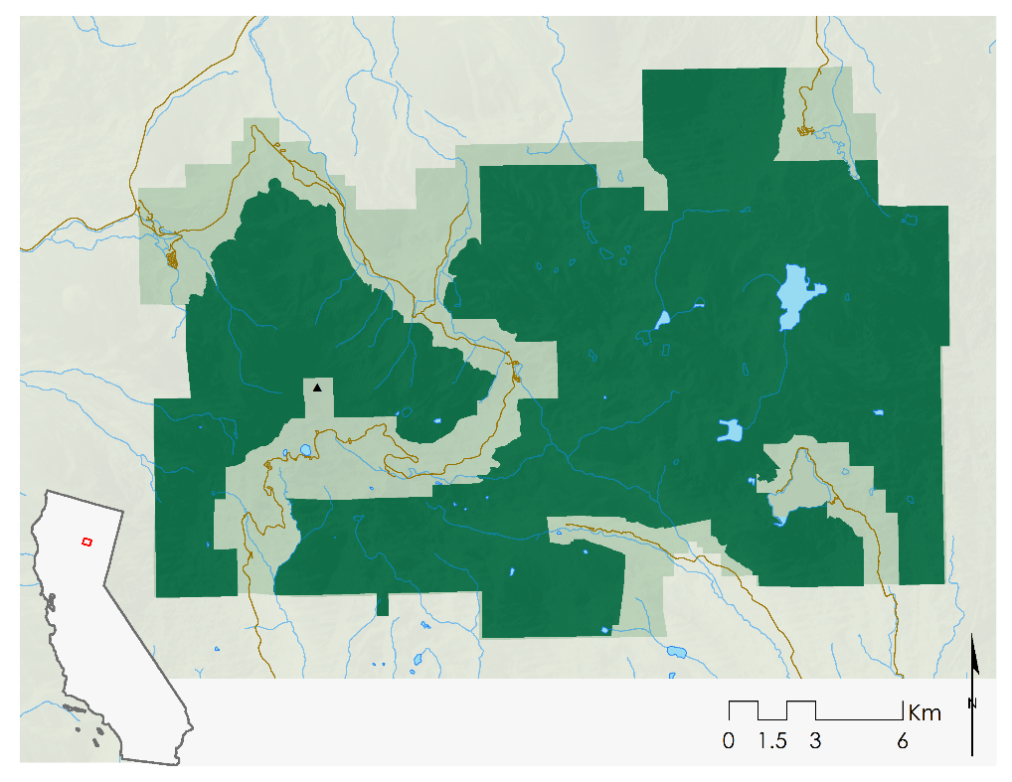

Mt Lassen

Protected Wilderness

Lassen Volcanic National Park

Roads

Figure 1. Study area of Lassen Volcanic National Park.

## 2.2. Project Partners & Objectives

This project targets the Disaster category of the Applied Sciences National Application Areas. Partners at Lassen Volcanic National Park need improved estimates of fuel loading in their ongoing stewardship planning process for the nearly 320 km2 of proposed and designated Wilderness area. Mechanical fuel treatment is not permitted within designated Wilderness, meaning prescribed and natural fires are the most viable option for restoring the forests. Without a detailed understanding of fuel and vegetation conditions, disasters like the 2012 Reading Fire occur. Analyzing earth observations that provide this critical information will ensure park officials are well prepared for any planned fire activity, and as prepared as possible to respond to wildland fire.

Project partners need historical and present-day maps of tree mortalities that drive excess fuel loading and an assessment of the utility of LiDAR data in fuel load characterization. To address these needs, this project seeks (1) to create a tool for quickly determining vegetation condition (growing, stable, declining) from time series of satellite imagery, (2) to create a higher resolution estimate of tree mortality, and (3) to demonstrate the added value of LiDAR for mapping vegetation and fuel loads.

# 3. Methodology

## 3.1. Data Acquisition

The park boundary delineates the study area. For historic tree mortality analysis, Landsat 5, 7 and 8 Surface Reflectance higher-level data products spanning the peak growing season from 1984 to 2016 were accessed through Google Earth Engine, in 5 year collections in order to fully capture forest disturbances (Jin & Sader, 2005; White, Kroh, & Pinder lll, 1995). Utilizing cloud-based imagery archives eliminated time-consuming downloads and reserving large amounts of local disk space to store over 30 years of data.

Present day tree mortality analysis leveraged Sentinel-2A imagery acquired through the Copernicus Scientific Data Hub, which is a cooperative program between the European Union and the European Space Agency (ESA). Imagery was acquired as a Level-1C product, which is Top-Of-Atmosphere (TOA) reflectance. The data were processed to reflectance using the Sen2Cor tool the Sentinel-2 Toolbox to apply terrain and atmospheric correction.

Airborne LiDAR data were acquired from NASA Goddard’s LiDAR, Hyperspectral and Thermal (G-LiHT) via their website. LiDAR data were flown over an area of 9834 m² in September 2012.  A maximum pulse density of 11.16 points/m² and an average pulse density of 4.52/m² were found, with a swath width of 60°. LiDAR data were flown in the Caribou Wilderness to the east of LVNP.

Environmental data layers including vegetative cover, soils data, and infrastructural assets, as well as accompanying metadata, were provided in several geodatabases by the project partners. Fire history data layers were also used to qualitatively validate mortality events.

## 3.2. Data Processing & Analysis

### 3.2.1. Historical Tree Mortality Mapping

To determine historical tree mortality, we tracked how Earth-observation-based indicators of vegetative health shift over annual growing seasons. The general approach is a trend analysis of vegetative health, similar to the methodology used by (Röder, Udelhoven, Hill, del Barrio, & Tsiourlis, 2008), or as a simplification of the LandTrendr approach (Kennedy, Yang, & Cohen, 2010).

Orthorectified Landsat imagery (5 TM, 7 ETM+, 8 OLI) top of atmosphere and surface reflectance products that cover Lassen National Volcanic Park were directly accessed within Google Earth Engine, and filtered to the peak growing season at LVNP. This results in 7 to 8 revisits spanning a growing season of May 15th through September 15th in a year (S. Buckley, personal communication, June 26, 2017). A cloud-score band was calculated from the top of atmosphere imagery, then appended to the surface reflectance product, for later use in compositing. Next, vegetation indices were calculated for each image within the growing season. The Normalized Difference Moisture Index (NDMI) and Normalized Difference Vegetation Index (NDVI) have previously been applied to tree mortality mapping in the Sierra Nevada Mountain Range with success (Potter, 2016), and were selected for the present study. The calculations to generate these spectral indices are shown in (Equation 1 & 2).

$\text{NDMI=}\frac{\text{NIR-SWIR}}{\text{NIR+SWIR}}$ (1)

$\text{NDVI=}\frac{\text{NIR-RED}}{\text{NIR+RED}}$ (2)

Following calculation of NDVI and NDMI, all images within a growing season were compiled into a single composite based on selecting the the most cloud-free and highest value of NDVI on a per pixel basis, with double weighting for NDVI over cloud score. This clear-sky, “greenest pixel” composite was generated for each year in a 5 year period in order to fully capture forest disturbances (Jin & Sader, 2005; White et al., 1995).

Once all yearly composites were generated, a linear regression was fit for each pixel over the 5-year period. The slope of the best fit line identified the trend of the pixel, where growth over the period was indicated by a positive slope, stable vegetation state (potentially healthy, dead, or non-vegetated) indicated by slopes near 0, and decline and mortality indicated by a negative slope. (Figure 2) illustrates the script used to determine vegetation trend for each pixel.

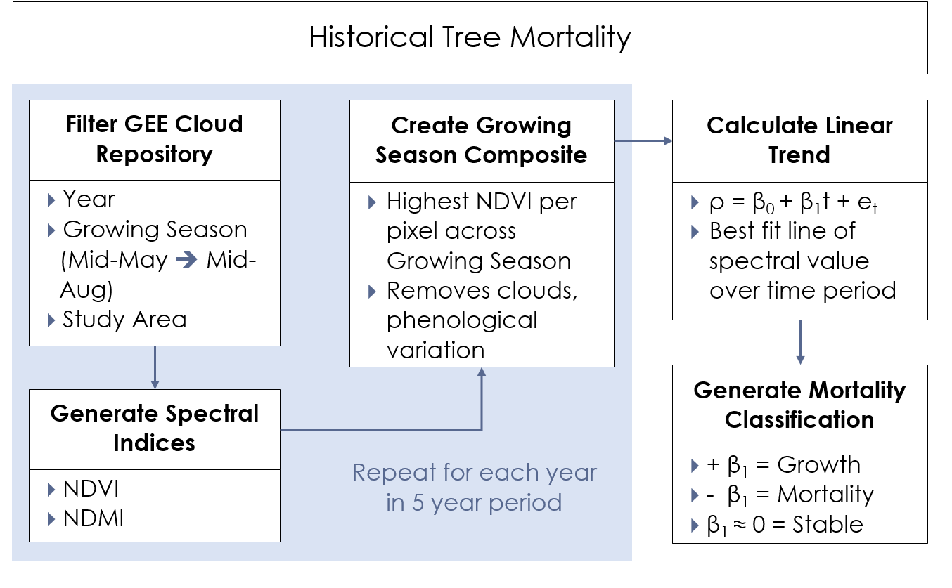

Figure 2. Workflow for historical tree mortality analysis using Landsat data in Google Earth Engine.

### 3.2.2. Present Day Tree Mortality Mapping

Present day tree mortality was examined using Sentinel-2 multispectral data, to take advantage of the higher resolution offered over the Landsat series (10m vs. 30m pixel size). A single Sentinel-2 scene from the most recent growing season, August, 3rd 2016, was downloaded, radiometrically preprocessed and orthorectified. The Sen2Cor correction algorithm was applied to the scene to remove atmospheric effects using the Scientific Toolbox Exploitation Platform (STEP).  Bands in the 60m resolution were discarded, while bands in the 20m resolution (Bands 5, 6, 7, and 11) were resampled from 20m to 10m.  NDMI and NDVI were calculated then stacked with the Sentinel bands and clipped to the LVNP region.

Next, the coefficient trend output of SAVETREE for 2012-2016 was used to create 950 training points of decline or mortality, and points of growth or stability. These points were vectorized and used to train a Support Vector Machine (SVM) in ArcMap. The SVM was trained using the Sentinel-2 image stack, NDMI, and the SRTM digital elevation model as an additional raster.  The classifier definition file was then used to classify the entire scene to ultimately show areas of mortality or decline (Figure 3).

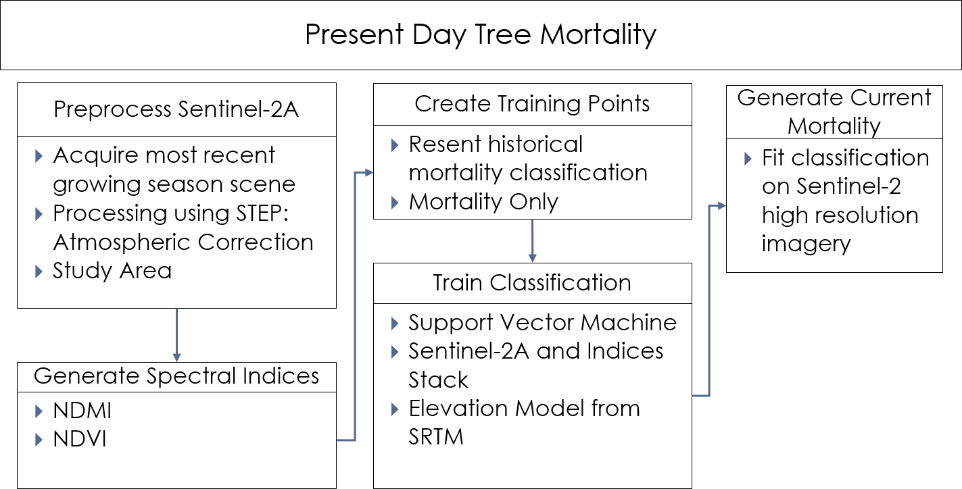

Figure 3. Workflow for present day tree mortality analysis using Sentinel-2 and SRTM imagery.

### 3.2.3. LiDAR Feasibility Analysis

The LiDAR data were first filtered to separate ground points from the rest of the point cloud. Next, a bare earth model was created from the ground points, creating a continuous surface with a 2m cell size. The bare earth model was then used to create a normalized canopy height model. Next, canopy cover above 2m was modeled at a 15m cell size, which is thought to provide good results. Understory vegetation density was binned at 0.5m steps from 0 to 2m and processed in the same manner. Cover or vegetation density is estimated following (Equation 3).

|  |  |
| --- | --- |
| $$Cover=\frac{Number of Returns Greater than Heightbreak}{Total Number of Returns}$$ | (3) |

To identify areas of fuel risk from LiDAR we identified areas as Single-Story Fuel Heavy, Multi-Story Fuel Heavy, and Multi-Story Fuel Heavy with Slope Risk. A decision tree was used to identify areas based off various thresholds for canopy height, canopy cover, understory vegetation density, and slope. Single-Story Fuel Heavy areas were identified as where canopy height was above 3m and canopy cover was 50% or greater. Multi-Story risk rears were defined as areas with Single-Story Fuel Heavy plus an understory vegetative density of 50% or greater. Lastly, the Multi-Story Fuel Heavy with Slope Risk areas were identified as the Multi-Story Fuel Heavy regions which also had slope 20 degrees or greater (Figure 4).

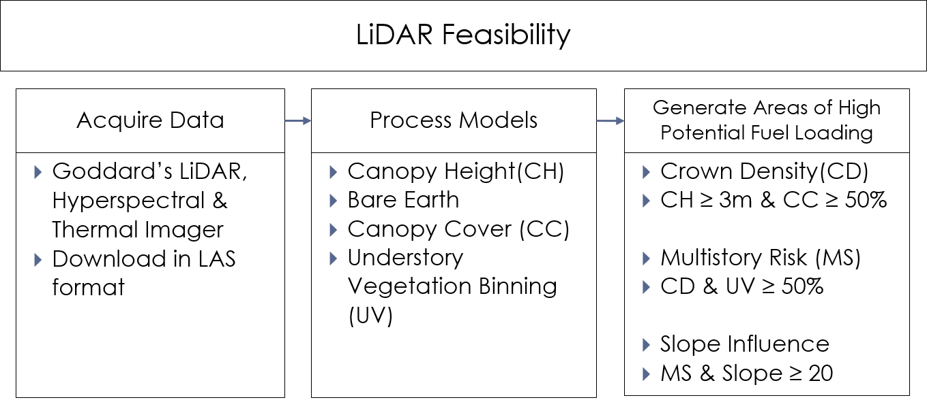

Figure 4. Workflow for LiDAR feasibility analysis using G-LiHT data.

# 4. Results & Discussion

## 4.1. SAVETREE

Historical tree mortality analysis was scripted within Google Earth Engine to provide snapshots of trends in park health. The primary output is a time series trend analysis, which inputs the study period (end year, duration) and desired spectral index (NDVI, NDMI, NBR), calculates a linear regression of spectral values over time, and visualizes an image of the regression slope value for every pixel over the study area (Figure 5). The secondary output is a bivariate plot of NDMI and NDVI for the final year of the period, which provides a qualitative snapshot of forest health across these two indices (Figure 6). The inputs are ingested in a simplified user interface, which removes the need to edit code. Additionally, users can interactively click a point on the displayed image to obtain a graph of the spectral values over the period, allowing them to assess the validity of the trend slope.

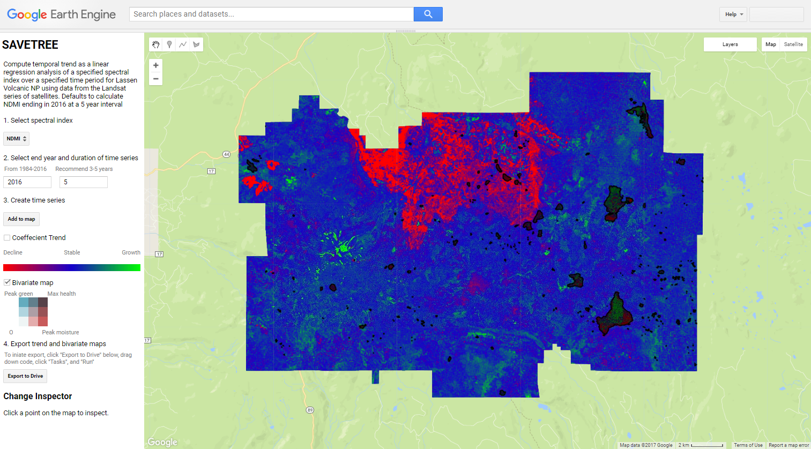

Figure 5. Screenshot of the graphical user interface panel and output linear regression trend image from the SAVETREE tool. The displayed image is calculated for the period of 2012-2016 using NDMI.

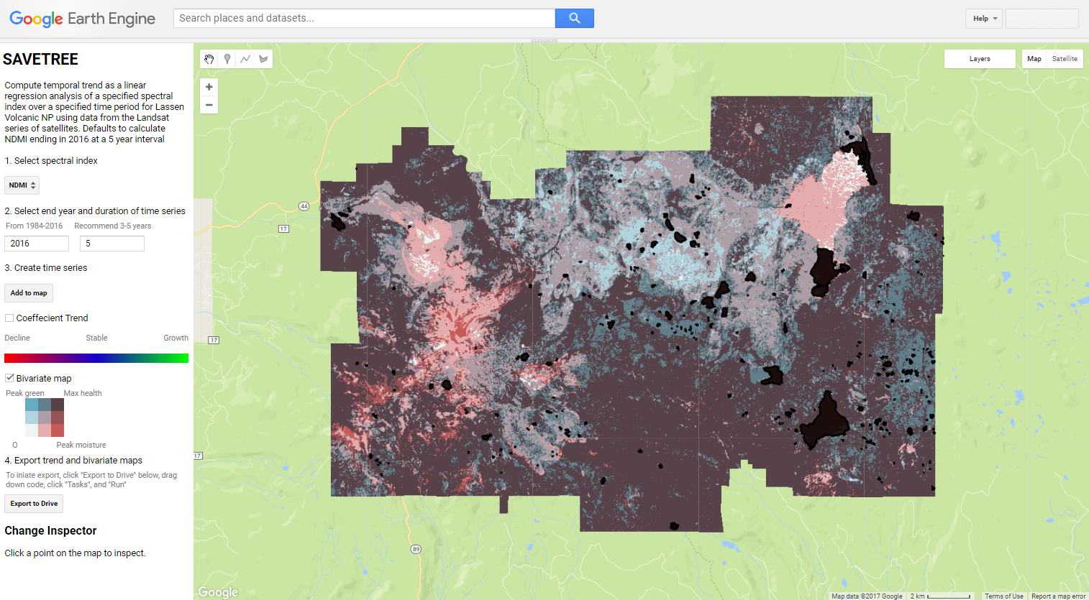

Figure 6. Screenshot of the bivariate plot of NDVI and NDMI for the year 2016 within the SAVETREE tool.

Building SAVETREE within Google Earth Engine has several key benefits for our partners stemming from GEE’s cloud architecture. Google’s servers host all imagery including new daily acquisitions, and handles all image manipulation and processing. This removes the burden of downloading large file-size Landsat scenes, storing imagery on volumes of hard disk space, or occupying computing power for image processing. Instead, the user’s browser acts as a terminal to the server’s computing capabilities by transferring a script of commands to the server side and receiving an output graphic for visualization within the web interface. This facilitates usage by park officials, as limited internet speeds and computer resource availability make traditional remote sensing image acquisition, storage, and processing infeasible for this type of analysis.

## 4.2. Present Day Mortality Map

The present-day mortality estimate was derived using a SVM classification, with training points identified from SAVETREE coefficients for NDMI for 2012-2016. Sentinel-2 imagery, NDMI and elevation were then classified resulting in a 10m resolution map of mortality for LVNP (Figure 7).  This higher resolution map can allow park managers to identify more nuanced areas of mortality and decline within the park. Additionally, as the sentinel series matures it will become possible to apply the same methods of SAVETREE to create a higher resolution product.

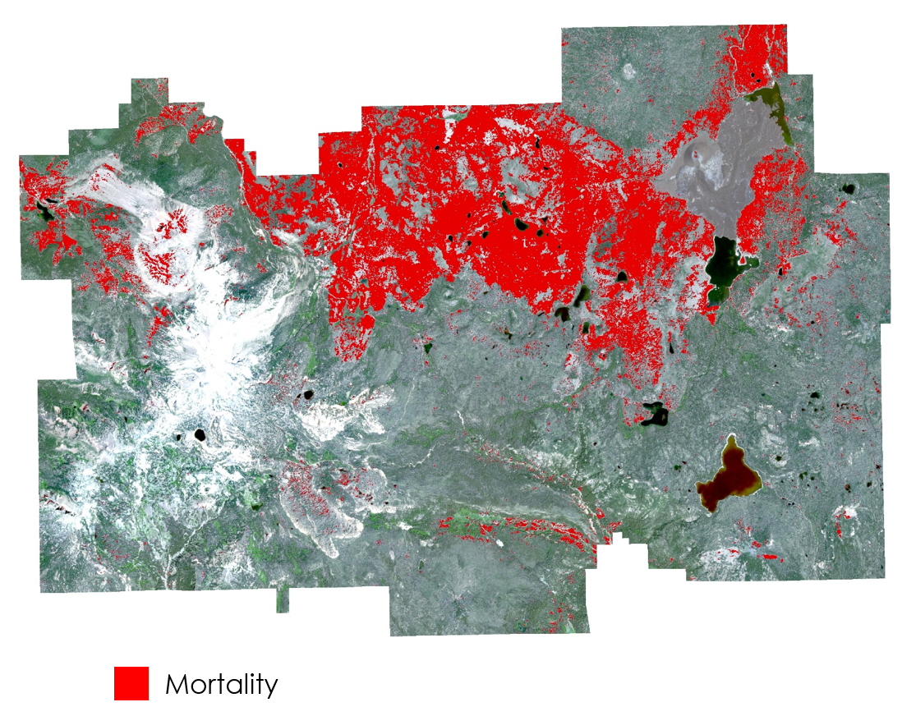

Figure 7. Map of present day tree mortality extent within Lassen Volcanic National Park. Mortality was classified from Sentinel-2 and SRTM v3 data.

The cross-validation rate for the SVM classification was 0.82 which indicates it is fairly accurate. This could be increased by training the SVM using *in situ* mortality data. SVM can be very powerful even with only a few samples, however for an accurate representation samples should be taken from across the entire park. Additionally, error in the present-day classification could arise from using the output of the SAVETREE product. SAVETREE shows a linear relation of a spectral index over time, thus it is very good at detecting disturbances but it is possible for the most recent year to be a “growing” pixel while still maintaining an overall negative trend. Other errors could stem from the upscaling of lower resolution Sentinel-2 bands to 10m.

## 4.3. LiDAR Feasibility

LiDAR is a power data source to aid in managing forests. It can create various models to aid in forest management such as canopy height, vegetation densities, bare surface models such as slope and aspect and estimates of biomass. It is important to assess the quality of LiDAR data for analysis or when planning for a LiDAR acquisition. The USFS has broken it down into three quality levels each which can meet different needs (Table 1).

Table 1. USFS LiDAR quality levels and suggested data products.

|  |  |  |  |
| --- | --- | --- | --- |
|  | Quality Level 1 | Quality Level 2 | Quality Level 3 |
| Nominal aggregate pulse density (m-2) | 3-8 pulses |  |  |
| Scan angle | ≤ ± 13° of nadir | ≤ ± 13° of nadir | ≤ ± 20° of nadir |
| Returns per pulse | ≥ 4 | Minimum 2, > 4 preferred | 1 |
| Ground beam footprint | Narrow setting, ≤ 30 cm | Narrow setting, ≤ 30 cm | < 100cm |
| Horizontal accuracy | 50cm | 50cm | 50cm |
| Vertical accuracy | < 15cm | < 15cm | < 15cm |
| Recommended applications | Modeled forest  inventory parameters  (basal area, volume,  biomass, canopy fuel  variables, etc.)  High resolution  topographic products in  dense vegetation cover  Includes any Q2 and Q3  applications | First order forestry  derivatives (canopy  height, percent canopy  cover and density)  General habitat  characterization  High resolution  topographic products  in moderate vegetation  cover | Moderate resolution  topographic products |

For example, the G-LiHT LiDAR data, it has a nominal footprint diameter of 10 cm, a range precision of 5cm, and a pulse density of ~5 pulses per meter squared which would generally place it in the Q1 level. However, it has a swath angle of 30 degrees from nadir. This increased swath angle is not ideal for forestry purposes as the objects in the fringes cannot be fully scanned resulting in only the side facing the laser to be scanned (Figure 8).

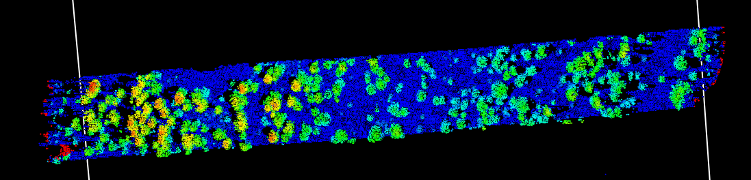

Figure 8. "Shadows" show up on the far right and left fringes of an overhead view of a portion of the G-LiHT LiDAR sample data.

The fuel risk areas derived from LiDAR (Figure 9) is one example of a potential product that is readily available to create, and provides a good starting estimate of fuel heavy areas.  Areas of high fuel loading are shown for both crown fuels and understory vegetation, and slope can be weighted in as well. These estimates could be significantly improved upon by identifying individual to plot level canopy base height which has been demonstrated by (García et al., 2017) whereas a pseudo-waveform is generated of each plot to estimate the canopy base height which can then be extrapolated across the entire LiDAR data set. Further, LiDAR in accompany with plot data has shown to good at estimating aboveground biomass (Ferraz et al., 2016), and has been used with Landsat imagery to estimate fuel loads (García et al., 2017; Mutlu et al., 2008).

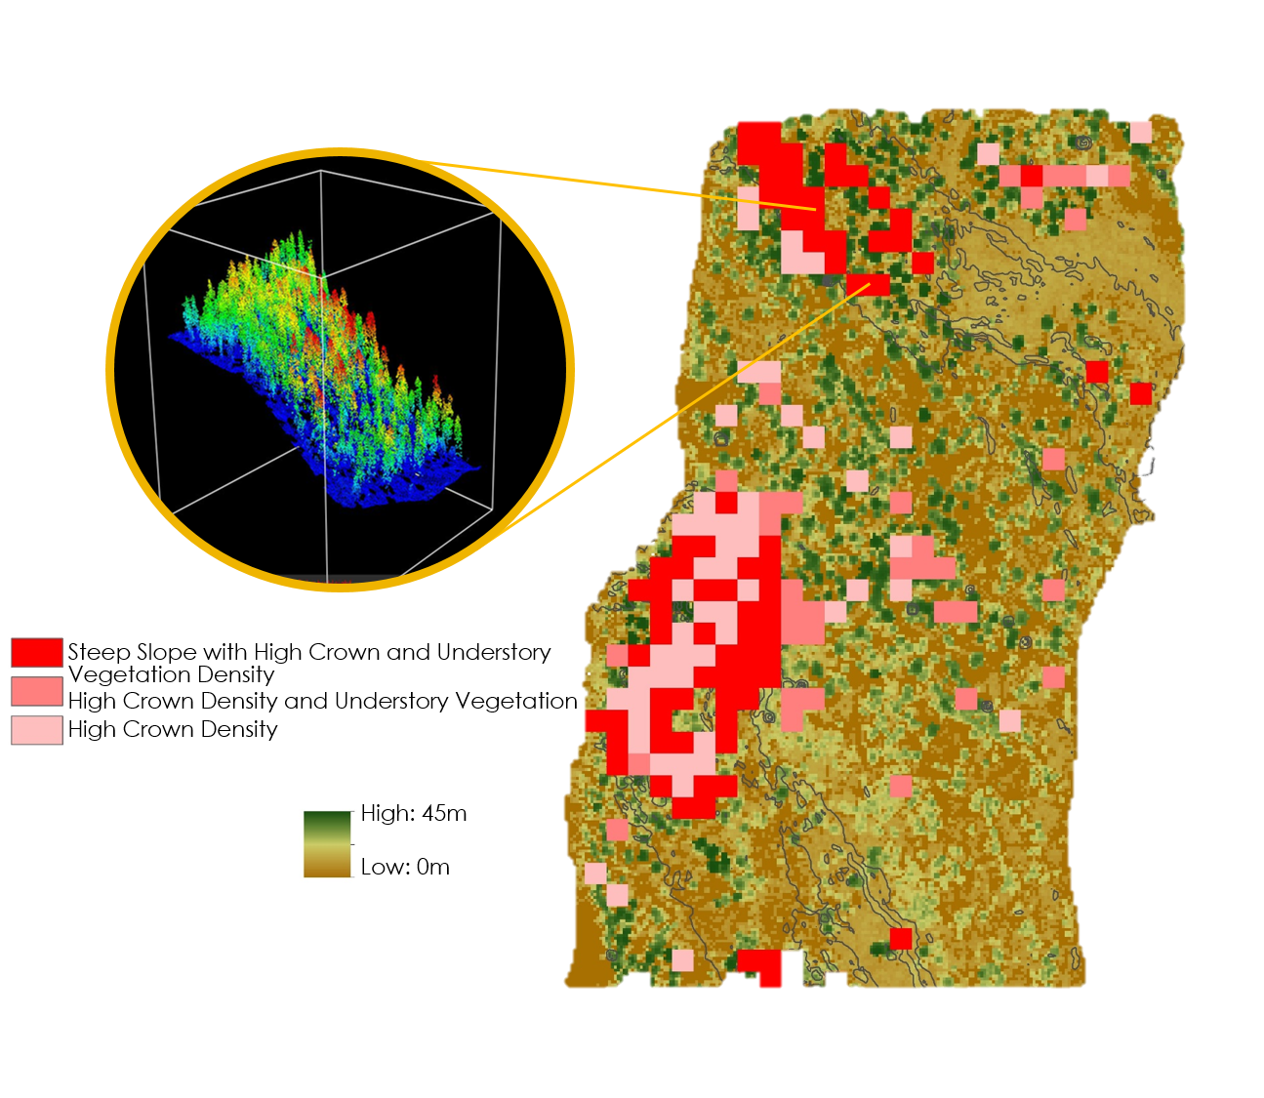

Figure 9. High fuel load areas identified using G-LiHT LiDAR data, demonstrating the high level of detail achievable in both horizontal and vertical spatial domains.

## 4.4. Future Work

There is no end to future work in applying earth observations in LVNP. The present project takes a broad-scale approach. Researchers could further this project with a more in-depth analysis of specific areas and events of interest. Specifically, a case study of the 2012 Reading Fire, analysis of the LiDAR data in Badger Creek area, and calculating spatial statistics for SAVETREE would build on the existing work. Some of this future work will be undertaken during the project’s continuation over the next 10-week DEVELOP term.

The priority for future work is to study pre- and post-fire conditions for the Reading Fire. This study would provide forest managers with details of the forest under extreme fire danger conditions resulting from severe fuel loading and environmental stress. They could deduce what might happen if they see the same conditions in the future. Pre-fire UAVSAR data is available from NPS to incorporate to this study.

Also, LiDAR flown by the U.S. Forest Service in the Badger Creek area could be attained along with corresponding plot data. Partners at LVNP are working with other agencies on a restoration project North of the park as part of a Collaborative Forest Landscape Restoration (CFLR) process. This CFLR is part of the park’s ongoing wilderness stewardship commitment to increase the resilience forest’s resilience. The LiDAR fuel heavy areas estimate can be applied for the CFLR as well trying out more precise estimations utilizing canopy base height, and aboveground live biomass. Additionally, a fusion of LiDAR and Sentinel could be explored to estimate biomass of dead or decline trees. This would enhance present work studying the feasibility of using LiDAR to estimate fuel loads within the park.

The SAVETREE tool could be expanded in future work. Further leveraging the temporal and spatial extent of the Landsat archive, researchers could apply geospatial statistical analysis methods to study spatial and temporal autocorrelation of mortality events, as well as test environmental factors as predictive variables for mortality. Understanding if long-term mortality events influence other mortalities would provide partners with information to potentially minimize or isolate mortalities. Even more, if there are predictive variables for mortality, park managers could pay special attention to areas that might be vulnerable for morality. Additionally, incorporating the Fire History dataset from LVNP into SAVETREE would add another dimension of analysis. Further quantitative and qualitative analysis could be done with this dataset, comparing fire events in different areas of the park. For example, regrowth from fires of different severity, ignition type, burn time, or vegetation type could be detected with Earth Observations, which is quantifiable. Visualizing the geographic extent of past fires during the user-selected time interval into the SAVETREE tool could enable qualitative analysis within the tool’s user interface. While SAVETREE computes and visualizes historical tree mortality, this data is prime for deriving further information from spatial statistics that could help partners manage wildland fire risk at Lassen.

All future work applying NASA Earth Observations to fuel loading at LVNP is dependent on resources rather than need. The focuses outlined above reflect the partner's’ priorities for reinforcing the forest’s resilience.

# 5. Conclusions

Removing access limitations from partners at LVNP can provide them with critical information on assessing forest health. Bridging the gap between data availability and implementation of management actions with remote sensing tools can allow the park to better leverage their resources.

Developing SAVETREE in Google Earth Engine circumvents these limitations. The Earth Engine architecture pushes processing onto Google’s servers instead of on local machines. The platform is also freely available for non-commercial use. Therefore, this method succeeds in providing partners with a way to access historical vegetation health data without the technological burden. Furthermore, the tool allows the user to repeat the same analytical methods in the future. Demonstrating the outputs to the partners on-site at Lassen revealed that the mortality and regrowth outputs displayed in SAVETREE were identifiable by partners as large-scale fire events, small-scale prescribed fire and mechanical removal, as well as post-fire replanting.

Leveraging Sentinel-2 imagery provides the highest-resolution, most-recent assessment of mortality events. The technical knowledge and computing power necessary to perform this analysis of present-day mortality are less accessible and repeatable for partners, and the Sentinel-2 sensor lacks the historical archive available for Landsat data. However, the increased resolution for current park conditions will be helpful for directed park management activities, and as the Sentinel-2 archive builds, methods used in the SAVETREE tool may be applicable to this dataset.

LiDAR data provides the highest detail for mapping fuel loads, and additionally provides measurements of vertical strata that are not achievable with multispectral remote sensing. Under-canopy vegetation loads are readily observed using airborne LiDAR, but are inaccessible by traditional multispectral remote sensing. Although it is a costly dataset to acquire, a full LiDAR dataset of the park would yield the most detail of fuel loads throughout the park, and greatly aid management decisions.

# 6. Acknowledgments

We would like to thank our project partners at Lassen Volcanic National Park, Steve Buckley and Elizabeth Hale. Contributions by Jenna Williams at NASA DEVELOP were instrumental to the project’s success, as was the support of our science advisors, Juan Torres-Perez, Vince Ambrosia, Cindy Schmidt and Keith Weber.

Landsat 5 TM, Landsat 7 ETM+, Landsat 8 OLI, and Shuttle Radar Topography Mission (SRTM) v3 data courtesy of the U.S. Geological Survey. G-LiHT data courtesy of the NASA Goddard Space Flight Center. Sentinel-2 data courtesy of the European Space Agency Copernicus Sentinel program.

Any opinions, findings, and conclusions or recommendations expressed in this material are those of the author(s) and do not necessarily reflect the views of the National Aeronautics and Space Administration.

This material is based upon work supported by NASA through contract NNL16AA05C and cooperative agreement NNX14AB60A.

# 7. Glossary

**Earth observations** – Satellites and sensors that collect information about the Earth’s physical, chemical, and biological systems over space and time

**Biomass** – Organic material. Also refers to the weight of organic material

**Fire exclusion –** Policies which require immediately extinguishing naturally occurring fires. This was the status quo in the first half of the 20th century.

**Fire regime –** The combination of fire frequency, predictability, intensity, seasonality, and size characteristics of fire in a unique ecosystem. Disturbance regimes are used to characterize the spatial scale and temporal patterns of disturbance and subsequent response and recovery of ecosystems (Averill et al., 1995).

**Fire severity –** A qualitative measure of the immediate effects of fire on the ecosystem. It relates to the extent of mortality and survival of plant and animal life both aboveground and belowground and to loss of organic matter. An intense fire may not necessarily be severe.

**Fire suppression –** The act of extinguishing a naturally occurring wildland fire as rapidly as possible.

**Fuel loading –** The weight per unit area of fuel often expressed in tons per acre or tons per hectare.

**Fuel moisture content –** This is expressed as a percent or fraction of oven dry weight of fuel. It is the most important fuel property controlling flammability.

**Prescribed fire –** A planned fire ignited by fire managers in a targeted region to reduce fuel loads with a controlled plan.

# References

Airey Lauvaux, C., Skinner, C. N., & Taylor, A. H. (2016). High severity fire and mixed conifer forest-chaparral dynamics in the southern Cascade Range, USA. *Forest Ecology and Management*, *363*, 74–85. https://doi.org/10.1016/j.foreco.2015.12.016

Allen, C. D., Macalady, A. K., Chenchouni, H., Bachelet, D., McDowell, N., Vennetier, M., … Cobb, N. (2010). A global overview of drought and heat-induced tree mortality reveals emerging climate change risks for forests. *Forest Ecology and Management*, *259*(4), 660–684. https://doi.org/10.1016/j.foreco.2009.09.001

Andersen, H.-E., McGaughey, R. J., & Reutebuch, S. E. (2005). Estimating forest canopy fuel parameters using LIDAR data. *Remote Sensing of Environment*, *94*(4), 441–449. https://doi.org/10.1016/j.rse.2004.10.013

Assal, T. J., Anderson, P. J., & Sibold, J. (2016). Spatial and temporal trends of drought effects in a heterogeneous semi-arid forest ecosystem. *Forest Ecology and Management*, *365*, 137–151. https://doi.org/10.1016/j.foreco.2016.01.017

Calkin, D. E., Gebert, K. M., Jones, J. G., & Neilson, R. P. (2005). Forest Service Large Fire Area Burned and Suppression Expenditure Trends, 1970–2002. *Journal of Forestry*, *103*(4), 179–183.

Chu, T., & Guo, X. (2013). Remote Sensing Techniques in Monitoring Post-Fire Effects and Patterns of Forest Recovery in Boreal Forest Regions: A Review. *Remote Sensing*, *6*(1), 470–520. https://doi.org/10.3390/rs6010470

Ferraz, A., Saatchi, S., Mallet, C., Jacquemoud, S., Gonçalves, G., Silva, C. A., … Pereira, L. (2016). Airborne Lidar Estimation of Aboveground Forest Biomass in the Absence of Field Inventory. *Remote Sensing*, *8*(8), 653. https://doi.org/10.3390/rs8080653

García, M., Saatchi, S., Casas, A., Koltunov, A., Ustin, S. L., Ramirez, C., & Balzter, H. (2017). Extrapolating Forest Canopy Fuel Properties in the California Rim Fire by Combining Airborne LiDAR and Landsat OLI Data. *Remote Sensing*, *9*(4), 394. https://doi.org/10.3390/rs9040394

Hais, M., Jonášová, M., Langhammer, J., & Kučera, T. (2009). Comparison of two types of forest disturbance using multitemporal Landsat TM/ETM+ imagery and field vegetation data. *Remote Sensing of Environment*, *113*(4), 835–845. https://doi.org/10.1016/j.rse.2008.12.012

Hendricks, K., Exline, J., Neill, C., Wuchner, G., Woffinden, B., Wade, J., … Keller, P. (2012). *Reading Fire Review*. Lassen Volcanic National Park: Lassen Volcanic National Park. Retrieved from https://www.nps.gov/lavo/learn/management/reading-fire.htm

Jin, S., & Sader, S. A. (2005). Comparison of time series tasseled cap wetness and the normalized difference moisture index in detecting forest disturbances. *Remote Sensing of Environment*, *94*(3), 364–372. https://doi.org/10.1016/j.rse.2004.10.012

Kennedy, R. E., Yang, Z., & Cohen, W. B. (2010). Detecting trends in forest disturbance and recovery using yearly Landsat time series: 1. LandTrendr — Temporal segmentation algorithms. *Remote Sensing of Environment*, *114*(12), 2897–2910. https://doi.org/10.1016/j.rse.2010.07.008

Mutlu, M., Popescu, S. C., Stripling, C., & Spencer, T. (2008). Mapping surface fuel models using lidar and multispectral data fusion for fire behavior. *Remote Sensing of Environment*, *112*(1), 274–285. https://doi.org/10.1016/j.rse.2007.05.005

Pettorelli, N., Vik, J. O., Mysterud, A., Gaillard, J.-M., Tucker, C. J., & Stenseth, N. C. (2005). Using the satellite-derived NDVI to assess ecological responses to environmental change. *Trends in Ecology & Evolution*, *20*(9), 503–510. https://doi.org/10.1016/j.tree.2005.05.011

Pierce, A. D., Farris, C. A., & Taylor, A. H. (2012). Use of random forests for modeling and mapping forest canopy fuels for fire behavior analysis in Lassen Volcanic National Park, California, USA. *Forest Ecology and Management*, *279*, 77–89. https://doi.org/10.1016/j.foreco.2012.05.010

Potter, C. S. (2016). Landsat Image Analysis of Tree Mortality in the Southern Sierra Nevada Region of California during the 2013-2015 Drought. *Journal of Earth Science & Climatic Change*, *07*(03). https://doi.org/10.4172/2157-7617.1000342

Röder, A., Udelhoven, T., Hill, J., del Barrio, G., & Tsiourlis, G. (2008). Trend analysis of Landsat-TM and -ETM+ imagery to monitor grazing impact in a rangeland ecosystem in Northern Greece. *Remote Sensing of Environment*, *112*(6), 2863–2875. https://doi.org/10.1016/j.rse.2008.01.018

Skowronski, N. S., Clark, K. L., Duveneck, M., & Hom, J. (2011). Three-dimensional canopy fuel loading predicted using upward and downward sensing LiDAR systems. *Remote Sensing of Environment*, *115*(2), 703–714. https://doi.org/10.1016/j.rse.2010.10.012

van Wagtendonk, J. W., & Root, R. R. (2003). The use of multi-temporal Landsat Normalized Difference Vegetation Index (NDVI) data for mapping fuel models in Yosemite National Park, USA. *International Journal of Remote Sensing*, *24*(8), 1639–1651. https://doi.org/10.1080/01431160210144679

White, J. D., Kroh, G. C., & Pinder lll, J. E. (1995). Forest Mapping at Lassen Volcanic National Park, California, Using Landsat TM Data and a Geographical Information System. *Photogrammetric Engineering & Remote Sensing*, *61*(3), 299–305.