**NASA DEVELOP National Program**



Langley Research Center

*Summer 2013*

South Pacific Oceans

Predicting the Movement of Pumice Rafts for Enhanced Navigational Warnings

**Technical Report Rough Draft**

July 3, 2013

Michael Bender, Penn State University (Project Co-leader)

Joshua Kelly, University of Rhode Island (Project Co-leader)

Maureen Kelly, University of Maryland

Corey Walters, St. Louis University

Dr. Kenton Ross, NASA DEVELOP NPO (Science Advisor)

**Abstract**

Pumice rafts are expansive masses of pumice clasts floating on the ocean surface produced by silicic shallow submarine and subaerial explosive volcanic eruptions.  The goal of this project was to enhance knowledge of pumice rafts and develop accessible and practical methodologies for predicting the movement of pumice rafts in the South Pacific region.  Two volcanoes in this region have recently erupted and formed pumice rafts: Home Reef volcano (Tonga) in 2006 and Havre Seamount (Kermadec Islands, New Zealand) in 2012.  These raft events were used as examples to test the trajectory prediction model since they occurred during times at which high spatial and temporal resolution true color imagery were being collected and they have been frequently described in peer reviewed literature, both of which were crucial in providing validation for our models.

Project partners included Dr. Bradley Scott from GNS Science New Zealand and Dr. Greg Vaughan from the U.S. Geological Survey. They are particularly interested in learning how to predict the movement of pumice rafts for enhanced navigational advisement to maritime authorities. Remote sensing data acquired from NASA’s Earth Observing System (EOS) satellites Aqua and Terra were used to image and track the pumice raft produced from the 2012 Havre Seamount eruption.  Additional data acquired from NASA’s EOS satellites Jason-2 and QuikSCAT were used to predict the trajectory of the pumice raft using the General NOAA Operational Modeling Environment (GNOME).  GNOME is a modeling tool used to predict the possible trajectory a pollutant might follow on a body of water using wind and ocean current satellite data.

Learning more about the processes and transport mechanisms of pumice rafts is significant for a number of ecological and economic reasons.  Pumice rafts pose a hazard to marine transportation as individual clasts can block seawater intake valves of large ships and cause hull damage to smaller vessels.  Rafts can also be detrimental to fisheries; a large kill of deep-sea fish followed the arrival of pumice rafts during the 1984 Home Reef eruption.  Additionally, rafts have the potential to introduce harmful invasive species to pristine areas as they drastically increase dispersal distances for otherwise benthic or relatively sedentary organisms. This novel and easily adaptable methodology can be used by island and coastal nations and fishery managers to forecast when and where a pumice raft will be, drastically enhancing maritime navigational warnings and response times to eventual pumice landfall.

**Keywords**

Pumice raft, GNOME, submarine volcano, eruption, South Pacific

**Introduction**

Pumice rafts are expansive masses of pumice floating on the ocean surface produced by silicic shallow submarine and subaerial volcanic eruptions. Pumice is a highly vesicular silicic to intermediate glass foam, which commonly floats on water as a result of its low density (<1 g/cm3; Fisher and Schminke 1984). Generation of highly vesicular pumice requires rapid gas exsolution and decompression bubble growth in magma, as well as reorganization of bubbles into elongated cylinders or polyhedral cells (Cashman et al. 2000). Experiments and in situ observations have shown that cold pumice can remain afloat for over 1.5 years and travel thousands of kilometers (Figure 1). Hot pumice often sinks immediately on immersion in water as conversion of absorbed water to steam flushes out air, increasing the density of the clast (Whitham and Sparks 1986). Pumice rafts are significant for several biological and economic 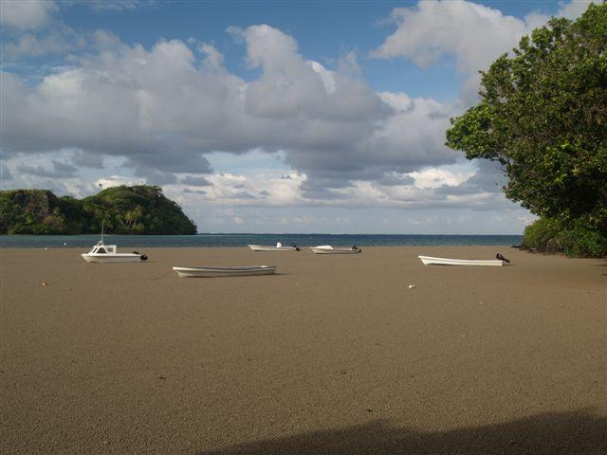reasons.

**Figure 1.** Home Reef pumice raft beached in Fiji in 2006. Image courtesy of Dr. Bradley Scott from GNS Science

Pumice rafts are made up of individual clasts typically 1 cm in size, small enough to be ingested into seawater intake valves posing a hazard to maritime transportation. Rafts also have a detrimental effect on fisheries as they can cause a large kill of deep-sea fish (1984 Home Reef pumice raft) in addition to asphyxiating marine life when stranded in shallow water near shore (Bryan et al 2004; Figure 2). Pumice rafts are an extremely effective rafting agent and can drastically increase dispersal distances for otherwise benthic or relatively sedentary organisms (Jokiel 1990). This can have both adverse and favorable biological effects as they can introduce harmful invasive species to otherwise pristine areas or contribute nutrients necessary for plant growth to the soils of coral cay islands that are otherwise strongly impoverished (Stone et al. 2000).

The objectives of this project were to develop an accessible and practical methodology for predicting the trajectory a pumice raft will follow immediately post-eruption and to determine which volcanoes in the study area satisfy the requirements for producing a pumice raft. The study area is focused in the southwestern Pacific Ocean, as it is an ideal area to examine the characteristics and dispersal of sea-rafted pumice. It is bounded to the east by an area of active island arc volcanism including silicic, explosive, pumice-producing eruptions and bounded to the west >3000 km away by the non-volcanic margin of eastern Australia with extensive sand beaches that serve as excellent repositories of pumice rafts (Bryan et al. 2004; Figure 3). The two most recent pumice raft events within this region were modeled: 2006 Home Reef volcanic island and 2012 Havre Seamount. These events were chosen as there is an abundance of peer-reviewed literature that allowed for model validation (Bryan et al. 2012) in addition to readily available moderate-resolution satellite imagery, both of which were necessary for providing model validation.

This project contributes to the Oceans, Disasters, and Ecological Forecasting NASA national application areas. Concerning Disasters and Oceans, this project has furthered understanding and knowledge as to why and where pumice rafts occur. The pumice raft trajectory model is an important tool that can be used to forecast when and where a pumice raft will be, drastically enhancing maritime navigational warnings. Additionally, this model can be used by countries that are most frequently impacted by pumice rafts (Fiji, Tonga, etc.) to develop coastal hazard mitigation techniques in preparation for eventual pumice landfall.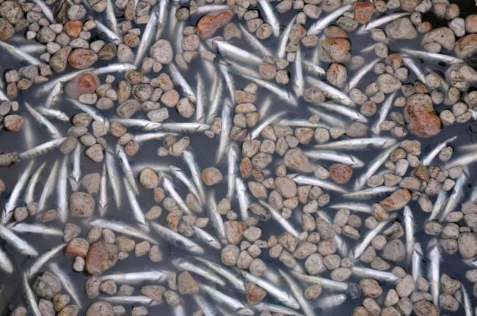 This project contributes to the Ecological Forecasting application area as pumice rafts can have severe impacts on the ecology of both local and global environments. As mentioned previously, pumice rafts can introduce harmful invasive species to delicate communities. Additionally, rafts have the potential to be thick and coherent enough to transport larger objects and materials across the globe (i.e. the 1883 Krakatoa pumice raft, which transported human bones >6000 km to east Africa in ten months). Biological investigations of the area near the source volcano can be used in conjunction with the trajectory model to predict what invasive species are present and where they could potentially be transported.

**Figure. 2** Dead fish float among pumice stones in the Nilahue River after the eruption of the Puyehue-Cordon Caulle volcano in Rininahue, southern Chile, on Wednesday, June 8, 2011. (AP Photo/Carlos Succo)

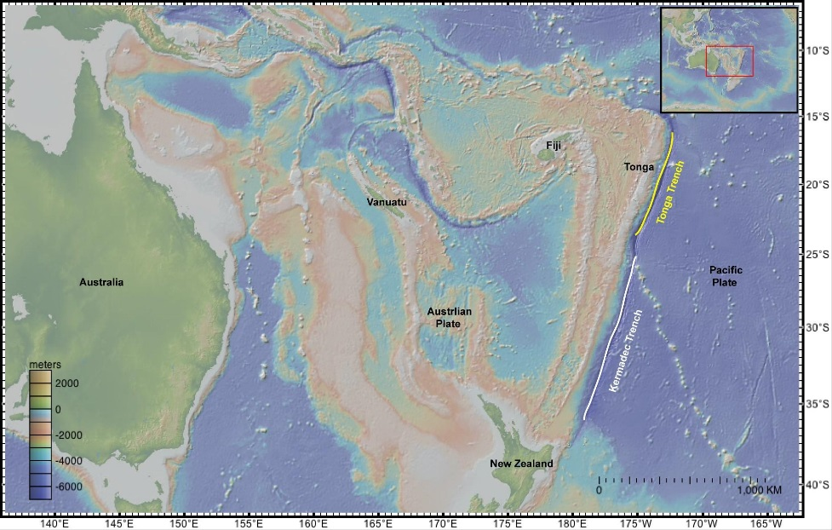The main project partner and end user is Dr. Bradley Scott from GNS Science. GNS Science is New Zealand’s leading provider of Earth, geoscience and isotope research and consultancy services. Dr. Scott is the Volcano Surveillance Coordinator and is heavily involved in the GeoNet project, the National GeoHazards monitoring for New Zealand. He is interested in the hazards that South Pacific Ocean volcanoes pose for both maritime and aviation. Dr. Scott and GeoNet are focused on the detection of volcanic activity, but would like to be more familiar with remote sensing techniques that could help them detect pumice on the sea surface. Methodologies that describe how to generate a high resolution true color image of the eruption site and predict the trajectory the newly formed pumice raft will follow would significantly increase their abilities to provide timely and accurate navigational warnings. Dr. Greg Vaughan is a Research Geologist for the United States Geological Survey (USGS) and is interested in the application of quantitative remote sensing techniques to study dynamic geologic and environmental processes, with an emphasis on volcanic and geothermal phenomena. Dr. Vaughan provided guidance on pumice classification techniques and ancillary pumice raft data sets.

**Figure 3.** Bathymetric map of the Southwestern Pacific Ocean showing locations of major tectonic features (created with GeoMapApp)

**Methodology**

**Data Acquisition**

*Acquisition of MODIS Imagery*

Moderate-Resolution Imaging Spectroradiometer (MODIS) level 1b data was acquired through the Level 1 and Atmosphere Archive and Distribution System (LAADS) website. The MODIS sensor on board the Aqua satellite was used at the Aqua Level 1 products group and Level 1b calibrated radiances of 500m. The collection used was the 5-MODIS Collection 5 – L1, Atmosphere and Land. The data search outcomes were then presented and data was selected and downloaded. MODIS Conversion Toolkit (MCTK) was downloaded in order to convert the data into a usable form for ENVI. The converted and georeferenced IMG bands were then present in the Available Bands List. To view the image in true color, bands 1, 4, and 3 were selected in RGB.

*Acquisition of Data for GNOME*

While current, wind, and geographical data are available in a variety of formats, GNOME solely utilizes NetCDF (.nc) files or ASCII files for currents and winds, and boundary (.bna) files for land/shoreline data. Surface winds were obtained from August 10, 2006 to April 30, 2007 using the National Climatic Data Center (NCDC) archive of blended seawinds, accessible via FTP. Current data was obtained using the Ocean Surface Current Analyses (OSCAR) data through the OSCAR Data Display and Download page. Land data was derived from the Global Self-consistent, Hierarchical, High-resolution Geography (GSHHG) dataset, generated through the GNOME Online Oceanographic Data Server (GOODS) website.

*Acquisition of Data for Hazard Map*

Maritime shipping lane data was acquired from the National Oceanic and Atmospheric Administration (NOAA) in the form of a GeoTIFF shapefile. From October 2004 through October 2005, 1,189,127 mobile ship data points were collected from 3,374 commercial and research vessels, which is about 11% of all ships at sea in 2005. These data points for each vessel were connected to show shipping routes over the course of one year. A world country boundary shapefile was acquired from geocommons. The “Oceans” basemap was acquired directly from ArcGIS. Determining the eruption and magma conditions necessary to produce a pumice raft required extensive literature review as all known historical pumice rafts in the study area were researched and analyzed to determine similarities (Appendix A).

**Data Processing**

*Enhancing Pumice Raft Imagery*

To enhance the visual detection of the pumice rafts, an RGB to HSV transformation was performed in ENVI. The Hue, Saturation and Value (HSV) bands were loaded into RGB as H,S,V. This transformation highlighted the pumice and made them stand out fairly well. Unfortunately, the edges of the clouds were also a similar color to the pumice rafts so without previous knowledge of the locations of the pumice it would be difficult to distinguish between the two. Another attempt to highlight the pumice was made by loading one of the bands (band 1 works best) in Gray Scale and using ENVI Color Tables to enhance the colors. There were many options for changing the image colors but the BLUE/GREEN/RED/YELLOW color table worked best. This tool allowed for brightening and adjusting the intensity of the colors for the image.

*Processing Data for GNOME*

OSCAR provides an interface that allows selection of current data over a specified period of time, and all of the data is contained within one NetCDF file. As a result, no manipulation was required to import it into GNOME. Wind data from the NCDC is provided in one file per day. GNOME does not allow multiple NetCDF files for one variable, so daily NetCDFs had to be merged into one NetCDF. This was accomplished by creating a master text file that points to several NetCDFs.

*Processing Data for Hazard Map*

Shipping lane data was imported into ArcGIS and symbolized according to route density (value between 1 and 1,158 vessels per route). A volcano database was created in Microsoft Excel containing information necessary in determining if a pumice raft could be produced (magma composition and water depth) in addition to other fundamental data (location coordinates, last eruption date, etc.). This .xls file was then imported into ArcGIS and volcanoes were plotted as points and visually classified as having produced a historical pumice raft or not.

**Data Analysis**

*Analysis in GNOME*

Data analysis in GNOME is possible in two modes: Standard and Diagnostic. Diagnostic Mode was used, given the need to consider daily meteorological data rather than climatic trends, among other parameters. These parameters are discussed in GNOME’s technical documentation.

The most important parameters noted were persistence and pollutant type. Persistence indicates whether the object has the potential to sink and resurface, thereby having a variable windage (how much wind influences an object’s movement). While some pumice can have neutral buoyancy, it was assumed that the raft itself does not. Rather, the raft remains at the surface, and so “infinite” was used. For pollutant type under spill settings, “non-weathering” was used, as pumice does not weather like oil. Other parameters considered were refloat half-life (whether substances might be washed off shore back into water) and windage.

*Analysis with ArcMap and GNOME*

The GNOME interface allows the end user to visually analyze simulated particles of pumice, but geoprocessing of those points is only possible by exporting splot files. Further analysis of data generated from GNOME was accomplished by saving “NOAA Standard Splot Files (for GIS)” at a 7 day interval. These files were imported one-by-one into ArcGIS using GNOME’s Trajectory Import Tool, which automatically creates a geodatabase at a user-specified interval (in this case, one week). The splots were then arranged with recent week shapefiles layered under later week shapefiles. In addition, each week was colored from cool to warm colors to show the trajectory over time.

*Analysis of Hazard Map*

Visual inspection of the map shows minor and major maritime shipping routes that are at risk of intercepting a pumice raft.

**Results & Discussion**

**Volcano Hazard Map**

Extensive literature review of peer-reviewed publications, textbooks, and Internet databases has revealed magma and eruption conditions that are common to all pumice raft-producing volcanoes. Volcanoes that have produced pumice rafts in the South Pacific Ocean are: Healy Seamount, New Zealand (1360); Havre Seamount, New Zealand (2012); Unnamed 0403-091, Tonga (2001); Curacoa Reef, Tonga (1973); Falcon Island, Tonga (1970); Home Reef, Tonga (1984 and 2006); Metis Shoal, Tonga (1979); Submarine Volcano III, Tonga (1999); and Unnamed #2, Tonga (1937). The magma compositions of the pumice from all of the above eruptions are intermediate to felsic (>60 % SiO2; see Appendix A). Additionally, these volcanoes occupy an extremely shallow water depth range between 17 and 1100 m. This was expected as rapid decompression gas exsolution is required to produce these extremely low-density products. According to the ideal gas law, as pressure increases (water depth) then the volume a gas (within magma) occupies decreases. Erupted magma containing lesser amounts of exsolved gas will produce high-density eruptive products that will immediately fall out of the eruption column and onto the seafloor. The hydrostatic pressure at the water depths of these pumice raft volcanoes (17-1000 m) allows for rapid gas expansion and generation of low density pumice.

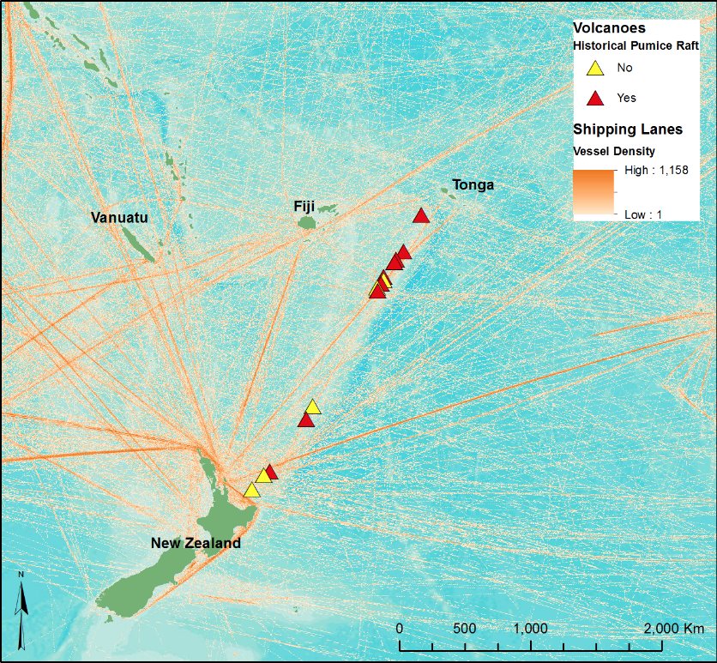Having identified the magma and eruption conditions required for pumice raft formation, further literature review was done to describe these conditions for every volcano in the study area. Volcanoes that were found to have basaltic andesitic, andesitic, and dacitic magma compositions at water depths between 17 and 1100 m were chosen as volcanoes that are a high risk of producing a pumice raft if they were to erupt. There are a total of 14 volcanoes in the South Pacific region that have the potential to produce a pumice raft (see Appendix A). Visual inspection of the hazard map shows that a major shipping route between the north island of New Zealand and Tonga is within extremely close proximity to 7 of these high risk volcanoes, 6 of which have produced a pumice raft in the past (Figure 4).

**Figure 4.** Hazard map showing locations of volcanoes capable of producing a pumice raft and major shipping lanes

**Pumice Raft Imagery**

Analyzing MODIS imagery in ENVI was helpful for looking at pumice rafts whose existence and location was already known, but there was no way to identify an unknown pumice raft by looking for a specific spectral signature. Pumice rafts do not have a unique signature and were too similar to that of clouds. A number of classifications were performed on MODIS images of pumice rafts and a classification standard could not be identified. Supervised and Unsupervised classifications were utilized in ENVI but were unsuccessful in differentiating the pumice from the clouds. As stated in the methodology section, Hue Saturation Value (HSV) and imagery enhanced by Color Tables were both effective in enhancing the contrast of pumice rafts from their surroundings (Figure 5). Despite these enhancements, it was determined that True Color images were just as effective in distinguishing the pumice from clouds and ocean water with the naked eye as the HSV and Color Tables. It is recommended that future projects imaging pumice rafts should utilize moderate-resolution (250 m) true color imagery from MODIS.

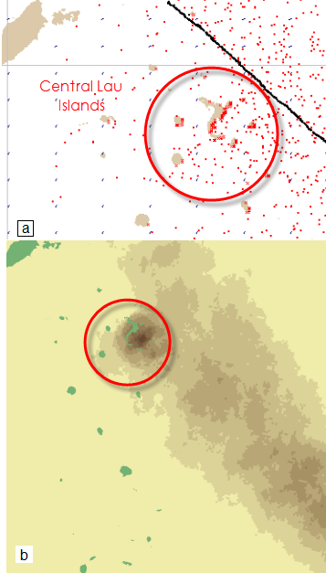

**Figure 6.** GNOME model for 2 September 2006. **a** GNOME software output **b** Density plot created in ArcGIS emphasizes concentrated pumice

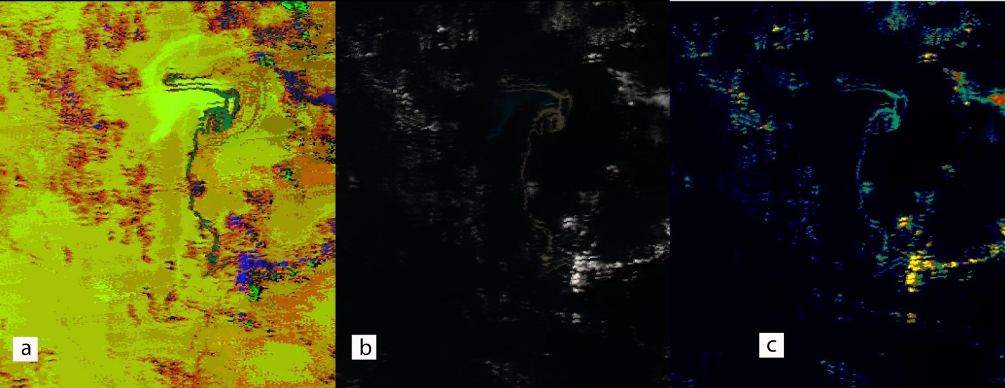

**Figure 5.** MODIS imagery of the 2006 Home Reef pumice raft. **a** Hue, Saturation, and Value image **b** “True color” image **c** ENVI Color Table enhancement image

**GNOME Trajectory Prediction Model**

*2006 Home Reef*

Utilizing easily accessible data, along with free and open-source products, a novel methodology for generating pumice raft trajectories was developed. This methodology was scrutinized against a peer-reviewed study and an accompanying published trajectory for the Home Reef eruption of 2006. The Home Reef event was also cross-referenced with in situ observations aggregated from the Smithsonian Institute’s Global Volcanism Program. In addition, the trajectory of the 2012 Havre Seamount pumice raft was validated by MODIS sensor observations.

The Home Reef pumice raft trajectory in particular underscored the skill of the GNOME model, given its performance over a temporally and spatially large-scale event. The model predicted the first pumice raft landfall in Fiji within a 48 hour margin. The first pumice raft was spotted by crew aboard the ship *Soren Larsen* just west of the Central Lau Islands on the evening of 30 August 2006 (Smithsonian, p. 3). The model showed pumice entering the region around noon local time on 1 September.

The model is corroborated by other in situ observations as well. According to Roberta Davis from the Makaira Resort in Taveuni, Fiji, pumice arrived on 14 September. The model shows a particle of pumice making landfall within 1 kilometer accuracy on the same day. That given area did not have additional false positives. While this accuracy was not commonplace as a whole, the general skillfulness of the model on the mesoscale level was better than expected given the simplicity of the model. Even if this methodology were no more skillful - or even slightly less skillful - than the published methodology to which it was compared, it is still successful. For the purpose of this project was to equip local decision makers who may have limited resources with a free and user-friendly method for predicting pumice raft movement. In that respect, this methodology is far better than the published Bryan et. al. (2012) methodology which relies on MatLab, which is both costly and more technically demanding.

Nonetheless, in one way this methodology may have been more skillful than the published methodology. Beyond one hundred days, the model lost skill. Yet, the model successfully predicted the pumice raft’s eventual landfall in Papua New Guinea, which is supported by in situ observations and was not seen in the published trajectory. Uncertainty particles reached Papua New Guinea as early as February 2007, while best track particles arrived in late April. Pumice was spotted approximately 100 km east-southeast of Woodlark Island, Papua New Guinea on 18 July 2007 (Smithsonian, p. . The model showed pumice reaching this area approximately 52 days earlier than was actually observed. This error was not unreasonable given the model was only initialized once in the 200-day period post-eruption. Particle splots representing pumice were exported at a weekly interval, layered with newer weekly splots behind older splots, and colored as time progressed. This yielded a visualization similar to the trajectory published by Bryan et al. (2012) (Figure 9).

*2012 Havre Seamount*

The GNOME prediction model output shows the 2012 Havre Seamount forming a pumice raft that was initially lineated in a Northwest-Southeast direction on 19 July 2012. The raft quickly moves in a southeasterly direction and approaches the south side of the volcano in less than two weeks. After four weeks, the pumice raft is on the east side of the volcano at a distance of about 123 km. From this location, the raft drifts in a northeasterly direction while rapidly dispersing and forming many small linear patches of pumice. This model shows a slow drift rate of ~5.7 km/day relative to the other modeled pumice raft.

Since the Havre pumice raft is a recent event and the raft hasn’t (or perhaps will not) make landfall, there is little to no data or peer-reviewed information on it. The only method of validation was to spatially and temporally correlate the GNOME trajectory output with moderate-resolution (250 m) MODIS true color imagery (Figure 10). The pumice raft became extremely difficult to see around one month after forming due to extensive wind shearing and breaking up. This process is represented in the model by the dispersal of the splots in a Northwest-Southeast direction as the pumice moves to the Northeast. The series of satellite images shows that the majority of the pumice raft did drift to the Northeast and the dates of each image correlate well with the dates of the same location in the model. Correlation became difficult around mid-September as the pumice continued to thin and became difficult to see in MODIS imagery.

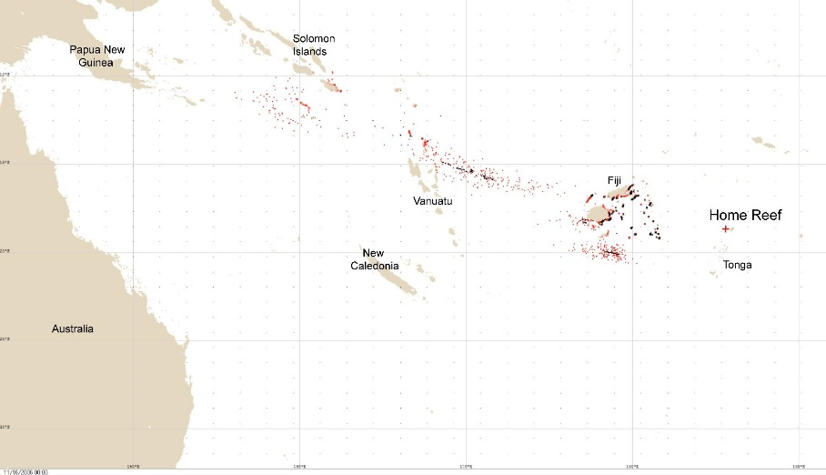

**Figure 7.** 2006 Home Reef pumice raft trajectory output in GNOME, black dots represent best forecast and red dots are uncertainty

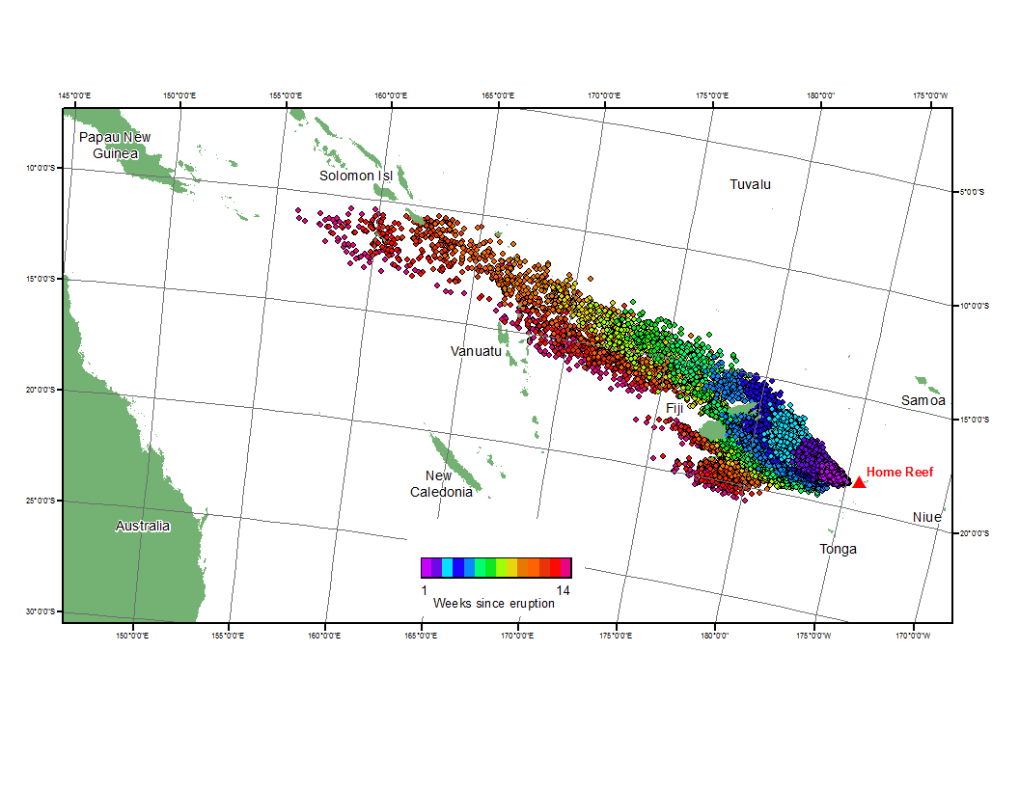

**Figure 8.** Weekly progression map of the 2006 Home Reef pumice raft

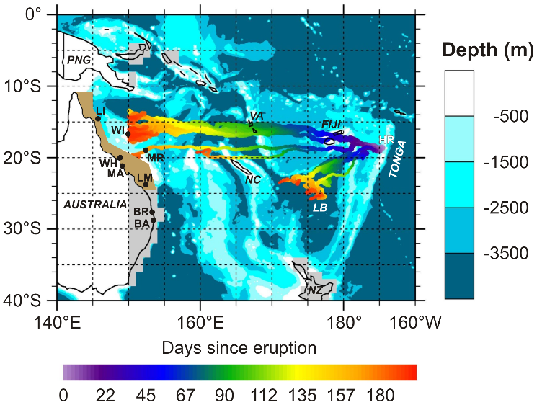

**Fig. 9** Trajectory map of the 2006 Home Reef pumice rafts, based on the surface velocity field (Bryan et al. 2012)

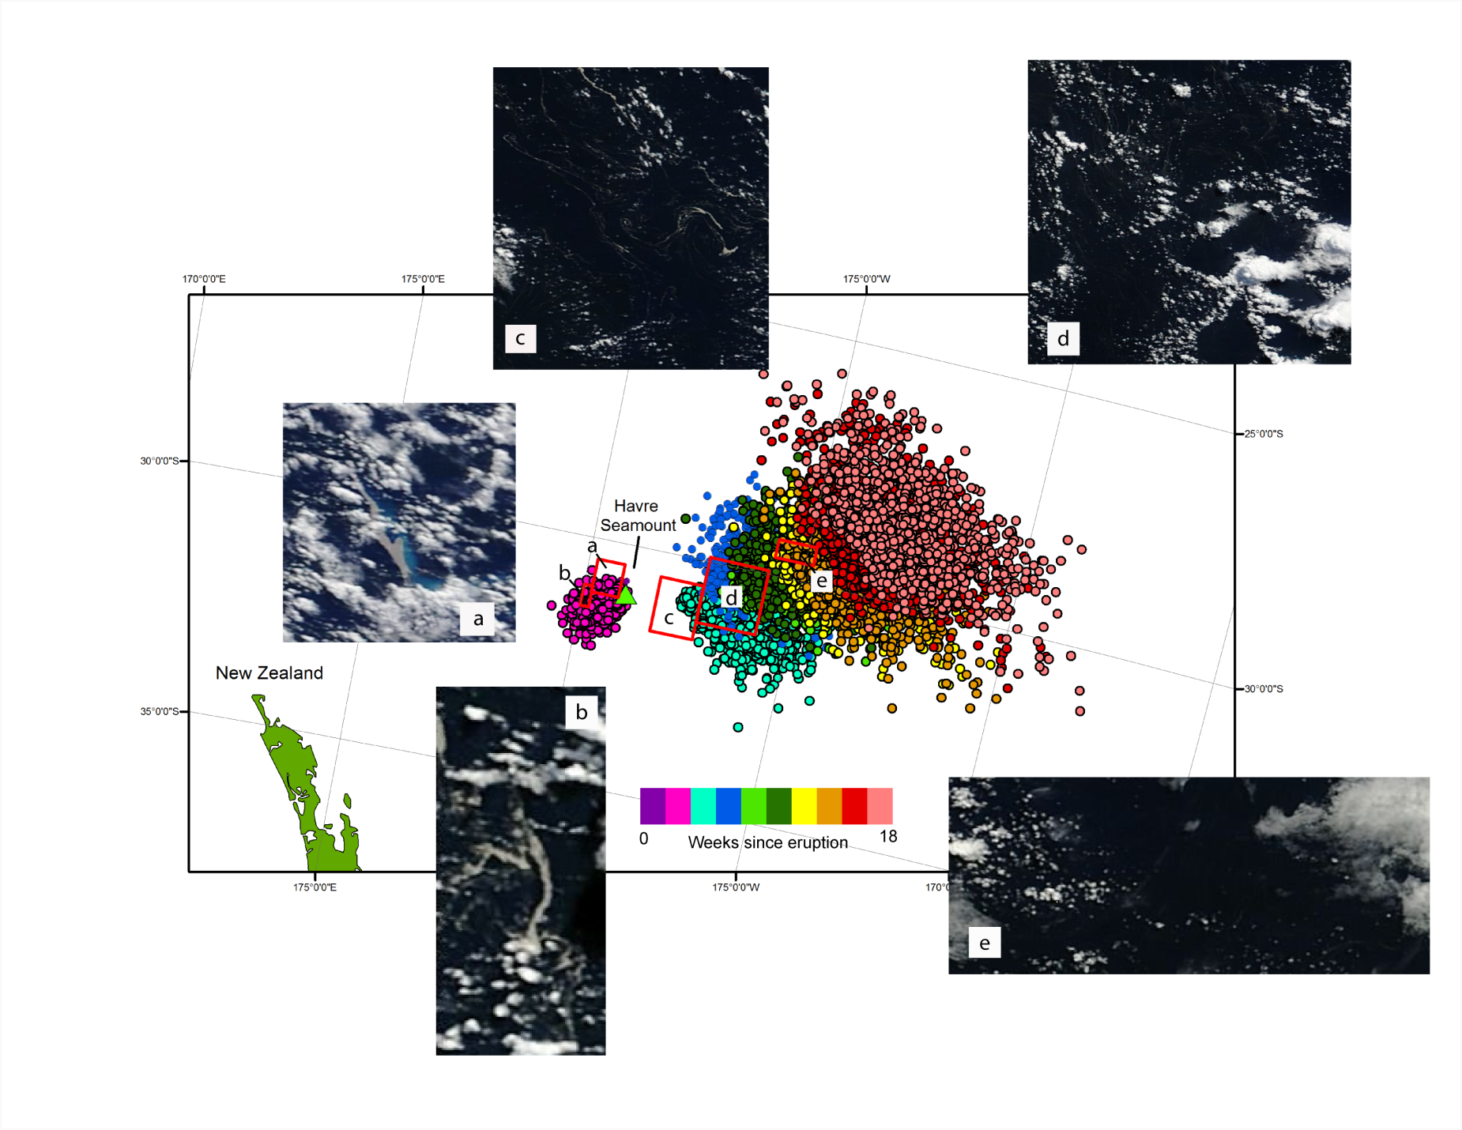

**Figure 10.** GNOME Predicted biweekly movement of the 2012 Havre Seamount pumice raft with accompanying MODIS 250 m true color images. **a** 19 July **b** 25 July **c** 15 August **d** 24August **e** 20September

**Errors and Uncertainty**

*Meteorological Data*

A clear distinction must be made between meteorological data used in this project to validate past pumice raft trajectories (i.e., observed data) and data that might be operationally used in GNOME to predict the movement of occurring pumice rafts (i.e., forecast data). In the purest sense, data used in this project should contain no error, since it is observed and not forecast. Numerous instruments are used in the derivation of OSCAR current data, and while anomalous data should be excluded in the filtering of that data, some error cannot be ruled out. Because of the accuracy of the hindcast data, we were able to run the GNOME model more than 90 days out with skillful accuracy (skillful meaning the model performed better with meteorological data over climatological trends, and that results were in agreement with in situ and satellite observations).

In contrast, forecast current and wind data used operationally for oil spills usually fail to produce trajectories within one mile of accuracy after 48 hours (Galt, 1998). It is expected similar results would occur with pumice. GNOME’s skill in hindcasting pumice raft events has been proven, as has its skill in predicting ongoing oil spills. Its skill in operational use to track pumice rafts has yet to be determined, due to the low occurrence of pumice raft events and the lack of historical forecast data, which could be used to perform a hindcast with *forecast* data rather than *observed* data.

*Model Bias & Calibration*

The GNOME model algorithms and how it handles inputted data is absolutely accurate. However, using the model operationally can prove difficult when calibration from overflight data is not possible (Watabayashi et al., 2013).

Accuracy of inputted data is also a limitation. For operational use, model bias of the inputs themselves (i.e., winds and currents from GFS, NAM, and other models) should also be considered. As is best practice, multiple models should be used to make a best-guess, and ensembles may be used to provide an area of uncertainty.

*Limited Spatial Coverage of Remote-Sensing Products*

OSCAR current data has limited spatial coverage near areas containing land. An area approximately 100,000 km2 encompassing the Western Division of Fiji and surrounding ocean (as outlined in Figure 11) contains no data. A similar gap in data occurs over western Espiritu Santo, Vanuatu and the Coral Sea. These gaps are intentional, as noise in data toward land makes that data unreliable. Some data could be obtained from buoys, though such data was limited in our study area. Thus, no data was utilized for these gaps. Even so, these areas do have wind data, which is the most important component of pumice raft movement. Fortunately, these large gaps in data only occurred near large masses of land, and only affected the western half of the land masses. Thus, these gaps are relatively minor, considering that the eastward sides of large land masses – which are not affected by the data gap – would likely disrupt larger pumice rafts before they can affect the areas affected by data outages.

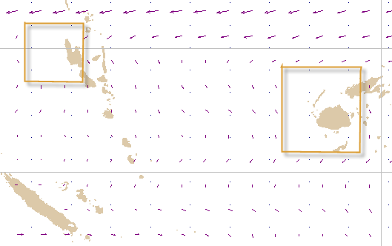

**Figure 11.** GNOME GUI screenshot showing the lack of ocean current data near shore

Additionally, the balance of high spatial to high temporal resolution was a limiting factor in imaging pumice rafts. Daily data is necessary to identify the initial formation of a pumice raft at the vent site in addition to tracking the daily movement of the pumice raft, particularly when the raft is moving at rates of up to 20 km/day. Complicating the issue further, pumice rafts rapidly disperse and thin to less than 1 km after a month of drifting and exposure to wind shear. These pumice “patches” are incredibly difficult to see in MODIS 250 m imagery but are easily observed in 15 to 30 m Landsat imagery. Ideally, a transition from MODIS to the Operational Land Imager sensor on board Landsat 8 would allow for continuous high spatial resolution imaging and tracking of pumice rafts. Unfortunately, with the higher spatial resolution of OLI comes a much lower temporal resolution. Landsat 8 only has a 16-day repeat cycle as opposed to Aqua and Terra’s 24-hour cycle. This significant decrease in temporal resolution would make tracking pumice rafts via remote sensing nearly impossible.

**Future Work**

Efforts to establish new techniques for the remote sensing of pumice rafts should be the primary focus for future work. Between this project and all other previous studies, it is clear that MODIS and other visible/NIR spectrum satellites are limited in their abilities to identify and track pumice rafts a few weeks after their formation. Microwave sensors such as RADARSAT-1 could be more proficient in imaging pumice rafts at a higher spatial and temporal scale because of its longer wavelength radiation, which allows it to create cloud-free imagery at extremely high resolution (up to 30 m).

**Conclusions**

Pumice rafts are most commonly observed in the South Pacific region as a result of frequent shallow explosive submarine eruptions. Fourteen volcanoes that belong to the Kermadec and Tonga trenches are a high risk of producing pumice rafts if they were to erupt as they meet the eruptive conditions necessary for their formation: intermediate to felsic magma compositions and a water depth between 17 and 1100 m. A major marine shipping route between Tonga and New Zealand overlies 7 of these volcanoes, 6 of which have already produced a pumice raft in the past.

Remote sensing of pumice rafts is limited to moderate resolution data (15-250 m) gathered from the Aqua, Terra, and Landsat satellites. A number of pumice classification techniques were attempted to determine a unique spectral signature in the visible wavelength spectrum but none could distinguish pumice from clouds any more effectively than true color. The biggest issue in monitoring pumice rafts using satellite imagery is the rate at which the pumice raft thins as it moves across the ocean surface. From this project, it was found that pumice rafts are easily identified upon formation in MODIS 250 m imagery but after ~5 weeks of exposure to wind shear while floating, the rafts thinned to less than 1 km and became extremely difficult to see. Additionally, extensive cloud coverage inhibits the spatial and temporal resolution at which pumice rafts may be tracked using satellite imagery.

The GNOME model developed for predicting the movement of pumice rafts in the South Pacific region has been validated using two different methods. The 2006 Home Reef predicted trajectory correlated incredibly well with in situ observations of the pumice raft and the published model by Bryan et al. (2012). The 2012 Havre Seamount predicted trajectory was validated by spatially and temporally correlating it with Aqua/Terra MODIS moderate-resolution satellite imagery of the pumice raft obtained from the LAADS website. Having validated the model using both of these methods, the South Pacific Oceans team is extremely confident that it can be used for maritime navigational warnings and coastal hazard management policies during future pumice raft events.

**Acknowledgments**

The South Pacific Oceans team would like to acknowledge our science advisor, Dr. Kenton Ross, for his critique and helpful advice from start to finish. Many thanks to Dr. Caitlin O’Connor from NOAA for being a tremendous help with GNOME. Further thanks to Dr. Greg Vaughan from the USGS and Dr. Bradley Scott from GNS Science for their advice and recommendations. Finally, a sincere thank you to Lauren Childs-Gleason, James Favors, Beth Brumbaugh, and Lauren Makely from the DEVLEOP National Program Office for editing all of our project deliverables and providing guidance along the way.

**References**

Bryan SE, Cook A, Evans JP, Colls PW, Wells MG, Lawrence MG, Jell JS, Greig A, Leslie R (2004) Pumice rafting and faunal dispersion during 2001-2002 in the Southwest Pacific: record of a dacitic submarine explosive eruption from Tonga. Earth Planet. Sci. Lett 227:135-154.

Bryan SE, Cook AG, Evans JP, Hebden K, Hurrey L, Colls P, Jell JS, Weatherley D, Firn J (2012) Rapid, long-distance dispersal by pumice rafting. PLoS ONE 7(7): e40583. doi: 10.1371/journal.pone.0040583

Cashman KV, Sturtevant B, Papale P, Navon O (2000) Magmatic fragmentation, in Sigurdsson H, Houghton BF, McNutt SR, Rymer H, and Stix J, eds., Encyclopedia of Volcanoes: San Diego, Academic Press, p. 421-430.

Fisher RV, Schminke HU (1984) Pyroclastic rocks. Springer Berlin Heidelberg New York Tokyo p. 1-472.

Galt JA (1998) Uncertainty Analysis Related to Oil Spill Modeling. Spill Sci. Technol. 4:4, 231-238.

Gamble JA, Christie RHK, Wright IC,Wysoczanski RJ (1997) Primitive K-rich magmas from Clark volcano, southern Kermadec arc: a paradox in the K-depth relationship. Can Mineral 35:275-290.

Hekinian R, Muhe R, Worthington TJ, Stoffers P (2008) Geology of a submarine volcanic caldera in the Tonga Arc: Dive results. J Volc Geotherm Res 176(4):571-582

Jokiel PL (1990) Long-distance dispersal by rafting: reemergence of an old hypothesis, Endeavour 14 (1990) 66-73.

Jones B, de Ronde CEJ, Renaut RW (2008) Mineralized microbes from Giggenbach submarine volcano. J Geophys Res 113, B08S05, doi:10.1029/2007JB005482.

Klemetti E. “Havre Seamount: the source of Kermadec island pumice raft?” Wired Eruptions Blog. 13 August 2012. Web. 06 June 2013. <http://www.wired.com/wiredscience/2012/08/source-of-kermadec-island-pumice-raft-eruption-identified/>

Mantas VM, Pereira AJSC, Morais PV (2011) Plumes of discolored water of volcanic origin and possible implications for algal communities. The case of the Home Reef eruption of 2006 (Tonga, Southwest Pacific Ocean). Rem Sens Environ 115:1341-1352.

Smithsonian Institute, Global Volcanism Program. (2006). Extensive pumice rafts between Tonga and Fiji during August-October. *Bulletin of the Global Volcanism Network*, 31(9).

Stone EL, Migvar L, Robinson WL (2000) Growing plants on atoll soils, Lawrence Livermore National Laboratory, University of California Livermore.

Taylor PW (1999) A volcanic hazards assessment following the January 1999 eruption of Submarine Volcano III Tofua Volcanic Arc, Kingdom of Tonga. AVI Occasional Report No. 99/01.

Watabayashi G, Macfayden A, Barker C (2013) NOAA's Use of GNOME for Japan Tsunami Debris Modeling. Abstract presented at 2013 Special Symposium on the Transport and Diffusion of Contaminants from the Fukushima Dai-Ichi Nuclear Power Plant, AMS, Austin, Tex., 6 Jan.

Whitham AG, Sparks RSJ (1986) Pumice. Bull Volc 48:209-223.

Wright IC, Gamble JA (1999) Southern Kermadec submarine arc caldera volcanoes (SW Pacific): caldera formation by effusive and pyroclastic eruption. Mar Geol 161:207-227.

**Appendices**

**Appendix A**

|  |  |  |  |  |  |  |  |  |
| --- | --- | --- | --- | --- | --- | --- | --- | --- |
| **Country** | **Volcano** | **Latitude** | **Longitude** | **Last Erupted** | **Magma composition** | **Water depth (m)** | **Historical** | **Source** |
|  |  |  |  |  |  |  | **Pumice Raft** |  |
| New Zealand | Clark | -36.446 | 177.839 | Unknown | Basaltic andesite-dacite | 860 | No | GVP, Gamble et al. 1997 |
| New Zealand | Giggenbach | -30.036 | -178.712 | Unknown | Basalt-dacite | 65 | No | GVP, Jones et al. 2008 |
| New Zealand | Healy | -35.004 | 178.973 | 1360 | Dacite | 1100 | Yes | GVP |
| New Zealand | Havre Seamount | -31 | -178.985 | 2012 | Intermediate to felsic | 1100 | Yes | Klemetti 2012 |
| New Zealand | Rumble II West | -35.353 | 178.527 | Unknown | Andesite to dacite | 907 | No | GVP, Wright and Gamble, 1999 |
| Tonga | 0403-091 | -18.325 | -174.365 | 2001 | Dacite | 200-300 | Yes | GVP, Bryan et al. 2004 |
| Tonga | Curacoa | -15.62 | -173.67 | 1979 | Dacite | 37 | Yes | GVP |
| Tonga | Falcon Island | -20.32 | -175.42 | 1970 | Andesite | 17 | Yes | GVP |
| Tonga | Home Reef | -18.992 | -174.775 | 2006 | Dacite | 10 | Yes | GVP, Mantas et al. 2011 |
| Tonga | Hunga Tonga-Hunga Ha'apai | -20.57 | -175.38 | 2009 | Basaltic andesite-andesite | 149 | No | GVP |
| Tonga | Metis Shoal | -19.18 | -174.87 | 1995 | Dacite | 43 | Yes | GVP |
| Tonga | Submarine Volcano III | -20.85 | -175.53 | 1999 | Intermediate to felsic | 13 | Yes | GVP, Taylor 1999 |
| Tonga | Volcano #1 | -21.15 | -175.75 | 1813 | Andesite to dacite | 450 | No | GVP, Hekinian et al. 2008 |
| Tonga | Unnamed | -21.38 | -175.65 | 1937 | Intermediate to felsic | 500 | Yes | GVP |
|  |  |  |  |  |  |  |  |  |
| GVP = Global Volcanism Program (Smithsonian) available at: http://www.volcano.si.edu/index.cfm |  |  |  |  |  |  |  |  |
|  |  |  |  |  |  |  |  |  |