**NASA DEVELOP National Program**

****Mobile County Health Department

**Summer 2013**

**Southeast Agriculture and Disasters**

*Assisting State and Federal Post-Wildfire Assessments through the Application of EOS Data*

**Team Lead:** Walt Clark (University of South Alabama), waltclark4@gmail.com

**Team Members:**

Rachael Isphording (Embry-Riddle Aeronautical University)

Rebecca Lanier (University of Southern Mississippi)

Shikher Mishra (University of South Alabama)

Skyler Sampson (University of South Alabama)

**Advisors & Mentors:**

Dr. Bernard Eichold, M.D., Dr.P.H. (MCHD)

Dr. Kenton Ross, PhD (NASA LaRC)

Joe Spruce (Computer Sciences Corporation)

**Applied Sciences National Applications Addressed:** Agriculture, Disasters, Health & Air Quality

**Study Area:** Florida, Texas

**Study Period:** August–September 2011; April–August 2012; and March–April 2013

**Community Concerns**

* 4-5 million acres of land burn in the US each year
* As urban areas in the Southeast expand, wildfires are becoming a greater social, public health, and economic concern
* Prescribed burning is the easiest and most economically efficient method of wildfire prevention in the Southeast, but can also adversely affect air quality
* At present, the impacts of smoke emissions on air quality can only be deduced by field estimates of burned biomass after a wildfire has ended, through direct sensing of the air around an active wildfire, or through remote sensing
* Forestry, agriculture, and the forest products industry are among the top manufacturing industries in the Southeast with ~68 % of the land cover in Alabama alone as timberland. An estimated $21 billion is generated as result of the forest products and the timber growing industry. Other states in the southern US (e.g., North Carolina, Georgia, and Arkansas) share similar statistics.

**80-100 Word Blurb**

As wildfires in the United States become more significant, the need for enhanced decision support tools monitoring severity are needed. The MCHD DEVELOP team conducted research using NASA EOS to identify wildfires that were significant for their ecoregion. The team applied imagery from Terra/Aqua MODIS, Suomi NPP VIIRS, and the Landsat 5, 7 & 8 TM/ETM+/OLI sensors. RdNBR Burn severity, extent, temperature, and burn power of each fire was derived before comparing RdNBR across sensors. The project also employed an innovative technique relating fire radiative power to biomass burned and aerosols emitted. These results were shared with end-user organizations through a web seminar.

**Abstract**

As the Southeast United States expands in population, the threat and risk of wildfires have caused increasing social, economic, and health concerns. Additionally, forestry and forest products represent leading industries in this region. To assist forestry interests at the state level assess the diverse effects of wildfires, the Mobile County Health Department NASA DEVELOP team identified multiple wildfires that were significant for their ecoregion to use as case studies. Relevant data and imagery was downloaded for days before, during, and after each studied fire from the Moderate Resolution Imaging Spectrometer (MODIS) sensor onboard Terra/Aqua, the Visible Infrared Imaging Radiometer Suite (VIIRS) sensor onboard Suomi NPP, and the Thematic Mapper (TM), the Enhanced Thematic Mapper Plus (ETM+), and the Operational Land Imager (OLI) sensors of the Landsat Program.

Several fire severity variables were derived from the satellite data sets and compared. Satellite-based total burn extent, greatest burn temperature, and fire radiative power (FRP) for each fire were obtained. The Relative differenced Normalized Burn Ratio (RdNBR) was calculated for each fire using available Landsat, MODIS, and VIIRS data. Cross sensor comparisons of RdNBR were made as well as comparisons to other variables such as temperature and FRP.

Given that regional air quality and forestry managers still find it difficult to ascertain fire aerosol contributions to ambient air quality, the project team reviewed an innovative method to estimate biomass burned and aerosol contributions. These aerosols were first identified using both VIIRS and MODIS aerosol optical depth (AOD) data and imagery. The team then estimated the effects the fires had on AOD data by approximating the total biomass burned and resultant aerosol loading based on coefficients of aerosol emission rates and MODIS derived FRP. After project implementation, the main findings were presented to Southeastern forestry agencies through an open webinar. In this presentation, case study results were presented including products depicting different fire severity indicator metrics. The benefits and caveats of using products from different sensors and their utility in the field were also discussed. The new method for estimating aerosol emission rates was introduced and relevant methodologies were handed off to interested partners. The presentation focused on the potential of near real time fire assessment products in regards to burn severity and fire aerosol contributions.

**Partners/Collaborators**

Florida Forest Service: Susan Leveritt, GIS Manager; John Sadler

Alabama Forestry Commission: Abi Dhakal, GIS Manager

Mississippi Forestry Commission: Dennis Dauterive, Fire Chief

USDA Forest Service Remote Sensing Applications Center: Brad Quayle, Monitoring Trends in Burn Severity Program Manager

**Current Management Practices & Policies**

Currently, wildfire mitigation in the Southeast focuses on two aspects: risk assessment before a fire and recovery efforts after containment. For this project, we focused on what remotely sensed data was available for active fires or post-burn assessment. In the Southern United States, wildfire interests focus on containment in order to prevent an actual wildfire if a forest or brush fire does not occur on managed land. However, fire that occurs on land managed for timber is a different case. In this case, rapid assessment and mitigation efforts are exercised in addition to containment. While most state forestry commissions in the Southeast utilize geographic information software and some remotely sensed data, the application of these resources is far less than is seen in the western United States. This can be attributed to the overall higher population densities in the rural South contributing to fire detection and the greater amount of rainfall that helps regulate fires that do occur.

**Benefit to End-User:**

* Near real-time satellite-based burn severity indicator maps will augment tools already available to state foresters in early post fire assessments
* The methodologies used to calculate burn severity products can be repeated by state agencies to further aid post wildfire analysis
* The effects of smoke emissions on air quality can also be estimated in near real-time as opposed to post-fire analysis
* Awareness that MODIS and forthcoming VIIRS near real-time hot spot fire products will give multiple snapshots per day of fire intensity during the fire
* The concept of Fire Radiative Power and its utility will be demonstrated through its relationship to burn severity and through emission estimations
* New products from recently launched sensors will be demonstrated

**Decision Support Tools**

* Burn extent and severity maps from VIIRS, MODIS, and Landsat
* Aerosol maps manifesting the impact of wildfires on the aerosol optical thickness of the area.
* Methodology for deriving smoke emission rates from measurements of FRP obtained from MODIS and their impacts on air quality.
* Google Earth case study material from fires that are familiar to end-users

**Earth Observations & Parameters**

Landsat 7, 8 – TM, ETM+, OLI - Layer stacks, Active Fires, Burn Extent, Severity, and RdNBR Terra & Aqua - MODIS – Layer stacks, Active Fires, Burn Extent, Severity, RdNBR, and aerosol optical thickness

Suomi NPP, VIIRS – Active Fires, Burn Extent, Severity, RdNBR, and Aerosol Optical Thickness

**Future Applicable NASA Missions**

TEMPO – Atmospheric pollutions

­­­SMAP – Soil moisture variations before and after fires

HyspIRI – Vegetation analysis; aerosol emissions

**Models Utilized**

HYSPLIT  
This project aims to demonstrate the various applications and utility of the active fire product. It is unlikely that model applications will be addressed in this term. However, fuel models from forestry interests can be married to active fire data to predict future fire movement. Also, the air quality aspect of this project requires CMAC or WRF model input for validation; though we apply the Hybrid Single Particle Langrangian Integrated Trajectory to qualitatively validate aerosol optical depth retrievals of fire aerosols from MODIS.

**Ancillary Datasets Utilized**

USFS RSAC Burn Severity Analyses

Partner in situ post fire burn assessments

GOES WF ABBA Algorithm Data

North American Model (Nam-12) 12 km Reanalysis

**Software Utilized**

ArcGIS – Raster Manipulation/Analysis, Image Enhancement & Map Creation of Landsat

ETM+, NPP VIIRS, Aqua/Terra MODIS

HYSPLIT – Aerosol Plume Trajectory Modeling

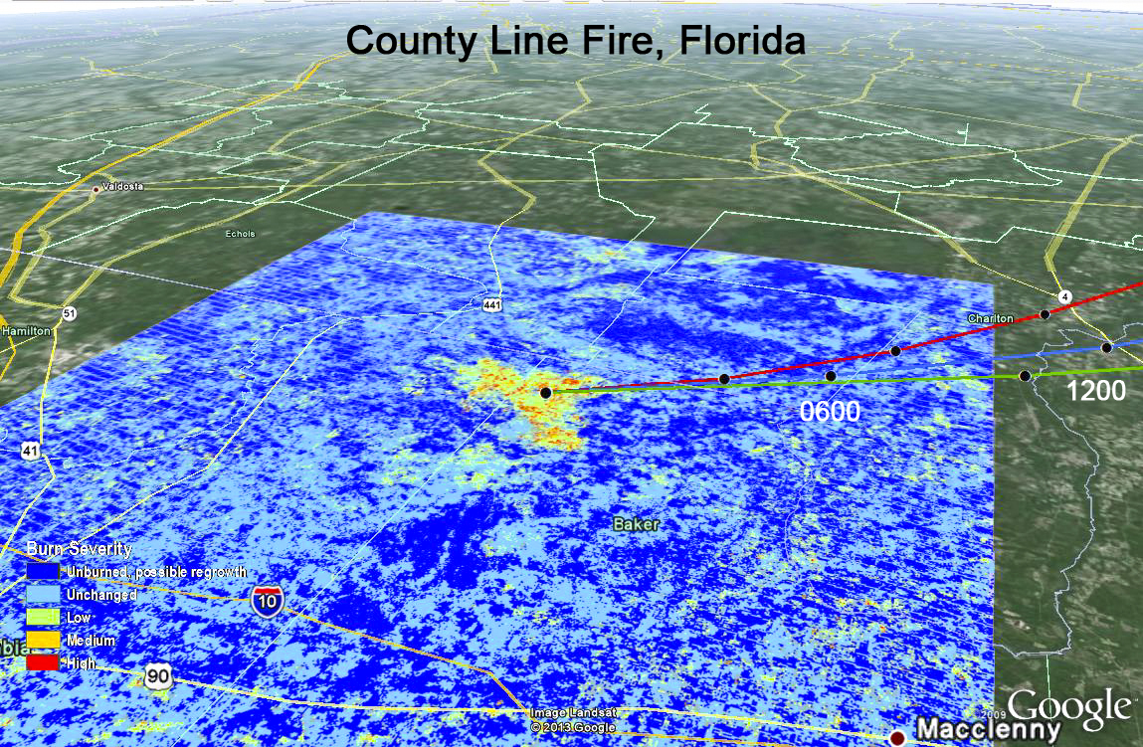

A Landsat RdNBR is displayed with Hysplit derived aerosol trajectories valid for April 9, 2012 during the County line Fire, FL. RdNBR analyses were compared across sensor and Hysplit trajectories were used to validate MODIS AOD data.