NASA DEVELOP National Program
USGS at Colorado State University
Summer 2017

Alaska Climate
Utilizing NASA Earth Observations to Model Suitable Habitat of Invasive Species in Alaskan Wetlands


Technical Report
Final Draft – August 11th, 2017

Emma Zink Hatcher (Project Lead)
Sarah Carroll
Audrey Martinez
Tim Mayer
Brian Woodward (Center Lead)

Dr. Paul Evangelista (Principal Investigator)
Dr. Amanda West (Science Advisor)

1. Abstract
The rapid expansion of purple loosestrife (Lythrum salicaria) and reed canarygrass (Phalaris arundinacea L.) into aquatic and wetland systems has reduced native plant abundance, decreased species diversity, and degraded wildlife habitats for birds and amphibians throughout North America. The expansion of these invasive species into northern latitudes as a result of changing climate trends poses mitigation challenges to natural resource managers. In the United States, this trend is particularly concerning in Alaska, where wetlands are of major economic and ecological importance. This project developed habitat suitability models utilizing spectral data from Terra and Aqua MODIS in conjunction with topographic and climatic variables to map historic and current suitable habitat for purple loosestrife and reed canarygrass across Canada and the United States. The resulting habitat suitability maps will support decision making and the planning of management actions by partners at the Alaska Region US Fish and Wildlife Service in the “Early Detection, Rapid Response” program for invasive species management.

Keywords
Remote Sensing, BRT, RF, MaxEnt, Invasive Aquatics, MODIS, Habitat Suitability Modeling
2. Introduction

  - Background Information
Invasive species can alter ecosystem functions such as nutrient cycling and fire regimes, and cause changes in native plant community structure. These changes are often associated with negative ecological and economic consequences, making them a high priority for natural resource managers (D’antonio & Vitousek, 1992). In the United States, an estimated 5,000 invasive plant species have established in ecosystems at a rate of approximately 7,000 ha/year since the early 1900’s (Pimentel et al., 2005). The annual costs associated with the control for common groups of invasive plants are estimated to exceed 30 billion USD in the United States (Babbitt, 1998; Pimentel et al., 2005). Invasive species are significantly more costly to manage once established, making early detection and prevention a high priority for land management agencies as a whole (Department of the Interior, 2016). Climate change has and will continue to disturb wetland ecosystems, creating areas more suitable to invasive species.

Reed canarygrass (Phalaris arundinacea L.) is a perennial emergent wetland grass known to be an aggressive invader that is now ubiquitous and dominant in wetlands across North America (Lavergne & Molofsky, 2004; Lavergne & Molofsky, 2007). It typically invades after a disturbance, and with a wealth of genetic diversity, it exhibits rapid growth and adaptability thereby outcompeting native vegetation (Lavergne & Molofsky, 2007). Reed canarygrass reduces native plant cover, plant diversity, and can also cause negative ecological impacts towards wildlife taxa (Lavoie et al. 2003; Spyreas et al., 2010).

Purple loosestrife (Lythrum salicaria) is also a perennial emergent wetland plant that was introduced to North America from Europe in the early 1800’s and is often found in areas invaded by reed canarygrass (Blossey et al., 2001). It has since spread throughout wetlands and riparian areas across 48 states and nine Canadian provinces at an estimated rate of 115,000 ha/year (Thomson et al., 1987; Blossey et al., 2001). It was first documented in Alaska in 2005 (Schrader, 2005). Purple loosestrife is self-pollinating with a short maturation period and prolific seed production, allowing it to readily adapt to new environments and climatic conditions (Thompson et al. 1987, Rawinski, 1982). Where it has successfully invaded, purple loosestrife often replaces native wetland plant communities with monospecific stands, reducing native plant biomass that provides habitat for wildlife species including birds, insects, and amphibians, such as the critically endangered bog turtle (Glyptemys muhlenbergii) (Blossey et al., 2001). Costs of control for purple loosestrife are estimated at more than 45 million dollars each year in the United States (Pimentel et al., 2005).

The effects of continued changes in climate are predicted to be the most severe in northern latitudes, and consequently, the primary and secondary effects of climatic shifts are expected to increase the likelihood of establishment of non-native species that were previously typical to temperate climates (Serreze et al., 2000; Moritz et al., 2002; Carlson & Shepherd, 2007). Alaska is one of these Arctic regions that is experiencing a rapid influx of invasive species. Many natural resources and tourism in Alaska are reliant on intact, biodiverse ecosystems (Jarnevich et al, 2014). The risk of invasive species establishment in Alaska equates to a risk of economic losses as fisheries and wildlife habitat are degraded as a direct response (Ebbert and Byrd, 2002).

  - Study Area and Period
The study area is the state of Alaska (Figure 1). Additional models also include the coterminous United States and Canada. The continental habitat suitability models provide the diversity of ecosystems, environmental conditions, and presence data required to provide the contextual habitat of these plant species. The study period covers the years from 1981 - 2016. Both purple loosestrife and reed canarygrass are relatively recent invaders to Alaska, but cover a large area in the lower latitudes of the contiguous United States and Canada.
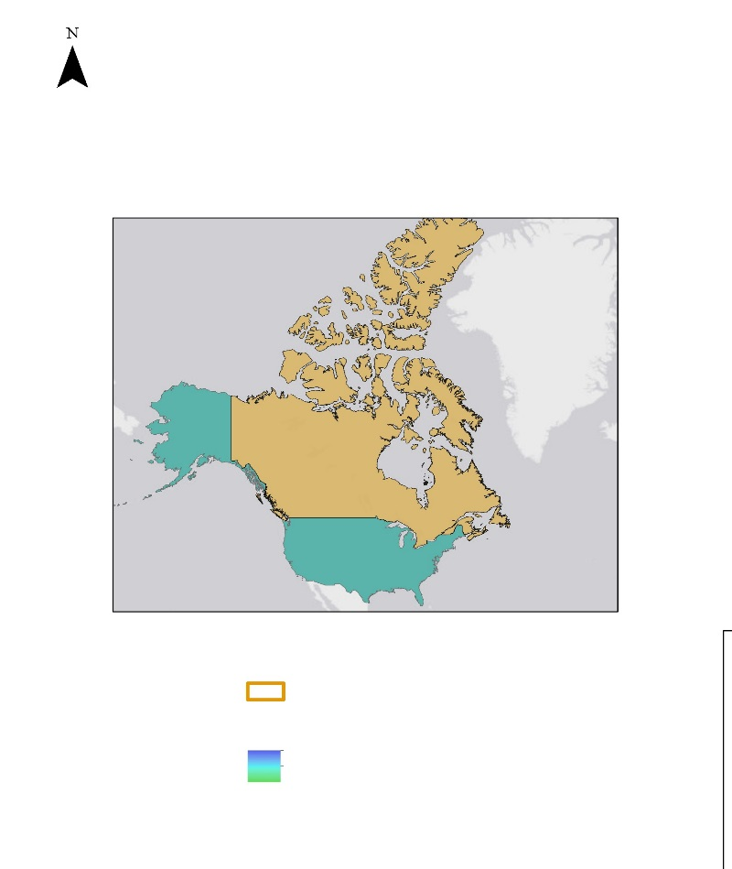
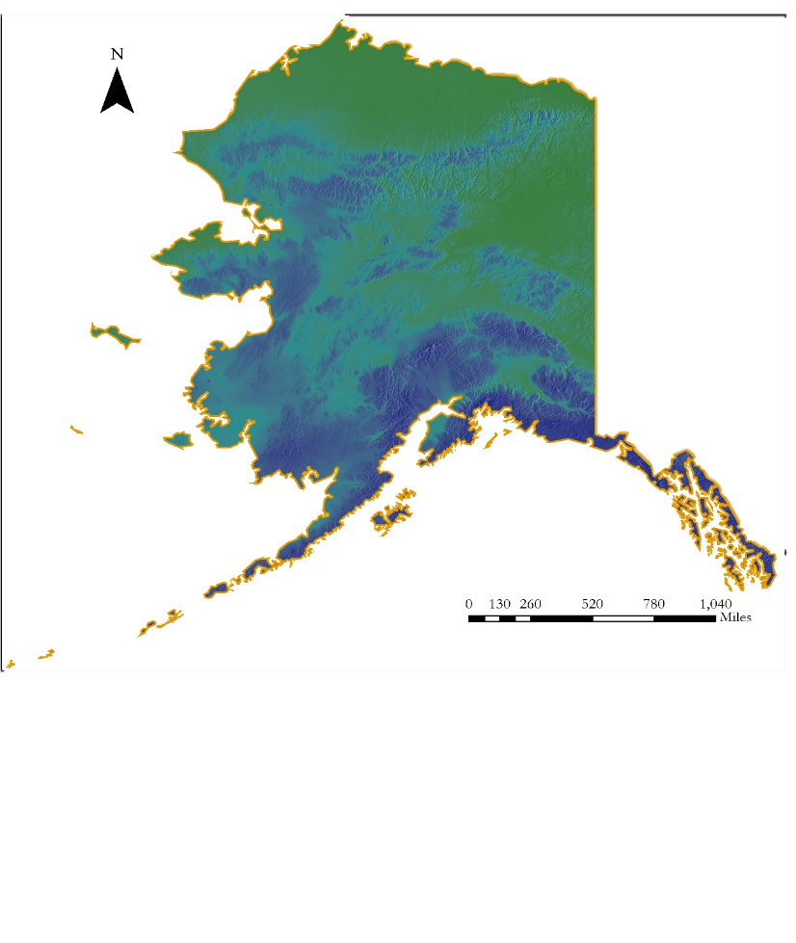
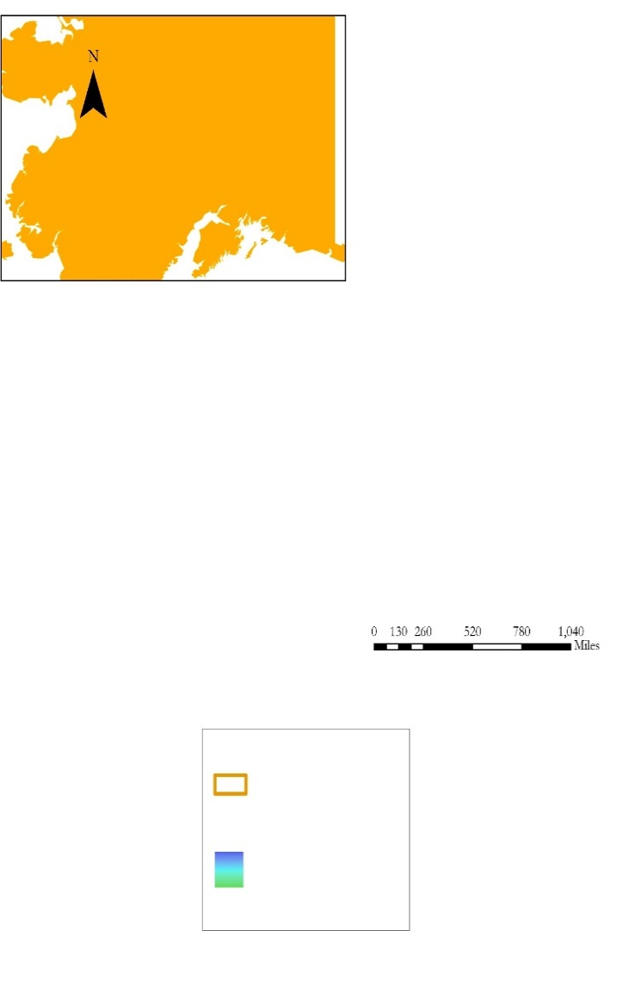
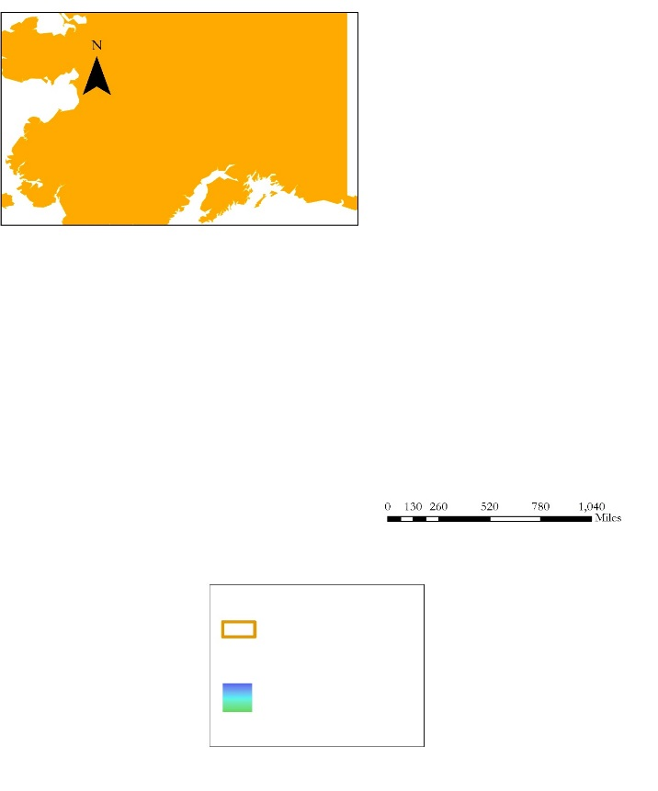
CANADA
CONUS
AK
Mean Annual
Precipitation (1981-2010)
Study Area
ALASKA

Figure 1. The Alaska Climate study area.

  - National Application Addressed
This project addresses the climate national application area of NASA’s Applied Sciences Program. Projects in this category utilize NASA Earth observations to analyze impacts and risks to human and environmental health relative to changing climate trends. The Alaska Climate team supported US Fish and Wildlife efforts to manage invasive species establishment risk in wetland ecosystems in the state of Alaska by providing continental and state level invasive species habitat suitability models. These models can be applied to support mitigation of economic and ecological impacts of invasive species by highlighting areas that are potentially suitable to support populations of these species.

  - Project Partners & Objectives
This project was conducted in partnership with the US Fish and Wildlife Service (USFWS), Alaska Region. The USFWS currently implements invasive species mitigation and monitoring through the “National Fish Habitat Action Plan”. Mitigation and management through this program applies field-based monitoring and surveillance of purple loosestrife and reed canarygrass. There is no region-wide map to inform target areas of high invasive species risk to support this effort. The models generated through this project both fill this data gap and support effective allocation of USFWS resources in areas that are environmentally suitable for purple loosestrife and reed canarygrass beyond where they have already established.

The primary objective of this project was to create maps of potential suitable habitat for purple loosestrife and reed canarygrass to highlight target areas for mitigation and monitoring. A second model on the continental scale provided the broader distribution of suitable niches for purple loosestrife and reed canarygrass. In addition, a tutorial was created to document methodology and facilitate the capacity for the US Fish and Wildlife Service Alaska Region to reproduce and refine maps for future needs.
3. Methodology

3.1 Data Acquisition
Species distribution models were built using topographic data, vegetation indices, land cover, and climate normals for the study period and area (Appendix 1). Presence data from both species were downloaded from the Global Biodiversity Information Facility (GBIF), USGS Biodiversity Information Serving Our Nation (BISON), Alaska Natural Heritage Program (AKNHP), and Early Detection Distribution mapping systems (EDD) databases. Purple loosestrife and reed canarygrass presence points from AKNHP were downloaded for the Alaska Region from 1987 to 2016 based on the documented history of these species in the state. Continental North American presence points used a combination of GBIF, BISON, AKNHP, and EDD from 1981 to 2016. Global topographic and land cover data, including elevation, slope, compound topographic index (CTI), and the global land cover (GLC) datasets were accessed at USGS. The digital elevation model (DEM) was a product of the Global Multi-resolution Terrain Elevation Data 2010 (GMTED10) dataset, which derived from the Shuttle Radar Topography Mission version 2 (SRTM v2).

Vegetation indices were derived from Terra and Aqua MODIS, which were downloaded and exported using Google Earth Engine. Surface reflectance from Terra MODIS and top of atmosphere reflectance (TOA) from Landsat 7 ETM+ were also downloaded and exported using Google Earth Engine. TOA reflectance bands were converted to tasseled cap brightness, greenness and wetness. Climate normals were obtained by the team using ClimateNA v5.10 software. ClimateNA software uses a digital elevation model (DEM) as an input to apply the Parameter Regression of Independent Slopes Model (PRISM) and ANUSLIN interpolation method to generate current climate normals (Wang et al., 2016). Partner feedback on preliminary model results was also collected in order to better visually assess whether a given model output was reasonable given the limited knowledge the team had about the ecology of wetland regions in Alaska.

3.2 Data Processing
All species presence data obtained through GBIF, BISON, EDD, and AKNHP were projected into NAD 1983 Albers Equal Area Conic. Several field observations had clear coordinate errors, such as zeros for both x and y coordinate values, and were removed from the overall dataset. The team converted the continental DEM in R software to be used as the input to derive climate normals for the study period in ClimateNA. All modeling was conducted at the scale of one kilometer. The output from ClimateNA was then reconverted in R into a raster dataset to be visualized in ArcGIS and ready for use in the Software for Assisted Habitat Modeling (SAHM) environment. All data were clipped to the study area shapefiles separately for the United States and Canada and again for Alaska. Raster templates were also created for the study areas to provide the modeling extent, coordinate system, and resolution of SAHM outputs. The template, predictor, and presence data were brought into SAHM and resampled and aligned using the Projection, Aggregation, Resampling, and Clipping (PARC) module to ensure spatial consistency across layers for modeling.
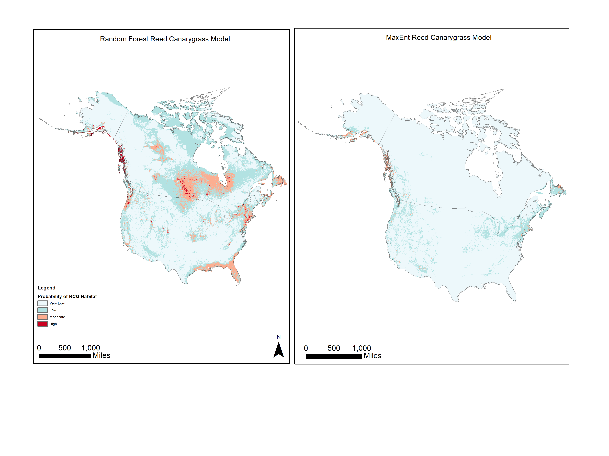
3.3 Data Analysis
Model iterations were conducted using the USGS Software for Assisted Habitat Modeling (SAHM). SAHM is a modeling package enabled through VisTrails, an open-source management and scientific workflow system (Morisette et al., 2013). The five main components in SAHM are input data, preprocessing, preliminary model analysis, correlative models, and output routines (Morisette et al., 2013). Within SAHM, the team constructed three unique habitat suitability models: continental scale models for purple loosestrife and reed canarygrass and a state-scale model for reed canarygrass in Alaska. Purple loosestrife was not modeled at the Alaska scale as the spread of this invasive species to Alaska is recent, and not enough presence points have yet been documented to justify a model specific to the state.

The team employed three modeling approaches within SAHM: Random Forest (RF), Boosted Regression Trees (BRT), and Maximum Entropy (MaxEnt). Covariates were evaluated for correlation and removed if the correlation coefficient between two was greater than 0.7. This process was conducted to avoid overfitting of model predictions. The validity and predictability of each model was assessed utilizing cross-validation and subsequently threshold dependent and threshold independent evaluation metrics produced by SAHM.

4. Results & Discussion
4.1 Analysis of Results
The resulting prediction maps indicate the relative probability that a given area has suitable habitat for each species. Multivariate environmental similarity surface (MESS) maps are produced for every model iteration. These maps show the percent similarity of a given area to the range of environments represented across presence point locations. To minimize uncertainty in model outputs, these MESS maps were utilized to eliminate areas of novel environmental conditions that could not be confidently evaluated in the final models.

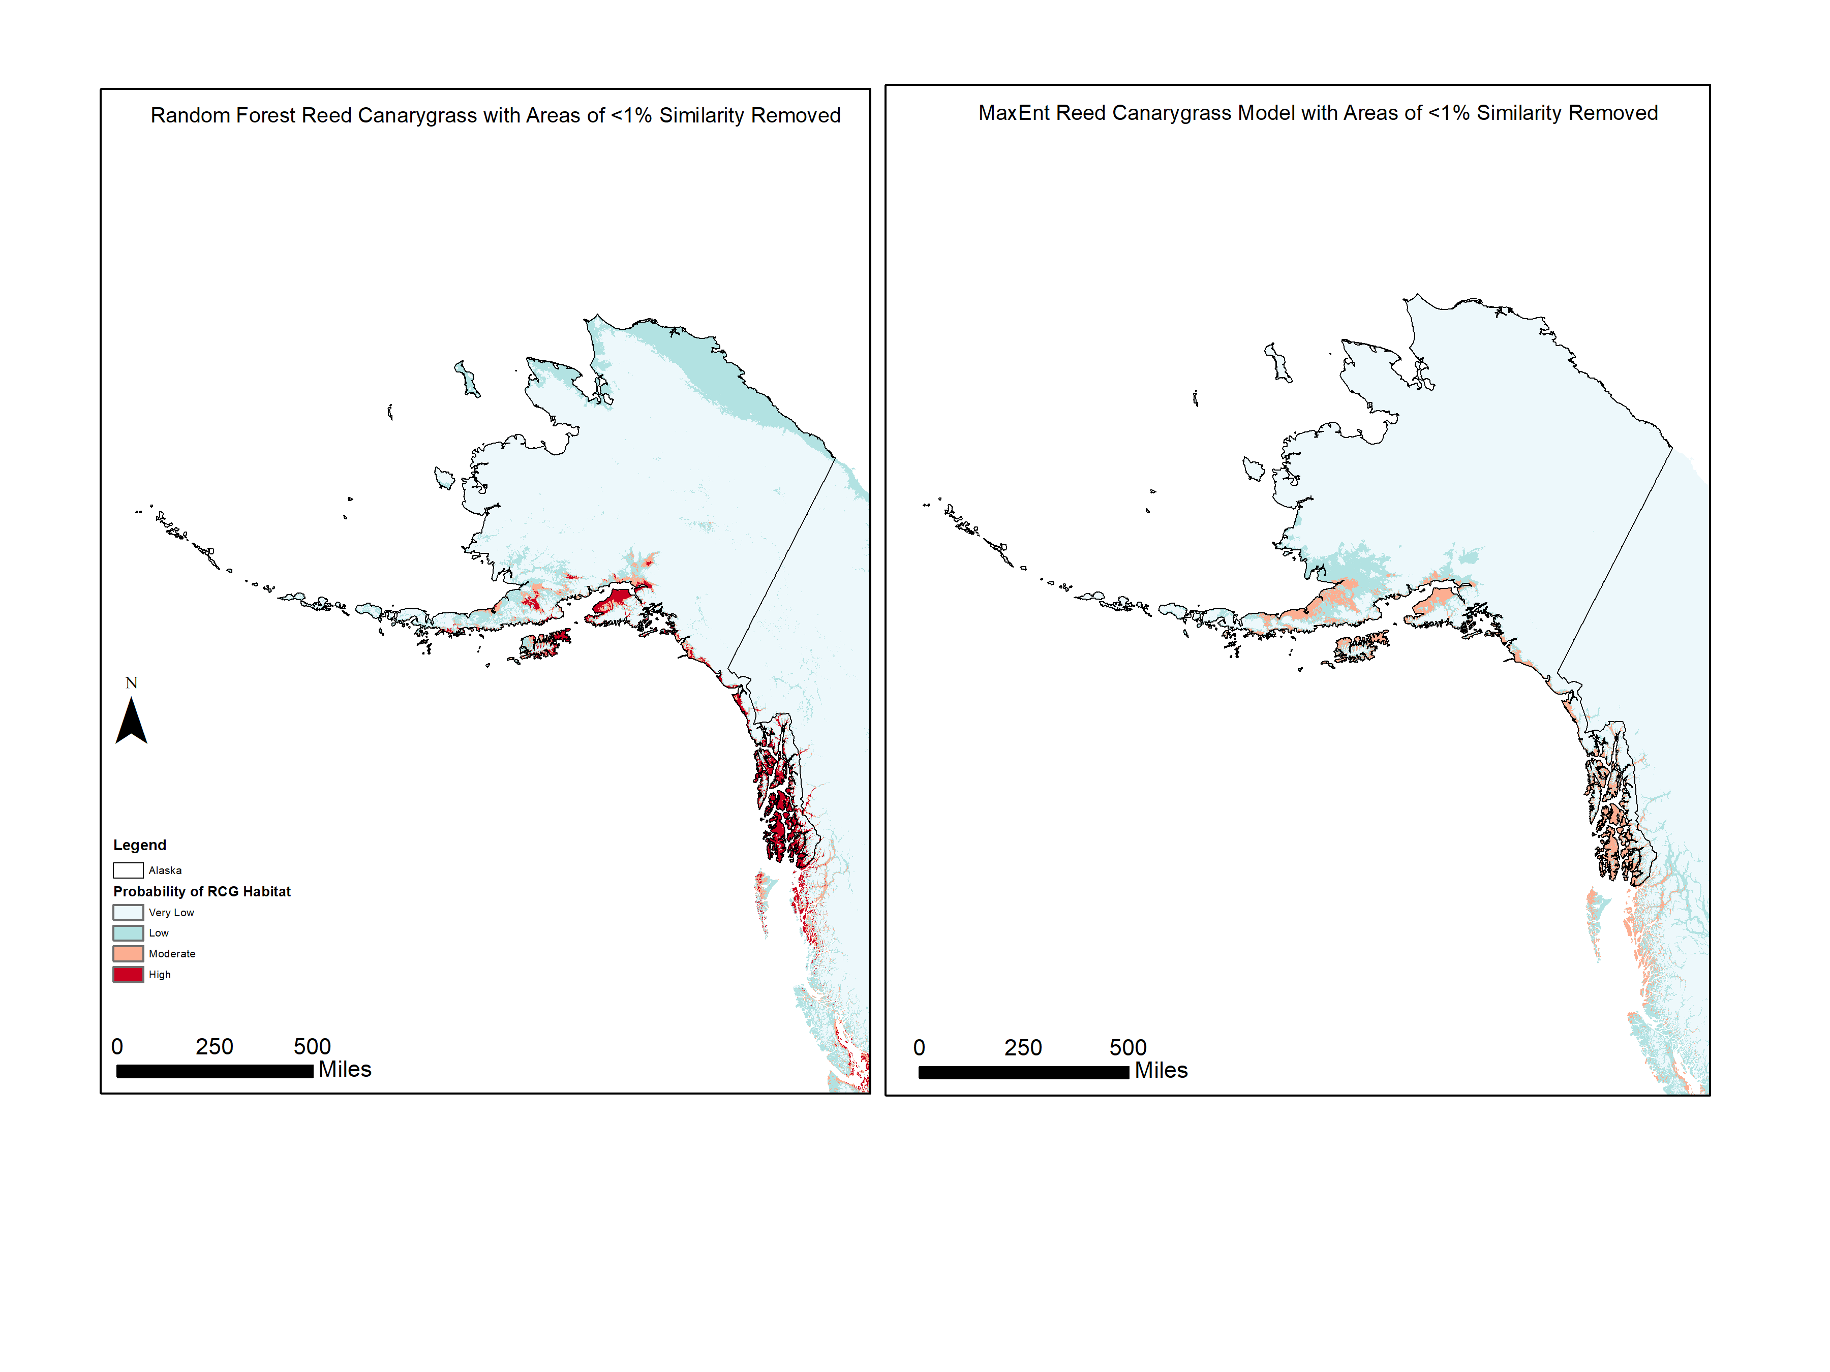
Across all model outputs, varying amounts of the southern or southwest coastlines of Alaska were predicted as high probability to have suitable habitat for both species. This pattern was especially strong in the continental projections into Alaska (Figure 2). The Alaska specific scale reed canarygrass had contrasting results, with significantly less coastal area included in the high probability range, and the highest predicted probability of suitable habitat in the interior of Alaska (Figure 3).
500
miles

Model outputs were evaluated using evaluation metrics that included AUC, sensitivity, and specificity. Visual comparisons to partner feedback were also made to assess the ecological strength of the models. As anticipated, MaxEnt models consistently underpredicted the probability of suitable habitat for both species and scales. Given the generalist nature of both species, MaxEnt was the weakest model based on visual assessment, however, the performance evaluation metrics for these types of models were reasonable. Boosted regression trees performed the worst both visually and using the suite of evaluation metrics, and those outputs were subsequently removed from consideration in the final results. Random forests models were the strongest both using partner visual assessment and using the model evaluation metrics (Appendix 2). For the random forests and MaxEnt continental reed canarygrass models, the top four predictors were elevation, Terra MODIS band 6 surface reflectance, average summer temperature, and solar radiation (Appendix 3).

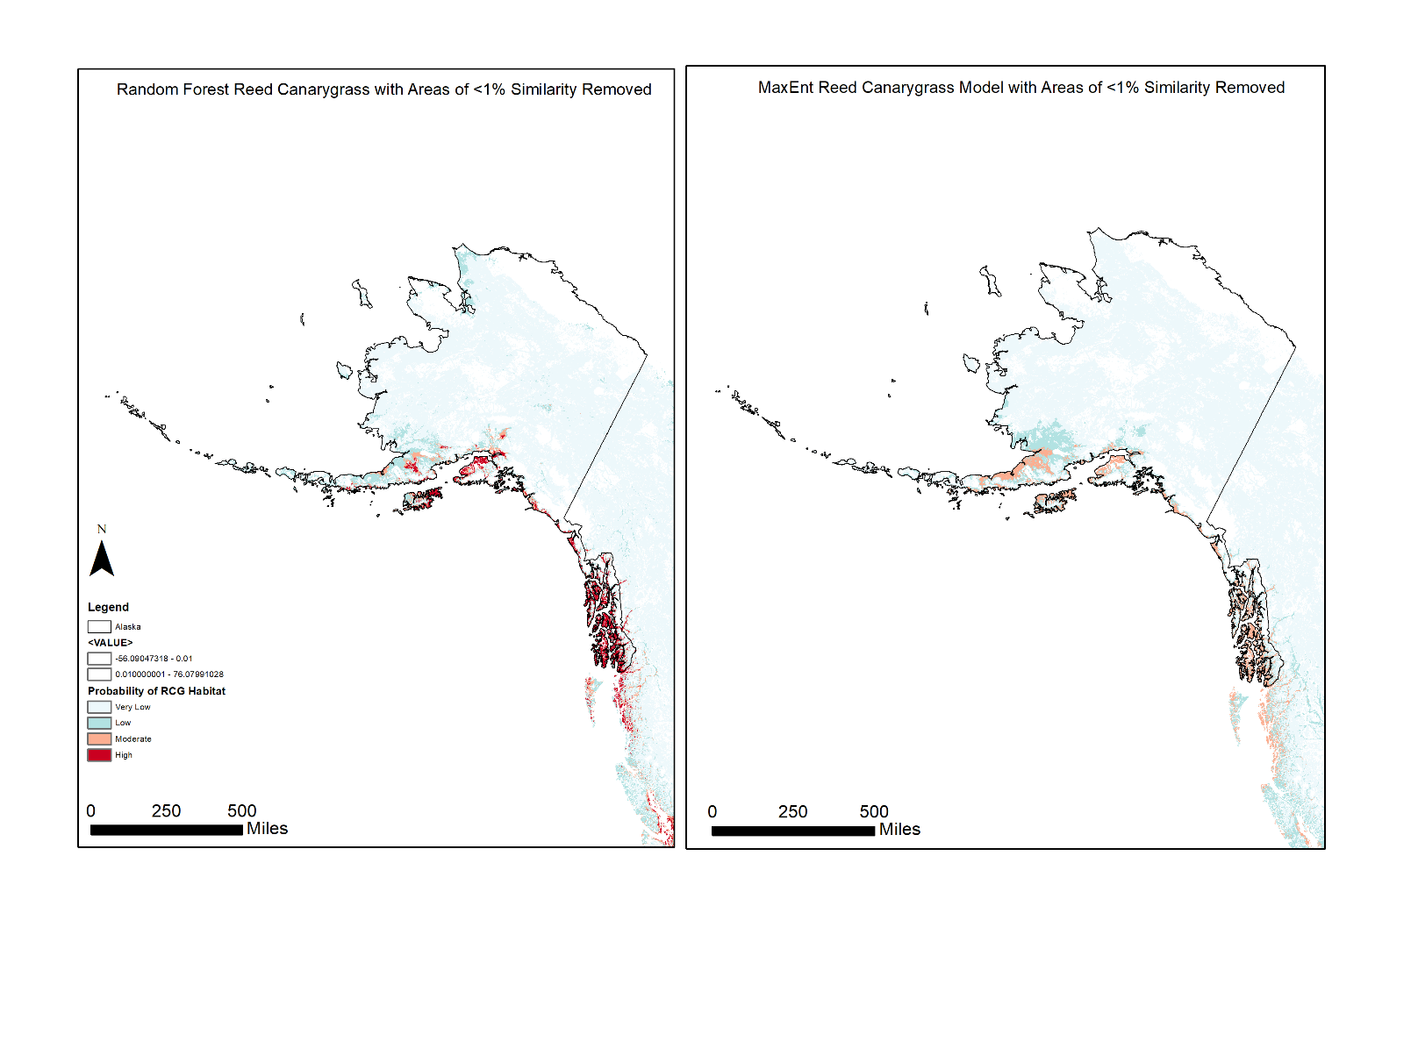
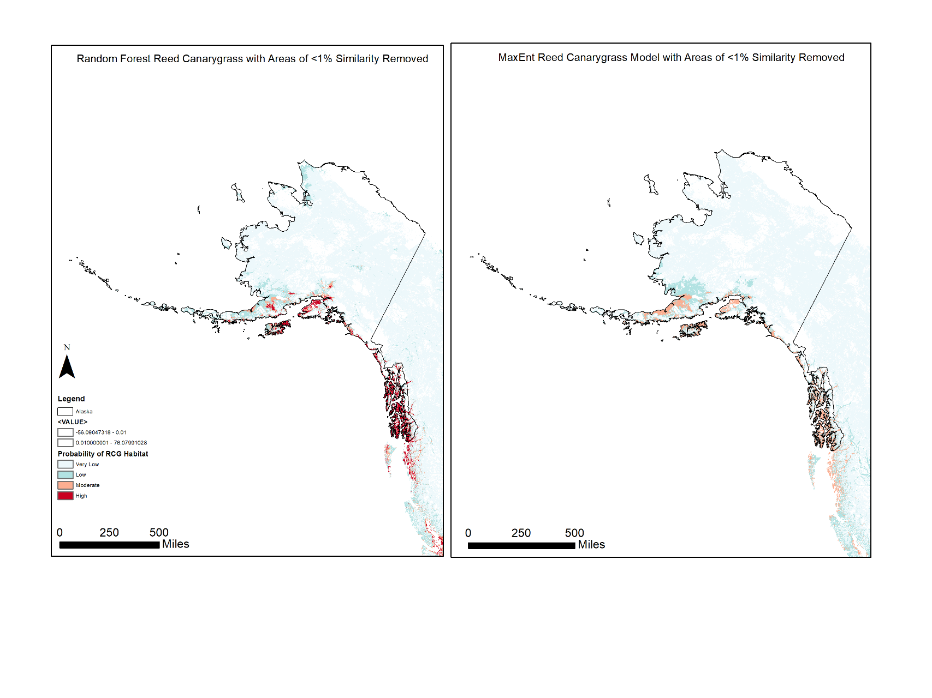
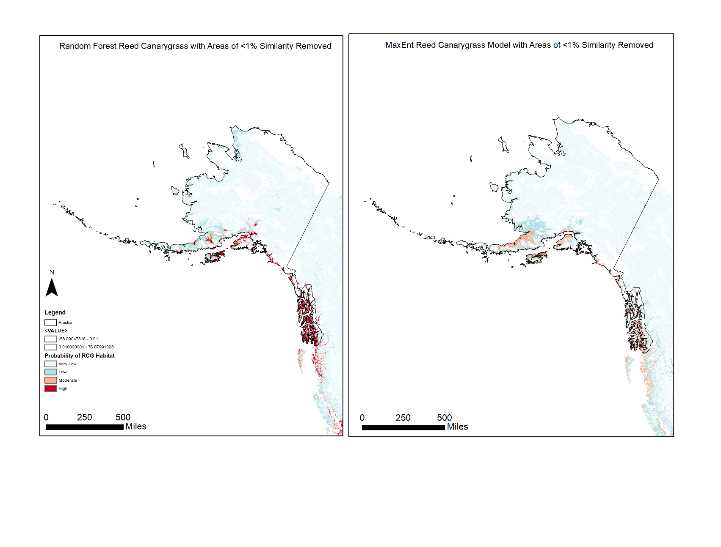
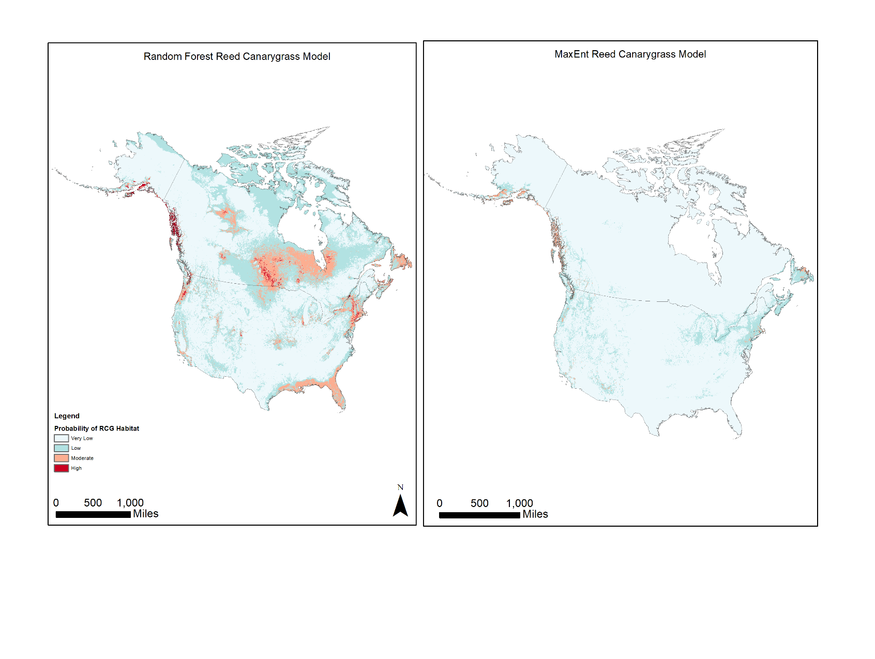
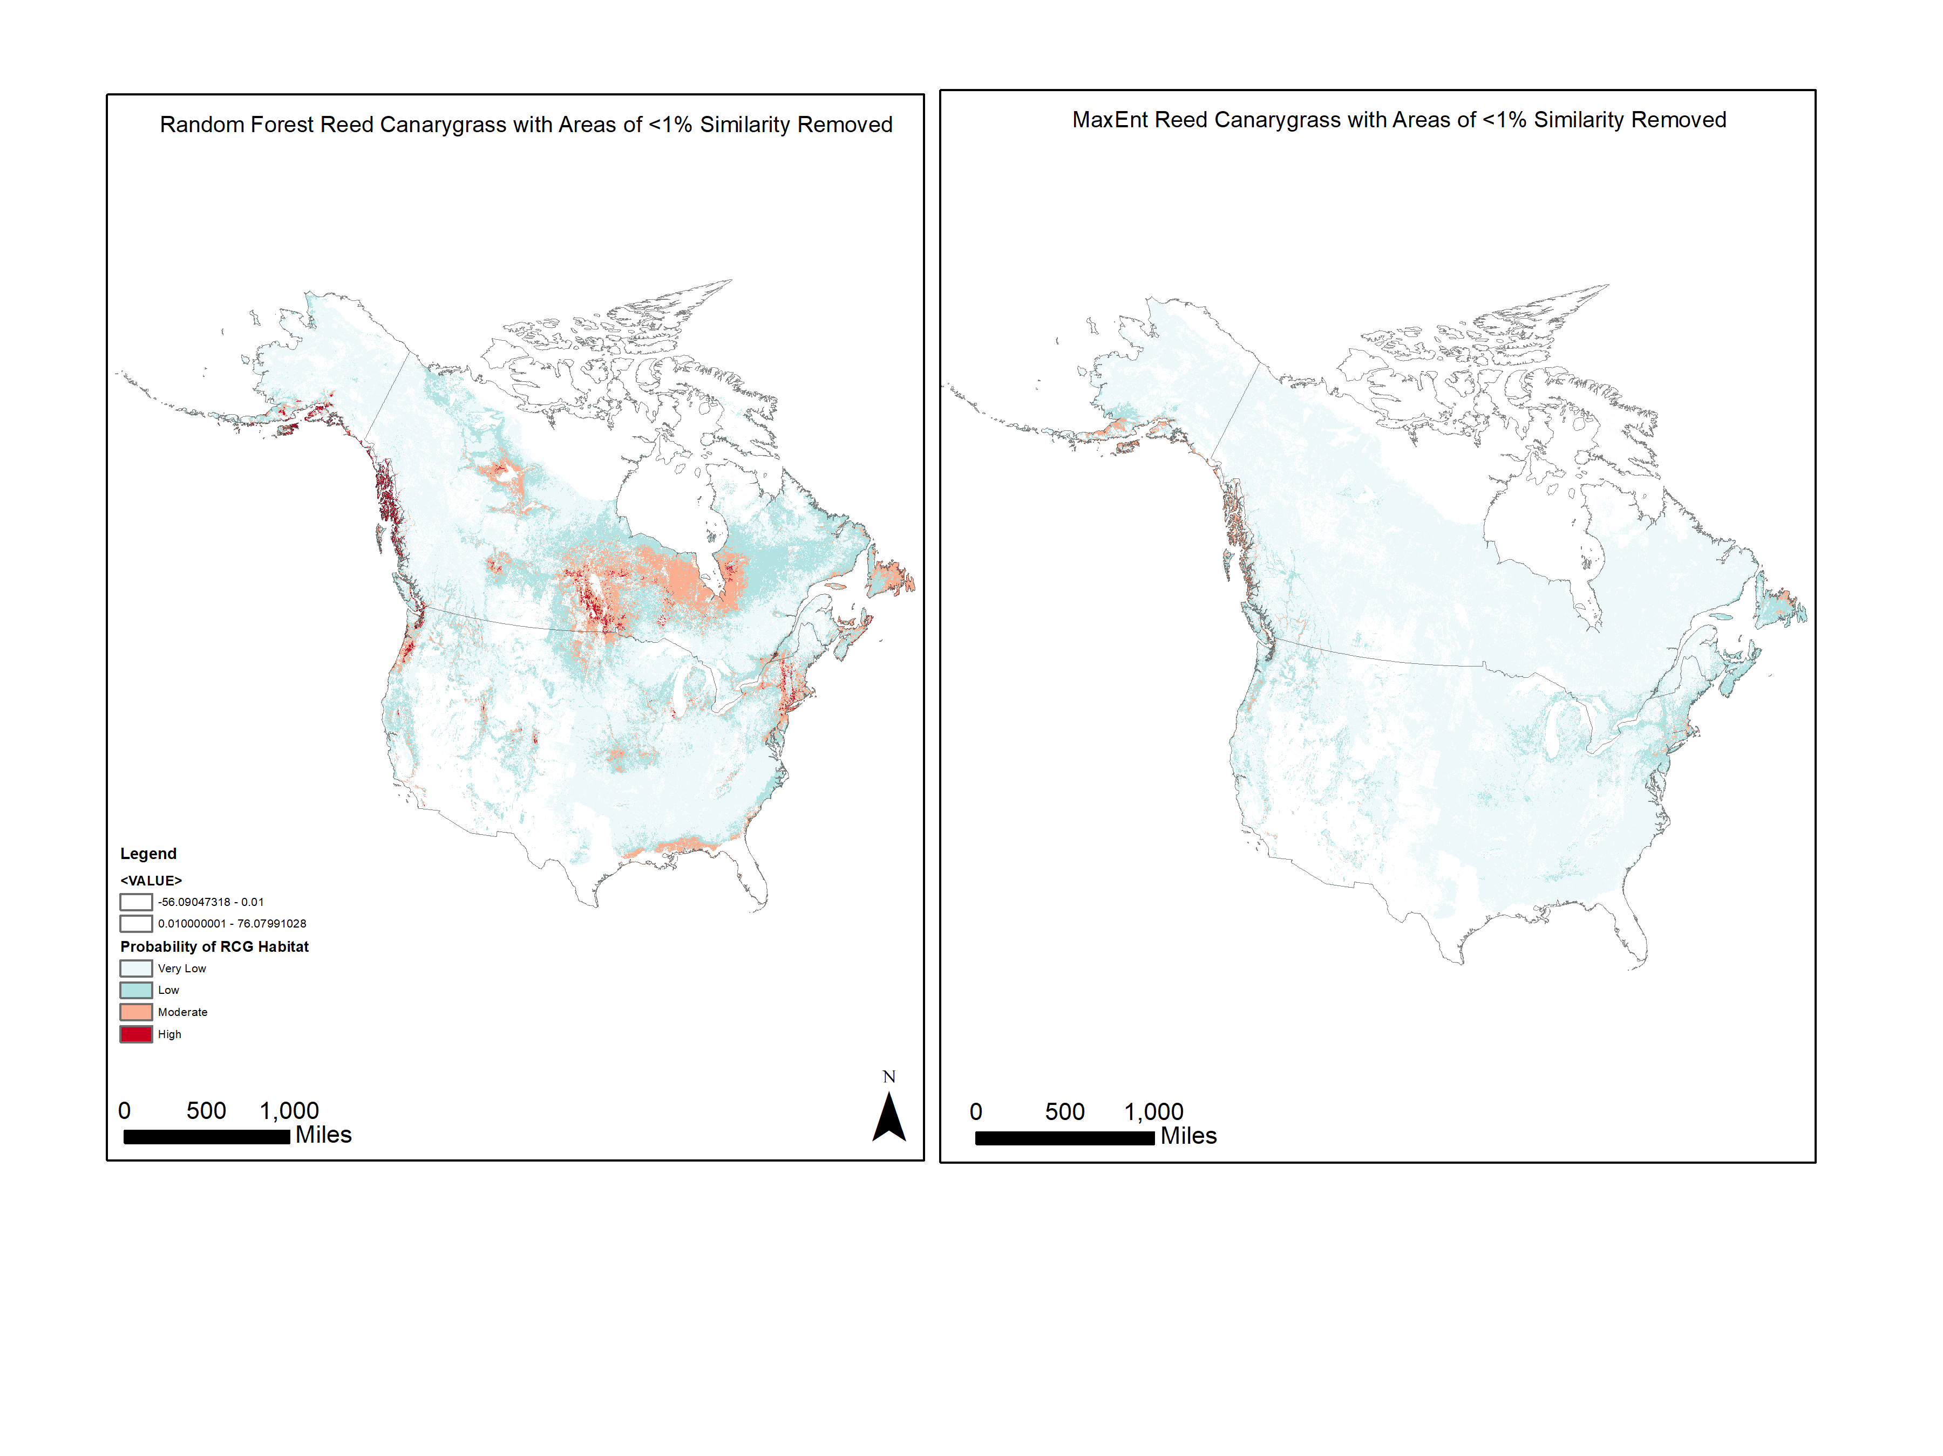
Figure 2. Reed canarygrass continental model projections in Alaska, Random Forest is on the left and MaxEnt is on the right.
miles
500
Very low
Low
Moderate
High
Probability of Reed Canarygrass Habitat
Eliminated due to extrapolation
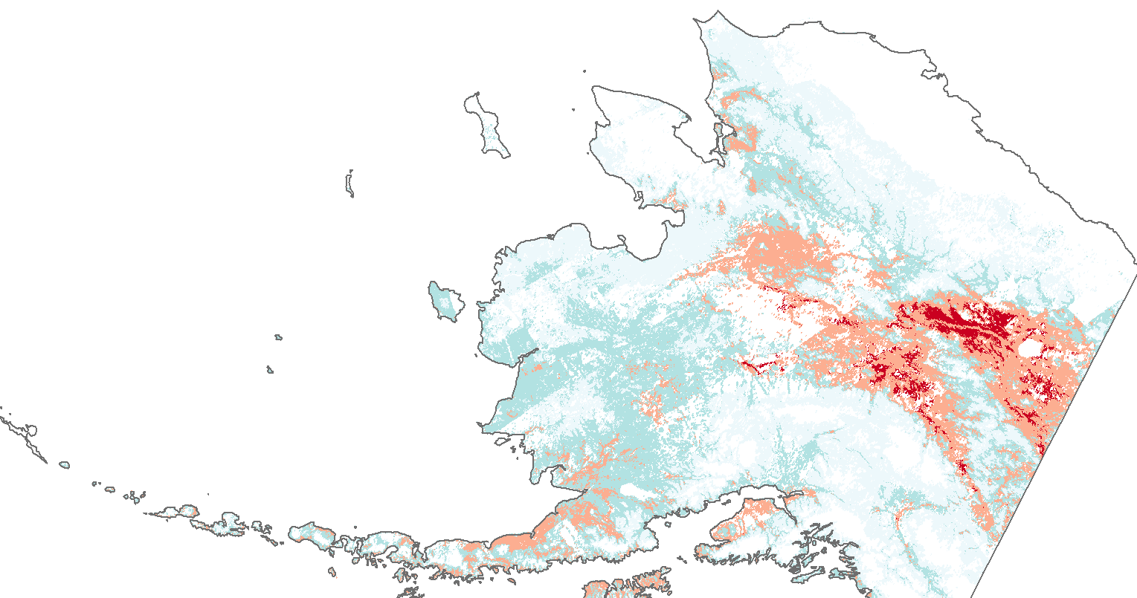
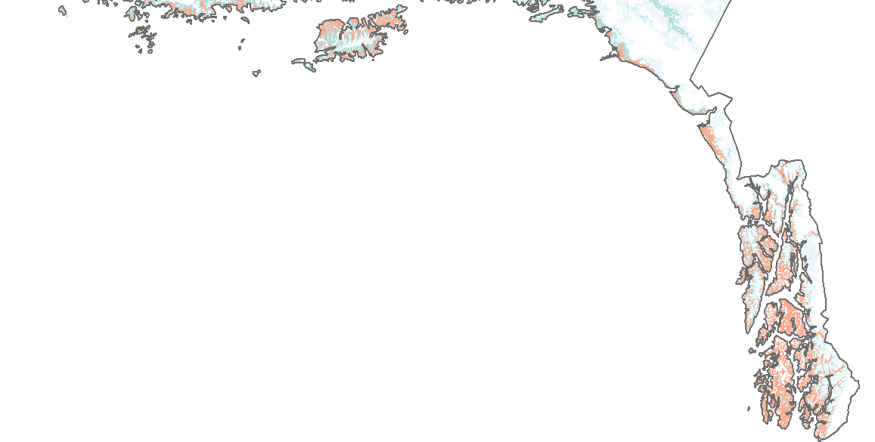
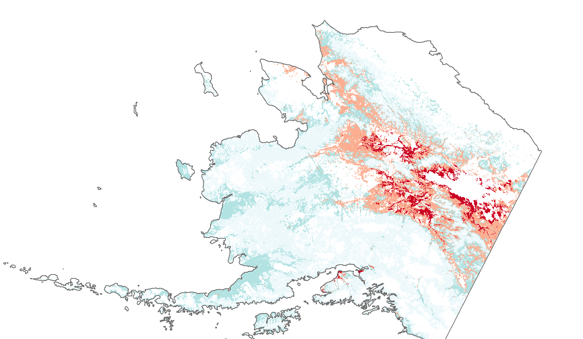
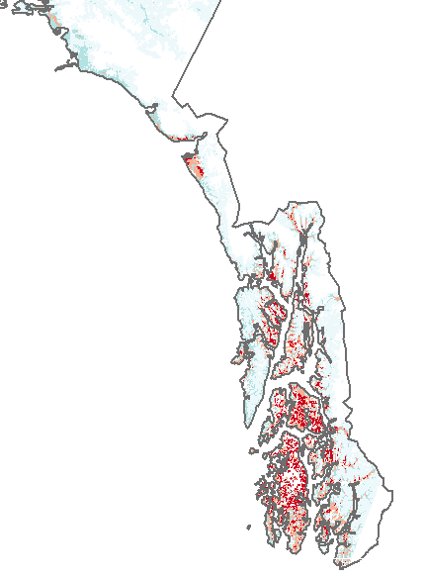
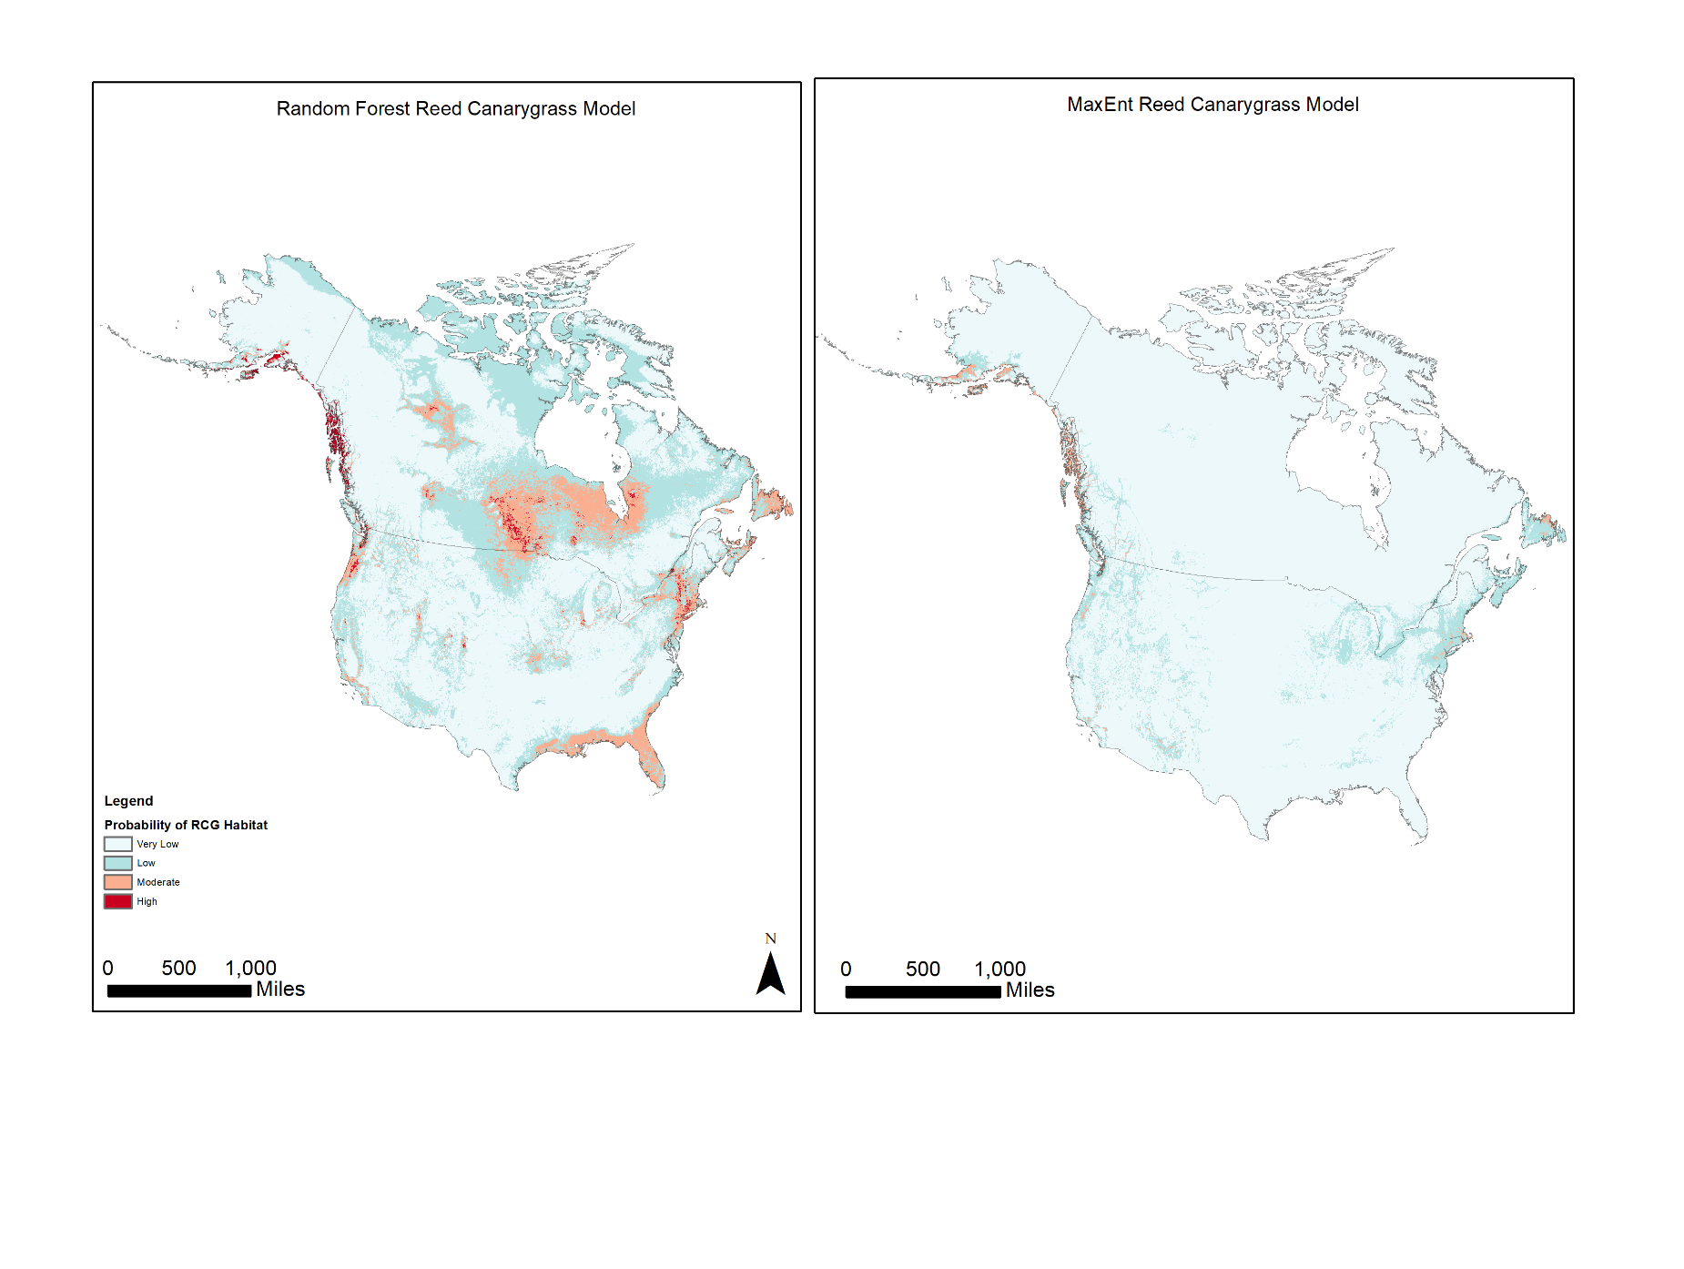
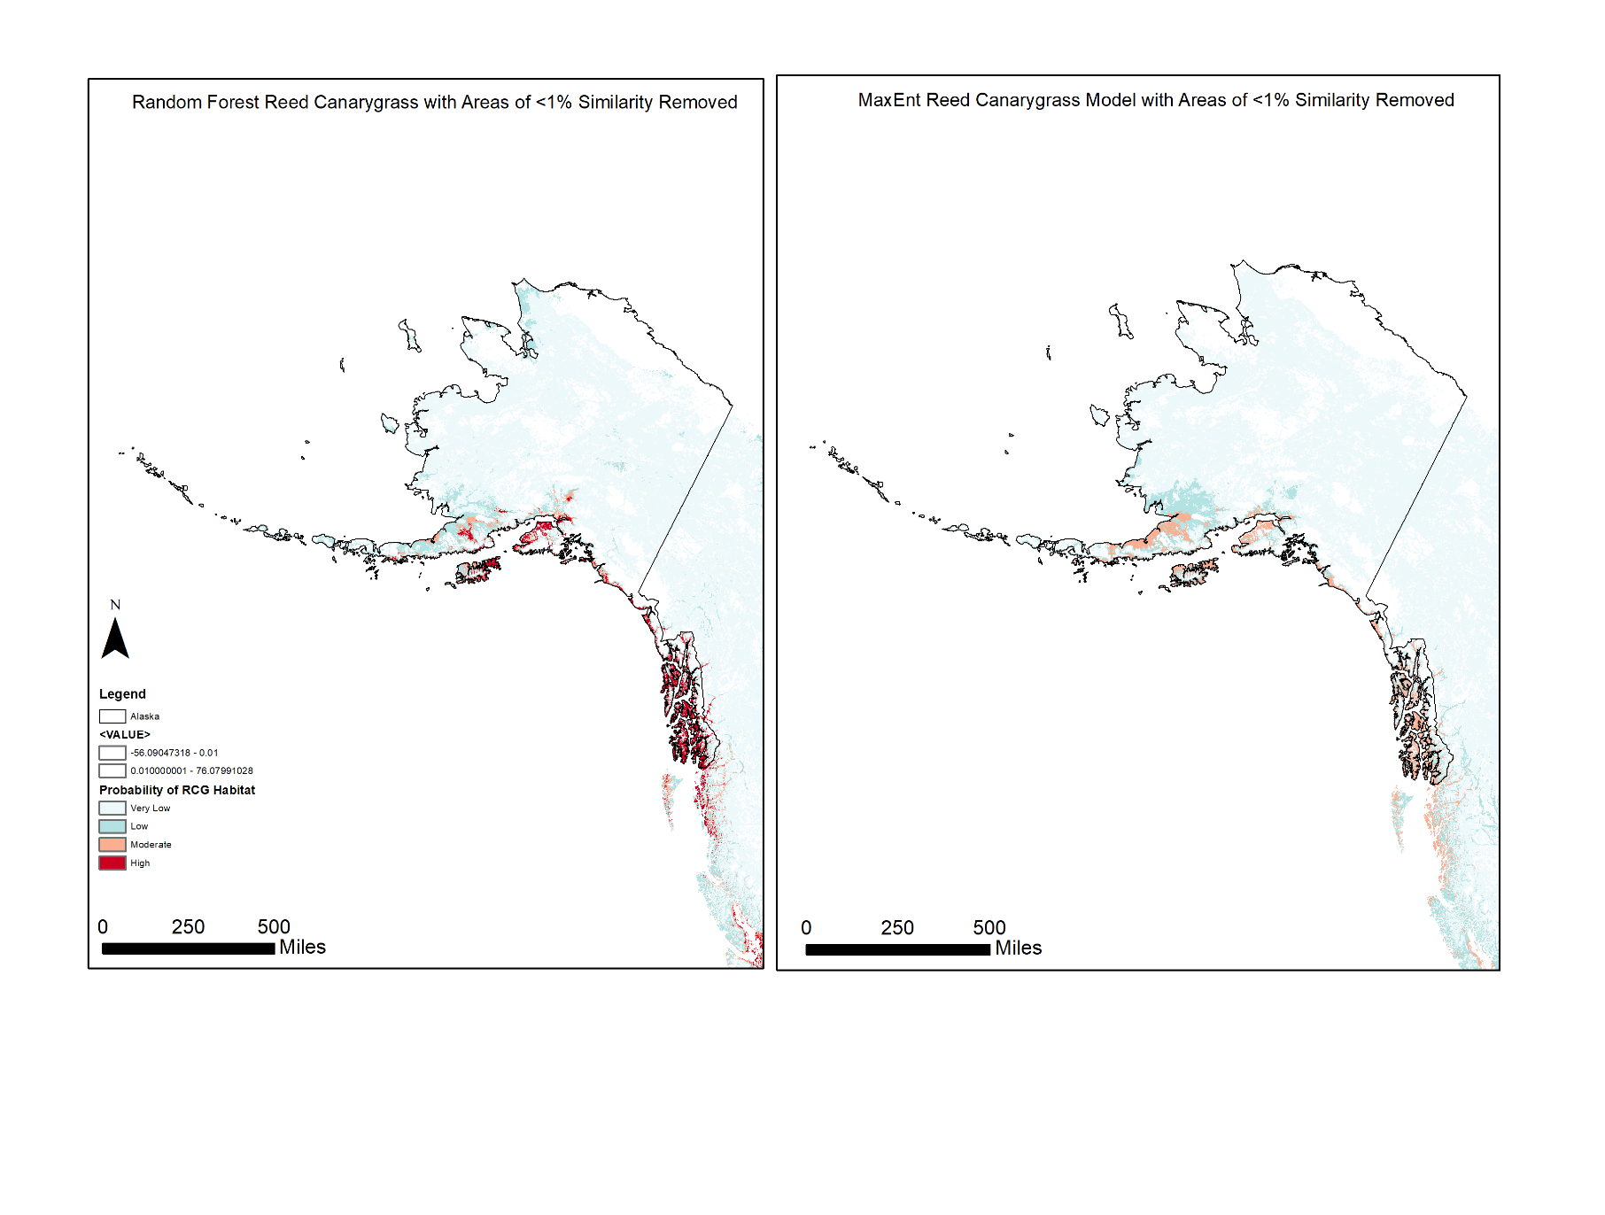
miles
500
Very low
Low
Moderate
High
Probability of Reed Canarygrass Habitat
Eliminated due to extrapolation
Figure 3. Reed canarygrass Alaska scale models, Random Forest is on the left and MaxEnt is on the right.

Given the ecology of both purple loosestrife and reed canarygrass, it was anticipated that the habitat suitability distributions would be similar. However, in the purple loosestrife prediction, far more of the southwest coast of Alaska was projected with higher probabilities than the southern coast (Figure 4). The purple loosestrife boosted regression trees model performed more reasonably based on visual verification of outputs compared to partner feedback than the boosted regression trees reed canarygrass outputs. However, the evaluation metrics remained poor for this model. Consistent with the reed canarygrass models, the strongest model for purple loosestrife was the random forest model once areas of extrapolation were removed.





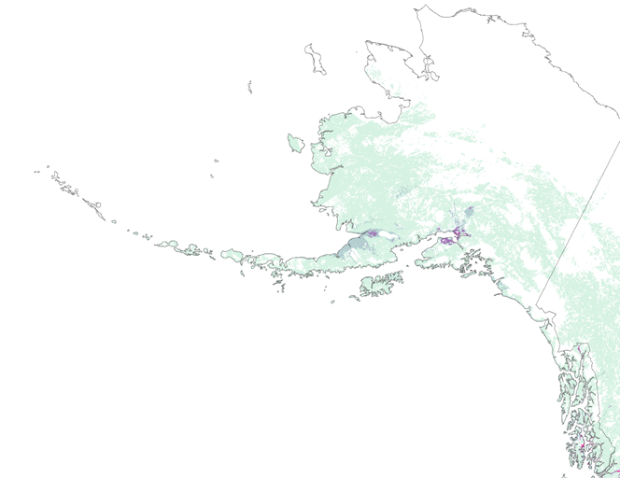
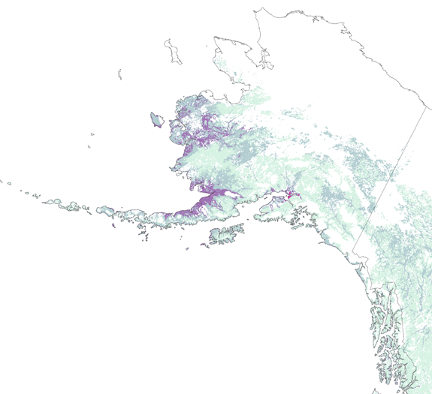
Very low
Low
Moderate
High
Relative Probability
of Suitable Habitat
Eliminated due to extrapolation

Figure 4. Purple loosestrife continental model results, Random Forest is on the left, and MaxEnt is on the right.

4.2 Future Work
Future work includes refinement and improvement of models developed during this project. Primarily, we recommend the creation and inclusion of additional datasets that would provide ecologically pertinent variables for these specific species at a finer scale, such as additional vectors of dispersal, and datasets that include water chemistry and disturbance dynamics. An additional predictor variable of potentially significant importance may describe change in stream flows and water levels would increase the ecological significance of the results. Another improvement would be to collect and apply presence and absence data in the novel environmental areas represented by the MESS maps to reduce the area eliminated by high uncertainty.

There is also the issue, especially with the genetically diverse reed canarygrass, of hybridization. It is possible that some of the presence points represent reed canarygrass hybrids or variants with different environmental limits and thresholds. Additional data collection in the form of surveying with detailed genetic information would allow for some control over the specific variants represented in the models.
5. Conclusions
Coastlines, wetland areas, and waterways represented areas of high suitability for both species. The continental and Alaska scale projections of reed canarygrass were significantly dissimilar in the spatial distribution of high probability in the models. This variation is a product of the unique climate extremes and environmental conditions of Alaska relative to the lower continental United States, and presented a challenge for models extrapolating across novel environments. To refine future models, the team recommends the development of more ecologically meaningful covariates that represent disturbance, hydrology, and vectors of dispersal that are specific to these species. Future avenues of exploration using these methods can improve upon these models through the inclusion of additional predictors and modeling at a finer scale in Alaska.

Across the model methods, random forest was the strongest model based on performance metrics, however, without the MESS map overlays, it consistently seemed to over-predict. MESS maps, which show areas of extrapolation, can be used to target underrepresented areas for survey. MaxEnt is characteristically conservative in its predictions with these types of models– especially given the amount of novel environments in our models, this method seemed to be limited by the lack of coverage of environments by the presence point distribution.

Alaska poses unique challenges for predicting potential invasive species distribution with its varying climate, and its lack of randomized field samples due to remote infrastructure. While much of the potential distribution is predicted in urbanized areas in southern areas of Alaska, changes in climate will continue to create conditions that support invasive species establishment. These results offer preliminary maps and areas for the USFWS Alaska region to target survey efforts for invasive species presence.
6. Acknowledgments
Dr. Paul Evangelista (Colorado State University Natural Resource Ecology Laboratory) (Science Advisor)
Dr. Amanda West (Colorado State University Natural Resource Ecology Laboratory) (Mentor)
Brian Woodward (Colorado State University Natural Resource Ecology Laboratory) (Center Lead)
Dr. Catherine Jarnevich (United States Geological Survey Fort Collins Science Center)
Aaron Martin (US Fish and Wildlife Service, Alaska Region)

Any opinions, findings, and conclusions or recommendations expressed in this material are those of the author(s) and do not necessarily reflect the views of the National Aeronautics and Space Administration.

This material is based upon work supported by NASA through contract NNL16AA05C and cooperative agreement NNX14AB60A.
7. Glossary
AKNHP – Alaska Natural Heritage Program, covers unsuitable habitat accessible to species
Area Under Curve (AUC) – a statistic obtained via the Receiver Operating Characteristic (ROC) curve that is used for model evaluation and comparison, which describes the predictive power of a suite of environmental variables relative to presence and absence points, ranging from 0 to 1
BISON – Biodiversity Information Serving Our Nation
BRT – Boosted Regression Tree, combines boosting and regression trees; Regression trees: recursive binary partitioning of predictor space into regions (elevation > 300m, present, absent). Boosting: stagewise methods to develop multiple models and combine them
CTI – compound topographic index
Digital Elevation Model (DEM) – a visual representation of elevation data acquired through the Shuttle Radar Topography Mission (SRTM) and National Elevation Data (NED)
Earth observations – satellites and sensors that collect information about the Earth’s physical, chemical, and biological systems over space and time
EDDmaps – Early Detection & Distribution MAPping System
Gbif – global biodiversity information facility
Generalized Linear Model (GLM) – a model that employs a standard methodology
GLC – global land cover
MaxEnt – Maximum Entropy Modeling, approach for modeling species niches and distributions
MODIS – MODerate resolution Imaging Spectroradiometer
PARC – Projection, Aggregation, Resampling, and Clipping
Presence data – covers suitable habitat accessible to species
PRISM – Parameter Regression of Independent Slopes Model
Receiver Operating Characteristic (ROC) Curve – a graphical plot between sensitivity and specificity
RF – Random Forest, classification and regression tree with bootstrap method
SAHM – Software for Assisted Habitat Modeling
Sensitivity – a statistic that measures the proportion of positives (presences) correctly identified
Specificity – a statistic that measures the proportion of negatives (non-presences) correctly identified
SRTM v2 – Shuttle Radar Topography Mission version 2
Tasseled Cap Transformations -
TOA – top of atmosphere reflectance
8. References

Babbitt, B. (1998). Statement by Secretary of the Interior on invasive alien species. Proceedings, National Weed Syposium, BLM Weed Page, 8-10.

Blossey, B., Skinner, L. C., & Taylor, J. (2001). Impact and management of purple loosestrife (Lythrum salicaria) in North America. Biodiversity and Conservation, 10(10), 1787-1807.

Carlson, M. L., & Shephard, M. (2007). Is the spread of non-native plants in Alaska accelerating?. UNITED STATES DEPARTMENT OF AGRICULTURE FOREST SERVICE GENERAL TECHNICAL REPORT PNW, 694, 117.

D'Antonio, C., & Vitousek, P. (1992). Biological Invasions by Exotic Grasses, the Grass/Fire Cycle, and Global Change. Annual Review of Ecology and Systematics, 23, 63-87. Retrieved from http://www.jstor.org/stable/2097282

Department of the Interior (2016). Invasive Species Early Detection and Rapid Response: Resource Guide.

DiMiceli, C.M., M.L. Carroll, R.A. Sohlberg, C. Huang, M.C. Hansen, and J.R.G. Townshend (2011), Annual Global Automated MODIS Vegetation Continuous Fields (MOD44B) at 250 m Spatial Resolution for Data Years Beginning Day 65, 2000 - 2010, Collection 5 Percent Tree Cover, University of Maryland, College Park, MD, USA.

Ebbert, S. E., & Byrd, G. V. (2002). Eradications of invasive species to restore natural biological diversity on Alaska Maritime National Wildlife Refuge. Turning the tide: the eradication of invasive species (CR Veitch and MN Clout, Editors). IUCN Invasive Species Specialist Group, Gland, Switzerland and Cambridge, United Kingdom, 102-109.

Lavergne, S., & Molofsky, J. (2004). Reed canary grass (Phalaris arundinacea) as a biological model in the study of plant invasions. Critical Reviews in Plant Sciences, 23(5), 415-429.

Jarnevich, C. S., Stohlgren, T. J., Kumar, S., Morisette, J. T., & Holcombe, T. R. (2015). Caveats for correlative species distribution modeling. Ecological Informatics, 29, 6-15.

Lavergne, S., & Molofsky, J. (2007). Increased genetic variation and evolutionary potential drive the success of an invasive grass. Proceedings of the National Academy of Sciences, 104(10), 3883-3888.

Lavoie, C., Jean, M., Delisle, F., & Létourneau, G. (2003). Exotic plant species of the St Lawrence River wetlands: a spatial and historical analysis. Journal of biogeography, 30(4), 537-549.

Moritz, C. (2002). Strategies to protect biological diversity and the evolutionary processes that sustain it. Systematic biology, 51(2), 238-254.

Morisette, J. T., Jarnevich, C. S., Holcombe, T. R., Talbert, C. B., Ignizio, D., Talbert, M. K., ... & Young, N. E. (2013). VisTrails SAHM: visualization and workflow management for species habitat modeling. Ecography, 36(2), 129-135.

NASA LP DAAC (2017) MOD09GQ.005 Terra Surface Reflectance Daily L2G Global 250m. Version 3. NASA Land Processes DAAC, USGS Earth Resources Observation and Science (EROS) Center, Sioux Falls, South Dakota (https://lpdaac.usgs.gov), accessed July 17, 2017, at DOI: 10.5067/MODIS/MOD09GQ.006.

Pimentel, D., Zuniga, R., & Morrison, D. (2005). Update on the environmental and economic costs associated with alien-invasive species in the United States. Ecological economics, 52(3), 273-288.

Rawinski, T. J. (1982). The ecology and management of purple loosestrife (Lythrum salicaria L.) in central New York. Cornell University, Jan..

Serreze, M. C., Walsh, J. E., Chapin, F. S., Osterkamp, T., Dyurgerov, M., Romanovsky, V. & Barry, R. G. (2000). Observational evidence of recent change in the northern high-latitude environment. Climatic change, 46(1-2), 159-207.

Spyreas, G., Wilm, B. W., Plocher, A. E., Ketzner, D. M., Matthews, J. W., Ellis, J. L., & Heske, E. J. (2010). Biological consequences of invasion by reed canary grass (Phalaris arundinacea). Biological invasions, 12(5), 1253-1267

Schrader, B. (2005). Assessment of Invasive Species in Alaska and its National Forests.

Thompson, D. Q., Stuckey, R. L., & Thompson, E. B. (1987). Spread, impact, and control of purple loosestrife (Lythrum salicaria) in North American wetlands. Thompson, D. Q., Stuckey, R. L., & Thompson, E. B. (1987). Spread, impact, and control of purple loosestrife (Lythrum salicaria) in North American wetlands.

USGS (2010). GMTED2010. Global Multi-resolution Terrain Elevation Data 2010. Accessed June 20th, 2017 at USGS Fort Collins Science Center, Fort Collins, CO 80526.

USGS (2017). LANDSAT/LE07/C01/T1_TOA. Landsat 7 Collection 1 Tier 1 TOA Reflectance (Orthorectified). Retrieved July 23, 2017 at https://explorer.earthengine.google.com/.

Yu L, Wang J, Gong P. Improving 30 m global land-cover map FROM-GLC with time series MODIS and auxiliary data sets: a segmentation-based approach. International Journal of Remote Sensing, 2013; 34(16):5851–5867.

9. Appendices

Appendix 1. Predictor Data Layers

Product | Collection Name | Source | Resolution (meters) | Date of Product
Digital Elevation Model (DEM) | GMTED2010 | Shuttle Radar Topography Mission (SRTM V2) | 30 | 2000  (2015 release)
Slope | - | DEM derivative | 1000
Roughness | - | Slope derivative | 1000
Compound Topographic Index | - | GMTED10, HYDRO1K | 1000
Flow Accumulation | - | Derivative of NHD flow lines and slope | 1000
Global Land Cover | FROM-GLC | Yu et al. (2013), Terra and Aqua MODIS | 500 | 2001-2010
Burned Area Index | MCD43A4_BAI | Chuvieco et al. (2002), Terra and Aqua MODIS | 500 | 1981-2017
Enhanced Vegetation Index | EVI MODIS | MODIS | 1000 | 1981-2017
Land Surface Temperature | MYD11A2 | Aqua MODIS | 1000 | 1981-2017
Vegetation Continuous Fields | MOD44B | Dimiceli et al. (2011),  Terra MODIS | 250 | 1981-2017
Normalized Difference Vegetation Index (NDVI) | MYD09GA_NDVI | Aqua MODIS | 1000 | 1981-2017
Normalized Difference Water Index (NDWI) | MYD09GA_NDWI | Aqua MODIS | 1000 | 1981-2017
Wetland | wetlands_93 | UNEP-WCMC | 1000 | 1993
Average Temperature of Spring, Summer, Fall and Winter | - | Wang et al. (2016), ClimateNA v5.21 | 500 | 2016
Mean Warmest Month Temperature (MWMT) | - | Wang et al. (2016), ClimateNA v5.21 | 500 | 2016
Mean Coldest Month Temperature (MCMT) | - | Wang et al. (2016), ClimateNA v5.21 | 500 | 2016
Temperature Difference (TD) | - | Difference between MCMT and MWMT; Wang et al. (2016), ClimateNA v5.21 | 500 | 2016
Precipitation of Spring, Summer, Fall, and Winter | - | Wang et al. (2016), ClimateNA v5.21 | 500 | 2016
Mean Summer Precipitation (MSP, May to September) | - | Wang et al. (2016), ClimateNA v5.21 | 500 | 2016
Annual Heat-Moisture Index (AHM) | - | Wang et al. (2016), ClimateNA v5.21 | 500 | 2016
Summer Heat-Moisture Index (SHM) | - | Wang et al. (2016), ClimateNA v5.21 | 500 | 2016
Degree Days below 0°C (DD<0) | - | Wang et al. (2016), ClimateNA v5.21 | 500 | 2016
Degree Days above 5°C (DD>5) | - | Wang et al. (2016), ClimateNA v5.21 | 500 | 2016
Degree Days above 18°C (DD>18) | - | Wang et al. (2016), ClimateNA v5.21 | 500 | 2016
Mean Annual Relative Humidity (RH) | - | Wang et al. (2016), ClimateNA v5.21 | 500 | 2016
Mean Annual Solar Radiation (MAR) | - | Wang et al. (2016), ClimateNA v5.21 | 500 | 2016
Extreme Minimum Temperature over 30 Years (EMT) | - | Wang et al. (2016), ClimateNA v5.21 | 500 | 2016
Extreme Maximum Temperature over 30 Years (EXT) | - | Wang et al. (2016), ClimateNA v5.21 | 500 | 2016
Day of Year on which Frost Free Period Begins (bFFP) | - | Wang et al. (2016), ClimateNA v5.21 | 500 | 2016
Day of Year on which Frost Free Period Ends (eFFP) | - | Wang et al. (2016), ClimateNA v5.21 | 500 | 2016
Number of Frost Free Days (NFFD) | - | Wang et al. (2016), ClimateNA v5.21 | 500 | 2016
Hargreaves Reference Evaporation (Eref) | - | Wang et al. (2016), ClimateNA v5.21 | 500 | 2016
Hargreaves Climatic Moisture Deficit (CMD | - | Wang et al. (2016), ClimateNA v5.21 | 500 | 2016
Precipitation as Snow (PAS) | - | Wang et al. (2016), ClimateNA v5.21 | 500 | 2016

Appendix 2. Model Evaluation, Continental Scale Reed Canarygrass and Purple Loosestrife

Reed Canarygrass | Evaluation Statistics | Train Dataset | Cross-Validation Dataset
Random Forest | AUC | 0.962 | 0.961
 | Sensitivity | 0.896 | 0.797
 | Specificity | 0.893 | 0.978
MaxEnt | AUC | 0.94 | 0.929
 | Sensitivity | 0.865 | 0.845
 | Specificity | 0.857 | 0.857

Purple Loosestrife | Evaluation Statistics | Train Dataset | Cross-Validation Dataset
Random Forest | AUC | 0.95 | 0.949
 | Sensitivity | 0.886 | 0.743
 | Specificity | 0.884 | 0.951
MaxEnt | AUC | 0.941 | 0.927
 | Sensitivity | 0.871 | 0.842
 | Specificity | 0.871 | 0.869

Appendix 3. Predictor variable importance

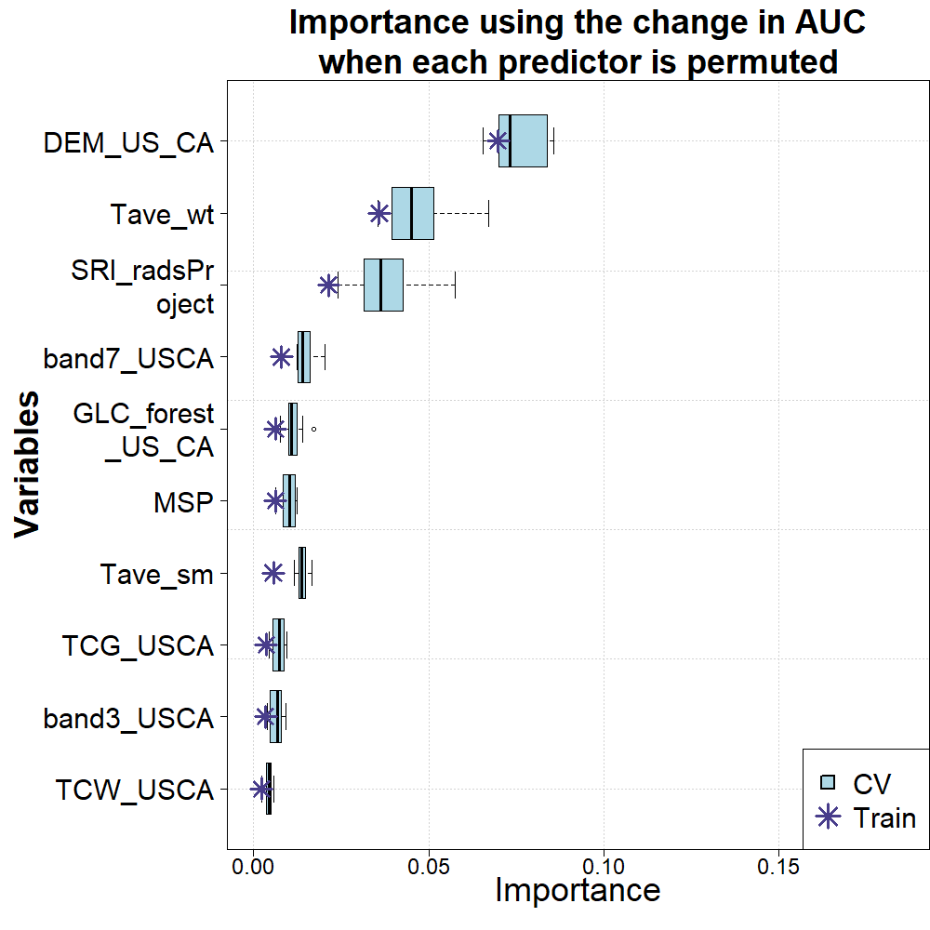

Random Forests: Continental Scale Reed Canarygrass
Elevation
Average Winter Temperatures
Solar Radiation
Terra MODIS Surface Reflectance, Band 7
GLC Forest Cover
Mean Summer Precipitation
Average Summer Temperatures
Tasseled Cap Greenness
Terra MODIS Surface Reflectance, Band 3
Tasseled Cap Wetness
Importance using the change in AUC when each predictor is permuted
Importance
CV
Train

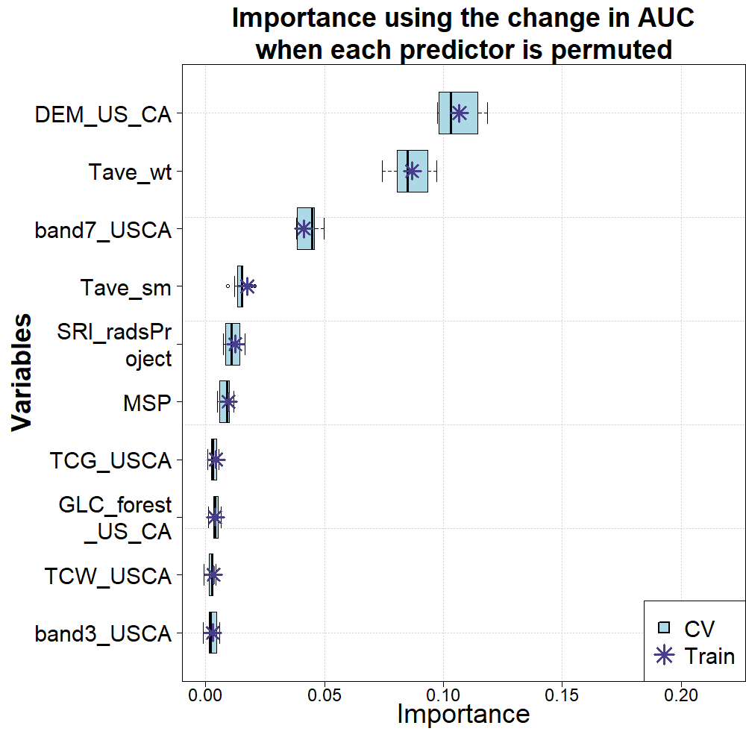
MaxEnt: Continental Scale Reed Canarygrass
Elevation
Average Winter Temperatures
Solar Radiation
Terra MODIS Surface Reflectance, Band 7
GLC Forest Cover
Mean Summer Precipitation
Average Summer Temperatures
Tasseled Cap Greenness
Terra MODIS Surface Reflectance, Band 3
Tasseled Cap Wetness
Importance using the change in AUC when each predictor is permuted
Importance
CV
Train

Random Forest: Continental Scale Purple Loosestrife
Importance using the change in AUC when each predictor is permuted

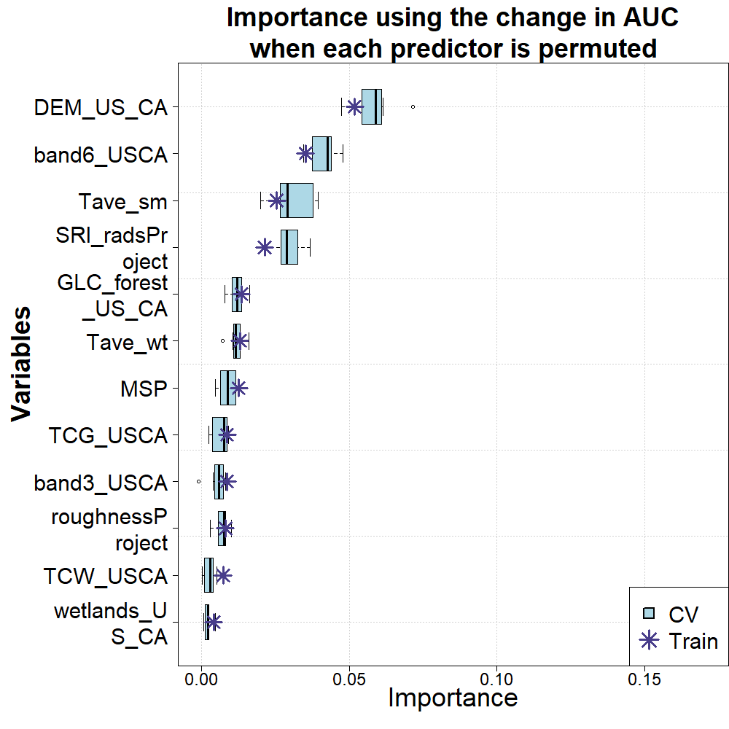
Elevation

Terra MODIS Band 6
Average Summer Temperature

Solar Radiation
GLC Forest Cover

Average Winter Temperature

Mean Summer Precipitation
Tasseled Cap Greenness
Terra MODIS Band 3

Roughness
Tasseled Cap Wetness

Wetlands

Importance

MaxEnt: Continental Scale Purple Loosestrife
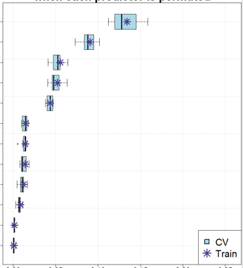
Elevation
Solar Radiation
Average Winter Temperature
GLC Forest Cover
Mean Summer Precipitation
Average Summer Temperature
Tasseled Cap Greenness
Terra MODIS Band 3
Tasseled Cap Wetness
Importance using the change in AUC when each predictor is permuted
0.00
0.05
0.10
0.15
Importance
0.20
Terra MODIS Band 6
Roughness
Wetlands
0.25

