NASA DEVELOP National Program
NASA Langley Research Center
Fall 2016

Glacier National Park Climate
Utilizing NASA Earth Observations to Quantify Landscape Disturbances Related to a Changing Climate in Glacier National Park from 1999-2016


Technical Report
Final Draft – November 15, 2016

Jordan Lubbers (Project Lead)
Dr. Sunita Yadav-Pauletti
Ryan Avery
Suzannah Richards
Joe Harris
Zachary Wardle

Dr. Kenton Ross, NASA Langley Research Center (Science Advisor)

1. Abstract
National parks face an increasing number of threats from climate and biotic stressors, which lead to both major and minor landscape disturbances. The effects of disturbance are wide-ranging (e.g., changing species composition, altering nutrient flow and biodiversity, and landscape alterations) and impact numerous ecosystems within the park. While disturbance is part of the ecological history of a region, the major drivers and magnitude of disturbance change over time. In this project, the team quantified and mapped landscape disturbances in Glacier National Park from 1999 to 2016 (for the months of June – September). Landsat data were used to detect and map biotic stress from pathogens (such as the mountain pine beetle), fires, avalanche tracks, and landslides by using a threshold-based decision tree classification scheme similar to the work of Goodwin and others. Based on this methodology, and cross referencing results with insect Aerial Detection Surveys from the US Forest Service, it was observed that pathogen presence is represented by a negative change in NDMI of 600-4,000, with potential “green attack” phases of pathogen attack being represented by negative changes in NDMI of 250-600. Abrupt disturbances such as landslides, floods, and avalanches are represented by changes in NDMI of greater than 4,000. These results will aid the National Park Service in natural resource management by predicting a multitude of landscape disturbances in response to climate change.

Keywords
Remote Sensing, Landsat, disturbance, pathogens, fire, avalanche, landslide, time series

2. Introduction
  - Background Information
Glacier National Park (GNP), located within the larger Crown of the Continent ecosystem, encompasses one million acres of northern Rocky Mountain wilderness in northwestern Montana (Figure 1). Considered one of the last “intact and pristine wilderness” areas in the contiguous United States, this area is home to many species of flora and fauna that have, unlike much of the American continent, remained unchanged since the arrival of European settlers two hundred years ago. Bisected longitudinally by the Continental Divide, the Crown of the Continent ecosystem is also home to the headwaters of three of North America’s largest rivers: the Columbia, the Missouri, and the Saskatchewan (Waldt, 2004). Despite its pristine nature, the park has been subject to various landscape changes over the past 100 years, primarily driven by a warming climate (Hall and Fagre, 2003). Within GNP, park managers have noted that the specific time period of 1999-2016 has been characterized by climatic extremes (Potter, 2016), the ramifications of which are poorly understood. Geographic Information Systems (GIS) and remote sensing tools have been used in the past to observe temporal vegetation change in other forested ecosystems (Goodwin et al., 2008; Vogelmann, et al., 2012; Banskota et al., 2014; Potter, 2016); however, these methods have infrequently been applied to GNP.
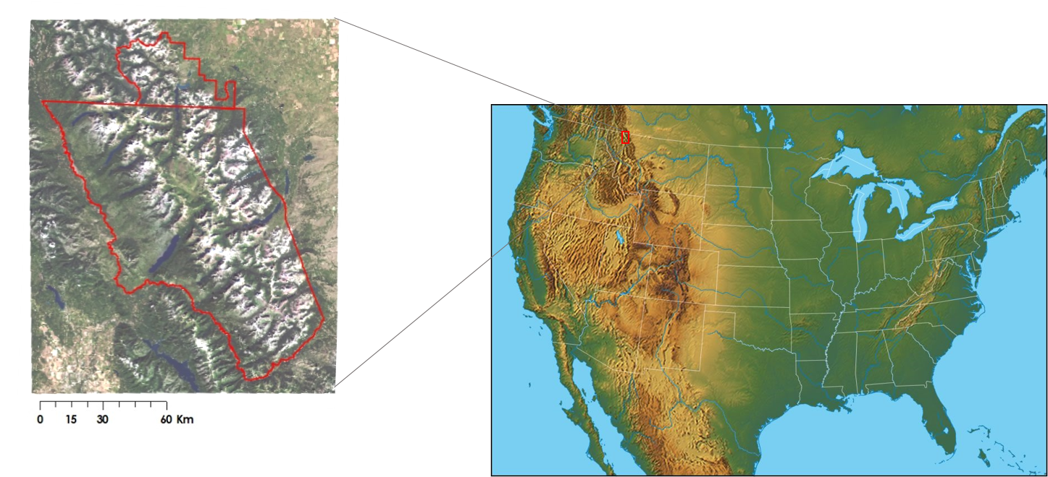
Figure 1: Inset map of Waterton Glacier National Park. U.S. Map courtesy of geology.com.

  - Project Partners & Objectives
This project partnered with Richard Menicke, Geographer for the National Park Service (NPS) at Glacier National Park and Dr. Christopher Potter, Senior Research Scientist for the National Aeronautics and Space Administration (NASA) Biospheric Branch at Ames Research Center. Richard Menicke was interested in quantifying and mapping landscape disturbances in GNP, so that park managers can better understand the changing landscape to improve future resource management decisions. Additionally, such projects are expected to provide the groundwork for future research endeavors in the park, including but limited to: the relationship between fire and pathogen spread, increased pathogen disturbance near surface water bodies, and growing risk of avalanches and landslides due to receding ice and snowmelt. As Chief Geographer at GNP, Mr. Menicke assisted the team by providing background information related to the park, such as specific ecological and disaster events in the park’s history and other areas of the park that are of particular interest. Dr. Christopher Potter was interested in the methodological development to quantify and differentiate moderate-level landscape disturbances, caused primarily by pathogens, using NASA Earth observations. His past research using NASA Earth observations to map and quantify temporal vegetation change caused by fire and his direct counsel has helped with various aspects of this project throughout the term. He aims to apply this project’s methodology to future remote sensing research related to fire and disturbance ecology.

This project falls under the Climate Application Area of NASA’s Applied Sciences Program and will help scientists, park staff, and land managers better understand the impacts of a changing climate on forested ecosystems. In this study, we propose a methodology for quantifying and mapping landscape disturbances related to a changing climate in Glacier National Park, specifically focusing on the time period of 1999-2016. The project uses a decision tree based threshold technique to differentiate the major drivers of disturbances using the Normalized Difference Vegetation Index (NDVI) and the Normalized Difference Moisture Index (NDMI). These disturbances include White Pine Blister Rust and the Mountain Pine Beetle, avalanches and landslides, and fire. To date, such techniques have not been applied to quantify and map disturbance in GNP.

3. Methodology
3.1 Data Acquisition
Richard Menicke and Glacier National Park provided the team with a variety of website links to geospatial data (Appendix 1). The team downloaded satellite and aerial imagery, a GNP boundary layer shapefile, forest insect and disease shapefiles and geodatabases, and a vegetation land cover classification map layer. The vegetation coverage was developed by the USGS and the NPS vegetation mapping program using aerial imagery from 1997-1999 and extensive field surveys. In addition to this data, Menicke provided Landsat-based and park staff-mapped shapefiles delineating fire perimeters, fire extent, and burn severity within GNP.

The bulk of the satellite data collected by the team was downloaded from the United States Geological Survey Earth Science Processing Architecture (USGS ESPA) website. The USGS makes all data available to the public and downloadable via online request. USGS National Gap Analysis Program (GAP) and Landsat surface reflectance data for the time period of 1999-2016 were downloaded. The reflectance data includes satellite images from Landsat 5 Thematic Mapper (TM), Landsat 7 Enhanced Thematic Mapper (ETM+), and Landsat 8 Operational Land Manager (OLI). The team also ordered NDVI and NDMI indices computed for each image in our time series of Landsat surface reflectance data using the ESPA Ordering Interface. Since GNP experiences high snow and cloud cover in most of the park for October through May, only data for the months of June through September were downloaded to reduce inaccuracies in surface spectral signatures.

Total precipitation averaged by year for four weather stations (Many Glacier, Flat Top Mountain, Pike Creek, and Emery) within and adjacent to GNP was accessed via the National Resources Conservation Service (NRCS) Snow Telemetry data set.

3.2 Data Processing
LANDSAT 5, 7, 8 (1999-2016 for months: June to September)
Each Landsat scene was clipped to the minimum bounding box of a 4 kilometer buffered park boundary, to include areas of interest directly outside Glacier National Park’s administrative boundaries in our analysis. Percent cloud cover was calculated for each image, and only images with less than 30% cloud coverage were selected for further analysis. Clouds, water, and snow were masked from Landsat scenes using each scene’s “cfmask” layer. Using a target date of July 21st, the resulting “NoData” pixels were filled in with the temporally closest Landsat scenes available within that year’s month range. Since NDMI is sensitive to changes in moisture that can be affected by seasonality, it was important to keep these composited Landsat scenes as close to the target date as possible. The reference date was selected because it occurs during the middle of the growing season at Glacier National Park. The yearly composited NDMI images were then used for subsequent analyses. NDMI was selected because of its recognized sensitivity to detect pathogen disturbance (Goodwin et al., 2008). The index is calculated with the following equation:

$$\text{NDMI =}\frac{\text{(NIR - MIR)}}{\text{(NIR + MIR)}}$$

where, MIR= surface reflectance mid-infrared band
and, NIR = surface reflectance near infrared band

NDMI values range from -1 to 1, and subsequently ∆NDMI ranges from -2 to 2. The team used a scale factor of 10,000 in order to work around data storage issues, so our values for ∆NDMI range from -20,000 to 20,000.

3.3 Data Analysis
In order to classify the yearly NDMI images, we applied a decision tree approach using threshold values. These thresholds were determined by comparing histogram overlap for areas within GNP affected by pathogens and healthy forest areas.
Images were first analyzed by comparing Normalized Difference Moisture Index (NDMI) for dates before and during known pathogen disturbance in the same area. Areas were chosen by referencing Aerial Detection Surveys (ADS) provided by the U.S. Department of Agriculture, in which pathogen disturbance was mapped by plane fly-over. Healthy forest polygons were mapped in Google Earth Engine API (GEE) using NAIP imagery and NDVI indices for individual years. These areas of healthy forest were restricted to areas identified as pine species within the NPS vegetation classification, and excluding areas of known pathogens.
The threshold value was then created by comparing NDMI histograms of healthy pine forest with NDMI histograms from areas characterized as “pathogen infested” by ADS (Figure 2) for a number of years throughout the study period. Threshold values were determined to maximize accuracy. Thus, a value for ∆NDMI reflecting a high amount of disturbance corresponds to roughly two standard deviations from the mean of histogram overlap (Figure 2). After masking-out burned areas, this threshold value was used to map pathogen disturbance temporally from 1999-2015 across Glacier National Park, similar to the work of Goodwin and others (2008) (Figure 3). Abrupt disturbance was classified with ∆NDMI values less than
-4000, high disturbance was between -450 and -4000, moderate disturbance was between -250 and -450, low disturbance corresponded to values ranging from 0 to -250, healthy vegetation from 0 to 650 and regeneration above 650. The high disturbance classification most likely corresponds to pathogen attack.

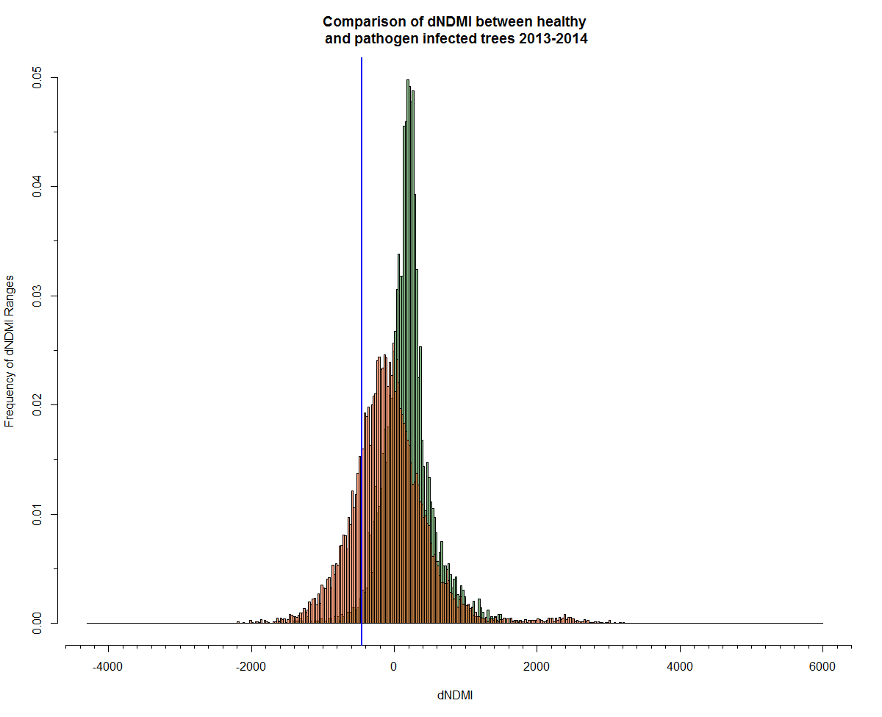
Figure 2: NDMI histograms for ADS polygon in orange and healthy vegetation sample in green. The blue line represents the threshold value for detecting pathogens (-450).

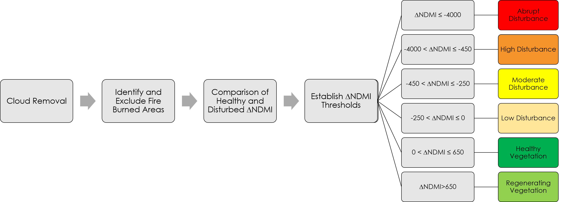Figure 3: Decision tree based methodology for identifying and mapping disturbances within Glacier National Park.

To observe trends in disturbance over time, data were divided into three 5-year time periods, 2000-2004, 2005-2010, and 2010-2015, and maps were created to reflect persistent disturbance in an area. In addition, rolling frequency maps using all 5-year time periods were also created for the study period. As mountain pine beetle attacks follow a signature time trajectory from green attack to red, then gray attack over a 5-year span (Wulder et al., 2006), the frequency trend maps are expected to provide evidence of persistent pathogen presence.

3.4 Evaluation
The ADS maps damage due to defoliation, mortality, discoloration, dieback, top kill, branch breakage, main stem broken or uprooted, and branch flagging. We assume these disturbances fall within the abrupt, high, and moderate categories mapped in the project. Post-classification, the percent of each disturbance category within the ADS polygons was calculated and threshold values used here were evaluated for correspondence to pathogen polygons. Misclassification within ADS polygons was analyzed using a Pearson’s correlation between forest categories and precipitation data averaged for four weather stations within or adjacent to GNP.

4. Results & Discussion
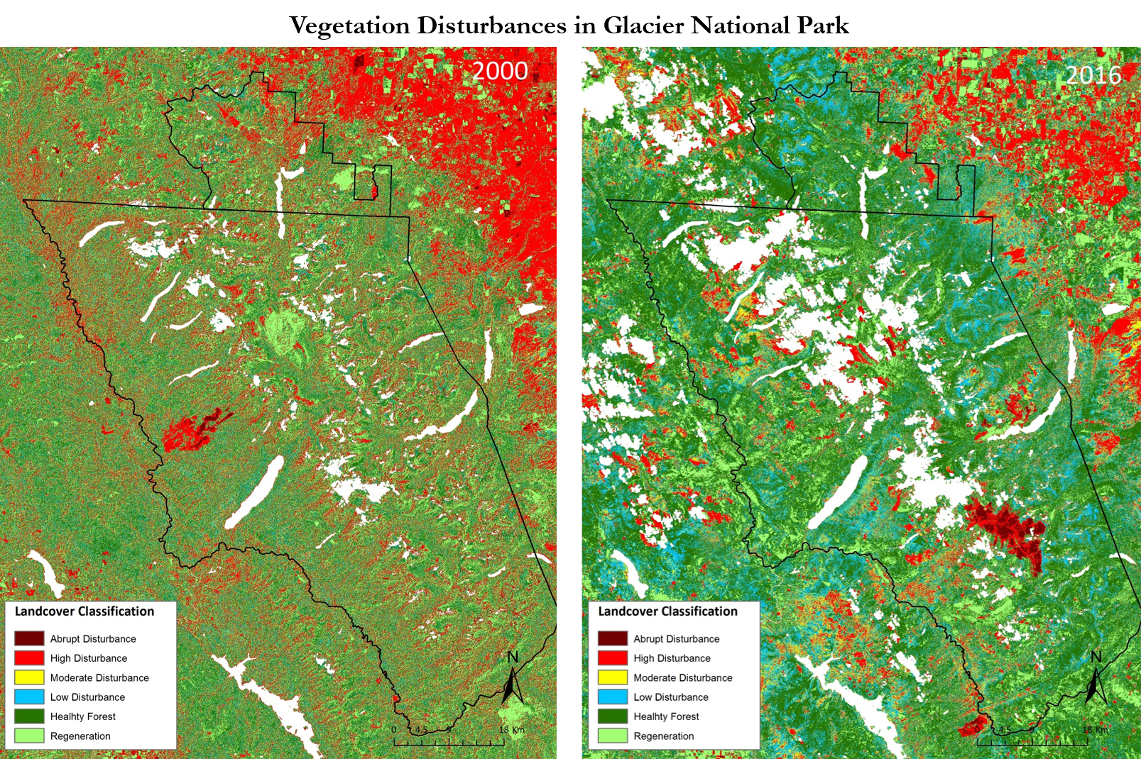

Figure 4: Classified Disturbance maps based on changes in NDMI for Glacier National Park. For full list of maps in 1999-2016 date range, see Appendix 2.
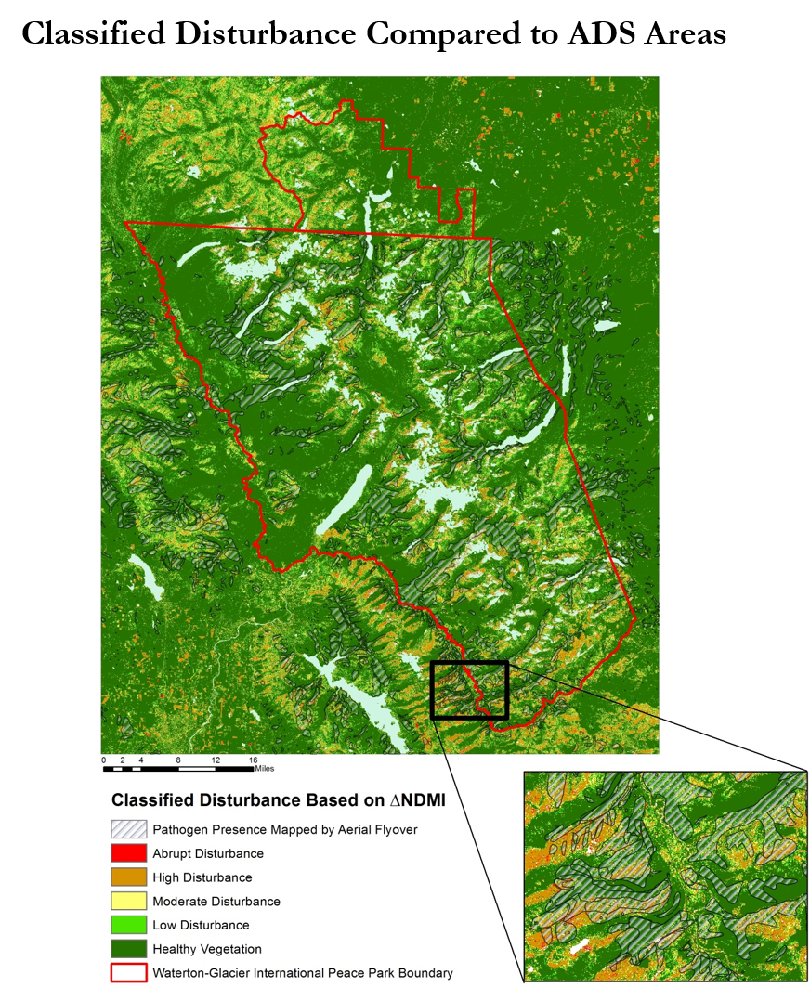
Figure 5: Our classified disturbance classifications compared to Aerial Detection Survey (ADS) pathogen presence areas.
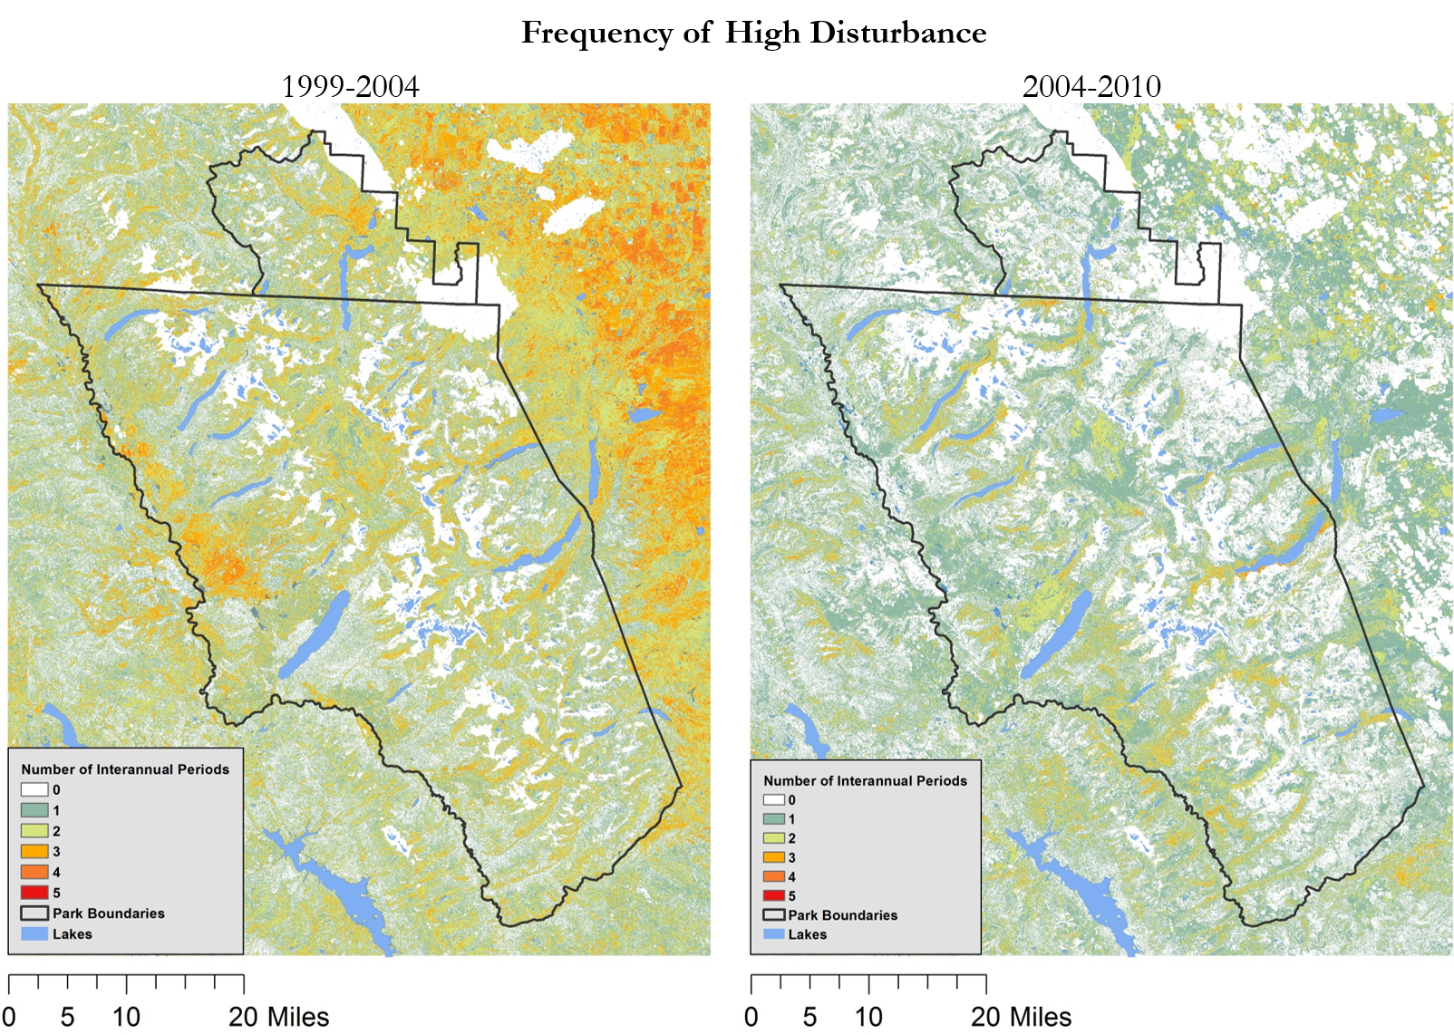
Figure 6: Disturbance frequency maps for the time periods 1999-2004 and 2004-2010. These maps illustrate how often certain areas are affected by high disturbance levels of NDMI change.

4.1 Analysis of Results
Disturbance maps created have correlations with both fire and pathogens for years that follow years with average or above average precipitation. Figure 4 illustrates how our disturbance maps on ∆NDMI are capable of picking up burned areas based by showing a fire affected area on the western side of the park in 2000. This is also noted for other years where large fires were present within the park (Appendix 2). Areas classified as high to moderate disturbance also correlate with boundary areas mapped by Aerial Detection Survey for insect and disease presence (Figure 5). Although not exact, it can be seen that there is significant overlap in some areas between areas mapped by this method, and our threshold classification.

By looking at disturbance frequency maps (Figure 6), certain geometries stand out as being affected by disturbance from three to five years. Due to this timespan being similar to the lifespan of the mountain pine beetle, it can be assumed that these areas have a chance of being proxies for detecting presence of mountain pine beetle infected forests. Disturbances such as fire, floods, avalanches, and landslides will conversely show up as only having been disturbed for one year, as it is a quick and biologically instantaneous event. It is also possible though that these areas have been perennially disturbed due to drought or other slower acting biologic stressors. Additionally, the rolling frequency maps may better detect emerging areas of disturbance.
It was also observed that portions of the study location to the northeast of the park are consistently under disturbance. This is most likely due to the areas being agricultural land where irrigation and crop growing have significant impacts on the NDMI values. This, coupled with the fact that these are not forested lands, leads us to suggest that this threshold classification should not be applied to those areas, as they are not true ‘natural systems’, and should only be kept within forested lands undisturbed by human influence.
The histograms for pathogen presence (mapped by ADS) and healthy forest display a great degree of overlap (Figure 2). While abrupt change is clearer with little overlap to healthy forest, high disturbance related to possible pathogen presence (threshold values from -450 to -4000) is more difficult to distinguish. At the lower thresholds for moderate and low disturbance, there is a high degree of overlap for the two histograms and it is not possible to discriminate these low-level disturbances from healthy forests. Due to the nature of aerial surveys, it is possible that healthy forest could occur within areas mapped as pathogen-presence. A possible solution to provide more discriminatory power would be to ground-truth a segment of the pathogen-infested areas. We expect this narrower range of ∆NDMI for pathogen-infested regions would display a smaller overlap with healthy forest regions.
4.2 Sources of Error
NDMI, being highly sensitive to changes in moisture, is also highly sensitive to precipitation variations from year to year. Therefore, years following ‘drought years’ show a much more pervasive presence of disturbances within the study area (Figure 7). Due to these findings, we suggest our model be used with caution in years following drought years, and if possible, be restricted to being used following years with average or above average precipitation. This will eliminate areas being falsely identified as pathogen infected, when in reality they are distressed from drought conditions.
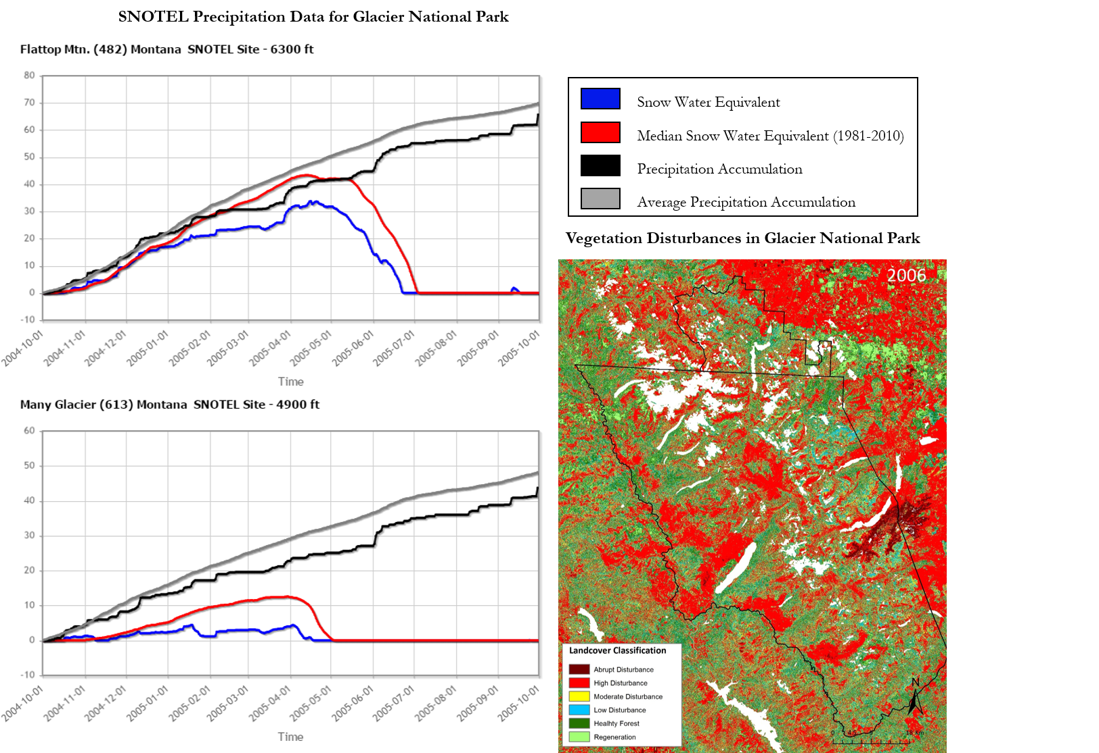
Figure 7: SNOTEL moisture data for water year 2005: October 2004 through October 2005. This is compared to a NDMI threshold map of disturbances for 2006. Due to drier conditions, there is an increase in high disturbance areas. For more SNOTEL data, see Appendix 4.

Error was also assessed by calculating the percentage of each disturbance category within ADS mapped polygons. Because we assumed that the ADS polygons map abrupt, high, and moderate disturbance, any pixels with the ADS polygons outside these categories are sources of potential error. The range for misclassification of ADS polygons in the healthy forest and regeneration categories combined varied from 10 to 60% over the time period. Correlation analyses between average total precipitation for the four climate stations and healthy forest plus regeneration misclassification shows a strong association (R² = 0.28; p=0.048, n=14; Figure 9). Thus in wetter than normal years, there is a higher chance of classifying healthy forest and regeneration as disturbance within ADS polygons (Figure 8). In contrast, for drier than average years, the proportion of the ADS polygons classified as disturbance categories increases; however, some of the disturbance may be related to drought and not necessarily pathogen vectors. Therefore, these results should be interpreted cautiously taking into consideration the temporal trends more visible in the frequency maps.

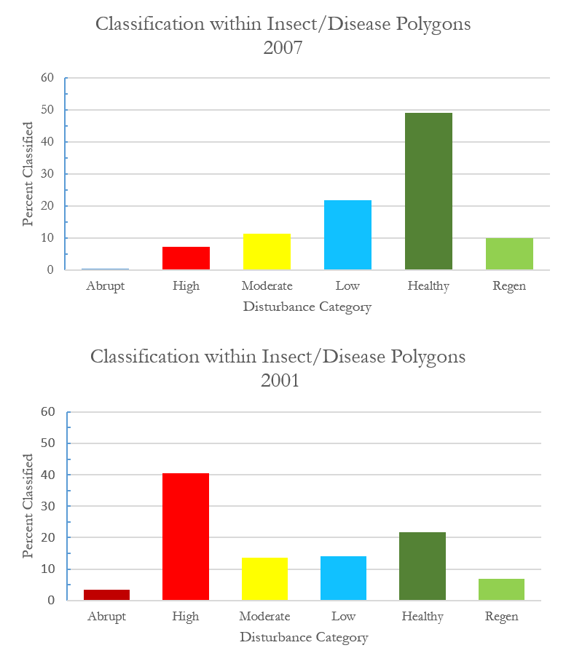
Figure 8: Histograms of disturbance classification within areas classified by Aerial Detection Survey (ADS) as having been affected by insect/disease.

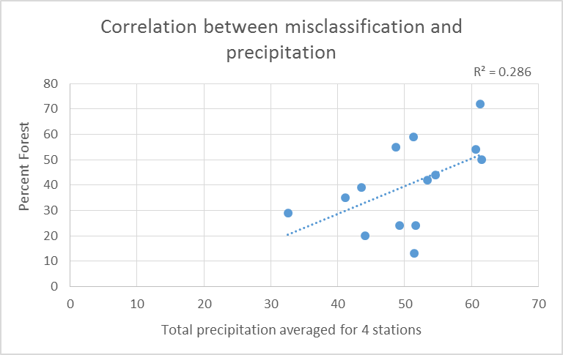

Figure 9: Correlation between classified forest categories within USDA ADS polygons and total precipitation averaged for 4 weather stations (R2 = 0.23; p=0.048, n=14)).

4.3 Future Work
Expanding upon the work already done in this term, ideas as to where to take this project in term two are as follows: use ∆NBR (Normalized Burn Ratio) to map fire areas and apply the same methodology to Waterton Lakes National Park in Canada, analyze disturbance frequency maps to try and look at why certain areas are disturbed more frequently than others (e.g. forest type, soil type, elevation, etc.), continue to work with area High School groups to better develop ground truth data sets that will allow for better accuracy assessment of our thresholds and overall more accurate disturbance maps, explore the correlation between Mountain Pine Beetle and fire (intensity and frequency).

5. Conclusions
Threshold based classification schemes can provide a relatively quick and effective way of identifying and mapping landscape disturbances. NDMI is very sensitive to changes in time of year and precipitation changes, therefore drought signatures can mimic pathogen disturbance signatures. It is for this reason that ∆NDMI threshold classification is best used with years following average or above average precipitation years. Furthermore, by improving ground truth accuracy of pathogen detection, accuracy of NDMI thresholds for detecting pathogens and other types of disturbance via remote sensing will increase and better be able to predict the way pathogens spread across the landscape over time.

6. Acknowledgments
The team would like to thank the following people for their contributions during this project. Without them, this work would not have been possible.

- Dr. Kenton Ross, Science Advisor, NASA Langley Research Center
- Dr. Christopher Potter, Senior Research Scientist, NASA Ames Research Center
- Richard Menicke, Geographer, National Park Service
- Whitefish and Columbia Falls High Schools

Any opinions, findings, and conclusions or recommendations expressed in this material are those of the author(s) and do not necessarily reflect the views of the National Aeronautics and Space Administration.

This material is based upon work supported by NASA through contract NNL11AA00B and cooperative agreement NNX14AB60A.

7. References
Banskota, A., Kayastha, N., Falkowski, M. J., Wulder, M. A., Froese, R. E., & White, J. C. (2014). Forest Monitoring Using Landsat Time Series Data: A Review. Canadian Journal of Remote Sensing, 40(5), 362–384. https://doi.org/10.1080/07038992.2014.987376
Goodwin, N. R., Coops, N. C., Wulder, M. A., Gillanders, S., Schroeder, T. A., & Nelson, T. (2008). Estimation of insect infestation dynamics using a temporal sequence of Landsat data. Remote Sensing of Environment, 112(9), 3680–3689. https://doi.org/10.1016/j.rse.2008.05.005
Hall, M. H. P., & Fagre, D. B. (2003). Modeled Climate-Induced Glacier Change in Glacier National Park, 1850–2100. BioScience, 53(2), 131–140.https://doi.org/10.1641/ 00063568(2003)053[0131:MCIGCI]2.0.CO;2
Potter, C. (2016). Vegetation Cover Change in Glacier National Park Detected using 25 Years of Landsat Satellite Image Analysis. Journal of Biodiversity Management & Forestry, 5(1). https://doi.org/10.4172/2327-4417.1000152
Vogelmann, J. E., Xian, G., Homer, C., & Tolk, B. (2012). Monitoring gradual ecosystem change using Landsat time series analyses: Case studies in selected forest and rangeland ecosystems. Remote Sensing of Environment, 122, 92–105. https://doi.org/10.1016/j.rse.2011.06.027
Waldt, R., (2004). Crown of the Continent. Helena, Montana: Riverbend Publishing

8. Content Innovation

Content Innovation #1
VPS video
Available on YouTube at:

Content Innovation #2
Glossary Viewer
- Aerial Detection Surveys (ADS) - provided by the U.S. Forest Service, Area Detection Surveys are a remote sensing technique used to detect forest changing events often attributed to insects and disease. These surveys are conducted using a small aircraft on which an observer visually gauges the extent of forest degradation. The observer will manually record his or her observations through sketches onto a map.
- Columbia, Missouri, Saskatchewan Rivers- Glacier National Park water can be considered the headwaters of rivers throughout the entire United States, including the three major rivers listed. The Columbia is one of the largest rivers in the Pacific Northwest and enters the Pacific Ocean. The Missouri River is the longest river in American and feeds into Mississippi River. The Saskatchewan is one of Canada’s major rivers and empties several hundred miles away into Lake Winnipeg.
- Crown of the Continent Ecosystem- This encompasses Glacier National Park, Great Bear Wilderness, Bob Marshall Wilderness, and Scapegoat Wilderness. The term “Crown of the Continent” was coined by George Bird Grinnell, an early American explorer who heavily advocated for the protection and establishment of what is now GNP. (https://www.nps.gov/glac/learn/historyculture/index.htm)
“Far away in northwestern Montana, hidden from view by clustering mountain peaks, lies and unmapped corner- The Crown of the Continent.” –George Bird Grinnell (1901)
(http://www.crownscience.org/topics/history/glaciernationalpark)
- Digital Elevation Models (DEM)- in a generalized sense, Digital Elevation Models (DEM) depict topographic elevation of a study area. DEMs are usually raster datasets with each pixel value of the raster given a particular elevation height. On a map, a DEM will illustrate a terrain with what looks like hill shade, giving the overall image a 3-dimenional appearance.

Goodwin’s Estimation of insect infestation dynamics using a temporal sequence of Landsat data – This scientific paper helped guide our data analysis and decision making processes. The paper discussed NDMI disturbances based on pine beetle attack. Goodwin and his supporting authors established healthy and unhealthy vegetation thresholds. Healthy vegetation’s NDMI pixel range was between 0 and 20,000, whereas unhealthy vegetation, based on pathogen presence, generally existed between 0 and -4,000.
- Landsat 5 Thematic Mapper (TM)- This satellite carries several sensors including the Thematic Mapper (TM) which uses seven spectral bands while scanning the Earth with a spatial resolution of 30 meters. Landsat 5 was launched by NASA in March of 1984. The Thematic Mapper sensor halted its imaging in
- Landsat 7 Enhanced Thematic Mapper (ETM+)- Landsat 7 satellite carrying the Enhanced Thematic Mapper (ETM+) sensor was launched by NASA in April of 1999. The sensor has eight spectral bands, a spatial resolution of 30 meters, and is still in use today. (http://landsat.gsfc.nasa.gov/the-enhanced-thematic-mapper-plus/)
- Landsat 8 Operational Land Manager (OLI)- Landsat 8 satellite carrying the Operational Land Manager (OLI) was launched by NASA in February 2013 and its still in operation today. The OLI has nine spectral bands and its spatial resolution in 30 meters. (http://landsat.gsfc.nasa.gov/operational-land-imager-oli/)
- Minimum envelope geometry- or referred to as a ‘Minimum bounding geometry’, is a tool used in ArcMap to delineate a polygonal area feature class based on chosen input classes.
- NASA’s Applied Sciences Program- consists of nine areas of application: Water Resources, Oceans, Weather, Climate, Disasters, Energy, Agriculture, Ecological Forecasting, Health and Air Quality. These nine areas of applications are intended to address environmental and public policy issues by conducting projects that apply NASA’s Earth Observations to community and environmental concerns. (https://develop.larc.nasa.gov/projects.php)
- NASA Earth observations- refers to NASA’s fleet of satellites which circumnavigates the Earth collecting timely scientific data 24/7.
- Normalized Difference Moisture Index (NDMI)- This index is based on vegetation moisture. Wetlands or vegetation with high levels of moisture will receive a higher index value (fraction) which is calculated using the following equation:
NDMI=(Near Infrared- Short wave Infrared)/ (Near Infrared+Short wave Infrared) (Goodwin et al, 2008)
NIR refers to near-infrared spectral band, and MIR refers to mid- infrared spectral band.
- Normalized Difference Vegetation Index (NDVI)- This index gauges the vegetation density based on spectral band analysis using the following equation:
NDVI= (NIR-VIS)/(NIR+VIS)
NIR stands for the near infrared wave, and VIS stands for the visible infrared wave. Like NDMI, larger fractions are areas with healthier vegetation. (http://earthobservatory.nasa.gov/)
- Pathogen disturbances- The pathogen disturbances analyzed in our project, using established vegetation indices, refer to both those known and unknown. Prevalent and growing in reoccurrence, Mountain Pine Beetle degradation and White Pine Blister Rust are some of the more familiar disturbances to GNP’s park service.
-Mountain Pine Beetles (Dendroctonus ponderosae) are native to the area, however climate change is likely accelerating the impacts of their destructive nature. The beetles burrow holes into the exterior of pines, firs, and spruces, degrading the bark which ultimately leads to the death of the tree. Normally, a cold winter in the park will lower the Mountain Pine Beetle population, but because of steadily increasing temperatures, their populations are rising.
-White Pine Blister Rust (Cronartium ribicola) is a stem rust fungus present in white pine tree species. Once infected, the non-native disease immediately kills its host.
(https://www.nps.gov/glac/index.htm)
- Surface reflectance data- refers to data obtained using remote sensing techniques by satellites-carrying sensors.
- Time series- Satellite images, or scenes, taken over a particular time period
- United States Geological Survey Earth Science Processing Architecture (USGS ESPA)- This USGS operated website allows for bulk ordering and downloading of Landsat time series scenes for a study area.
- USGS National Gap Analysis Program (GAP)- This USGS funded program provides land cover spatial data, species data, and protected areas data to the public. For our project, we utilized GAP’s land cover data which classifies land use and vegetation based on the NatureServe Ecological System Classification. (http://gapanalysis.usgs.gov/gaplandcover/)
November of 2011 and the satellite was later decommissioned in June of 2013. (http://landsat.usgs.gov/about_landsat5.php)
- WGIPP- acronym standing for Waterton-Glacier International Peace Park (WGIPP) which includes the U.S.’s Glacier National Park and the adjacent Waterton Lakes National Park of Canada.

Content Innovation #3
Inline Supplementary Material
- Figure 1
- Figure 2
- Figure 3
- Figure 4
- Figure 5
- Figure 6
- Figure 7
- Figure 8
- Figure 9

9. Appendices
Appendix 1: Data Download locations

USGS ESPA site for ordering Landsat Data
https://espa.cr.usgs.gov/login?next=https%3A%2F%2Fespa.cr.usgs.gov%2F

Digital Elevation Model (DEM) Data
http://viewer.nationalmap.gov/basic/?basemap=b1&category=ned,nedsrc&title=3DEP%20View

GAP Vegetation Classification Data
http://gapanalysis.usgs.gov/gaplandcover/data/download/

Glacier National Park Boundary
https://irma.nps.gov/DataStore/Reference/Profile/1042581

Glacier National Park Vegetation Classification Data
http://science.nature.nps.gov/im/inventory/veg/project.cfm?ReferenceCode=1047714

Forest Insect and Disease Aerial Detection Survey (ADS) Data
http://science.nature.nps.gov/im/inventory/veg/project.cfm?ReferenceCode=1047714

Glacier National Park Fire Perimeter Polygons Generated by Fire Management
http://irma.nps.gov/DataStore/Reference/Profile/1048748

Glacier National Park Fire Perimeter Polygons Generated from Landsat-based Burn Severity
https://irma.nps.gov/DataStore/Reference/Profile/1048749

Greater Crown of the Continent Ecosystem Fire Burn Severity Generated via Landsat
https://irma.nps.gov/DataStore/Reference/Profile/2224656

Natural Resources Conservation Service (NRCS) Snowpack Telemetry (SNOTEL) Data and Products
http://www.wcc.nrcs.usda.gov/snow/

Appendix 2: Inter-Annual Disturbance Maps Based on ∆NDMI
https://drive.google.com/open?id=0B7vo49iFoQEZVlFGVHYwbTZLaFk

Appendix 3: Disturbance Frequency Maps
https://drive.google.com/open?id=0B7vo49iFoQEZZTk5NTlZazdCMk0

Appendix 4: NRCS SNOTEL Water Year Charts
https://drive.google.com/open?id=0B7vo49iFoQEZT2FFdlhPZkNfdVU

Appendix 5: ADS Polygon Disturbance Classification Histograms
https://drive.google.com/open?id=0B7vo49iFoQEZZ0xPUk1xT3ZpZW8

