Coastal California Water Resources

Assessing Estuarine Ecosystems in California for Improved Wetland Monitoring and Management

 **Technical Report**

Karina Alvarez (Project Lead)

Molly Bruce

Roger Ly

Sarah Payne

***Advisors:***

Benjamin Holt (NASA Jet Propulsion Laboratory, California Institute of Technology)

Dr. Christine Lee (NASA Jet Propulsion Laboratory, California Institute of Technology)

Dr. Bruce Chapman (NASA Jet Propulsion Laboratory, California Institute of Technology)

# 1. Abstract

# Estuaries are vital ecosystems that serve important ecological functions. The Marine Life Protection Act aims to protect these ecosystems by establishing a network of marine protected areas (MPAs), in part by requiring regulatory agencies to monitor estuary extent and health. However, California has 23 estuarine MPAs (EMPAs) and approximately 440,000 total acres of estuarine habitat and, therefore, ground-based data collection can be time and resource intensive. This project used remotely sensed data to examine the health of California EMPAs in an effort to supplement ground-based field measurements. Specifically using Landsat 8 Operational Land Imager (OLI), Sentinel-2 MultiSpectral Instrument (MSI), and Sentinel-1 C-band Synthetic Aperture Radar (C-SAR), this project assessed mouth state, inundation extent, turbidity, Chlorophyll-a, and colored dissolved organic matter (CDOM) for estuaries observable with these sensors. The Normalized Water Difference Index (NDWI) from Sentinel-2 MSI was capable of capturing estuary mouth state and inundation extent. Meanwhile, Landsat 8 OLI and Sentinel-2 MSI indicated a capacity to capture differences in water quality metrics coinciding with changes to estuary mouth state using algorithms applied in Google Earth Engine (GEE). The GEE California Estuary Assessment (CEA) tools will allow project partners to better monitor and understand estuarine dynamics and health.

**Key Terms**

Marine Protected Areas, Estuary, Breach, Turbidity, Inundation, NDWI, Google Earth Engine, Landsat 8, Sentinel-2

# 2. Introduction

***2.1 Background Information***

An estuary is a wetland area where freshwater from a river meets saltwater from the sea, typically resulting in a variable mix of saltwater and freshwater. Bar-built estuaries (BBEs), which make up nearly half of California’s 577 distinct coastal confluences (Clark & O’Connor 2019), exhibit particularly variable conditions as a result of their location. BBEs occur at the intersection of streams with highly variable seasonal discharge and swell-exposed beaches with high wave energy (Harris et al. 2002). As a result of these forces, BBEs experience bar formation and failure processes (Rich & Keller 2013) that open and close, respectively, the estuary mouth to the ocean. When an estuary is open, or breaches, it is subject to tidal influences; when closed, an estuary receives only freshwater input.

The frequency of these breach events results in highly variable levels of inundation, turbidity, chlorophyll-a concentration, and colored dissolved organic matter (CDOM) (Largier et al. 2019). These factors directly effect phytoplankton concentration. For example, high levels of turbidity and/or CDOM reduce light penetration into the water column, thereby limiting photosynthesis and reducing chlorophyll-a concentration. Table A1 summarizes some of the observed relationships between these metrics and estuary mouth state (Largier et al. 2019). These factors influence the availability of phytoplankton which can have cascading effects on water quality.

Bar formation and failure processes also result in a diverse set of habitats (Clark & O’Connor 2019) that support a multitude of essential ecological functions including acting as nurseries for fish and invertebrates, providing habitats for endangered and threatened species, and filtering pollutants from water (Barbier et al. 2011). Unfortunately, development and other anthropogenic activities have disturbed these ecosystems, thereby contributing to changes in the natural timing, magnitude, and duration of important estuarine processes (Dahl 1990, Heady et al. 2015). For example, managed breaches occur through human intervention for both approved purposes (flood management) and non-approved purposes (recreation) (Largier et al. 2019).

Bearing in mind the important services provided by California’s estuaries but also the risks these estuaries confront, legislators passed the Marine Life Protection Act (MLPA) in 1999. The MLPA aims to protect estuary structure, function, diversity, abundance, cultural value, and educational value. To this end, the MLPA requires network monitoring of California’s Marine Protected Areas (MPAs). Various conservation organizations across the state including some of this project’s partner organizations are involved in this network monitoring. Presently, most of this monitoring is field-based. Field-based monitoring of these highly dynamic systems is cost-intensive and time-consuming, in turn curtailing decision makers’ ability to manage these estuaries efficiently. Furthermore, unlike many of California’s MPAs, there is a dearth of data and monitoring of estuary ecosystem function. This lack of data curtails managers’ ability to safeguard these spaces and assess the magnitude of anthropogenic impact.

In the absence of robust, field-based monitoring, remote sensing can serve as a supplemental source of information by providing data for estuarine ecosystems. Analyzing publicly-available remotely-sensed data has the capacity to be both less time-consuming and less-costly than field-based monitoring while also offering managers the opportunity to complete longer-term analysis and at higher temporal resolution. Previous studies have used remotely sensed data from a handful of platforms and sensors to monitor wetlands (Guo et al. 2017); for instance, studies have applied Earth observations (EO) to detect nearshore bars (Román-Rivera & Ellis 2019), assess inundation over time (Eid et al. 2020), measure chlorophyll-a concentration (Gitelson et al. 2007), and evaluate CDOM (Cao et al. 2018). This project uses satellite EOs to assess the health of selected California estuaries (*Figure 1*) from 2018 to 2021.

*Figure 1*. Six team-selected estuary study sites.

***2.2 Project Partners & Objectives***

The team worked directly with the Ocean Protection Council (OPC), Southern California Coastal Water Resources Project (SCCWRP), Moss Landing Laboratories, Central Coast Wetlands Group (CCWG), and the University of California, Los Angeles (UCLA) to create GEE tools that monitor and assess estuaries. CCWG, in partnership with the OPC and UCLA, is currently developing an estuary MPA (EMPA) monitoring program for the state of California that assesses EMPA health in comparison to reference sites. This project similarly examines a mix of EMPAs and reference sites. The California Estuary Assessment (CEA) tools produced in this project will aid existing monitoring programs by providing a more timely and nuanced analysis of estuarine habitat dynamics––specifically estuary mouth state and associated health metrics. By including analysis of remotely sensed data in their decision making, the OPC will be able to provide technical support and allocate funding to other state-level agencies that conduct long term EMPA monitoring using a more efficient and effective workflow. Objectives for this project term include the creation of time series charts to hand-off to partners in addition to the CEA tools.

# 3. Methodology

***3.1 Data Acquisition***

The team acquired all imagery in GEE (*Table 1*). Ancillary datasets include United States Fish and Wildlife Service (USFWS) National Wetlands Inventory accessed through the USFWS Wetlands Mapper, USGS 3D Elevation Project (USGS 3DEP) 1m DEMs obtained through the USGS 3DEP LidarExplorer, and Coastal National Elevation Database (CoNED) 1 m DEMS acquired through NOAA Data Access Viewer. The team used these data sets to designate the six estuary study sites used in the CEA tools. CCWG provided in-situ opening and closing dates for validation.

Table 1

*EO data acquired for this project.*

|  |  |  |  |  |
| --- | --- | --- | --- | --- |
| **Platform & Sensor** | **Processing Level** | **Resolution** | **Date Range of Available Data** | **Data Provider** |
| Landsat 8 OLI | Level 2 Surface Reflectance Tier 1 | 30 m, 16 day revisit | June 2013 to Present (Feb 2021) | United States Geological Survey (USGS) |
| Sentinel-2 MSI | Level 2A Surface Reflectance | 10 m, ~ 5 day revisit | December 2018 to Present | European Space Agency (ESA) Copernicus Open Access Hub |
| Sentinel-1 C-SAR | Level 1 GRD | 10 m, ~ 2-3 day revisit | April 2014 to Present | ESA Copernicus Open Access Hub |

***3.2 Data Processing***

The team primarily used GEE to process data and generate products in this study. To ensure clear optical imagery, the team first applied cloud filters and cloud masks to parse GEE image collections. The cloud filters and masks for each script varied slightly and are described in the subsections below.

*3.2.1 Study Area Shapefiles*

The team created two sets of shapefiles in ESRI ArcMap (Version 10.7.1) to account for dynamic estuarine processes. The methodology for both shapefiles incorporates suggestions from project partners. The first set of shapefiles aimed to include both landward and seaward processes associated with estuary mouth state change (*Figure 1*). Existing estuary area designations did not fully capture estuary interactions with the open ocean or maximum potential inundation extent. The team constructed polygons by merging USFWS National Wetlands Inventory (NWI) estuarine designated areas with mosaiced USGS 3DEP 1 m DEMs that were masked to areas below five meters in elevation to avoid upland areas. When USGS 3DEP 1m DEM products were not available for the study site, the team used USGS CoNED 1 m Topobathymetric models. Once merged, the team visually inspected shapefiles for inclusion of any urban areas. If shapefiles did include urban areas, the team manually excluded these from the shapefile using the reshape tool. For each study site, the team included an ellipse of 2,000 m from the estuary mouth into the ocean for improved water quality assessment extending into the open ocean. Finally, shapefiles were presented to project partners to ensure that they were sufficiently inclusive of the spatial scale of dynamic estuarine processes. Five of the six estuaries were deemed appropriate, although the partners recommended that the Ventura River estuary landward extent was expanded to the northeast slope and that polygon was appropriately adjusted.

The second set of shapefiles aimed to specifically focus on estuary mouth state change. To create these shapefiles, the team created a point at the center of each estuary mouth for the six selected sites. The team used time series visualizations of breach events to determine where breach events most commonly occurred and placed the point there. The team then created an adjustable buffer around this point and intersected this buffer with the larger estuary shapefile described above. With the exception of Drakes Estero (750 m radius buffer) and Malibu Lagoon (250 m buffer), all estuaries had a buffer of 500 m. The team used this resulting shape for breach detection analyses.

*3.2.2 Estuary Mouth State*

The team detected mouth state by assessing the continuity of water pixels between the estuary body and the open ocean. To do this, the team first applied a double cloud filter to ensure clear images. The first filter removed any image with greater than 20% cloud cover in the entire image area based on the metadata (‘CLOUDY_PIXEL_PERCENTAGE’ attribute). The team then applied an additional cloud filter based on the QA60 quality assurance band. To do this, the team clipped an image to the breach-specific study area and masked out clouds using the QA60 band. The resulting image was then placed through a percent cover analysis in which only images with 100% of the expected pixels in the study area—as would be expected for a clear image with no clouds masked—was kept in the image collection and included in analysis.

After applying this double cloud filter, the team then calculated the Normalized Difference Water Index (NDWI) from Sentinel-2 MSI image green and near-infrared (NIR) bands (Equation 1).

$\text{NDWI = }\frac{{\text{R}}_{\text{rs}}\text{(559) - }{\text{R}}_{\text{rs}}\text{(864)}}{{\text{R}}_{\text{rs}}\text{(559) + }{\text{R}}_{\text{rs}}\text{(864)}}$ (1)

In this equation, Rrs(559) represents reflectance values at 559 nm and refers to the green band, while Rrs(864) represents reflectance values at 864 nm and refers to the NIR band. On a scale of approximately -0.8 to 0.8, high positive values indicate water, low negative values indicate vegetation, and values near 0 indicate non-vegetated areas.

The team clipped processed NDWI images to the estuary mouth study area. The team then applied a threshold of 0.15 to create a binary image of water/not water. Previous studies have used a threshold of 0.1 to extract water from Sentinel-2 derived NDWI (Kaplan & Avdan 2017), but this project found that a value of 0.15 more often correctly distinguished water from non-vegetated surrounding areas (mudflats and sand).

The team then applied an object-based analysis for pre-processing. The goal of this method was to determine if the water inside an estuary was connected or disconnected to the water in the ocean. This analysis began by grouping clusters of water pixels and identified each cluster as unique objects. If an estuary mouth was open, water pixels inside the estuary connected to water pixels in the ocean, resulting in one continuous object. If an estuary mouth was closed, water pixels inside the estuary did not connect to water pixels in the ocean, resulting in two distinct objects. Because waves and small rock structures near the shore often created multiple small vestigial clusters, the team filtered out any clusters smaller than 100 pixels to ensure that only the main water bodies inside and outside the estuary were included in the object identification. This filter resulted in total object count of one or two in most cases, where one indicated an open mouth and two indicated a closed mouth. It should be noted that a filter value of 100 for pixel clusters did not completely eliminate all vestigial clusters, so some dates did result in larger values. This topic is further explored in the Results & Discussion section below.

To generate a time series of breach values, the team created a band for each image. To do this, the team first converted the objects in the image above into a vector class so that each object was now an individual vector. The number of these vectors, 1 or 2, was then stored in a variable. The team created a new band in the image whose values were all set to 1, then multiplied this band by the variable containing the number of vectors. This produced a band whose pixels were all equal to 1 or 2. Finally, the team generated a time series chart from this band using a mean reducer.

*3.2.3 Inundation*

In order to prepare the Sentinel-2 MSI imagery for analysis, the team applied some of the methods used for the breach detection data processing. The team utilized the same cloud filter and masking methodology on this image collection clipped to the larger estuary shapefile. The team then calculated NDWI for the images in this collection (Equation 1) and created a binary (using a 0.15 threshold value) for all images to distinguish between water and non-water.

In order to prepare the Sentinel-1 C-SAR imagery for analysis, the team converted data from decibels (dB) to natural values. However, the imagery was still more speckled than desired. In an effort to reduce this speckle, the team employed two primary techniques: (1) it incorporated the Refined Lee Filter, a recognized and respected noise reduction technique that “select[s] similar pixels to reinforce homogeneity according to eight non-square windows as the templates” (Xing et al. 2017), and (2) it applied a function to the imagery’s Vertical Transmit-Horizontal Receive Polarization (VH) and Vertical Transmit-Vertical Receive Polarization (VV) bands of “VV + 2VH”, a noise reduction technique Dr. Bruce Chapman, the team’s science advisor, suggested. With these speckle reduction techniques in place, the team began exploring various ways of visually rendering the data including: a daily display of the VV band and daily display of the VH band, an annual display of the reduced VV band and annual display of the reduced VH band, a ratio of the daily VV to VH bands, a ratio of the annual VV to VH bands, a ratio of the daily VH band to the annual reduced VH band, and a ratio of the daily VV band to the annual reduced VV band. However, upon visual inspection, the VV to VH ratios and the daily to annual ratios did not provide the team with useful outputs. With that in mind, as the team proceeded with its analysis, it focused on the daily VV band and the annual reduced VV band.

Similar to the Sentinel-2 MSI image processing, the team applied a threshold of 0.035 to the SAR imagery––specifically, the daily VV band––in order to distinguish water pixels from non-water pixels. The team selected this threshold after iterating through a range of threshold values across several study sites and several dates as a means of discerning which threshold performed best.

Once the team had image collections of binary water/non-water rasters for both Sentinel-2 MSI and Sentinel-1 C-SAR, the team applied a water pixel count function to each of these collections. This function counted the number of pixels that were identified as water, divided this number by the total number of pixels of the same resolution in the same area of interest, multiplied this dividend by 100 to produce a percent of water coverage in the area of interest, and finally assigned this value to all pixels in a new band. The team then iterated this function over each image collection and noted dates with significant drops in the percentage of water pixel coverage. Sudden drops served as a guide as the team embarked on visual examination of the imagery; partners and team members hypothesized that estuary mouth breach events would correspond with a drop in inundation levels as inland water flowed into the ocean. Thus, the team could examine imagery for the days preceding and following a significant drop in the percent of water pixel coverage in order to visually assess whether a breach event had taken place.

*3.2.4 Water Quality Metrics*

Before applying algorithms to assess water quality metrics, the team applied a cloud filter to the image collections. For both Landsat 8 OLI and Sentinel-2 MSI, the team filtered image collections using image metadata to include only images with less than 30% cloud cover. Once filtered, the team applied algorithms for each water quality metric to the relevant collections.

The team created raster layers to quantify turbidity using an algorithm in GEE initially developed by Sol Kim, Rafael Grillo Avila, and Xiaowei Wang at University of California, Berkeley with the guidance of Dr. Christine Lee. Their algorithm adapted an algorithm described by Nechad, Ruddick, & Neukermans (2009) which utilized surface reflectance in the red and near-infrared range of the spectrum. Reflectance values recorded in this range are heavily influenced by the suspension of Formazin, a uniformly-sized, insoluble, light scattering polymer that mimics the suspension of particles that cause turbidity in natural water systems and serves as the calibration standard for turbidity quantification (Rice, 1976). The turbidity layer produced models Formazin Nephelometric Units (FNUs) based on surface reflectance products (Equation 2). In this function, AT and C are wavelength-dependent calibration coefficients, while ρW is the reflectance value measured over water in the red band (645.5nm). The team applied this function to Landsat 8 OLI and Sentinel-2 MSI to derive turbidity values for each dataset.

$\text{Turbidity (FNU) = }\frac{{\text{A}}_{\text{T}}\text{*ρw}}{\text{1-ρw/C}}$ (2)

To produce a raster to monitor chlorophyll-a, the CEA water quality tool calculates a Normalized Difference Chlorophyll Index (NDCI) with Sentinel-2 MSI imagery. This tool uses the NDCI function according to Mishra & Mishra (2012) (Equation 3). Chlorophyll-a concentration is then calculated from the NDCI layer using Equation 4 (Mishra et al 2012). Due to the lack of spectral resolution centered around 708 nm, imagery from Landsat 8 OLI was not able to create layers to measure chlorophyll-a. The NDCI function produced a raster with a minimum pixel value of -1 and maximum value of 1 for the visualization of chlorophyll-a concentrations through remotely sensed data (Mishra et al. 2014). Pixels with values closer to 1 have higher likelihood of increased chlorophyll-aconcentration. Rrs(708) values represents reflectance values at 708 nm. and Rrs(665) represents reflectance values at 665 nm. For the chlorophyll-a concentration equation (Equation 4) a0, a1, and a2 are all calibration coefficients (14.036, 86.115, and 194.325). These coefficients were previously derived through a non-linear fit of observed chlorophyll-a data with NDCI values by the Belize Water Resources team at JPL of the summer 2019 NASA DEVELOP program.

$\text{NDCI = }\frac{{\text{R}}_{\text{rs}}\text{(708) - }{\text{R}}_{\text{rs}}\text{(665)}}{{\text{R}}_{\text{rs}}\text{(708) + }{\text{R}}_{\text{rs}}\text{(665)}}$ (3)

$\text{chlorophyll-a} \left(\text{mg*}{\text{m}}^{\text{-3}}\right)\text{=} {\text{a}}_{\text{0}}\text{+}\left({\text{a}}_{\text{1}}\text{*NDCI}\right)\text{+(}{\text{a}}_{\text{2}}\text{*}{\text{NDCI}}^{\text{2}}\text{)}$ (4)

The team derived CDOM values from Sentinel-2 MSI Level-2A data acquired in GEE. The team then calculated CDOM according to the equation developed by Chen et al. (2017) (Equation 5). The variables Rrs(B3) and Rrs(B5) represents bands 3 and 5 of Sentinel-2 MSI imagery. Band 3 measures radiance from the green portion of the electromagnetic spectrum while band 5 measures red-edge.

${\text{a}}_{\text{CDOM}}\text{(440) = 22.283}{\text{e}}^{\text{-1.724X}}\text{, X} \text{=} \frac{{\text{R}}_{\text{rs}}\text{(B3)}}{{\text{R}}_{\text{rs}}\text{(B5)}}$ (5)

The team then iterated these functions over image collections for the sensors described above to generate time series images and charts of turbidity, NDCI, chlorophyll-a concentration, and CDOM values.

***3.3 Data Analysis***

For each estuary attribute assessed—mouth state, inundation extent (Sentinel-2 MSI and Sentinel-1 C-SAR), and water quality metrics—the team generated time series charts of mean breach value, mean water pixel coverage, and mean water quality metric values, respectively. To analyze the effectiveness of the CEA tools, the team used Navarro River estuary as a case study. The team selected imagery from January 2020 to present to coincide with in-situ water level data provided by the partners. Slow increases in water level over time suggest a closed mouth while sharp drops in water level suggest a breach event. For the estuary mouth state analysis, the team compared each image’s breach value to in-situ water level data for the same date. Furthermore, the team compared the results of the CEA tool’s estuary mouth state analysis to NDWI imagery. Upon visual inspection, NDWI imagery helped determine if the estuary mouth was open or closed or if clouds potentially interfered with the CEA tool’s object-based analysis. The team also visually compared inundation extent and estuary health metrics to estuary mouth state time series, NDWI imagery, and in-situ data to help assess the CEAs tools accuracy.

# 4. Results & Discussion

***4.1 Analysis of Results***

*4.1.1 Estuary Mouth State*

This project found that Landsat 8 OLI’s spatial resolution of 30 m was too coarse to detect small changes in estuary mouth state that were essential for an accurate assessment. Comparatively, using Sentinel-2 imagery with a resolution of 10 m the CEA tool was able to capture changes in estuary mouth state over time. For Navarro River estuary from February 1st, 2020 to June 1st, 2020 the tool properly captured one of the three breach events that occurred (*Figure 2*). The CEA tool did not capture the first breach on February 11th in the first available Sentinel-2 image preceding the estuary mouth opening on February 12th. Instead, the GEE tool was delayed in determining the estuary mouth state as open until February 17th (*Figure 3*). The delay was most likely caused by the small size of the stream connecting the estuary to the ocean not being properly detected in the object-based analysis in the CEA estuary mouth state tool. The second breach event on March 12th, 2020 at first glance appears to be correctly detected by the CEA tool as open in the image collected on March 13th, 2020. However, upon further analysis of the March 13th, 2020 NDWI image, the open designation by the CEA tool is misplaced as the image has high levels of cloud cover with an indistinguishable estuary mouth state (*Figure 4*). The breach on May 19th, 2020 is not captured despite an image shortly after on May 22nd, 2020. An open estuary mouth state is visible on the NDWI imagery for May 22nd, 2020 yet, the CEA tool does not detect the state as open potentially due to fog or the small island located inland of the estuary mouth confusing the object-based analysis (*Figure 4*). The CEA tool’s semi-automated image designations of estuary mouth state require further refinement. The need for improved accuracy is especially apparent when comparing results to in-situ water level data and NDWI imagery.

*Figure 2*. CEA Tool estuary mouth state analysis for Navarro River estuary. Every dot is a Sentinel-2 image that was not flagged by the cloud filter.

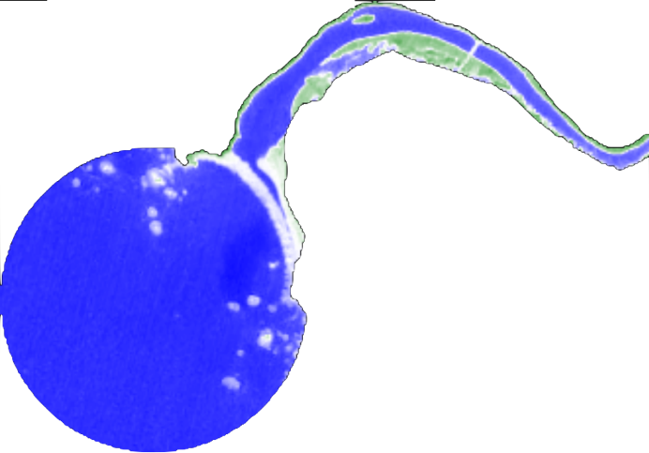 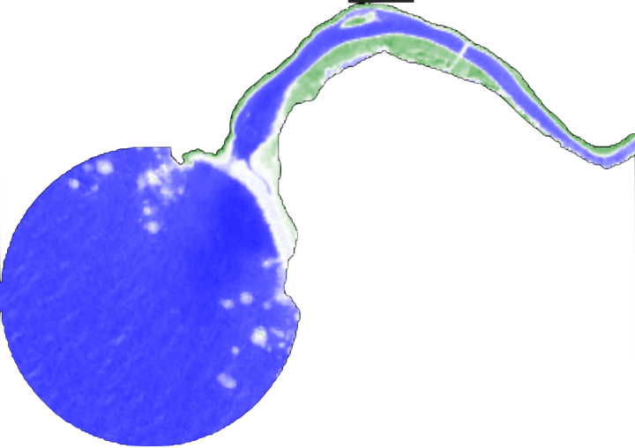 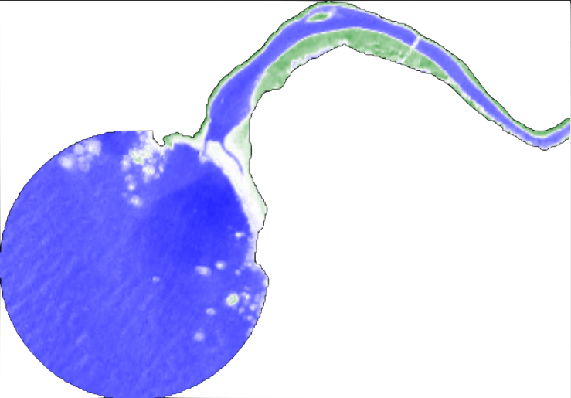*Figure 3*. CEA Tool estuary mouth state analysis NDWI imagery from February 7th, 2020 (left), February 12th 2020 (middle), and February 17th, 2020 (right). In the NDWI imagery, blue indicates water, white indicates non-vegetated land, and green indicates vegetation.

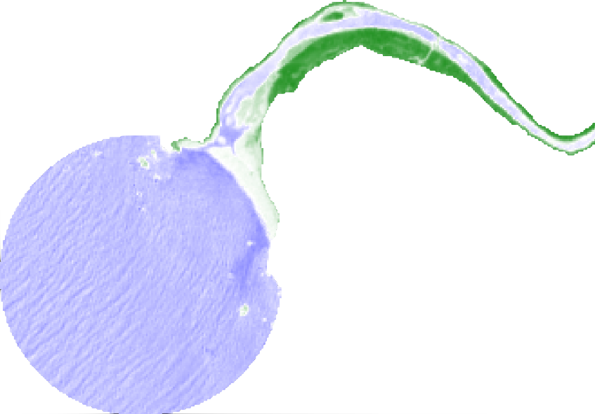

*Figure 4*. CEA Tool estuary mouth state analysis NDWI imagery from March 13th, 2020 (left) and May 22nd, 2020 (right). In the NDWI imagery, blue indicates water, white indicates non-vegetated land, and green indicates vegetation.

*4.1.2 Inundation*

This project found that Sentinel-2 MSI-derived NDWI was able to assess the inundation extent of estuaries (*Figure 5*). This project also found that Sentinel-1 C-SAR data increased temporal resolution, especially for periods during which cloud-free Sentinel-2 MSI imagery was not available. The availability of consistent, cloud-free images helped confirm results from the CEA tool estuary mouth state analysis and water quality analysis while also providing useful information in its own right for those extended periods of time. Figure 6 demonstrates the high temporal resolution of C-SAR data across our dates of interest; for the period from January 1st, 2020 to March 25th, 2020 at the Navarro River estuary, Sentinel-1 gathered imagery every two to three days. The team identified those dates shown in Figures 5 and 6 with a sharp drop in percentage of water pixel cover as likely dates when the estuary was breached.

*Figure 5.* Estuary inundation extent over time.

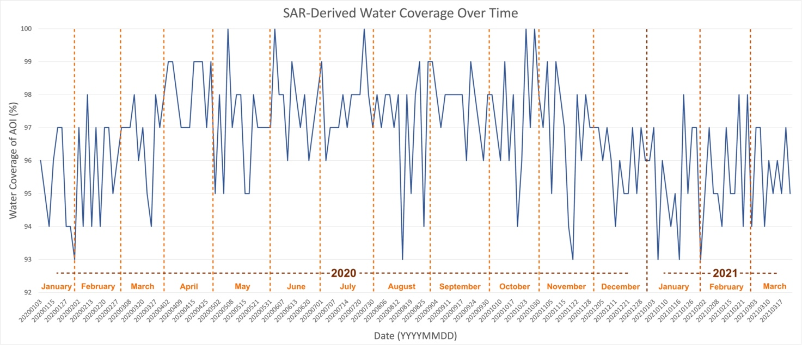*Figure 6*. Time series chart from January 2020 to March 2021 of SAR imagery-derived inundation levels as a percent of the area of interest covered by water pixels.

In-situ data highlighted several breach dates at the Navarro River estuary during the team’s temporal examination window that corresponded with drops in the percentage of water pixel coverage. Visual inspection of the thresholded C-SAR imagery confirmed the likelihood of breach events on or around the dates highlighted by the in-situ data. For instance, in-situ water-logger data showed a breach event on February 11th, 2020 and Figure 7 confirms a rapid drop in water levels from February 8th to February 14th of that year, as most easily visualized in the center of the image on the southern side of the estuary’s tail, just to the left of the peak of the curve. Likewise, in-situ water-logger data showed a second breach event on March 12th, 2020 and Figure 7 confirms a rapid drop in water levels from March 9th to March 15th of that year and in the same location of the image as previously described. Finally, in-situ water logger data showed a third breach event on May 19th, 2020 and Figure 7 confirms another rapid drop in water levels from May 15th, to May 20th of that year, this time more easily visualized on the eastern side of the estuary mouth.

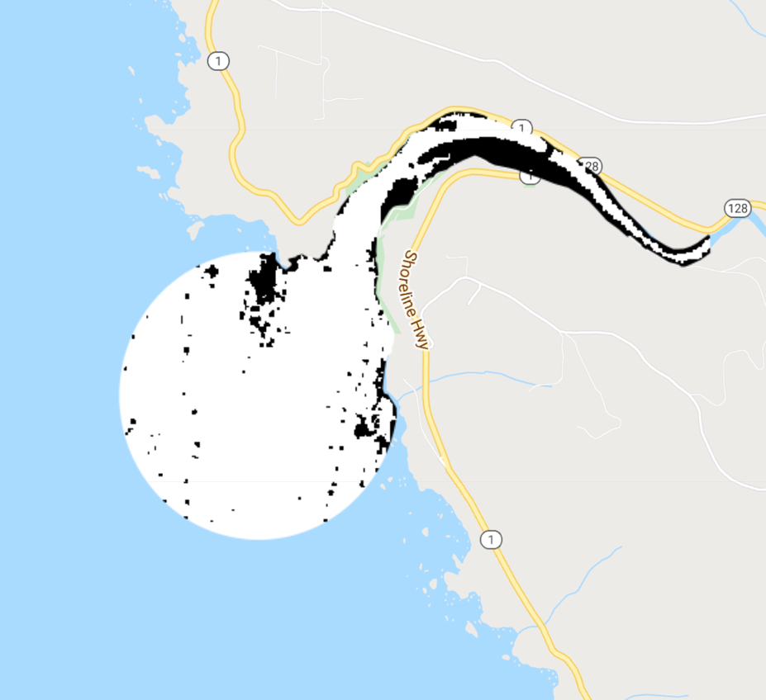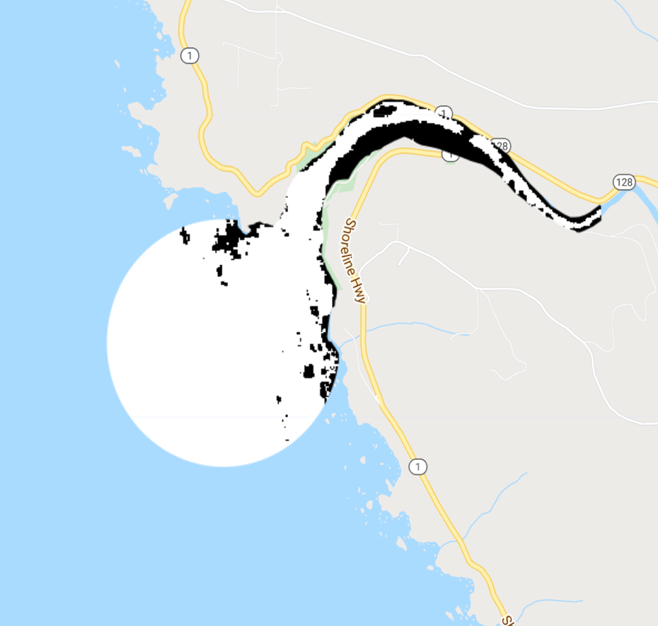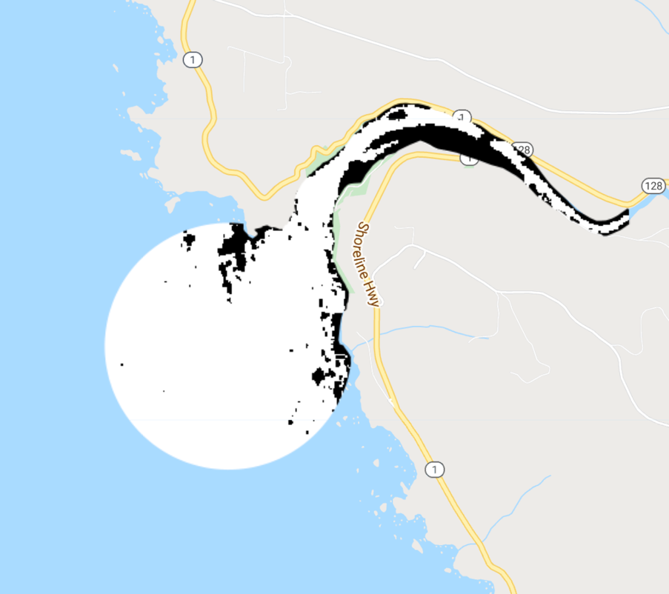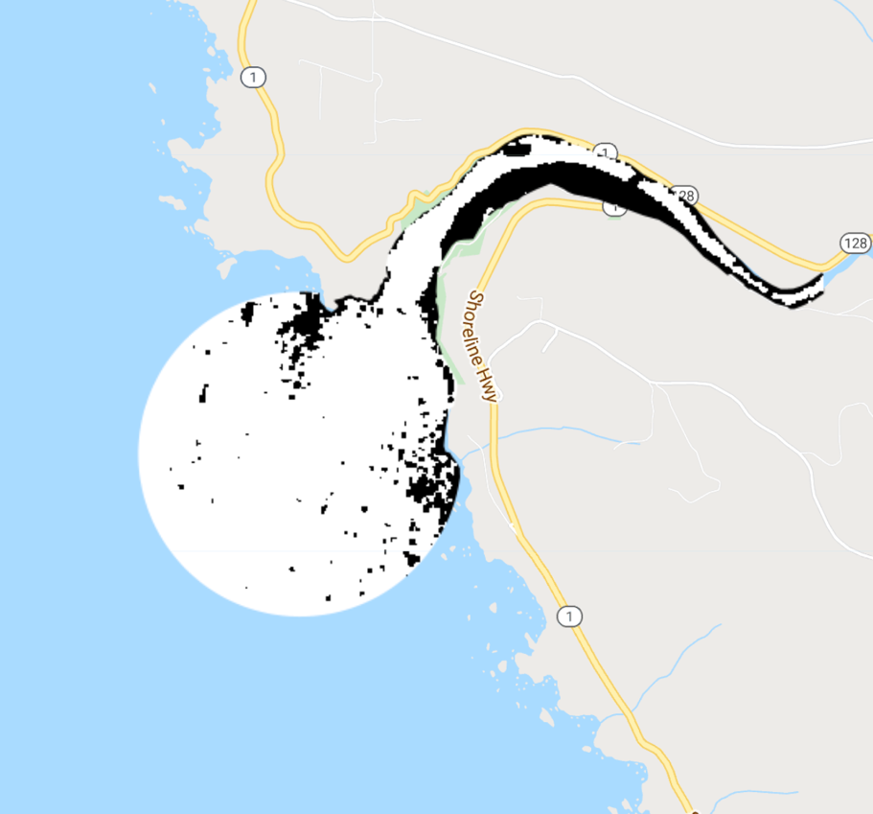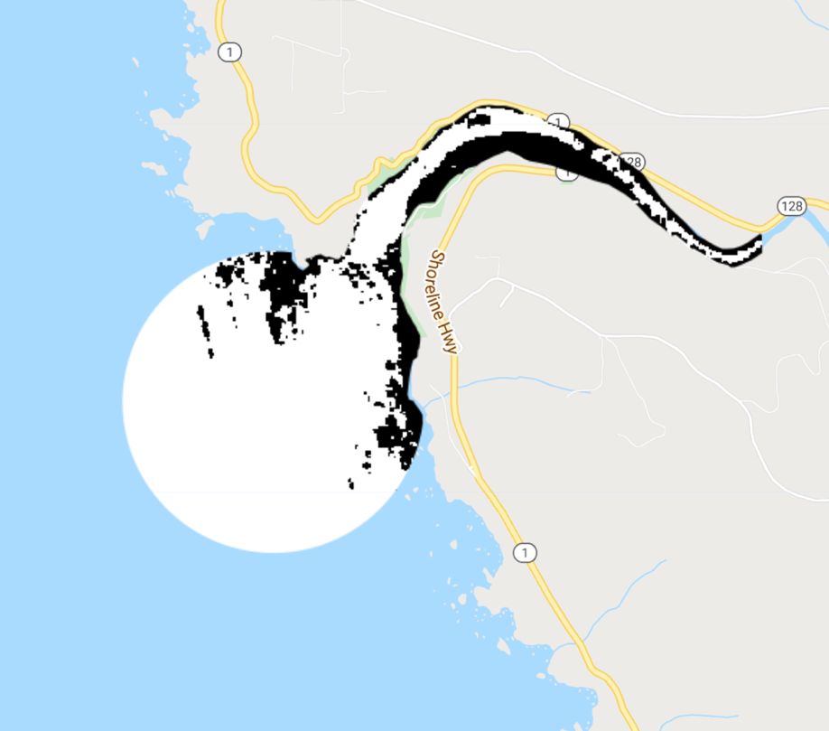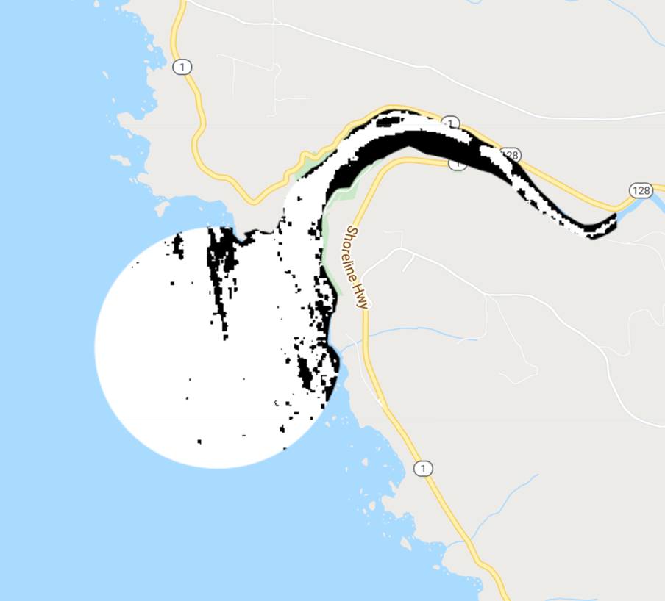*Figure 7*. CEA tool inundation extent analysis SAR threshold image from February 9th, 2020 (top left), February 14th, 2020 (top right), March 9th, 2020 (middle left), March 15th, 2020 (middle right) May 15th, 2020 (bottom left) & May 20th, 2020 (bottom right). Water pixels are symbolized in white while non-water pixels are symbolized in black.

*4.1.3 Water Quality Metrics*

Through visual inspection of each water quality metric, it was made clear that turbidity derived from Landsat 8 was the most successful in detecting changes in water quality correlating to estuary mouth state out of the all the metrics calculated. Figure 8 compares Landsat 8 derived turbidity products on dates where the in-situ water logger data indicated that an estuary mouth was closed (left) and open (right). High water levels in the water logger data around the time of early November 2019 suggested that the estuary mouth was closed. A drastic drop in water levels in the water logger data on February 11th, 2020 suggested a breaching event. The closest date observable with Landsat 8 data was February 6th, 2020 and the turbidity layer generated from this closely resembled what would be expected when the mouth state is open. Turbidity is expected to increase within the estuary when the mouth state is open. When visually comparing both images, turbidity is visibly higher within the estuary as well as outside the estuary in the open water. A sediment plume is also evident directly south of the mouth of the river shown in red on the February image. Although the February image was taken five days prior to when the in-situ data indicated a breach, this comparison shows that the turbidity images have the potential to detect changes in water quality associated with changes in estuary mouth state.

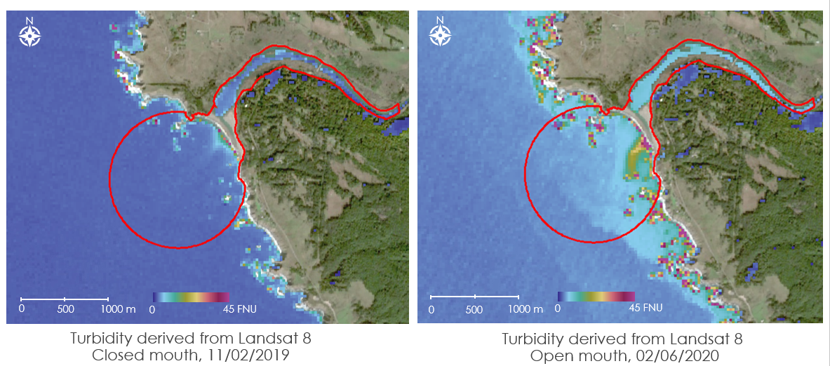

*Figure 8.* Turbidity layer derived from Landsat 8 over Navarro River. Areas of high turbidity are shown in red. Left image shows turbidity when the mouth is closed (Nov. 2nd, 2019) right image shows turbidity when mouth is opening (Feb. 6th, 2020).

Metrics generated from Sentinel-2 imagery were inconsistent due to atmospheric conditions, atmospheric correction error, and wave action. Inconsistencies were apparent in visual comparison of individual images and in the time series charts. The range for each metric shown varied widely and unrealistically across the year. Figures B1 and B2 give examples of some Sentinel-2 inconsistencies observed. As a result of Sentinel-2’s higher spatial resolution, the image captured waves in the open water. Wave breaks and sea foam can obstruct the sensor from capturing the sedimentation in the water. In the example shown in Figure B1, there are areas calculated as high turbidity, but when comparing to the true color imagery and analyzing the shape of these objects, these areas can be identified as waves. This causes the value plotted on the time series to be higher than expected and inaccurate. In Figure B2, the left image is unusable while the right image is ideal for calculating water metrics. The left image has a layer of fog or haze that returns reflectance values that cause error in visualization and create outliers in the time series. Water metrics generated from these obstructed images would be vastly inaccurate and unusable. As a result of inconsistencies of Sentinel-2 images throughout the year, chlorophyll-a, CDOM, and turbidity images and time series generated from this sensor could not be used to make inferences on water quality.

***4.2 Future Work***

The cloud filter posed a significant challenge during this term, especially for the accuracy of the estuary mouth state analysis, and is in need of further refinement. The double filter approach of first using the entire Sentinel-2 image metadata as a general cloud filter and then excluding images more stringently based on clouds over the estuary study area did appear to improve the number of appropriate images included in the CEA tool’s analysis. However, the second filter that utilized the Sentienl-2 QA60 band to flag clouds over the selected estuary study area had difficulty detecting high levels or “blankets” of cloud cover over the inland portion of the estuary or fog over the entire image. A proper balance between excluding cloudy imagery and over-filtering useable imagery is essential for capturing dynamic estuary events that can occur over the span of a few days. Future terms should look to adjusting the percentages of the existing cloud filter, investigate alternative frameworks to identifying cloud pixels in Sentinel-2 imagery, and ensuring that the cloud filter is consistently applied over all portions of the GEE tool if they remain separate scripts.

In addition to the cloud filter, future work should focus on continuing to refine the Sentinal-1 C-SAR analysis of estuary inundation. Owing to SAR’s strong ability to distinguish still water from land but its noisier job of distinguishing high-energy water with wave action from land, future work focused on refining existing code should clip the inundation analysis to just the portion of the estuary landward of the estuary mouth. This clipping should also do a stronger job of highlighting changes in inundation and should limit potential impacts linked to tidal changes. Future work should also pull apart the current time series analysis in order to assess potential water coverage variations linked to calibration differences between Sentinal-1A and Sentinel-1B as well as differences between ascending images and descending images; currently these are all charted on the same graph. Finally, future work should continue to examine speckle reduction techniques in addition to the Lee Filter and the VV + 2VH approaches. Speckle reduction efforts will improve the accuracy of the thresholded imagery and subsequent water pixel coverage-based time series analysis.

Likewise, future work should refine analysis of water quality metrics in order to address shortcomings associated with the averaged turbidity analysis, weaknesses in CDOM, and inaccuracies in chlorophyll-a. Improving filters to omit images with haze would assist the automation of the tool, as this would decrease the amount of user input needed to omit these outliers. Due to time constraints, calibration of turbidity and chlorophyll-a algorithms could not be conducted as thoroughly as desired. Comparison to field measurements, as well comparisons to products generated by the ACOLITE tool for water monitoring would help in the calibration of these metrics in the future. With the Google Earth Engine Python API, it might also be possible to integrate ACOLITE into Google Earth Engine. This would improve the assessment of water quality significantly as ACOLITE is a rigorously researched tool for water quality analysis.

More generally, future work should prioritize validation and continued refinement of existing approaches.

This should include the incorporation of in-situ water quality data to compare with remotely sensed measurements. In the next term of the project, the team will receive turbidity data, among other datasets still to be determined, from partners to validate preliminary results found in this term. With this continued refinement and validation, the team should consider expanding analysis to other estuary sites partners have identified as of management interest. Such expansion will aid in the validation process by helping the team assess whether existing methodologies are functional across all sites.

Beyond validating and refining current approaches that have already shown potential, future work might consider exploring new techniques for assessing estuary health. For instance, the second term could pursue a more sophisticated estuary classification. This classification could rely on more robust training datasets in order to pursue a Random Forest Classifier approach. Potential training datasets might include the California Vegetation (CALVEG) Habitat Types dataset from the U.S. Forest Service and the California Aquatic Resources Inventory (CARI) dataset. CALVEG relies on field-based observations, remote sensing data, and systematized, automated procedures in order to classify vegetation throughout the state of California. Meanwhile, CARI relies on the U.S. Fish & Wildlife Service’s National Wetland Inventory, the U.S. Geological Survey’s National Hydrography Dataset, and assessments produced by local and regional agencies in order to produce a map of California that classifies its various surface waters i.e., wetlands, rivers, lakes, riparian buffers, and streams. This more sophisticated classification of California’s estuarine spaces might focus on identifying particular types of vegetation, distinguishing mudflats, and doing a stronger job of identifying sandy beach areas. Finally, future work should prioritize the creation of a user-friendly interface to the CEA Tool through the creation of a Graphical User Interface (GUI). These efforts will ensure that partners who lack familiarity with Google Earth Engine and with JavaScript coding can nonetheless easily engage with the CEA Tool.

# 5. Conclusions

The Coastal California Water Resources team successfully created a preliminary version of the California Estuary Assessment (CEA) tools, a set of Google Earth Engine scripts that generates maps and time series charts of estuary mouth state, inundation extent, turbidity, chlorophyll-a concentration, and CDOM for the study area. The team found that Earth observations from multiple satellite sensors show promise especially for studying mouth state, inundation extent, and turbidity. Furthermore, these tools allow users to observe estuary health metrics relative to one another.

This study found that different satellite sensors were most applicable for different purposes. In terms of spatial resolution, Sentinel-2 MSI (10 m resolution) best observed estuaries of all sizes while Landsat-8 OLI (30 m resolution) best observed larger estuaries. The resolution of Sentinel-2 MSI imagery was also best suited to detected estuary mouth state change as these processes result on a finer spatial scale than other estuarine processes. When clouds limited data availability, inundation extent assessments from both Sentinel-2 MSI and Sentinel-1 C-SAR helped interpolate mouth state. This project found that these two sensors regularly detected greater inundation extents preceding a breach event and lower inundation extents immediately following a breach event. In conjunction, imagery from Sentinel-2 MSI and Sentinel-1 C-SAR sensors showed the potential to produce a time series of inundation extent with relatively high temporal resolution. Landsat-8 OLI may also provide an extra preview of inundation extent to support higher temporal resolution. Although Sentinel-2 MSI water quality products suggest a need for further calibration in the coastal zone, Landsat-8 OLI appeared well-suited for assessing turbidity in the study area.

The project objective was to improve EMPA monitoring by visualizing dynamic estuarine processes over time. The CEA tools created in this project provide increased spatial and temporal coverage of estuaries compared to field-based surveys and supplement resource-intensive in-situ data collection. The GEE platform supports efficient processing of large datasets such as image collections and allows users to easily access satellite imagery and share tools with other collaborators. Additionally, the GEE platform automatically updates to include the most recently available Earth observations, allowing users to perform timely analyses of estuarine processes.

This project’s products will allow our project partners to better understand and monitor estuarine processes over time, especially for EMPAs statewide. By supporting improved and coordinated monitoring of EMPAs, the CEA tools provide the OPC additional information to consider as they seek to effectively allocate resources to agencies and estuaries. Furthermore, the development of these tools and associated deliverables builds capacity in partner organizations to further apply Earth observations to estuary monitoring and management.

# 6. Acknowledgments

The Coastal California Water Resources team would like to thank our project partners from the OPC, CCWG, SCCWRP, and UCLA. Their field perspective, expertise, and encouragement was essential to ensure the CEA tools could be utilized for improved wetland monitoring and management. Thank you also to this project’s science advisors from the NASA Jet Propulsion Laboratory: Benjamin Holt, Dr. Christine Lee, Dr. Bruce Chapman. Their constructive feedback helped guide and refine the team’s lines of inquiry and their enthusiasm for the project made for robust and lively discussions. Finally, the team would like to thank Erica Caracelen for her support and encouragement throughout the DEVELOP term. Thank you all!

This material contains modified Copernicus Sentinel data (2014-2020), processed by ESA.

Any opinions, findings, and conclusions or recommendations expressed in this material are those of the author(s) and do not necessarily reflect the views of the National Aeronautics and Space Administration.

This material is based upon work supported by NASA through contract NNL16AA05C.

# 

# 7. Glossary

**ACOLITE** – A Python tool for processing Landsat (5/7/8) and Sentinel-2 imagery for coastal and inland water applications

**BBE** – Bar-built estuary

**Breach** – A break in the sand barrier at the estuary mouth. A breach may occur naturally or through human intervention.

**CDOM** – Colored dissolved organic matter. Higher levels of CDOM result in high turbidity and reduce photosynthesis.

**Chlorophyll-a** – The predominant type of chlorophyll in used in photosynthesis. Chlorophyll-a is often used as a proxy in field-based and remotely-sensed surveys for phytoplankton in aquatic ecosystems.

**Earth observations** – Satellites and sensors that collect information about the Earth’s physical, chemical, and biological systems over space and time

**EMPA** – Estuarine Marine Protected Area

**GEE** – Google Earth Engine

**MLPA** – Marine Life Protection Act

**MPA** – Marine Protected Area

**NDCI** – Normalized Difference Chlorophyll Index

**NDWI** – Normalized Difference Water Index

**Phytoplankton** – A micro-organism that photosynthesizes in aquatic ecosystem. They are an important source of food and producer of oxygen. They are primary indicators of ecosystem health

**Turbidity** – A measure of water clarity in which high turbidity corresponds to a large presence of suspended matter

# 8. References

Barbier, E. B., Hacker, S. D., Kennedy, C., Koch, E. W., Stier, A. C., & Silliman, B. R. (2011). The value of estuarine and coastal ecosystem services. *Ecological Monographs*, *81*(2), 169–193. https://doi.org/10.1890/10-1510.1

Cao, F., Tzortziou, M., Hu, C., Mannino, A., Fichot, C. G., Del Vecchio, R., Najjar, R. G., & Novak, M. (2018). Remote sensing retrievals of colored dissolved organic matter and dissolved organic carbon dynamics in North American estuaries and their margins. *Remote Sensing of Environment*, *205*, 151–165. https://doi.org/10.1016/j.rse.2017.11.014

Copernicus Sentinel-2 MSI Level 2A Data. [2013-2019]. Retrieved from Google Earth Engine, processed by ESA.

Clark, R., & O’Connor, K. (2019). A systematic survey of bar-built estuaries along the California coast.

Estuarine, *Coastal and Shelf Science*, *226*, 106285. https://doi.org/10.1016/j.ecss.2019.106285

Eid, A. N. M., Olatubara, C. O., Ewemoje, T. A., El-Hennawy, M. T., & Farouk, H. (2020). Inland wetland time-series digital change detection based on SAVI and NDWI indecies: Wadi El-Rayan lakes, Egypt. *Remote Sensing Applications: Society and Environment*, *19*, 100347. https://doi.org/10.1016/j.rsase.2020.100347

Gitelson, A. A., Schalles, J. F., & Hladik, C. M. (2007). Remote chlorophyll-a retrieval in turbid, productive estuaries: Chesapeake Bay case study. *Remote Sensing of Environment*, *109*(4), 464–472. https://doi.org/10.1016/j.rse.2007.01.016

Guo, M., Li, J., Sheng, C., Xu, J., & Wu, L. (2017). A Review of Wetland Remote Sensing. *Sensors*, *17*(4), 777. https://doi.org/10.3390/s17040777

Harris, P. T., Heap, A. D., Bryce, S. M., Porter-Smith, R., Ryan, D. A., & Heggie, D. T. (2002). Classification of Australian Clastic Coastal Depositional Environments Based Upon a Quantitative Analysis of Wave, Tidal, and River Power. *Journal of Sedimentary Research*, *72*(6), 858–870. https://doi.org/10.1306/040902720858

Heady, W. N., Clark, R. P., O’Connor, K., Clark, C., Endris, C., Ryan, S., & Stoner-Duncan, S. (2015). Assessing California’s bar-built estuaries using the California Rapid Assessment Method. *Ecological Indicators*, *58*, 300–310. https://doi.org/10.1016/j.ecolind.2015.05.062

Kaplan, G. & Avdan, U. (2017). Object-based water body extraction model using Sentinel-2 satellite imagery.

*European Journal of Remote Sensing*, *50*(1), *137-143*. https://doi.org/10.1080/22797254.2017.1297540

Largier, J., O’Connor, K., & Clark, R. (2019). Considerations for Management of the Mouth State of California’s Bar-built Estuaries: Final Report to the Pacific States Marine Fisheries Commission and NOAA (NA14NMF437012). 57.

Mishra, S. & Mishra, D.R. (2012). Normalized difference chlorophyll index: A novel model for remote estimation of chlorophyll-a concentration in turbid productive waters. *Remote Sensing of Environment*, *117*, 394-406. https://doi.org/10.1016/j.rse.2011.10.016

Nechad, B., Ruddick, K.G., & Neukermans, G. (2009) Calibration and validation of a generic multisensory algorithm for mapping of turbidity in coastal waters. *Proceedings of SPIE – The International Society for Optical Engineering*, *7473*. https://doi.org/10.1117/12.830700

Rice, E.W. (1976). The preparation of formazin standards for nephelometry. *Analytica Chimica Acta*, *87*(1), 251-253. https://doi.org/10.1016/S0003-2670(01)83146-9

Rich, A., & Keller, E. A. (2013). A hydrologic and geomorphic model of estuary breaching and closure. *Geomorphology*, *191*, 64–74. https://doi.org/10.1016/j.geomorph.2013.03.003

Román-Rivera, M. A., & Ellis, J. T. (2019). A synthetic review of remote sensing applications to detect nearshore bars. *Marine Geology*, *408*, 144–153. https://doi.org/10.1016/j.margeo.2018.12.003

Xing, X., Chen, Q., Yang, S., & Liu, X. (2017) Feature-based nonlocal polarimetric SAR filtering. *Remote Sensing*, *9*(1043), 1–19, https://doi.org/10.3390/rs9101043

# 9. Appendices

**Appendix A**

Table A1

*Changes in water quality metrics associated with estuary mouth state change. A triangle pointed upward indicates an increase while a triangle pointed downward indicates a decrease.*

|  |  |  |  |  |
| --- | --- | --- | --- | --- |
|  | **Inundation** | **Chlorophyll-a**  **(Open Water)** | **Turbidity** | **CDOM** |
| Closed Mouth State | Play with solid fill | Play with solid fill | Play with solid fill | Play with solid fill |
| Open Mouth State | Play with solid fill | Play with solid fill | Play with solid fill | Play with solid fill |

When the mouth is closed, inundation extent is expected to rise within the estuary. Additionally, since the estuary is not flowing into the ocean causing sedimentation turbidity and CDOM levels are expected to be lower and as a result chlorophyll-a levels will be higher in the ocean. When the mouth is open, inundation extent is expected to be smaller within the estuary as water flows into the ocean. As water flows into the ocean causing sedimentation, turbidity and CDOM levels will increase limiting photosynthesis and causing chlorophyll-a levels to decrease in the open ocean.

**Appendix B**

*Figure B1*. An example of wave action causing error in turbidity averaging.

*Figure B2*. An example of the dramatic differences between Sentinel-2 images throughout the year, left image captures wave action and haze while right image is clear and captures no waves