American Samoa Water Resources
Evaluating the Impacts of Land Cover and Water Quality Changes in American Samoa to Improve Watershed Management


Technical Report
Final Draft – August 8th, 2019

Marshall Worsham (Project Lead)
Melissa Collin
Eric Davis
Arev Markarian

Dr. Juan Torres-Pérez, Bay Area Environmental Research Institute, NASA Ames Research Center (Science Advisor)
Dr. John Olson, California State University Monterey Bay (Science Advisor)
Tomoko Acoba, Joint Institute for Marine and Atmospheric Research, University of Hawai’i at Manoa (Science Advisor)

1. Abstract
For at least the past two decades, the coral reefs and coastal ecosystems of the American Samoan island of Tutuila have experienced deteriorating water quality. Increased levels of sedimentation, nutrients, and other land-based sources of pollution (LBSP) have negatively impacted these systems and the local fishery-based economy. Traditional efforts to monitor these systems, such as in situ water quality sampling studies and field surveys of piggery operations, have proven insufficient, prompting the US Coral Reef Task Force (CRTF) Watershed Partnership Initiative (WPI) and the American Samoa Department of Marine and Wildlife Resources (DMWR) Coral Reef Advisory Group (CRAG) to seek new strategies. This project provided the partners with maps and geospatial data products to support management interventions designed to mitigate the impacts of land use and land cover change. A time series analysis deployed Earth observations from Landsat 8 Operational Land Imager (OLI) to analyze changes in land cover and chlorophyll-a (Chl-a) concentrations—a proxy for water quality—from 2013 to 2019 at an island-scale. Ancillary data products from the United States Department of Agriculture Natural Resources Conservation Service were used to depict change patterns in land cover at a more granular scale, using the Tafuna Plain, Nu’uuli watershed, and Faga’itua watershed as sample sites because of the biodiversity and vulnerability of their marine ecosystems. The end products supplied project partners with knowledge and tangible decision-support tools to maintain the structure and function of vital coastal ecosystems.

Keywords
remote sensing, Landsat, land use and land cover change (LULCC), coastal ecosystems, chlorophyll-a, coral reefs, management

2. Introduction
2.1 Background Information
American Samoa is an unincorporated United States territory in the Oceania region, approximately 4,200 km south of Hawai’i (Birkeland et al., 2008). The territory comprises the eastern portion of the Samoan archipelago and spans five volcanic islands (Tutuila, Aunu’u, Ofu, Olosega, and Ta’u) and two atolls (Rose Atoll and Swains Island), with a combined land area of approximately 200 km². The climate is warm and wet year-round, with average air temperatures between 27°C and 31°C (Craig, 2009). Precipitation varies over the islands but typically ranges from 300 to 500 cm per year (Craig, 2009). Owing to the islands’ steep terrain, major rain events tend to yield high rates of erosion and sedimentation in watersheds and near-shore marine environments (Coulter, 1941).

American Samoa is home to extensive reef ecosystems, which cover approximately 295 km² and represent key biodiversity hotspots. Over the past two decades, many reef habitats have experienced deteriorating water quality (Comeros-Raynal, et al., 2019). Although the reefs have historically rebounded from disturbances such as cyclones, bleaching events, and crown-of-thorns starfish (Acanthaster planci) outbreaks, chronic anthropogenic disturbances have become an increasing threat to these ecosystems (Birkeland, Green, Fenner, Squair, & Dahl, 2013; Craig, DiDonato, Fenner, & Hawkins, 2005).

This project focused on Tutuila, the largest island in American Samoa (-14.30° N, -170.72° E; Figure 1). At roughly 142 km², Tutuila hosts the majority of American Samoa’s 55,000 human inhabitants (World Bank Group, n.d.). The steep topography has limited urban development and land intensification to peripheral lowlands, straining coastal ecosystems (Craig et al., 2005). Mining operations, informal piggeries, former military dump sites, wastewater treatment plants, and industrial sites have all been flagged for leaching sediments, heavy metals, and fertilizers into local watersheds (Craig et al., 2005). More recent work has attributed declines in coral cover and benthic species diversity to non-point sources, namely land intensification, runoff, and insufficient watershed management practices (Shuler et al., 2019). While regulations exist to limit and mitigate these impacts, gaps in funding, a shortage of personnel, and inconsistent enforcement have hampered management efforts (Craig et al., 2005).

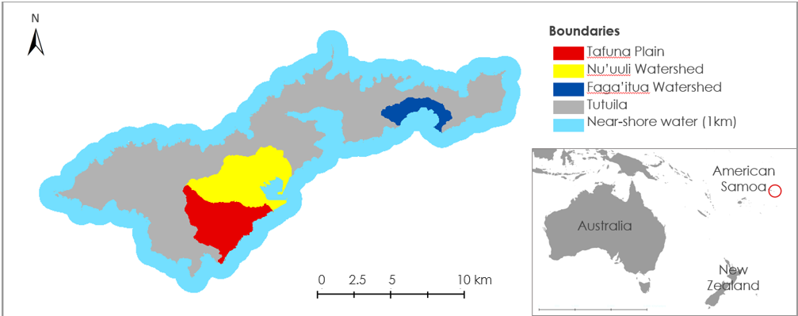
Figure 1. The study area comprised the American Samoan island of Tutuila; near-shore water within one km of the coastline; and three priority watersheds: Tafuna Plain, Nu’uuli Pala, and Faga’itua.

Previous studies have shown that applying supervised classifications to remotely sensed Earth observations can be an efficient method for evaluating the impacts of land use and land cover change (LULCC) at the island-scale (Kuechel, Naumann, Heiler, & Siegmund, 2003; Tan, San Lim, MatJafri, & Abdullah, 2010). Remote sensing technologies have also been proven to be reliable means of observing and quantifying patterns of chlorophyll-a (Chl-a) at the water surface, and a range of algorithms have been developed to map Chl-a concentrations (Guo et al., 2016; Ritchie, Zimba, and Everitt, 2003). One such algorithm, O’Reilly band ratio Chlorophyll-a OC2, has been widely accepted as an effective estimator of Chl-a concentrations from Landsat 8 surface reflectance data (O’Reilly et al., 1998; NASA Ocean Color, 2019). Resource and conservation managers in American Samoa have limited capacity to perform these types of analyses, and the majority of past research conducted on the island is outdated or reports single-point-in-time observations. As a result, this study aimed to analyze changes over the past seven years to provide more insight into interannual variance (Coulter, 1941; Craig et al., 2005).

2.2 Project Partners & Objectives
The United States Coral Reef Task Force (CRTF), Watershed Partnership Initiative (WPI) and the American Samoa Department of Marine and Wildlife Resources (DMWR), Coral Reef Advisory Group (CRAG) were the primary end-users of the data and insights derived in this study. CRAG develops and implements watershed and reef management plans in partnership with local communities. In addition, the advisory group conducts research, organizes community workshops, creates communication materials to support management interventions, and ensures compliance with fishery and wildlife regulations. Currently, the CRAG Watershed Coordinator has limited personnel and resources to monitor and manage water quality. The WPI, CRAG, and other agencies have completed baseline water quality studies and created point-in-time land cover maps in several priority watersheds, including Faga’alu, Nu’uuli Pala, Vatia, and Aunu’u. However, gaps in geospatial monitoring and evaluation mean that the effects of LULCC on coastal water quality across the study area are not yet well understood.

With the aim of further protecting vibrant and valuable reef resources, this project quantified LULCC dynamics on Tutuila from 2012 to 2019 and evaluated their influence on coastal water quality as measured by surface observations of Chl-a concentrations. In addition, the DEVELOP team produced maps, geospatial analyses, and outreach materials that enabled the partners to optimize watershed management strategies, support community-based conservation efforts, and protect coastal ecosystems into the future.

3. Methodology

3.1 Overview
This project tested the feasibility of employing Landsat 8 Operational Land Imager (OLI) Surface Reflectance (SR) data to assess the drivers of coastal water degradation in Tutuila over the last seven years. The team processed Landsat 8 imagery in Esri ArcMap 10.6, RStudio, and Google Earth Engine API to generate land cover classifications and estimate Chl-a concentrations at the island-scale. Ancillary imagery drawn from DigitalGlobe WorldView-2 and WorldView-3 sensors and processed by the Natural Resource Conservation Service (NRCS) allowed us to derive finer-scale land cover classifications for Tafuna, Nu’uuli Pala, and Faga’itua watersheds. The land cover products were then evaluated for changes over time. We used these outputs, along with a range of variables parameterizing other anthropogenic and abiotic factors, to evaluate the relationship between recent LULCC and water quality using a random forest regression model. The results were used to create maps and geospatial datasets, which provided the end users with a scientific basis and effective outreach materials to better inform community-based conservation efforts.
3.2 Data Acquisition
3.2.1 Earth Observation Data
We used the United States Geological Survey (USGS) EarthExplorer repository to acquire image collections from Landsat 8 OLI (Table 1). Cloud cover above the island limited the availability of useable images. For island-scale land cover analyses, we downloaded between two and five images with <30 percent cloud cover from April through October each year to capture the dry season. For the water quality analysis, we used a single scene taken during the dry season.

Table 1
Data used for island-scale LULCC and water quality analyses in Tutuila
Sensor | Product | Area | Spatial Resolution | Temporal Resolution | Years
Landsat 8 OLI | Tier 1 and Tier 2 Surface Reflectance | Tutuila | 30 m | 1 composite image per year | 2013 to 2019

3.2.2 Ancillary Data
One orthoimage from 2012 and 2017 was selected from the United States Department of Agriculture (USDA) NRCS Geospatial Gateway repository. NRCS orthoimages were downloaded as three-band multi-resolution seamless image databases (MrSID). These products were composites of smaller images sourced from WorldView-2 and WorldView-3 sensors in the respective years, and post-processed by the NRCS National Geospatial Center of Excellence. Shapefiles and raster files delimiting the island boundary, near-shore bathymetry, and watersheds were acquired from the National Oceanic and Atmospheric Administration (NOAA), the USGS, and other sources (Tables A1 and A2).

One orthoimage from 2012 and 2017 was selected from the USDA NRCS Geospatial Gateway repository. NRCS orthoimages were downloaded as three-band multi-resolution seamless image databases (MrSID). These products were composites of smaller images sourced from WorldView-2 and WorldView-3 sensors in the respective years, and post-processed by the NRCS National Geospatial Center of Excellence. Shapefiles and raster files delimiting the island boundary, near-shore bathymetry, and watersheds were acquired from NOAA, the USGS, and other sources (Tables A1 and A2).

3.3 Data Processing
3.3.1 Processing Composite Images and Shapefiles for Land Cover Analysis
Image processing was performed in Google Earth Engine and Esri ArcMap 10.6. The Landsat images, NRCS images, and ancillary shapefiles were projected to PACP00_UTM_Zone_2S using the North American Datum of 1983 (NAD1983). For annual island-scale land cover, we composited between one and five GeoTIFF datasets per dry season (April to October) over the study period to create a single relatively unobscured image. In Google Earth Engine, we applied a cloud and shadow mask to the Landsat 8 SR images using the datasets’ pixel QA band. This band is generated for the surface reflectance images by the USGS and uses the CFMASK algorithm to identify clouds, cloud confidence, cloud shadows, and snow. Images were then composited to generate a single annual image using the median pixel value. After generating the annual composites, we clipped the Landsat images to the island boundary using the NOAA Tutuila boundary shapefile to exclude water pixels and the neighboring island of Aunu’u from the land classification analysis in ArcMap. For the high-resolution land classifications, we clipped the NRCS orthoimages to the boundaries of the three watersheds of interest, Tafuna Plain, Nu’uuli Pala, and Faga’itua. Because the resulting subsets included pixels depicting waves and ocean water on Tafuna Plain beach, we created a polygon to outline and extract a smaller border to avoid water pixels. The same procedure was used to remove lagoons within the Nu’uuli Pala watershed.

3.3.2 Processing Landsat 8 for Water Quality Analysis
For the water quality analysis, we used Landsat 8 top-of-atmosphere (TOA) data to determine the concentration of Chl-a in near-shore water around Tutuila. Rather than using the composited scenes generated for land classification, which would have produced distorted measurements, we chose the least cloudy image from the dry season in each year between 2013 and 2019. We clipped these to a region of interest bounded by the 25-meter depth contour line derived from a bathymetric model of the island and a one-kilometer buffer around the Tutuila landform (Figure 2). This extraction process allowed us to examine near-shore water while excluding pixels depicting land and visible seafloor, which would have also distorted water quality readings. Using ACOLITE, a software developed at the Royal Belgian Institute for Natural Sciences (RBINS), we atmospherically corrected the images with the Dark Spectrum Fitting (DSF) algorithm. We then corrected the TOA data to surface reflectance and removed cloud and cloud shadow pixels with ACOLITE’s l2w_mask function.
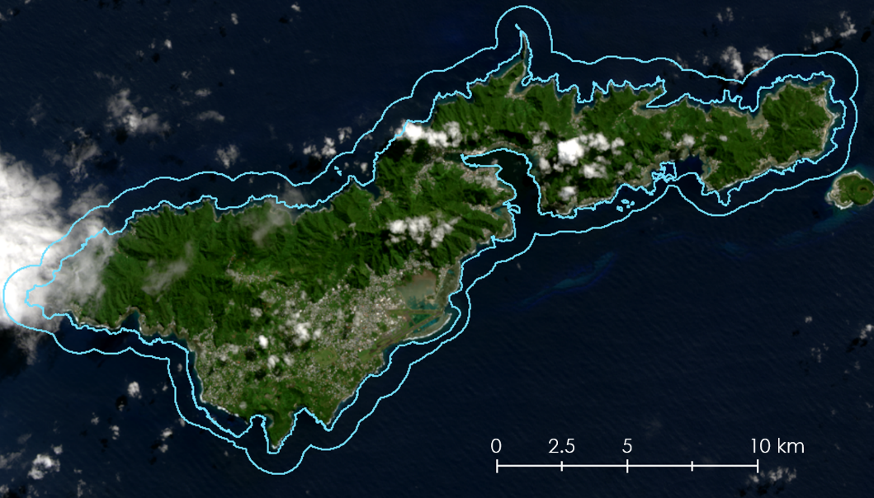
Figure 2. 2018 Landsat 8 image showing the region of interest for water quality analysis in light blue.

3.3.3 Random Forest Model Parameterization
To prime the water quality readings for the random forest regression, annual Chl-a levels were derived by taking the mean reading from pixels within designated zones surrounding the island of Tutuila. These ad hoc zones (Figure B1) were created in Esri ArcMap by the team and remained constant throughout the study period. This way, spatial data was integrated into the time series analysis.

3.4 Data Analysis
3.4.1 Land Cover Classification and Trend Analysis at Island Scale
Using the seven composited Landsat scenes for the years between 2013 and 2019, we classified the images according to land cover types in Esri ArcMap 10.6. We used the interactive supervised classification tool to manually draw between 15 and 40 training polygons for the four following land classes: impervious surfaces, canopy, clouds, bare earth, grass and agricultural land. The spectral signatures from these training sites allowed the program to classify the entire image.

The software created histograms of index values to summarize area and percent cover for each of the four classes for each of the seven years. We generated maps visualizing the classification on the island for each year. A change map was created using the raster calculator in ArcMap to compare and assess the land cover changes between 2013 and 2018 composited images. We selected 2018 for this phase of the analysis because it represents the most recent year with sufficient data; 2019 images were still being captured and processed during this study, and extensive cloud cover remained in our 2019 composite.

3.4.2 Land Cover Classification and Trend Analysis at Watershed Scale
We performed the same supervised classification method on the clipped 2012 and 2017 NRCS orthoimages in ArcMap 10.6. Given the overlapping spectral radiances of features within the images, we funneled our classifications into four types of land cover: shadow, impervious surfaces including building and bare land, grassland and agriculture, and tree canopy. We drew a set of training polygons for each of the six images using ArcMap’s Image Processing toolbar. Between 20 and 40 polygons were created per land cover type and per year. An identical methodology was used to compare classifications of the watersheds, create histograms of cover distribution between 2012 and 2017 images, and create LULCC maps for each watershed.

3.4.3 Water Quality Trend Analysis
Using the O’Reilly band ratio Chl_OC2 algorithm in ACOLITE, we derived estimates of Chl-a concentrations in Landsat 8 surface reflectance-corrected datasets (O’Reilly et al., 1998; Equation 1). We converted these results to raster files using a GeoTIFF conversion script in RStudio. The result was a map of point observations of Chl-a concentrations in mg m⁻³ for a single day each year. We calculated the mean Chl-a concentration within the region of interest and displayed these values in a scatter plot to depict changes in water quality over time.
${\text{log}}_{\text{10}}\left(\text{chlor_a}\right)\text{=}{\text{a}}_{\text{0}}\text{+}\sum_{\text{i}\text{=1}}^{\text{4}}{{\text{a}}_{\text{i}}}{\left({\text{log}}_{\text{10}}\left(\frac{{\text{R}}_{\text{rs(λblue)}}}{{\text{R}}_{\text{rs(λgreen)}}}\right)\right)}^{\text{i}}$ (1)

3.4.4 Accuracy Assessments and Kappa Coefficients
We validated the island-scale and watershed-scale classifications by creating 200 stratified random points for each classified image in ArcMap, then compared the classes to visual interpretation of the original images and high-resolution imagery. Error matrices were generated to quantify the percent accuracy and analyze agreement using the kappa coefficient. The kappa coefficient is a robust statistic that measures agreement while accounting for the possibility of agreement by chance. The coefficient itself ranges from zero to one, with zero representing the amount of agreement equivalent to random chance and one representing perfect agreement.
3.4.5 Random Forest Modeling
We developed a model to evaluate the sensitivity of Chl-a levels to LULCC, as well as a range of abiotic and anthropogenic variables. A time series analysis demanded a model that measured variation over time. The random forest regression model was used to quantify the relationship of LULCC, and additional environmental and anthropogenic variables to water quality over the course of the study period. Ancillary datasets were transformed in Microsoft Excel to capture each variable’s potential impact on water quality. RStudio and the randomForest package (version 4.6-14) based on the machine learning algorithm developed by Breiman & Cutler were used to run the model (Breiman, 2001). The partial dependence plots were used to understand the relative importance of each variable to display a depiction of the marginal impact of each explanatory variable on the response, Chl-a observations.

4. Results and Discussion

4.1 Analysis of Results
Our map products show the successful detection of land cover and water quality changes, and our resulting statistics and figures yield satisfactory accuracy from our chosen methodology. Landsat 8 and NRCS imagery can be employed to assess the degree of land cover change at an island-scale, and watershed-scale, respectively.

4.1.1 Land Cover Classification and Trend Analysis at Island-Scale Results
The simple percent agreement calculated for each of the seven annual land cover maps of Tutuila ranged from 76.24 percent in 2017 to 86.93 percent in 2013, with an overall average of 81 percent (Figure G1). Calculated producer accuracy indicated that of the classes, clouds were classified most accurately, with an average producer accuracy of 94.09 percent, followed by canopy at 80.01 percent, bare/agriculture at 71.48 percent and impervious at 70.82 percent.
Despite cloud masking, the varying remaining cloud cover influenced the outputs for percent cover (Figure 3). High amounts of clouds significantly skewed the remaining classes percent cover distributions, since it obstructs the actual, on the ground land cover (Figure E1 to E7). Years with minimal cloud cover, such as 2015, 2017, and 2018, showed very consistent land cover values, with classes varying between one and two percent between years (Table F1).

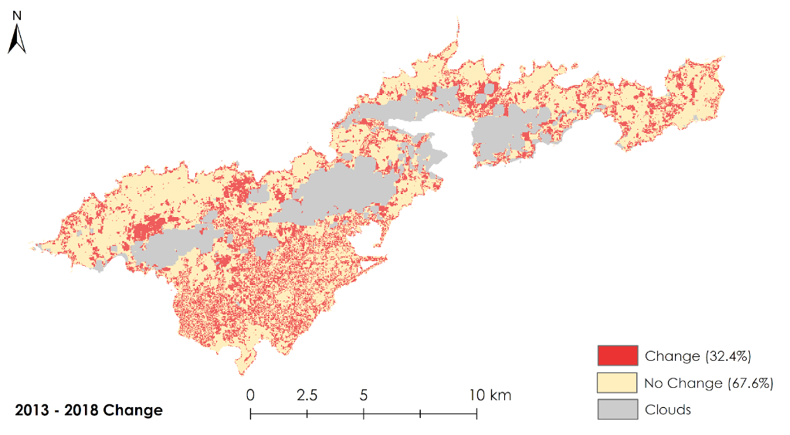
Figure 3. Land cover change map for the island of Tutuila between 2013 and 2018

The 2013 to 2018 change map indicated that 32.4 percent of the visible land had changed from one class to another, while 67.6 percent remained the same (Figure D1). However, analyzing each land class found minimal changes in percent cover, with only a slight increase in impervious surface and decrease in the canopy (Figure C1 to C7). We attribute these conflicting results to misclassification. The classification performed well at distinguishing canopy and clouds from the other classes and could accurately identify regions as either impervious surface or bare/agriculture but struggled in discerning between the two classes. The misclassification between impervious and bare/agriculture was not detected when calculating overall percent cover but was apparent on a pixel-by-pixel basis.
While the classification on the composites performed well overall on the island, the 30-meter resolution proved to be too coarse to accurately capture the complexities of land cover variation, especially in dense urban areas. Seasonal compositing of images made across an eight-month period also introduced spectral and temporal nuances. These nuances were due to the diverse landscape having to be aggregated into the dominant spectral signature for each pixel. Additionally, variations in spectral values between the years were often mistaken for changes in land cover classes. These limitations can be observed specifically in the Tafuna Plain region, where the majority of Tutuila’s population resides. As a result, any conclusions about gross changes in land cover on the island should be approached with a degree of caution.

4.1.2 Land Use and Land Cover Classification and Trend Analysis at Watershed-Scale Results
The simple percent agreement between the classifications of the three watersheds in 2012 and 2017 ranged from 64 percent to 95 percent, with a mean of 78 percent (Table L1). Kappa coefficients indicated “moderate agreement”, ranging from 0.38 to 0.82, with a mean of 0.57.

Tafuna Plain watershed was covered mostly by forest in 2012 (43%) as well as impervious surfaces (42%) (Figure J1 to J6). Forest cover increased by 2017 (53%) due to possible regrowth after storm events (Table 2). Grass and agriculture cover remained unchanged. Nu’uuli Pala watershed was covered with forest (63%) and impervious cover (23%) in 2012. By 2017 forest cover increased while impervious surfaces decreased. Similarly, majority of the Faga’itua watershed was covered by forest as well (71%), which also increased by 2017 (88%). The most densely populated of the three watersheds, Tafuna Plain, had the highest relative percentage of impervious cover in 2017 (53%).

Table 2
Percent cover by class in Tafuna Plain, Faga’itua, and Nu’uuli watersheds
WS | Year | Percent Cover (%)
 |  | Shadow | Canopy | Impervious | Grass/Ag
Tafuna | 2012 | 3.6 | 42.9 | 41.9 | 11.6
 | 2017 | 1.1 | 52.8 | 33 | 13.1
Faga'itua | 2012 | 15.7 | 71.2 | 4.9 | 8.2
 | 2017 | 1.8 | 87.8 | 7.1 | 3.3
Nu'uuli | 2012 | 10.8 | 62.6 | 22.9 | 3.7
 | 2017 | 4.6 | 75.4 | 17.3 | 2.7
Of the three watersheds, Tafuna Plain underwent the greatest magnitude of change from 2012 to 2017(Figure 4). The adjacent Nu’uuli Pala watershed experienced less change but more than the less populated Faga’itua watershed (Figure K1 to K2). Nu’uuli Pala has topological features that increase the slope compared to Tafuna Plain and offers less available land for sprawl, therefore decreasing the level of land conversion (Figure H1 to H6). Similar trends were detected in the Faga’itua watershed (Figure I1 to I3).

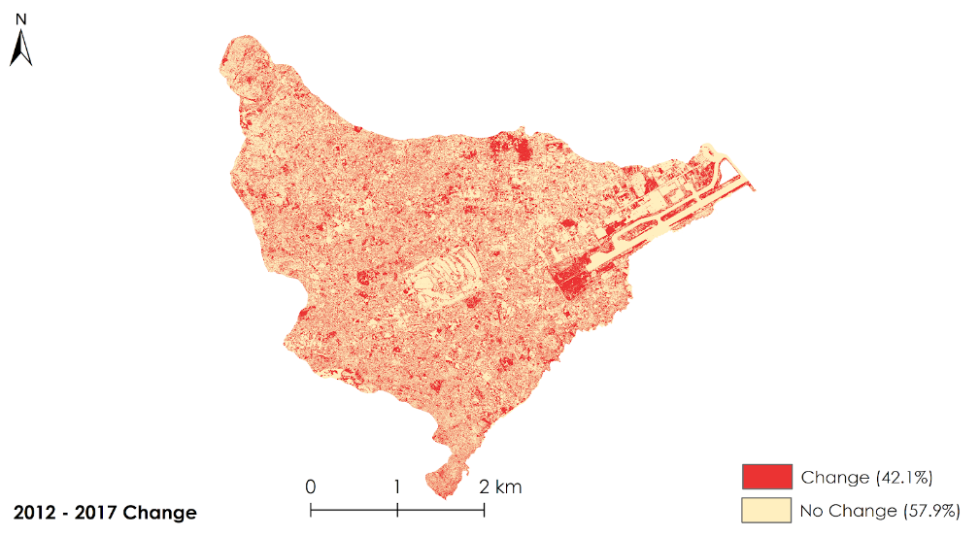
Figure 4. Detected change in classifications between 2012 and 2017 in Tafuna Plain.
Land intensification was evident at a large scale, particularly in the Tafuna Plain watershed. Several areas classified as canopy in 2012 had been converted to grass/agriculture by 2017 (Figure 5). Similar small-scale intensification was detected successfully throughout the watersheds.
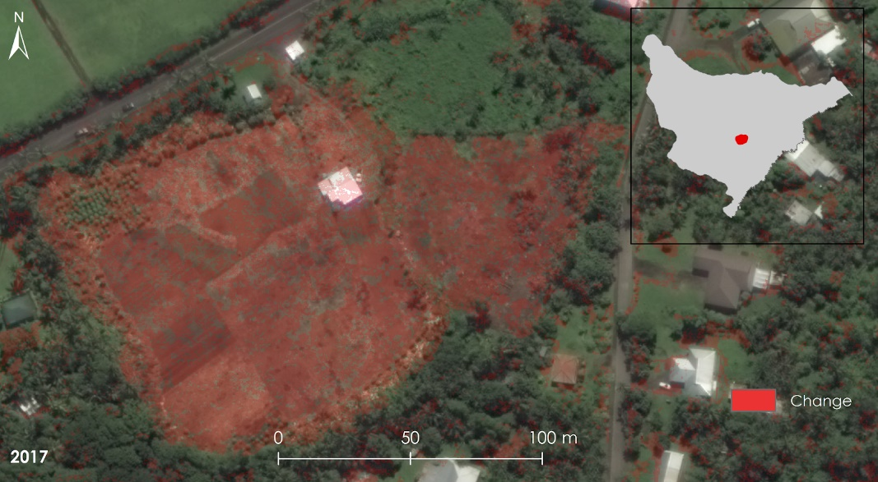
Figure 5. Detection of small-scale land intensification can be seen in Tafuna Plain watershed
4.1.3 Water Quality Trend Analysis Results
Chl-a concentrations in unclouded near-shore water pixels ranged from 0.0 to more than 3.0 mg m⁻³, with a mean of 74.3 percent of pixels observed each year. Mean Chl-a values across the study area ranged from 0.41 mg m⁻³ in 2017 to 0.84 mg m⁻³ in 2019 (Figure 6). Inter-annual observations revealed a slightly increasing trend (Appendix M). However, the reliability of this interference is limited by the temporal resolution; with only seven observations taken during five different months, it is not clear that the trend accurately portrays in situ variance. Chl-a concentrations may, in fact, vary on a weekly or monthly basis within or beyond the range of mean values reported.

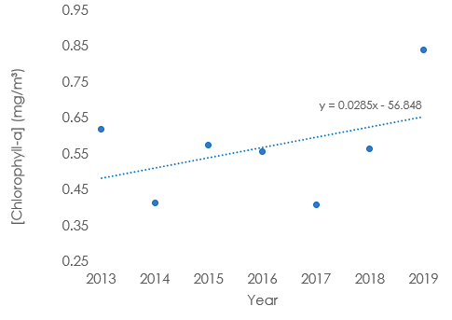
Figure 6. Annual mean Chl-a concentrations in near-shore water around Tutuila, American Samoa
4.1.4 Random Forest
The random forest regression model explained 45.75 percent of the variance in Chl-a measurements. The directionality and relative importance of each predictor variable’s relationship with observed water quality are reported in Figure M1. Variable importance is reported as the percent increase in the mean squared error (MSE) and an increase in node purity. The increase in MSE is used to quantify the degree a model’s efficacy would decrease if a particular predictor variable were to be omitted from the model. Increase in node purity is another conventional output of a random forest model, but one that is often prone to bias (Strobl, Boulesteix, Zeileis, & Horton, 2007), resulting from varying scales of measurement and number of potential categories in predictor variables.
The five variables with the highest explanatory power or highest increase in root mean square error, as well as their respective partial dependence plots are displayed in Appendix N. Wind speed, air temperature, and percent bare/agricultural land cover showed the strongest relationship with variance in water quality. Of these, the model assigned the greatest explanatory power to daily maximum wind speed (m/s). Wind has been documented as a powerful factor in the surface activity of coastal ecosystems, due to its influence on nutrient mixing, upwelling, and other circulation processes (Demers, Therriault, Bourget, & Bah, 1987). Limited input data and potential biases in the data demand that the outputs of the model be taken with a degree of uncertainty, although the results are nonetheless valuable. Further validation with in situ measurements could potentially strengthen and further validate the outputs of this study.

4.2 Future Work
As with any geospatial analysis, our study faced limitations and yielded directions for further research. First, the timeframe of the project was substantially truncated by the availability of Earth observations. The original project scope proposed a 30-year time series analysis. However, we were only able to source valid data from Landsat sensors after 2013. In 1992, the Tracking and Data Relay Satellite System (TDRSS) on Landsat 5 went offline. As a result, the mission was able to acquire data only within the range of a network of land-based antennae (NASA Landsat Science, 2019a). This network did not cover American Samoa. Similarly, the Landsat 7 Scan Line Corrector (SLC) failed in May 2003 (NASA Landsat Science, 2019b), and images of the study area acquired since then proved unusable. These issues yielded a significant temporal gap, making meaningful historical time series analysis impracticable.

In a study area that experiences 300 or more days of rain a year, cloud cover was pervasive in most Landsat images. With composites, the temporal resolution was constrained to a single image per year. Even without the cloud obstruction, Landsat 8’s return interval (16 days) makes it difficult to monitor subtle or rapid changes in water quality. In future work, we suggest introducing the European Space Agency (ESA) Copernicus Sentinel-2 Multispectral Instrument (MSI) observations into the analysis for higher spatial and temporal resolution.

Additional analysis is also needed to validate the land classifications. We compared our classifications to visual observation of the composited surface reflectance images. Error analysis based on ground-truth data would help to confirm the accuracy and reliability of supervised classifications. Furthermore, with Light Detection and Ranging (LiDAR) data and hyperspectral orthoimagery, it may be possible to distinguish among classes and more precisely identify vegetation communities, potentially even down to the functional-trait or genera level.

Further work could also improve the statistical modeling procedure piloted in this study. Larger samples, higher temporal resolution, and data acquired over a longer timescale would help to improve the power of the model. To produce a robust model of the relationship between LULCC and water quality, it is imperative to incorporate seasonal variability and variability following major disturbances, such as cyclones. Although extant remote sensing data present limitations, in the future it may be possible to introduce such fine-grained observations.

5. Conclusions
This project focused on applying NASA Earth observations and ancillary remote sensing data to create a time series analysis of trends in LULCC and water quality in Tutuila, American Samoa. Although Earth-observing satellites can effectively monitor LULCC, current instruments are limited in their capacity to detect significant change at the island-scale. In cases where atmospheric clouds obscure Landsat 8 images, masking and compositing images across a season can remove significant cloud cover to facilitate an analysis of surface reflectance data over time.

The team successfully generated island-scale land classifications from annual Landsat 8 derived imagery. The extensive cloud cover and wet climate of the tropical Pacific inhibited the availability of usable satellite images, but compositing observations over the course of a season proved a sufficient strategy for a coarse analysis. Notably, island-scale classifications indicated a net change in cover from forest to impervious surfaces. On the other hand, supplementary orthoimages obtained from the USDA NRCS proved difficult to classify, likely a result of the high resolution nature of the mosaics. Maps and histograms summarizing land use and land cover changes over time enabled our partners to monitor trends over the course of the study period.

Diagrams displaying Chl-a concentrations along the coast of Tutuila revealed key areas prone to poor water quality, as well as trends in water quality changed over the past seven years. Maps generated in this study equipped our partners to target management interventions and communicate effectively with local stakeholders. The random forest regression model tied together the several disparate aspects of the study and quantified the relationships between water quality and a variety of factors, including LULCC trends. The model identified key variables and their relative importance, allowing the team and partners to contextualize how certain factors affect the coastal environment. However, the limitations of the study demand that the random forest model and its outputs be taken with careful interpretation. With more data and observations, this machine learning model can be validated and applied more effectively. Projecting forward, higher resolution imagery and more data collection (remote and in situ) will be necessary to enhance water quality monitoring and to precisely identify drivers of change. As evidenced, insights derived by the team will enable partners, especially the US CRTF and the American Samoan DMWR, CRAG to direct resources and community-based conservation efforts to optimally address island-scale watershed management.

6. Acknowledgments
The American Samoa Water Resources team thanks the partners, mentors, and advisors who made this project possible. In particular, we are grateful to:
- Va’amua Henry Sesepasara, US Coral Reef Task Force, Watershed Partnership Initiative
- Fa’asalafa Diana Kitiona, American Samoa Department of Marine and Wildlife Resources, Coral Reef Advisory Group
- Alice Lawrence, American Samoa Department of Marine and Wildlife Resources, Coral Reef Advisory Group
- Sabrina Woofter, American Samoa Department of Marine and Wildlife Resources
- Katie Nalesere, American Samoa Department of Marine and Wildlife Resources
- Dr. Juan Torres-Pérez, Bay Area Environmental Research Institute, NASA Ames Research Center
- Dr. John Olson, California State University Monterey Bay
- Tomoko Acoba, Joint Institute for Marine and Atmospheric Research, NOAA and the School of Ocean and Earth Science and Technology, University of Hawai’i at Manoa
- Dr. Kenton Ross, DEVELOP National Program, NASA Langley Research Center
- Tony Kimmet, US Department of Agriculture, Natural Resources Conservation Service, National Geospatial Center of Excellence
- Fa’amao Asalele, American Samoa Environmental Protection Agency
- Antonina Teo, American Samoa Environmental Protection Agency
- Dr. Christopher Shuler, University of Hawai'i at Manoa
- Megs Seeley, DEVELOP Geoinformatics Fellow, NASA DEVELOP National Program Tempe Node
- Farnaz Bayat, DEVELOP Center Lead, NASA Ames Research Center
- Jerrold Acdan, DEVELOP Project Coordination Fellow, NASA Ames Research Center

Any opinions, findings, and conclusions or recommendations expressed in this material are those of the author(s) and do not necessarily reflect the views of the National Aeronautics and Space Administration.

This material is based upon work supported by NASA through contract NNL16AA05C.

7. Glossary
Chl-a – Chlorophyll-a, a pigment found in all algae, whose concentration in water can be used as a proxy measurement of water quality
Earth observations – Satellites and sensors that collect information about the Earth’s physical, chemical, and biological systems over space and time
GeoTIFF – georeferenced TIFF raster file
HAB – Harmful algal bloom
In situ – A reference to data acquired through field observation and collection, as opposed to remote sensing
Landsat – A series of satellites co-managed by NASA and the USGS that have continuously collected remote sensing data since 1972
LBSP – Land-based sources of pollution
LiDAR – Light Detection and Ranging, a remote sensing method that uses light in the form of a pulsed laser to measure variable distances from a sensor to the Earth’s surface
LULCC – Land use and land cover change
MrSID – Multiresolution seamless image database, a file format for encoding georeferenced raster graphics, such as orthophotos
OLI – Operational Land Imager, a Landsat 8 Earth Observations System satellite sensor

Proxy – An indirect measure of a phenomenon that is strongly correlated with that phenomenon, commonly used when direct measures of the outcome are unavailable and/or unobservable
Watershed – An area or ridge of land that separates waters flowing to different rivers, basins, or seas

8. References
American Samoa Department of Commerce. (2019). Tutuila Counties [Data file]. Retrieved June 25, 2019, from https://hub.arcgis.com/datasets/ASGIS::tutuila-counties

American Samoa Department of Commerce Coastal Management Program. (2002). Tutuila Major Watersheds [Data file]. Retrieved June 25, 2019, from https://www.google.com/url?qDcA=http://dusk.geo.orst.edu/djl/samoa/&sa=D&ust=1565200833432000&usg=AFQjCNEJKY8MZDIceYosQJqRinstFPQ

American Samoa Department of Marine and Wildlife Resources. (2012). 2012 Land use mapping and habitat Classification [Data file].

Birkeland, C., Craig, P., Fenner, D., Smith, L., Kiene, W.E., & Riegl, B. M. (2008). Geologic setting and ecological functioning of coral reefs in American Samoa. In B. M. Riegl & R. E. Dodge (Eds.), Coral Reefs of the USA (pp.741-765). Springer, Dordrecht. https://doi.org/10.1007/978-1-4020-6847-8_20

Birkeland, C., Green, A., Fenner, D., Squair, C., & Dahl, A. (2013). Substratum stability and coral reef resilience: Insights from 90 years of disturbances on a reef in American Samoa. Micronesica, 2013(6), 1-16. Retrieved from http://micronesica.org/sites/default/files/2013-06_birkeland_et_al_aua_transects_screen_res.pdf

Breiman, L. (2001). Random forests. Machine Learning, 45(1), 5-32. https://doi.org/10.1023/A:1010933404324

Comeros-Raynal, M., Lawrence, T., Sudek, A., Vaeoso, M., McGuire, M., Regis, K., & Houk, J. (2019). Applying a ridge-to-reef framework to support watershed, water quality, and community-based fisheries management in American Samoa. Coral Reefs, 38(3), 505-520. https://doi.org/10.1007/s00338-019-01806-8

Coulter, J. W. (1941). Land utilization in American Samoa. Honolulu, Hawaii: Bernice P. Bishop Museum.

Craig, P. C. (2009). Natural history guide to American Samoa. (3rd ed.). Pago Pago, American Samoa: National Park of American Samoa, Department of Marine and Wildlife Resources, and American Samoa Community College. Retrieved from https://www.nps.gov/npsa/learn/nature/upload/NatHistGuideAS09.pdf

Craig, P., DiDonato, G., Fenner, D., & Hawkins, C. (2005). The state of coral reefs of American Samoa (NOAA Technical Memorandum NOS NCCOS 11 pp. 312-334). In J. Waddell (ed.), The state of coral reef ecosystems of the United States and Pacific Freely Associated States: 2005. Silver Spring, MD: NOAA/NCCOS Center for Coastal Monitoring and Assessment’s Biogeography Team. Retrieved from https://repository.library.noaa.gov/view/noaa/17792

Demers, S., Therriault, J. C., Bourget, E., & Bah, A. (1987). Resuspension in the shallow sublittoral zone of a macrotidal estuarine environment: Wind influence. Limnology and Oceanography, 32(2), 327-339. https://doi.org/10.4319/lo.1987.32.2.0327

Fagatele Bay National Marine Sanctuary. (2009). Tutuila Nearshore Bathy Derived from Ikonos [Data file]. Retrieved June 25, 2019, from http://dusk.geo.orst.edu/djl/samoa/

Guo, Q., Wu, X., Bing, Q., Pan, Y., Wang, Z., Fu, Y., … Liu, J. (2016). Study on retrieval of chlorophyll-a concentration based on Landsat OLI imagery in the Haihe River, China. Sustainability, 8(8), 1-15, 758. https://doi.org/10.3390/su8080758

Keuchel, J., Naumann, S., Heiler, M., & Siegmund, A. (2003). Automatic land cover analysis for Tenerife by supervised classification using remotely sensed data. Remote Sensing of Environment, 86(4), 530-541. https://doi.org/10.1016/S0034-4257(03)00130-5

NASA Landsat Science. (2019a). Landsat 5. Retrieved June 25, 2019, from https://landsat.gsfc.nasa.gov/landsat-5/

NASA Landsat Science. (2019b). Landsat 7. Retrieved June 25, 2019, from https://landsat.gsfc.nasa.gov/landsat-7/

NASA Ocean Color. (2019). Chlorophyll a (chlor_a). Retrieved August 7, 2019, from https://oceancolor.gsfc.nasa.gov/atbd/chlor_a/

National Oceanic and Atmospheric Administration Center for Environmental Information. (2019). Global Surface Summary of the Day [Data File]. Retrieved July 22, 2019, from https://www.ncdc.noaa.gov/cdo-web/datasets/GHCND/stations/GHCND:AQW00061705/detail

National Oceanic and Atmospheric Administration Center for Environmental Information. (2019). Southern Oscillation Index (SOI) [Data file]. Retrieved July 22, 2019, from https://www.ncdc.noaa.gov/teleconnections/enso/indicators/soi/

National Oceanic and Atmospheric Administration Center for Environmental Information. (2019). Storm Events Database [Data File]. Retrieved July 22, 2019, from https://www.ncdc.noaa.gov/stormevents/choosedates.jsp?statefips=97%2CAMERICAN+SAMOA

National Oceanic and Atmospheric Administration National Data Buoy Center. (2019). Historical Meteorological Data [Data File]. Retrieved July 22, 2019, from https://www.ndbc.noaa.gov/histsearch.php?station=nstp6

National Oceanic and Atmospheric Administration National Weather Service Forecast Office (2019). NOAA Online Weather Data [Data File]. Retrieved July 22, 2019, from https://w2.weather.gov/climate/xmacis.php?wfo=samoa

O'Reilly, J. E., Maritorena, S., Mitchell, B. G., Siegel, D. A., Carder, K. L., Garver, S. A.,… Mcclain, C. (1998). Ocean color chlorophyll algorithms for SeaWiFS. Journal of Geophysical Research: Oceans, 103(C11), 24937-24953. https://doi.org/10.1029/98jc02160

Ritchie, J. C., Zimba, P. V., & Everitt, J. H. (2003). Remote sensing techniques to assess water quality. Photogrammetric Engineering & Remote Sensing, 69(6), 695-704. https://doi.org/10.14358/PERS.69.6.695

Shuler, C. K., Amato, D. W., Gibson, V., Baker, L., Olguin, A. N., Dulai, H., ... Alegado, R. A. (2019). Assessment of terrigenous nutrient loading to coastal ecosystems along a human land use gradient, Tutuila, American Samoa. Hydrology, 6(1), 18. https://doi.org/10.3390/hydrology6010018

Strobl, C., Boulesteix, A. L., Zeileis, A., & Hothorn, T. (2007). Bias in random forest variable importance measures: Illustrations, sources and a solution. BMC bioinformatics, 8(1), 25. https://doi.org/10.1186/1471-2105-8-25

Tan, K. C., San Lim, H., MatJafri, M. Z., & Abdullah, K. (2010). Landsat data to evaluate urban expansion and determine land use/land cover changes in Penang Island, Malaysia. Environmental Earth Sciences, 60(7), 1509-1521. https://doi.org/10.1007/s12665-009-0286-z

US Department of Agriculture, Natural Resources Conservation Service National Geospatial Center of Excellence. (2012, 2016, 2017, 2019). DigitalGlobe WorldView 2/WorldView 3 US Pacific Basin Orthoimagery [Data files]. Retrieved June 25, 2019, from https://nrcs.app.box.com/v/gateway/folder/64324799351

US Geological Survey. (2013-2019). Landsat 8 OLI (Operational Land Imager) and TIRS (Thermal Infrared Sensor) 15- to 30- meter multispectral data from Landsat 8. US Geological Survey Earth Resources Observation and Science Center, accessed 25 June 2019. https://doi.org//10.5066/F71835S6

World Bank Group. (n.d.). International development, poverty, & sustainability. Retrieved June 19, 2019, from http://www.worldbank.org/

9. Appendices

Appendix A. Ancillary Datasets
Table A1
Ancillary data applied in land classification and water quality analysis
Source | Product | Area | Spatial Resolution | Years | Parameters
USDA NRCS US Pacific Basin Islands orthoimagery | ECW orthoimage mosaic | Faga’itua Bay and Nu’uuli | 0.5 m | 2012,  2017 | True color surface reflectance
American Samoa Department of Commerce | Shapefile of Tutuila landform | Tutuila; Aunu’u | N/A | N/A | Counties
NOAA Pacific Islands Fisheries Science Center, Pacific Islands Benthic Habitat Mapping Center | Mosaic of the bathymetry of Tutuila Island | Tutuila | 5m | 2009 | Bathymetry
American Samoa Department of Commerce, Coastal Management Program | Shapefile of major watersheds of Tutuila | Tutuila | N/A | 2002 | Watershed boundaries
American Samoa Department of Marine Wildlife Resources | 2012 Habitat Classification .lpk | Tutuila, Aunu’u | N/A | N/A | Land classifications

Table A2
Ancillary data used in random forest modeling
Source | Product | Area | Temporal Resolution | Years | Variables
NOAA National Data Buoy Center (NDBC) | Historical Meteorological Observations in Pago Pago | Pago Pago Harbor, Station NSTP6 | Daily | 2013 to 2019 | Wind speed
NOAA National Weather Service Forecast Office | NOAA Online Weather Data (NOWDate) | Pago Pago Harbor | Daily, Monthly | 2013 to 2019 | Precipitation  Air temperature
NOAA National Center for Environmental Information (NCEI) | Southern Oscillation Index | Pacific Ocean | Monthly | 2013 to 2019 | El Niño/La Niña (ENSO) variability
NOAA NCEI | Storm Events Database | Tutuila | Daily | 2012 to 2019 | Storm events
NOAA NCEI | Global Surface Summary of the Day | Pago Pago Airport | Daily | 2013 to 2019 | Wind speedFigure

Appendix B. Water Quality Buffer

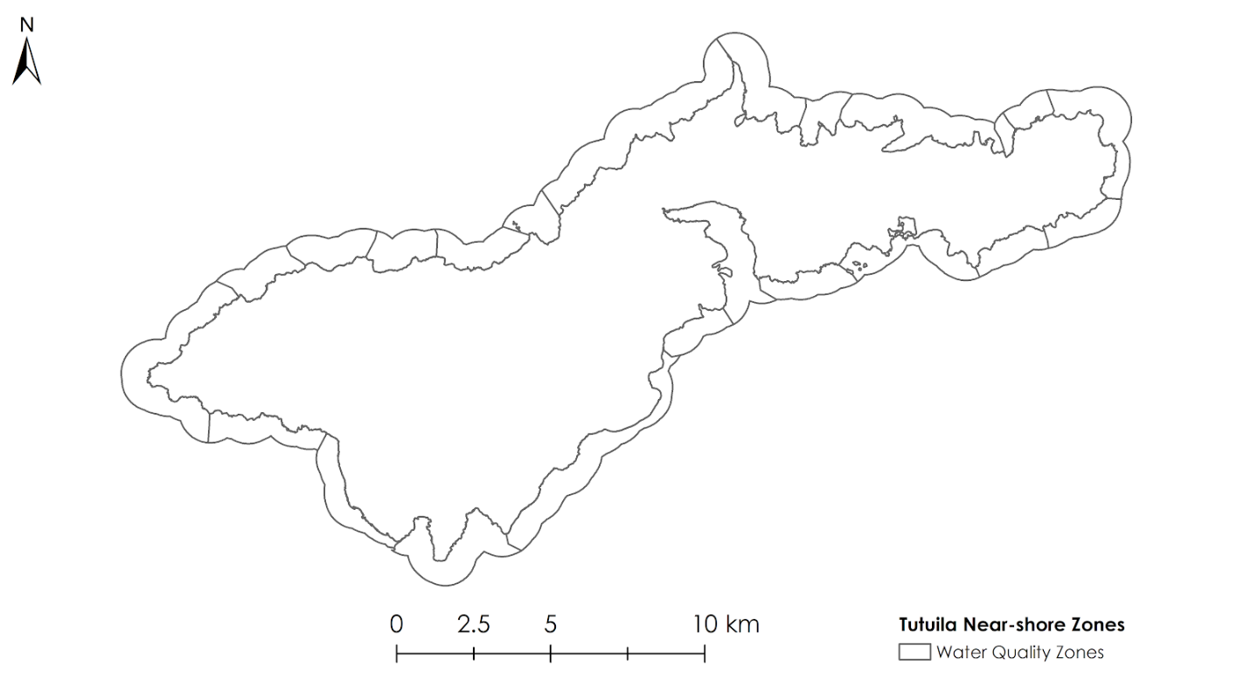
Figure B1. Zones within 1 km buffer area created to integrate water quality readings into random forest model

Appendix C. Island-Scale Annual Percent Cover Histograms

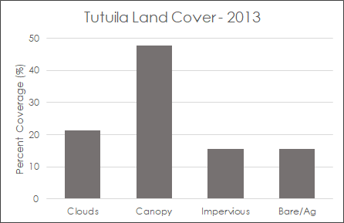 | 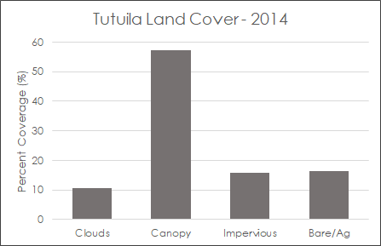
Figure C1. Tutuila island land cover for 2013 | Figure C2. Tutuila island land cover for 2014
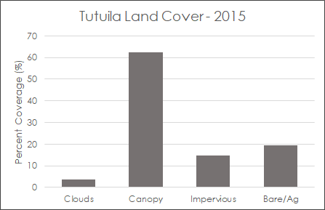 | 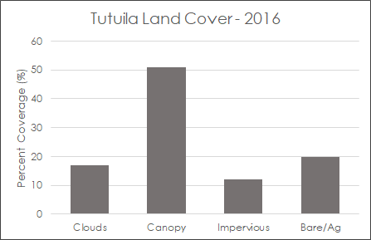
Figure C3. Tutuila island land cover for 2015 | Figure C4. Tutuila island land cover for 2016

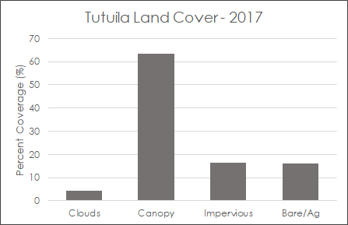 | 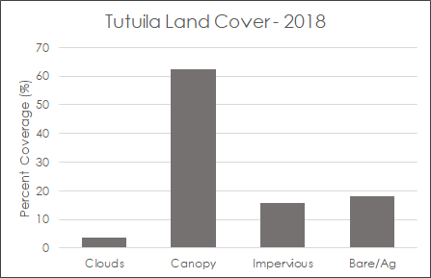
Figure C5. Tutuila island land cover for 2017 | Figure C6. Tutuila island land cover for 2018
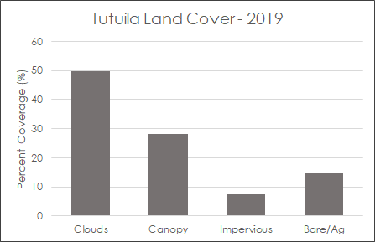
Figure C7. Tutuila island land cover for 2019

Appendix D. Island-Scale Annual Percent Cover Histogram

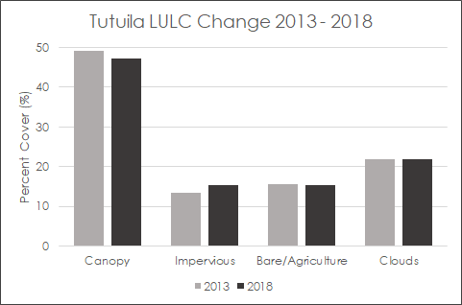
Figure D1. Tutuila island land cover percent change from 2013 to 2018

Appendix E. Island-scale Annual Land Cover Maps

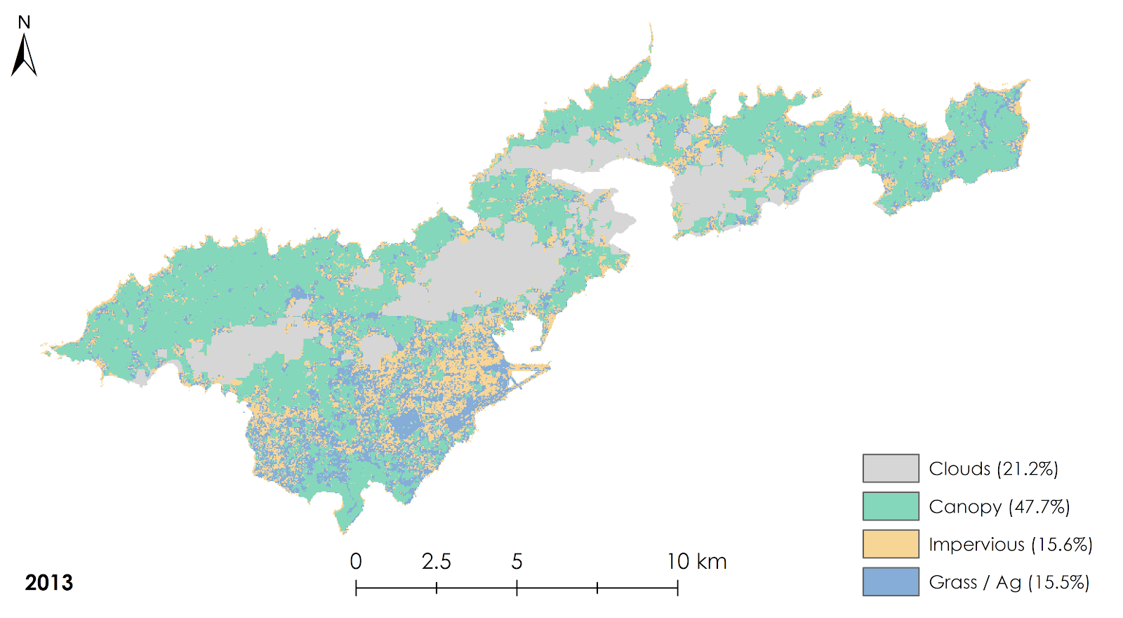Figure E1. Land cover classification for 2013 using a pixel composite of Landsat 8 Surface Reflectance imagery

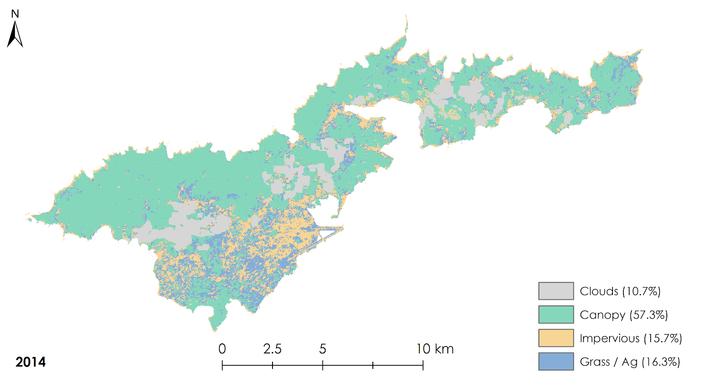Figure E2. Land cover classification for 2014 using a pixel composite of Landsat 8 Surface Reflectance imagery

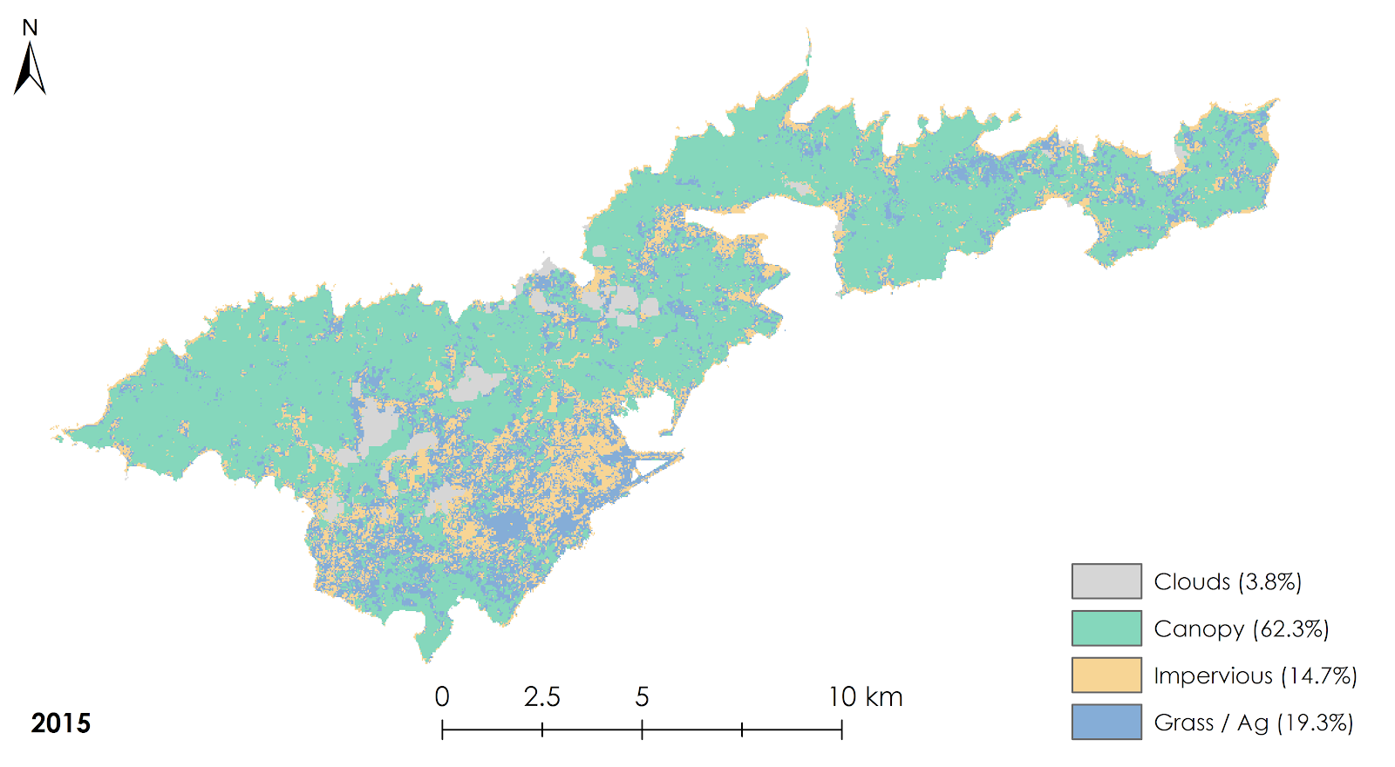Figure E3. Land cover classification for 2015 using a pixel composite of Landsat 8 Surface Reflectance imagery

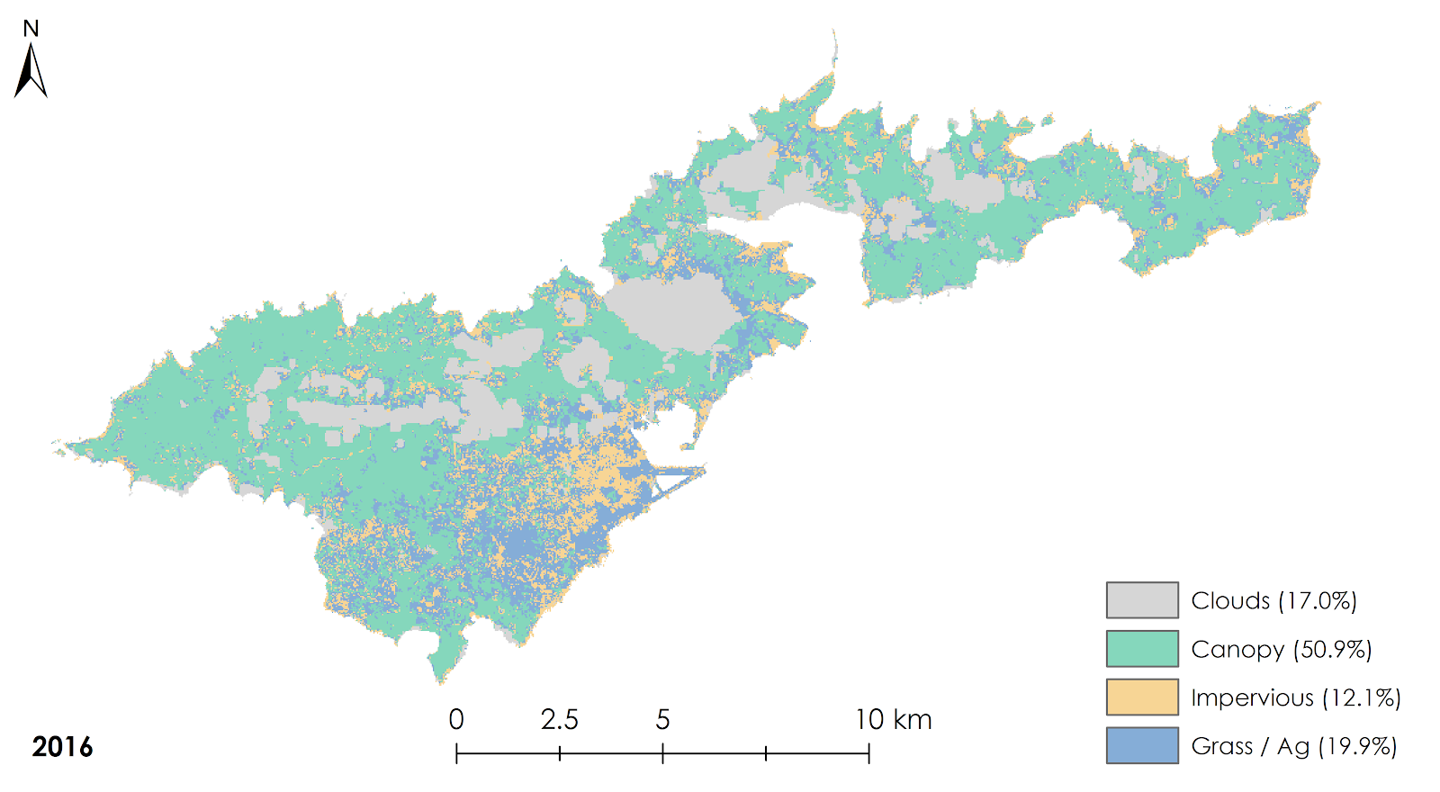Figure E4. Land cover classification for 2016 using a pixel composite of Landsat 8 Surface Reflectance imagery

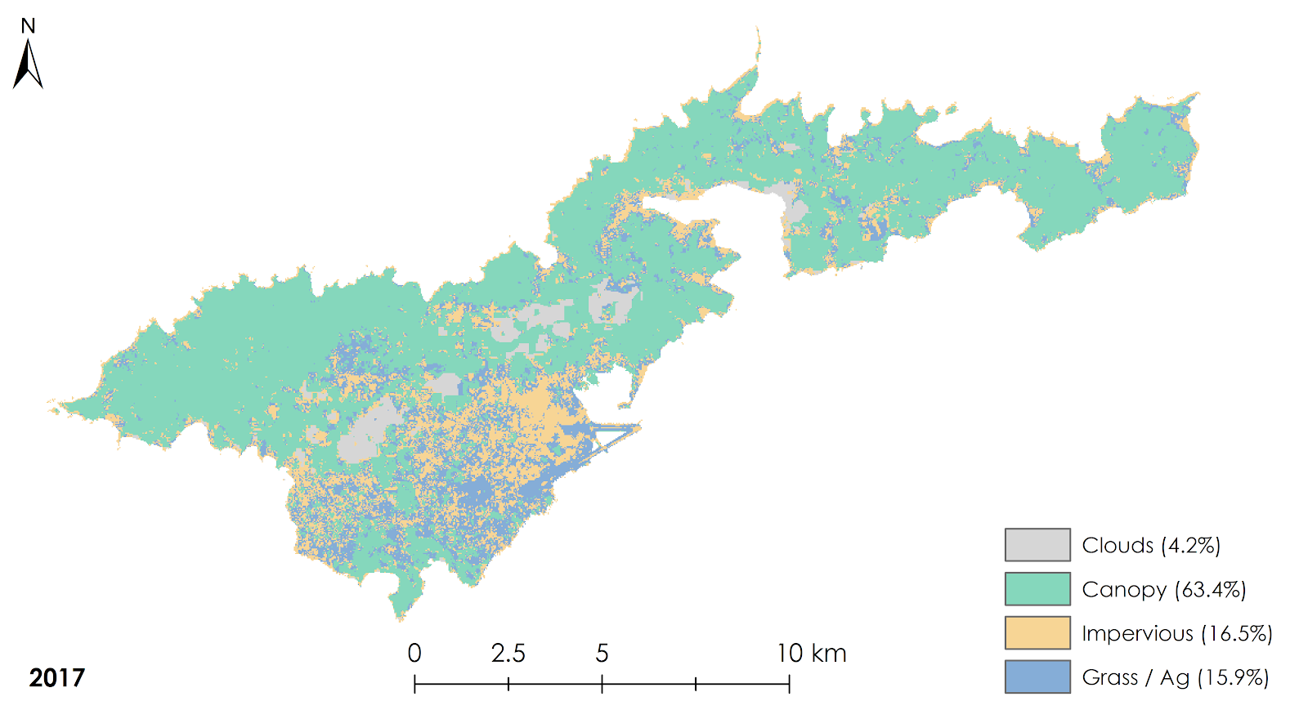
Figure E5. Land cover classification for 2017 using a pixel composite of Landsat 8 Surface Reflectance imagery

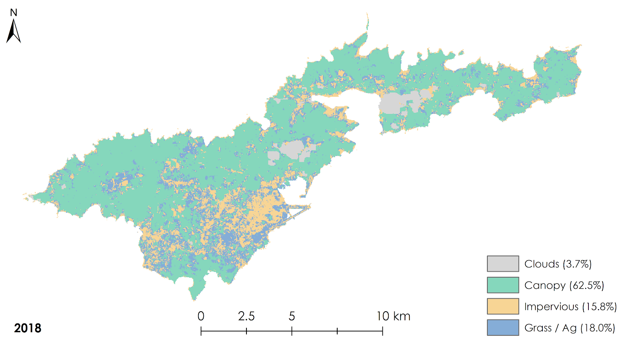
Figure E6. Land cover classification for 2018 using a pixel composite of Landsat 8 Surface Reflectance imagery

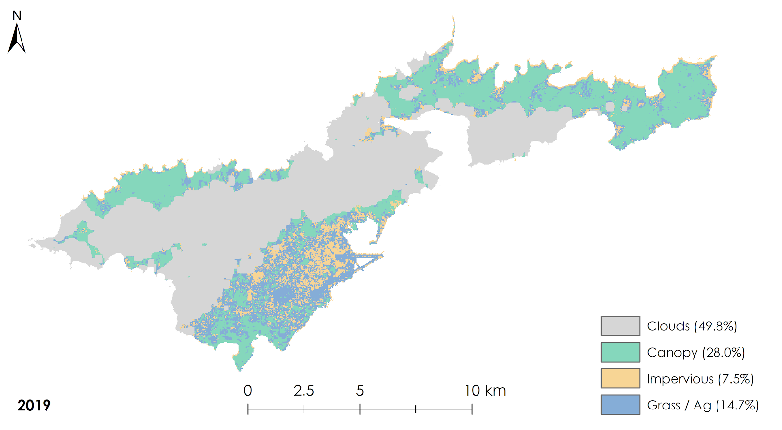Figure E7. Land cover classification for 2019 using a pixel composite of Landsat 8 Surface Reflectance imagery

Appendix F. Island-scale Annual Percent Cover

Table F1
Annual percent land cover on Tutuila using Landsat 8 pixel composites
Year | Percent Cover (%)
 | Clouds | Canopy | Impervious | Bare/Ag
2013 | 21.2 | 47.7 | 15.6 | 15.5
2014 | 10.7 | 57.3 | 15.7 | 16.3
2015 | 3.8 | 62.3 | 14.7 | 19.3
2016 | 17.0 | 50.9 | 12.1 | 19.9
2017 | 4.2 | 63.4 | 16.5 | 15.9
2018 | 3.7 | 62.5 | 15.8 | 18.0
2019 | 49.8 | 28.0 | 7.5 | 14.6

Appendix G. Island-scale Accuracy Assessment

Table G1
Accuracy assessment results for the images as a whole and accuracy by land cover class
Year | % Agreement | Kappa Coefficient | Producer Accuracy (%)
 |  |  | Clouds | Canopy | Impervious | Bare/Ag
2013 | 86.93 | 0.80 | 91.30 | 90.10 | 71.43 | 83.33
2014 | 83.50 | 0.72 | 84.00 | 86.29 | 84.00 | 69.23
2015 | 80.79 | 0.62 | 83.33 | 80.26 | 73.08 | 100.00
2016 | 77.00 | 0.62 | 100.00 | 72.93 | 73.33 | 66.67
2017 | 76.24 | 0.53 | 100.00 | 82.43 | 54.17 | 45.00
2018 | 78.82 | 0.58 | 100.00 | 78.43 | 82.61 | 64.71
2019 | 84.00 | 0.75 | 100.00 | 69.62 | 57.14 | 71.42
Average | 81.04 | 0.66 | 94.09 | 80.01 | 70.82 | 71.48

Appendix H. Watershed-scale Annual Percent Cover Histograms

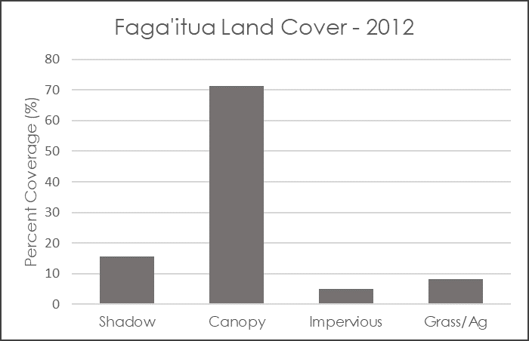 | 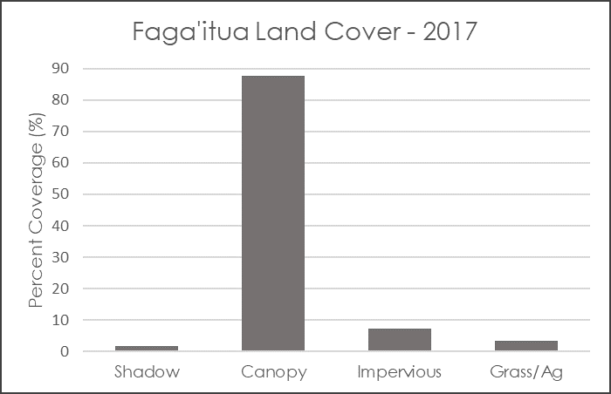
Figure H1. Faga’itua watershed land cover for 2012 | Figure H2. Faga’itua watershed land cover for 2017
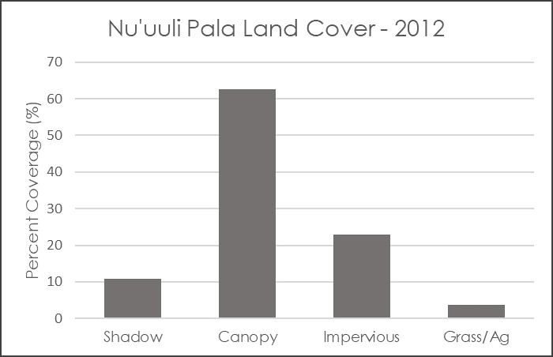 | 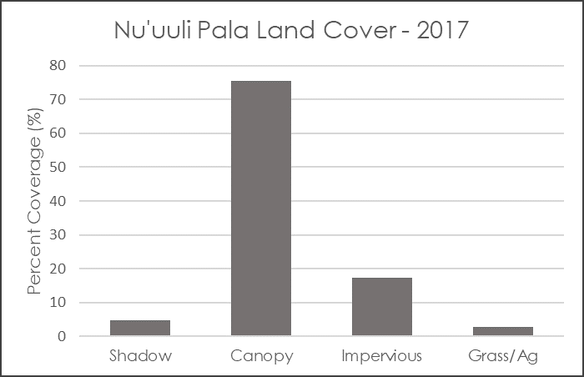
Figure H3. Nu’uuli Pala watershed land cover for 2012 | Figure H4. Nu’uuli Pala watershed land cover for 2017

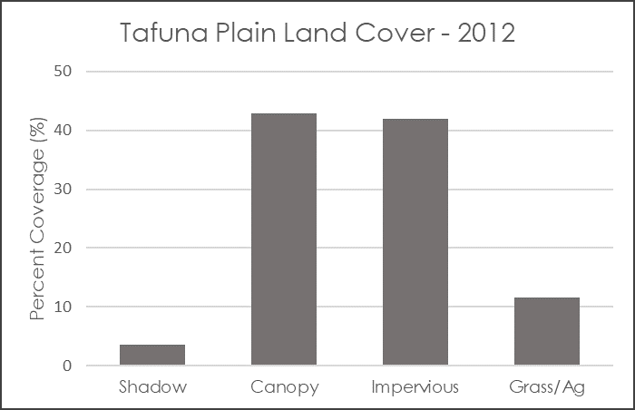 | 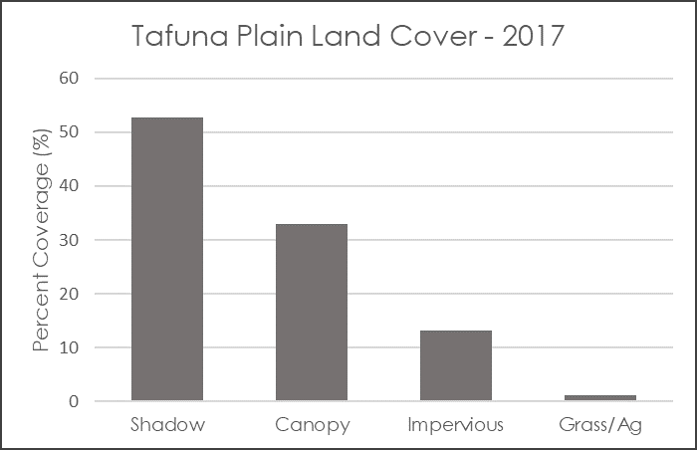
Figure H5. Tafuna Plain watershed land cover for 2012 | Figure H6. Tafuna Plain watershed land cover for 2017

Appendix I. Watershed-scale Percent Cover Change Histograms

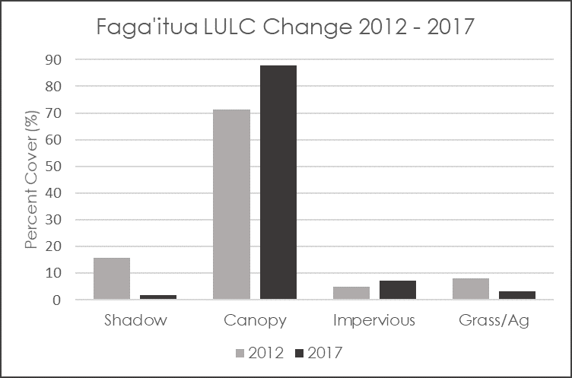 | 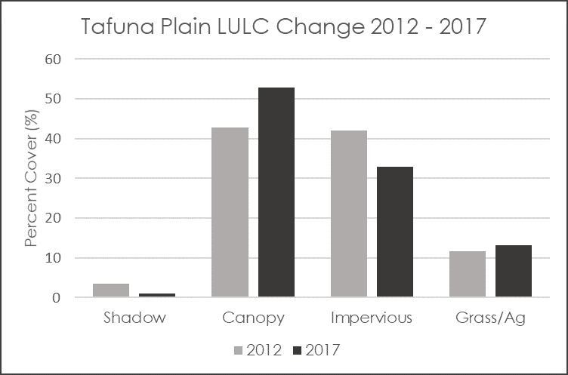
Figure I1. Percent land cover change of Faga’iuta watershed | Figure I2. Percent land cover change of Tafuna Plain watershed
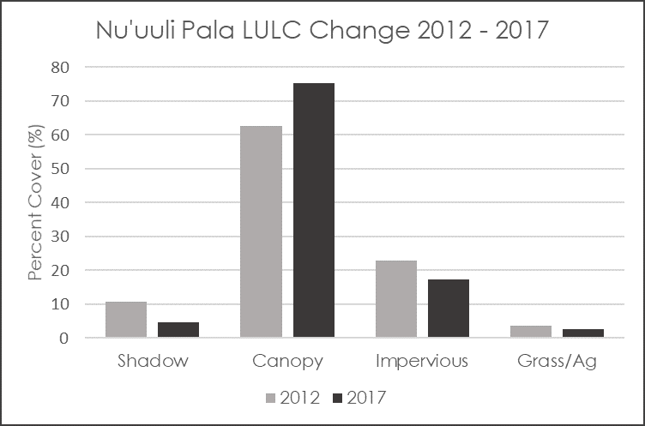
Figure I3. Percent land cover change of Nu’uuli Pala watershed

Appendix J. Watershed-scale Land Cover Maps: Tafuna Plain

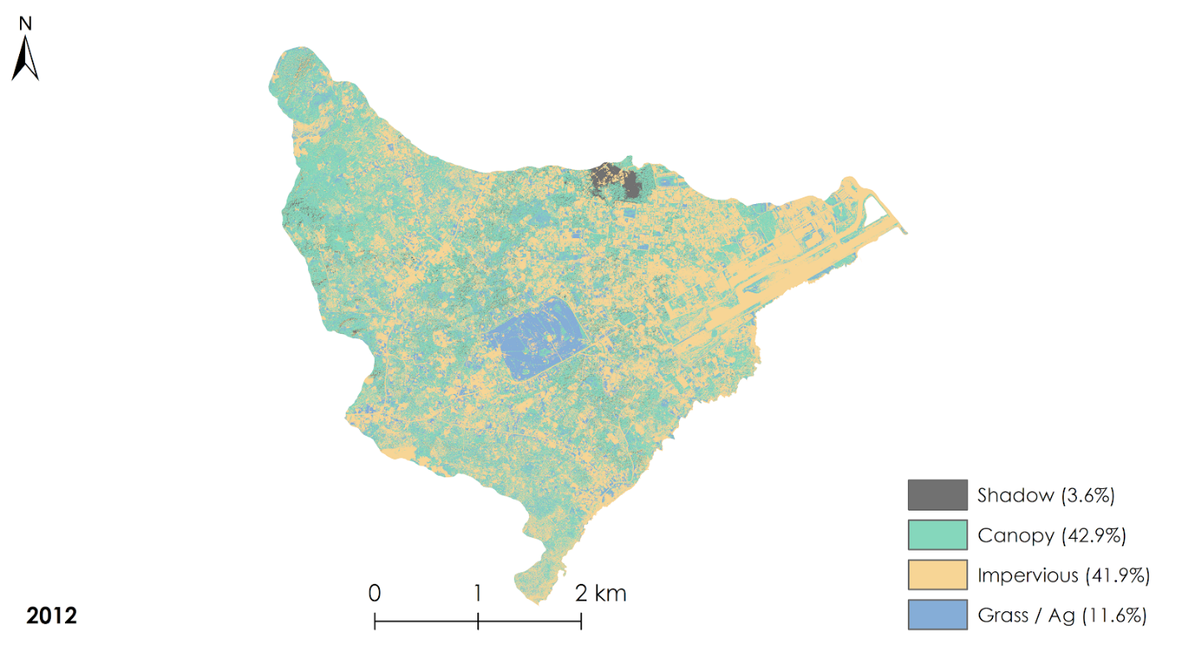
Figure J1. Land cover classification for 2012 of Tafuna Plain created from NRCS orthoimagery

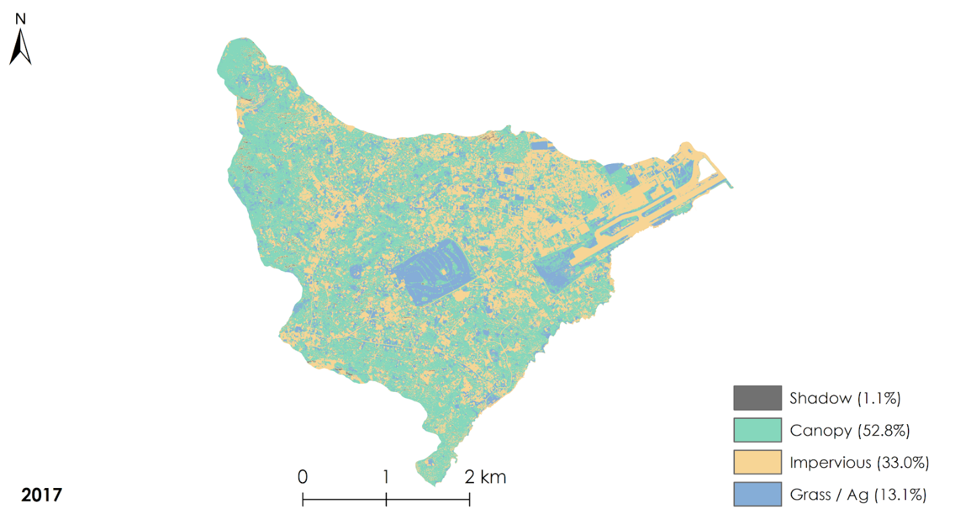Figure J2. Land cover classification for 2012 of Tafuna Plain created from NRCS orthoimagery

Appendix J. Watershed-scale Land Cover Maps: Faga’itua

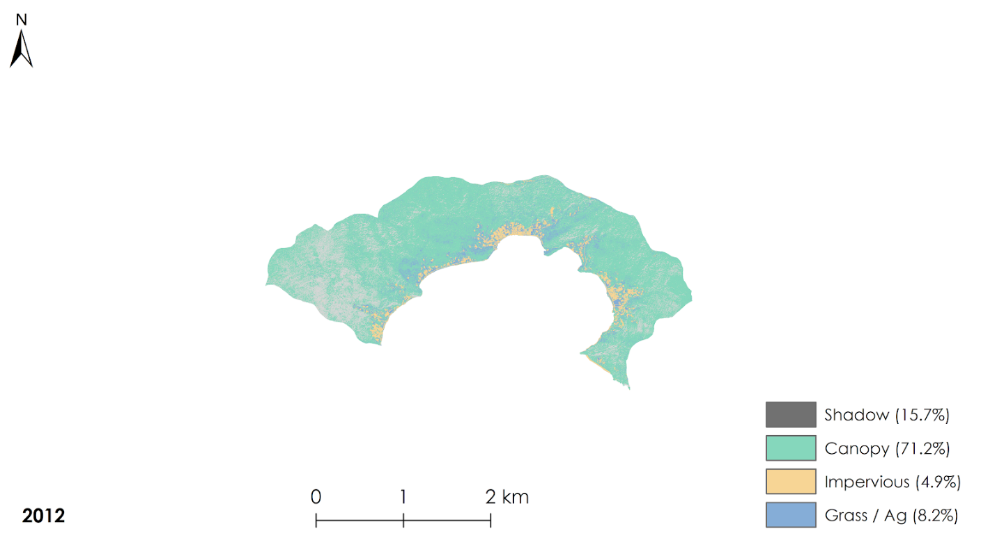
Figure J3. Land cover classification for 2012 of Faga’itua created from NRCS orthoimagery

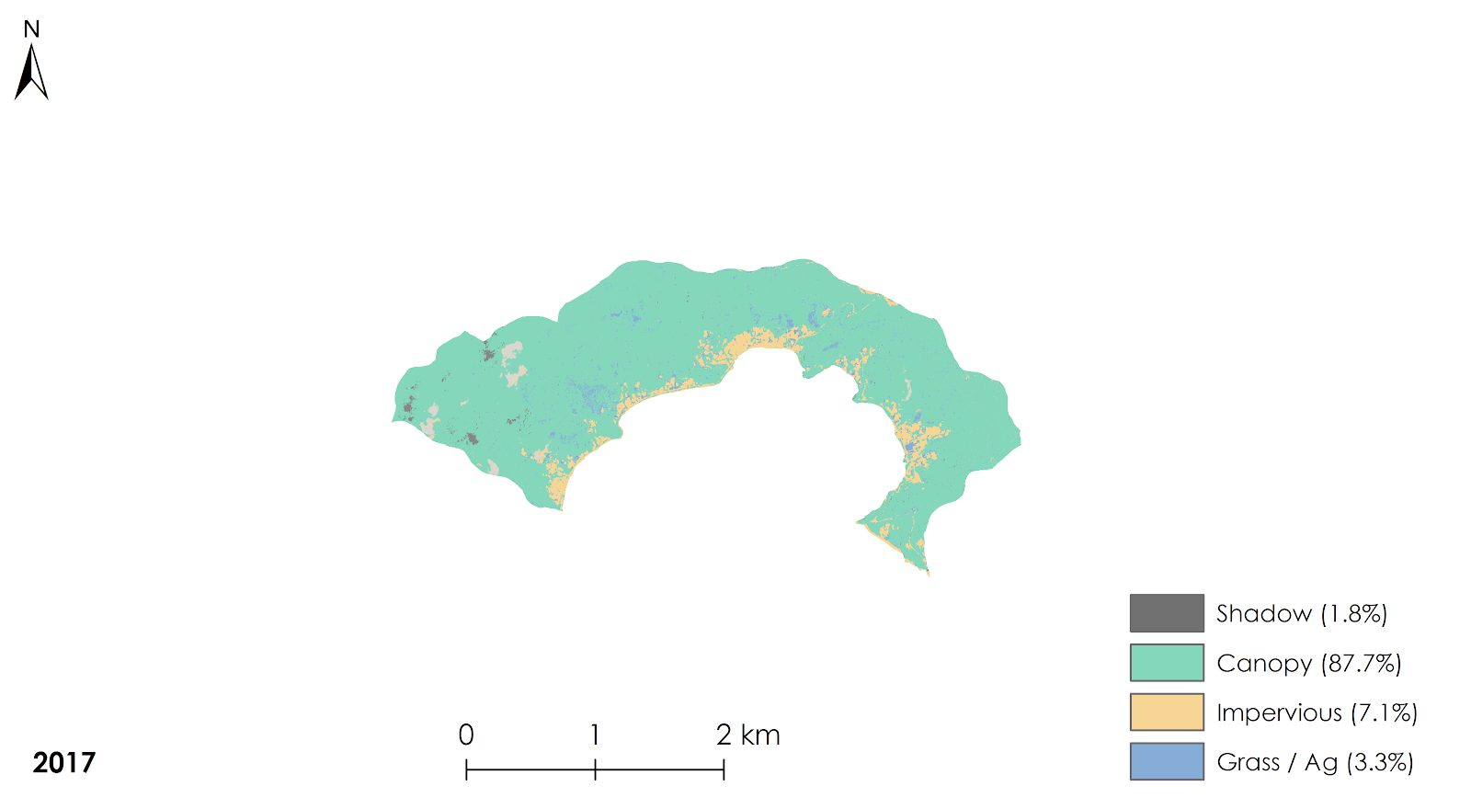Figure J4. Land cover classification for 2012 of Faga’itua created from NRCS orthoimagery

Appendix J. Watershed-scale Land Cover Maps: Nu’uuli Pala
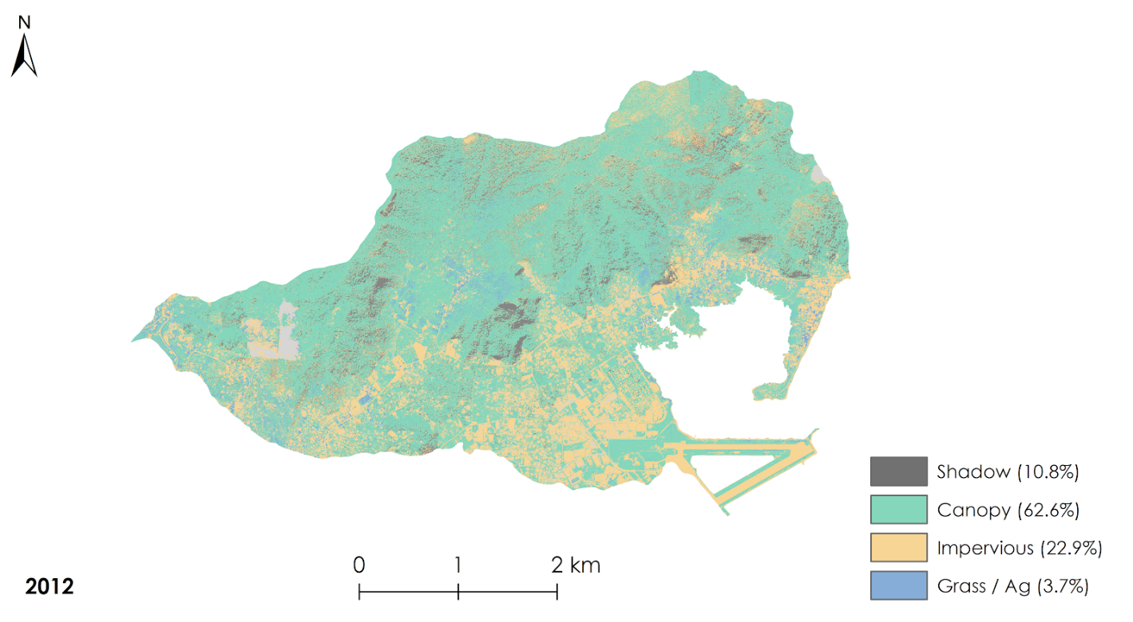
Figure J5. Land cover classification for 2012 of Nu’uuli Pala created from NRCS orthoimagery

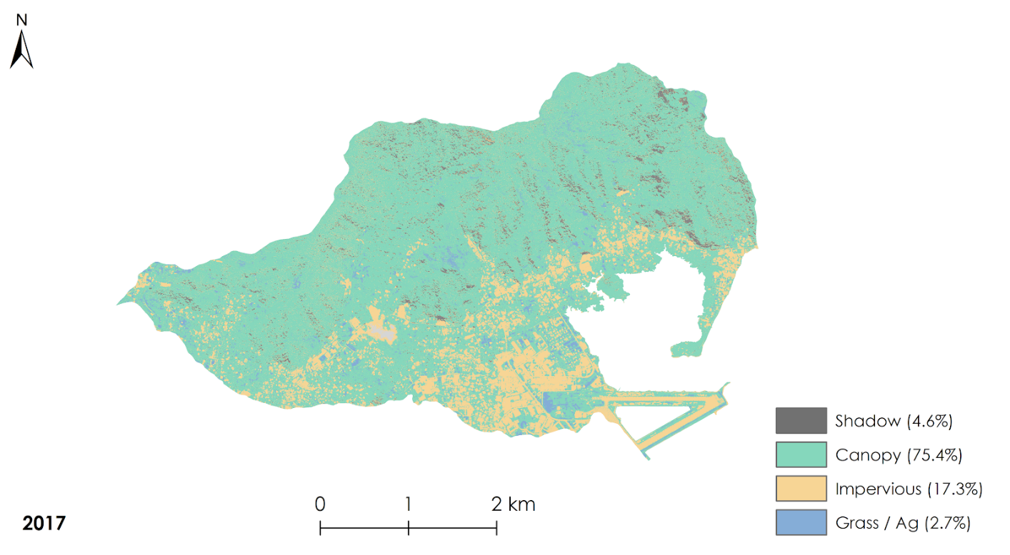Figure J6. Land cover classification for 2017 of Nu’uuli Pala created from NRCS orthoimagery

Appendix K. Watershed-scale Land Cover Change Maps

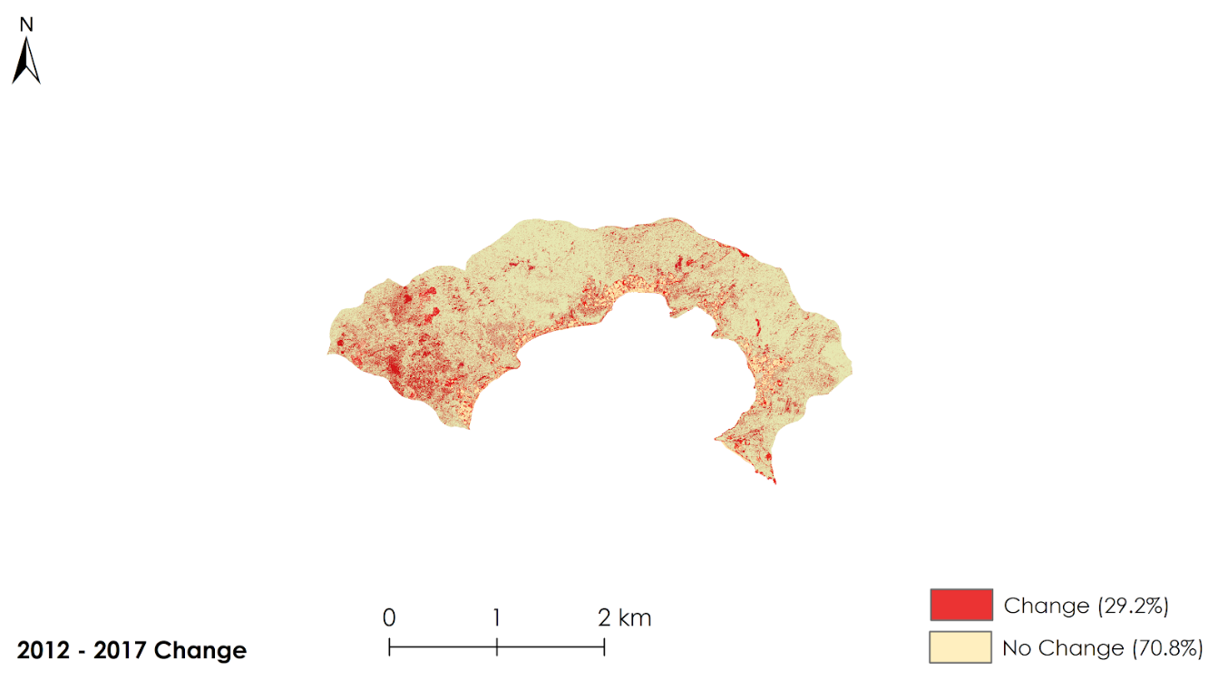
Figure K1. Detected degree of change in classifications between 2012 and 2017 for Faga’itua, one of the three watersheds of interest

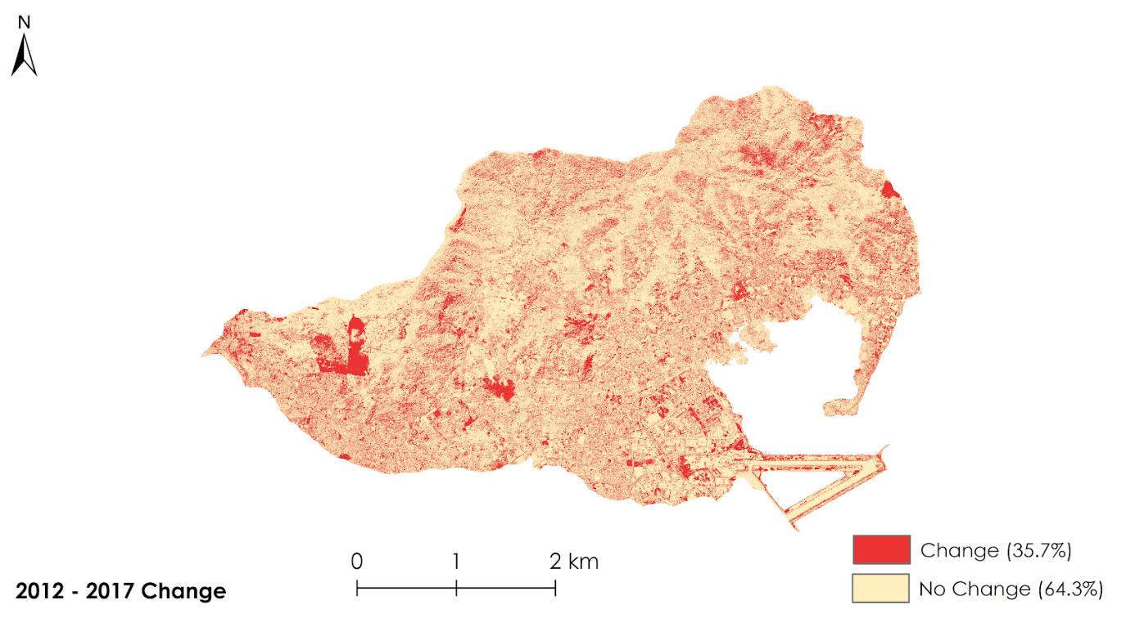
Figure K2. Detected degree of change in classifications between 2012 and 2017 for Nu’uuli Pala, one of the three watersheds of interest

Appendix L. Watershed-scale Accuracy Assessments

Table L1
Accuracy assessment results for the watershed as a whole and accuracy by land cover class
 | Year | % Agreement | Kappa Coefficient | Producer's Accuracy
 |  |  |  | Shadow | Canopy | Impervious | Grass/Ag
Tafuna | 12 | 64.18 | 0.48 | 10 | 74 | 100 | 34
 | 17 | 76.92 | 0.65 | 62 | 88 | 90 | 46
Faga'itua | 12 | 95.28 | 0.82 | 100 | 95 | 100 | 75
 | 17 | 90.09 | 0.62 | 86 | 93 | 91 | 33
Nu'uuli | 12 | 67.32 | 0.38 | 67 | 73 | 70 | 26
 | 17 | 74.29 | 0.47 | 50 | 88 | 58 | 32

Appendix M. Chlorophyll-a Concentration Maps

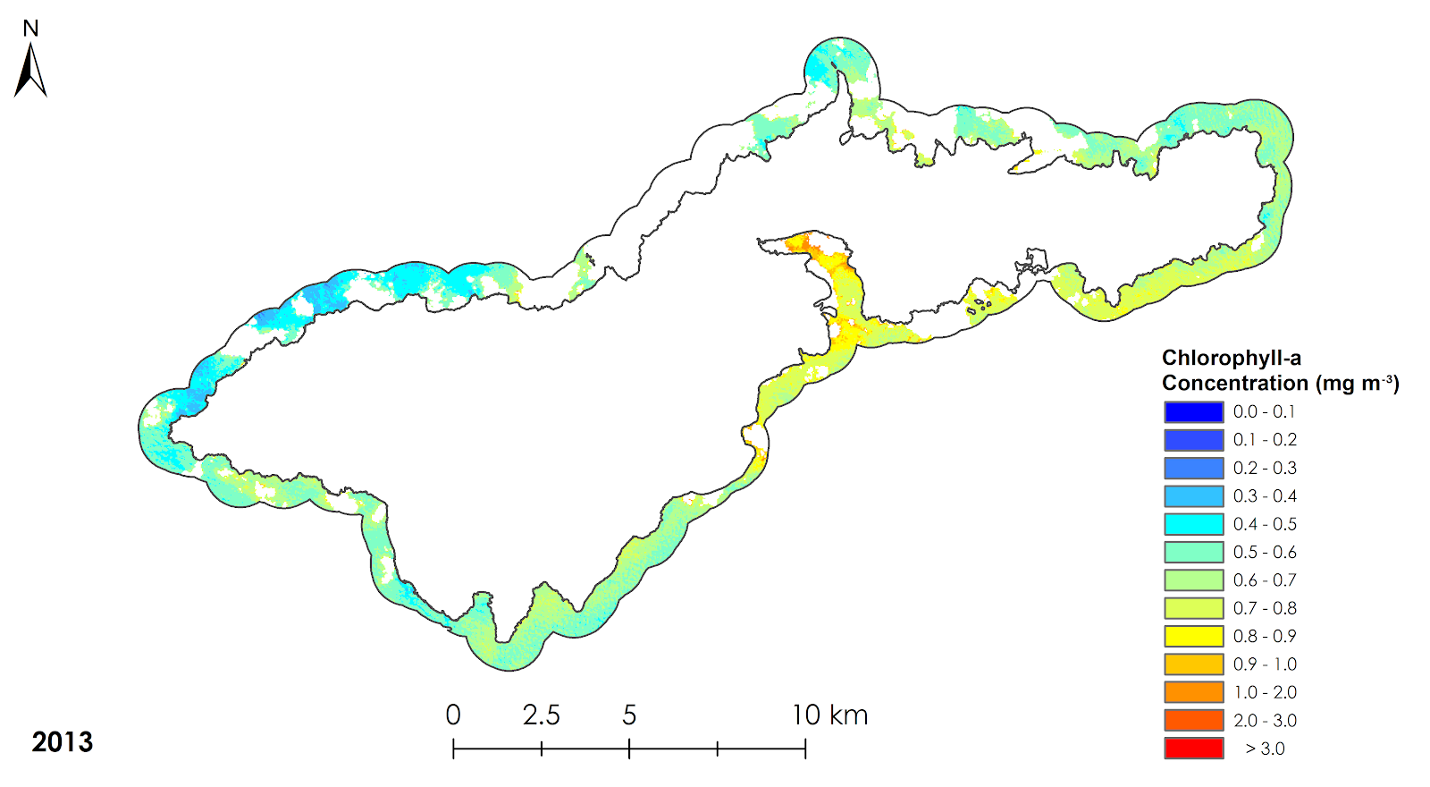
Figure M1. Chlorophyll-a concentration around Tutuila in the dry season of 2013

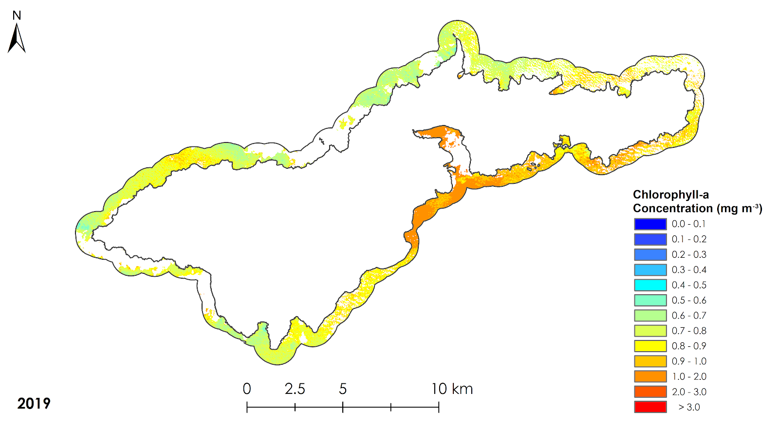
Figure M2. Chlorophyll-a concentration around Tutuila in the dry season of 2019

Appendix N. Chlorophyll-a Variable Importance Chart

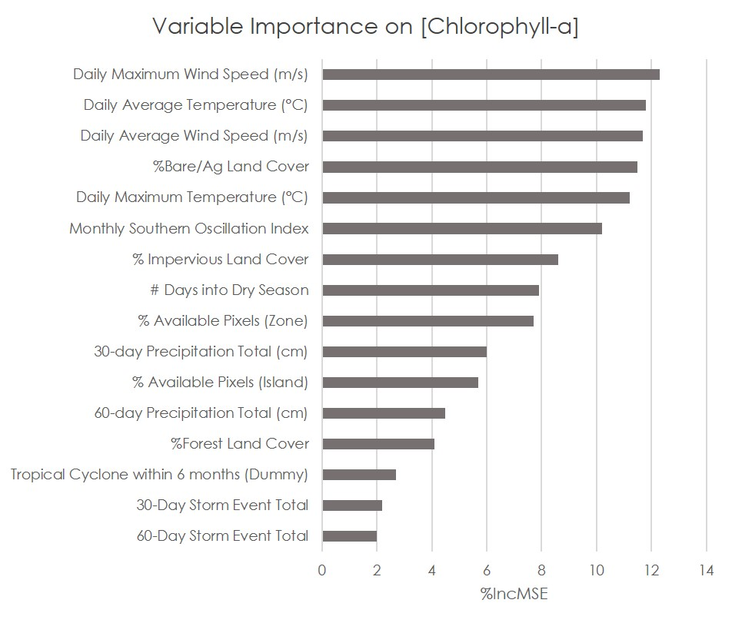
Figure N1. Relative Variable Importance (% Increase MSE) in explaining [Chlorophyll-a]

Appendix O. Random Forest Model Partial Dependence Charts

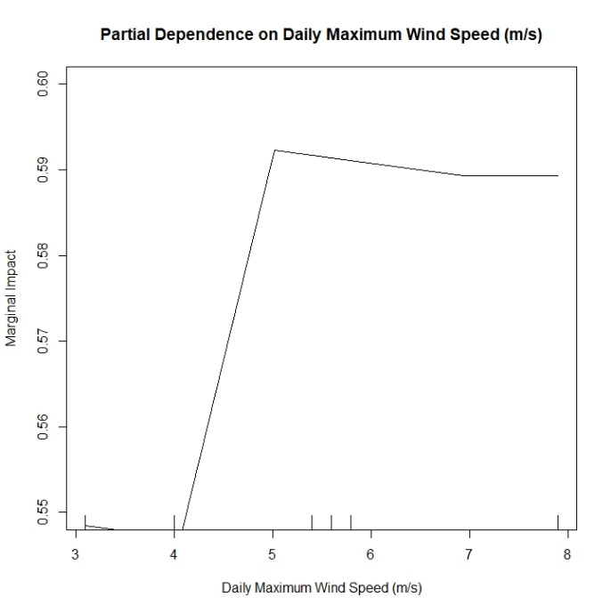 | 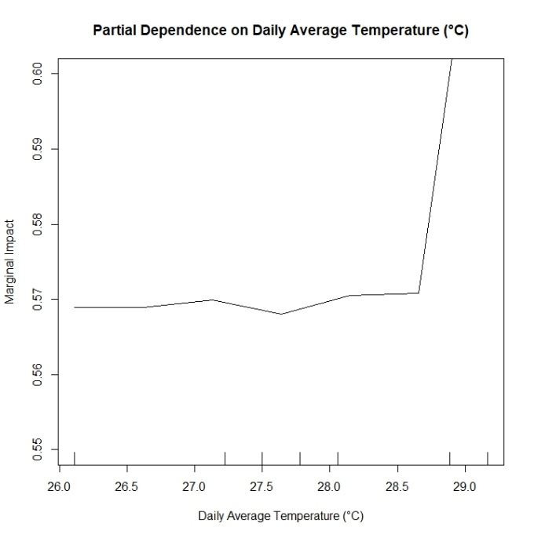
Figure O1. Partial dependence of Chl-a on daily maximum wind speed | Figure O2. Partial dependence of Chl-a on daily average temperature
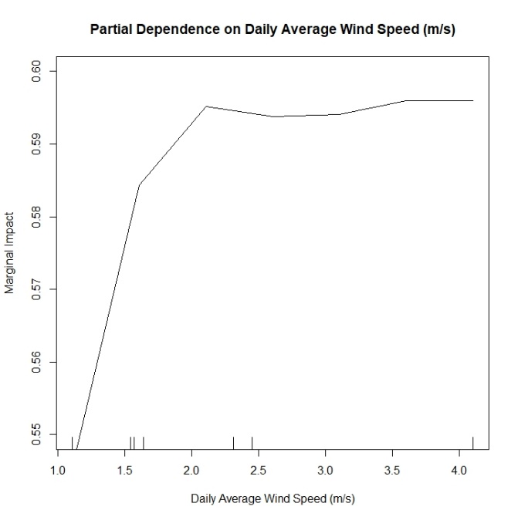 | 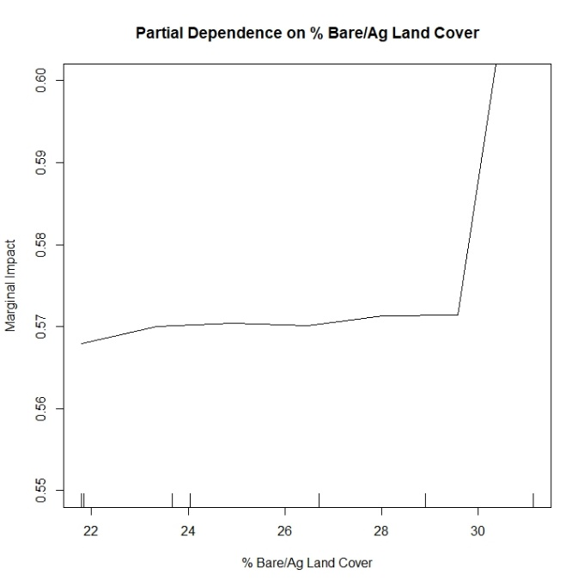
Figure O3. Partial dependence of Chl-a on daily average wind speed | Figure O4. Partial dependence of Chl-a on percent cover of bare and agricultural land

Appendix O. Random Forest Model Charts

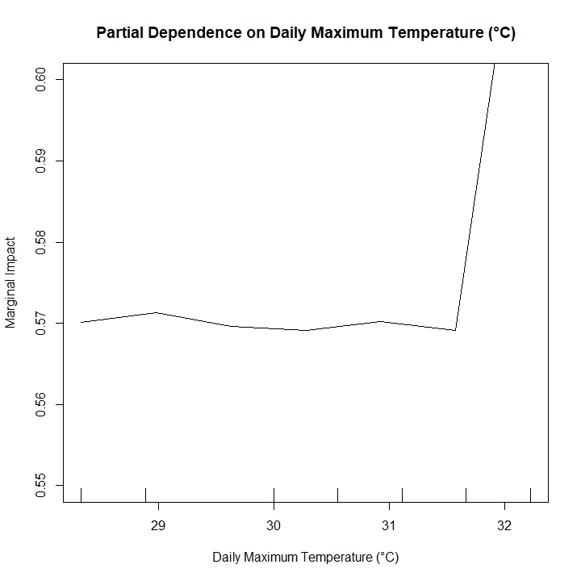
Figure O5. Partial dependence of Chl-a on daily maximum temperature

