**NASA DEVELOP National Program**



Alabama – Marshall

*Fall 2017*

North Alabama Ecological Forecasting

Spatial Modeling of the Fragmentation of Local Species Habitat from Increasing Urbanization in North Alabama

 **Technical Report**

Final Draft – November 17, 2017

Nicholas McVey (Project Lead)

Helen Baldwin-Zook

Emily Kinkle

Dr. Jeffrey Luvall, NASA Marshall Space Flight Center (Science Advisor)

Dr. Robert Griffin, University of Alabama in Huntsville (Science Advisor)

Leigh Sinclair, University of Alabama in Huntsville/Information Technology and Systems Center (Mentor)

# 1. Abstract

Alabama is one of the four most biodiverse states in the United States, and is the state with the overall greatest diversity of aquatic species in the U.S. This biodiversity is at risk as urbanization increases in Alabama. The Land Trust of North Alabama works to preserve green space and encourages stewardship through environmental education. The North Alabama Ecological Forecasting team partnered with the Land Trust of North Alabama to identify areas critical to maintaining local species habitat within Madison and Limestone counties. As urbanization increases within these counties, essential habitats are threatened. To identify where land cover changes are occurring and areas are most vulnerable to urbanization, the North Alabama Ecological Forecasting team conducted a supervised classification of land class types utilizing data from Landsat 5 Thematic Mapper (TM), Landsat 8 Operational Land Imager (OLI), and Shuttle Radar Topography Mission Version 4 (SRTM). The team then used the classification along with other parameters to produce an Urbanization Model Algorithm, Urbanization Prediction Tool, and a Landscape Fragmentation Map. These tools will enable the Land Trust of North Alabama to target land for acquisition and subsequent preservation and stewardship.

**Keywords**

Remote sensing, Landsat 8, Landsat 5, land use, urban growth, North Alabama, biodiversity

# 2. Introduction

This project focused on Madison and Limestone counties in northern Alabama (Figure 1). These two counties have undergone significant development over recent years and are expected to continue to flourish. From 1980 to 2010, the Madison County population has increased by over 137,000 people, while Limestone County has grown by over 36,000 people (U.S. Census Bureau, 2012). Increased commercial development and urbanization in rural areas of western Madison and eastern Limestone counties of northern Alabama are altering the natural makeup of the landscape. Madison and Limestone counties have just over 1,400 square miles of biodiverse land. One of the most common reasons for development of land is for agriculture as local production of food must keep up with a growing population. More large-scale agricultural fields lead to increased runoff pollution which negatively impacts native species’ habitats. In addition to agricultural development, urban growth is also a concern for local species’ habitats as the city of Huntsville is one of America’s fastest growing cities. These areas are a primary concern for the project partners, the Land Trust of North Alabama. The Land Trust is specifically concerned that rapid growth development in Madison and Limestone counties will negatively impact the natural landscapes of the region, and more importantly, the habitats of threatened and endangered species found in the area. This boom in urbanization highlights challenges and necessities for expanded conservation efforts. Without sufficient conservation efforts, many species in the area could be at risk of habitat loss, including 30 endangered and threatened species (U.S. Fish & Wildlife Service, n.d.). This project used data from 1980 – 2017 to project urbanization to 2045 and analyze the threat of urbanization to local species’ habitats.

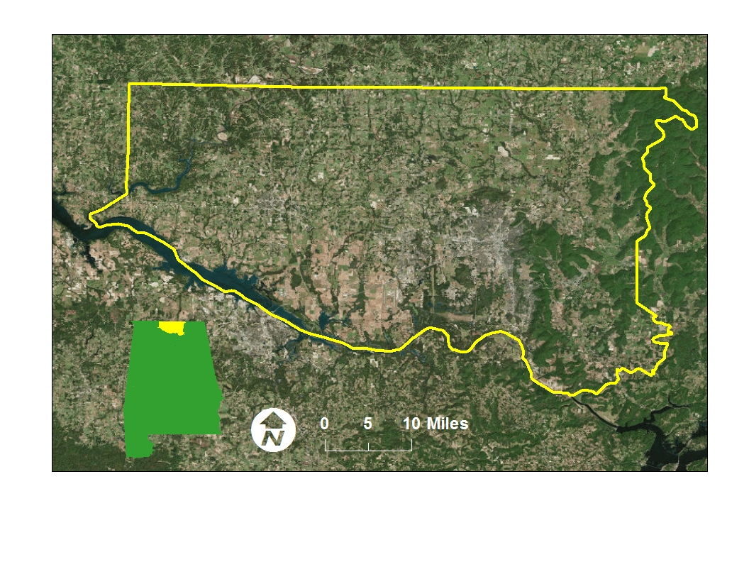

**Madison and Limestone Counties**

*Figure 1*. This is a map of the study Area of Madison and Limestone Counties in northern Alabama.

* 1. ***Project Partners & Objectives***

The ecological forecasting application area studies land use and land change from past to present in order to understand how the environment is changing. Understanding how the land is changing allows for the development of a model that projects where and what future land change is most likely. This model can be beneficial to conservation efforts and sustainable ecosystem management by providing information about potentially negative changes in land use such as wetland to urban development. Understanding where these potentially harmful land use changes are possible will allow policy makers to take necessary steps to mitigate the negative effects of development. The North Alabama Ecological Forecasting team partnered with the Land Trust of North Alabama to predict urbanization trends and their impact on local habitats. The Land Trust’s mission is “to preserve and protect land and its legacies, including wildlife habitats, farms, historic sites, waterways, and mountains for conservation, public recreation, and environmental education to enhance quality of life in North Alabama” (Land Trust, 2017). This organization works with local land owners and government officials to acquire land for conservation and to educate the public and the land owners about the natural habitats and ecosystems that are present in the local area. There are some restrictions at the federal level that encourage conservation, such as building restrictions in flood plains mandated by the Federal Emergency Management Agency—however, the Land Trust works to preserve land that would otherwise be available for development. Currently, the Land Trust primarily obtains land in Madison County. Due to increasing populations and urbanization, they seek to preserve land in Limestone County as well. The Land Trust’s decision making heavily relies on field studies and outsourced or volunteered research. The organization needs an accurate system for long-term strategic conservation planning, but currently do not possess the resources to develop an automated tool for them to use.

The team developed end products to assist the Land Trust in making decisions regarding conservation of land. The Favorability for Development Map and Species Impact Tool will provide the Land Trust with additional information about predicted development and subsequent impact on habitat to effectively make a case for procurement of land. Once the land is obtained, the Land Trust can allocate the necessary resources to preserve and protect areas of interest that are home to threatened or endangered species. Aside from acquisition of land, the Land Trust will be able to use the tools developed from this project to educate the public and land owners in the area about the potential impact of development on local species habitats, which will aid in conservation efforts.

# 3. Methodology

***3.1 Data Acquisition***

The team acquired Landsat 5 Thematic Mapper (TM) (USGS Landsat 5 TOA Reflectance (Orthorectified with Fmask) and Landsat 8 Operational Land Imager (OLI) image collections through Google Earth Engine. The team developed a code to parse through these image collections and retrieve the least cloudy image for the Path/Row combinations that covered the study area for each year of the study period. The code also incorporated a study area shapefile created in ArcMap 10.4 and Google Earth, to clip the imagery to Madison and Limestone counties. Shuttle Radar Topography Mission v4 data were downloaded from cgair-csi.org to provide the topography of the region (Jarvis 2008).

The project partners at the Land Trust identified several species of particular interest. These species were the Price’s potato bean (*Apios priceana*), the green salamander (*Aneides aeneus*), and Morefield’s leather flower (*Clemamtis morefieldii*). The team also acquired data on the American black duck (*Anas rubipes*), the cave salamander (*Eurycea lucifuga*), and the northern slimy salamander (*Plethodon glutinosus*) and were also included in the study. Green salamander observations within the study area were acquired from Andrew Cantrell, a student researcher at Alabama Agricultural and Mechanical University, and Rebecca John from Auburn University. Data for American black duck observations were retrieved from the eBird website as a text file and converted to CSV for use in Esri ArcGIS. Price’s potato bean, cave salamander, and northern slimy salamander data were acquired from Christine Easterwood at the U.S. Army Garrison, Redstone Arsenal, and Rebecca John at Auburn University. Morefield’s leather flower data were acquired from Michael Barbour at the Alabama Natural Heritage Program, Auburn University.

Data for the urbanization model were acquired from the Homeland Infrastructure Foundation-Level Data (HIFLD) Subcommittee open data webpage, from which location data for colleges, fire stations, hospitals, and public schools were isolated. The 2006 and 2011 National Land Classification Database (NLCD) acquired from the Multi-Resolution Land Characteristics Consortium (MRLC) website in order to determine the average urban growth rate for the study area.

***3.2 Data Processing***

The datasets acquired by Google Earth Engine had undergone a Top of Atmosphere (TOA) correction. The Top of Atmosphere corrections converts the Digital Number values that the remotely sensed information is stored in to a meaning reflectance value that can be used to determine the source of the values. Additionally, the SRTM data covering both Limestone and Madison counties were acquired as two separate rasters. These rasters were mosaicked together and clipped to the study area shapefile.

For the HIFLD data, the team considered how areas surrounding the study area such as large cities just outside of the study area could potentially impact results. The team incorporated data including the surrounding areas in the analysis to more accurately represent the study area and variable effecting potential urban growth. A shapefile was created to encompass the study area and surrounding areas. All of the point data were clipped to the new shapefile, and distance rasters for each dataset were made using the Euclidean Distance tool. The NLCD data was reclassified from least suitable to most suitable for urbanization.

***3.3 Data Analysis***

To project urbanization, Fuzzy Logic Modeling was used in ArcMap 10.4. First, the Fuzzy Membership tool was used to assign fFuzzy Membership values to each of the datasets being used. The team determined that the most appropriate membership for distances to colleges, fire stations, public schools, and hospitals was a linear membership. This was determined based on the knowledge that people prefer to live near these specific locations and, therefore, the areas nearby these places will typically be built up before an area further away. A MSLarge membership was used for the reclassified NLCD, meaning that the input values with larger values have higher membership. After assigning the Fuzzy Memberships, the data were clipped to the study area shapefile. All of the Fuzzy Memberships were then input into the Fuzzy Overlay tool.

The average total change of developed land per year was calculated using the 2006 and 2011 NLCD. All pixels classified as developed (i.e. High, Medium, Low, and Open) were counted respectively, the 2006 total was subtracted from the 2011 total, and then divided by the intervening years. This process generated an urban growth rate of 1% per year for north Alabama. The team repeated this calculation with a Maximum Likelihood land classification for 2006 and 2011 created from Landsat 5 imagery in the efforts that the team’s land use classification would potentially be more accurate than the NLCD’s and therefore more representative of the true growth rate of north Alabama. The average urban growth rate calculated was approximately 2%. The accuracy of the NLCD classification is 85% (Wickham, 2013) and incorporates a ground truth verification process—therefore, further analysis used the growth rate derived from the NLCD rather than the visual classification created. Using the NLCD classification growth rate, the team estimated the projected development through 2100, including the project amount of total urban area (Appendix A). To understand the significance of this urban growth rate, the team examined the number of years it would wake this 1% urban growth per year to develop all of the highly favorable lands. Highly favorable lands are designated as so by being open lands and having the lowest average distance to each of the 4 factors chosen, fire stations, colleges, hospitals, and public schools. To do this used the total area (km2) of the highly favorable classification from the Favorability for Development Map and subtracted this estimate growth from it. This process shows the estimated number of years it would take at 1% urban growth per year to develop all of the highly favorable lands. Figure 3 below shows this estimation.

After the projected urban growth map was analyzed, an impact analysis was conducted on local species habitats in efforts to assess where potential land development could negatively impact local species. The point location observations of each species served as a basis for the species impact map. The impact of urbanization does not need to be directly on top of the existing species habitat to impact the species—therefore, the team created a buffer around each point of the species data in efforts to better represent the impact of encroaching urbanization. Songbirds typically need a buffer of at least 150 - 330 feet, and sometimes can extend to 660 feet (Hannon, 2012). Mammals can require a buffer ranging from about 300 to 1000 feet around their habitat (Bilecki, 2003). Fish and aquatic species need a relatively small 33 to 330 feet buffer (Jones, 1999). Ultimately, a 250-meter buffer was selected to represent the necessary buffer size for all species. After the buffers were created, each species’ habitat was intersected with the Favorability for Development Map.

# 4. Results & Discussion

***4.1 Analysis of Results***

The output of this tool (Figure 2) shows favorability for development from low to high. The areas already developed can be identified as well, since developed land was assigned the highest membership.

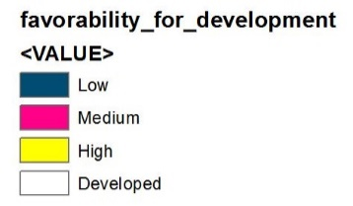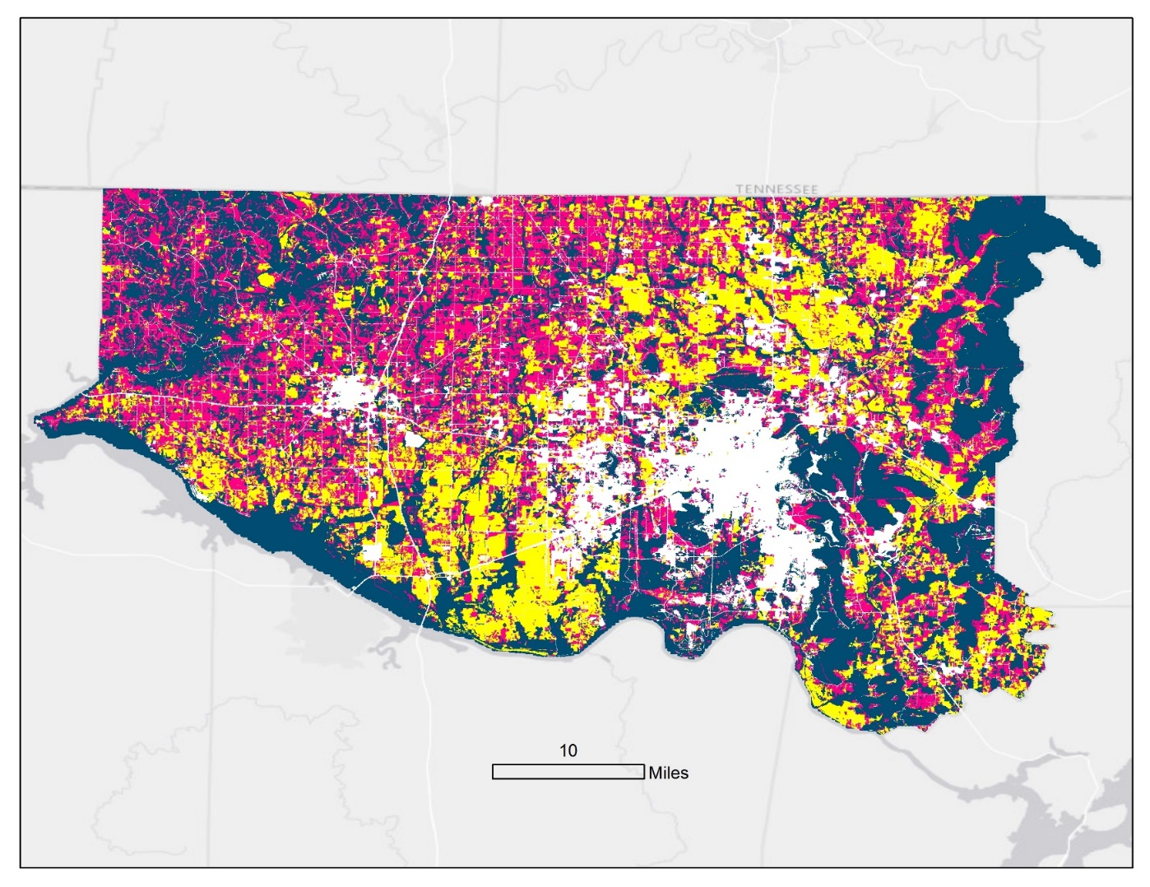

Developed

High

Medium

Low

**Favorability for Development**

*Figure 2.* This map shows the favorability for development in Madison and Limestone counties.

*Figure 3.* This table depicts the projected total amount of highly favorable land available (in sq. km.) in north Alabama from the year 2017 through 2101.

*Table 1.* An analysis of threat to species habitat due to increasing urbanization

|  |  |  |  |
| --- | --- | --- | --- |
| Species | Area in High  m2 | Area in Medium  m2 | Area in Low  m2 |
| American Black Duck  *Anas rubripes* | 1.7x106 | 1.0x106 | 6.0x106 |
| Green Salamander  *Aneides geneus* | 6.2x104 | 3.0x105 | 7.4x106 |
| Morefield’s Leather Flower  *Clematis morefieldii* | 1.1x104 | 4.9x104 | 1.7x106 |
| Northern Slimy Salamander  *Plethodon alutinosus* | 6.2x104 | 3.0x105 | 7.4x106 |
| Cave Salamander  *Eurycea Lucifuga* | 6.2x104 | 3.0x105 | 7.4x106 |

*Figure 4.* Threat to species habitat due to urban development

From the table, the current extent of highly favorable land available is approximately 760,000 km2. It is projected that by the year 2045, approximately 25% of all highly favorable land will be developed. The 25% increase in developed areas across north Alabama would yield that 16% of the total land area in Madison and Limestone counties will be considered developed. Furthermore, at the 1% growth rate, all highly favorable lands are projected to be developed by the year 2100. As Limestone and Madison counties continue to grow, it is possible that the 1% growth rate will increase over time, which could potentially accelerate the development of lands in north Alabama.

The American black duck (Anas rubripes) had the largest amount of habitat in areas highly favorable for future land development., and accounted for the highest overall threat without 8,600 sq.km. of their habitat falling into a category of development (Table 1). With such a large amount of the American Black Duck habitat falling into high and medium levels of potential development, the species will likely face negative impacts from future development.

The green salamander, cave salamander, and northern slimy salamander all had similar amounts of habitat that fell into each development favorability level. This is most likely due to the similarity of their habitats. The salamanders’ habitats primarily fell into the low favorability classification, which means that the potential impact from future urban growth is minimal in the near future.

The Morefield’s leatherflower had the lowest amounts of area in any of the development favorability categories. Consequently the threat of impact on the Morefield’s leatherflower’s habitat is the lowest all species studied for this project.

***4.2 Future Work***

Including more species would more accurately portray the impacts of urbanization. The project only assessed the impact of urbanization on select species, but all species living in the areas facing development will be impacted. The species studied were chosen based on project partner interest and available data, but measuring the potential impact of urbanization on these few species could be misleading. If the impact is underestimated, further development could be extremely detrimental to species not included in this project. On the other hand, if the impact is overestimated, development may be impeded resulting in profit losses for the city and county.

Additionally, the team determined that most of the endangered species in the study area are aquatic, such as clams, snails, and fish. Creating a hydrological model would more accurately portray the impact of urbanization on aquatic species. This model would provide a meaningful way to measure the estimated effects of potential runoff from newly developed agricultural land and urban development on aquatic species.

This project was designed around the Landsat series of satellites to gather a better understanding of the historical context of urbanization of north Alabama. Looking forward, this project could be conducted using Sentinel-2 data, as it has much higher spatial and temporal resolution. These improvements would allow for more accurate maps to be produced for the Land Trust of North Alabama.

# 5. Conclusions

Habitat for a diverse set of species in Limestone and Madison counties is diminishing and being replaced with urban areas. Areas that are highly suitable for development will be urbanized by 2045, with most of urbanization taking place in the areas located between Huntsville, Athens, and Decatur. The American black duck, the green salamander, the Morefield’s leather flower, the northern slimy salamander, and the cave salamander are all expected to be negatively impacted from increased urbanization. The species selected for study were chose to cover the large variety of species native to north Alabama. Habitats for the American black duck that are negatively impacted by urbanization will also likely harm the habitats of other water fowl species, such as the Whooping crane (*Grus americana*). Similar conclusions can be made for other salamander or plant species. The Land Trust of North Alabama works to conserve land and will be able to utilize the tool created during this project to help study the impact of urbanization on any potential species using location point data. The maps generated from this project, and future maps generated from the tool, will allow the Land Trust to educate local government officials and land owners on the potential negative impacts of urbanization on local species’ habitats. Ultimately, they will be able to identify areas where conservation efforts are needed, and then put forth the resources necessary to conserve that property.

# 6. Acknowledgments

* Marie Bostick (Executive Director, Land Trust of North Alabama)
* Andy Prewett (Land Manager, Land Trust of North Alabama)
* Hallie Porter (Development Director, Land Trust of North Alabama)
* Dr. Jeffrey Luvall (Science Advisor, NASA Marshall Space Flight Center)
* Dr. Robert Griffin (Science Advisor, University of Alabama in Huntsville)
* Leigh Sinclair (Mentor, University of Alabama in Huntsville/Information Technology and Systems Center)
* Maggi Klug (Alabama—Marshall Center Lead NASA DEVELOP)
* Mercedes Bartkovich (Alabama—Marshall Fellow, NASA DEVELOP)
* Dashiell Cruz (Alabama—Marshall Fellow, NASA DEVELOP)
* Andrew Cantrell (Alabama Agricultural and Mechanical University)
* Christine Easterwood (U.S. Army Garrison, Redstone Arsenal)
* Michael Barbour (Alabama Natural Heritage Program, Auburn University)
* Rebecca John (Auburn University)

Any opinions, findings, and conclusions or recommendations expressed in this material are those of the author(s) and do not necessarily reflect the views of the National Aeronautics and Space Administration.

This material is based upon work supported by NASA through contract NNL16AA05C and cooperative agreement NNX14AB60A.

# 7. Glossary

**Earth Observations** – Satellites and sensors that collect information about the Earth’s physical, chemical, and biological systems over space and time

**Fuzzy Logic ­**– is a form of [many-valued logic](https://en.wikipedia.org/wiki/Many-valued_logic) in which the [truth values](https://en.wikipedia.org/wiki/Truth_value) of variables may be any real number between 0 and 1. It is employed to handle the concept of partial truth, where the truth value may range between completely true and completely false

**National Land Cover Database (NLCD)** – National dataset containing information about land change and land use designations such as pasture/water/urban

**Operational Land Imager ­**– Sensor aboard Landsat 8 Satellite, records data at 30m resolution on a 16-day return cycle; launched February 11, 2013

**Shuttle Radar Topography Mission** – Orbital study of the global topography of the earth, launched in 2001; the program mapped over 80% of the world’s topography

**Thematic Mapper** – Sensor aboard Landsat 5 Satellite, recording data at 30m resolution on a 16-day return cycle; launched with Landsat 5 on March 1, 1984

**Top of Atmosphere** – Mathematical conversion of remotely sensed data from digital number type to reflectance values

**Urbanization** – the process of making an area more urban

# 8. References

Bilecki, L. C. (2003). Bat Hibernacula in the Karst Landscape of Central Manitoba: Protecting Critical Wildlife Habitat while Managing for Resource Development. Diss, University of Manitoba

Bostick, M. (2017, October). Personal interview

Cantrell, A**.** (MS, May 2011; Advisor Dr. Wang). Thesis: H[ERPETOFAUNAL AND SMALL MAMMAL RESPONSE TO OAK REGENERATION TREATMENTS ON THE MID-CUMBERLAND PLATEAU OF SOUTHERN TENNESSEE.​](http://www.aamu.edu/Academics/alns/bes/Centers/CFEA%20Publications/Thesis_CantrellAndrew2010.pdf) Master’s Thesis, 134 pages. Alabama A&M University, Normal, Alabama.

Hannon, S. J., C. A. Paszkowski, S. Boutin, J. DeGroot, S. E. Macdonald, M. Wheatley, and B. R. Eaton. (2002). Abundance and species composition of amphibians, small mammals, and songbirds in riparian forest buffer strips of varying widths in the boreal mixed wood of Alberta. Canadian Journal of Forest Research 32 (10): 1784–1800.

Jarvis, A., H.I. Reuter, A. Nelson, E. Guevara. (2008). Hole-filled SRTM for the globe Version 4. available from the CGIAR-CSI SRTM 90m Database. [http://srtm.csi.cgiar.org](http://www.cgiar-csi.org/2010/03/108/uot;http:/srtm.csi.cgiar.org)

Jones III, E. B. D., G. S. Helfman, J. O. Harper, and P. V Bolstad. (1999). Effects of Riparian Forest Removal on Fish Assemblages in Southern Appalachian Streams. Conservation Biology 13 (6): 1454–1465.

Land Trust. (2017). Land Trust of North Alabama. Retrieved from http://www.landtrustnal.org/about

NatureServe. (2014). *Elassoma alabamae*. The IUCN Red List of Threatened Species 2014: e.T202436A13482095. Retrieved from http://dx.doi.org/10.2305/IUCN.UK.2014-3.RLTS.T202436A13482095.en

Stein, B.A. (2002). States of the union: Ranking America’s biodiversity. Arlington, Virginia: NatureServe

U.S. Census Bureau. (2012). Alabama 2010: Population and Housing Unit Counts. Retrieved from https://www.census.gov/prod/cen2010/cph-2-2.pdf

U.S. Fish & Wildlife Service. (n.d.). Environmental Conservation Online System: Species Reports. Retrieved from https://ecos.fws.gov/ecp/species-reports

U.S. Geological Survey Earth Resources Observation And Science Center. (2012). Provisional Landsat TM Surface Reflectance [Data set]. U.S. Geological Survey. https://doi.org/10.5066/f7kd1vz9

U.S. Geological Survey Earth Resources Observation And Science Center. (2014). Provisional Landsat OLI Surface Reflectance [Data set]. U.S. Geological Survey. https://doi.org/10.5066/f78s4mzj

Wickham, J. D., Stehman, S. V., Gass, L., Dewitz, J., Fry, J. A., & Wade, T. G. (2013). Accuracy assessment of NLCD 2006 land cover and impervious surface. Remote Sensing of Environment, 130, 294-304.

# APPENDIX A

Availability of Highly Favorable Land for Development

An analysis of projected growth of urban areas in north Alabama. Area is calculated by multiplying current total area by the growth rate of 1% for each year through 2100. The increase each year is calculated and subtracted from the Favorability for Development Maps, which determined the total area for each of the three favorability levels. Assuming that highly favorable land would be developed prior to any development in either the medium or low category, the change in area each year was subtracted from the highly favorable land available total, resulting in the forecasted land available each year.

|  |  |  |  |
| --- | --- | --- | --- |
| **Year** | **Area (m2)** | **Increase (m2)** | **Highly Favorable Land (Available)** |
| **2017** | 582,238 | 0 | 764,231 |
| **2018** | 588,060 | 5,822 | 758,408 |
| **2019** | 593,941 | 5,881 | 752,528 |
| **2020** | 599,880 | 5,939 | 746,588 |
| **2021** | 605,879 | 5,999 | 740,589 |
| **2022** | 611,938 | 6,059 | 734,531 |
| **2023** | 618,057 | 6,119 | 728,411 |
| **2024** | 624,238 | 6,181 | 722,231 |
| **2025** | 630,480 | 6,242 | 715,988 |
| **2026** | 636,785 | 6,305 | 709,683 |
| **2027** | 643,153 | 6,368 | 703,316 |
| **2028** | 649,584 | 6,432 | 696,884 |
| **2029** | 656,080 | 6,496 | 690,388 |
| **2030** | 662,641 | 6,561 | 683,827 |
| **2031** | 669,267 | 6,626 | 677,201 |
| **2032** | 675,960 | 6,693 | 670,508 |
| **2033** | 682,719 | 6,760 | 663,749 |
| **2034** | 689,547 | 6,827 | 656,922 |
| **2035** | 696,442 | 6,895 | 650,026 |
| **2036** | 703,407 | 6,964 | 643,062 |
| **2037** | 710,441 | 7,034 | 636,028 |
| **2038** | 717,545 | 7,104 | 628,923 |
| **2039** | 724,720 | 7,175 | 621,748 |
| **2040** | 731,968 | 7,247 | 614,501 |
| **2041** | 739,287 | 7,320 | 607,181 |
| **2042** | 746,680 | 7,393 | 599,788 |
| **2043** | 754,147 | 7,467 | 592,321 |
| **2044** | 761,688 | 7,541 | 584,780 |
| **2045** | 769,305 | 7,617 | 577,163 |
| **2046** | 776,998 | 7,693 | 569,470 |
| **2047** | 784,768 | 7,770 | 561,700 |
| **2048** | 792,616 | 7,848 | 553,852 |
| **2049** | 800,542 | 7,926 | 545,926 |
| **2050** | 808,548 | 8,005 | 537,920 |
| **2051** | 816,633 | 8,085 | 529,835 |
| **2052** | 824,799 | 8,166 | 521,669 |
| **2053** | 833,047 | 8,248 | 513,421 |
| **2054** | 841,378 | 8,330 | 505,090 |
| **2055** | 849,792 | 8,414 | 496,676 |
| **2056** | 858,290 | 8,498 | 488,179 |
| **2057** | 866,873 | 8,583 | 479,596 |
| **2058** | 875,541 | 8,669 | 470,927 |
| **2059** | 884,297 | 8,755 | 462,171 |
| **2060** | 893,140 | 8,843 | 453,329 |
| **2061** | 902,071 | 8,931 | 444,397 |
| **2062** | 911,092 | 9,021 | 435,376 |
| **2063** | 920,203 | 9,111 | 426,266 |
| **2064** | 929,405 | 9,202 | 417,063 |
| **2065** | 938,699 | 9,294 | 407,769 |
| **2066** | 948,086 | 9,387 | 398,382 |
| **2067** | 957,567 | 9,481 | 388,902 |
| **2068** | 967,142 | 9,576 | 379,326 |
| **2069** | 976,814 | 9,671 | 369,654 |
| **2070** | 986,582 | 9,768 | 359,886 |
| **2071** | 996,448 | 9,866 | 350,021 |
| **2072** | 1,006,412 | 9,964 | 340,056 |
| **2073** | 1,016,476 | 10,064 | 329,992 |
| **2074** | 1,026,641 | 10,165 | 319,827 |
| **2075** | 1,036,907 | 10,266 | 309,561 |
| **2076** | 1,047,276 | 10,369 | 299,192 |
| **2077** | 1,057,749 | 10,473 | 288,719 |
| **2078** | 1,068,327 | 10,577 | 278,141 |
| **2079** | 1,079,010 | 10,683 | 267,458 |
| **2080** | 1,089,800 | 10,790 | 256,668 |
| **2081** | 1,100,698 | 10,898 | 245,770 |
| **2082** | 1,111,705 | 11,007 | 234,763 |
| **2083** | 1,122,822 | 11,117 | 223,646 |
| **2084** | 1,134,050 | 11,228 | 212,418 |
| **2085** | 1,145,391 | 11,341 | 201,077 |
| **2086** | 1,156,845 | 11,454 | 189,623 |
| **2087** | 1,168,413 | 11,568 | 178,055 |
| **2088** | 1,180,097 | 11,684 | 166,371 |
| **2089** | 1,191,898 | 11,801 | 154,570 |
| **2090** | 1,203,817 | 11,919 | 142,651 |
| **2091** | 1,215,855 | 12,038 | 130,613 |
| **2092** | 1,228,014 | 12,159 | 118,454 |
| **2093** | 1,240,294 | 12,280 | 106,174 |
| **2094** | 1,252,697 | 12,403 | 93,771 |
| **2095** | 1,265,224 | 12,527 | 81,244 |
| **2096** | 1,277,876 | 12,652 | 68,592 |
| **2097** | 1,290,655 | 12,779 | 55,813 |
| **2098** | 1,303,562 | 12,907 | 42,907 |
| **2099** | 1,316,597 | 13,036 | 29,871 |
| **2100** | 1,329,763 | 13,166 | 16,705 |
| **2101** | 1,343,061 | 13,298 | 3,407 |