**Cluster busting**

1. Pick out the layers you want by right clicking on the layer stack and selecting metadata
   1. Select the layer you want deleted
   2. Click “Edit” and then select Delete Current Layer

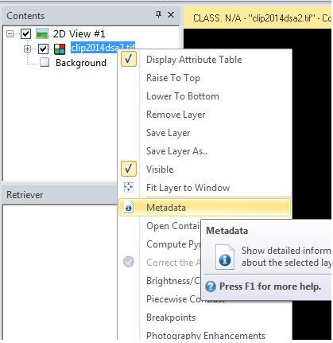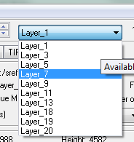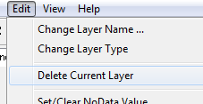

1. Classify the layers using X amount of classes in this case we did 30 using ISODATA
   1. Choose about 3 times the amount of classes you have to compare to
   2. The more iterations the better, We chose to do around 15, then click OK

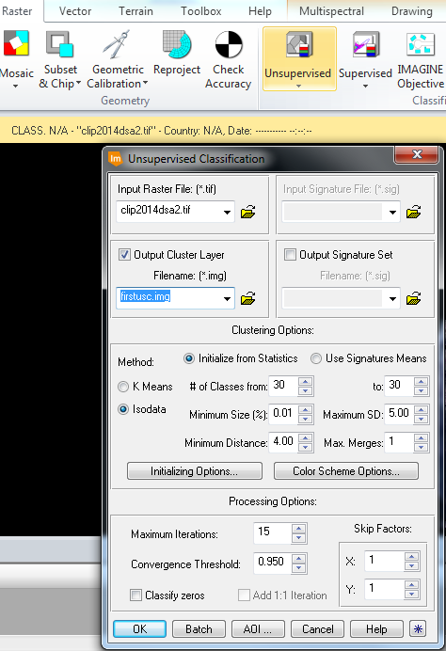

1. Identify those classes by making all of them one color except for the one class you are classifying by:
   1. Using Google Earth
   2. Using Landsat Images
2. Then add the map which you are comparing classes to and match each class where it best fits
   1. If a class is confused, as in its all over the map or in multiple categories of the map you are comparing (the bad classes), then label it as confused (gray color classes below)
   2. Once this is complete for all of the layers color code it accordingly

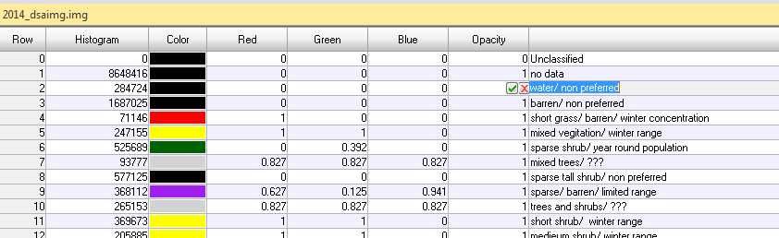

1. Under raster tab click Thematic, then click Recode

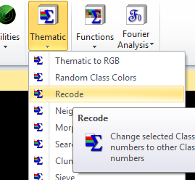

* 1. Recode so that your good classes and number 1- X amount of layers plus one for the confused classes is a total of X plus 1 classes (in this case we had 6 classes plus 1)

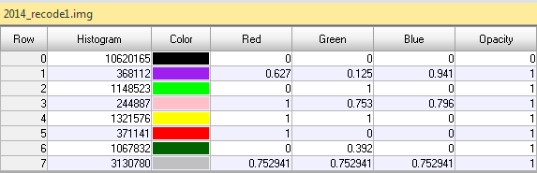

* 1. Recode again to 0 and 1, the 1’s are just the undesired pixels (or row 7 in previous recode layer)

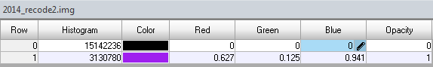

* + 1. **Pro Tip**: Do not go to the recode under the Thematic tab because it does not work

1. Under Raster tab click Subset & Chip then hit Mask

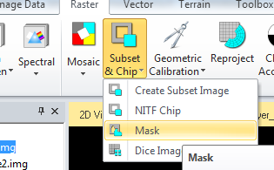

1. Then in the input file use the original layer stack
   1. For the mask file use the second recode layer (the layer with just two classes)
   2. Name the output file and click OK

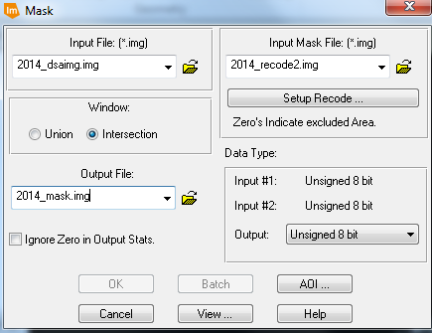

1. Once that layer is uploaded into ERDAS run another unsupervised classification (USC) on that layer (just repeat steps 2-5)
   1. We only did two runs of USC. More could be done but due to time constraints we only did two
2. Once those steps are repeated its time to recode both batches of classes from each USC run
   1. We used a dual numbering system so that the original six layers 1-6 became 10-60
   2. The second number in this system stands for the secondary class that particular layer appeared in a lot as well

So if summer class was number 2 and year round population was 6 that class would become 26

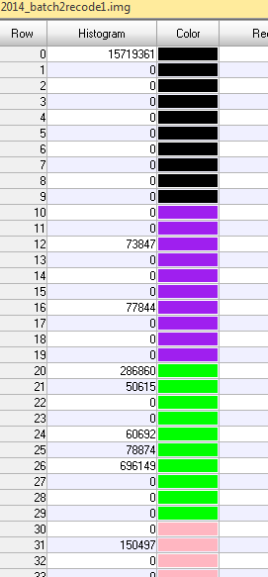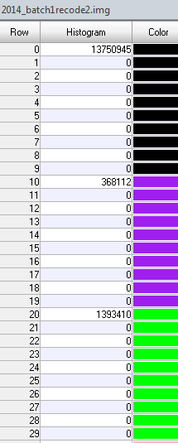

1. Once those layers are recoded it’s time to take them over to ArcMap to create the final image
   1. Make sure the Metadata wasn’t stripped
   2. If metadata was stripped click on Metadata

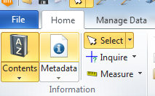

* 1. Then go to Edit and click Add/Change Projection

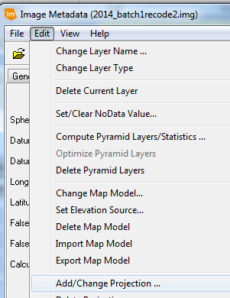

* 1. Keep all of these layers in .img files because they seemed to work the best between Arc and ERDAS

1. Once both of those layers are loaded into Arcmap it is time to merge the two images. For this, use the Con tool.
   1. The conditional raster is the layer with just two classes (0 and 1)
      1. Expression: Write VALUE = 1 (in all capital letters)
      2. If true use the second batch of classes from the second USC
      3. If false use the first batch of classes from the first USC

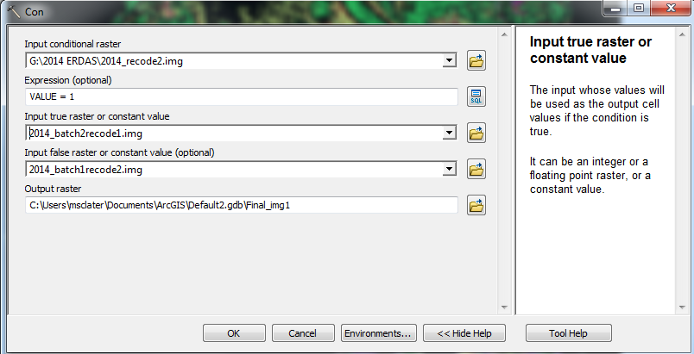

1. Once the Con tool has run its time to clip the image to your study area