**NASA DEVELOP National Program**



NASA Ames Research Center

*Spring 2016*

Puerto Rico Health & Air Quality

A Geospatial Assessment of Environmental Variability in Puerto Rico and its Relation to Confirmed Dengue Fever Cases

 **Technical Report**

Rough Draft-Feb18, 2016

Andrew Nguyen (Project Lead)

Martha Sayre

Dr. Pablo Méndez Lázaro,

Medical Sciences Campus of the University of Puerto Rico (Science Advisor)

Dr. Roberto Barrera,

U.S. Centers for Disease Control and Prevention Dengue Branch (Science Advisor)

Dr. Juan Torres-Pérez, Bay Area Environmental Research Institute (Science Advisor)

Previous Contributors:

Alannah Johansen

# 1. Abstract

Vector-borne diseases such as dengue fever, chikungunya, and Zika pose a major threat to the health of Caribbean communities. *Aedes aegypti (Ae. Aegypti),* the primary vector of these viruses, is dependent on humans for reproduction, and has been detected in populated areas within Puerto Rico. The vector’s lifecycle and its transmission of dengue in Puerto Rico have been connected to specific environmental conditions. This study examined environmental conditions related to Confirmed Dengue Fever Cases (CDFC) for Puerto Rico from January 2009 - December 2013 to model the distribution of dengue infected *Ae. aegypti* and its relation to these conditions. This project used monthly NASA Terra/ Aqua MODIS Normalized Difference Water Index, along with day and night land surface temperature (DLST / NLST) products, Geostationary Operational Environmental Satellite system Puerto Rico Water Energy Balance humidity products, and Climate Hazards Group InfraRed Precipitation and Satellite total precipitation (TP) modeled data. A Maximum Entropy Species Distribution Model and Earth Trends Modeler within Clark Labs’ TerrSet were used to spatially delineate monthly *Ae. aegypti* habitat suitability, determine the permutation importance of the environmental conditions, and quantify island-wide environmental trends. TP and DLST had the highest mean relative importance of the dynamic environmental variables, agreeing with several studies that climatic environmental conditions play a significant role in disease transmission.

**Keywords**

Remote Sensing, Maximum Entropy Species Distribution, MaxEnt, MODIS, *Aedes aegypti*

**2. Introduction**

**2.1 Background**

Dengue fever (DF), chikungunya, and Zika viruses are debilitating and potentially fatal mosquito-borne illnesses that are endemic in tropical and sub-tropical regions [CDC, 2014a]. The Centers for Disease Control and Prevention (CDC) estimated that over 400 million people are infected globally each year by any one of four different serotypes, or variations, of the dengue virus (DENV) [CDC, 2014b]. Prior to 2013, chikungunya and Zika viruses had been reported in most equatorial countries. These viruses are now reported in Caribbean countries, including Puerto Rico.

Globally, DENV is spread by multiple species of mosquito within the genus, *Aedes*. The main vectors worldwide are *Aedes aegypti (Ae. Aegypti) and Aedes albopictus,* with the primary vector in Puerto Rico being *Ae. Aegypti* [Cox et al., 2007]. *Ae. aegypti* is a domestic mosquito that lives and breeds near or within human-occupied structures [CDC, 2014a]. Thus, the majority of these mosquitoes exist in developed urban regions, such as San Juan and Bayamon [Barrera et al., 2011]. This species lays its eggs in a variety of water containers such as rain barrels, abandoned tires, plastic jugs, or pot holes on roads that are in close proximity to humans [CDC, 2014a; Barrera et al., 2011].

To better understand the spread of DENV, an awareness of the habitat suitability of thevector is needed. This study used Confirmed Dengue Fever Cases (CDFC) in Puerto Rico as a proxy for *Ae. aegypti* locations, due to the lack of island-wide *in-situ* *Ae. aegypti* presence data. There are multiple contributing environmental conditions that have been implicated in the spread and density of this vector, including increases in precipitation, ambient temperature, relative humidity (RH), and vegetation water content [Johansson et al., 2009; Mendez-Larzaro et al., 2014; Patz et al., 1998; Barrera et al., 2011, Estallo et al. 2011]. Increases in precipitation and temperature can result in the proliferation of *Ae. aegypti* by providing suitable breeding habitat and by hastening their development and reproductive cycles [Johansson et al., 2009]. Increases in temperature can also shorten the incubation period required for *Ae. aegypti* to become infectious after a virus-infected blood meal, which leads to an increase in the proportion of vectors after a warming period [Johansson et al., 2009; Patz et al., 1998]. Also, increases in RH have been shown to result in increased oviposition and hatching rates in *Ae. aegypti*, leading to increases in mosquito population density [Arruda Pedrosa de Almeida Costa et al., 2010]. Vegetation water content has been shown to indirectly measure humidity in soil, precipitation [Breshears et al. 1997, Jackson et al. 2004], and water status from field ecologists [Estallo et al. 2011]. These factors create conditions for mosquito proliferation.

In order to study the relationship between favorable environmental conditions and increases in Confirmed Dengue Fever Cases (CDFC) (See section 3.1.1), this study utilized remotely-sensed products to determine the distribution of *Ae. aegypti* and quantify the contribution of environmental factors to DF epidemic and non-epidemic periods on the island of Puerto Rico from 2009 to 2013. To do this, the number of CDFC were analyzed from a continuous environmental geospatial modeling perspective.

**2.2 Project Objectives**

The primary objective of the first phase of this project was to utilize the Maximum Entropy (MaxEnt) Species Distribution Model within TerrSet’s Habitat and Biodiversity Modeler (HBM) as a predictive suitability model for DF incidence (using CDFC) in Puerto Rico based upon NASA Earth Observation (EO) environmental variables. This method produced island-wide risk assessment maps of potential CDFC. The secondary objective was to perform a Time Series Frequency Analysis (TSFA) to explore the relationship between SST and CDFC, as well as the relationships between each of these and all the other chosen environmental variables. Project results provided a geospatial overview of both DF risk and the factors contributing to DF incidence in Puerto Rico from 2009-2013.

The objectives of the second phase were to include additional variables in MaxEnt, and apply a narrowed study area based upon the habitat assessment map (see previous study). This will allow the analysis to focus solely on the relative importance of each of the environmental conditions contributing to DF outbreaks. This allows for a more complete understanding of the effect of environmental conditions on DF epidemics. Additionally, the project examined trends in environmental conditions to assess seasonal changes (onset/offset) in order to identify the changes in the environmental conditions related to CDFC seasonality.

**2.3 Study Area**

Analyses were performed within the political boundaries of the Commonwealth of Puerto Rico. The island is an unincorporated United States territory located in the Caribbean Sea with general coordinates of 18°15'N latitude and 66°30'W longitude (Figure 1). Puerto Rico is a small, densely-populated island with a total area of 9,104 km2 and a population of over 3.5 million. The climate is tropical with annual average temperatures between 21°C and 27°C, and a rainy season from April to November. Climate varies along the length of the island, with the drier regions occurring in the south. Land-based analyses were performed for the entire island, based on the Habitat Assessment Map (HAM) (See section 3.3.1) for DENV-infected *Ae. aegypti.*

HAM was produced by combining *Ae. aegypti* habitat preferences with CDFC locations, as well as LC and elevation data. *Ae. aegypti* have a known habitat preference for low-elevation urban areas [Lozano-Fuentes et al, 2012]. Studies conducted in Mexico showed common *Ae. aegypti* presence in altitudes up to 1,700 m above mean sea level, and occasional presence in altitudes from 1,700 m to 2,130 m [Lozano-Fuentes et al., 2014; 2012]. Thus, the resultant map locates the habitat of DENV-infected *Ae. aegypti* to be along the majority of Puerto Rico coastline, low elevations, and inland urban areas, such as Caguas (Figure 2). Analysis of the HAM showed that 96.6% of all CDFC were contained within the habitat and corridor boundaries, with 86.8% being in the primary or secondary habitat, and 9.8% in the primary or secondary corridors. Additionally, the total percentage increased to 97.3% when CDFC, within a distance of 100 m of the range boundaries, were included in the analysis.

**2.4 Study Period**

The project examined the months from January 2009 through December 2013. This date range coincides with the most recent dengue outbreak years (2010, 2012, and 2013) according to CDFC *in-situ* data (See 3.1 Data).

**2.5 National Application(s) Addressed**

This project addressed the Health and Air Quality Application area within NASA’s Applied Sciences Program. By using NASA Earth Observing data, as well as modeled data products, this project focused on human welfare through the use of a Maximum Entropy Species Distribution Model to produce monthly DF risk assessment maps and to determine the contribution of environmental variables to DF epidemics in Puerto Rico. Model outputs will be used by public health administrations to help predict and mitigate DF outbreaks in the future.

**2.6 Project Partners**

Currently, the project end users, who include the Center for Disease Control (CDC)-Dengue Branch, University of Puerto Rico-Medical Sciences Department, and the Puerto Rico Department of Public Health, use quantitative research on vector-borne diseases and outbreaks to inform public policy on vector control measures that can be taken to prevent the spread of diseases like DF.

The Puerto Rico Department of Health provides citizen services and public health announcements, and conducts health assessments pertaining to dengue awareness on the island. The agency reports on recent statistics and information regarding mosquito vector habitats, and publishes scientific literature related to various illnesses in Puerto Rico. The Dengue Branch of the CDC, located in San Juan, Puerto Rico, is dedicated to dengue research and health outreach. The agency employs public health practices, such as education on the household spread of dengue, and diagnostic testing. They also conduct molecular research and field investigations regarding dengue contraction and control. The results of this study will be able to inform both agencies on the contribution of environmental factors to DF outbreaks, allowing them to improve dengue prevention protocols.

**3. Methodology**

**3.1** **Data**

All data collected were obtained or downloaded in monthly time steps from January 2009 to December 2013. The data are divided into two categories: point *in-situ* data and raster environmental data.

**3.1.1 Point in- situ data**

***2000-2015 Confirmed Dengue Fever Cases (CDFC)***

A dataset of daily CDFC from January 2000 to August 2015 was obtained from the CDC, with a total of 44,338 CDFC. The CDC Dengue Branch tracks and monitors reported dengue cases and confirms these cases through laboratory testing. A vast majority of the data contain addresses, country name, zip code, and latitude/longitude coordinates. Cases without latitude/longitude coordinates or data that did not occur within the study period were excluded. This study used a total of 29,575 CDFC points within Puerto Rico. Increases, peak, and decrease of CDFC during this time period, generally, follow a seasonal time frame from late July to late January.

**3.1.2 Raster Environmental Data**

***2009-2013 Terra/ Aqua Moderate Resolution Imaging Spectroradiometer (MODIS)***

Two sets of *MODIS* data were downloaded to produce (1) Land Surface Temperature (LST) and (2) Normalized Difference Water Index (NDWI)

1. MOD11C3v5, a MODIS level 3 data product, provided monthly DLST and NLST (Kelvin) at .05º resolution. LST data were downloaded for the h11v07 tile using Reverb, through the Land Process Distributed Active Archive Center (LP DAAC) website [LP DAAC, 2000].
2. MOD09A1 level 3, 500m data products are 8-day averages of Surface Reflectance. One image was downloaded with the least cloud cover for every month during the study period. The NDWI equation was then applied to derive vegetation water content values for each image.

***Climate Hazard Group InfraRed Precipitation with Stations (CHIRPS)***

TPdata (mm/month) at .05º resolution, from the Climate Hazard Group InfraRed Precipitation with Stations (CHIRPS) archive were downloaded from the University of California, Santa Barbara’s Climate Hazards Group website for each month of interest [CHG, 2015]. CHIRPS is a precipitation product from a combination of satellite and *in-situ* station data; it monitors drought and other environmental issues. The inputs to CHIRPS include modeled and Earth-observed precipitation data from the Climate Hazard Group’s Precipitation Climatology model, infrared satellite data from NOAA, Tropical Rainfall Measuring Mission (TRMM) data from NASA, NOAA Climate Forecast System data, and *in-situ* precipitation measurements [Funk et al., 2014].

***Geostationary Operational Environmental Satellite system Puerto Rico Water Energy Balance (GOES-PRWEB)***

Relative humidity (%) data were obtained from GOES-PRWEB which provides several island-scale estimated and modeled environmental datasets for Puerto Rico [GOES-PRWEB, 2009]. Incident radiation data are derived from Geostationary Operational Environmental Satellite system (GOES) and used to estimate net radiation, which is then used to further derive Photosynthetically Active Radiation. Additionally, solar radiation data from GOES are used to predict daily reference evapotranspiration along with an array of other important environmental conditions, including soil moisture. Precipitation data are sourced from NOAA’s Advanced Hydrologic Prediction Service to produce runoff and several other hydrological variables.

***2001 National Land Cover Database (NLCD)***

NLCD2001 for Puerto Rico was used as a land cover (LC) map and has a spatial resolution of 30 m. The map is a product of the Multi-Resolution Land Characteristics Consortium (MRLC) and was derived from Landsat 5 and 7 imagery. The Puerto Rico NLCD map was downloaded from the MRLC website [MRLC, 2001]. Since *Ae. aegypti* are known to occur in their highest densities in developed and urban areas[Cox et al., 2007], the NLCD map was included as a static variable in the MaxEnt model in order to account for these habitat preferences.

***USGS Elevation***

The USGS 3D Elevation Program (3DEP) Digital Elevation Model (DEM) with a resolution of ⅓ arc second was used for elevation data. These LiDAR-based images were sourced from the USGS National Map Database [USGS, 2015]. Elevation can contribute to the available habitat for *Ae. aegypti* in a location due to the species’ climatic preferences [Lozano-Fuentes et al., 2012]. While elevation is not considered a weighted variable, geospatial results and model outputs that incorporate elevation data (See 3.2 Data Processing) will help link the role of elevation to occurrences of CDFC.

**Hydrologic Units**

Four hydrologic unit (huc8) shapefiles were downloaded, covering the Island of Puerto Rico, from the Watershed Boundary Dataset within the Geospatial Data Gateway. These hydrologic units break up the island into Western, Southern, North-Eastern and Northern watersheds and were used within ETM in order to see the difference in environmental trends between the watersheds, acting as a proxy for ecological regions [Pablo Méndez Lázaro, personal communication, February 10th 2016].

**3.2 Data Processing**

All monthly 2009-2013 CDFC, DLST, NLST, NDWI, RH and TP data were processed in order to conform to the data prerequisites of the Maximum Entropy Species Distribution Model within TerrSet; all of the monthly datasets were re-projected to the World Geodetic System (WGS) 1984 coordinate system.

***Point in- situ data***

Point shapefiles were created using known latitude/longitude coordinates for all laboratory CDFC using data supplied by project partners at the CDC Dengue Branch. Trends and separate point files were also created in monthly time steps for the study period (Figure 3 and 4).

***Environmental Variables***

Processing of LC, elevation, DLST, NLST, NDWI, RH, and TP were conducted using a combination of ArcGIS 10.3 Model Builder, ArcPy, and R-commander; this expedited the task of processing five years of monthly data for each variable.

All products were converted from their original forms into TIFFs and re-projected to the WGS 1984 coordinate system. The 3DEP DEM tiles containing parts of the island of Puerto Rico were then mosaicked together and clipped to the boundary shapefile of the island. All other products were subsequently resampled bilinearly to the ⅓ arc second DEM, which had the finest resolution among the variables, and clipped to the boundary shapefile of Puerto Rico. DLST and NLST were further processed to correct for a scale factor of .02, using the raster calculator tool in ArcGIS 10.3. All of the products’ *no data values* were set after processing (back to their originals). The resultant TIFF files were then converted to RST format and further processed using TerrSet software. The values of the LC classes in Puerto Rico were reclassified into a numerically sequential order. Finally, all files were resampled to a uniform extent and several parameters within the metadata were updated. These include the addition of value units, as well as the classification of *no data values* as background.

**3.3 Analysis**

Analyses were conducted to geospatially predict CDFC as a proxy to *Ae. aegypti* and statically analyze environmental variables that are known to contribute vector proliferation.

**3.3.1 Maximum Entropy Species Distribution Model**

Maximum Entropy (MaxEnt) Species Distribution modeling was conducted for every month from January 2009 to December 2013 for the entire country of Puerto Rico using Clark Labs’ TerrSet 1.0. TerrSet is a software system that incorporates IDRISI GIS Analysis, image processing tools, and several modeling approaches for analysis of geospatial data [Clark University, 2015].

Due to the presence-only nature of the CDFC data, the MaxEnt portion of the Habitat Suitability / Distribution Module within TerrSet’s Habitat and Biodiversity Modeler (HBM) was chosen to model the geographic suitability of *Ae. aegypti* suitability related to DF incidence in all of Puerto Rico. MaxEnt is a machine learning model that used the principle of maximum entropy to assign a predicted probability of suitable conditions for CDFC occurrences at each pixel location. The model accomplished this by starting with a uniform distribution, randomly assigning 75% of the presence points to be used for training, and then successively using each point to improve the fit of the model to the presence data [Phillips, 2006]. The remaining 25% of the data points were then used to test the accuracy of the predictions.

Model runs were performed in monthly time-steps from 2009-2013 to produce DF risk assessment maps based on the probability distribution of CDFC. In addition, MaxEnt model gave estimates of the relative contributions of each environmental variable to the final model output in the form of permutation importance values. MaxEnt estimates these values by tracking which variables most contribute to the overall fit of the model at each training step, then by measuring the decrease in fit when the values of each of the variables are randomly rearranged. The advantage to this estimation method is that it gives values of relative importance that are independent of the path used to calculate them [Phillips, 2006].

***Application of Time Lags to MaxEnt Model***

Once environmental conditions become favorable, time is required for mosquito populations to proliferate and for mosquitoes to become infectious after an infected blood meal. After an onset of symptoms begin to appear in infected people, cases can be diagnosed and confirmed through laboratory testing. Due to these delays between changes in the environment and the increase in DF incidence, it was necessary to apply a time lag for each environmental variable to the MaxEnt model runs. The lengths of the time lags were chosen for each variable based on previous studies. For DLST and NLST, a time lag of three months was chosen based on the work of Keating [2000] who showed that the increase in DF cases in Puerto Rico occurred 12 weeks following the peak in ambient temperature. A two-month time lag was chosen for TP based on work by Moore et al. [1978] whose results indicated that peak DF incidence in south-western Puerto Rico occurs 6-8 weeks after peak rainfall. A two-month time lag was also chosen for RH following the work of Gharbi et al. [2011] who used a Seasonal Autoregressive Integrated Moving Average model to determine that the strongest correlation between RH and dengue incidence in Guadeloupe, French West Indies occurred at a time lag of 7 weeks. So, a two month estimate of RH time lag was based on this study, since no studies were found that determined the time lag between RH and DF incidence specifically in Puerto Rico. Lastly a 5 month lag was applied to NDWI. This takes into account findings from Estallo et al. 2011and the time it takes to produce a CDFC from pupal stages to reporting of the disease [Roberto Barrera, personal communication, October 28th 2015].

***Habitat Assessment Map (HAM)***

The Habitat Assessment module within TerrSet’s HBM uses both a land cover and a habitat suitability map to assign regions of primary and secondary habitat, as well as potential corridors. Using this module, a habitat assessment was performed during the previous phase using all CDFC from Jan 2009 - Dec 2013 along with the static variables of LC and elevation. Only developed areas were chosen to be included as potential habitat since *Ae. aegypti* is known to be dependent on humans for survival [Harrington, 2005]. All gap distances between and outside of the developed areas were estimated to be 400 m based on the work of Reiter et al. [1995] who estimated a 30 m - 440 m *Ae. aegypti* dispersal range in San Juan by using rubidium-marked eggs. Additionally, Harrington et al. [2005] used a release and recapture method to estimate a dispersal range of 12 m - 102 m in Puerto Rico with 87% of recaptures occurring within the same home they were released. This shows that the majority of *Ae. aegypti* would most likely not disperse beyond an estimated 400 m gap distance.

The habitat assessment model also uses a habitat suitability map as a weighted assessment of potential habitat locations. The habitat suitability map was generated for this study by using the MaxEnt model with inputs of all CDFC within the study period, as well as LC and elevation. Minimum weighted index values of 0.5 and 0.2 were chosen for primary and secondary habitat, respectively, since those values corresponded with the minimum values of known habitat preferences. Since both the presence of CDFC and the habitat preferences of *Ae. aegypti* were used to produce the habitat assessment map, the resultant habitat classifications can be designated as belonging to those *Ae. aegypti* individuals that are infected with any serotype of DENV.

***Analysis of Model Outputs***

Mean monthly permutation importance values for DLST, NLST, NDWI, RH, and TP were calculated for all years, as well as both epidemic and non-epidemic years. These values were compared to each other and to the mean monthly number of training cases in order to determine trends in the factors that are contributing to dengue outbreaks.

MaxEnt also gives estimates of the predictive ability of the output for each model run. First, it gives values corresponding to the overall gain of the predictive ability of the model for both training and testing. Second, it calculates the area under the curve (AUC) for both training and testing curves on a sensitivity vs. 1-specificity graph [Phillips et al., 2006]. Third, it uses a binomial test of omission to calculate p-values, testing the null hypothesis that there is no statistically significant difference between the ability of the model output or a random prediction to predict the location of test points. MaxEnt also performs a jackknife test that gives an additional measure of variable importance by measuring the training and testing gain for each variable by itself and for the model with that variable omitted [Phillips, 2006]. All of these measures were used to test for differences in model accuracy with respect to differing time lag scenarios.

**3.3.2 ETM Analyses:**

To explore the relation between time series of island wide environmental conditions, short term trend analyses on four Hydrological Unit Codes (HUC-1) within the Puerto Rico were performed using the Earth Trends Modeler (ETM) Seasonal Trend Analysis tool. An image time series was created for each condition which then enables the identification of de-seasoned inter-annual trends as well as seasonal trends (Appendix …).

***MaxEnt Analysis***

**4. Results & Discussion**

**4.1 Maximum Entropy Species Distribution Model**

# 5. Conclusions

# 6. Acknowledgments

We would like to acknowledge Dr. Pablo M*é*ndez-L*á*zaro from Medical Sciences Campus of the University of Puerto Rico, and Dr. Roberto Barrera from the U.S. Centers for Disease Control and Prevention (CDC) Dengue Branch for project advisement and data sources. + JUAN TORRES-PEREZ We would also like to thank Jessica Cabrera from the Puerto Rico Department of Health for her overall support of the project. Lastly, we would like to thank Chippie Kislik and Victoria Ly for their support and supervision throughout the project as the management team at DEVELOP NASA Ames Research Center.

Any opinions, findings, and conclusions or recommendations expressed in this material are those of the author(s) and do not necessarily reflect the views of the National Aeronautics and Space Administration.

This material is based upon work supported by NASA through contract NNL11AA00B and cooperative agreement NNX14AB60A.

# 7. References

Arruda Pedrosa de Almeida Costa, E., E. Maria de Mendonça Santos, J. Cavalcanti Correia, and C. Maria Ribeiro de Albuquerque (2010), Impact of small variations in temperature and humidity on the reproductive activity and survival of *Aedes aegypti* (Diptera, Culicidae), *Rev. Bras. Entomol., 54*(3), 488-493.

Barrera, R., M. Amador, and J. MacKay (2011), Population Dynamics of *Aedes aegypti* and Dengue as Influenced by Weather and Human Behavior in San Juan, Puerto Rico, *PLOS Neglected Tropical Diseases*, 5(12), e1378.

Box, G. E. P., and G. M. Jenkins (1976), *Time series analysis: forecasting and control*, Holden-Day, Oakland, California.

Brown, O. B., P. J. Minnett, R. Evans, E. Kearns, K. Kilpatrick, A. Kumar, R. Sikorski, and A. Závody (1999), MODIS Infrared Sea Surface Temperature Algorithm Algorithm Theoretical Basis Document Version 2.0, *University of Miami*, 33149–1098.

Climate Hazard Group (CHG) (2015), Climate Hazards Group InfraRed Precipitation with Station data (CHIRPS) Version 2, January 2009 to December 2013, University of California, Santa Barbara. Available from: ftp://[chg-ftpout.geog.ucsb.edu/pub/org/chg/products/CHIRPS-2.0/global_monthly/tifs/](http://chg-ftpout.geog.ucsb.edu/pub/org/chg/products/CHIRPS-2.0/global_monthly/tifs/) (last acessed 5 October 2015).

Centers for Disease Control and Prevention (2014), Dengue and the *Aedes aegypt*i mosquito, <http://www.cdc.gov/dengue/resources/30Jan2012/aegyptifactsheet.pdf> (last acessed 11 November 2015).

Centers for Disease Control and Prevention (2014), Dengue Epidemiology, <http://www.cdc.gov/Dengue/epidemiology/index.html> (last accessed 5 October 2015).

Centers for Disease Control and Prevention (CDC) National Environmental Public Health (NCEH) Tracking Program (2005), A geoprimer: Environmental public health tracking, Version 1.0, <http://www.cdc.gov/nceh/tracking/pdfs/geoprimer.pdf> (last acessed 11 November 2015).

Cox, J., M. E. Grillet, O. M. Ramos, M. Amador, and R. Barrera (2007), Habitat segregation of Dengue vectors along an urban environmental gradient, *Am. J. Trop. Med. Hyg.*, 76(5), 820–826.

Clark Labs (2015), Clark University. [https://clarklabs.org/products/.](https://clarklabs.org/products/)

Eisen, L., and S. Lozano-Fuentes (2009), Use of Mapping and Spatial and Space-Time Modeling Approaches in Operational Control of Aedes aegypti and Dengue, edited by A. J. Tatem, *PLoS Neglected Tropical Diseases*, *3*(4), e411, doi:10.1371/journal.pntd.0000411.

Focks, D. A., and R. Barrera (2006), Dengue transmission dynamics: Assessment and Implications for control. *WHO Report of the Scientific Working Group meeting on Dengue, Geneva, 01/2006*.

Funk, C. et al. (2014), A Quasi-Gloabal Precipitation Time Series for Drought Monitoring, US Geological Survey, 1-5.

Gubler, DJ (2002), Epidemic dengue/dengue hemorrhagic fever as a public health, social and economic problem in the 21st century. Trends Microbiol 10: 100–103.

GOES-PRWEB (2009), Relative Humidity, <http://academic.uprm.edu/hdc/GOES-PRWEB_RESULTS/> (Updated Daily).

Harrington, L. C., T. W. Scott, K Lerdthusnee, T. C. Coleman, A. Costero, G. G. Clark, J. J. Jones, S. Kitthawee, P. Kittayapong, R. Sithiprasasna, and J. D. Edman (2005), Dispersal of the Dengue vector Aedes aegypti within and between rural communities, *Am. J. Trop. Med. Hyg.*, 72(2), 209–220.

Helsel, D. R., and R. M. Hirsch (1993), *Statistical Methods in Water Resources*, Elsevier.

Hurtado-Díaz, M., H. Riojas-Rodríguez, S. J. Rothenberg, H. Gomez-Dantés, and E. Cifuentes (2007), Short communication: Impact of climate variability on the incidence of dengue in Mexico: Impact of climate variability on the incidence of dengue in Mexico, *Tropical Medicine & International Health*, *12*(11), 1327–1337, doi:10.1111/j.1365-3156.2007.01930.x.

Johansson, M. A., F. Dominici, and G. E. Glass (2009), Local and Global Effects of Climate on Dengue Transmission in Puerto Rico, edited by E. Massad, *PLoS Neglected Tropical Diseases*, *3*(2), e382, doi:10.1371/journal.pntd.0000382.

Land Processes Distributed Active Archive Center (LP DAAC) (2000), MODIS 11C3

Land Surface Temperature and Emissivity Monthly L3 Global 0.05Deg CMG, Version 5, January 2009 to December 2013, https://lpdaac.usgs.gov/dataset_discovery/modis/modis_products_table/mod11c3, NASA EOSDIS Land Processes DAAC, USGS Earth Resources Observation and Science (EROS) Center, Sioux Falls, South Dakota.

Little, E., R. Barrera, K. C. Seto, and M. Diuk-Wasser (2011), Co-occurrence Patterns of the Dengue Vector Aedes aegypti and Aedes mediovitattus, a Dengue Competent Mosquito in Puerto Rico, *EcoHealth*, *8*(3), 365–375, doi:10.1007/s10393-011-0708-8.

Lozano-Fuentes, S. C., Welsh-Rodriguez, A. J. Monaghan, D. F. Steinhoff, C. Ochoa-Martinez, B. Tapia-Santos, M. H. Hayden, and L Eisen (2014), Intra-annual changes in abundance of *Aedes (Stegomyia) aegypti* and *Aedes (Ochlerotatus) epactius* (Diptera: Culicidae) in high-elevation communities in Mexico, *J. Med. Entomol*., 51(4), 742-751.

Lozano-Fuentes, S. C., M. H. Hayden, C. Welsh-Rodriguez, C. Ochoa-Martinez, B. Tapia-Santos, K. C. Kobylinski, C. K. Uejio, E. Zielinski-Gutierrez, L. Delle Monache, A. J. Monaghan, D. F. Steinhoff, and L Eisen (2014), The dengue virus mosquito vector *Aedes aegypti* at high elevation in Mexico, *Am. J. Trop. Med. Hyg*., 87(5), 902-909.

Méndez-Lázaro, P., F. E. Muller-Karger, D. Otis. M. J. McCarthy, and M. Peña-Orellana (2014), Assessing climate variability effects on Dengue incidence in San Juan, Puerto Rico, *Int. J. Environ. Res. Public Health*, 11, 9409-9428.

Moore, C. G., B. L. Cline, E. Ruiz-Tiben, D. Lee, H. Romney-Joseph, and E. Rivera-Correa (1978), *Aedes aegypti* in Puerto Rico: Environmental determinants of larval abundance and relation to dengue virus transmission, *Am J Trop Med Hyg*, 27, 1225-1231.

Multi-Resolution Land Characteristics Consortium (MRLC) (2001), National Land Cover Database Puerto Rico Version 1,<http://www.mrlc.gov/nlcd01_data.php>, U.S. Geological Survey, Earth Resources Observation and Science (EROS) Center, MRLC Project, Sioux Falls, SD.

Patz, J. A., W. J. Martens, D. A. Focks, and T. H. Jetten (1998), Dengue fever epidemic potential as projected by general circulation models of global climate change., *Environmental Health Perspectives*, *106*(3), 147.

Phillips, S. (2006), A brief tutorial on Maxent. *AT & T Research*, http://www.cs.princeton.edu/~schapire/maxent/tutorial/tutorial.doc.

Phillips, S., R.P. Anderson, and R.E Schapire (2006), Maximum entropy modelling of species geographic distributions, *Ecological Modelling*, *190*, 231–259.

Ramos, M. M. et al. (2008), Epidemic dengue and dengue hemorrhagic fever at the Texas–Mexico border: results of a household-based seroepidemiologic survey, December 2005, *The American journal of tropical medicine and hygiene*, *78*(3), 364–369.

Reiter, P, M. A. Amador, R. A. Anderson, and G. G. Clark (1995), Short report: Dispersal of Aedes aegypti in an urban area after blood feeding as demonstrated by rubidium-marked eggs, *Am. J. Trop. Med. Hyg., 52*(2), 177-179.

Spence, J. M., M. A. Taylor, and A. A. Chen (2004), The effect of concurrent sea-surface temperature anomalies in the tropical Pacific and Atlantic on Caribbean rainfall, *International Journal of Climatology*, *24*(12), 1531–1541, doi:10.1002/joc.1068.

Sharp, T. M., E. Hunsperger, G. A. Santiago, J. L. Muñoz-Jordan, L. M. Santiago, A. Rivera, R. L. Rodriguez-Acosta, L. Gonzalez Feliciano, H. S. Margolis, and K. M. Tomashek (2013), Virus-Specific Differences in Rates of Disease during the 2010 Dengue Epidemic in Puerto Rico, *PLOS Neglected Tropical Diseases*, 7(4), e2159.

US Census Bureau (USCB) (2015), Commuting (Journey to Work) Main, http://www.census.gov/hhes/commuting.

US Geological Survey (USGS) The National Map (TNM) (2015), 3D Elevation Program (3DEP), <http://nationalmap.gov/3DEP/index.html>.

**Appendix A: Figures**

*Figure 1*: Study area 1: Analyses using the MaxEnt model were conducted within the political boundaries of the Commonwealth of Puerto Rico.

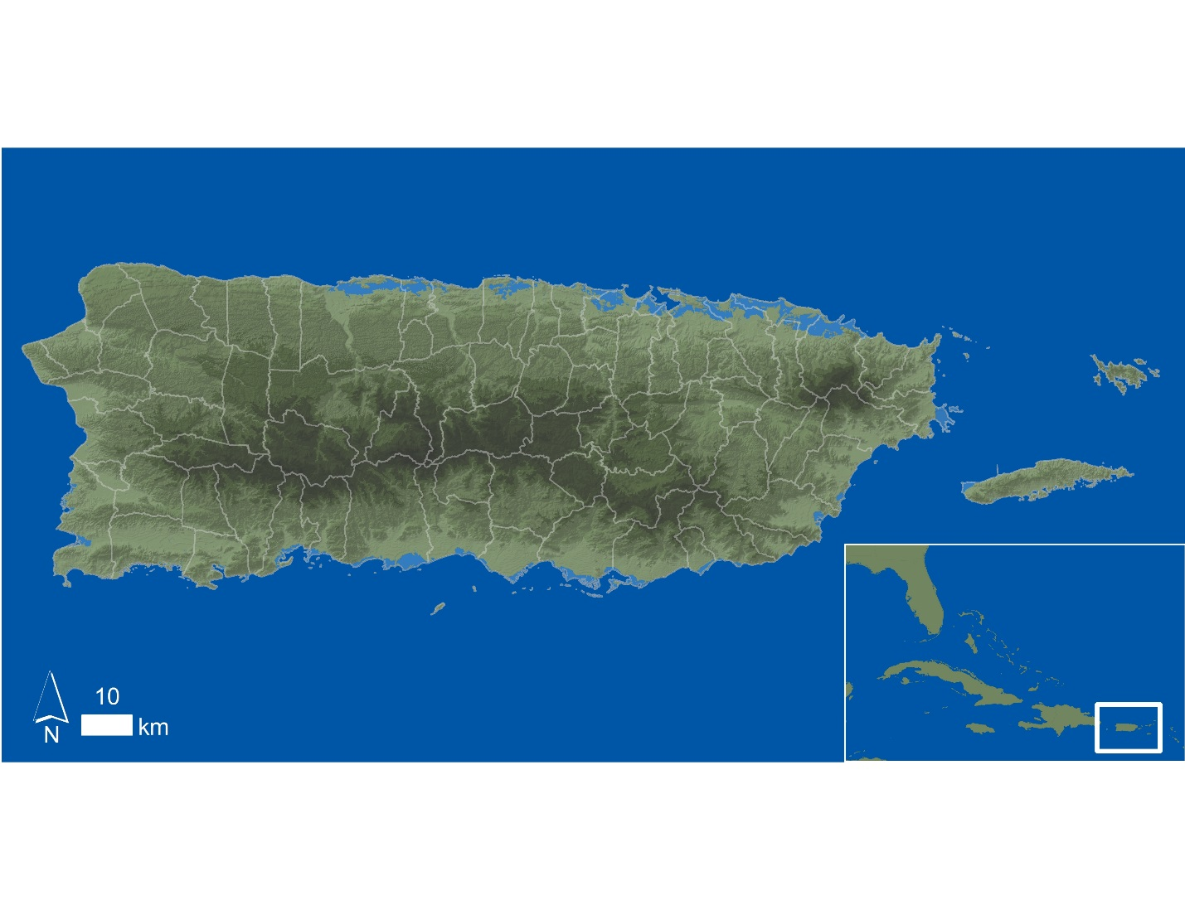

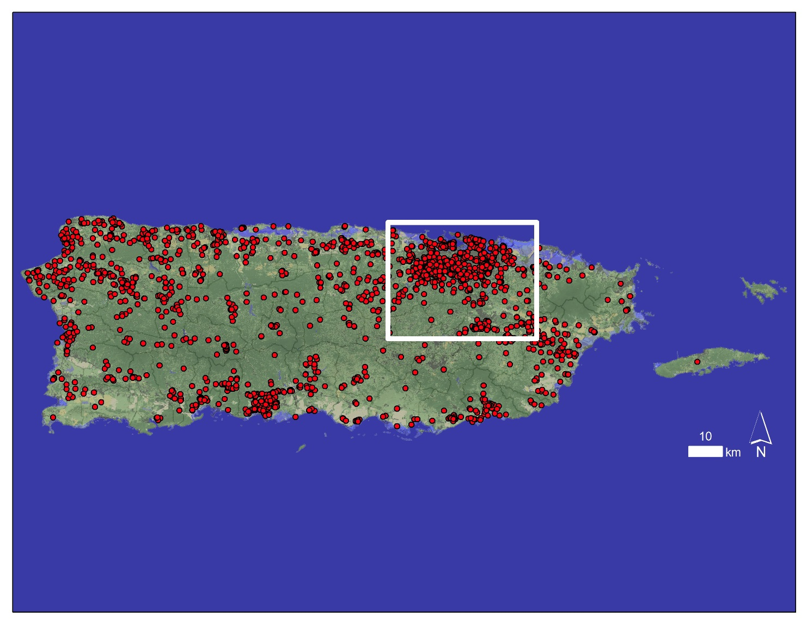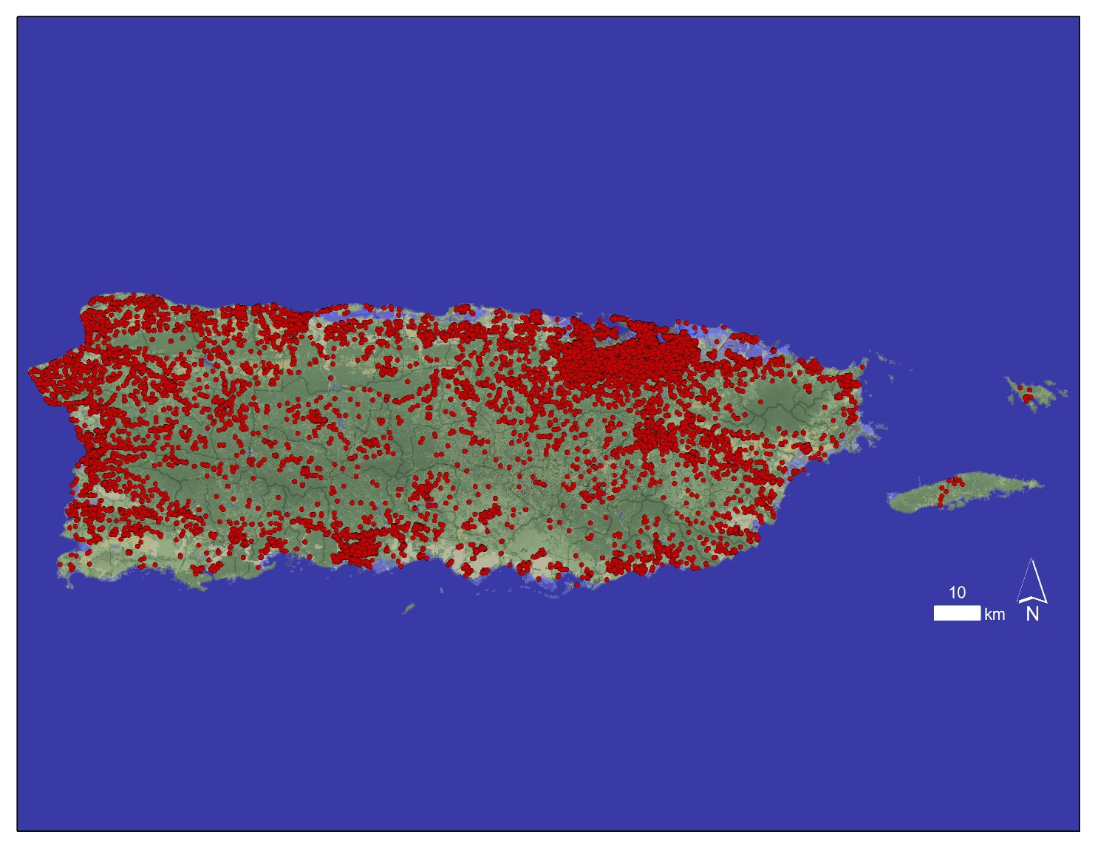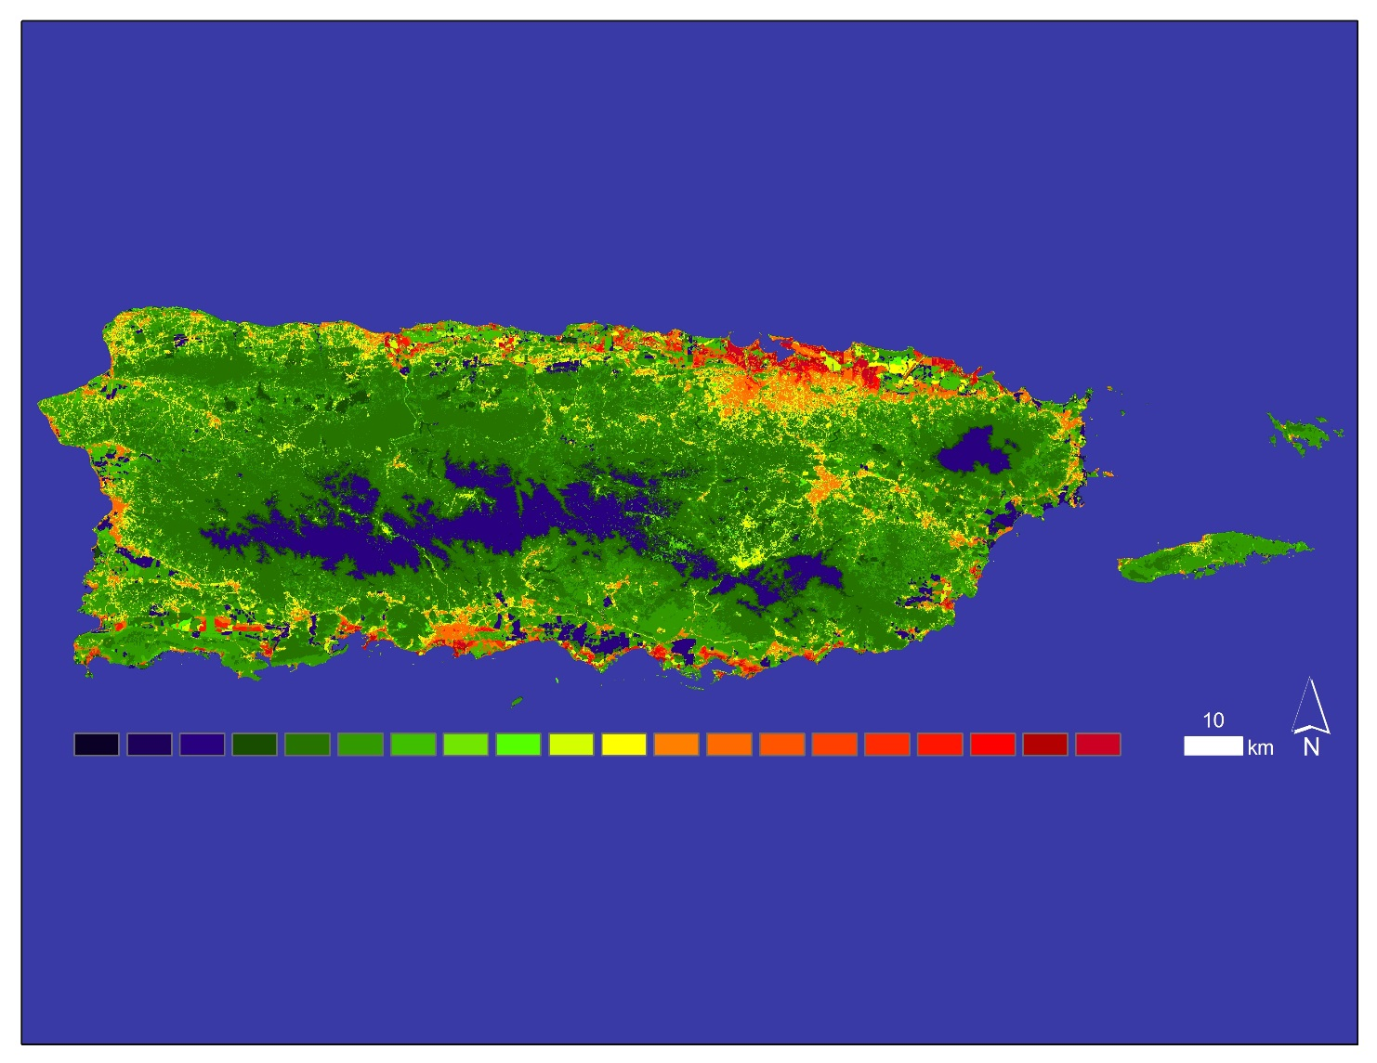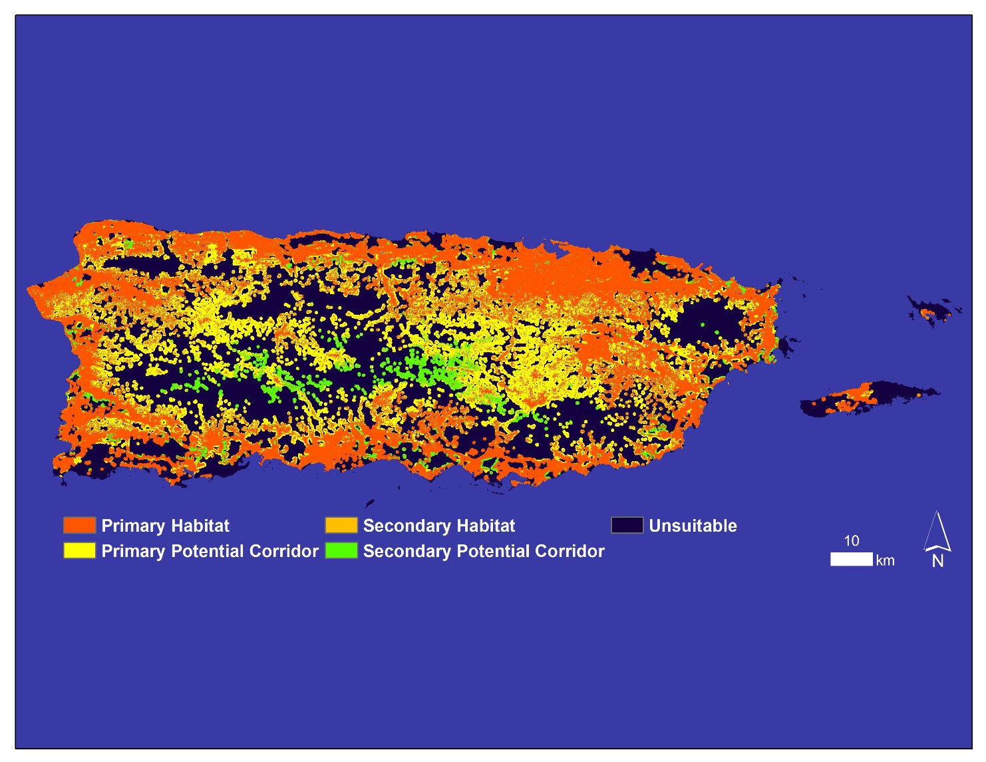

*Figure 5*: Map showing the locations all CDFC that occurred during August 2010, the month with the highest number of CDFC during the study period. The San Juan metropolitan area is highlighted.

*Figure 4*: Map showing the locations all CDFC that occurred in Puerto Rico from January 2009 – December 2013.

*Figure 8*: Habitat suitability map for DENV infected *Ae. aegypti* produced by the MaxEnt model using inputs of all CDFC from January 2009 – December 2013, as well as LC and elevation. Warmer colors represent regions of higher habitat suitability.

*Figure 9*: Habitat assessment map for DENV infected *Ae. aegypti* produced by TerrSet’s Habitat Suitability Module within HBM using map inputs of LC and habitat suitability.