**NASA DEVELOP National Program**



Jet Propulsion Laboratory

*Spring 2017*

Santa Monica Mountains Climate

Using NASA Earth Observations to Determine the Extent of Drought-Related Dieback in Oak Woodlands within the Santa Monica Mountains, California

**Technical Report**

March 29, 2017

Natalie Queally (Project Lead)

Emil Chang

Nick Rousseau

Dr. Natasha Stavros, NASA Jet Propulsion Laboratory (Science Advisor)

Dr. Erika Podest, NASA Jet Propulsion Laboratory (Science Advisor)

# 1. Abstract

The Santa Monica Mountains stretch along the west coast of California between the coastal city of Oxnard and the populous urban hub of Los Angeles. Despite the close urban proximity, the Santa Monica Mountains still retain 80% native vegetation cover, including precious expanses of coastal sage scrub, chaparral, valley grassland, and oak woodland. While 30,000 ha of this land is protected by public and private conservation agencies within the Santa Monica Mountains National Recreation Area (61,000 ha total), the area has still suffered from the recent severe and prolonged drought in California. These effects have been especially detrimental to oak woodlands, which are more susceptible to pest infestations during times of abiotic stress. Because these woodlands are prized for their aesthetic value and ecosystem services, land managers will benefit from finding high-risk areas that will suffer more from drought effects. Current practices to assess changes in vegetation rely mostly on field studies, which are restricted by large scale landscapes, time, and resources. Incorporating remote sensing in the assessment of high-risk areas for drought-related dieback will allow land managers to develop larger scale solutions. The Santa Monica Mountains Climate team at JPL aims to discover the effect of drought on vegetation dieback from 2010 to 2016 using optical data from AVIRIS and radar data from UAVSAR.

**Keywords**

Remote sensing, AVIRIS, UAVSAR, oak woodland, MESMA, RVI

# 2. Introduction

* 1. ***Background Information***

The Santa Monica Mountains comprise a large, relatively pristine, and ecologically complex example of a Mediterranean ecosystem in coastal southern California (Dixon, 2003). The mountains are home to 450 vertebrate species, including 50 mammal, 384 bird, and 36 reptile and amphibian species. The mountains also contain important California plant assemblages, which largely contribute to the state’s designation as a global Biodiversity Hotspot (Tiszler & Rundel, 2007, Myers et al. 1999).

Coast Live Oak (*Quercus agrifolia)* woodlands are an essential and fragile part of this ecosystem (Tiszler, et. al., 2007). Although they comprise only three percent of land cover in the Santa Monica Mountains, the economic consequences of oak woodland loss are significant. Oaks have both use and non-use value, ranging from added real estate value to aesthetic appeal. They also provide important ecosystem services, such as temperature moderation, air pollution and stormwater runoff mitigation, substrate erosion control, water table management, and carbon sequestration (Dagit, Carlberg, & Scott, 2014). Each mature oak tree can sequester an estimated 9 metric tons of carbon across a 50 year lifespan, and the current extent of oak woodlands throughout the state of California are thought to sequester 325 million metric tons of above and below-ground carbon (Dagit, 2014). Due to these qualities, a typical mature coast live oak located within an oak woodland can be valued at $100,000 (Dagit, Carlberg, & Scott, 2014).

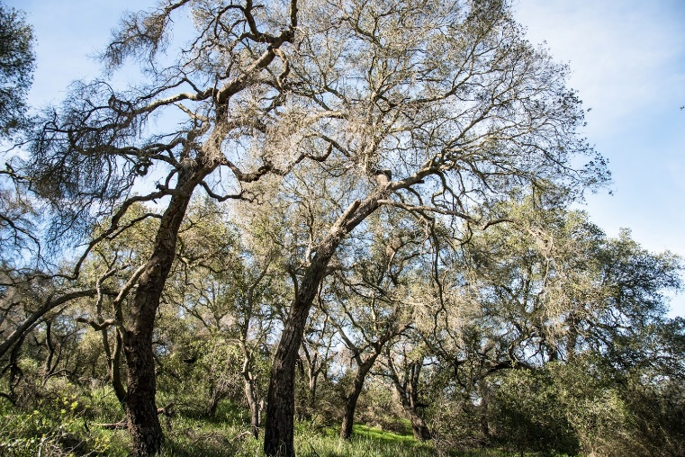

**Figure 1.** Oak trees experiencing loss of leaves in the Santa Monica Mountains. Image credit: Emil Chang

Unfortunately, oak woodlands and the other precious habitats within the Santa Monica Mountains are threatened by a myriad of abiotic and biotic stressors.  Encroaching urban and suburban development, habitat fragmentation, introduction of invasive species, increased fire frequency, and increasing climate variability all threaten the integrity of the land. Although years of low rainfall and extended drought punctuated by moderate to severely wet years are not uncommon, the increased severity of these fluctuations as a consequence of an increasingly variable climate have taken a toll on the vegetation of the Santa Monica Mountains (Tiszler & Rundel, 2007).

According to the United States Drought Monitor, most of California has been in a state of drought since 2012. Currently, Los Angeles County is considered to be in extreme drought (US Drought Monitor). This does not bode well for the Santa Monica Mountains, more than half of which reside in LA County (with the rest located in Ventura County). To assess the effects of the recent drought on oak dieback, this study will focus on the Santa Monica Mountains and neighboring Simi Hills. The chosen time period will provide a baseline of land cover before the drought began, and show the annual changes up until the most recent series of winter storms that hit in early 2017.

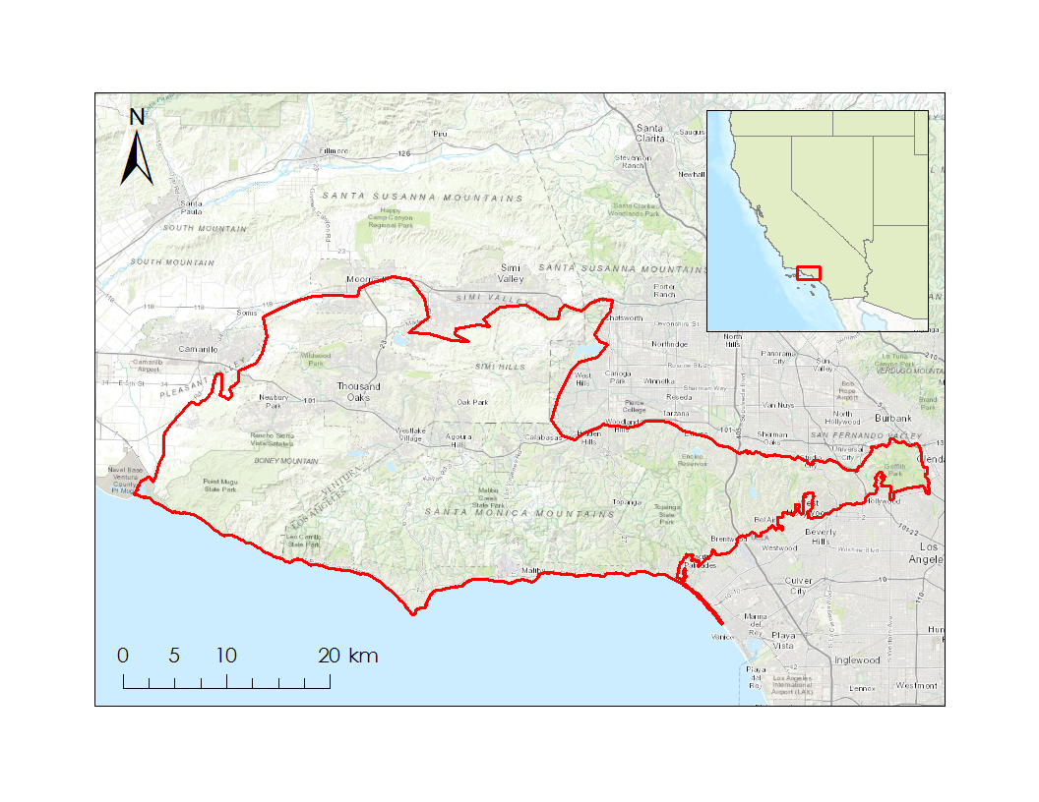

CA

Study Area

AZ

NV

UT

**Figure 2.** The project study area covers the Santa Monica Mountains and Simi Hills within Los Angeles and Ventura Counties.

* 1. ***Project Partners & Objectives***

This project addresses the national application area of climate. In the Santa Monica Mountains, vegetation distribution depends on many topographic factors like slope, elevation, and aspect, as well as climatic factors, like water, temperature, and fire history (Tiszler & Rundel, 2007). While the topographic features tend to stay fixed, the climatic factors are always changing. These climatic variations in the Santa Monica Mountains are likely affecting oak tree loss. Viewing the changes in land cover over time and finding spatial relationships between these changes and climatic variables will provide much needed insight into the patterns of vegetation dieback.

Collaborators for the project include Rosi Dagit and Jen Mongolo of the Resource Conservation District of the Santa Monica Mountains (RCDSMM); Irina Irvine, Marti Witter, and Joey Algiers of the National Park Service (NPS); Suzanne Good and Danielle LeFer of the California Department of Parks and Recreation (CDPR); Kim Corella of the California Department of Forestry and Fire Protection (CAL FIRE); Jay Lopez of LA County Department of Forestry and Fire Protection; and Sabrina Drill of the University of California Cooperative Extension. Many collaborators are involved due to their value of oak woodlands and other Mediterranean vegetation types threatened by severe drought and invasive pest infestations. Although many different parties are invested in assessing the damage that has been done to native vegetation, most of the work has been done on individual field sites. Evaluation on a larger scale using remote sensing has not yet been explored, and would be helpful in assessing the Santa Monica Mountains on a park-wide scale. This project benefits from all the work they have done on the ground, collecting data about vegetation distribution, tree health, and invasive pest prevalence. In turn, these collaborators will benefit from the large-scale applications of incorporating remotely sensed data.

The objective of this project was to help our partners understand the spatial patterns of the oak tree loss and shrub dieback in the Santa Monica Mountains National Recreation Area. Our team mapped the annual changes in fractional cover of green vegetation, non-photosynthetic vegetation, and substrate from 2013-2016 using data from Airborne Visible/Infrared Imaging Spectrometer (AVIRIS). The team used Multiple Endmember Spectral Mixture Analysis (MESMA) on AVIRIS data for its available years (2013-2016) to differentiate these land cover types. Because AVIRIS data were not available for our desired time period, the study also uses UAVSAR data to observe vegetation changes from 2010-2015. By incorporating other datasets for vegetation type, precipitation, and temperature, the goal was to identify high-risk areas for vegetation dieback within the study area.

# 3. Methodology

***3.1 Data Acquisition***

The team accessed the AVIRIS data portal and found that four flightlines were needed per year to cover the study area. Although the team had initially narrowed the data acquisition time to summer months in order to view vegetation at a similar state of phenology, data products were not available from the same month for all years. The most consistent dates that fell near the desired summer period were May 2013, June 2014, May 2015, and June 2016. The team downloaded a total of sixteen Level-2 Reflectance scenes, with four adjacent flight lines for each year (Appendix E).

Since AVIRIS was launched in 2013, the team decided to try to extrapolate the AVIRIS data from 2010 – 2012 with UAVSAR data. The team downloaded UAVSAR data through JPL’s UAVSAR Data Portal. These data provided an ideal spatial resolution (1.8m) to visualize changes in small oak patches. Two flight lines covered the entire study area and data were available in years 2010-2015. Despite efforts to keep aerial data seasonal, the months in which the data were available were not consistent. The most ideal data considering phenology and local precipitation was collected at the following times: April 2010, July 2011, November 2012, May 2013, October 2014, and June 2015 (southern swath only) (APPENDIX). The team downloaded orthorectified versions of the three polarizations of radar (HH – horizontal polarization transmitted and horizontal polarization received, VV – vertical polarization transmitted and vertical polarization received, and HV – horizontal polarization transmitted and vertical polarization received) in linear units as well as metadata for each flight. For years where slope incidence angle files were available, these were also downloaded.

Finally, in order to understand how climatic variables may be affecting vegetation in the Santa Monica Mountains, the team downloaded precipitation, maximum and mean temperature, mean dewpoint temperature, and minimum and maximum vapor pressure deficit from Oregon State’s Parameter-elevation Relationships of Independent Slopes Model (PRISM) Climate Group. The team downloaded these data for the study period January 2010 - Dec 2016, in addition to the 30-year normals calculated for 1981 - 2010. The data were taken from a PRISM pixel (16km2)in the study area (Appendix D).

***3.2 Data Processing***

3.2.1 AVIRIS

After acquiring the AVIRIS data, the team spatially subset each flight line using a boundary rectangle that enclosed the study area. Noting that some years had “bad bands,” or bands with bad data, listed in the metadata, the team spectrally subset each image to exclude bands 108 – 113 and 154 – 167. Because the end goal was to classify the image as green vegetation, nonphotosynthetic vegetation, and substrate based on spectral reflectance, it was important that the spectral library used for the classification was as pure as possible. To build this library, it was necessary to pull “endmembers” from within an AVIRIS image. An endmember is a “pure pixel,” or pure spectral representation for a certain class. Choosing these endmembers required comparing imagery with high spatial resolution, including both National Agriculture Imagery Program (NAIP) Orthoimagery and Google Earth Pro, to AVIRIS. Using the high-resolution imagery and the vegetation map provided by partners, endmembers were chosen from pixels that appeared to be 100% covered by a certain class. From within the AVIRIS images themselves, a spectral library of endmembers was created. Using Dr. Dar Roberts’ VIPER (Visualization & Image Processing for Environmental Research) Tools Package, these endmembers were used to perform Multiple Endmember Spectral Mixture Analysis (MESMA) (Roberts et al., 2017).

**Figure 3.** The plot shows the spectral reflectance of the GV, NPV and S endmembers. Breaks show where “bad bands” were removed from further analysis.

When the AVIRIS sensor measures a spectrum, it is actually measuring the combination of the spectra of every material within the sensor’s field of view. That means that for every AVIRIS pixel (approximately 15.5m spatial resolution), the reflectance value could represent a mixture of many surface materials. MESMA is a form of spectral unmixing that models the linear combination of spectra for each pixel, and as such can be used to find fractional cover of different materials (Dennison & Roberts, 2003). Due to the very high spectral resolution of AVIRIS (possessing 224 bands at 10nm intervals), the selection of endmembers is critical in accurate land cover mapping using spectral information. Although a spectral library for MESMA could contain hundreds of spectra, there are trade-offs between a more extensive library, computational efficiency, and parsimonious interpretation (Dennsion & Roberts, 2003). Other studies, such as that of Li, Ustin, and Lay (2005) used as few as nine endmembers. Due to time constraints and in the interest of balancing accuracy and the simplicity of the model, the team chose 12 endmembers to model using MESMA: five green vegetation (GV), four nonphotosynthetic vegetation (NPV), and three substrate (S). Dr. Roberts’s VIPER tools also adds in a fourth endmember: shade. This “shade” endmember represents zero reflectance. MESMA was performed on each flightline individually using 4-Endmember models, which means that VIPER tools attempted to unmix each pixel with all four classes: GV, NPV, S, and shade. For each resulting image from MESMA, shade normalization was also performed using VIPER tools. This removes the shade component from the fractional cover, effectively correcting for incidence angle (Roberts et al., 2017). After that, the fraction of alive (FAL) cover was calculated for each flightline in order to assess the changes in live vegetation over time. The formula was created as follows:

$FAL= \frac{GV}{GV+NPV}$ (1)

Once FAL was calculated, the flightlines for each year were mosaicked together and the years were stacked in ENVI so that they all had the same spatial extent and cell size of 15.6 m x 15.6 m. This allowed the years to be subtracted to create the final product of FAL change. The FAL difference was found by subtracting consecutive years; for example, the FAL change between 2013 and 2014 was found by subtracting 2013 from 2014. Therefore, negative results would show where FAL had decreased from the previous year, and positive results would show where FAL increased from the previous year. The final FAL images were calculated as 2014-2013, 2015-2014, and 2016-2015.

3.2.2 UAVSAR

After acquiring the UAVSAR data, the team used a Python script to create headers for each UAVSAR .grd file, masked out abnormal values outside 0-1, and clipped each swath to our study area in ENVI. From there, the best method to measure vegetation seemed to be the Radar Vegetation Index (RVI). RVI is less sensitive to incidence angle and environmental conditions, and measures the complexity of biophysical variables. (Kim et al, 2012) Unlike a Normalized Difference Vegetation Index (NDVI), which becomes saturated after a certain threshold of greenness, RVI will continuously measure plant growth or dieback outside of spectral reflectance. (Kumar et al, 2013) RVI is also less affected by error in heavily vegetated areas, which makes it ideal for the Santa Monica Mountains. (Huang et al 2016) Previous literature on RVI have only used small-scale experiments with a controlled incidence angle over farmland crops, such as wheat, rice, soybeans, corn, barley, and canola. (Kim et al 2012, 2014, Srivastava et al 2016, Huang et al 2016) However, using RVI analysis with UAVSAR and monitoring an area with diverse vegetation structure and as large as the Santa Monica Mountains has not been previously tested.

According to RVI tests with L-band (24cm), C-band (5.6cm), and X-band (3.1cm), L-band RVI calculations have been found to have the best correlation with vegetation water content (VWC), leaf area index (LAI), and NDVI. (Kim, et. al 2012) UAVSAR is taken at the L-band with a 1.5m resolution and its precision autopilot allows spatial consistency for a time series. It is expected that vegetation water content and volume geometry are directly related to the health and maturity of the plant. (Ulaby, 1975) Therefore, as a plant dies, its water content decreases and its surface geometries becomes less complex. RVI is a measure of the complexity of surface geometry. This means that as vegetation grows and water content increases, RVI will increase. Near smooth surfaces have an RVI value of 0. (Kim et al, 2014) The formula is as follows, in which σHV is the cross polarization backscattering power and σHH and σVV are copolarization backscattering power:

$RVI= \frac{8σ_{HV}}{σ_{HH}+2σ_{HV}+σ_{VV}}$ (Kim, et al. 2012)

After the RVI was calculated with band math in ENVI, the team applied a 3x3 low pass filter and prepared for incidence angle correction. Incidence angle still affects RVI values, especially considering the variable topography in the study area. Mountain sides facing the sensor tended to yield a higher return than sides facing away. Because of this, incidence angle correction was performed for years with available slope incidence angle files (2012-2015). With help from Bruce Chapman, each RVI ran through an IDL code that normalizes RVI values according to the average RVI value at incidence angle 45° and disregarded data taken at less than 20° or more than 70°. We found the incidence angle had a similar effect on RVI through all the images so performed our corrections according to a best-fit line. (Appendix B) This created clearer trends of vegetation and eliminated error values on mountainsides, as seen in Fig.4. The entire process was repeated for each year for both swaths (excluding the incidence angle correction for years without slope incidence angle files). Corrected RVI images were put into ArcMap and each swath was differenced on an annual basis before mosaicking the northern and southern swaths. The final product consisted of annual change images: 2011-2010, 2012-2011, 2013-2012, 2014-2013, and 2015-2014.

|  |  |
| --- | --- |
| C:\Users\emchang\AppData\Local\Microsoft\Windows\INetCache\Content.Word\incanglecompare1.jpg | C:\Users\emchang\AppData\Local\Microsoft\Windows\INetCache\Content.Word\incanglecompare2i.jpg |

**Figure 4.** Incidence angle corrected RVI shown on the left, non-corrected image shown on the right. Notice the distortion on the mountainside near the top part of the image is removed. A clearer trend of vegetation also occurs in the corrected image.

***3.3 Data Analysis***

3.3.1 Relating FAL and RVI difference

The first step in analysis was to see if there was a relationship between RVI and FAL difference for their overlapping years, 2014-2013 and 2015-2014. RVI was resampled to match the spatial resolution of AVIRIS (15.6m), and stacked with the FAL difference images so that all difference images had the same cell size and spatial extent. A code was used in R to randomly subset 70% of the total pixels in both the 2014-2013 FAL and 2014-2013 RVI difference images. These corresponding points were plotted against each other. This was repeated for 2015-2014 FAL and 2015-2014 RVI. If a relationship appeared in this scatterplot (linear, quadratic) then the team would have fit a regression line and used this function to extrapolate the AVIRIS FAL data for 2010 - 2012. However, there was no clear relationship (Appendix C). The lack of relationship could be either due to the limited temporal overlap between AVIRIS and UAVSAR data or due to the lack of correlation between structural and spectral vegetation patterns. From this point onward all analysis was done separately on FAL and RVI difference images.

3.3.2 Climate Variables

In order to view the relationships between change in RVI and FAL and different climatic variables, the team acquired data on precipitation, temperature, dewpoint temperature, and vapor pressure deficit. Each variable was compared to FAL and RVI separately. It is important to note that all variables were measured annually from January to December. The team recognizes that precipitation is typically analyzed by the water year, which spans from October 1st – September 30th. However, due to time constraints we processed it on the same January – December timeline as all other variables.

For precipitation, the team looked at two measures: annual precipitation and annual number of precipitation days. The purpose of this was to see the effects of both total rainfall and factor in whether the rain came down all at once or distributed over multiple days (Appendix D.1-2). For temperature, the team looked at three different variables: annual mean temperature, and number of days when the maximum temperature exceeded 90 °F. (Appendix D.3-4). These measures allowed the team to view not only the effect of mean temperature, but also the effect of extreme heat days. Only the mean values were available for dewpoint temperature (Appendix D.5). Dewpoint temperature refers to the temperature to which the air (at an initial temperature and pressure) must be cooled for water to condense and dew to form. This is a common indicator of the amount of moisture in the air (Lawrence 2005). Finally, the team also assessed minimum, maximum, and mean vapor pressure deficit (Appendix D.6-8). Vapor pressure deficit describes the difference between the current moisture in the air and how much it will hold when saturated. VPD is naturally linked to canopy transpiration rates, and higher VPD is associated with higher transpiration rates (Kirschbaum, 2004).

Each climate variable was plotted against FAL and RVI change. A linear regression, RMSE, and R2 was calculated for each. The RMSE shows how well the trendline fit the points, and R2 shows how well each climate variable explained the values for FAL/RVI change.

**4. Results & Discussion**

***4.1 Analysis of Results***

4.1.1 FAL Change

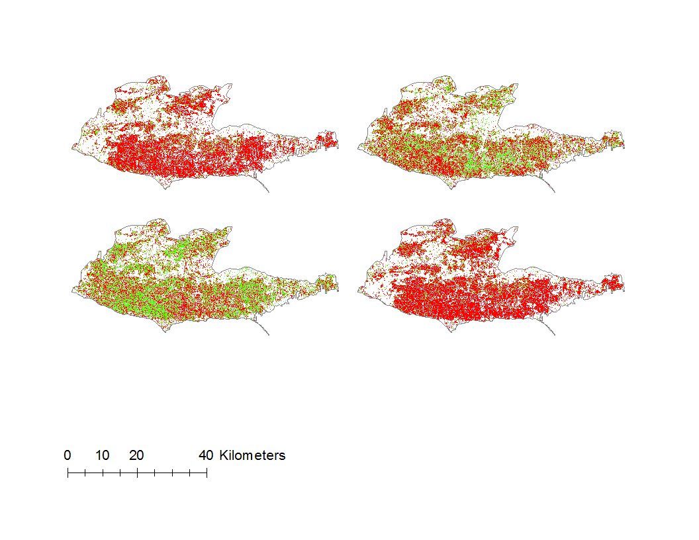

Negative change (-1 – -0.1)

No change (-0.1 – 0.1)

Positive change (0.1 – 1)

2014 - 2013

2015 - 2014

2016 - 2015

2016 – 2013

**Figure 5**. Annual change in FAL.

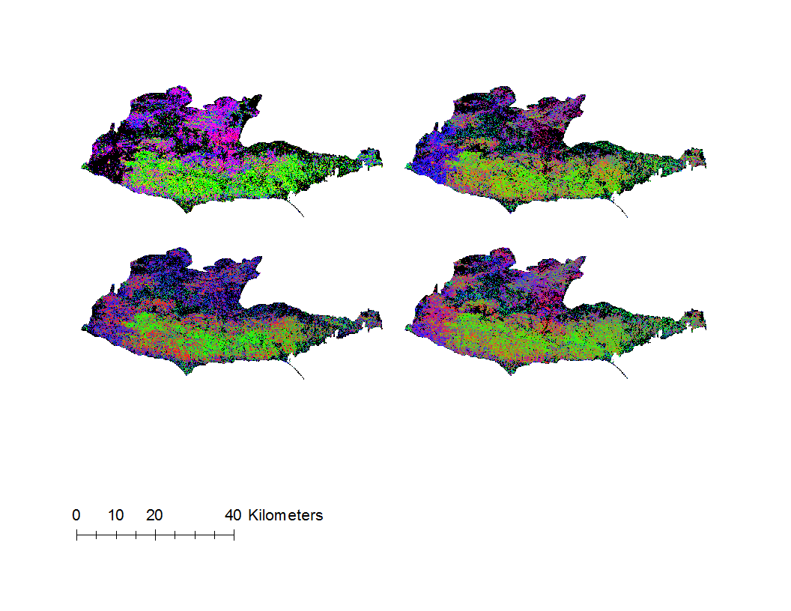

2014

2013

2016

2015

NPV

GV

S

**Figure 6**. MESMA images showing fractional cover of GV, NPV, and S.

It appears that the FAL change images (Fig. 5) do not delineate isolated vegetation change areas. Rather, they seem to show a broader trend of overall plant health across the entire study area. The 2014-2013 change image shows a dramatically red result, implying widespread loss of green vegetation. The same result can be seen in the overall change from 2013 - 2016. However, the increasing positive change, marked with green symbology, can clearly be seen in the 2015-2014 and 2016-2015 images. This would imply that the period from 2013 - 2014 caused the greatest stress on vegetation in the study area, but the plants began to recover from 2014 onwards. This same temporal pattern appears in the RVI change images, discussed later in this paper.

Although it would be preferable to test this method over a longer time period (given data availability), these images do present the idea that tracking FAL change may give better results about broad scale ecosystem health, but may not be a good way to identify particular areas of great stress. Part of this limitation stems from the fact that the FAL calculation does not take into account the substrate fraction. The 2013 fire, which showed up extremely clearly in the RVI change images (Fig. 7), is not so evident in the FAL change images. When consulting the actual MESMA images (Fig. 6), it became clear that the pixels within the burned area were largely unclassified (2013) or classified as substrate (2014-2015). This is not unreasonable, if the fire removed most vegetation and left only bare ground. However, judging the FAL change images alone could result in missing crucial information about the landscape.

This classification also raised many questions about the effect of seasonal change. The initial goal was to avoid spring images for MESMA classification altogether, recognizing that studies have shown phenology to hide long-term changes due to its effect on spectral response (Lambin, 1996). On the contrary, another study by Roberts et al. (1997) using AVIRIS data showed that seasonal effects did not cause dramatic changes in the spectral reflectance of evergreen vegetation, a category that coast live oak falls under. Because the months of May and June were by far the most consistent option, the team decided to stick with them to reduce uncertainties caused by images from completely different times of year. Ultimately, even if evergreen species were less affected than others, it is very possible that including the month of May affected the change results and hid other long-term trends. It could also explain why the change from 2013-2014 is so drastic. Further studies using this methodology on images from different seasons may help provide insight.

Finally, another indicator of error can be seen in the RMSE images (Appendix A). These images were a standard output of the MESMA process. In VIPER tools, the team defined the maximum RMSE for modeling the pixels as any given class was 10% for 2013-2015 and 5% for 2016. The value for 2016 was lower because the spectral library itself was pulled from one of the 2016 images, which were all acquired on the same date. Therefore it was expected that these images would be easier for VIPER tools to model. Less trust should be placed in the classification of areas with higher RMSE.

4.1.2 RVI Change

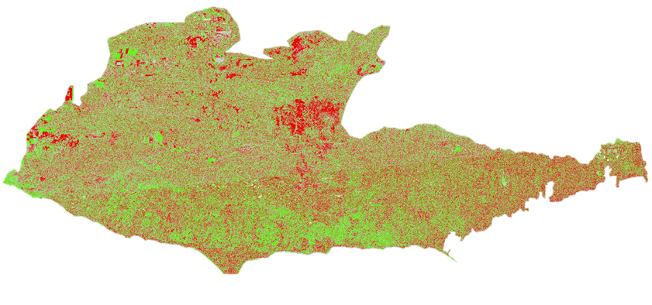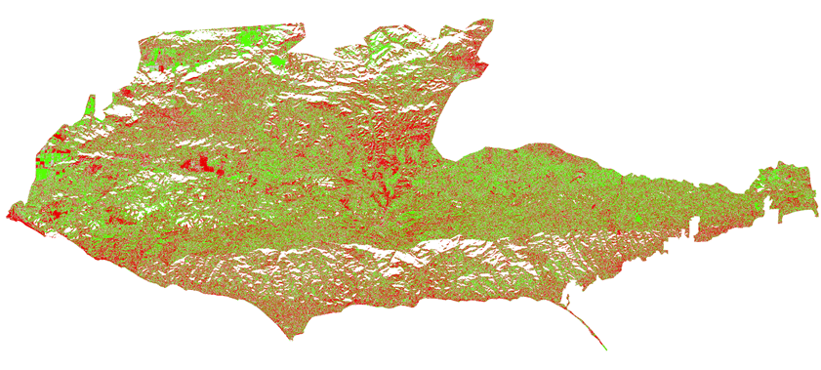

2011-2010

2012-2011

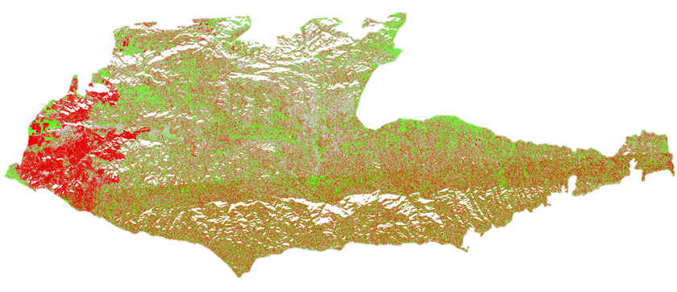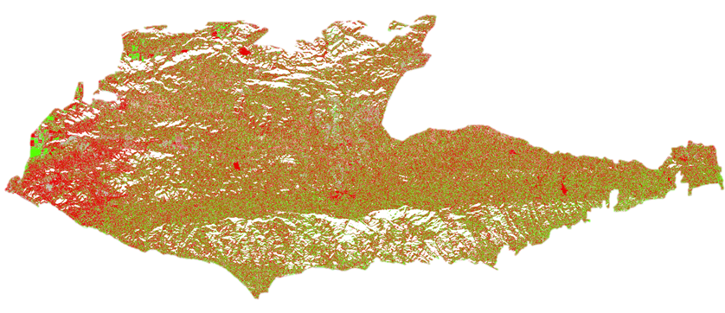

2014-2013

2013-2012

2014-2010

2015-2014

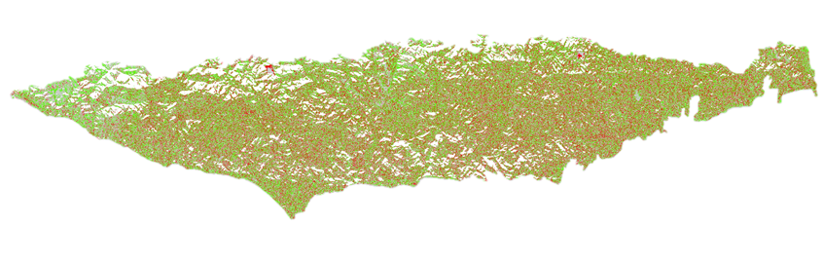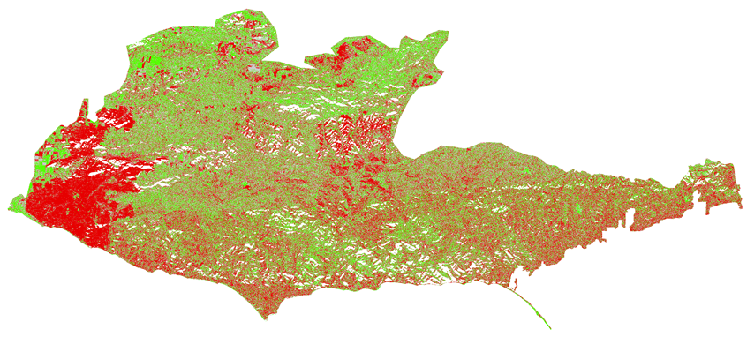

Negative change (Min- -.1)

No change (-.1- .1)

Positive change (.1 – Max)

**Figure 7.** RVI annual differences and total difference from 2014-2010

|  |  |
| --- | --- |
| Year | RVI median |
| 2011-2010 | 0.006554 |
| 2012-2011 | 0.006069 |
| 2013-2012 | -0.00583 |
| 2014-2013 | -0.05604 |
| 2015-2014 | 0.023436 |

**Table 1.** These values show the median RVI difference value per annual change. Due to non-normal distribution of some years, median was taken instead of mean; medians calculated with R code.

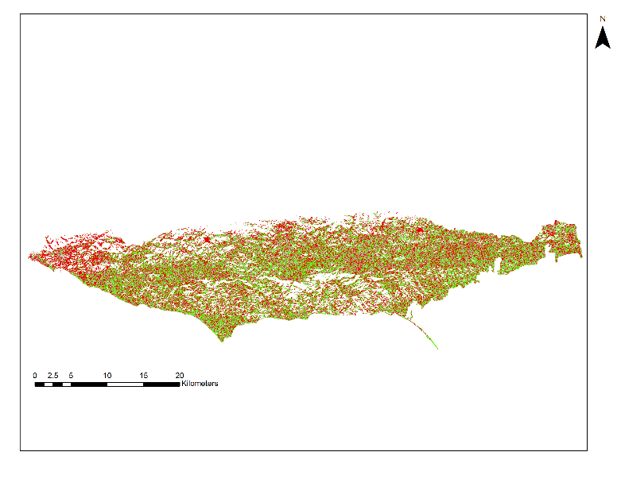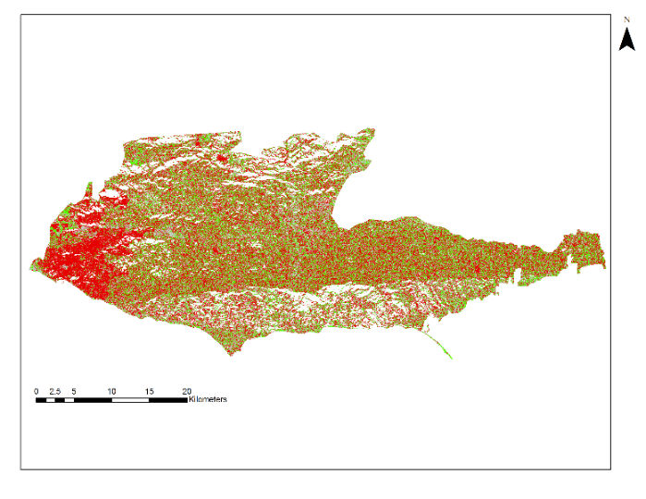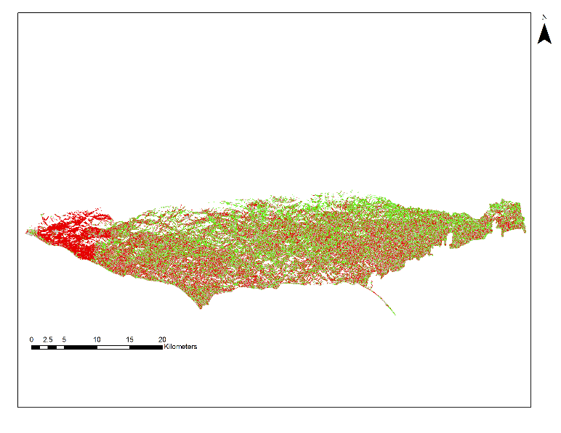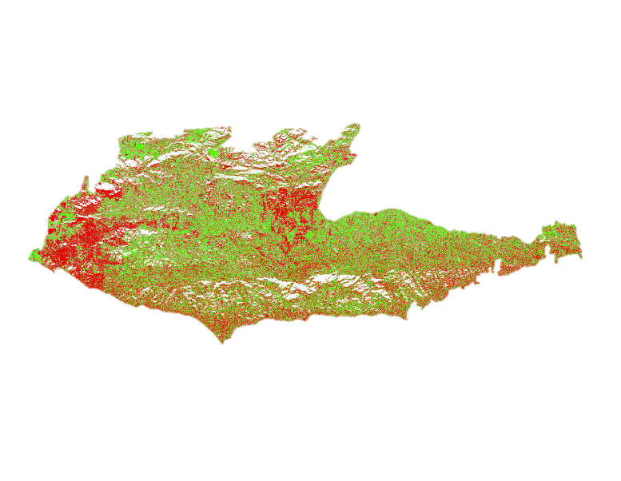

Negative change (Min- -.1)

No change (-.1- .1)

Positive change (.1 – Max)

October 2014-November 2012

May 2013-April 2010

June 2015-May 2013

June 2015-July 2011

**Figure 8.** RVI differences accounting for seasonal change. These differences were taken between years with similar acquisition months.

The patterns of red show negative change, or decrease in surface complexity, throughout the annual differences. Especially starting in 2012-2011, the clusters of red follow vegetation patterns given in the vegetation map supplied by the National Park Service. The negative change mostly includes shrubland areas with dominant species *Malosma laurina*, *Ceanothus spinosus*, and *Artemisia californica*, which may mean these shrubs show the most structural change when stressed. Because of the availability of UAVSAR download dates, RVI differences also capture seasonal changes, such as in annual grasslands. For example, the 2010 UAVSAR data were collected in April when grasslands are alive and the 2011 UAVSAR data were collected in July when grasslands are dry. Therefore, the 2011-2010 difference not only shows drought effects but also normal seasonal changes. Differences considering seasonal differences were calculated, shown in Fig. 8, in an attempt to isolate vegetation changes without seasonal effects. However, differences involving 2015 only show the southern swath as the northern flight did not occur in 2015.

The most noticeable negative change is the 2013 fire in the southwest part of the park, which can be seen in 13-12, 14-13, and some seasonal changes. The 2014-2013 difference shows the most negative change overall and has the lowest median (see Table 1), which means structural depletion from the 2013 fire continued into 2014. Due to the noise and high resolution of UAVSAR, it seems that RVI may be more helpful in evaluating holistic changes, such as severe fire damage, as opposed to tracking individual species. Extreme incidence angles in the mountains also attribute to lack of data in parts of the park. Even with incidence angle corrections, the southern and northern swaths do not mosaic perfectly, which accounts for some error where the extents meet. In addition, the incidence angle correction applied with one best-fit line across all the years and swaths. Each flight may vary slightly in incidence angle effect. Without ground trothing, it is also difficult to confirm all RVI changes are entirely attributed to vegetation dieback. Even though RVI has been shown to be closely correlated with VWC, there is still the possibility that RVI is affected by substrate moisture and other environmental conditions. (Huang et al, 2016) It is also important to consider the L-band sensor and the size of the monitored vegetation species. Since oaks are evergreen, the most noticeable structural indication of stress would be a holistic canopy-level die-off. In reality, the leaves die at different rates and sometimes may not fall the tree, which makes oak dieback difficult to trace with RVI. Since work with RVI using UAVSAR and on this large of a scale has not been done before, it is difficult to compare the observations and errors from this study to other RVI investigations.

4.1.3 Climate Variables

The 2014-2013 differences shows the greatest negative change for both FAL and RVI, which correlate with 2013 being the driest year and 2014 being the hottest year according to PRISM climate data. The delayed response to low precipitation may indicate that vegetation takes some time to show physical responses to high stress. The drop in RVI change takes place a year after significant drop in precipitation but during a considerable rise in annual mean temperature. The vegetation seems to recover after 2014 with both RVI and FAL differences showing a positive trend in the 2015-2014 difference and the 2016-2015 FAL difference. Both RVI and FAL changes appear to have a direct relationship with mean precipitation and precipitation days and an inverse relationship with mean temperature, extreme heat days, mean dewpoint temperature, and vapor pressure deficit.

It is reasonable to believe that an increase in precipitation would cause an increase in greenness (or for radar, surface roughness), and that an increase in temperature or extreme heat days would cause increased plant stress and a decrease in greenness. While some of these relationships have promisingly high R2 and low RMSE values, it is still difficult to place high confidence in them due to the small number of data points. For example, the linear regression between FAL change and mean temp has an R2 value 0.78 and RMSE of 0.04. These are good indicators of a high correlation between the two, but it is based on only three data points. For the same variable, RVI change has an R2 of 0.19 and RMSE 0.02, based on five data points (Appendix D.3). The R2 is drastically lower, and this is the highest R2 value observed for a regression with RVI change and any climate variable.

***4.2 Future Work***

There are many possibilities in extending this project to another term. The first of these would be to expand the study period to include the storms of early 2017. It would be interesting to see how the precipitation from that time may have affected vegetation stress. Another interesting addition would be to include data on infestations of the polyphagous shot-hole borer. Although we had initially intended to analyze this in our project, we were never able to acquire relevant data. A third aspect of this project that could be expanded upon is the use of FAL in looking at vegetation changes. While the team had to perform all the steps of calculating FAL step by step, including the choice of endmembers and development of the spectral library, soon there will be a standard Level-3 product straight from NASA providing GV-NPV-S fractions for all AVIRIS images. This would greatly reduce the change of human error in processing the images. On the UAVSAR side, another interesting continuation would be to look further into using RVI with UAVSAR data. The method is fairly new and not many studies have been done using RVI to study vegetation. This project appears to be the first to use RVI with UAVSAR over such a large study area; future studies can develop this methodology further for a wider variety of analyses. Finally, more work should be done on observing the oak woodland areas in particular. While most of this project was dedicated to working on producing the RVI and FAL data, the results applied more to the entire study area than to the oaks. The team extracted mean RVI and FAL change values from within the oak polygons provided in the NPS vegetation map, but due to time constraints could not investigate further (Appendix G).

# 5. Conclusions

Although the original goal was to relate FAL change to RVI change, it became clear that a relationship could not be defined, at least for the limited overlapping years of 2013-2015. It is unsurprising that the two did not have a clear relationship; although FAL change and RVI change are both meant to show where there is vegetation loss or gain, they do so in very different ways. FAL is measuring the actual greenness of vegetation while RVI is measuring the rough polarized returns of vegetation. Even though they lacked a clear relationship, they each succeeded in showing areas of vegetation change. RVI was exceptional at delineating the perimeter of a large 2013 fire, as well as annual grassland areas. FAL did not show such defined areas of change, but did show in which years the plants were under more stress. The FAL change, for example, from 2013-2014 is dramatically more negative than the other change years. This is reciprocated in the RVI change for that time period.

The inclusion of the climate variables also provided a great deal of insight. It is difficult to assess relationships between these variables and FAL and RVI change because there are so few data points we were able to generate due to limited data availability.

# 6. Acknowledgments

* Dr. Natasha Stavros (NASA Jet Propulsion Laboratory)
* Dr. Erika Podest (NASA Jet Propulsion Laboratory)
* Benjamin Holt (NASA Jet Propulsion Laboratory)
* Erika Higa (NASA DEVELOP Geoinformatics Fellow, NASA Jet Propulsion Laboratory)
* Kate Cavanaugh (NASA DEVELOP Spring 2017, NASA Jet Propulsion Laboratory)
* Dr. Bruce Chapman (NASA Jet Propulsion Laboratory)
* Christine Rains (NASA Jet Propulsion Laboratory)
* Rosi Dagit (RCD Santa Monica Mountains)

Any opinions, findings, and conclusions or recommendations expressed in this material are those of the author(s) and do not necessarily reflect the views of the National Aeronautics and Space Administration.

This material is based upon work supported by NASA through contract NNL16AA05C and cooperative agreement NNX14AB60A.

# 7. Glossary

**AVIRIS –** Airborne visible/ Infrared Imaging Spectrometer. A very high spectral resolution sensor, measuring spectral radiance across 224 bands at 10nm intervals.

**Biodiversity Hotspot** - a terrestrial location defined by containing at least 0.5% (or 1500) of the world’s plant species as endemics and having lost 70% or more of its primary vegetation

**CAL FIRE** – California Department of Forestry and Fire Protection

**CDPR** – California Department of Parks and Recreation

**Endmember** – pure representation of an image class, used to build spectral library for spectral unmixing

**FAL** – Fraction of Alive Cover, used to show change in fractional cover of green vegetation

**LAI** – Leaf area index

**MESMA** – Multiple endmember spectral mixture analysis, used to classify image based on land cover classes derived from endmembers

**NAIP** – National Agriculture Imagery Program, produces 1m resolution aerial imagery

**NPS** – National Park Service

**PRISM** – Parameter-elevation Relationships of Independent Slopes Model, climate group from Oregon State University that develops spatial climate datasets from 1895 to present

**RCDSMM** – Resource Conservation District of the Santa Monica Mountains

**RVI**- Radar Vegetation Index, polarization band math that highlights vegetation

**UAVSAR** – Unmanned Aerial Vehicle Synthetic Aperture Radar, fully polarimetric sensor from JPL taken at the L-band

**VWC** – Vegetation Water Content

**VIPER** – Visual & Image Processing for Environmental Research lab at University of California, Santa Barbara under Dr. Dar Roberts

# 8. References

Dagit, R. (2014). Oak woodland conservation management planning in southern CA – lessons learned.

Proceedings of the 7th California Oak Symposium: Managing Oak Woodlands in a Dynamic World,

Visalia, CA.

Dagit, R., Carlberg, C., Cuba, C., & Scott, T. (2014)*.* Economic incentives for oak woodland preservation and

conservation*.* Proceedings of the 7th California Oak Symposium: Managing Oak Woodlands in a

Dynamic World, Visalia, CA.

Dennsion, P.E. & Roberts, D.A. (2003). Endmember selection for multiple endmember spectral mixture

analysis using endmember average RMSE. *Remote Sensing of Environment* 87, 123-135. doi:10.1016/S0034-4257(03)00135-4

Dixon, J. (2003). Designation of ESHA in the Santa Monica Mountains [Memorandum]. San Francisco, CA:

California Coastal Commission.

Huang, Y., Walker, J. P., Gao, Y., Wu, X., & Monerris, A. (2016). Estimation of vegetation water content

from the radar vegetation index at L-band. *IEEE Transactions on Geoscience and Remote Sensing* *54*(2),

981-989. doi:10.1109/tgrs.2015.247180

Kim, Y., Jackson, T., Bindlish, R., Lee, H., & Hong, S. (2012). Radar vegetation index for estimating the

vegetation water content of rice and soybean. *IEEE Geoscience and Remote Sensing Letters* *9*(4),

564-568. doi:10.1109/lgrs.2011.2174772

Kim, Y., Jackson, T., Bindlish, R., Hong, S., Jung, G., & Lee, K. (2014). Retrieval of wheat growth

parameters with radar vegetation indices. *IEEE Geoscience and Remote Sensing Letters* *11*(4),

808-812. doi:10.1109/lgrs.2013.2279255

Kirschbaum, M. U. F. Direct and indirect climate change effects on photosynthesis and transpiration. *Plant*

*Biology 6*(3), 242 - 253. doi:10.1055/s-2004-820883

Kumar, S. D., Rao, S. S., & Sharma, J. R. (2013, September). Radar Vegetation Index as an Alternative to NDVI for Monitoring of Soyabean and Cotton. In *Proceedings of the XXXIII INCA International Congress (Indian Cartographer)* (Vol. 19, p. 21).

Lawrence, M.G. (2005). The relationship between relative humidity and the dewpoint temperature in moist

air: a simple conversion and applications. *Bulletin of the American Meteorological Society 86*(2),

225-233. doi:10.1175/BAMS-86-2-225

Lambin, E.F. (1996). Change detection at multiple temporal scales—seasonal and annual variations in

landscape variables. *Photogrammetic Engineering and Remote Sensing* 62, 931-938.

Li, L., Ustin, S. L., & Lay, M. (2005). Application of multiple endmember spectral mixture analysis (MESMA)

to AVIRIS imagery for coastal salt marsh mapping: a case study in China Camp, CA, USA. *International Journal of Remote Sensing 26*(23), 5193-5207. doi:10.1080/01431160500218911

Myers, N., Mittermeier, R.A., Mittermeier, C. G., da Fonseca, G. A. B., & Kent, J. (2000). Biodiversity

hotspots for conservation priorities. *Nature* 403, 853-858. doi: 10.1038/35002501

NOAA, USDA, & UNL. (2017). U.S. Drought Monitor. Retrieved from:

http://droughtmonitor.unl.edu/Home.aspx

Roberts, D.A., Alonzo, M., Wetherley, E., Dudley, K., & Dennison, P. (2007). Multiscale analysis of urban

areas using mixing models, in D.A. Quattrochi, E. Wentz, N.S. Lam & C.W. Emerson (ed) *Scale in Remote Sensing and GIScience Applications*, CRC press, 247-282.

Roberts, D.A., Green, R.O., and Adams, J.B. (1997). Temporal and spatial patterns in vegetation and

atmospheric properties from AVIRIS. *Remote Sensing of Environment* 62, 223-240.

Srivastava, P.K, O’Neill, P., Cosh, M., Lang, R., & Joseph, A. (2015). Evaluation of radar vegetation indices

for vegetation water content estimation using data from a ground-based SMAP simulator. *2015*

*IEEE International Geoscience and Remote Sensing Symposium (IGARSS).* doi:10.1109/igarss.2015.7326012

Tiszler, J., & Rundel, P. W. (2007). Santa Monica Mountains: Biogeography and cultural history. Flora and

ecology of the Santa Monica Mountains: Proceedings of the 32nd annual Southern California

Botanists symposium, ed. D. A. Knapp, 1-17.

Ulaby, F. (1975). Radar response to vegetation. *IEEE Transactions on Antennas and Propagation,* *23*(1), 36-45.

doi:10.1109/tap.1975.1140999

AVIRIS data courtesy of NASA/JPL-Caltech

UAVSAR data courtesy of NASA/JPL-Caltech

# 9. Appendices

**Appendix A: MESMA RMSE images**

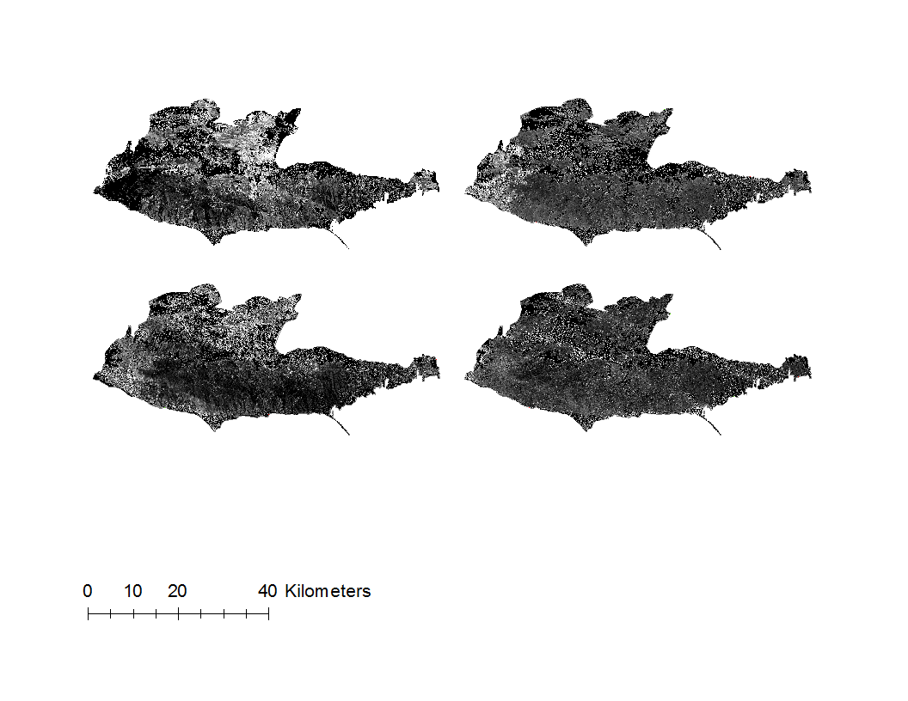**Appendix B: UAVSAR Incidence Angle vs RVI relationship**

Average RVI at given incidence angles 20°-70°

**Appendix C: RVI and FAL Relationship Plots**

A corresponding 70% of the total points were picked from both FAL and RVI overlap years and plotted against each other. No clear relationship was found.

2014-2013

2015-2014

FAL

FAL

RVI

RVI

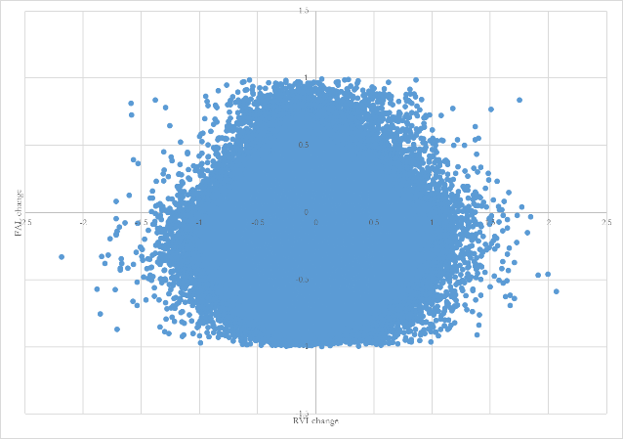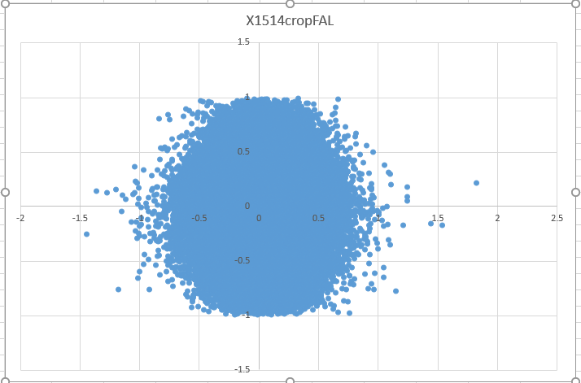

**Appendix D: Climate Variable Plots**

All differences are plotted on most recent year (Ex. 2014-2013 is plotted on 2014). Climate data taken from 4km2 PRISM quadrant (24.0791, -118.7323) at 1516ft elevation.

Variable 1: Total annual precipitation

Variable 2: Annual number of days of precipitation

Variable 3: Annual mean temperature

Variable 4: Annual number of days reaching maximum temperature greater than 90°F

Variable 5: Annual mean dewpoint temperature

Variable 7: Annual minimum vapor pressure deficit (VPD)

Variable 8: Annual maximum vapor pressure deficit (VPD)

Variable 9: Annual mean vapor pressure deficit (VPD)

**Appendix E: AVIRIS Scenes**

|  |  |  |
| --- | --- | --- |
| Year | Month | Flight Name |
| 2013 | May | f130522t01p00r13 |
| 2013 | May | f130522t01p00r11 |
| 2013 | May | f130522t01p00r12 |
| 2013 | May | f130522t01p00r10 |
| 2014 | June | f140613t01p00r11 |
| 2014 | June | f140613t01p00r12 |
| 2014 | June | f140613t01p00r10 |
| 2014 | June | f140613t01p00r08 |
| 2015 | May | f150528t01p00r12 |
| 2015 | May | f150528t01p00r14 |
| 2015 | May | f150528t01p00r11 |
| 2015 | May | f150528t01p00r10 |
| 2016 | June | f160616t01p00r14 |
| 2016 | June | f160616t01p00r15 |
| 2016 | June | f160616t01p00r13 |
| 2016 | June | f160616t01p00r11 |

**Appendix F: UAVSAR scenes**

|  |  |  |
| --- | --- | --- |
| Acquisition Date | **Flight Number** | **Product ID** |
| April 15, 2010 | SanAnd_26524 | SanAnd_26524_10029_004_100415_L090_CX_01 |
| April 15, 2010 | SanAnd_26526 | SanAnd_26526_10029_006_100415_L090_CX_01 |
| July 8, 2011 | SanAnd_26524 | SanAnd_26524_11047_002_110708_L090_CX_01 |
| July 8, 2011 | SanAnd_26526 | SanAnd_26526_11047_004_110708_L090_CX_02 |
| November 14, 2012 | SanAnd_08523 | SanAnd_08523_12133_000_121114_L090_CX_01 |
| November 19, 2012 | SanAnd_08525 | SanAnd_08525_12135_006_121119_L090_CX_01 |
| May 31,2013 | SanAnd_08523 | SanAnd_08523_13102_008_130531_L090_CX_01 |
| May 28, 2013 | SanAnd_08525 | SanAnd_08525_13096_002_130528_L090_CX_01 |
| October 24, 2014 | SanAnd_26524 | SanAnd_26524_14158_004_141023_L090_CX_01 |
| October 23, 2014 | SanAnd_08525 | SanAnd_08525_14158_003_141023_L090_CX_01 |
| May 11, 2015 | SanAnd_26525 | SanAnd_26524_15059_006_150511_L090_CX_01 |

**Appendix G: Mean FAL and RVI Change – Oak Woodlands**

|  |  |  |  |  |
| --- | --- | --- | --- | --- |
| Year | Mean FAL change | Mean FAL change (oaks) | Median RVI change | Mean RVI change (oaks) |
| 2011-2010 | -- | -- | 0.006554 | 0.009565 |
| 2012-2011 | -- | -- | 0.006069 | 0.045621 |
| 2013-2012 | -- | -- | -0.00583 | -0.01088 |
| 2014-2013 | -0.21149 | -0.2221 | -0.05604 | -0.02478 |
| 2015-2014 | -0.05501 | 0.0049 | 0.023436 | 0.013105 |
| 2016-2015 | 0.004311 | -0.0632 | -- | -- |

**Appendix H: RMSE and R2 for PRISM Plots**

|  |  |  |  |  |
| --- | --- | --- | --- | --- |
| Variable | RMSE for RVI plot | R2 for RVI | RMSE for FAL plot | R2 for FAL |
| Annual Precip | 0.027023 | 0.0053 | 0.08061 | 0.2158 |
| Days of Precip | 0.02528174 | 0.1301 | 0.05049 | 0.6925 |
| Mean Temp | 0.024386 | 0.1564 | 0.04255 | 0.9937 |
| Days over 90 | 0.024323 | 0.1945 | 0.0072 | 0.7815 |
| Mean Dewpoint | 0.025213565 | 0.1339 | 0.06393 | 0.5069 |
| Min VPD | 0.026936948 | 0.116 | 0.09059 | 0.0097 |
| Max VPD | 0.025233192 | 0.1332 | 0.04276 | 0.7793 |
| Mean VPD | 0.025778619 | 0.0951 | 0.05798 | 0.5943 |