**NASA DEVELOP National Program**



NASA Marshall Space Flight Center

*Summer 2015*

East Africa Disasters

Using NASA Satellite Data to Predict Landslide Hazards in Uganda and Rwanda

 **Technical Report**

Rough Draft – June 25, 2015

Leigh Sinclair (Project Lead)

Padraic Conner (Co-Project Lead)

Tyler Finley

Jeanné le Roux

Dr. Jeffrey Luvall, NASA at NSSTC (Science Advisor)

Dr. Robert Griffin, University of Alabama in Huntsville (Science Mentor)

# I. Abstract

[Placeholder - do not put anything here until the final draft submission. The abstract in the project summary is where the working draft of the abstract should “live”]

**Keywords**

Landslide, Rwanda, Uganda, Remote Sensing, Disasters, Global Landslide Catalog

# II. Introduction

“The term ‘landslide’ describes a wide variety of processes that result in the downward and outward movement of slope-forming materials including rock, soil, artificial fill, or a combination of these. The materials may move by falling, toppling, sliding, spreading, or flowing” (Highland 2004). The East African countries of Rwanda and Uganda have an unfortunate history of disastrous landslides due to a combination of intense rainfall events, topography, and populations living on or near steep slopes. For example, on March 1, 2010, a landslide struck the Bududa region of Eastern Uganda, killing over 350 people and leaving more than 5000 others homeless (Zawedde 2010). Currently, both national governments have disaster preparedness policies and programs in place for such events, but these efforts are limited in scope and are more focused on disaster response than prevention or early warning. These countries lack the spatial and temporal information required to accurately and effectively identify hazardous areas and properly warn at-risk populations. Instead, mitigation efforts have involved merely moving populations away from areas known to have incurred landslides in the past (Nsengiyumva 2012).

The objective of this project was to supply the national governments and related organizations of Uganda and Rwanda with decision support information that will enable them to more effectively identify hazardous locations and warn at-risk populations. This objective was split into three sub-goals which included updating the Global Landslide Catalog (described below), creating a landslide hazard potential map, and performing a preliminary assessment on the ability of three different rainfall detecting satellites to predict landslides. These project objectives address the Disasters section of NASA’s Applied Science application areas.

The first goal was to update the The Global Landslide Catalog (GLC), an online database created in 2007 at NASA Goddard Space Flight Center (GSFC) to document global rainfall-triggered landslide events. The GLC compiles information through a combination of newspaper reports, published articles, disaster databases, Google alerts, blog entries, and personal witness accounts. Each entry can be identified as a point on a map with specific information including date, time, location accuracy, landslide size, landslide type, and fatalities (Kirschbaum et al. 2015). Updates to this catalog will allow SERVIR to more effectively support landslide monitoring efforts.

The second goal focused on creating a landslide hazard potential map that incorporated a number of known landslide risk factors to visually display areas where landslides are most likely to occur. This was accomplished through a review of the literature to determine which risk factors to considerand which thresholds of each factor were likely to cause a landslide. The resulting map gave end users concrete locations to apply appropriate policies and mitigation efforts rather than reliance on anecdotal evidence or spotty field studies.

The final goal was a preliminary assessment of satellite rainfall performance in identifying landslide conditions. Measurements from both the Tropical Rainfall Measuring Mission (TRMM) and Global Precipitation Mission (GPM) were compared with ground-based measurements from the Climate Hazards Group InfraRed Precipitation and with Station Data (CHIRPS) to assess their accuracies in monitoring rainfall events that were known to trigger landslides.

The study area for this project encompassed the countries of Rwanda and Uganda, found in East Africa. Due to their topography, landslides can occur almost anywhere within their borders, although some sites see a much higher incidence. The Mt. Elgon region of Eastern Uganda is one such example. This study used historical landslide records and precipitation data spanning from 1998 until present day.

SERVIR - the Regional Visualization and Monitoring System – is a joint effort between NASA and the United States Agency for International Development (USAID) utilizing Earth observations and predictive models derived thereof to aid decision makers. SERVIR has partnered with the Regional Center for Mapping of Resources for Development (RCMRD) in Nairobi, Kenya to create a SERVIR hub in Africa. RCMRD services 18 member countries including Uganda and Rwanda and oversees a variety of projects that improve environmental management and resilience to climate change. Currently, information on landslides from remotely-sensed platforms is limited in Uganda and Rwanda. While there is a general knowledge of where landslide-prone areas are located in both countries, more precise mapping and a more thorough investigation of landslide characteristics in the region will help disaster management officials with preventative practices regarding rainfall-triggered landslides.

# III. Methodology

***Landslide Event Data Identification***

The first objective of this study was to update the GLC. This served a dual purpose as it helped improve the catalog as well as helped determine where landslides are historically common in both Uganda and Rwanda. GLC entries in Uganda and Rwanda were examined individually to check for location accuracy. Entries with a location accuracy of 5 km or less were considered for the hazard study and recorded on a spreadsheet.

Google Earth’s time slide viewer was used to visually identify additional landslide points in Uganda and Rwanda. Landslide coordinates were collected and recorded as KML files. The available date of imagery before each landslide was visible, as well as the date of imagery after each landslide became visible, was recorded. Due to inconsistencies in available imagery over Uganda and Rwanda, the time interval between before and after imagery ranged from 2 days to nearly 12 years in duration. A subset of landslide points with a date range of 1 year or less were chosen for the hazard study in order to keep fluctuating precipitation and soil moisture variables relevant in the hazard analysis. These points were also added to the GLC.

***Landslide Hazard Map Creation***

Once additional landslide points were identified, the focus of the study shifted to the landslide hazard potential map.. Factors considered in this study were: elevation, slope, aspect, plan curvature, distance from roads, road density, distance from streams, stream density, stream order, watersheds, population density, Integrated Moisture Index (IMI), Topographic Wetness Index (TWI), and slope length factor. Each of these factors is described below.

Once all variables and thresholds were identified, a fuzzy logic overlay was used to combine all of the variables to display at risk areas. The layer of historical landslide locations identified in the GLC and Google Earth was compared to the hazard map to test the relative success of the methodology.

30-meter resolution elevation data for Uganda and Rwanda were retrieved from Shuttle Radar Topography Mission 2 (SRTM2) data. Individual tiles spanning the study area were downloaded, reprojected from GCS WGS 1984 coordinate system to WGS 1984 Web Mercator Auxiliary Sphere, and then mosaicked together. The mosaicked layer was then clipped to the combined country boundary of Uganda and Rwanda using the “Clip” tool in ArcMap.

A slope profile for Uganda and Rwanda was derived from the SRTM2 elevation data and processed using the ArcGIS spatial analyst tool “Slope.” Resulting pixels had a 30 meter resolution with pixel values ranging from 0 degrees to 81.5 degrees slope.  The elevation data was also used to derive aspect, which shows the direction of slope on a 360 degree scale. The “Aspect” tool was used resulting in a 30 meter resolution raster with values ranging from -1 degrees to 360 degrees.

The hydrography of the study area was also derived using the SRTM2 elevation data. ArcMap was used to fill all sinks in the DEM and then used to derive flow direction and flow accumulation. Next, ArcMap was used to delineate streams, assign stream order, and identify watersheds. Distance to stream was calculated using the “Euclidian Distance” tool and drainage density was calculated using the “Focal Statistics” tool in ArcMap. The sum of waterways within a 50 cell radius (235km2 area) of each point was mapped.

Slope length (LS) factor is a combination of slope length and slope angle that is frequently used in erosion studies. It is calculated with the following equations:

                                                         L=(*m*+1)(A/22.1)*m*

Where *L* is the slope length factor at some point on the landscape, *λ_A* is the area of upland flow, *m* is an adjustable value depending on the soil’s susceptibility to erosion,and 22.1 is the unit plot length.

                                                      S=(sin(0.01745x*deg*)/0.09)*n*

Where*θ* is the slope in degrees, 0.09 is the slope gradient constant, and *n* is an adjustable value depending on the soil’s susceptibility to erosion.

These equations were combined and input into “Raster Calculator” in ArcMap. Values for *m* and *n* were taken from published literature to give good results in high spatial variability (Oliveira et al. 2013). The final equation as entered in “Raster Calculator” was:

*Power(“flow accumulation raster”*[cell resolution in meters]/22.1,0.4)*Power(Sin(“slope raster in degrees”*0.01745))/0.09, 1.4)*1.4*

Curvature topography for Rwanda and Uganda was created using the SRTM2 DEMs and the ArcMap “Curvature” tool. Both plan and profile curvatures were generated and were then clipped to the study area. Positive plan curvature values indicated divergence of flow while negative values indicated convergence. Positive profile curvature values indicated convex profiles while negative values indicated concave profiles.

A raster image depicting distance from roads was created using a roads shapefile obtained from SEDAC Global Roads Open Access Dataset and the “Euclidean Distance” tool. The raster was then clipped to the study area.

IMI is a measure of relative soil moisture first described in Iverson et al.  1997. A revised formula was used due to differences in soil data. First, hillshade, curvature, and flow accumulation were derived in ArcMap. These were then standardized on a 0-1 scale using Raster Calculator. Soils data were obtained from the International Soil Reference and Information Centre website. Soil drainage class and soil depth to bedrock data were obtained in 250 m resolution. Soil depth was divided by soil drainage class and then standardized on a 0-1 scale to give water holding capacity. IMI was then derived using the following equation in raster calculator:

*(“hillshade raster”*.4)+(“flow accumulation raster”* .3)+(“curvature raster”*.1)+(“water holding capacity raster”*.2)*

The surface area ratio shows how rugged the terrain is. This helped identify landscape patterns that corresponded with soil characteristics, vegetation, or rock type. First, a minimum elevation raster, a maximum elevation raster, and a smoothed DEM were calculated by using the “Focal Statistics” tool in ArcMap. Then, the surface area ratio was calculated with the following equation in raster calculator:

(“10x10” - “minDEM”) / (“maxDEM” - “minDEM”)

Where 10x10 refers to the smoothing factor for the elevation raster, *minDEM* is the minimum elevation raster, and*maxDEM* is the maximum elevation raster

The Topographic Wetness Index (TWI) is a steady-state wetness index showing how wet an area may be based on the topography. This was calculated by using a DEM over the study area. First, flow direction, flow accumulation, and slope were derived in ArcMap. Next, TWI was calculated from the following equation in raster calculator:

Ln((“FlowAcc” * 900) / Tan(“Slope”))

Where, *FlowAcc* is the flow accumulation...

# IV. Results & Discussion

**Analysis of results**TBD

**Errors and Uncertainties**Due to volcanic activity and recurrent brush fires in the East African rift there was a considerable amount of smoke in the Landsat data. There was also difficulty with cloud cover. In addition, small villages named in news articles were frequently not documented on any accessible maps.

**Future Work**This project used a heuristic method to examine the factors associated with landslides in Uganda and Rwanda. This problem could be approached from other directions. Project partner, Eric Anderson is working on using a statistical method utilizing logistic regression. It could also be approached with a logical method using Multiple Factor Method (MuF). MuF is based on logical operation that incorporates the additive influence of the higher susceptibility level of the instability factors (Bathrellos et al. 2009). Another term might also address the rainfall intensity-duration threshold for East Africa.

# Other areas of interest for future studies should include Malawi. Project partner Dennis Macharia expressed a need for study in Malawi as it is an emerging landslide hotspot. Kenya and Tanzania would also be useful areas for further study due to the number of landslide events that occur in these countries.

# V. Conclusions

TBD

# VI. Acknowledgments The East Africa Disasters team would like to acknowledge Dr. Jeffrey Luvall and Dr. Robert Griffin for providing guidance and support throughout this project. We would also like to thank our project partners Eric Anderson, Dr. Dalia Kirschbaum, and Denis Macharia for guidance and for providing data for this project.

# This material is based upon work supported by NASA through contract NNL11AA00B and cooperative agreement NNX14AB60A.

# VII. References

Bathrellos, G. D., D. P. Kalivas, and H. D. Skilodimou. “GIS-based Landslide Susceptibility  
 Mapping Models Applied to Natural and Urban PLanning in Trikala, Central  
 Greece.” *Estud. Geol. Estudios Geológicos* 65.1 (2008): 49-65. Web.

Caine, Nel. “The Rainfall Intensity: Duration Control of Shallow Landslides and Debris  
 Flows.” *Geografiska Annaler. Series A, Physical Geography* 62.1/2 (1980): 23.  
 Web.

Chien-Yuan, Chen, Chen Tien-Chien, Yu Fan-Chieh, and Lin Sheng-Chi. “Analysis of  
 Time-varying Rainfall Infiltration Induced Landslide.” *Environmental Geology  
 Environ Geol* 48.4-5 (2005_: 466-79. Web.

Corominas, Jordi, and José Moya. “A Review of Assessing Landslide Frequency for  
 Hazard Zoning Purposes.” *Engineering Geology* 102.3-4 (2008): 193-213. Web.

Corominas, J., J. Moya, and M. Hurlimann. “Landslide Rainfall Triggers in the Spanish  
 Eastern Pyrenees.” *Mediterranean Storms: Proceedings of the 4th EGS Plinius  
 Conference Held at Mallorca, Spain, October 2002* (2002): n. pag. Web.

Crozier, Michael J., and Thomas Glade. “Landslide HAzard and Risk: Issues, Concepts  
 and Approach.” *Landslide Hazard and Risk Glade/Landslide* (2005): 1-40. Web.

Dai, F.c, and C.f Lee. “Landslide Characteristics and Slope Instability Modeling Using  
 GIS, Lantau Island, Hong Kong.” *Geomorphology* 42.3-4 (2002): 213-28. Web.  
Eisbacher, G. H. “First-Order Regionalization of Landslide Characteristics in the  
 Canadian Cordillera.” *Geoscience Canada* 6.2 (n.d.): 69-79. Web.

Grosse, Scott. *More People More Trouble: Population Growth and Agricultural Change  
 in Rwanda (A Case Study of the Population-Agriculture-Environment Nexus).*  
 Tech. Vol. 2. N.p.: Office of Sustainable Development Division of Productive  
 Sector Growth and the Environment Bureau for Africa U.S. Agency for  
 International Development, 1994. Web.

Guzzetti, Fausto, Alessandro Cesare Mondini, Mauro Cardinali, Federica Fiorucci,  
 Michele Santangelo, and Kang-Tsung Chang. “Landslide Inventory Maps: New  
 Tools for an Old Problem.” *Earth-Science Reviews* 112.1-2 (2012): 42-66. Web.

Guzzetti, Fausto, Silvia Peruccacci, Mauro Rossi, and Colin P. Stark. “The Rainfall  
 Intensity-duration Control of Shallow Landslides and Debris Flows: An Update.”  
 *Landslides* 5.1 (2007)L 3-17. Web.

Highland, Lynn. “USGS Fact Sheet 2004-3072: Landslide Types and Processes.” *USGS Fact  
 Sheet 2004-3072: Landslide Types and Processes.* USGS, n.d. Web.

*Impacts of Floods and Landslides on Socio-Economic Development Profile.* Rep. Kigali:  
 Ministry of Disaster Management and Refugee Affairs, 2012. Web.

Iverson, Louis R., et al. "A GIS-derived integrated moisture index to predict forest

composition and productivity of Ohio forests (USA)." Landscape Ecology 12.5

(1997): 331-348.

Kirschbaum, D. B., R. Adler, Y. Hong, and A. Lerner-Lam. “Evaluation of a Preliminary  
 Satellite-based Landslide Hazard Algorithm Using Global Landslide Inventories.”  
 *Natural Hazards and Earth System Science Nat. Hazards Earth Syst. Sci.* 9.3 (2009):  
 679-86. Web.

Kirschbaum, Dalia Bach, Robert Adler, Yang Hong, Stephanie Hill, and Arthur  
 Lerner-Lam. “A Global Landslide Catalog for Hazard Applications: Method,  
 Results, and Limitations.” *Nat Hazards Natural Hazards* 52.3 (2009): 561-75. Web.

Kirschbaum, Dalia, Thomas Stanley, and Yaping Zhou. “Spatial and Temporal Analysis of  
 a Global Landslide Catalog.” *Geomorphology* (2015): n. pag. Web.

Knapen, A., M.g. Kitutu, J. Poesen, W. Breugelmans, J. Deckers, and A. Muwanga.  
 “Landslides in a Densely Populated County at the Footslopes of Mount Elgon  
 (Uganda): Characteristics and Causal Factors.” *Geomorphology* 73.1-2 (2006):  
 149-65. Web.

Moeyersons, Jan. “The Topographic Thresholds of Hillslope Incisions in Southwestern  
 Rwanda.” *Catena* 50.2-4 (2003_: 381-400. Web.

Nsengiyumva, Jean Baptiste. *Disaster High Risk Zones on Floods and Landslides.* Rep.  
 Kigali: Ministry of Disaster Management and Refugee Affairs, 2012. Web.

Oliveira, A. H., D.A.F. de Freitas, G.K. Neto, M.L.N. Silva, M.A. da Silva, & N. Curi.  
 “Development of topographic factor modeling for application in soil  
 erosion models.” 2013. INTECH Open Access Publisher.

Reid, M., R. Baum, R. Lahusen, and W. Ellis. “Capturing Landslide Dynamics and  
 Hydrologic Triggers Using Near-real-time Monitoring.” *Proceedings of the 10th  
 International Symposium on Landslides and Engineered Slopes, 30 June - 4 July  
 2008, Xi’an, China Landslides and Engineered Slopes. From the Past to the Future* (2008): 179-91. Web.

Schnur, Mark T. *NDVI and EVI Estimation of Root Zone Soil Moisture in East Texas*. Thesis.  
 University of Texas in San Antonio, n.d. N.p.; n.p., n.d. Web.

Sivakami, C., and A. Sundaram. “Landslide Susceptibility Zone Using Frequency Ratio  
 Model, Remote Sensing & GIS - A Case Study of Western Ghats, India (Part of  
 Kodaikanal Taluk).” *Journal of Environment and Earth Science* 4.22 (2014_: 54-61.  
 Web.

“Terrain Roughness - 13 Ways.” *GIS 4 Geomorphology*. GIS 4 Geomorphology, n.d. Web.  
 19 June 2015.

*The National Disaster Management Policy*. Rep. Kigali: Ministry of Disaster Management  
 and Refugee Affairs, 2012. Web.

*The National Policy for Disaster Preparedness and Management.* Rep. The Republic of  
 Uganda, Sept. 2010. Web.

“Topographic Wetness Index.” *GIS 4 Geomorphology*. GIS 4 Geomorphology, n.d. Web.  
 19 June 2015.

Wang, Lingli, John J. Qu, and Xianjun Hao. “Forest Fire Detection Using the Normalized  
 Multi-Band Drought Index (NMDI) with Satellite Measurements.” *Agriculture and  
 Forest Meteorology* 148.11 (2008): 1767-776. Web.

Yeslinacar, E., and T. Topal. “Landslide Susceptibility Mapping: A Comparison of Logistic  
 Regression and Neural Networks Methods in a Medium Scale Study, Hendek  
 Region (Turkey).” *Engineering Geology* 79.3-4 (2005): 256-66. Web.

Zawedde, J. “Uganda: Companies aid landslide victims.” *Reliefweb.* From Uganda Red  
 Cross, 16 March 2010. Web. 18 June 2015.  
 <http://reliefweb.int/rport/uganda/uganda-companies-aid-landslide-victims-0>

# VIII. Content Innovation

TBD

# IV. Appendix A: *Maps of Individual Landslide Variables*

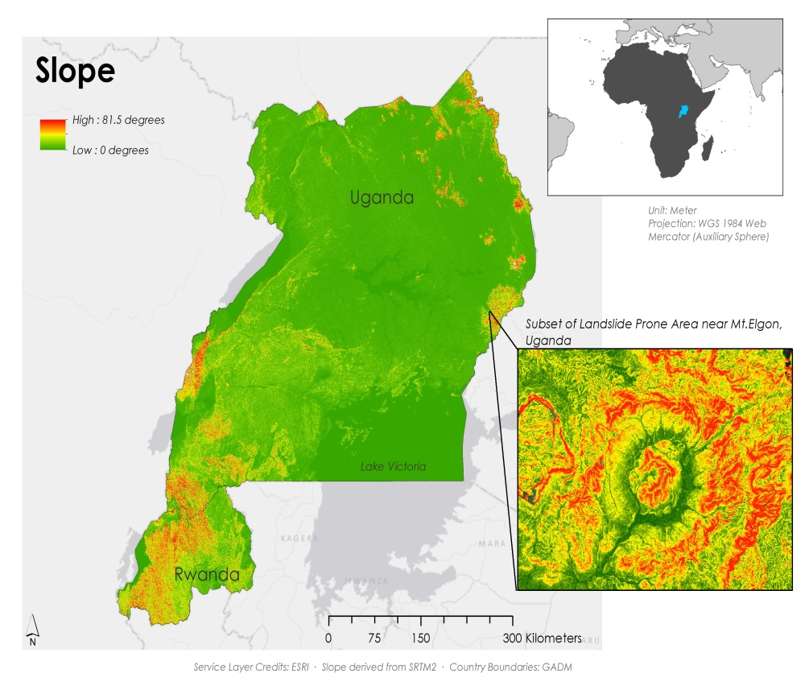

Figure 1: Slope over Rwanda and Uganda

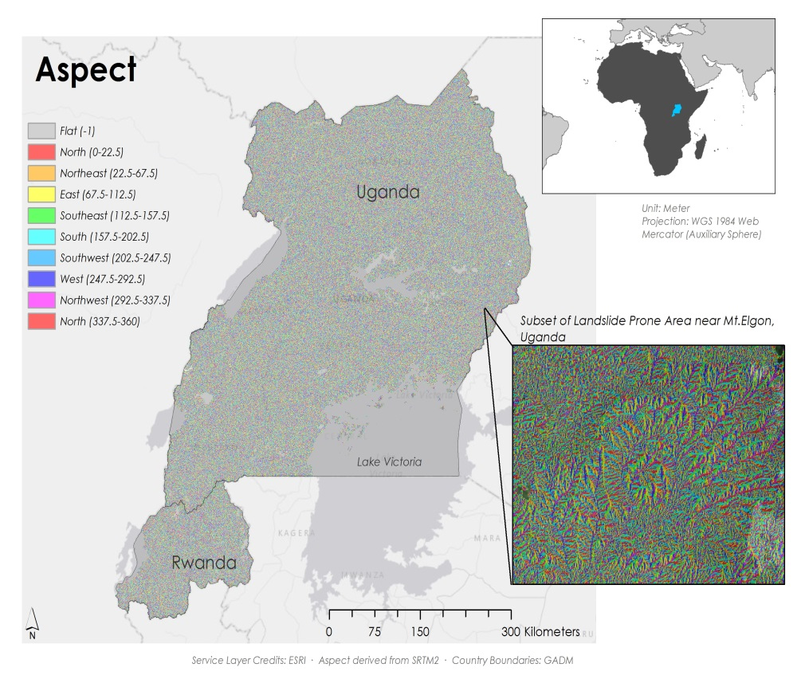  
Figure 2: Aspect over Rwanda and Uganda

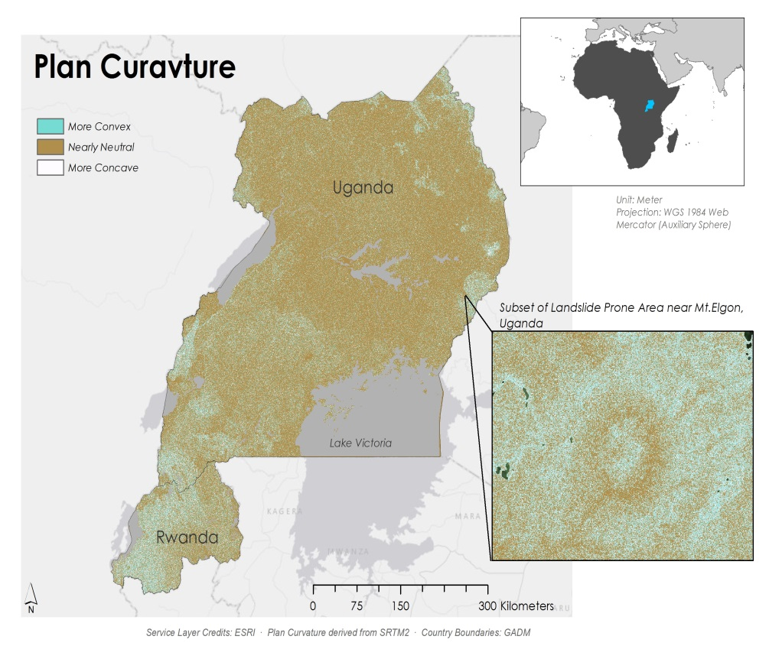  
Figure 3: Plan Curvature over Rwanda and Uganda

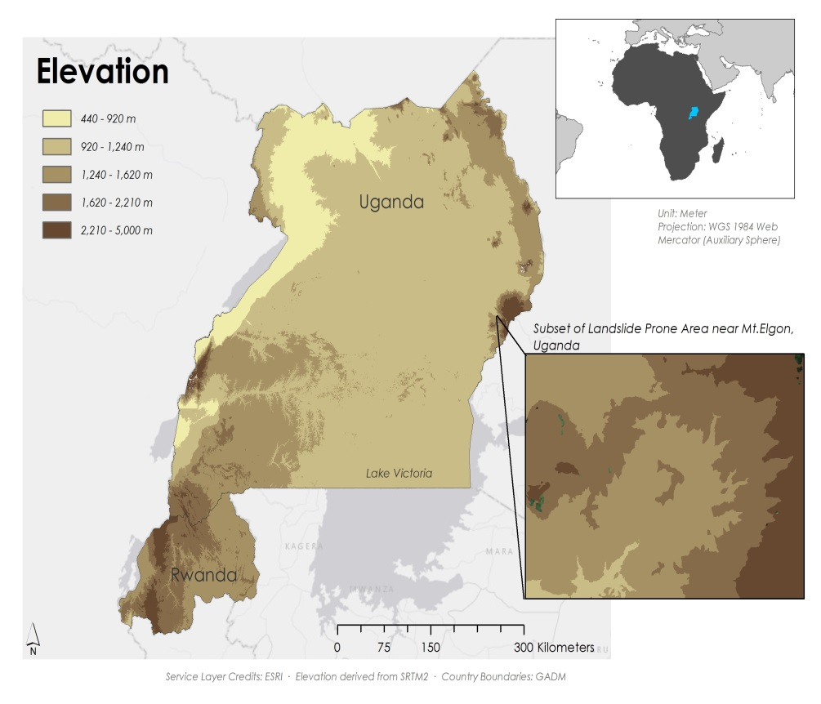   
Figure 4: Elevation over Rwanda and Uganda  
  
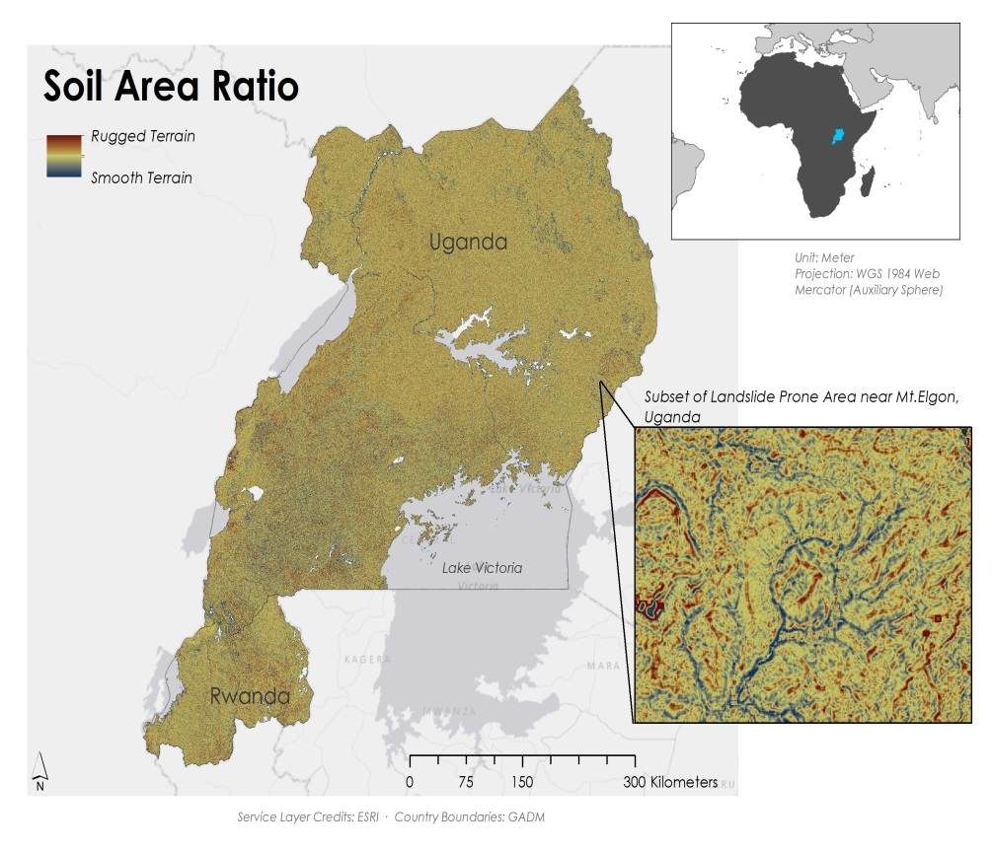  
 Figure 5: Soil Area Ratio over Rwanda and Uganda

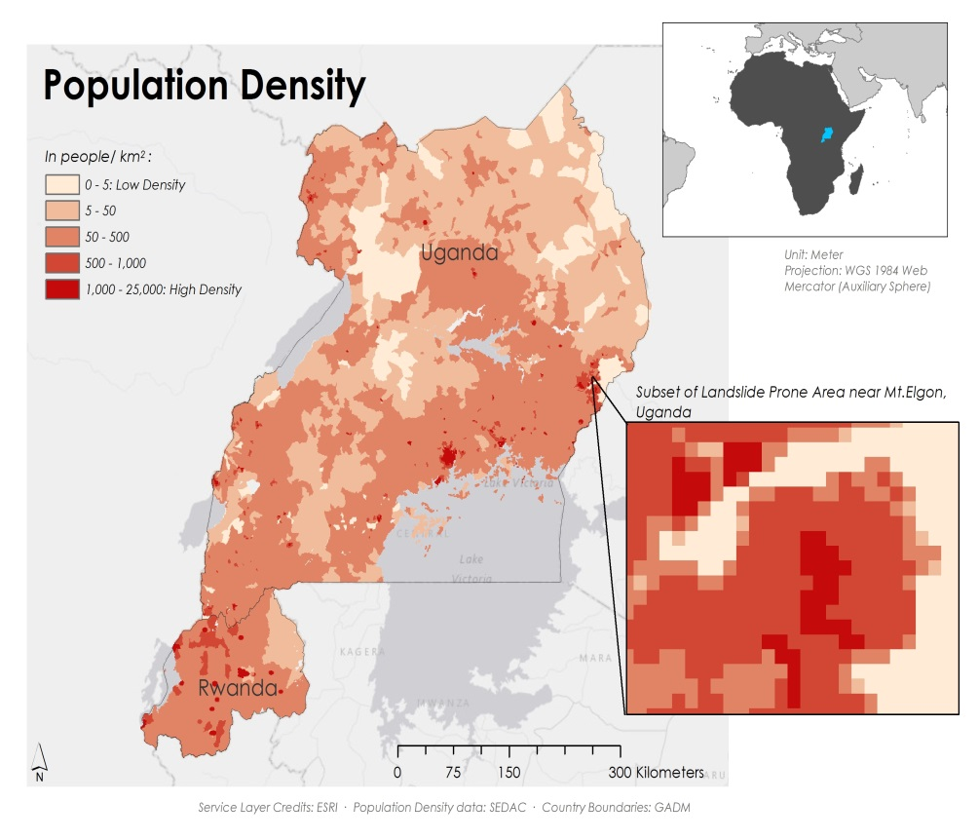   
Figure 6: Population Density of Rwanda and Uganda