**NASA DEVELOP National Program**



National Centers for Environmental Information - Asheville

*Fall 2015*

Missouri River Climate

Understanding runoff in the Missouri River Basin using NASA and NOAA satellite observations for improved river system management and decision support

**Technical Report** 

Rough Draft – October 8, 2015

Emily Sturdivant (Project Lead)

Nancy Barnhardt

Alec Courtright

Sam Swanson

DeWayne Cecil, GST (Science Advisor)

# I. Abstract

[Placeholder - do not put anything here until the final draft submission. The abstract in the project summary is where the working draft of the abstract should “live”]

**Keywords**

Missouri River Basin, Runoff, Water Management, Soil moisture, Snow Water Equivalent, Microwave Remote Sensing, Seasonality

# II. Introduction

In 2011, an unprecedented rain-on-snow event following one of the largest snow years in recorded history led to massive floods in the Missouri River Basin (MRB). To prevent the Basin’s dams from being overtopped and possible dam failure the United States Army Corps of Engineers (USACE) were forced to release up to 160,000 cubic feet per second (cfs) from basin dams - the largest amount since record-keeping began in 1898 [USGAO 2014]. Subsequent flooding and damage along the Missouri River from Montana to Missouri affected farms, homes, businesses, industries, public infrastructure, and transportation networks, costing the agency approximately $1 billion [USGAO 2014]. A 2014 report by the U.S. Government Accountability Office concluded that although Army Corps officials could not have predicted such an event, further research should be conducted to better understand the environmental factors that drive runoff in the MRB.

The Missouri River Basin Water Management Division (MRBWMD) currently uses a monthly runoff forecast to anticipate Basin conditions at six dam and reservoir locations. At the beginning of each calendar year, USACE forecasts expected monthly runoff. They then revise the forecast to produce a 3-week outlook, which estimates water supply across the region and determines reservoir inflows, releases, storage levels, and hydropower generation. Present forecasts incorporate basin conditions (i.e. soil moisture and snowpack) from meteorological stations and volunteer data collection, historical trends, and climate estimations [USACE, 2006]. However, the upper Missouri River Basin is a data poor region with sparsely located ground stations to detect terrestrial water conditions and few volunteers to collect *in situ* data. For example, although mountain snowpack runoff is well-measured, there is little available information on surface water storage and snow water equivalents in the Northern Plains region [Grode, 2015].

The influence of such environmental variables as frost depth, soil moisture, snowpack, and precipitation on the river system is poorly quantified. In particular, coverage of the Northern Plains region by on-the-ground monitoring sites is sparse, resulting in incomplete understanding of the historical trends, seasonality, and current conditions of the many hydrological inputs to a highly variable river system [Grode, 2015]. This study aimed to expand the knowledge base of these data-sparse areas by incorporating remotely sensed data into Basin forecasting. Improved detection of these variables through validated NASA Earth Observations and NOAA Climate Data Records enhanced decision-making processes concerning basin flood control, fish and wildlife, irrigation, hydropower, recreation, navigation, and threatened and endangered species.

**Project Objectives**

The project used remotely sensed, reanalysis, and *in situ* data from the previous 35 years to improve the understanding of water supply and runoff in the Missouri River Basin. With a focus on the Northern Plains region of the basin, it 1) detected historic and present winter severity, soil moisture, and snow water equivalent through a combination of NASA Earth Observations, NOAA CDRs, and *in situ* data, 2) documented the normal and anomalous conditions for the Northern Plains region, 3) performed exploratory analyses of the association between these driver variables and stream discharge with a focus on seasonality and anomalous events.

**Study Period**

This project studied the 35 years between September of 1979 and November 2015. However, there are differences with data availability throughout the study period. For more information on what data is available for which time periods refer to Tables 1 and 2.

**Study Area**

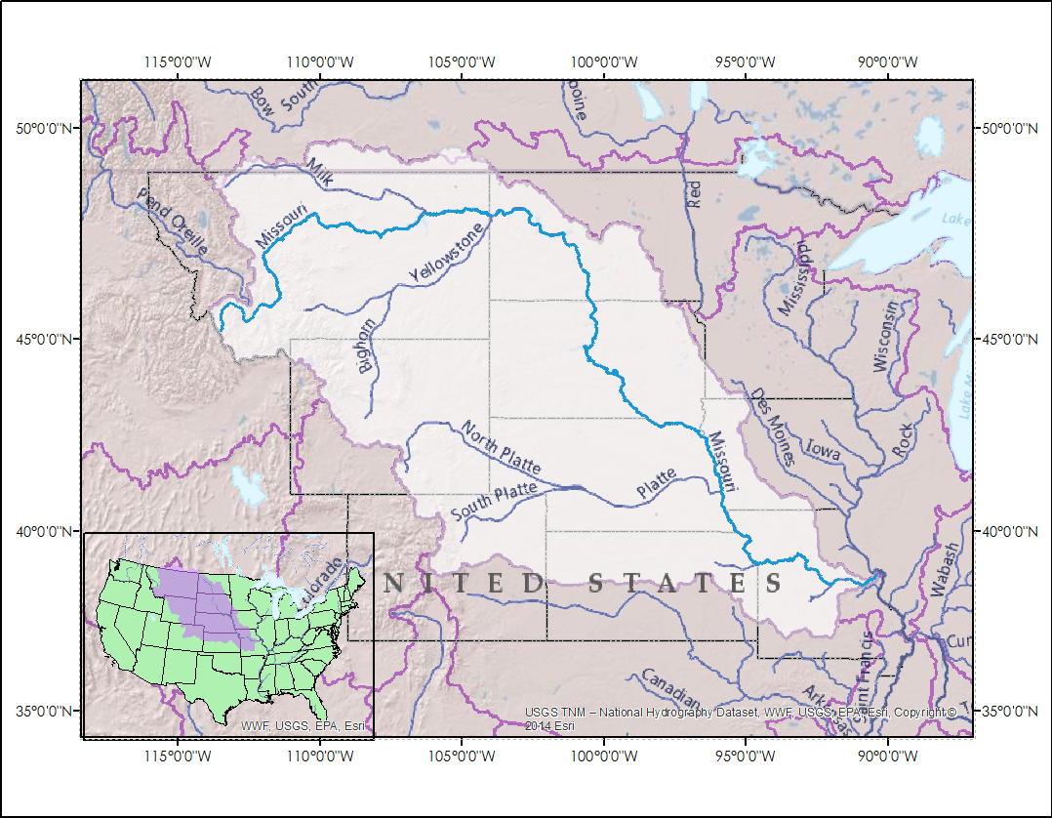

Figure 1. [This map will be improved and updated throughout the project] The Missouri River flows from the mountains of Montana through the Great Plains of the Dakotas. It is regulated by six major dams operated by the USACE. Source: Emily Sturdivant and Missouri River Climate team.

The Missouri River Basin covers 529,300 square miles and contains the largest reservoir system (by storage) in the United States [“The Missouri River Story”, 2010]. The three uppermost reservoirs on the Missouri River, Fort Peck, Garrison, and Oahe, contain nearly 90 percent of the system’s 71.4 million acre-feet (MAF) of storage [USACE, 2006]. This study focused on the upper Missouri River Basin, as the three reservoirs mentioned above are crucial to the Mainstem Reservoir System and USACE. The upper basin stretches from western Montana to Sioux City, Iowa, spanning large portions of Montana, North Dakota, South Dakota, and Wyoming. Within the upper Missouri River Basin, east of the Rocky Mountains, lies the Northern Plains region, a largely unpopulated prairie-land whose heavy snowpack and rapid melt in 2011 played a major role in that year’s historic floods [USGAO, 2014]. Despite its importance when forecasting runoff potential in the MRB, the Northern Great Plains region is poorly understood due to a lack of *in situ* stations measuring snowpack, soil moisture, and winter severity.

**NASA Application Areas**

The project addressed NASA’s Applied Science Application Areas of Climate, Water Resources, and Agriculture. Although the project did not directly analyze weather and climate, soil moisture, snowpack, and winter severity are proxy variables of climate and are very interrelated with one another. The dynamics among the variables studied will help USACE to effectively manage water resources throughout the basin, especially in years of extreme drought or flood. These water resources are crucial to agriculture in the region, as previously discussed.

**Project Partners**

The project sought to achieve a relevant and informative product for end-users by involving Kevin Grode, P.E., of the USACE MRBWMD, Dennis Todey, PhD, a State Climatologist and Associate Professor at South Dakota State University, and Doug Kluck, the NOAA Regional Climate Services Director for the Central Region. Kevin Grode directs the Reservoir Regulation Team, a team of hydraulic engineers and computer specialists who conduct studies and produce short- and long-term forecasts pertaining to the regulation of the Missouri River Mainstem Reservoir System.  Of the predictive variables used by the Reservoir Regulation Team to update forecasts, soil moisture, frost depth, and snow water equivalent remain largely un-quantified, especially in the Northern Plains region [Grode, 2015]. The MRBWMD will use trends in these variables provided by this DEVELOP team and their correlation with stream runoff to improve their decision-making processes.

The work of Dennis Todey and Doug Kluck helps to disseminate information to the public. Dr. Todey is an expert on current climate conditions and outlooks across the Northern Plains and Midwest. Mr. Kluck works closely with the Regional Climate Centers, state climatologists, federal and state governments, and others to develop climate data stewardship, build climate change capacity, and assess climate services needs by sector.  To this end, Mr. Kluck and Dr. Todey are interested in a product that can assist with forecasting runoff in the Missouri River Basin, especially long-term forecasts in light of trends associated with climate change. An improved understanding of trends in these variables and their effect on runoff will aid in their communications with basin organizations and residents.

# III. Methodology

The stated objectives were achieved through acquisition, processing, and analysis methodologies customized to each variable and the relevant available datasets. All datasets are both left in their original temporal resolution, after they have been verified as serially complete, and aggregated to monthly summary statistics for standardized comparisons with other datasets.

* Asterices indicate the most current stage of the methodology. All stages after * are only planned and have not yet been executed.

In addition to the data described below, shapefiles of watershed boundaries were used to limit the scope of analysis and to restrict correlations between spatially contiguous independent variables and the finite dependent variable of streamflow to the hydrologic regions. DEMs of the basin region and shapefiles of the river network also provided context reference and were obtained from USGS.

Table 1. Remotely sensed data.

|  |  |  |  |  |  |  |  |
| --- | --- | --- | --- | --- | --- | --- | --- |
| Variable | Data product | Platform | Product level | Resolution | Observation frequency | Time period | Source |
| Precipitation | CMORPH | Multiple | NCEI CDR | 4km | 30 min | 1991-present | NOAA NCEP CPC |
| Snow water equivalent | GlobSnow SWE | SMMR, SSM/I, ground-based | Daily Snow Water Equivalent (L3B) | 25km | daily, weekly, monthly | 1979-2012 | ESA GlobSnow consortium |
| Soil moisture | NLDAS | GOES |  | 1 degree | monthly | 1979-present | NASA GES-DISC |

Table 2. *In-situ* data.

|  |  |  |  |  |  |  |
| --- | --- | --- | --- | --- | --- | --- |
| Variable | Data product | Platform | Distribution of stations | Observation frequency | Time period | Source |
| Discharge | USGS water | stream gauge stations | - | daily (average) | 1979-present | USGS |
| Soil moisture | SCAN | ground stations | ~ 4 sites in study area | daily | varies | NOAA NRCS |
| Precipitation | GHCN | array of ground stations | - | daily |  | NOAA |
| Stream gauge locations | HCDN | Low-impact stream gauges data set | 75 gauges in study area | daily | 1974-2009 | USGS |

**Snow Water Equivalent**

The GlobSnow consortium derives an estimate of snow water equivalent (SWE) from satellite observations and ground station data. It incorporates measurements from NASA Earth Observations’ SSM/I and SMMR sensors and from the ECMWF weather stations. The GlobSnow data product includes both daily and weekly estimates at 25km grid spacing, from 1979 to 2012, which are publicly accessible at <http://www.globsnow.info/swe/> [Luojus et al., 2010]. It improves upon SWE calculations derived from SSM/I, which are especially accurate over medium elevation flat plains with seasonal snow cover, which accurately describes the Northern Plains region [Vuyovich et al., 2014]. Although data is available in daily measurements, data for many days and locations is missing because not every area is passed overhead by an SSM/I- or SMMR-equipped satellite every day. To provide a SWE estimate for every day, weekly snow water equivalents were constructed using the SWE on a given day and the previous 6 days, so that a daily value is summarized by a week-long period.

1. The complete series of weekly data was downloaded in NetCDF format and converted to GeoTIFF using R. The pixels contained within the Missouri River Basin were extracted to conduct time series analyses for each pixel.
2. R software was used to calculate the summary statistics of the following: onset of winter, onset of spring, total accumulation of SWE in a year, max SWE in a year.
3. Next, statistical trends were analyzed in the SWE time series from 1979 to 2012 using R statistical packages.

**Soil moisture**

Two datasets were used to analyze soil moisture: Soil Climate Analysis Network (SCAN) *in situ* measurements and the NLDAS-2 modeled soil moisture product. SCAN *in situ* stations from the National Resource Conservation Service (NRCS) produce near real-time daily measurements of soil moisture and are available in CSV format. Data records from some sites begin in the 1990s and others in the 2000s, depending on the date of installation.

The North American Land Data Assimilation System (NLDAS) provides near real-time data on a 0.125° grid over central North America.  It is produced using NASA Geostationary Operational Environmental Satellites (GOES) and ground station data [Xia, 2012]. The model of NLDAS used was Noah. The format of the data was in gridded binary so it had to be read by the system GDAL.

1. After the data was read, it was plotted in Excel for exploratory analysis.*
2. The R software was used to identify trends and anomalies over time. This was done by visually inspecting figures and through calculations.
3. The seasonality of each of the individual sub-basins within the study area was also analyzed.
4. After an individual analysis on the sub-basins in the area, the NLDAS data was used to show the utility of the SCAN sites. All of the measurements from the NLDAS data were used for comparison with the area surrounding the SCAN sites to see how closely the SCAN sites can measure the soil moisture for the subbasin that they are a part of.
5. The SCAN sites were used to validate the findings of NLDAS.

**Winter severity**

Surface temperature data were used to identify winter severity. Daily temperature observations from 1981-2010 were downloaded from the NOAA NCEI website’s index for public data (http://www1.ncdc.noaa.gov/pub/data/normals/1981-2010/supplemental/source-datasets/). Serially complete, daily temperature maximums and minimums are stored by NCEI. The original temperature measurements came from Global Historical Climatology Network stations and were processed by NCEI [Bilotta et al., 2015] and was used to calculate normals.

1. The temperature minimums and maximums from 1981 - 2010 were downloaded from NOAA NCEI via ftp and analyzed using the R software.
2. The protocol employed by Bilotta et al. [2015] was used to calculate the air-freezing index (AFI). First, the Freezing-degree days (FDD) of each season for every station were calculated and then the Air-freezing index (AFI) was calculated using FDD.
3. Data from GHCN stations were downloaded and imported it into Excel where they were formatted for use in ArcGIS. In ArcGIS, the XY values were imported as a layer and saved as a shapefile with the locations of the GHCN stations. A previously downloaded shapefile of the Missouri River Basin was used to identify GHCN stations within our study region.
4. In R studio the FDD and AFI of only the GHCN stations within our study region were isolated.
5. The start date, end date, and length of each winter were calculated from the FDD and AFI graphs.
6. Linear regression analyses were performed in RStudio to identify changing trends in the start date, end date, and length of each winter.

**Streamflow**

I*n situ* measurements of stream discharge were obtained for trend analysis and correlation with the region’s driver variables. The USGS provides daily, average discharge from 1979 to the present with a well-populated network of stream gauge stations across the nation. The USGS Hydro-Climatic Data Network (HCDN) is a more selective list within this network, updated in 2009, that only includes waterways without major anthropogenic disturbance, “to provide a streamflow data set suitable for analyzing hydrologic variations and trends in a climatic context” (Lins 2012).

1. Measurements of daily mean discharge in cubic feet/second (cfs) from 1979 - 2015 in the Missouri River Basin were obtained as a CSV from USGS Surface-Water Daily Data. The list of HCDN-2009 stations were also downloaded as an Excel file from the USGS HCDN site.
2. Both datasets were imported into R and days with missing observations removed.
3. Common stations between the HCDN-2009 dataset and the USGS Surface-Water network were merged in R, producing a dataset from 1979-2015 of streamflow gauges within the MRB that “reflect prevailing meteorological conditions” (Lins 2012).
4. Daily, average discharge in relation to the previously-described independent hydrologic variables (SWE, winter severity, and soil moisture) was analyzed over the study period.

**Precipitation**

PERSIANN-CDR is an estimate of precipitation at 0.25° resolution produced by NOAA NCEI. It was downloaded and clipped to the study area using wget, Dnnpy, and R.

1. The monthly average precipitation for the 35 years of study was calculated in R software. This provided the baseline from which to identify anomalous patterns.
2. Only the pixels within a given drainage area were selected for individual analysis.
3. The time series of precipitation was correlated to time series of streamflow. A multivariate stepwise regression analysis determined the relative influence of each variable on the streamflow. Lagged correlation analyses were run iteratively on both the relevant daily data and data aggregated to monthly time steps. The correlations were evaluated with lags from 1 to 4 days and from 1 to 2 months.

# IV. Results & Discussion

[Placeholder for the Rough Draft. We do not yet have any results to describe or discuss, but we expect them to include the following:

SWE:

* Annual time series of SWE at a heterogeneous selection of at least three sites.
* Interannual time series of average annual SWE at the same selection of sites.
* Trends in snowpack for the entire upper basin calculated from statistical analysis.
* Results of seasonal timing of melt onset correlated with streamflow data.
* Spatial and temporal results plotted on an interactive map

Soil moisture:

* Graphics plotting soil moisture change over time for both SCAN and NLDAS
* Maps showing the individual soil moisture mean over time for each year that NLDAS has been operating
* A comparison between the SCAN sites’ data and the NLDAS data showing the utility of the *in situ* data

Winter severity:

* Graphs plotting changes in FDD and AFI for each station
* A map of the region showing changing trends by area.

Discussion will include (from template):

* Analysis of Results: What can you tell from your graphs, images, etc? What does this mean for your project?
* Errors & Uncertainty: What factors could you not account for, what things didn’t work out like you expected they would, etc.
* Future Work: If this project was to be selected for another term, what would be the focus? What other areas would be of interest?

End of placeholder.]

# V. Conclusions

[Placeholder for final conclusions. Word count: 200-600 (~a page).]

# VI. Acknowledgments

We wish to acknowledge the enthusiasm, support, and science provided by the following people:

* Rocky Bilotta
* Anthony Arguez
* Ethan Shepherd
* Jesse Bell
* Carrie Vuyovich
* Kevin Stamm
* Jessica Sutton
* Emma Baghel
* Deke Arnt
* James

Any opinions, findings, and conclusions or recommendations expressed in this material are those of the author(s) and do not necessarily reflect the views of the National Aeronautics and Space Administration.

This material is based upon work supported by NASA through contract NNL11AA00B and cooperative agreement NNX14AB60A.

# VII. References

Bilotta, Rocky, Jesse E. Bell, Ethan Shepherd, and Anthony Arguez. "Calculation and Evaluation of an Air-Freezing Index for the 1981–2010 Climate Normals Period in the Coterminous United States."American Meteorological Society. NOAA NCEI, Jan. 2015. Web. 21 Sept. 2015.

"Great Plains." *The Columbia Electronic Encyclopedia*. Infoplease, 2012. Web. 02 Oct. 2015.

Grode, K. (2015), *personal communication.*

"The Missouri River Story". *Columbia Environmental Research Center*. U.S. Geological Survey. Retrieved 2010-04-10.

"Temperature - Precipitation - Sunshine - Snowfall." *Map of Sioux City*. U.S. Climate Data, 2015. Web. 02 Oct. 2015.

U.S. Army Corps of Engineers (2006), Missouri River Mainstem Reservoir System Master Water Control Manual, Reservoir Control Center, Northwestern Division - Missouri River Basin, Omaha, NE, <<http://www.nwd-mr.usace.army.mil/rcc/reports/mmanual/MasterManual.pdf>>.

U.S. Government Accounting Office (2014), MISSOURI RIVER FLOOD AND DROUGHT: Experts Agree the Corps Took Appropriate Action, Given the Circumstances, but Should Examine New Forecasting Techniques, GAO-14-741: Published: Sep 12, 2014. Publicly Released: Sep 12, 2014.

Vuyovich, C. M., J. M. Jacobs, and S. F. Daly (2014), Comparison of passive microwave and modeled estimates of total watershed SWE in the continental United States, Water Resour. Res., 50, 9088–9102, doi:10.1002/2013WR014734.

# VIII. Content Innovation

**Interactive Map Viewer**

We will provide KMZs of our results - summarized trends of SWE, AFI, and soil moisture - that can be viewed and downloaded from Google Earth

**Interactive Plot Viewer**

We will provide those same trends for viewing in interactive plots that include data points, trend lines, and seasonality analyses.

**Audio Slides**

We will provide an abridged presentation with audio to explain the project.

# IV. Appendices

Insert here