Coronado National Memorial Disasters

Investigating Geohazards & Slope Failure Susceptibility Utilizing NASA Earth Observations

 **Technical Report**

Final Draft – March 29th, 2024

Andrea Slotke (Project Lead)

Mikki Arimitsu

Maggie Drelichman

Alexander Behzadi

***Advisors:***

Mr. Sean McCartney, NASA Goddard Space Flight Center, Science Systems and Applications, Inc. (Science Advisor)

Mr. Thomas Stanley, NASA Goddard Space Flight Center, University of Maryland Baltimore County (Science Advisor)

***Lead:***

Ms. Stephanie Willsey (Maryland – Goddard)

# **Abstract**

The Coronado National Memorial (CORO), located in Hereford, Arizona, is situated along the United States' southern border, featuring recently established but still incomplete border barrier roads. This landscape is inherently prone to geohazards, and debris flow due to the steep mountainous topography, complex terrain, monsoonal rains, and freeze/thaw action - and the new infrastructure has exhibited these processes in the form of rockfall, embankment failure, and debris flow. NASA DEVELOP partnered with CORO to conduct a feasibility assessment of Earth observations for identification of geohazards and slope failure susceptibility. Leveraging Earth observations (United States Geological Survey 3D Elevation Program Digital Elevation Model and a locally obtained Light Detection And Ranging-derived Digital Elevation Model) from 2019 to 2023, and geospatial datasets starting from 2008, the study was able to provide tools to determine the focus for damage mitigation, identify areas most susceptible to slope failures, and prioritize at risk assets through three products: change detection maps, slope failure susceptibility maps, and a slope failure prioritization model. With an emphasis on monitoring high-risk areas and prioritizing mitigation efforts, the project addresses a critical gap in remediation strategies and aims to enhance preservation and safety of the region. Results of this study found that (i) the most identifiable areas of change were the road cuts and debris directly adjacent to the roads created for border construction, (ii) areas of highest slope failure susceptibility are located in mountainous areas with erosive geology, and (iii) roads resulting from border construction have approximately twice the risk of slope failure as roads created by the national park service.

**Key Terms**

Geohazard, monsoon, slope failure susceptibility, heuristic method, change detection, slope failure prioritization, National Park Service

# **Introduction**

Landslides are among the costliest natural disasters within the United States, creating monetary damages between $2 billion and $4 billion annually (Fleming & Taylor, 1980). These costs involve infrastructure, homes, and life. To manage unstable slopes and address geologic hazards, the National Park Service (NPS) has established the Unstable Slope Management Program (USMP), prioritizing hazard identification, risk assessments, mitigation, and incident preparation, particularly for critical infrastructure (National Park Service, 2018).

The first step in characterizing slope failure is understanding the preconditions and mechanisms at play. Various types of slope failure (e.g., rockfall, debris flow, etc.) result from different processes and regional influenced by regional properties such as geomorphology and climate. Therefore, expert knowledge of the local area and field reconnaissance are important for identifying slope instability. Remote sensing has proven useful as a tool to support in-situ methods, allowing for identification of areas to prioritize monitoring, mitigation, and restoration.

## *2.1 Project Partners*

NASA DEVELOP partnered with the NPS Southeast Arizona Group (SEAZ) to investigate geohazards and slope failure susceptibility. The NPS SEAZ manages three sites, the Coronado National Monument (CORO), Chiricahua National Monument, and Fort Bowie National Historic Site, which are collectively vital for local economies and historical significance. A 2010 NPS report showed that over 201,000 visitors spent $8,076,000 at these three sites and in local communities, supporting several jobs in the area. (National Park Service, 2022).

Established in 1952, CORO commemorates the Coronado Expedition of 1540 and offers recreational activities like the Arizona Trail’s southern terminus. Under the USMP, partners actively manage hazards, especially those near infrastructure like roads, trails, and monuments (National Park Service, 2018). Concerns exist from CORO’s history of slope instability, which is worsened by seasonal storms and burn scars. Project partners are particularly concerned about road segments constructed to create and maintain the U.S.-Mexico border barrier. The project objective was to provide tools to determine the focus for damage mitigation, identify areas most susceptible to slope failures, and prioritize at risk assets through three products: change detection maps, slope failure susceptibility maps, and a slope failure prioritization model.

## *2.2 Study Area*

Construction of the border barrier road within CORO began in mid-August of 2019 and was suspended on January 20th, 2020. The topography close to the border divides road and border construction into two separate segments, identified by NPS SEAZ as the east and west roads. The west side road is ~ 2 kilometers of switchbacks with a ~500-meter gap to the east side road due to the steep topography of the area (Figure 1). The east side road continues through the side of the mountains as switchbacks for ~2.5 kilometers. This study focused on data from both before and after border road construction (2008-2023).

Figure 1. This Topographic Map displays Coronado National Memorial, the area of interest for the project. The red lines represent the border road construction, calling attention to the gap in the east and west roads due to steep topography.

## *2.3 Biophysical Description*

CORO lies within the Apache Highlands Ecoregion, known for its Madrean Sky Islands which boast diverse ecosystems influenced by elevation and aspects (Marshall et al., 2004; National Park Service, n.d.). Bands of differing ecological units progress up mountain slopes, with self-standing pine-oak habitats at high elevations and Sonoran or Chihuahuan desert habitat at the lowest elevations. The area’s geological composition, including limestone, sandstone, breccia, andesite, dacite lava or tuff, rhyolite tuff, volcaniclastic conglomerate, and colluvium, contributes to landslide susceptibility. Faults, including those crossing the newly constructed road, further exacerbate landslide susceptibility.

## *2.4 Scientific Basis*

Remote sensing is crucial for landslide studies and encompasses three main stages: identification, monitoring, and spatial analysis and hazard prediction (Metternicht et al., 2005). Approaches for identification and monitoring incorporate one or more of the following: optical, thermal, microwave, and light detection and ranging (LiDAR) data (Metternicht et al., 2005). It is common for researchers to pair satellite optical images with a LiDAR-derived bare-ground representation of topographic surface, called a digital elevation model (DEM), to improve accuracy (Metternicht et al., 2005). Several landslide process-related terrain attributes can be derived from DEMs (e.g., slope angle and shape, aspect), making them beneficial for mapping land movement (Brock et al., 2020).

Identification of landslides often involves characterizing their quantity, distribution, type and estimations of dimensions. This can be done using manual inventory methods, but in recent years automation has become more prevalent, incorporating pixel-based and/or object-based image analysis, supervised classification, and change detection analysis to improve efficiency (Amatya et al., 2022). Both methods require quality input imagery (e.g., a high-resolution DEM or optical image) and should involve ground verification.

Landslide analysis methods typically include heuristic methods, data-derived models, and physically based models (Metternicht et al., 2005). Model inputs will often include the landslide inventory described above and other inherent susceptibility characteristics such as hydrological, geomorphological, or vegetative factors (Mantovani et al., 1994). Heuristic models use knowledge-driven judgement regarding physical properties (e.g., rock will not fall on flat slopes) and require minimal data input. Statistical models use mathematical calculations and weighted parameters and require a large sample set of ground verified instances of landslides. Physically based models require high quality imagery inputs (i.e., DEM) to include landscape parameters as a key driver of landslides and require minimal identified instances.

Based on available landslide inventory and imagery, the project team elected to perform a heuristic fuzzy overlay, detailed in the Data Analysis section. This method accounts for uncertainties inherent in spatial analysis and limited knowledge of the relationship between the inputs and slope instability. The input variables will have varying degrees of membership from an interval of 0 to 1. Full membership is represented by 1, while 0 represents non-membership (Kritikos & Davies, 2015).

# **Methodology**

## *3.1 Data Acquisition*

The Earth observation data used in this study were sourced from various repositories, including the United States Geological Survey (USGS) Earth Explorer, USGS Lidar Explorer, and the Land Processing Distributed Active Archive Center (LP DAAC) covering the period between 2019 and 2023 (Appendix A: Table A1). This timeframe was selected to align with the pre-and post-border barrier study period. Despite acquiring data from multiple sources, not all datasets were used in the final analysis due to temporal and spatial limitations. The most valuable datasets, chosen for their high spatial resolution, include a locally flown LiDAR-derived DEM (10-centimeter), USGS 3D Elevation Program (3DEP) DEM (1-meter) from September 15, 2020, and USGS 3DEP DEM (10-meter) from December 29, 2021. Additionally, analysis incorporated datasets provided by the NPS SEAZ, such as a fault layer and a geohazard layer quantifying erosion risk. Individual assets layers for roads, the border road, and trails were also integrated into the final products.

## *3.2 Data Processing*

All data processing described throughout this section was completed using the graphic user interface of ArcGIS Pro 3.2.0. The slope failure susceptibility map and slope failure prioritization model geoprocessing steps were then transferred to ModelBuilder and Python script for repeatability (Appendix B: Figure B1 & B2). All layers for the change detection map were in the NAD 1983 UTM Zone 12 N projection, and all layers for the slope failure susceptibility map and slope failure prioritization model were put into the NAD 1983 geographic coordinate system prior to processing.

### 3.2.1 Digital Elevation Model (DEM) Change Detection Map

The project team created a pre- to post-construction change detection map by using a USGS 3DEP DEM (1-meter) from 2020 and a locally flown LiDAR-derived DEM (10-centimeter) from 2023 to discern terrain difference. The change detection map serves to compare alterations in ground conditions, assisting project partners in determining areas for in-situ monitoring and damage mitigation efforts. The process involved several steps in ArcGIS Pro 3.2.0. First, two 2020 3DEP DEM raster tiles were mosaiced to encompass the area of interest. Next, the 2023 LiDAR-derived DEM (10-centimeter) was resampled to match the spatial resolution of the USGS 3DEP DEM (1-meter). Finally, the resulting DEMs from the previous steps were used to perform image subtraction via the raster calculator tool (Equation 1).

$$\begin{aligned}2023-2020=DEM_DIFF \#\left(1\right)\end{aligned}$$

### 3.2.2 Slope Failure Susceptibility Map

To ensure compatibility and consistency across various data sources, individual processing steps were conducted to refine the raw datasets for analysis. Four key input variables were created: slope, plan curvature, erosion risk, and fault lines (Table 1). Using spatial analyst tools in ArcGIS Pro, slope and plan curvature were derived from USGS DEM imagery (10-meter) dated 2021. The NPS Inventory and Monitoring Division provided vector datasets including fault lines and geohazards. The Euclidian distance tool was used on the fault lines while the Polygon to Raster tool was employed on the geohazards layer to rasterize the dataset, specifically “field 5” which denotes erosion risk. A fuzzy membership was applied to each of the four input variables which assigns a membership value to indicate the degree of association with each location and subsequently standardizes the inputs for comparability. Then all four inputs were aggregated using a fuzzy overlay with a Gamma overlay type with the default value of 0.9. This process resulted in a raster layer with a continuous scale from zero to one, representing areas with varying degrees of slope failure susceptibility. To facilitate interpretation and decision-making, this scale was then classified into five categories via quantile class interval, ranging from very low to very high susceptibility. Finally, ocular validation was conducted by comparing historic occurrence of debris flows with the categorized levels.

Table 1  
Fuzzy Overlay Variables + Fuzzy Membership Parameters

|  |  |  |  |  |  |  |
| --- | --- | --- | --- | --- | --- | --- |
| Input Variable | Source | Fuzzy Membership Type | Midpoint | Spread | Min | Max |
| Slope | 3DEP DEM | Large | 20 | 4 | N/A | N/A |
| Plan Curvature | 3DEP DEM | Linear | N/A | N/A | 10 | -10 |
| Erosion Risk | NPS Inventory and Monitoring Division | Large | 3 | 0.5 | N/A | N/A |
| Fault Lines | NPS Inventory and Monitoring Division | Small | 0.09 | 1 | N/A | N/A |

### 3.2.3 Slope Failure Prioritization Model

The slope failure prioritization model was created in ArcGIS Pro 3.2.0, considering risk factors such as hazard, vulnerability, and value. This model aimed to assist partners in prioritizing assets most susceptible to slope failure. The model utilized four input layers: hazard data derived from the fuzzy overlay results (Figure 3), and asset layers for trails, roads, and the border construction road provided by project partners (Table 2). Each asset was assigned a vulnerability rating of 100% under the assumption that debris flow would render them unusable. Exposure values were standardized to prioritize assets based on inherent risk, while future iterations of the model could incorporate additional factors such as user count, repair costs, or other valuations metrics for weighted prioritization.

Table 2   
Slope Failure Prioritization Model Inputs

|  |  |  |  |
| --- | --- | --- | --- |
| **Asset Type** | **Layer Type** | **Pre-processing** | **Quantitative Buffer Size** |
| Slope Failure Susceptibility | Raster | none | n/a |
| Memorial Roads | Vector | removed road | 2-meter |
| Border Construction Roads | Vector | none | 2-meter |
| Trails | Vector | none | 1-meter |

Prioritization metrics involved both quantitative and qualitative assessments. Quantitatively, the team identified the percentage of area within each susceptibility category and created a qualitative map using bi-directional buffers around each asset (Table 2). Pre-processing was conducted on the 2018 roads layer, removing a road segment that fell entirely outside the slope failure susceptibility map raster layer, as detailed in the Limitations and Uncertainties section. No other layers underwent pre-processing. Buffer sizes selected to reflect ground coverage, with a 2-meter buffer around memorial roads and border construction roads, and a 1-meter buffer around trails (Table 2). The “Tabulate Intersection” geospatial analysis tool was performed on the 1- and 2-meter asset buffers, using no environmental settings and setting the coordinate system of all input files to WGS 1984 prior to running the tool. This tool allowed for quantification of the area of each slope failure susceptibility prioritization category (Very High, High, Moderate, Low, Very Low, and No Data) within the 1-2 meter buffers. Finally, maps for each asset type were created using a 50-meter buffer of the pre-processed asset layers to visually identify locations along key assets for prioritized in-situ monitoring.

## 3.3 Data Analysis

### 3.3.1 Digital Elevation Model (DEM) Change Detection Map

After subtracting the pre- and post-border construction DEMs, the team conducted optical qualitative validation. This process entailed using partner provided photo points, ground observations and high-resolution satellite imagery from Google Earth Pro. Several locations within the Change Detection Map were selected for validation. While the validation process indicated a positive relationship with validation points, suggesting reliable results, a more robust validation approach is required.

*3.3.2 Slope Failure Susceptibility Map*

A fuzzy overlay method was employed in ArcGIS Pro 3.2.0 to assess and visualize the susceptibility to slope failure across CORO. This approach acknowledges the inherent uncertainties in spatial analysis and considers the complex relationships between input variables and output. The selection of variables was informed by expert opinion, literature review, local conditions, and available datasets. Validation of results was conducted by comparing historic debris flow initiation points (provided as a shapefile by project partners) with the model's output susceptibility classes using two methods: a manual comparison of occurrence and an Area Under the Curve Receiver Operating Characteristic (AUC ROC) to represent the true positive and false positive rate as represented in an AUC curve plot (Figure 4). The AUC ROC analysis was completed using the ROC tool from the externally downloaded toolbox ArcSDM.pyt (Rönkkö et. al., 2023) in ArcGIS Pro 3.2.0.

*3.3.3 Slope Failure Prioritization Model*

The slope failure prioritization model was created with the fuzzy overlay results from the slope failure susceptibility map and three asset layers: trails, roads, and new border construction roads. The assets were equal in both risk and vulnerability. The model utilized two kinds of buffers: a qualitative 50-meter buffer and quantitative 1-2 meter buffer. The 50-meter buffer was created to show a visualization of the slope failure susceptibility categories within each asset and provide maps to aid in on site monitoring. The quantitative 1-2 meter buffer was created to determine the area of each susceptibility category within each asset. The distinction of the 1-2 meter buffer represents the width of each asset. The trail asset received a 1-meter buffer while the two road assets received a 2-meter buffer.

# **Results & Discussion**

## *4.1 Analysis of Results*

*4.1.1 Digital Elevation Model (DEM) Change Detection Map*

The change detection vividly portrays landscape alterations, distinguishing areas of depletion and aggregation. Purple hues denote removal zones, while yellow shades represent appreciation zones (Figure 2). Predominantly pink areas indicate minimal landscape change, except for the vicinity surrounding the newly constructed road. Darker sections delineate switchback outlines on the mountain's side, where roads were built at lower elevations. Lighter areas, signifying accumulation, predominantly border road cuts, seemingly coincide with construction debris. Findings indicate that the most identifiable areas of change were the road cuts and debris directly adjacent to the roads created for border construction.

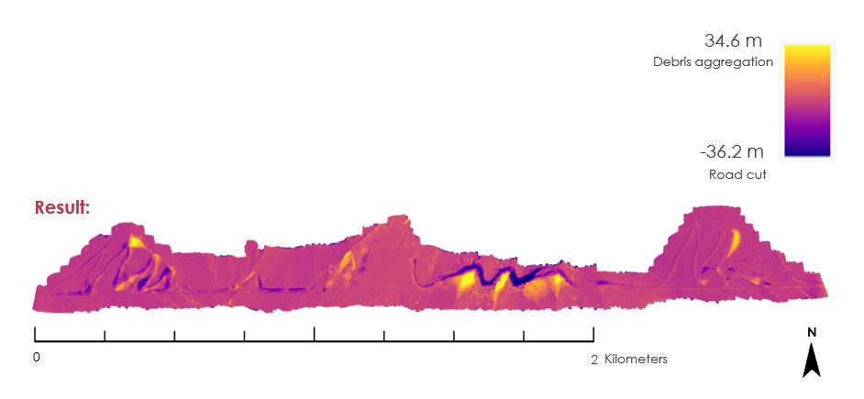

*Figure 2.* Change Detection Map.

*4.1.2 Slope Failure Susceptibility Map*

The fuzzy overlay yielded a continuous-scale susceptibility map, classified into five susceptibility classes from very low to very high susceptibility using the quantile method (Figure 3). These results align with the anticipated interaction of each input parameter. High to very high susceptibility zones are predominantly situated in steep mountainous regions, particularly those with erosive geology, in the north and western of the memorial, whereas low to very low susceptibility areas are prevalent in the low-sloped grasslands to the east of the memorial. Fault groups are evident in three monument areas: the northeast corner, diagonally across the southwest quadrant, and diagonally in the south-central region, all categorized as very high susceptibility. Similarly, distinct patches of the very high categorization underscore the influence of the geologic erosion factors. For example, the U-shaped area rated very high exhibits greater erodibility due to being comprised of colluvium rock compared to its surroundings. Notably, no single input variable dominates the result, indicating appropriate variable weights.

*Figure 3.* Slope Failure Susceptibility Map. Rectangle denotes area with erodible colluvium rock type.

Validation results indicated a positive relationship between susceptibility categorizations and known debris flow initiation points, based on both the manual comparison and the AUC ROC methods. Manual comparison found that most debris flow initiation points from the validation dataset fall within high or very high susceptibility categorizations; fewer than 5% of the 84 validation points were in moderate to very low classes. Using the AUC ROC methodology, the AUC value for the debris flow initiation points was determined to be 0.864, on a scale of 0.5 (poor performance) to one (perfect performance), indicating that the slope failure susceptibility map is acceptable compared to this validation dataset (Figure 4). These findings instill confidence in the results, offering valuable insights for informed land management and hazard mitigation strategies.

Figure 4 AUC ROC curve model of the debris flow initiation points and the slope failure susceptibility map demonstrating an AUC value of 0.864, which is indicative of high accuracy.

### 4.1.3 Slope Failure Prioritization Model

Results are presented in two forms: qualitative visualization of priority locations within each asset type and calculation of percent area of each asset in each risk category. The qualitative 50-meter buffer aided in visualizing categorical susceptibility levels within the three different assets (Figure 5). Project partners can use these maps to identify areas for prioritized in-situ monitoring and/or remediation, particularly focusing on assets with high slopes and erosive soils. Percentages of each prioritization category within the 1- or 2-meter buffers of the three asset types were calculated to identify the most at-risk asset types (Table 3). Trails exhibited the largest percentage area in the very high prioritization category, acknowledging their unique usage primarily by hikers as opposed to motorized vehicles on roads. Despite nearly 30% of the border road buffer containing no data (due to it extending beyond the input susceptibility layer), over 50% of the asset’s area fell within the moderate to very high priority rating, with approximately 10% classified as very high priority. This was due to the area’s highly erodible geology and steep slopes. By comparison, CORO’s pre-existing roads contained about half (22.5%) of their area in the moderate to very high priority categories. These maps and calculations will guide the NPS SEAZ personnel in determining specific areas and types of assets to prioritize for monitoring and remediation efforts, streamlining decision-making processes without the need to individually balance each physical factor.

Figure 5. Slope Failure Prioritization Model results with qualitative 50-meter asset buffer for visual identification of areas to prioritize in-situ monitoring and/or remediation.

Table 3   
Slope Failure Prioritization: Percent Susceptibility by Asset

|  |  |  |  |  |  |  |
| --- | --- | --- | --- | --- | --- | --- |
|  | **Very High** | **High** | **Moderate** | **Low** | **Very Low** | **No Data** |
| Trails | 18.2% | 26.0% | 27.4% | 20.6% | 5.0% | 0.32% |
| Roads | 2.8% | 8.2% | 11.5% | 33.6% | 43.4% | 0.32% |
| Border Construction | 10.0% | 7.9% | 35.4% | 16.7% | 0.15% | 29.6% |

### **4.2 Limitations and Uncertainties**

One major limitation of this study is the scope of landslides addressed, which only includes certain types such as debris flows, excluding others like rockfall and gully erosion. These diverse types stem from varying physical processes, necessitating additional models to address their locations and prioritize areas accordingly. While this study focuses on debris flow initiation points, it does not analyze runout trajectory, distance, or location, which are crucial for prioritizing at-risk assets but cannot be determined from the slope failure products alone.

Data availability posed a significant limitation within this study. Analyses were constrained by the challenge of acquiring data with adequate spatial resolution, extent, and temporal resolution. Prioritizing imagery with the highest spatial resolution followed by spatial extent and temporal resolution was essential to meet partner priorities, especially along the lengthy border construction area.

The spatial resolution of key input datasets, (e.g., 3DEP, erosion risk layers) limited the accuracy of resulting product boundaries, affecting the visualization of changes in smaller features and areas influenced by multiple forces. Similarly, the spatial variability of input layers limited the result specificity. For example, the erosion risk layer used in the slope failure susceptibility map and slope failure prioritization model contained three risk categories based on field surveys with limited horizontal accuracy and geological classes, constraining the delineation of the resulting slope susceptibility map (Figure 6). Additionally, uncertainties in prioritization maps stemmed from assigned vulnerability and value ratings. Assuming equal vulnerability and value for all assets may have oversimplified the prioritization process, indicating the potential for refinement by considering asset materials and value to staff and visitors.

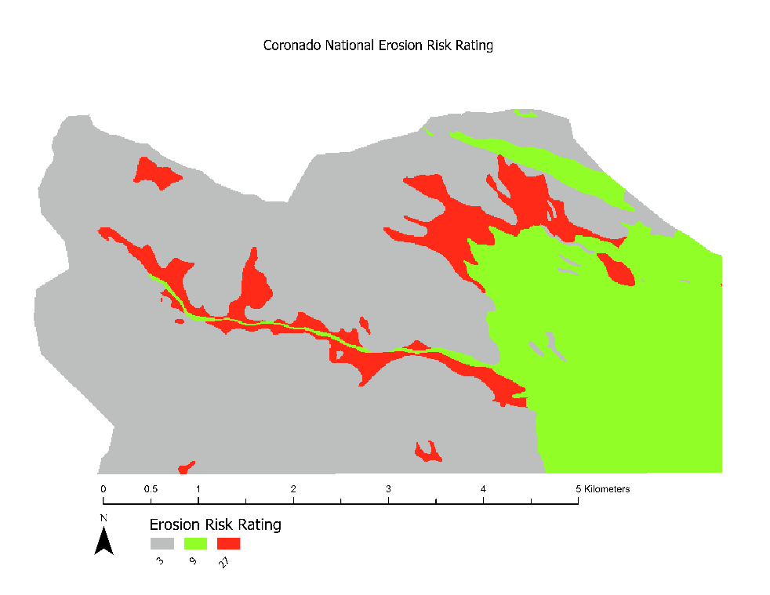

Figure 6. Distribution of erosion risk rating across Coronado National Memorial was created as three categories of risk based on expert opinion of geologic classes.

Spatial extent and temporal resolution of datasets were constrained by the availability of data with sufficient spatial resolution. In the change detection map, the team’s capacity to acquire only two DEM products within the study period with high spatial resolution (1-meter or less) limited the spatial extent to the area immediately surrounding the border road construction. Similarly, temporal resolution of analysis was restricted by the availability of only two images with high spatial resolution and limited validation data. Despite initial intentions to illustrate the effects of semi-annual monsoonal rains, this was infeasible with only two images available with high resolution. Additionally, the dataset used for verification of the slope failure susceptibility map comprised spatial points of debris flow occurrence without temporal information, impeding the team’s ability of verifying the timing or source of events.

Furthermore, a specific error in this study’s dataset involved misalignment of input layers, requiring unorthodox troubleshooting methods. Despite numerous attempts to adjust the position of the erosion risk layer, the slope failure susceptibility map failed to align with the roads layer, resulting in one road on the eastern border of CORO being outside the slope failure susceptibility map. Rectification efforts included ensuring that spatial reference and grid were consistent across all layers and adjusting cell size and snap raster of the overlay tool to match that of the other inputs. Consequently, this asset segment was excluded from the study due to the error, which rendered values for the slope failure susceptibility entirely as no data.

## *4.3 Feasibility for Partner Use*

The following datasets proved insufficient for this analysis due to limitations in spatial and temporal resolution. The Terra Advanced Spaceborne Thermal Emission and Reflection Radiometer (ASTER) DEM lacked data within the targeted temporal range, hindering the analysis of pre-and post-monsoon season. Additionally, the course nature of its 30-meter resolution rendered ASTER imagery unsuitable for this study area. Landsat 8 and 9, Global Precipitation Measurement (GPM) Integrated Multi-satellite Retrievals for GPM (IMERG), and Daymet weather data all lacked the necessary spatial resolution for analysis. Furthermore, while NAIP data revealed areas of aggregation and depletion, only one image pre- and post-border construction was available within the desired temporal range. Ultimately, a locally flown LiDAR-derived DEM (10-centimeter) and USGS 3D Elevation Program (3DEP) DEM (one-meter) proved to be useful in successfully meeting the objectives of the project.

The results of this project will benefit the NPS SEAZ in their immediate efforts and future management practices by providing products which can be used for immediate prioritization of remediation efforts and methods to be used in future monitoring. These products will provide the NPS SEAZ with access to geolocated maps which can be used to identify areas most susceptible to slope failure, especially along key infrastructure. Ancillary results of the project (e.g., useful Earth observation products, methodology, literature review) will support project partners in future work, in the event this work need be replicated (e.g., availability of additional datasets, planning for construction of new infrastructure).

## *4.4 Future Recommendations*

To enhance the robustness of this project, several additional analyses are recommended. Firstly, further validation of the slope failure susceptibility map is essential, incorporating both qualitative and quantitative approaches. Expanding the verification dataset to encompass a wider temporal range will strengthen the reliability of results.

Furthermore, to address the full spectrum of landslide processes, additional analyses should be undertaken to specifically account for mechanisms such as rockfall and gully erosion. Currently, the model does not differentiate between these processes, but doing so could offer insights into appropriate engineering controls and/or remediation strategies tailored to each type of landslide. By expanding the scope of analyses to cover a broader range of processes, the project’s applicability and utility can be significantly enhanced.

# **Conclusions**

This project undertook a focused analysis of geohazards, specifically targeting debris flows within the Coronado National Memorial. While initial assessments revealed challenges due to spatial resolution limitations in NASA Earth observation products, alternative datasets such as the USGS 3DEP DEM and partner-provided debris flow recognition points enabled the recognition and digitization of debris flows along the border construction and facilitated hazard susceptibility mapping across the memorial.

The resulting products, including the change detection map and slope failure susceptibility map, benefitted from high-resolution imagery, and expanded coverage and spatial resolution of regional to global datasets could further improve the extent and accuracy of analyses. This would enable better identification of seasonal changes in the change detection map and provide more nuanced spatial differences in input variables for the slope failure susceptibility map.

By addressing partner concerns regarding safety risks and environmental damages associated with border infrastructure, this project delivered valuable tools for identifying landscape changes, assessing susceptibility to slope instability, and prioritizing intervention areas. Through automated processes in ArcGIS Pro, the project provided insights into areas requiring in-situ monitoring remediation efforts, as well as tools for automating long-term risk assessment of existing assets and future infrastructure planning.

# **Acknowledgements**

The Coronado Disasters team would like to thank project partners the National Park Service’s (NPS) Southeast Arizona Group (SEAZ), specifically Jessica Garcia for cooperation and entrusting DEVELOP with this project. Additional gratitude is extended to Thomas Stanley and Sean McCartney for advising this study, along with Pukar Amatya for technical consulting. Lastly, the team would like to thank Stephanie Willsey for guidance and feedback throughout this project.

Any opinions, findings, and conclusions or recommendations expressed in this material are those of the author(s) and do not necessarily reflect the view of the National Aeronautics and Space Administration.

This material is based upon work supported by NASA through contract 80LARC23FA024.

# **Glossary**

**3DEP –** 3D Elevation Program

**ASTER –** Advanced Spaceborne Thermal Emission and Reflection Radiometer

**CORO –** Coronado National Memorial

**CSDA** - Commercial Smallsat Data Acquisition

**DEM** – Digital Elevation Model

**Earth observations** – Satellites and sensors that collect information about the Earth’s physical, chemical, and biological systems over space and time

**Fuzzy Membership –** Transforms the input raster into a 0 to 1 scale, indicating the strength of a membership in a set, based on a specified fuzzification algorithm

**Fuzzy Overlay –** Thisallows the analysis of the possibility of a phenomenon belonging to multiple sets in a multicriteria overlay analysis. Not only does Fuzzy Overlay determine what sets the phenomenon is possibly a member of, it also analyzes the relationships between the membership of the multiple sets.

**GPM** – Global Precipitation Measurement

**IMERG** - Integrated Multi-satellite Retrievals for GPM

**LiDAR** - Light Detection and Ranging

**LP DAAC –** Land Processing Distributed Active Archive Center

**NAIP** - National Agriculture Imagery Program

**NPS** – National Park Service

**OLI** – Operational Land Imager

**ROC Curve** – Receiver Operating Characteristic curve, or ROC curve, is a graphical plot that illustrates the performance of a binary classifier model

**SEAZ** – Southeast Arizona Group

**Spatial Resolution** – The dimensions of the area on the ground represented by a single cell in a raster or pixel in an image. The size of a pixel, or its spatial resolution, affects the level of detail represented in an image.

**Tabulate Intersection** – Computes the intersection between two feature classes and cross tabulates the area, length, or count of the intersecting features

**Temporal Resolution** – The frequency or rate at which images are captured over the same geographic location

**USMP –** Unstable Slope Monitoring Program

# **References**

Amatya, P., Kirschbaum, D., & Stanley, T. (2022). Rainfall-induced landslide inventories for Lower Mekong based on Planet imagery and a semi-automatic mapping method. *Geoscience Data Journal*, *9*(2), 315–327. <https://doi.org/10.1002/GDJ3.145>

ASTER Overview. (n.d.). LP DAAC USGS. Retrieved February 15, 2024, from

<https://lpdaac.usgs.gov/data/get-started-data/collection-overview/missions/aster-overview/#aster-temporal-and-spatial-resolution>

Brock, J., Schratz, P., Petschko, H., Muenchow, J., Micu, M., & Brenning, A. (2020). The performance of landslide susceptibility models critically depends on the quality of digital elevations models. *Geomatics, Natural Hazards and Risk*, *11*(1), 1075–1092. <https://doi.org/10.1080/19475705.2020.1776403>

Fleming, R. W., & Taylor, F. A. (1980). Estimating the costs of landslide damage in the United States. *Circular*. <https://doi.org/10.3133/CIR832>

Google Earth V 7.3. (October 10, 2023). Coronado National Memorial, Arizona, United States. 31º 19’58.24” N, 110º15’55.63” W, Eye alt. Airbus. Landsat / Copernicus 2024

Huffman, G.J., E.F. Stocker, D.T. Bolvin, E.J. Nelkin, Jackson Tan (2019), GPM IMERG Early Precipitation L3 1 day 0.1 degree x 0.1 degree V06, Edited by Andrey Savtchenko, Greenbelt, MD, Goddard Earth Sciences Data and Information Services Center (GES DISC), Accessed: *2024-02-29*, [10.5067/GPM/IMERGDE/DAY/06](https://doi.org/10.5067/GPM/IMERGDE/DAY/06)

Kritikos, T., & Davies, T. (2015). Assessment of rainfall-generated shallow landslide/debris-flow susceptibility and runout using a GIS-based approach: application to western Southern Alps of New Zealand. *Landslides*, *12*(6). <https://doi.org/10.1007/s10346-014-0533-6>

Mantovani, F., Soeters, R., & Van Westen, C. J. (1994). 1-s2.0-0169555X9500071C-main. *Geomorphology*, *15*, 213–225. [https://doi.org/https://doi.org/10.1016/0169-555X(95)00071-C](https://doi.org/https:/doi.org/10.1016/0169-555X(95)00071-C)

Marshall, R., Turner, D., Gondor, A., Gori, D., Enquist, C., Luna, G., Paredes Aguilar, R., Anderson, S., Schwartz, S., Watts, C., Lopez, E., & Comer, P. (2004). *An Ecological Analysis of Conservation Priorities in the Apache Highlands Ecoregion*.

Metternicht, G., Hurni, L., & Gogu, R. (2005). Remote sensing of landslides: An analysis of the potential contribution to geo-spatial systems for hazard assessment in mountainous environments. *Remote Sensing of Environment*, 284–303. <https://doi.org/10.1016/j.rse.2005.08.004>

NASA/METI/AIST/Japan Spacesystems and U.S./Japan ASTER Science Team (2001). *ASTER DEM Product* [Data set]. NASA EOSDIS Land Processes Distributed Active Archive Center. Accessed 2024-02-29 from <https://doi.org/10.5067/ASTER/AST14DEM.003>

National Park Service. (n.d.). *Foundation Document Overview Coronado National Memorial Arizona*.

National Park Service. (2018). *Resource Management and Risk Mitigation - Geohazards (U.S. National Park Service)*. https://www.nps.gov/subjects/geohazards/managing-risk-and-mitigating-hazards.htm

National Park Service. (2022, January 3). *Southeast Arizona Group of National Park Sites*.

Rönkkö, T. and Kallunki, J. (29 December 2023). *ArcSDM* [Software]. GitHub. <https://github.com/gtkfi/ArcSDM/tree/master>

Thornton, M.M., R. Shrestha, Y. Wei, P.E. Thornton, S-C. Kao, & B.E. Wilson. (2022). Daymet: Daily Surface Weather Data on a 1-km Grid for North America, Version 4 R1. ORNL DAAC, Oak Ridge, Tennessee, USA. <https://doi.org/10.3334/ORNLDAAC/2129>

U.S. Geological Survey (2020). AZ CochiseCounty 3 2020. Distributed by OpenTopography. Accessed 2024-02-21 from <https://portal.opentopography.org/usgsDataset?dsid=AZ_CochiseCounty_3_2020>.

U.S. Geological Survey EROS Archive. Landsat Archives. Collection 2 Landsat 8-9 OLI/TIRS Level-2 Data Products – Surface Reflectance from http://doi.org/[10.5066/P9OGBGM6](https://doi.org/10.5066/P9OGBGM6)

U.S. Geological Survey. (2020). National Agricultural Imagery Program (NAIP) Digital Ortho Quarter Quadrangle (DOQQ). Accessed on 2024-02-21, https://doi.org/10.5066/F7QN651G

# **Appendices**

## Appendix A: Additional Tables

Table A1   
List of sensors and data products used for this project

|  |  |  |  |  |  |
| --- | --- | --- | --- | --- | --- |
| Satellite & Sensor | Data Product & Parameters | Processing Level | Data Provider | Spatial Resolution | Temporal Resolution |
| Landsat 8- OLI | Optical Imagery  RGB True Color | Level 2 Surface Reflectance Tier 1 | USGS Earth Explorer | 30m | 16 days |
| Landsat 9- OLI-2 | Optical Imagery RGB True Color | Level 2 Surface Reflectance Tier 1 | USGS Earth Explorer | 30m | 16 days |
| Terra ASTER | DEM | Digital Elevation Model – Level 1A | LP DAAC | 30m | Varies* |
| USGS Locally Flown LiDAR | DEM | NA | CORO Team | 10cm | NA |
| USGS 3DEP | DEM | NA | USGS Lidar Explorer | 1m | NA |
| USGS 3DEP | Slope, plan curvature | NA | USGS Lidar Explorer | 10m | NA |
| National Agriculture Imagery Program | NAIP | DOQQ | USGS Earth Explorer | 1m | 2–3 years |
| GPM | IMERG | Level 3 | NASA | 10km |  |
| Daymet | NA | V4 | LP DAAC | 1km | Daily |
| NA | Assets (Roads, Border Road, Trails, Debris Flow) | NA | NPS SEAZ | NA | NA |
| NA | Geology (Faults) | NA | NPS SEAZ | NA | NA |
| Digital Geologic-GIS Map of Coronado National Memorial | Geohazards Layer (Erosion Risk) | Defined by project partners | NPS SEAZ | NA | NA |

*Terra ASTER DEM data from the LP DAAC varies in temporal resolution.

## Appendix B: Model Builder Figures

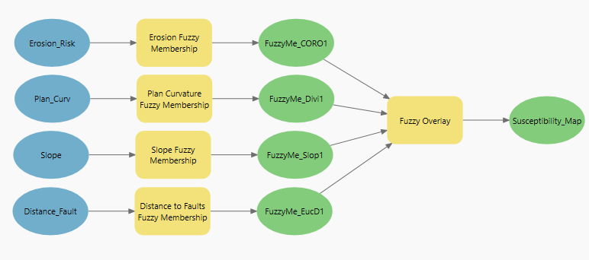*Figure B1.* ArcGIS Pro ModelBuilder for slope failure susceptibility map. Fuzzy overlay variables and fuzzy membership parameters are defined in Table 1

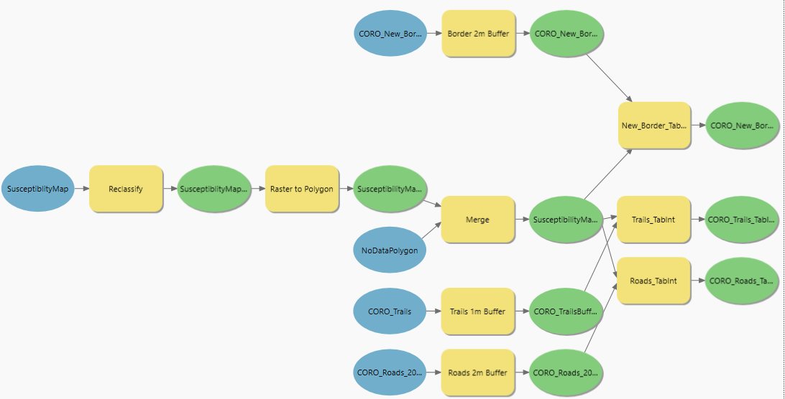*Figure B2.* ArcGIS Pro ModelBuilder for slope failure prioritization model. No environmental parameters nor processing extent were defined for any of the geoprocessing tools.