Arizona Water Resources II

Utilizing Aerial Imagery and NASA Earth Observations to Assess Pinyon-Juniper Tree Mortality in Flagstaff, AZ

 **Technical Report**

Final – November 17th, 2022

Arina Morozova (Project Lead)

Jessica Birk

Jamal Jaffer

Greg Peargin

***Advisors:***

Sean McCartney, Science Systems and Applications, Inc., NASA Goddard Space Flight Center (Science Advisor)

Joseph Spruce, Science Systems and Applications, Inc. (Science Advisor)

***Previous Contributors:***

Nicole Ramberg - Pihl

Margaret Jaenicke

Anne Britton

Abbi Brown

Liam Megraw

# 1. Abstract

Pinyon-juniper woodlands (PJW) provide critical and resilient habitat for the local mammal and small bird species of Arizona's northern xeric environment. Drought in Arizona has been persistent for many decades, yet in 2021 PJW experienced a mass tree mortality event at the Wupatki National Monument (WNM) and in other areas across the American Southwest. Previously, researchers at the National Park Service (NPS) and the team from the NASA DEVELOP National Program attempted to quantify the extent of mortality in Northern Arizona between 2015 and 2021 using high resolution National Agricultural Imagery Program (NAIP) aerial photographs. This project aimed to improve the previous term’s methodology and expanded the comparison of the post-mortality event in 2021 to include tree cover assessments for 2017 and 2019. In this iteration, the team utilized NAIP imagery in conjunction with Landscape Fire and Resource Management Planning Tools (LANDFIRE) to calculate the total difference in PJW mortality using an unsupervised classification model trained from multi-date Modified Soil-Adjusted Vegetation Index (MSAVI) and the Visible Atmospherically Resistant Index (VARI) data for the study area. The research also assessed correlations between tree mortality and environmental factors using Western Land Data Assimilation System (WLDAS) modelled climate data. Average PJW mortality from 2015 to 2021 was 21.63% including 19.8% in WNM with the vast majority of dieback occurring between 2019 and 2021. The correlations were weak with the most correlated variables being bare soil evaporation (0.15), rainfall (0.14), groundwater storage (0.13), and wind speed (0.12), perhaps indicating drought as a likely driver of PJW mortality.

**Key Terms**

pinyon-juniper woodlands, tree mortality, drought, National Park Service, remote sensing, climate change, Indigenous peoples

# 2. Introduction

***2.1 Background Information***

Over the last three decades, Arizona has experienced severe, frequent, and lengthy drought conditions, which has led to ecological and hydrological alterations in the region (Arizona Department of Water Resources, 2022) including changes in fire regime and drastic reductions in tree canopy cover (Clifford et al., 2011). Studies detected that western regions are prone to prolonged and reoccurring droughts (Bonan, 2015) and they predict further increase in temperature and low precipitation in the Southwestern US for the future (Adams & Kolb, 2005; Archer & Predick, 2008; Zhang et. al., 2021). Persistent drought conditions have resulted in major pinyon-juniper woodland (PJW) tree mortality events in recent years throughout Wupatki National Monument and the surrounding region (U.S. Forest Service [USFS], 2015). PJW is a vital habitat type for local flora and fauna and are culturally important to the region’s Hopi, Zuni, and Navajo peoples. PJW is also a frequent iconic feature of southwestern US landscapes.

PJW areas have historically been able to tolerate periods of drought (Poulos, 2014). Low specific leaf area and resistance to stress-induced xylem cavitation allow the juniper trees (*Juniperus osteosperma, Juniperus monosperma*) to store water effectively (Wilson et al., 2008). However, prolonged exposure to multiyear droughts have taken a toll, even on these hardy trees. The stress induced from rising temperatures and an increasingly arid environment can cause air bubbles to form inside the pinyon-juniper trees, which block it from receiving adequate water. This lack of water makes PJW more susceptible to diseases and beetle infestation, leading to extensive mortality (Clifford et. al., 2013; Redmond et. al., 2018). The widespread PJW mortality event was first reported in April 2021 and caused great concern, due to the lack of knowledge as to why they are dying off (USFS, 2021). While many potential causes have been pinpointed, additional research is greatly needed to identify the causes and create appropriate management decisions.

The area of PJW mortality encompasses more than 1.2 million hectares across Arizona and neighboring states (USFS, 2015). The study area for this project is centrally located in Northern Arizona just north of Flagstaff in the southwestern reach of the Colorado Plateau. The study area is mostly covered by two US Forest Service lands (Coconino and Kaibab National Forests) and three National Parks Service lands (Grand Canyon National Park, Wupatki National Monument, and Sunset Crater Volcano National Monument) which contain nearly all the PJW in the study area (Figure 1). This stretch of PJW provides local species vital resting areas at the fringes of water availability before the landscape extends into sparse grassland and desert.

Term I of this project produced preliminary tree mortality maps of the PJW regions in 2015 and 2021 by using Esri ArcGIS Pro 2.9.3, multi-year NAIP Imagery, and image classification methods. These maps were then used to calculate the percent mortality between the two given years. Graphs of environmental attributes, such as soil moisture and mean monthly precipitation, were assessed from 2015 to 2021 to show the downward trend in water available to PJW. Continuing the previous term’s work, Term II research acquired NAIP data from 2017 and 2019 to expand upon the time series of PJW mortality previously mapped between 2015 and 2021. The additional years of NAIP data was needed to help pinpoint when tree mortality occurred. Environmental variables from corresponding years were averaged for each time period. The team also looked at previous historical estimates to further explore the climatic trends in the study region. Term II built upon this research by refining classification methods, enhancing temporal resolution of years between 2015 and 2021, and performing more in-depth environmental and mortality correlation analyses.

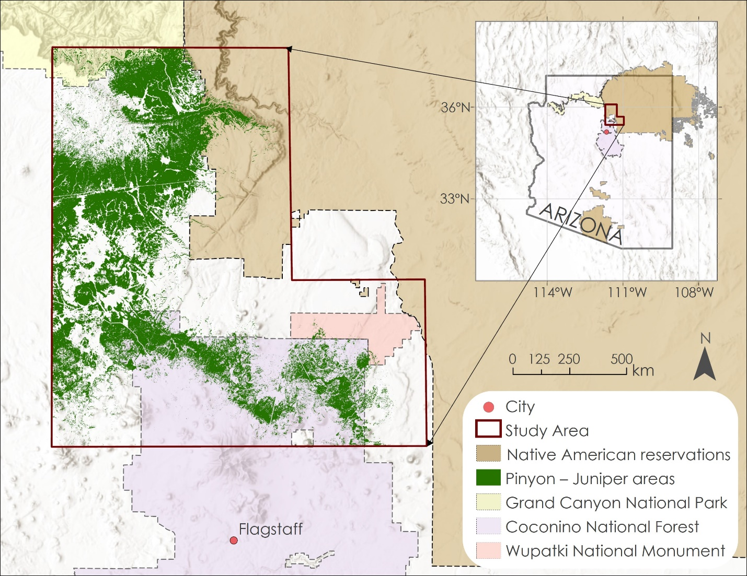

Figure 1. Study area includes the Coconino National Forests, the Wupatki National Monuments, and the Southern Rim of Grand Canyon National Park. The map also shows the PJW extent and Native American reservations. PJW extent source: LANDFIRE 2.0.0 [Data set]. Native American reservations extent source: US Census Bureau, Department of Commerce. Basemap Source: ESRI NAIP Imagery, ESRI World Hillshade.

***2.2 Project Partners & Objectives***

The Arizona Water Resources II team partnered with the National Park Service (NPS) at the Flagstaff Area National Monuments. The NPS manages natural and cultural resources at mentioned national monuments. It practices controlled burning to help manage forest health and improve the local habitat. In addition, the NPS informs local agencies, landowners, and governments on regional environmental conditions and ongoing issues through their NPS website and at their visitor centers. Due to a drastic PJW mortality event in 2021, NPS staff considered integrating NASA Earth observational data into their current forest management practices to protect the species and create a plan for potential PJW restoration. The main objectives of this project included: 1) measure the extent of PJW mortality using the methods from the previous term of this project and incorporate new methodology based on refined modelling procedures, 2) examine if pinyon-juniper mortality correlates with environmental factors, such as temperature, precipitation, land surface temperature, evapotranspiration, soil type, and soil moisture over the study period, and 3) provide partners with the PJW assessment methods from this work to support their decision-making practices and ability to monitor tree mortality events at WNM after the project term.

# 

# 3. Methodology

***3.1 Data Acquisition***

To analyze the most impactful environmental factors related to drought and PJW mortality, the team acquired meteorological observables and modeled outputs from the Western Land Data Assimilation System (WLDAS). Dr. Jessica Erlingis-Lamers for Western Land Data Assimilation System project at NASA Goddard Space Flight Center provided WLDAS dataset specifically for the study region. WLDAS uses land surface modeling and data assimilation for long-term records of near-surface hydrology. This modeled climatic data uses NASA’s Land Information System (LIS) to simulate land surface states and fluxes (Erlingis at al., 2021). WLDAS data is created using Moderate Resolution Imaging Spectroradiometer (MODIS) from the Terra satellite, Visible Infrared Imaging Radiometer Suite (VIIRS) from the Suomi National Polar-orbiting Partnership (Suomi-NPP) weather satellite, and instruments from the Gravity Recovery and Climate Experiment (GRACE) mission (Table 1). The team utilized the modeled data from WLDAS to extract the following environmental variables: air temperature, rainfall, snowfall, soil moisture, soil temperature, ground water storage, total and bare soil evapotranspiration, wind speed, and specific humidity at 1-kilometer spatial resolution from 1991 to 2022.

Table 1

*NASA Earth observations (EO) datasets used by WLDAS*

|  |  |  |
| --- | --- | --- |
| **EO incorporated into WLDAS** | **Spatial Resolution of WLDAS** | **Years of WLDAS used in analysis** |
| **Terra MODIS** | 1 kilometer | 1991 – Present |
| **Suomi-NPP VIIRS** |
| **GRACE** |

The team also used National Agriculture Imagery Program (NAIP) data for mapping tree cover for select years within the study period. The team acquired NAIP scenes taken in the visible and near-infrared spectrums at 1-meter spatial resolution for 2015 and at 0.6-meter spatial resolution for years 2017, 2019, and 2021 from EarthExplorer. Additionally, the team recollected the ancillary geospatial datasets available after the first term of the project, including LANDFIRE dataset with current vegetation types. Detailed 2016 and 2020 land cover classifications at 30-meter spatial resolution were merged for the study region. LANDFIRE’s Existing Vegetation Type (EVT) dataset was used to reduce computational expense by clipping the NAIP tiles to only those areas classified as pinyon-juniper woodland or savannah.

Table 2

*Ancillary datasets*

|  |  |  |
| --- | --- | --- |
| **Product Name** | **Use** | **Dataset Year** |
| NAIP digital multispectral aerial imagery | Tree cover detection | 2015 – 2021 |
| LANDFIRE Existing Vegetation Type [v1.4.0] | Land cover classification and detection of PJW mortality | 2016, 2020 |

***3.2 Data Processing***

*3.2.1 Pinyon-Juniper Mortality Mapping*

Data processing for the mortality mapping portion of the study consisted of three stages: 1) image classification model training; 2) data preparation, classification, and accuracy assessment; and 3) mortality calculation. All three stages were completed using ArcGIS Pro. Therefore, all references to “tools” in this section refer to Geoprocessing Tools in ArcGIS Pro.

*3.2.1.1 Stage 1: Model Training*

In the first processing stage, the team trained a single model to identify live tree crowns for all years for which NAIP data was acquired. To obtain a model that could discern between trees and other kinds of vegetation, despite variations in soil and vegetation types across the study area, the team used an 8-scene mosaic of 2021 NAIP images covering the southeastern portion of the study area for training, as this region possessed a variety of soils and vegetation types found throughout the study area, as well as areas of PJW mortality and non-mortality. From the bands of this mosaic, two vegetation canopy greenness indices – given by Equations (1) and (2), respectively – were calculated: the Modified Soil Adjusted Vegetation Index (MSAVI2, which utilizes NAIP’s Near Infrared and Red spectral bands) (Qi et al., 1994) and the Visual Atmospherically Resistant Index (VARI, which uses NAIP’s Green, Red, and Blue spectral bands) (Gitelson et al., 2002).

$\text{MSAVI2=}\frac{\text{2}\left(\text{NIR+1}\right)\text{-}\sqrt{{\text{(2NIR+1)}}^{\text{2}}\text{-8(NIR-Red)}}}{\text{2}}$ (1)

$\text{V}\text{ARI= }\frac{\text{Green-Red}}{\text{Green+Red-Blue}}$ (2)

To further mitigate spatial variations, as well as temporal variations (both annual and seasonal, as the images from different years were not always taken in the same month), MSAVI and VARI were both standardized by subtracting their means and dividing by their standard deviations, which also ensured that neither index had a larger influence on the classifier than the other due to differences of scale (Qi et. al., 1994, Chuvieco et. al., 2002). The team then constructed a color composite from the two standardized indices, which they used as input for the Iso Cluster Unsupervised Classification tool in ArcGIS Pro. After creating an initial 60 classes, the team merged these down to six by iteratively following the lowest-tier recommendations of the Dendrogram tool, whose output is a tree diagram which suggests class merges in order of shortest inter-class distance (${\text{d}}_{\text{mn}}$), as found by Equation (3). Equation (3) utilizes the means (${\text{μ}}_{\text{mi}}, {\text{μ}}_{\text{ni}}$) and variances (${\text{Var}}_{\text{mi}},{\text{Var}}_{\text{ni}}$) of any given pair of the classes.

${\text{d}}_{\text{mn}}\text{=}\sqrt{\sum_{\text{i=1}}^{\text{N}}{\frac{{\left({\text{μ}}_{\text{mi}}\text{-}{\text{μ}}_{\text{ni}}\right)}^{\text{2}}}{\sqrt{{\text{Var}}_{\text{mi}}{\text{Var}}_{\text{ni}}}}}}\text{, where }\text{m,n}\text{ are classes in band }\text{i}$ (3)

After each round of merges, the spectral signatures of the remaining classes were recalculated, and the training data was classified again using the Maximum Likelihood Classification (MLC) tool, which for every pixel value (x) calculates the probability of membership [Pr(x)] in each class using Equation (4) (where $\text{μ}$ is the mean of each class and $\text{σ}$ is the standard deviation of each class) and assigns that class label whose probability is greatest. The resulting raster was then visually assessed by the team to determine whether tree pixels were represented by a single, distinctive class; if they were not, the merging procedure was repeated. Training was considered complete once an easily distinguishable “tree” cover class had materialized.

$\text{P}\text{r}\left(\text{x}\right)\text{=}\frac{\text{1}}{\text{σ}\sqrt{\text{2π}}}{\text{e}}^{{\text{-}\frac{\text{1}}{\text{2}}\left(\frac{\text{x-μ}}{\text{σ}}\right)}^{\text{2}}}$ (4)

*3.2.1.2 Stage 2: Data Preparation, Classification, and Accuracy Assessment*

In the second processing stage, the team used Python scripting to automatically: calculate the MSAVI2 and VARI of each NAIP scene; standardize them; construct composites from them; classify the composites with the MLC tool, using the signature file produced during training to determine class membership probabilities; and, finally, reclassify the MLC output, such that the “tree” class received a value of 1 and all other classes a value of 0. The team then mosaicked the reclassified rasters by year, creating four rasters showing all live tree crowns found within the study area in their respective years. Next, to reduce errors in the mosaics, the team created two masks: one to address burns and shadow, derived from thresholding the Burn Area Index (BAI) (Chuvieco et al., 2002); the other to address soil brightness, derived from thresholding a brightness index defined by the team. The formulas for these indices are given by Equations (5) and (6), and they utilize NAIP’s Red & Near-infrared and Red, Green, & Blue spectral bands respectively.

$\text{B}\text{AI=}\frac{\text{1}}{{\left(\text{0.1-Red}\right)}^{\text{2}}\text{+}{\left(\text{0.06-NIR}\right)}^{\text{2}}}$ (5)

$\text{B}\text{rightness=Red*Green*Blue}$ (6)

These masks were formulated as conditional rasters such that, when multiplied with the tree crown mosaics, they set as 0 the value of tree pixels whose mask counterparts violated the threshold condition. As a final preparatory step, the team ran the Boundary Clean tool on the masked mosaics to remove isolated pixels caused by non-tree vegetation. The team then assessed the accuracy of the classification model by generating 500 points, 250 each for tree and non-tree pixels, using the Create Accuracy Assessment Points tool with a “Equalized Stratified Random” sampling strategy, then comparing the predictions of the boundary-cleaned, classified mosaics to the original 2021 NAIP images at each of these points; accuracy was found to be 87.4%, while precision and recall were found to be 81.2% and 92.7%, respectively.

*3.2.1.3 Stage 3: Mortality Calculations*

In the final processing stage, mortality maps for 2017, 2019, and 2021 were calculated by subtracting each of these years’ map of live green canopies from the map that preceded it sequentially. The resulting rasters had three possible pixel values: 1 (mortality), 0 (no change), and –1 (growth). The growth pixels were reclassified to have a value of 0, so that the raster would instead have two values: 1 (mortality) or 0 (no mortality). Using the raw change in mortality and live tree crown rasters, two series of “percent” mortality maps were created: one showing the percent change over each two-year period, given the number of live tree crowns at the start of each period; the other showing the cumulative percent mortality since 2015, given the total number of tree crowns identified from 2015 until the start of the two-year period (e.g., the 2019 cumulative percent mortality combined the 2017 and 2019 mortality rasters and the 2015 and 2017 live tree crown rasters). For each raster in these two series, the team used the Aggregate tool to sum the number of mortality and live tree crown pixels per square kilometer (to spatially match the resolution of the WLDAS data used in the correlation analysis), then divided the sum of the mortality pixels by the sum of the live tree crown pixels to obtain the average mortality. When carrying out the aggregations, a hand-drawn polygon was used as a mask to clip the resulting raster to the extent of pinyon-juniper woodland (derived from LANDFIRE Existing Vegetation Type [LF EVT]) within the study area.

*3.2.2 Environmental Variables*

Environmental variables extracted from the WLSDAS dataset included air temperature, precipitation (rainfall and snowfall), soil moisture, soil temperature, ground water storage, total evapotranspiration, bare soil evaporation, wind speed, and specific humidity, and mortality percentage rasters were projected to coordinate system for North America between 114°W and 108°W (NAD83 / UTM zone 12N) for Arizona and clipped to the study area. These daily climatic variables were stored in multidimensional, georeferenced NetCDF files. The team executed a Python code in the Jupyter Notebook computing platform to extract the values for each environmental variable and calculate the average of air temperature, soil moisture, soil temperature, ground water storage, total and bare soil evapotranspiration, wind speed, and specific humidity and the summation for rainfall and snowfall values. Temperature values were converted from Kelvin to Celsius, while evapotranspiration, rainfall, and snowfall values were converted from kilogram-meters per second to millimeters per day. The team decided to conduct the correlation analysis between the environmental variables and tree mortality using the annual averages and accumulation per year (Climate Assessment for the Southwest, 2022). The ten selected environmental variables were converted from their native NetCDF format to raster layers in ArcGIS Pro and added together as a data frame to be exported as comma-separated values (CSV) files. The team used the CSV files to generate time series plots that visualized the trends of climatic conditions for the 30-year period from 1991 to 2021. Tree mortality maps showing the percentage of dead PJW canopy cover were converted to text files and then into data frames. The tree mortality data frames, showing percent tree mortality at different locations in our study area, were then joined and combined with the annual, averaged environmental variable data frames. This allowed the team to see a location, the percent tree mortality, and the specific values for environmental variables per pixel.

***3.3 Data Analysis***

The team started with exploratory analysis of the tree mortality results from the previous project term, to identify patterns among the environmental variables and PJW mortality. The team utilized coding in Python via Jupyter Notebook using Pandas, NumPy, and Seaborn libraries to create a numeric correlation analysis between mortality percentage and all environmental variables from WLDAS data for May 2015 and 2021. Due to the large amounts of data and limited computing power, exploratory correlations between environmental variables and tree mortality were first performed on the micro daily level, using a sample of two days in 2015 and two days in 2021. This allowed the team to understand a snapshot of the data. The same correlation was then performed on a monthly level, using the entire months of May in 2015 and 2021. This allowed the team to incorporate more environmental data into the correlation. The team saw similar variables emerging as the highest correlated variables, including bare soil evaporation, specific humidity and groundwater storage. Based on the exploratory results from the first term’s mortality map, the team proceeded with the ten variables and looked at the data on a Macro Annual Level, using annualized data to compare with Term 2 tree mortality. This strengthened the correlation because more environmental data was incorporated, instead of simply looking at it from a daily or monthly time step and will be discussed further in the next section.

# 4. Results & Discussion

***4.1 Analysis of Results***

*4.1.1 Pinyon-Juniper Mortality Mapping*

The overall accuracy for the land cover classification was 93.0% for 2015, 89.8% 2017, 88.2% for 2019, and 92.0% for 2021 (Table 3). For the accuracy assessment the team generated 500 points and used a stratified random sample. The overall accuracy for all study years was greater than 87%, which is appropriate for further spatial and correlation analysis. Confusion matrices for all the years from the classification analysis are provided in Appendix A.

Table 3

*Accuracy assessment results for land cover classifications*

|  |  |  |  |
| --- | --- | --- | --- |
| Assessment | # of Random Points | Method | Percent (%) Accuracy |
| 2015 Classification | 500 | stratified random | 93.0 |
| 2017 Classification | 500 | stratified random | 89.8 |
| 2019 Classification | 500 | stratified random | 88.2 |
| 2021 Classification | 500 | stratified random | 92.0 |

An estimated 6.5 percent of pinyon-juniper trees experienced mortality between years 2015 and 2017 across the whole study area. The mortality between years 2015 and 2019 was 9.9 percent. Lastly the total mortality for the entire study period between years 2015 and 2021 made up 21.6 percent of the total PJW. The mortality was spatially distributed across the study region. Some pinyon-juniper trees experienced complete mortality, while others were not affected by it (Figure 2).

Figure 2. Cumulative pinyon-juniper tree mortality percentage across the study area for 2015 - 2021. Basemap Source: ESRI NAIP Imagery, ESRI World Hillshade.

The team also analyzed the PJW Mortality in Wupatki National Monument separately from the entire study region. Overall, almost 20 percent of pinyon-juniper trees experienced mortality in Wupatki National Monument in year 2021 with the vast majority of dieback occurring between 2019 and 2021 (Figure 3).

Figure 3. Cumulative pinyon-juniper tree mortality percentage across Wupatki National Monument for 2021. Basemap Source: ESRI NAIP Imagery, ESRI World Hillshade.

*4.1.2 Correlation analysis*

The correlations between environmental variables and PJW mortality showed that bare soil evaporation, rainfall, ground water storage, and wind speed correlate most strongly to Pinyon-Juniper tree mortality. The team performed four correlations using different time periods: 2015–2017, 2017–2019, 2019–2021, and finally an encompassing period from 2015–2021. The final correlations were found by averaging the correlation coefficients together to yield 0.15, 0.14, 0.13, and 0.12 for bare soil evaporation, rainfall, ground water storage, and wind speed respectively (Table 5). It is important to note that all environmental variables produced weak correlations in that they are less than 0.25. The implications of these correlation analyses will be further discussed in the conclusion.

Exploratory analysis demonstrated the highest correlation between tree mortality and total evapotranspiration, bare soil evaporation, and rainfall (Appendix B). The team also explored correlations between environmental variables and found three inverse relationships of importance. Firstly, soil and air temperature were found to be inversely correlated with snowfall, with a correlation of –0.67. When temperature increased, snowfall decreased. Secondly, soil temperature and soil moisture were found to be inversely correlated with a correlation of –0.69. When soil temperature increased, soil moisture decreased. Lastly, air temperature and groundwater storage were found to be inversely correlated with a correlation of –0.50. When air temperature increased, groundwater storage generally decreased.

Table 5

Correlation coefficients for featured environmental variables compared to tree mortality maps

|  |  |  |  |
| --- | --- | --- | --- |
| **2015–2017** | **2017–2019** | **2019–2021** | **2015–2021** |
| Groundwater Storage (0.15) | Wind Speed (0.09) | Rainfall (0.20) | Rainfall (0.19) |
| Specific Humidity (0.11) | Air Temperature (0.11) | Air temperature (0.19) | Bare Soil Evaporation (0.16) |
| Bare Soil Evaporation (0.11) | Groundwater Storage (0.10) | Soil temperature (0.19) | Air Temperature (0.15) |
| Rainfall (0.09) | Rainfall (0.08) | Wind speed (0.18) | Soil Temperature (0.14) |
| Wind Speed (0.09) | Snowfall (0.08) | Bare Soil Evaporation (0.18) | Groundwater Storage (0.13) |

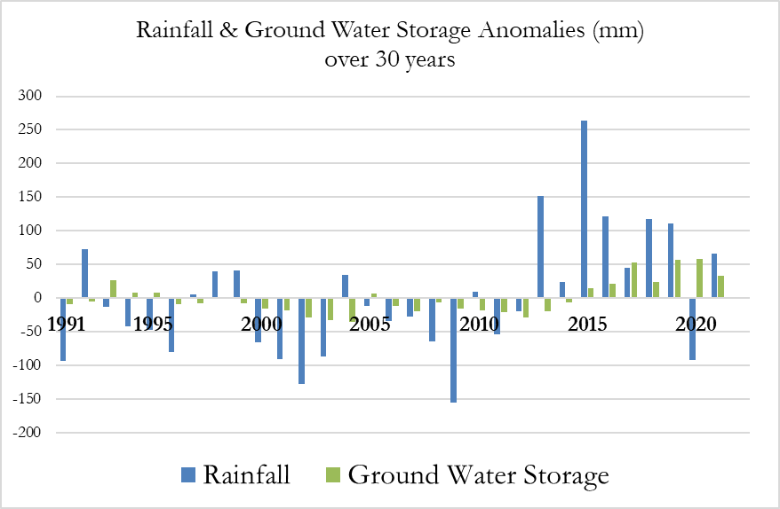

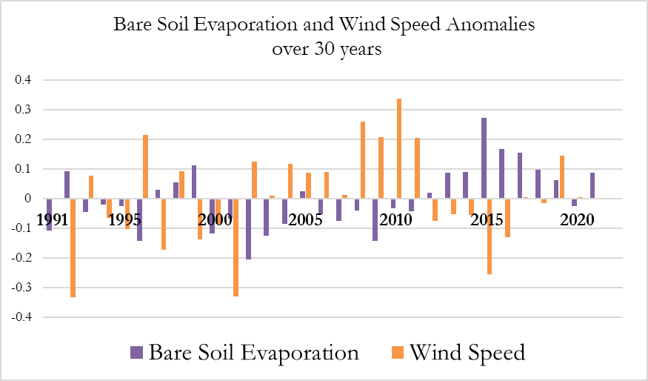

Figure 4. Annual anomalies for rainfall (mm), ground water storage (mm), bare soil evaporation (mm), and wind speed (m/s) in the study region for time period 1991 – 2021. Source: WLDAS.

An overview of the climatic trends for the environmental variables most correlated to the pinyon-juniper tree mortality in the study region is represented in Figure 4. The trends demonstrated significantly lower rainfall and ground water storage amount specifically for pre-mortality events (before 2013) in comparison to 30-year average climate normal from 1991 to 2020. This result corresponds to accumulative drought conditions in the study region. Wind speed anomalies represent a higher-than-average values during the pre-mortality events. Increased wind speed impact the evapotranspiration by bringing the heat energy and removing the significant amount of moisture from the soil (Geological Survey, 1982; Nori & Davies, 2007). Increased bare soil evaporation is detected in the last decade (since 2012). Increased bare soil evaporation can lead to limited water availability in disturbed forests and, therefore, cause the tree mortality (Biederman et. al., 2014). Climate trends for rest of the environmental variables that were not correlated to pinyon-juniper tree mortality are displayed in Appendix C.

***4.2 Limitations and Future Work***

There are multiple limitations that the team was faced with when creating the mortality maps and correlations with environmental data from the WLDAS model, including: 1) the accuracy of the classification model; 2) the range of climate variables chosen and their spatial resolutions; and 3) the computational expense of working with large volumes of data. The team was able to improve the classification model to refine previous estimates of tree mortality and to achieve a higher overall tree mortality mapping accuracy than the first term of this project. However, false positives across the entire broadly defined study area remained an issue, as burns, shadows, and certain kinds of soils and non-tree vegetation – shrubs and light-colored soils, in particular – were sometimes misclassified as PJW. Through the Boundary Clean and two masks, these misclassifications were reduced, but not eliminated. The Boundary Clean removed small clusters of isolated pixels, thereby removing grasses and smaller shrubs, but not larger ones. The masks, on the other hand, were created by thresholding the BAI and Brightness indices; the thresholds were chosen such that some true PJW pixels were unlikely to be inadvertently masked out, which also inevitably kept some shadow, burn, and soil pixels misclassified as PJW. To improve classification accuracy, further tuning of the thresholds and class merges could be performed. Additionally, creating multiple classification models for different years and subsections of the study area, rather than a single model to classify the entire study area in all years, would likely produce better results. In addition, other spectral indices could be tried to eliminate non-woody areas in known PJW areas. The use of 30m PJW mask from LANDFIRE data was another factor in that it includes some non-PJW areas and excludes some real PJW when used with the 1-meter or better NAIP tree cover maps.

An additional limitation exists in that only ten environmental variables were chosen to correlate to pinyon-tree mortality. Perhaps also combined use of multiple environmental variables could enable better predictions of tree mortality than use of one environmental variable at a time.

Considering reviews of literature regarding pinyon-juniper tree mortality in the study region, there were other factors that could affect tree mortality than could be analyzed in the correlation. One of these factors is the presence of bark beetles that can seriously affect pinyon-juniper trees, especially with respect to species of pinyon pine. Climate change has been shown to alter the life cycle of bark beetles, sometimes increasing the probability of infestation, and leading to increased tree mortality (Anderegg et al., 2015). Drought conditions in the early 2000s resulted in widespread mortality of pinyon pine trees across the southwest US attributed to infestation with the pinyon ips beetle (*Ips confuses*) (Floyd et al., 2009). More work is necessary to uncover the relationships between rise in temperature and the presence of insects that could be contributing to PJW mortality. Also changing seasonality of environmental parameters for the study area should be explored further in the research. Specifically, future studies can look at how the winter season is getting warmer and shorter, as well as at the change in amount of precipitation during the monsoon season.

Lastly, there were limitations to the 1km2 resolution of WLDAS data. WLDAS environmental data was chosen because it was a consistent source for all environmental variables; however, 1km2 resolution is too coarse (~247 acres per 1km2 pixel) to look at trees that are at most 6m2 in crown width. This weakened the correlations between a given environmental variable and tree mortality because the analysis included relatively large areas of bare soil and other vegetation along with the trees. Overall, other climate datasets with finer spatial resolution than WLDAS dataset could potentially lead to more accurate correlation results and avoid the loss of data due to resolution. Other sources of climatic data such as point locations with weather station data may be useful to also consider as well.

# 5. Conclusions

The results of this research support the ground observations from National Park Service and US National Forest Service that PJWs have experienced severe mortality, particularly between 2019 and 2021. In stretches of Wupatki National Monument and Coconino National Forest, PJW tree mortality reached near 100% for areas of previous pinyon-juniper woodland extent with a total average mortality of 21.63% for the entire study area and period. For the most part, the severity of this mortality event was effectively captured by the indexed NAIP imagery as the unsupervised classification method produced a high accuracy compared to available reference data. This term’s estimate of percent tree mortality contrasts with the previous term of the project where they found a higher percentage of tree mortality for the study area. The previous term created additional low probability masks that did not consider a large portion of the PJW where there was lower mortality, which could explain the different results with the current term. Both models appeared to effectively predict locations with PJW tree mortality, yet this current research was able to capture pinyon-juniper extent into lower probability areas where there was less mortality while retaining a high accuracy, therefore lowering the total average mortality of the study area. Regardless, the areas of high mortality are consistent between results and demonstrate the loss of critical habitat in this region. Both terms produced maps showing locations with tree mortality that could be used to assess areas in the field and to plan land resource management efforts, such as habitat restoration.

While tree mortality maps were effectively derived through this research, it is difficult to explain the relationship between tree mortality and environmental climactic factors from the WLDAS data. However, the correlation analyses did yield some interesting results. The most correlated variable with PJW mortality is bare soil evaporation. An increase in bare soil evaporation decreases the rate of recharge for water in the soil and therefore the availability of water for the trees, directly linking this factor to pinyon-juniper tree mortality (Morillas et al., 2016). The second most correlated variable, rainfall, is the clearest indicator of drought, and unsurprisingly showed that trees which received the lowest rainfall had the highest mortality. Third, groundwater storage was also correlated to tree mortality, which decreases significantly in the Colorado River Basin during drought periods (Castle et al., 2014). Finally, the fourth most strongly correlated variable was wind speed, which initially was a surprising result. However, an increase in wind speed has been shown to increase the amount of bare soil and total evapotranspiration (Davarzani et al., 2014), potentially impacting the availability of water to the trees and increasing mortality. While an unexpected result, previous research supports that climate change is affecting the variability of wind speed (Nori & Davies, 2007; Greene et al., 2010), and could be of interest when assessing PJW mortality in the future. Also, studies have shown that bark beetles outbreaks rely a lot on changing of seasonality (Raffa et al., 2015) and stronger winds (Santos & Whitham, 2010) leading to increased tree mortality. Though the relationships developed through the correlation analysis are statistically weak, they provide possible clues on what could be the drivers of this mortality. More research is needed to further parse through how seasonality of these variables might affect mortality as the team was unable to address such questions due to limited processing power and time constraints.

# 

# 6. Acknowledgments

The team would like to thank our project partners, Mark Szydlo and Julie Long, from the National Park Service at Wupatki National Monument. We would also like to thank our science advisors from Goddard Space Flight Center: Sean McCartney and Joseph Spruce, and our project fellow Carli Merrick from NASA DEVELOP at Goddard Space Flight Center. Lastly, the team would like to acknowledge the past contributors of this project during the Spring 2022 DEVELOP term: Nicole Ramberg-Pihl (Project Fellow) and Arizona Water Resources team (Margaret Jaenicke, Anne Britton, Abbi Brown, and Liam Megraw). The team is sincerely grateful to all who have supported and guided us throughout this project.

Any opinions, findings, and conclusions or recommendations expressed in this material are those of the author(s) and do not necessarily reflect the views of the National Aeronautics and Space Administration.

This material is based upon work supported by NASA through contract NNL16AA05C.

# 7. Glossary

**BAI -** Burn Area Index

**Earth observations** – Satellites and sensors that collect information about the Earth’s physical, chemical, and biological systems over space and time

**Evapotranspiration** – A process through which water is transferred to the atmosphere from the land by both evaporation from the soil surface and transpiration from plants

**Iso Cluster** –Iterative process used in classification methods that computes the minimum Euclidean distance when assigning each candidate cell of a raster to a cluster

**LANDFIRE EVT** –LANDFIRE Existing Vegetation Type

**MSAVI -** Modified Soil-Adjusted Vegetation Index

**NAIP** – National Agriculture Imagery Program

**NPS** – National Park Service

**PJW** – Pinyon-juniper woodlands, or areas that have the presence of at least one species each of juniper and pinyon pine (*Pinus* spp.-*Juniperus* spp.)

**Specific Humidity** –Amount of water vapor contained in a unit of air and is expressed as grams of water vapor per kilogram of air

**USDA** – United States Department of Agriculture

**USFS** – United States Forest Service

**USGS** – United States Geological Survey

**VARI -** Visible Atmospherically Resistant Index

**WNM** – Wupatki National Monument

**Xylem Cavitation** –a process thatoccurs when air is pulled across interfaces between xylem water and air resident in the body of a plant. This process leads to air blockages in the xylem that cut the plant off from its water supply in the soil.

# 8. References

Adams, H.D. & Kolb, T.E. (2005). Tree growth response to drought and temperature in a mountain landscape in northern Arizona, USA. *Journal of Biogeography, 32,* 1629-1640. <https://doi.org/10.1111/j.1365-2699.2005.01292.x>

Anderegg, W.R.L., Hicke, J.A., Fisher, R.A., Allen, C.D., Aukema, J., Bentz, B., Hood, S., Lichstein, J.W., Macalady, A.K., McDowell, N., Pan, Y., Raffa, K., Sala, A., Shaw, J.D., Stephenson, N.L., Tague, C., & Zeppel, M. (2015). Tree mortality from drought, insects, and their interactions in a changing climate. *New Phytol, 208*, 674-683. <https://doi.org/10.1111/nph.13477>

Archer, S.R., & Predick, K.I. (2008). Climate Change and Ecosystems of the Southwestern United States. *Rangelands, 30*(3), 23-28. [https://doi.org/10.2111/1551-501X(2008)30[23:CCAEOT]2.0.CO;2](https://doi.org/10.2111/1551-501X(2008)30%5b23:CCAEOT%5d2.0.CO;2)

Arizona Department of Water Resources. (2022). Drought. Retrieved on October 7, 2022, from <https://new.azwater.gov/drought>

Biederman, J., Harpold, A., Gochis, D., Ewers, B., Reed, D., Papuga, S., & Brooks, P. (2014). Increased evaporation following widespread tree mortality limits streamflow response. *Water Resources Research, 50*(7). <https://doi.org/10.1002/2013WR014994>.

Bonan, G. (2015). *Ecological Climatology: Concepts and Applications* (3rd ed.). Cambridge: Cambridge University Press. <https://doi.org/10.1017/CBO9781107339200>

Castle, S. L., Thomas, B. F., Reager, J. T., Rodell, M., Swenson, S. C., & Famiglietti, J. S. (2014). Groundwater depletion during drought threatens future water security of the Colorado River Basin. *Geophysical research letters, 41*(16), 5904-5911. <https://doi.org/10.1002/2014GL061055>

Chuvieco, E., M. Pilar Martin, & A. Palacios. (2002). Assessment of Different Spectral Indices in the Red-Near-Infrared Spectral Domain for Burned Land Discrimination. *Remote Sensing of Environment, 112*, 2381-2396. <https://doi.org/10.1080/01431160210153129>

Clifford, M.J., Cobb, N.S. & Buenemann, M. (2011). Long-Term Tree Cover Dynamics in a Pinyon-Juniper Woodland: Climate-Change-Type Drought Resets Successional Clock. *Ecosystems, 14*, 949–962. <https://doi.org/10.1007/s10021-011-9458-2>

Clifford, M.J., Royer P.D., Cobb N.S., Breshears D.D., & Ford, P.L. (2013). Precipitation thresholds and drought-induced tree die-off: insights from patterns of *Pinus edulis* mortality along an environmental stress gradient. *New Phytologist,* *200,* 413-421. <https://doi.org/10.1111/nph.12362>

Climate Assessment for the Southwest. (2022). Temperature and Precipitation. Retrieved on October 5, 2022, from <https://climas.arizona.edu/sw-climate/temperature-and-precipitation>

Davarzani, H., Smits, K., Tolene, R. M., & Illangasekare, T. (2014). Study of the effect of wind speed on evaporation from soil through integrated modeling of the atmospheric boundary layer and shallow subsurface. Water resources research, 50(1), 661-680. <https://doi.org/10.1002/2013WR013952>

Erlingis, J.M., Rodell, M., Peters-Lidard, C.D., Li, B., Kumar, S.V., Famiglietti, J.S., Granger, S.L., Hurley, J.V., Liu, P.-W., & Mocko, D.M. (2021). A High-Resolution Land Data Assimilation System Optimized for the Western United States. *Journal of the American Water Resources Association, 57*(5), 692– 710. <https://doi.org/10.1111/1752-1688.12910>

Floyd, M.L., Clifford, M., Cobb N.S., Hanna, D., Delph, R., Ford, P., & Turner, D. (2009). Relationship of stand characteristics to drought-induced mortality in three Southwestern piñon-juniper woodlands. *Ecological Applications, 19*(5), 1223-1230.  <https://doi.org/10.1890/08-1265.1>

Geological Survey (U.S.) (1982). *U.S. Geological Survey water-supply paper*. U.S. G.P.O. U.S.

Gitelson, A. A., Stark, R., Grits, U., Rundquist, D., Kaufman, Y., & Derry, D. (2002). Vegetation and soil lines in visible spectral space: A concept and technique for remote estimation of vegetation fraction. *International Journal of Remote Sensing 23*(13), 2537-2562. <https://doi.org/10.1080/01431160110107806>

Greene, S., Morrissey, M., & Johnson, S. E. (2010). Wind climatology, climate change, and wind energy. *Geography Compass*, *4*(11), 1592-1605. <https://doi.org/10.1111/j.1749-8198.2010.00396.x>

Jaenicke, M., Britton, A., Brown, A., & Megraw, L. (2022, March). Arizona Water Resources: Utilizing Aerial Imagery and NASA Earth Observations to Assess Pinyon-Juniper Tree Mortality in Flagstaff, AZ. In *2022 Spring DEVELOP.*

Morillas, L., Pangle, R. E., Maurer, G. E., Pockman, W. T., Mcdowell, N., Huang, C. W., ... & Litvak, M. E. (2017). Tree mortality decreases water availability and ecosystem resilience to drought in piñon‐juniper woodlands in the southwestern US. *Journal of Geophysical Research: Biogeosciences*, *122*(12), 3343-3361. <https://doi.org/10.1002/2017JG004095>

National Park Service. (2015). *Pinyon-Juniper Woodlands - Introduction & Distribution.* Retrieved September 20, 2022, from <https://www.nps.gov/articles/pinyon-juniper-woodlands-distribution.htm>

National Park Service. (2015). *Pinyon-Juniper Woodlands – Species Composition and Classification*. Retrieved September 15, 2022, from <https://www.nps.gov/articles/pinyon-juniper-woodlands-species-composition-classification.htm>

Nori, M., & Davies, J. (2007). Change of wind or wind of change. *Climate change, adaptation and pastoralism, WISP, IUCN: Nairobi*.

Poulos, H.M. (2014). Tree mortality from a short-duration freezing event and global-change-type drought in a Southwestern piñon-juniper woodland, USA. *PeerJ*, 2:e404. <https://doi.org/10.7717/peerj.404>

Qi, J., Chehbouni, A., Huete, A.R., Kerr, Y.H., & Sorooshian, S. (1994). A modified soil adjusted vegetation index. *Remote Sensing of Environment, 48*(2), 119-126. <https://doi.org/10.1016/0034-4257(94)90134-1>

Raffa, K. F., Aukema, B. H., Bentz, B. J., Carroll, A. L., Hicke, J. A., & Kolb, T. E. (2015). Responses of tree-killing bark beetles to a changing climate. In *Climate change and insect pests, 7*, 173-201.

Redmond, M.D., Weisberg, P.J., Cobb, N.S., Clifford, M.J. (2018). Woodland resilience to regional drought: Dominant controls on tree regeneration following overstorey mortality. *Journal of Ecology, 106*, 625– 639. <https://doi.org/10.1111/1365-2745.12880>

Santos, M. & Whitham, T. (2010). Predictors of Ips confusus Outbreaks During a Record Drought in Southwestern USA: Implications for Monitoring and Management. *Environmental management, 45*, 239-49. <https://doi.org/10.1007/s00267-009-9413-6>.

US Census Bureau, Department of Commerce (2017). *TIGER/Line Shapefile, Current American Indian Tribal Subdivision (AITS) National*. [Data set]. <https://catalog.data.gov/dataset/tiger-line-shapefile-2017-nation-u-s-current-american-indian-tribal-subdivision-aits-national>

U.S. Department of Agriculture. (2021). *National Agriculture Imagery Program (NAIP)* [Data set]. U.S. Department of Agriculture. <https://doi.org/10.5066/F7QN651G>

U.S. Department of the Interior, Geological Survey, and U.S. Department of Agriculture. (2016). *Existing Vegetation Type Layer, LANDFIRE* 2.0.0 [Data set]. <http://landfire.cr.usgs.gov/viewer/>

U.S. Forest Service. (2015). Drought and piñon-juniper woodlands: Changing fuel loads from tree mortality. <https://www.fs.usda.gov/rmrs/projects/drought-and-pi%C3%B1on-juniper-woodlands-changing-fuel-loads-tree-mortality>

U.S. Forest Service. (2021). https://www.fs.usda.gov/rmrs/projects/drought-and-pi%C3%B1on-juniper-woodlands-changing-fuel-loads-tree-mortalityUSFS.(2021, April 21). *Drought causing juniper die-off in central and northern Arizona*. U.S. Forest Service. <https://www.fs.usda.gov/detail/kaibab/news-events/?cid=FSEPRD906836>

Wilson, C.J., Manos, P.S., Jackson, R.B. (2008). Hydraulic Traits are Influenced by Phylogenetic History in the Drought-Resistant, Invasive Genus Juniperus (Cupressaceae). *American Journal of Botany, 95*(3), 299-314. <https://doi.org/10.3732/ajb.95.3.299>

Zhang, F., Biederman, J. A., Dannenberg, M. P., Yan, D., Reed, S. C., & Smith, W. K. (2021). Five decades of observed daily precipitation reveal longer and more variable drought events across much of the western United States. *Geophysical Research Letters, 48*, e2020GL092293. <https://doi.org/10.1029/2020GL092293>

# 9. Appendices

**Appendix A:**

**Confusion matrices**

|  |  |  |  |  |
| --- | --- | --- | --- | --- |
|  | **2015** | **2017** | **2019** | **2021** |
| True positive | 25 | 25 | 60 | 54 |
| False Positive | 2 | 3 | 11 | 23 |
| True Negative | 440 | 424 | 381 | 406 |
| False Negative | 33 | 48 | 48 | 17 |
| True Positive Rate | 92.59% | 89.29% | 84.51% | 70.13% |
| False Positive Rate | 7.41% | 10.71% | 15.49% | 29.87% |
| True Negative Rate | 93.02% | 89.83% | 88.81% | 95.98% |
| False Negative Rate | 6.98% | 10.17% | 11.19% | 4.02% |

**Appendix B:**

**Exploratory analysis using 1st project term tree mortality results**

|  |  |
| --- | --- |
| **Micro Daily Level** | **Mezzo Monthly Level** |
| **May 1 & 2, 2015 – May 1 & 2, 2021** | **May 2015 – May 2021** |
| Bare Soil Evaporation (0.25) | Evapotranspiration (0.21) |
| Wind Speed (0.24) | Bare Soil Evaporation (0.16) |
| Specific Humidity (0.23) | Rainfall (0.15) |
| Soil Moisture (0.18) | Groundwater Storage (0.12) |
| Groundwater Storage (0.17) | Specific Humidity (0.09) |

**Appendix C:**

**Climate trends for environmental variables used in correlation analysis from 1991 to 2021. Source: WLDAS**

|  |  |
| --- | --- |
|  |  |
|  |  |