Lambayeque Water Resources

Assessing Hydrologic Patterns Using NASA Earth Observations to Address Tree Mortality in Peru’s Coastal Mesquite Forests

 **Technical Report**

Final Draft – April 2nd, 2020

Jared Kelly (Project Lead)

Fressia Bechard

Luke Quattrochi

Jay Oliver

Dr. Kenton Ross, NASA Langley Research Center (Science Advisor)

Dr. Venkataraman Lakshmi, University of Virginia (Science Advisor)

# 1. Abstract

The mesquite (*Prosopis* sp.) forests in Northwestern Peru have had a significant increase in tree mortality in the past fifty years. Within this time frame, 17% of the forest extent was lost and the forest saw an average annual declination rate of 0.33% (Ektvedt, Vetaas, & Lundberg, 2012). These habitats support the region's rich biodiversity and play an important role in local community economies. Several hydrologic causes for mesquite mortality have been hypothesized, but local researchers lack spatially comprehensive techniques to address the problem. While *in situ* research is currently being utilized in an attempt to explain this recent anomaly, landscape-level visualizations through remote sensing have not been produced to find connections between hydrologic trends and the health of Northwestern Peru’s mesquite forests. Climate Hazards Group InfraRed Precipitation with Station data and Global Land Data Assimilation System data were analyzed to assess hydrologic patterns pertaining to precipitation and soil moisture in the Lambayeque region of Peru. These data were then paired with vegetation indices derived from Terra Moderate Resolution Imaging Spectroradiometer (MODIS) and Suomi National Polar-orbiting Partnership (NPP) Visible Infrared Imaging Radiometer Suite (VIIRS) to display how changing hydrologic patterns relate to the health of mesquite trees. These data were then compiled on a monthly basis over the 30-year study period to create a time series product, which was later referenced with background research to find the likely causes of recent forest decline. The results will assist in the Lambayeque Regional Government’s understanding of recent biological declination and will help them design strategies to mitigate forest decline in Lambayeque, Peru and surrounding regions.

**Keywords**

remote sensing, *Prosopis,* mesquite, precipitation, tree mortality, soil moisture, vegetation indices, conservation

# 2. Introduction

* 1. ***Background Information***

The tropical dry forests of Peru’s western coast are dominated by the presence of several keystone species within the genus *Prosopis*, known commonly as mesquite or “Algarrobo” trees. The genus consists of 44 flowering spiny tree species and maintains a worldwide range in both tropical and subtropical regions of 129 countries throughout Africa, Asia, the Americas, Europe, and Australia (Shackleton, Le Maitre, Pasiecznik, & Richardson, 2014). According to Depenthal and Yoder (2018), *Prosopis* is visually distinctive with “strikingly contorted trunks, tiny leaflets, yellow fruit pods, spreading growth form and dense reddish-brown hardwood.” The trees grow in clay-sandy and loamy-sandy soils where the pH is neutral (Galera, 2000). *Prosopis* sp. are primarily located below 600 meters of elevation in lowland seasonally dry tropical forests. This environment contains lower species richness than neighboring forests at higher altitudes (Linares-Palomino & Ponce-Alvarez, 2009). *Prosopis* sp. are extremely hardy and have evolved to withstand the extreme conditions set by their arid environment. These can include harsh temperatures, infrequent rainfall, prolonged sun exposure, and increasing human interference. Felker (2009) has even compared these trees to more “desert type” plants such as cacti, due to their characteristic abilities to tolerate heat and drought conditions. In addition to its biological functionality, the genus provides several physical services to the surrounding environment. Edible, leguminous pods enrich the surrounding soil and promote fertility through nitrogen fixation, which demonstrates the tree’s “great importance to many of the world’s arid ecosystems” (Felker, 2005). Dense, durable wood and a deep root system act as a safeguard against erosion and sand dune migration, while leaves with a high surface area protect other vegetation, insects, and animals from the direct ultraviolet rays of the desert sun (Nolazco & Roper, 2014). Mesquite trees also regulate the temperature of the surrounding environment, an important benefit to an area prone to temperature-dependent natural disasters (Aldebaran de Villasante Llaquet, 2019). These traits have allowed mesquite to be one of the most recognizable and dependable tree species in the world.

Because of its distinctive biological traits and physical properties, *Prosopis* sp. are regarded as a fundamental resource for humans. The trees have been integrated into Peruvian culture as food, fuel, medicine, construction material, and other resources for rural desert communities for thousands of years (Depenthal & Meitzner-Yoder, 2018). Because of its commonality and functionality, mesquite trees are recognized, and even revered, within Peruvian society. Community knowledge on the uses and significance of “Algarrobo” is extensive and meaningful. A local stated in an interview that while growing up in Peru, “it was as if the forest was part of the…home” (Depenthal, & Meitzner-Yoder, 2018). Beresford-Jones (2004) articulates this importance through his research:

*No other desert tree has as pervasive an influence upon neighboring vegetation, soil quality and moisture, sub-canopy microclimate, and wildlife and insect populations. In modifying the environmental extremes of deserts, especially one as arid as the Peruvian…coast, Prosopis makes what would otherwise be inhospitable terrain habitable for other species, including humankind.*

While the resiliency and uses of *Prosopi*s have allowed the genus to prosper worldwide, the plants are experiencing a rapid decline in health and high rates of mortality within the northern regions of Peru. In the past fifty years, 17% of northwestern Peru’s dry forests have been lost, resulting in an annual declination rate of 0.33% (Ektvedt, Vetaas, & Lundberg, 2012). In all cases, mesquite forests have demonstrated poor growth and vigor, which is marked by a lack of foliage, light green leaves, and little to no fruiting and flowering. Forest regeneration may be at risk because the small percentage of trees that are in good condition bloom very little or not at all. The height of the trees has noticeably diminished, with more individuals retaining small, bush-like anatomy rather than thicker, taller trees. Fifteen years ago, individual trees could produce up to 80 kilograms of honey annually. Today, that amount has dropped to roughly 5 kilograms annually. These are just a few of the outward signs of the tree’s failing health. Based on their mesquite research, Baena, Moat, Whaley, and Boyd (2017) have concluded that “a highly complex and dynamic ecosystem now exists that requires close monitoring to quantify change and respond effectively with adaptation strategies in order to manage the decline in Algarrobo-dependent biodiversity and sustain community livelihoods.”

* 1. ***Hypotheses for Mesquite Forest Decline***

The stark decline of the mesquite forests of Peru can be linked to multiple factors, as vegetation health is reliant on the interaction between several sensitive systems. For the purposes and extent of this study, possible causes of tree mortality in the region considered for this project can be categorized under two types of factors: environmental and anthropogenic.

*2.2.1 Environmental*

One of the biggest challenges facing the *Prosopis* genus is the vagaries associated with the changing hydrology of the region. Rainfall patterns in Peru differ greatly between the coastal, mountain, and rainforest regions of the country (Lagos, Silva, Nickl, & Mosquera, 2008). The “rainy season” for northern Peru typically occurs between mid-October and late March, providing the area with a vast majority of its average yearly rainfall. Water levels in northern Peru are also greatly influenced by the arrival of El Niño Southern-Oscillation (ENSO) events. These episodes of increased rainfall typically occur every two to seven years, with severe events occurring every 15 to 20 years (NOAA, n.d.). According to Tapley and Waylen (1990), northern Peru receives “abnormally high” precipitation rates of roughly 88% more rainfall during an ENSO year compared to an average rainfall event. These rare episodes of abundant freshwater availability fuel intense ecological flourishment throughout the country. Ferreyra (1993) states that the benefits from strong precipitation events, like those from ENSO seasons, can last for over a year before normal vegetation conditions return. Research by Rundel et al. (1991) showed that plants in arid environments, including mesquite trees, must adapt germination cues to account for rare precipitation events. Excess rainfall during ENSO events acts as a catalyst in the reproductive cycle of *Prosopis* species. Extra water increases the likelihood of seedlings developing into juvenile plants through the drought season. Increased precipitation also allows the region’s valuable groundwater supply to be replenished, which *Prosopis* sp. use nearly exclusively for their water intake. In recent decades, El Niño events have weakened, resulting in less accumulated rainfall and higher temperatures for Peru’s northern region. In response, there has been a noticeable decline in the germination rate of many of the trees, causing reproduction rates to decrease significantly (Carevic, 2016). When paired with other harmful factors, this decline in precipitation dramatically deteriorates the presence of *Prosopis* sp. within the forests of northern Peru.

The mesquite trees have been increasingly plagued by insect infestations and fungal infections. Auris (2019) described the main culprit to be *Enallodiplosis discordis,* a small parasitic insect that uses the *Prosopis* sp. leaves as a food source for its larval stage. The loss of leaf surface area lessens the plant’s photosynthetic capabilities and water storage, leading to “one of the main causes of the decline of the carob tree” (Auris, 2019). The presence of this insect is significantly linked to precipitation; normal precipitation patterns mitigate high pest populations. The lower precipitation levels seen in recent decades have been contributing to high populations of these insects, increasing their range throughout mesquite forests. Pathogenic fungi have also been a contributing factor to the decline observed in Peru’s mesquite forests. Project partners in Peru state that parasitic mushrooms, whose abundance is possibly linked to climate change, plague the trunks and root systems of the trees. These pests, and possibly others, interfere with mesquite’s ability to absorb and store nutrients, a much-needed physiological adaptation for an arid environment. The most notable aspect of these preceding parameters lies in their traceability from precipitation. It can be inferred that changing rainfall patterns lead to a cascade of problematic environmental factors not limited to those described above.

*2.2.2 Anthropogenic*

Agriculture is the driving force of the Peruvian economy. The chief crops of the region include sugarcane and rice (U.S. Department of the Interior, 1970). These crops require substantial areas of flat land with no competitive vegetation. To create cultivation fields, farmers clear large areas of forest containing several species within the *Prosopis* genus. According to Ektvedt, Vetaas, and Lundberg (2012), agricultural expansion has been the primary cause of deforestation in the last fifty years. This practice has only gained momentum since a large agrarian land reform took place in 1969. The substantial amount of water needed to sustain crop production places stress on environments in all parts of the world, but especially in the already water-scarce areas of Peru. The northern governmental districts are some of the world’s largest producers of rice, sugarcane, and cotton, which are the three most water-intensive crops per kilogram (World Wildlife Fund, 1986). Increased agricultural expansion will only continue to deteriorate the range of mesquite forests, destroying habitats needed for environmental stability and a host of other organisms.

Excessive groundwater pumping has been a debated issue for the coastal regions of Peru for several decades. Davis (1974) states that there can be an abundant groundwater supply in terms of total water present, but most of this supply is found more than 100 meters below the surface. The low rate of precipitation leaves little surface water available for crop production, causing a heavy dependence on aquifers and well-watered farms. The country of Peru uses about 80% of its freshwater resources for agriculture alone (Kuroiwa, Castro, Lucen, & Montenegro, 2014). In the northern region, this depletion of groundwater paired with the area’s unstable precipitation patterns has created a situation where water use and availability is rarely in balance. While “desert species have developed different adaptations to cope with water scarcity,” *Prosopis* sp. are only able to tolerate water absence to a certain threshold (Chávez, Clevers, Herold, Acevedo, & Ortiz, 2013). This places even more stress on vegetation in an area where “the competition between plants and wells is most critical, as many plants rely exclusively on groundwater” (Ponce, 2014). As predicted by Davis (1974), “the most striking effect of groundwater development will be the eventual destruction of [freshwater] springs and areas of phreatophytic vegetation.”

In many cases, mining operations are established near agricultural fields and water sources, posing health hazards to those connected with these resources. Bech et al. (1997) explain that native Peruvian farmers who live downstream of mines attribute some health problems of people and livestock to the ingestion of metals in plants and water, in addition to noticeable toxic effects on native vegetation and crops. Cano (2013) states that many communities are concerned with this economic practice, as “contamination is firmly associated with mining.” As noticed by Carevic (2016), “[forest] ecosystems tend to be distributed in zones close to industrial activities or big cities that, on average, present high rates of population growth and constitute a direct threat to the natural ecosystems.” Both agricultural and acid mine drainage have polluted a number of freshwater aquifers in Peru through salinization. While the trees are tolerant towards most salinization episodes, water depletion has made soil unusually concentrated (Felker, 2009).

Mesquite logging has been a major practice for decades, as the removal and use of the trees has several benefits. While these practices promote economic growth, these uses are resulting in overexploitation of the forests. Recognizing this issue, local governments have attempted to put regulations in place to avoid drastic forest depletion. Many of the propositions have either failed to be approved or are ambiguous towards the legal uses of mesquite in local communities. “This history of protection and the current legal ambiguity around harvesting has pushed *Algarrobo* harvesting into a practice which is widespread but not discussed or conducted openly” (Depenthal and Meitzner Yoder, 2018). In the province of Chaco, Argentina, over 100,000 tons of *Prosopis* logs are used for furniture manufacturing annually, and few planting efforts are put in place to replenish the trees (Felker, 2005).

* 1. ***Community Concerns***

The disappearance of *Prosopis* sp. introduces several concerns for Peruvian communities and the surrounding environment. The loss of mesquite forests results in the disappearance of resources that are utilized daily in this region, impacting a large portion of people already experiencing poverty. Rodríguez et al. (2005) stated that “as wood availability and animal pasturage depend on forest growth, variations in forest productivity and growth can have considerable economic impacts on the rural population.” A reduction in the cleansing effects of mesquite on local water sources would result in more pollutant-related health situations and lower crop yields. The ability of *Prosopis* forests to prosper in harsh environments allows floral and faunal biodiversity to flourish in areas where it would otherwise be very low. Mesquite mortality reduces the range of these forests and forces other organisms to either migrate to ill-suited environments or perish along with the trees. The absence of mesquite’s deep root structures can facilitate drastic erosion of the region’s dry, sandy soil and lead to desertification. Water uptake by the trees also prevents disastrous flooding, a problem that has escalated in recent years during El Niño events. After a severe ENSO event occurred in Spring 2017, botanist Ana Juárez noted: “the ongoing destruction of the dry forest seems to have exacerbated erosion and flooding from the storms” (Fraser, 2017). These concerns represent the immediate effects of mesquite mortality, with several indirect consequences possible if the problem persists.

Past research in the area has predominantly utilized *in situ* field research from scientists in Peru to monitor mesquite forests. Recently, a study conducted by the German Society for International Cooperation (GIZ) within a protected area of Peru observed overall forest health, soil types, and land cover. This 7,000-hectare reserve, known as the Huacrupe la Calera Reserve Zone, was set aside by the Peruvian government to remain aware of changing mesquite forest conditions. Young and Rodríguez (2006) estimated the total amount of protected conservation land in Peru to be 13%, about twice as much as the United States in terms of the total percentage of land area. While this effort is commendable, insufficient research efforts and a lack of jurisdiction have opened opportunities for forest exploitation. Because the issue of *Prosopis* sp. tree mortality in the region is relatively recent, no long-term studies or landscape-scale observations have been conducted on causes or effects. Governments in the area lack the resources to utilize GIS and remote sensing data and depend on limited field measurements to gain knowledge on precipitation, evapotranspiration, soil moisture, and vegetation extent. Current decision-making processes do not take into account the benefits of large-scale, spatiotemporal studies on these environmental indices.

* 1. ***Study Area***

The study area of this project was the region of Lambayeque, including the surrounding regions of Piura, Cajamarca, Tumbes, and La Libertad. These small departments (a term used by the Peruvian Government to denote regions) in northwestern coastal Peru are characterized by the desert landscapes that support the abundant presence of *Prosopis* sp. in the region. “The Peruvian Pacific coastline is part of the Peru-Chile desert, one of the world’s oldest and driest deserts. It is characterized by extreme environmental juxtaposition: hyperarid desert, crossed by lush riparian oases along perennial rivers draining the western face of the Andean cordillera, adjacent to one of the world’s richest marine ecosystems” (Beresford-Jones, 2004). As recognized by Baena, Moat, Whaley, and Boyd (2017), Lambayeque is a rich biodiversity hotspot, with much of the flora and fauna of the region experiencing high levels of endemism. A temperature inversion resulting from a low layer of the cold Humboldt Current and a higher layer of tropical air prevents precipitation in the coastal region. This stratification is responsible for the “dry oceans” and aridity of Northern Chile, Peru, and Southern Ecuador (Beresford-Jones, 2004). The people of the region generally live a low-income lifestyle and rely heavily on family agricultural practices. The chief crops of Lambayeque include sugarcane and rice, with other areas of Peru producing potatoes, peppers, quinoa, cotton, and fish (Cermal & Aranzaens, 2014; Montecino & Lange, 2009; U.S. Department of the Interior, 1970). Currently, Lambayeque is experiencing the highest level of *Prosopis* mortality in Peru.

Ecoregions of Northwestern Peru

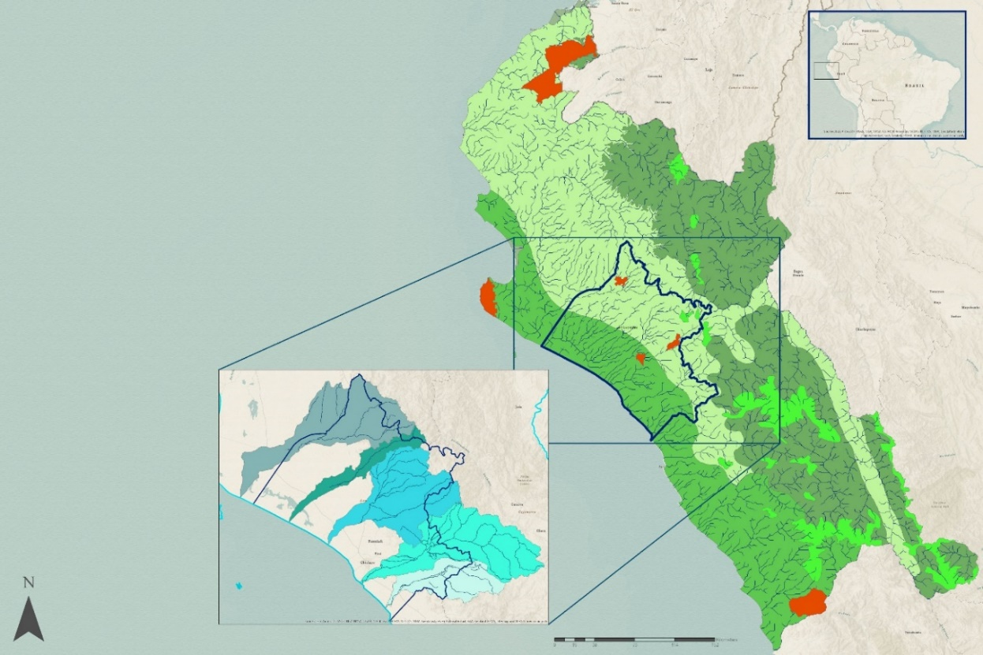

Figure 1. Study area and surrounding regions of Peru described by dominant terrestrial land types. Map created using ArcGIS Pro.

Cuenca Zaña

Cuenca Olmos

Cuenca Motupe

Cuenca Cascajal

Cuenca Chancay-Lambayeque

**Lambayeque Water Basins**

Tropical and Subtropical Dry Broadleaf Forests

Tropical and Subtropical Moist Broadleaf Forests

Montane Grasslands and Shrublands

Mangroves

Deserts and Xeric Shrublands

**Terrestrial Ecoregions**

Lambayeque

Rivers

Protected Areas with Mesquite Forests

km

152

76

38

0

* 1. ***Project Partners & Objectives***

The partners on this project are Juan Chapoñan Sanchez from the Lambayeque Regional Government’s Department of Agriculture and Natural Resources, Professor of Agronomy Eleazar Rufasto from the Universidad Nacional Pedro Ruiz Gallo, and Dr. Deborah Woodcock from the Clark University’s George Perkins Marsh Institute. The partner’s interest in the project stems from a desire to protect the *Prosopis* sp. trees and eliminate their declining health. The partner’s prior research on the health and soil types of mesquite forests has helped to gain awareness of the problem, but the scarce availability of spatiotemporal analyses for large ecoregions has left their *in-situ* data incomprehensive.

The goal of the project was to further assess how changing hydrologic factors affect *Prosopis* sp. mortality in the Lambayeque, Peru region through the use of remote sensing data. Discussions of appropriate indices to use for the parameters of precipitation, soil moisture, evapotranspiration, and vegetation health helped to determine final deliverable products. Data analyses were performed to generate the time-series for the hydrologic parameters of the study. Lastly, the results of the project were used to draw conclusions about the factors affecting mesquite forest health and were communicated to the partners. The partners may use the finished products to facilitate prompt decision-making and informative policy creation for Peru’s mesquite forests.

# 3. Methodology

To visualize the information collected through background research, environmental factors were analyzed to find a pattern that could explain the forest loss anomaly. These included a time series of precipitation, soil moisture, evapotranspiration, and vegetation health in the area of interest. The study region, which encompasses the regions of Tumbes, Piura, Lambayeque, La Libertad, and Cajamarca in northwestern Peru, was chosen due to the coarser spatial resolution of the data being analyzed. This wider area also allowed the project to address other regions of Peru where mesquite forests have seen similar patterns of decline.

***3.1 Data Acquisition***

Three NASA Earth observations and two ancillary datasets were used to produce a digital elevation model (DEM) and obtain information on precipitation, evapotranspiration, soil moisture, and vegetation health between the years of 1989 and 2019. These indices would allow multiple hydrological factors to be studied in comparison to vegetation over a thirty-year duration, showing the effects of dynamic hydrological trends on areas containing mesquite forests.

To evaluate precipitation totals, data from the National Oceanic and Atmospheric Administration’s (NOAA) Climate Hazards Center Infrared Precipitation with Stations (CHIRPS) were downloaded from the Famine Early Warning Systems Network (FEWS NET) developed by the USGS and the United States Agency for International Development (USAID) (Climate Hazards Center, 2020). CHIRPS provides a daily, pentadal, and monthly quasi-global (50°S - 50°N) Earth-view with a high spatial resolution of (0.05°). For the purposes of this project, only monthly aggregates of CHIRPS data were used due to its high temporal and spatial resolution over the study region. To evaluate soil moisture and evapotranspiration, datasets from the Global Land Data Assimilation System (GLDAS) were utilized. These data were accessed via the Goddard Earth Science Data and Information Services Center (GES DISC). The specific dataset used is GLDAS Noah Land Surface Model L4 monthly 0.25 x 0.25-degree V2.1 (GLDAS_NOAH025_M 2.1), which shows soil moisture and evapotranspiration at monthly increments (Beaudoing & Rodell, 2020). The data have a spatial resolution of 0.25°, equating to 25 x 25-kilometer pixels. Due to the smaller range of the study area, this produced files that were coarse in resolution. To assess vegetation health and to quantify the biomass of *Prosopis* sp. forests, the group used the Normalized Difference Vegetation Index (NDVI), which is represented by Equation 1:

(1)

*NDVI = (NIR – Red) / (NIR + Red)*

“NIR” represents radiation in the Near-Infrared portion of the electromagnetic spectrum reflected by vegetation and “Red” describes the red light reflected by vegetation. Healthy vegetation reflects more NIR and absorbs more red light, which can be analyzed on a -1 to +1 yield based on the formula. For these data, we used one-kilometer resolution products from the Terra Moderate Resolution Imaging Spectroradiometer (MODIS) and the Suomi National Polar-orbiting Partnership (NPP) Visible Infrared Imaging Radiometer Suite (VIIRS)(Didan, 2015; Didan & Barreto, 2018). MODIS was used to generate results for data between the years 2000 and 2019. After 2012, VIIRS was used as an alternative to MODIS, as MODIS sensors will eventually be decommissioned. The datasets used were the MODIS/Terra Vegetation Indices Monthly L3 Global 1 km SIN Grid (MOD13A3 v006) and VIIRS/NPP Vegetation Indices Monthly L3 Global 1 km SIN Grid (VNP13A3 v001), which were obtained from the Land Processes Distributed Active Archive Center (LP DAAC). A summary of data products can be found in Table 1.

|  |  |  |  |  |  |  |  |
| --- | --- | --- | --- | --- | --- | --- | --- |
| Normalized Difference Vegetation Index (NDVI) | Terra MODIS | MOD13A3.006 | LP DAAC | Monthly | 1000m | Monthly NDVI | Vegetation Health |
| Normalized Difference Vegetation Index (NDVI) | Suomi National Polar-Orbiting (NPP) | VNP13A3.001 | LP DAAC | Monthly | 1000m | Monthly NDVI | Vegetation Health |
| Soil Moisture/ Evapotranspiration | Global Land Data Assimilation System (GLDAS) | N/A | GES DISC | Monthly | 25km x 25km | cm | Soils Moisture  Evapotranspiration  Time Series |
| Precipitation Data | Climate Hazard Center Infrared Precipitation with Station (CHIRPS) | N/A | Climate Hazard Group University of Santa Barbara | Monthly | 5km | mm/month | Precipitation Time Series |
| Data  Type | **Data**  **Source** | **Sensor** | **Database** | **Temporal**  **Resolution** | **Spatial**  **Resolution** | **Parameters** | **Usage** |

Table 1

*Summary of data products used in project analysis.*

***3.2 Data Processing***

The data for this project were obtained in both NetCDF format and HDF5 format. Both file types were converted into GeoTiff files using Python to display visual results using ArcGIS Pro. The following sections describe the processing for the individual hydrologic parameters of precipitation, soil moisture, and evapotranspiration as well as for the comparison factor of vegetation health.

*3.2.1 Elevation Model and Hydrology*

A Digital Elevation Model was generated using data from the Shuttle Radar Topography Mission (SRTM). This model was processed in ArcMap using the tool ArcHydro to map the hydrology of the five primary water basins in the Department of Lambayeque: Zaña, Moutupe, Chancay, Cascajal, and Olmos. The first model produced was a stream order model to map the tributaries. A flow model was then produced which provided water direction and basin output. The water basin areas were then used to establish vegetation anomaly changes to monitor changes in forest health in the watershed.

*3.2.2 Precipitation*

To begin understanding the hydrological cycles of Peru, the initial step was to analyze the CHIRPS monthly precipitation data. Precipitation data were analyzed between the years 1989 to 2018 to incorporate strong El Niño events in 1998, 2008, and 2018. While data regarding soil moisture, evapotranspiration, and vegetation health were analyzed from 2000 to 2019, precipitation was assessed a decade earlier to observe precursor anomaly years of strong and weak precipitation.

Python programming language was used to efficiently automate the data processing and separate the files for analysis within the desired time frame. Instead of analyzing the data based on the calendar year (January to December), using the water year of the study region provided a look into the natural cycles of precipitation trends. Precipitation in Peru is strongest between October and March. Therefore, establishing a water year of October to September provided an analysis of when precipitation increases, reaches a peak, and subsides organically. To do this, Python script read in all of the CHIRPS data and grouped them based on the water year. Each aggregate started with the data for October of one year and ended with September of the following calendar year. The code looped through all files from 1989 to 2018 until each had twelve months’ worth of data.

*3.2.3 Soil Moisture & Evapotranspiration*

The soil moisture and evapotranspiration data obtained from the GLDAS included soil moisture at different depths (10-40 cm, 40-100 cm, 100-200 cm) and evapotranspiration between 2001 and 2019. Because the dataset was aggregated monthly, a total of 239 files were obtained for each parameter over the study period. These data were processed using both ArcGIS Pro and Python scripting, where the different parameters for soil moisture and evapotranspiration were obtained independently. Through the use of Python scripting, files were extracted from their NetCDF format and converted into GeoTiff. A second script was then applied to extract the TIF files to fit over the area of interest.

*3.2.4 Vegetation Health*

The monthly NDVI measurements encompassed the time frame between 2000 and 2019. The MODIS and VIIRS imagery obtained from the LP DAAC was processed using both Python and ArcGIS Pro. Similar to GLDAS, Python was used to convert files into a GeoTiff format to later be uploaded into ArcGIS Pro. Because the files were obtained from the LP DAAC, the study area was divided into two scenes with each monthly measurement divided into two individual scenes. To obtain one monthly measurement, the *Mosaic to New Raster* tool was applied using Arcpy. The output files were then extracted to fit the area of interest using the *Extract by Mask* tool. A series of monthly rasters ranging from 2001-2010 were aggregated to produce a long-term NDVI vegetation health raster for each of the months from January to December. The long-term average NDVI rasters were manipulated using the raster calculator function of ArcMap to produce monthly NDVI change anomalies.

***3.3 Data Analysis***

After all the data were processed to fit the study area, further analysis was performed to determine if relationships could be found between precipitation, soil moisture, evapotranspiration, and NDVI over time. Once all of the water year aggregates were produced, a *Cell Statistics* tool was used in a loop to find the sum of rainfall per pixel, per water year. The sum of these monthly averages was then projected into single rasters to compare water year trends over the 30-year study period. These rasters were then clipped down to the extent of the study region using the *Extract by Mask* tool in Python and projected into ArcGIS Pro. The areas of precipitation were displayed from low to high as light blue to dark blue features, respectively. This would allow for connections to be made between precipitation and vegetation health in the study region over time. The creation of a line graph displaying the change of maximum precipitation per pixel over the 30-year study period was implemented to create a line of regression showing an increase, decrease, or steadiness of precipitation over time. Because Lambayeque is known to be partially arid and the trees are not located in all portions of the study area, precipitation measurements were obtained from smaller areas where there were known populations of the *Prosopis* sp. trees. This would allow for more precise results with regards to which hydrological measurements show the mesquite forest’s decline in Lambayeque specifically. To do this, measurements were taken within three river basins in the study area (the Chancay, Cascajal, and Motupe) and three forested areas located within the river basins (Laquipampa, Huacrupe, and Bosque de Pomac). CHIRPS data were used to measure the total sum of precipitation levels in the water basins using the *Zonal Statistics* tool in ArcGIS Pro to produce a total sum of precipitation for the three basins. The sum of precipitation within the river basins is correlated to how much water the protected forests are receiving because the source of the nearby rivers is further upstream and out of the interest area. From this, line graphs showing the Chancay, Motupe, and Cascajal river basins were derived to show the total sum of precipitation in the area compared to the maximum pixel values of precipitation and compared to the other variables over the study period. The results of the graphs portray annual water years showing either high or low precipitation. The rasters from these anomalous years were analyzed closely and compared to soil moisture, evapotranspiration, and vegetation health to find visible correlations between hydrologic cycles and overall vegetation health.

For soil moisture and evapotranspiration, points were extracted from within each of the protected forest areas using the *Feature to Point* tool and merged into one file using the *Merge* tool. A table was developed using the *Sample* tool in ArcGIS Pro to extract the desired values from the TIF files for each water year. The tables were then converted into a Microsoft Excel format to perform statistical analyses. As with precipitation, line graphs were developed for the protected areas showing how soil moisture values fluctuated between 2001 and 2019. Similar to the precipitation data, the *Cell Statistics Processing* tool was then applied to the GLDAS files to group each parameter by water year. Because the water year in the region of Peru goes from October to September, cell statistics were calculated from 2001 to 2019. The average was calculated for each soil moisture depth while the evapotranspiration data were summed. Lastly, as with precipitation and GLDAS data, the average cell statistics per water year were obtained between 2001 and 2019.

Finally, NDVI values were calculated for the protected forest areas. The three polygons were merged into one file, and the *Zonal Statistics to Table* tool was applied using the NDVI water year rasters to find the area-averaged mean NDVI value per water year. This process was done individually for each year, as the tool can only process one raster file at a time. A table was manually developed on Microsoft Excel imitating the format used for the soil moisture to keep the measurements consistent between variables. Visual representation was once again developed to demonstrate how NDVI changed in the forested areas from 2001 to 2019. NDVI anomaly analysis focused on February and March. This occurred as the study region received the majority of its precipitation in December and January. According to Zefeng Chen, Weiguang Wang, and Jianyu Fu in an article published in the January 2020 Journal of Nature, the typical NDVI lag-lead relationship between precipitation and vegetation response is a 1–2-month lag. A mask was applied to the water basin and protected areas within Peru to produce rasters which demonstrated only where vegetation had declined to show the localities most adversely impacted with as little visual pollution as possible.

# 4. Results & Discussion

*4.1 Elevation Model and Hydrology*The hydrological modeling of the SRTM data led to the outputs of stream order and flow direction rasters (see *Figure B1* in Appendix B). According to the analysis, the Moutupe watershed had the most extensive network of rivers. Despite the abundance of rivers, this watershed did not maintain the highest precipitation values (see *Figure A1* in Appendix A). According to the Lambayeque Watershed Drainage Model, the Chancay basin had the highest average height of the five basins studied (see *Figure B2* in Appendix B). According to our precipitation analysis, Chancay had the highest precipitation values. This discrepancy may be the result of higher precipitation resulting from lower pressure systems in higher elevations (see *Figure A1* in Appendix A). However, more ecological and precipitation analysis is necessary.

*4.2 Precipitation*

After data processing and visualization, precipitation trends of the study region became apparent over the 30-year study period. A high extreme in overall precipitation occurred roughly every nine to ten years, which corresponds to recorded El Nino events in 1998, 2008, and 2017. The line of regression shows an overall decrease in precipitation in the past thirty years, with a negative slope of -3.78 (see *Figure A1* in Appendix A). It can be inferred that El Niño events have been decreasing in strength as well, from maximum pixel sum values of 3592 mm in 1998 to 2905 mm in 2017.  The intervals of high and low precipitation can best be visualized and correlated to other variables for the years of 2015 and 2017 (see *Figures C1 & C2* in Appendix C). Since the raster scale was set from high to low based on the maximum pixel, it may appear that 2015 had similar levels of precipitation as 2017. However, the scale differs between these two maps, with maximum rainfall in 2015 at 1892 mm and maximum rainfall in 2017 at 2905 mm. These maps also visualize how rainfall was distributed across the study region. This is important when considering vegetation health compared to precipitation. After running the *Zonal Statistics* tool for the Rio Chancay, Cascajal, and Motupe river basins, the line graph produced displayed similar trends to the maximum cell precipitation levels of the entire study area (see *Figure A2* in Appendix A). There appeared to be similar trends of decreased precipitation in 1992, 2015, and 2018 and increased precipitation in 1998, 2008, and 2017. In addition, between the years of 2008 and 2017, there has been a steady decrease in precipitation levels.

*4.3 Evapotranspiration*

Evapotranspiration levels can be clearly differentiated between the forested areas of Bosque de Pomac, Laquipampa, and Huacrupe. Huacrupe, was the lone area located in the Cascajal Basin in the northern region of Lambayeque, while the other two forested areas were within the Chancay Basin in the southern region of Lambayeque. As the graph shows, evapotranspiration increased in Huacrupe while it decreased in Laquipampa and stayed relatively constant in the Bosque de Pomac (see *Figure A3* in Appendix A). This shows that both basins had different water intake values and that the forested areas could be adversely affected by other factors causing such evapotranspiration fluctuations. With the exception of Laquipampa, the water basins experienced the highest water loss during ENSO periods.

*4.4 Soil Moisture*

After soil moisture data was processed for depths of 10 to 40 cm, 40 to 100 cm, and 100 to 200 cm, results demonstrated that soil moisture remained constant for both Huacrupe and the Bosque de Pomac (see *Figure A4* in Appendix A). This trend is opposite within the forested area of Laquipampa, where yearly soil moisture demonstrated an overall decrease. This trend shows that there is a stable amount of water content within two of the three forested areas, implying that there could be other factors that are affecting a decrease in the *Prosopis* sp. forest. On the other hand, the decrease in soil moisture in Laquipampa could also denote that water resources are being diverted away from the forested area for other uses.

*4.5 Vegetation Health*

Similar to soil moisture, the vegetation health index shows that in all three forested areas, there is heightened variability as vegetation health fluctuates from one year to the next (see *Figure A5* in Appendix A). Overall, trends for NDVI stayed at a constant level. The vegetation health index in the area may take into account other forms of vegetation, such as agricultural produce or other native plant species found in the area. Even though trends seem to be constant, it is clear that the most volatile vegetation health can be observed in the Huacrupe forested area. This also shows that on average, Huacrupe is the region with the lowest vegetation health overall. The year 2017 had the highest NDVI values, but according to the monthly NDVI anomaly analysis in February 2017, there was the highest vegetation stress from the case study years we evaluated. 2017 was an anomalous year, setting the record for the warmest year without an El Niño. The spike in rainfall in the study area occurred in March from catastrophic flooding. The increase in precipitation resulted from a localized weather event on the Pacific coast of Ecuador and Peru known as the Coastal Niño. This is differentiated from an [El Niño](https://en.wikipedia.org/wiki/El_Ni%C3%B1o) event as a Coastal Niño stays local and does not expand into the equatorial central Pacific Ocean, and thus does not impact global temperatures (López 2017). The event had major impacts on Colombia, Western Brazil, Ecuador, and Peru. The significant increase in precipitation in 2017 from this event led to the greatest NDVI based on the water year analysis, despite being a La Niña year.

*4.6 Analysis of Results*

To understand the relationship between precipitation, soil moisture, evapotranspiration, and vegetation health, anomalous water years for high and low precipitation were selected for visualization. These years were selected from a subset of the study period where there was data for all three factors (precipitation, evapotranspiration, and NDVI). 2015, which had low precipitation levels, and 2017, which had high precipitation levels, met all of these criteria (see *Figures C1 & C2* in Appendix C). Rasters of the different factors provided a visual to analyze the correlations of extremes in the graphs.

It can be seen from the images that the lower levels of precipitation in 2015 (1892 mm) and the higher levels of precipitation in 2017 (2905 mm) had a direct correlation with vegetation health (see *Figures C1 & C2* in Appendix C). In the NDVI map for 2015, the red value (representing low vegetation health) stretches further inland and is more apparent than in the image for NDVI in 2017. The images also show a correlation between areas of increased precipitation, evapotranspiration (represented in dark blue), and healthy vegetation (represented in light green).

A few errors were encountered in the course of this study that should be noted. While the precipitation data covered the entirety of the 30-year study period, data for soil moisture, evapotranspiration, and vegetation health were only available from 2000 onward. This significantly reduced the number of years that could be directly compared. The low resolution of data for soil moisture and evapotranspiration resulted in coarse maps for the study region. The NDVI results possibly incorporated vegetation health from species other than mesquite, which explains why NDVI health appears to levels off in the results. In the preliminary steps of this project, the group was unable to obtain shapefiles for every protected area within the study region, limiting the number of comparisons made between the parameters of the study. Aggregating the annual water-year estimates of NDVI obscures what is happening on a monthly basis. The water-year NDVI analysis showed that 2017 was a wet year, although much of this precipitation was concentrated after the rainy season. Both January and February 2017, months where heavy rainfall is typical, were abnormally dry.

*4.7 Future Work*

This study can act as preliminary work for future research on hydrologic patterns in Peru. Several other factors, both natural and anthropogenic, could be examined to gain knowledge on changing systems, including groundwater, agricultural land shifts, geology, soil types, mining, irrigation, urbanization, and deforestation. Also, a machine-learning tool could be created to predict future changes in vegetation health based on these studies. This would allow researchers to calculate possible areas of vulnerability in mesquite forests, which could mitigate future episodes of forest degradation.

# 5. Conclusions

From the results above, a series of conclusions can be made about Peru’s hydrologic patterns and their effects on the region’s vegetation health. First, there is a clear pattern showing that precipitation levels have been decreasing over the past 30 years, as seen in the graphs of maximum cell values for the study region and for the total sum values of the three river basins. These trends also demonstrate that ENSO events have been decreasing in strength. This shows that during these periods, there was less water entering the region. Because precipitation levels have a direct correlation on vegetation health, this could explain the recent decline of forests over the past twenty years. However, these trends did not hold true with the other variables that were studied, as they did not directly show a decrease in their parameters. Second, it is important to note that evapotranspiration and soil moisture are dependent on the location of the basins. This may make the measurements skewed, as they are subject to different pressures such as agricultural practices and other anthropogenic activities. To better understand if soil moisture and evapotranspiration are functionally related to vegetation health, it would be recommended to look at other factors such as soil type, root depth, and surface temperature. Thirdly, the overall NDVI vegetation health index was relatively stable, which runs contrary to anecdotal evidence. As aforementioned in the results, this could have been because the NDVI measures may have taken into account various types of tree species other than mesquite. Overall, results show that there is a direct correlation between precipitation levels and vegetation health. Research should be conducted on additional hydrologic parameters and anthropogenic factors in order to understand all systems negatively affecting mesquite forests in Lambayeque.

# 6. Acknowledgments

We wanted to express our gratitude to our science advisor Dr. Kenton Ross for advising us on developing the project methodology and providing guidance throughout the project term. We would also like to thank Dr. Venkataraman Lakshmi out of the University of Virginia for his input and critique of the project. We would like to thank Dr. Deborah Woodcock, Juan Chapoñan Sanchez, and Eleazar Rufasto for sharing field data and expertise throughout the development of this project. Additionally, we would like to thank our Fellow Sydney Neugebauer and the NASA DEVELOP National Program for providing the opportunity and guidance to work on this project.

Any opinions, findings, and conclusions or recommendations expressed in this material are those of the author(s) and do not necessarily reflect the views of the National Aeronautics and Space Administration.

This material is based upon work supported by NASA through contract NNL16AA05C.

# 7. Glossary

**CHIRPS –** Climate Hazards Group InfraRed Precipitation with Station data. These data were developed by the University of California Santa Barbara Climate Hazards Center and the USGS with support from NASA, NOAA, and USAID.

**DEM –** Digital elevation model

**Earth observations –** Satellites and sensors that collect information about the Earth’s physical, chemical, and biological systems over space and time

**ENSO –** El Niño Southern Oscillation. An irregularly periodic variation in winds and sea surface temperature

**GPM –** Global Precipitation Measurement

**GRACE –** Gravity Recovery and Climate Experiment, a NASA Earth observation tool to detect gravity field anomalies. In the context of the project, GRACE was used to determine groundwater depth.

**GLDAS –**Global Land Data Assimilation System. A reanalysis system that ingests satellite and ground-based observational data products to integrate and generate land surface models.

**La Niña/El Niño –** Global Weather patterns part of the Oceanic Niño Index

**MODIS** – Moderate Resolution Imaging Spectroradiometer

**NDVI –** Normalized Distribution Vegetation Index, used to assess vegetation greenness

**ONI** – Oceanic Niño Index, the temperature of the ocean

**SRTM** – Shuttle Radar Topography Mission

**VIIRS –**Visible Infrared Imaging Radiometer Suite, one of the five primary sensors on the Suomi National Polar-orbiting Partnership satellite.

# 8. References

Aldebaran de Villasante Llaquet, I. (2019, June 7). The carob tree, livelihood of Peru, in danger. *La Vanguardia.* Retrieved from https://www.lavanguardia.com/

Auris, K. G. C. (2019). *Occurencia Estacional de un* Cecidomyiidae *en Algarrobo (*Prosopis pallida*) H. B. K. en Pacasmayo – Peru* (Unpublished doctoral dissertation). Universidad Nacional Agraria la Molina, Lima, Peru.

Baena, S., Moat, J., Whaley, O., & Boyd, D. S. (2017). Identifying species from the air: UAVs and the very high resolution challenge for plant conservation. *PLoS ONE, 12*(11), 1-21. doi:10.1371/journal.pone.0188714

Beaudoing, H. & Rodell, M. (2020). GLDAS Noah Land Surface Model L4 monthly 0.25 x 0.25 degree V2.1 [Data set]. Earth Sciences Data and Information Services Center (GES DISC), accessed 18 February 2020. doi:10.5067/SXAVCZFAQLNO

Bech, J., Poschenrieder, C., Llugany, M., Barceló, J., Tume, P., Tobias, F. J.,…Vásquez, E. R. (1997). Arsenic and heavy metal contamination of soil and vegetation around a copper mine in Northern Peru. *The Science of the Total Environment, 203,* 83-91. Retrieved from https://s3.amazonaws.com/academia .edu.documents/44459996/Arsenic_and_heavy_metal_contamination_of20160405-1303-joibuv.pdf?response-content-disposition=inline%3B%20filename%3DArsenic_and_Heavy _Metal_Contamination_of.pdf&X-Amz-Algorithm=AWS4-HMAC-SHA256&X-Amz-Credential=AKIAIWOWYYGZ2Y53UL3A%2F20200313%2Fus-east-1%2Fs3%2Faws4_request &X-Amz-Date=20200313T141210Z&X-Amz-Expires=3600&X-Amz-SignedHeaders=host&X-Amz-Signature=16b6f861e7d18d605798758666ced5ad8c81a4289556001a242f943a3696cfb7

Beresford-Jones, D. G. (2004). *Pre-Hispanic* Prosopis-*Human Relationships on the South Coast of Peru: Riparian Forests in the Context of Environmental and Cultural Trajectories of the Lower Inca Valley* (Unpublished doctoral dissertation). University of Cambridge, Cambridge, MA. Retrieved from https://www.academia.edu/31529134/Pre-Hispanic_Prosopis-Human_Relationships_on_the_South_Coast_of_Peru_Riparian_Forests_in_the_Context_of_Environmental_and_Cultural_Trajectories_of_the_Lower_Ica_Valley

Cano, A. (2013). Top Down or Bottom Up?: Social Participation, Agriculture and Mining in the Integrated Management of the Chancay-Lambayeque Watershed [Abstract]. *Editorial Fund, Universidad del Pacífico, 40*, 43-76. Retrieved from https://ideas.repec.org/a/pai/apunup/en-73-02.html

Carevic, F. S. (2016). Towards an integration of plant ecophysiological traits for the conservation of endangered species in ecosystems under water stress. *Idesia, 34*(3), 33-38. Retrieved from https://scielo.conicyt.cl/pdf/idesia/v34n3/art05.pdf

Cermal, H. & Aranzaens, C. (2014). *About Peru: Agriculture.* Retrieved from the Peru Information website: https://www.peruinformation.org/agriculture-c1x01

Chávez, R. O., Clevers, J. G. P. W., Herold, M., Acevedo, E., & Ortiz, M. (2013). Assessing Water Stress of Desert Tamarugo Trees Using *in situ* Data and Very High Spatial Resolution Remote Sensing. *Remote Sensing, 5*(10), 5064-5088. doi:10.3390/rs5105064

Chuai, X. W., Huang, X. J., Wang, W. J., & Bao, G. (2013). NDVI, temperature and precipitation changes and their relationships with different vegetation types during 1998–2007 in Inner Mongolia, China. *International journal of climatology*, *33*(7), 1696-1706. doi: 10.1002/joc.3543

Climate Hazards Center. (2020). CHIRPS 2.0 Global Monthly [Data set]. Climate Hazard Group University of Santa Barbara, accessed 4 February 2020. https://data.chc.ucsb.edu/products/CHIRPS-2.0/global_monthly/tifs/

Davis, S. N. (1974). Hydrogeology of Arid Regions. In G. W. Brown, Jr. (Ed.), *Desert Biology* (pp. 1-30) New York City, NY: Academic Press. Retrieved from https://books.google.com/books?hl=en&lr=&id =EiTLBAAAQBAJ&oi=fnd&pg=PA1&dq=aquifer+extraction+lambayeque&ots=rJ8RvfNDPL&sig=tJB3D9Sk4GkBulnVvQaKPOP0Fzk#v=onepage&q=aquifer%20extraction%20lambayeque&f=false

Didan, K. (2015). MOD13A3 MODIS/Terra vegetation Indices Monthly L3 Global 1km SIN Grid V006 [Data set]. NASA EOSDIS Land Processes DAAC, accessed 30 January 2020. https://doi.org/10.5067/MODIS/MOD13A3.006

Didan, K. & Barreto, A (2018). VIIRS/NPP Vegetation Indices Monthly L3 Global 1km SIN Grid V001 [Data set]. NASA EOSDIS Land Processes DAAC, accessed 3 February 2020. https://doi.org/10.5067/VIIRS/VNP13A3.001

Depenthal, J., & Meitzner Yoder, L. S. (2018). Community Use and Knowledge of *Algarrobo* (*Prosopis pallida*) and Implications for Peruvian Dry Forest Conservation. *Revista de Ciencias Ambientales (Tropical Journal of Environmental Sciences), 52*(1), 49-70. doi: http://dx.doi.org/10.15359/rca.52-1.3

Ektvedt, T. M., Vetaas, O. R., & Lundberg, A. (2012). Land-Cover Changes During the Past 50 Years in the Semi-Arid Tropical Forest Region of Northern Peru. *Erdkunde, 66*(1), 57-75. doi:10.3112/erdkunde.2012.01.05

Felker, P. (2005). Mesquite Flour: New Life for an Ancient Staple. *Gastronomica, 5*(2), 85-89. doi:10.1525/gfc.2005.5.2.85

Felker, P. (2009). Unusual Physiological Properties of the Arid Adapted Tree Legume *Prosopis* and their Applications in Developing Countries. In E. De le Barrera & W. K. Smith (Eds.), *Perspectives in Biophysical Plant Ecophysiology: A Tribute to Park S. Nobel* (pp. 221-255). Mexico City, Mexico: Universidad Nacional Autónoma de México. Retrieved from https://books.google.com/books?hl=en&lr=&id=RF3Ew5QDTGEC&oi=fnd&pg=PA221&dq=prosopis+spp+physiology&ots=lshkxdGL_t&sig=GuJ0kfJNvjEoIHfPOoggR--reYs#v=onepage&q=prosopis%20spp%20physiology&f=false

Ferreyra, R. (1993). Registros de la Vegetación en la Costa Peruana en Relación con el Fenómeno El Niño. *Bulletin de I’Institut Français d’Etudes Andines, 22*(1), 259-266. Retrieved from http://cidbimena.desastres.hn/docum/crid/CD_nino/pdf/spa/doc9284/doc9284-contenido.pdf

Fraser, B. (2017). Peru’s floods teach tough lessons: Surprise El Niño causes devastation, but presents bounty for ecologists. *Nature, 544,* 405-406. doi: 10.1038/544405a

Galera, F. M. (2000). *El Género Prosopis “Algarrobos” en América Latina y el Caribe. Distribución, Bioecología, Usos y Manejo* [The Gender Prosopis “Algarrobos” in Latin America and the Caribbean. Distribution, Bioecology, Uses and Management]. Retrieved from http://www.fao.org/3/AD314S/AD314S08.htm

Kuroiwa, A. J. M., Castro, L. F., Lucen, M. N., & Montenegro, J. I. (2014). Integrated water resources in Peru – The long road ahead. In P. Martinez-Santos, M. M. Aldaya, & M. R. Llamas (Eds.), *Integrated Water Resources Management in the 21st Century: Revisiting the Paradigm* (pp. 189-216). London, UK: Taylor and Francis Group. Retrieved from https://books.google.com/books?hl=en&lr=&id=CB7lAgAAQBAJ &oi=fnd&pg=PA189&dq=saltwater+intrusion+lambayeque&ots=WyiHnaUPQH&sig=NLEL56wuoWnnghFy5hRTLxAb3Q0#v=onepage&q&f=false

Lagos, P., Silva, Y., Nickl, E., & Mosquera, K. (2008). El Niño? related precipitation variability in Perú. *Advances in Geosciences, 14,* 231-237. hal-00297103

Linares-Palomino, R. & Ponce-Alvarez, S. I. (2009). Structural patterns and floristics of a seasonally dry forest in Reserva Ecológica Chaparri, Lambayeque, Peru. *Tropical Ecology, 50*(2), 305-314. Retrieved from http://citeseerx.ist.psu.edu/viewdoc/download?doi=10.1.1.525.1437&rep=rep1&type=pdf

López, M. (2017, April 1). 5 preguntas para entender el Fenómeno El Niño costero que golpea Perú. Retrieved March 1, 2020, from https://rpp.pe/blog/mongabay/5-preguntas-para-entender-el-fenomeno-el-nino-costero-que-golpea-peru-noticia-1038554

Montecino, V. & Lange, C. B. (2009). The Humboldt Current System: Ecosystem components and processes, fisheries, and sediment studies. *Progress in Oceanography, 83*(1-4), 65-79. doi:10.1016/j.pocean.2009.07.041

National Oceanic and Atmospheric Administration. (n.d.). *Explaining El Niño.* Retrieved from Pacific Marine Environmental Laboratory website: https://www.pmel.noaa.gov/elnino/faq#often

Nolazco, S. & Roper, J. J. (2014). The challenge of estimating population trends in the endangered Peruvian Plantcutter (*Phytotoma raimondii*) and implications for conservation. *Ornitologia Neotropical, 25*(2), 125-134. Retrieved from https://www.researchgate.net/publication/266384046_The_challenge _of_estimating_population_trends_in_the_endangered_Peruvian_Plantcutter_Phytotoma_raimondii_and_implications_for_conservation

Ponce, V. M. (2014, December). *Effect of groundwater pumping on the health of arid vegetative ecosystems.* Retrieved from http://groundwaterpumping.sdsu.edu/effect_of_groundwater_pumping.pdf

Rodríguez, R., Mabres, A., Luckman, B., Evans, M., Masiokas, M., & Ektvedt, T. M. (2005). “El Niño” events recorded in dry-forest species of the lowlands of northwest Peru. *Dendrochronologia.* doi:10.1016/j.dendro.2005.05.002

Rundel, P. W., Dillon, M. O., Palma, B., Mooney, H. A., Gulmon, S. L., & Ehleringer, J. R. (1991). The phytogeography and ecology of the coastal Atacama and Peruvian deserts. *Aliso, 13*(1), 1-49. Retrieved from https://www.researchgate.net/publication/285532961_The_phytogeography_and_ ecology_of_the_coastal_Atacama_and_Peruvian_Deserts

Shackleton, R. T., Le Maitre, D. C., Pasiecznik, N. M., & Richardson, D. M. (2014). *Prosopis:* a global assessment of the biogeography, benefits, impacts and management of one of the world’s worst woody invasive plant taxa. *AoB Plants 6,* 1-18. Retrieved from https://www.researchgate.net/ publication/270731892_AoB_PLANTS-2014-Shackleton-aobpla_plu027

Tapley, Jr., T. D. & Waylen, P. R. (1990). Spatial variability of annual precipitation and ENSO events in western Peru. *Hydrological Sciences Journal, 35*(4), 429-446. doi:10.1080/02626669009492444

U.S. Department of the Interior. (1970). *Ground-Water Resources of the Lambayeque Valley, Department of Lambayeque, Northern Peru, 1969* (Geological Survey Water-Supply Paper No. 1663-F). Washington, D.C.: S. L. Schoff & J. L. Sayan M. Retrieved from http://citeseerx.ist.psu.edu/viewdoc/download?doi=10.1.1.996.2574&rep=rep1&type=pdf

World Wildlife Fund. (1986). Thirsty Crops: Our food and clothes: eating up nature and wearing out the environment? *Living Waters: Conserving the source of life.* Retrieved from http://assets.panda.org/downloads/wwfbookletthirstycrops.pdf

Young, K. R. & Rodríguez, L. O. (2006). Development of Peru’s Protected-Area System: Historical Continuity of Conservation Goals. In K. S. Zimmerer (Ed.), *Globalization & New Geographies of Conservation* (pp. 229-252). Chicago, IL: The University of Chicago Press. Retrieved from https://books.google.com/books?id=UdLK-UGj7YkC&pg=PA234&lpg=PA234&dq=protected+%22mesquite%22+forests+peru&source=bl&ots=Mw_1Lb3yWi&sig=ACfU3U0KrMnBrXaqofqo34GYGaE9q-TOeQ&hl=en&ppis=_c&sa=X&ved=2ahUKEwiv5oS3mPDnAhWzlHIEHZOGBWQQ6AEwCXoECA4QAQ#v=onepage&q=protected%20%22mesquite%22%20forests%20peru&f=false

**Appendix A**

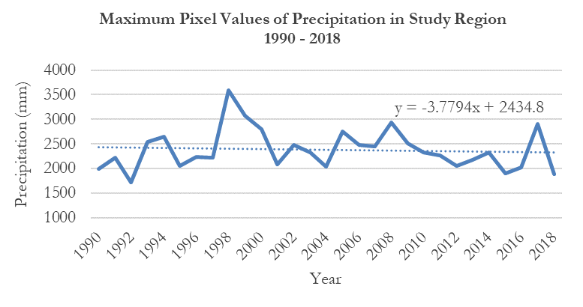

Figure A1. Maximum precipitation levels of the study region. Graph created using ArcGIS Pro and Microsoft Excel.

*Figure A2.* Graph showing total precipitation by water basin between 1990 and 2018. Graph created using ArcGIS Pro and Microsoft Excel.

*Figure A3.* Graph of evapotranspiration in protected forest areas of Lambayeque. Graph created using ArcGIS Pro and Microsoft Excel.

**10 - 40 cm**

**40 - 100 cm**

**100 - 200 cm**

Figure A4. Graph of soil moisture at varying depths in protected areas of Lambayeque. Graph created using ArcGIS Pro and Microsoft Excel.

Figure A5. Vegetation health for protected areas in Lambayeque. Graph created using ArcGIS Pro and Microsoft Excel.

**Appendix B**

Río Zaña Flow Direction

1

2

4

8

16

32

64

128



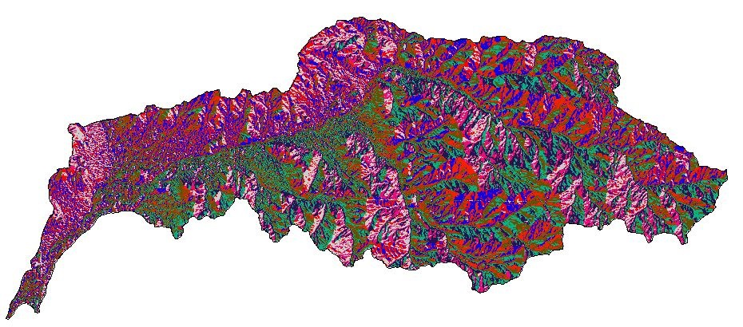

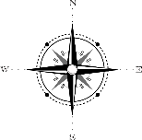

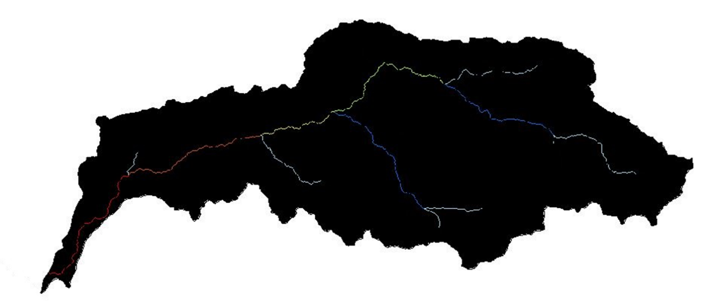



1

2

3

4

5

6

7

Río Zaña Stream Order

2



Figure B1. Example maps of individual watersheds within the department of Lambayeque. Hydrological modeling demonstrating stream order and flow direction of the Zaña River Watershed. Maps created using ArcGIS Pro.

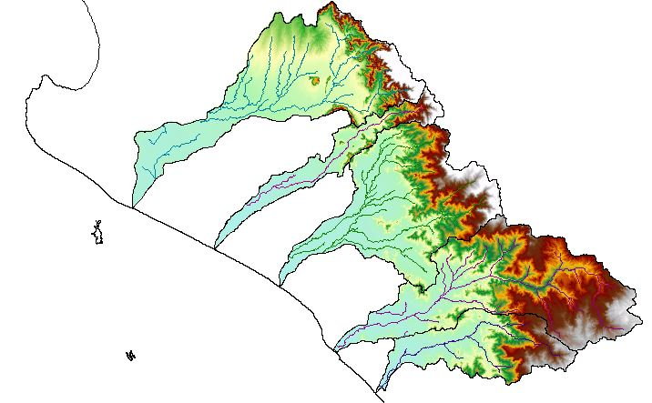

Cuenca Cascajal



4097 Meters

-1 Meters

Digital Elevation

Flow Direction Model

Watershed & Peru boundaries

Cuenca Olmos

Cuenca Moutupe

Cuenca Zaña

Cuenca Chancay

Cuenca Zaña



Figure B2. The Department of Lambayeque Watershed Drainage Model. The model combines the five primary watersheds of the Department of Lambayeque using digital elevation, river flow, and stream output parameters.

**Appendix C**

***2015***

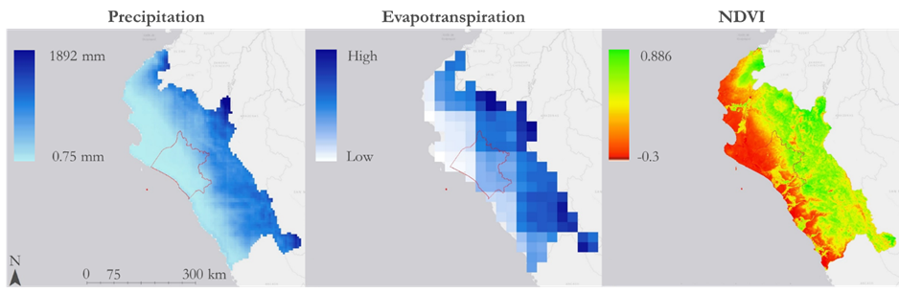

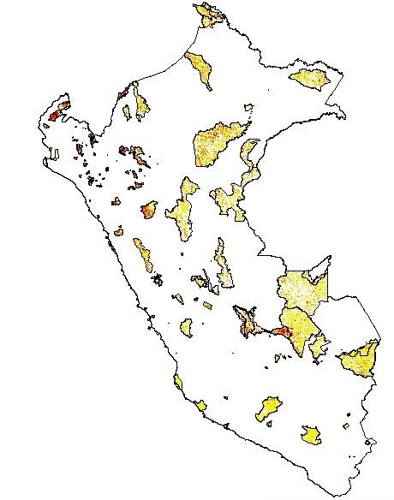

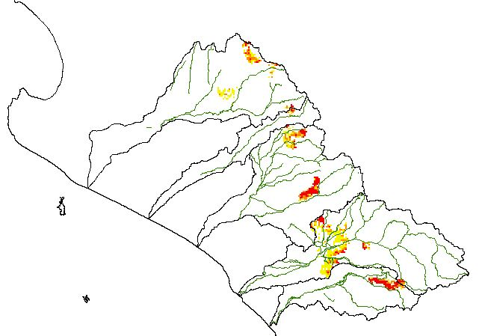



NDVI Anomaly –

Vegetation Decline

-0.3 to -0.2

-0.2 to -0.1

-0.1 to -0.001



Peru Political &

Watershed Boundaries

Figure C1. Study region maps of precipitation, evapotranspiration, water-year vegetation health, and February NDVI anomaly map for Peru and Lambayeque Water Basins for the year 2015.

***2017***

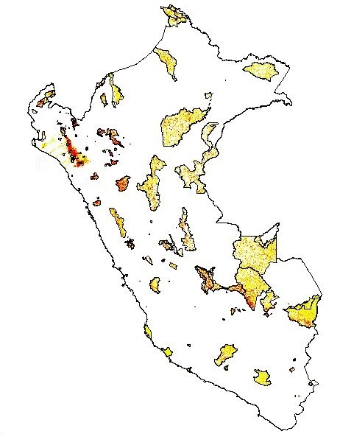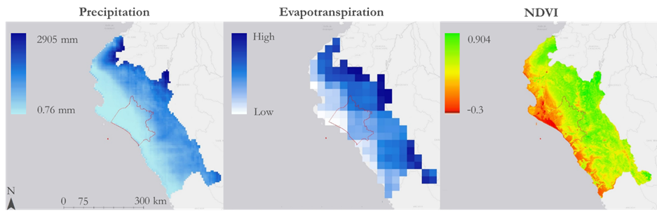

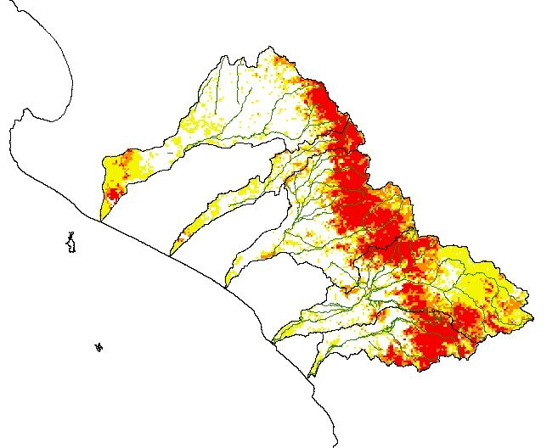



NDVI Anomaly –

Vegetation Decline

-0.3 to -0.2

-0.2 to -0.1

-0.1 to -0.001



Peru Political &

Watershed Boundaries

Figure C2. Study region maps of precipitation, evapotranspiration, water-year vegetation health, and February NDVI anomaly map for Peru and Lambayeque Water Basins for the year 2017.