**NASA DEVELOP National Program**



NASA Marshall Space Flight Center

*Summer 2015*

Thailand Agriculture

Monitoring Food Crop Health and Stress Due to Changing Climate for Enriched Agricultural Land Management

 **Technical Report**

Rough Draft – June 25, 2015

Timothy Klug (Project Lead)

Arom Boekfah

Chayanit Choomwattana

Komsan Rattanakijsuntorn

Watanyoo Suksa­-ngiam

Atipat Wattanuntachai

Dr. Jeffrey Luvall (NASA at National Space Science and Technology Center)

Dr. Robert Griffin (University of Alabama in Huntsville)

# I. Abstract

[Placeholder - do not put anything here until the final draft submission. The abstract in the project summary is where the working draft of the abstract should “live”]

**Keywords**

Thailand, Agriculture, Rice, Climate, Precipitation, Remote Sensing, Land Cover Classification

# II. Introduction

**Background Information**

Thailand is well-known not only as one of the world’s largest rice exporter, but also as a producer of high quality rice. Rice can be grown in almost every region of Thailand, especially in the central and northeastern region. Northeastern Thailand, or Isan, is famous for its agriculture industry, particularly its rice crops. This region is known as the area where rice is grown most, but the rice yield per hectare is low due to several factors, such as a lack of irrigation, soil erosion, drought, and undulating topography (Ricepedia, 2015). Tung Kula Rong Hai is a sub-region in Northeastern Thailand where Thai jasmine rice, or Thai Khao Hom Mali, is grown most. Tung Kula Rong Hai partially covers five provinces including Surin, Maha Sarakham, Buri Ram, Si Sa Ket, and Roi Et for total area of 3,200 km2 (The Nation, 2014).

On 12 February 2013, European Commission has officially granted the protection of the “Thai Khao Hom Mali Thung Kula Rong-Hai” as a registered European Union’s Protected Geographical Indication or PGI. Set for better protection within 27 European Union Member States, this is the first-ever South East Asian PGI being recognized and the second by the European Union. As of today, the selling price of Thai Khao Hom Mali Rice is more than twice of an average selling price of normal white rice (USDA, 2015).

Roi Et has the largest land portion in Tung Kula Rong Hai covering almost 50% of the region. Moreover, rice is the most important agricultural product in Roi Et, especially Thai Khao Hom Mali Thung Kula Rong-Hai. However, most of the rice grown in Isan including Roi Et is rain-fed, which climate change has a significant impact on rice yield. Therefore, in this study, Roi Et was chosen as the study area where the researchers monitored and recorded data determining precipitation and land temperature. Policy makers and researchers are able to understand the impact of climate change on the rice production especially in Roi Et province. There was also rice subsidy scheme from 2011 to 2014 leading to expanding of rice production in Thailand included in the analysis.

**Project Objectives**

Satellite images were used to remotely monitor agricultural lands under the change of environmental variables, such as precipitation and land surface temperature.

The use of satellite imagery is relatively cost-effective in comparison to field surveys over large agricultural areas. This project improved the understanding of agricultural lands under changing climate patterns and thus could be useful for decision management of the crop growing input, such as fertilizer.

**Study Area**

This project focused on paddy fields in the northeastern region of Thailand. These rice fields are vulnerable to climate change due to rain-fed water dependence. Roi Et province was chosen to be the focused study area due to its large paddy fields, and those areas are suitable for growing jasmine rice, which is a very important crop in Thailand.

Roi Et is located in the middle of Isan region covering 8,300 km2 of land. Most of its land cover consists of plains with 120-160 m height above mean sea level. It borders the Phuphan mountain range in the north. Central Roi Et is undulating plain while the Southern region is comprised of low lands which locates Thung Kula Rong-Hai.

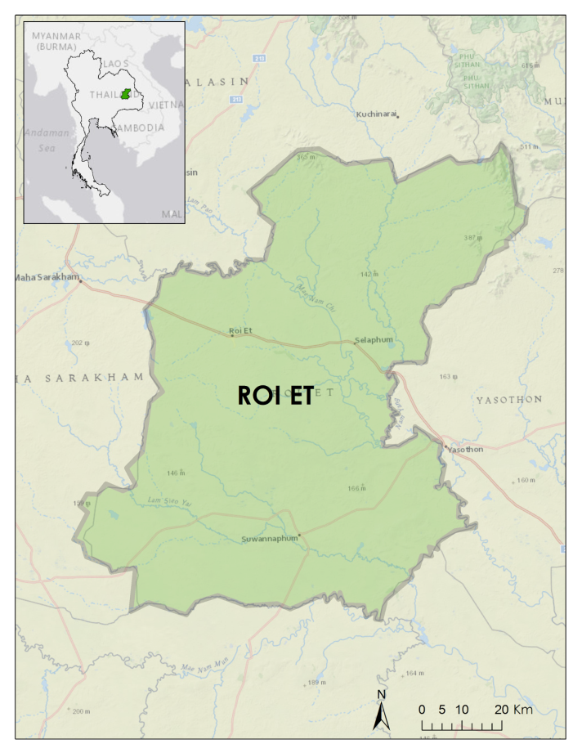

Figure 1: Study Area map displaying Roi Et province.

**Study Period**

To evaluate changing climate change patterns, such as precipitation and temperature related with rice crop in Roi Et, Aqua and Terra Moderate Resolution Imaging Spectroradiometer (MODIS), Suomi NPP Visible Infrared Imaging Radiometer Suite (VIIRS), Landsat 5 Thematic Mapper (TM), Landsat 7 Enhanced Thematic Mapper Plus (ETM+), Landsat 8 Operational Land Imager (OLI), Global Precipitation Measurement (GPM) and Tropical Rainfall Measuring Mission (TRMM) data were downloaded from 2000 to 2015.

**National Applications Addressed**

The NASA national application area addressed in this project was agriculture. This project used NASA Earth observations to monitor precipitation and temperature in Roi Et, Thailand. The study was to assist decision makers in understanding the relationship between climate change and rice production by identifying trends of rice yields in recent years. This project used NASA Earth observations and statistics from Thai government bodies.

**Project Partners**

Royal Thai Embassy, Collaborator/Boundary Organization, POC: Gam Raksaphaeng

SERVIR Mekong, Collaborator/Boundary Organization, POC: Bill Crosson

SERVIR Mekong, Collaborator/Boundary Organization, POC: Peter Cutter

# III. Methodology

**Data Acquisition**

Initial land cover classifications were conducted using Landsat imagery on the tile with path and row 127, 49 because it covered the entirety of the chosen study area. Landsat 8 imagery were collected from October 2014 and February 2015. Imagery from recent years were processed first due to the increased availability of validation resources. These images were selected for their relatively low cloud coverage percentages and because they characterize Thai wet and dry seasons respectively. These images also provided opportunity to compare calculated total rice crop area against The Geo-Informatics and Space Technology Development Agency’s rice crop yield dataset for 2014.

Additional Landsat 5 and 7 scenes were downloaded and classified in order to complete the time series over the entire study period. [TBD]

Precipitation data from TRMM and GPM [TBD]

Land surface temperature data from Landsat, VIIRS, and MODIS [TBD]

**Data Processing**

[In Progress]

All Landsat images were downloaded from USGS’s GLOVIS and preprocessed using the dnppy top-of-atmosphere digital number to reflectance conversion script. Additional python scripts were written to automate the reflectance conversion, remove negative reflectance values, and create composite band rasters of each Landsat scene. Once the images were preprocessed, training samples were drawn within the study area in order to perform a Maximum Likelihood Estimate (MLE) land cover classification. Pixels in the rice crop land cover classification were estimated using zonal statistics and converted into square kilometers for further comparisons.

Because rice yield during dry seasons in Roi Et was minimal, land cover classifications of dry season imagery involved classifying plots predicted to grow rice and validating these predictions with subsequent wet season imagery. In order to estimate changes in land cover over the duration of the study period, percentages of rice crop coverage were compared between wet and dry seasons over the duration of the study area. The wet season Landsat 8 scene from October 2014 contained cloud coverage over roughly 10% of the study area. A cloud mask was created and applied to both the wet and dry season images so that comparisons of rice cover percentages could be compared between seasons.

**Data Analysis**

[TBD]

# IV. Results & Discussion

**Analysis of Results**

[TBD]

**Errors & Uncertainty**

The main sources of error in this project were the result of necessary assumptions made during the land cover classification step. Because of the rain-fed nature of agriculture in Northeastern Thailand, the availability of cloud-free imagery during the growing seasons was minimal. The few wet season Landsat images containing only partial cloud cover were classified anyway with the clouds and cloud shadows masked out. Percentages of total rice area of production were compared to images between seasons, which introduced potential errors depending on the land features covered by the mask.

Dry season imagery contained neither clouds, nor rice. These images were classified with the assumption that dry rice paddies with exposed soil would be reused to plant rice again at the start of the following wet season. Careful validation was required to ensure that uniform replanting had occurred and that the paddies had not been converted to other land features between seasons.

In addition, it became necessary to divide classification of the geographically large study area between two participants. The division of labor improved the project’s efficiency, but added an extra level of human error to our classifications.

**Future Work**

[TBD]

# V. Conclusions

The supervised land cover classifications of Landsat images produced a platform for remotely monitoring rice yields in Northeastern Thailand. The total area of rice crops present in wet season imagery was compared with designated rice paddy land cover during the dry seasons. The statistics drawn from total rice area throughout individual years was compiled over the course of the study period in order to draw conclusions about trends in rice production and climate.

# VI. Acknowledgments

Dr. Jeffrey Luvall (NASA at NSSTC)

Dr. Robert Griffin (University of Alabama in Huntsville)

Dr. Bill Crosson (NASA at NSSTC)

Dr. Peter Cutter (NASA SERVIR Mekong)

Gam Raksaphaeng (Royal Thai Embassy)

This material is based upon work supported by NASA through contract NNL11AA00B and cooperative agreement NNX14AB60A.

# VII. References

Childs, Nathan. (2015): USDA Rice Outlook. Web. 12 June 2015.

Kuneepong, P. “Modelling Economic Crop Yield and Climate Change in Thailand.” (2001): Modelling and Simulation Society of Australia and New Zealand Inc. Web. 19 June 2015. <http://www.mssanz.org.au/MODSIM01/Vol%202/Kuneepng.pdf>

Ricepedia. Thailand. (2015): Web. 19 June 2015. <http://ricepedia.org/thailand>

“Rice from Thung Kula Rong Hai wins innovation award in Paris.” (2014):  The Nation. Web. 19 June 2015. <http://www.nationmultimedia.com/aec/Rice-from-Thung-Kula-Rong-Hai-wins-innovation-awar-30246459.html>

# VIII. Content Innovation

In preparation for DEVELOP’s coming microjournal, please select two content innovation features to support your paper. For each item, please list the name of the feature, and include the tool itself if possible (eg. glossary terms and definitions). If the tool does not work in Microsoft Word (eg. Interactive MATLAB Figure Viewer), please list the file name and upload the related file to the microjournal folder on the DEVELOP Exchange. If you choose to use Inline Supplementary Material, please also include where the material should appear in the text.

**Some options include:**

AudioSlides

Database Linking Tool

Data Profile

Executable Papers

Featured Author Videos

Featured Multimedia for this Article (video and podcast options)

Glossary Viewer

Inline Supplementary Material (figures, tables, computer code)

Interactive Map Viewer

Interactive MATLAB Figure Viewer

Interactive Plot Viewer

Nomenclature Viewer

# IV. Appendices

Insert here