**NASA DEVELOP National Program**

****NASA Ames Research Center

**Spring 2016**

**Short Title: Caribbean Oceans**

**Subtitle:** Utilizing NASA Earth Observations to Detect, Monitor, and Respond to Unprecedented Levels of *Sargassum* in the Caribbean Sea

**VPS Title:** Inundation: Diving into a Historical Perspective on Caribbean *Sargassum*

**Project Team & Partners**

**Project Team:**

Jordan Ped (Project Lead), Jordan.W.Ped@nasa.gov

Erica Scaduto

Emma Accorsi

**Advisors & Mentors:**

Dr. Juan Torres-Pérez (Bay Area Environmental Research Institute)

**Partner Organizations:**

Consorcio de Instituciones de Investigación Marina del Golfo de México y del Caribe (CiiMarGoMC) (End-User), POC: Dr. Porfirio Alvarez Torres

Centro Interdisciplinario de Ciencias Marinas: Instituto Politécnico Nacional (CICIMAR-IPN) (End-

User), POC: Dr. Francisco Arreguin, Dr. Norma Patricia Muñoz, Dr. Mariana Elvira Callejas Jiménez

Comisión Nacional para el Conocimiento y Uso de la Biodiversidad (CONABIO) (Collaborator),

POC: Dr. Sergio Cerdeira

El Colegio de la Frontera Sur (ECOSUR) (Collaborator), POC: Dr. Laura Carillo

Universidad Autónoma de Baja California (UABC) (Collaborator), POC: Dr. Eduardo Santamaria

del Angel

University of Puerto Rico, Department of Marine Sciences (Collaborator), POC: Dr. Roy A.

Armstrong

**Project Details**

**Applied Sciences National Application Addressed:** Oceans

**Study Area:** Caribbean Sea, Caribbean Nations (Cuba, Haiti, Dominican Republic, Puerto Rico, Jamaica, Trinidad and Tobago, Guadeloupe, Bahamas, Saint Lucia, Curacao, Aruba, Saint Vincent and the Grenadines, Grenada, Antigua and Barbuda, Dominica, Cayman Islands, Saint Kitts and Nevis, Saint Maarten, Turks and Caicos, British Virgin Islands, Anguilla, Caribbean Netherlands, Saint Barthelemy, Montserrat)

**Study Period:** January 2003 – March 2016

**Earth Observations & Parameters:**

Aqua, Moderate Resolution Imaging Spectroradiometer (MODIS) – Sea Surface Temperature,

Photosynthetically Available Radiation, Primary Productivity, Chromophoric Dissolved

Organic Material (CDOM), Chlorophyll-a

Terra, MODIS - Remote Sensing Reflectance

SAC-D, Aquarius – Sea Surface Salinity

Polar Orbiting Environmental Satellites, Advanced Very High Resolution Radiometer (AVHRR) –

Sea Surface Temperature

**Ancillary Datasets Utilized:**

* Sea Education Association (SEA) - Cruise Tow Datasets (Cruise 237 and 239)

**Model Utilized:**

* Clark Labs’ TerrSet- Earth Trends Modeler (ETM)- Seasonal Trends Analysis, Inter-annual Trends Analysis

**Software Utilized:**

TerrSet – Time series, statistical analysis, forecasting

ArcGIS – Raster manipulation/analysis, ground truth spatial identification

**Project Overview**

**80-100 Word Objectives Overview:**

In 2015, the nations of the Caribbean were inundated by an unprecedented amount of *Sargassum,* apelagic brown seaweed, triggering great concern across the region. In the open ocean, floating *Sargassum* mats serve as diverse nutrient-rich ecosystems for a range of invertebrate and vertebrate species. However, when they reach coastlines in large quantities, *Sargassum* imposes an enormous cost on local ecotourism-based economies. This project uses NASA Earth observations to detect *Sargassum* across the Caribbean Sea, model its growth, and predict its proliferation. A better understanding of these events will help these economies, and promote sustainable management practices.

**Abstract:**

In the years 2011 and 2015, the nations of the Caribbean Sea were overwhelmed by the unprecedented quantity of *Sargassum* that washed ashore. This issue prompted international discussion to better understand the origins, distribution, and movement of *Sargassum*, a free-floating brown macro alga with ecological, environmental, and commercial importance. In the open ocean, *Sargassum* mats serve a vital ecological function. However, when large quantities appear onshore without warning, *Sargassum* threatens local tourist industries and near-shore ecosystems within the Caribbean. As part of the international response, this project investigated the proliferation of this seaweed within the Sargasso and Caribbean Seas from 2003-2015, and used NASA Earth observations to detect and model *Sargassum* growth across the region. The Caribbean Oceans team derived the Floating Algal Index (FAI) using Terra MODIS data, and compared the FAI to various oceanic variables to determine the ideal pelagic environment for *Sargassum* growth. The project also examined the annual spread of *Sargassum* throughout the region by using TerrSet’s Earth Trends Modeler. As part of the international effort to better understand the life cycle of *Sargassum* in the Caribbean, the results of this project will help local economies thrive and promote sustainable management practices.

**Community Concerns:**

* The origins of major *Sargassum* events are unknown, and this prevents an accurate forecasting of the arrival of *Sargassum* and a proactive, ecosystem-sensitive solution for removal.
* Near-shore ecosystems, especially sea turtle nesting sites, are often harmed by the efforts to remove large quantities of *Sargassum*. Heavy machinery that is used to clear it can be destructive to these sites.
* Communities, as well as federal and local governments across the Caribbean region, are concerned about the adverse effects on the tourist industry.

**Current Management Practices & Policies**:

Currently, tourist industries within affected coastal areas are utilizing live webcams to monitor shores for *Sargassum* occurrences. The Mexican government has released regulation standards on how to remove *Sargassum* on beaches, which usually require the use of heavy machinery. This method can kill marine species or significantly stir the sand, thereby disrupting coastal environments. Other methods include removal of *Sargassum* by hand, which is time-consuming and costly. Caribbean governments rely mostly on sightings reports from local fishermen and other coastal community members, as Earth observations have not been incorporated into governmental policies and practices.

**Decision Support Tools & Benefits:**

|  |  |  |
| --- | --- | --- |
| **End-Product** | **Earth Observations Used** | **Benefit & Impact** |
| Replicable and regionally-calibrated *Saragssum* Index | Terra MODIS | An accurate *Sargassum* index will provide a basis for further research and a method for early warnings |
| *Sargassum* Environmental Model | Aqua/Terra Modis, Aquarius | This provides data that indicate what oceanic variables have the most significant effect on large *Sargassum* events |

**Project Imagery**

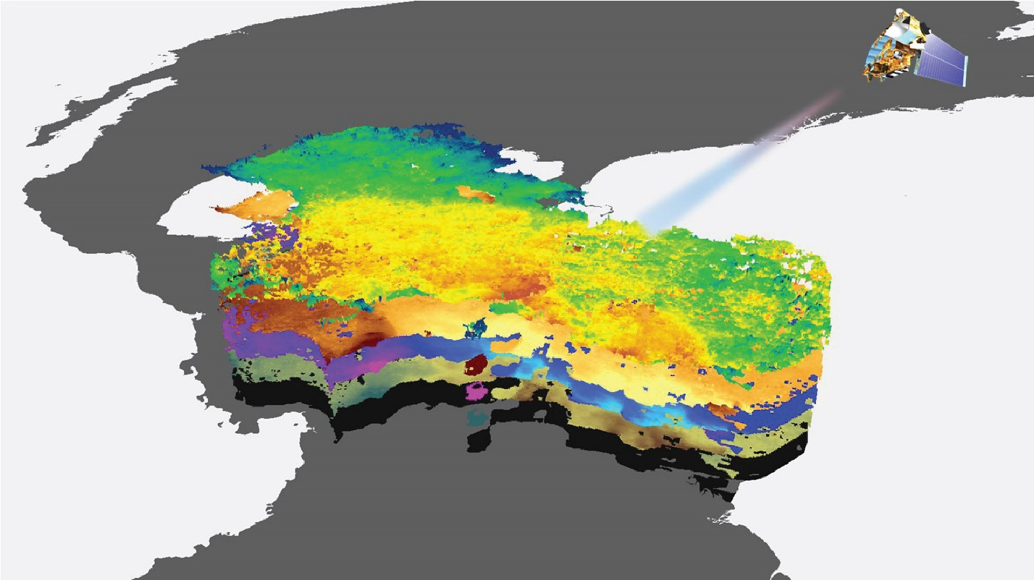

**Caption:** Photosynthetically available radiation, primary productivity, and sea surface temperature data from 2003-2015 were overlaid with the Floating Algal Index to model *Sargassum* in the Caribbean Sea. Image Credit: Caribbean Oceans Team.

**Image:** Spring2016_ARC_CaribbeanOceans_VPS_Image.jpg

**Software Release Requirements**

Category I - Software Release action is not required.