**NASA DEVELOP National Program**



NASA Jet Propulsion Laboratory

*Fall 2015*

Louisiana Ecological Forecasting

*Using UAVSAR, AVIRIS and AirSWOT to Examine Historic Trends and Model Sediment Transport within the Wax Lake Delta, Louisiana to Inform Coastal Restoration Efforts*

 **Technical Report**

Rough Draft – October 8, 2015

Emily Beck (Project Lead)

Brittany Zajic

Raul Garcia

Dr. Cathleen Jones (JPL) (Science Advisor)

Dr. Marc Simard (JPL) (Science Advisor)

# I. Abstract

Land loss due to erosion, land subsidence and sea level rise along the Louisiana coast has amounted to 4900 km2 since the 1930s, and an additional 4500 km2 could be lost within 50 years if no action is taken. While most of the coastline is suffering land loss, the Wax Lake Delta has been building at a rate of approximately 0.8 km2 per year since the early 1970s. This study used remotely sensed and *in situ* data as well as Deltares Delft3D hydrological modeling software to model water flow and sediment transport in the Wax Lake Delta in order to better understand deltaic sediment dynamics and forecast delta formation. Outputs from the model include modeled sediment transport, water flow and an elevation time series. These outputs will be used to inform coastal research by project partners at the Naval Research Laboratory in Mississippi and the Louisiana Universities Marine Consortium, and to direct restoration projects in areas of the coast where marshes are eroding.

**Keywords**

Modeling, Remote Sensing, Sediment Transport, Delta Formation, Coastal Restoration

# II. Introduction

Land loss due to erosion, land subsidence and sea level rise along the Louisiana coast has amounted to 4900 km2 since the 1930’s, threatening one of the most economically important port systems in the United States as well as the tapestry of unique cultures that contribute to the region’s rich history (Olea & Coleman, 2014). The State of Louisiana’s Comprehensive Master Plan for a Sustainable Coast (2012) confirmed that Louisiana has the potential to lose up to an additional 4500 km2 over the next 50 years unless immediate efforts are taken to combat this trend. Although most of the Mississippi River Delta system is suffering land loss, the Wax Lake Delta has created over 50 km2 of new deltaic surface since the early 1970s, building at a rate of approximately 0.8 km2 per year (Kleiss 2009). Much work has been done to understand what natural processes contribute to this growth, but these studies are limited by a lack of tested models and key observations. Measurements that do exist are largely boat-based and inherently spatially and temporally limited.

The first objective of this study is to use remotely sensed data, *in situ* data and hydrological modeling software to model water flow and sediment transport within the Wax Lake Delta in order to examine delta formation and obtain a better understanding of why the area is experiencing aggregation. We also aim to observe and analyze long term delta growth patterns using Landsat imagery in Google Earth Engine API. The results will support current research in the region, provide data to coastal scientists and managers and offer insight into how to direct coastal restoration projects in areas of Louisiana where coastal marshes are eroding, often at rapid rates. The study area for this project is the Wax Lake Delta in Louisiana (see Figure 1), and the study period is from January 1985 to October 2015. The NASA Earth Observations Systems used in this project were Uninhabited Aerial Vehicle Synthetic Aperture Radar (UAVSAR), Air Surface Water and Ocean Topography (AirSWOT), Airborne Visible-Infrared Imaging Spectrometer – Next Generation (AVIRIS-NG), and Landsat 5 Thematic Mapper (TM) and Landsat 8 Operational Land Imager (OLI).  UAVSAR, mounted beneath the Gulfstream-III, measures Earth surface change (Chapman 2015) and has the capability to see below vegetation, examine water level, and properties of both thick vegetation cover and the ground below it (Dr. Jones, C., personal communication, November 2015) using an L-band radar antenna with a wavelength of about one foot (Chapman 2015).  AirSWOT is a multi-purpose Ka-band radar, mounted on King Air B200, which can be used to obtain centimeter-level topographic maps of water surfaces and flood plains (Srinivasan 2015). AVIRIS-NG, an optical sensor with 432 bands, has been developed to provide continued access to high signal-to-noise ratio imaging spectroscopy measurements in the solar reflected spectral range from a DHC-6 Twin Otter platform (Lundeen 2015). Landsat 5 TM and Landsat 8 OLI data were used in Google Earth Engine API, Google’s cloud-based geospatial processing environment that allowed for long-term historic observation of the Wax Lake region.

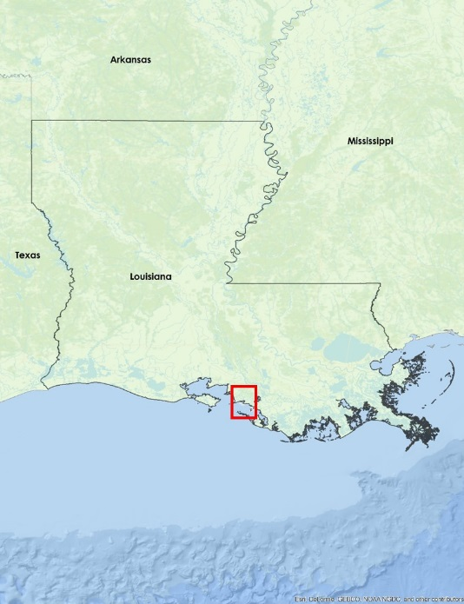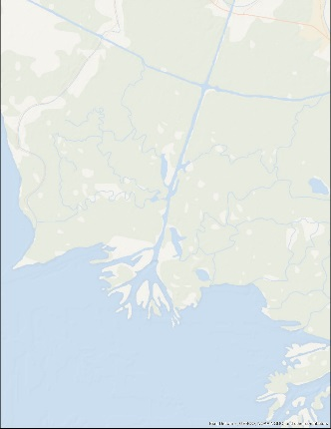

Figure 1: Wax Lake Delta, LA

This project addresses the ecological forecasting national application area, and by combining AirSWOT, UAVSAR and AVIRIS-NG data, *in situ* data and modeled outputs, restoration efforts within Louisiana would be better informed to promote coastal aggradation.

Some end products of the study will include a hydrological model of the Wax Lake Delta, modeled sediment transport data and water flow data and a modeled elevation time series. These end products will inform research by our project partners. Those partners include Richard Crout, an oceanographer from the Naval Research Laboratory at Stennis Space Center in Mississippi and Doctor Alexander Kolker from the Louisiana Universities Marine Consortium. Mr. Crout is investigating buoyancy plume modulation of coastal processes in the area impacted by the Mississippi and Atchafalaya River discharge. His project utilizes an ocean circulation model complement in situ observations that requires water level and discharge rates from the Atchafalaya Bay and Wax Lake outlet region. The products from our project will help initiate the model. Dr. Kolker is an academic liaison to Louisiana’s Comprehensive Master Plan for a Sustainable Coast that is being developed for 2017. The products of this project will provide Dr. Kolker with a broad-scale picture of the accretion process to inform the development of an improved sediment distribution algorithm that will help these managers understand how to direct land restoration efforts along the Louisiana coast.

# III. Methodology

**Vegetation Productivity Change Analysis**

To examine historic trends of the Wax Lake Delta, Landsat 5 and Landsat 8 imagery were used in Google Earth Engine API to create a time series of the delta formation from January 1985 to October 2015. The Landsat 5 TM dataset used in Google Earth Engine was “LANDSAT/LM5_L1T” representing Landsat 5 MSS DN values, orthorectified and level 1 product, displaying yearly median values of bands R: 7, G:4, B:2, to minimize cloud coverage. The Landsat 8 OLI dataset used in Google Earth Engine API was “LANDSAT/LC8_L1T” representing DN values, orthorectified and level 1 product, displaying yearly median values of bands R:7, G:5, B:3, to again minimize cloud coverage and best display delta growth.

Google Earth Engine API was also used to observe historic trends of vegetation greenness. Three ten-year Normalized Difference Vegetation Index (NDVI) difference images from Landsat 5 TM and 8 OLI were created for the same time period of 1985 to 2015. Google Earth Engine API creates the 32 day NDVI composites used in this study from Landsat 5 and Landsat 8 Level L1t orthorectified scenes, using top-of-atmosphere reflectance values. NDVI scenes are generated from the Near-Infrared and Red bands of each separate satellite, and range in values from -1.0 to 1.0. Median values from each year were taken and subtracted to create a NDVI difference image, the first representing 1985 to 1995, the second representing 1995 to 2005, and the third representing 2005 to 2015 (see Figure 2).

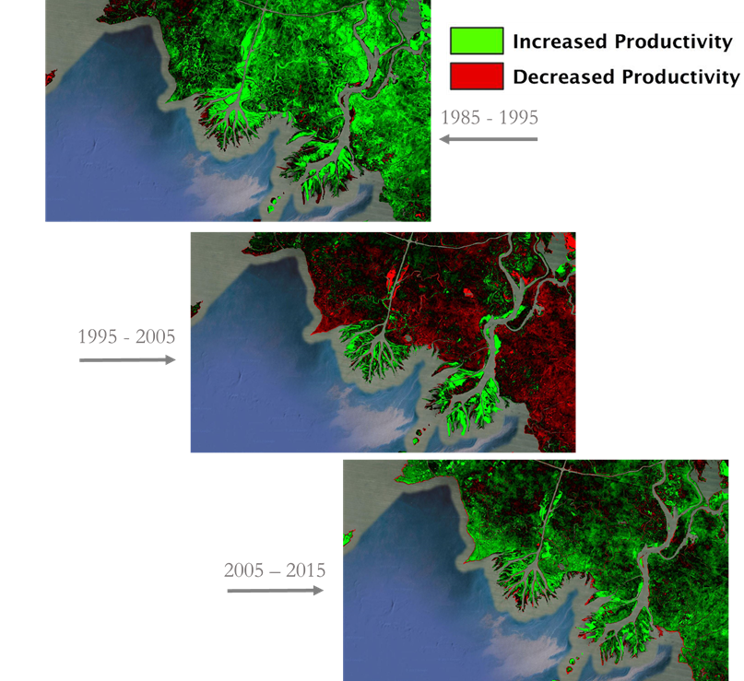

Figure 2c

Figure 2b

Figure 2a

Figure 2: NDVI difference images from Landsat 5 and Landsat 8 using Google Earth Engine API

**Vegetation Classification of AVIRIS-NG Data**

To examine the vegetation in and around the Wax Lake Delta, seven AVIRIS-NG images from May and June 2015 were classified using ENVI 5.3. The images were acquired from our project advisor, Dr. Marc Simard, and had already been calibrated to reflectance. *In situ* vegetation species information was obtained from the Coastwide Reference Monitoring System (CRMS) stations in the delta and field data from Dr. Marc Simard. Each CRMS station provided latitude, longitude, and most dominant vegetation species by percent cover.

Since AVIRIS-NG has 432 spectral bands of wavelengths ranging from 380 nm – 2510 nm, the Layer Stacking tool was used to process only the Red, Green, Blue, and Near Infrared bands; their wavelengths were 641.81 nm, 551.66 nm, 471.52 nm, and 862.19 nm respectively. The Cross-Track Illumination Correction tool was used on all seven images to account for a ramp in spectral profile. A parallelepiped supervised classification was done to classify all of the water bodies in the study area. A Region of Interest (ROI) was constructed on each image using a threshold from the supervised classification to make a single ROI for the water bodies. A mask was then created from the water body ROI to disregard those data values. An ISODATA unsupervised classification, with the water body mask, was used on each image to classify the vegetation. The resulting classification produced 33 classes on each image. Ten main plant species were determined based on *in situ* data and the Combine Classes tool was used to merge the 33 classes into 10 classes based on spatial distribution. The resulting seven images were mosaicked together using the Seamless Mosaic tool. The coordinates from each CRMS station and *in situ* data was associated with a pixel of the same coordinates in the mosaicked classification. The class associated with those specific coordinates was then identified as a specific vegetation species based on 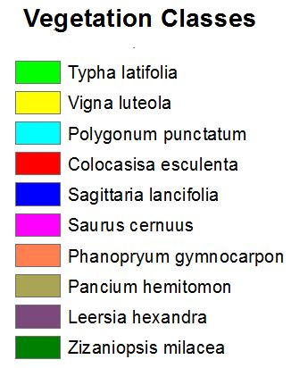percent cover (see Figure 3).

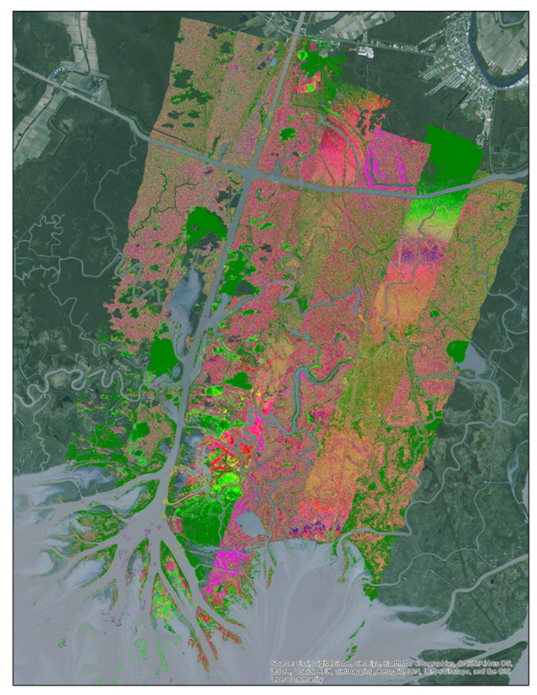Figure 3: Unsupervised ISODATA Classification

**Delta Hydrological Model**

A hydrological and sediment transport model of the Wax Lake Delta was constructed using Deltares Delft3D software. Delft3D is an open source modeling suite designed to investigate hydrodynamics, sediment transport and morphology for fluvial, estuarine and coastal environments using 2D and 3D models (Deltares). The software consists of several modules for model grid creation, and analysis of flow, waves, and water quality. For this project, we constructed a 2D model of the Wax Lake Outlet and Delta using the Delft3D-FLOW module. The model was built using surface topography data in xyz format. Bathymetry for the Wax Lake Delta was created by and obtained from Dr. John Shaw at the University of Arkansas. Wax Lake Outlet channel bathymetry was interpolated using transect points from the US Army Corps of Engineers 1999 Atchafalaya River Hydrographic Survey and the Kriging interpolation method in ArcGIS version 10.3. A channel mask created using UAVSAR data was used to determine the channel boundary.

The raster datasets were converted to xyz format using the Geospatial Data Abstraction Library (GDAL) in order to create a depth layer that could be read by Delft3D. Grid, enclosure and bathymetry files were created in Delft to establish the model domain (see Figure 4). Since the Wax Lake Delta is a river dominated system, wind, wave and tidal forces were omitted from the model for the sake of simplification. Sediment transport was modeled using two sediment fractions: non-cohesive very fine sand with a median grain size of 100 µm and cohesive mud with a median grain size of 15 µm and a fall velocity of 0.00025 m/s2. The model has two boundaries: an upstream flow boundary at the mouth of the outlet, and an open offshore water level boundary.

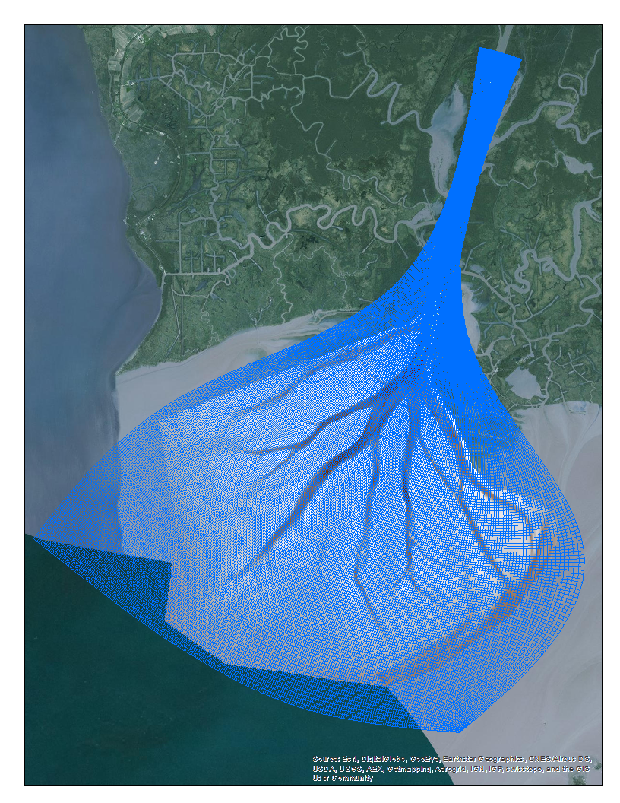

*Figure 4: Wax Lake Delta bathymetry and Delft3D model grid*

# IV. Results & Discussion

**Vegetation Productivity Change Analysis**

As stated before, the Landsat time series was created to observe visual stages of Wax Lake Delta growth from 1985 to 2015. To further analyze the time series data, NDVI difference images were created to allow long term analysis of vegetation greenness in the study area. Because NDVI image analysis is an index of plant “greenness” or photosynthetic activity, this is an important factor when considering wetland vegetation productivity. Vegetation analysis such as the NDVI difference images performed are important when considering the data available from the AVIRIS-NG vegetation classification. Interpolating vegetation productivity data with the AVIRIS-NG vegetation classification analysis can prove beneficial to determine which species classes are healthy, or high NDVI “greenness” values, and which species classes are not healthy, or low NDVI “greenness” values, which is significant for validation of the remotely-sensed data. Of the three NDVI difference images (see Figure 2), 1985 to 1995 and 2005 to 2015 follow initial assumptions of continued growth and vegetation productivity of the region. The 1995 to 2005 NDVI difference image (see Figure 2b) shows significant decrease in vegetation in the region surrounding the delta, and preliminary results suggest this is due to active hurricane activity in Louisiana in 2005, with both Hurricane Katrina and Hurricane Rita causing billions of dollars in damage according to NOAA.

**Vegetation Classification of AVIRIS-NG Data**

After the ten most abundant vegetation species were associated with the ISODATA classification, the most dominant species in the study area was identified as Pancium hemitomon, 25.2% of the classified pixels, followed by Zizaniopsis milacea, 23.2% of the classified pixels.

Due to a ramp in the spectral profile of the images, the mosaic was not completely seamless even though the Cross-Track Illumination Correction tool was used. The correction adjusted the data values, which made the Parallelepiped supervised classification less accurate because it misclassified a small portion of vegetation as water. Therefore, 3 of the images were analyzed without correction applied so the supervised classification of the water bodies could be more accurate. Since the supervised classification images accounted for slightly more than just the water bodies, this led to an underclassification of vegetation species.

Vegetation classification results will be used with *in situ* data from Dr. Simard to estimate biomass and a vegetation roughness value. That value can be used in the Delft3D model to approximate the effect of vegetation on water flow and sediment transport. The classification will also be used to create a bathymetry layer using a Leaf Area Index (LAI).

**Delta Hydrological Model**

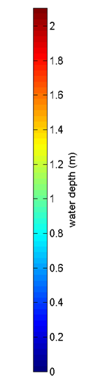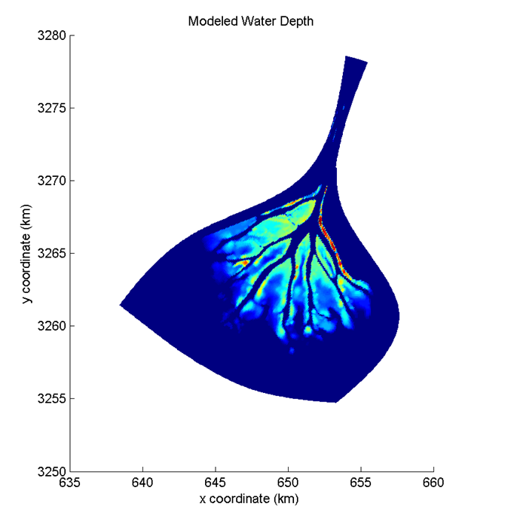Preliminary results from the hydrological model show water flow in the delta, and depth values are similar to measured depth values (see Figure 5). However, due to technical and data issues and time constraints, the model has not yet been calibrated. Model calibration should be completed to ensure the accuracy of model outputs.

Figure 5: Uncalibrated Delft3D hydrological model output showing modeled water depth in the Wax Lake Delta, LA

Potential sources of error in the model outputs include lack of calibration, channel bathymetry and the sediment fractions used. Since the model has not yet been calibrated using the AirSWOT data, results may not accurately replicate measured flow conditions. Also, the channel bathymetry layer available for this project was an inaccurate representation of the flow pattern of the Wax Lake Outlet, since the channel raster had several meanders and satellite imagery of the outlet shows a straight channel. As a result, channel bathymetry had to be created from survey transect points collected in 1998-99 and depth between transects interpolated. Channel depth could have changed since the data was collected or depth between transects could have been inaccurately interpolated.

The construction of this Delft3D model offers the potential to analyze many different flow and sediment transport scenarios that could occur in the Delta over time. Future work should include model calibration using AirSWOT and model runs with different flow rates, sediment characteristics and concentrations. Shallow bathymetry and land change from UAVSAR can also be incorporated. The effect of vegetation on flow could also be assessed, using either a simulated layer that represents plant species with cylindrical rods or incorporating vegetation roughness estimated using the classified AVIRIS-NG data. The flexibility of the model setup offered by Delft3D allows for several avenues of future research on land building in the Wax Lake Delta.

# V. Conclusions

The Wax Lake Delta is an important area for research since it is building land while the coastline around it is eroding. This is particularly important since land loss in the region is occurring at such as rapid rate and strongly effects the local economy. While several research projects are being done to investigate the causes of land loss and its impacts, hydrological and sediment transport modeling are particularly useful techniques since models can be easily adjusted to examine different scenarios. The model and outputs created for this DEVELOP project are the initial framework for a more robust model that will include vegetation biomass and bathymetry data from NASA AVIRIS-NG and UAVSAR sensors and be calibrated using AirSWOT. In addition, the work being done in the Wax Lake Delta with AirSWOT and AVIRIS-NG, which is airborne and *in situ*, simulates two space borne sensor missions that will be launched in 2020. AirSWOT is a precursor to the Surface Water Ocean Topography (SWOT) sensor, which will be able to measure surface water height globally in oceans and large rivers over 100 meters. Another 2020 satellite benefitting from this experiment is the NASA-ISRO SAR mission (NISAR), a synthetic aperture radar that will measure ground displacement and above-ground biomass globally. Use of the airborne sensors in delta research and modeling will help demonstrate the capability of the space borne sensors. Results from this project will contribute to existing research and enable analysis of multiple flow and sediment transport scenarios to examine the factors that affect accretion in the delta.

# VI. Acknowledgments

We would like to thank our science advisors Marc Simard and Cathleen Jones at NASA JPL for their guidance and expertise throughout the term. We would also like to thank Gwen Miller from DEVELOP at JPL for her help with Delft3D software.

Any opinions, findings, and conclusions or recommendations expressed in this material are those of the author(s) and do not necessarily reflect the views of the National Aeronautics and Space Administration.

This material is based upon work supported by NASA through contract NNL11AA00B and cooperative agreement NNX14AB60A.

# VII. References

Chapman, B. (2015, October 1). *UAVSAR Uninhabited Aerial Vehicle Synthetic Aperture*

*Radar*.Retrieved from <http://uavsar.jpl.nasa.gov/>

Dr. Jones, C. (2015, November 3). Personal Interview.

Kleiss, B. 2009. The Utilization of the Mississippi River in the Restoration of Coastal Louisiana. US Army Corps of Engineers Mississippi Valley Division. Retrieved from <http://www.conference.ifas.ufl.edu/NCER2009/PPTPDF_pres/4-Thursday/3-Avalon%20Room/PM/0220%20B%20Kleiss.pdf>

Louisiana (2012). Coastal Protection and Restoration Authority. Louisiana ’s Comprehensive Master Plan for a Sustainable Coast.

Lundeen, S. (2015, July 1). *Airborne Visible/Infrared Imaging Spectrometer AVIRIS Next*

*Generation*. Retrieved from <http://avirisng.jpl.nasa.gov/>

Olea, R. a., & Coleman, J. L. (2014). A Synoptic Examination of Causes of Land Loss in Southern Louisiana as Related to the Exploitation of Subsurface Geologic Resources. *Journal of Coastal Research*, *297*(5), 1025–1044. http://doi.org/10.2112/JCOASTRES-D-13-00046.1

Srinivasan, M. (2015, October 1). *Surface Water and Ocean Topography*.Retrieved from

<http://swot.jpl.nasa.gov/airswot>

# 

# VIII. Content Innovation

**Glossary**

**­*In situ* data**: measurements taken directly from the source/ground.

**Remotely Sensed data**: measurements taken from a distance, typically from an aircraft or satellites.

**Orthorectification**: the process of correcting the geometry of an image such that the scale of the photograph is uniform and can be measured as a map.

**Raster**: A spatial data model that defines space as an array of equally sized cells arranged in rows and columns, and composed of single or multiple bands.

**Bathymetry**: the measurement of depth of water in oceans, seas, or lakes.

**NDVI**: Normalized Difference Vegetation Index; an index of photosynthetic activity

**LAI**: Leaf Area Index; a dimensionless quantity that characterizes plant canopies

**L-Band:** the range of 1 – 2 GHz frequency of the radio spectrum

**Ka-Band**: the range of 26.5 – 40GHz frequency of the microwave band

**Cohesive Sediment:** Sediment with a grain size less than 63 μm; generally contains significant proportion of clays, where electromagnetic properties cause the sediment to bind together.

**Non Cohesive Sediment**: Sediment with a coarse grain size, generally larger than 63 μm. Usually the material is loose and does not bond well together.

**Typha latifolia**: Broadleaf Cattail

**Vigna luteola:** Cowpea

**Polygonum punctatum**: Dotted Smartweed

**Colocasisa esculenta**: Taro

**Sagittaria lancifolia**: Broadleaf Arrowhead

**Saurus cernuus**: Lizard’s Tail

**Phanopryum gymnocarpon**:Swamp Panic Grass

**Pancium hemitomon**: Maidencane

**Leersia hexandra**: Southern Cutgrass

**Zizaniopsis milacea**: Giant Cutgrass