Visayan Islands Ecological Forecasting

Identifying and Evaluating Changes in Land Use and Land Cover on the Visayan Islands over Time for Reintroduction of the Visayan Warty Pig *(Sus cebrifons*) and Visayan Spotted Deer *(Rusa alfredi)*

 **Technical Report**

Final Draft – November 21st, 2019

Ryan Slapikas (Project Lead)

Naomi Belle

Eze Amadi

Lusitania Savio

Dr. Marguerite Madden, University of Georgia (Science Advisor)

Dr. Sergio Bernardes, University of Georgia (Science Advisor)

# 1. Abstract

The islands of Negros and Panay in the Philippines contain the last existing habitat for the critically endangered Visayan spotted deer (*Rusa alfredi*) and Visayan warty pig (*Sus cebifrons*). NASA DEVELOP partnered with the Arizona Center for Nature Conservation – Phoenix Zoo, International Union for Conservation of Nature Species Survival Commission, and Talarak Foundation Inc. for this study. The initiative was to analyze and map changes in vegetation health in order to identify potential habitat areas for the reintroduction of the warty pig and spotted deer species to the Visayan Islands. The study utilized Landsat 5 Thematic Mapper (TM), and Landsat 8 Operational Land Imager (OLI) and Terra Moderate Resolution Imaging Spectroradiometer (MODIS) data acquired from Google Earth Engine (GEE). GEE was used to perform historical Normalized Difference Vegetation Index (NDVI) and Enhanced Vegetation Index (EVI) analysis along with land classifications. RStudio was used for NDVI and EVI forecasting and supervised classification comparison. The team also used the Land Change Modeler within TerrSet software to forecast land use and land cover (LULC) for the years 2030 and 2050. This methodology allowed the team to predict future land cover and potential habitat areas for the reintroduction of the two species. The LULC classification forecasts revealed a potential decrease in primary forests on the islands of Panay and Negros. Favorable habitats were also identified using buffer analysis based on habitat preferences for the Visayan warty pig and spotted deer.

**Keywords**

Normalized Difference Vegetation Index (NDVI), Enhanced Vegetation Index (EVI), ecological forecasting, vegetation, Landsat, forest cover

# 2. Introduction

* 1. ***Background Information***

The Philippines is a diverse archipelagic country and is considered one of the 18 mega-biodiverse countries in the world, housing two-thirds of the earth’s biodiversity (Protected Areas and Wildlife Bureau, 2009). Globally, the Philippines is placed high in priority among other countries for wildlife conservation due to its large number of endemic species and decreasing biodiversity. About sixty-seven percent out of 180 species of mammals in the Philippines are endemic, including the Visayan warty pig *(Sus cebrifons)* and Visayan spotted deer *(Rusa alfredi*). These two species are now threatened due to extirpation from most of their former habitat caused by continual habitat destruction through illegal logging and clearing for agriculture along with excessive hunting and poaching (Cox, 1987; Maala, 2001). Compared to other deer around the world, the Visayan spotted deer is considered the most endangered. The trading of this species is protected under Appendix I of the Convention on International Trade of Endangered Species (Oliver, Cox, & Dolar, 1991). Panay and Negros (*Figure 1*) are two islands within the Visayan Islands group with sufficient primary forest available for the reintroduction of the two endemic species.

 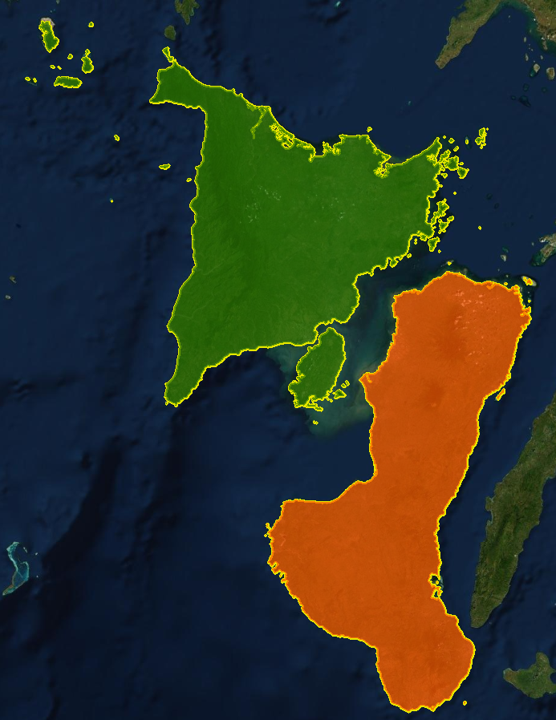

Negros Island

Panay Island

Visayan Islands

0

25

50

75

100

km

**N**

Philippines

*Figure 1*. Panay and Negros Islands, Central Philippines

Philippines

Restoration efforts have been made to reverse the negative effects on forest health and biodiversity in the Philippines. The Philippines government implemented the National Greening Program (NGP) with an objective to plant 1.5 billion trees over a six-year period from 2011 to 2016. The program aimed to increase environmental stability and economic security (Department of Environment and Natural Resources, 2019). The Expanded National Integrated Protected Area Systems Act of 2018 strengthens the security of protected areas. The act also added over 100 legislated protected areas in the Philippines. This act alone will not be enough to completely restore the decreasing native biodiversity.

Despite the importance of this project, the limited knowledge of Earth observations and the absence of GIS resources in the study area necessitates the partners to generate *in situ* data, which is not always successful. In one instance, the Arizona Center for Nature Conservation and Talarak foundation used camera traps in one of the three National Parks on Negros Island to track species and human movement. Unfortunately, over a time period of 8 months, neither a Visayan warty pig nor a Visayan spotted deer was observed. Furthermore, the rigid terrain in parts of the study area limits the collection of ground truth data. Thus, assessments of the study area using NASA Earth observations will enable the partners to discover potential sites for reintroduction of the two species.

Freemantle, Wacher, Newby, & Pettorelli (2013) used Normalized Difference Vegetation Index (NDVI) to evaluate spatial and temporal trends of forest production in the protected area of the Ouadi Rime–Ouadi Achim Game Reserve (OROAGR) in central Chad. The study intended to utilize this information for the reintroduction of the Scimitar-horned Oryx (*Oryx dammah*). The team applied NDVI to the protected area of the OROAGR to evaluate spatial variation in greenness levels. Results displayed an increase in greening in the southern part, most likely due to an increase in precipitation. These results provided a starting point to discuss future suggestions for the reintroduction of the Scimitar-horned Oryx. The research revealed a drying trend in the northern portion of the study areas possibly due to human impact (Freemantle et al., 2013).

Remote sensing and GIS are powerful tools to develop accurate and timely information on the spatial distribution of land use and land cover changes over large areas (Reis, 2008). Kulloli and Kumar (2014) applied NDVI to evaluate biomass and used ground truth data for land cover classification of the Arnott Bhandari (*Commiphora wightii*). The medicinal plant species suffer from over exploitation and habitat fragmentation due to human activities. The study discovered two possible sites for the reintroduction of the plant species in India. Remote sensing can provide essential information on long-term changes in climatic conditions, which can help assess how suitable an area might be for the reintroduction of species (Freemantle et al., 2013).

***2.2 Project Partners & Objectives***

**N**

Philippines

The Fall 2019 Visayan Islands Ecological Forecasting team collaborated with the Arizona Center for Nature Conservation – Phoenix Zoo, the International Union for Conservation of Nature (IUCN) – Species Survival Commission, and Talarak Foundation Inc., with the objective to aid the reintroduction of the two endemic species: Visayan warty pig and Visayan spotted deer. Both Talarak Foundation Inc. and the Arizona Center for Nature Conservation are directly involved with the reintroduction program by participating in planning meetings with stakeholders, such as the Department of Natural Resources, natural park officials, and village leaders. Education initiatives to increase community empathy are also being done by the stationed organization, Talarak Foundation. In addition, to be an advisor and collaborator for the reintroduction program, the Arizona center provides instructions on how to collect ground data. The IUCN – Species Survival Commission, on the other hand, is one of the many organizations which takes charge of funding the Talarak Foundation for the breeding and the reintroduction of these two endemic species. The results from this project will be used by IUCN to update information regarding the two species on the IUCN Red List of Threatened Species. This will inform the many users of the Red List on the current status of these two endemic species.

The project assessed the status and trend of vegetation health by generating NDVI and EVI time series from 1987 to 2019 and produced land use and land cover (LULC) classification maps in ten-year intervals for the duration of the study. These maps were used to evaluate changes over time and forecast LULC to the years 2030 and 2050 to show the future landscape and habitat. These organizations will share the results from these assessments with stakeholders to select potential sites for the reintroduction of the two endemic species. Furthermore, the end products provided the baseline data to monitor the progress of reforestation and conservation efforts for the habitats of these species. These results will aid in educational initiatives for the mitigation of detrimental activities that impact the natural habitat of the endemic species and enhance restoration efforts.

# 3. Methodology

***3.1 Data Acquisition***

We used Google Earth Engine (GEE) API to collect and process Surface Reflectance Tier 1 Landsat 5 Thematic Mapper (TM) and Landsat 8 Operational Land Imager (OLI) data. As seen in *Figure 2,* we acquired Landsat 5 TM data from 1987 to 2013, and Landsat 8 OLI data from 2014 to 2019. We also used Google Earth Pro and GPS coordinates from Talarak Foundation Inc. for a detailed view of the landscape terrain to digitize training points. Ancillary data and shapefiles of the Philippines including island boundaries, protected areas, and provinces from PhilGIS were used to assist in the extraction of the remotely sensed data. The classification accuracies of our LULC classification maps were generated from an error matrix that was generated in GEE. Terra Moderate Resolution Imaging Spectroradiometer (MODIS) data were acquired from 2000 to 2019 for our study area and used to produce NDVI and EVI time series charts and maps. Texture Analyses and Digital Elevation Model (DEM) were produced from Gray Level Co-occurrence Matrix (GLCM) and Shuttle Radar Topography Mission (SRTM) respectively.

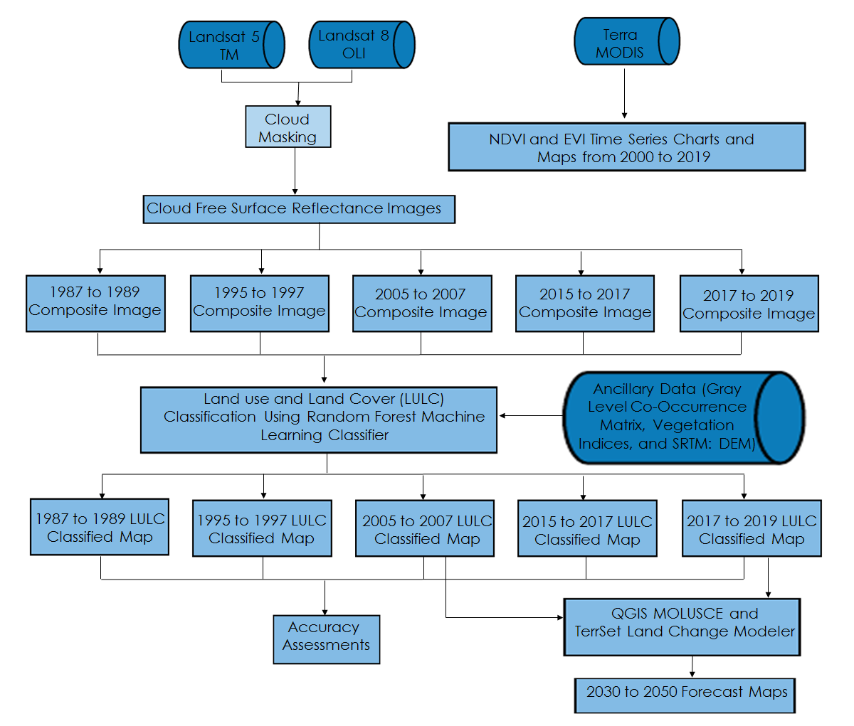

*Figure 2*. Overview of the Research Methodology

***3.2 Data Processing***

Landsat 5 TM Tier 1 bands 1, 3, and 4 from 1987 to 2013, and Landsat 8 OLI bands 2, 4, and 5 from 2014 to 2019 were all selected for this study. Due to the tropical location of this region, many of the satellite images had cloud cover obscuring the image. For images that had cloud cover, we utilized the quality assurance band (pixel_qa) to remove clouds and cloud shadows from the image collections. The data gaps that were left by cloud masking were filled by taking three-year composites to get the cloud-free images for the selected years of 10-year intervals. The median greenest pixel function utilized the median values of NDVI to augment the disparity in land cover classes.

NDVI (Equation 1) was calculated using bands 3 and 4 from Landsat 5 TM, while bands 4 and 5 were used from Landsat 8 OLI. Enhanced Vegetation Index (EVI; Equation 2) was calculated using bands 1, 3 and 4 from Landsat 5 TM, and bands 2, 4 and 5 from Landsat 8 OLI. These vegetation indices results were used for an assessment of vegetative health over time. NDVI and EVI Timeseries from 2000 to 2019 were extracted from Terra MODIS using GEE.

$\text{NDVI = }\frac{\text{NIR - Red}}{\text{NIR + Red}}$ (1)

$\text{EVI = 2.5 ×}\frac{\text{NIR - Red}}{\text{NIR + 6 × Red - 7.5 × Blue + 1}}$ (2)

ArcMap 10.6.1 and Google Earth Pro were used to collect training points for the LULC classes. GEE was used to process the data for the LULC classifications. DEM data were collected from SRTM using GEE to extrapolate the slope, elevation, and aspect of the study area. Ancillary data (roads and country boundaries) were collected from PhilGIS to define the study area. We also calculated Normalized Difference Built-up Index (NDBI), Normalized Difference Water Index (NDWI), Normalized Difference Moisture Index (NDMI), Tasseled Cap Brightness (TCB), Tasseled Cap Wetness (TCW), Tasseled Cap Greenness (TCG), and texture Gray-Level Co-occurrence Matrix (GLCM) for our LULC classifications. The equations for these indices can be found in Appendix A.

***3.3 Data Analysis***

To investigate vegetation changes, we analyzed NDVI and EVI from 1987 to 2019 (Appendices B and C). NDVI and EVI measure vegetation density and health. NDVI is chlorophyll sensitive, and EVI is more responsive to canopy structural variations. NDBI was used to identify urban and non-urban areas. NDWI and NDMI were used to identify the structural variability due to the amount of water and moisture present in plants respectively. Tasseled Cap indices calculate greenness, brightness, wetness, and distinguish between vegetation pixels using weighted sums of Landsat bands. GLCM texture analysis takes into account the spatial relationships of different pixels and calculates the probability of occurrence of pairs of specified pixels. Texture analysis has proven to improve the overall accuracy of classifications due to cells having distinct texture differences from each other. For example, an image that has fifty percent of black cells to white cells can have different textures as seen in *Figure 3.* Thisshows the different textures from three images that have over fifty percent of the area with black cells. The use of GLCM was applied to each composite using a 3x3 cell window that moved in every direction, calculating seven different textures within the image. GLCM within R produces texture for mean, variance, homogeneity, contrast, dissimilarity, entropy and second moment. These textures assist in defining particular classes over other classes that could not be distinguished with the Landsat bands alone. Contrast measures the local variations within the matrix. Second moment provided the sum of squared elements, where homogeneity measures the closeness of the distribution of elements (Haralick, Shanmugam, & Dinstein, 1973).

**Year**

**NDVI Value (Kelvin)**

*Figure 3*. Overview of the Texture analysis

The team used bands from Landsat 5 TM and Landsat 8 OLI along with various indices to create LULC classification maps for 1987 to 1989, 1995 to 1997, 2005 to 2007, 2015 to 2017, and 2017 to 2019 composites (Appendix D). We applied the Random Forest Machine Learning classifier (Breiman, 2001) to the trained data and 80/20 split for training and validating, respectively. An error matrix table was generated to determine the producer, user, overall accuracies, and the kappa coefficient of the map. The classified LULC maps of 2007 to 2009 composite and 2017 to 2019 composite were used as inputs to inform forecasting models for the years 2030 and 2050 using QGIS Modules for Land Use Change Simulations (MOLUSCE) and TerrSet Land Change Modeler (LCM).

TerrSet LCM is a software that lets users observe changes in land use and land cover over input periods and forecasts to a specified time period in the future. The modeler has tools that perform data preparation, processing and accuracy validation. The modeler assimilated our input data and created transition potentials that we specified. These transition sub-models were decided after gaining knowledge from partners and experts in the area. To calculate the transition, we input the 5th order polynomial spatial trend of change from primary to secondary forest, elevation, distance from agriculture, distance from urban, evidence likelihood of urbanization, evidence likelihood of transitioning from primary to secondary forest, and evidence likelihood of transitioning from secondary forest to grassland. All these were run as static variables. We used the Multi-Layer Perceptron (MLP) Neural Network for the transition potential analyses because it simultaneously models multiple transitions. The MLP Neural Network creates a random collection of pixels that have experienced transitions and another set of cells for each pixel that could have experienced transitions. For our analyses, we used five transitions: Primary Forest to Secondary Forest, Secondary Forest to Rice, Secondary Forest to Grassland, Secondary Forest to Urban, and Sugarcane to Grassland. The MLP also contains neurons that have various weights that automatically adjust to improve accuracy with each run. We ran the model multiple times to improve the accuracy to a minimum of 75 percent but settled on the highest value of accuracy we could get. The sample size was 1606 and we specified an iteration value of 10,000.

# 4. Results & Discussion

***4.1 Analysis of Results***

The collection of NDVI and EVI from Terra MODIS allowed for statistical analysis of the NDVI and EVI trends from 2000 to 2019. *Figure 3 and 4* below show a timeseries of the fluctuation of vegetation health along with the mean for the area. In both the NDVI Timeseries and the EVI Timeseries the slope of the mean indicates that there was an increase in vegetation on Panay and Negros. Although there is an increase in vegetation, the data does not allow for distinguishing invasive plant species from indigenous species.

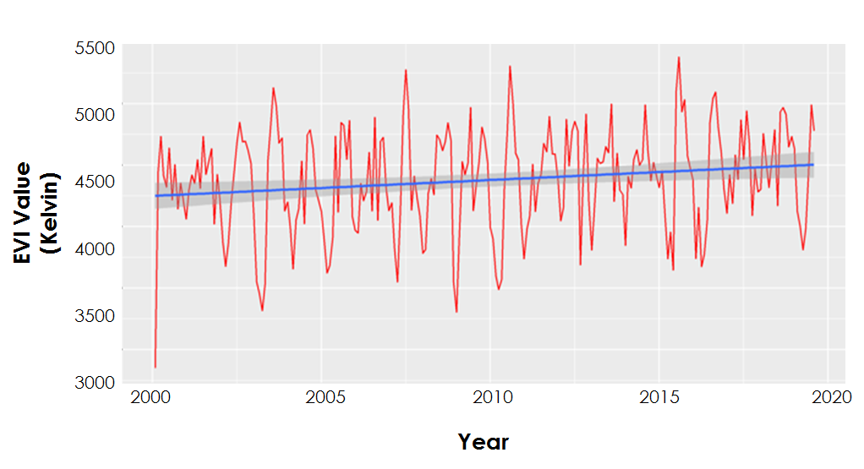*Figure 3.* 2000 to 2019 NDVI Timeseries

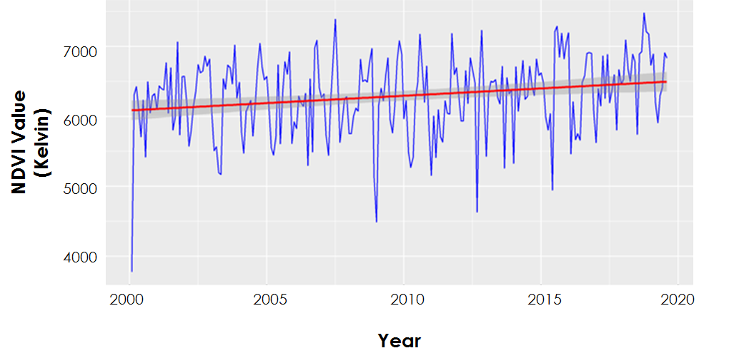

*Figure 4.* 2000 to 2019 EVI Timeseries

Our NDVI and EVI change maps indicate a noticeable overall increase in vegetation cover on the western part of Negros (*Figures 5 and 6*). On the other hand, an NDVI and EVI decrease can be seen on most parts of Panay, and northern Negros. The decrease in NDVI and EVI values on Panay and in the two national parks in central Negros are particularly evident and these locations are some of the potential areas where the reintroduction of the two endemic species could occur. Furthermore, as stated above, the increase in overall vegetation in these two islands could be credited to insufficient data in distinguishing between invasive and native plants. Thus, most of the vegetation growth seen on Negros is possibly invasive secondary trees.

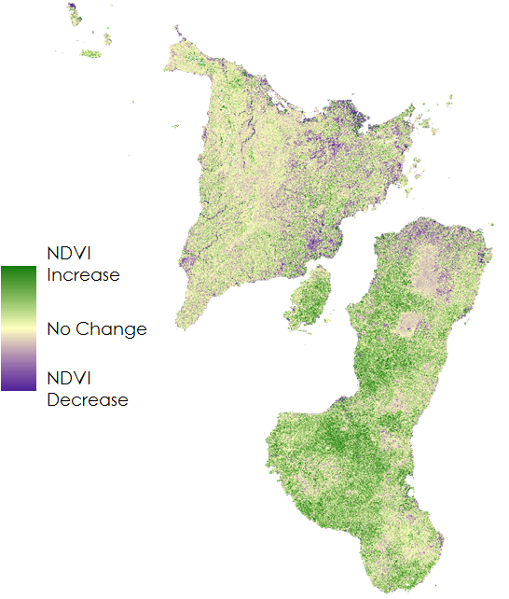

*Figure 5.* NDVI change between 1987 and 2019. Areas in green reflect an increase in vegetation cover,   
while areas in purple show a decrease in vegetation cover

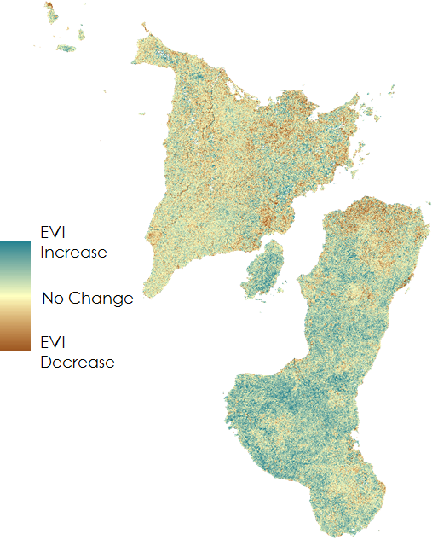

*Figure 6.* EVI change between 1987 and 2019. Areas in blue reflect an increase in vegetation cover, while the areas in brown show a decrease in vegetation cover

The LULC classifications for each composite within the timeseries showed an overall accuracy of over 79 percent with earlier years reaching up to 92 percent. The Kappa coefficient ranged from 80 to 90 percent due to GLCM and Tasseled Cap indices along with other vegetation indices used in the Random Forest classifier. The use of previous studies showed that contrast, dissimilarity, entropy, and variance are mostly associated with visual edges of land-cover patches (Hall-Beyer, 2017). Analyzing the textures in RStudio showed homogeneity, mean, and angular second moment associated with patch interiors. When the training data with the satellite sensor bands were tested, an overall accuracy of 80 percent was attained. The implementation of GLCM, as well as Tasseled Cap indices, increased the overall accuracy of the classifier from 3 percent to 11 percent for all of the composites. The use of the Classification and Regression Trees (CART) classifier produced substantial results but fell short in comparison to the Random Forest classifier. CART had overall accuracies that ranged from 76 to 91 percent.

Overall, the LULC classification maps showed a decrease in primary forest and a corresponding increase in secondary forest (*Figure 7*) in the study area. This is particularly evident in the central Panay Mountain Range, and the three national parks on Negros (Northern Negros National Park, Mt. Kanla-on National Park, and Balinsasayao Twin Lakes Natural Park). In addition to the secondary forest, a visible increase in grasslands could also be seen on Negros.

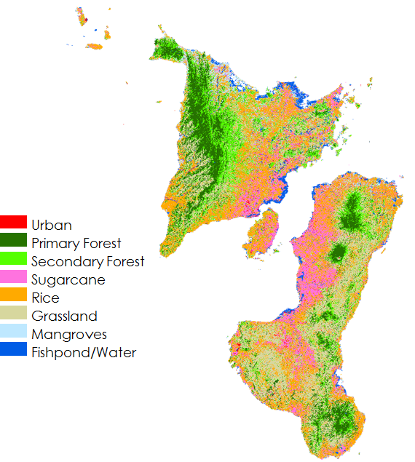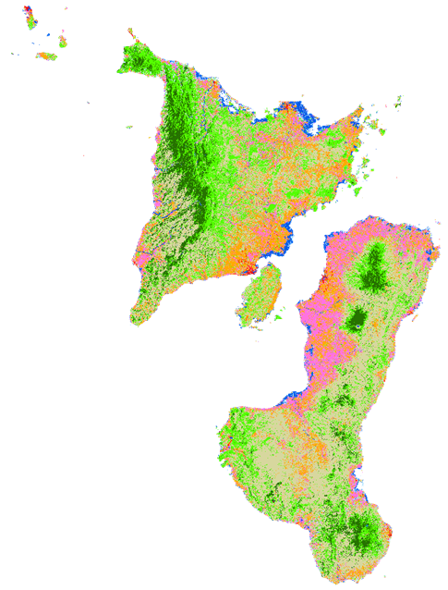

*Figure 7.* 1987 and 2019 land use and land cover classification (respectively)

Furthermore, the LULC images from the classifier classified the primary forest and secondary forest with little confusion between the two classes. Distinguishing between sugarcane and rice produced the most confusion in the error matrix due to the proximity of these two crops in plantations. Primary forest showed a decrease from 1987 to 2019 with a loss of 126,924 hectares (Table 1). The decrease in the primary forest led to an increase in the secondary forest from about 313,981 hectares in 1987 to 546,810 hectares in 2019, which represents a 74% increase in secondary forest. This increase can be attributed to a 36% loss of primary forest from 1987 to 2019 and the increase of invasive plantations. The LULC classifications also showed an increase in urban areas from 1987 to 2019. The increase in urban areas was estimated to be from about 22,452 hectares to 44,932 hectares, which represents a 100 percent increase. As urban areas expand outward more roads and buildings are built where plantations once were situated, this explains the continuing loss of primary forest and the slight decline in rice.

Table 1   
*Total area change of LULC from 1987 to 2019. Red indicates loss and black indicates an increase in total area.*

|  |  |  |
| --- | --- | --- |
| **Class** | **Description** | **LULC change from 1987 to 2019 (ha)** |
| 0 | Urban | 22,480.386 |
| 1 | Primary Forest | 126,923.993 * |
| 2 | Secondary Forest | 232,828.737 |
| 3 | Sugarcane | 7,566.524 |
| 4 | Rice | 373,975.168 * |
| 5 | Grassland | 300,441.161 |
| 6 | Mangroves | 36,882.1504 * |
| 7 | Fishpond/Water | 25,535.3194 * |

*\*Red indicates loss and black indicates an increase in total area.*

The LULC forecast within QGIS MOLUSCE was used for validation using the composite LULC classification maps of 1995 to 1997 and 2005 to 2007 to forecast to 2017. The accuracy of the forecasts was 64 percent. QGIS MOLUSCE uses multiple models to assist in forecasting land cover change. The model used in this analysis was an Artificial Neural Network (ANN) to train the model for forecasting. The model was then used to predict the land cover change. Certain explanatory variables such as elevation, distance from roads, and distance from cities were used to assist the model in forecasting.

Forecasting to 2030, as well as 2050, showed a continued decrease in the primary forest along with the secondary forest with overall grasslands, rice, and sugarcane increasing. Through QGIS MOLUSCE and Terrset it was observed that forecasted primary forest decreased in both 2030 and 2050 by approximately 26,310 hectares and 52,019 hectares 2050 respectively. The forecasted area of secondary forest in 2030 decreased by 97,569 hectares and 185,793 hectares from 2019 to 2050. The decline in secondary forest and primary forest are substantial and raise concern for the future of the Visayan warty pig and Visayan spotted deer. In the forecasting for both 2030 and 2050, agriculture such as grasslands, rice, and sugarcane increased from 2019 with grasslands increasing by 121,167 hectares in 2030 and 221,643 hectares in 2050. The growth of grasslands contributed to the steady decline in primary forest and secondary forest in the forecasted years. Rice and sugarcane both increased in 2030 and 2050 forecasts, rice went from 344,273 hectares in 2019 to 359,478 hectares in 2030. While the 2050 forecast for rice revealed similar area as to that of 2030. Sugarcane was estimated to grow in both 2030 and 2050, with an increase in sugarcane of 11,418 hectares from 2019 to 2030 and 23,067 hectares from 2019 to 2050. Although the forecasting for 2030 and 2050 showed significant results for primary forest and secondary forest, as well as grasslands, urban was forecasted incorrectly due to our accuracy in the forecasting.

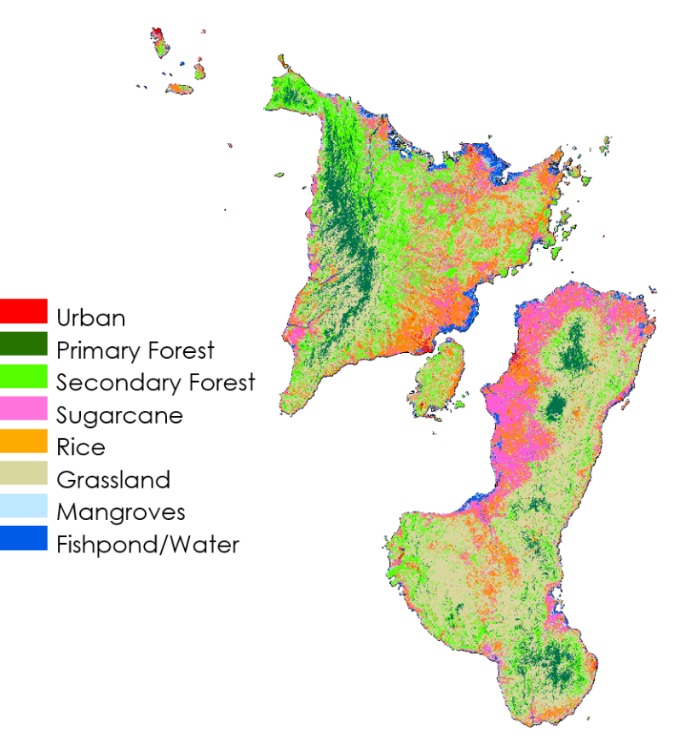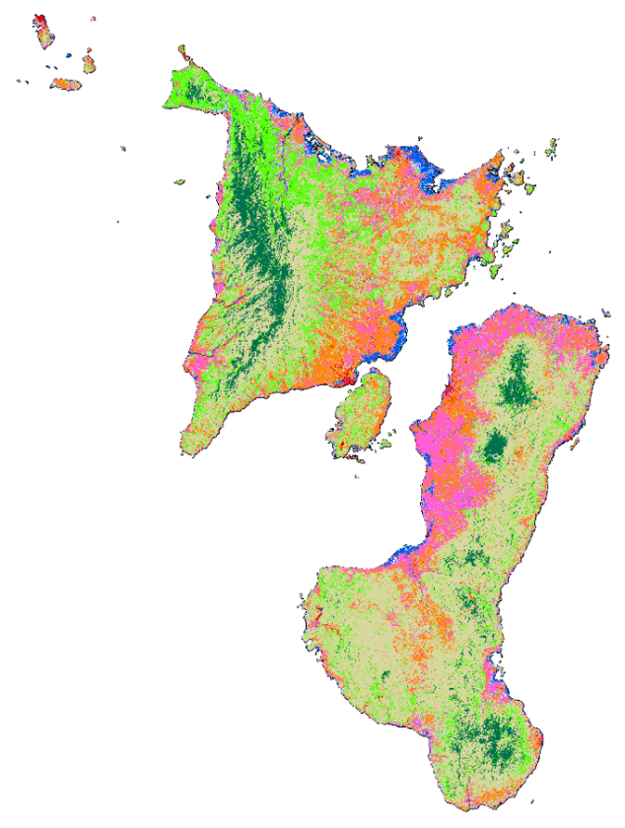

*Figure 8.* LULC Forecasting for 2030 (left) and 2050 (right)

***4.2 Future Work***

Classifying invasive plantations from native plantations can further aid the partners in determining potential sites for the two species along with supplying the government with the resources to see where invasive species are encroaching onto the indigenous forest. Thus, *in situ* data of invasive plantations can be used to map out the areas where the invasive plants are encroaching onto the indigenous plants. Historical data on agriculture for the area can help improve the classifications for previous years and allow for a higher degree of certainty for validation of the LULC classification maps. Further research in the study area with higher resolution imagery can improve the understanding of locations, and importance to preserve indigenous plant species. Furthermore, utilizing explanatory variables such as the size of the two endemic species’ preference areas between primary and secondary forest, distance from populations, population size, town locations, and distance from roads can be useful in a habitat suitability analysis to discover suitable locations on the two islands for the reintroduction of these two endemic species.

# 5. Conclusions

GLCM along with Tasseled Cap indices allowed for improved LULC classification accuracies for the islands of Panay and Negros in the Visayan Islands. Due to the inclusion of ancillary data such as textures, variance, mean, entropy, dissimilarity, homogeneity, contrast, and second moment, the classifier better separated the classes. The use of Tasseled Cap indices improved the classes by extracting the brightness, wetness, and greenness of each class to better enhance class distinction. The use of a Random Forest algorithm was seen to be the best model when classifying the composites which outperformed CART in overall accuracy by 12 percent when both models were used in the project.

The results acquired from the 2030 and 2050 forecasting made it clear that although vegetation health might be increasing from later years within the NDVI and EVI timeseries, primary and secondary forest are decreasing and diminishing the extent for suitable habitats for the two endemic species. The LULC classification showed that there was a loss of primary forest by about 127,000 hectares with exponential gain in urban areas for every LULC map from 1987 to 2019. Changes in the 1987 LULC to the 1997 LULC explained the overall loss of indigenous plants and the increase of particular invasive species as grasslands increased and primary forest decreased. The trend continued from year to year with a consistent loss of primary forest and increased area of grasslands. The Philippines government has enacted laws to improve environmental health, but the planting of invasive species is leading to the eradication of primary forest in Panay and Negros. The loss of these areas will, in turn, lead to the extinction of endemic animals like the warty pig and spotted deer.

The Arizona Center for Nature Conservation – Phoenix Zoo, the IUCN – Species Survival Commission, and Talarak Foundation Inc. have made it their mission to improve the environment for these species. The results obtained from this project will create awareness to help prevent further deforestation and change the forecast for 2030 and 2050. From these outputs, we informed our partners of potential regions for the reintroduction of the Visayan warty pig and spotted deer species in Negros and Panay. We also provided them with an informed analysis of the area to direct their habitat restoration efforts for optimal outputs.

# 6. Acknowledgments

We would like to thank our partner organizations Arizona Center for Nature Conservation – Phoenix Zoo, the International Union for Conservation of Nature – Species Survival Commission, and Talarak Foundation Inc. for their contributions and continued support to the completion of the project. The team would also like to thank Dr. Marguerite Madden at the University of Georgia for her expertise and input. Finally, this project would not have been completed without feedback from the Fellow at NASA DEVELOP Georgia – Athens Node, Shelby Ingram.

Any opinions, findings, and conclusions or recommendations expressed in this material are those of the author(s) and do not necessarily reflect the views of the National Aeronautics and Space Administration.

This material is based upon work supported by NASA through contract NNL16AA05C.

# 7. Glossary

**Archipelagic** –Internationally recognized state or country that comprises a series of islands that form an archipelago

**Biodiversity** –The variety of life in the world or in a particular habitat or ecosystem

**Endemic** –Native and restricted to a certain place

**Endemism** –Ecological state of a species being uniquely defined to a geographical location i.e. an island, nation, or country

**Enhanced Vegetation Index (EVI)** –Measurement of vegetation density and health, EVI is more responsive to canopy structural variations

**Gray-Level Co-Occurrence Matrix** (**GLCM)** –A statistical method of examining texture that considers the spatial relationship of pixels

**Mega-biodiverse Countries** –Group of nations that possess the greatest number and diversity of animal and plants species

**Normalized Difference Built Index (NDBI)** – An index that calculates large values for likely urban and built-up areas

**Normalized Difference Moisture Index (NDMI)** – an index that calculates the measure of leaf moisture content removing internal structure and dry matter distortions

**Normalized Difference Vegetation Index (NDVI)** –Measurement of vegetation density and health, NDVI is chlorophyll sensitive

**Normalized Difference Water Index (NDWI)** – An index calculated to measure water content in vegetation

**Random forest classifier** – A machine learning algorithm that determines which class a pixel belongs to be based on training data

**Remote Sensing** –The science of obtaining information about objects or areas from a distance, typically from aircraft or satellites

**Tasseled Cap Transformation** – Designed to analyze and map vegetation and urban development changes detected by various satellite sensor systems

# 8. References

Breiman, L. (2001). Random forests. *Machine Learning*, *45*(1),5-32. https://doi.org/10.1023/A:101093340

Cox, R. (1987). The Philippine spotted deer and the Visayan warty pig. *Oryx, 21*(1), 37-42. doi: 10.1017/s0030605300020469

Department of Environment and Natural Resources. (2019). The national greening program. Retrieved October 1, 2019, from https://r8.denr.gov.ph/index.php/98-webpage/psamar/547-national-greening-program.

Freemantle, T., Wacher, T., Newby, J., & Pettorelli, N. (2013). Earth observation: Overlooked potential to support species reintroduction programmes. *African Journal of Ecology*, *51*(3), 482-492. doi: 10.1111/aje.12060

Hall-Beyer, M. (2017). Practical guidelines for choosing GLCM textures to use in landscape classiﬁcation tasks over a range of moderate spatial scales. *International Journal of Remote Sensing*, *38*(5), 1312–1338. doi: <https://dx.doi.org/10.1080/01431161.2016.1278314>

Haralick, R. M., K. Shanmugam, & I. Dinstein. 1973. Textural features for image classification. IEEE Transactions on Systems, Man and Cybernetics SMC-3:610–621.

Kulloli, R. N., & Kumar, S. (2014). Comparison of bioclimatic, NDVI and elevation variables in assessing extent of commiphora wightii (arnt.) bhand. *The International Archives of Photogrammetry, Remote Sensing and Spatial Information Sciences*, *40*(8), 589-595. doi: http://dx.doi.org/10.5194.

Maala, C. P. (2001). Endangered Philippine wildlife species with special reference to the Philippine eagle (*Pithecophaga jefferyi*)and tamaraw (*Bubalus mindorensis*). *Journal of International Development and Cooperation, 8*(1), 1-17. doi: [10.15027/14360](https://doi.org/10.15027/14360)

NASA Earth Observing System Data and Information System (EOSDIS) Land Processes Distributed Active Archive Center (LP DAAC), Accessed October 2018. doi: 10.5067/MODIS/MOD13Q1.006

NASA JPL. (2013). NASA Shuttle Radar Topography Mission Global 1 arc second. NASA EOSDIS Land Processes DAAC, accessed 9 October 2019. https://doi.org/10.5067/MEaSUREs/SRTM/SRTMGL1.003

Oliver, W. L. R., Cox, C. R., & Dolar, L. L. (1991). The Philippine spotted deer conservation project. *Oryx*, *25*(4), 199-205. doi: 10.1017/s0030605300034335

Protected Areas and Wildlife Bureau. (2009). The 4th Philippine national report to the convention on biological diversity: Assessing progress towards the 2010 biodiversity target. Retrieved from <https://www.undp.org/content/dam/philippines/docs/environment/4th%20Philippine%20National%20Report%20to%20the%20Convention%20on%20Biological%20Diversity.pdf>

Reis, S. (2008). Analyzing land use/land cover changes using remote sensing and GIS in Rize, North-East Turkey. *Sensors*, *8*(10), 6188-6202. doi:10.3390/s8106188

# U.S. Geological Survey Earth Resources Observation and Science Center. (2012). Provisional Landsat TM Surface Reflectance. US Geological Survey. https://doi.org/10.5066/F7KD1VZ9

U.S. Geological Survey Earth Resources Observation and Science Center. (2014). Provisional Landsat OLI Surface Reflectance. US Geological Survey. https://doi.org/10.5066/F7KD1VZ9

# 9. Appendices

**Appendix A – Index Equations**

Normalized Difference Built Index (NDBI)

$\text{NDBI = }\frac{\text{SWIR - NIR}}{\text{SWIR + NIR}}$ (A1)

Normalized Difference Moisture Index (NDMI)

$\text{NDMI = }\frac{\text{NIR - SWIR}}{\text{NIR + SWIR}}$ (A2)

Normalized Difference Water Index (NDWI)

$\text{NDWI = }\frac{\text{Green - NIR}}{\text{Green + NIR}}$ (A3)

Tasseled Cap Brightness (TCB)

$\text{TCB} \text{= }\text{(0.2043*BLUE)+(0.4158*GREEN)+(0.5524 * RED)+(0.5741 * NIR)+(0.3124 * SWIR1)+(0.2303 * SWIR2})$

(A4)

Tasseled Cap Greenness (TCG)

$\text{TCB} \text{= }\text{(-0.1603*BLUE)+(0.2819*GREEN)+(-0.4934*RED)+(0.7940*NIR)+(-0.0002*SWIR1)+(-0.1446 * SWIR2)}$ (A5)

Tasseled Cap Wetness (TCW)

$\text{TCB} \text{= }\text{(0.0315*BLUE)+(0.2021*GREEN)+(0.3102*RED)+ (0.1594*NIR)+(-0.6806*SWIR1)+(-0.6109*SWIR2)}$ (A6)

**Appendix B – NDVI**

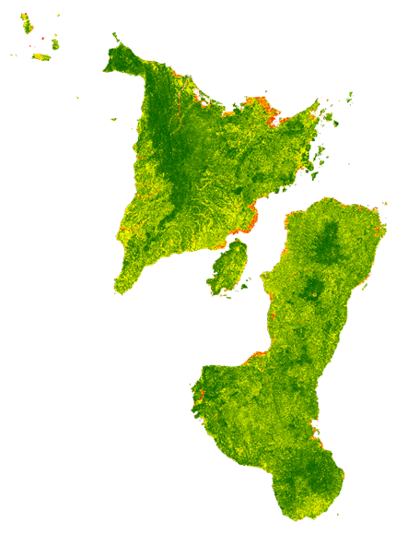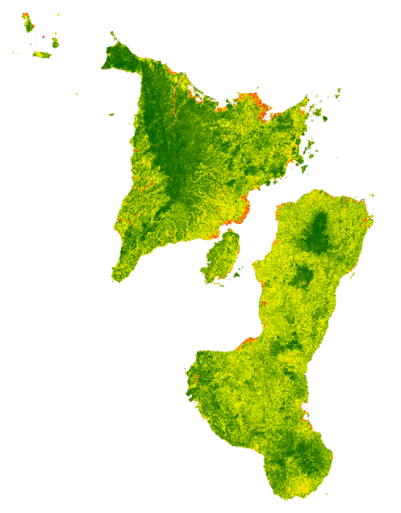

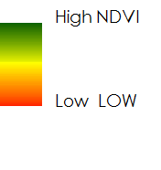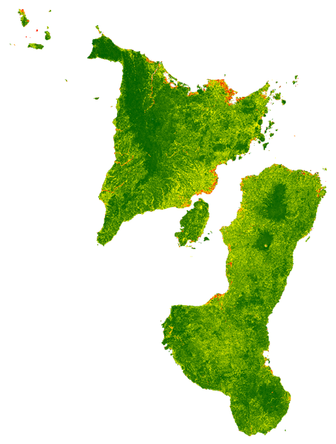

*Figure B1.* NDVI maps for 1997, 2007, and 2017 respectively. High vegetation cover is shown in dark green.

**Appendix C – EVI**

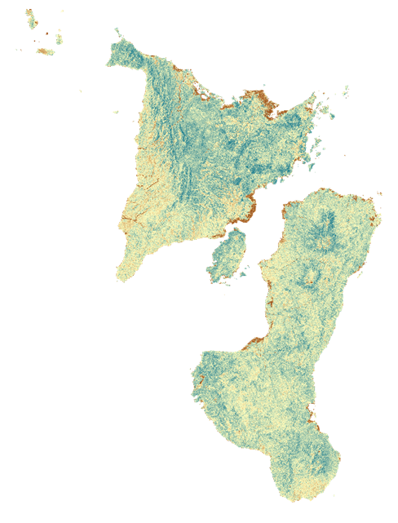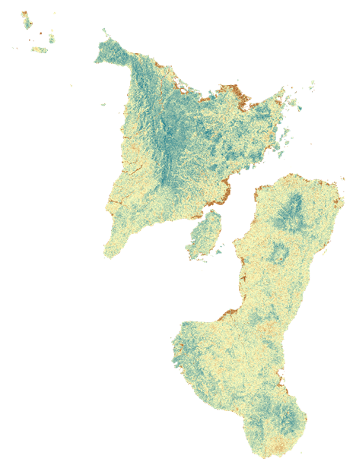

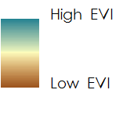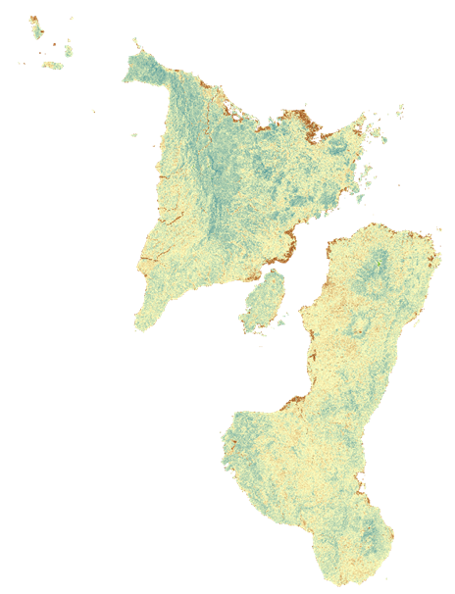

*Figure C1.* EVI maps for 1997, 2007, and 2017 respectively. High vegetation cover is shown in blue.

**Appendix D – Land Use and Land Cover**

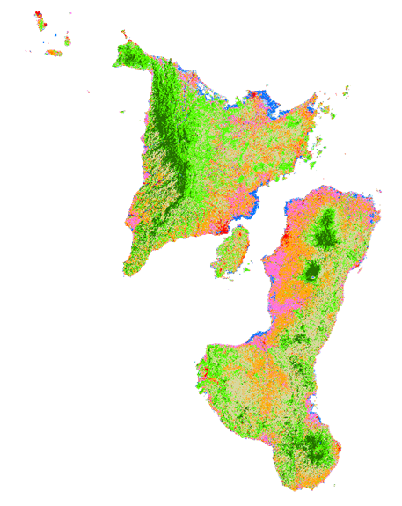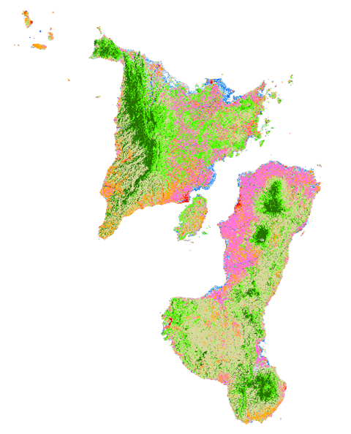

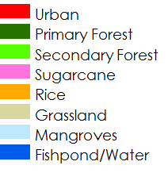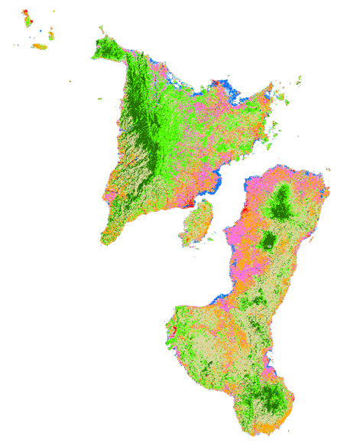

*Figure D1.* Land use and land cover classification for 1997, 2007, and 2017 respectively.