NASA DEVELOP National Program
Colorado – Fort Collins
Fall 2017

Colorado River Basin Water Resources II
Utilizing NASA Earth Observations to evaluate the distribution of Russian olive and its impact on evapotranspiration in the Upper Colorado River Basin


Technical Report
Final Draft – November 16, 2017

Katie Walker (Project Lead)
Caroline Martin
Dan Carver
Kristin Davis
Kevin Gallagher

Paul Evangelista, Natural Resource Ecology Laboratory, Colorado State University (Science Advisor)
Amanda West, Natural Resource Ecology Laboratory, Colorado State University (Science Advisor)
Gabriel Senay, USGS, Fort Collins and North Central Climate Science Center (Science Advisor)
Catherine Jarnevich, USGS, Fort Collins Science Center (Science Advisor)
Anthony Vorster, Natural Resource Ecology Laboratory, Colorado State University (Mentor)
Brian Woodward, Natural Resource Ecology Laboratory, Colorado State University (Mentor)

Previous Contributors:
Megan Vahsen
Emily Campbell
Julia Sullivan
Chanin Tilakamonkul
Brian Woodward

1. Abstract
Riparian plant communities are vital to water quality, erosion control, biodiversity, and functionality of river ecosystems. The invasion of nonnative Russian olive (Elaeagnus angustifolia L.) poses a risk to these fragile ecosystems, as it outcompetes native riparian species such as cottonwoods (Populus spp.) and willows (Salix spp.) in semiarid environments throughout the western United States. Russian olive is well-established in the Colorado River Basin, which supplies water to 40 million people. Studies show that Russian olive alters riparian evapotranspiration rates, streamflow, and sediment regimes. Quantifying the effect of this species on the Colorado River Basin is vital for managing water quality and quantity. In this study, the team 1) mapped the distribution of Russian olive in the San Juan River (a tributary of the Colorado River) using Landsat 5 Thematic Mapper (TM), Landsat 8 Operational Land Imager (OLI), and Sentinel-2 MultiSpectral Instrument (MSI) imagery, 2) compared the accuracy of Landsat 5 and 8 presence maps to those of Sentinel-2, and 3) determined relative evapotranspiration (ET) rates for Russian olive. We identified predictor variables and utilized Software for Assisted Habitat Modeling (SAHM) to generate multiple classification algorithms, including boosted regression trees (BRT), general linear model (GLM), multivariate adaptive regression splines (MARS), and random forest (RF). These algorithms were used to produce presence maps and evaluate modeling approaches. The Walton Family Foundation will use our products to assess previous restoration efforts of Russian olive and to prioritize future management plans and restoration efforts.

Keywords: Russian olive, invasive species, remote sensing, SAHM, evapotranspiration, Colorado River Basin

2. Introduction
  - Background Information
Riparian ecosystems represent a unique transition between terrestrial and aquatic environments and are highly biodiverse zones. In the western United States, riparian zones represent less than 5% of the land area, but they serve as habitat and migration corridors for about 80% of animals in the surrounding terrestrial environment (Salo & Theobald, 2016). These areas also provide important ecosystem services, such as maintaining water quality by preventing erosion (Salo & Theobald, 2016).

Timing, periodicity, and variability of flowing water characterize hydrologic regimes and strongly affect plant communities in riparian areas (Reynolds & Shafroth, 2017; Poff et al., 1997). Native riparian vegetation requires periodic inundation of the floodplain. This periodic inundation provides inputs like surface water, nutrient-rich sediment accumulation, and groundwater recharge (Collette & Pither, 2015; Reynolds & Cooper, 2010). Anthropogenic factors, however, such as agriculture, groundwater pumping and the spread of invasive species, have significantly altered historical hydrological processes in the past several decades (DeWine & Cooper, 2007). This has negatively affected the plant species richness of riparian areas and the geomorphologic processes that maintain these systems (Reynolds & Shafroth, 2017; Schook, Carlson, Sholtes, & Cooper, 2016).

The Upper Colorado River Basin (UCRB) represents a major source of water for the western United States and Mexico (Reynolds & Shafroth, 2017). The UCRB spans 250,000 square kilometers, and directs flows from almost 65 million hectares of land annually from Utah, Arizona, Colorado and New Mexico (DeWine & Cooper, 2007). The waters of the UCRB irrigate agriculture, support human development, and provide important ecosystem services (Reynolds & Shafroth, 2017). However, recent invasion of Tamarisk (Tamarix spp., also known as salt cedar) and Russian olive (Elaeagnus angustifolia) has altered water use and quality in the UCRB. It has degraded riparian habitat and prevented regeneration of the dominant native species in this region, primarily cottonwood trees (Populus spp.) and willow (Salix spp.) (Reynolds & Cooper, 2010).

Russian olive, a woody shrub or small tree native to Eurasia, was introduced to the United States in the early 20th century for use as a windbreak, bank stability, erosion control, and as an ornamental (Hamilton, Megown, Lachowski, & Campbell, 2006). Russian olive escaped cultivation and spread into riparian areas in western states, outcompeting native species through life history strategies such as drought and shade-tolerance, nitrogen fixation, and seed longevity (Collette & Pither, 2015). Because of these traits, Russian olive can establish underneath closed canopies of cottonwood stands and germinate in lower soil moisture conditions than native counterparts, underscoring the need for control of this invasive species (Reynolds & Cooper, 2010).

In 2007, Congress passed the Salt Cedar and Russian Olive Control Demonstration Act to encourage research into the extent of invasion by and the removal of these invasive species (Congress, 2006). Russian olive also is classified as a Class B Noxious Weed in Colorado, which requires a state mandated plan to manage populations and prevent further spread (Colorado Department of Agriculture Conservation Services, 2014). Despite these mandates, scientists and managers lack information on the invasion rates and extent of Russian olive. Studies have generated habitat suitability models for Russian olive and distribution maps for other invasive species to prioritize management actions (Jarnevich, Evangelista, Stohlgren, & Morisette, 2011; Jarnevich & Reynolds, 2010). To our knowledge, no studies to date have used remotely sensed data to detect Russian olive. Additionally, invasive species like Tamarisk and Russian olive could use more water and have higher ET rates compared to native riparian vegetation. This suggests that Russian olive presence could decrease stream flow and reduce water supply (Glenn et al., 1998; Reynolds & Cooper, 2010). Distribution maps of Russian olive can provide an important baseline for understanding the geographic extent of this invasive species and prioritizing restoration and management actions.

Our study area included riparian corridors located in Landsat scene WRS-2 TOA Path 35, Row 34, in the southern portion of the UCRB. The study area included portions of the San Juan and Animas Rivers in Utah, Colorado and New Mexico. Our project will build upon the methodology of the previous Colorado River Basin Water Resources team, which mapped riparian areas and Tamarisk cover in the UCRB (Vahsen et al., 2017).

  - Project Partners & Objectives
Our primary objectives for this project were to:
1) Utilize data collected by Landsat 5 Thematic Mapper (TM), Landsat 8 Operational Land Imager (OLI) and Thermal Infrared Sensor (TIRS), Shuttle Radar Topography Mission version 3 (SRTM V3), and Sentinel-2 MultiSpectral Instrument (MSI) to model the distribution of Russian olive in the San Juan River (a tributary of the Colorado River) for 2006 and 2016 by creating binary presence/absence maps; 2) Compare the accuracy and feasibility of Landsat 5 and 8 modelling efforts to those of Sentinel-2; 3) Employ Landsat 8 Band 10, or the thermal band, to determine relative evapotranspiration (ET) rates for Russian olive.

Our partners at the Walton Family Foundation were provided with maps identifying Russian olive presence in 2006 and 2017, difference maps between these two years, and an evapotranspiration map from 2017 These maps will aid our partners in evaluating and prioritizing restoration efforts. We collaborated with the U.S. Geological Survey (USGS) Fort Collins Science Center, the North Central Climate Science Center, and the Natural Resource Ecology Laboratory (NREL) at Colorado State University (CSU) to provide research and methodologies for our study. This project addresses the NASA DEVELOP Water Resources application area, as our distribution and evapotranspiration maps will help our partners begin to understand how the presence of Russian olive may influence the hydrologic cycle.

3. Methodology
To accomplish these objectives, we used Landsat 5 Thematic Mapper (TM), Landsat 8 Operational Land Imager (OLI), and Sentinel-2 MultiSpectral Instrument (MSI) imagery (ESA) to fit models detecting Russian olive presence and absence (US Geological Survey Earth Resources Observation and Science Center & ESA). Modelling ET required a separate workflow, utilizing Landsat 8 thermal band imagery in combination with environmental inputs.
In addition to comparing data sources, years, and sensors, we investigated two modelling approaches to for modeling Russian olive presence in our study area. We performed variable selection and utilized a random forest classification algorithm in R version 3.4.2 using the VSURF package. We also fit multiple statistical algorithms in the USGS’s Software for Assisted Habitat Modeling (SAHM). SAHM is a provenance management system for environmental modeling created by the USGS (Talbert, 2012). Our response variable was Russian olive presence or absence, so the outputs of these models were binary presence and absence maps masked by the Valley Bottom delineation (V-BET).

3.1 Data Acquisition
We received pre-processed Landsat 5 TM and Landsat 8 OLI/TIRS imagery from WRS-2 Path 35, Row 34 TOA during the growing season (April-October) and with less than 20% cloud cover for two time periods (2005/2006 and 2015/2016) for use in modeling Russian olive from Dr. Paul Evangelista’s lab in the Natural Resource Ecology Laboratory (NREL) at Colorado State University. These prepared spectral indices included the Enhanced Vegetation Index (EVI), Short Wave Infrared (SWIR1) and SWIR 2, blue, Near Infrared (NIR), Normalized Difference Vegetation Index (NDVI), Tasseled Cap transformations, Modified Soil Adjusted Vegetation Index (MSAVI), and Modified Normalized Difference Water Index (MNDWI). We obtained Sentinel-2 MSI imagery from the European Space Agency Copernicus Open Access Hub. We used the Landsat and Sentinel-2 imagery as inputs for our Russian olive presence models.

Russian olive is visually distinct in both field surveys and satellite imagery due to its silver-gray color (Hamilton et al., 2006; Madurapperuma, Oduor, Anar, & Kotchman, 2013). Our field data included locations of Russian olive presence and absence obtained from the Evangelista Lab at NREL. After close inspection of available field data provided by NREL, we concluded that field data collected in the 2005-2006 time frame provided a low level of accuracy. Therefore, an additional digital sampling approach was employed. Because of its high 1-meter spatial resolution, imagery from the National Agricultural Imagery program (NAIP) was used within Google Earth Engine (GEE) to collect additional sample presence and absence points. We used ocular estimation to select points with greater than 50% Russian olive cover along the San Juan River as presence points. We selected areas absent of Russian olive using an approximate 50m diameter around the selected location for absence points. This was done for the 2005-2006 and 2015-2017 time frames. We refer to these points hereon as our digitally sampled points.

For evapotranspiration (ET), we obtained climate datasets such as evapotranspiration reference (ETo), surface temperature (Ts), and air temperature (Ta). Evapotranspiration reference and maximum Ta were acquired from Climate Engine but the data was initially sourced from University of Idaho Gridded Surface Meteorological Data (Huntington J et al, 2017). Earth Explorer was used to obtain a Landsat 8 image of June 2017, which is the peak of the growing season, when ET rates are highest.
3.2 Data Processing and Analysis
We used valley-bottom delineations to limit our study area and the data included in our models (Vahsen et al., 2017 & Gilbert et al., 2016). Variable selection using the VSURF package in R allowed us to identify important predictors for each period and dataset (Table 1).

Table 1. Top six predictor indices ranked by frequency of occurrence.
Frequency of Landsat 5 and Landsat 8 Indices
Rank | Predictor Indices
1 | Blue
2 | Tasseled Cap Brightness
3 | Modified Normalized Difference Water Index (MNDWI)
4 | Near Infra-red (NIR)
5 | Short Wave Infra-red 1 (SWIR1)
6 | Global Environmental Monitoring Index (GEMI)

We extracted values from our remotely sensed imagery to our 2005, 2006, 2016, and 2017 field and digitally sampled points such that each presence or absence point had associated values of focal indices and bands. Of those variables identified as important for detecting Russian olive, we removed variables with correlation coefficients > 0.7 and used the resulting list to fit our models. We then fit random forest models in R to the predictor list of indices and bands and the Russian olive presence and absence data for each data type, year and sensor to produce binary maps of Russian olive presence and absence in our study area.

We conducted a comparison of the maps using single and multi-model approaches. We employed the USGS’ Software for Assisted Habitat Modelling (SAHM) to facilitate this comparison (Talbert, 2012). We evaluated each of the statistical models’ fit in SAHM and compared their accuracy using various test statistics (Morisette et al. 2006). SAHM evaluation metrics such as confusion matrices, ROC curves, MESS maps, and ensemble maps were used to evaluate how our models performed. Based on these metrics, we selected the best performing model to detect Russian olive presence in the UCRB for the 2006 and 2016 growing seasons.

Conversely, our evapotranspiration model required a series of calculations using a combination of environmental variables and earth observations. From Landsat 8 imagery, we used band 10 (thermal band) as input. We converted this imagery to land surface temperature (Ts) values in a Python script. Digital Number (DN) is the intensity value of a pixel in a remote sensing image. The script transforms these values into solar radiance, which is the energy emitted from the earth that the satellite receives. Because the Ts is used to determine the relative latent energy occurring at the earth’s surface, the Ts can be calculated from the solar radiance. ET can then be calculated using energy budget equations.

Ta, Ts and ETo were used as inputs for an evapotranspiration model called the Operational Simplified Surface Energy Balance (SSEBop), which was created by Senay et al., 2013. The model assumes that pixels where there is evapotranspiration from plants are cool and that bare ground pixels are hot. These two examples are used as boundary conditions and are used in calculating evapotranspiration fraction (ETf), which is the fraction of net radiation energy being used by evapotranspiration. ETf value ranges from 0(dry) to 1(wet), which are the boundary conditions. Once ETf was calculated, we multiplied ETf by the ETo value to obtain actual evapotranspiration. Then ET rates were extracted using a random forest presence and absence model. A riparian map and a land cover types map from LANDFIRE were layered.

4. Results
4.1 Analysis of Russian olive Presence and Absence Model Results
Random forest models utilizing Landsat imagery performed well according to select evaluation statistics. Excluding the model trained on Landsat 5 field data, all random forest models run in R had out-of-bag errors below 6% and area under receiver operator curve (AUC) values greater than 62% (Table 1). This suggests that Russian olive lends itself well to remote sensing research due to its unique spectral signature.

Random forest models trained on digitally sampled data detected a lower percent cover of Russian olive than models trained on field sampled data. The former also had a higher model performance based on evaluation metrics such as out-of-bag Error and AUC (Table 1).

By comparing the Landsat 8 field and digitally trained models, we could analyze differences in model results and create a more nuanced discussion of the effect training data had on the model performance. The field model predicted 49.30 km of Russian olive presence, 37.9 ${\text{km}}^{\text{2}}$ of which were not identified as Russian olive by the model trained using digital data. This accounted for 76.9% of all the Russian olive mapped by the field model. The digital model predicted 35.92 km² of presence, 21.8 ${\text{km}}^{\text{2}}$, of which were not predicted as Russian olive by the field model. This accounted for 60.7% of all the Russian olive mapped by the digital model (Table 1). The high level of disagreement between the two models but strong accuracy statistics suggests that these training data represent different occurrence of Russian olive in the landscape. It is believed that the differences in the heterogeneity of the underlying land cover associated with Russian olive may be the cause of this discrepancy.

Sentinel-2 had higher model performance metrics than Landsat-8, suggesting that Sentinel-2 is well-suited for detecting Russian olive presence. Sentinel-2 distinguished this species with more precision due to its higher spatial resolution, and yielded a more accurate boundary between vegetation and water (Figure 2). A comparison map showed 6.4${\text{km}}^{\text{2}}$ mapped as Russian olive by the Landsat 8 model was not predicted as presence by the Sentinel-2 model. This accounted for 65.3% of the area predicted to be Russian olive. Similarly, 5.1 ${\text{km}}^{\text{2}}$ mapped as Russian olive by the Sentinel-2 model was not predicted as Russian olive by the Landsat 8 model. This accounted for 58.6% of the area predicted to be Russian olive by the Sentinel-2 model (Table 2, Figure 2). Both models were trained with the same dataset, so this variance is due to differences in the sensors.

4.1.1. Random Forest Modeling Approach

Table 2. Modelled area of Russian olive cover.
Data Set | Area Valley Bottom Detected as Russian Olive (%) |  | Area Detected as Russian Olive (${km}^{2}$)
 | Digital | Field | Digital | Field
LS5 | 3.30 | 63.75 | 113.25 | 2166.43
LS8 | 1.06 | 1.46 | 35.92 | 49.30
LS8 subset | 1.42 | N/A | 9.77 | N/A
Sentinel | 1.26 | N/A | 8.69 | N/A

Table 3. Select binary model evaluation statistics.
Data Set | Out of Bag Error (%) |  | AUC (Area Under Receiver Operator Curve)
 | Digital | Field | Digital | Field
LS5 | 2.44 | 15.36 | 0.69 | 0.60
LS8 | 2.94 | 6.01 | 0.68 | 0.62
LS8 subset | 2.11 | N/A | 0.68 | N/A
Sentinel | 2.09 | N/A | 0.77 | N/A

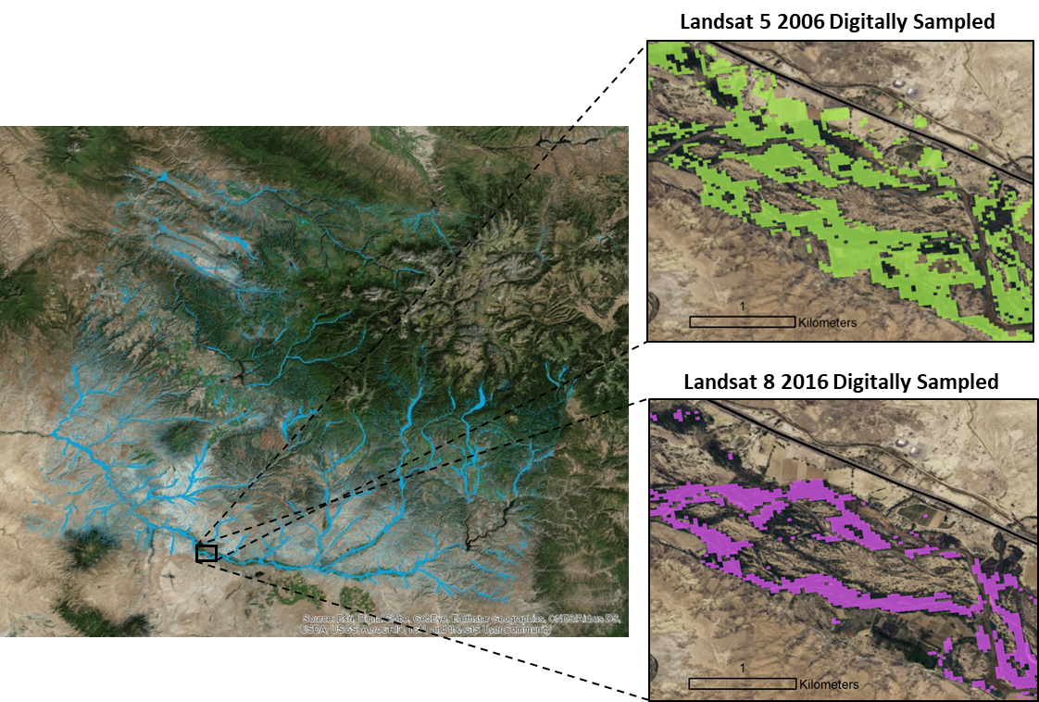

Figure 1. Comparison of binary model outputs created for 2006 and 2016 using digitally sampled points.

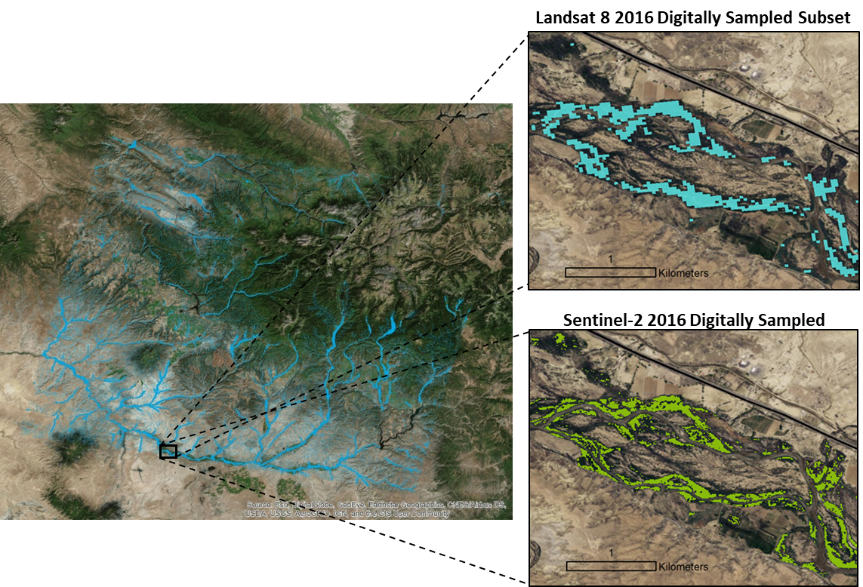

Figure 2. Comparison of binary model outputs created for 2016 using Landsat 8 and Sentinel-2 imagery.

4.1.2. SAHM Modeling Approach
Although performing variable selection and fitting a single model in R was faster than fitting multiple models in SAHM, SAHM produced more thorough and robust evaluation metrics for judging model performance. Additionally, modeling Russian olive presence in SAHM allowed us to visualize areas where multiple models detected presence, which strengthened our confidence in the accuracy of those detections.
Utilizing random forest (Breiman, 2001; Belgiu & Drăgut, 2016), boosted regression tree (Elith, Leathwick & Kastie, 2008), generalized linear model (McCullagh, 1984), and multivariate adaptive regression splines (Friedman, 1991) via SAHM allowed us to analyze a greater variety of evaluation statistics, compare model algorithms, and evaluate potential errors in a spatial context based on output MES maps (Figure 4). Based on evaluation statistics and confusion matrices, models performed comparably for both Landsat 5 and Landsat 8 imagery (Table 4). Each model was trained on a unique data set (i.e., unique by year of imagery and by data collection method), so it was difficult to compare models across time. Differences in image quality, data acquisition, radiometric resolution, etc., could cause differences in model output across sensors. This was validated by our SAHM modelling results when applying a model generated from Landsat 5 imagery to Landsat 8 imagery and points.

Table 4. SAHM Model Evaluation Metrics.
Landsat 5
Model | % Correctly Classified | Sensitivity | Specificity | AUC
BRT | 96.3 | 0.965 | 0.962 | 0.995
GLM | 91.8 | 0.921 | 0.916 | 0.978
MARS | 93.2 | 0.939 | 0.929 | 0.98
RF | 94.3 | 0.939 | 0.945 | 0.976
Landsat 8
BRT | 92.6 | 0.926 | 0.926 | 0.977
GLM | 95.9 | 0.959 | 0.959 | 0.99
MARS | 95.7 | 0.956 | 0.957 | 0.987
RF | 94.5 | 0.945 | 0.945 | 0.982

4.2 Analysis of Evapotranspiration Model Results
During June 2016, evapotranspiration rates for areas with Russian olive presence was relatively greater than in the riparian area without Russian olive, with rates of 5.34 and 4.43 respectively. As expected the ET rates for Russian olive were greater than trees, grasses, shrubs, herbaceous species, other riparian vegetation types within the riparian map (Table 5). Notably, higher ET rates are observed near the streams and decrease with increasing distance from the streams. This may be due to the fact that individual 30m² pixels often partially include open water. Also, ET rates are much higher within the riparian zone of the San Juan River compared to its smaller tributaries.

Table 5. Evapotranspiration Rates by Land Cover Type (mm/day).
Land Cover Type | MIN | MAX | RANGE | MEAN | STANDARD DEVIATION | AREA
Riparian without Russian olive | 0 | 9.10 | 9.10 | 4.43 | 1.94 | 767.03
Russian olive | 0 | 9.06 | 9.06 | 5.34 | 1.82 | 35.92
Exotic Herbaceous | 0 | 8.70 | 8.70 | 2.76 | 1.76 | 1.23
Shrubland | 0.40 | 6.46 | 6.06 | 2.90 | 1.29 | 3.17
Exotic Tree-Shrub | 0 | 8.81 | 8.81 | 4.20 | 2.16 | 5.27
Riparian | 0.59 | 7.63 | 7.04 | 4.49 | 1.28 | 11.34
Grassland | 0.71 | 8.09 | 7.38 | 4.59 | 1.44 | 2.19
Conifer | 1.83 | 7.69 | 5.86 | 4.88 | 1.13 | 12.51
Hardwood | 0.61 | 8.72 | 8.11 | 6.05 | 1.02 | 26.18
Open Water | 0 | 9.10 | 9.10 | 6.21 | 1.63 | 21.62


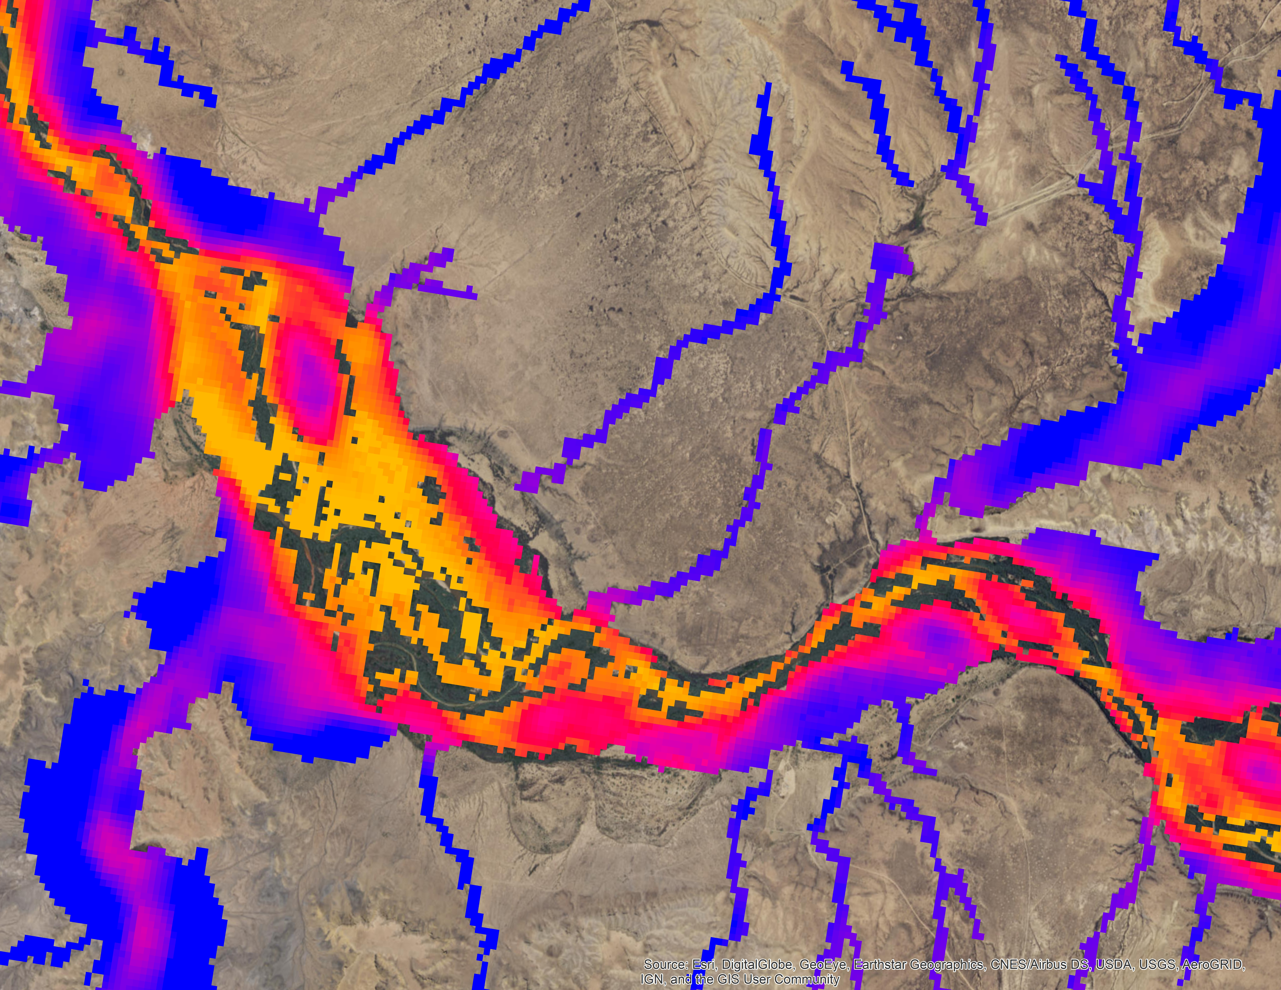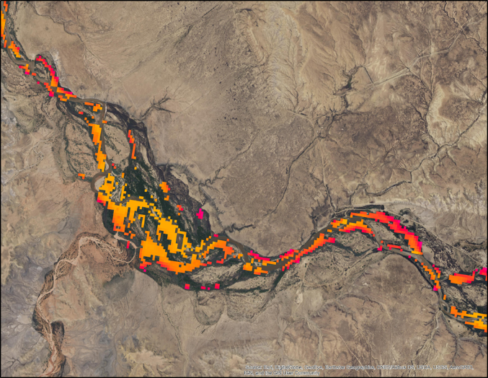
9.25 mm/day
0 mm/day
Presence
Absence
Figure 3. Evapotranspiration rates in detected presence versus absence areas.

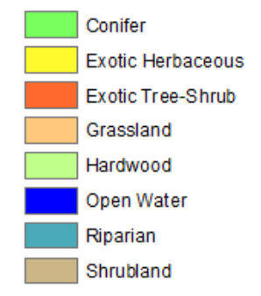
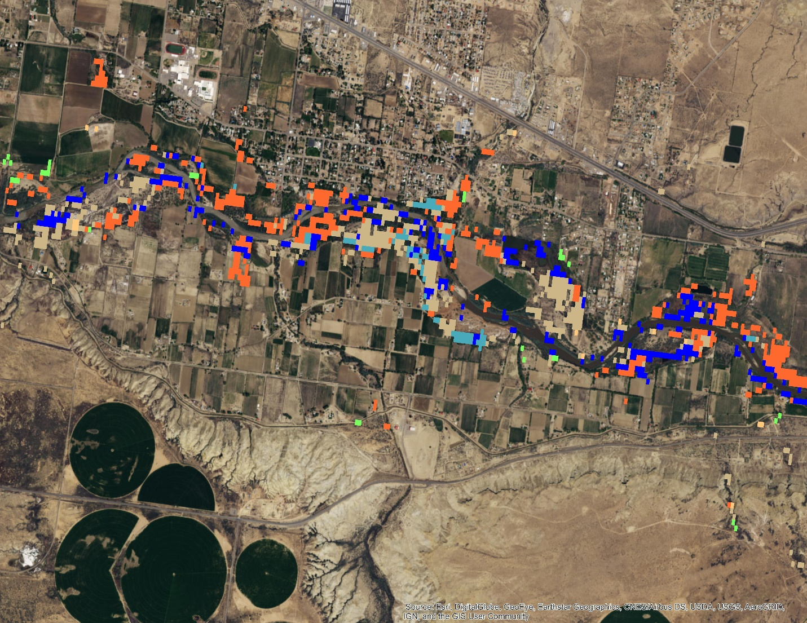
Figure 4. Vegetation Types along a section of the San Juan River (LANDFIRE).

5. Discussion
5.1 Comparison of Field and Digitally Sampled Data
Our study shows that models trained using digitally sampled data can provide a comparable product to models trained using high quality field data. In addition, models trained using digitally sampled data significantly outperformed models trained using field data. Models trained on field data collected in 2005 and 2006 over-predicted because the data used to train the models were not collected specifically for remote sensing purposes. For example, an ocular assessment of these data points revealed that many points marked as presence represented single trees or stands that were small enough that they would not dominate the spectral reflectance within a single pixel.

Our digital sampling methodology depended on aerial imagery from the National Agricultural Imagery Program, which is temporally (2004-2016) and spatially limited. The spatial coverage and quality of NAIP imagery, however, has improved over time. Thus, our methodology is more effective for recent study periods. Although models fit to digitally sampled data outperformed models fit to field data, we note that quality field data or significant knowledge of the study area and species is necessary to train individuals to sample species presence and absence. Additionally, the quality of the digitally sampled data is dependent on an individual’s ability to distinguish the species of interest. We suggest increasing the amount and geographic variation of digitally sampled data to better extrapolate modeling results to the entire study area.

While our models trained with high quality field data detected a similar total area of Russian olive compared to our models trained with digitally sampled data, the spatial distribution of Russian olive largely differed between these models. The field data were more geographically diverse than the digitally sampled data and seem to have captured more heterogeneous land cover types. In contrast, our methodology for digitally sampling Russian olive focused on capturing large homogenous patches of Russian olive. We believe this difference in sampling methodology is why the spatial distribution of Russian olive presence and absence differed between these models.

5.2 Expanding Upon the Evapotranspiration Model
In this study, we created an estimated evapotranspiration model for a single day. While this model provides a basis for relative comparisons within our focal Landsat scene, it is difficult to draw firm conclusions from a single sample. We built our ET methodology into a Python script to allow for reproducibility across multiple images and time periods. If ET rates are important for informing land management decisions across time, our methodology should be repeated over multiple time periods. One could use a time series analysis to better characterize ET rates and strengthen one’s ability to draw conclusions about the effect of a given land cover type on ET.

SSEBop is a relatively new model that reliably estimates evapotranspiration (Alemayehu, Griensven, Senay & Bauwens, 2017). The ability to calculate ET for large areas and multiple vegetation types is critical to determining how vegetation types can affect the hydrological cycle. Remote sensing can be an efficient and economical method for monitoring ET at a regional scale. Higher ET rates for Russian olive compared to native riparian vegetation suggest Russian olive could alter the hydrological cycle and stream functionality. Managers can use these calculations to prioritize restoration and reduce the negative effects of ET on stream flow and water supply.

5.3 Challenges in Comparing Models Across Sensors and Time
Russian olive grows more slowly than other riparian invaders; therefore, it is unlikely that more Russian olive existed in our study area in 2006 compared to 2016 unless there was extensive restoration and removal of Russian olive during that period. We found limited evidence to suggest extensive ecological restoration or removal, and as a result, we have more confidence in models fit to Landsat 8 and Sentinel-2 imagery than in models fit to Landsat 5 imagery. Due to the lower radiometric resolution (8-bit) of Landsat 5 imagery and the lower quality training data used to fit the Landsat 5 model, we believe it is difficult obtain results of comparable caliber to a Landsat 8 model from a Landsat 5 model.

In this study, we attempted to compare how different sensors detected Russian olive in our study area. To do this, we took the model fit to imagery of one sensor and fit it to imagery from the other (e.g., we fit the Landsat 8 model to Landsat 5 imagery). We encountered issues with our data and fitting the models during this process, so we were unable to complete these efforts within the time frame of the project. Thus, we are not able to claim how or why a specific model is mapping the same feature differently. This does not change the value of our outputs, rather it informs how we should view and compare these products moving forward.

5.4 Future Work
Although this project is in its final term, our work may aid in related future research. The team calculated ET rates in Russian olive presence and absence areas, in riparian map provided by NREL, and within land cover types from LANDFIRE. This level of nuance may allow for a more accurate and useful comparison between the evapotranspiration ET rates of Russian olive and that of native riparian vegetation. This could involve using field data or NASA earth observations to identify native riparian vegetation, but may be challenging due to the diversity of riparian species.

The comparison of Landsat 5 and Landsat 8 models could be improved. A normalization calculation would help make the comparison more feasible and accurate. Also improving digital sampled point methodology would improve models. We suggest including a Landsat cell grid over focal imagery to improve accurate identification of presence thresholds and sampling based on those thresholds.

SAHM was a helpful tool that provided many evaluation metrics that show how our models performed and allowed comparison of models. Our SAHM modelling methodology could also be applied to the previous term’s Tamarisk mapping project for a more robust evaluation of their Tamarisk model results and comparisons.

6. Conclusions
This study investigated four questions: (1) where and how much Russian olive exists, (2) how sampling methods compare in quantifying Russian olive, (3) how sensors compare, and (4) how evapotranspiration rates differ in areas with Russian olive presence versus areas with native vegetation cover. The following are the concluding remarks to these questions:
- Digital and field sample points generally yielded comparable percent cover of Russian olive using the random forest model algorithm, except for the 2005 maps where field data produced much greater percentage of Russian olive. Even though models contained similar percent cover, they showed some disagreement on the spatial distribution of Russian olive. Discrepancies between field and digital models were due to the way data was collected. The field dataset used consisted of datasets from many sources with inconsistent sampling methods. Alternately, digital data was collected with the same methods and with remote sensing modeling in mind. However, field data was used to train the persons that digitally sampled our training data.
- All classification models in SAHM were generally very accurate based on output evaluation metrics; no significant differences between model performance were found except when using different datasets (field vs. digital). Even though the overall statistical accuracy was similar between models, spatial distribution varied. One SAHM evaluation tool, the ensemble map, generated a distribution map showing where models spatially agreed and disagreed, so we have high confidence in the map where they agree.
- Landsat 5 produced a large and unrealistic percentage of Russian olive, whereas Landsat 8 produced accurate and realistic distributions. NAIP imagery was limited for 2005 at the San Juan River location; therefore, sampling points were limited This may have decreased accuracy in our model outputs for Landsat 5. Sentinel 2 presence maps were the most accurate and distinguished the boundary between land and river with the most precision. Comparing sensors was found to be difficult because of the inherent differences between sensors. A normalization calculation would need to be applied so that a comparison between sensors is more appropriate.
- SSEBop can be applied to extensive regional areas and can be used to look at how ET changes over time. Even though it was initially created to monitor water use in agricultural lands it is found to be effective in monitoring various vegetation species including invasive species, Russian olive, and monitor water use and availability.
In conclusion, our study produced valuable maps of Russian olive presence and evapotranspiration rates in riparian zones in the San Juan River using multiple modelling techniques and comparisons. The presence maps will help land managers and our partners prioritize management efforts where Russian olive is shown as present on our maps. Removal of Russian olive will help conserve native riparian ecosystems and restore the river a healthy state which is the mission of our partners. ET maps provide information on how Russian olive alters the hydrological cycle. It could also be used to determine where ET rates are abnormally high or low, which could provide locations where riparian vegetation needs to be restored. Partners will not only get accurate distribution maps but will also know which models worked best in mapping Russian olive and could apply our methods to other vegetation types. Future efforts in mapping Russian olive should focus on refining methods in digitally sampled points to produce the most accurate models.

7. Acknowledgments

We would like to acknowledge the following advisors, partners and collaborators who helped conduct this study: Dr. Paul Evangelista, Dr. Amanda West, Anthony Vorster and Brian Woodward from Colorado State University’s Natural Resource Ecology Laboratory; Timothy Mayer, NASA DEVELOP’s Fort Collins Center Lead; Dr. Catherine Jarnevich and Dr. Gabriel Senay from the US Geological Survey’s Fort Collins Science Center; Dr. Steve Leisz from Colorado State University’s Graduate Degree Program in Ecology; Peter Skidmore from the Walton Family Foundation.

This material contains modified Copernicus Sentinel data (2017), processed by ESA.

Any opinions, findings, and conclusions or recommendations expressed in this material are those of the author(s) and do not necessarily reflect the views of the National Aeronautics and Space Administration.

This material is based upon work supported by NASA through contract NNL16AA05C and cooperative agreement NNX14AB60A.

7. Glossary

Boosted regression tree (BRT) – A decision tree based classification algorithm that additively combines simple decision trees to lower predictive error

Earth observations – Satellites and sensors that collect information about the Earth’s physical, chemical, and biological systems over space and time

Evapotranspiration – The process of water evaporation from soil and transpiration from plants, causing a water flux between the land and atmosphere

Generalized linear models (GLMs) – Transformations of linear regression models that can be fit to data with non-normal distributions

Google Earth Engine (GEE) – A cloud-based geospatial analysis tool

Multivariate adaptive repression splines (MARS) – A non-parametric regression model

National Agricultural Imagery Program (NAIP) – Program administered through the US Department of Agriculture's Farm Service Agency (FSA) to acquire aerial imagery during the agricultural season of the continental US

Random forest – A supervised classification algorithm that generates an ensemble of decision trees

Software for Assisted Habitat Modelling (SAHM) – Software created by the US Geological Survey to map species’ habitat, with the ability to fit five different types of habitat models

8. References
Alemayehu, T., Griensven, A. V., Senay, G. B., & Bauwens, W. (2017). Evapotranspiration Mapping in a Heterogeneous Landscape Using Remote Sensing and Global Weather Datasets: Application to the Mara Basin, East Africa. Remote Sensing, 9(4), 390.

Belgiu, M., & Drăgut, L. (2016). Random forest in remote sensing: A review of applications and future directions. ISPRS Journal of Photogrammetry and Remote Sensing, 114, 24–31. https://doi.org/10.1016/j.isprsjprs.2016.01.011

Breiman, L. (2001). Random forests. Machine Learning, 45(1), 5–32. https://doi.org/10.1023/A:1010933404324

Collette, L. K. D., & Pither, J. (2015). Russian-olive (Elaeagnus angustifolia) biology and ecology and its potential to invade northern North American riparian ecosystems. Invasive Plant Science and Management, 8(1), 1–14. https://doi.org/10.1614/IPSM-D-14-00037.1

Colorado Department of Agriculture Conservation Services. (2014). Russian olive. Retrieved from https://www.colorado.gov/pacific/agconservation/russian-olive

Congress. Salt Cedar and Russian Olive Control Demonstration Act (2006). Retrieved from https://www.congress.gov/109/plaws/publ320/PLAW-109publ320.pdf

DeWine, J. M., & Cooper, D. J. (2007). Effects of river regulation on riparian box elder (Acer negundo) forests in canyons of the upper Colorado River Basin, USA. Wetlands, 27(2), 278–289. https://doi.org/10.1672/0277-5212(2007)27[278:EORROR]2.0.CO;2

Elith, J., Leathwick, J. R., & Hastie, T. (2008). A working guide to boosted regression trees. Journal of Animal Ecology, 77(4), 802–813. https://doi.org/10.1111/j.1365-2656.2008.01390.x

ESA. (2017). Copernicus and Open Access Hub. European Commission: European Space Agency, 2014-2017. Accessed October 2017. http://scihub.copernicus.eu/

Evangelista, P.H., 2017. Russian olive, tamarisk, and riparian vegetation. Colorado State University [Data file].

Friedman, J. H. (1991). Multivariate adaptive regression splines. The Annals of Statistics, 19(1), 1–67. Retrieved from http://www.jstor.org/stable/2241837

Gilbert, J. T., Macfarlane, W. W., & Wheaton, J. M. (2016). The Valley Bottom Extraction Tool (V-BET): A GIS tool for delineating valley bottoms across entire drainage networks. Computers & Geosciences, 97, 1-14.

Glenn, E., Tanner, R., Menendez, S., Kehret, T., Moore, D., Garcia, J., & Valdes, C. (1998). Growth rates, salt tolerance and water use characteristics of native and invasive riparian plants from the delta of the Colorado River, Mexico. Journal of Arid Environments, 40, 281-294.

Hamilton, R., Megown, K., Lachowski, H., & Campbell, R. (2006). Mapping Russian olive: Using remote sensing to map an invasive tree. Retrieved from https://doi.org/RSAC-0087-RPT1

Huntington, J., Hegewisch, K., Daudert, B., Morton, C., Abatzoglou, J., McEvoy, D., & Erickson, T. (2017). Climate Engine: Cloud computing of climate and remote sensing data for advanced natural resource monitoring and process understanding. Bulletin of the American Meteoroogical Society. http://journals.ametsoc.org/doi/abs/10.1175/BAMS-D-15-00324.1.

Jarnevich, C. S., Evangelista, P. H., Stohlgren, T. J., & Morisette, J. T. (2011). Improving national-scale invasion maps: Tamarisk in the western United States. Western North Americal Naturalist, 71(2), 164–175. Retrieved from http://www.jstor.org/stable/41718135

Jarnevich, C. S., & Reynolds, L. V. (2010). Challenges of predicting the potential distribution of a slow-spreading invader: A habitat suitability map for an invasive riparian tree. Biological Invasions, 13(1), 153–163. https://doi.org/10.1007/s10530-010-9798-4

Morisette, J. T., Jarnevich, C. S., Ullah, A., Cai, W., Pedelty, J. A., Gentle, J. E., … Schnase, J. L. (2006). A tamarisk habitat suitability map for the continental United States. Frontiers in Ecology and the Environment, 4(1), 11–17. https://doi.org/10.1890/1540-9295(2006)004[0012:ATHSMF]2.0.CO;2

Madurapperuma, B. D., Oduor, P. G., Anar, M. J., & Kotchman, L. A. (2013). Understanding factors that correlate or contribute to exotic Russian-olive (Elaeagnus angustifolia) invasion at a wildland–urban interface ecosystem. Invasive Plant Science and Management, 6(1), 130–139. https://doi.org/10.1614/IPSM-D-12-00021.1

McCullagh, P. (1984). Generalized linear models. European Journal of Operational Research, 16(3), 285–292. https://doi.org/10.1016/0377-2217(84)90282-0

Poff, N. L., J. D. Allan, M. B. Bain, J. R. Karr, K. L. Prestegaard, B. D. Richter, R. E. Sparks, and J. C. Stromberg. (1997). The natural flow regime. Bioscience, 47, 769–84.

Reynolds, L. V., & Cooper, D. J. (2010). Environmental tolerance of an invasive riparian tree and its potential for continued spread in the southwestern US. Journal of Vegetation Science, 21(4), 733–743. https://doi.org/10.1111/j.1654-1103.2010.01179.x

Reynolds, L. V., & Shafroth, P. B. (2017). Riparian plant composition along hydrologic gradients in a dryland river basin and implications for a warming climate. Ecohydrology, 10:e1864 (December 2016), 1–13. https://doi.org/10.1002/eco.1864

Salo, J. A., & Theobald, D. M. (2016). A multi-scale, hierarchical model to map riparian zones. River Research and Applications, 32, 1709–1720. https://doi.org/10.1002/rra.3019

Schook, D. M., Carlson, E. A., Sholtes, J. S., & Cooper, D. J. (2016). Effects of moderate and extreme flow regulation on populus growth along the Green and Yampa Rivers, Colorado and Utah. River Research and Applications, 32, 1698–1708. https://doi.org/10.1002/rra.3020

Talbert, C. (2012). Software for Assisted Habitat Modeling Package for VisTrails (SAHM: VisTrails). Fort Collins, CO: U.S. Geological Survey.

US Geological Survey Earth Resources Observation and Science Center. (2014). Landsat TM Surface Reflectance (data set). https://dx.doi.org/10.5066/F78S4MZJ

US Geological Survey Earth Resources Observation and Science Center. (2014). Provisional Landsat OLI Surface Reflectance (dataset). https://dx.doi.org/10.5066/F78S4MZJ

Vahsen, M., Campbell, E., Carver, D., Sullivan, J., Tilakamonkul, C., & Woodward, B. (2017). Utilizing NASA Earth Observations to Evaluate Invasive Species Cover in Riparian Areas of the Colorado River Basin. Fort Collins, CO.

