NASA DEVELOP National Program
NASA John C. Stennis Space Center
Fall 2015

Texas Disasters II
Utilizing NASA Earth Observations to Assist the Texas Forest Service in Mapping and Analyzing Fuel Loads and Phenology in Texas Grasslands


Technical Report
Final Version – November 19, 2015

J. Michael Brooke (Project Lead)
Meredith Williams
Teresa Fenn

Joseph Spruce, NASA Stennis Space Center (Science Advisor)

Previous Contributors:
Benjamin Beasley
Alex Holland
Kristen Kelehan

I. Abstract
The risk of severe wildfires in Texas can be related to weather phenomena such as drought and recent urban expansion into wild land areas. In recent years, Texas’ wild land areas have experienced sequences of wet and dry years that have increased the wildfire risk and frequency. To prevent and contain wildfires, the Texas Forest Service (TFS) has been evaluating and reducing potential fire risk in order to improve fire management efforts. This task is difficult due to the vast and varied landscape of Texas. The TFS assesses fire risk by monitoring and assessing vegetative fuel types and fuel loads. This project employed NASA Earth observations, including Landsat and MODIS data, to better assist the TFS. In doing so, Landsat and MODIS data were analyzed to produce maps of vegetation type and specific vegetation phenology as it related to potential wildfire fuel loads. Fuel maps from 2010-2011 and 2014-2015 fire seasons created by Texas Disasters I project were used and provided alternating, complementary map indicators of wildfire risk in Texas. The TFS will utilize project end products and capabilities to evaluate and better understand wildfire risk across Texas.

Keywords
Remote Sensing, Fuel Load, Wildfire, Landsat, MODIS, Disasters

II. Introduction

Background Information:
Wildfires in Texas have increased due to several contributing components, mainly, human influences on the environment, such as recent urbanization and climate change. In 2011, Texas suffered one of the worst wildfire seasons and droughts ever recorded in the history of the state. According to Emerging Texan Communities, 80 percent of wildfires are occurring within two miles of communities. With the recent development into these wildfire areas, the risk of property loss and loss of life has increased. In 2011, 31,453 wildfires burned 4 million acres and destroyed 2,947 homes (Texas Forest Service 2011). According to the Texas Forest Service, in April 2011, the state of Texas documented six of the 10 largest wildfires in the history of the state. Bear Creek Fire recorded as the largest wildfire ever to burn in East Texas at 41,050 acres and the most acres burned in a single wildfire season at 4,011,709 acres (Texas Forest Service 2011). According to Texas state climatologist John Nielsen-Gammon, October 2010 through September 2011 was the driest twelve-month period in Texas history.

The historical 2011 wildfire season and drought was preceded by an abnormally wet year in 2010. According to the National Oceanic Atmospheric Administration (NOAA), the winter of 2010 had low humidity and precipitation variations as a result of a La Niña. La Niña refers to the periodic cooling of the ocean surface temperatures in central and east-central equatorial Pacific that occurs every three to five years (NOAA 2012). A La Niña event beginning in the winter of 2010 brought drier than normal weather conditions across the Southeastern portion of the United States. The abnormally wet year in 2010 allowed for an increase in vegetation growth therefore an increase in fuel load. These factors followed by a drought contributed to the most severe wildfire season the state of Texas has ever recorded.

Project Objectives:
The project objective was to map the phenology of specific vegetation types as it related to wildfire fuel loads. Mapped wildfire fuel types and fuel loads were acquired from the NASA Stennis Space Center Texas Disasters project and NASA Langley Research Center Texas Water Resources project to provide a more synergistic analysis of wildfire risk in Texas.

Study Area:
The project encompassed the entire state of Texas (Figure 1). Texas is the second largest state in the Unites States and it varies both climatically and topographically. The northern part of Texas, known as the panhandle, is dry, barren, and consists of mostly grasslands. The central part of the state, known as the hill country, is a transition from flat woods to grassland areas. The eastern part of Texas is the wettest region in the state and is mainly composed of pine forest. The southern region of the state is dry and mountainous with interspersed desert regions. The western region of Texas is known for dry, hot weather and vegetation mostly consisting of grasslands and shrubs. Due to the large size of Texas a smaller study area within Texas was selected for more intensive study. The focus area included the 2011 Possum Kingdom Complex wildfire (Figures 1 and 2) and consisted of six counties: Palo Pinto, Young, Stevens, Wise, Jack, and Parker County. The Possum Kingdom Complex wildfires burned 126,000 acres and destroyed 168 homes in this area during the historic 2011 wildfire season.

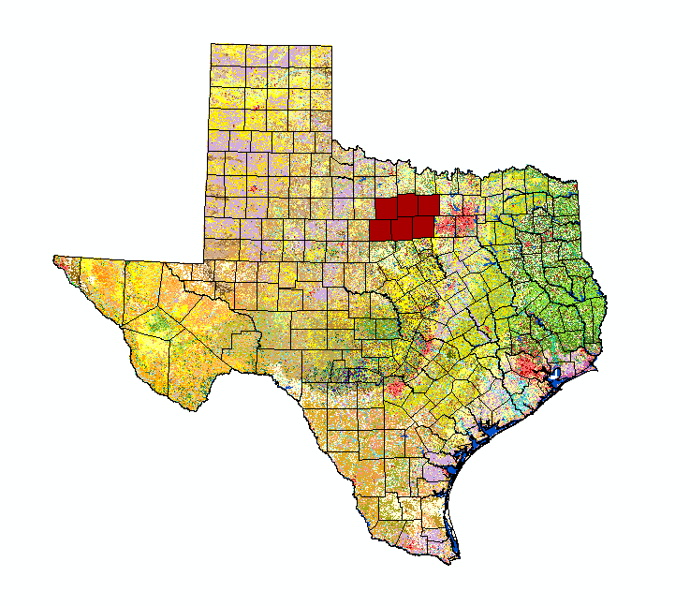

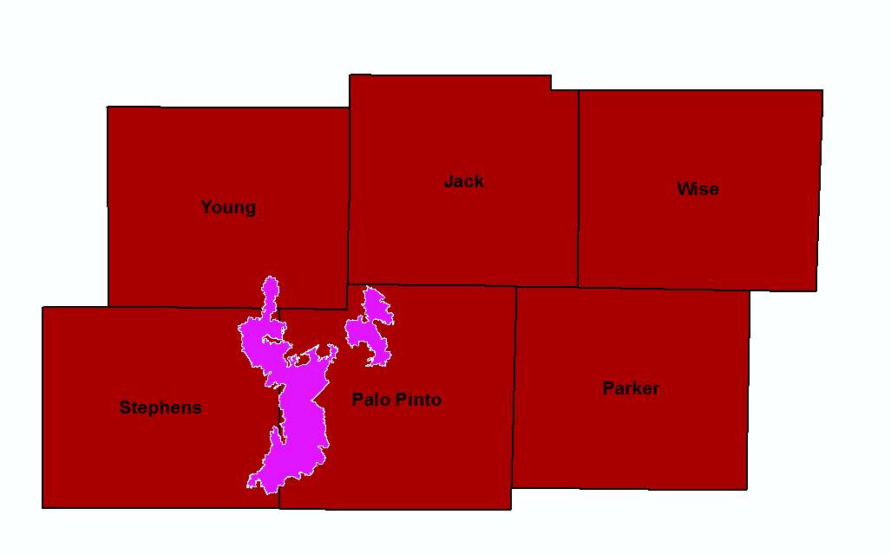

Figure 2: Possum Kingdom Complex in Study Area

Figure 1: Study Area

Study Period:
This project utilized NASA Earth observations and ancillary data collected from 2000 until present. The study period included data from the years 2010-2011 in which 2010 was an abnormally wet year followed by the historical 2011 wildfire season.

National Applications Addressed:
This project regards the Disasters, Ecological Forecasting, Agriculture, and Water Resources application areas.

Project Partners:
Project partners included the Texas Forest Service (TFS) and the United States Department of Agriculture (USDA) Forest Service (USFS). The TFS estimates and evaluates potential fire risk in order to manage and allocate resources for the prevention and containment of potential wildfires across Texas. The TFS currently utilizes data derived from the United States Geological Survey (USGS) LANDFIRE program which predicts and monitors wildfires. The project methodologies and results provided supplemental information from the two previous TFS support projects at SSC and LaRC, along with this project, to the TFS and USFS to help aid, monitor, and prevent, future wildfires.

III. Methodology
Data Acquisition:
MODIS based phenology data from 2000-2015 was obtained from the USFS ForWarn system (http://forwarn.forestthreats.org/). These data consisted of an annual nationwide NDVI image with corresponding day of the year (DOY) value. Each yearly image includes 14 layers which corresponded to seven key points across the growing season NDVI curve (Norman et al, 2013)(Figure 3). This project focused primarily on the left 80% of maximum NDVI, maximum NDVI, and right 20% of maximum NDVI DOY and NDVI magnitude values.

Level 1, Landsat 8 OLI imagery was acquired from the USGS EarthExplorer website (http://earthexplorer.usgs.gov/) for summer 2015 in order to assure the most up to date yet cloud-free imagery. Two scenes of Landsat 8 imagery were required to cover the study area.

Precipitation data from 2000-2015 as well as the 30-year average was acquired from PRISM Climate Group, Oregon State University (http://prism.oregonstate.edu). This nationwide dataset contains precipitation data measured in mm at 4 km resolution.

Soil data was downloaded from the Texas Natural Resources Information System (https://tnris.org/).

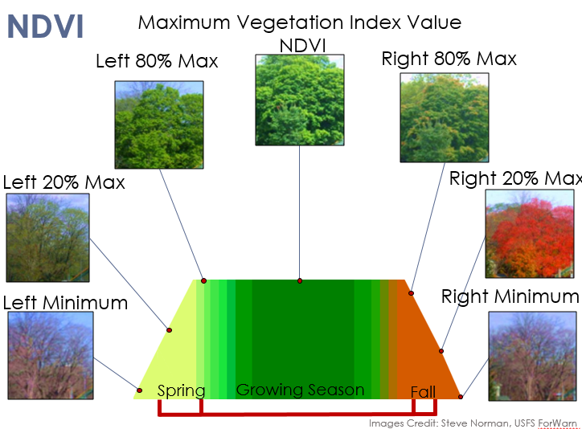
Figure 3. NDVI curve showing seven key points in the growing season.

Data Processing:
ForWarn MODIS phenology data from 2000-2014 was averaged using ERDAS IMAGINE model maker to obtain a baseline phenology dataset to which individual years could be compared. All ForWarn data was then subset to the study area using ArcGIS 10.3.1. The DOY images were smoothed using a 3x3 median filter in ArcGIS to reduce any anomalies.

Landsat 8 OLI imagery was corrected to Top of Atmosphere reflectance and mosaicked using ERDAS IMAGINE 8.7. The resulting mosaicked imagery was subset to the study area using ArcGIS.

Landsat 8 imagery was stacked with MODIS phenology data to create a 17 layer stacked image. An unsupervised classification with 51 classes was performed on this image using ERDAS IMAGINE 8.7.

PRISM precipitation data was converted from mm to inches using the raster calculator in ArcGIS for ease of interpretation. The data was then subset to the study area using the clip raster tool in ArcGIS 10.3.1.

Soil classification data for the state of Texas was subset to the study area using the clip raster tool in ArcGIS 10.3.1. This data was further subset specific classes of landcover from the combined MODIS and Landsat classified image.

Data Analysis:
The data was analyzed in ArcGIS 10.3.1. PRISM precipitation data were analyzed to find wetter than average years followed immediately by a drier than average year. 2010 was a wetter than average year followed immediately by a severe drought in 2011.

Once the primary years for the focus of the study were determined, ForWarn processed MODIS phenology data from 2000-2014 were averaged for both day of year (DOY) and NDVI values to establish a baseline. The resulting DOY image was smoothed using the median filter in ArcGIS. This allowed general trends in phenology to become more apparent. Using the raster calculator in ArcGIS and the change detection function in ERDAS IMAGINE, Large Integral NDVI images were compared to the mean as well as to previous years to determine which years were more productive in terms of NDVI. The resulting images show change in Large Integral NDVI. Greens indicate a positive change while reds indicate a negative change (Figure 4).

To better analyze trends in phenology, an unsupervised classification was performed using ERDAS IMAGINE 8.7 on an image stack containing 14 layers of 2014 MODIS phenology data (all NDVI and corresponding DOY images) as well as the red, near infrared, and shortwave infrared bands of a mosaicked 2015 Landsat 8 scene. The color table is based on class-specific Landsat false color RGB values (Figure 5). The resulting image shows land cover classes that have similar phenology and Landsat reflectance characteristics.

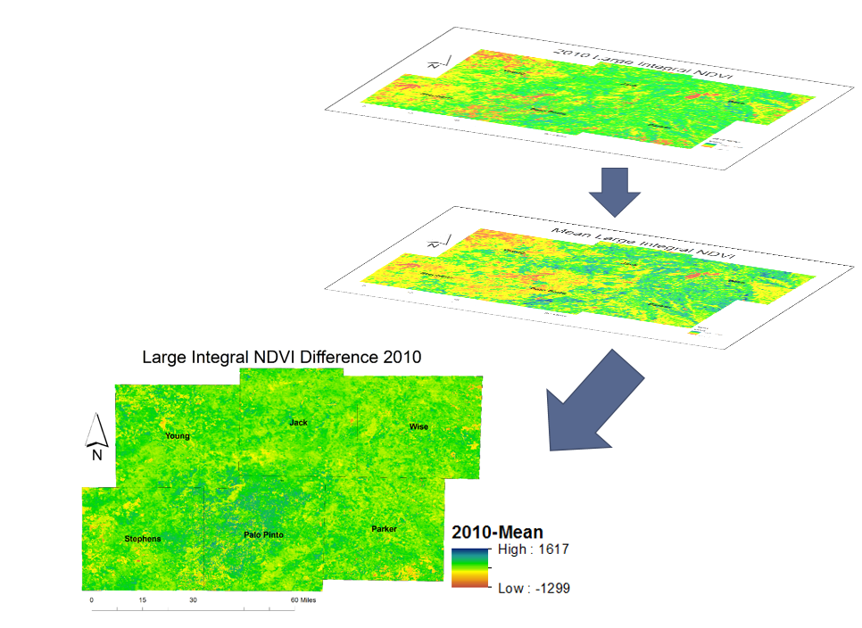
Figure 4. Images of Large Integral NDVI values were compared to the mean Large Integral NDVI from 2001-2014.
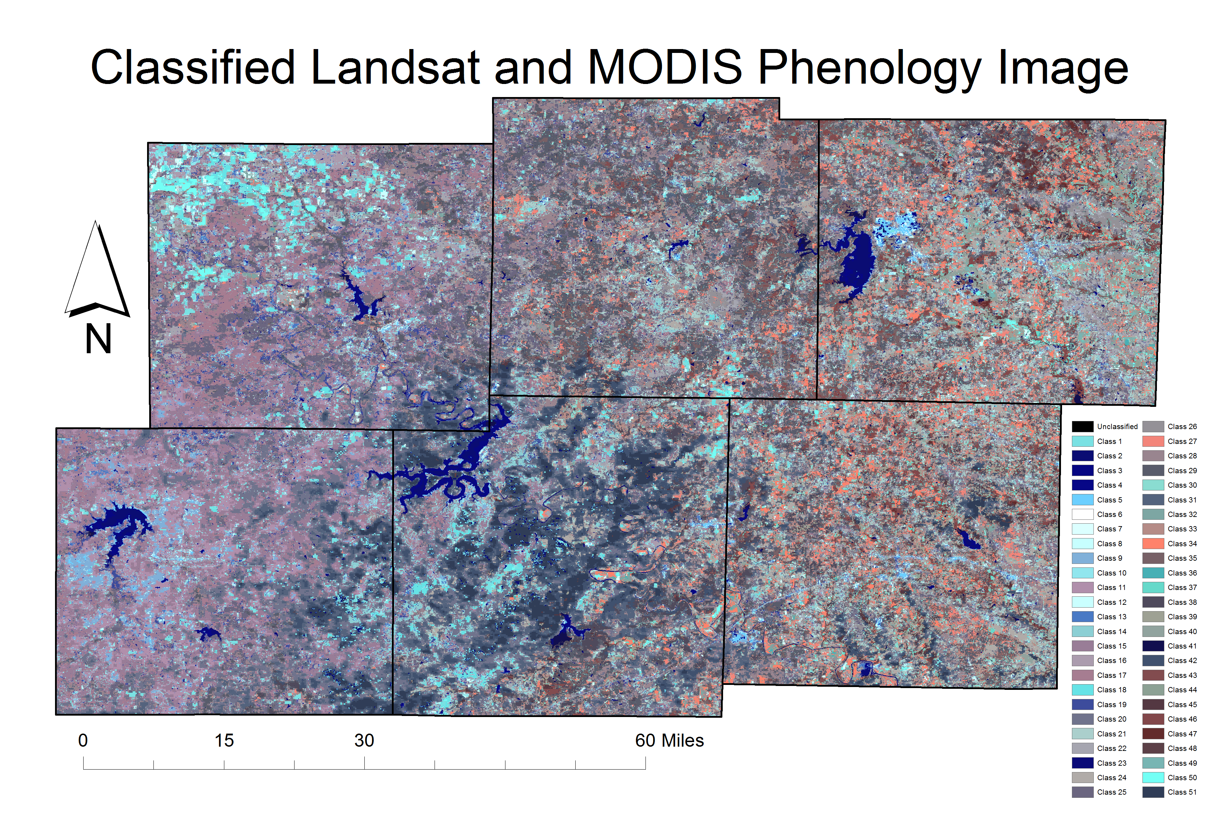
Figure 5. Classified image with 51 classes. Classes have similar phenolgy and Landsat infrared characteristics.

IV. Results & Discussion
During analysis of the MODIS phenology data an area of NDVI values in the south-central portion of the study area stood out as having similar phenology characteristics. This area showed a lower NDVI response during a drier than average year but during a wetter than average year the NDVI response was similar to the surrounding area (Figure 6). In order to determine what may be driving this phenological response, the classified image (Figure 5) was examined in detail.

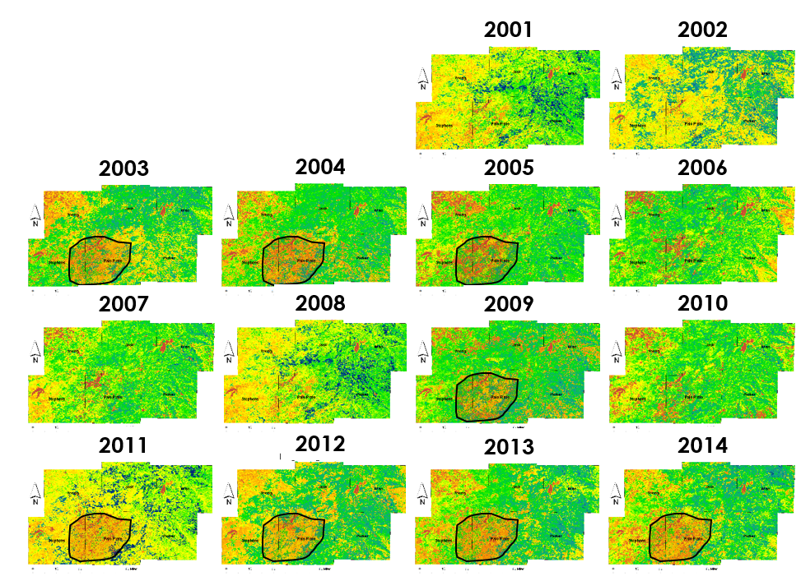
Figure 6. Outlined areas of similar Large Integral NDVI values during dry years.

As classes were highlighted within the classified image, an area in the south-central portion of the study area held a concentration of classes with similar phenology (Figure 7). This area was determined to be at a greater risk for wildfires in a dry year following a wet year. This high risk area corresponded with the 2011 Possum Kingdom Complex Fire (Figure 8).
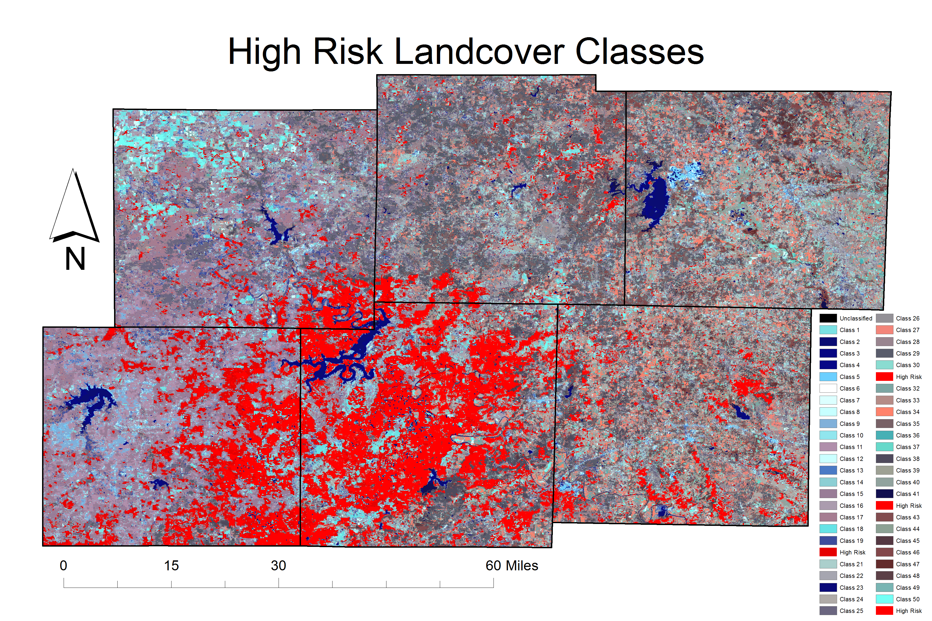
Figure 7. Four landcover classes clustered in the south central portion of the study area.
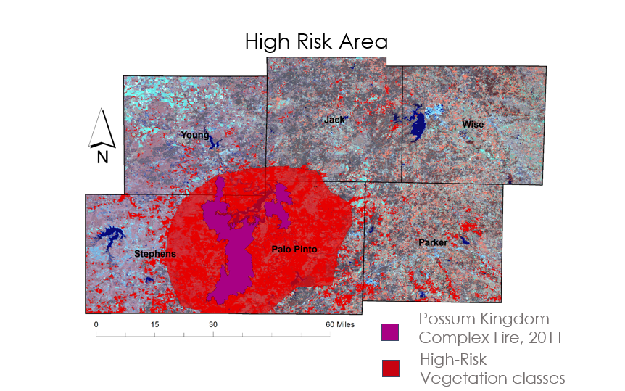
Figure 8.High risk area for wildfires (red) encompasses the Possum Kingdom Complex Fire (purple) from 2011.
In order to quantify the NDVI values and associated DOY values, mean values were extracted from selected vegetation classes within the high risk area (Figures 9 and 10). The data show that during a wet year (2010) the NDVI value was higher than the mean and the growing season was substantially longer than the mean. Additionally, during a dry year (2011) the NDVI values were lower and the growing season was shorter.

Figure 9. NDVI Magnitude comparing Mean, 2010, and 2012 values at specific points in the growing season. Values scaled by 10,000.
These numbers indicate that there was much more biomass that accumulated in 2010 that contributed to a more severe wildfire season in 2011. This buildup was due to longer growing season and higher NDVI values throughout the 2010 season.
Our team noted two key points that our partners may want to keep in mind in future fire seasons. If by mid-May the un-scaled NDVI value has not reached close to 0.6 within the majority of the High-Risk Area, there is a greater risk of wildfires. If the previous year had a growing season near 200 days long combined with a max NDVI of 0.7, the fuel load may contribute to more severe wildfires in the current year.
Sources of error could include misclassification of land cover types as well as mixed pixels from combining 30 m resolution Landsat data with 230 m resolution MODIS data. This may be resolved through the use of data fusion techniques such as STAR FM. Also, analysis of all points in the NDVI curve may lead to a better understanding of how the phenology responses vary throughout the year. Timing of the first freeze may also be a factor in severity of the next year’s fire season. Finally, masking the burn scar of major fires before data is processed may help eliminate errors.

Figure 10. DOY values corresponding to points in the phenology curve. Note low value for 2011 right 20% indicating short growing season.

V. Conclusions
There is a high-risk area within the study area that appears to have an enhanced phenological response to both wet and dry years relative to the surrounding area. This high risk may be driven more by soil type than climate (though the latter does contribute to risk). This area may experience greater risk for large, damaging wildfires given a La Nina climatic event after a previously lush year (e.g., 2011 versus 2010). As yearly climate swings grow more pronounced and growth continues in the area, this risk may escalate.

VI. Acknowledgments
The team would like to thank our Science Advisors, Joseph Spruce, NASA Stennis Space Center and Dr. Kenton Ross, NASA Langley Research Center. We would also like to thank our partners Tom Spencer and Curt Stripling with the Texas Forest Service and William Hargrove with the USDA Forest Service. Additionally we would like to thank the participants from the first term of this project for their previous work, Benjamin Beasley, NASA DEVELOP at Stennis Space Center, Alex Holland, NASA DEVELOP at Stennis Space Center, and Kristen Kelehan, NASA DEVELOP at Stennis Space Center. Finally, we would like to then the Texas Water Resources LaRC Summer 2015 team, Megan Buzanowicz, NASA DEVELOP at Langley Research Center, Laura Lykens, NASA DEVELOP at Langley Research Center, Zacary Richards, NASA DEVELOP at Langley Research Center, and Jeff Close, NASA DEVELOP at Langley Research Center.
Any opinions, findings, and conclusions or recommendations expressed in this material are those of the author(s) and do not necessarily reflect the views of the National Aeronautics and Space Administration.

This material is based upon work supported by NASA through contract NNL11AA00B and cooperative agreement NNX14AB60A.

VII. References
Hargrove, William, Joe Spruce, Gerry Gasser, Forrest Hoffman, and Danny Lee. "A New National MODIS-Derived Phenology Data Set Every 16 Days, 2002 through 2006." USDA Forest Service - Eastern Forest Threat Assessment Center, *NASA Stennis Space Center, and Oak Ridge National Laboratory.

National Wildfire Coordinating Group. "National Fire Danger Rating System (NFDRS)." Van Nostrand's Scientific Encyclopedia 2005. Web. 11 Oct. 2015.

Norman, Steven P.; Hargrove, William W.; Spruce, Joseph P.; Christie, William M.; Schroeder, Sean W. 2013. Highlights of satellite-based forest change recognition and tracking using the ForWarn System. Gen. Tech. Rep. SRS-GTR-180. Asheville, NC: USDA-Forest Service, Southern Research Station. 30 p.

Potter, Kevin M.; Conkling, Barbara L., eds. 2015. Forest health monitoring: national status, trends, and analysis 2013. General Technical Report SRS-207. Asheville, NC: U.S. Department of Agriculture Forest Service, Southern Research Station. 199 p.

"Texas A&M Forest Service Home Page." Texas A&M Forest Service Home Page. Web. Nov. 2015. http://texasforestservice.tamu.edu/

"US Forest Service." US Forest Service. Web. Oct. 2015. http://www.fs.fed.us/

VIII. Content Innovation
AudioSlides - 2015Fall_SSC_TexasDisastersII_TechPaper_AudioSlides.ppt

Featured Author Video - 2015Fall_SSC_TexasDisastersII_TechPaper_FeaturedAuthorVideo.mov

Interactive Map Viewer - - 2015Fall_SSC_TexasDisastersII_TechPaper_map.kmz

