**NASA DEVELOP National Program**



NASA Langley Research Center

*Summer 2015*

Heat-Health & Spatial Variation in Maricopa County, Arizona

Enhancing Extreme Heat Intervention and Preparedness Activities Using Remote Sensing and Spatial Analysis of Heat-Related Risks and Mortality in Maricopa County, Arizona

**Technical Report** 

Rough Draft – June 25, 2015

Amy Stuyvesant (Project Lead)

Geordi Alm

Rocky Garcia

Emma Baghel

April Rascon

Bernardo Gracia

Dr. David Hondula, Arizona State University (Science Advisor)

Dr. Kenton Ross, NASA DEVELOP National Program (Science Advisor)

# I. Abstract

Extreme heat causes more human fatalities in the United States than any other natural disaster, elevating the concern of heat-related mortality. Maricopa County, Arizona is specifically known for its high heat index and is the leading megapolitan area in the U.S. for population growth and urbanization. As Phoenix expands, the increase in urban strictures raises nighttime temperatures and induces a positive feedback loop, creating an urban heat island (UHI) effect. Individuals at higher risk are unequally distributed, leaving the poor, homeless, non-native English speakers, elderly, and socially isolated vulnerable to heat events. While this is a devastating incidence, it can be prevented. The Arizona Department of Health Services and the Phoenix Heat Relief Network, among others, are working to create more effectively placed cooling centers and heat warning systems to aid those with the highest exposure. Using NASA Earth observation technology from Landsat 8, Aqua (MODIS), and Terra (ASTER) satellites (sensors) the daily spatial and temperature variability within the UHI was quantified over the summer seasons of 2005 – 2014. A series of One-way Analysis of Variance revealed significant differences between daily surface temperature averages of the hottest 30% of census tracts within a single season. Visual analyses displayed shifts of where and how consistently the top 30% occur. These results provided detailed information regarding nuances within the UHI effect and will allow pertinent recommendations regarding the health department’s adaptive capacity. They also hold essential components for future policy regarding appropriate locations for cooling centers and efficient warning systems.

**Keywords**

Remote Sensing, Heat, Urban Climate, Spatial, Public Health, Vulnerability, Socioeconomic

# II. Introduction

**Project Objectives**

Our project created a hotspot consistency map of Maricopa County, Arizona for detection of extreme heat anomalies on various scales (i.e. daily, monthly, and seasonal). In conjunction, we determined the current use and frequent users of relief resources for establishing how this correlates with current socioeconomic vulnerability assumptions in literature. From this, we analyzed the variability within anomalies and survey results as a means of determining where, when, and how relief efforts could intervene.

**Current Issue - Urbanization & Heat-Related Risks**

With compounding issues from a warming climate and the vastly increasing rates of land use change to include more impermeable surfaces and less vegetative cover, dense urban areas around the globe are experiencing amplified urban heat island effects resulting in an increase in heat related and heat caused deaths (Anderson & Bell, 2010, Greene et al., 2011, Hartz et al., 2012, and Zhang et al. 2013). Maricopa County, Arizona is currently experiencing such a phenomenon. According to the U.S. Census Bureau, Maricopa County’s population increased by 10,160,000 individuals in a period of four years (USCB, 2015 and Hondula, 2014). Maricopa County, Arizona is the leading megapolitan area in the U.S. for population growth and urbanization (Hondula, 2014). On top of this, the area is specifically recognized for its high heat index (Hondula, 2014). The region’s hot desert climate and extended periods of high temperatures cause human health consequences to continually escalate and with the county’s increased rate of urbanization, extreme heat rises as a human health concern. (Coutts et al., 2007, Greene et al., 2011 and Hondula, 2014).

From 2006 to 2013, about 1,050 deaths due to extreme heat were reported (MCDPH, 2014 and Uejio, 2011). Other common and important physical health symptoms include heat cramps and heat exhaustion (Harlan, 2006 and Uejio, 2011). Those who were considered to be the most vulnerable (lack of resources to cope with the environmental threat) mirror other cities facing this issue and included males, elderly, poor, homeless, socially isolated, elderly, and minorities (MCDPH, 2014, Harlan, 2006, Johnson & Wilson, 2009). Most heat-related illnesses and deaths were found in major cities at home, sports and recreational areas, construction and industrial sites, and streets and highways (MCDPH, 2014 and Davis et al., 2003). While county wide relief efforts exist, there is currently no policy explicitly related to monitoring or preventing heat caused and heat related deaths.

Recent studies examine this phenomenon in Maricopa county in terms of satellite data on temperature and surface features of larger time scales and socioeconomic factors predicted and assumed from census type data(Dousset et al, 2011, Golden et al., 2008, Grossman-Clark et al., 2010, Harlan et al., 2012, and Hondula et. al, 2015). However, these studies have yet to examine the nuances of extreme heat days and nights, such as potential differences within the hot days themselves as well as throughout an entire season. On top of that, recent surveys conducted by MCDPH provide novel content in the actual distribution and use of relief aid resources, such as warning system deployment and cooling center location use. With our data we may then establish how these resources are used and how the daily heat threats vary in order to establish where future cooling centers and warning message systems could be deployed.

**Study Area and Study Period**

Maricopa County is a 9,203 square mile range located in the southwestern portion of Arizona (Rasmussen, 2012 and Golden, et al., 2008). This landscape includes steep, linear mountain ranges that alternate with lengthy deserts created from sand filling in the basins (Rasmussen, 2012). Due to Arizona’s diverse landscape, arid climate, and sparse cloud cover, the temperature varies dramatically from daytime to nighttime. Located in an arid subtropical climate, Maricopa County has an annual average high temperature of 88.5 °F and the highest average high during the month of July at 108 °F (U.S. Climate Data, 2015 and USA, 2015). The hottest temperature was 122 °F on July 27 and 28 in 1995. (Mesa.AZweather, 2014). Temperatures of 104-128 °F is NOAA’s Heat Index “danger” zone and serves as an appropriate threshold for severe heat stress as anything higher will likely result in sunstroke and heatstroke (Harlan, 2003). In most cases, the majority of heat distress calls occur during the hot and moist North American Monsoon period later in the summer when the ground gets excessively heated and that moisture-filled air rises along the mountain ranges to produce thunderstorms (Golden et al., 2008). This research focused on the extreme heat during the hottest months of the year from May through September during the period between 2005 and 2014.

**National Applications Addressed and Project Partners**

Our project primarily addressed Health & Air Quality as well as Climate. Partnering with this project are the Arizona Department of Health Services (ADHS), Maricopa County Department of Public Health (MCDPH), the GIS Lab at Arizona State University (ASU), and the Center for Policy Informatics (CPI) at ASU. ADHS coordinates the statewide heat safety task force, for which the MCDPH and ASU are active participants, and leads the state’s participation in Centers for Disease Control and Prevention’s (CDC) Building Resilience against Climate Effects initiative. Decision support tools and project findings were shared through statewide heat safety meetings.

# III. Methodology

DATA ACQUISITION

Ground truth data, to cross-reference remotely sensed air temperature, is available through the University of Utah’s MesoWest database. Utilizing the MesoWest API and python scripting, the data for 285 weather observation stations throughout Maricopa County was obtained from 2006 to present for the months of May through September (InlineSupp. 1). The data was then georeferenced in ArcMap and organized in a custom built geodatabase.

Surface temperature data came from NASA Earth observations, as did data for the land use classification (Table 1).

**Table 1:** **NASA Earth observations utilized**. Most data came from the MODIS (Moderate Resolution Imaging Spectroradiometer) sensor on the Aqua satellite. Data downloaded with ‘dnppy’ module. *Source*: Land Processes Distributed Active Archive Center (LP DAAC) FTP collection

|  |  |  |  |  |
| --- | --- | --- | --- | --- |
| **Name** | **Source** | **Dates** | **Details** | **Bands** |
| Aqua MODIS | LP DAAC FTP | May - Sept (2005 - 2015) | MYD11A1 Grid: h08v05 | land surface temperature/emissivity |
| Terra ASTER | LP DAAC FTP | May 2006 | ASTER Level 1B | all |
| Landsat 8 OLI TIRS | LP DAAC FTP | May 2006 | Path 41 Row 33 | all |

Shapefiles of Maricopa County were collected from the ASU Repository of GIS data. Percent of impermeable surfaces was used from the National Land Cover Database (NLCD), hosted by United States Geological Survey (USGS). National Centers for Environmental Prediction (NCEP) Reanalysis data were also utilized to determine the synoptic atmospheric conditions in the desert southwest during extreme heat events in Maricopa County (InlineSupp2). Community Assessment for Public Health Emergency Response (CASPER) survey data came from the Maricopa County Department of Health from 2006 - 2015 and additional data came from the Census Bureau database.

DATA PROCESSING AND ANALYSIS

**Task 1: Remote Sensing Climatology of Maricopa County Surface Temperatures to Isolate Extreme Heat Days and Nights**

*Processing*

The Kelvin (K) values of the MODIS product required band math applying the scale factor of 0.02 for true K values. Each ‘.hdf’ file was converted into ‘.tif’ format and projected into ‘Sinusoidal’ in order to ensure consistent projection of each file, performed with the ‘extract_from_hdf’ function in the ‘dnppy’ module. MODIS images were further subset to the contour line of Maricopa County using the ‘clip_to_shape’ function in the ‘dnppy’ module.

*Analysis*

The MODIS data are stored as a daytime and a nighttime surface temperature for each pixel. Once we pre-processed the MODIS data, we had a loosely based climatology of surface temperatures in Maricopa County for the specified date range.

**Task 2: Determine and Analyze How and When Extreme Heat Anomalies Occur**

*Processing*

The processed MODIS data used in Task 1 were also utilized for Task 2. We calculated census tract surface temperature averages for each clipped MODIS image, day and night, in RStudio using a census tract shapefile (InlineSupp 3). These surface temperatures were converted into degrees Celsius (C).

*Analysis*

Temperature anomaly dates were isolated with the weather station data by running a script in Matlab to separate all days with a maximum temperature above 104°F (313.15 K). We then ran a Python script to delete MODIS images not in this specified date file (InlineSupp 4). We first executed a chi-squared contingency table test for association where the variables tested were month (May – September) and year (2005 – 2014) and the count data compared was extreme heat days within each month for every year. Once this association was established, we isolated the average surface temperature of the hottest 30% of census tracts on all anomalous days.

Exploring measures of central tendency, a series of One-Way ANOVAs were performed in RStudio to compare how average daily temperatures averaged monthly of the top 30% hottest tracts compared throughout a season. Of seasons deemed significantly different, a post-hoc Tukey’s Honestly Significant Difference (HSD) test was performed to determine which months were statistically significant. The year 2012 was isolated for more in depth analysis as it had the most normal distribution and the most usable images (Appendix 1). These figures examined trends throughout the season of each cloud free anomalous day and night where the season was split into early-, mid-, and late-season categories.

**Task 3: Model Predictions for Current State of Resource Use**

*Processing*

Survey results were converted from ArcMap ‘.xlsx’ into a ‘.csv’ for analysis in RStudio. Once in RStudio data columns will be stacked appropriately for the particular analysis and subsets will be created to facilitate a more organized data analysis approach.

*Analysis*

In RStudio we performed a binary logistic regression to determine what demographic factors relate to certain uses of relief aid. This looked at the likelihood of AC use (with the outcome variable as ‘yes’ or ‘no’) versus various predictor variables (income, if the household contains a non-English speaker, percent non-white individuals).

**Task 4: Maps of Heat Recurrence with Surface Feature Classification**

*Processing*

The MODIS surface temperatures averaged over census tracts was utilized for the spatial consistency map.

For the purposes of classification, Landsat 8 Bands 2, 3, and 4 were first pan-sharpened to a 15m resolution and stacked. This image was then converted to reflectance by using the conversion information in the metadata files in order to ensure normalized results over the various sensors using the following equations:

*ρλ'* = *MρQcal* + *Aρ* and $ρλ= \frac{ρλ'}{sin(θSE)}$,

**Equation 1**: Converting digital number of pixel to a reflectance value, where *Mρ* represents the multiplicative value, *Qcal* represents the band being converted, and *Aρ* represents the additive value. Note: sun elevation angle (SE) is converted from degrees to radians *Source*: Using the USGS Landsat 8 Product. *USGS* <<http://landsat.usgs.gov/Landsat8_Using_Product.php>>, Accessed 17 June 2015.

ASTER images of the same study period have been downloaded and may be used next term as a possibly better proxy for the fine-tuned land classification that distinguishes types of urban environments.

*Analysis*

Using Model Builder in ArcGIS, we input each anomalous day for a season and tracked the number of occurrences each tract ranked in the hottest 30% throughout the season to create a percent of spatial consistency for each tract (InlineSupp 5). We overlaid the spatial location of respondents answering that something actively prevents them using A/C in their household. We compared these hotspot regions to already generated maps by Sharon Harlan et al., (2013). Harlan’s research specifically maps mortalities with average surface temperature, while our maps use a broader scope including those who suffer from heat related and heat caused illnesses. We visually analyzed how daily anomalies compare with current maps.

To further this analysis, we completed a supervised classification of the Landsat 8 images that had been pre-processed and converted into reflectance to determine what surface features are under these hot spots. As an added measure, we looked at the NLCD’s information on percent of impermeable surfaces in the study area to see if there is a correlation between the consistently hottest tracts and the percent of impermeable surfaces underneath.

# IV. Results & Discussion

**Task 2: Determine and Analyze How and When Extreme Heat Anomalies Occur**

A chi-squared contingency table test for association was performed (InlineSupp 6) to determine if there is a significant association between month (May – September) and year (2005 – 2014) for counts of extreme heat days. The analysis yielded a significant association (χ2(36) = 66.83, *p* = 0.001, α = 0.05) between month and year (Table 2).

**Table 2**: Temperature heat anomaly days (n = 768) for month (May – September) and year (2005–2014). *Source*: University of Utah’s MesoWest database.

|  |  |  |  |  |  |  |  |  |  |  |
| --- | --- | --- | --- | --- | --- | --- | --- | --- | --- | --- |
|  | ***Study Years*** | | | | | | | | | |
| ***Month*** | **2005** | **2006** | **2007** | **2008** | **2009** | **2010** | **2011** | **2012** | **2013** | **2014** |
| **May** | 5 | 7 | 2 | 3 | 4 | 0 | 0 | 6 | 0 | 6 |
| **June** | 12 | 27 | 20 | 19 | 8 | 19 | 15 | 22 | 29 | 25 |
| **July** | 28 | 22 | 21 | 25 | 26 | 27 | 24 | 22 | 22 | 25 |
| **August** | 13 | 13 | 20 | 20 | 24 | 21 | 27 | 20 | 21 | 15 |
| **September** | 8 | 2 | 12 | 5 | 10 | 18 | 14 | 7 | 11 | 10 |
| ***Total*** | **66** | **71** | **75** | **72** | **72** | **85** | **80** | **77** | **83** | **81** |

Of note, July and August did not yield values very different from the expected count value, while May revealed the most variation. Additionally, in 2006 May represented 9.8% of the extreme heat days while the two years with the highest overall count, 2010 and 2013, May represented 0% of the days. Given that May is in the beginning of the summer season and July and August are in the middle, the results concur the beginning of the season is more vulnerable to variability in number of heat events between years while mid-season heat day count is fairly consistent over time. This will aid the focus of adaptive capacity for decision makers choosing when to focus on deploying additional relief resources.

To narrow in on what is going on in these extreme heat days, one-way ANOVAs were performed to compare average surface temperature (C) between months for each year in the study period for both daytime (Appendix 2/InlineSupp. 7) and nighttime (Appendix 3/InlineSupp. 8) values. For daytime temperatures, tests revealed three patterns with significant results, depicted in the years 2005 (F(4,40) = 2.623 *p* = 0.049, α = 0.05), 2012 (F(4,29) = 5.102 *p* = 0.003, α = 0.05), and 2014 (F(4, 35) = 4.251 *p* = 0.006, α = 0.05). Post-hoc testing using Tukey’s HSD revealed which months significantly differ from one another (Figure 1). The same analyses were repeated for extreme heat nights, where all years were significant (Appendix XX). Matching the daytime example years, 2005 (F(3,25) = 5.60, *p* = 0.003), 2012 (F(4,27) = 10.63, *p* < 0.001), and 2014 (F(4,47) = 11.23, *p* < 0.001) post-hoc testing also demonstrated which months are significantly different (Figure 2).

**Summer Daily Average Surface Temperatures Averaged Monthly**

**in Maricopa County, AZ (2005, 2012, 2014)**

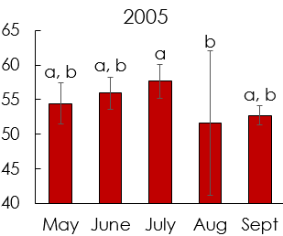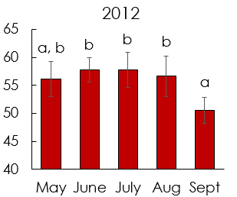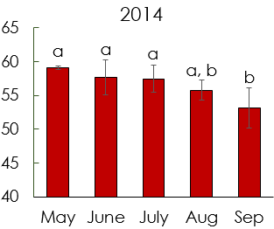

**Figure 1**: Average daily surface temperature (C) for each month in the year 2006 (left), 2012 (middle), and 2014 (right) in Maricopa County, AZ. Averages represent the hottest 30% of census tracts for each day that were then averaged monthly. Like letters above error bars indicate values that are not significantly different. *Source*: Aqua/MODIS MYD11A1 LST L3 product.

**Summer Nightly Average Surface Temperatures Averaged Monthly**

**in Maricopa County, AZ (2005, 2012, 2014)**

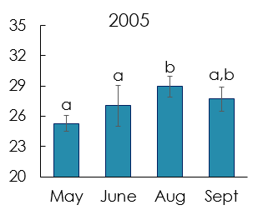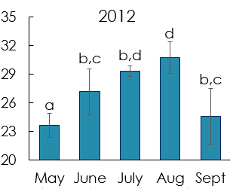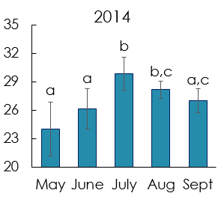

**Figure 2**: Average nightly surface temperature (C) for each month in the year 2006 (left), 2012 (middle), and 2014 (right) in Maricopa County, AZ. Averages represent the hottest 30% of census tracts for each day that were then averaged monthly. Like letters above error bars indicate values that are not significantly different. *Source*: Aqua/MODIS MYD11A1 LST L3 product.

Monthly averages do vary throughout the season, with a general peak of significantly higher values in the mid-season averages. Narrowing the scope to daily variation, averages of the hottest 30% tracts were visualized with the average of the rest of the tracts for individual days and were broken up into early-season (May 1 - 31), mid-season (June 29 - August 13), and late-season (August 28 - September 30).

For the day temperatures, we found a large variability between days with as much as 10°C difference between days (Figure 3). On top of that, the highest average in the early season is comparable to mid-season averages (Figure 3). Although May’s monthly average is generally lower than July and August, isolated days can reach rivaling temperatures to July and August, suggesting warning messages could reflect this to the public, as their health may be at an equally high of risk. For night temperatures, each part of the season is fairly consistent and distinct (Figure 4) with a lag of warmer temperatures lasting into the late season, not apparent in the daytime averages. Although daytime temperatures are lowering relative to earlier dates, the heat is remaining trapped at night into the late season and these temperatures are not lowering compared to the mid-season. Warning messages have the potential to ensure the public is knowledgeable about this sustained health risk into the late season.

**Daily Average Surface Temperature in Maricopa County, AZ**

**(early-, mid-, and late-season)**

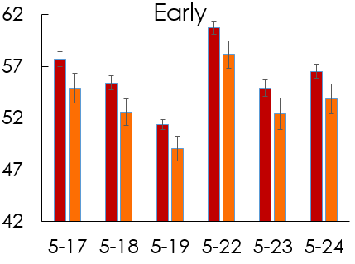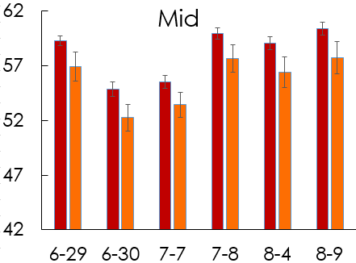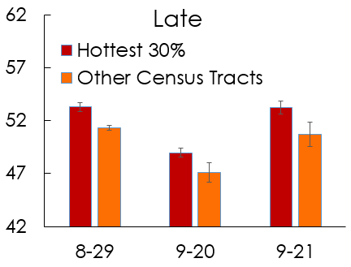

**Figure 3**: The top 30% hottest census tracts averaged daily next to the corresponding daily average of the rest of the census tracts in the same day. This is split between early season (May 1 - May 31), mid-season (June 29 - August 13), and late season (August 28 - September 30) for the year 2012 in Maricopa County, AZ. Source: Aqua/MODIS MYD11A1 LST L3 product.

**Nightly Average Surface Temperature in Maricopa County, AZ**

**(early-, mid-, and late-season)**

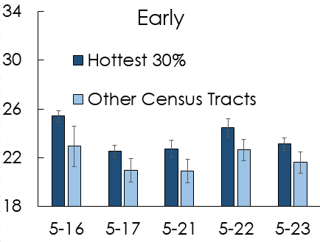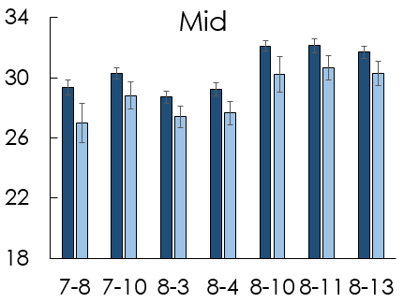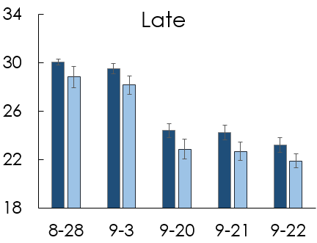

**Figure 4**: The top 30% hottest census tracts averaged nightly next to the corresponding nightly average of the rest of the census tracts in the same day. This is split between early season (May 1 - May 31), mid-season (June 29 - August 13), and late season (August 28 - September 30) for the year 2012 in Maricopa County, AZ. Source: Aqua/MODIS MYD11A1 LST L3 product.

**Task 3: Model Predictions for Current State of Resource Use**

In an effort to add more context to the human concern of A/C, a binary logistic regression using median income to regress survey responses of individuals not using A/C for some reason, such as cost or their homes not being equipped with A/C (Table 3).

**Table 3**: Binary logistic regression for census bureau income and survey response of having a non-english speaker in the household on likelihood of answering that something prevents individual from using A/C. *Source*: MCDPH’s CASPER survey results (2006 - 2014).

|  |  |  |  |  |
| --- | --- | --- | --- | --- |
| **Term** | **Coefficient** | **St. Error** | **Z-Value** | ***p*-value** |
| **Intercept** | 1.84 | 0.432 | 1.415 | 0.157 |
| **Income** | 1.00 | 5.33E-06 | 1.236 | 0.216 |
| **Non-English (Yes)** | 0.999 | 0.3561 | -2.798 | 0.005 ** |
| **Percent Non-White** | 0.997 | 0.00717 | -0.340 | 0.734 |

Having someone in the household that does not speak English proved the only significant predictor of likelihood of A/C use. This fits assumed patterns in the literature and suggests further efforts to deploy warning messages and outreach material regarding cooling centers to non-English speakers. Income not being significant may be because we used census bureau median income rather than the respondent's actual income. When we compared the percent of non-white residents between Census Bureau data and survey data, the survey regression still came back as insignificant but the p-value lowered greatly (p = 0.734 to p = 0.07). While this result was not significant, it does suggest utilizing income values of actual households could produce significant results.

When comparing current literature results from Harlan et al. (2013), the northern two regions matched (Appendix 4/InlineSupp. 9). Harlan’s study also highlighted the downtown area as having substantial deaths. While our study did show these as consistently hot tracts, there was not a clear clumping of survey respondents answering they do not use A/C. This either indicates the downtown area was not thoroughly surveyed, or the fatalities in this area are not related to lack of A/C. Additionally, our hotspots highlight other phenomena outside of mortalities, such as those suffering from heat related or heat caused illnesses.

**Task 4: Maps of Heat Recurrence with Surface Feature Classification**

In terms of spatial consistency, for the example year of 2012 we mapped census tracts occurring between 41 - 51 %, 31 - 40%, 21 - 30%, 11 - 20%, and 2 - 10% of the time throughout the season (Figure 5). We overlaid survey responses from the CASPER results of respondents answering “Yes” to the question regarding if they did not use A/C for some reason. We created a similar map for the entire study period to demonstrate the consistency between years, where the three isolated areas of highest incidence are the same for 2012 and the entire study period (Figure 5).

**Hotspots for Neighborhood Vulnerability to Extreme Heat Events for 2005 - 2014**

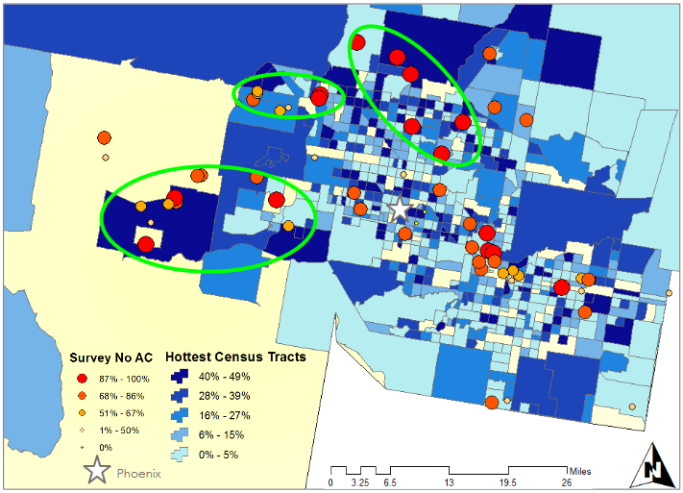

**Figure 5**: Daily average surface temperatures to determine consistency throughout season (blue shades, 2005 - 2014) mapped with CASPER responses to question regarding respondents not using A/C (red to orange). Note: Green circles identify regions of residents at highest risk throughout entire season. *Source*: Aqua/MODIS MYD11A1 LST L3 product and CASPER survey.

To begin addressing the ‘why’ questions related to this problem we began a land use classification using pan-sharpened Landsat 8 images (Figure 6). We compared these to the NLCD percent land cover (Figure 6).

**Land Use Classification Assessment of Landsat 8 Imagery**

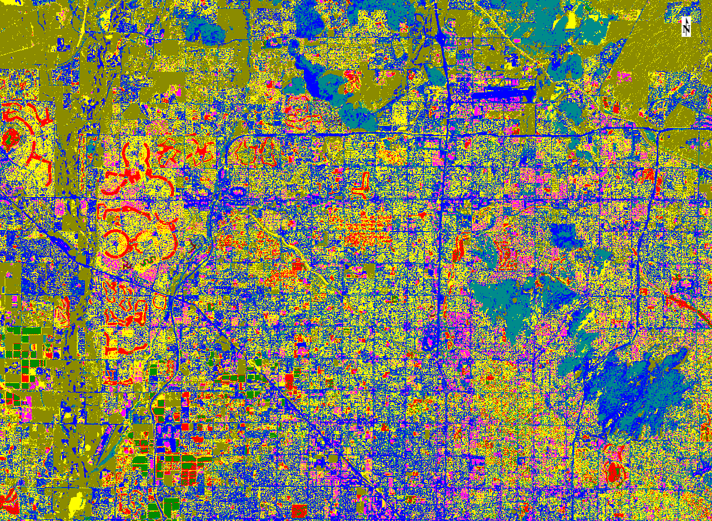

**Figure 6**: Land use classification for a pan-sharpened 15m Landsat 8 bands 4-3-2 on May 1, 2013 of specific urban surface (left) and NLCD percent of impervious surfaces for 2011(right). Source: Landsat 8 OLI/TIRS and NLCD/USGS.

We aimed to assess the accuracy of implementing 15m resolution imagery to try and distinguish between residential areas (yellow), urban areas (pink), major roads (blue), healthy green vegetation (light green), concrete (red), bare land (forest green), sparse vegetation (teal), and water (black). Based on our first attempts, 15m resolution of a true color image does not seem to be an accurate way to classify these land areas. A finer resolution or a more advanced classification scheme that encompasses spectral mixing of an individual pixel would provide more accurate results.

# V. Conclusions

When looking at both the count of extreme heat days and the actual daily temperature averages of the 30% hottest census tracts, the early season consistently large variability between days. The deployment of warning messages must anticipate that people will need to be warned a varying amount in terms of how often messages are deployed and the level of severity. Similarly, warning messages must be continued to be deployed into the late season and cooling centers must remain available due to the lag of warm night temperatures. Even though surfaces are cooling during the day, the heat is being held creating consistently warm nights, meaning residents are still not receiving the relief they need at night and therefore their health is still at risk. The three regions we isolated that are consistently hot throughout the season and house residents not able to use A/C could be targeted for specific warning messages. Furthermore, cooling center locations may be present, plentiful, and within close proximity to all residents in these areas.

# VI. Acknowledgments

Special thanks to David Hondula (science advisor), Dr. Kenton Ross (NASA science advisor), Emily Adams and Dan Wozniak (Center Lead and Assistant Center Lead) Jeff Ely (DEVELOP geoinformatics), and Grant Mercer (DEVELOP participant).

This material is based upon work supported by NASA through contract NNL11AA00B and cooperative agreement NNX14AB60A.

# VII. References

Anderson, G., & Bell, M. L., 2010, Heat Waves in the United States: Mortality Risk during

Heat Waves and Effect Modification by Heat Wave Characteristics in 43 U. S. Communities, Environmental health perspectives, v. 119,no. 2,p. 210-218.

Coutts, A. M., Beringer, J., & Tapper, N. J., 2007. Impact of increasing urban density on

local climate: spatial and temporal variations in the surface energy balance in

Melbourne, Australia, Journal of Applied Meteorology and Climatology, v. 46, no.

4, p. 477-493.

Davis, R.E., Knappenberger, P.C., Michaels, P.J., & Novicoff, W.M., 2003, Changing heat

related mortality in the United States: Environmental Health Perspectives, v. 111,

no. 14, p. 1712-1718.

Dousset, B., Gourmelon, F., Laaidi, K., Zeghnoun, A., Giraudet, E., Bretin, P., ... &

Vandentorren, S. (2011). Satellite monitoring of summer heat waves in the Paris

metropolitan area. *International Journal of Climatology*, *31*(2), 313-323.

Golden, J.S., Hartz, D.H., Brazel, A, et al., 2008, A biometeorology study of climate and

heat-related morbidity in Phoenix from 2001 to 2006: International Journal of

Biometeorology, v. 52, p. 471-480, doi: 10.1007/s00484-007-0142-3.

Greene, S., Kalkstein, L. S., Mills, D. M., & Samenow, J, 2011, An examination of climate

change on extreme heat events and climate-mortality relationships in large US cities, Weather, Climate, and Society, v. 3,no. 4,p. 281-292.

Grossman-Clarke, S., Zehnder, J. A., Loridan, T., & Grimmond, C. S. B, 2010, Contribution

of land use changes to near-surface air temperatures during recent summer

extreme heat events in the Phoenix metropolitan area, *Journal of Applied*

*Meteorology and Climatology*, v. *49*,no. 8,p. 1649-1664.

Harlan, S.L., Brazel, A.J., Prashad, L., et al., 2006, Neighborhood microclimates and

vulnerability to heat stress: Social Science & Medicine: v. 63, p. 2847-2863.

Harlan, S. L., Declet-Barreto, J. H., Stefanov, W. L., & Petitti, D. B., 2012, Neighborhood effects on heat deaths: social and environmental predictors of vulnerability in

Maricopa County, Arizona. Environmental health perspectives, v.121,no. 2,p. 197

204.

Hartz, D. A., Golden, J. S., Sister, C., Chuang, W. C., & Brazel, A. J, 2012, Climate and heat-related emergencies in Chicago, Illinois (2003–2006), *International journal of*

*biometeorology*, v. *56,no.* 1,p. 71-83.

Hondula, D.M., Georgescu, M., and Balling Jr., R.C., 2014, Challenges associated with

projecting urbanization-induced heat-related mortality: Science of the Total

Environment, v. 490, p. 538-544. doi:10.1016/j.scitotenv.2014.01.130

Hondula, D.M., Davis, R.E., Saha, M.V., et al., 2015, Geographic dimensions of heat

related mortality in seven U.S. cities: Environmental Research, v. 138, p. 439-452.

Johnson, D. P., & Wilson, J. S, 2009, The socio-spatial dynamics of extreme urban heat

events: the case of heat-related deaths in Philadelphia, Applied Geography, v.

29,no. 3,p. 419-434.

LoVecchio, F., Stapczynski, J.S., Hill, J., et al., 2005, Heat-related mortality-Arizona, 1993

2002, and United States, 1979-2002: Morbidity and Mortality Weekly Report, v. 54,

p. 628-630.

Maricopa County Department of Public Health: Division of Disease Control: Office of Epidemiology (MCDPH), 2014, Heat-Associated Deaths in Maricopa County, AZ Final Report For 2013, <http://www.maricopa.gov/publichealth/Services/EPI/pdf/heat/2013annualreport.pdf> (accessed June 2015).

Mesa.AZweather, 2014, Annual Data Table:

<http://www.mesa.azweather.com/archives/history-table.html> (accessed June 2015).

National Weather Service, 2015, National Oceanic and Atmospheric Administration:

NWS Heat Index: <http://www.nws.noaa.gov/om/heat/heat_index.shtml>

(accessed June 2015).

Rasmussen, J.C., 2012, Geologic History of Arizona: Rocks and Minerals, v. 87, no. 1, p.

56-63.

Uejio, C.K., Wilhelmi, O.V., Golden, J.S., et al., 2011, Intra-urban societal vulnerability to

extreme heat: The role of heat exposure and the built environment,

socioeconomics, and neighborhood stability: Health & Place, v. 17, p. 498-507.

United States Census Bureau (USCB), 2015, QuickFacts Beta: Maricopa County, AZ:

<http://www.census.gov/quickfacts/table/POP010210/00> (accessed June 2015).

U.S. Climate Data, 2015, Climate Maricopa - Arizona:

[http://www.usclimatedata.com/climate/maricopa/arizona/united](http://www.usclimatedata.com/climate/maricopa/arizona/united%09states/usaz0131)

[states/usaz0131](http://www.usclimatedata.com/climate/maricopa/arizona/united%09states/usaz0131) (accessed June 2015).

USA, 2015, Maricopa County Weather: [http://www.usa.com/maricopa-county-az](http://www.usa.com/maricopa-county-az%09weather.htm)

[weather.htm](http://www.usa.com/maricopa-county-az%09weather.htm) (accessed June 2015).

Zhang, H., Qi, Z. F., Ye, X. Y., Cai, Y. B., Ma, W. C., & Chen, M. N, 2013, Analysis of land

use/land cover change, population shift, and their effects on spatiotemporal

patterns of urban heat islands in metropolitan Shanghai, China, Applied Geography, v. 44,p. 121-133.

# VIII. Content Innovation

KMZ File of final map in developexchange folder.

Inline Supplementary files in developexchange folder.

# 

# 

# IV. Appendices

Appendix 1:

A major consideration of using space based observation platforms is the data quality limitations set forth by cloud cover and other sensor inhibitors. For this reason we established a method to only utilize MODIS images that are among the best quality for this analysis framework. Once the MODIS Image was clipped to the county census tracts and those values extracted, every image that reported an “NA” value for 150 or greater tracts was discarded. Below are graphs depicting the number of Heat Days per month, as well as the number of useable day and nighttime images. The most apparent observation that can be made from these graphs is the disparity in monthly data quality. The July and August season mark the beginning of the summer Monsoon, which contributes a large amount of cloud cover to the region and is the primary inhibitor of MODIS satellite image quality. A more nuanced observation was the diurnal effects on data quality, which is assumed to be attributed to the lack of thunderstorm convection overnight and the building of atmospheric subsidence aloft which decreases the amount of cloud cover overnight.

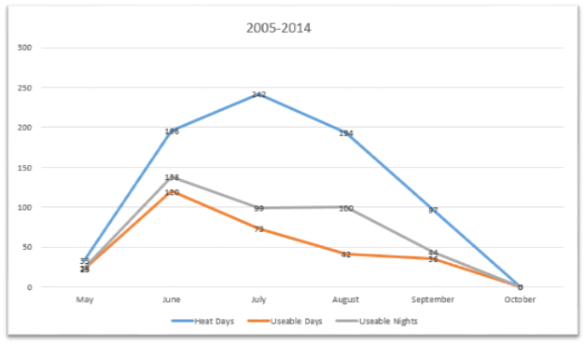

|  |  |
| --- | --- |
|  |  |
|  |  |
|  |  |
|  |  |
|  |  |

Appendix 2: ANOVA and post-hoc testing for all day months

**Summer Nightly Average Surface Temperatures Averaged Monthly**

**in Maricopa County, AZ (2006 - 2013)**

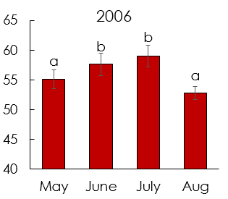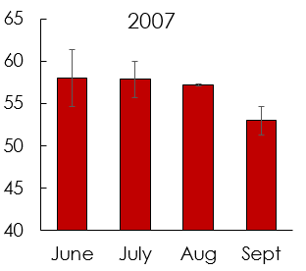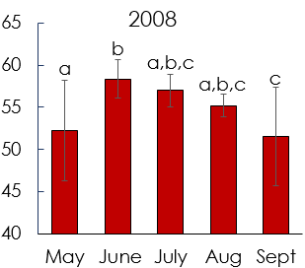

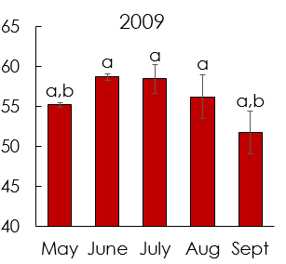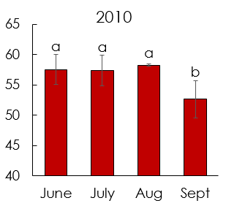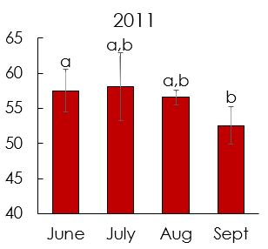

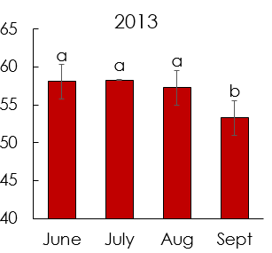

**Figure 7**: Daily averages further averaged monthly of the hottest 30% of census tract for months. All years, except 2007, showed significant results – 2006 (F(3,27) = 10.80, *p* < 0.001), 2008 (F(4,29) = 5.56, *p* = 0.002), 2009 (F(4,30) = 8.12, *p* < 0.001), 2010 (F(3,38) = 10.69, *p* < 0.001), 2011 (F(3,22) = 4.51, *p* < 0.01), and 2013 (F(3,32) = 7.34, *p* < 0.001). Post-hoc testing determined which months are significantly different. Note: like letters indicate months that are not significantly different. In addition, missing years are in body of technical paper and missing months are due to either a lack of cloud free images or the month did not have any extreme heat days (see chi-squared table for count of extreme heat days). *Source*: Aqua/MODIS MYD11A1 LST L3 product.

Appendix 3: ANOVA and post-hoc testing for all night months

**Summer Nightly Average Surface Temperatures Averaged Monthly**

**in Maricopa County, AZ (2006 - 2013)**

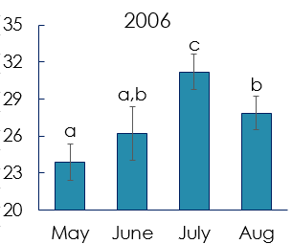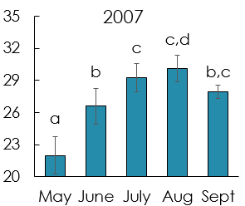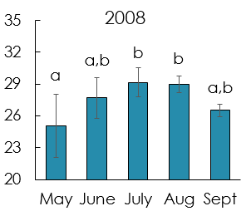

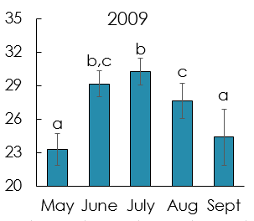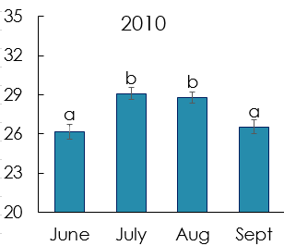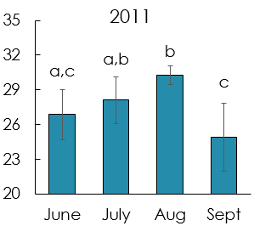

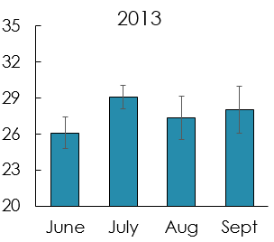

**Figure 8**: Nightly averages further averaged monthly of the hottest 30% of census tract for months. All years showed significant results – 2006 (F(3,37) = 22.61, *p* < 0.001), 2007 (F(4,45) = 24.80, *p* < 0.001), 2008 (F(4,34) = 4.80, *p* = 0.004), 2009 (F(4,36) = 19.50, *p* < 0.001), 2010 (F(3,49) = 8.84, *p* < 0.001), 2011 (F(3,41) = 13.27, *p* < 0.001), and 2013 (F(3,29) = 7.58, *p* < 0.001). Post-hoc testing determined which months are significantly different. Note: like letters indicate months that are not significantly different. In addition, missing years are in body of technical paper and missing months are due to either a lack of cloud free images or the month did not have any extreme heat days (see chi-squared table for count of extreme heat days). *Source*: Aqua/MODIS MYD11A1 LST L3 product.

Appendix 4: Maps created by Harlan et al., 2013.

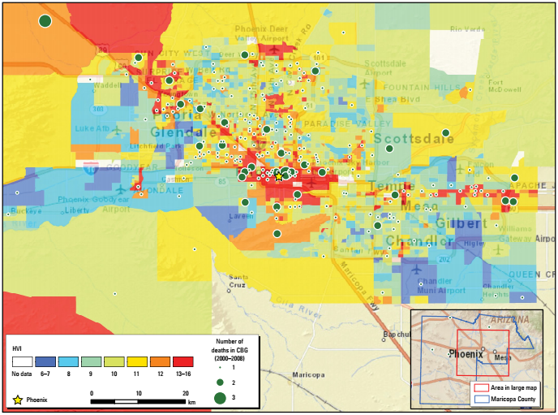

**Figure9**: “HVI scores (using a method modified from Reid et al. 2009) mapped for 2,081 census block groups (CGBs) in Maricopa County, Arizona. Higher scores represent higher vulnerability. The map inset in the lower right corner indicates the urbanized area of Maricopa County (red box) shown in the larger map. The county, which also contains a much larger area of uninhabited desert and sparse settlement, is outlined in blue. The urbanized area covers all the cities and all but one of the major towns in the county. Residences of only four people who died from heat exposure were located outside the urbanized area (green circles in inset).” Source: Harlan et al., 2013.

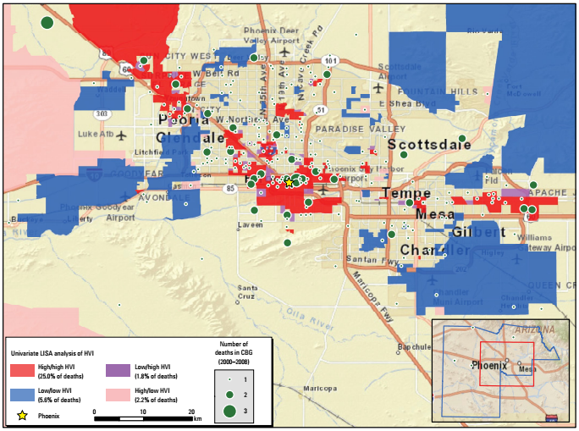

**Figure 10**: “Univariate analysis of the LISA-identified clusters of census block groups (CBGs) in Maricopa County, Arizona, with similar or dissimilar HVI scores (*p*-value ≤ 0.05). High/high areas in the map are clusters of neighboring CBGs with uniformly high vulnerability scores; low/low areas are clusters with low vulnerability scores; low/high areas represent a CBG with a low vulnerability score neighbored by high vulnerability CBGs; high/low areas represent a CBG with a high vulnerability score neighbored by low vulnerability CBGs. Entries in the legend (next to the colored boxes) also show the percentages of 2000–2008 heat-related decedents who were residents in each type of cluster.” Source: Harlan et al., 2013.

Appendix 5: Additional Maps and Figures

The following figures, Hot Seasons 2006-2013, display ECMWF Reanalysis Data (2-Meter Air Temperature). The synoptic type classification indicates a consistent hot weather regime in the desert southwest, particularly located in the Arizona Basin and Range region highlighted in Figure 1.

|  |
| --- |
| Figure 1 – The summer season for 2012 displays the average 2 – Meter Air Temperature Maxima located in the Arizona Basin and Range, covering the southwesternmost area of the state. This region is consistently contains the highest air temperatures in the country. |
| Figure 1.1 - Hot Season 2006 |
| Figure 1.2 - Hot Season 2007 |
| Figure 1.3 - Hot Season 2008 |
| Figure 1.4 - Hot Season 2009 |
| Figure 1.5 - Hot Season 2010 |
| Figure 1.6 - Hot Season 2011 |
| Figure 1.7 - Hot Season 2012 |
| Figure 1.8 - Hot Season 2013 |

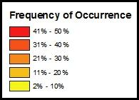

Figures 2.1-2.9 display the seasonal spatial variation, by census track, of the areas of Maricopa County that are consistently among the hottest in the county. Surface temperature values were determined for each census track on a heat day* in a season. The top 30% were selected for each day and then compiled for the entire season. The data was then reclassified and an occurrence score was assigned to each track. The maps below are displaying the frequency of occurrence, normalized by a percent of the total, of each track in the top 30%. For example, a **RED** tract was among the most consistently warm tracts, in this case a track would have have been highlighted in the top thirty percent on a hot day, 41%-50% of the season.

*Heat days were determined by parsing the KPHX (Phoenix International Airport) hourly weather observations for days that met or exceeded a 24-Hour high temperature of 104 ºF.

|  |  |
| --- | --- |
| Figure 2.0 – Hot Season 2005 | Figure 2.1 – Hot Season 2006 |
| Figure 2.2 – Hot Season 2007 | Figure 2.3 – Hot Season 2008 |
| Figure 2.4 – Hot Season 2009 | Figure 2.5 – Hot Season 2010 |
| Figure 2.6 – Hot Season 2011 | Figure 2.7 – Hot Season 2012 |
| Figure 2.8 – Hot Season 2013 | Figure 2.9 – Hot Season 2005 |