Huntsville Urban Development II

Utilizing NASA Earth Observations to Map the Urban Heat Island and Evaluate Vulnerability in Huntsville, Alabama

 **Technical Report**

August 11th, 2023

James Karroum (Project Lead)

Awroni Bhaduri

Kindrea Gibbons

Natalie O’Kraski

***Advisors:***

Dr. Jeffrey Luvall, NASA Marshall Space Flight Center (Science Advisor)

Dr. Robert Griffin, The University of Alabama in Huntsville (Science Advisor)

***Previous Contributors:***

Greta Paris

Sabine Nix

Thomas Quintero

Amanda Tomlinson

***Fellow:***  
Laramie Plott (LaRC)

# 1. Abstract

Huntsville, Alabama has seen a boom in growth over recent years. One consequence of this urban expansion is the exacerbation of the Urban Heat Island (UHI) effect across the city. This project identified the areas within Huntsville the greatest potential for heat reduction and community health benefits from tree-planting efforts. The team created maps of land surface temperature (LST), the normalized difference vegetation index (NDVI), and the normalized difference built-up index (NDBI) over June through August from 2019 to 2022 using data from ECOsystem Spaceborne Thermal Radiometer Experiment on Space Station, Landsat 8 Operational Land Imager (OLI) and Thermal Infrared Sensor (TIRS), Landsat 9 OLI-2 and TIRS-2. The team identified areas with high LST, low NDVI, and high NDBI as areas with the greatest potential for heat reduction via tree-planting. Social factors relating to age, race, income, and self-reported health were adapted from Tree Equity Score to map community need for tree cover. When combining social with environmental factors, the team determined areas with the greatest potential for UHI mitigation: west-central and north downtown Huntsville. The team’s partner organization, the City of Huntsville, can use this priority map to guide their future tree-planting, and weigh the factors assessed according to their preference.

**Key Terms**

Urban heat island, land surface temperature, NDVI, NDBI, NLCD, ECOSTRESS, Maxar

# 2. Introduction

***2.1 Background Information***

An urban heat island (UHI) is an urbanized area that experiences higher temperatures due to reduced natural landscapes and the properties of urban materials, leading to increased energy consumption, decreased air quality, and adverse human health impacts (EPA, 2022a; Jacob & Winner, 2006; Stone, 2008). Major causes of the UHI include changes in how surfaces reflect, emit, and conduct heat due to the replacement of vegetation with asphalt and concrete (Luvall et al., 2019); wind flow disruptions from elevated structures; decreased water infiltration through paved surfaces; and decrease in soil moisture resulting in lower evapotranspiration rates (Comarazamy et al., 2013). Another factor that compounds the creation of UHI is urban canyons, which are created when building walls on opposite sides of a street absorb longwave radiation emitted by surfaces at night, trapping energy between buildings and increasing temperatures within the city (Comarazamy et al., 2013). The UHI increases the demand for electricity, and the burning of fossil fuels emits air pollutants and greenhouse gases (EPA, 2022c). Two types of these pollutants — nitrogen oxides and volatile organic compounds — react in the presence of heat and sunlight to form ground-level ozone, another pollutant. These reactions occur more with the elevated temperatures caused by the UHI (EPA, 2023). Increased temperatures from the UHI have direct effects on human health. For instance, exposure to temperatures over 35°C for an extended period prevented metabolic heat dissipation and increased the likelihood of death or acquiring a heat-related illness (Dousset et al., 2019). The elderly, children, individuals with preexisting disabilities, and underprivileged households are all particularly susceptible to heat morbidity from the UHI (Dousset et al., 2019).

One common UHI mitigation strategy is through tree-planting initiatives that target areas with high surface thermal energy and elevated air pollutant concentrations (Luvall et al., 2015). Another strategy is green roofing, a vegetative layer on roofs that provides shade and enables evapotranspiration (EPA, 2022b). Increasing green roofing cause linear reductions in daytime roof surface temperatures (Sharma et al., 2016). Cool roofing — roofs painted in a way that increases albedo — is another popular strategy (EPA, 2022b). All of these change the distribution of a UHI by altering surface energy composition. Alternatively, the use of photovoltaic rooftops with a high albedo by insulated buildings reduces the thermal stress of roof surfaces, annual cooling load, and subsequent energy usage (Dominguez et al., 2011).

This project’s study area is the city of Huntsville, Alabama. Huntsville’s population grew 26.3% from 2010 to 2022, more than three times the national rate of 7.95% over the same period (City of Huntsville, 2023; USCB, 2022; USCB, 2021). Most of the city’s recent urban expansion has been from the conversion of agricultural land, and the city is interested in learning how this growth affects Huntsville’s vulnerability to the problems associated with the UHI (City of Huntsville, personal communication, June 13, 2023).

The first-term team utilized Earth observations and ancillary datasets to create products to assist the city in identifying areas affected by UHI. They calculated annual land surface temperature (LST), and derived land cover classes to distinguish trees, vegetation, impervious surfaces, and water. The team found that from 2010 to 2019, LST increased approximately 4°F for all census tracts within the city while the total amount of tree cover increased by approximately 3% (Paris et al., 2020).

This team chose a study period from 2019 to 2022 to include more recent data than the 2010–2019 study period of the previous term of the project and to account for trees planting from 2020 onward. The team used Earth observations from June 1 to August 31 — the meteorological summer of each year — for consistency with the first term, and because the UHI effect is more pronounced during these months (Imhoff, et al., 2010).

***2.2 Project Partners & Objectives***

The team partnered with the City of Huntsville’s Director of Urban and Economic Development, Arborist within the Landscape Management Department, and Geographic Information Systems (GIS) Manager. Decision-making capabilities and implementation processes vary among departments, as each office collaborates with city leaders to develop policies and sustainable plans to increase tree cover, reducing the effects of the UHI in Huntsville. The city currently does not utilize remote sensing products and hopes this collaboration will shed light on the various remote sensing and Google Earth Engine (GEE) products helpful in urban planning research.

The partners were concerned about the effects of population growth and development on UHI. In partnership with the city, the project’s overall goal is to create a geodatabase mapping the UHI, which the city can use to identify high-risk areas and inform mitigation strategies. The project’s objectives are to analyze Landsat, National Land Cover Database (NLCD), and International Space Station ECOsystem Spaceborne Thermal Radiometer Experiment on Space Station (ISS ECOSTRESS) to quantify changes in LST and land cover over time and identify potential correlation with urban development, map the extent of the UHI in Huntsville, and classify roof and pavement materials.

# 3. Methodology

***3.1 Data Acquisition***

*3.1.1 Land Cover*

The team used Landsat 8 Collection 2 Tier 1 calibrated top-of-atmosphere (TOA) reflectance images from the operational Land Imager (OLI) instrument to assess impervious and vegetative surfaces throughout the city. The team collected satellite imagery from June 1st to August 31st with Landsat 8 using data from 2019 to 2022 and Landsat 9 utilizing data from 2022. After collecting these satellite images from GEE, the team acquired 2019 data from the United States Geological Survey’s (USGS) National Land Cover Database (NLCD) to be integrated with the Landsat imagery in GEE. The NLCD Landsat-based data at a 30-m resolution assisted in distinguishing land cover and establishing thresholds for Normalized Difference Vegetation Index (NDVI) and Normalized Difference Built-up Index (NDBI) based on land cover classifications.

Table 1

*Satellites and Sensors used to produce NDVI, NDBI, LST, and roof identification maps*

|  |  |  |  |
| --- | --- | --- | --- |
| **Satellites and Sensors** | **Dates of Data** | **Parameter** | **Resolution** |
| Landsat 8 OLI | 2019-2022 | NDVI, NDBI | 30 m |
| Landsat 8 TIRS | 2019-2022 | LST | 100 m |
| Landsat 9 OLI-2 | 2022 | NDVI, NDBI | 30 m |
| Landsat 9 TIRS-2 | 2022 | LST | 100 m |
| ECO2LSTE ECOSTRESS Land Surface Temperature/Emissivity Daily L2 Global | 2019-2022 | LST | 70 m |
| ECO1BGEO ECOSTRESS Geolocation Daily L1B Global | 2019-2022 | Projection | 70 m |
| ECO2CLD ECOSTRESS Cloud Mask Daily L2 Global | 2019-2022 | Cloud Mask | 70 m |
| MOD11A1 MODIS/Terra Land Surface Temperature/Emissivity Daily L3 Global 1-km SIN Grid | 2019-2022 | Nighttime LST | 1000 m |

Table 2

*Datasets utilized to assess heat vulnerability*

|  |  |  |
| --- | --- | --- |
| **Ancillary Data** | **Dates of Data** | **Indicators** |
| National Land Cover Database (NLCD) | 2019 | NDVI & NDBI Validation |
| U.S. Census Bureau American Community Survey (ACS) | 2014-2018 | Social Vulnerability Index |
| Center for Disease Control CDC 500 Cities | 2017 | Health Risk Index |
| American Forests Tree Equity Score | 2014-2018 | Heat Vulnerability Index |

*3.1.2 Land Surface Temperature (LST)*

The team calculated LST using Landsat 8 Thermal Infrared Sensor (TIRS) and Landsat 9 Thermal Infrared Sensor 2 (TIRS-2) imagery at a 100-m resolution from June 2019 to August 2022 (Table 1). LST values from the Landsat 8 imagery were determined for 2019 to 2022 with Landsat 9 helping calculate LST for 2022. The team retrieved ECOSTRESS data from the public NASA Earthdata database. The team selected the relevant ECOSTRESS data for the study area for the months of June, July, and August of 2019 through 2022. The team downloaded ECOSTRESS data in the format of a Hierarchical Data Format version 5 (HDF5) file. The data products downloaded were ECO2LSTE.001, which portrayed LST and emissivity, ECO1BGEO.001, which had geolocation information, and ECO2CLD.001, which provided the cloud mask.

*3.1.3 Identifying the UHI*

The team determined the average 2022 summertime LST to identify the UHI within Huntsville using Landsat 8 TIRS imagery during the summer months of 2022. The team identified the UHI and compared daytime and nighttime LST in June 2022 using ECOSTRESS and Terra Moderate Resolution Spectroradiometer (MODIS). Using the NASA Earthdata database, the team acquired the LST layer from ECO2LSTE ECOSTRESS Land Surface Temperature/Emissivity Daily L2 Global 70 m to determine daytime LST in August 2022 and nighttime LST in June 2020. The team also retrieved the nighttime LST 1-km layer from MODIS to calculate the nighttime LST in June 2020.

*3.1.5 Assessing Heat Vulnerability*

The team assessed heat vulnerability in Huntsville by relating LST, NDVI, and NDBI to socioeconomic and health data at the census block level. Team members acquired socioeconomic and health data by downloading a raster created by American Forests containing Huntsville’s tree equity score per census block. Specifically, the team chose these datasets: Proportion in Poverty, Proportion of People of Color, Unemployment Rate, Proportion Under 18, Proportion 65 or Older, and Health Risk Index. American Forests based the tree equity score on the US Census Bureau American Community Survey for 2014 to 2018 data and the CDC 500 Cities dataset (Table 2). The Topologically Integrated Geographic Encoding and Referencing shapefiles retrieved from the City of Huntsville GIS Department data depot were imported into GEE and ArcGIS Pro 2.5 to assess LST, NDVI, NDBI, and surface reflectance within Huntsville at a census block level to correlate vulnerable areas to UHI. As the Tree Equity Score data is based on other data from 2014-2018, the downloaded raters did not include data from portions of the city that have been annexed since.

***3.2 Data Processing***

*3.2.1 Land Cover (NDVI and NDBI)*

Landsat 8 & 9 OLI were imported to GEE and clipped to the city of Huntsville. Next, the team added a cloud mask to obtain images with less than 20% cloud cover and averaged them in GEE. Team members calculated NDVI for the images acquired to assess the distribution of vegetation throughout the city for images collected between 2018 and 2022 (Equation 1). The team calculated NDVI from Landsat 8 OLI and Landsat 9 OLI-2 imagery by utilizing the near-infrared (NIR) and red bands (Kshetri, 2018).

$$\begin{aligned}\text{NDVI} \text{=} \frac{\text{NIR} \text{–} \text{Red}}{\text{NIR+Red}}\#\left(1\right)\end{aligned}$$

Then the team calculated NDBI to determine the distribution of impervious surfaces throughout the city between 2018 and 2022 (Equation 2). By utilizing the near-infrared (NIR) and shortwave-infrared (SWIR) bands from Landsat 8 OLI and Landsat 9 OLI-2, the team calculated NDBI (Kshetri, 2018). The team combined Landsat images used for each year by calculating the average of each pixel to produce an NDVI and NDBI image for each summer season from 2018 to 2022. Team members checked each image for missing data before downloading for analysis.

$$\begin{aligned}\text{NDBI} \text{=} \frac{\text{SWIR} \text{–} \text{NIR}}{\text{SWIR+NIR}}\#\left(2\right)\end{aligned}$$

*3.2.2 Land Surface Temperature (LST)*

The team utilized Landsat 8 TIRS imagery from GEE and applied a cloud and cloud shadow mask to the images. Team members implemented a scale factor function to the masked images using the surface reflectance and surface temperature bands on Landsat 8 TIRS. To reduce the image collection, the team clipped the images to the imported shapefile of Huntsville’s city limits and acquired the median of the images from June 1st to August 31st for the study year. To calculate LST, the team converted the thermal infrared 1 band’s units from Kelvin to degrees Fahrenheit, and applied a reducer mean to the imagery and bands of Landsat 8 TIRS. Using Landsat 8 and 9 TIRS, the team also produced LST maps at the census block level to support heat vulnerability assessments and statistical analysis. The team performed a similar method when calculating LST with Landsat 9 TIRS-2 imagery for 2022 (Equation 3).

$$\begin{aligned}\text{LST=}\frac{\text{BT}}{\text{1+(0.0000109×}\frac{\text{BT}}{\text{0.01438}}\text{×}\text{ln}\left(\text{ε}\right)\text{)}},\#\left(3\right)\end{aligned}$$

where ε represents emissivity and BT denoted brightness temperature in Kelvin (Rosado et al., 2020).

To create maps using data from ECOSTRESS, the team acquired a python code from a NASA Earth data repository (Bitbucket). The code converts ECOSTRESS swath data products into projected GeoTIFFs. The team extracted LST and cloud mask data from this process.

***3.3 Data Analysis***

*3.3.1 Land Surface Temperature (LST)*

The team loaded the projected GeoTIFFs into ArcGIS Pro and clipped them to the imported shapefile of Huntsville’s city limits. The team further clipped the clipped images from corresponding years and months together by averaging raster cell values. This created an average LST map for each month in the study period. The team found the average LST for each year of the study period by averaging raster cell values of each monthly average LST map for each year. The team also created maps only containing data from images taken during the day, which were specified by advisors to be from 10 AM to 6 PM. Using the same process as mentioned previously, the team created monthly and annual LST maps using only daytime data. These daytime LST maps were then used to create new maps that showed the anomalies in LST within the city for each year. The team did this by subtracting all pixel values in the daytime LST map by a baseline value. The baseline value was the average pixel value of 9 pixels located in southeastern Huntsville. This was done for each year of the study period.

The team validated the yearly average LST from ECOSTRESS by utilizing the LST values calculated from Landsat 8 TIRS and Landsat 9 TIRS-2 for June 2019 to August 2022. The team utilized MODIS nighttime LST values for June 2020 to further validate nighttime LST from ECOSTRESS for June 2020. The team used Landsat and MODIS to corroborate the LST values from ECOSTRESS due to the rarity associated with collecting images containing the entire city from ECOSTRESS data. Since ECOSTRESS scans images from the International Space Station (ISS), the pixel resolution degrades to a range of 90 m to 110 m for ECOSTRESS imagery. This is due to the geolocation of ECOSTRESS being based on slightly inaccurate measurements of the position and pointing of the ISS which can be negatively impacted by heavy cloud cover.

*3.3.2 Land Cover*

The team used thresholds created by the term one team to classify tree cover, impervious surfaces, water, and vegetation from NDVI and NDBI (Paris et al., 2020). Then the team used ArcGIS Pro to determine the mean, standard deviation, maximum, and minimum pixel values for NDVI and NDBI values in each land cover class defined by NLCD 2019 data. They then assigned NDVI threshold values for each category based on the different pixel value ranges in NLCD land cover classes to conduct reclassification for 2019 and 2022.

Table 2   
*NDVI thresholds used to classify land cover types.*

|  |  |
| --- | --- |
| **Land Cover Class** | **NDVI Threshold Values** |
| Tree Cover | Greater than 0.75 |
| Pervious Cover | 0.60 - 0.75 |
| Developed / Impervious Cover | 0.00 - 0.60 |
| Water | Less than 0.00 |

The team used thresholds in GEE to classify NDVI images into the land cover classes described above. A confusion matrix was created in GEE for 2019 and 2022 to determine the accuracy of the threshold reclassification for NLCD using Landsat data. Then a change detection analysis using the minus tool in Arc GIS Pro obtained the difference between the reclassified NLCD 2019 and 2022 imagery. After that, team members manually checked the imagery to determine the accuracy of the analysis.

*3.3.3 Assessing Heat Vulnerability*

The team took the 6 downloaded Tree Equity Score rasters and imported them into ArcGIS Pro. From there they performed a weighted overlay analysis and set weighting equal across all six. Once the output was ready, they then visually compared the map with other produced LST maps to find overlapping census blocks that are both vulnerable to heat and have an exacerbated UHI for targeted mitigation efforts.

# 4. Results & Discussion

***4.1 Analysis of Results***

*4.1.1 Land Cover (NDVI & NDBI)*

To assess urban development within Huntsville, the team mapped the average NDBI for the summer months from 2019 to 2022. The map below displays the average NDBI for 2022 with the bright pink areas representing highly developed land that mostly consists of manufactured infrastructures and impervious surfaces (Figure 1). Highly developed areas were mainly prevalent in western and downtown Huntsville with western Huntsville experiencing the highest concentration of impervious surfaces. This coincides with the numerous industrial sites located in this region such as the Mazda Toyota Manufacturing Plant and the fulfillment centers for Target and Amazon. This area was highly industrialized due to Huntsville International Airport and Interstate 565 being conveniently located in this area to allow for the efficient transportation of goods. The turquoise-colored regions corresponded to areas that have experienced minimal development within the city. This coincided with the protected mountainous regions in eastern Huntsville. When mapping the change in NDBI from 2019 to 2022, the greatest increase in impervious surfaces occurred in western Huntsville. The aggregation of built-up areas within downtown Huntsville remained relatively consistent within this period. Significant changes in the concentration of impervious surfaces mainly occurred in western Huntsville with some areas experiencing a decrease in built-up (Appendix A1). This coincided with the addition of trees and greenspaces following the construction of the Mazda Toyota Manufacturing Plant and nearby residential areas.

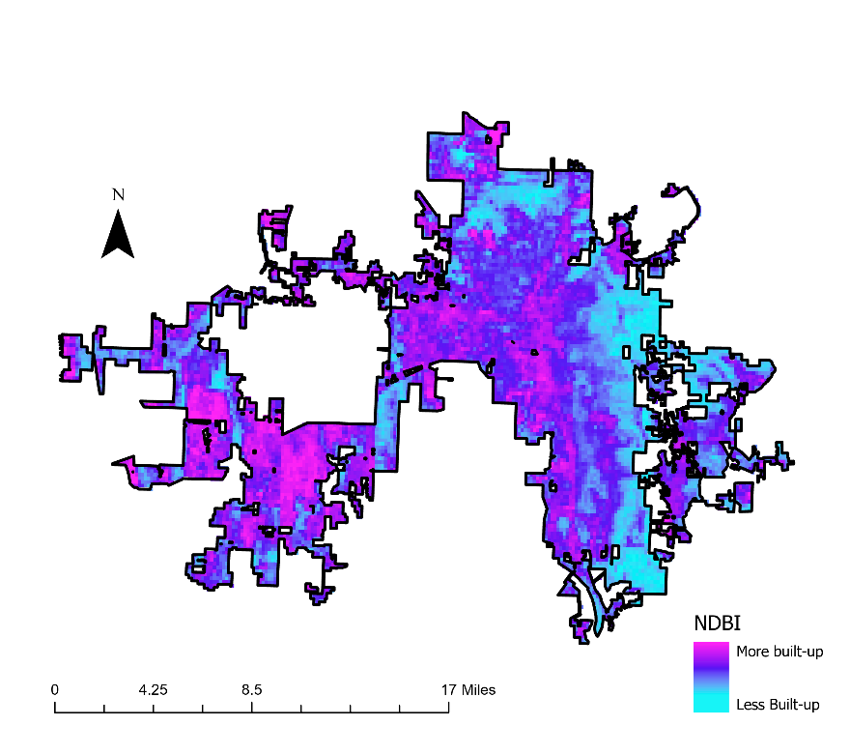

*Figure 1.* This map displays the average NDBI for Huntsville in 2022

While identifying areas of potential UHIs, the team assessed vegetation and mapped the average NDVI during the summer months from 2019 to 2022. The map below (Figure 2) displays highly vegetated regions in green, with yellow representing low vegetation and white representing no vegetation. Portions of the city with little or no vegetation correspond to developed areas with impervious surfaces or growing regions such as downtown and western Huntsville. Over the last few years, west Huntsville has seen extensive development with the construction of Polaris, numerous apartment complexes, and shopping centers. NDVI is useful in remote sensing studies but has a few downfalls. The reflectance values used to obtain NDVI are affected by rainfall, which could cause a dry vegetated area to appear with low or no vegetation. Therefore, combining the analysis with others is necessary to validate conclusions drawn from the analysis.

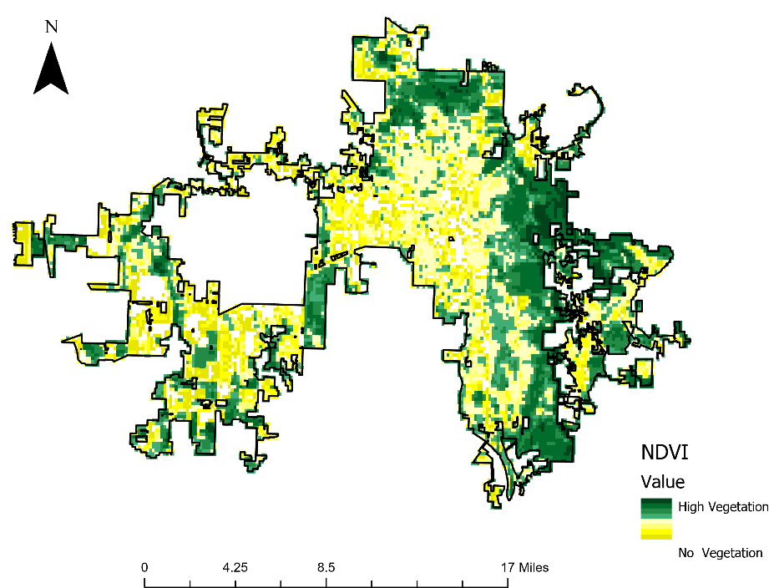

*Figure 2.* This map shows the average NDVI of Huntsville in 2022.

To validate NDVI and NDBI, the team conducted an NLCD reclassification with average NDVI for 2019 and 2022 (Figure A2) in GEE. The reclassification for 2019 and 2022 contains a 94.8% overall accuracy rate indicating that land cover has not experienced significant change during the three years. The change detection analysis conducted in Arc GIS Pro validated that a small change occurred for the city during the three years. As a result of the maps the change detection analysis created (Figure A3), it is difficult to be sure about the change each pixel value indicates because the information does not exhibit trends.

*4.1.2 Land Surface Temperature (LST)*

After the team constructed maps of the average LST for each year in the study period, a time series was made to show the differences and changes in LST. The time series allowed for the team to assess which areas in the city of Huntsville consistently exhibit the highest and lowest LST, as well as visualize areas with changing LST. The team additionally identified indications of a UHI. The average absolute LST for 2022 can be seen in Figure 3 below. An indication of a UHI can be seen in the downtown area in central Huntsville, as well as in the western portion of the city. These areas consistently indicated the presence of a UHI for the entirety of the study period. The eastern portion of the city consistently exhibited lower LST, which is due to the presence of heavily forested areas. The dark red areas in western Huntsville can be attributed to industrial complexes and busy roadways.

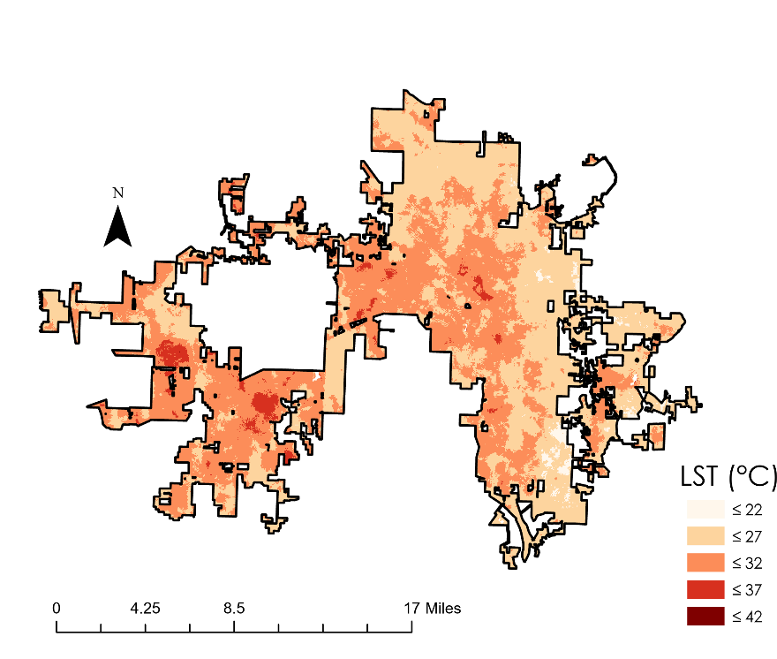

*Figure 3.* This map shows the absolute LST of Huntsville in 2022.

A pitfall of mapping absolute LST for each year is the inconsistency in data. ECOSTRESS did not have a set interval for capturing images, and even when it did capture one, it did not always encompass the entirety of the city. Because of this, each month and year did not have the same amount of data representing it, and each pixel value was not represented equally. To more accurately represent the UHI in the city, the team constructed daytime LST maps to only consider data that can be directly affected by tree canopy cover. The advisor-specified interval for daytime imagery was 10 AM to 6 PM. Any time outside of this interval had data that could not be affected by the presence of tree canopy. The daytime LST map for 2022 can be seen in Figure 4 below. The team observed a higher absolute LST in the downtown area when only considering daytime measurements. Western Huntsville exhibited relatively similar LST after the adjustment.

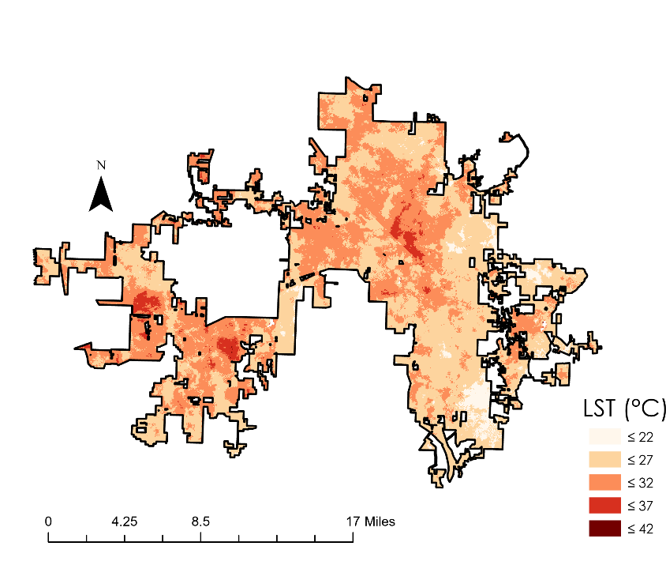

*Figure 4.* This map shows the absolute daytime LST in Huntsville in 2022.

Although mapping absolute LST helped identify the indication of a UHI, it only highlighted the differences in LST relative to its surroundings. The team decided that representing the city in a way that highlights areas that have higher LST than normal was more beneficial to the partners because it could better represent areas under distress. The team determined that the normal or baseline LST for the city each year was to be represented by the average LST of southeastern Huntsville. This area was selected because it was a heavily forested area that recorded lower LST consistently. This area essentially represented what the city’s average LST would be if it were not urbanized. The LST anomalies can be seen in Figure 5 below. This map more clearly and accurately identified the indication of a UHI, which remained in central and western Huntsville. Comparing the LST anomalies maps for each year in a time series also allowed the team to better assess the changes and expansion of the UHI. This is because the absolute LST exhibited each year can differ from year to year and month to month based on precipitation patterns, climate, and other variable environmental factors. Comparing LST to a baseline value better represented the true differences in LST throughout the city.

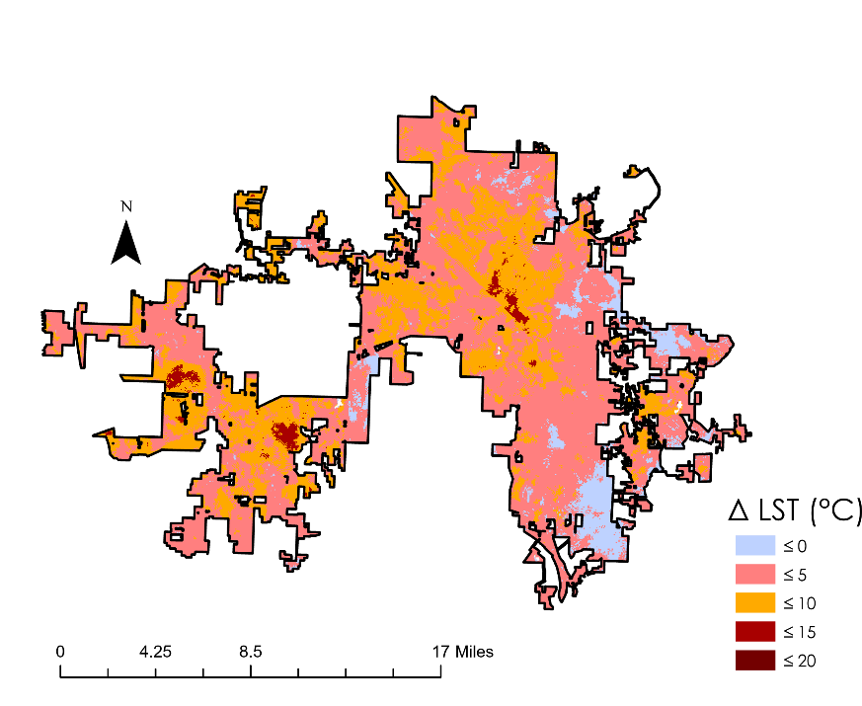

*Figure 5.* This map shows the LST anomalies in Huntsville in 2022.

*4.1.4 Assessing Heat Vulnerability*

After averaging Tree Equity data across the city at the census block level, the output showed interesting trends. First, the largest area of increased Heat Vulnerability is North Huntsville, while the largest area of decreased Heat Vulnerability is East Huntsville beginning at Downtown. Additionally, West-Central Huntsville has some of the most concentrated Heat Vulnerability and two of the most at-risk census blocks (specifically those at the Southeast Intersection of Interstate 565 and Memorial Parkway). South of Interstate 565, Memorial Parkway acts as a clear border in Heat Vulnerability, yet north of Interstate 565 Heat Vulnerability is spread evenly on both sides of the Parkway.

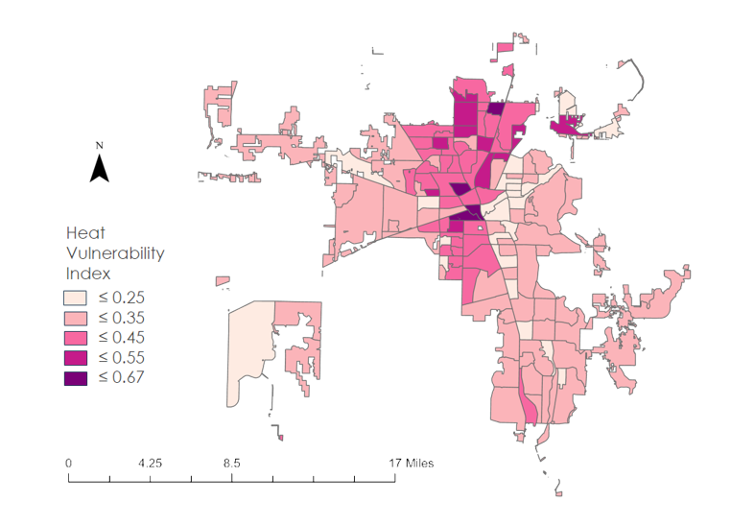

*Figure 6*. The Heat Vulnerability Index split up by census tract across Huntsville.

Comparing these data to the LST Anomaly Map (Figure 5) and the absolute Daytime Temperature Map (Figure 4), showcase that West-Central Huntsville has large and concentrated area of overlap in both Vulnerability and UHI. Additionally, the census tracts directly north of the Urban Core have widespread overlap (although this overlap does seem to drop northward as the furthest north Vulnerable Census blocks have larger amounts of vegetation and less heat than those closest to the Urban Core; Figure 2). As Tree Equity Score does not include data from the Western-Most areas of Huntsville, these areas were not taken into account for the Vulnerability analysis. However, theses area should be studied further as there are two large UHI anomalies that overlay built-up areas near the Huntsville airport and the Western Boundary of the City (Figure 5; Figure 1).

***4.2 Feasibility Assessment***

*4.2.1 Roof Types*

One additional goal of this project was to discover how much a role roof types play in the UHI across Huntsville. The team attempted to discover this by taking high resolution Maxar Worldview 2 & 3 imagery and running it through a GEE random forest classifier (developed by the NASA DEVELOP Fall 2022 MSFC Guatemala & Panama Urban Development team; Ruiz et al., 2020) and comparing this with the LST from ECOSTRESS. The team unfortunately ran out of time before completing this task; however, the classifier was at a point of distinctly separating different types of landcover indicating that with further work, this method may be feasible for identifying roof types across the city.

*4.2.2 LST and Landcover*

Some uncertainties occurred when cloud masking for Landsat and ECOSTRESS imagery because the team could not guarantee the calculations for NDBI, NDVI, and LST were based on cloudless imagery. This meant imagery containing clouds produced skewed results for our LST and land cover maps. Limitations arose when creating the heat vulnerability map because the team did not gather the most recent socioeconomic data from the American Community Survey. Since the team based this map on Census data collected before the expansion of Huntsville’s city limits, this meant newly acquired areas within the city were not represented in the heat vulnerability map. This meant the heat vulnerability map may not accurately represent a community’s true need for trees. When utilizing ECOSTRESS to calculate LST, the pixel values in the LST maps may not be represented equally due to ECOSTRESS rarely collecting imagery of the entire city. Overall, the methods utilized by the team to assess LST and land cover throughout Huntsville showed our partners the various ways they can incorporate remote sensing tools into their urban planning research. Although the partners do not currently utilize remote sensing data products, these results will function as a baseline for the city’s future efforts to create detailed maps showcasing areas highly vulnerable to the effects of UHIs and to ultimately mitigate UHIs within the city.

***4.3 Future Work***

Future work could include investigating the cause in variance of LST throughout the city, assessing the effect roof materials have on the UHI, and identifying viable areas for tree planting initiatives. The partners showed interest in assessing the flood plains in Huntsville and relating it to the maps that have been created through this project. They additionally were interested in simulating tree planting in the city and modeling it over the next 30 to 40 years to assess its effect on LST. Completing this analysis in conjunction with a focused look on areas of projected development can showcase what the future of heat in Huntsville will be.

# 5. Conclusions

The team determined there was no consistent trend in change in absolute LST within the city of Huntsville during the study period. The LST exhibited month to month and year to year variation based on environmental factors such as climate. For LST anomaly, the team also found that the strongest indication of a UHI was found in the downtown area, industrial complexes, and areas of new development. West-central Huntsville was determined to be the area with the greatest potential for heat reduction and community health benefits from tree planting initiatives. Western Huntsville has seen the largest amount of new development and hence has experienced the most noticeable increase in LST during the study period but needs further Socioeconomic study. The heat vulnerability map found that North Downtown and West of Downtown Huntsville are the regions most vulnerable to heat in the heart of the UHI. All of these findings can be used to help guide future tree plantings within areas of higher LST and vulnerability.

As Huntsville continues to grow, the UHI has potential to grow with it, but by incorporating remotely-sensed data such as those included in this study, the city is equipped with more spatial information and data to both understand and mitigate the UHI in the years to come. Before this project, the partners relied on donations and donor preferences for the selection of tree planting locations. These results can allow the partners to make more informed decisions when targeting areas for tree planting by including LST, NDVI, and NDBI data in their decision-making processes.

# 

# 6. Acknowledgements

The Summer 2023 NASA DEVELOP Huntsville Urban Development II team would like to thank our partners at the City of Huntsville for their collaboration and assistance with this project. The team is grateful for the technical guidance and feedback imparted by our science advisors Dr. Jeffrey Luvall and Dr. Robert Griffin and appreciate the additional support provided by Brianne Minton and John Mandel. The team would also like to extend a thank you to our Fellow Laramie Plott who supplied our team with immense support and resources to ensure this project was a success.

DigitalGlobe/Maxar data were provided by NASA’s Commercial Archive Data for NASA investigators ([cad4nasa.gsfc.nasa.gov](http://cad4nasa.gsfc.nasa.gov)) under the National Geospatial-Intelligence Agency’s NextView license agreement.

Any opinions, findings, and conclusions or recommendations expressed in this material are those of the author(s) and do not necessarily reflect the views of the National Aeronautics and Space Administration.

This material is based upon work supported by NASA through contract NNL16AA05C.

# 

# 7. Glossary

**Earth observations** – Satellites and sensors that collect information about the Earth’s physical, chemical, and biological systems over space and time

**Emissivity** – An object’s ability to emit infrared energy

**GEE** – Google Earth Engine

**LST** – Land Surface Temperature

**MODIS** – Moderate Resolution Imaging Spectroradiometer

**NDVI** – Normalized Difference Vegetation Index

**NDBI** – Normalized Difference Built-up Index  
**NLCD –** National Land Cover Database

**SAVI** – Soil-Adjusted Vegetation Index

**Tree Equity Score** – A rating that indicates necessity for trees in an area based on socioeconomic and environmental factors

**UHI** – Urban Heat Island

# 8. References

*Browse lp daac data user resources / ecostress_swath2grid—Earthdata source code repository*. (n.d.). Retrieved August 9, 2023, from <https://git.earthdata.nasa.gov/projects/LPDUR/repos/ecostress_swath2grid/browse>

City of Huntsville, Alabama (2023, July 10). *City of Huntsville Statistics.* <https://maps.huntsvilleal.gov/HuntsvilleStats>

Dewitz, J. & U.S. Geological Survey. (2021). *National Land Cover Database (NLCD) 2019 Products (ver. 2.0, June 2021)*. ScienceBase. <https://www.sciencebase.gov/catalog/item/5f21cef582cef313ed940043>

Dousset, B., Luvall, J., & Hulley, G., 2019 <https://doi.org/10.1016/B978-0-12-814458-9.00007-1>

EPA, 2022a <https://www.epa.gov/heatislands/learn-about-heat-islands>

EPA, 2022b <https://www.epa.gov/heatislands/heat-island-cooling-strategies>

EPA, 2022c <https://www.epa.gov/heatislands/heat-island-impacts>

EPA, 2023 <https://www.epa.gov/ground-level-ozone-pollution/ground-level-ozone-basics>

Grover, A. & Singh, R. B. (2015). Analysis of urban heat island (UHI) in relation to normalized difference vegetation index (NDVI): A comparative study of Delhi and Mumbai. *Environments, 2015,* 2, 125–138. <https://doi.org/10.3390/environments2020125>

Hook, S. & Hulley, G. (2019). *ECOSTRESS land surface temperature and emissivity daily L2 global 70 m V001 [Data set]*. NASA EOSDIS Land Processes DAAC. <https://doi.org/10.5067/ECOSTRESS/ECO2LSTE.001>

Imhoff, M. L., Zhang, P., Wolfe, R. E., & Bounoua, L. (2010). Remote sensing of the urban heat island effect across biomes in the continental USA. *Remote Sensing of Environment, 114*(3), 504–513. <https://doi.org/10.1016/j.rse.2009.10.008>

Kshetri, T. (2018). NSVI, NDBI, & NDWI Calculation Using Landsat 7, 8. *GeoWorld, 2,* 32-34.

Luvall, J. C., Quattrochi, D. A., Rickman, D. L., & Estes Jr., M. G. (2015). Urban heat islands. *Encyclopedia of Earth Sciences 2nd Edition*, 2015, 310–318. <https://doi.org/10.1016/B978-0-12-382225-3.00442-4>

Paris, G., Nix, S., Quintero, T., & Tomlinson, A. (2020). *Huntsville Urban Development: Utilizing NASA earth observations to evaluate urban tree canopy and land surface temperature for green infrastructure development and urban heat mitigation in Huntsville, AL.* NASA DEVELOP National Program, Alabama – Marshall. <https://ntrs.nasa.gov/citations/20205008333>

Rosado, R. M., Guzmán, E. M., Lopez, C. J., Molina, W. M., García, H. L., & Yedra, E. L. (2020). Mapping the LST (Land Surface Temperature) with Satellite Information and Software ArcGis. *IOP Conference Series: Materials Science and Engineering*, *811*(1), 012045. <https://doi.org/10.1088/1757-899x/811/1/012045>

Ruiz, J., Lademan, V., Valle Rodriguez, C.D.M., & Whittemore, A. (2022). *Guatemala and Panama Urban Development: Evaluating the Effects of Urban Expansion on Social and Environmental Vulnerability in Guatemala and Panama.* NASA DEVELOP National Program, Alabama – Marshall. <https://ntrs.nasa.gov/citations/20220018398>

Sharma et al., 2016 <https://iopscience.iop.org/article/10.1088/1748-9326/11/6/064004/pdf>

U.S. Census Bureau, 2021 <https://www.census.gov/data/tables/time-series/dec/popchange-data-text.html>

U.S. Census Bureau, 2022 <https://www.census.gov/newsroom/press-releases/2022/2022-population-estimates.html>

U.S. Geological Survey Earth Resources Observation and Science Center. (2020, November 27). *Landsat 8-9 OLI/TIRS Collection 2 Level-2 Science Products*. US Geological Survey. <https://doi.org/10.5066/P9OGBGM6>

Wan, Z., Hook, S., & Hulley, G. (2021). *MOD11A1 MODIS/Terra land surface temperature/Emissivity daily L3 global 1km SIN Grid V061 [Data set]*. NASA EOSDIS Land Processes DAAC. <https://doi.org/10.5067/MODIS/MOD11A1.061>

# 9. Appendices

**Appendix A**

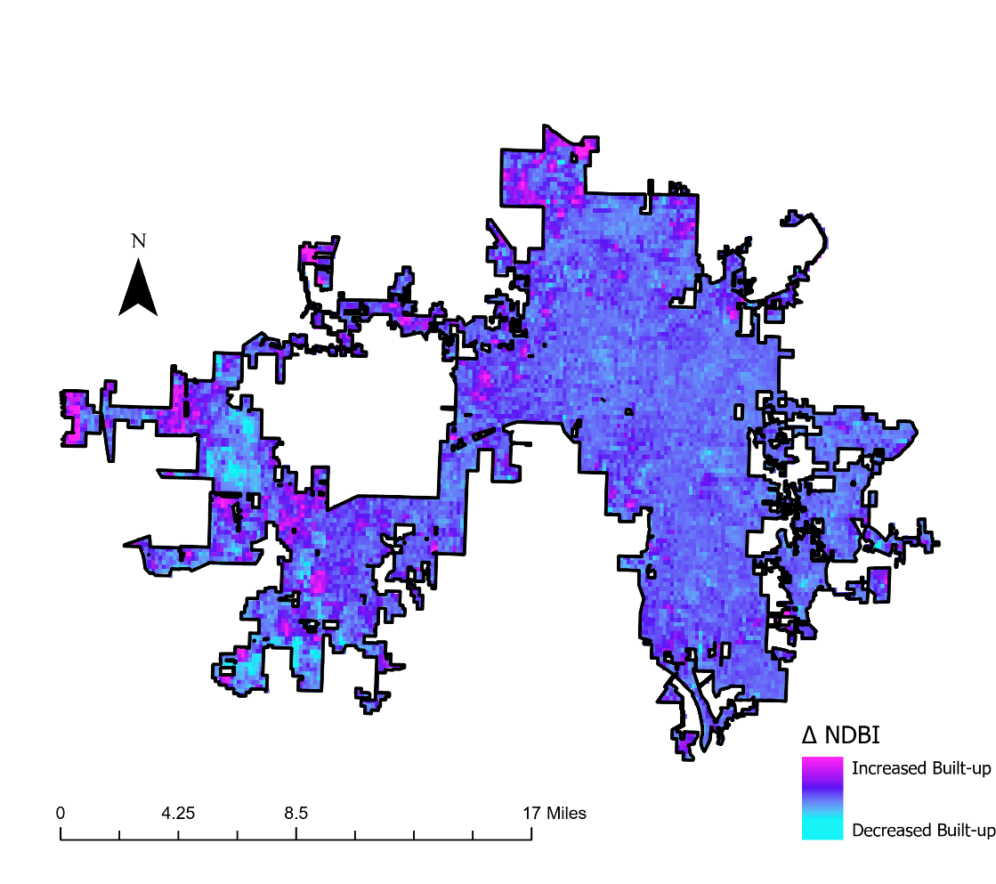

Figure A1. This map displays the change in NDBI from 2019 to 2022. This change is discussed in Section 4.1.1.

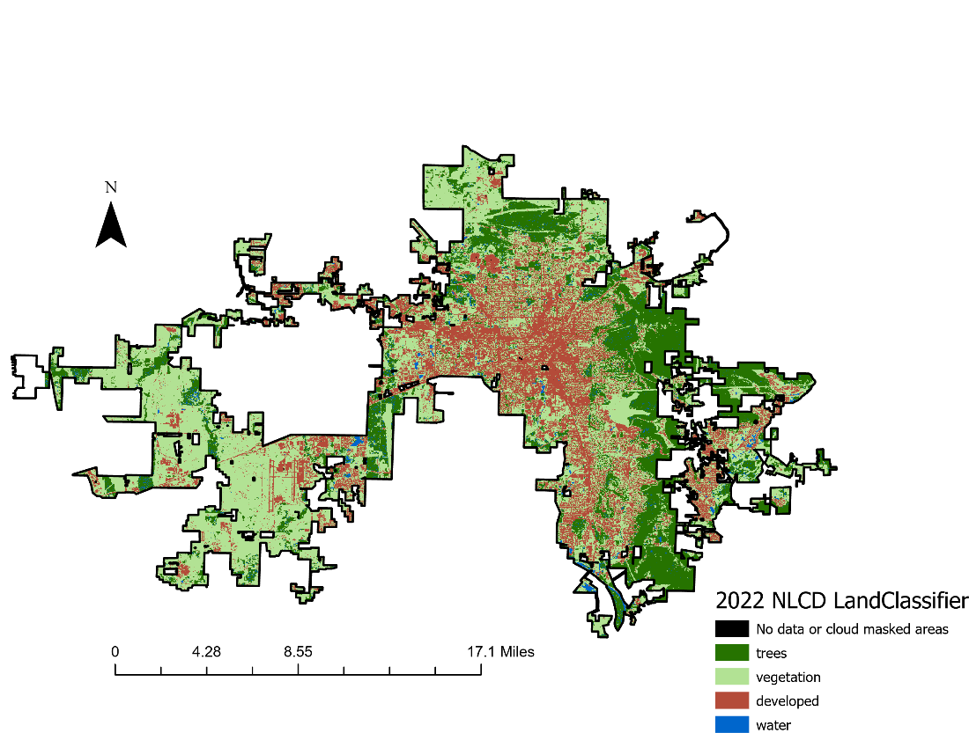

Figure A2: Map displays the NCLD reclassification for 2022 discussed in section 4.1.1

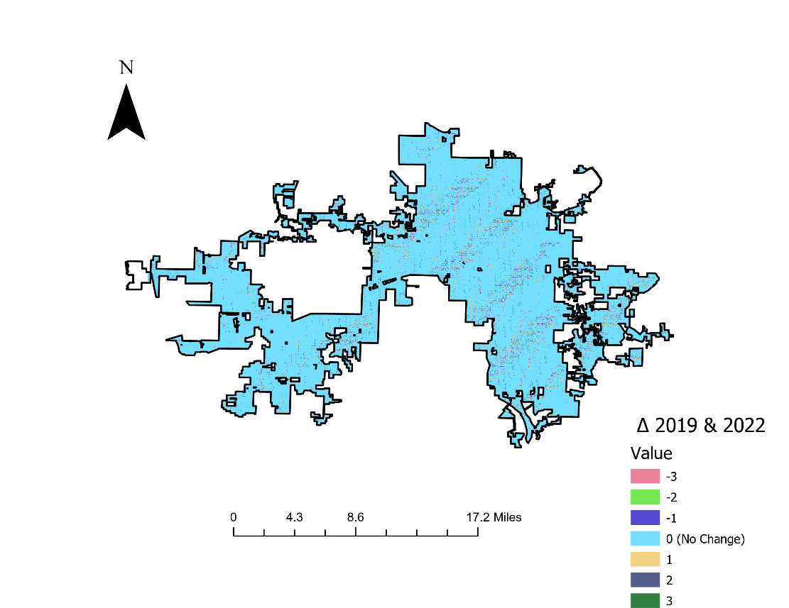

Figure A3: Map displays the change detection analysis discussed in Section 4.1.1