Carmel Valley Urban Development

Monitoring Land Cover Change to Understand Conservation Outcomes in Coastal California

 **Technical Report**

Final – November 17th, 2022

Cooper Campbell (Project Lead)

Devina Garcia

Julia Portmann

Audrey Wilson

***Advisors:***

Dr. Anthony Vorster (Colorado State University, Natural Resource Ecology Laboratory)

Dr. Brian Woodward (Santa Lucia Conservancy)

***Fellow:***  
Sarah Hettema (Colorado – Fort Collins)

# 1. Abstract

Urban expansion in diverse ecosystems has numerous detrimental impacts, including diminished biodiversity, impaired water quality, and reduced carbon storage potential. In the Carmel Valley region of California’s Central Coast, the Santa Lucia Preserve (SLP) implemented a unique land management plan in the 1990s to allow limited development while conserving the majority of the land. Our goal was to test whether our partner’s (Santa Lucia Conservancy [SLC]) management plan effectively reduced urban spread and forest cover loss compared to surrounding areas from 1991 to 2019. We used Landsat 5’s Thematic Mapper (TM) and Landsat 8’s Operational Land Imager (OLI) to classify land cover into eight classes (agriculture, developed [infrastructure], developed [structures], forest, grasslands, rocks/cliffs, shrubs, water) using a random forest classification (which used Data from Shuttle Radar Topography Mission 7 as predictor variables), then modeled land cover change using IDRISI TerrSet Land Change Modeler (LCM). The best models for both years used all variables and a combined developed class (1991 OOB error = 17.4%, 2019 OOB error = 20.1%). The greatest vegetation loss occurred in grasslands; 11% of grasslands on SLP were developed, along with 14% of public and 12% of private. Throughout the study area, developed and forest land cover increased by 2%, while grasslands decreased by 4% and shrubs by 2%. Approximately 3.5% of privately owned forest was developed, while about 1% of public and SLC-owned forests were. The transition between vegetation classes masked losses within each class, and further analysis of the drivers of land cover change is necessary to fully evaluate the efficacy of the SLC conservation model. The SLC will use these results to aid in determining the allocation of the organization's resources going forward.

**Key Terms**

Remote sensing, Landsat, land cover change, Google Earth Engine, LandTrendr, random forest, IDRISI TerrSet Land Change Modeler

# 2. Introduction

***2.1 Background Information***

Land cover change is a major ecological issue that affects both local and global environments. Urban expansion is a form of land cover change that refers to an increase in the structural development of a settlement. In the Central Coast region of California, urban expansion has been linked to a reduction in natural environments, increase in impervious surfaces, and a resulting loss of its immense biodiversity and essential ecosystem services (Chan et al. 2006; Davis et al. 2008; Chen et al. 2010). Urban land cover in this region is extensive and predicted to increase (Matchett et al. 2017).

Land management practices centered on conservation models are established to combat and protect the natural environment from the negative impacts of land cover change. Within the Central Coast, the Santa Lucia Preserve (SLP) (Figure 1) was established with a unique plan to prioritize biodiversity while allowing sustainable development to occur (SLC 2022). In their conservation plan, 10,000 acres of the 20,000 total acres remain fully protected, 8,000 acres are under conservation easements by property owners, and the remaining 2,000 acres are available to gradually be developed (SLC 2022). With this plan, the SLP aimed to slow urban development and maintain biodiversity relative to the surrounding region.

Monitoring conservation models such as SLP’s is imperative. Remote sensing and Geographic Information Systems (GIS) can be utilized to conduct land cover analyses that provide quantitative data on the effectiveness of conservation models (Liu et al. 2015). Satellite imagery provides spatiotemporal data of the Earth’s surface that is essential to conduct a change detection analysis, which allows the user to observe and compare land cover changes across a large area between multiple periods of time (Kennedy et al. 2010; Liu et al. 2015; Hamad et al. 2018).

Landsat satellite data has been collected since 1972, and provides multi-spectral, 30 m resolution imagery of the Earth’s surface. Due to its relatively fine spatial resolution and long-term image archive, Landsat imagery is commonly employed for change detection analyses (USGS 2022a). The National Agriculture Imagery Program (NAIP) has produced remote imagery since 2004 at a very high spatial resolution, but lower temporal resolution (Nagel & Yuan 2016). Utilizing these imagery sources in conjunction can allow for nuanced land cover change results (Nagel & Yuan 2016).

The random forest modeling method uses decision trees to accurately predict and classify land cover from satellite imagery (Breiman 2001; Gislason et al. 2006; Hayes et al. 2014; Rodriguez-Galiano et al. 2011). Given existing land cover datasets, the IDRISI TerrSet Land Change Modeler (LCM) is a useful tool to assess changes and transitions across a study period. The LCM utilizes Markov matrices to assess land cover change and effectively measures urban development and forest cover trends over time (Hamad et al. 2018; Camacho Olmedo et al. 2015; Liu et al. 2015).

Our study aimed to analyze land cover changes on the Santa Lucia Preserve and in the broader Carmel Valley region in the Central Coast of California (Figure 1) from 1991 to 2019 using Landsat 5 Thematic Mapper (TM) and Landsat 8 Operational land Imager (OLI) imagery, and ancillary data. This study will help assess the effectiveness of the Santa Lucia Conservancy’s (SLC) management plan to reduce urban spread and forest cover loss within the SLP over time and its role as a conservation model.

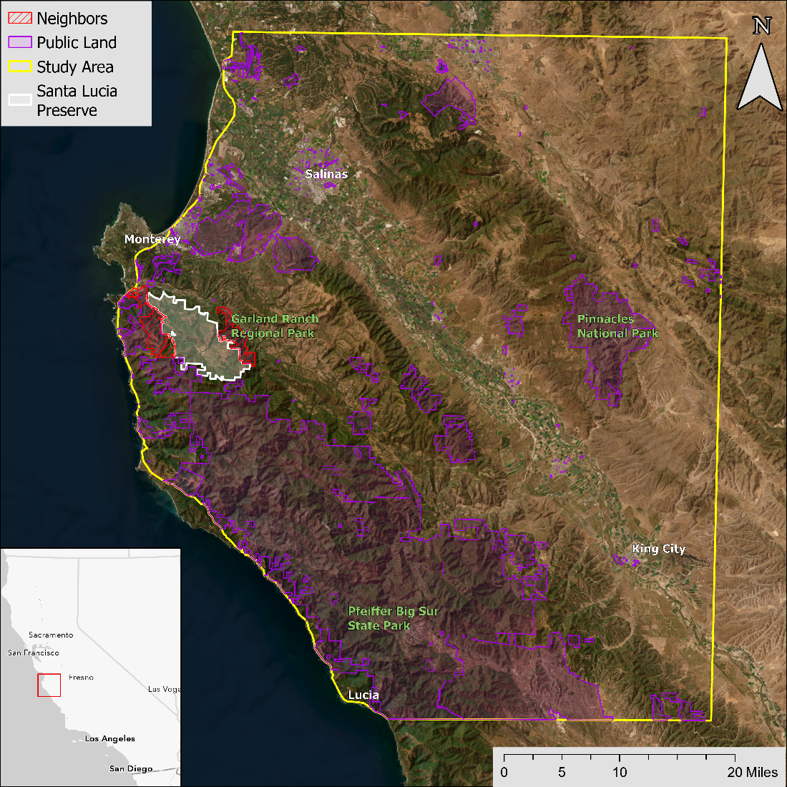

*Figure 1*. This study area map shows the Santa Lucia Preserve (SLP) and surrounding Carmel Valley. The SLP is outlined in white, neighbors in red, public lands in purple, and the broader study area is outlined in yellow. Map layer credits: Earthstar Geographics, Esri, HERE, Garmin, FAO, NOAA, USGS, EPA.

***2.2 Project Partners & Objectives***

We partnered with the Santa Lucia Conservancy (SLC), an organization that manages the Santa Lucia Preserve in the Carmel Valley of Central California. The SLC is seeking to evaluate their conservation model by investigating changes in land cover over the last thirty years on the Santa Lucia Preserve compared with surrounding properties. The SLC will use the project results to determine the effects of their management approaches such as limiting development, maximizing conserved core habitat, invasive vegetation thinning, and prescribed fire, and to aid in the allocation of the organization's resources going forward. While the SLC currently uses spatial data, they lack the capacity to implement Earth observations, and the project will allow the SLC to understand the impacts of their preservation in the context of the greater area. The primary objective of the project was to model land cover changes in the Carmel Valley from the 1990s to the present day.

# 3. Methodology

***3.1 Data Acquisition***

Our primary data source for this project was Landsat imagery, as it provided the requisite temporal (30 m) and spatial (16 day) resolution for the study (Table 1; USGS 2018a; USGS 2018b). We accessed and processed the data with Google Earth Engine (GEE) JavaScript API. We also analyzed National Agriculture Imagery Program (NAIP) data, which has a one-meter resolution and allowed for fine-scale modeling, but it was not available for the start year and has limited temporal resolution. As a result, we only incorporated NAIP imagery for a 2019 model as an exploratory exercise for future work.

Table 1

*Earth Observation Data*

|  |  |  |
| --- | --- | --- |
| **Dataset** | **Parameters** | **Use** |
| **Landsat 5 Thematic Mapper (TM),** Collection 2 Tier 1 | Tasseled cap brightness (TCB); wetness (TCW); greenness (TCG); normalized difference vegetation index (NDVI); normalized difference moisture index (NDMI); and red, green, blue (RGB), near infrared 1 (NIR1), & NIR2 surface reflectance | Primary imagery for random forest models to classify land cover type in 1991. |
| **Landsat 8 Operational Land Imager (OLI),** Collection 2 Tier 1 | TCB; TCW; TCG; NDVI; NDMI; and NIR, shortwave infrared 1 (SWIR1), & SWIR2 surface reflectance | Primary imagery for random forest models to classify land cover type in 2019. |
| **National Agriculture Imagery Program (NAIP)** | RGB, NDVI | Secondary imagery dataset to run random forest models with finer-scale spatial resolution. Not available for study start year, and insufficient temporal resolution to account for seasonal variation. |
| **Shuttle Radar Topography Mission (SRTM)** | Digital elevation model (DEM), slope, aspect, landform, roughness, surface relief ratio | Parameters used as input variables in random forest model. |

The project partner provided 1990s and 2019 habitat class shapefiles on the SLP. The 2019 map was derived from high resolution aerial imagery and field expeditions. The SLC has frequently relied on this map during field work and confirmed a high level of accuracy. The SLC also provided a shapefile of land ownership in neighboring properties. Because the habitat type map did not cover the surrounding areas, we used 2001 and 2020 LANDFIRE Existing Vegetation Type (EVT) v2.0.0 to classify habitat in the surrounding area, validate random forest models, and limit the study extent to areas with similar habitat types (LANDFIRE 2022). The additional datasets used are described in Table 2.

Table 2

*Ancillary datasets*

|  |  |  |
| --- | --- | --- |
| **Dataset** | **Source** | **Use** |
| **Santa Lucia Preserve Habitat Type Map** | Provided by project partner | Training data for random forest models. Highly accurate shapefile of habitat types within preserve. |
| **LANDFIRE Existing Vegetation Type (EVT)** | Vegetation type | Preparation of training data for random forest models for land outside of Preserve. Also used to validate models and determine study extent. |
| **Neighboring Property Map** | Provided by project partner | Identification of land ownership and conservation status of areas surrounding Preserve for comparison of forest cover change. |
| **California Land Ownership** | California Department of Forestry and Fire Protection | Used to identify areas with different land ownership in the study area for comparative land cover change analyses. |
| **California Roads** | US Census Bureau TIGER database | Source for calculation of Euclidean Distance to road, a variable in random forest model. |
| **Soil Types** | USDA gNATSGO | Input data for random forest model. |

***3.2 Data Processing***

We accessed Landsat data for 1991 and 2019 through the Google Earth Engine (GEE) JavaScript API. Because associated metadata cannot account for the exact location of the study area, we loaded the entire image collection for each year to visually select images with minimal cloud cover over the region of interest. We selected the clearest image for each spring (April), summer (July), and fall (October) to incorporate seasonal variation in vegetative growth and spectral indices and applied a cloud mask to filter any remaining clouds using the quality assessment (QA) band. We then calculated tasseled cap brightness, wetness, and greenness indices (TCB, TCW, TCG) for the seasonal mosaics for 1991 and 2019 (Equation 1, 2, 3). We calculated the normalized difference vegetation index (NDVI) and normalized difference moisture index (NDMI) (Equations 4, 5) for each season for both years from the Landsat rasters and calculated the difference between spring and fall values for the TCW, TCB, TCG, NDVI, and NDMI, to account for differing levels of seasonal variation in different habitats. Equations 1-5 all utilize a variety of surface reflectance spectral bands (e.g., blue, green, red, NIR, SWIR1, & SWIR2).

$$TCB=\left(blue⋅0.3029\right)+\left(green⋅0.2786\right)+\left(red⋅0.4733\right)+\left(NIR⋅0.5599\right)+$$

$\left(SWIR1⋅0.508\right)+\left(SWIR2⋅0.1872\right)$

(1)

$$TCW=\left(blue⋅0.1511\right)+\left(green⋅0.1973\right)+\left(red⋅0.3283\right)+\left(NIR⋅0.3404\right)+\left(SWIR1⋅-0.7117\right)+\left(SWIR2⋅-0.4559\right)$$

(2)

$TCG=\left(blue⋅-0.2941\right)+\left(green⋅-0.243\right)+\left(red⋅-0.5424\right)+\left(NIR⋅0.7276\right)+\left(SWIR1⋅0.0713\right)+\left(SWIR2⋅-0.1608\right)$

(3)

$$NDVI=\frac{\left(red-green\right)}{red+green}$$

(4)

$$NDMI=\frac{\left(NIR-SWIR1\right)}{NIR+SWIR1}$$

(5)

Using ArcGIS Pro 3.0.2, we reclassified habitat types in the SLC Land Cover map into our focal categories (Table 3). We processed the DEM to create elevation, aspect, and slope rasters. We also calculated landform, roughness, and surface relief ratio from the DEM (Evans et al. 2014). Using the California roads shapefile, we generated a continuous raster of Euclidean distance to the nearest road.

Table 3

*Land cover classes used in the random forest model.*

|  |  |  |
| --- | --- | --- |
| **Final Class** | **Original SLP Class** | **Description** |
| Agriculture | N/A | Primarily crops (especially grapes) and golf courses |
| Developed, infrastructure | Developed | Roads, parking lots |
| Developed, structures | Developed | Buildings |
| Forest | Conifer forest, non-native trees, riparian woodland, upland hardwood | Hardwood, softwood trees, riparian areas |
| Grasslands | Non-native grasses and forbs, upland native herbaceous, naturally sparsely vegetated | Grasses, forbs, herbaceous, oak savanna |
| Rocks/Cliffs | N/A | Bare rock or cliffs |
| Shrub | California chaparral, coastal scrub, naturalized non-native scrub | California chaparral, coastal scrub, medium-sized vegetation |
| Water | Water | Any area of open water |

We clipped all layers to the study area, then resampled, reprojected, and snapped all layers to ensure identical spatial resolution, coordinate systems, and extents. To prepare training data for random forest models, we created 150 random points per habitat bin on the SLP, then added an additional 100 to 200 spread evenly throughout the entire study area using base imagery from the time period and the LANDFIRE EVT classifications to guide placement (total ~2100 points). All training points were spaced at least 60 m apart. Using R Studio, we extracted values from all input rasters to each point.

***3.3 Data Analysis***

We classified land cover using random forest models in R with the randomForest, VSURF (variable selection using random forests), and raster packages (Liaw & Wiener 2002; Genuer et al. 2019; Hijmans 2022, respectively). We used an eight-class model: agriculture, developed infrastructure, developed structures, forest, grasslands, rocks/cliffs, shrub, and water (Table 3). Using training data, we ran initial random forest models for 1991 and 2019 with all variables, then used VSURF to identify the most important predictors. For the 1991 classification, VSURF identified 17 variables as most important to the model. For the 2019 classification, VSURF identified 19 variables as most important to the model. We ran additional random forest models with reduced variables using all important predictors for each year, the top ten important predictors for each year, and the top five important predictors for each year. Each model was also run using a seven-class scheme, combining the two developed classes into a single class.

For each model, we used 1000 trees and the default number of variables tried at each split (mtry = 2, 4, or 6). The model ran with 2/3 of the data (n = ~1400), withholding 1/3 (n = ~700) to validate the classification and calculate error metrics (Breiman 2001). We assessed accuracy using the out of bag (OOB) error and class errors (Rodriguez-Galiana et al. 2012).

After classifying land cover throughout our study region, we used the IDRISI TerrSet Land Change Modeler (LCM) to map changes between 1991 and 2019 land cover within the Santa Lucia Preserve and in the surrounding region and generate graphs of gains and losses in each class. We mapped the transition between each of land cover classes (e.g., forest to urban, urban to forest, shrub to urban). Using the raster outputs of the LCM and random forest models, we calculated the percent gain and percent loss in each land cover class throughout the designated time period in ArcGIS Pro. We used the LCM and ArcGIS Pro to identify specific areas of high change in the study region, which we then examined using the Monitoring Trends in Burn Severity (MTBS) database (USGS 2022b). MTBS provided historic data on fires in the region. We also used LandTrendr to produce a time series analysis of change in land cover on the Santa Lucia Preserve as compared to the surrounding region.

# 4. Results & Discussion

***4.1 Analysis of Results***

***4.1.1 Land cover classification results***

The best model for both years, based on out of bag (OOB) and class errors, was that which used all variables and a combined developed class (Figure 2). The OOB error for the 1991 model was 17.36%, while the average class error was 17.09% and the OOB error for the 2019 model was 20.12% with an average class error of 20.56% (Figure 3). The shrub land class was most often misclassified as grasslands and forest for both years (Appendix Table A1). The forest land class was most often misclassified as shrubs in 1991, and both grassland and shrubs in 2019 (Appendix Table A1). The next best model for 1991 included the top 17 variables and for 2019 included the top 19 variables, with the developed classes combined in both cases (Appendix Table A2; Appendix Table A3). The most common cover type for both years was shrubs, followed by grasslands and forest (Figure 2). The increase in water cover was likely a classification error.

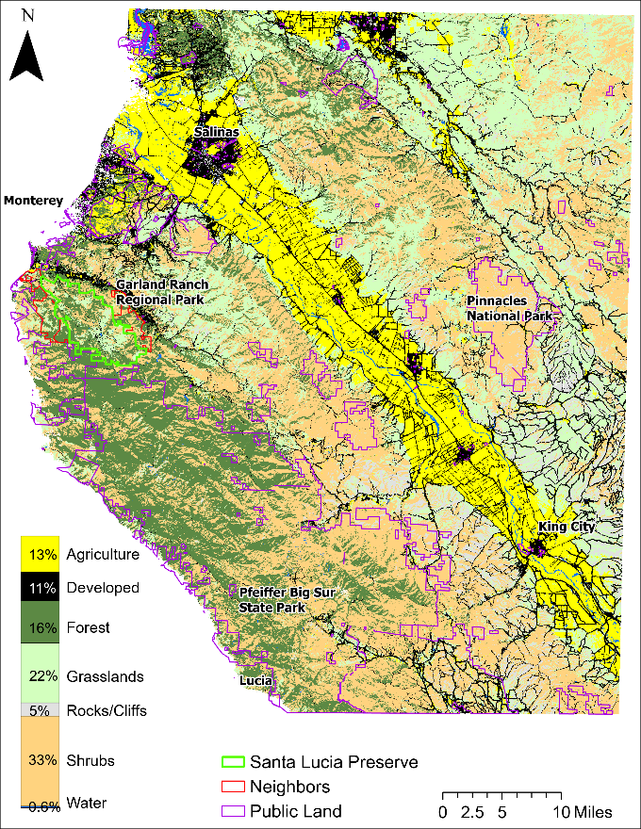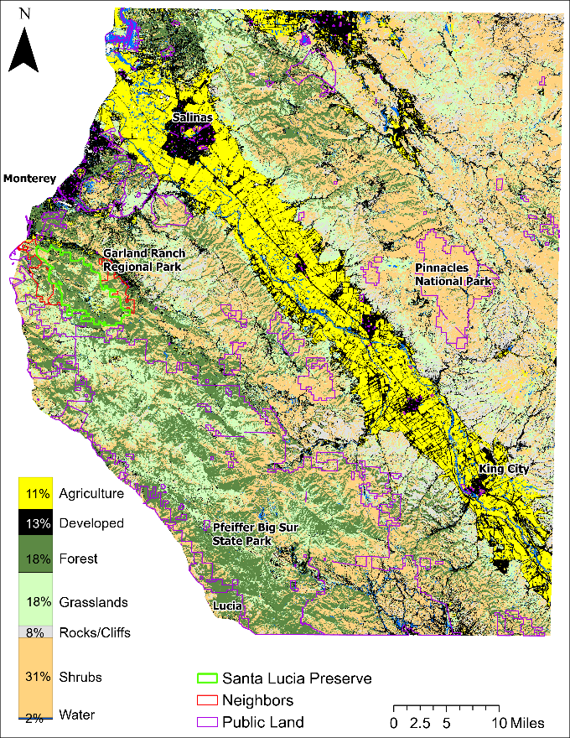*Figure 2*. These land cover classifications from 1991 (left) and 2019 (right) show the results of our best random forest model.

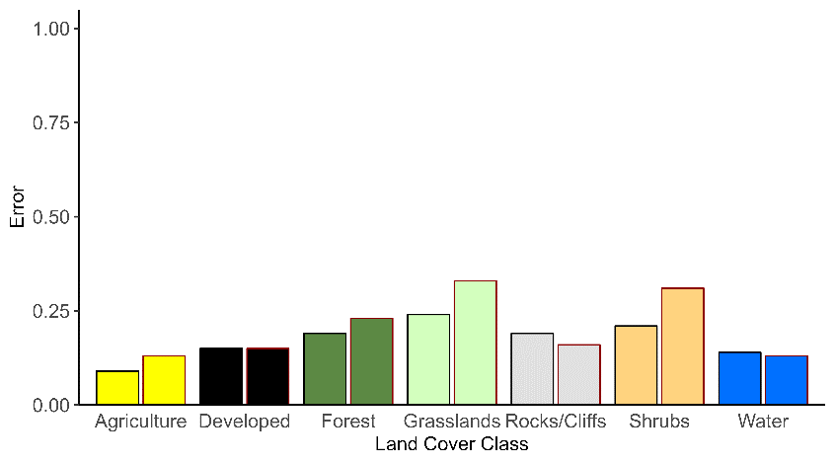

*Figure 3*. Class error (percent) for the best two models, with the 1991 results on the left for each class outlined in black and the 2019 results on the right for each class outlined in red.

***4.1.2 Land cover change results***

The change analysis of our classification results showed that in the complete study area, all vegetation classes had both gains and losses (Figure 4). Forest cover showed a high degree of persistence (Appendix Figure B1), with some areas of gains as well as losses. Developed areas (Figure 4, Appendix Figure B2) increased, while shrublands and grasslands were the most volatile and had net decreases in area over the study period (Figure 4, Appendix Figure B4). Aside from the golf course development, nearly all new agriculture appeared outside of the Preserve (Appendix Figure B3). On the SLP alone, forests saw a proportionally higher increase, while developed areas saw a small increase (Figure 5). As in the complete study area, shrublands and grasslands on the SLP saw the greatest decreases.

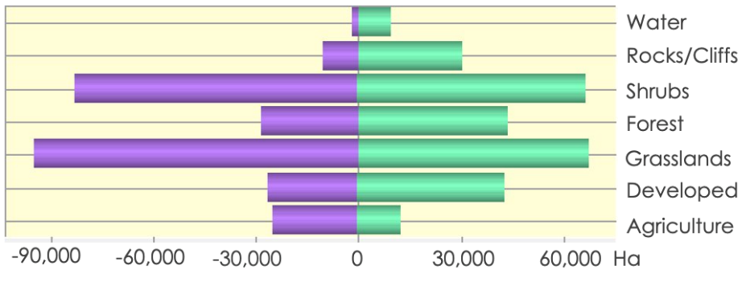

*Figure 4*. Hectares of loss and gain between 1991 and 2019 for each land cover class over the entire study area

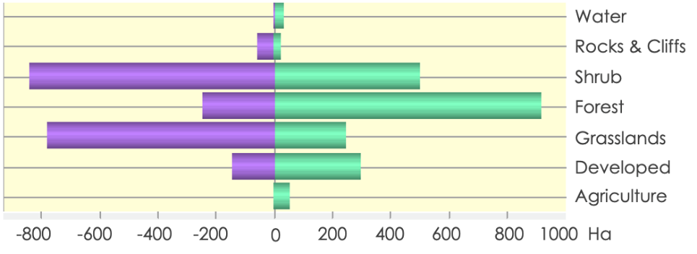

*Figure 5*. Hectares of loss and gain between 1991 and 2019 for each land cover class within only the Santa Lucia Preserve

Privately held lands saw the greatest percent increase in forest cover over the study period, followed closely by the SLP, while overall forest cover on public lands experienced little change, and the neighboring protected properties lost a small percentage of forest cover (Table 4). Mapping the gains, losses, and persistence areas of the study area showed that the greatest area of forest loss was on the land south of the Preserve, while the Preserve saw a high degree of persistence in forest cover (Appendix Figure B1). While most of the development occurred on private land, the SLP experienced the largest percent increase in development, likely due to the small amount of developed area at the start of the study period (Table 5). Grasslands were the most vulnerable to development, with 11% of SLC grasslands, 14% of public, and nearly 13% of private grasslands experiencing development during the study period (Table 6).

Table 4

*Change in forest cover by landowner type in the study area. The “Neighbors” category includes Palo Corona Regional Park and Garland Ranch Regional Park, managed by the Monterey Peninsula Regional Park District, and Big Sur Land Trust’s Mitteldorf Preserve, all of which border the SLC.*

|  |  |  |
| --- | --- | --- |
| **Landowner** | **Total Change (Hectares)** | **Percent Change** |
| Public | 525.06 | 0.87% |
| Private | 14,893.38 | 38.15% |
| Neighboring properties | -43.65 | -2.40% |
| Santa Lucia Conservancy | 667.62 | 19.04% |

Table 5

*Change in development by landowner type in the study area. The “Neighbors” category includes Palo Corona Regional Park and Garland Ranch Regional Park, managed by the Monterey Peninsula Regional Park District, and Big Sur Land Trust’s Mitteldorf Preserve, all of which border the SLC.*

|  |  |  |
| --- | --- | --- |
| **Landowner** | **Total Change (Hectares)** | **Percent Change** |
| Public | 1202.13 | 15.21 |
| Private | 17,836.29 | 28.54 |
| Neighboring properties | 43.92 | 39.29 |
| Santa Lucia Conservancy | 153.63 | 66.81 |

Table 6

*Percent change in vegetation to developed or agricultural land. Identifies area that transitioned from vegetation to an anthropogenic class. The “Neighbors” category includes Palo Corona Regional Park and Garland Ranch Regional Park, managed by the Monterey Peninsula Regional Park District, and Big Sur Land Trust’s Mitteldorf Preserve, all of which border the SLC.*

|  |  |  |  |  |  |  |
| --- | --- | --- | --- | --- | --- | --- |
| **Landowner** | **Forest To Agriculture** | **Forest To Developed** | **Grass To Agriculture** | **Grass To Developed** | **Shrub To Agriculture** | **Shrub To Developed** |
| Public | 0.11 | 1.14 | 1.10 | 14.13 | 0.03 | 1.70 |
| Private | 0.29 | 3.50 | 4.07 | 12.63 | 0.08 | 2.66 |
| Neighbors | 0.01 | 0.60 | 1.20 | 12.80 | 0.12 | 1.74 |
| SLC | 0.01 | 1.30 | 2.56 | 10.98 | 0.13 | 1.81 |

We overlaid major wildfire events in the study area with the forest change calculated (Figure 6). The areas with the greatest forest cover loss occurred in the region where the Basin Complex fire (2008) and Soberanes fire (2016) took place, identifying the likely cause for this major transition. The SLP was not impacted directly by these fires, and experienced minimal forest cover loss during the study period.

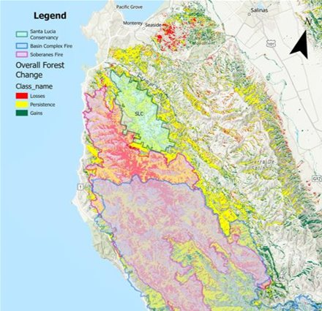

*Figure 6*. Map of major historic burns in the study area overlaid with the forest change in the same area.

***4.2 Future Work***

A detailed breakdown of land cover transitions would enable managers to parse out the effects of management strategies and identify areas with the fastest rates of urbanization. Further investigating the drivers of change in the study area could answer unresolved questions about transitions between classes and the permanence of these changes, such as regrowth after a burn versus permanent conversion to development. A beneficial follow up study could include more specific categories of private landholdings. Because private lands saw such a drastic increase in forest cover, it would be useful to investigate how forest cover changed on the diverse types and sizes of properties that private land includes. We also saw some odd transitions, such as developed areas changing to a different land cover type. While this may be due to vegetation regrowth and succession (e.g., along roadsides), further investigation could determine if it was instead misclassification.

Additional investigation into the ecological ramifications of the observed land cover change would be useful and is of interest to the partner. One aspect would be examining connectivity of habitats; there was both gain and loss of each habitat, but if intact forests, for example, are being destroyed and smaller patches replanted, the ecological functionality of forests in the region has changed. Currently, our results do not capture this aspect. Secondly, a metric to qualitatively assess forest health would be beneficial for management in the region. In some areas, forest patches have persisted, but are not necessarily as healthy as they were historically.

Future work could also expand the number of years in which land cover was assessed, particularly by adding an intermediate year between 1991 and 2019, or a later year closer to the present to investigate the area’s rapid changes over the last few years. In addition, the use of NAIP imagery on a small scale could be further investigated to capture changes too fine to be detected with the coarser Landsat resolution, such as the single-family residences that are characteristic of development on the Preserve. Lastly, it could be useful to forecast the predicted land cover change both on the Preserve and in the surrounding region up to the current date, and into the near future. There is a firm limit on the amount of development that can occur on the Preserve, but private lands in the area will likely continue to be converted to development and agriculture. An analysis of the SLC conservation strategy will not fully demonstrate the value of this method of conservation until the prescribed development on the Preserve has been completed.

# 5. Conclusions

Our analyses showed that throughout the study area, forests and developed areas increased slightly over the study period, while grasslands and shrublands decreased. The same general trends were true for the Santa Lucia Preserve. However, forest cover gains were proportionally larger, and the area that was developed on the Preserve is small.

Our study showed that forest cover increased on the Santa Lucia Preserve by a noticeable margin compared to surrounding public lands, but less than on surrounding private lands. This result is a reasonable outcome, as the Los Padres National Forest makes up a significant portion of the public land in the study area and was adversely affected by the Basin Complex fire in 2008 and the Soberanes Fire in 2016, contributing to a large amount of loss in forest cover during the study period. Private lands were presumably less affected by this disturbance due to the higher level of protection they are afforded in wildland fire incidents. Much of the burned area transitioned to grassland. This increase in grassland mitigates the overall decrease in grassland that is clear in much of private lands in the study area (Appendix Figure B4). Also noteworthy is the large transition from grasslands to shrublands in the northeast of the study area. We hypothesize that this transition may be due to a decrease in livestock grazing but would require further investigation to confirm. The Preserve, though lesser in forest cover gains than private lands, saw a large degree of persistence in forest cover over the course of the study period, which can be regarded as a success in habitat preservation.

In mapping the transitions of vegetation classes to agriculture and developed classes, we observed that agricultural development was confined to the golf course on the SLP, and present throughout the Salinas Valley, which is consistent with expectations. Structural and infrastructural development was widespread throughout the study area. The transition of vegetated habitats to agriculture and development was dominated by grasslands both on and off of the SLP, which suggests that grasslands may be a particularly vulnerable type of habitat in the Carmel Valley region. Historically, grasslands have had fewer barriers to development than forests, and have only recently been studied for their ecological importance. This could be a useful observation for the SLC when directing efforts toward habitats of conservation importance.

Finally, we determined that despite their 30-meter resolution, Landsat data products were a highly useful tool for land change analysis at the scale of this study. Our classification models were able to successfully capture changes in the landscape at a fine scale, such as the golf course development on the SLP and single roads, despite initial concern that we would miss smaller developments. However, it should be considered that smaller homes and developments on and off the SLP could have been masked at the resolution of our study. Conversely, the fine spatial scale NAIP data offers useful spatial resolution but demanded more computational power than was feasible for our study. Future studies can implement the use of Landsat data in landscape scale change monitoring and consider the use of NAIP in more focused applications.

# 

# 6. Acknowledgments

We would like to thank our node Fellow Sarah Hettema, our science advisor Dr. Tony Vorster, and our science advisor and partner Dr. Brian Woodward. We also thank PC Fellows Brandy Nisbet-Wilcox and Laramie Plott for their feedback and edits.

Any opinions, findings, and conclusions or recommendations expressed in this material are those of the author(s) and do not necessarily reflect the views of the National Aeronautics and Space Administration.

This material is based upon work supported by NASA through contract NNL16AA05C.

# 

# 7. Glossary

**Decision trees** – Method for partitioning data using a series of yes/no decisions

**DEM** – Digital Elevation Model

**Earth observations** – Satellites and sensors that collect information about the Earth’s physical, chemical, and biological systems over space and time

**GEE** – Google Earth Engine

**IDRISI TerrSet LCM** – Land change modeling program developed by Clark Labs

**LandTrendr** – Land disturbance modeling program in Google Earth Engine

**Markov matrix** – One type of probability matrix

**Multi-spectral imagery** – Imagery with bands varying along the electromagnetic spectrum, including red, green, blue, and infrared

**NAIP** – National Agriculture Imagery Program

**NDMI** – Normalized Difference Moisture Index

**NDVI** – Normalized Difference Vegetation Index

**OOB error** – Out of bag error, method for validating random forest model using data withheld from the model

**Random Forest** – Modeling technique utilizing decision trees

**Spatial resolution** – Pixel size at which imagery is taken, high resolution = small pixels, low resolution = large pixels

**Tasseled cap indices** – Suite of indices derived from satellite spectral bands

**TCB** – Tasseled-cap Brightness

**TCG** – Tasseled-cap Greenness

**TCW** – Tasseled-cap Wetness

**Temporal resolution** – Time scales at which data are collected, high resolution = many data points per year, low resolution = few data points per year

# 8. References

Breiman, L. (2001). Random forests. *Machine Learning, 45*, 5–32. <https://doi.org/10.1023/A:1010933404324>

Camacho Olmedo, M. T., Pontius, R. G., Paegelow, M., & Mas, J.-F. (2015). Comparison of simulation models in terms of quantity and allocation of land change. *Environmental Modelling & Software*, *69*, 214–221. <https://doi.org/10.1016/j.envsoft.2015.03.003>

Chan, K. M. A., Shaw, M. R., Cameron, D. R., Underwood, E. C., & Daily, G. C. (2006). Conservation Planning for Ecosystem Services. PLoS Biology, 4(11), e379. <https://doi.org/10.1371/journal.pbio.0040379>

Chen, X., Li, B.-L., & Allen, M. F. (2010). Characterizing urbanization, and agricultural and conservation land-use change in Riverside County, California, USA: Characterizing land-use change. *Annals of the New York Academy of Sciences*, 1195(S1), E164–E176. <https://doi.org/10.1111/j.1749-6632.2009.05403.x>

Davis, E. B., Koo, M. S., Conroy, C., Patton, J. L., & Moritz, C. (2008). The California Hotspots Project: Identifying regions of rapid diversification of mammals. *Molecular Ecology, 17*(1), 120–138. <https://doi.org/10.1111/j.1365-294X.2007.03469.x>

Evans J. S., Oakleaf, J., Cushman, S. A., Theobald, D. (2014). An ArcGIS Toolbox for Surface Gradient and Geomorphometric Modeling, version 2.0-0. Accessed 11 October 2022 at <http://evansmurphy.wix.com/evansspatial>

Genuer, R., Poggi, J.M., & Tuleau-Malot, C. (2019). VSURF: Variable Selection Using Random Forests. R package version 1.1.0. <https://CRAN.R-project.org/package=VSURF>

Gislason, P. O., Benediktsson, J. A., & Sveinsson, J. R. (2006). Random forests for land cover classification. *Pattern Recognition Letters, 27*(4), 294–300. <https://doi.org/10.1016/j.patrec.2005.08.011>

Hamad, R., Balzter, H., & Kolo, K. (2018). Predicting Land Use/Land Cover Changes Using a CA-Markov Model under Two Different Scenarios. *Sustainability*, *10*(10), 3421. <https://doi.org/10.3390/su10103421>

Hayes, M. M., Miller, S. N., & Murphy, M. A. (2014). High-resolution landcover classification using Random Forest. *Remote Sensing Letters*, *5*(2), 112–121. <https://doi.org/10.1080/2150704X.2014.882526>

Hijmans, R.J. (2022). raster: Geographic Data Analysis and Modeling. R package version 3.5-29. <https://CRAN.R-project.org/package=raster>

Kennedy, R. E., Yang, Z., & Cohen, W. B. (2010). Detecting trends in forest disturbance and recovery using yearly Landsat time series: 1. LandTrendr — Temporal segmentation algorithms. *Remote Sensing of Environment*, *114*(12), 2897–2910. <https://doi.org/10.1016/j.rse.2010.07.008>

LANDFIRE. (2022). Existing Vegetation Type Layer, LANDFIRE 2.0.0, U.S. Department of the Interior, Geological Survey, and U.S. Department of Agriculture. Accessed 12 October 2022 at <http://www.landfire/viewer>.

Liaw, A., & Wiener, M. (2002). Classification and Regression by randomForest. R News 2(3), 18--22.

Liu, Y., Dai, L., & Xiong, H. (2015). Simulation of urban expansion patterns by integrating auto-logistic regression, Markov chain and cellular automata models. *Journal of Environmental Planning and Management*, *58*(6), 1113–1136. <https://doi.org/10.1080/09640568.2014.916612>

Matchett, E. L., & Fleskes, J. P. (2017). Projected Impacts of Climate, Urbanization, Water Management, and Wetland Restoration on Waterbird Habitat in California’s Central Valley. *PLOS ONE, 12*(1), e0169780. <https://doi.org/10.1371/journal.pone.0169780>

Nagel, P., & Yuan, F. (2016). High-resolution Land Cover and Impervious Surface Classifications in the Twin Cities Metropolitan Area with NAIP Imagery. *Photogrammetric Engineering & Remote Sensing, 82*(1), 63–71. <https://doi.org/10.14358/PERS.83.1.63>

NASA Shuttle Radar Topography Mission (SRTM). (2013). Shuttle Radar Topography Mission (SRTM) Global. Distributed by OpenTopography. <https://doi.org/10.5069/G9445JDF.> Accessed: 2022-10-11

Rodriguez-Galiano, V. F., Ghimire, B., Rogan, J., Chica-Olmo, M., & Rigol-Sanchez, J. P. (2012). An assessment of the effectiveness of a random forest classifier for land-cover classification. *ISPRS Journal of Photogrammetry and Remote Sensing*, *67*, 93–104. <https://doi.org/10.1016/j.isprsjprs.2011.11.002>

Santa Lucia Conservancy (SLC). (2022). *The preserve model*. Santa Lucia Conservancy. Retrieved October 13, 2022, from <https://slconservancy.org/the-preserve-model/>

United States Geologic Survey (USGS). (2018a). *Landsat 4-5 TM Level-2 Data Products - Surface Reflectance* [Data set]*.* USGS EROS Archive. <https://doi.org/10.5066/F7KD1VZ9>

United States Geologic Survey (USGS). (2018b). Landsat 8 OLI/TIRS Level-2 Data Products - Surface Reflectance [Data set]. USGS EROS Archive. <https://doi.org/10.5066/f78s4mzj>

USGS. (2022a). *Landsat missions*. Landsat Missions | U.S. Geological Survey. Retrieved October 13, 2022, from <https://www.usgs.gov/landsat-missions>

U.S. Geological Survey National Center for Earth Resources Observation and Science and the USDA Forest Service Geospatial Technology and Application Center. (2022b). MTBS Burn Area Boundary [Data set]. Monitoring Trends in Burn Severity. <https://www.mtbs.gov/direct-download>

# 9. Appendices

Appendix A

Table A1

*Confusion matrices for best 1991 and best 2019 model.*

|  |  |  |  |  |  |  |  |
| --- | --- | --- | --- | --- | --- | --- | --- |
| 1991 | agriculture | developed | grassland | forest | shrub | rocks/cliffs | water |
| agriculture | 226 | 11 | 10 | 0 | 0 | 0 | 1 |
| developed | 16 | 356 | 18 | 8 | 9 | 8 | 2 |
| grassland | 1 | 11 | 246 | 21 | 24 | 18 | 3 |
| forest | 2 | 9 | 9 | 226 | 32 | 0 | 0 |
| shrub | 0 | 8 | 24 | 27 | 242 | 3 | 1 |
| rocks/cliffs | 2 | 5 | 20 | 1 | 17 | 207 | 2 |
| water | 6 | 9 | 4 | 6 | 2 | 0 | 163 |
| 2019 | agriculture | developed | grassland | forest | shrub | rocks/cliffs | water |
| agriculture | 217 | 26 | 1 | 0 | 1 | 1 | 3 |
| developed | 17 | 468 | 22 | 21 | 12 | 5 | 3 |
| grassland | 2 | 20 | 175 | 19 | 38 | 7 | 0 |
| forest | 3 | 14 | 25 | 228 | 22 | 0 | 4 |
| shrub | 2 | 12 | 33 | 34 | 218 | 17 | 0 |
| rocks/cliffs | 3 | 6 | 8 | 3 | 17 | 198 | 2 |
| water | 3 | 16 | 4 | 7 | 5 | 1 | 239 |

Table A2

*Out of bag (OOB) errors for all random forest models.*

|  |  |
| --- | --- |
| **Model** | **OOB error** |
| 1991, all variables | 23.59% |
| 2019, all variables | 25.89% |
| 1991, all variables, combined developed | 17.36% |
| 2019, all variables, combined developed | 20.12% |
| 1991, top 17 variables | 20.44% |
| 2019, top 19 variables | 25.82% |
| 1991, top 10 variables | 22.67% |
| 2019, top 10 variables | 29.20% |
| 1991, top 5 variables | 33.49% |
| 2019, top 5 variables | 39.35% |
| 1991, top 17 variables, combined developed | 19.49% |
| 2019, top 19 variables, combined developed | 22.23% |

Table A3

*List of top variables used in the models, ranked in order of importance*

|  |  |
| --- | --- |
| **1991** | **2019** |
| Roughness | Roughness |
| Euclidean distance to roads | Slope |
| Slope | Euclidean distance to roads |
| Elevation | Spring TCB |
| Spring TCB | Summer green band |
| Spring NIR1 | Summer TCG |
| Summer TCB | Spring red band |
| Fall NDMI | Summer TCB |
| Spring green band | Spring NIR |
| Spring blue band | Summer SWIR2 |
| Spring NDMI | Fall NDVI |
| Spring TCG | Summer SWIR1 |
| Spring TCW | Spring TCG |
| Fall TCW | Summer blue band |
| Fall red band | Elevation |
| Fall NDVI | Spring NDVI |
| Spring-fall TCB difference | Spring SWIR1 |
|  | Spring SWIR2 |
|  | Fall NDMI |

Appendix B

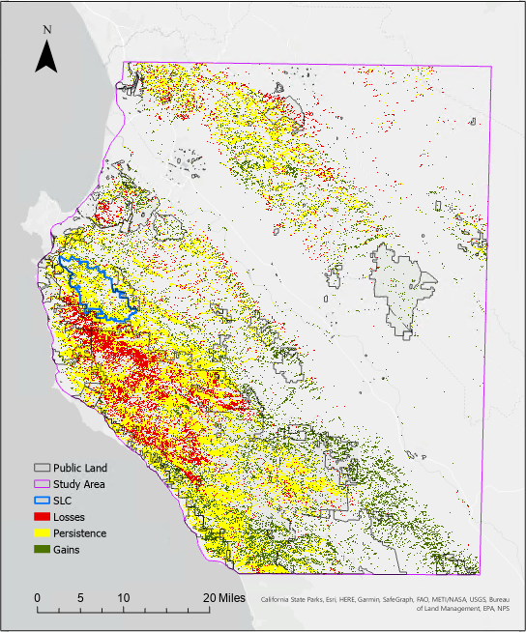

*Figure B1*. Forest cover change between 1991 and 2019. Forest loss occurred largely on public land in the western region of the study area, and there was a high degree of persistence overall.

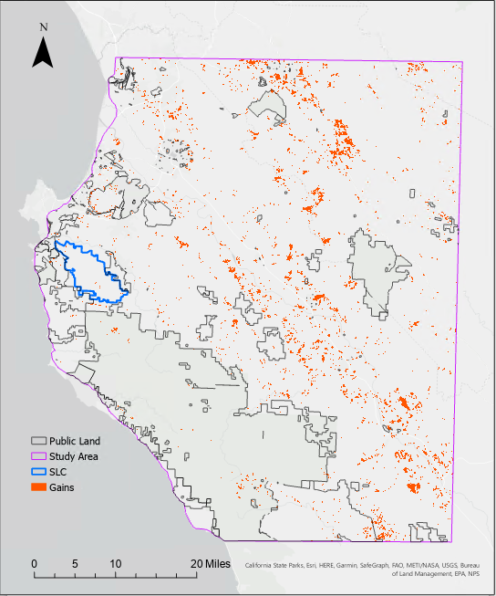

*Figure B2.* Increases in development. Most land developed between 1991 and 2019 was privately owned. The Santa Lucia Preserve and public land had minimal increases in development.

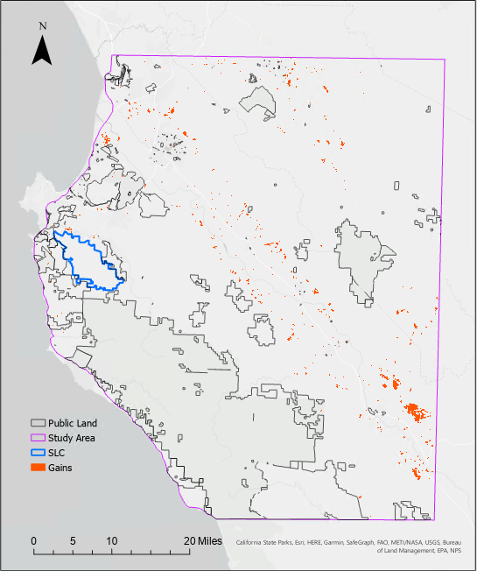

*Figure B3.* Increases in agriculture. Gains in agricultural land were largely along the Carmel Valley. Agriculture in the area is primarily grapes and golf courses.

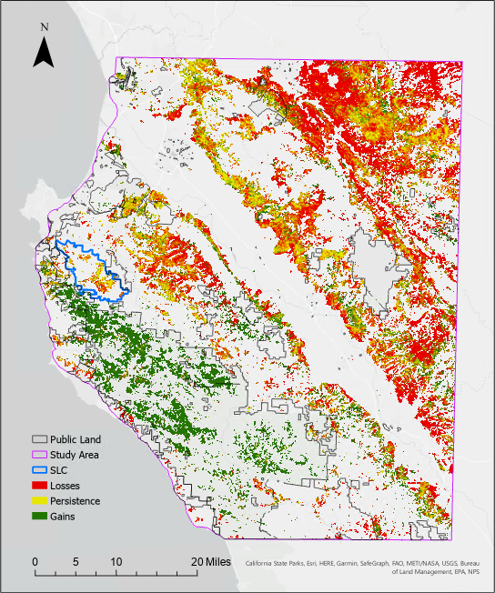

*Figure B4.* Changes in grassland. Grasslands experienced the greatest losses during the study period Most losses occurred on private lands. A large increase in grass cover on public land in the western portion of the study area corresponds with a loss in forest cover. These gains mask the severity of the decreases in grassland in other parts of the study area.