Mesoamerica Ecological Forecasting

Assessing Land Cover Change to Inform Management Planning for the Mesoamerican Biological Corridor

 **Technical Report**

Final – November 17th, 2022

Hanna Jung (Deliverables Lead)

Ross Kalter (Technical Lead)

Amelia Untiedt

Cristina Villalobos-Heredia

***Advisors:***

Betzy Hernández (NASA SERVIR)

Dr. Emil Cherrington (NASA SERVIR)

Lauren Carey (NASA SERVIR)

Africa Flores (NASA SERVIR)

Sylvia Wilson (USGS SilvaCarbon)

Dr. Robert Griffin (University of Alabama Huntsville)

Dr. Jeffrey Luvall (NASA Marshall Space Flight Center)

***Fellow:***  
Brianne Kendall (MSFC)

# 1. Abstract

In 1992, Central America and Mexico drew up an agreement to establish the Mesoamerican Biological Corridor (MBC) which defines natural corridors to connect nearly 600 protected areas. The MBC is home to 9% of the world's terrestrial species on 0.7% of the world's landmass, yet this biodiverse area has been impacted by great levels of deforestation. The MBC supports protected areas and the important conservation efforts that are tied into the area’s economic and sustainable development. The NASA DEVELOP team partnered with NASA SERVIR, Sistema de la Integración Centroamericana (SICA), Tropical Agriculture Research and High Education Center (CATIE), and Ministries of the Environment for Costa Rica, El Salvador, and Guatemala to assess forest cover change in the MBC. While the southern states of Mexico are included in the MBC, the team excluded Mexico in this study. The team acquired data from Landsat 5 Thematic Mapper (TM), Landsat 7 Enhanced Thematic Mapper Plus (ETM+), Landsat 8 Operational Land Imager (OLI), and Landsat 9 OLI-2 to develop a forest versus non-forest classification. This classification was used to create a Land Use Land Cover Change (LULC) trend map and Deforestation Detection Time Series analysis between 1992 and 2022. The team found that minimum distance classification was the most effective classifier for the project scope. Analysis showed that 6.18% of the study area experienced forest loss and 10.99% experienced forest growth. These observations will help partners visualize the evolution and severity of deforestation and allow decision making for future land management and transboundary conservation efforts.

**Key Terms**

Deforestation, land use change, Mesoamerican Biological Corridor, biodiversity, Landsat, remote sensing

# 2. Introduction

***2.1 Background Information***

The Mesoamerican Biological Corridor (MBC) is a multinational initiative for conservation and development, including Mexico, Guatemala, Belize, Honduras, El Salvador, Nicaragua, Costa Rica, and Panama. Made up of 600 protected areas and connecting corridors, the MBC is a hotspot for 7% of the world’s biodiversity (Ray, 2006). Unfortunately, the MBC is facing severe environmental threats from many human activities such as logging, mining, agriculture, and urban expansion. Central America has experienced periods of vast deforestation in the latter half of the twentieth century (Redo et al, 2012). Currently, there is an estimated annual forest loss of 400,000 hectares in Central America (Graham, n.d.). Deforestation has many detrimental environmental effects like increased CO2 emission, species extinction, and forest fragmentation. Fragmentation from deforestation reduces the size of the environment but also alters the quality of the landscape (Taipa-Armijos et al., 2015). At the end of the twentieth century and into the twenty-first, regrowth has been observed in Central America; however, fragmentation remains a constant issue that challenges the MBC’s goals to create connectivity between isolated populations (Redo et al., 2012; Graham, n.d.).

Alongside environmental influences, the MBC also faces threats from social and political boundaries (López and Jiménez, 2007). The MBC operates using a multinational structure that crosses national borders, resulting in the need for many different agencies to be included in its operations. The Central American Commission on Environment and Development (CCAD) and the Ministries of Environment from the eight countries of the MBC manage regional decision-making and implementation for the corridor. (López and Jiménez, 2007) The varying demands and political perspectives of these decision makers can cause challenges in the management of the corridor. There are also social influences in the MBC. Alongside designated protected areas, there are indigenous human settlements within the corridor. Previous studies have shown that many indigenous communities implement effective conservation management practices because there are less levels of deforestation in protected areas and indigenous areas (Sze, 2022). Due to its scale, the MBC covers a multitude of diverse populations who all have individual influence on the corridor.

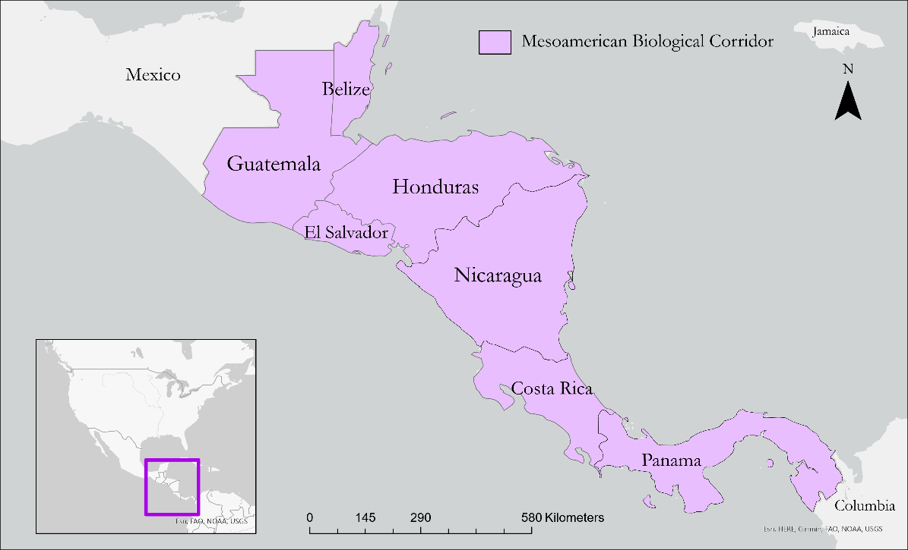

*Figure 1.* This map displays the countries of interest within the MBC.

The end goal of this study was to analyze landcover and deforestation trends in the MBC. While there have been past studies that have focused on this very topic, most are spatially and temporally limited. This study was significant because it both collectively looked at deforestation throughout Mesoamerica, excluding Mexico, that comprises the MBC (*Figure 1*), and it reviewed land cover change over a period of thirty years from 1992 to 2022. Previous studies have used a variety of methods to analyze deforestation and land cover change. In a 2017 study by Ramirez-Maija et al., the land cover classification was broken up into four classes of forest (distinguished by climate affinity), one agriculture class, and several other land cover classes. In the 2012 study by Redo et al., MODIS imagery was utilized to map land use land cover trends. They also trained the classifier on human interpretation of high-resolution imagery. In a 2017 study by Schlesinger et al., a digital estimation map of forest cover and other major land uses in the MBC was used to quantify land use change within transboundary and protected areas. This land cover map was created in 2011 by The Water Center for the Humid Tropics of Latin America and Caribbean (CATHALAC) and under the Regional Program for the Reduction of Vulnerability and Environmental Degradation (PREVDA).

***2.2 Project Partners & Objectives***

This project partnered with NASA SERVIR, Sistema de la Integración Centroamericana (SICA), Tropical Agriculture Research and High Education Center (CATIE), and the Ministries of the Environment for Costa Rica, El Salvador, and Guatemala to address concerns of intensifying deforestation in the MBC. The Ministries of Environment of Costa Rica, El Salvador, and Guatemala are responsible for resource management and environment, focusing on the support and development within their own countries. SICA aims to create harmonious development for all individuals of the entire region. CATIE also promotes green development and sustainable well-being for Latin America and the Caribbean.

The team's objectives were to classify, identify, and visualize deforestation trends to help the partners gain a stronger understanding of forest change trends to aid their decision making. The methods for this project provide a definition for deforestation that is universal to the MBC, making the end-product applicable to all countries within the MBC. The team used NASA Earth observations to classify land cover change of forest and non-forest within the MBC. This classification was then used to identify forest cover change in a time span of 30 years. This was visualized by producing land use land cover change trend maps of the years 1992 and 2022. These analyses will help the partners to observe forest change in the MBC. It will also build the capacity of the partners to use NASA Earth observations in their future work and conservation efforts.

# 3. Methodology

***3.1 Data Acquisition***

The team acquired Landsat data of the MBC through NASA SERVIR’s asset collection in Google Earth Engine (GEE), a cloud-based platform that processes remote sensing data from satellite imagery. The asset included mosaiced, cloud free images of the MBC for every year between 1984 and 2022 at 30m and 100m resolutions along with the Central America 2010 Land Cover map of the MBC and raster images of protected areas and international boundaries. The asset imagery used by the team was comprised of Landsat 5 Thematic Mapper (TM), Landsat 7 Enhanced Thematic Mapper Plus (ETM+), Landsat 8 Operational Land Imager (OLI), and Landsat 9 Operational Land Imager 2 (OLI-2) datasets. The necessary source materials for each dataset are outlined in Table 1.

Table 1.

*Descriptions of Earth observations used in preprocessing*

|  |  |  |  |
| --- | --- | --- | --- |
| **Sensor** | **Processing Level** | **Data Provider** | **GEE ImageCollection ID** |
| **Landsat 5 TM** | Collection 2 Tier 1 Surface Reflectance | United States Geological Survey (USGS)/GEE | LANDSAT/LT05/C02/T-1 |
| **Landsat 7 ETM+** | Collection 2 Tier 1 Surface Reflectance | USGS/GEE | LANDSAT/LE07/C02/T1 |
| **Landsat 8 OLI** | Collection 2 Tier 1 Surface Reflectance | USGS/GEE | LANDSAT/LC08/C02/T1 |
| **Landsat 9 OLI-2** | Collection 2 Tier 1 Surface Reflectance | USGS/GEE | LANDSAT/LC09/C02/T1 |

***3.2 Data Processing***

*3.2.1 Image Design*

Because the MBC is a cloud-dense, tropical area, it was imperative to mask out pixels that indicated cloud cover which would have otherwise been interpreted incorrectly. Unfortunately, the availability of cloud-free imagery from 1992-2022 was limited due to the moist, tropical climate that characterizes much of the area. The team worked with 30m and 100m resolution cloud-free Landsat imagery provided as an asset by NASA SERVIR. Ultimately the 100m resolution data was used to make the computations of classification faster because 100m pixels are equal to exactly one hectare of land, and the 100m data was available for the entirety of the 30-year study period. The mosaiced 100m Landsat surface reflectance imagery from NASA SERVIR was stored as an image collection containing a band for every year representing every possible Landsat band-year combination, such as ‘B1_1984’ and ‘B2_2022.’ The team designed a script that extracted the relevant red, green, blue, near infrared (NIR), and short-wave infrared (SWIR) bands for both 1992 and 2022. Each image was clipped to the area of interest (AOI) to create annual, mosaiced 100m resolution images of the MBC to be used as predictor images for landcover classification.

*3.2.2 Sampling Design*

In order to obtain a representative sample and account for much of the variation within forest and non-forest landcover, the team consulted with advisors and decided to split the binary classification into sub-groups. Different countries have different definitions of land cover types, especially when it comes to forest.

Therefore, a standardized classification was necessary for this regional study. The team used the same moderate-resolution 2010 landcover classification map used by Schlesinger et al (Hernández Sandoval et al, 2011), henceforth referred to as the Central America 2010 Land Cover map, as a source from which to draw training data for the classification (As its classification was derived from Landsat imagery, contained diverse landcover classes, and was ground-verified at many points, it offered the best proxy for true land cover at a relative midway point of the study period). The pixel values of the single-band image ranges from 1-15, corresponding to 15 different landcover types: mangroves, broadleaf forest, coniferous forest, mixed type forest, shrubs, savannas, pastures, annual crops, monocrops, permanent crops, urban areas, areas of scarce vegetation, wetlands, water bodies, and plateaus. To collect adequate training points from each sub-group, the team used a stratified random sample to split the image into these fifteen strata, randomly select a sample of 300 points in each stratum and generate a feature collection to store all the points.

*3.2.3 Landcover Classification*

After assembling the training data, the team used the sampleRegions function in GEE to determine the predictor values at each training data location of the 2010 mosaiced Landsat predictor image. The 2010 predictor image was used as an initial training environment because the training locations originate from a 2010 classification scheme. Using 2010 as a midway point in the time scale accounted for some of the climatic variations over the 30 years. The classifier often confused classes with similar reflectance properties like savannas, pastures, and pines. To assist with visualization, the team experimented with aggregation of the classification into five broader classes, shown in Figures A1-A4 in the appendix. These five classes were forest, non-forest, water, agriculture, and grassland.

The team trained both Random Forest and Minimum Distance classifiers on the 2010 predictor image using the training points. It was determined that a Minimum Distance model performed better at classifying areas of forest and non-forest because it pinpointed outlying pixels more accurately and resulted in a less grainy classification. The addition of a mode neighbor reducer also helped to capture and “smooth out” many outlier pixels. Once the supervised classification model was trained and tested on the 2010 predictor image, the team applied the classification to the 1992 100m and 2022 100m predictor images. Finally, the team grouped the classified images into forest, non-forest, and water in order to obtain 1992 and 2022 forest/non-forest classifications of the MBC. “Forest” included mangroves, broadleaf forest, coniferous forest, and mixed type forest. “Non-forest” included shrubs, savannas, pastures, annual crops, monocrops, permanent crops, urban areas, areas of scare vegetation, wetlands, and plateaus. “Water” included water.

3.2.4 *Image clipping*

The team exported forest/non-forest images and an AOI shapefile from GEE and imported them onto ArcGIS Pro for further data processing. The Clip Raster tool within ArcGIS Pro was used to clip the Land Cover change images to the extent of the AOI shapefile. Clipped images provide a better data analysis as it removes “No Data” pixels that have an effect on forest, non-forest, and total pixel counts.

***3.3 Data Analysis***

After clipping the images, the team ran a change detection analysis using the Raster Calculator in ArcGIS Pro. This tool allows the user to detect temporal change by performing simple algebra on raster data. This subtraction determines the difference in pixel values over time. The team subtracted the earlier date was from the later date, in this case 2022 minus 1992. The resulting change detection raster was then used to visualize the change in forest and non-forest pixels between 1992 and 2022. The same process was used to create a change detection raster at 10-year intervals. The team then created a histogram to obtain pixel values corresponding to their binary category (forest or non-forest). Percent of forest loss and forest gain was calculated using Equation 1, shown below.

$$\frac{variable pixel count}{total pixel count}×100=\%$$

*Equation 1****.***

Next, the ancillary datasets were imported into ArcGIS and laid over the 1992-2022 Change Detection layer to identify areas of change and further investigate these specific case study areas. To visualize change at 10-year intervals, the team took the forest/non-forest images for 1992, 2002, 2012, and 2022 and created an animation within ArcGIS Pro that was then exported as a GIF. The images used for this animation are shown in Figures A5-A8 in the appendix.

# 4. Results & Discussion

*4.1 Analysis of Results*

By performing visual and timeseries analysis with Raster Calculator in ArcGIS, the team assessed the amount of forest loss and forest gain in the MBC. The analysis focused on the MBC as a whole, but also included layers for protected areas and indigenous communities, and a case study area in Guatemala. These additional layers helped make inferences about forest loss and gain throughout the MBC and aided the team’s case studies.

*4.1.1 Change Detection Analysis*

The 1992-2022 Change Detection showed a 6.18% change to forest loss and a 10.99% change to forest growth. These statistics were obtained from Equation 1 and are represented in Table A1 and Table A2 in the appendix. The percent of forest loss and gain is shown in Figure 2 and further visualized in Figure 3. The forest gain was higher than expected. Due to the time constraints of the project, the classification was not effectively able to determine the difference in spectral signatures between native forest and tree cover, or agricultural forest. Despite these errors in the classification, the team decided to continue to use the term “forest cover change” instead of “tree cover change.” It is very likely that agricultural locations, such as palm oil plantations, were incorrectly misclassified as forest. There has been a recent increase in the production of palm oil in Central America, which could explain the unexpected forest growth in the change detection (Richard Furumo, 2017). Visual analysis comparing the areas of forest growth on the change detection to Google Earth satellite imagery also suggested that there was some misclassification of agriculture into forest.

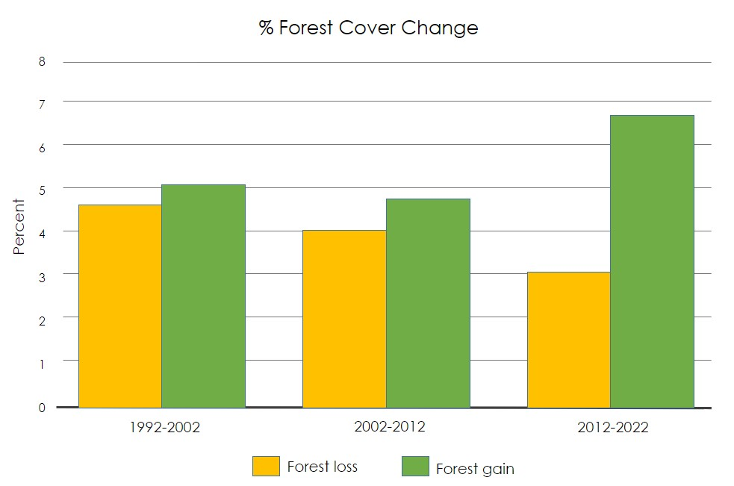   
*Figure 2.* Percent change in forest cover between 1992 to 2022

The team also created a change detection analysis for change between 1992 to 2002, 2002 to 2012, and 2012 to 2022. This allowed the team to look at forest cover trends in further detail between different decades. These images are shown in Figures B1-B3 of Appendix B. The geography of an area can influence forest growth trends. For example, isolated areas which are more difficult to access may have fewer human influences and therefore lower levels of deforestation. In Panama, for example, there is a clear distinction of forest and non-forest bisecting the country. This area is a geological formation of mountains and ridges dividing hydrological areas known as the continental divide. Because the continental divide is challenging to cross, there is less deforestation on one side. There is forest to the north of the divide and non-forest to the south, and as illustrated by the 1992-2022 Change Detection map, there is no change in these northern areas. It is also important to consider areas of no change. If an area was well preserved in 1992 and has shown little change in 2022, that suggests that it continues to be well preserved three decades later. If there is no change in a protected area, it could suggest that the protected area is well managed.

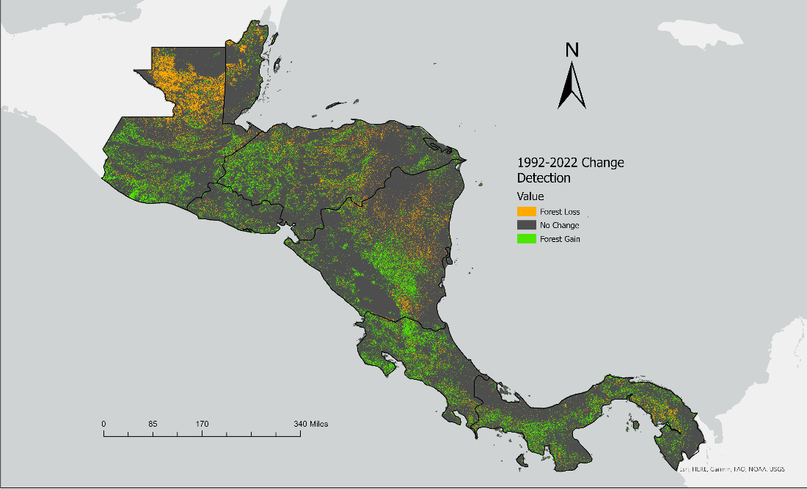

*Figure 3.* 1992-2022 Change Detection map

*4.1.2 Protected Areas*

The team overlayed the 1992-2022 Change Detection map with a protected areas layer and performed a visual analysis shown below in Figure 4. This layer included United Nations Education, Scientific, and Cultural Organization (UNESCO) designated biospheres, national parks, international parks, and many other park designations. Visual analysis did not show any trends between forest cover change and protected areas for the MBC. The team noticed a trend of little change or no change within some of these protected areas. This suggested that these protected areas may be benefitting from effective management. Some of these protected areas are also isolated and much harder to access than others, which may also contribute to these areas of no change. There are also protected areas in regions of concentrated forest loss. Forest loss is often observed on the edges of the protected areas, but visual analysis observed a few areas of concentrated forest loss within the interior of the protected areas.

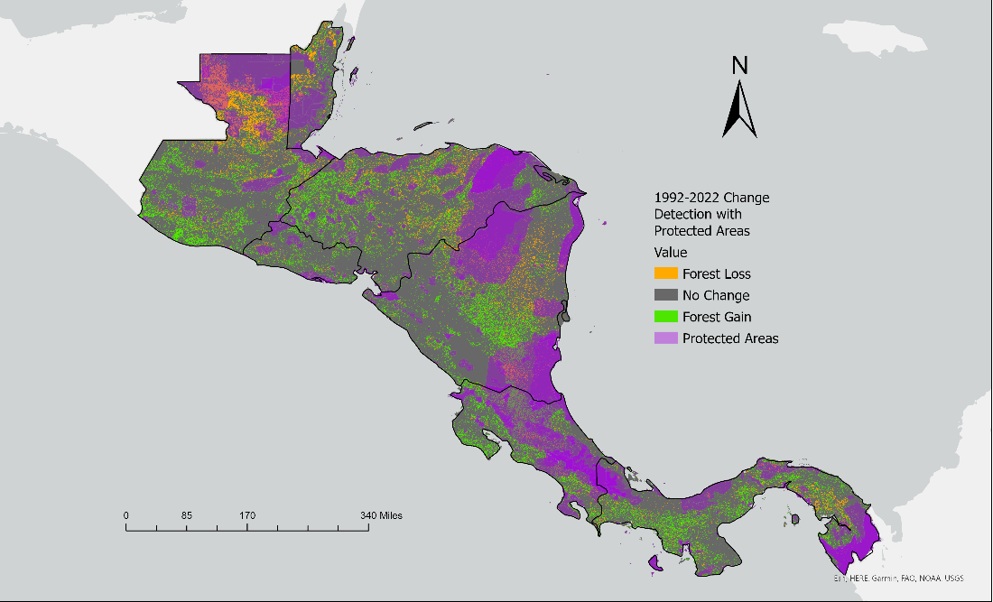

*Figure 4.* Change Detection between 1992-2022 including layer for protected areas

*4.1.3 Indigenous Communities*

The team also overlayed the 1992-2022 Change Detection map with an indigenous community layer and performed a visual analysis at the request of the partners. The Indigenous Communities layer is shown below in Figure 5. A visual analysis did not indicate any clear trends between forest cover change analysis and indigenous communities in the MBC. One area that the team highlighted in this analysis was the La Mosquitia region in Eastern Honduras and Nicaragua. In this region are the Rio Platano Biosphere Reserve and the Bosawas Reserve. The interiors of these reserves have large areas of no change. The Sumu-Mayangna, Tawalhca, Miskito, and Pech communities also live within these areas. These communities practice subsistence agriculture within the park, but it is on a much smaller scale compared to commercial agricultural practices (Godoy, 1997). These findings concur with the conclusion from the 2022 Sze et al. paper stating that indigenous communities in Latin America have been found to have lower levels of deforestation than managed protected areas.

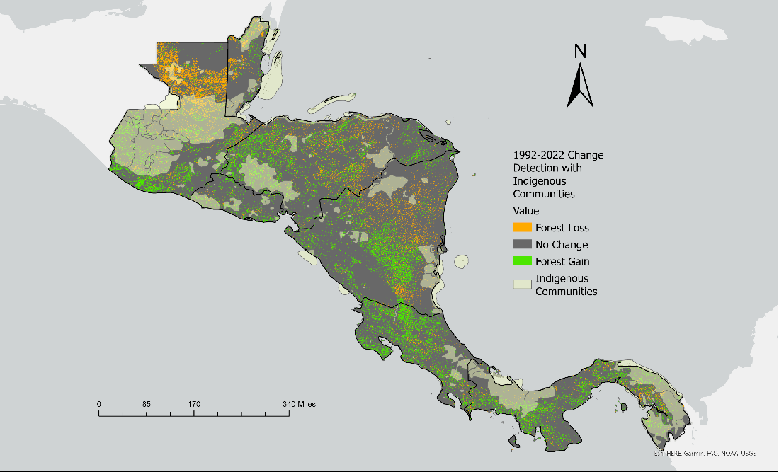

*Figure 5.* Change detection between 1992-2022 including layer for indigenous communities

*4.1.4 Guatemala Case Study*

Guatemala was chosen as a case study at the behest of the partners, shown below in Figure 6. In recent history, there has been notable forest loss. Over a twenty-year period, there was a reported loss from 83% forested areas to 31% of forested areas (Chicas et al., 2016). In the Petén region in Northern Guatemala, there is a distinct line separating an area of no change and forest loss. This is the Maya Biosphere Reserve. The Maya Biosphere Reserve is part of three contiguous UNESCO Biosphere Reserves (The other two being Calakmul and Montes Azules Biosphere Reserves in the southern Mexico). The reserve is a hotspot for biodiversity. It is suggested that is holds up to 34% of the total species of vascular plants that exist in Guatemala (UNESCO).

There was a 12.34% forest loss during the 30-year period. This likely came from an increase of agricultural activity in the region (Shriar, 2002). Guatemala was in a civil war from 1960 to 1996. During the war, Northern Guatemala was considered to be a dangerous area to live in. At the end of the war, there was a migration north to this area for access to agricultural land (Shriar, 2002). Much of the land available for agriculture south of this region was already claimed. In order for farmers to claim land as their own, they had to move farther north to Petén (Carr, 2009).

The Maya Biosphere was not excluded from this agricultural expansion. Even though there is a buffer zone around the southern edge of the reserve, there has still been agricultural practices reported within what was then the reserve boundaries (Shriar, 2002). More forest loss can be seen on the western side of the reserve than the eastern side. This is because the western half has more water and lower elevation, which makes it easier to access (Dan Irwin, interview by Amelia Untiedt, October 26, 2022). The change detection map in Figure 6 showed a large concentration of forest loss in Laguna del Tigre, a park located within the reserve. There are also indigenous communities living within the eastern side of the biosphere. Additionally, forest fires in this area can contribute to forest loss.

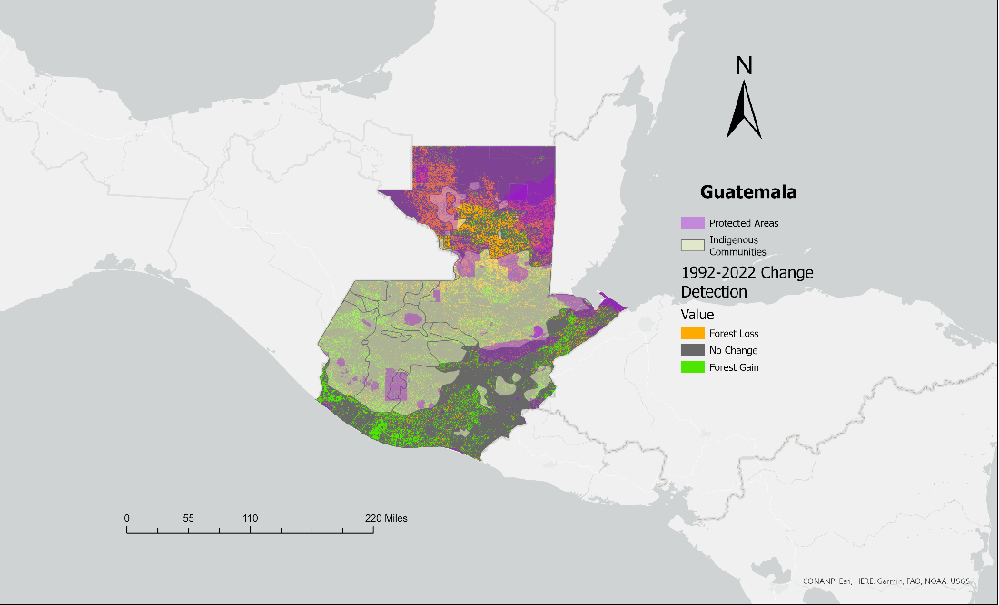

*Figure 6.* Guatemala 1992-2022 Change Detection with Protected Areas and Indigenous Communities Layers

***4.2 Errors and Limitations***

Many factors are worth considering throughout the stages of methodology and have implications for the results of the project analysis. The team observed various errors and limitation during the process of image design, sampling data, and classification. These errors and limitations are discussed in the following sections.

*4.2.1 Limits of Image Design*

The values of Earth observation pixels are inherently aggregated from surrounding pixels. Thus, even after extreme processing of images, the value is never a true representation of the landcover beneath. Additionally, using 100m resolution is coarser than 30m resolution, meaning the value of each 100m pixel cannot detail the same amount of information as multiple 30m pixels can of the same area, leading to an inaccurate capturing of the true landcover present. While 30m resolution is ideal, access to 30m cloud-free imagery of the region was limited throughout the 30-year time span.

*4.2.2 Limits of Sampling Design*

Sampling 2010 training data to classify landcover in 1992 and 2022 assumes conditions were the same across these years, when in reality the spectral properties vary annually, such as during years of drought or excessive rainfall. Furthermore, it is worth noting that the Central America 2010 Land Cover map image is a classification itself, therefore the pixel values were derived by a model. Other sources of validated training data were investigated, such as Collect Earth Online, but failed to be of use because it lacked timestamps. Additionally, drawing only 300 points from each of the 15 classes (4500 points total) in the Central America 2010 Land Cover map may not be an adequate sample size for such a large area. Sampling 500 points (7500 total) was considered but yielded too many features for GEE to handle, exhausting the classifier.

*4.2.3 Limits of Classification*

Classifying up to 15 different land cover types is complex. This is because land cover status differs by time of year and location along with seasonal, climatic, and other natural changes that can easily make the spectral properties vary. For example, the classifier could distinguish savannas and pastures in Costa Rica but not in Guatemala. This led to some forest sub-groups being inaccurately labeled as non-forest and ultimately a ‘salt and peppered’ result that didn’t represent reality. If preference lies on classifying the sub-groups more accurately, further investigation is necessary.

***4.3 Future Work***

Given the numerous challenges and limitations of a regional forest cover classification, there are various avenues for future work. The classifiers struggled to differentiate the similar spectral signatures of some ecosystem classes, often misclassifying non-forest as forest. Additional validated training data would assist the classifier in differentiating similar spectral signatures. Future studies could consider different classification schemes and alternative training data to help account for the misclassification.

The team also faced misclassification with agricultural areas such as shade coffee or palm oil plantations being classified as forest. It is very difficult to differentiate between agricultural forest and native forest using Landsat imagery. A future study could use Light Detecting and Ranging (LIDAR) or Synthetic Aperture Radar (SAR) imagery to separate these two categories and test their ability to differentiate forest cover and agricultural sites. Since there has been an increase in agriculture in Central America, especially palm oil, this could be a very informative study to help identify new pressures on the MBC (Richard Furumo, 2017).

The analysis has shown forest regrowth in parts of the MBC; however, a previous study found that forest regrowth can be different from the original growth (Redo et al, 2012). Often a drier forest type grows back where there was previously a wetter forest type. This is concerning because wetter forest types have higher biodiversity than drier types (Redo et al, 2012). A future land cover analysis could investigate which forest types are growing back and how that will alter the landscape.

# 

# 5. Conclusions

This study addressed intensifying deforestation trends and other community concerns in the Mesoamerican Biological Corridor by utilizing Earth observations and assets provided by NASA SERVIR. The team developed a forest/non-forest classification map and created LULC maps to illustrate forest change over a thirty-year period. From these analyses, the team was able to make the following conclusions.

Differentiating between land cover types in a large area such as the MBC requires holistic training data. Accounting for landcover and ecosystem diversity in a classification is challenging, especially in regions like the MBC which includes over 200 different ecosystems. There are limited land cover maps available for the entirety of the MBC. Pooling the resources of all the parties involved in the MBC could develop a thorough and all-encompassing set of training data. This requires consensus and communications between the parties involved in the management of the corridor.

The analysis of the 1992-2022 Change Detection map found a 6.18% change to forest loss and a 10.99% change to forest gain. The change to forest gain was higher than expected, which could be due to errors in the classification. Upon visual comparison to satellite images and discussions with advisors and partners, it appears that some of the agricultural forest may have been misclassified as forest instead of non-forest. This further emphasizes the importance of holistic training data.

From the classification scheme developed, the team found that despite being an older classifier, Minimum Distance classification was the most effective. Other classifiers struggled with either differentiating between different classes or producing a gritty visual output. Minimum Distance created a smoother visual and was capable of differentiating the similar spectral signatures in the classification. This classifier will be able to assist the end users with classification at a regional level, which matches with the MBC’s goal of being a multinational initiative towards conservation and development.

# 

# 6. Acknowledgments

The Mesoamerica Biological Corridor Ecoforecasting team would like to thank our partners from NASA SERVIR, Sistema de la Integración Centroamericana (SICA), Tropical Agriculture Research and High Education Center (CATIE), and Ministries of the Environment for Costa Rica, El Salvador, and Guatemala for their guidance and support throughout this project. Thank you to our science advisors Betzy Hernández, Dr. Emil Cherrington, Lauren Carey, Africa Flores, Sylvia Wilson, Dr. Robert Griffin, and Dr. Jeffrey Luvall for their technical support. Thank you to our fellow Brianne Kendall for her leadership and guidance throughout the duration of our project, as well as Dr. Kent Ross and Laramie Plott for their assistance with the project. The team would also like to thank the DEVELOP network for fostering an inclusive and supportive work environment.

Any opinions, findings, and conclusions or recommendations expressed in this material are those of the author(s) and do not necessarily reflect the views of the National Aeronautics and Space Administration.

This material is based upon work supported by NASA through contract NNL16AA05C.

# 

# 7. Glossary

**Area of Interest (AOI) –** focus on a particular area

**Central American Commision on Environment and Development (CCAD)** –Regional institution responsible for management of the MBC

**Earth observations** – Satellites and sensors that collect information about the Earth’s physical, chemical, and biological systems over space and time

**Enhanced Thematic Mapper Plus (ETM+) –** eight band, whisk-broom multispectral scanning radiometer

**Forest Fragmentation –** the loss of forest by the division of large continuous forested areas into smaller pieces of forest; typically, by roads, agriculture, utility corridors, subdivisions, or other human developments.

**Google Earth Engine (GEE) –** cloud-based platform that allows users to perform geospatial analysis

**Indigenous Communities –** Culturally distinct ethnics groups that are associated to a particular geographic area

**Mesoamerican Biological Corridor (MBC)** **–** Amultinational initiative for conservation and development, including Mexico, Guatemala, Belize, Honduras, El Salvador, Nicaragua, Costa Rica, and Panama.

**MODIS** – Moderate Resolution Imaging Spectroradiometer

**Protected Areas** – locations that receive protected because they hold areas of high ecological, cultural, or natural value

**Sistema de la Integración Centroamericana (SICA) –** Institutional framework of Regional Integration in Central America

**Sample** –a subset or portion of the region mapped

**Sampling design** – a protocol for selecting those locations at which reference data will be collected

**USGS –** United States Geological Survey

# 8. References

Broadbent, E. N., Zambrano, A. M. A., Dirzo, R., Durham, W. H., Driscoll, L., Gallagher, P., ... & Randolph, S. G. (2012). The effect of land use change and ecotourism on biodiversity: a case study of Manuel Antonio, Costa Rica, from 1985 to 2008. *Landscape Ecology*, *27*(5), 731-744, [s10980-012-9722-7.pdf (springer.com)](https://link.springer.com/content/pdf/10.1007/s10980-012-9722-7.pdf)

Carr, D. (2009). Population and deforestation: why rural migration matters. *Progress in Human Geography*, *33*(3), 355-378. https://doi.org/10.1177/0309132508096031

Chicas, S. D., Omine, K., Arevalo, B., Ford, J. B., & Sugimura, K. (2016). Deforestation Along the Maya Mountain Massif Belize-Guatemala Border. *International Archives of the Photogrammetry, Remote Sensing & Spatial Information Sciences*, 41. <https://pdfs.semanticscholar.org/ac28/a52650de634ae3fd686e2748ca0c96d17cae.pdf>

Dan Irwin, interviewed by Amelia Untiedt, October 26, 2022

Godoy, R., O'neill, K., Groff, S., Kostishack, P., Cubas, A., Demmer, J., ... & Martínez, M. (1997). Household determinants of deforestation by Amerindians in Honduras. *World Development*, *25*(6), 977-987. <https://doi.org/10.1016/S0305-750X(97)00007-7>

Graham, D. (n.d.). *Mesoamerican biological corridor: Mexico to Panama*. Mesoamerican Biological Corrdior. Retrieved October 5, 2022, <https://www.tbpa.net/docs/62_Meso_American_Biological_Corridor.pdf>

Hernández Sandoval, B. E., Garcia, B., Garrish, V., Cherrington, E. A., Picado, F., & Sempris, E. (2011). Mapa Centroamericana de cobertura y uso de la tierra, cambios de cobertura y uso de la tierra 1980-1990-2000-2010. *ResearchGate*. <https://doi.org/10.13140/RG.2.2.16349.82409>

López, A., Jiménez, A. (2007) Latin American Assessment Environmental Conflict and Cooperation: The Mesoamerican Biological Corridor as a Mechanism for Transborder Environmental Cooperation. *United Nations Environment Programme*, P. 54, [The Mesoamerican Biological Corridor (conservationcorridor.org)](https://conservationcorridor.org/cpb/L%c3%b3pez_and_Jim%c3%a9nez_2007.pdf)

Ray, D. K., Welch, R. M., Lawton, R. O., & Nair, U. S. (2006). Dry season clouds and rainfall in northern Central America: Implications for the Mesoamerican Biological Corridor. *Global and Planetary Change, 54*(1-2), 150-162, from <https://doi.org/10.1016/j.gloplacha.2005.09.004>

Redo, D. J., Grau, H. R., Aide, T. M., & Clark, M. L. (2012). Asymmetric forest transition driven by the interaction of socioeconomic development and environmental heterogeneity in Central America. *Proceedings of the National Academy of Sciences*, *109*(23), 8839-8844, [Asymmetric forest transition driven by the interaction of socioeconomic development and environmental heterogeneity in Central America (pnas.org)](https://www.pnas.org/doi/pdf/10.1073/pnas.1201664109)

Richard Furumo, P., & Mitchell Aide, T. (2017, February 2). *Characterizing commercial oil palm expansion in Latin America: Land use change and trade*. IOPScience. Retrieved November 7, 2022, from https://iopscience.iop.org/article/10.1088/1748-9326/aa5892/meta

Schlesinger, P., Munoz Brenes, C. L., Jones, K. W., & Vierling, L. A. (2017). The Trifinio Region: A case study of transboundary forest change in Central America. *Journal of Land Use Science, 12*(1), 36-54. <https://doi.org/10.1080/1747423X.2016.1261948>

Shriar, A. J. (2002). Food security and land use deforestation in northern Guatemala. *Food Policy, 27*(4), 395-414. https://doi.org/10.1016/S0306-9192(02)00046-5

Sze, J. S., Carrasco, L. R., Childs, D., & Edwards, D. P. (2022). Reduced deforestation and degradation in Indigenous Lands pan-tropically. *Nature Sustainability*, *5*(2), 123-130, [Reduced deforestation and degradation in Indigenous Lands pan-tropically (whiterose.ac.uk)](https://eprints.whiterose.ac.uk/186258/1/Sze_etal_ManuscriptDraft_2021-10-12.pdf)

Tapia-Armijos, M. F., Homeier, J., Espinosa, C. I., Leuschner, C., & de la Cruz, M. (2015). Deforestation and forest fragmentation in South Ecuador since the 1970s–losing a hotspot of biodiversity. *PloS One, 10*(9), from <https://doi.org/10.1371/journal.pone.0133701>

UNESCO. (2020, November 10). *Maya Biosphere Reserve, Guatemala*. UNESCO. Retrieved November 10, 2022, from <https://en.unesco.org/biosphere/lac/maya>

US Geological Survey (USGS). (2013). Landsat 5 Thematic Mapper (TM) Level 2, Collection 2, Tier 1 Top of Atmosphere Reflectance [Dataset]. Earth Engine Data Catalog/USGS. Retrieved October 2022, from <https://doi.org/10.5066/P9IAXOVV>

US Geological Survey (USGS). (2013). Landsat 7 Enhanced Thematic Mapper Plus (ETM+) Level 2, Collection 2, Tier 1 Top of Atmosphere Reflectance [Dataset]. Earth Engine Data Catalog/USGS. Retrieved October 2022, from <https://doi.org/10.5066/F7319TSJ>

US Geological Survey (USGS). (2013). Landsat 8 Operational Land Imager (OLI) Level 2, Collection 2, Tier 1 Top of Atmosphere Reflectance [Dataset]. Earth Engine Data Catalog/USGS. Retrieved October 2022, from <https://doi.org/10.5066/P9OGBGM6>

US Geological Survey (USGS). (2021). Landsat 9 Operational Land Imager (OLI-2) Collection 2, Tier 1 Top-of-Atmosphere Reflectance [Dataset]. Earth Engine Data Catalog/USGS. Retrieved October 2022, from <https://doi.org/10.5066/P9OGBGM6>

# 9. Appendix

# Appendix A

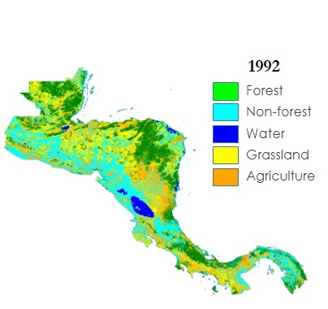

*Figure A1.* Five class land cover classification for 1992 where green is forest, Cyan is non-forest, blue is water, yellow is grassland, and orange is agriculture.

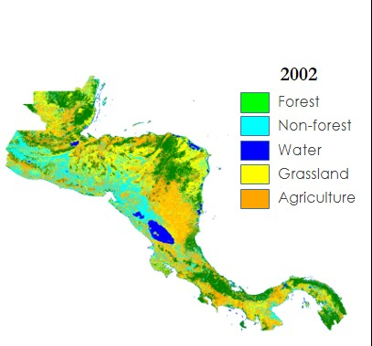

*Figure A2.* Five class land cover classification for 2002 where green is forest, Cyan is non-forest, blue is water, yellow is grassland, and orange is agriculture.

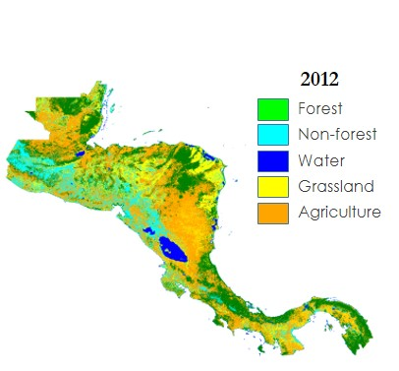

*Figure A3.* Five class land cover classification for 2012 where green is forest, Cyan is non-forest, blue is water, yellow is grassland, and orange is agriculture.

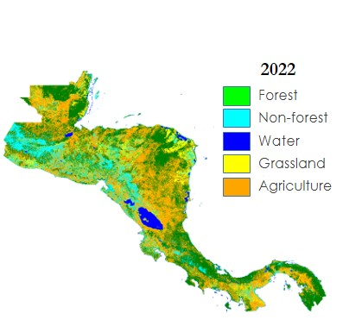

*Figure A4.* Five class land cover classification for 2022 where green is forest, Cyan is non-forest, blue is water, yellow is grassland, and orange is agriculture.

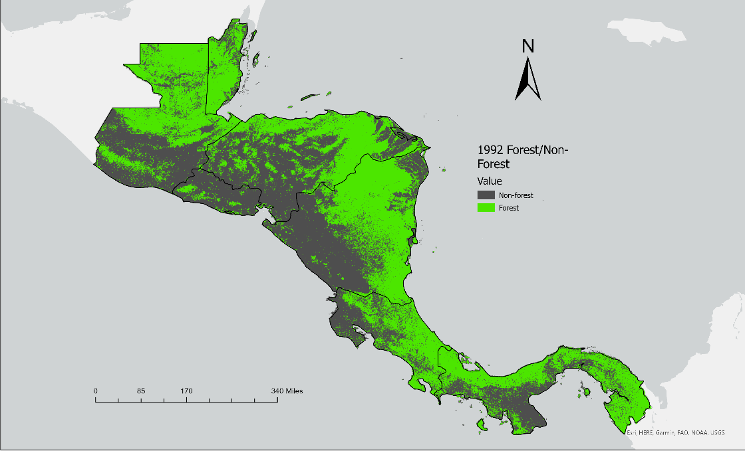

*Figure A5.* Forest/non-forest classification for 1992 where grey is non-forest, green is forest

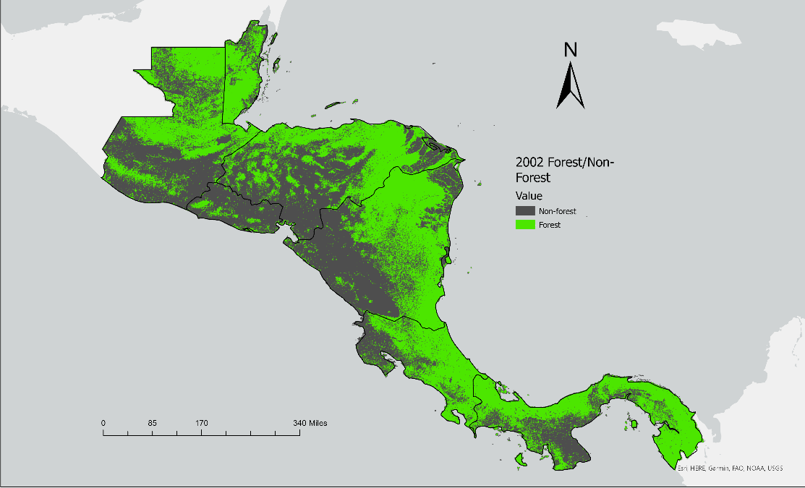

*Figure A6.* Forest/non-forest classification for 2002 where grey is non-forest, green is forest

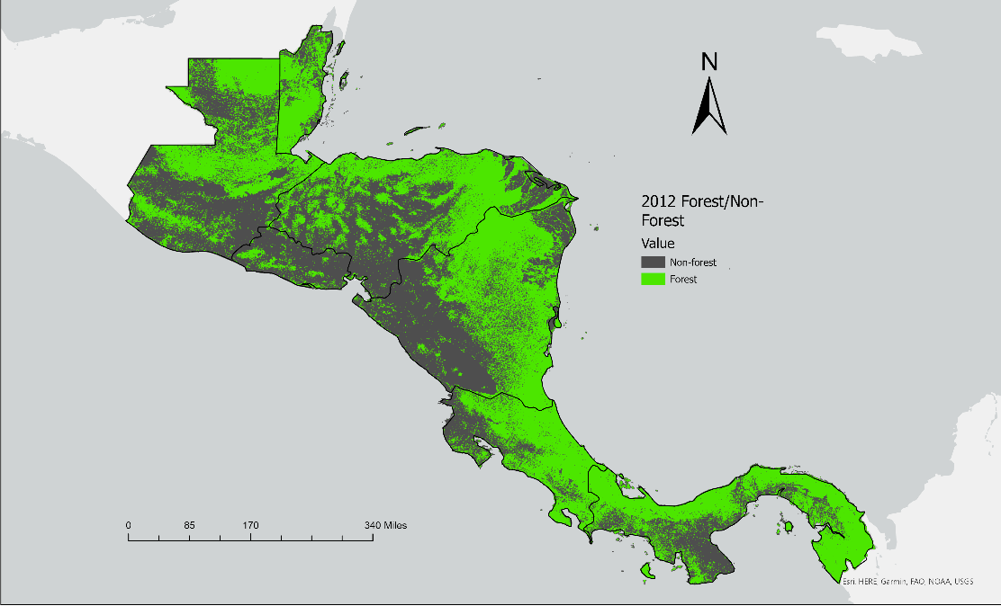

*Figure A7.* Forest/non-forest classification for 2012 where grey is non-forest, green is forest

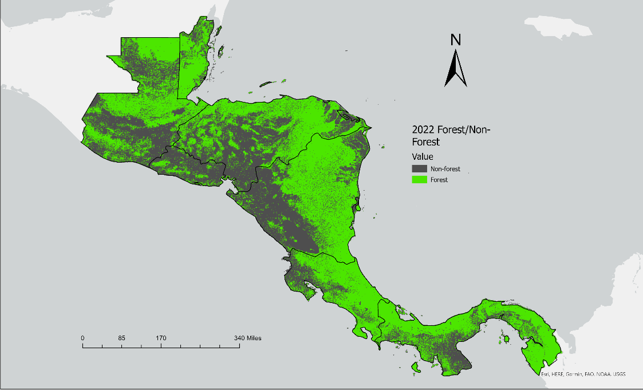

*Figure A8.* Forest/non-forest classification for 2022 where grey is non-forest, green is forest

# Appendix B

|  |  |  |  |
| --- | --- | --- | --- |
| **Year** | **Forest Loss (hectares)** | **No Change (hectares)** | **Forest Gain (hectares)** |
| 1992-2022 | 3,347,630 | 44,851,805 | 5,953,955 |
| 1992-2002 | 2,559,176 | 48,780,484 | 2,813,730 |
| 2002-2012 | 2,219,274 | 49,322,703 | 2,611,413 |
| 2012-2022 | 1,721,228 | 48,751,302 | 3,680,860 |

*Table B1.* Table of pixels or hectares of forest loss, no change, and forest gain.

|  |  |  |  |
| --- | --- | --- | --- |
| **Year** | **Forest Loss (%)** | **No Change (%)** | **Forest Gain (%)** |
| 1992-2022 | 6.18 | 82.82 | 10.99 |
| 1992-2002 | 4.72 | 90 | 5.19 |
| 2002-2012 | 4.09 | 91.07 | 4.82 |
| 2012-2022 | 3.17 | 90 | 6.79 |

*Table B2.* Table of percentage of forest loss, no change, and forest gain.

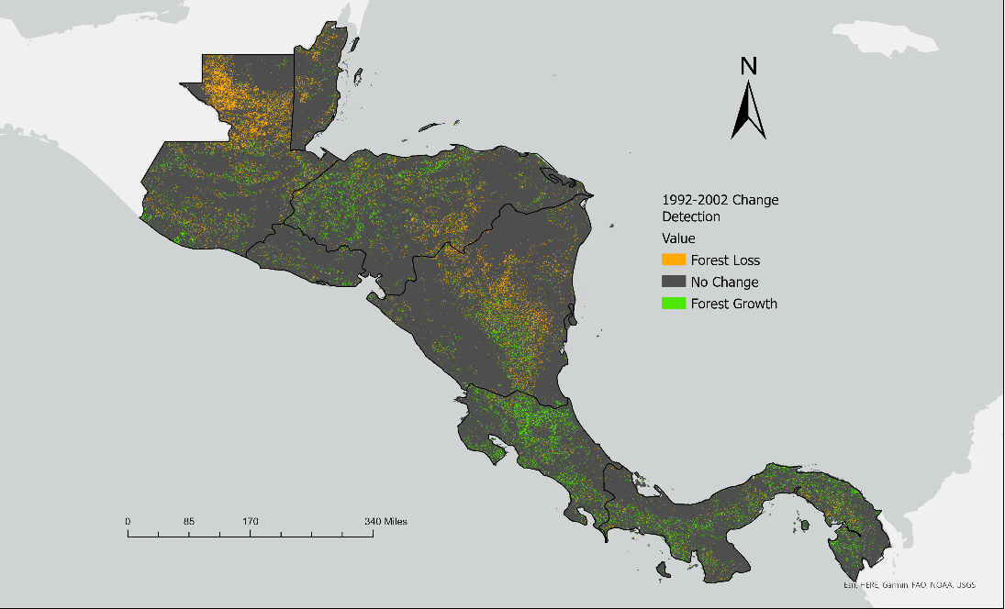

*Figure B1.* Decadal forest cover change detection of 1992-2002

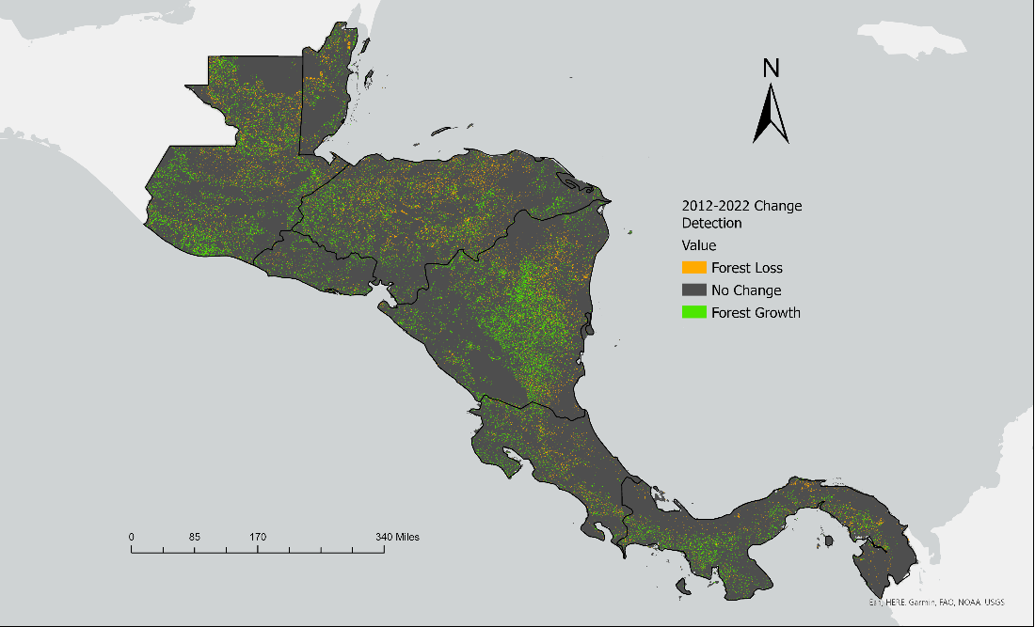

*Figure B2.* Decadal forest cover change detection of 2002-2012



*Figure B3.* Decadal forest cover change detection of 2012-2022.

1992-2002, 2002-2012, and 2012-2022 in order of appearance.