**NASA DEVELOP National Program**



Alabama - Mobile

*Fall 2017*

Coastal Alabama Water Resources II

Using NASA Earth Observations to Obtain Water Quality Trends in the Mobile Bay

and Mississippi Sound to Enhance Future Oyster Habitat Suitability and Fisheries Management

 **Technical Report**

Final Draft – November 16, 2017

Dionne Blanks (Project Lead)

Chad Austin

Gregory Leenig

Madeline Statkewicz

Joseph Spruce, NASA Langley Research Center (Science Advisor)

Dr. Kenton Ross, NASA Langley Research Center (Science Advisor)

Previous Contributors:

Mercedes Bartkovich

Xin Hong

Leah Parker

Amy Schwarber

**1. Abstract**

The Mobile Bay and Mississippi Sound region comprise the majority of the coastal estuaries along the Alabama and Mississippi Gulf Coast. These bodies of water provide the conditions needed to sustain diverse wildlife species and coastal habitats. Changes in water quality parameters directly impact native species, specifically the Eastern oyster (*Crassostrea virginia*). The project observed water quality by creating a time series analysis of turbidity, salinity, and sea surface temperature in the Mobile Bay and Mississippi Sound from September 2003 to May 2007. The Aqua Moderate Resolution Imaging Spectroradiometer (MODIS) Ocean Color and Sea Surface Temperature (SST) products were used to measure salinity and SST values. Landsat 5 Thematic Mapper (TM) Surface Reflectance data were used to retrieve turbidity. This will provide project partners with additional methodologies to aid future fisheries management and marine habitat restoration throughout the region.

**Keywords**

Aqua MODIS, Landsat 5 TM, water quality parameters, coastal habitat

# 2. Introduction

* 1. ***Background Information***

The Mobile Bay and Mississippi Sound comprise a section of the northern Gulf of Mexico coastal waters from Hancock County, Mississippi to Baldwin County, Alabama (Figure 1). This region hosts a wide variety of ecologically and economically important marine organisms. One keystone species, the eastern oyster (*Crassostrea virginica*) is a highly valued member of the Alabama and Mississippi coastal ecosystems. The sustainability of oysters and their habitats requires responsive coastal zone management and the preservation of the native coastal and estuarine ecosystems.

The eastern oyster is a critical component of the economy and culinary tradition of coastal Mississippi and Alabama. Since 2012, the seafood industry has provided nearly 20,000 jobs per year in Mississippi and Alabama and over $800 million in sales annually, with shellfish being a prominent feature in this industry (Posadas, 2017). In 2016, the farm-gate value from commercial oyster operations in Alabama alone were over $1.9 million (Grice & Walton, 2017). Oyster reefs improve biodiversity by providing a rigid substratum to support other epibiotic marine invertebrates (Orff, 2013; Gregalis, 2008). Oyster reefs also foster finfish populations and may be a positive ingredient needed for greater fish production (Mississippi Department of Environmental Quality, 2016; Peterson et al., 2003). As filter-feeders, oysters can filter approximately 50 gallons of water a day, and consequently the ability of oyster reefs to reduce pollutants and sediment is quite significant (Orff, 2013). Estuarine ecosystems occasionally must contend with the deleterious effects of eutrophication, the process in which excessive amounts of nutrients stimulate algal blooms, depleting the oxygen in the water (Carpenter, 2005). Oysters can help alleviate some coastal pollution by diminishing eutrophication via denitrification, the removal of molecular nitrogen and nitrates (Carmichael et al., 2012; Kellogg et al., 2014). Importantly, oyster reefs also aid in protecting shoreline infrastructure and property by attenuating the energy of larger, high-powered waves and storm surges by as much as 76 to 93 percent (The Nature Conservancy, 2009; Orff, 2013).

Given the importance of the eastern oyster, water quality parameters that affect its habitat are of interest. Currently, many oyster reefs in the coastal regions of Mississippi and Alabama are in fair condition, but have been adversely impacted in the past decade and a half by major storms, flooding, and the Deepwater Horizon oil spill in 2010 (Buck, 2005; Park, Valentine, Sklenar, Weis, & Dardeau, 2007; Raghavachari et al., 2013; Vignier et al., 2016). Furthermore, given the catastrophic degradation of similar reefs along the North American Atlantic coast due to anthropogenic and environmental stressors, vigilant local preservation and restoration efforts are important for maintaining oyster reefs in the region (Beck et al., 2009). As a brackish-water invertebrate, the eastern oyster can tolerate fluctuations in salinity, however it is important for oysters to remain within certain parameters in order to thrive (Eleuterius, 1977; La Peyre, Eberline, Soniat, & La Peyre, 2013). Increased turbidity alters trophic interactions in estuaries, altering species composition which increases crab abundance, thus influencing growth in juvenile oysters as well (Lunt and Smee, 2014). Cook et al. (1998) studied the relationship between increasing sea surface temperature and its effects on oyster health in the Chesapeake Bay. Sharp, rising temperatures in water can cause oyster populations to decrease. Therefore, salinity, turbidity and sea surface temperature (SST) are core parameters to be considered in habitat suitability and water quality assessments pertaining to oysters.

Due to concerns about marine habitat degradation in the Mobile Bay and Mississippi Sound, the NASA DEVELOP program initiated a project to help demonstrate the potential of satellite remote sensing for monitoring coastal water quality parameters important to marine wildlife throughout the region. The team from the summer 2017 term employed NASA Earth observation (EO) data to quantify the effects of salinity, turbidity and temperature changes on oyster and manatee habitats in the Mississippi Sound and Mobile Bay from 2007 to 2017. The project used EO data from the Aqua MODIS, Landsat 5, and Landsat 8 platforms to generate a time series analysis and habitat suitability maps for the eastern oyster and West Indian manatee. A key goal of the Coastal Alabama Water Resources II project was to identify areas most ideal for oyster habitat restoration initiatives. This project expanded the effort to produce an oyster habitat suitability model to include data from 2003 to 2007, thus providing our partners with methodologies that could possibly assist future oyster restoration and fisheries management. The project also endeavored to forecast the water quality parameters, however, due to the limited time frame and technical resources, the team was unable to produce such products.

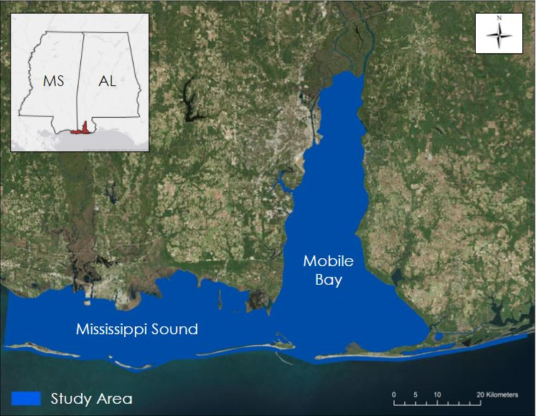

*Figure 1.* Project study area of the Mobile Bay and Mississippi Sound located within the Gulf of Mexico along the coastline of Alabama and Mississippi

* 1. ***Project Partners & Objectives***

This project falls under NASA’s Water Resources national application area and focuses on evaluating trends in the water quality parameters salinity, SST, and turbidity. The project partnered with the Alabama Coastal Foundation (ACF), the Alabama Chapter of the Nature Conservancy (TNC), the Mississippi - Alabama Sea Grant Consortium (MASGC), and the Manatee Sighting Network at the Dauphin Island Sea Lab (DISL). The DISL collaborated to provide guidance and data for the project. Currently, the end users (ACF, TNC, MASGC) rely on *in situ* data obtained from buoys and field measurements to assess salinity, temperature, and turbidity. Water quality data acquired from remote sensing has the potential to improve the partners’ ability to better manage the local marine environment, once such data has been sufficiently processed and analyzed.

During the first term of the project in the summer of 2017, the Alabama – Marshall and Alabama – Mobile NASA DEVELOP teams evaluated SST, salinity, and turbidity changes in the study area from June 2007 to June 2017 to identify areas suitable for target species’ habitat. The main objective of the fall 2017 project is to calculate water quality parameters from June 2003 to June 2007 and combine these results with the data from the summer 2017 term to obtain a more extensive time series analysis showing overall water quality trends in the study area. The project results were provided to the partners with methodologies that may enhance future decision making for their organizations. The ACF will distribute the results to its partners in the state, educate the public, promote current oyster shell recycling, and identify potential locations to place recycled oyster shells for oyster reef restoration. The MASGC will disseminate the results to its local and national partners, improve the success of local oyster farmers, evaluate shellfish habitat conditions, and educate the public. The TNC will use the results to improve the restoration of living shorelines, which incorporate oysters.

# 3. Methodology

***3.1 Data Acquisition***

For this project, the team utilized image data products from Landsat 5 Thematic Mapper (TM) and Aqua Moderate Resolution Imaging Spectroradiometer (MODIS). Aqua MODIS Goddard Space Flight Center (GSFC) Ocean Color Remote Sensing Reflectance was used to evaluate salinity changes, while Aqua MODIS Ocean Color Sea Surface Temperature products were used to produce and assess SST changes. Landsat 5 images were acquired to evaluate turbidity changes in the study area.

In total, twenty-five daily Aqua MODIS GSFC Ocean Color Remote Sensing Reflectance 1km Level-2 images were acquired to calculate salinity measurements between September 2003 and May 2007. Twenty-five images were also acquired to derive SST. These satellite images were acquired from NASA’s Ocean Color website. The team acquired five multispectral scenes of Landsat 5 TM 30m resolution for path 21 and row 39 between November 2003 and December 2006 from USGS Earth Explorer to generate turbidity maps.

The salinity and SST buoy data were acquired from the Mobile Bay National Estuary Program (MBNEP), the Mississippi Department of Marine Resources (MDMR), and the National Estuarine Research Reserve System (NERRS) (Figure 2). Turbidity buoy measurements were also obtained from these same sources, but were not used for data validation purposes because of the limited number of corresponding satellite image data. In total, only three buoy stations were utilized for 2003-2007 because the available historical data for the project study period was limited in comparison to the data accessible by the current buoy network. Additionally, there were a limited number of buoy sites that intersected with locations presenting feasible satellite image data. The data from the buoy stations along the coastlines could not be used for validation because the viable remote sensing images contain pixels in close proximity to land masses. The MBNEP buoy station was located at Middle Bay Lighthouse, centered in Mobile Bay, Alabama. The MDMR buoy was situated at Round Island, in the eastern portion of the Mississippi Sound. The buoy from the NERRS was centered in Point Aux Chenes Bay, Mississippi.

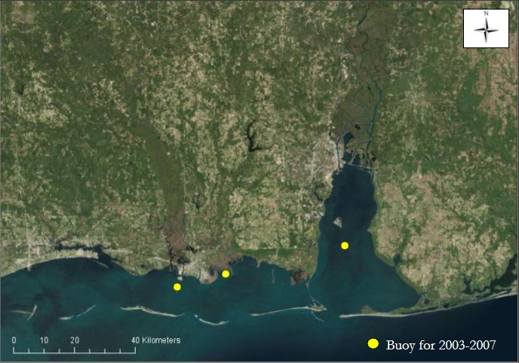

*Figure 2*. Buoys used for water quality parameter validation from 2003 to 2007

***3.2 Data Processing***

***3.2.1 Aqua MODIS data process for retrieving salinity***

The raw Aqua MODIS true color imagery acquired was in NetCDF format. The team uploaded the imagery to the NASA SeaDAS program and re-projected to the Universal Transverse Mercator Zone 16 (North American Datum 1983) map projection. For each daily image, spectral bands 1 at 667 nm and 10 at 488 nm were exported individually as GeoTIFF files. The GeoTIFFs were imported to Esri ArcGIS Pro and the raster images were clipped to the shape of the study area using the Clip tool. For each date, the Raster Calculator tool to divide the 667 nm band by the 488 nm band to obtain a salinity reflectance ratio, indicated by Equation 1. This salinity algorithm method was developed by Lemieux in 2013.

Remote Sensing Reflectance Ratio = $\frac{\text{667 nm}}{\text{488 nm}}$ (1)

The team assessed the performance Aqua MODIS salinity data products using multiple dates of *in situ* data collected from three buoy stations located at Sound Island, MS, Point Aux Chenes Bay, MS, and Middle Bay Lighthouse in Mobile Bay, AL, from 2003 to 2007. The satellite and *in situ* data were compared statistically using a linear regression analysis. Unfortunately, the low amount of buoy locations was insufficient to formally validate the satellite salinity maps across the entire geographic domain, but did give some information on how well the satellite and *in situ* data compared for the 3 buoy locations. However, the amount of reference locations for 2003-2007 was much less than that available for assessing the salinity products for 2007-2017. Consequently, we were not able to comprehensively assess the performance of the salinity mapping for 2003-2007. A very low correlation was evident between the 2003-2007 satellite salinity maps and the *in situ* salinity data collected from the 3 buoys. The results of the correlation analysis for the 2003-2007 MODIS salinity maps and in situ data from the 3 buoy locations is included in Appendix A.

***3.2.2 Sea surface temperature retrieval***

All sea surface temperature products from the Aqua MODIS sensor were processed by the NASA Ocean Biology Processing Group (OBPG). The OBPG computed SST products to Level-2 at 1km resolution and generated by short wave algorithm. This utilizes MODIS band 22 at 3.959µm and 23 at 4.050 µm. The long-wave algorithm makes use of band 31 at 11µm and 32 at 12 µm (Franz, 2006).

The raw Aqua MODIS SST imagery acquired was in NetCDF format, and the imagery was uploaded to the NASA SeaDAS program. The imagery was reprojected to the Universal Transverse Mercator Zone 16 (North American Datum 1983) map projection, as well as converted to GeoTIFF file format. The GeoTIFFs were imported to Esri ArcGIS Pro and the raster images were clipped to the shape of the study area using the Clip tool. The SST data was retrieved by extracting the SST “band”, which was band 1.

The team computed the correlation of the available Aqua MODIS SST data from June 2003 to May 2007 with corresponding measurements from the three buoy sensors located in the study area. The buoys used for the SST validation were located at Sound Island, MS, Point Aux Chenes Bay, MS, and Middle Bay Lighthouse in Mobile Bay. A linear regression analysis was conducted to assess the relationship between the SST data acquired from NASA EO products and the SST data from the buoys. The linear regression produced a coefficient of determination (R2) of 0.95 (n = 105), indicating a strong correlation between the earth observation SST product and the *in situ* buoy temperature data (Figure 3).

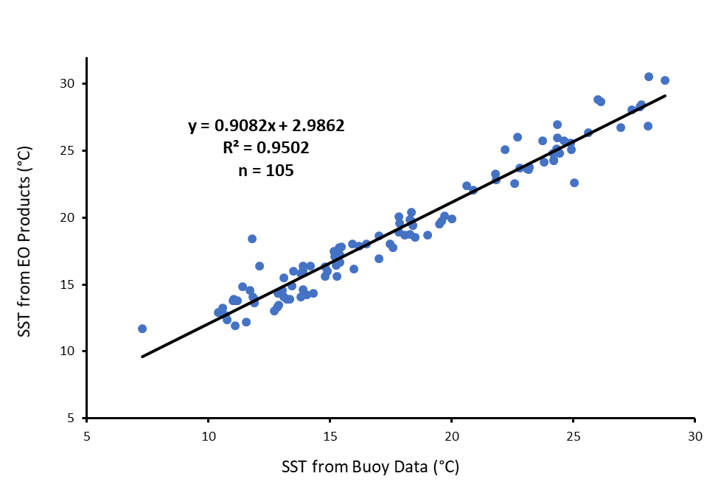

*Figure 3*. Linear regression comparing sea surface temperature data from buoys to Aqua MODIS Ocean Color Sea Surface Temperature product from 2003 to 2007 (n = 105, R2 = 0.95).

***3.2.3 Turbidity retrieval***

According to Doxaran et al. (2002), turbid water is 80% of reflectance signals in the 0.63-0.69 µm channel and between 70%-90% of reflectance signals in 0.75-0.9 µm channel. The team used Landsat 5 TM at 30 m resolution, Band 3 (red) and Band 4 (near infrared band) to retrieve turbidity maps for 2003 and 2007.

Additionally, the project utilized the Dogliotti et al. (2015) algorithm included in the software ACOLITE v. 201707180 to generate turbidity estimation maps from the satellite images. Turbidity map retrieval products were not validated with buoy data due to insufficient data for the historical dates considered in the fall term project. Buoy data on turbidity were not consistently being collected until 2006.

***3.3 Data Analysis***

***3.3.1 Change detections for salinity, sea surface temperature, and turbidity***

Twenty-five dates of relatively cloud free Aqua MODIS Ocean Color data from September 16, 2003 to May 1, 2007 were chosen for the salinity time series while twenty-five Aqua MODIS SST images were selected to evaluate the SST changes in the study period. For the turbidity time series, the team used five dates of Landsat 5 TM from November 30, 2003 to December 8, 2006 (Table A1). After processing, the images in ArcGIS Pro were realigned so that the pixels were the same size and georeferenced to a common reference point. The No Data values were reclassified for each ratio raster image. Using the Cell Statistics mean tool, the averages for each water parameter were calculated. By utilizing the Image Analysis Difference tool, the differences were calculated between 2003 and2007 for salinity, SST, and turbidity.

***3.3.2 Habitat suitability analyses***The Fuzzy Logic Model in ArcGIS Pro was used to create the habitat suitability map of the study area for Eastern oysters from 2003-2007. Unlike the first part of the coastal water resources project, due to time constraints and data availability, habitat suitability maps were not created for West Indian Manatees. Fuzzy logic is a decision-making modeling process used for the control of complex and nonlinear systems (Davidson and Hayward, 2003). Oyster occurrence does not change seasonally. Based upon annual averages of observed EO data water quality parameters, a single provisional habitat suitability map was generated. To produce this map, Fuzzy Linear Membership was selected (Environmental Systems Research Institute, Inc., 2016) and used for turbidity with 0 as a minimum and 50 as a maximum (Table 1).

To create a precise habitat suitability map would require an abundance of accurate input variables. Since the creation of the habitat suitability map from this project only included three environmental variables, due to various environmental uncertainties such as wave movement, depth of buoy locations for validation, and an unquantified influence of saltwater predators, it would be best to pair the map with past and current oyster farms data if one were looking to apply such an end product for future making decisions.

Table 1.  
*Habitat ranges of salinity, sea surface temperature, and turbidity for the Eastern Oyster. Turbidity units are in Jackson turbidity units (JTU). JTU are approximately equivalent to both Nephelometric Turbidity Units (NTU) and Formazin Nephelometric Units (FNU) (World Health Organization, 2017).*

|  |  |  |  |
| --- | --- | --- | --- |
|  | **Eastern Oyster** | |  |
| ***Water Quality Parameter*** | ***Optimal Range*** | ***Membership Type*** | ***Reference*** |
| **Salinity** | 12-27 PPT | Fuzzy Near (20 PPT) | Linhoss et al., 2016 |
| **Temperature** | 20-30°C | Fuzzy Near (20 °C) | Cake, 1983 |
| **Turbidity** | <50 FNU | Linear (0,50) | Cake, 1983 |

**4. Results & Discussion**

Water quality change maps are shown in Figure 4. The salinity change map showed a slight increase in the central Mobile Bay, while in the Mississippi Sound, there was a moderate decrease or lower values throughout the western Mississippi Sound area comparing September 2003 to May 2007. The turbidity change map indicated that turbidity increased in the northern delta of Mobile Bay and eastern Mobile Bay. For the western Mississippi Sound and west-central Mobile Bay, the same product showed decreasing turbidity for September 2003 - May 2007. The SST change map indicated that sea surface temperature decreased in the western Mississippi Sound and northern Mobile Bay comparing September 2003 and May 2007. Based on the mapping products from this project, much of the study area did not show a significant increase or decrease in temperature.

The team was unable to derive a future water quality time series trend. To generate these trends requires accurate input variables, however, due to the low temporal and spatial resolution of the sensor data, and inadequate correlation between Earth observation and the limited number of *in situ* data, the team was unable to create future times series trends.

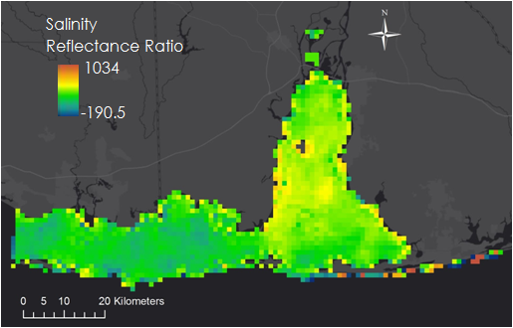 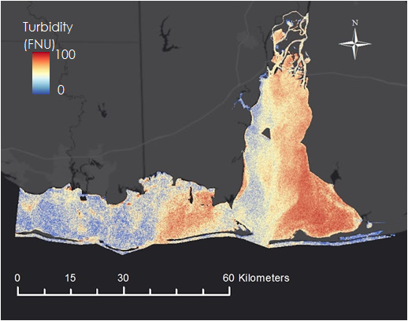

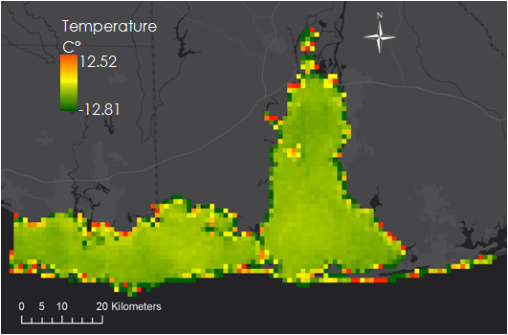

*Figure 4.* Changes in satellite-based provisional maps of salinity (A), sea surface temperature (B), and turbidity (C) levels within Mobile Bay and Mississippi Sound from 2003-2007. Positive values represent an increase while negative values represent a decrease.

A provisional oyster habitat suitability map is shown in Figure 5. This map was not validated given the lack of reference data, however, it does provide a means to visualize areas of potential oyster habitat suitability based on the three observed water quality parameters in conjunction with decision rules for thresholding such parameters. Based on this map, the western Mississippi sound and central Mobile Bay showed more suitability for eastern oysters. The northern and southeastern Mobile Bay demonstrated low suitability for oysters. In generating this map, it was hoped that the map would provide an indication of oyster habitat suitability for the historic period prior to the years addressed by the preceding summer term 2017 project which pertained to years 2007-2017.

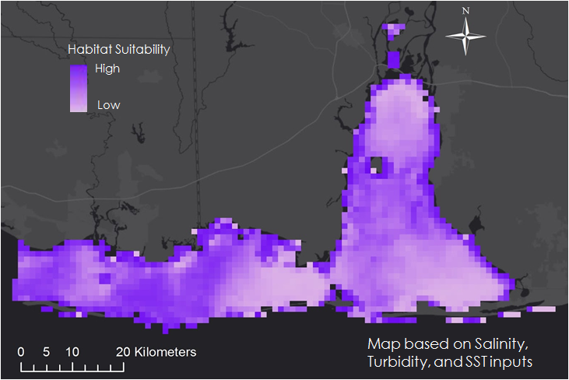

*Figure 5.* Potential relative habitat suitability map for eastern oysters from Map 2003 - June 2007 where the darker areas represent higher suitability and the lighter areas of lower suitability. This map is provisional map that could possibly be further enhanced using additional water quality parameter data as well as additional data analysis.

**5. Conclusions**

NASA Earth observations were used to generate geospatial water quality time series maps of turbidity, salinity, and sea surface temperature for the Mobile Bay and Mississippi Sound region. These provisional change maps indicated those portions of the Mississippi Sound that exhibited signs of decreased in salinity, turbidity, and sea surface temperature. Areas throughout the eastern and western regions of the Mobile Bay showed increases in all the calculated water quality parameters.

Due to the highly dynamic nature of the observed water quality parameters, these change maps were difficult to interpret. The project computed and compared changes based on average conditions for 2007 versus 2003. There may be alternative methods to generate more precise water quality change analysis that could provide the partners with better end results. Frequent cloud coverage was also a limiting factor in computing the necessary water quality parameter products, and more work is needed to better discriminate cloud contamination over coastal water. The oyster habitat suitability map is highly provisional and may be improved upon using other data and analytical techniques. Finally, more research is required to validate the provisional salinity maps for 2003-2007 and to derive forecasts of all three of the observed water quality parameters.

**6. Acknowledgments**

The Coastal Alabama Water Resources II team thanks the science advisors, mentor, project partners, and the Coastal Alabama Oceans team for offering their time and assistance to helping us complete the project.

Mentor/Science Advisors

* Bernard Eichold, M.D., PhD, Mobile County Health Department
* Joseph Spruce, Science Systems and Applications, Inc
* Dr. Kenton Ross, NASA Langley Research Center

Partners

* Mark Berte, Alabama Coastal Foundation
* Dr. Ruth Carmichael, Dauphin Island Sea Lab’s Manatee Sighting Network
* Russell Grice, Oyster Aquaculture Business Specialist
* Dina Knight, The Nature Conservancy

Others

* Mercedes Bartkovich
* Farnaz Bayat
* Dashiell Cruz
* Elaina Gonsoroski
* Xin Hong
* Maggi Klug
* Tyler Lynn
* Leah Parker
* Danielle Quick
* Amy Schwarber
* Leigh Sinclair, University of Alabama in Huntsville/Information Technology and Systems Center
* Dr. Maury Estes, University of Alabama in Huntsville
* Dr. Robert Griffin, University of Alabama in Huntsville
* Dr. Jeffrey Luvall, NASA Marshall Space Flight Center
* Dr. Just Cebrian, Dauphin Island Seal Lab
* Dr. Brian Dzwonkowski, Dauphin Island Sea Lab
* Mimi Tzeng, Dauphin Island Sea Lab
* Renee Collins, Dauphin Island Sea Lab
* Josh Goff, Dauphin Island Sea Lab

Any opinions, findings, and conclusions or recommendations expressed in this material are those of the author(s) and do not necessarily reflect the views of the National Aeronautics and Space Administration.

This material is based upon work supported by NASA through contract NNL16AA05C and cooperative agreement NNX14AB60A.

**7. Glossary**

**Earth observations** – satellites and sensors that collect information about the Earth’s physical, chemical, and biological systems over space and time

**Keystone species** – a species in which other species depend on in an ecosystem

**Spatiotemporal changes** – the changes concerning in both space and time

**Biodiversity** – the diversity or variety of life within a given ecosystem

**Aqua MODIS** - Satellite sensor specialized to detect water and water quality at 1 km resolution

**Landsat 5 TM** - Satellite sensor that detects true color imagery at 30 m resolution

**Turbidity** - cloudiness of a fluid caused by suspended particles

**Sea surface temperature** - surface temperature of the water

**Salinity** - amount of salt dissolved in water

**8. References**

Beck, M.W. et al. (2009). Shellfish Reefs at Risk: A Global Analysis of Problems and Solutions. The Nature

Conservancy. Retrieved from https://www.conservationgateway.org/ConservationPractices/Marine /Documents/Shellfish%20Reefs%20at%20Risk-06.18.09-Pages.pdf

Buck, E. H. (2005). Hurricanes Katrina and Rita: Fishing and Aquaculture Industries–Damage and Recovery.

Congressional Research Service, Library of Congress.

Cake, E.W. (1983). Habitat suitability index models: Gulf of Mexico American oyster. *U.S. Department of the*

*Interior Fish and Wildlife Service,* 1-37.

Carpenter, S. R., (2005) Eutrophication of aquatic ecosystems: Bistability and soil phosphorus. *Inaugural*

*Article, 102(9),* 10002-10005, doi: 10.1073/pnas.0503959102

Carmichael, R. H., Walton, W., Clark, H., & Ramcharan, C. (2012). Bivalve-enhanced nitrogen removal from coastal estuaries. *Canadian Journal of Fisheries and Aquatic Sciences*, *69*(7), 1131–1149. https://doi.org/10.1139/f2012-057

Cook, T., Folli, M., Klinck, J., Ford, S., and Miller, J (1998). The relationship between increasing sea-surface temperature and the northward spread of Perkinsus marinus (Dermo) Disease Epizootics in Oysters. *Estuarine, Coastal and Shelf Science, 46*, 587-597.

Davidson, V. and Hayward, G. Fuzzy logic applications (2003). *Analyst (128)*, 1301-1306. doi: 10.1039/bb312701j

Dogliotti, A. I., Ruddickb, K. G., Nechadb, B., Doxaranc, D., & Knaeps, E. (2015). A single algorithm to retrieve turbidity from remotely-sensed data in all coastal and estuarine waters. *Remote Sensing of Environment, 156*(1), 157-168.

Doxaran, D., Froidefond, J., Lavender, S., & Castaing, P. (2002). Spectral signature of highly turbid waters application with SPOT data to quantify suspended particulate matter concentrations. *Remote Sensing of Environment, 81*(1), 149-161. doi:10.1016/S0034-4257(01)00341-8

Eleuterius, C. K. (1977). Location of the Mississippi Sound’s oyster reefs as related to salinity of bottom waters during 1973-1975. *Gulf Research Reports*, *6*. https://doi.org/10.18785/grr.0601.03

Environmental Systems Research Institute, Inc. (2016). Applying fuzzy logic to overlay rasters. *ArcMap*.

Retrieved November 7, 2017 from [http://desktop.arcgis.com/en/arcmap/10.3/tools/spatial-](http://desktop.arcgis.com/en/arcmap/10.3/tools/spatial-analyst-toolbox/applying-fuzzy-logic-to-overlay-rasters.htm)

analyst-toolbox/applying-fuzzy-logic-to-overlay-rasters.htm

Franz, B. (2006). Implementation of SST processing within the OBPG. Earth Data. Retrieved June 25, 2017 from <https://oceancolor.gsfc.nasa.gov/docs/modis_sst/>

Gregalis, K. C., Powers, S., & Heck Jr., K (2008). Restoration of oyster reefs along a bio-physical gradient in

Mobile Bay, Alabama. *Journal of Shellfish Research,* 27(5), 1163-1169.

Grice, R.., & Walton, B.  Auburn University Marine Extension and Research Center. Alabama Shellfish

Aquaculture Situation and Outlook Report: Production Year 2016. Retrieved from http://masgc.org/assets/uploads/publications/1312/alabama_shellfish_aquaculture_situation_and_outlook_report_2016.pdf

Hanafin, J. A. (2002). *On sea surface properties and characteristics in the infrared*. University of Miami. Retrieved from

http://scholarlyrepository.miami.edu/dissertations/1907

Hanafin, J. A., & Minnett, P. J. (2013). Thermal Profiling of the Sea Surface Skin Layer Using FTIR

Measurements. In *Gas Transfer at Water Surfaces* (pp. 161–166). American Geophysical Union. https://doi.org/10.1029/GM127p0161

Hargis, W.J. Jr and Haven, D.S. (1999) Chesapeake oyster reefs, their importance, destruction and guidelines

for restoring them. *Oyster reef habitat restoration: A synopsis and synthesis of approaches.* Virginia Institute of

Marine Science Press. Gloucester Point, VA. 329-358.

Kellogg, M. L., Smyth, A. R., Luckenbach, M. W., Carmichael, R. H., Brown, B. L., Cornwell, J. C., … Higgins, C. B. (2014). Use of oysters to mitigate eutrophication in coastal waters. *Estuarine, Coastal and Shelf Science*, *151*, 156–168. https://doi.org/10.1016/j.ecss.2014.09.025

La Peyre, M. K., Eberline, B. S., Soniat, T. M., & La Peyre, J. F. (2013). Differences in extreme low salinity

timing and duration differentially affect eastern oyster (Crassostrea virginica) size class growth and mortality in Breton Sound, LA. *Estuarine, Coastal and Shelf Science*, *135*, 146–157. https://doi.org/

10.1016/j.ecss.2013.10.001

Lemieux, P. A. (2013). Development of an Algorithm for Salinity Estimates in Mobile Bay Alabama and

             Mississippi Sound. American Institute of Aeronautics and Astronautics. Retrieved June 05, 2017.

Linhoss, A.C., Camacho, R., and Ashby, S. (2016). Oyster habitat suitability in the Northern Gulf of Mexico. *Journal of Shellfish Research 35*(4), 841-849

Lunt, J.,and Smee, D. (2014). Turbidity influences trophic interactions in estuaries. *Limnology and Oceanography*. 59(6), 2002-2012. https://doi.org/10.4319/lo.2014.59.6.2002

Mississippi Department of Environmental Quality and National Fish and Wildlife Foundation. (2016). The

Mississippi Gulf Coast restoration plan. Retrieved from http://www.restore.ms/wp-content/uploads/2016/07/2016-Addendum-FINAL-10.31.2016.pdf

NASA Goddard Space Flight Center, Ocean Ecology Laboratory, Ocean Biology Processing Group. Moderate-resolution Imaging Spectroradiometer (MODIS) Aqua Ocean Color Data; 2014 Reprocessing. NASA OB.DAAC, Greenbelt, MD, USA, accessed 11 July 2017. doi: 10.5067/AQUA/MODIS_OC.2014.0.

NASA Goddard Space Flight Center, Ocean Ecology Laboratory, Ocean Biology Processing Group. Moderate-resolution Imaging Spectroradiometer (MODIS) Aqua Ocean Color Data; 2014 Reprocessing. NASA OB.DAAC, Greenbelt, MD, USA, accessed 27 September 2017. doi: 10.5067/AQUA/MODIS/L3B/RRS/2014

National Oceanic and Atmospheric Administration. (2015). Fisheries Economics of the United States, 2015.   
 Retrieved from https://www.st.nmfs.noaa.gov/Assets/economics/publications/FEUS/FEUS-  
 2015/Report-Chapters/FEUS%202015%2009-GulfofMexico_Final2_508.pdf

The Nature Conservancy. (2010). The economics of oyster reef restoration in the Gulf of Mexico.

Retrieved from http://www.habitat.noaa.gov/pdf/tnc_oyster_economics_factsheet.pdf

Orff, K. (2013). Shellfish as living infrastructure. *Ecological Restoration*, *31*(3), 317–322.

https://doi.org/10.3368/er.31.3.317

Park, K., Valentine, J. F., Sklenar, S., Weis, K. R., & Dardeau, M. R. (2007). The Effects of Hurricane Ivan in

the Inner Part of Mobile Bay, Alabama. *Journal of Coastal Research*, *235*, 1332–1336. https://doi.org/10.2112/06-0686.1

Peterson, C. H., Grabowski, J. H., & Powers, S. P. (2003). Estimated enhancement of fish production

resulting from restoring oyster reef habitat: quantitative valuation. *Marine Ecology Progress Series*, *264*, 249–264.

Posadas, B. (2017). Economic contributions of the Mississippi-Alabama seafood industry.

Mississippi Sea Grant Consortium. Retrieved from http://masgc.org/news/article/economic-contributions of-the-mississippi-alabama-seafood-industry

Raghavachari, N., Showmaker, K., Liu, P., Jafari, N., Barker, N., Willett, K. L., … Reyero, N. G. (2013).

Genomics Research Group (GRG): Elucidating the Effects of the Deepwater Horizon Oil Spill on the Atlantic Oyster Using Global Transcriptome Analysis. *Journal of Biomolecular Techniques : JBT*, *24*(Suppl), S68–S69.

U.S. Geological Survey (USGS) Earth Resources Observation and Science Center. (2016). Landsat Thematic Mapper (TM) C1 Level 1. Retrieved September 20, 2017 from https://landsat.usgs.gov/landsat-data-access

Vignier, J., Soudant, P., Chu, F. L. E., Morris, J. M., Carney, M. W., Lay, C. R., … Volety, A. K. (2016). Lethal and sub-lethal effects of Deepwater Horizon slick oil and dispersant on oyster (Crassostrea virginica) larvae. *Marine Environmental Research*, *120*, 20–31. https://doi.org/10.1016/j.marenvres.2016.07.006

World Health Organization (2017). Turbidity Measurement: the Importance of Measuring Turbidity.

Retrieved November 7, 2017 from http://www.who.int/water_station_health/publications/

[envsanfactsheets/en/index.1.html](http://www.who.int/water_station_health/publications/envsanfactsheets/en/index.1.html)

**9. Appendices**

APPENDIX A.

Figure A1. Linear regression comparing salinity data from buoys to salinity reflectance ratio from remote sensing data from 2003 to 2007 (n=42, R2 = 0.012).

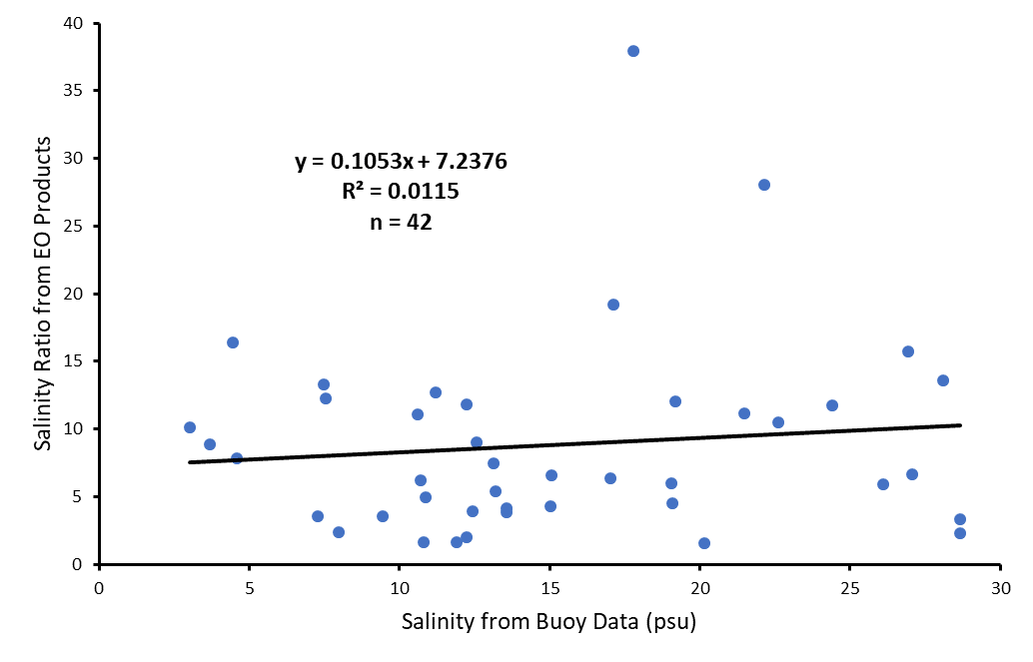

Regarding the above figure, the satellite salinity products for 2003-2007 were derived from Aqua MODIS Goddard Space Flight Center (GSFC) Ocean Color Remote Sensing Reflectance data. The three buoy stations used for the salinity validation were located at: 1) Sound Island in the eastern Mississippi Sound, 2) Point Aux Chenes Bay, MS, and 3) Middle Bay Lighthouse in the Mobile Bay, AL. The results from the linear regression showed a very weak correlation between the MODIS salinity mapping products and the salinity measurements obtained from these three buoy stations. In contrast, based on work done in the previous term, the same correlation analysis for 2007-2017 showed a correlation of moderate strength. There are many possible reasons why the correlation was much lower for the 2003-2007 versus 2007-2017 period. The main factor is that the very limited amount of buoy locations available for 2003-2007. Another factor is that one of the three buoys available for 2003-2007 was close to the coastal lands. In addition, it is unclear if the satellite and buoys were measuring salinity at the same level in the water column. The buoy sensors measure salinity at an unknown shallow depth while the MODIS sensor acquires reflectance data from only the top surface of the water for a depth of approximately 1 mm (Hanafin, 2002; Hanafin & Minnett, 2013). In summary, the limited number of buoy stations was deemed insufficient for assessing the provisional MODIS-based salinity mapping products for 2003-2007. The correlation shown in the above figure provides some information on the correlation with satellite and reference data at the 3 buoy locations, though this may be confounded by one of the buoys being close to land.

APPENDIX B.

Table B1. Julian date and years used for time series analyses of salinity, sea surface temperature, and turbidity data from NASA Earth observations

|  |  |  |  |
| --- | --- | --- | --- |
| Satellite Sensor Source | Water Quality Parameter | Year | Julian Date |
| Landsat 5 TM | Turbidity | 2003 | 334 |
| Landsat 5 TM | Turbidity | 2004 | 049 |
| Landsat 5 TM | Turbidity | 2004 | 352 |
| Landsat 5 TM | Turbidity | 2006 | 038 |
| Landsat 5 TM | Turbidity | 2006 | 326 |
| Aqua MODIS | SST | 2003 | 259 |
| Aqua MODIS | SST | 2003 | 295 |
| Aqua MODIS | SST | 2003 | 325 |
| Aqua MODIS | SST | 2003 | 361 |
| Aqua MODIS | SST | 2004 | 021 |
| Aqua MODIS | SST | 2004 | 070 |
| Aqua MODIS | SST | 2004 | 124 |
| Aqua MODIS | SST | 2004 | 262 |
| Aqua MODIS | SST | 2004 | 333 |
| Aqua MODIS | SST | 2004 | 362 |
| Aqua MODIS | SST | 2005 | 060 |
| Aqua MODIS | SST | 2005 | 117 |
| Aqua MODIS | SST | 2005 | 167 |
| Aqua MODIS | SST | 2005 | 250 |
| Aqua MODIS | SST | 2005 | 303 |
| Aqua MODIS | SST | 2006 | 031 |
| Aqua MODIS | SST | 2006 | 063 |
| Aqua MODIS | SST | 2006 | 161 |
| Aqua MODIS | SST | 2006 | 269 |
| Aqua MODIS | SST | 2006 | 301 |
| Aqua MODIS | SST | 2007 | 025 |
| Aqua MODIS | SST | 2007 | 064 |
| Aqua MODIS | SST | 2007 | 096 |
| Aqua MODIS | SST | 2007 | 121 |
| Aqua MODIS | SST | 2007 | 141 |
| Aqua MODIS | Salinity | 2003 | 259 |
| Aqua MODIS | Salinity | 2003 | 288 |
| Aqua MODIS | Salinity | 2003 | 318 |
| Aqua MODIS | Salinity | 2003 | 325 |
| Aqua MODIS | Salinity | 2003 | 361 |
| Aqua MODIS | Salinity | 2004 | 022 |
| Aqua MODIS | Salinity | 2004 | 038 |
| Aqua MODIS | Salinity | 2004 | 262 |
| Aqua MODIS | Salinity | 2004 | 271 |
| Aqua MODIS | Salinity | 2004 | 333 |
| Aqua MODIS | Salinity | 2005 | 035 |
| Aqua MODIS | Salinity | 2005 | 060 |
| Aqua MODIS | Salinity | 2005 | 250 |
| Aqua MODIS | Salinity | 2005 | 303 |
| Aqua MODIS | Salinity | 2005 | 360 |
| Aqua MODIS | Salinity | 2006 | 018 |
| Aqua MODIS | Salinity | 2006 | 271 |
| Aqua MODIS | Salinity | 2006 | 301 |
| Aqua MODIS | Salinity | 2006 | 322 |
| Aqua MODIS | Salinity | 2006 | 353 |
| Aqua MODIS | Salinity | 2007 | 025 |
| Aqua MODIS | Salinity | 2007 | 053 |
| Aqua MODIS | Salinity | 2007 | 064 |
| Aqua MODIS | Salinity | 2007 | 096 |
| Aqua MODIS | Salinity | 2007 | 128 |

APPENDIX C.

Table C1. Location of Buoys used to validate satellite data for salinity and sea surface temperature.

|  |  |  |  |  |
| --- | --- | --- | --- | --- |
| **Buoy Location** | **Source** | **Water Quality Parameter** | **Latitude** | **Longitude** |
| Middle Bay Lighthouse, Mobile Bay, AL | MBNEP | SST, Salinity | 30.4367 | -88.0117 |
| Round Island, MS | MDMR | SST, Salinity | 30.3081 | -88.5839 |
| Point Aux Chenes Bay, MS | NERRS | SST, Salinity | 30.3486 | -88.4185 |

APPENDIX D.

Table D1. Julian Dates and years associated with sea surface temperature and salinity validation using buoy data and linear regression analysis.

|  |  |  |
| --- | --- | --- |
| Year | Julian Date | Water Quality Parameter |
| 2003 | 259 | SST, Salinity |
| 2003 | 272 | SST |
| 2003 | 275 | SST, Salinity |
| 2003 | 288 | SST, Salinity |
| 2003 | 295 | SST, Salinity |
| 2003 | 307 | SST, Salinity |
| 2003 | 318 | SST, Salinity |
| 2003 | 325 | SST, Salinity |
| 2003 | 329 | SST |
| 2003 | 334 | SST |
| 2003 | 336 | SST |
| 2003 | 345 | SST |
| 2003 | 352 | SST |
| 2003 | 361 | SST, Salinity |
| 2004 | 021 | SST, Salinity |
| 2004 | 022 | SST, Salinity |
| 2004 | 028 | SST, Salinity |
| 2004 | 038 | SST, Salinity |
| 2004 | 049 | SST |
| 2004 | 070 | SST |
| 2004 | 072 | SST |
| 2004 | 077 | SST |
| 2004 | 092 | SST |
| 2004 | 106 | SST |
| 2004 | 118 | SST |
| 2004 | 126 | SST, Salinity |
| 2004 | 127 | SST, Salinity |
| 2004 | 287 | SST, Salinity |
| 2004 | 310 | SST |
| 2004 | 348 | SST |
| 2004 | 349 | SST |
| 2004 | 350 | SST |
| 2004 | 351 | SST |
| 2004 | 355 | SST |
| 2004 | 362 | SST |
| 2005 | 016 | SST |
| 2005 | 017 | SST |
| 2005 | 035 | SST, Salinity |
| 2005 | 041 | SST |
| 2005 | 060 | SST, Salinity |
| 2005 | 067 | SST |
| 2005 | 069 | SST, Salinity |
| 2005 | 071 | SST |
| 2005 | 092 | SST |
| 2005 | 117 | SST |
| 2005 | 147 | SST |
| 2005 | 167 | SST |
| 2005 | 250 | SST, Salinity |
| 2005 | 284 | SST, Salinity |
| 2005 | 289 | SST, Salinity |
| 2005 | 298 | SST, Salinity |
| 2005 | 303 | SST, Salinity |
| 2005 | 321 | SST |
| 2006 | 018 | SST, Salinity |
| 2006 | 031 | SST |
| 2006 | 036 | SST |
| 2006 | 038 | SST |
| 2006 | 040 | SST |
| 2006 | 081 | SST |
| 2006 | 086 | SST |
| 2006 | 095 | SST |
| 2006 | 104 | SST |
| 2006 | 132 | SST |
| 2006 | 138 | SST |
| 2006 | 141 | SST |
| 2006 | 157 | SST |
| 2006 | 161 | SST |
| 2006 | 271 | SST, Salinity |
| 2006 | 280 | SST, Salinity |
| 2006 | 301 | SST, Salinity |
| 2006 | 307 | SST |
| 2006 | 313 | SST, Salinity |
| 2006 | 322 | SST, Salinity |
| 2006 | 326 | SST |
| 2006 | 338 | SST |
| 2006 | 353 | SST, Salinity |
| 2007 | 009 | SST |
| 2007 | 025 | SST, Salinity |
| 2007 | 037 | SST, Salinity |
| 2007 | 053 | SST, Salinity |
| 2007 | 064 | SST, Salinity |
| 2007 | 066 | SST, Salinity |
| 2007 | 096 | SST, Salinity |
| 2007 | 102 | SST, Salinity |
| 2007 | 121 | SST |
| 2007 | 128 | SST |
| 2007 | 137 | SST |
| 2007 | 141 | SST |