Richmond Disasters

Tracking and Assessing Stormwater Flooding in Richmond, Virginia to Improve Water Quality Monitoring and Resources Management

 **Technical Report**

August 10th, 2023

Kaylee Tanner (Project Lead)

Trinity Johnson

Maggie Lincoln

Brodie Thiele

***Advisors:***

Dr. Kenton Ross, NASA Langley Research Center (Science Advisor)

Lauren Childs-Gleason, NASA Langley Research Center (Science Advisor)

***Fellow:***  
Olivia Landry (LaRC)

# 1. Abstract

Pluvial flooding is the most frequent and widespread type of flooding in urban areas. It occurs when intense precipitation events overwhelm the capacity of soils and drainage systems. The Richmond Regional Planning District Commission (PlanRVA) provides planning services for flood resilience and emergency management for 9 localities in Central Virginia. Their efforts are hindered by a lack of information on the location and severity of pluvial flooding. We used the InVEST Urban Flood Risk model, which estimates an area’s capacity to retain stormwater, the Arc-Malstrøm bluespot model, which predicts the location and depth of flooding, and data from NASA’s Global Precipitation Measurement (GPM) satellite to analyze historic flood events and identify areas with high flood risk. We analyzed the Social Vulnerability Index from the US Census to identify areas with the greatest need for flood mitigation efforts. We concluded that census tracts in more urbanized areas tend to have higher flood risk and social vulnerability. For these areas of concern, we created detailed maps depicting flood risk and predicted flood depth for various precipitation levels. One limitation of this study was the use of simplistic models that did not account for runoff processes, antecedent moisture conditions or existing drainage infrastructure. While these models required many assumptions and produce large errors, the results are sufficient for rough regional analyses and narrowing the scope of future work. PlanRVA will use these results to enhance existing flood risk information, improve resilience planning, and focus infrastructure projects.

**Key Terms**

Pluvial flooding, flood risk, social vulnerability index, GPM IMERG, InVEST Urban Flood Risk Mitigation model, Arc-Malstrøm, Richmond

# 2. Introduction

***2.1 Background Information***

*2.1.1 Pluvial Flooding*

Floods in urban areas are an old but urgent problem. Large areas of impervious surfaces and inadequate drainage systems turn rainstorms into disasters as sewers and drains back up and stormwater accumulates on the surface, closing roads, overwhelming sewage systems, flooding homes and businesses, and eroding soil with fast-moving overland flow. Known as pluvial flooding, these events are caused by intense rainfall exceeding the capacity of soils and drainage systems to absorb and move water away from built infrastructure.

Pluvial floods threaten the health, safety, and well-being of urban communities and are likely to increase in both frequency and severity as climate change causes more intense storms (Houston et al., 2011; McDermott, 2022). Inland flooding is identified as a key impact of climate change on social vulnerability (Office of Atmospheric Programs, 2021). As urban populations expand, there is a vital need to develop resiliency against the impacts of pluvial floods (Hammond et al., 2015). Analysis of social and environmental vulnerability to these floods enables decision-makers to more effectively prepare for and respond to the impacts of urban flooding (Rosenzweig et al., 2018).

*2.1.2 Flood Modeling*

Information about flood risks and impacts is vital to responding to disasters and developing resilient communities (Hammond et al., 2015). Because of this, there is a large body of research on modeling various types of floods (Bulti & Abebe, 2020). Studying and modeling pluvial flooding in urban areas, however, presents some unique challenges (Douglas et al., 2010). Watersheds are more difficult to accurately delineate in areas with built infrastructure. There is limited data available on the location, type, and condition of stormwater infrastructure. In addition, stormwater infrastructure is subject to unpredictable changes (such as clogged storm drains), further complicating efforts to create models that accurately reflect conditions on the ground.

Creating highly accurate flood models that account for land cover, soil characteristics, and topography at a high spatial resolution is not usually feasible for urban areas (Luo et al., 2022). The outputs of simple models that roughly indicate potential for dangerous flooding are useful for planning and focusing mitigation efforts. Comparing the outputs of flood models with additional data about the study region, including maps of built infrastructure and socioeconomic data, allows planners to identify high-risk areas for more detailed analysis and flood mitigation efforts. We used two different pluvial flood models—The Natural Capital Project’s InVEST Urban Flood Risk Mitigation Model and the Arc-Malstrøm bluespot model—and combined their results to generate a more comprehensive view of pluvial flooding in our study area than would be provided by a single model.

*2.1.3 Study Area and Period*

Urban areas in Central Virginia frequently experience flooding that causes road closures, property damage, and health and environmental hazards, especially in areas with a combined sewer system (Meyers, 2023; Dennis, 2021). Our study focused on the nine localities of the Greater Richmond Region: the Town of Ashland, Charles City County, Chesterfield County, Goochland County, Hanover County, Henrico County, New Kent County, Powhatan County, and the City of Richmond (Figure 1). These nine localities span a total of 2,126 square miles and have a combined population of over one million people (U.S. Census Bureau, 2010).

There are several historically underserved communities within the greater Richmond region that are vulnerable to pluvial flooding. Southside Richmond is an example of a disadvantaged community that frequently experiences road closures, property damage and other issues due to flooding. There are continued efforts for environmental justice in the region. 19.8% of the population of Richmond live below the poverty line, which is above the national average of 11.6% (U.S. Census Bureau, 2020).

This project evaluated flooding that occurred between June 2010 and June 2023, with a focus on a specific case study storm that occurred on May 18th and 19th, 2018. Severe flood events in Richmond, such as Hurricane Gaston in 2004, which dropped over 12 inches of rain in a day and caused 8 deaths and nearly $20 million in damages, are exacerbated by inadequate forecasting and planning (Brown et al., 2006). We used large past storm events as starting points to evaluate future flood risk, and also analyzed the impact of rainfall amounts associated with 1-, 10-, and 100-year storms.

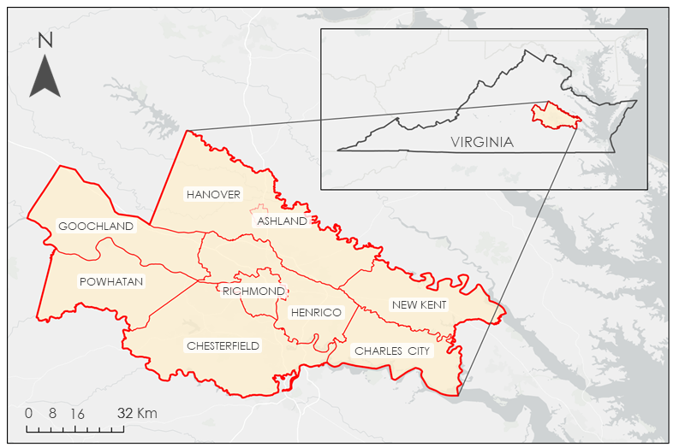

*Figure 1.* Study area of the nine localities that constitute the Greater Richmond Region.

***2.2 Project Partners & Objectives***

In partnership with PlanRVA and Groundwork RVA, this project identified areas in the greater Richmond region that are prone to pluvial flooding and analyzed how they correspond with socioeconomic factors. PlanRVA is an organization comprised of nine local governments that work together to improve planning across the region. Much of its work involves providing data and suggestions to local governments. It is also able to direct some federal funds to these localities for approved projects. PlanRVA has created a publicly accessible fluvial flood risk map and hopes to include data from pluvial flooding in the future. Groundwork RVA is a non-profit organization that engages and provides youth with experiential learning opportunities focused on environmental stewardship, community development, and college and career readiness. They offer programming to high school students and recent graduates. The students work with local community partners and leaders to revitalize green spaces in their communities. Groundwork RVA works to ensure that youth have safe and equitable access to bikes, bike paths and bike safety in the Southside Richmond communities. Identifying key pluvial flooding areas will help these partners better educate local communities and inform future decision-making.

# 3. Methodology

***3.1 Data Acquisition***

*3.1.1 Hydrologic Model Inputs*

Our data selection was guided by the requirements of the hydrologic models we used, which are discussed in section 3.2, and the partners’ suggestions on socioeconomic data relevant to their work. The InVEST model requires a soil type dataset, land cover dataset, watershed boundaries, a digital elevation model, and an additional precipitation measurement dataset when using the modified version of InVEST. Arc Malstrøm requires a digital elevation model, building footprints, and a hydrography dataset. Table 1 summarizes the inputs for the hydrologic models; details about each product are described below.

Table 1

*Data inputs for the InVEST and Arc-Malstrøm hydrologic models*

|  |  |  |
| --- | --- | --- |
| **Data Product** | **Source** | **Downloaded From** |
| USGS (United States Geological Survey) Watershed Boundary Dataset (WBD) for 2-digit Hydrologic Unit – 02 | U.S. Geological Survey (USGS) | USGS National Hydrography Products Website |
| National Land Cover Database (NLCD) 2019 Land Cover (CONUS) | USGS Earth Resources Observation and Science (EROS) Center | Earth Engine Data Catalog |
| Gridded Soil Survey Geographic (gSSURGO) Database | U.S. Department of Agriculture (USDA) Natural Resources Conservation Service | USDA NRCS gSSURGO website |
| National Oceanic and Atmospheric Administration (NOAA) Atlas 14 Point Precipitation Frequency Estimates: Virginia | NOAA Hydrometeorological Design Studies Center | NOAA Hydrometeorological Design Studies Center Precipitation Frequency Data Server (PFDS) |
| Integrated Multi-Satellite Retrievals for GPM (IMERG) V07 Level 3 Final Run Half-Hourly | NASA Global Precipitation Measurement (GPM) Mission | Earth Engine Data Catalog |
| National Resources Conservation Service (NRCS) Curve Numbers | NRCS eDirectives – Part 650 – Engineering Field Handbook: Chapter 2 | -- |
| USGS one meter DEM VA Sandy 2014 (published 2020-03-30) | U.S. Geological Survey (USGS) | USGS Data Download Application |
| 1/3rd arc-second Digital Elevation Models (DEMs) | U.S. Geological Survey (USGS) | USGS Data Download Application |
| USGS National Hydrography Dataset Best Resolution (NHD) - Virginia | U.S. Geological Survey (USGS) | USGS Data Download Application |
| Virginia Building Footprints | Virginia Geographic Information Network (VGIN) (Virginia Department of Emergency Management, 2023) | VGIN Website |

*3.1.1.1 InVEST Inputs*

The Hydrologic Unit Code (HUC)-12 watershed boundary dataset from the United States Geological Survey is the smallest watershed delineation provided by the USGS (U.S. Geological Survey, 2023). Watershed boundaries are required by the InVEST model. We downloaded the Digital Elevation Models (DEMs), also sourced from the USGS, at 1/3 arc-second (approximately 10 meters) resolution for the entire study area. We included all quadrants intersecting the applicable region of interest. In partnership with the Multi-Resolution Land Characteristics Consortium, the U.S. Geological Survey provides definitive land cover datasets for the United States—the National Landcover Database (NLCD). We used Google Earth Engine to download the most recent version, NLCD 2019. This data were used as the land cover input for the InVEST model. We downloaded soil type data from the U.S. Department of Agriculture’s 2019 Gridded Soil Survey Geographic (gSSURGO) database to classify soil types and drainage classes and calculate curve numbers (discussed below). This data were used as the soil type input for the InVEST model.

We used two types of precipitation data to inform the design storms we implemented for both models: historical raster data, which shows the spatial variation in depth for specific storms that have already occurred, and predicted storm depths for various return periods from the NOAA Precipitation Frequency Data Server. For the raster data, we used the precipitation variable from the gridMET product by the University of California Merced, which provides daily estimates of precipitation accumulation at approximately 4 km resolution, and NASA’s GPM IMERG product. IMERG provides half-hourly estimates of precipitation, but at much lower resolution—roughly 11 km. We downloaded both gridMET and IMERG data in Google Earth Engine. The InVEST model was run with both gridMET and IMERG used as precipitation inputs.

The InVEST Urban Flood Risk Mitigation Model uses the NRCS Curve Number method to estimate runoff volume for a particular watershed and storm. Every unique combination of land use and soil type has its own curve number, which approximates how much of a given volume of precipitation will be absorbed by that area during the storm. Curve number varies by storm and by the hydrologic condition of the land, so assigning curve numbers is imprecise and requires some simplifying assumptions and educated guesses. We used the tables in Chapter 2 of the Part 650 Engineering Field Handbook from the USDA (USDA, 2021) to assign curve numbers to each combination of land use and soil type found in the study area. For land uses that had multiple curve number options based on hydrologic condition, we selected the “Fair” number or the “Poor” number if “Fair” was not an option, because a worse hydrologic condition results in higher runoff, and since we are investigating flooding, we required the model to represent worst-case scenarios without producing unreasonably high results.

*3.1.1.2 Arc Malstrøm Inputs*

We used the same 1/3 arc-second resolution DEMs used for the watershed delineation as input for the Arc Malstrøm model for the full study area, but we downloaded an additional DEM with 1-meter resolution for just the City of Richmond in order to perform more detailed modeling for that specific area. The NHD Best Resolution Dataset was downloaded from USGS for the entire state of Virginia. This dataset represents water drainage using rivers, streams, canals, lakes, ponds, coastlines, dams, and stream gages. The shapefile from the dataset that we used was flow lines, which acts as the hydro adaptations input for bluespot modeling. Lastly, we acquired building footprints from the Virginia Geographic Information Network.

*3.1.2 Social Vulnerability Data*

Social Vulnerability Index values are a measure of a community’s susceptibility to the negative effects of hazards. Factors such as poverty and transportation access affect how well a community is able to respond to a disaster and prevent suffering and financial loss as well as what additional resources they may need. For our analysis we used the 2020 Centers for Disease Control and Prevention (CDC)/Agency for Toxic Substances and Disease Registry (ATSDR) Social Vulnerability Index which uses 16 variables sourced from the U.S. Census on a census tract level. These factors are comprised of four themes: socioeconomic status, household characteristics, racial and ethnic minority status, and housing type/transportation.

***3.2 Data Processing***

*3.2.1 Data Preparation*

With the exception of the watershed boundaries, all spatial datasets were clipped to the same minimum bounding box outlining the 9-locality study area and reprojected to EPSG:5070 NAD 83 Conus Albers coordinates. For the watershed boundaries, we performed further delineation on the HUC-12 basins within and intersecting the study area in order to increase the resolution of the final outputs from the InVEST model. This process used the 1/3 arc-second resolution DEM data, of which tiles intersecting the HUC-12 watersheds of interest were mosaiced together, reprojected, then clipped to the analysis region. We first filled the DEM to get rid of sinks then ran flow direction and flow accumulation tools. We used a flow accumulation threshold of 15,000 to create a raster of intermittent streams. Gaps between streams sections were filled using the stream link tool. We ran the watershed tool using the flow direction and linked stream rasters as inputs, obtaining watersheds with an average area of roughly 1.1 km2 (and a maximum of 9.6 km2).

The NLCD data required little processing; we visualized the data in Earth Engine to ensure there were no issues and then clipped and reprojected it before exporting it as a GeoTIFF. The NLCD classification system makes use of 20 codes, each of which identify a different type of landcover. The most common landcover in the greater Richmond area is forest (land use codes 41–43), with large areas of developed land (codes 22–24) concentrated around Richmond, and small areas of cultivated land (codes 81–92) spread throughout the rest of the area.

In order to get the raster of soil hydrologic groups required by the InVEST model, we used ArcGIS Pro to extract the ‘drainage class’ attribute from the gSSURGO geodatabase and save it as a single raster layer. gSSURGO provides 7 drainage classes. Class A soils have the fastest infiltration rate, meaning stormwater is absorbed quickly and does not pool on the surface, therefore creating the least amount of runoff. Class D soils have the slowest infiltration rate and the most runoff potential. Classes B and C represent soils with moderately high and moderately low runoff potential, respectively (USDA, 2023). In addition to the single letter classifications, there are 3 “dual” classifications: A/D, B/D, and C/D. These identify soils that, under certain conditions including a high-water table, have the highest runoff potential, but sometimes behave like one of the other letter designations. Since InVEST only accepts 4 soil hydrologic groups, we had to assign soils with a dual classification to a single letter value. Because this study is concerned with flooding, we chose to represent the worst-case scenario by assigning dual class soils to D, which will result in the highest amount of runoff possible from those soils. It is important to note that gSSURGO soil classifications can vary significantly by county (i.e., a soil that would be classified as A in one county is classified as B in another), as there is inadequate standardization between county-level surveys. This heterogeneity in survey methods is a source of error in the final model results.

Because of the lack of available ground truth data for model calibration and the fact that neither model had a temporal component, IMERG data was not useful as a model input, but we used Google Earth Engine to summarize the half-hourly rainfall estimates into daily values for each county and used the resulting time series to analyze the frequency and intensity of past storms. We used this data to inform the design storms we used in the base InVEST model and to assess the future likelihood of floods of different severities.

*3.2.2. InVEST Model*

The InVEST model is used by researchers to quantify and predict the impact of a variety of ecosystem services (Hamel et al., 2021; Li et al., 2021; The Natural Capital Project, 2023; Zhong & Wang, 2017). InVEST’s Urban Flood Risk Mitigation model focuses specifically on stormwater flooding in urban areas. The model calculates runoff reduction, which is the amount of runoff retained in a given pixel relative to the storm volume, highlighting which areas of a study region will effectively retain and absorb stormwater and which areas may be impacted by pluvial flooding. The model also calculates potential economic damage by comparing the runoff results with maps of built infrastructure (Arkema et al., 2017). The model takes inputs of land use and soil type characteristics for the study region and uses the NRCS Curve Number method to calculate runoff at each pixel for a given design storm or actual observed precipitation depth. We used a modified version of the model created by the Spring 2023 DEVELOP InVEST Urban Development team that accepts spatially distributed rainfall data rather than a single precipitation depth for the entire study area, which improves the accuracy of the results. The model is very simple and has high uncertainty in terms of actual runoff volume but is useful for identifying the impact of different land uses on pluvial flood intensity for the study region and understanding which areas of the region are most vulnerable to potential floods, as well as for investigating the relative impacts of different precipitation amounts (Arkema et al., 2017).

*3.2.3. Arc-Malstrøm Bluespot Model*

The concept of bluespots originated in a report by the Danish Road Institute and refers to depressed landscape areas that are likely to fill or overflow during a storm (Danish Road Institute, 2010). Bluespot models use digital elevation models, precipitation depth data, and soil and land use data to identify flood sensitive areas (Climate Adapt, 2016). The methodology was originally designed for identifying vulnerable sections of roadway but has since been used to study urban flooding more generally. The Arc-Malstrøm model combines the analysis of the location and extents of landscape sinks with some hydrologic modeling of flowpaths and pour points in order to provide a rough overview of where stormwater is likely to accumulate (Balstrøm & Crawford, 2018).

The primary Arc-Malstrøm model input is a conditioned DEM. We edited the USGS DEM by burning building footprints onto it using the Add Buildings to DTM tool in the Bluespot Screening Supplements toolbox. This was done so that even if the DEM is slightly inaccurate, water will not be routed through buildings. We then burned streamlines onto the output DEM from the previous step so that bodies of water running under bridges or similar structures would not have their flow altered. Next, we ran the Identify Bluespot Features tool using the hydrologically conditioned DEM. We chose 5 cm and 1 m3 as the minimum depth and volume for our bluespots. The outputs of this process were streams, pour points, bluespots, and bluespot watersheds.

***3.3 Data Analysis***

Using the results of both models, we created a flood risk index that identifies areas with high potential for pluvial flooding, then analyzed the relationship between this index and various social vulnerability indicators at the census-tract level. For tracts we identified as having both high flood risk and high social vulnerability, we performed more in-depth analysis using data with higher spatial resolution. We also analyzed historical precipitation data to provide context for the storms we modeled.

*3.3.1 Combined Model Outputs*

To create the flood risk index, we found the mean runoff retention rate calculated by InVEST for each census tract, and the percentage of each tract covered by the blue spots produced by the Arc-Malstrøm model. We calculated the flood risk index by normalizing these two variables on a scale of 0–1 using a min-max stretch and combining them using the following equation:

$$\frac{\text{BS} \text{+} \left(\text{1} \text{-} \text{Ret}\right)}{\text{2}}$$

A tract with a large percentage of area covered by blue spots and a low mean runoff retention will have a high flood risk index value, and a tract with a low percentage of area covered by blue spots and a high mean runoff retention will have a low value. This allows us to identify which census tracts have the most potential for flooding based on a combination of low runoff retention capacity and more areas where water is likely to collect during a storm.

In addition to the flood risk index at the census tract level, we performed a more detailed analysis of the Arc-Malstrøm blue spots using the runoff retention results from InVEST to investigate the relative likelihood of actual flooding. Each blue spot is associated with a “blue spot watershed”—the land area that contributes runoff to that particular blue spot. We ran the InVEST model using the bluespot watersheds as an input, which produced an estimated flood volume for each bluespot watershed. We then divided each watershed flood volume by the area of its respective bluespot to get an estimated depth for each bluespot. This characterizes pluvial flooding more accurately than either the InVEST model or the Arc-Malstrøm model on their own, because the bluespots simulate the effect of water pooling in surface depressions, while InVEST accounts for the fact that some areas produce a greater amount of runoff than others.

*3.3.2 Social Vulnerability Analysis*

We combined our flood risk index with the Social Vulnerability Index (SVI) by joining the datasets using census tract geoIDs. To showcase areas of high need in both SVI and flood risk we created a bivariate map of the two variables using the quantile method. We examined the overall SVI score as well as the individual themes of socioeconomic status, household characteristics, and racial and ethnic minority status.

# 4. Results & Discussion

***4.1 Analysis of Results***

*4.1.1 Arc-Malstrøm Results*

Arc-Malstrom yielded several results, the most valuable of which was the bluespots. Bluespots are defined by Arc-Malstrom as areas where water is likely to pool in a storm. The model also identified the watersheds for the bluespots, which are the surrounding areas from which a bluespot collects runoff. Figure 2 shows the bluespot polygons at 10 m resolution. Figure 3 shows the bluespots only for Richmond proper at a 1 m resolution. These bluespots allow us to see where roads, buildings, and other infrastructure may be impacted by pluvial flooding. Though bluespots and bluespot watersheds were the only results from the model that we used, it also provided pour points (where water would pour from one bluespot to another) and streams (re-derived flowlines).

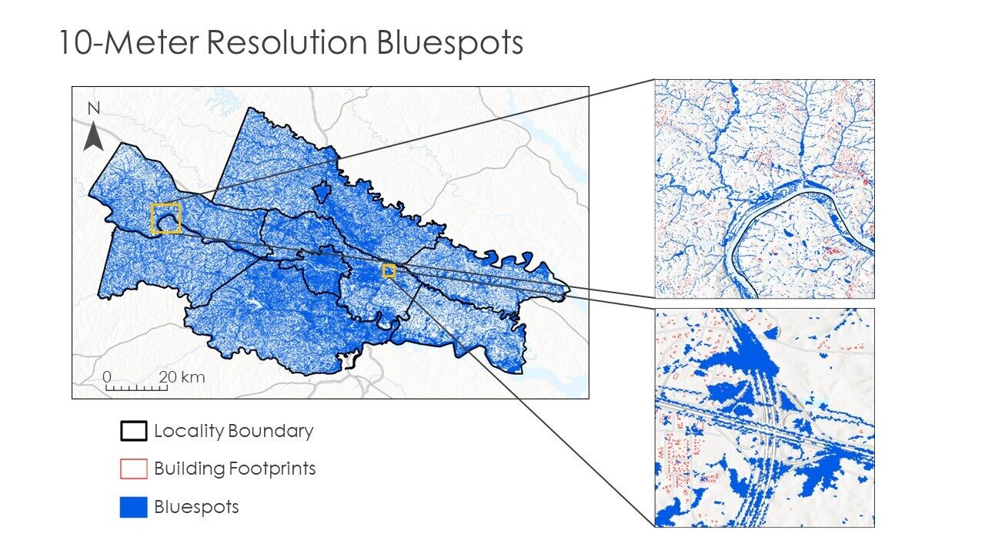

*Figure 2.* 10-meter resolution bluespots

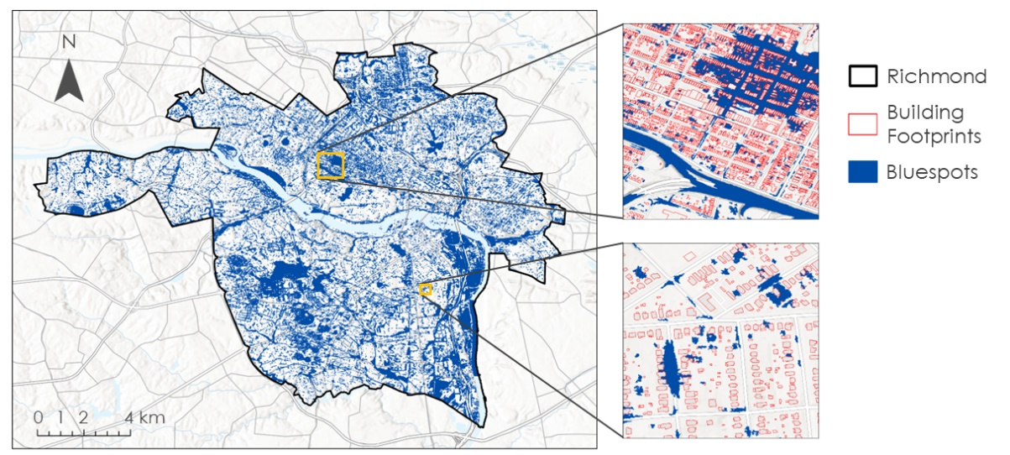

*Figure 3.* 1-meter resolution bluespots: Emphasis on Richmond

*4.1.2 InVEST Urban Flood Risk Mitigation Results*

The InVEST Urban Flood Risk Mitigation model generates three main outputs: runoff retention proportion, runoff depth, and runoff volume. Figure 4 shows what proportion of the precipitation is retained by the land. The higher the retention, the more water the ground can absorb and the less will run off. We used the runoff volume produced by a version of the model run with the bluespot watersheds as inputs (described in section 3.3.1) to compute pooling depths by bluespot. We did not use the runoff depth output raster for any further analysis.

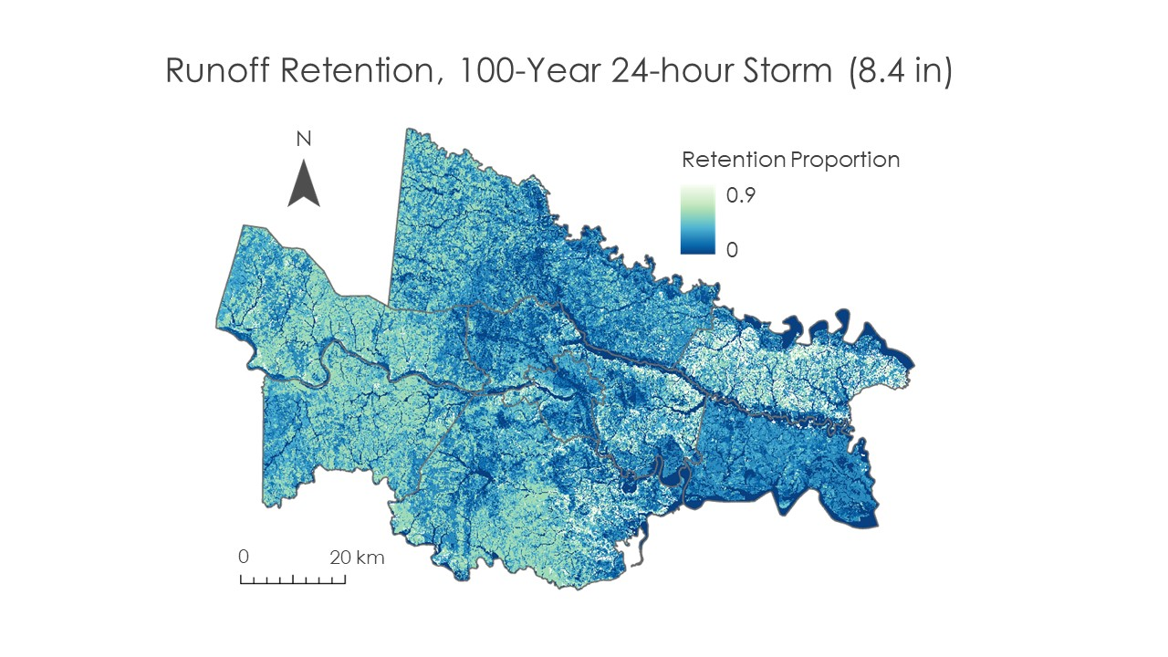

*Figure 4.* Proportion of runoff retained by the soil for a 100-year storm event of 213 mm

*4.1.3 Combined Model Results*

Figure 5 shows the results of the flood risk index by census tract calculated from the results of the Arc-Malstrøm and InVEST models as described in Section 3.3.1. This shows that the counties with the highest flood risk are located in Richmond, particularly on the south side, the Town of Ashland, and in Hanover, Charles City, and New Kent counties. It’s important to note that inconsistencies in soil classification between counties causes flood risk to be exaggerated in certain areas—this is likely why Charles City and New Kent counties are highlighted. Other than this, however, this map matches what has been observed by people in this area—small, highly populated counties in urban areas experience the most severe pluvial flooding.

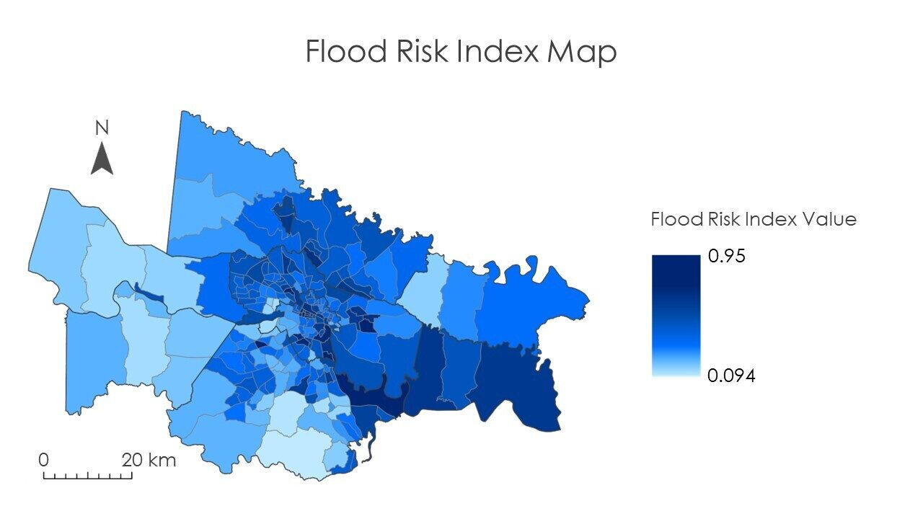

*Figure 5*. Flood risk index by census tract calculated from percent bluespot coverage and mean runoff retention value

The bluespot depth analysis conducted by running the InVEST model with the bluespot watersheds calculated with Arc-Malstrøm provided maps of bluespots with depths for the modeled storm. Figure 5 shows a map of the study area with the precipitation depth for May 18th–19th, 2018 as measured by GPM IMERG, with markers indicating bluespots predicted by the combined model results to have a depth greater than 200mm. The inset map is a part of the layer used to identify the flooded bluespots, which shows the individual bluespots and colors them by predicted depth. The results of this analysis method allow us to identify areas most impacted by the May 2018 storm, based on the precipitation depth and their relative vulnerability to flooding due to the presence of bluespots and low infiltration capacity. This provides more detailed information than the census-level flood risk map, facilitating targeted interventions to prevent flooding in specific areas.

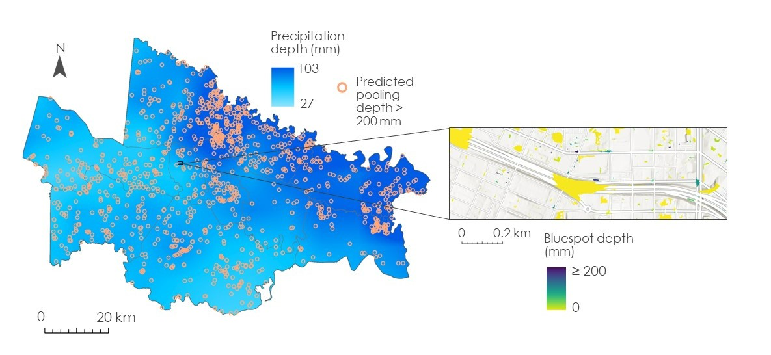

*Figure 6*. Bluespot depths for the observed storm on May 18th–19th, 2018 with IMERG precipitation depth

*4.1.4 Social Vulnerability Results*

We visualized the relationship between the flood risk index and SVI using a bivariate map which highlights census tracts with both a high flood risk and social vulnerability, shown in Figure 7. These tracts are more likely to be heavily impacted by stormwater flooding and have a harder time recovering. Appendix 9.1 includes bivariate maps broken down by theme, compiling flood risk with socioeconomic status, racial and ethnic minority status, and household characteristics.

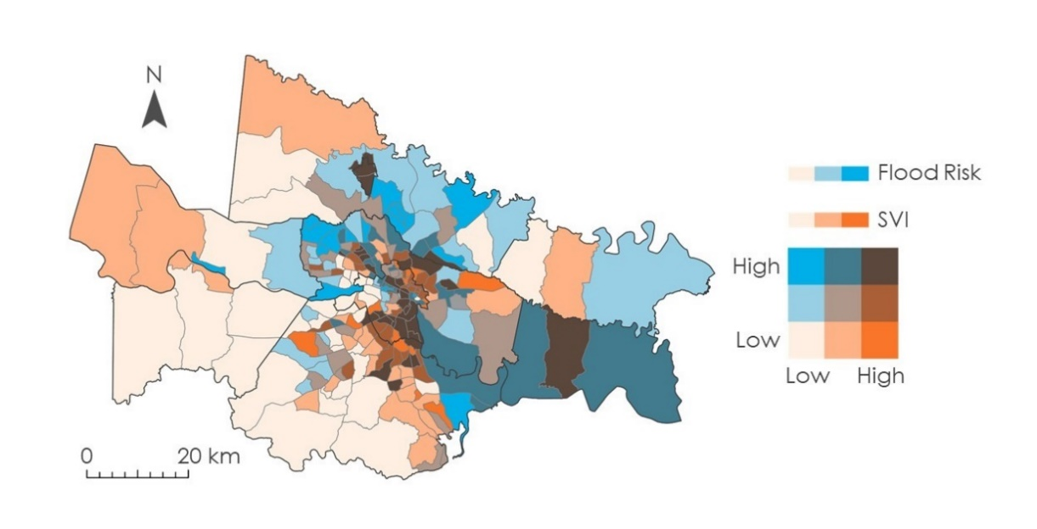

*Figure 7.* Flood risk and social vulnerability

***4.2 Uncertainties and Limitations***

The main source of error and uncertainty in this work comes from the highly simplified nature of both the InVEST and Arc-Malstrøm models. Neither of these models account for important hydrologic processes and conditions such as overland flow, antecedent moisture condition, and existing drainage infrastructure. In addition, the bluespot delineation process creates some artificially deep sinks near buildings, which are not realistic or representative of actual conditions and cause the model to predict catastrophic flood depths which are not physically possible.

As mentioned previously, classification of soil hydrologic groups is not standardized across counties, so in one county a soil may be classified as “B”, and in the next it would be classified as “A”, resulting in drastically different runoff retention estimates from the InVEST model. We found that specifically the counties of New Kent and Charles City had very inconsistent soil classification despite being located right next to each other with relatively the same land makeup.

We also found that IMERG data consistently underestimates rainfall depths, based on comparison with rain gauge data in Richmond. Although most of our results use design storms rather than the IMERG data because we were assessing future flood risk, it is important for future work to be aware that the depths predicted by IMERG may be less than what actually occurred. Finally, our analysis of bluespots at the 1-meter resolution was limited to Richmond proper because of data storage constraints.

***4.3 Feasibility Assessment***

We found that it is feasible to use Arc-Malstrom and InVEST to generate rudimentary maps showing potential areas of high pluvial flood risk. However, the most valuable outputs for the partners were those of the hydrologic models run with design storms, rather than outputs produced using Earth observation data. This is because their work focuses on determining future risk as opposed to investigating historic flooding events, so precipitation rates need to be constant across the study area in order to correctly characterize relative flood risk. GPM IMERG data is purposeless for this type of work except in the case where ground-truth data is available to calibrate the model with an observed storm and flood depths. Unfortunately, there is no reliable in-situ flood data for comparison, so GPM IMERG data is not useful for this application.

***4.3 Future Work***

The team’s assessments will allow Plan RVA to possibly integrate pluvial flooding data as a factor in their flood risk mapper. They will also be able to hand off these results to localities to make their own decisions on how to manage flooding. Collaborator PlanRVA will be able to use the results to determine areas in the Richmond area that have the greatest need for green infrastructure given the flood risk index, social vulnerability index, and street-level flooding maps.

# 5. Conclusions

We concluded that several census tracts with a high flood risk index also rank high on the social vulnerability index. Specifically, census tracts in urban areas tend to have both higher flood risk and higher social vulnerability. Some of these areas included Ashland and Richmond, with Charles City County being a non-urban area with high risk. In Richmond, areas that were at the highest risk for both flooding and social vulnerability were near Clopton, East Highland Park, and other areas in Southside Richmond. We also concluded that GPM IMERG data can be used to examine the impact of previous storms and validate pluvial flood models, but due to the lack of observed flood measurements we were unable to perform this type of analysis. In addition, because it tends to underestimate actual precipitation depths, it is not a good reference for predicting the impact of large future storms.

# 6. Acknowledgements

The Richmond Disaster team thanks our project partners at PlanRVA and Groundwork RVA for the time, resources, and insights they contributed to our project. We also thank our science advisor Dr. Ross who helped us work through challenges we faced when processing and analyzing our data and gave us guidance on our project.

​​This work utilized data made available through the NASA Commercial Smallsat Data Acquisition (CSDA) program. Any opinions, findings, and conclusions or recommendations expressed in this material are those of the author(s) and do not necessarily reflect the views of the National Aeronautics and Space Administration. This material is based upon work supported by NASA through contract NNL16AA05C.

# 7. Glossary

**Bluespot** – Surface land area where the likelihood of pluvial flooding is relatively high with affiliated consequences.

**Earth observations** – Satellites and sensors that collect information about the Earth’s physical, chemical, and biological systems over space and time.

**GEE** – Google Earth Engine: a cloud-based geospatial analysis platform that allows users to visualize and analyze satellite imagery.

**GPM** – Global Precipitation Measurement: an international satellite mission that measures both active precipitation and atmospheric conditions.

**HUC** – Hydrologic Unit Code: a unique code used to identify watersheds based on the USGS’s four-level classification system and typically consisting of two to eight digits.

**IMERG** – Integrated Multi-satellitE Retrievals for GPM: an algorithm that uses GPM imagery to calculate precipitation amounts over the Earth’s surface.

**InVEST** –Integrated Valuation of Ecosystem Services and Tradeoffs: a suite of models used to map and evaluate the changes in ecosystems influencing natural goods and services that sustain human life.

# 8. References

Arkema, K. K., Griffin, R., Maldonado, S., Silver, J., Suckale, J., & Guerry, A. D. (2017). InVEST Urban Flood Risk Mitigation Model. *Annals of the New York Academy of Sciences*, *1399*(1), 5–26. <https://doi.org/10.1111/nyas.13322>

Balstrøm, T., & Crawford, D. (2018). Arc-Malstrøm: A 1D hydrologic screening method for stormwater assessments based on geometric networks. *Computers & Geosciences*, *116*, 64–73. <https://doi.org/10.1016/j.cageo.2018.04.010>

Brown, Z., Lin, Y.-L., & Kaplan, M. (2006). Factors that contributed to the Hurricane Gaston flooding event in Richmond, Virginia. *27th Conference on Hurricanes and Tropical Meteorology*.

Bulti, D. T., & Abebe, B. G. (2020). A review of flood modeling methods for urban pluvial flood application. *Modeling Earth Systems and Environment*, *6*(3), 1293–1302. <https://doi.org/10.1007/s40808-020-00803-z>

Climate Adapt. (2016, June 7). *The Blue Spot model: A key tool in assessing flood risks for the climate adaptation of national roads and highway systems—English*. <https://climate-adapt.eea.europa.eu/en/metadata/tools/the-blue-spot-model-a-key-tool-in-assessing-flood-risks-for-the-climate-adaptation-of-national-roads-and-highway-systems>

Danish Road Institute. (2010). *Methods to Predict and Handle Flooding on Highways: The Blue Spot Concept*. Road Directorate. <https://en.klimatilpasning.dk/media/297917/the_blue_spot_concept_report_181.pdf>

Dennis, B. (2021, September 17). Flash floods wallop downtown Richmond, eyewitness videos detail damage. *WRIC ABC 8News*. <https://www.wric.com/news/local-news/richmond/flash-floods-wallop-downtown-richmond-eyewitness-videos-detail-damage/>

Douglas, I., Garvin, S., Lawson, N., Richards, J., Tippett, J., & White, I. (2010). Urban pluvial flooding: A qualitative case study of cause, effect and nonstructural mitigation. *Journal of Flood Risk Management*, *3*(2), 112–125. <https://doi.org/10.1111/j.1753-318X.2010.01061.x>

Hamel, P., Guerry, A. D., Polasky, S., Han, B., Douglass, J. A., Hamann, M., Janke, B., Kuiper, J. J., Levrel, H., Liu, H., Lonsdorf, E., McDonald, R. I., Nootenboom, C., Ouyang, Z., Remme, R. P., Sharp, R. P., Tardieu, L., Viguié, V., Xu, D., … Daily, G. C. (2021). Mapping the benefits of nature in cities with the InVEST software. *Npj Urban Sustainability*, *1*(1), Article 1. <https://doi.org/10.1038/s42949-021-00027-9>

Hammond, M. J., Chen, A. S., Djordjević, S., Butler, D., & Mark, O. (2015). Urban flood impact assessment: A state-of-the-art review. *Urban Water Journal*, *12*(1), 14–29. <https://doi.org/10.1080/1573062X.2013.857421>

Houston, D., Werrity, A., Bassett, D., Geddes, A., Hoolachan, A., & McMillan, M. (2011). *Pluvial (rain-related) flooding in urban areas: The invisible hazard* [Research Reports or Papers]. Joseph Rowntree Foundation. <https://www.jrf.org.uk/report/pluvial-rain-related-flooding-urban-areas-invisible-hazard>

Li, M., Liang, D., Xia, J., Song, J., Cheng, D., Wu, J., Cao, Y., Sun, H., & Li, Q. (2021). Evaluation of water conservation function of Danjiang River Basin in Qinling Mountains, China based on InVEST model. *Journal of Environmental Management*, *286*, 112212. <https://doi.org/10.1016/j.jenvman.2021.112212>

Luo, P., Luo, M., Li, F., Qi, X., Huo, A., Wang, Z., He, B., Takara, K., Nover, D., & Wang, Y. (2022). Urban flood numerical simulation: Research, methods and future perspectives. *Environmental Modelling & Software*, *156*, 105478. <https://doi.org/10.1016/j.envsoft.2022.105478>

McDermott, T. K. J. (2022). Global exposure to flood risk and poverty. *Nature Communications*, *13*(1), Article 1. <https://doi.org/10.1038/s41467-022-30725-6>

Meyers, R. (2023, March 9). *Richmond now more at risk for flash flooding*. NBC 12. <https://www.nbc12.com/2023/03/09/richmond-now-more-risk-flash-flooding/>

NASA Global Precipitation Measurement Mission. (2023). *IMERG: Integrated Multi-satellitE Retrievals for GPM*. <https://gpm.nasa.gov/data/imerg>

Natural Resources Conservation Service. (2023). *Gridded Soil Survey Geographic (gSSURGO) Database*. <https://www.nrcs.usda.gov/resources/data-and-reports/gridded-soil-survey-geographic-gssurgo-database>

NOAA. (2017, April 21). *NOAA Atlas 14 PF Map: Contiguous US*. NOAA ATLAS 14 POINT PRECIPITATION FREQUENCY ESTIMATES: VA. <https://hdsc.nws.noaa.gov/pfds/pfds_map_cont.html?bkmrk=va>

Office of Atmospheric Programs, E. (2021). *CLIMATE CHANGE AND SOCIAL VULNERABILITY IN THE UNITED STATES - A focus on Six Impacts* [dataset]. <https://doi.org/10.1163/9789004322714_cclc_2021-0166-513>

Rosenzweig, B. R., McPhillips, L., Chang, H., Cheng, C., Welty, C., Matsler, M., Iwaniec, D., & Davidson, C. I. (2018). Pluvial flood risk and opportunities for resilience. *WIREs Water*, *5*(6), e1302. <https://doi.org/10.1002/wat2.1302>

The Natural Capital Project. (2023). *InVEST User Guide—InVEST documentation*. <https://storage.googleapis.com/releases.naturalcapitalproject.org/invest-userguide/latest/en/index.html>

U.S. Census Bureau. (2010). *U.S. Census Bureau QuickFacts: United States*. <https://www.census.gov/quickfacts/fact/table/goochlandcountyvirginia,newkentcountyvirginia,chesterfieldcountyvirginia,charlescitycountyvirginia,ashlandtownvirginia,richmondcityvirginia/POP010210>; <https://www.census.gov/quickfacts/fact/table/powhatancountyvirginia,hanovercountyvirginia,henricocountyvirginia,richmondcityvirginia/POP010210>.

U.S. Geological Survey. (n.d.). *National Land Cover Database*. Retrieved July 3, 2023, from <https://www.usgs.gov/centers/eros/science/national-land-cover-database>

U.S. Geological Survey. (2023). *Watershed Boundary Dataset | U.S. Geological Survey*. <https://www.usgs.gov/national-hydrography/watershed-boundary-dataset>

USDA. (2021, February). *NRCS eDirectives—Part 650—Engineering Field Handbook*. <https://directives.sc.egov.usda.gov/viewerFS.aspx?id=3619>

USDA. (2023). *Dominant Soil Hydrologic Group—ScienceBase-Catalog*. <https://www.sciencebase.gov/catalog/item/4fc52c12e4b00e9c12d8c3a7>

Virginia Department of Emergency Management. (2023, June 30). *Virginia Building Footprints*. <https://vgin.vdem.virginia.gov/datasets/virginia-building-footprints/about>

Zhong, L., & Wang, J. (2017). Evaluation on effect of land consolidation on habitat quality based on InVEST model. *Transactions of the Chinese Society of Agricultural Engineering*, *33*(1), 250–255.

# 9. Appendices

**Appendix A: Flood Risk Bivariate Maps**

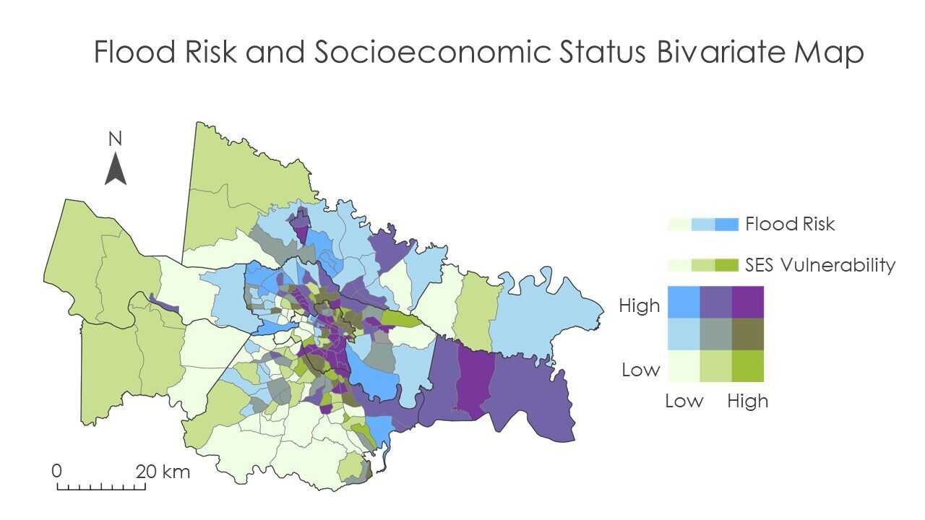

*Figure 8.* Flood Risk and Socioeconomic Status

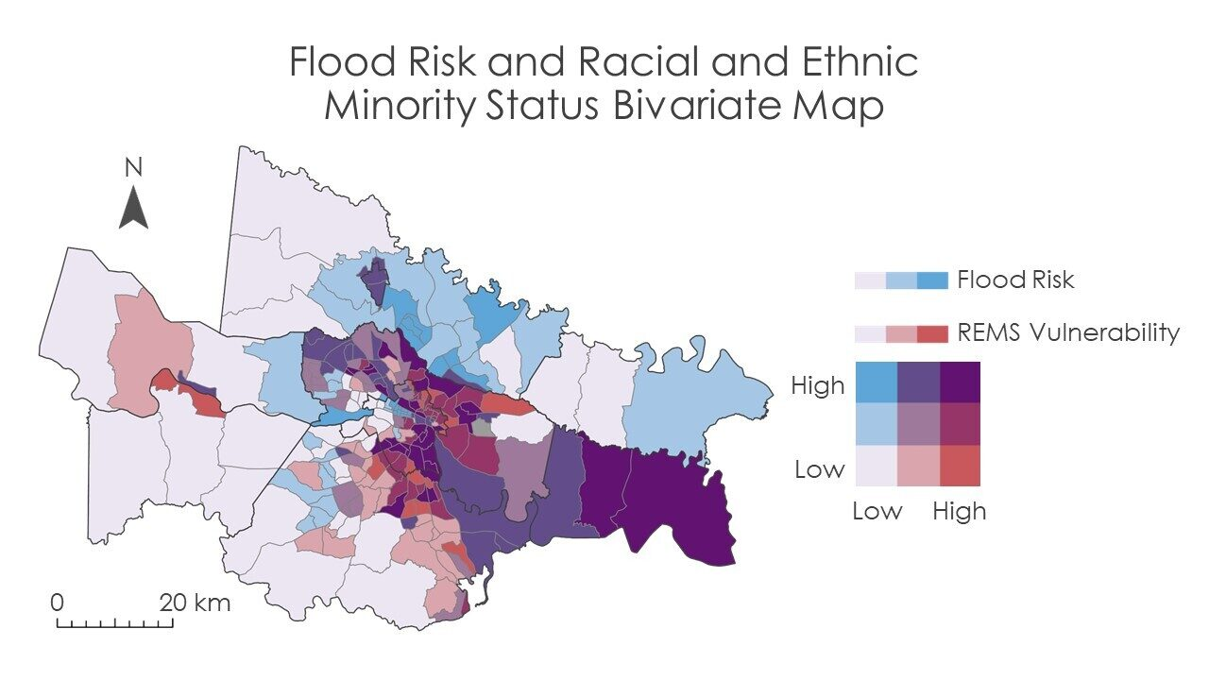

*Figure 9.* Flood Risk and Racial and Ethnic Minority Status

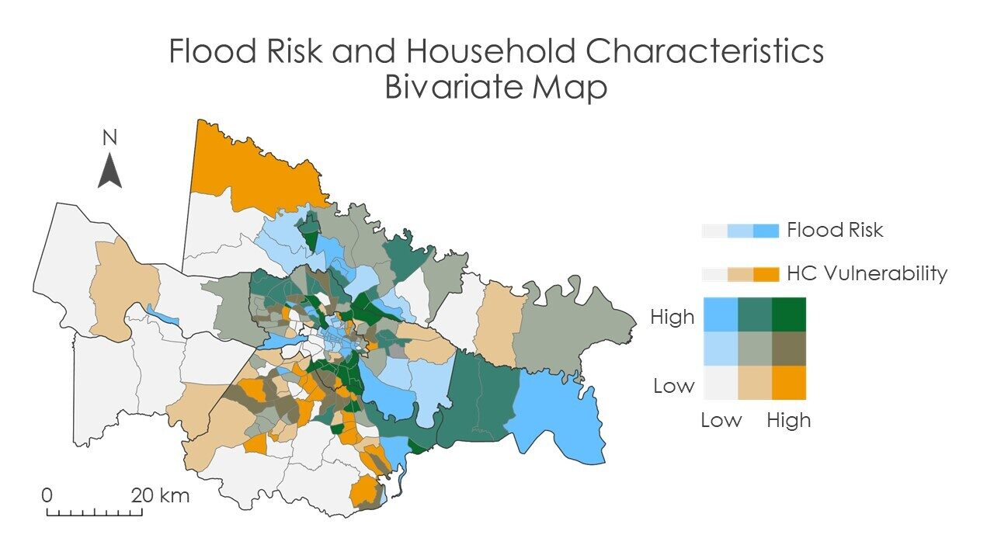

*Figure 10.* Flood Risk and Household Characteristics