**NASA DEVELOP National Program**

****USGS at Colorado State University – Fort Collins, CO

**Fall 2015**

**Short Title: Wyoming Ecological Forecasting**

**Subtitle:** Mapping Cheatgrass Distribution and Phenology in a Post-Wildfire Landscape in Wyoming’s Medicine Bow National Forest

**VPS Title:** A Changing Landscape: Monitoring Cheatgrass with Satellite Imagery

**Project Team & Partners**

**Project Team:**

Darin Schulte (Project Lead), darin.schulte@du.edu

Chandra Fowler

Stephanie Krail

Oliver Miltenberger

**Advisors & Mentors:**

Dr. Paul Evangelista (Colorado State University, Natural Resource Ecology Lab)

Dr. Amanda West (Colorado State University, Natural Resource Ecology Lab)

**Partner Organizations:**

Wyoming Game and Fish Department (End-User), POC; Ryan Amundson

United States Forest Service (USFS) (End-User), POC; Katharine Haynes

Colorado State University, Natural Resource Ecology Lab (Collaborator), POC; Amanda West

**Project Details**

**Applied Sciences National Application Addressed:** Ecological Forecasting

**Study Area:** Medicine Bow National Forest, WY

**Study Period:** May 2014 – September 2015

**Earth Observations & Parameters:**

Landsat 8, OLI - land cover

Landsat 8, TIRS - land cover

Terra, MODIS - phenology

Space Shuttle, SRTM - elevation

**Ancillary Datasets Utilized:**

* USFS Administrative Boundaries - management boundaries
* USFS Arapaho Wildfire Boundary - wildfire boundaries
* Natural Resource Ecology Lab Field Data - percent cover vegetation

**Models Utilized:**

* Boosted Regression Tree (BRT)
* Generalized Linear Model (GLM)
* Multivariate Adaptive Regression Splines (MARS)
* Random Forest (RF)

**Software Utilized:**

ArcGIS - Landsat imagery processing, derivation of vegetation / topographic indices and map creation

R - Statistical modeling and graphing

Software for Assisted Habitat Modeling (SAHM) for VisTrails - Species distribution modeling

**Project Overview**

**80-100 Word Objectives Overview:**

Cheatgrass (*Bromus tectorum*) is a well-documented invasive species in the American West that has been shown to alter nitrogen cycles, compete with native grass and forb species, and modify historic fire regimes. The 2012 Arapaho Fire in the Medicine Bow National Forest (MBNF) of Southeastern Wyoming burned over 40,000 ha leaving the area susceptible to cheatgrass encroachment. We used multi-temporal / multi-spectral indices, field data, and species distribution modeling, to map cheatgrass spatial distribution and assess the phenological characteristics of areas with heavy cheatgrass cover. Our findings support the planning and implementation of targeted cheatgrass management in the area.

**Abstract:**

The Medicine Bow National Forest (MBNF) consists of approximately 560,000 ha in South Central Wyoming. Elevation in MBNF ranges from approximately 1,000m to 4,000m and results in a relatively wide range of local climate variation, wildlife habitat types, and recreational usage. Dominant plant communities include ponderosa pine (*Pinus ponderosa*) forests and sagebrush (*Artemesia sp.*) steppe. Mammal populations of mule deer (*Odocoileus hemionus*), elk (*Cervus canadensis*), pronghorn (*Antilocapra americana*), and moose (*Alces alces*), constitute important ecological and economic management concerns within the National Forest. In 2012 the Arapaho Fire burned approximately 40,000 ha of land within MBNF. Cheatgrass (*Bromus* tectorum), an invasive plant species in the Western U.S., is known to rapidly colonize disturbed sites and dramatically alter historic fire regimes, nutrient/water dynamics, and outcompete native plant species. The Arapaho Fire burned areas managed as critical habitat, as defined by the Endangered Species Act (ESA), for several wildlife species and the targeted reduction of cheatgrass cover in the region is a priority. To facilitate management practices conducted by project partners, we created a cheatgrass landcover map and phenological profile for the study area using Landsat 8 OLI / TIRS and Terra MODIS data from the 2015 growing season. We used a series of vegetation and topographic indices as predictors of cheatgrass cover as well as field data to construct a Species Distribution Model (SDM) for the Arapaho Fire site. The phenological profile for predicted cheatgrass locations was estimated using Landsat 8 OLI and Terra MODIS data for targeted aerial herbicide spraying.

**Community Concerns:**

* Cheatgrass is known throughout the Western U.S. as a problematic invasive species that can alter hydrologic and nutrient regimes, outcompete native grasses, and increase fire intensity while thriving in post-burn areas.
* As of 2005, an estimated 22.5 million ha in the U.S. were affected by cheatgrass.
* Mitigation of areas where cheatgrass has successfully established can be very expensive. In the mid 1990’s the control of fires in areas of cheatgrass establishment in the Great Basin was estimated to cost 10 million dollars annually.
* In order to effectively target areas for cheatgrass management, highly accurate maps of cheatgrass cover are needed. Currently, field surveys are the only method of estimating cheatgrass distribution. Due to the difficulty in accessing much of the post-burn area, remote sensing provides a valuable alternative.
* A better understanding of the regional phenology of cheatgrass will allow land managers to effectively plan the timing of herbicide application.

**Current Management Practices & Policies**:

Currently, land managers are utilizing field surveys and expert knowledge to estimate the spatial distribution of cheatgrass in the MBNF as well as dictate the timing of aerial spraying. Challenging terrain makes such surveys time intensive, physically challenging, and expensive.

**Decision Support Tools & Benefits:**

|  |  |  |
| --- | --- | --- |
| **End-Product** | **Earth Observations Used** | **Benefit & Impact** |
| Cheatgrass Cover Map | Landsat 8 OLI & TIRS | Identification of locations with extensive (i.e., greater than 40%) cheatgrass cover to aid in targeted management and mitigation |
| Cheatgrass Phenological Characterization | Landsat 8 OLI & Terra MODIS | Inform the timing of herbicide application to coincide with the appropriate phenological phase of cheatgrass within the study area |

**Project Imagery**

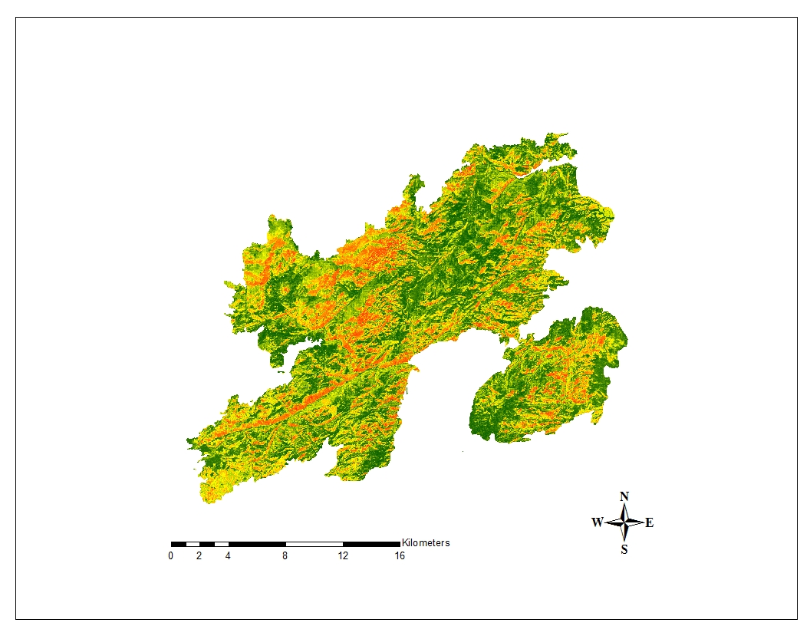

High

Low

Figure 1. Probability map illustrating the predicted probability of cheatgrass cover.

**Software Release Requirements**

Category 1