Georgia Disasters II
Evaluating the Impacts of Hurricane Irma on Georgia Heirs Property Owners Using NASA Earth Observations


Technical Report
Final – March 31st, 2023

Shakirah Rogers (Project Lead)
Nathan Tesfayi
Matthew Murray
Clarence Jackson

Advisors:
Dr. Marguerite Madden (University of Georgia)
Dr. Cassandra Johnson Gaither (USDA Forest Service)
Joseph Sousa (Georgia Department of Community Affairs)

Previous Contributors:
Isabella Chittumuri
Nancee Uniyal

Fellow:
Sarah Payne (Georgia – Athens)

1. Abstract
Heirs property owners are especially vulnerable to natural and manmade disasters. This group of people have inherited property left with no clear title and thus have unclear group ownership with the other legal owners, which are all spouses, children, etc. of past owners. After Hurricane Irma made landfall in Georgia in September of 2017, heirs property owners became more likely to be denied access to federal relief due to the legal status of their property title. To observe how this group was impacted by Hurricane Irma, the NASA DEVELOP team partnered with The Georgia Heirs Property Law Center (The Center), a non-profit law firm that works with heirs properties owners. The team used computer assisted mass appraisal (CAMA) data to identify likely heirs property owners. They cross referenced this map with a flood map produced with surface reflectance and backscatter imagery from Landsat 8 OLI, Sentinel-2 MSI, and Sentinel-1 C-SAR, sensors to identify communities in need of relief or assistance. The flood extent maps were validated against United States Geological Survey (USGS) Hurricane Irma High Water Mark in situ data taken the same day Irma crossed into Georgia. To further evaluate the impacted group, the team correlated the flood and heirs property likelihood maps to FEMA denials based on titles issues. The team’s end products were handed off to the Georgia Heirs Property Law Center for use in community outreach, educational materials, and to help direct where The Center can work to prioritize its limited legal resources.
Key Terms
CAMA, Hurricane Irma, heirs property, ACS, FEMA, flood extent, HYDRAFloods

2. Introduction
2.1 Background Information
Across the southern United States, a minimum value of 5.5 billion dollars' worth of equity is trapped in the legal complications of heirs property (Pippin et al., 2017). Heirs properties are created when a property owner dies without a will or when a will is not executed properly by the local judiciary. When an owner dies in this way, the property is passed down to all legal heirs, which usually includes the owner’s spouse and children. Each of these new owners have equal rights to the property, thus resulting in a “tangled title”, a legal limbo which makes the property ineligible for a variety of local, state, and federal programs, including disaster relief programs.

On September 11th, 2017, Hurricane Irma moved into southern Georgia, the location of our study area, causing significant damage. The storm brought wind gusts of up to 62 mph, heavy rain, and a 3–5 ft storm surge that led to coastal flooding. The damage was estimated to cost $50.5 billion for the U.S. and $670 million for Georgia, making Irma the 5th most expensive hurricane in U.S. history at the time (Cangialosi et al., 2021). Hurricane Irma caused widespread property damage, which had an especially devastating impact on heirs property owners. In general, heirs properties are more likely to become degraded and abandoned, resulting in an immense loss of generational wealth, especially among moderate-to-low income and racially marginalized communities. Heirs properties are prominent among black communities, comprising up to 41 percent of Black-owned properties in the rural South and contributing to a long history of land stealing (Gaither et al., 2019). The group ownership inherent to heirs properties also make them susceptible to a forced sale initiated by any of the fractional owners.

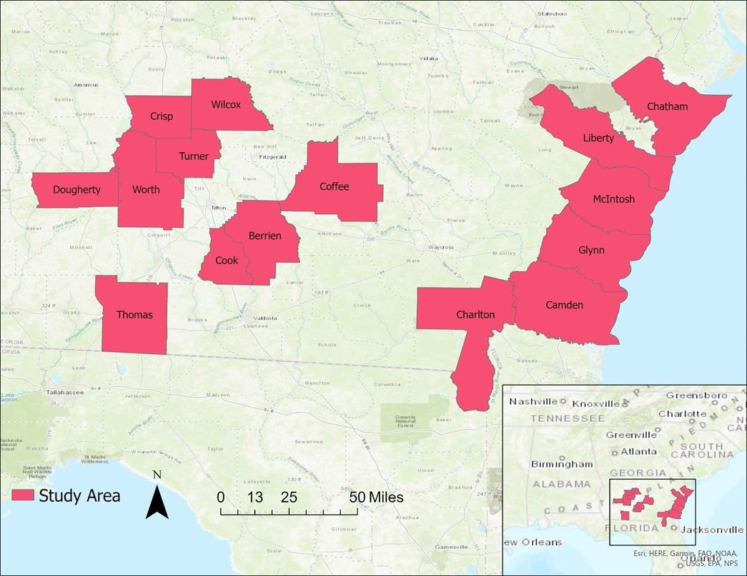
Figure 1: A map showing the counties in the study area.
Figure 1. A map showing the counties in the study area.

This project focused on 15 counties across Southern Georgia (Figure 1). The team chose these 15 due to their designation for Federal Emergency Management Agency (FEMA) Public Assistance and Individual Assistance (Georgia Department of Community Affairs, 2020). All the counties identified by FEMA were affected by storm surges, intense winds, and/or rainfall related to Hurricane Irma. The study period was from January 2012 to September 2017 to account for pre-and post-hurricane conditions, such that permanent water in the study area would not be considered flood analysis. We used computer assisted mass appraisal (CAMA) data in conjunction with flood extent mapping to identify potential heirs property owners who may have been affected by or especially vulnerable to natural disaster-based flooding.

Past studies have investigated the use of both optical and synthetic aperture radar (SAR) imagery to measure flood extent (Williams et al., 2021). Optical sensors have often been used as the primary sensors for surface water detection, but the satellites’ revisit times and the high cloud cover from flooding events are consistent limitations to flood detection. Hurricanes are extremely cloudy events, and flood extents are expected to recede in matters of hours to days, sometimes before cloud cover has fully dispersed. This made SAR and its cloud-penetrating radar an invaluable tool for flood detection and extent mapping (Grimaldi et al., 2020). Similar to this study, other researchers have used the thresholding algorithm Edge Otsu to detect flood; in a 2020 study, two threshold algorithms, Bmax Otsu and Edge Otsu, were compared on their abilities to accurately differentiate between water and non-water classes for surface water mapping, which proved Edge Otsu to be more accurate with an accuracy range of 94–95 percent (Markert et al., 2020).

After flood extent and distribution near land parcels was determined, the likelihood of a given parcel presently being heirs property was incredibly important to investigate in order to understand the effects of a natural disaster on this vulnerable group. Each heirs property is unique, and short of direct title examination there is no certain way to identify a particular parcel as being as heirs property or not. To this end, while using the tax records made available by the University of Georgia (UGA) Carl Vinson Institute of Government, the team identified parcels as being probable heirs property. Literature on heirs properties was scant and divided as to identification, but as a seminal piece in the field, the team started with parameters outlined by the U.S. Forestry Service (Pippin et al., 2017).

The first term found higher flood extents along coastal counties using Sentinel-1 C-SAR imagery as compared to inland counties. In comparison, optical imagery indicated that the majority of flooding was inland, but we believe this was an issue caused by the dynamic range and water-detecting capability of Landsat 7 ETM+. Landsat 7 was nixed in the second term due to this. To identify potential heirs properties, the team filtered CAMA data for Camden County. This acted as a proof of concept for the project’s second term. The previous team investigated the inclusion of structural damage maps in their analysis, but this goal proved infeasible due to cloud obscuration and the spatial resolution of the imagery.

2.2 Project Partners & Objectives
The Center specializes in clearing and condensing heirs property titles and partnered with the Georgia Department of Community Affairs to provide services to heirs property owners. This partnership grant provides funds for disaster mitigation planning and educational outreach to help inform heirs property owners in vulnerable communities of their legal rights regarding tangled titles. The NASA DEVELOP team partnered with The Center to produce flood extent maps overlayed with by-county density of probable heirs properties in order to help The Center better direct its resources to vulnerable communities.

The objective of this project was to use remotely sensed data to assess the impacts of Hurricane Irma on Georgia heirs property owners. The team created flood extent maps, using optical and SAR imagery, that they refined to show flooding and validated against in situ data from the USGS. The team also filtered CAMA data using Python to identify potential heirs properties and approximated the total values of these properties. Then they made a bivariate map of flood extent and potential heirs property concentrations to emphasize the impacts of Hurricane Irma. The Center aims to use these data to improve their outreach efforts and disaster response planning.

Initially, the team was interested in looking at rates of FEMA relief denials and a Social Vulnerability Index and how that did or did not correlate with the relative density of heirs properties. This piece of the project was determined to require more data processing than was available in the term to extract meaningful relationships.

3. Methodology
3.1 Data Acquisition
3.1.1 Flood Extent Observations and Validation
To assess flood extent, we acquired data from the satellites listed in the table below (Table 1). We acquired all Landsat OLI, Sentinel-2 MSI, and Sentinel-1 C-SAR imagery from Google Earth Engine (GEE) image collections within the time period of September 11, 2017, to September 21, 2017. Surface reflectance imagery from the Sentinel-2 MSI Level-2A GEE collection was not available in this study area at this time. Attempts to acquire this imagery are described under 4.1.2.

The Flood Event Viewer portal provided USGS High Water Mark (HWM) in situ flood data from Hurricane Irma found with streamgages and stormgages. The USGS collected the data on September 11, 2017. Lastly, we validated our remotely sensed flood extent against the USGS dataset.

Table 1.
Earth observation satellites and sensors, parameters, and image capture dates
Platform / Sensor | Parameters | Processing Level | Image Capture Dates
Landsat 8 OLI | Surface reflectance | Level 2 Collection 2 Tier 1 | 9/12/2017  9/14/2017  9/19/2017
Sentinel-2 MSI | Top of Atmosphere (TOA) | Level-1C | 9/12/2017  9/19/2017
Sentinel-1 C-SAR | Backscatter | Level-2A | 9/12/2017  9/15/2017  9/16/2017  9/17/2017  9/18/2017

3.1.2 Heirs Property Predictions and Socioeconomic Indicators
To assess the potential of a given parcel being heirs property, the team obtained CAMA data from the Carl Vinson Institute of Government (CVIG), a unit of the Office of Public Service and Outreach at the University of Georgia (UGA). We gathered data at the county level for the purposes of assessing tax burden, standardizing 13 of 15 counties using the WinGAP format, which is the primary CAMA software used in the state of Georgia for property tax appraisal. The remaining two counties, Chatham and Glynn, use non-standard, locally developed data formats. The dates of the data the team acquired ranged from 2014–2022. Since each county updates its own CAMA based on local needs, the dates that the team acquired varied individually from county to county.

Based on Pippin et al. (2017), the team identified certain demographics as more likely to be heirs property owners: racial and ethnic minorities, median-to low-income households, etc. These demographics coincided with many groups vulnerable to environmental hazards identified by the Social Vulnerability Index (SoVI) from 2010–2014, which combined data from the 2010 census and the Census Bureau’s 5-year American Community Survey (ACS). The team created an index based on Cutter et al. (2003) with the intention of comparing hazard data. To attempt to verify a correlation of demographics to heirs property owners for this research, the team obtained the pre-processed data from the Hazards Vulnerability & Resilience Institute (HVRI).

3.2 Data Processing
3.2.1 Flood Extent – Landsat 8 OLI and Sentinel-2 MSI+
The team mapped flood extent using the Hydrologic Remote Sensing Analysis for Floods (HYDRAFloods) tool within the GEE Python API. We acquired image collections within the study region and the time period following Hurricane Irma for Landsat 8 OLI and Sentinel-2 MSI (Table 1). Within these regional and temporal parameters, we obtained four images from Landsat 8 OLI and two from Sentinel-2 MSI. To emphasize water in optical imagery, the team applied a Modified Normalized Difference Water Index (mNDWI, Equation 1), a ratio of green and shortwave infrared bands, to the imagery (Zhou et al., 2017). The team then defined floods as areas with water still present when referential permanent water was masked out, using the permanent water sources found with the European Commission Joint Research Center (JRC) Yearly Water Classification History from 2012–2017. The team utilized Edge Otsu, an algorithm that distinguishes water classes from non-water classes, to identify regions of flooding (Markert et al., 2020). Next, the team post-processed flood extent to mask out extraneous flood that appeared in the ocean via ArcGIS Pro using the National Weather Service (NWS) United States and Territories shapefile.
$mNWDI = \frac{Green - SWIR}{Green + SWIR}$ Equation 1

3.2.2 Flood Extent – Sentinel-1 C-SAR
The team used the HYDRAFloods tool through GEE’s Python API to prepare and perform analysis on imagery from Sentinel-1 C-SAR for the study area. The team selected a nine-day period, September 11th, 2017, through September 21st, 2017, to observe the impact of Hurricane Irma and produced nine images from Sentinel-1 with VV polarization. Water was more distinguished in the VV polarization of Sentinel-1. Signal interference from the ground creates speckles in the images. To reduce noise resulting from signal interference from the ground, the team applied a Gamma-Gamma Maximum-a-posteriori speckle filter (Beauchemin et al., 1995). We established an upper bound above the ground using elevation data from the Global Hydrography Digital Elevation Model from MERIT Hydro, identifying areas 20 meters above the nearest drainage point, to look for water within those limits (Yamazaki, 2019). To correct shadows from possible buildings or hills, the team applied a pseudo-terrain flattening algorithm created by Vollrath et al. (2020) that used elevation data from the USGS 3D Elevation Program (3DEP). In the same manner as Landsat 8 and Sentinel-2 flood extents, the team used the NWS U.S. and Territories shapefile to mask out the outlying values of the flood extent.

3.2.3 Heirs Property Predictions and Socioeconomic Indicators
In order to properly assess all parameters that the team used to search for likely heirs properties, the team acquired CAMA data for all counties, with assistance from the CVIG. Each county required a constellation of individual comma separated values (CSV) files to investigate all the desired parameters. For counties under the WinGAP standardization, a given CSV file contained an assortment of property parcels identified by their “RealKey,” which uniquely identified a parcel across multiple data sets, and associated data indicating things like a parcel’s special tax exemptions, owner information, and last recorded sale date. Counties that did not use the WinGAP standardization, Chatham and Glynn, included the same or similar information, but had no standardized “RealKey” and instead used a different local identifier.

For a given county, the team read the associated CAMA data into a Google Colabs Python notebook from multiple CSV files using the open source “pandas” library and native Python methods (McKinney, 2010). The team read the data into a pandas dataframe, with rows corresponding to unique parcels identified by their “RealKey” value and columns of the different data used by county tax assessors. Once read into a pandas dataframe, the team dropped all columns that did not correspond to the team’s chosen parameters from the dataframe. The team only kept the “RealKey” consistently, as it allowed for identifying parcels between individual CSV files.

Next, the team generated a binary array of 1s and 0s for each parameter. We assigned a 1 to a given parcel if it met the criteria for identifying a likely heirs property for that parameter, and a 0 if otherwise. The team joined each binary vector with its corresponding vector of “RealKeys” to make an n x 2 matrix for each parameter, where n is the number of properties in a given dataset. After the team evaluated each parameter in this way, we joined each of the individual dataframes along the “RealKey” column using the pandas native join method. This ensured that every parcel that appeared in multiple datasets for a given county had all available parameters associated with it. The end result was a matrix where each row described a given “RealKey’s” adherence to the set of parameters and each column described which “RealKeys” adhered to the given parameter (Ex. Tables A.1 and A.2).

3.3 Data Analysis
3.3.1 Flood Extent – Analysis and Validation
The team measured flood extent from each satellite using a pixel count in ArcGIS Pro with the zonal statistics function. In Excel, the team then scaled each satellites’ flood pixels to the respective spatial resolution, finding the total area experiencing flooding on specific dates. The team found the percent area of flood per county by comparing the area of pixels of flood to the county’s area.

The team validated the remotely sensed flood extent of Sentinel-1 and Landsat 8 to the in situ HWM data. The sensors and gages from this data measured the real-time flood along the coast. Sentinel-2 only had imagery that covered inland counties, so we excluded it from validation. The HWM data included the site coordinates, the exact date and time of measurement, and the surveyed water elevation. We found intersections of the 42 in situ HWM points to flood pixels using a 100 ft buffer. We justified this buffer distance keeping in mind the georeferencing offset satellite pixels may have and the potential for flood extent to be undercounted from remote sensing. In order to use the intersect tool in ArcGIS, we converted the raster flood extent to polygons.

3.3.2 Choice of Parameters and Weights for Investigating CAMA Data
One of the primary difficulties in the identification of heirs properties is that in the absence of manual inspection of titles, there is no agreed upon or established method in heirs property research to easily identify heirs properties. There are several indicators used in a variety of studies that seem to indicate a certain level of confidence from researchers interested in the problem. The choice of parameters and the associated weights/importance given to each was a challenging series of choices made by the team in conjunction with The Center, science advisors, and results from a literature review (Pippin et. al., 2017). The team settled on a constellation of parameters, vetted by The Center (Table 2):

- Any “special terms” that were used to indicate a multitude of owners
- Records of tax bills paid by a person or persons outside of the county
- Multiple listed owners
- A last sale date greater than 30 years
- Any type of special tax status granted to the parcel based on land use

The Center provided the team a short list of what they deemed “special terms”, such as “heirs of” or “et. al", that, in their experience of consolidating heirs property titles, were the strongest indicators of an heirs property. The team identified these terms in the CAMA data using Python, comparing owner information found in the CAMA data directly to the list provided by The Center. If found, the team assigned a weight to the terms such that the associated property would always be above the team’s heirs property identification weight threshold. If information regarding where taxes on the property were paid from was available, a similar process was used to identify if a person within the study area was paying taxes from out of town or outside of the county, and apply a similar, but less significant weight. A similar process was applied to identify if a parcel had non-natural owners, a sale date more than 30 years ago, and/or a special tax status. The team chose weights for the different parameters such that identification of any of the special terms OR any two of the remaining parameters was sufficient to flag a parcel as a probable heirs property.

Table 2. Parameters by which the team identified likely heirs properties, sourced from the literature, and input from the team’s partner (The Center) and science advisors
Parameter | Description | Numerical Weight
Special Terms (“Heirs of”, “Estate of”, “et. al", etc.) | Identified by The Center as being the single best indicator | 4 (meant to over-identify or be a singular identifier)
Last Sale Date Greater than 30 Years | If a property has not been sold in 30+ years, it may have passed on due to a death | 2
Out of County Tax Payments | The title has passed to the care of someone outside of the county the parcel resides in due to a tangled inheritance | 1
Non-Natural Owners | Since it is common for spouses to share a title, 3+ owners indicate group ownership | -1
Special Tax Status | To acquire a special tax status (ex: homestead exemption), typically an owner must demonstrate a clean title. | -1

The team assembled the weights into a vector, $\vec{w}$, in order to easily perform a dot product. A dot product is a mathematical operator that, in this context, scales each element of B according to the elements of the weight vector, $\vec{w}$ (for more information on the dot product, see Appendix A.1):

$B⋅\vec{w}=\vec{s}$
Equation 2
Where $B$is the matrix developed using the Boolean masking and array joining techniques described in Section 3.2.3. The vector, $\vec{s}$, encodes the information corresponding to the likelihood of a property being heirs property, as identified by the team. In short, the matrix math becomes Equation 3 (for more information on the dot product, see Appendix A.1):

$$w_{0}\vec{r}+w_{1}\vec{b_{1}}+w_{2}\vec{b_{2}}+w_{3}\vec{b_{3}}+w_{4}\vec{b_{4}}+w_{5}\vec{b_{5}}=\vec{s}$$
Equation 3

Here, the weights w₁ through w₅, are non-zero corresponding to the weights and parameters above. The 0th weight (w₀) corresponds to the vector of RealKeys ($\vec{r}$) and is always set to zero so that the RealKey only serves as a unique identifier and is never included in the total weight. The vectors $\vec{b_{1}}$ through $\vec{b_{5}}$ are filled with binary values, zero and one, indicating if the corresponding row/RealKey does or does not meet the associated criteria associated with that vector.

After calculating the vector of total weighted sums, the team made a direct comparison to a confidence threshold. For the n^{th} weighted sum, $s_{n}$, the team asserts that the associated RealKey, $r_{n}$, is likely an heirs property if $s_{n}≥Threshold$. The team chose multiple thresholds to indicate increasing confidence of a given property being an heirs property as the total weighted sum increases.

4. Results & Discussion
4.1 Analysis of Results
4.1.1 Flood Analysis
The study area was not contiguous, so the maps in Figure 2 and Figure 3 were split by coastal and inland flood extent. Only Sentinel-1 C-SAR had coverage over the entire study area. The total area of flood for the study area from Sentinel-1 C-SAR was 109.68 km². In inland counties, the area of flood was 24.51 km², and the coastal counties had 85.17 km² of flood extent. The breakdowns of the area and percentages of flood per county are shown in Figure 8. The majority of remotely sensed flood from Sentinel-1 C-SAR occurred along the coast, which is exemplified in Figure 6, where black bars represent coastal counties. Landsat 8 OLI only captured imagery along the coast, so the combined map of remotely sensed flood is shown only on the coast (Figure 4). Landsat 8 OLI detected more flood extent in the five coastal counties than Sentinel-1 C-SAR in both Figure 7 and Table 3. The total area of flood from Landsat 8 was 268.84 km². More flood extent was measured along the coast by Landsat 8 than Sentinel-1 for the entire study area. For further comparison, observing exclusively coastal flood and exclusively the area of coastal counties, Landsat 8 detected that 8.46% of the coastal counties were flooded, and Sentinel-1 detected that 2.68% of coastal counties were flooded from Hurricane Irma.

Sentinel-2 MSI took imagery along inland counties. The team did not feel confident in our detection of flood extent due to several issues and time limitations with the imagery. The detected flood from Sentinel-2 MSI miscategorized cloud shadows as flood.

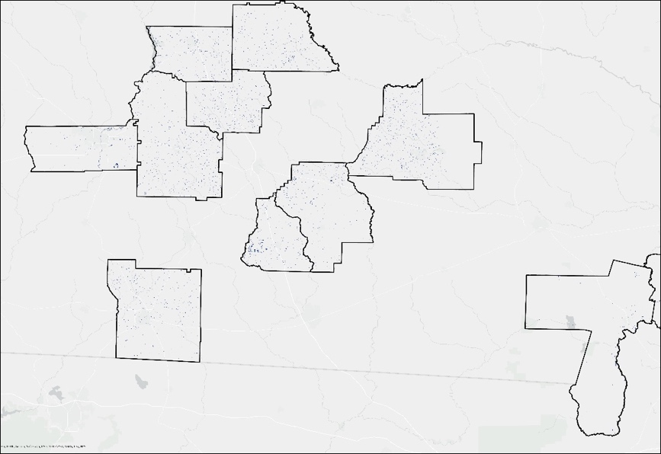
Figure 2. Flood extent detected by Sentinel-1 C-SAR in inland counties of the study area.

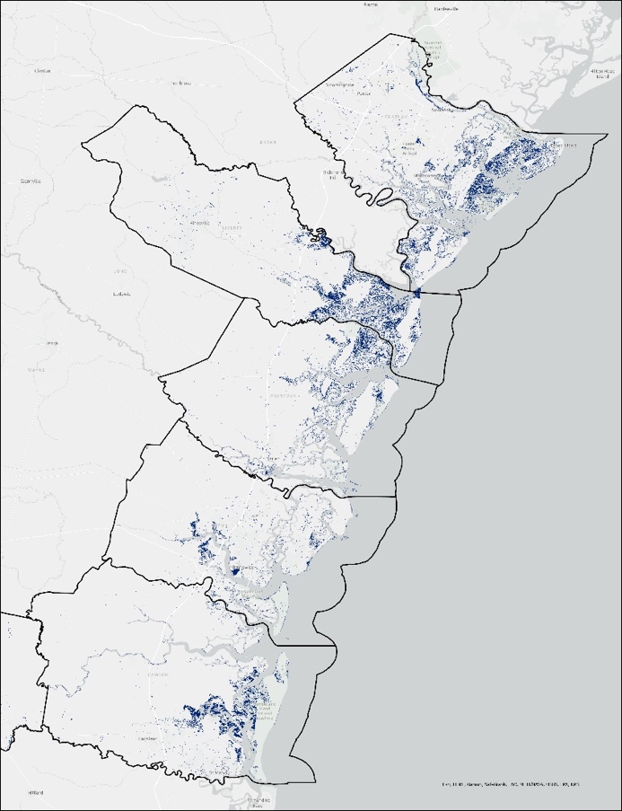
Figure 3. Flood extent detected by Sentinel-1 C-SAR along coastal counties in the study area.

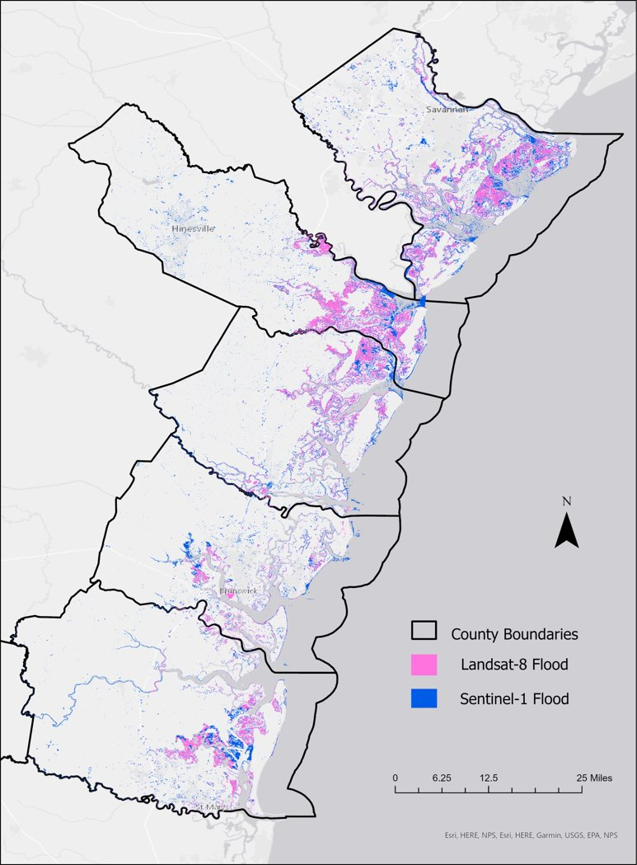

Figure 4. Flood extent detected by Sentinel-1 C-SAR and Landsat 8 OLI along coastal counties in the study area.
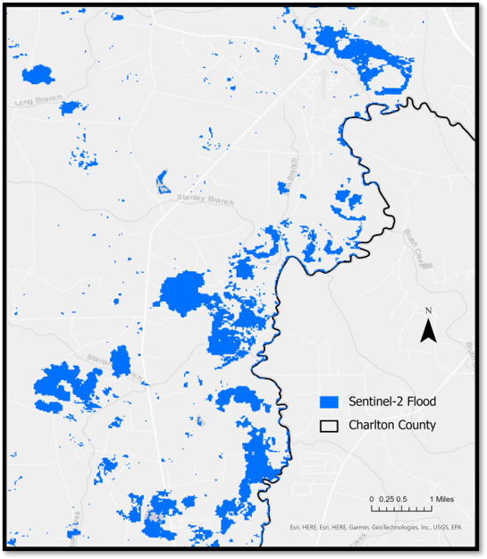
Figure 5. Flood extent detected by Sentinel-2 MSI along an inland county in the study area.

Figure 6. Bar graph of the percentage of flood extent in each county measured by Sentinel-1 C-SAR.

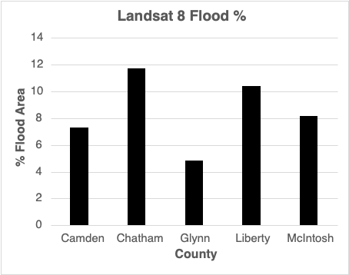
Figure 7. Bar graph of the percentage of flood extent in each county measured by Landsat 8.
Table 3. Percent of flood and flood area (km²) in each county found with Sentinel-1 C-SAR (S1) and Landsat 8 OLI (LS8)
County | S1 % Flood | S1 Flood  Area (km²) | LS8 % Flood | LS8 Flood  Area (km²)
Berrien | 0.19 | 2.216
Camden | 1.93 | 15.121 | 7.28 | 56.98
Charlton | 0.12 | 0.974
Chatham | 4.38 | 27.655 | 11.71 | 74.02
Coffee | 0.69 | 4.143
Cook | 0.97 | 2.261
Crisp | 0.86 | 2.424
Dougherty | 0.43 | 1.429
Glynn | 1.36 | 7.934 | 4.84 | 28.34
Liberty | 3.27 | 19.729 | 10.37 | 62.58
McIntosh | 2.57 | 14.733 | 8.17 | 46.92
Thomas | 0.42 | 2.306
Turner | 0.96 | 2.774
Wilcox | 0.59 | 2.248
Worth | 0.65 | 3.730
Total Study Area | 1.30 | 109.68 | 3.20 | 268.84

4.1.2 Flood Extent Error
Sentinel-1 C-SAR was the most reliable sensor used in this research to detect flood due to its all-weather capabilities and the number of images it can capture. However, SAR has limitations observing flood in areas of complicated geometry. The most readily sensed flood using SAR would be in flat areas with no trees or buildings. The flood extent from SAR was likely reporting less flood than in reality in residential and agricultural areas. For example, a neighborhood could display flood pixels in the middle of the street and not surrounding the houses, so this could be misread that those properties were unaffected. To account for this, we observed properties within 100 feet of flood with the Near Function in ArcGIS. Areas of complicated geometry also seem to be an issue for optical imagery, which is expanded upon in Appendix C.

We attempted to acquire the surface reflectance imagery for Sentinel-2 MSI from sources other than GEE, such as the Sentinel Hub EO browser, which provides direct downloads of pre-processed imagery. Surface reflectance, or bottom-of-atmosphere (BOA), imagery has more pre-processing applied than TOA, making BOA imagery more readily useable for research. The Sentinel Hub EO browser only provided download access for individual bands B1–B12; the exclusion of other bands, such as the QA60 or the Single Look Complex (SLC) band, impeded proper cloud masking. We were not successful in finding Sentinel-2 Level-2A imagery for the study area and time from the Scihub Copernicus Open Access Hub. Therefore, we were limited in our access to BOA imagery and did not end up using it in our research. The only imagery available for this study from Copernicus was Level-1C, which was already available in the GEE Data Catalog, so we used this.

4.1.3 Flood Validation Results and Errors – Landsat 8 OLI, Sentinel-1 C-SAR, and USGS in situ
Out of a total of 42 USGS points in our study area, Sentinel-1 C-SAR had 17 points of intersection between remotely sensed and in situ flood, and Landsat 8 had 12 points of intersection. There were 11 coinciding points between Sentinel-1 C-SAR and Landsat 8 that intersected with HWM in situ data. The team only used one dataset to validate the flood extent. More in situ datasets would help increase accuracy of the validation. Converting the remotely sensed flood to polygons also simplified the pixels, so some data and area could be lost in the conversion.

4.1.4 CAMA Analysis
From the CAMA data, the team determined that there were 30,678 parcels of probable heirs properties across the 15 counties in the study area. The highest reported was 15,102 in Chatham County and the lowest was 198 in Cook County, with a fractional percentage of heirs properties ranging from 2%–13%. A more detailed breakdown by county can be found in Table 4 below.

Table 4. Each county with the total number of probable heirs properties detected in that county and the percentage of total properties that probable heirs properties comprise.
County | Probable Heirs Properties | Probable Heirs Property to Total Properties (%)
Berrien | 256 | 2.1
Camden | 1338 | 4.4
Charlton | 566 | 5.6
Chatham* | 15102 | 13.1
Coffee | 1246 | 4.6
Cook | 198 | 2.0
Crisp | 1642 | 9.9
Dougherty | 3058 | 5.9
Glynn* | 1935 | 3.9
Liberty | 1645 | 2.8
McIntosh | 370 | 2.6
Thomas | 1790 | 5.2
Turner | 159 | 2.6
Wilcox | 473 | 7.1
Worth | 909 | 5.3
*: County is not on the WinGAP CAMA Standardization
Early analysis of CAMA data revealed the connection of heirs property and historically disenfranchised communities. Notably, we see the highest percentage of heirs property in Chatham County, which saw Savannah serve as a local hub in North America for the Trans-Atlantic Slave trade. The next highest county we see is Crisp, which sits along the Flint River and was historically home to poor farming communities. Both counties see the highest percentages of probable heirs properties and seem to have historical context that supports these numbers.

Figure 6. Percent of heirs properties per total properties in each county.

Figure 7. Value of Probable Heirs Property per County.

Table 5. Total Property Value of the Probable Heirs Properties Identified
County Name | Total Value of Probable Heirs Property
Berrien | $23,264,093
Charlton | $65,900,431
Chatham | $1,731,113,515
Coffee | $94,494,382
Cook | $24,011,050
Crisp | $148,388,281
Glynn | $1,069,584,884
McIntosh | $35,973,162
Thomas | $219,996,219
Turner | $23,810,789
Wilcox | $4,867,476
Worth | $135,016,466

In terms of monetary value, Chatham County occupies the largest portion of value with 48% of the total value from the study area (Figure 7). Glynn County also made up a significant portion of the total value, comprising 30% of the total value. The total value of the available countries is $3,576,420,748.00. Because of significant gaps in the CAMA data, Camden, Dougherty, and Liberty counties are not included within the value calculation.

4.1.5 CAMA Error
Short of manually inspecting the title of a property or being familiar with the owner(s), detection of heirs properties is mercurial. During early discussions with The Center and advisors, the team decided on over-identifying heirs properties rather than under-identifying. Even for experienced researchers, the new-ness of heirs property research and uniqueness of individual situations makes any sort of definitive measure incredibly difficult, and The Center wanted to be more prepared rather than less prepared.
The selected parameters are limited to what The Center expected to reasonably encounter in CAMA data in Southern Georgia. There may be a more robust way to perform the analysis on the given CAMA data, but that would require significantly more research and time. Additionally, the lack of a standardized tax assessment system across the United States would make comparing data sets that may or may not be working on the same information very difficult. This meant that the team had no model or established method to compare the study area to. We expected there to be an under-identification of heirs property, but did not know by how much. For example, The Center noted in their intimate experience with heirs properties in Berrien and Cook counties, heirs properties are a significant problem for these communities. Berrien and Cook have many, large mobile home communities; mobile homes are often heirs properties, but they are not included in the CAMA data. The Center described two common situations to the team: (1) post natural disaster heirs property owners with blighted homes will put mobile homes on the land but would not be flagged by the current methods, and (2) a mobile home community on privately owned land that has a clear title could be full of heirs property mobile homes and thus also not be flagged.

As a quick check, in a region of 400 parcels that The Center closely inspected, they found a count of 104 parcels of likely heirs property. The team, by their metrics in the same region, found a count of 96 parcels of likely heirs property. This is reassuring, but at the time of writing, The Center or the team have not been able to confirm that the same parcels were identified. The Center has been working in this particular region of Georgia due to its high concentration of heirs property, but without a parcel-by-parcel validation, we cannot be certain that The Center and the team are in precise agreement. This is the closest to validation the team had access to.

4.1.6 Bivariate Analysis
The team employed a bivariate choropleth map to compare the incidence of flood and percentage of heirs property in the study area. Chatham was the most impacted by both, having 13.1% heirs property and 4.38% of flood. Liberty and Mcintosh were significantly affected by flooding but had a lower incidence of heirs property. Counties like Charlton and Wilcox had higher incidence of heirs property, but lower area of flood. To further examine the intersection between flood and heirs property, the team also calculated how many heirs properties were within 100ft of any flooding. The team found a total of 986 parcels within close proximity to flood.

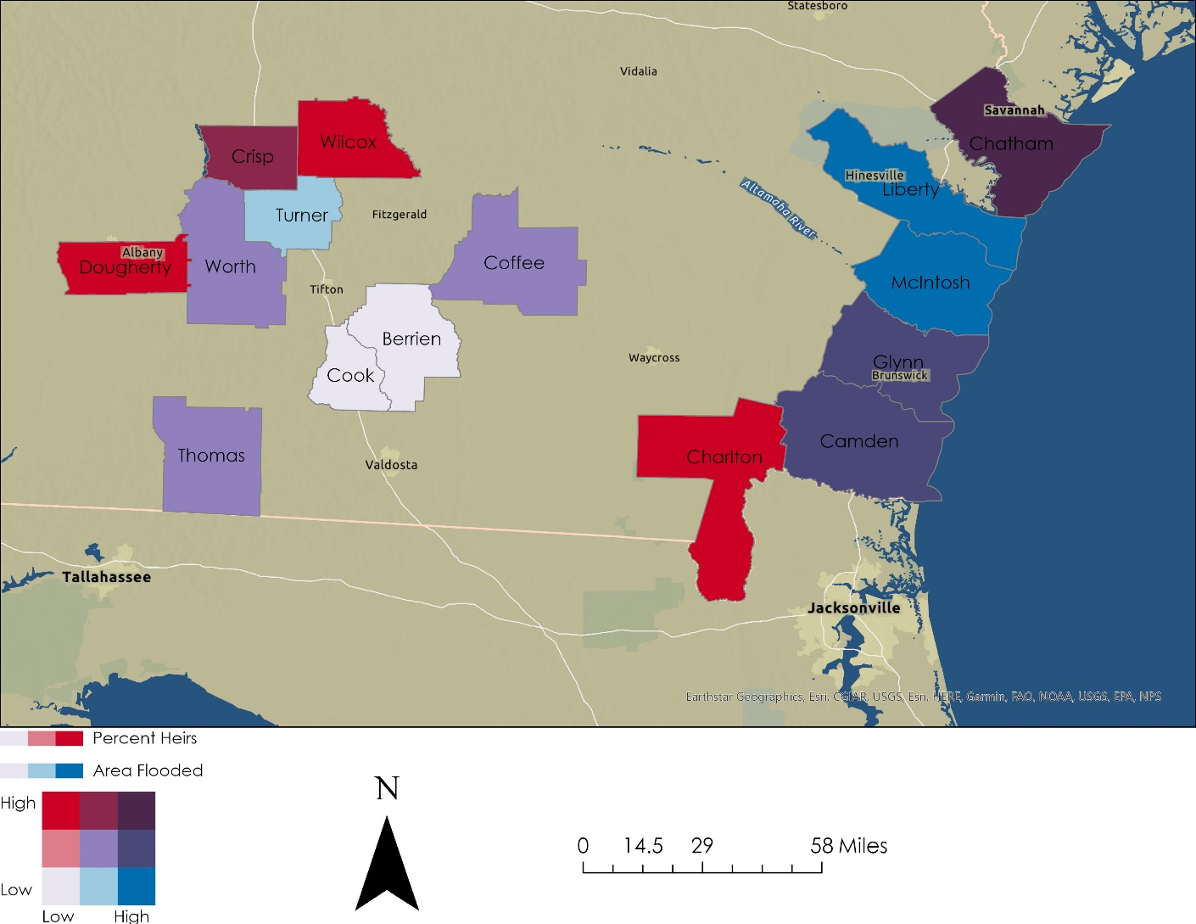
Figure 8. Bivariate choropleth comparing percent heirs property and area of county flooded.

4.2 Future Work
4.2.1 Future Flood Extent
The team identified flood extent using the Edge Otsu thresholding algorithm method. Imperfect thresholding, both in terms of over and under identification, was a limitation for all flood extent maps.
Edge Otsu also had an issue identifying flood along thin waterways, which were common in the study area. With more time and the USGS in situ dataset, the threshold parameters used to identify the “water” class could be adjusted; also, different thresholding algorithms could be compared to find the most accurate flood extent with the validation.

The in situ data was measured on September 11, 2017, but none of the satellites captured imagery on that exact date (Table 1). Flood validation for the future should consist of more in situ datasets. Regional elevation information could also be incorporated into the remotely sensed flood extent to interpret where the detected flood would have flowed. A time series of the flood extent would also provide vital information to which days experienced the most flood and inform the validation with the remotely sensed flood closest to the date the in situ data was measured. Future work could also investigate the Floodwater Depth Estimation tool in HYDRAFloods that approximates the depth of flood as a means to measure the severity of flood. The flood could also be validated if found, because the HWM data included water elevation.

For Sentinel-2 MSI, the team used TOA imagery; TOA imagery had a haze that would need to be corrected using atmospheric corrections on every image in the collection. Extensive atmospheric corrections were beyond the scope of the project, but the team attempted a dark-object subtraction, which is a simplified atmospheric offset to make the imagery more analogous to surface reflectance (Wicaksono, 2018). Both sets of imagery from Landsat 8 and Sentinel-2 were cloud filtered. However, the metadata available to cloud filter Sentinel-2 imagery did not include the cloud shadows. Cloud shadows could be found with the azimuth angle of the sun, available imagery from the Sentinel-2 Cloud Probability collection for the image capture days, and more information to determine the direction the cloud shadows were cast and their approximate size, but this was beyond the time limitations of this project.

4.2.2 Future CAMA and Heirs Identification
The biggest issue with the identification of heirs property, that simply cannot be overstated, is how little certainty there is to operate on. With very little to validate against and no established convention, the results of most methods vary significantly, and even within a given method can report significantly different fractions of a study area as heirs property depending on the dataset used. The team believes that the weighted index methodology we chose to use is robust and useful, but incomplete. It is very likely that there are fields in the CAMA data that are strong indicators of heirs property that we and The Center were not directly able to ascertain. Additionally, the fine-tuning of the individual weights is another way that results could be refined.

Both issues, too much data with hidden relationships and parameters that need to be very finely adjusted for optimal results, are problems that can be tailored specifically to machine learning on a neural network (Appendix B). If there were a way to, for a given county, confidently identify a subset of parcels in that county as heirs or not-heirs property by direct examination, a machine learning model could in principle be trained on CAMA data and these clearly identified parcels. A model like this could also reasonably use some or all of the parameters we dropped on account of their connection to heirs property being tenuous or non-obvious. For example, WinGAP counties recorded parcels to which boats and avionics were registered, and perhaps, all heirs properties by random chance have a neighbor with a boat or airplane, which we would never know.

4.2.3 Future Demographic and FEMA Investigation
The team investigated correlations between socially vulnerable groups, particularly with the SoVI developed for natural disasters, but did not find any correlations in the time left for this project. A granular comparison of demographics to each county and perhaps each census-block group would need to be compared to see the entire picture. Heirs property owners tend to comprise socially vulnerable demographics, but a social vulnerability index could easily overlook these heirs property communities. For example, the SoVI considers a community less vulnerable if it has high wealth, but this does not factor in if that same community has a high wealth disparity. In our study area, Chatham was the wealthiest county and would be categorized as not socially vulnerable despite the high proportion of probable heirs properties. A majority white farming community with low median wealth would be likely to have many heirs properties from both the literature and The Center’s experience, but it would easily be flagged as not socially vulnerable due to its racial and ethnic minority makeup. Community-specific knowledge would be required to look at demographics and to ascertain how those demographics should be observed in community-minded natural disaster research going forward.

We also did not find any correlation between the Washington Post FEMA title difficulty denials. The Washington Post data was part of a study assessing if there was a national trend where racial minorities were denied more often based on title difficulties but was not an immediately comprehensive enough dataset to compare to for this research for this specific event. The methods used by the Washington Post could potentially be replicated for the Hurricane Irma event alone. It is also important to note that heirs property owners are more likely to not apply for disaster relief in the first place, and it would be insightful if verified heirs property owners were surveyed on their willingness and confidence in applying for disaster relief programs.
5. Conclusions
Heirs properties are a serious issue in historically disadvantaged and disenfranchised communities. Chatham County, which sits at the center of the Gullah-Geechee Cultural Heritage Corridor and was previous home to hub of the Trans-Atlantic Slave Trade in Savannah, is the county found by the team with the highest percentage of heirs property. The next highest is Crisp County, which sits along Georgia’s Flint River, home to historic and traditionally impoverished farming communities. Our flood extent analysis found that heirs properties along Georgia’s coast are most at risk of flooding during hurricane events due to storm surge. Our analysis found 85.17 km² of flooding throughout the 5 coastal counties, while the 8 inland counties had 24.51 km² of flooding. Even though Hurricane Irma's path tracked directly over inland Southern Georgia, 7” of rain seemed to have not produced a significant flooding event in the inland portion of the study area. This is to say nothing about potential property damage due to tree deadfall, or anything wind related, which was not studied by the team. For disaster mitigation planning, flood mitigation efforts should be prioritized to coastal regions of the State of Georgia.
Using a bivariate visualization, we were able to identify counties that had a significant percent of heirs property and experienced high flood. Chatham County had 13.1 percent heirs property and 27.7 km² of flood, making it vulnerable to heirs property destruction. Furthermore, Chatham County housed over 1.7 billion dollars of potential heirs property, which could have incredible implications to generational wealth loss to damaged and blighted properties. Glynn and Camden were also relatively high in heirs property and flood, with Glynn having 8 km² of flooding and 3.9% heirs property. Camden had 15.1 km² of flooding and 4.4% heirs property. Inland counties like Dougherty and Charlton were high in heirs percentage, 5.9% and 5.6% respectively, but lower in flooding, 1.4 km² and 1.0 km². The heirs properties in these counties were not as heavily impacted by flooding as the coastal counties.
An exploratory analysis of parcels most vulnerable to flood produced 986 parcels within 100 ft of flooding, allowing the team to identify specific instances of a parcel-flood interaction. The Center will be able to use our heirs property density by county to inform and focus their outreach. Our analysis is more conservative than Pippen et. al., 2017, but more liberal than most other estimates (Carpenter et al., 2016). By providing this range of analysis with The Center’s own experience in affected communities, we help to complete the picture of heirs property distribution. With this data, The Center will be able to present a case study of the effect of Hurricane Irma on heirs property owners to the Georgia Department of Community Affairs and county governments, helping heirs property owners preserve their land, homes, and way of life.

6. Acknowledgments
The Georgia Disasters II team would like to thank previous team members, Isabella Chittumuri and Nancee Uniyal. We appreciate our science advisors for their incredible insight, expertise, and advice on broaching this topic: Dr. Cassandra Johnson Gaither, Dr. Marguerite Madden, and Joseph Sousa. We had many unofficial advisors too: Jimmy Nolan of the CVIG who walked the team through the tax appraisal data on multiple occasions; Dr. Ryan Thomson and Dr. Connor Bailey who discussed Southeastern history, their heirs property research, and GIS ethics with us; and Dr. Kenton Ross who helped the team with remote sensing on multiple occasions. We’d also like to acknowledge the NASA DEVELOP Fellows who keep the program running, especially Sarah Payne of the GA node, whose suggestions and energy consistently kept the team on track.
Special thanks to our partners of the Georgia Heirs Property Law Center, Skipper StipeMaas, Delene Porter, and Tiffany Reed, who were instrumental to the development of this under-researched topic and incredibly knowledgeable and insightful on the studied community.
This material contains modified Copernicus Sentinel data (2017), processed by ESA.

Any opinions, findings, and conclusions or recommendations expressed in this material are those of the author(s) and do not necessarily reflect the views of the National Aeronautics and Space Administration.

This material is based upon work supported by NASA through contract NNL16AA05C.

7. Glossary
Bottom-of-atmosphere – surface reflectance dataset that has atmospheric corrections
CAMA – Computer Assisted Mass Appraisal, a database of tax records collected and collated for the purposes of tax assessment that includes all properties in a county, including tax-exempt properties, such as churches and hospitals
The Center – The Georgia Heirs Property Law Center
Earth observations – Satellites and sensors that collect information about the Earth’s physical, chemical, and biological systems over space and time
FEMA – Federal Emergency Management Agency
GEE – Google Earth Engine
Heirs property – A type of property ownership that occurs when a property owner dies without the necessary legal paperwork to confer ownership, the title of the property becomes “tangled”
HYDRAFloods – Hydrologic Remote Sensing Analysis for Floods – A program used to process satellite imagery to produce flood maps
MNDWI – Modified Normalized Difference Water Index
MSI – Multispectral Instrument, sensor on Sentinel-2 used to collect data in the RGB to Infrared spectrum
Natural peoples – No business, governmental organizations, religious institutions etc.
OLI – Operational Land Imager, sensor on Landsat 8 used to collect data in the RGB to Infrared spectrum
SAR – Synthetic Aperture Radar – Active remote sensor that creates two-dimensional images of landscapes
Specular reflection – the reflected ray travels in one outgoing direction after hitting a smooth surface
VV Polarization – The vertical/vertical polarization band
WinGAP – A specific standardization of CAMA data used by most counties in Georgia

8. References
Beauchemin, M., Thomson, K. P. B., & Edwards, G. (1995). Optimization of the Gamma-Gamma MAP filter for SAR image clutters, International Journal of Remote Sensing, 17(5), 1063-1067. https://doi.org/10.1080/01431169608949067

Cangialosi, J. P., Latto, A.S., & Berg, R. (2021). National Hurrican Center Tropical Cycle Report. Hurricane Irma (AL112017). NOAA, National Weather Service. https://www.nhc.noaa.gov/data/tcr/AL112017_Irma.pdf

Carpenter, A., Jones, S., & Pippin, S. (2018). Understanding Heirs’ Properties in the Southeast. Federal Reserve Bank of Atlanta. March/April Partner Updates. https://www.atlantafed.org/community-development/publications/partners-update/2016/02/160419-understanding-heirs-properties-in-southeast
Copernicus Sentinel Data (2014). Sentinel-1 C-SAR . Retrieved from Google Earth Engine. https://developers.google.com/earth-engine/datasets/catalog/COPERNICUS_S1_GRD

Copernicus Sentinel Data (2015). Sentinel-2 MSI. Retrieved from Sentinel Hub. Sentinel Hub, https://www.sentinel-hub.com, Sinergise Ltd.

Cutter, S. L., Boruff, B. J., & Shirley, W. L. (2003). Social Vulnerability to Environmental Hazards *: Social
Vulnerability to Environmental Hazards. Social Science Quarterly, 84(2), 242–261.
https://doi.org/10.1111/1540-6237.8402002

Dreier, H., & Ba Tran, A. (2021, July 11). ‘The real damage’ Why FEMA is denying disaster aid to Black families that have lived for generations in the Deep South. The Washington Post. https://www.washingtonpost.com/nation/2021/07/11/fema-black-owned-property/

Gaither, C. J., Carpenter, A., Lloyd-McCurty, T., & Toering, S. (2019). Heirs’ property and land fractionation: fostering stable ownership to prevent land loss and abandonment. June 15, 2017, Atlanta, GA. e-Gen. Tech. Rep. SRS-244. Asheville, NC: U.S. Department of Agriculture Forest Service, Southern Research Station. 105 p. https://www.srs.fs.usda.gov/pubs/gtr/gtr_srs244.pdf.

Georgia Department of Community Affairs. (2020). State of Georgia Disaster Recovery Plan. https://www.dca.ga.gov/sites/default/files/2017_cdbg-dr_action_plan_substantial_amendment_2_revised_1.pdf

Grimaldi, S., Xu, J., Li, Y., Pauwels, V.R.N., & Wallker, J.P. (2020). Flood mapping under vegetation using single SAR acquisitions. Remote Sensing of Environment, 237, 111582. https://doi.org/10.1016/j.rse.2019.111582

Markert, K. N., Markert, A. M., Mayer, T., Nauman, C., Haag, A., Poortinga, A., Bhandari, B., et al. (2020). Comparing Sentinel-1 Surface Water Mapping Algorithms and Radiometric Terrain Correction Processing in Southeast Asia Utilizing Google Earth Engine. Remote Sensing, 12(15), 2469. MDPI AG. Retrieved from http://dx.doi.org/10.3390/rs12152469

McKinney, W. (2010). Data Structures for Statistical Computing in Python. 56–61. https://doi.org/10.25080/Majora-92bf1922-00a

Pippin, S., Jones, J., & Johnson Gaither, C. (2017, September). Identifying Potential Heirs Properties in the Southeastern United States, A New GIS Methodology Utilizing Mass Appraisal Data. U.S. Department of Agriculture Forest Service. https://www.srs.fs.usda.gov/pubs/gtr/gtr_srs225.pdf

Vollrath, A., Mullissa, A., & Reiche, J. (2020). Angular-based radiometric slope correction for sentinel-1 on
Google Earth engine. Remote Sensing, 12(11). https://doi.org/10.3390/rs12111867

Wicaksono, P., & Hafizt, M. (2018). Dark Target Effectiveness for dark object subtraction atmospheric correction method on mangrove above ground carbon stock mapping. IET Image Processing, 12(4). https://ietresearch.onlinelibrary.wiley.com/doi/10.1049/iet-ipr.2017.0295

Williams, C., Carey, L., De Los Santos, M., Fanelli, D., & Ireland, P. (2021). Central America Disasters: Using Earth observations to map flooding for disaster monitoring, inform potential risk, and prepare for possible response. NASA DEVELOP National Program, Alabama – Marshall. https://ntrs.nasa.gov/citations/20210026458

Yamazaki D., D. Ikeshima, J. Sosa, P.D. Bates, G.H. Allen, T.M. Pavelsky. (2019). MERIT Hydro: A high-resolution global hydrography map based on the latest topography datasets. Water Resources Research, 55(6), 5053-5073. https://doi.org/10.1029/2019WR024873

Zhou, Y., Dong, J., Xiao, X., Xiao, T., Yang, Z., Zhao, G., ... & Qin, Y. (2017). Open surface water mapping algorithms: A comparison of water-related spectral indices and sensors. Water, 9(4), 256. https://www.mdpi.com/2073-4441/9/4/256

9. Appendices
Appendix A. Weights and Matrix Math
A.1 The Dot Product
The dot product is a powerful math operator that measures how closely parallel two vectors are within an N dimensional vector space, scaled by their lengths. In the context of matrix math, a dot product between an MxN matrix and an Nx1 vector is equivalent to performing the elementwise multiplication of a given row of the matrix by the Nx1 vector and then adding all the results together. The example below is for a very small matrix and vector for simplicity, but the principle extends to larger matrices. Importantly, the vector needs to be as long as the matrix is wide for this operation to be able to be carried out.
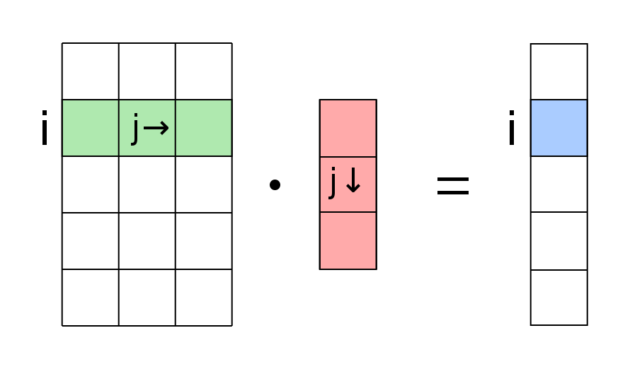
Figure A.1. Multiplying the i^{th} row of the matrix on the left by the vector of length j and summing the result into the i^{th} element of the resulting vector.
Image licensed under Creative Commons by SA-4.0. Created by Wikimedia Commons user Quartl

A.2 Example Matrix
REALKEY | Sale Date | Special Terms | Tax Status | Out of County | Non-Natural Persons
11111 | Y | Y | N | N | N
22222 | N | Y | N | Y | N
33333 | Y | N | N | N | N
44444 | Y | N | Y | Y | N
Table A.1. An example of a county dataset in matrix form after the application of a Boolean mask.
To carry out the dot product, we made a standard Boolean transformation, replacing Y with 1 and N with 0:
11111 | 1 | 1 | 0 | 0 | 0
22222 | 0 | 1 | 0 | 1 | 0
33333 | 1 | 0 | 0 | 0 | 0
44444 | 1 | 0 | 1 | 1 | 0
Table A.2. The same matrix as Table A.1, under a transformation to binary space in order to take the dot product of it with the vector of weights.

Appendix B. Neural Networks
Very broadly, a neural network is a type of machine learning or artificial intelligence that is designed to work in the same way or similarly to the human brain. At one end of a pipeline, you have a set of input parameters, and on the other end of the pipeline, you have a set of output parameters. In between, you have collections of so-called neurons arranged in layers. Each layer can, in principle, be comprised of any number of neurons. Each neuron within a particular layer takes weighted inputs from every neuron on the previous layer, applies a non-linear activation function to those inputs, and then either activates or does not activate based on that function. The output of this neuron is then sent to every neuron on the next layer. This repeats for every neuron in each layer, and every layer in the entire network. At the end, depending on your formulation, you will have some interpretable result.
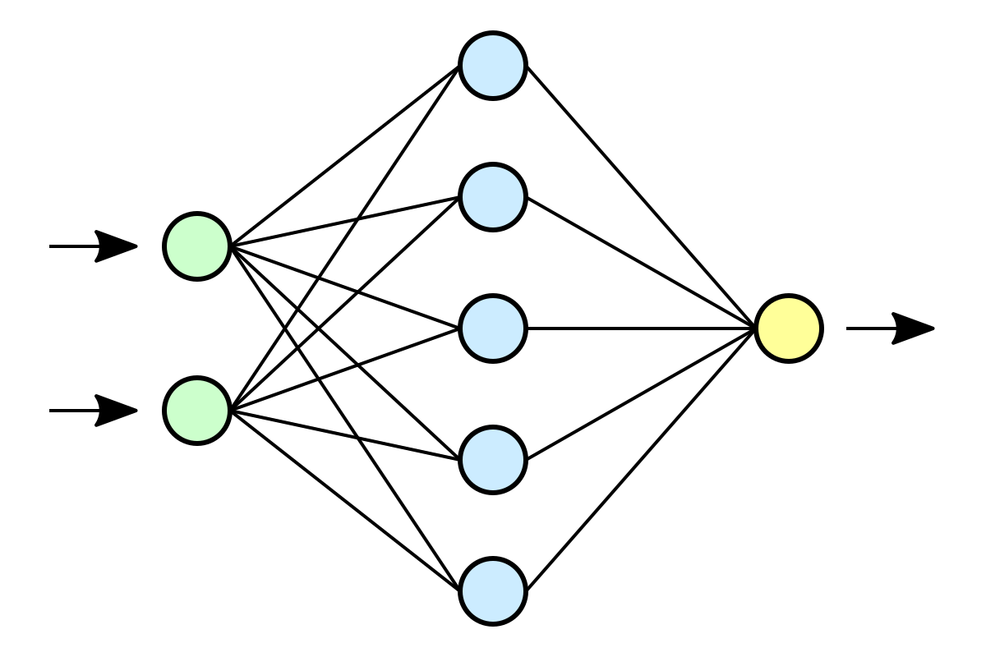
Figure B.1: A very simple neural network with an input layer, one “hidden layer,” and one output layer.
Image licensed under Creative Commons by SA-4.0. Created by Wikimedia Commons user Dake, Mysid
The biggest strength of a neural network is the ability for it to be “trained” to identify patterns that emerge from images and/or data. If you have a dataset for which you know the classification, say whether or not a given parcel that appears in the tax record is an heirs property, as well as a set of associated data, you can have an algorithm adjust the weights of each connection as well as the non-linear activation function of each neuron until the neural network returns the known classification. Do this for a large enough set of known classifications, and you have a relatively robust model to predict unknown classifications.

Appendix C. County Flood Extent Examples
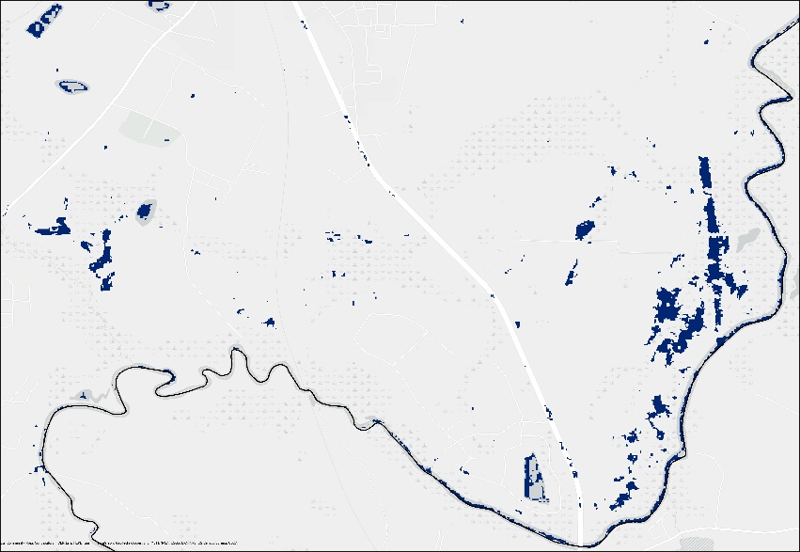
Figure C.1 Flood extent detected by Sentinel-1 C-SAR in Charlton County.

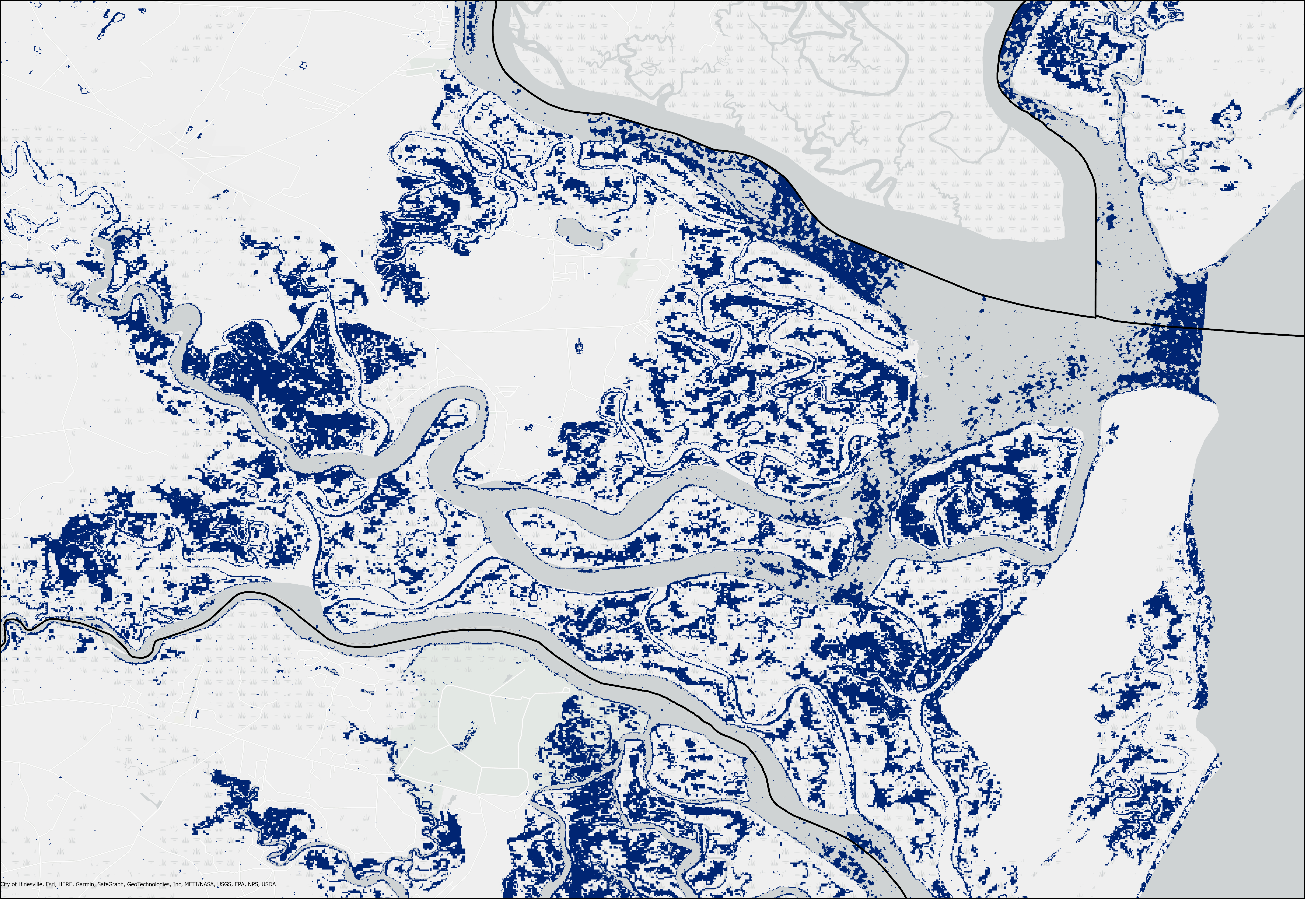
Figure C.2 Flood extent detected by Sentinel-1 C-SAR in Liberty County.

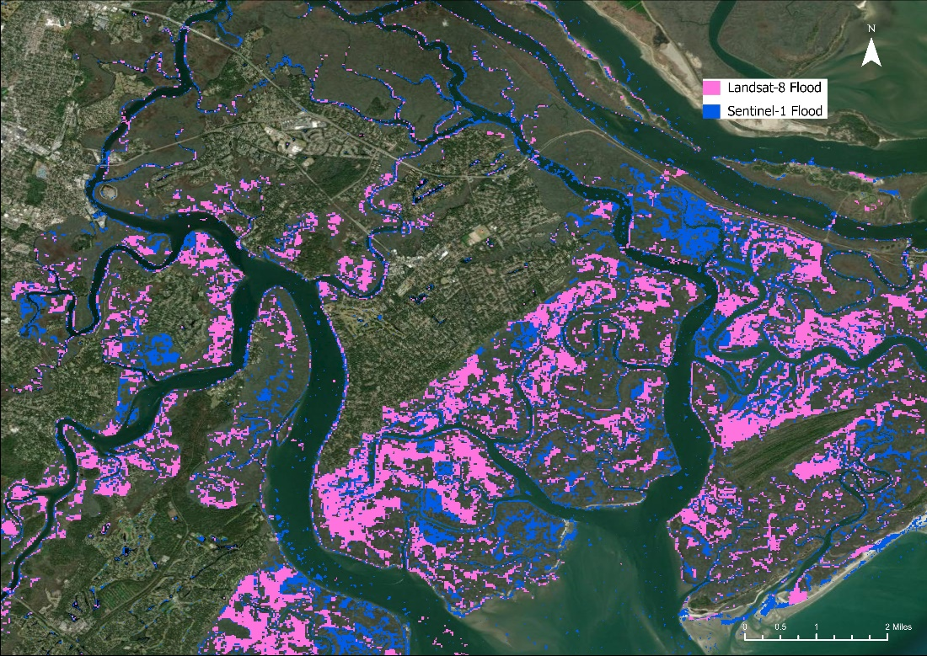
Figure C.3 Flood extent detected by Landsat 8 and Sentinel-1 in Savannah, Georgia.

This is an example image of the flood found from Landsat 8 and Sentinel-1. It is easier to note differences in what types are covered by either satellite. Sentinel-1 has more images due to its more common revisit time in the area. Sentinel-1 has a 5 (or 6) day revisit time, but the Sentinel-1 constellation collected imagery for this study area revisited more often than the expectation, which is perhaps due to the study area’s location closer to the equator. Landsat 8, which has a temporal resolution of 16-days, has fewer images. Areas with many buildings or trees seem difficult to capture flood extent for both sensors. The image above emphasizes this issue; flood extent is measured along permanent waterbodies and more flat areas. It would stand to reason, the area in the center of Figure 4 surrounded by waterbodies and remotely sensed flood would likely also be flooded. For later dates of imagery captured, flood may have already dissipated in the area.

