Costa Rica & Panama Ecological Forecasting

Detecting Land Change Along the Mesoamerican Biological Corridor in Costa Rica and Panama for Targeted Resource Management

**Technical Report**

Final Draft – November 21, 2019

Molly Azami

Kara Bissonnette

Mahsa Khodaee

Zachary Leslie

Dr. Marguerite Madden, University of Georgia (Science Advisor)

Dr. Sergio Bernardes, University of Georgia (Science Advisor)

# 1. Abstract

La Amistad International Park connects southern Costa Rica and northern Panama as part of the Mesoamerican Biological Corridor. Despite the existence of conservation programs within this region, human-induced and natural ecological disturbances threaten native species and alter forest ecosystems. To assess these threats, the NASA DEVELOP Costa Rica & Panama Ecological Forecasting team partnered with the Ministry of Environment and Energy in Costa Rica and the National Environmental Authority in Panama to create products that monitor land use and land cover (LULC) change in La Amistad and surrounding areas. The team mapped LULC changes from 1999 to 2019 using Landsat 5 Thematic Mapper (TM), Landsat 7 Enhanced Thematic Mapper Plus (ETM+), and Landsat 8 Operational Land Imager (OLI). The time series maps were then used in QGIS to forecast LULC in 2029. The 2029 forecast map projected major LULC conversions and highlighted regions of significant change over time. To map short-term forest changes, the project team created a Forest Change Detection Tool (FCDT) developed in Google Earth Engine’s API. The tool used the aforementioned Earth observations and Sentinel-2 Multispectral Instrument (MSI) to ensure that any month of interest can be observed by partners. Analyses of the LULC maps and the development of the FCDT helped partners involved in protecting the corridor to identify areas in need of attention and conservation resources.

**Keywords**

land use land cover, protected areas, forecast map, Landsat, Google Earth Engine, QGIS

# 2. Introduction

* 1. ***Background Information***

From active volcanoes to coral reefs, Costa Rica and Panama are home to some of the most biologically diverse regions in the world. The areas’ tropical forests are integral to maintaining this biodiversity. The most recent Global Forest Resources Assessment by the Food and Agriculture Organization of the United Nations showed that forest and other wooded land covered 54.2 percent of Costa Rica’s territory and 69.3 percent of Panama’s territory (Food and Agriculture Association of the United Nations, 2015). Despite the global significance of these ecosystems, deforestation and loss of tropical forest cover continue to plague Central America’s diverse landscapes (Portillo-Quintero & Smith, 2018). With rapid global population growth and an increased demand for natural resources, tropical forests are often clear-cut for food security and biofuel. (Koh, Miettinen, Liew, & Ghazoul, 2011).

In the past forty years, there has been a dramatic increase in the establishment of conservation zones in an effort to combat widespread tropical deforestation (Andam, Ferraro, Pfaff, Sanchez-Azofeifa & Robalino, 2008). One of Central America’s most integrative conservation cooperatives is the Mesoamerican Biological Corridor (MBC). Established in the late 1990s, the MBC is made up of over 600 protected areas that connect diverse ecosystems and natural habitats in Panama, Costa Rica, Nicaragua, Honduras, El Salvador, Guatemala, Belize, and southern states in Mexico. The conservation areas are currently monitored by regional and local governments to encourage economic development and protect the areas’ biodiversity (Miller, Chang, & Johnson, 2001). This project tracked land and forest change throughout the conservation areas in La Amistad Caribe, La Amistad Pacífico, and Osa in Costa Rica and La Amistad International Park in Panama (*Figure 1*).

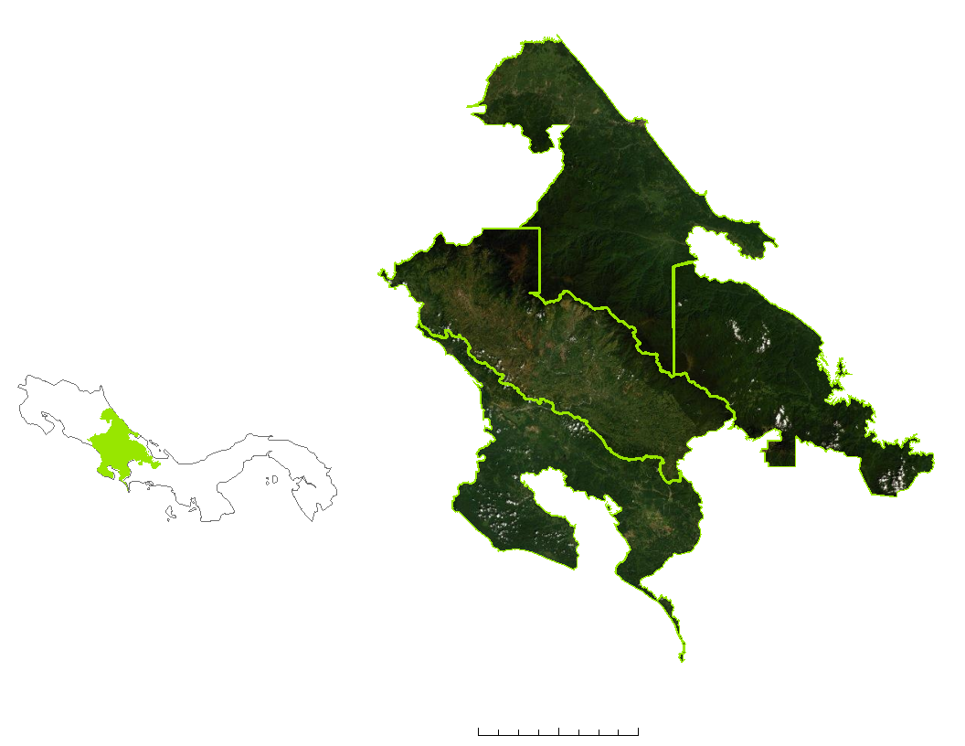

0

Kilometers (Km)

25

50

N

La Amistad Panama

La Amistad Pacífico

La Amistad Caribe

Osa

Costa Rica

Panama

Study area



Study area boundaries



*Figure 1*. Outlined study areas of La Amistad Caribe, La Amistad Pacífico and Osa in Costa Rica and La Amistad International Park in Panama on ESRI DigitalGlobe World Imagery basemap.

Recent studies have shown the importance of remote sensing technology in mapping potential conservation areas (Ford & Horn, 2018), mapping land use change, and producing cloudless imagery for further ecological research (Stach et al., 2009). The introduction of high-resolution satellite imagery and the advancement of image processing techniques has allowed scientists to more effectively classify land use and land cover, and to better monitor dynamic changes in both manmade and natural environments (Rawat & Kumar, 2015). This technology has also increased our capacity to assess patterns of forest change. Remote sensing and GIS technologies play an integral role in understanding the factors that influence land use and land cover change (Rathinagiri et al., 2010).

* 1. ***Project Partners & Objectives***

The Costa Rican National Center for Geoenvironmental Information and the National Environmental Authority of Panama are active in regulating the balance of economic development and ecological sustainability in transboundary initiatives like the MBC. The Ministry of Environment and Energy in Costa Rica is responsible for resource management and environmental protection, and the National Environmental Authority of Panama proposes policies and laws and advises organizations on environmental standards. These organizations monitor protected areas through online satellite imagery data sources such as the United States Geological Survey (USGS), European Space Agency (ESA), National Oceanic and Atmospheric Administration (NOAA), NASA and Earth Observation Link, but they do not have access to any consistent tool to frequently check forest cover change.

These Central American Integration System (SICA) organizations partnered with the Fall 2019 NASA DEVELOP Costa Rica & Panama Ecological Forecasting team created a Forest Change Detection Tool operated in Google Earth Engine (GEE) API. This change detection tool can help the regulatory agencies of the MBC check satellite imagery for updated land use changes in protected areas. This project also classified land cover changes from 1999 to 2019 and used this information to create forecast change maps of land cover for the year 2029. The insights derived from these maps and the Forest Change Detection Tool 2.0 can help land managers and policy-makers direct necessary resources toward areas of high change and therefore a high priority.

# 3. Methodology

***3.1 Land Use Land Cover Classification and Forecasting***

***3.1.1 Data Acquisition***

Our team used the GEE API to process and analyze atmospherically corrected satellite imagery to map land use land cover (LULC) in the study area. Images were acquired at decadal intervals from 1999 to 2019. The three years 1999, 2009, and 2019 were chosen to provide the team with enough data to forecast land cover changes from the most recent year, 2019.

Landsat 5 Thematic Mapper (TM) Surface Reflectance Tier 1, Landsat 7 Enhanced Thematic Mapper Plus (ETM+) Surface Reflectance Tier 1 and Landsat 8 Operational Land Imager (OLI) Surface Reflectance Tier 1 data were used to map LULC over the study time period. Landsat 5 TM was used for the year 1999, Landsat 7 ETM+ for the year 2009, and Landsat 8 OLI for the year 2019. Images were collected for the entire desired year. Additionally, topographic information from Japan Aerospace Exploration Agency (JAXA) Advanced Land Observing Satellite (ALOS) 3D World Model was used to improve upon the accuracy of the LULC mapping. *Figure 2* provides an overview of the project’s research methodology. An overview of the satellites and sensors utilized in this project is in Appendix A.

**Data Collection**

**Landsat 5 TM**

**Landsat 7 ETM+**

**Landsat 8 OLI**

**Advanced Land Observing Satellite**

**Google Earth Pro & Ancillary Data**

**Cloud Masking**

**Digital Elevation Model and**

**Slope Maps**

**Classification**

**1999 Classification Map**

**2009 Classification Map**

**2019 Classification Map**

**QGIS Modules for Land Use Change Simulations**

**Accuracy Assessment**

1999

**Cloud Free Surface Reflectance Images**

2009

2019

**2019 Forecast Map**

**2029 Forecast Map**

**QGIS Modules for Land Use Change Simulations**

1999

2009

2019

*Figure 2.* Classification and forecasting methodology flowchart

***3.1.2 Data Processing***

The algorithms, parameters, and manual restrictions used to process data in this project were chosen based on the researched and tested methods of the NASA DEVELOP summer 2018 Honduras Ecological Forecasting team. The clouds and cloud shadows were masked out from the acquired Landsat images using the CFMask algorithm (Zhu & Woodcock, 2012) and the pixel Quality Assessment (QA) bands. Any gaps resulting from cloud masking in pixels with no cloud-free images for our months of interest were filled with the maximum Normalized Difference Vegetation Index (NDVI) values of a longer (one-year) image collection. The image collections then used the quality-mosaicking method to create a composite image. Several vegetation indices including NDVI (Equation 1), Enhanced Vegetation Index (EVI; Equation 2), Normalized Difference Bare Index (NDBI), Normalized Difference Moisture Index (NDMI) and Normalized Difference Water Index (NDWI) improved our classifications by helping to differentiate between LULC classes. The equations for these indices are in Appendix B.

$\text{NDVI=}\frac{\text{NIR-Red}}{\text{NIR+Red}}$ (1)

$\text{EVI =2.5 }\text{*} \frac{\left(\text{NIR-Red}\right)}{\text{(NIR+6 x Red - 7.5 x Blue+1)}}$ (2)

The Gray-Level Co-occurrence Matrix (GLCM) texture analysis (Haralick, Shanmugam, & Dinstein, 1973) was also used in this study to enhance classification accuracy. Gray-Level Co-occurrence Matrix is a statistical method that analyzes the texture of an image by considering the spatial relationship of pairs of pixels with specific values. Slope, aspect and elevation were also used in the classification process, produced from JAXA ALOS Digital Elevation Model (DEM).

***3.1.3 Data Analysis***

Ten classes were chosen for the LULC classification in our study area in Costa Rica: plantation, mangrove, water, agriculture & grassland, bare soil & urban, primary forest, secondary forest, coffee, natural palm and pineapple (*Figure 3*). The plantation class was inclusive of banana, palm, teak, and other possible plantations within the study area. Five classes were chosen to classify the Panama region of interest: water, agriculture & grassland, bare soil & urban, primary forest, and secondary forest.

To classify the land cover types of our study area in 1999, 2009, and 2019, the Random Forest Machine Learning algorithm (Beriman, 2001) was used with 50 decision trees. For each year, the team trained this algorithm using ground-based points. Points were specified by using visual interpretations of Google Earth Pro historical images and ancillary data provided by the partners. To validate the points, 80% of these points were randomly selected for training the classification algorithm and 20% were selected for testing. To assess the accuracy of our classification, the team used a confusion matrix to obtain the overall accuracy and Kappa coefficient. To enhance our classification, we applied a majority filter method and elevation restrictions for particular classes (Appendix D). Maps with an overall accuracy below 80% were improved by adding and validating training points (*Figure 3*).

2019

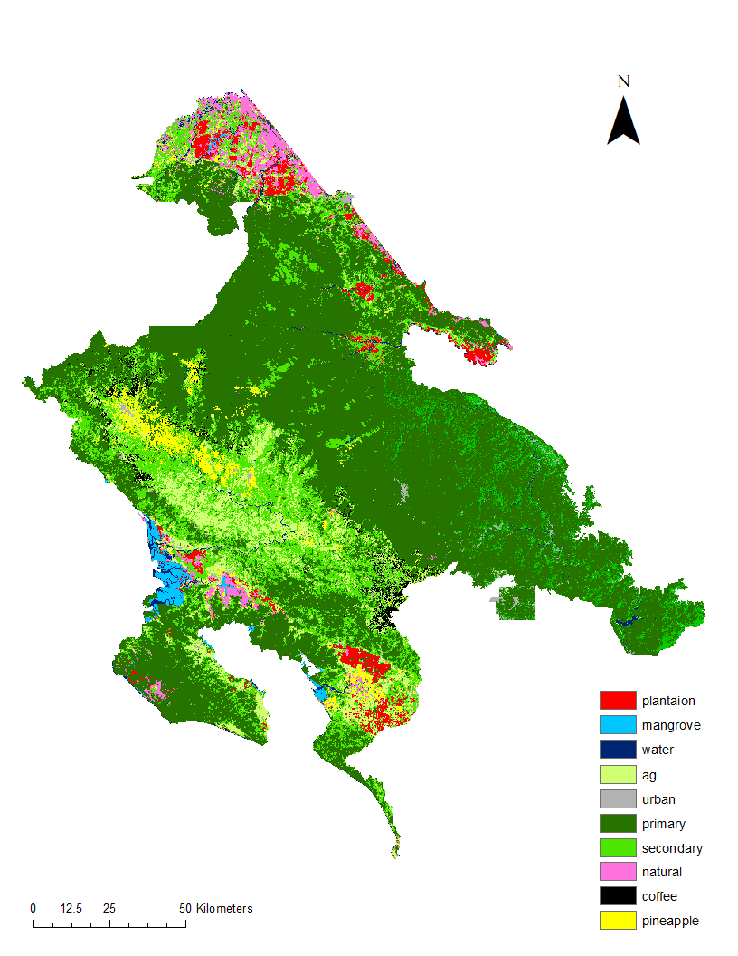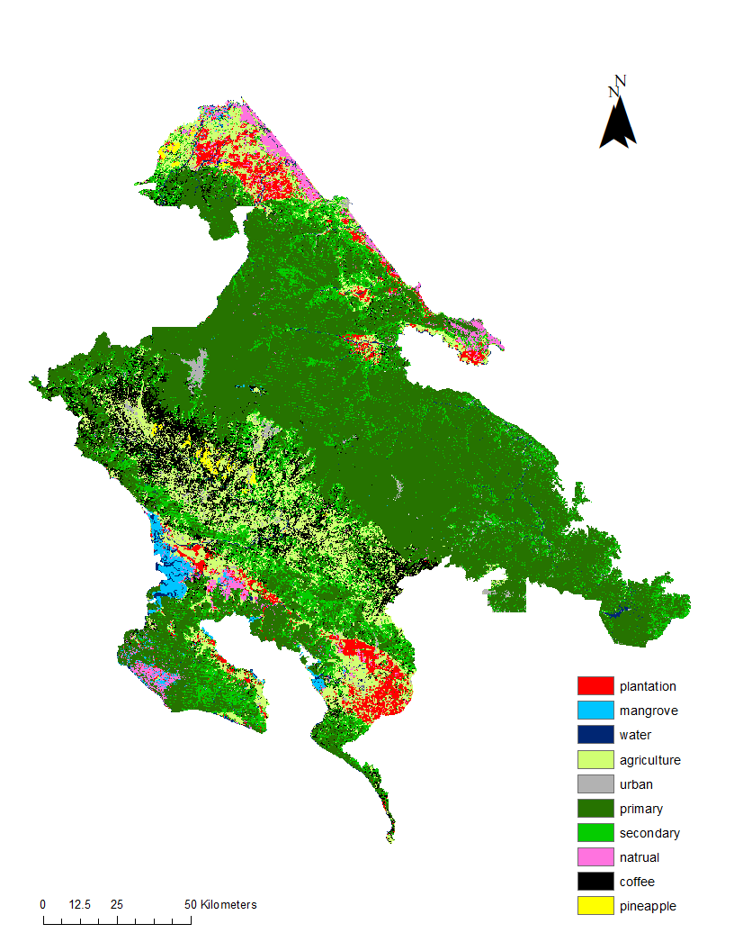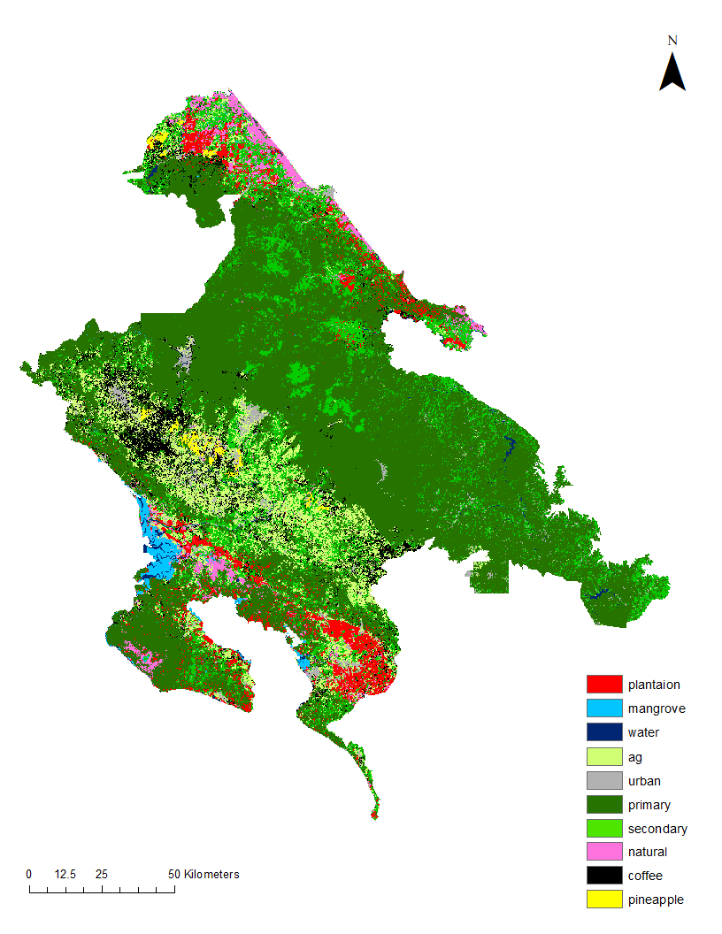

0 25 50 Kilometers (Km)



N

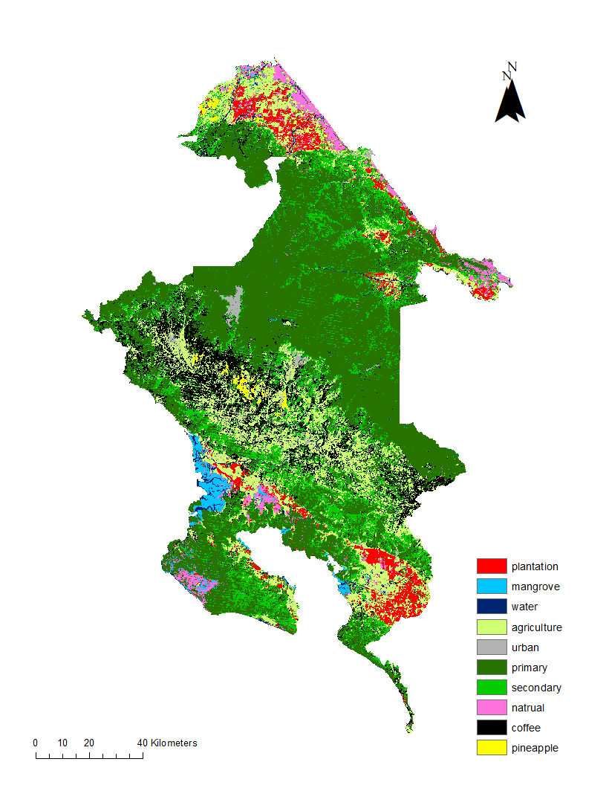

Plantation

Mangrove

Water

Agriculture & Grass

Bare Soil & Urban

Primary Forest

Secondary Forest

Natural Palm

Coffee

Pineapple

*Figure 3.* Classified land use time series maps for both the Costa Rica and Panama study areas from left to right: 1999, 2009, 2019

This project utilized the Method of Land Use Evaluation (MOLUSCE) plugin in QGIS 2.18.14 to forecast the 2029 LULC in the study area. MOLUSCE requires two classified maps, period A and period B. The plugin trains a model to predict the changes from period A to period B. It then uses this trained model to project the future LULC maps. To assess the forecasting accuracy in our study the project team first produced a 2019 forecast map by ingesting the 1999 and 2009 classified maps into the MOLUSCE modeler. We then used the 2019 classified map as a reference map to assess the accuracy of the 2019 forecast map. In this process the Logistic Regression model was used, though the Artificial Neural Network (ANN) was also tested. ALOS DEM maps were integrated into the model as an explanatory variable to calculate the largest transition contributor. The transition matrix produced by the model was used to explain the class percentage change from 1999 to 2009 and 2009 to 2019. The team conducted the same process with the 2009 and 2019 classified maps to forecast the 2029 classified map.

***3.2. Forest Change Detection Tool 2.0***

***3.2.1 Data Acquisition***

The NASA DEVELOP Summer 2018 Honduras Ecological Forecasting project team created the original Forest Change Detection Tool (FCDT) within the GEE API. The tool processes Landsat 8 OLI Surface Reflectance Tier 1, Landsat 7 ETM+ Surface Reflectance Tier 1, and Sentinel-2 MultiSpectral Instrument (MSI) Level –1C. Our team used the same code with added enhancements to improve upon the usability of the Forest Change Detection Tool 2.0.

***3.2.2 Data Processing***

The FCDT 2.0 used NDVI and 2-band Enhanced Vegetation Index (EVI2) to represent vegetation change difference maps over a short period of time.To improve the quality of the images, cloud and cloud shadow masks were applied to the acquired Landsat 8 OLI and 7 ETM+ images with the CFMask algorithm (Zhu & Woodcock, 2012) and QA bands. The code also used the same cloud and shadow masking technique with the addition of the thermal band for Sentinel-2 MSI. The resulting cloud-free images are then mosaicked using a quality mosaic with the maximum NDVI band value.

***3.2.3 Data Analysis***

To detect the changes the team used produced NDVI and EVI2 difference maps with time steps of 1 month, 3 months, and 12 months prior to the date of interest. To detect the changed pixels a thresholding approach was applied on all difference maps. NDVI and EVI2 change thresholds were identified and tested by using statistical analysis. One, two and three standard deviations from the mean were tested as threshold ranges for both indices. Based on team members' opinions, optimized thresholds were set by using three standard deviations for NDVI and trial and error for EVI2. The three change maps for NDVI and EVI2 were then stacked to each other to derive a priority map.

Values in the priority map were labeled as low, medium, and high (*Figure 4*). The ranking of priority reflects the frequency of change detected in the three change maps. Pixels that were detected as a change in one of the change maps were ranked as low priority, detected in two of the maps were ranked medium priority, and detected in all three maps were ranked as high priority.

*Figure 4.* Priority map and layers demonstrated from the FCDT 2.0

# 4. Results & Discussion of Errors and Uncertainties

***4.1 Land Use Land Cover Classification and Forecasting***

***4.1.1 Analysis of Results***

The overall accuracy and Kappa coefficients of our classification maps varied from 80 to 85% and 73 to 85%, respectively. Our results indicated that from 1999 to 2009 the primary forest in the Costa Rica regions of interest declined by about 7.29% while agriculture & grasslands increased about 4.24%. From 2009 to 2019 the agriculture & grasslands declined by about 3.66% while primary forest increased by about 4.46%. For each decadal classification increase and decrease see Appendix C. Secondary forest increased from 1999 to 2009 and then declined through 2019. This can be explained by the regrowth and recovery of secondary forest from 2009 to 2019. Coffee increased from 2009 to 2019 for about 0.39%.

The LULC maps over the Panama regions of interest showed that the area is mainly covered by primary and secondary forests. In this region there was a slight increase in primary forest from 1999 to 2009 but decreased by 2019. In addition, bare soil & urban and agriculture & grass classes increased slightly from 1999 to 2019, particularly in the southern part of the study area in Panama.

The forecast validation process using the “2019 reference LULC map” and “2019 forecast LULC map” indicated that for both Costa Rica and Panama, the Logistic Regression training model was more accurate (with overall Kappa coefficient of 0.53 for Costa Rica and 0.55 for Panama), compared to the ANN method. The percentage of each class in Costa Rica’s 2029 map (*Figure 5*, Table C3) showed an increase in both Agriculture & grass and bare soil & urban classes. Based on this map, there will be an increase in primary forest, and a decrease in secondary forest, natural palm, and coffee classes. The land cover percentage for Panama’s 2029 map (*Figure 6*, Table C4) also indicated an increase in primary forest while predicting a decrease in secondary forest. This map forecasts a slight increase in bare soil & urban area, especially in the middle and southern study area in Panama.



Plantation

Mangrove

Water

Agriculture & Grass

Bare Soil & Urban

Primary Forest

Secondary Forest

Natural Palm

Coffee

Pineapple

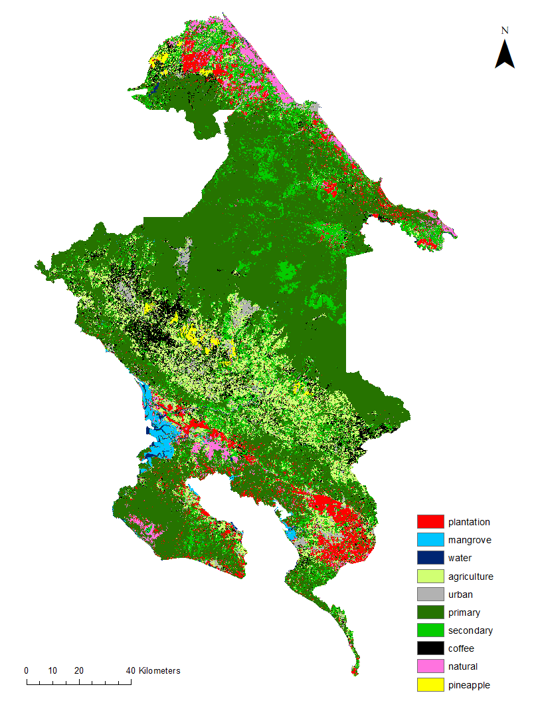

N



40

20

0

Km

*Figure 5.* Forecast map for the Costa Rica study areas in the year 2029

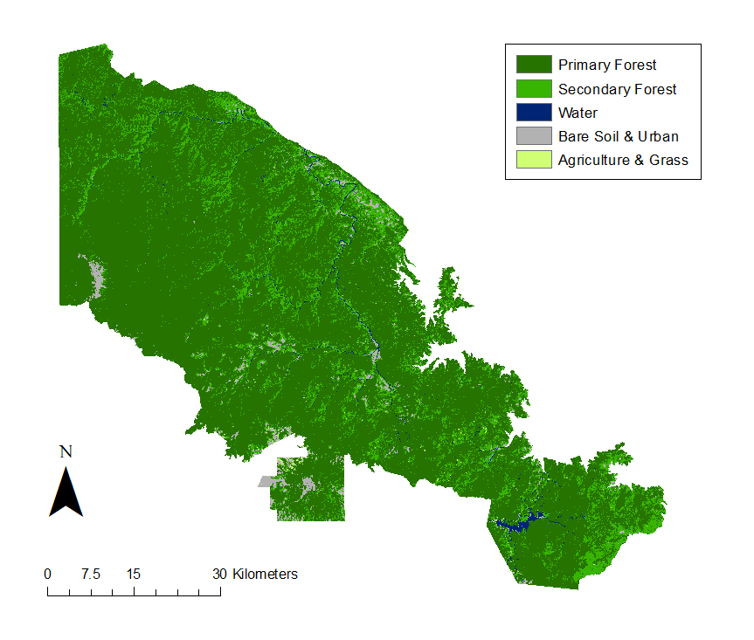

Primary Forest

Secondary Forest

Water

Bare Soil & Urban

Agriculture & Grass

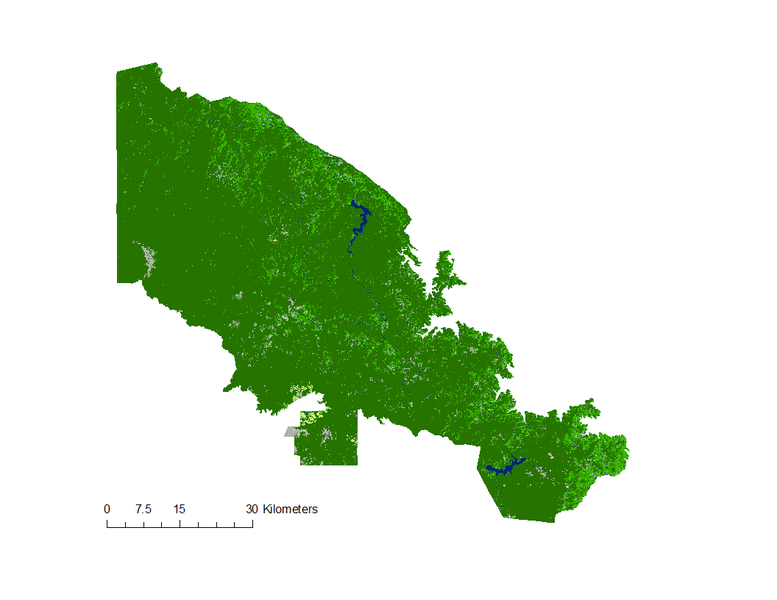

N



0

30

15

Km

*Figure 6.* Forecast map for the Panama study area in the year 2029

***4.1.2 Discussion of Errors and Uncertainties***

Our LULC mapping results documented the changes from 1999 to 2019. In this process, the team determined potential misclassification in some specific classes such as coffee and pineapple. When pineapple training points were determined, some were placed on recently harvested areas. These pixels could have a similar value as bare soil & urban class causing misclassification between the two classes. Misclassified maps can then affect the forecasted maps.

***4.2 FCDT 2.0***

***4.2.1 Analysis of Results***

The Forest Change Detection Tool 2.0 was applied to each shapefile defining the region of interest in Costa Rica and Panama. To test the ability of the priority maps to detect forest disturbance, a known region of change in Costa Rica with an area of 4,9064 m2, centered at (83° 4'41.72"W, 9°45'28.76"N) (Appendix E) was identified through Google Earth Pro. This area showed the conversion of forest land cover to bare soil in February 2019. Running the FCDT 2.0 for February 2019 indicated that most of the pixels in the selected region were labeled as high or medium in both NDVI and EVI2 priority maps (Appendix E). The FCDT 2.0 was then run for several dates before February 2019, however, no change was detected for these dates which can show the reliability of the tool.

***4.2.2 Discussion of Errors and Uncertainties***

Originally when the team ran the FCDT 2.0 for the study area in Panama, Google Earth Engine showed a “memory exceeded” error. The shapefile used to run the tool encompassed a mountainous park with a high percentage of cloud coverage, and he FCDT 2.0 code could not find any imagery below the 20% cloud coverage parameter. The team found that using a larger shapefile to initially run the tool, then clipping the results to a smaller desired region of interest was the most efficient way to combat this issue. Additionally, the cloud coverage percent parameter can be changed but is not recommended in the case that the composite image may have significant amounts of gaps (null data). Sentinel-2 MSI Level – 1C contains imagery from 2016 to the present year, 2019, which limits the range of historical data accessible to the FCDT 2.0. When the team tested any date earlier than January 2016, an error was displayed.

***4.3 Future Work***

This project will continue for a second term. There are opportunities to improve upon and refine land use land cover classifications to ensure accuracy in land use tracking and forecasting. This term’s project team found that it was often difficult for our classifications to distinguish between primary and secondary forest and suggest combining the two classes in future time series and forecasting maps. Using fewer classes can improve upon the accuracy of the classification process. The next project team can look deeper into the texture analyses used in this term’s classification code by constructing a Principal Component Analysis (PCA) on each of the GLCM textures.

The Land Use Conflict Identification Strategy (LUCIS) model can serve to further refine this term’s forecasting. The LUCIS model analyzes development patterns over time to show land suitability for different purposes, mainly urban growth, agricultural development, or land conservation. This model uses more detailed explanatory variables like distance from roads, slope, elevation, distance from streams, distance from urban areas, distance from previously disturbed areas, economic state, social awareness, education status, and population to improve upon predicted changes in land use land cover. The projected patterns of land use from the LUCIS model will allow partners to obtain an idea of forecasted land use conflict with greater accuracy.

In addition, there are opportunities to increase the capacity of the Forest Change Detection Tool 2.0. The current tool creates maps from retroactive dates based on a user entered month and year. With the inclusion of older satellite imagery and enhancements to the code, the tool can be programmed to create priority maps over a greater time period, based on what is desired by the user. The code should be further enhanced to bypass Sentinel-2 imagery and use imagery available from the Landsat satellites to ensure dates before January of 2016 can be used. It is also recommended that future researchers look at Hansen’s Global Forest Change dataset from the Earth Engine Data Catalog to show short term change instead of using the FCDT 2.0.

# 5. Conclusions

Our results indicated that historical LULC maps can be used to monitor and forecast the spatial and temporal dynamics of change over time. The time series maps for both Costa Rica and Panama show a consistent decrease in secondary forest and grassland and an increase in bare soil and urban areas from 1999 to 2019. The areas of interest in Costa Rica also showed an increase in plantation land cover. These trends are consistent with and reflective of economic and industrial development. Time series and forecast maps visualize land use land cover change over time and serve to highlight areas with high potential to undergo land use change. By comparing the 2029 forecast map and 2019 classified map, the partners can monitor the spatial pattern of possible changes from current time to 2029. The Forest Change Detection Tool 2.0 created in GEE API with its accompanying operating procedures manual provides partner organizations with an easy tool to create visual representations of short-term vegetation change for their areas of interest. A balance of short-term and long-term change mapping techniques can improve upon land use tracking. This allows policy makers and land managers to prepare for and minimize the effects of any negative effects that industrialization may have on biodiversity.

# 6. Acknowledgments

We would like to acknowledge Dr. Rafael Monge Vargas, Sara Mora, Cornelia Miller, Heileen Aguilar, Christian Vargas, Iván Avila, Marilyn Ortega and Daniel Villavicencio from the Ministry of Environment and Energy in Costa Rica, and Roney Samaniego, National Environmental Authority of Panama, as well as their many other respective team members for their involvement throughout the duration of this project. Their expertise and open communication allowed this project to begin and progress at a steady pace. Thank you to Sean McCartney and Emil Cherrington from NASA, Dr. Steve Padgett-Vasquez from the NASA DEVELOP National Program, and Estefanía Palacios from the University of Georgia for translating our work to ensure the effective communication to our partners. We would like to acknowledge the NASA DEVELOP Summer 2018 Honduras Ecological Forecasting project team for their initial creation of a Deforestation Detection Tool that our team’s innovators had the opportunity to adapt. The team would like to thank Dr. Marguerite Madden at the University of Georgia’s Center for Geospatial Research for her guidance and wisdom, and for her accessibility to the project team. We would also like to thank Dr. Sergio Bernardes and Amanda Aragon at the University of Georgia Center for Geospatial Research for their technical and motivational support. Thank you to all other contributors to the project, including Ryan Slapikas. Lastly, thank you to our DEVELOP Georgia – Athens Node Fellow, Shelby Ingram, for her contributions and tireless enthusiasm and support throughout this project’s duration.

This material contains modified Copernicus Sentinel data (2019) processed by ESA.

Any opinions, findings, and conclusions or recommendations expressed in this material are those of the author(s) and do not necessarily reflect the views of the National Aeronautics and Space Administration.

This material is based upon work supported by NASA through contract NNL16AA05C.

# 7. Glossary

**Artificial Neural Network (ANN)** – An information processing model that processes nonlinear relationships

**Biological Corridor** – Geographic area that connects topography, ecosystems, habitats, and protects the biodiversity of the ecosystems it connects

**Central American Integration System (SICA)** – A United Nations affiliated regional economic integration system made up of member states from Belize, Costa Rica, Dominican Republic, El Salvador, Guatemala, Honduras, Nicaragua, and Panama as of October 2019

**Digital Elevation Model (DEM)** – A 3-dimensional computer-generated representation of terrain, using elevation data

**Earth observations** – Satellites and sensors that collect information about the Earth’s physical, chemical, and biological systems over space and time

**Enhanced Vegetation Index (EVI)** – Optimized vegetation index that quantifies vegetation for each pixel of a remote sensing image, improved sensitivity in high biomass regions with atmospheric corrections

**2-band Enhanced Vegetation Index (EVI2)** – An optimized vegetation index calculated using only the Red and Near Infrared bands, omitting the Blue band found in the original EVI equation

**Google Earth Engine (GEE)** – Cloud-based API for global data analysis

**Gray-Level Co-occurrence Matrix (GLCM)** – A statistical analysis that considers the spatial relationship of pixels in an image to determine texture features

**Land cover** – Physical materials on Earth’s surface, including but not limited to forests, bodies of water and urban areas

**Landsat 5 Thematic Mapper (TM)** –Satellite and sensor (low Earth orbit) launched March 1, 1984, to collect imagery of the surface of Earth

**Landsat 7 Enhanced Thematic Mapper Plus (ETM+)** – Satellite and sensor launched April 15, 1999, to collect and refresh imagery of the surface of Earth with less cloud cover

**Landsat 8 Operational Land Imager (OLI)** –Satellite and sensor launched February 11, 2013, to continue acquisition of earth observation and imagery collection

**Land use** –Human management and adaptation of natural resources and environment

**Near Infrared (NIR)** – Reflection in the near-infrared spectrum

**Normalized Difference Vegetation Index (NDVI)** – A measurement of live vegetation density

**QGIS Modules for Land Use Change Simulations (MOLUSCE)** – MOLUSCE is a plugin in QGIS for land change evaluation

**Remote Sensing** – Using a satellite or high-flying aircraft to obtain information about an object from a distance

# 8. References

Andam, K. S., Ferraro, P. J., Pfaff, A., Sanchez-Azofeifa, G. A., & Robalino, J. A. (2008). Measuring the effectiveness of protected area networks in reducing deforestation. *Proceedings of the National Academy of Sciences of the United States of America, 105*(42), 16089-16094.<http://doi.org/10.1073/pnas.0800437105>

Avelino, J., Barboza, B., Araya, J. C., Fonseca, C., Davrieux, F., Guyot, B., & Cilas, C. (2005). Effects of slope exposure, altitude and yield on coffee quality in two altitude *terroirs* of Costa Rica, Orosi and Santa María de Dota. *Journal of the Science of Food and Agriculture, 85*(11), 1869-1876. <https://doi.org/10.1002/jsfa.2188>

Breiman, L. (2001). Random Forests. *Machine Learning, 45*(5). https://doi.org/10.1023/A:1010933404324

Food and Agriculture Association of the United Nations. (2015). Global forest resources assessment 2015. Retrieved October 2, 2019, from <http://www.fao.org/forest-resources-assessment/past-assessments/fra-2015/en/>

Ford, A., & Horn, S. (2018). Above and below the Maya forest. *Science*, *361*(6409), 1313-1314.<https://doi.org/10.1126/science.aav0887>

Furey, S., Landry, O., Trust, S., & Fynn, I. (2019). Talamanca-Osa Ecological Forecasting II: Assessing Habitat Suitability and Human-Jaguar Conflict Areas to Identify Potential Jaguar Corridors Connecting La Amistad and Corcovado National Parks in Costa Rica. *Technical Report. NASA DEVELOP National Program: Georgia Node, Athens, GA.*

Haralick R. M., Shanmugam K., & Dinstein I. (1973). Textural features for image classification. *IEEE Trans 6*(SMC-3), 610-621. https://doi.org/10.1109/TSMC.1973.4309314

Koh, L. P., Miettinen, J., Liew, S. C., & Ghazoul, J. (2011). Remotely sensed evidence of tropical peatland conversion to oil palm. *PNAS, 108*(12), 5127-5132. <https://doi.org/10.1073/pnas.1018776108>

Miller, K., Chang, E., & Johnson, N. (2001). *Defining common ground for the Mesoamerican Biological Corridor.* [PDF file]. Washington, D.C.: World Resources Institute. Retrieved October 3, 2019, from<https://www.wri.org/publication/defining-common-ground-mesoamerican-biological-corridor>

Portillo-Quintero, C., & Smith, V. (2018). Emerging trends of tropical dry forests loss in North & Central America during 2001-2013: The role of contextual and underlying drivers. *Applied Geography, 94,* 58-70.<https://doi.org/10.1016/j.apgeog.2018.03.011>

Rathinagiri, S., Manivel, M., Raj, J., Pugalanthi, V., Ravichandran, N., & Anand, V. D. (2010). Remote sensing and GIS based forest cover change detection study in Kalrayan hills, Tamil Nadu. *Journal of Environmental Biology, 31*(5), 737-747. Retrieved October 10, 2019, from <https://www.researchgate.net/publication/286000485_Remote_sensing_and_GIS_based_forest_cover_change_detection_study_in_Kalrayan_hills_Tamil_Nadu>

Rawat, J. S., & Kumar, M. (2015). Monitoring land use/cover change using remote sensing and GIS techniques: A case study of Hawalbagh block, district Almora, Uttarakhand, India. *The Egyptian Journal of Remote Sensing and Space Science, 18*(1), 77-84. https://doi.org/10.1016/j.ejrs.2015.02.002

Stach, N., Salvado, A., Petit, M., Faure, J. F., Durieux, L., Corbane, C., … Deshayes, M. (2009). Land use monitoring by remote sensing in tropical forest areas in support of the Kyoto Protocol: The case of French Guiana. *International Journal of Remote Sensing*, *30*(19), 5133-5149. <https://doi.org/10.1080/01431160903022969>

US Geological Survey Earth Resources Observation and Science Center. (2019). Provisional Landsat 5 TM Surface Reflectance. [Data set]. U.S. Geological Survey. <https://doi.org/10.5066/P9QB18BR>

U.S. Geological Survey Earth Resources Observation and Science Center. (2019). Provisional Landsat 7 ETM+ Level-2 Surface Reflectance. [Data set]. U.S. Geological Survey.<https://doi.org/10.5066/f7q52mnk>

US Geological Survey Earth Resources Observation and Science Center. (2019). Provisional Landsat 8 OLI Surface Reflectance. [Dataset]. U.S. Geological Survey.<https://dx.doi.org/10.5066/F78S4MZJ>

Zhu, Z., & Woodcock, C. E. (2012). Object-based cloud and cloud shadow detection in Landsat imagery. *Remote Sensing of Environment, 118,* 83-94.<https://doi.org/10.1016/j.rse.2011.10.028>

# 9. Appendices

**Appendix A.**

**Satellite and Sensor Descriptions**

Table A1

*Satellites and sensors used in data acquisition*

|  |  |  |  |
| --- | --- | --- | --- |
| **Platform & Sensor** | **Source** | **Resolution** | **Year Acquired** |
| Landsat 5 TM | USGS | 30 m | 1999, 2009 |
| Landsat 7 ETM+ | USGS | 30 m | 1999, 2009, 2019 |
| Landsat 8 OLI | USGS | 30 m | 2019 |
| Sentinel-2 MSI | European Union/ESA/Copernicus | 10/20 m | 2019 |
| ALOS PRISM | JAXA | 30 m | 1999, 2009, 2019 |

**Appendix B.**

**Indices Equations and Wavelength Values**

Table B1

*Spectral vegetation indices and equations*

|  |  |  |
| --- | --- | --- |
| **Index** | **Abbreviation** | **Equation** |
| Normalized Difference Bare Index | NDBI | $$\frac{\text{Green-}\text{Red}}{\text{Green+Red}}$$ |
| Normalized Difference Moisture Index | NDMI | $$\frac{\text{SWIR1-Red}}{\text{SWIR1+Red}}$$ |
| Normalized Difference Water Index | NDWI | $$\frac{\text{NIR-SWIR1}}{\text{NIR+SWIR1}}$$ |
| Tasseled-Cap Brightness | TCB | (0.2043 * BLUE) + (0.4158 * GREEN) + (0.5524 * RED) + (0.5741 * NIR) + (0.3124 * SWIR1) + (0.2303 * SWIR2) |
| Tasseled-Cap Greenness | TCG | (-0.1603 * BLUE) + (0.2819 * GREEN) + (-0.4934 * RED) + (0.7940 * NIR) + (-0.0002 * SWIR1) + (-0.1446 * SWIR2) |
| Tasseled-Cap Wetness | TCW | (0.0315 * BLUE) + (0.2021 * GREEN) + (0.3102 * RED) + (0.1594 * NIR) + (-0.6806 * SWIR1) + (-0.6109 * SWIR2) |

Table B2

*Surface reflectance bands and wavelengths used to calculate spectral vegetation indices*

|  |  |  |  |  |  |  |
| --- | --- | --- | --- | --- | --- | --- |
| **Surface Reflectance** | **Landsat 5 TM** | | **Landsat 7 ETM+** | | **Landsat 8 OLI** | |
| **Band** | **Wavelength (μm)** | **Band** | **Wavelength (μm)** | **Band** | **Wavelength (μm)** |
| Blue | 1 | 0.45 - 0.52 | 1 | 0.45 - 0.52 | 2 | 0.452 - 0.512 |
| Green | 2 | 0.52 - 0.60 | 2 | 0.52 - 0.60 | 3 | 0.533 - 0.590 |
| Red | 3 | 0.63 - 0.69 | 3 | 0.63 - 0.69 | 4 | 0.636 - 0.673 |
| NIR | 4 | 0.77 - 0.90 | 4 | 0.77 - 0.90 | 5 | 0.851 - 0.879 |
| SWIR 1 | 5 | 1.55 - 1.75 | 5 | 1.55 - 1.75 | 6 | 1.566 - 1.651 |

**Appendix C.**

**LULC Time Series and Forecast Map Percent Change**

Table C1

*1999 through 2019 land use and land cover percentages of the study area in Costa Rica by class*

|  |  |  |  |  |
| --- | --- | --- | --- | --- |
| **Class** | **Description** | **Percent of study area 1999** | **Percent of study area 2009** | **Percent of study area 2019** |
| 1 | Palm Plantation | 3.79 | 6.06 | 6.36 |
| 2 | Mangrove | 1.16 | 1.48 | 1.36 |
| 3 | Water | 1.37 | 1.40 | 0.72 |
| 4 | Agriculture & Grass | 11.73 | 15.97 | 12.31 |
| 5 | Bare Soil & Urban | 0.78 | 1.08 | 2.68 |
| 6 | Primary Forest | 53.10 | 45.81 | 50.27 |
| 7 | Secondary Forest | 15.47 | 17.23 | 15.67 |
| 8 | Natural Palm | 4.47 | 7.69 | 6.77 |
| 9 | Coffee | 3.46 | 2.77 | 3.16 |
| 10 | Pineapple | 4.67 | 0.51 | 0.69 |

Table C2

*1999 through 2019 land use and land cover percentages of the study area in Panama by class*

|  |  |  |  |  |
| --- | --- | --- | --- | --- |
| **Class** | **Description** | **Percent of study area 1999** | **Percent of study area 2009** | **Percent of study area 2019** |
| 1 | Primary Forest | 82.53 | 86.38 | 83.93 |
| 2 | Secondary Forest | 14.29 | 10.66 | 12.56 |
| 3 | Water | 0.88 | 0.94 | 0.90 |
| 4 | Bare Soil & Urban | 2.15 | 1.67 | 2.20 |
| 5 | Agriculture & Grass | 0.15 | 0.36 | 0.41 |

Table C3

*2029 forecasted land use and land cover percentages of the study area in Costa Rica by class*

|  |  |  |  |  |
| --- | --- | --- | --- | --- |
| **Class** | **Description** | **Percent of study area 2019** | **Forecasted percent of study area 2029** | **Overall increase/decrease 2019 to 2029** |
| 1 | Palm Plantation | 6.36 | 6.11 | -0.25 |
| 2 | Mangrove | 1.36 | 1.24 | -0.12 |
| 3 | Water | 0.72 | 0.55 | -0.17 |
| 4 | Agriculture & Grass | 12.31 | 11.37 | -0.94 |
| 5 | Bare Soil & Urban | 2.68 | 3.09 | 0.41 |
| 6 | Primary Forest | 50.27 | 53.92 | 3.65 |
| 7 | Secondary Forest | 15.67 | 13.60 | -2.07 |
| 8 | Natural Palm | 6.77 | 6.30 | 0.47 |
| 9 | Coffee | 3.16 | 3.06 | -0.10 |
| 10 | Pineapple | 0.69 | 0.75 | 0.06 |

Table C4

*2029 forecasted land use and land cover percentages of the study area in Panama by class*

|  |  |  |  |  |
| --- | --- | --- | --- | --- |
| **Class** | **Description** | **Percent of study area 2019** | **Forecasted percent of study area 2029** | **Overall increase/decrease 2019 to 2029** |
| 1 | Primary Forest | 83.93 | 87.29 | 3.36 |
| 2 | Secondary Forest | 12.56 | 8.99 | -3.57 |
| 3 | Water | 0.90 | 0.81 | -0.09 |
| 4 | Bare Soil & Urban | 2.20 | 2.51 | 0.31 |
| 5 | Agriculture & Grass | 0.41 | 0.37 | -0.04 |

**Appendix D.**

**Elevation Restrictions**

Table D1

*Literature review influenced elevation restrictions*

|  |  |  |  |
| --- | --- | --- | --- |
| Class | **Elevation Restrictions in Code** | **Elevation Range from Literature** | **Literature Source** |
| Coffee (in region of interest in Costa Rica) | Greater than 870 m | 1000 m to 1300 m | Avelino et al., (2005).  Furey, S., Landry, O., Trust, S., & Fynn, I. (2019). |
| Water (in eastern part of the study area in Panama) | Less than 1300 m | NA | NA |

**Appendix E.**

**Forest Change Detection Tool Area of Change Case Study**

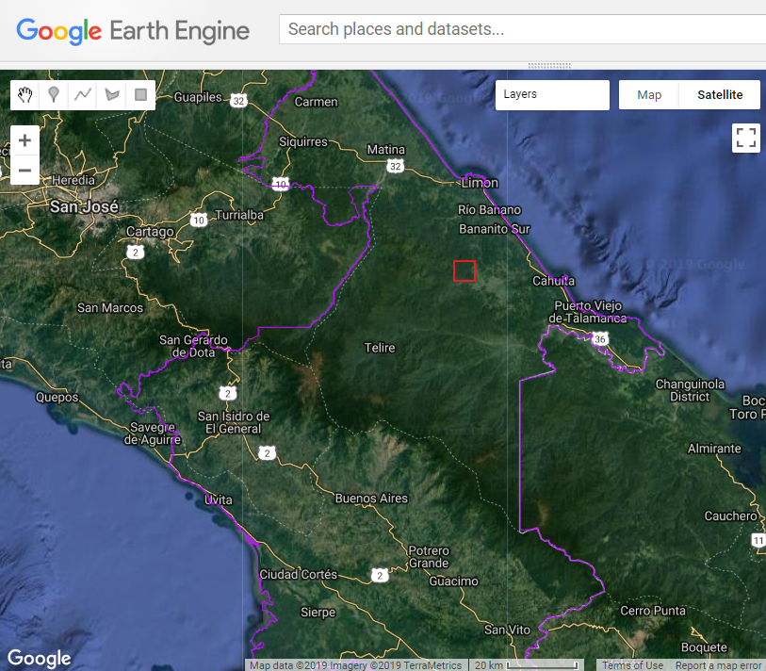

*Figure E1.* FCDT 2.0 change detection results: area of known change image from Google Earth Engine

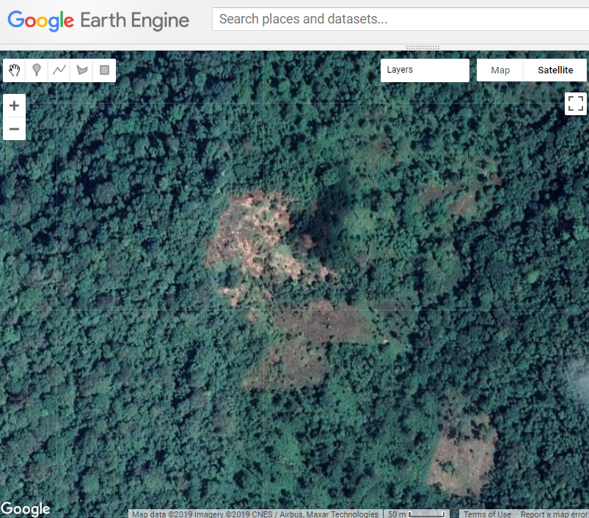

*Figure E2.* FCDT 2.0 change detection results: area of known change close-up image from Google Earth Pro

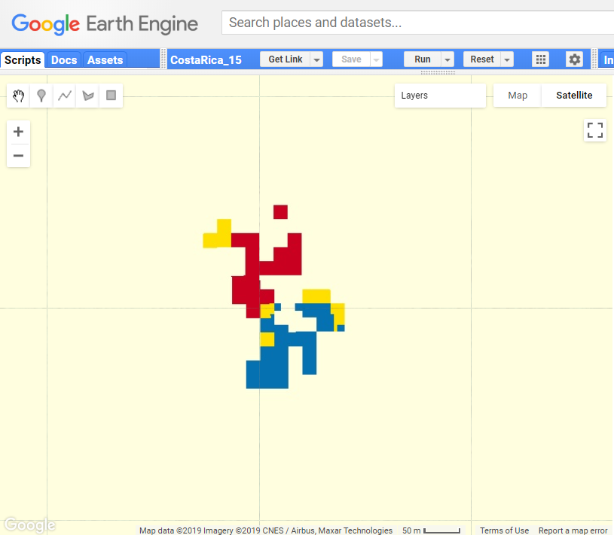

*Figure E3.* FCDT 2.0 change detection results: NDVI from February 2019

NDVI priority map

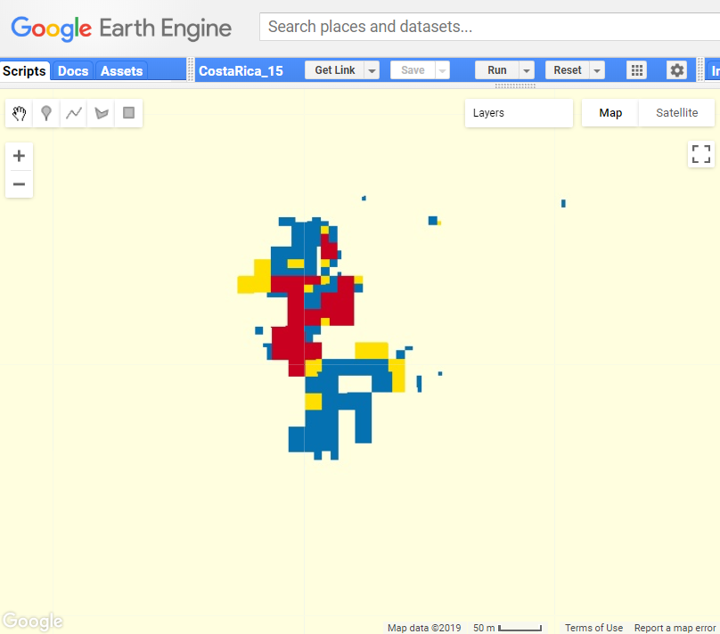

*Figure E4.* FCDT 2.0 change detection results: EVI2 priority map from February 2019

NDVI priority map